Name of Journal: World Journal of Clinical Cases
Manuscript NO: 72188
Manuscript Type: CASE REPORT

Acute esophageal obstruction after ingestion of psyllium seed husk powder: A case report

Shin S et al. Esophageal obstruction after psyllium seed ingestion

Sujeong Shin, Jung Ho Kim, You Ho Mun, Han Sol Chung

Sujeong Shin, Jung Ho Kim, You Ho Mun, Han Sol Chung, Department of Emergency Medicine, Yeungnam University School of Medicine and College of Medicine, Daegu 42415, South Korea

Author contributions: Kim JH was the patient's emergency physician, reviewed the literature and performed review and editing; Shin S reviewed the literature and contributed to manuscript drafting; Mun YH and Chung HS reviewed the literature; Shin S and Kim JH were responsible for the revision of the manuscript for important intellectual content; all authors issued final approval for the version to be submitted.

Supported by the 2021 Yeungnam University Research Grant.

Corresponding author: Jung Ho Kim, MD, MM, Assistant Professor, Chief Doctor, Department of Emergency Medicine, Yeungnam University School of Medicine and College of Medicine, 170, Hyeonchung-ro, Daegu 42415, South Korea. jhkimem@yu.ac.kr

Received: October 8, 2021
Revised: December 2, 2021
Accepted: January 19, 2022
Published online: March 6, 2022
Abstract
BACKGROUND
Bezoar is a mass of hardened external material found in the gastrointestinal (GI) tract. It may form anywhere in the GI tract, but esophageal bezoar is rare because of the short esophageal transit time. Psyllium seed husk is an indigestible natural derivative that is widely used as an herbal laxative. Herein, we report a case of acute esophageal obstruction caused by a bezoar after ingestion of psyllium seed husk powder.

CASE SUMMARY
A 76-year-old male with Parkinson's disease visited the emergency department with swallowing difficulty approximately 10 h after ingesting psyllium seed husk powder. Symptoms began a few hours after ingestion and progressed to severe dysphagia. There were no abnormal findings on simple radiography. However, a computed tomography scan revealed an approximately 2.0 cm × 2.5 cm mass located near the gastro-esophageal junction. After grinding, the mass was removed using an endoscopic capture net. Esophageal bezoars may cause life-threatening complications. Patients with Parkinson's disease may have esophageal motility dysfunction, which may increase esophageal transit time. Since our patient had Parkinson's disease, this effect may have contributed to the formation of the bezoar.

CONCLUSION
Attention should be paid to using bulk-laxatives, and an appropriate specified regimen will be needed when marketed as a dietary supplement.

Key Words: Bezoar; Esophagus; Obstruction; Parkinson’s disease; Psyllium; Case report

©The Author(s) 2022. Published by Baishideng Publishing Group Inc. All rights reserved.

Citation: Shin S, Kim JH, Mun YH, Chung HS. Acute esophageal obstruction after ingestion of psyllium seed husk powder: A case report. World J Clin Cases 2022; 10(7): 2336-2340
URL: https://www.wjgnet.com/2307-8960/full/v10/i7/2336.htm
DOI: https://dx.doi.org/10.12998/wjcc.v10.i7.2336

Core Tip: In patients with functional esophageal disorders such as in those with Parkinson's disease, bulk-forming laxative regimens may increase the risk of esophageal bezoar formation. Furthermore, bulk-forming laxatives such as psyllium seed husk can be purchased cheaply over the counter in the form of herbal medications. Therefore, we recommend that physicians pay more attention to the use of bulk-forming laxative regimens in these patients. Furthermore, optimal usage guidelines and warning messages may need to be included when selling psyllium seed husk as a health supplement.

INTRODUCTION
Bezoar is a mass of hardened external material found in the gastrointestinal (GI) tract^{[1]}. It is commonly found in the stomach, small intestine, and colon; however, esophageal bezoar is rare because the short esophageal transit time does not allow one to form^{[2]}. Esophageal bezoar can be successfully removed by endoscopic intervention; however, bezoar removal requires attention because of the high failure rate of conservative or endoscopic intervention when mechanical obstruction is complicated^{[3]}.
Psyllium seed husk is an indigestible natural derivative of Plantago ovata, which consists of 65% insoluble polysaccharides^{[1,3]}. It is inexpensive and widely used as an herbal laxative; however, it may have adverse effects. Cases of bezoar due to psyllium seed husk causing GI tract obstruction are rare but have been reported^{[1,3]}. However, there are few reports of esophageal obstruction caused by bezoars due to psyllium seed husk^{[4]}.
Herein, we report a case of acute esophageal obstruction caused by a bezoar after ingestion of psyllium seed husk powder.

CASE PRESENTATION
Chief complaints
A 76-year-old man visited the emergency department (ED) because of swallowing difficulty and epigastric discomfort approximately 10 h after ingesting psyllium seed husk powder to relieve constipation.

History of present illness
His symptoms began a few hours after the ingestion. Initially, his symptoms were not severe, and he was monitored at home. However, the symptoms continued to worsen. Therefore, he visited the local clinic, where he was administered metoclopramide, but the symptoms did not improve.

History of past illness
He had hypertension, diabetes mellitus, and Parkinson's disease. He said that he sometimes suffered from dyspepsia or dysphagia after taking the powder previously as well, but the current symptoms were the most serious.

Personal and family history
He was diagnosed with Parkinson's disease at our department of neurology 3 years before visiting the ED and started taking Stalevo (125 mg of levodopa, 31.25 mg of carbidopa, and 200 mg of entacapone) twice a day. After 7 mo of follow-up, he decided to consult a neurologist near his house for the management of Parkinson's disease. Additionally, he was taking psyllium seed husk powder, about 5 g with water per day, for constipation, purchased from a drugstore without a prescription.

Physical examination
When he tried to swallow, immediate esophageal discomfort and regurgitation prevented any solid or liquid intake, even saliva. There were no accompanying GI symptoms, such as diarrhea or abdominal pain. He also did not present with any focal neurological abnormalities.

Laboratory examinations
Initial biochemical results were as follows: white blood cell count: 6740/μL, levels of hemoglobin 13.7 g/dL, aspartate aminotransferase: 33 IU/L, alanine aminotransferase: 5 IU/L, total bilirubin: 2.34 mg/dL, direct bilirubin: 0.59 mg/dL, serum amylase: 68 IU/L, blood urea nitrogen: 17 mg/dL, serum creatinine: 1.13 mg/dL, and C-reactive protein: 0.052 mg/dL.

Imaging examinations
Simple posteroanterior radiography at the ED showed no specific abnormal pathological findings. We suspected esophageal achalasia or food impaction; therefore, we decided to perform an abdominal computed tomography (CT) scan for differential diagnosis. Abdominal CT scan revealed an approximately 2.0 cm × 2.5 cm mass located just above the gastro-esophageal junction (Figure 1). We suspected a bezoar due to the presence of psyllium seed husk powder.

MULTIDISCIPLINARY EXPERT CONSULTATION
He underwent gastroendoscopy for a definitive diagnosis and mass removal, which revealed focal mucosal hyperemia and an approximately 2.0 cm sized bezoar bolus at the gastro-esophageal junction (Figure 2A).

FINAL DIAGNOSIS
The final diagnosis in the present case was esophageal obstruction due to bezoar of psyllium seed husk powder.

TREATMENT
Immediately after the endoscopic diagnosis, removal of the bezoar using a capture net after grinding was performed (Figure 2B).

OUTCOME AND FOLLOW-UP
Two hours after endoscopic removal, food passage through the esophagus was good, and there were no specific abnormal symptoms or signs. We decided to proceed with evaluation for dysphasia, achalasia, or other GI pathologies at the outpatient department, and he was discharged.

DISCUSSION
Psyllium seed husk contains indigestible polysaccharides and forms a gel in water. It also has hygroscopic characteristics that allow it to retain water and expand rapidly. Because of these properties, it is used as an herbal medication to treat constipation and hemorrhoids and to control weight^{[3]}. Additionally, it has recently been used to achieve abdominal distension before CT enterography and magnetic resonance enterography to increase diagnostic accuracy^{[5]}. However, several complications due to the use of psyllium seed husk have also been reported. Hefny et al^{[3]} reported that intestinal obstruction resulted from ingestion of psyllium seed husk for constipation management without an adequate amount of water. Chen et al^{[5]} reported small bowel obstruction caused by a bezoar due to psyllium seed husk, which was used as an oral contrast agent.
Esophageal bezoar formation is associated with structural or functional problems, such as previous GI surgery, GI stricture, and achalasia, which are risk factors for increased esophageal transit time^{[2,3]}. Additionally, excessive persimmon ingestion or psychiatric disease may be related to esophageal bezoar formation^{[6]}. Esophageal obstruction related to the malposition of a nasogastric tube has been reported in a patient with Parkinson's disease^{[7]}. Swallowing difficulty due to oropharynx and esophageal dysfunction has been reported in up to 77% of patients with Parkinson's disease; esophageal motility dysfunction in these patients is characterized by increased transit time, abnormal peristalsis, achalasia, etc^{[8]}. Therefore, esophageal motility impairment and increased esophageal food residence time may increase the chances of bezoar formation in patients with Parkinson's disease. Our patient had Parkinson's disease, which may have collaterally contributed to the formation of the bezoar due to psyllium seed husk. Additionally, he had sometimes experienced dyspepsia or dysphagia after taking psyllium seed husk powder previously, did not eat any other solid foods until symptoms appeared, and symptoms developed not long after taking powder. In this regard, we believe that his bezoar was due to psyllium seed husk powder, although componential analysis was impossible in our hospital.
Esophageal bezoar may cause life-threatening complications, such as severe intestinal obstruction, perforation, or asphyxia due to aspiration^{[9]}. Fortunately, regurgitation in our patient did not cause aspiration or progression to other serious complications. However, patients with chronic medical problems, such as Parkinson's disease, have a high risk of serious complications such as pneumonia or respiratory arrest due to aspiration, and esophageal bezoar formation may increase this risk. Additionally, such patients frequently use GI bulking agents, such as psyllium seed husk, to control GI problems such as constipation.
There are a few methods for the treatment of esophageal bezoar, including dissolution using proteolytic enzymes, endoscopic removal, and surgical procedures^{[10]}. In our case, the bezoar was pushed into the stomach, followed by fragmentation and extraction.
In addition to psyllium hull powder, there are various bulk laxatives. Additionally, the dosage and concentration of the medication may be more important than the type of regimen in patients with esophageal motility disorders. However, psyllium seed husk powder is a widely used bulk laxative, and some specific regimens can cause unexpected problems in people with certain comorbidities. Therefore, we believe that uncontrolled bulk-forming laxative regimens may increase the risk of esophageal bezoar formation in patients with functional esophageal disorders, such as those with Parkinson's disease. Furthermore, bulk-forming laxatives such as psyllium seed husk can be purchased cheaply over-the-counter as herbal medications. Therefore, we recommend that physicians pay more attention to the use of bulk-forming laxative regimens in these patients. Furthermore, optimal usage guidelines and warning messages may need to be included when selling psyllium seed husk as a health supplement.

CONCLUSION
Bulk-forming laxatives can be purchased easily but may increase the risk of esophageal obstruction in patients with functional esophageal disorders. Therefore, physicians should take this into account, and specify the appropriate regimen when marketed as a dietary supplement.

REFERENCES
1 Agha FP, Nostrant TT, Fiddian-Green RG. "Giant colonic bezoar:" a medication bezoar due to psyllium seed husks. Am J Gastroenterol 1984; 79: 319-321 [PMID: 6711534]
2 Yeoh SW. Esophageal bezoar due to karaya gum granules used as a laxative. Clin J Gastroenterol 2017; 10: 437-441 [PMID: 28730320 DOI: 10.1007/s12328-017-0764-x]
3 Hefny AF, Ayad AZ, Matev N, Bashir MO. Intestinal obstruction caused by a laxative drug (Psyllium): A case report and review of the literature. Int J Surg Case Rep 2018; 52: 59-62 [PMID: 30321826 DOI: 10.1016/j.ijscr.2018.10.001]
4 Noble JA, Grannis FW Jr. Acute esophageal obstruction by a psyllium-based bulk laxative. Chest 1984; 86: 800 [PMID: 6488929 DOI: 10.1378/chest.86.5.800a]
5 Chen YA, Cervini P, Kirpalani A, Vlachou PA, Grover SC, Colak E. Small bowel obstruction following computed tomography and magnetic resonance enterography using psyllium seed husk as an oral contrast agent. Can J Gastroenterol Hepatol 2014; 28: 391-395 [PMID: 25157531 DOI: 10.1155/2014/501043]
6 Kement M, Ozlem N, Colak E, Kesmer S, Gezen C, Vural S. Synergistic effect of multiple predisposing risk factors on the development of bezoars. World J Gastroenterol 2012; 18: 960-964 [PMID: 22408356 DOI: 10.3748/wjg.v18.i9.960]
7 Shulman LM, Minagar A, Weiner WJ. Perdiem causing esophageal obstruction in Parkinson's disease. Neurology 1999; 52: 670-671 [PMID: 10025817 DOI: 10.1212/wnl.52.3.670]
8 Pfeiffer RF. Gastrointestinal dysfunction in Parkinson's disease. Lancet Neurol 2003; 2: 107-116 [PMID: 12849267 DOI: 10.1016/s1474-4422(03)00307-7]
9 England G, Heath KJ, Gilbert JD, Byard RW. Forensic features of pharmacobezoars. J Forensic Sci 2015; 60: 341-345 [PMID: 25537433 DOI: 10.1111/1556-4029.12679]
10 Yaqub S, Shafique M, Kjæstad E, Thorsen Y, Lie ES, Dahl V, Bakka N, Røkke O. A safe treatment option for esophageal bezoars. Int J Surg Case Rep 2012; 3: 366-367 [PMID: 22609703 DOI: 10.1016/j.ijscr.2012.04.008]

Footnotes
Informed consent statement: We were unable to contact the patient. Written informed consent was not necessary because the patient data were not included in the manuscript.

Conflict-of-interest statement: The authors declare that there are no potential conflicts of interest relevant to this article.

CARE Checklist (2016) statement: The authors have read the CARE Checklist (2016), and the manuscript was prepared and revised according to the CARE Checklist (2016).

Open-Access: This article is an open-access article that was selected by an in-house editor and fully peer-reviewed by external reviewers. It is distributed in accordance with the Creative Commons Attribution NonCommercial (CC BY-NC 4.0) license, which permits others to distribute, remix, adapt, build upon this work non-commercially, and license their derivative works on different terms, provided the original work is properly cited and the use is non-commercial. See: https://creativecommons.org/Licenses/by-nc/4.0/

Provenance and peer review: Unsolicited article; externally peer reviewed.
Peer-review model: Single blind

Peer-review started: October 8, 2021
First decision: December 2, 2021
Article in press: January 19, 2022

Specialty type: Emergency medicine
Country/Territory of origin: South Korea
Peer-review report’s scientific quality classification
Grade A (Excellent): 0
Grade B (Very good): 0
Grade C (Good): C, C
Grade D (Fair): 0
Grade E (Poor): 0

P-Reviewer: Deng K, YALÇINKAYA İ S-Editor: Liu JH L-Editor: A P-Editor: Liu JH
Figure Legends

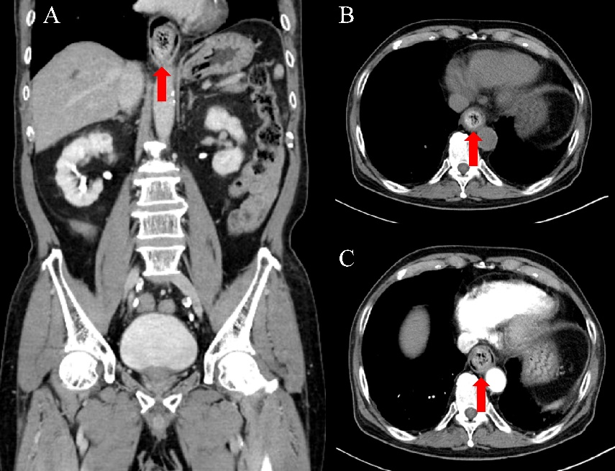
Figure 1 Abdominal computed tomography scans in the emergency department. The red arrows indicate an approximately 2.0 cm × 2.5 cm bezoar located just above the gastro-esophageal junction. A: Coronal view; B and C: Plain view.
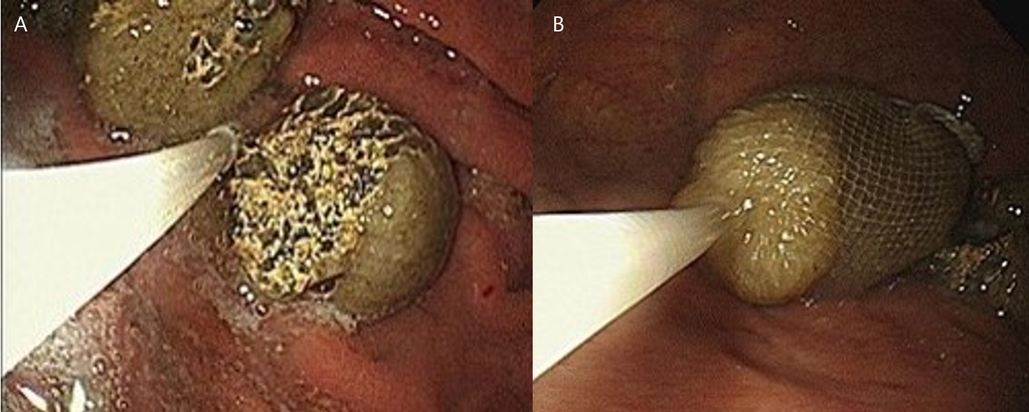
Figure 2 Endoscopic removal of the psyllium seed husk bezoar. Endoscopic diagnosis and removal of the bezoar was performed. A: Gastroendoscopy showing focal mucosal hyperemia, and an approximately 2 cm food bolus at the gastro-esophageal junction. B: After grinding, the large bezoar was endoscopically removed and was captured using a capture net.

Published by Baishideng Publishing Group Inc
7041 Koll Center Parkway, Suite 160, Pleasanton, CA 94566, USA
Telephone: +1-925-3991568
E-mail: bpgoffice@wjgnet.com
Help Desk: https://www.f6publishing.com/helpdesk
https://www.wjgnet.com

© 2022 Baishideng Publishing Group Inc. All rights reserved.

