e1'!!-1f­
J6 1shitfeng®

Baishideng Publishing Group Co., Limited
Room 903, Building D, Ocean International Center,
No.62 Dongsihuan Zhonglu, Chaoyang District, Beijing100025, China
Telephone: +86-10-8538-1892 Fax: +86-10-8538-1893
E-mail: bpg@baishideng.com http: /fwww.wjgnet.com

BAISHIDENG PUBLISHING GROUP CO., LIMITED COPYRIGHT ASSIGNMENT

Name of Journal:World journal of Gastroenterology
ESPS Manuscript NO: 497
Title: Efficacy and safety of Chlorel/a supplementation in adults with chronic HCV infection

Authors:Jose Azocar M.D., D.Sc and Arley Diaz, M.D.

1This manuscript is not simultaneously being considered by other journals.
2 This manuscript has no redundant publication, plagiarism, data fabrication or falsification.
3 There is no conflict of interest in this paper.
4 The experiments were done in compliance with the laws regarding the use of animals and human subjects.
5 The material contained in this manuscript is original, except when appropriately
referenced to other sources, and that written permission has been granted by any existing copyright holders.
6 We agree to transfer to Baishideng Publishing Group Co., Limited all rights of the
manuscript, including: (1) all copyright ownership in all print and electronic formats; (2) the right to grant permission to republish or reprint the stated material in whole or in part, with or without a fee; (3) the right to print copies for free distribution or sale; and (4) the right to republish the stated material in a collection of articles or in any other format. Articles published by this publisher are distributed under the terms of the Creative Commons Attribution Non-commercial License, which permits use, distribution, and reproduction in any medium, provided the original work is properly cited, the use is non commercial and is otherwise in compliance with the license.
7 There are no grammar, syntax, spelling, punctuation or logic errors in this paper.
8 All tables have been correctly placed and clearly indicated.
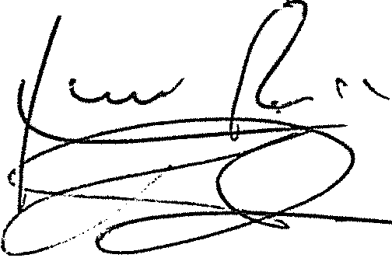9 The references are numbered in the ,order they appear in the text. Authors

1J.Azocar Signature :

Date: December 26, 2012

2 A. Diaz Signature : Date: December 26, 2012

