Name of Journal: World Journal of Gastroenterology
Manuscript NO: 34162
Manuscript Type: ORIGINAL ARTICLE

Retrospective study
Doublecortin and CaM kinase-like-1 as an independent prognostic factor in patients with resected pancreatic carcinoma

Nishio K et al. Significance of DCLK1 in pancreatic cancer

Kohei Nishio, Kenjiro Kimura, Ryosuke Amano, Bunzo Nakata, Sadaaki Yamazoe, Go Ohira, Kotaro Miura, Naoki Kametani, Hiroaki Tanaka, Kazuya Muguruma, Kosei Hirakawa, Masaichi Ohira

Kohei Nishio, Kenjiro Kimura, Ryosuke Amano, Sadaaki Yamazoe, Go Ohira, Kotaro Miura, Naoki Kametani, Hiroaki Tanaka, Kazuya Muguruma, Kosei Hirakawa, Masaichi Ohira, Department of Surgical Oncology, Osaka City University Graduate School of Medicine, Abeno-ku, Osaka 545-8585, Japan

Bunzo Nakata, Department of Surgery, Kashiwara Municipal Hospital, Kashiwara City, Osaka 582-0005, Japan

Author contributions: Kimura K designed the studies; Nishio K drafted the manuscript; Amano R, Muguruma K, Tanaka H, Yamazoe S, Ohira G, Miura K, Kametani N and Hirakawa K provided support in design and interpretation of the study; Nishio K and Kimura K performed the statistical analyses; Hirakawa K and Nakata B helped in drafting of the manuscript; Ohira M provided overall supervision of the manuscript; all authors read and approved the final manuscript.

Institutional review board statement: The study was reviewed and approved by the Osaka City University Institutional Review Board.

Informed consent statement: Written informed consent was obtained from all patients.

Conflict-of-interest statement: The authors declare that they have no competing interests.

Data sharing statement: No additional data are available.

Open-Access: This article is an open-access article which was selected by an in-house editor and fully peer-reviewed by external reviewers. It is distributed in accordance with the Creative Commons Attribution Non Commercial (CC BY-NC 4.0) license, which permits others to distribute, remix, adapt, build upon this work non-commercially, and license their derivative works on different terms, provided the original work is properly cited and the use is non-commercial. See: http://creativecommons.org/licenses/by-nc/4.0/

Manuscript source: Unsolicited manuscript

Correspondence to: Kenjiro Kimura, MD, PhD, Senior Lecturer, Department of Surgical Oncology, Osaka City University Graduate School of Medicine, 1-4-3 Asahimachi, Abeno-ku, Osaka 545-8585, Japan. kenjiro@med.osaka-cu.ac.jp
Telephone: +81-6-66453838
Fax: +81-6-66466450

Received: March 31, 2017
Peer-review started: April 8, 2017
First decision: April 26, 2017
Revised: May 11, 2017
Accepted: July 22, 2017
Article in press:
Published online:

Abstract
AIM
To elucidate the effect of expression of doublecortin and CaM kinase-like-1 (DCLK1) in patients with pancreatic ductal adenocarcinoma (PDAC).

METHODS
Tumor specimens were obtained from 136 patients with pancreatic cancer who had undergone resection without preoperative therapy between January 2000 and December 2013 at the Department of Surgical Oncology, Osaka City University. The resected specimens were analyzed for associations with clinicopathological data, including DCLK1 expression, epithelial mesenchymal transition (EMT) marker expression, and cancer stem cell (CSC) marker expression. Univariate and multivariate survival analyses were performed and we assessed the association between DCLK1 expression and clinicopathological factors, including the EMT marker and CSC marker.

RESULTS
In total, 48.5% (66/136) of the pancreatic cancer samples were positive for DCLK1. Patients with DCLK1-positive tumors had significantly shorter survival times than those with DCLK1-negative tumors (median, 18.7 mo vs 49.5 mo, respectively; P < 0.0001). Positive DCLK1 expression correlated with histological grade (P = 0.0290), preoperative CA19-9 level (P = 0.0060), epithelial cell adhesion molecule (EpCAM) expression (P = 0.0235), and the triple-positive expression of CD44/CD24/EpCAM (P = 0.0139). On univariate survival analysis, five factors were significantly associated with worse overall survival: histological grade of G2 to G4 (P = 0.0091), high preoperative serum SPan-1 level (P = 0.0034), R1/2 (P < 0.0001), positive expression of DCLK1 (P < 0.0001) or CD44 (P = 0.0245). On multivariate survival analysis, R1/2 [odds ratio (OR) = 2.019, 95% confidence interval (CI): 1.380-2.933; P = 0.0004] and positive DCLK1 expression (OR = 1.848, 95%CI: 1.2854-2.661; P = 0.0009) were independent prognostic factors.

CONCLUSION
DCLK1 expression was found to be an independent prognostic factor and it may play a crucial prognostic role by promoting acquisition of stemness.

Key words: doublecortin and CaM kinase-like-1; Pancreatic cancer; Epithelial mesenchymal transition; Cancer stem cell; Prognostic factor

© The Author(s) 2017. Published by Baishideng Publishing Group Inc. All rights reserved.

Core tip: Doublecortin and CaM kinase-like-1 (DCLK1) is a microtubule- associated kinase and has recently attracted much attention as an important cancer stem cell marker. DCLK1 expression is correlated with aggressiveness in various cancers. However, there have been few investigations correlating DCLK1 expression with survival in pancreatic ductal adenocarcinoma (PDAC). PDAC patients with DCLK1-positive tumors had significantly shorter survival times than those with DCLK1-negative tumors. DCLK1 expression was an independent prognostic factor by multivariate survival analysis. Furthermore, DCLK1-positive expression was correlated to EpCAM expression and triple-positive expression of CD44/CD24/EpCAM. These findings suggest DCLK1 may have a crucial prognostic role in acquisition of stemness.

Nishio K, Kimura K, Amano R, Nakata B, Yamazoe S, Ohira G, Miura K, Kametani N, Tanaka H, Muguruma K, Hirakawa K, Ohira M. Doublecortin and CaM kinase-like-1 as an independent poor prognostic factor for resected pancreatic cancer. World J Gastroenterol 2017; In press
INTRODUCTION
Although the number of treatment strategies has increased for pancreatic ductal adenocarcinoma (PDAC), the disease still has a poor prognosis. Malignancy of PDAC is devastating, with a 5-year overall survival rate of approximately 5%^{[1]}. The high mortality rate associated with PDAC is known to be due to extensive invasion into the surrounding tissues and early metastasis to distant organs; however, the molecular mechanisms of the highly aggressive nature of PDAC remain unclear.
Doublecortin and CaM kinase-like-1 (DCLK1) is a microtubule-associated kinase that has recently attracted much attention as an important cancer stem cell (CSC) marker. DCLK1 contains two doublecortin domains in the N terminus, which are involved in the regulation of microtubule polymerization, and a serine/threonine protein kinase domain in the C terminus. Between the N and C termini, there is a serine/proline-rich domain that mediates multiple protein-protein interactions^{[2]}. DCLK1 is predominantly expressed in the low two-thirds of the intestinal crypt epithelium and occasionally in crypt-based columnar cells^{[3]}. Originally, DLCK1 was reported as a putative intestinal and pancreatic stem cell marker^{[4,5]}. More recently, however, DCLK1 has been demonstrated as expressed in CSCs but to be undetectable in normal stem cells^{[6]}. Knockdown of DCLK1 in pancreatic cancer cells resulted in tumor growth arrest and the downregulation of Snail, Slug and Twist, which inhibit epithelial mesenchymal transition (EMT)^{[7-9]}. As such, DCLK1 has become the focus of research into its potential as a candidate therapeutic target for various cancers.
Several studies have demonstrated that DCLK1 expression is correlated with cancer aggressiveness in colorectal^{[10]}, esophageal^{[11]}, breast^{[12]}, and renal cell^{[9]} carcinomas. However, only few studies have investigated the correlation of DCLK1 expression with survival in PDAC. The aim of this study was to elucidate the effect of DCLK1 expression on the survival of patients with PDAC. Moreover, the correlations of clinicopathological features, including expression of EMT and CSC markers, with DCLK1 expression were investigated.

MATERIALS AND METHODS
Patients
The current study used tissue samples from 136 patients who underwent pancreatic resection for PDAC at our institution. All patients were histologically confirmed to have a common type of invasive ductal carcinoma of the pancreas. Patients with neuroendocrine carcinomas, mucinous cystic carcinomas, or intraductal papillary mucinous carcinomas were excluded. Moreover, we excluded patients who had undergone neoadjuvant therapy. Clinical records were reviewed to examine clinical features, including demographic data (age and sex) and therapeutic data (chemotherapy performed after surgery, and interval from surgical resection to death). This study was approved by the ethics committee of Osaka City University and was in compliance with the Declaration of Helsinki. Each patient provided informed consent before tissue samples were obtained.

Surgery and pathology
Surgery involved standard or subtotal stomach-preserving pancreaticoduodenectomy in 76 (55.9%) patients, distal pancreatectomy in 54 (39.7%) patients, and total pancreatectomy in 6 (4.4%) patients. Regional lymph node dissection was performed in all patients. The resected specimens were fixed in 10% formalin at room temperature, and the size and gross appearance of each tumor were recorded. The pathologic stage of all tumor specimens was determined using the staging system of the American Joint Committee on Cancer (AJCC), 7th edition^{[13]}. Tumor differentiation was classified according to the classification of tumors of the World Health Organization as well-differentiated (G1), moderately differentiated (G2), poorly differentiated (G3), or undifferentiated (G4)^{[14]}.

Immunohistochemistry
Formalin-fixed, paraffin-embedded tumor tissue was cut into 4-μm thick sections and immunohistochemistry was performed using a protocol previously reported by our group but with some modifications^{[15]}. The most representative section of tumor for each case was selected for analysis. We analyzed not only DCLK1 expression, but also the expression of E-cadherin, N-cadherin, vimentin, and Snail as EMT markers, and CD24, CD44, CD133, and epithelial cell adhesion molecule (EpCAM) as CSC markers. The primary antibodies used for immunohistochemistry were: rabbit polyclonal anti-DCLK1 antibody (1:80 dilution; Abcam, Cambridge, MA, United States); rabbit polyclonal anti-Snail antibody (1:80 dilution; Abcam); mouse monoclonal anti-E-cadherin antibody (1:50 dilution; Dako Co., Carpinteria, CA, United States); rabbit monoclonal anti-vimentin antibody (1:100 dilution; Cell Signaling, Danvers, MA, United States); rabbit polyclonal anti-N-cadherin antibody (1:100 dilution; Abcam); goat polyclonal anti-CD24 antibody (1:20 dilution; Santa Cruz Biotechnology, Dallas, TX, United States); mouse monoclonal anti-CD44 antibody (1:50 dilution; Dako Co); mouse monoclonal anti-CD133 antibody (1:10 dilution; Miltenyi Biotec, Gladbach, Germany); and mouse monoclonal anti-EpCAM antibody (1:500 dilution; Cell Signaling).

Evaluation of staining
Intensity of the immunohistochemical staining (staining score) of each marker in a cancerous lesion of each sample was determined using a scoring system that ranged from 0 to 3 (0, no staining; 1, weak staining; 2, moderate staining; and 3, strong staining). Cytoplasmic staining was estimated for the analysis of DCLK1 and vimentin expression. Nuclear staining was estimated for the analysis of Snail expression. Membranous staining was estimated for the analysis of E-cadherin, N-cadherin, CD24, CD44, CD133 and EpCAM expression.
An example of the expression of each marker is shown in Figures 1 and 2. The staining score of each sample represents the average score of five randomly selected fields in the cancerous lesion. As there are no definitive standards that could be used to define positive and negative staining in this study, we defined a score of more than 2 as ̒positive staining̓ to roughly divide the samples into positive- and negative-staining groups. The scoring was performed by two surgeons (KN and KK) in a blinded fashion. Differences in scoring were resolved by validation of the two surgeons.

Outcome measures
The demographic and clinical variables included age, sex, tumor location, tumor size, surgery, histological grade, AJCC classification, lymph node metastasis, adjuvant therapy, resection margin status, preoperative serum CA19-9 level, preoperative serum SPan-1 level, and expression of DCLK-1, Snail, E-cadherin, N-cadherin, vimentin, CD24, CD44, CD133 and EpCAM. For patients with preoperative jaundice, we used the preoperative serum CA19-9 data that were obtained after the jaundice had been reduced. At our medical center, endoscopic or percutaneous bile duct drainage is usually performed in patients with jaundice. For all patients, the CA19-9 level that was used in the analysis was measured when the total bilirubin level was < 5 mg/dL.

Statistical analysis
Categorical variables were compared using the χ² test or Fisher’s exact test. Survival was calculated using the Kaplan-Meier method, and comparisons between groups were carried out by the log-rank test. P values < 0.05 were considered to be statistically significant. Variables with a significance of P < 0.05 on univariate analysis were included in the multivariate regression analysis to identify factors associated with survival after surgery. Statistical analyses were performed using SAS version 11.0 software (SAS Institute, Inc., Cary, NC, United States).

RESULTS
Characteristics of patients with resected PDAC
Characteristics of the patients who underwent surgery for PDAC are shown in Table 1. All patients were followed for survival, and the median follow-up period was 21.0 mo (range, 2.3-175.2 mo). The median overall survival time (MST) was 27.1 mo. The actuarial 3- and 5-year survival rates were 39.9% and 26.6%, respectively. Of the 136 total patients, 96 underwent adjuvant chemotherapy (5-fluorouracil: n = 1; tegafur-uracil: n = 28; gemcitabine: n = 46; S-1: n = 21).

Expression of DCLK1 and its effect on survival
Of the 136 total patients, 66 (48.5%) were positive for DCLK1 expression and 70 (51.5%) were negative for DCLK1 expression. The MST of the DCLK1-positive patients was 18.7 mo, while that of that DCLK1-negative patients was 49.5 mo. The MST of the DCLK1-positive patients was significantly shorter than that of the DCLK1 -negative patients (P < 0.0001; Figure 3).
We examined relapse-free survival (RFS) and recurrent patterns of 121 patients, excluding patients with macroscopic residual tumor. Among these 121 patients, 57 were positive for DCLK1 expression and 64 patients were negative for DCLK1 expression. The DCLK1-positive patients relapsed more frequently, with 46 (80.7%) compared to the 40 (62.5%) DCLK1-negative patients who relapsed (P = 0.0438). The DCLK1-positive patients also had significantly shorter RFS than the DCLK-negative patients (P = 0.0005; Figure 4). Furthermore, of the 46 recurrent patients with DCLK1-positive tumors, 17 (37.0%) had local recurrence and 29 (63.0%) had distant metastasis. Of the 40 recurrent patients with DCLK1-negative tumors, 16 (40.0%) had local recurrence and 24 (60.0%) had distant metastasis. These results did not show significant difference for the recurrent pattern (P = 0.82).

Association of DCLK1 expression with clinicopathological factors
Table 2 shows the association of DCLK1 expression with clinicopathological factors, including EMT and CSC markers. The factors showing a significant correlation with positive DCLK1 expression were histological grade (P = 0.0290), high preoperative serum CA19-9 level (P = 0.0060), and EpCAM expression (P = 0.0235). Furthermore, referring to past literature^{[16]}, we examined the combination of CSC markers and found that triple–positive CD44/ CD24/EpCAM expression was significantly correlated with DCLK1 expression (P = 0.0139).

Survival analysis of clinicopathological factors, including EMT and CSC markers, in resected PDAC
Table 3 shows the results of the univariate and multivariate survival analyses. Tumor size, histological grade, tumor grade (T) category, node (N) category, preoperative serum CA19-9 level, preoperative serum SPan-1 level, adjuvant therapy, resection margin status, and the expression of DCLK1, Snail, E-cadherin, N-cadherin, vimentin, CD24, CD44, CD133, and EpCAM were evaluated. On univariate analysis, five factors were significantly associated with worse overall survival: histological grade of G2 to G4 (P = 0.0091), high preoperative serum SPan-1 level (P = 0.0034), R1/2 factor (P < 0.0001), positive expression of DCLK1 (P < 0.0001) or CD44 (P = 0.0245). On multivariate analysis, R1/2 [odds ratio (OR) = 2.019, 95% confidence interval (CI): 1.380-2.933; P = 0.0004] and positive DCLK1 expression (OR = 1.848; 95%CI: 1.2854-2.661; P = 0.0009) were independent factors of poor prognosis.

DISCUSSION
In the present study, we performed immunohistochemistry to analyze the expression of DCLK1 and clinicopathological variables, including EMT and CSC markers, to determine their correlation with survival in 136 patients with PDAC. DCLK1 expression was found to be significantly associated with the expression of EpCAM and the triple-positive expression of CD44/CD24/EpCAM. Moreover, DCLK1 expression was identified as an independent prognostic factor in resected PDAC. These findings suggest that DCLK1 may have a crucial prognostic role in the acquisition of stemness.
DCLK1, a putative marker of intestinal and pancreatic stem cells, is upregulated in various solid tumors, including colorectal, pancreatic, breast and prostate cancers, when compared to paired normal tissues^{[8-17]}. Furthermore, recent reports indicated that DCLK1 can be used as a prognostic factor in colorectal cancer^{[18-19]}. However, no reports have yet indicated a correlation between DCLK1 expression and the prognosis of patients with PDAC.
Cells with positive DCLK1 expression showed CSC properties in pre-invasive pancreatic cancer^{[20]}. In addition, small interfering (si)RNA-mediated knockdown of DCLK1 resulted in the upregulation of micro RNA (miR)-200a, an inhibitor of EMT, and the corresponding upregulation of E-cadherin following the downregulation of ZEB1 and ZEB2 in both human pancreatic and colorectal cancer cells^{[7-17]}. Weygant et al^{[9]} demonstrated that siRNA-mediated knockdown of DCLK1 in clear cell renal carcinoma cells results in decreased expression of EMT and pluripotency factors, and significantly reduces the invasion, migration, focal adhesion, drug-resistance and clonogenic capacities of cells. Chandrakesan et al^{[10]} reported that DCLK1 is critically involved in facilitating intestinal tumorigenesis by enhancing pluripotency and EMT factors in adenomatous polyposis coli (APC) mutant intestinal tumors. Sureban et al^{[21]} indicated that XMD8-92 treatment of pancreatic tumors resulted in the inhibition of DCLK1 and downstream oncogenic pathways (i.e. EMT, pluripotency, angiogenesis and anti-apoptotic pathways). These findings suggest that DCLK1 expression in human pancreatic cancer might directly regulate EMT, pluripotency and angiogenesis, and is significantly associated with survival. Although the abovementioned investigations on the molecular mechanisms of DCLK1 are all very important, we felt that there was a lack of reports on DCLK1 expression and its prognostic value in clinical samples of PDAC. As such, we investigated this topic, and found that DCLK1 over-expression had a significant impact on survival.
The results of the current study also indicated that the expression of EMT markers, such as E-cadherin, N-cadherin, vimentin and Snail, was not associated with poor prognosis. Cates et al^{[22]} reported that the expression of EMT markers in PDAC was not associated with the duration of survival. In contrast, Yamada et al^{[23]} reported that EMT markers predicted the prognosis of pancreatic cancer and that the EMT markers were associated with portal vein invasion and lymph node metastasis. Other researchers have also indicated that the expression of ZEB1 in pancreatic cancer is associated with poor prognosis^{[24,25]}.
Furthermore, we investigated stem cell markers, such as CD24, CD44, CD133 and EpCAM, to see whether they were associated with poor prognosis. Only the expression of CD44 showed an association with worse prognosis in the univariate analysis, but this association was not seen in the multivariate analysis. Pancreatic CSCs were first described by Li et al^{[5]} in 2007. In our study, pancreatic cancer cells with triple-positive expression of CD44/CD24/EpCAM comprised only 0.2% to 0.8% of all the pancreatic cancer cells, but they had a 100-fold higher tumorigenic potential than the non-tumorigenic cancer cells^{[5]}. In addition, Ohara et al^{[16]} reported that triple-positive CD44/CD24/EpCAM expression was not correlated with poor prognosis, but overlapped with poorly differentiated cells and possessed high proliferative potential in clinical pancreatic cancer. Furthermore, they showed that the presence of double-positive CD44/CD24 expression appeared to be correlated with poor prognosis^{[16]}. Finally, Akita et al^{[26]} reported that EpCAM was a significant prognostic factor in pancreatic cancer.
To elucidate the role of DCLK1, we also analyzed the association between DCLK1 expression and clinicopathological factors, including EMT and CSC markers. Our results showed that positive EpCAM expression was significantly correlated with positive DCLK1 expression. Furthermore, examination of the combination of stem cell markers showed that the triple-positive expression of CD44/CD24/EpCAM was significantly correlated with positive DCLK1 expression in PDAC. In contrast, positive EMT marker expression was not associated with positive DCLK1 expression. These results suggest that PDAC with DCLK1 expression may gain biological malignant potential by acquiring stemness. Some investigators have demonstrated DCLK1 expression on tumor stem cells that continuously produce tumor progeny in the polyps of APC^{Min/+} mice, with ablation of these DCLK1-positive tumor stem cells resulting in a marked regression of polyps without any apparent damage to the normal intestine^{[6]}. These findings suggest that DCLK1 exists in pancreatic tumor cells with stemness and that targeting DCLK1-positive cells may be a very effective advanced therapy. Recently, Westphalen et al^{[27]} reported that there is a possibility of DCLK1 positive cells being the origin of PDAC. Accordingly, it has been postulated that DCLK1 is not only associated with stemness but also with carcinogenesis. Further studies are needed to fully elucidate the role of DCLK1 in PDAC.
There are some limitations to the present study which must be considered when interpreting the findings. This study was conducted at a single institution, and it had a small sample size. Moreover, it was a retrospective evaluation. A prospective investigation with a larger sample size is needed to confirm the significance of DCLK1 expression.
In conclusion, positive DCLK1 expression was identified as an independent prognostic factor in PDAC. The expression of DCLK1 was found to be associated with the triple-positive expression of CD44/CD24/EpCAM as well as EpCAM expression. Collectively, these findings indicate that DCLK1 may play a crucial prognostic role in the acquisition of stemness.

COMMENTS
Background
Doublecortin and CaM kinase-like-1 (DCLK1) is a microtubule-associated kinase and has recently attracted much attention due to its recognized importance as a cancer stem cell (CSC) marker. Several studies have demonstrated that DCLK1 expression is correlated with aggressiveness in various cancers. However, only few studies have investigated the correlation of DCLK1 expression with survival in pancreatic ductal adenocarcinoma (PDAC). It is therefore worthwhile to elucidate the effect of DCLK1 expression on the survival of patients with PDAC.

Research frontiers
It has been reported that knockdown of DCLK1 in pancreatic cancer cells resulted in tumor growth arrest and the downregulation of epithelial mesenchymal transition (EMT), pluripotency and angiogenesis. Furthermore, several studies have demonstrated that DCLK1 expression is correlated with aggressiveness in various cancers. By using this marker in clinical samples of PDAC, we were able to identify DCLK1 expression as an independent prognostic factor in resected PDAC.

Innovations and breakthroughs
We found that DCLK1 over-expression had a significant impact on survival in resected PDAC, using clinical samples of PDAC. Furthermore, our findings suggest the possibility that PDAC with DCLK1 expression may gain biological malignant potential by acquiring stemness.

Applications
The results of the present study suggest that DCLK1 exists in pancreatic tumor cells with stemness, and that targeting DCLK1-positive cells may be very effective advanced therapy.

Terminology
DCLK1 is a microtubule-associated kinase and has recently attracted much attention as an important CSC marker, and has been reported as a putative intestinal and pancreatic stem cell marker. Recently, it has been reported that DCLK1 expression in human pancreatic cancer might directly regulate EMT, pluripotency, and angiogenesis.

Peer-review
Although this study is retrospective in design, it is well structured and the subject is very interesting. The manuscript is correctly written and the conclusions are justified by the data.

REFERENCES
1 Siegel R, Naishadham D, Jemal A. Cancer statistics, 2012. CA Cancer J Clin 2012; 62: 10-29 [PMID: 22237781 DOI: 10.3322/caac.20138]
2 Ohmae S, Takemoto-Kimura S, Okamura M, Adachi-Morishima A, Nonaka M, Fuse T, Kida S, Tanji M, Furuyashiki T, Arakawa Y, Narumiya S, Okuno H, Bito H. Molecular identification and characterization of a family of kinases with homology to Ca2+/calmodulin-dependent protein kinases I/IV. J Biol Chem 2006; 281: 20427-20439 [PMID: 16684769 DOI: 10.1074/jbc.M513212200]
3 May R, Sureban SM, Hoang N, Riehl TE, Lightfoot SA, Ramanujam R, Wyche JH, Anant S, Houchen CW. Doublecortin and CaM kinase-like-1 and leucine-rich-repeat-containing G-protein-coupled receptor mark quiescent and cycling intestinal stem cells, respectively. Stem Cells 2009; 27: 2571-2579 [PMID: 19676123 DOI: 10.1002/stem.193]
4 May R, Riehl TE, Hunt C, Sureban SM, Anant S, Houchen CW. Identification of a novel putative gastrointestinal stem cell and adenoma stem cell marker, doublecortin and CaM kinase-like-1, following radiation injury and in adenomatous polyposis coli/multiple intestinal neoplasia mice. Stem Cells 2008; 26: 630-637 [PMID: 18055444 DOI: 10.1634/stemcells.2007-0621]
5 Li C, Heidt DG, Dalerba P, Burant CF, Zhang L, Adsay V, Wicha M, Clarke MF, Simeone DM. Identification of pancreatic cancer stem cells. Cancer Res 2007; 67: 1030-1037 [PMID: 17283135 DOI: 10.1158/0008-5472.CAN-06-2030]
6 Nakanishi Y, Seno H, Fukuoka A, Ueo T, Yamaga Y, Maruno T, Nakanishi N, Kanda K, Komekado H, Kawada M, Isomura A, Kawada K, Sakai Y, Yanagita M, Kageyama R, Kawaguchi Y, Taketo MM, Yonehara S, Chiba T. Dclk1 distinguishes between tumor and normal stem cells in the intestine. Nat Genet 2013; 45: 98-103 [PMID: 23202126 DOI: 10.1038/ng.2481]
7 Sureban SM, May R, Qu D, Weygant N, Chandrakesan P, Ali N, Lightfoot SA, Pantazis P, Rao CV, Postier RG, Houchen CW. DCLK1 regulates pluripotency and angiogenic factors via microRNA-dependent mechanisms in pancreatic cancer. PLoS One 2013; 8: e73940 [PMID: 24040120 DOI: 10.1371/journal.pone.0073940]
8 Sureban SM, May R, Lightfoot SA, Hoskins AB, Lerner M, Brackett DJ, Postier RG, Ramanujam R, Mohammed A, Rao CV, Wyche JH, Anant S, Houchen CW. DCAMKL-1 regulates epithelial-mesenchymal transition in human pancreatic cells through a miR-200a-dependent mechanism. Cancer Res 2011; 71: 2328-2338 [PMID: 21285251 DOI: 10.1158/0008-5472.CAN-10-2738]
9 Weygant N, Qu D, May R, Tierney RM, Berry WL, Zhao L, Agarwal S, Chandrakesan P, Chinthalapally HR, Murphy NT, Li JD, Sureban SM, Schlosser MJ, Tomasek JJ, Houchen CW. DCLK1 is a broadly dysregulated target against epithelial-mesenchymal transition, focal adhesion, and stemness in clear cell renal carcinoma. Oncotarget 2015; 6: 2193-2205 [PMID: 25605241 DOI: 10.18632/oncotarget.3059]
10 Chandrakesan P, Weygant N, May R, Qu D, Chinthalapally HR, Sureban SM, Ali N, Lightfoot SA, Umar S, Houchen CW. DCLK1 facilitates intestinal tumor growth via enhancing pluripotency and epithelial mesenchymal transition. Oncotarget 2014; 5: 9269-9280 [PMID: 25211188 DOI: 10.18632/oncotarget.2393]
11 Vega KJ, May R, Sureban SM, Lightfoot SA, Qu D, Reed A, Weygant N, Ramanujam R, Souza R, Madhoun M, Whorton J, Anant S, Meltzer SJ, Houchen CW. Identification of the putative intestinal stem cell marker doublecortin and CaM kinase-like-1 in Barrett's esophagus and esophageal adenocarcinoma. J Gastroenterol Hepatol 2012; 27: 773-780 [PMID: 21916995 DOI: 10.1111/j.1440-1746.2011.06928.x]
12 Liu YH, Tsang JY, Ni YB, Hlaing T, Chan SK, Chan KF, Ko CW, Mujtaba SS, Tse GM. Doublecortin-like kinase 1 expression associates with breast cancer with neuroendocrine differentiation. Oncotarget 2016; 7: 1464-1476 [PMID: 26621833 DOI: 10.18632/oncotarget.6386]
13 Edge SB, Byrd DR, Compton CC, Fritz AG, Greene FL, Trotti A, editors. AJCC cancer staging manual (7th ed). New York, NY: Springer; 2010
14 Fred T, Bosman ES, Sunil R, Ohgaki H. WHO Classification of Tumours of the Digestive System. International Agency for Research on Cancer 2010
15 Murata A, Amano R, Yamada N, Kimura K, Yashiro M, Nakata B, Hirakawa K. Prognostic predictive values of gemcitabine sensitivity-related gene products for unresectable or recurrent biliary tract cancer treated with gemcitabine alone. World J Surg Oncol 2013; 11: 117 [PMID: 23710668 DOI: 10.1186/1477-7819-11-117]
16 Ohara Y, Oda T, Sugano M, Hashimoto S, Enomoto T, Yamada K, Akashi Y, Miyamoto R, Kobayashi A, Fukunaga K, Morishita Y, Ohkohchi N. Histological and prognostic importance of CD44(+) /CD24(+) /EpCAM(+) expression in clinical pancreatic cancer. Cancer Sci 2013; 104: 1127-1134 [PMID: 23679813 DOI: 10.1111/cas.12198]
17 Sureban SM, May R, Mondalek FG, Qu D, Ponnurangam S, Pantazis P, Anant S, Ramanujam RP, Houchen CW. Nanoparticle-based delivery of siDCAMKL-1 increases microRNA-144 and inhibits colorectal cancer tumor growth via a Notch-1 dependent mechanism. J Nanobiotechnology 2011; 9: 40 [PMID: 21929751 DOI: 10.1186/1477-3155-9-40]
18 Gagliardi G, Goswami M, Passera R, Bellows CF. DCLK1 immunoreactivity in colorectal neoplasia. Clin Exp Gastroenterol 2012; 5: 35-42 [PMID: 22557932 DOI: 10.2147/CEG.S30281]
19 Gao T, Wang M, Xu L, Wen T, Liu J, An G. DCLK1 is up-regulated and associated with metastasis and prognosis in colorectal cancer. J Cancer Res Clin Oncol 2016; 142: 2131-2140 [PMID: 27520310 DOI: 10.1007/s00432-016-2218-0]
20 Bailey JM, Alsina J, Rasheed ZA, McAllister FM, Fu YY, Plentz R, Zhang H, Pasricha PJ, Bardeesy N, Matsui W, Maitra A, Leach SD. DCLK1 marks a morphologically distinct subpopulation of cells with stem cell properties in preinvasive pancreatic cancer. Gastroenterology 2014; 146: 245-256 [PMID: 24096005 DOI: 10.1053/j.gastro.2013.09.050]
21 Sureban SM, May R, Weygant N, Qu D, Chandrakesan P, Bannerman-Menson E, Ali N, Pantazis P, Westphalen CB, Wang TC, Houchen CW. XMD8-92 inhibits pancreatic tumor xenograft growth via a DCLK1-dependent mechanism. Cancer Lett 2014; 351: 151-161 [PMID: 24880079 DOI: 10.1016/j.canlet.2014.05.011]
22 Cates JM, Byrd RH, Fohn LE, Tatsas AD, Washington MK, Black CC. Epithelial-mesenchymal transition markers in pancreatic ductal adenocarcinoma. Pancreas 2009; 38: e1-e6 [PMID: 18766116 DOI: 10.1097/MPA.0b013e3181878b7f]
23 Yamada S, Fuchs BC, Fujii T, Shimoyama Y, Sugimoto H, Nomoto S, Takeda S, Tanabe KK, Kodera Y, Nakao A. Epithelial-to-mesenchymal transition predicts prognosis of pancreatic cancer. Surgery 2013; 154: 946-954 [PMID: 24075276 DOI: 10.1016/j.surg.2013.05.004]
24 Bronsert P, Kohler I, Timme S, Kiefer S, Werner M, Schilling O, Vashist Y, Makowiec F, Brabletz T, Hopt UT, Bausch D, Kulemann B, Keck T, Wellner UF. Prognostic significance of Zinc finger E-box binding homeobox 1 (ZEB1) expression in cancer cells and cancer-associated fibroblasts in pancreatic head cancer. Surgery 2014; 156: 97-108 [PMID: 24929761 DOI: 10.1016/j.surg.2014.02.018]
25 Kurahara H, Takao S, Maemura K, Mataki Y, Kuwahata T, Maeda K, Ding Q, Sakoda M, Iino S, Ishigami S, Ueno S, Shinchi H, Natsugoe S. Epithelial-mesenchymal transition and mesenchymal-epithelial transition via regulation of ZEB-1 and ZEB-2 expression in pancreatic cancer. J Surg Oncol 2012; 105: 655-661 [PMID: 22213144 DOI: 10.1002/jso.23020]
26 Akita H, Nagano H, Takeda Y, Eguchi H, Wada H, Kobayashi S, Marubashi S, Tanemura M, Takahashi H, Ohigashi H, Tomita Y, Ishikawa O, Mori M, Doki Y. Ep-CAM is a significant prognostic factor in pancreatic cancer patients by suppressing cell activity. Oncogene 2011; 30: 3468-3476 [PMID: 21399662 DOI: 10.1038/onc.2011.59]
27 Westphalen CB, Takemoto Y, Tanaka T, Macchini M, Jiang Z, Renz BW, Chen X, Ormanns S, Nagar K, Tailor Y, May R, Cho Y, Asfaha S, Worthley DL, Hayakawa Y, Urbanska AM, Quante M, Reichert M, Broyde J, Subramaniam PS, Remotti H, Su GH, Rustgi AK, Friedman RA, Honig B, Califano A, Houchen CW, Olive KP, Wang TC. Dclk1 Defines Quiescent Pancreatic Progenitors that Promote Injury-Induced Regeneration and Tumorigenesis. Cell Stem Cell 2016; 18: 441-455 [PMID: 27058937 DOI: 10.1016/j.stem.2016.03.016]
P-Reviewer: Huan C, Kang KM S-Editor: Gong ZM
L-Editor: E-Editor:
Specialty type: Gastroenterology and hepatology
Country of origin: Japan
Peer-review report classification
Grade A (Excellent): 0
Grade B (Very good): 0
Grade C (Good): C, C
Grade D (Fair): 0
Grade E (Poor): 0

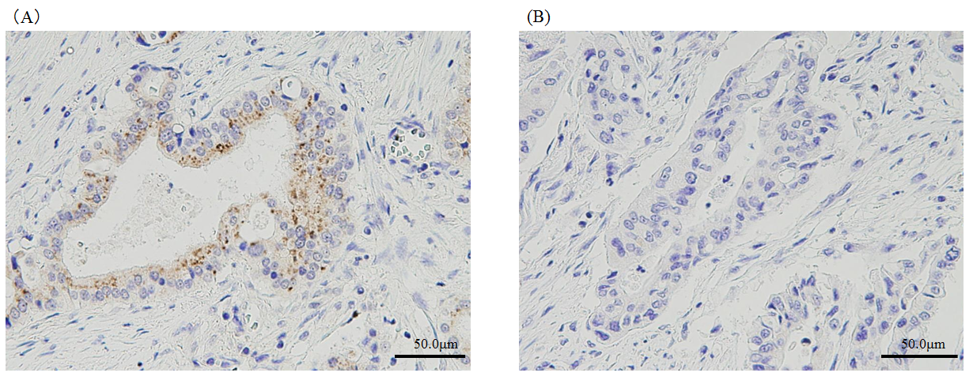
Figure 1 Immunohistochemical analysis of doublecortin and CaM kinase-like-1 expression. A: Positive expression; B: Negative expression. DCLK1: Doublecortin and CaM kinase-like-1.

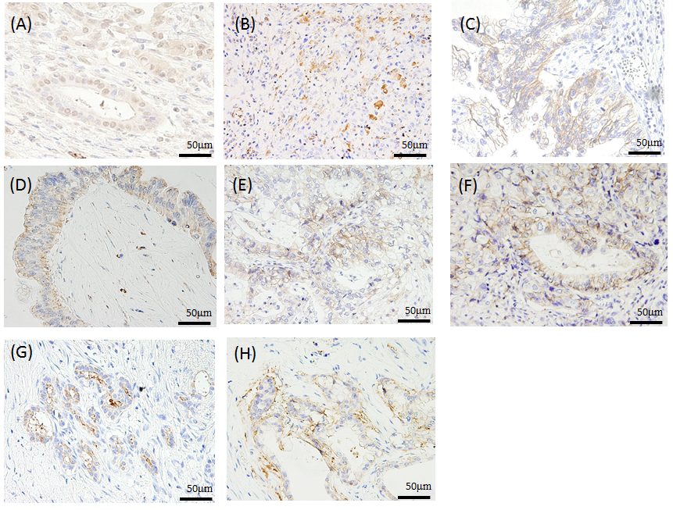
Figure 2 Immunohistochemical analysis of doublecortin and CaM kinase-like-1 expression, and epithelial mesenchymal transition and stem cell markers in pancreatic cancer. All pictures show positive expression for each marker (× 200). A: Snail; B: Vimentin; C: E-cadherin; D: N-cadherin; E: CD24; F: CD44; G: CD133; H: EpCAM. DCLK1: Doublecortin and CaM kinase-like-1; EpCAM: Epithelial cell adhesion molecule.

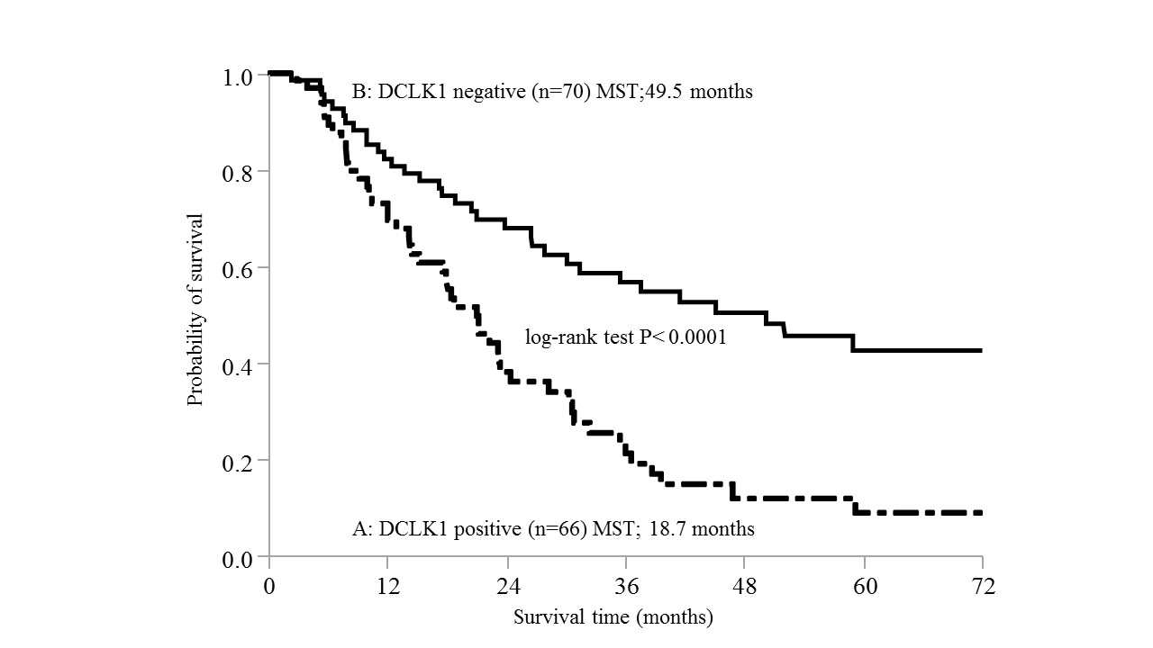
Figure 3 Overall survival of patients according to doublecortin and CaM kinase-like-1 expression. A: The MST of patients with DCLK1-positive tumors was 18.7 mo; B: That of patients with DLCK1-negative tumors was 49.5 mo. The MST of patients with DCLK1 positivity was significantly shorter than that of patients with DCLK1 negativity (P < 0.0001). DCLK1: Doublecortin and CaM kinase-like-1; MST: Median overall survival time.

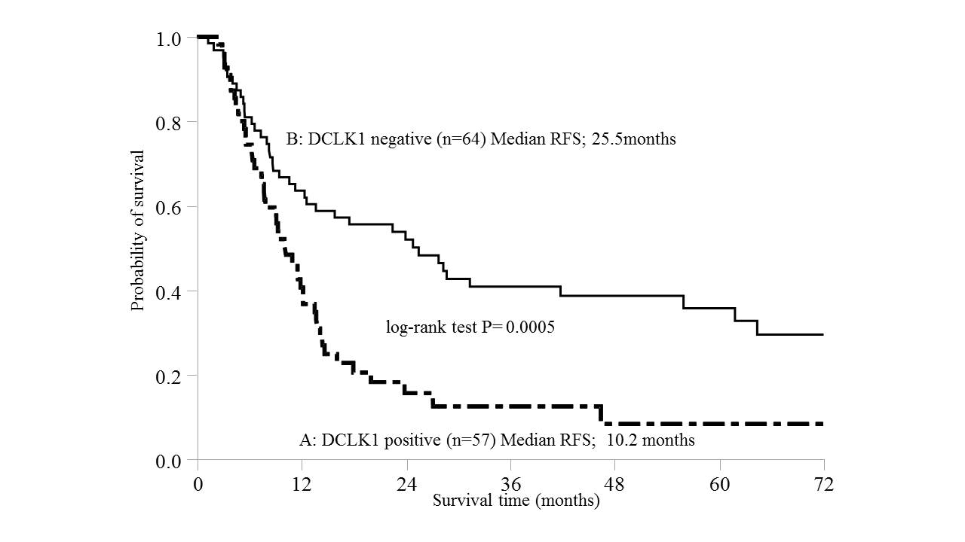
Figure 4 Relapse-free survival of patients according to doublecortin and CaM kinase-like-1 expression, excluding patients with macroscopic residual tumor. A: RFS of patients with DCLK1 positivity was 10.2 mo; B: That of patients with DCLK1 negativity was 25.5 mo. Relapse of patients with DCLK1 positivity was significantly shorter than that of patients with DCLK1 negativity (P = 0.0005). DCLK1: Doublecortin and CaM kinase-like-1; RFS: Relapse-free survival.

Table 1 Clinicopathological characteristics of the patients
Characteristic | n
Age
Median (range) | 70 (34-85)
Sex
Male | 66
Female | 70
Location
Head | 80
body-tail | 56
Tumor size in cm
Median (range) | 3 (1-18)
Surgery
Pancreaticoduodenectomy | 76
Distal pancreatectomy | 54
Total pancreatectomy | 6
Histological differentiation
G1 | 20
G2 | 89
G3 | 17
G4 | 10
AJCC staging system
ⅠA | 5
ⅠB | 15
ⅡA | 46
ⅡB | 56
Ⅲ | 3
Ⅳ | 11
Lymph node
N0 | 70
N1 | 66
Adjuvant therapy
Yes | 96
No | 40
Resection margin status
R0 | 86
R1 | 35
R2 | 15
AJCC: American Joint Committee on Cancer.

Table 2 Association between doublecortin and CaM kinase-like-1 expression and clinicopathological factors in resected pancreatic ductal adenocarcinoma n (%)
Characteristic | DCLK-1, n = 136 |  | P value
 | Positive, n = 66 | Negative, n = 70
Tumor size in cm |  |  | 0.2962
＜ 2 | 11 (16.7) | 17 (24.3)
≥ 2 | 55 (83.3) | 53 (75.7)
Histological grade |  |  | 0.0290
G1 | 5 (7.6) | 15 (21.4)
G2-4 | 61 (92.4) | 55 (78.6)
T category |  |  | 0.4326
T1/T2 | 14 (21.2) | 19 (27.1)
T3/T4 | 52 (78.8) | 51 (72.9)
N category |  |  | 1.00
N0 | 34 (51.5) | 37 (52.9)
N1 | 32 (48.5) | 33 (47.1)
Serum CA19-9 level |  |  | 0.0060
Normal | 14 (21.2) | 31 (44.3)
Elevated | 52 (78.8) | 39 (55.7)
Serum SPan-1 level
Normal | 23 (34.8) | 34 (48.6) | 0.1198
Elevated | 43 (65.2) | 36 (51.4)
Residual tumor |  |  | 0.2148
R0 | 38 (57.6) | 48 (68.6)
R1/2 | 28 (42.4) | 22 (31.4)
Snail |  |  | 0.1237
Positive | 41 (62.1) | 34 (48.6)
Negative | 25 (37.9) | 36 (51.4)
E-cadherin |  |  | 0.1151
Positive | 31 (47.0) | 23 (32.9)
Negative | 35 (53.0) | 47 (67.1)
N-cadherin |  |  | 0.5967
Positive | 23 (34.8) | 28 (40.0)
Negative | 43 (65.2) | 42 (60.0)
Vimentin |  |  | 0.5232
Positive | 6 (9.1) | 4 (5.7)
Negative | 60 (90.9) | 66 (94.3)
CD24 |  |  | 0.3758
Positive | 27 (40.9) | 23 (32.9)
Negative | 39 (59.1) | 47 (67.1)
CD44 |  |  | 1.00
Positive | 49 (74.2) | 52 (74.3)
Negative | 17 (25.8) | 18 (25.7)
EpCAM |  |  | 0.0235
Positive | 46 (69.7) | 35 (50.0)
Negative | 20 (30.3) | 35 (50.0)
CD133 |  |  | 0.8301
Positive | 12 (18.2) | 14 (20.0)
Negative | 54 (81.8) | 56 (80.0)
CD24+ CD44+ EpCAM+ |  |  | 0.0139
Positive | 18 (27.3) | 7 (10)
Negative | 48 (72.7) | 63 (90)
DCLK1: Doublecortin and CaM kinase-like-1; EpCAM; Epithelial cell adhesion molecule; PDAC: Pancreatic ductal adenocarcinoma.

Table 3 Univariate and multivariate survival analyses in resected pancreatic ductal adenocarcinoma
Variable | Comparison | Univariate analysis |  |  | Multivariate analysis
 |  | n | MST in mo | P value | Hazard ratio | 95%CI | P value
Tumor size in cm | ＜ 2 | 28 | 36.6 | 0.0735
 | ≥ 2 | 108 | 23.8
Histological grade | G1 | 20 | Not reached | 0.0091 | 1.362 | 0.844-2.318 | 0.2130
 | G2-4 | 116 | 23.8
T category | T1/T2 | 33 | 30.3 | 0.7279
 | T3/T4 | 103 | 28.27
N category | N0 | 71 | 35.4 | 0.0505
 | N1 | 65 | 21.2
Serum CA19-9 | Normal | 45 | 31.37 | 0.2057
 | elevated | 91 | 24.43
Serum SPan-1 | Normal | 57 | 36.6 | 0.0034 | 1.286 | 0.905-1.840 | 0.1608
 | elevated | 79 | 21.2
Adjuvant therapy | No  Yes | 30  96 | 23.3  30.3 | 0.21
Resection margin status | R0 | 86 | 36.6 | < 0.0001 | 2.019 | 1.380-2.933 | 0.0004
 | R1/2 | 50 | 17.9
DCLK1 | Negative | 70 | 50.1 | < 0.0001 | 1.848 | 1.2854-2.661 | 0.0009
 | Positive | 66 | 21.0
Snail | Negative | 61 | 30.3 | 0.2377
 | Positive | 75 | 26.57
E-cadherin | Negative | 82 | 26.57 | 0.5448
 | Positive | 54 | 30.3
N-cadherin | Negative | 85 | 26.57 | 0.4568
 | Positive | 51 | 36.03
Vimentin | Negative | 126 | 30.07 | 0.0659
 | Positive | 10 | 17.9
CD24 | Negative | 86 | 24.43 | 0.6359
 | Positive | 50 | 30.3
CD44 | Negative | 35 | 45.1 | 0.0245 | 1.267 | 0.855-1.919 | 0.2414
 | Positive | 101 | 24.43
CD133 | Negative | 110 | 23.37 | 0.1485
 | Positive | 26 | 36.6
EpCAM | Negative | 55 | 23.37 | 0.6580
 | Positive | 81 | 30.07
DCLK1: Doublecortin and CaM kinase-like-1; EpCAM: Epithelial cell adhesion molecule; MST: Median overall survival time; N: Node; PDAC: Pancreatic ductal adenocarcinoma; T: Tumor.

