Name of Journal: World Journal of Psychiatry
Manuscript NO: 86085
Manuscript Type: ORIGINAL ARTICLE

Retrospective Study
Sleep disturbances are associated with anxiety, depression, and decreased quality of life in patients with coronary heart disease

Zheng D et al. Sleep disturbance prevalence in CHD patients

Da Zheng, Rui-Juan Tan, Wei Liu, Peng-Cheng Song, Feng-De Li

Da Zheng, Feng-De Li, Department of Cardiovascular Medicine, Hengshui People’s Hospital, Hengshui 053000, Hebei Province, China

Rui-Juan Tan, Department of Pharmacy, Hengshui People’s Hospital, Hengshui 053000, Hebei Province, China

Wei Liu, Department of Psychiatry, Hengshui People’s Hospital, Hengshui 053000, Hebei Province, China

Peng-Cheng Song, Department of Traditional Chinese Medicine, Hengshui People’s Hospital, Hengshui 053000, Hebei Province, China

Author contributions: Zheng D initiated the project and designed the experiment; Tan RJ conducted the clinical data collection; Liu W performed postoperative follow-up and recorded the data; Song PC conducted a number of collation and statistical analyses; Li FD wrote the original manuscript and revised the paper; All authors read and approved the final manuscript.

Supported by Scientific Research Program on Chinese Medicine, No. 2023460.

Corresponding author: Feng-De Li, Doctor, Department of Cardiovascular Medicine, Hengshui People’s Hospital, No. 180 Renmin Road, Taocheng District, Hengshui 053000, Hebei Province, China. lifengdehssrmyy@163.com

Received: June 30, 2023
Revised: August 8, 2023
Accepted: August 25, 2023
Published online: October 19, 2023

Abstract
BACKGROUND
Studies have shown that sleep disorders are closely related to anxiety and depression, and the quality of life (QoL) of patients with sleep disorders is generally poor.

AIM
To examine the occurrence of sleep disorders in people with coronary heart disease (CHD) and their relationships with QoL, depression, and anxiety.

METHODS
As per the sleep condition, 240 CHD individuals were separated into two groups: non-sleep disorder group (n = 128) and sleep disorder group (n = 112). The self-rating anxiety scale (SAS), self-rating depression scale (SDS), and World Health Organization criteria for the Quality of Life Brief scale (WHOQOL-BREF) scores of the two groups were compared. Logistic regression method was used to analyze the independent risk factors of CHD patients with sleep disorders. Multivariate logistic regression analysis was employed to develop the risk prediction model. The association among the Pittsburgh Sleep Quality Index, SAS, and SDS was examined using Spearman’s correlation analysis.

RESULTS
The incidence of sleep disorder was 46.67% in 240 patients. The scores of SAS and SDS in the sleep disorder group were higher than those in the non-sleep disorder group, and the WHOQOL-BREF scores were lower than those in the non-sleep disorder group (P < 0.05). The risk prediction model of sleep disturbances in CHD patients was constructed using the outcomes of multivariate logistic regression analysis, P = 1/[1 + e (-2.160 + 0.989 × (female) + 0.001 × (new rural cooperative medical insurance) + 2.219 × (anxiety) + 2.157 × depression)]. The results of a Spearman’s correlation study revealed that sleep quality was strongly adversely connected with the physiological field, psychological field, and social relation scores in QoL, and was considerably positively correlated with SAS and SDS (P < 0.05).

CONCLUSION
A multivariate logistic regression model can better predict the occurrence of sleep disorders in CHD patients. Sleep disorders in CHD patients are significantly correlated with QoL, depression, and anxiety.

Key Words: Coronary heart disease; Sleep disorder; Quality of life; Depression; Anxiety

©The Author(s) 2023. Published by Baishideng Publishing Group Inc. All rights reserved.

Citation: Zheng D, Tan RJ, Liu W, Song PC, Li FD. Sleep disturbances are associated with anxiety, depression, and decreased quality of life in patients with coronary heart disease. World J Psychiatry 2023; 13(10): 732-742
URL: https://www.wjgnet.com/2220-3206/full/v13/i10/732.htm
DOI: https://dx.doi.org/10.5498/wjp.v13.i10.732

Core Tip: Sleep disorder is a common clinical problem, and the correlation between sleep disorder and anxiety and depression has been widely discussed in clinical practice. This study explored the problem of sleep disorder in patients with coronary heart disease (CHD) and its correlation with anxiety, depression, and quality of life (QoL). The results showed that the incidence of sleep disorder is higher in patients with CHD, and is positively correlated with anxiety and depression, and negatively correlated with QoL.

INTRODUCTION
Coronary heart disease (CHD) can damage people’s health and lead to death. Sleep disorders are a prevalent aspect of CHD that can have a negative effect on a patient’s quality of life (QoL), cause coronary events, increase disease progression, and influence patients’ survival^{[1,2]}. As a result, treating patients’ sleep disorders will enable them to have a longer life expectancy. Exploring the influencing factors of sleep disorders is conducive to further research and evaluation of sleep disorders in CHD patients. Patients with CHD are more likely to experience negative feelings, depression, and anxiety as a result of the disease, which affects their QoL. The reason may be that CHD is critical and difficult to treat and may be accompanied by symptoms such as angina pectoris or arrhythmia, and excessive worry may lead to anxiety and depression^{[3,4]}. There is currently little research on the influence of anxiety and depression on the sleep quality of CHD patients, and there are also few studies on the influence of demographic and clinical factors on sleep problems in CHD patients.
Our present research aimed to study and explore the current status of sleep disorders in CHD patients and its correlation with QoL, depression, and anxiety to establish a standard for therapeutic prevention and management of sleep disturbances in individuals with CHD.

MATERIALS AND METHODS
Data sources
Clinical data were gathered from 240 CHD patients (114 females and 126 males) with an age range of 48-79 years (average age = 61.58 ± 6.93) referred to our facility between January 2020 and September 2022. The study inclusion criteria: (1) All patients met the Diagnostic Criteria for Coronary atherosclerotic Heart Disease^{[5]}; (2) the vital signs were stable after treatment; (3) no history of drug abuse; and (4) patients with normal communication ability. Exclusion criteria were: (1) Patients with depression, schizophrenia, or other mental diseases; (2) patients with cognitive impairment; (3) patients with cerebrovascular disease or central nervous system disease; (4) patients with malignant tumor disease; and (5) patients with heart failure. This study was approved by the ethics committee.

Data collection
General data such as sex, age, disease type, smoking, marital status, hypertension, diabetes, family history of CHD, dyslipidemia, education level, working status, and type of medical insurance of all patients were collected.

Observation indexes
(1) The Pittsburgh Sleep Quality Index (PSQI)^{[6]} score of 240 CHD patients was collected. Each of the seven evaluation items on the scale received a score between 0 and 3, for a range of 0 to 21 points. A score > 7 points denotes poor sleep quality and a sleep disorder, whereas a score of 7 points shows good sleep quality and no sleep disorders. The lower the score, the poorer the sleep quality. Then 240 patients with CHD were divided into the sleep disorder group and non-sleep disorder group according to the PSQI score, and the incidence of sleep disorder in 240 patients with CHD was calculated; (2) The self-rating anxiety scale (SAS)^{[7]} and self-rating depression scale (SDS)^{[7]} scores of CHD patients with and without sleep disturbances were collected and compared. There are 20 items in SAS scale; ≥ 50 is classified as anxiety, and the higher the score, the more serious the anxiety. The SDS scale consists of 20 items; ≥ 53 points indicates depression, and the higher the score, the more serious the degree of depression; (3) The World Health Organization criteria for the Quality of Life Brief scale^{[8]} score of CHD patients with and without sleep disturbances were collected and compared. The scale includes four dimensions, namely physiology, psychology, environment, and social relation, and each dimension scores 0-100 points; (4) A comparison of the general data for the sleep disorder group and the non-sleep disorder group was done; (5) To examine independent risk factors of sleep problems in CHD patients, components with statistically significant variations in basic information were considered in the multivariate logistic regression analysis; (6) The logistic regression analysis findings were used to develop the risk prediction model. The area under the curve (AUC), receiver operating characteristic (ROC), and Hosmer-Lemeshow analyses were employed to examine the model’s degree of correlation, and the ROC curve was constructed to demonstrate how effectively the model predicts results. The closer the AUC is to 1.0, the higher the prediction efficiency; and (7) The association among PSQI, SAS, and SDS was investigated using Spearman’s correlation analysis.

Statistical analyses
Two individuals working independently entered the study data into Excel tables, and SPSS 24.0 statistical software was employed to examine and interpret the data. The experimental data are expressed as the mean ± SD, and the t-test was used to compare homogeneous and normally distributed data. Numbers "n" and percentages "%" were employed to characterize the counting data, and the χ² test was performed to compare groups. For multivariate analyses, a logistic regression model was utilized, and Spearman’s correlation analysis was performed for correlation analyses. The threshold for statistical significance was set at P < 0.05 for all bilateral tests.

RESULTS
Comparison of the incidence of sleep disorders in CHD patients
Among the 240 patients, 112 CHD patients had PSQI scores > 7 points and had a sleep disorder, with an incidence of 46.67%.

Comparison of QoL, depression, and anxiety scores of CHD individuals with sleep disorder and without sleep disorders
As can be seen in Table 1, the difference between the SDS and SAS scores in both groups was statistically significant (P < 0.05; Figure 1).

Comparison of QoL scores of CHD patients in both groups
The sleep disorder group scored lower on the social relation, psychological field, and physiological field compared to the non-sleep disorder group (P < 0.05). Environmental field scores between the two groups were not significantly different (P > 0.05) (Figure 2, Table 2).

Single-factor analysis of sleep disorders in CHD patients
No significant difference was observed in both groups in terms of disease type, smoking, marital status, hypertension, diabetes, family history of CHD, dyslipidemia, educational level, and working status. In the group of people with sleep disorders, there were more female patients (P < 0.05), patients under the age of 60, individuals in new rural cooperative medical systems, and patients with anxiety and depression (Table 3).

Multivariate logistic regression investigation of sleep disorders in individuals with CHD
The parameters with significant differences in the univariate study of sleep quality disorders in CHD patients were subjected to multivariate logistic regression analysis. The sleep disorder of patients was taken as dependent variables, and sex, age, medical insurance type, anxiety and depression were taken as independent variables (Table 4). Multivariate logistic regression analyses showed that females, new rural cooperative medical insurance, depression, and anxiety were independent risk factors for sleep disorders in individuals with CHD (P < 0.05; Table 5).

Establishment and calibration of the multivariate logistic regression model
The risk prediction model of sleep disturbances in CHD patients was established using the results of a multivariate logistic regression study, P = 1/[1 + e (-2.160 + 0.989 × (female) + 0.001 × (new rural cooperative medical insurance) + 2.219 × (anxiety) + 2.157 × depression)], and the Hosmer-Lemeshow test was used, χ² = 7.284, P = 0.506, indicating a good fit between the model and the observed values, as shown in Figure 3.

Prediction efficiency of the logistic regression model
Figure 4 illustrates the outcomes of ROC analysis, which revealed that the model had a good predictive effect (P < 0.05). Moreover, the AUC of the risk prediction model for sleep disorders in CHD patients was 0.851 with a 95% confidence interval (CI) of 0.803-0.900.

Correlation between sleep disorders and anxiety, depression, and QoL
As indicated in Table 6, Spearman’s correlation analysis revealed that sleep quality exhibited a strong negative association with the physiological field, psychological field, and social relations of QoL, and was positively associated with SAS and SDS (P < 0.05; Figures 5 and 6).

DISCUSSION
Sleep disturbances have been linked to an increased risk of CHD and the development of CHD, according to several studies conducted both domestically and internationally^{[2,9,10]}. Disease factors, psychological factors, and environmental factors can affect the sleep quality of CHD patients. In this study, 46.67% of 240 CHD patients had sleep disorders, accounting for a relatively high proportion. Sleep disorders in CHD patients are very serious and should be paid attention to. In this study, CHD patients with sleep disorders had higher SAS and SDS scores than CHD patients without sleep disorders, and their QoL scores were substantially lower than those of patients without sleep disorders, showing that sleep disorders can have an impact on a patient’s psychological health and QoL.
Multivariate logistic regression analyses showed that females, new rural cooperative medical insurance, depression, and anxiety were independent risk factors for sleep disorders in individuals with CHD (P < 0.05). According to research by Ulander et al^{[11]}, women are more prone than men to experience sleep disorders. According to Wang et al^{[12]}, female cancer patients have an increased incidence of sleep disorders. In line with the aforementioned study, these findings support the previous study by showing that sex is a definite risk factor for anxiety problems in patients with CHD. It is speculated that the reason may be that female patients are more sensitive, their mood is easy to fluctuate, and their sleep quality is easy to be affected. The specific reason needs to be further explored. Most patients with the new rural cooperative medical insurance are rural patients. They are not as economically secure as patients in metropolitan areas, and there are disparities in the payment rates between the employee medical insurance and the new rural cooperative medical insurance, which adds to the financial strain on patients and their families and impairs patient sleep. The new rural cooperative medical insurance is thus a significant risk factor for sleep problems in CHD patients in this study.
Sejbuk et al^{[9]} reported that anxiety is a negative factor affecting sleep quality. Bonanni et al^{[13]} also believe that depression and anxiety are related to menopause insomnia. Anxiety and depression were found to be independently associated risk factors for sleep disorders in this investigation, which was similar to previous research findings. CHD patients have serious physical discomfort and reduced QoL, and their strong concern for prognosis is easy to affect sleep quality. Long-term sleep disorders can lead to increased blood pressure, cardiovascular system dysfunction and neurological dysfunction, and further, aggravate psychological stress^{[14,15]}. By contrast, anxiety, depression, and other adverse emotions can seriously affect the endocrine of patients, causing body discomfort symptoms such as palpitation and chest tightness, further affecting sleep and leading to sleep disorders^{[16-18]}. To increase the quality of their sleep, patients with depression and anxiety should receive psychological treatment, while female CHD patients and CHD patients with new rural cooperative medical insurance should receive clinical attention. A sleep disorder prediction model was developed using multivariate logistic regression, and its prediction performance was assessed using the ROC curve. This prediction model’s AUC value was 0.851 (95%CI = 0.803-0.900), showing that it has a strong predictive value for sleep problems in CHD patients.
Sleep disorder is a process of dual physiological and psychological disorders^{[19]}, and some anxiety and depression patients tend to shift more attention to sleep problems, trying to improve physiological and psychological disorders by adjusting sleep, but they are more likely to be nervous, and further aggravate sleep disorders, forming a vicious cycle. Long-term anxiety, depression and sleep disorders cause and affect each other, seriously affecting patients’ work and life, and in severe cases, it may lead to functional disorders and further reduce the QoL. In addition, sleep disorders are one of the main characteristics of depression, mainly manifested by early waking, difficulty in maintaining sleep, and waking dysthymic tendencies. Serious anxiety and depression can cause psychological stress and lead to autonomic nervous disorder, and the wake-up system of the brain related to sleep and the hypnotic system is in an unbalanced state, and the excitation of the wake-up system will further lead to sleep disorders^{[20-22]}.
Adverse emotions such as anxiety and depression before bedtime can promote the activity of the reticuloendothelial system, promote the release of norepinephrine, enhance the activity of the body, and cause sleep disorders. In this study, the Spearman’s correlation study showed that sleep quality was inversely correlated with the physiological field, psychological field, and social relations in QoL and positively associated with SAS and SDS. This finding implies that patients with sleep disorders should focus on enhancing their poor mood and QoL to prevent an unnecessary vicious cycle that negatively affects their prognosis. The shortcoming of the present work is that it included too few influencing factors and could not identify the reason for the high incidence of sleep disorders. Besides, it only used SAS and SDS scales to conduct a simple psychological assessment of patients, and in-depth structured psychological interviews are not conducted, which may lead to bias in survey results. Therefore, it is necessary to increase the analysis of influencing factors for further and in-depth exploration.

CONCLUSION
In summary, risk variables for sleep disturbances in CHD patients include sex, new rural cooperative medical insurance, depression, and anxiety. The risk factor prediction model established by multivariate logistic regression has good predictive efficacy. The considerable inverse relationship between sleep disorders and QoL and the substantial positive relationship between sleep disorders and depression and anxiety suggests that individuals may be able to improve their depressive moods through psychological counselling and break the vicious cycle of mutual influence between a bad mood and sleep quality. In terms of economic pressure, cost-effective treatment programs can be selected for patients as far as possible to reduce the economic pressure on patients’ families, which is conducive to improving their bad mood, improving their sleep quality and QoL, and improving their prognosis.

ARTICLE HIGHLIGHTS
Research background
Studies have shown that sleep disorders are closely related to anxiety and depression, and the quality of life (QoL) of patients with sleep disorders is generally poor. The significance of this study is to explore the status quo and risk factors of sleep disorders in patients with coronary heart disease (CHD) and their correlation with anxiety, depression and QoL. To provide reference for the prevention and treatment of sleep disorders in clinical CHD.

Research motivation
The current status of sleep disorders in patients with CHD is the main topic of this study. At present, it is clinically necessary to explore the current status of sleep disorders in patients with CHD and its correlation with anxiety, depression and QoL, so as to provide reference for the prevention and treatment of patients with CHD sleep disorders. The significance of this study is to explore the risk factors of patients with CHD sleep disorders and their correlation with anxiety, depression and QoL, encourage clinical teams to continue to explore CHD sleep disorders, and promote the continuous progress of sleep disorder prevention and treatment technology.

Research objectives
The incidence of sleep disorders in patients with CHD was 46.67%. Sex, female, new rural cooperative medical insurance, anxiety and depression were independent risk factors for CHD sleep disorders. It was confirmed that CHD sleep disorders were closely related to anxiety, depression and QoL, providing a new reference for clinical prevention and treatment of CHD sleep disorders in the future.

Research methods
The clinical data of patients were retrospectively analyzed, and the patients were divided into the sleep disorder group and the non-sleep disorder group according to their sleep conditions. The general data of the two groups were statistically analyzed by independent sample t-test and χ² test. The risk factors of sleep disorders in patients with CHD were analyzed by the logistic multivariate regression method and a risk prediction model was built. Receiver operating characteristic was used to analyze the effectiveness of the risk prediction model, and Spearman’s correlation was used to analyze the correlation between sleep disorders and anxiety, depression, and QoL.

Research results
Patients with CHD sleep disorder are closely related to anxiety, depression and QoL, and sex, female, new rural medical insurance, anxiety and depression are risk factors for patients with CHD sleep disorder, providing a new reference for the prevention and treatment of patients with CHD sleep disorder. It is necessary to further expand the sample size to explore the influencing factors of patients with CHD sleep disorder.
Research conclusions
Patients with CHD sleep disorders can interact with anxiety and depression, forming a vicious circle, so clinical attention should be paid to psychological intervention for patients with CHD sleep disorders.

Research perspectives
Sleep disorders in patients with CHD are closely related to anxiety and depression, which can have a negative impact on QoL. Emotional intervention methods can be used to improve sleep disorders and QoL in patients with CHD.

REFERENCES
1 Dey S, Sun E, Frishman WH, Aronow WS. Sleep Disorders and Coronary Artery Disease. Cardiol Rev 2023; 31: 219-224 [PMID: 36301202 DOI: 10.1097/CRD.0000000000000478]
2 Huang BH, Duncan MJ, Cistulli PA, Nassar N, Hamer M, Stamatakis E. Sleep and physical activity in relation to all-cause, cardiovascular disease and cancer mortality risk. Br J Sports Med 2022; 56: 718-724 [PMID: 34187783 DOI: 10.1136/bjsports-2021-104046]
3 Zhou Y, Zhu XP, Shi JJ, Yuan GZ, Yao ZA, Chu YG, Shi S, Jia QL, Chen T, Hu YH. Coronary Heart Disease and Depression or Anxiety: A Bibliometric Analysis. Front Psychol 2021; 12: 669000 [PMID: 34149564 DOI: 10.3389/fpsyg.2021.669000]
4 Blumenthal JA, Smith PJ, Jiang W, Hinderliter A, Watkins LL, Hoffman BM, Kraus WE, Liao L, Davidson J, Sherwood A. Effect of Exercise, Escitalopram, or Placebo on Anxiety in Patients With Coronary Heart Disease: The Understanding the Benefits of Exercise and Escitalopram in Anxious Patients With Coronary Heart Disease (UNWIND) Randomized Clinical Trial. JAMA Psychiatry 2021; 78: 1270-1278 [PMID: 34406354 DOI: 10.1001/jamapsychiatry.2021.2236]
5 Joseph J, Velasco A, Hage FG, Reyes E. Guidelines in review: Comparison of ESC and ACC/AHA guidelines for the diagnosis and management of patients with stable coronary artery disease. J Nucl Cardiol 2018; 25: 509-515 [PMID: 28884447 DOI: 10.1007/s12350-017-1055-0]
6 Morris JL, Rohay J, Chasens ER. Sex Differences in the Psychometric Properties of the Pittsburgh Sleep Quality Index. J Womens Health (Larchmt) 2018; 27: 278-282 [PMID: 29154713 DOI: 10.1089/jwh.2017.6447]
7 Dunstan DA, Scott N, Todd AK. Screening for anxiety and depression: reassessing the utility of the Zung scales. BMC Psychiatry 2017; 17: 329 [PMID: 28886698 DOI: 10.1186/s12888-017-1489-6]
8 Young CA, Mills R, Al-Chalabi A, Burke G, Chandran S, Dick DJ, Ealing J, Hanemann CO, Harrower T, Mcdermott CJ, Majeed T, Pinto A, Talbot K, Walsh J, Williams TL, Tennant A; TONiC study group. Measuring quality of life in ALS/MND: validation of the WHOQOL-BREF. Amyotroph Lateral Scler Frontotemporal Degener 2020: 1-9 [PMID: 32597226 DOI: 10.1080/21678421.2020.1752244]
9 Sejbuk M, Mirończuk-Chodakowska I, Witkowska AM. Sleep Quality: A Narrative Review on Nutrition, Stimulants, and Physical Activity as Important Factors. Nutrients 2022; 14 [PMID: 35565879 DOI: 10.3390/nu14091912]
10 Cheng M, Lei X, Zhu C, Hou Y, Lu M, Wang X, Wu Q. The association between poor sleep quality and anxiety and depression symptoms in Chinese patients with coronary heart disease. Psychol Health Med 2022; 27: 1347-1356 [PMID: 33506709 DOI: 10.1080/13548506.2021.1874440]
11 Ulander M, Rångtell F, Theorell-Haglöw J. Sleep Measurements in Women. Sleep Med Clin 2021; 16: 635-648 [PMID: 34711387 DOI: 10.1016/j.jsmc.2021.07.004]
12 Wang Z, Du W, Jin S, Zhu Y, Quan C, Zhang X, Feng Y, Mo Y, Wang J. Analysis of preoperative sleep quality and related influencing factors in cancer patients. Support Care Cancer 2022; 31: 4 [PMID: 36512163 DOI: 10.1007/s00520-022-07483-8]
13 Bonanni E, Schirru A, Di Perri MC, Bonuccelli U, Maestri M. Insomnia and hot flashes. Maturitas 2019; 126: 51-54 [PMID: 31239118 DOI: 10.1016/j.maturitas.2019.05.001]
14 Al Naamani Z, Gormley K, Noble H, Santin O, Al Maqbali M. Fatigue, anxiety, depression and sleep quality in patients undergoing haemodialysis. BMC Nephrol 2021; 22: 157 [PMID: 33910523 DOI: 10.1186/s12882-021-02349-3]
15 Ghrouz AK, Noohu MM, Dilshad Manzar M, Warren Spence D, BaHammam AS, Pandi-Perumal SR. Physical activity and sleep quality in relation to mental health among college students. Sleep Breath 2019; 23: 627-634 [PMID: 30685851 DOI: 10.1007/s11325-019-01780-z]
16 Al-Khani AM, Sarhandi MI, Zaghloul MS, Ewid M, Saquib N. A cross-sectional survey on sleep quality, mental health, and academic performance among medical students in Saudi Arabia. BMC Res Notes 2019; 12: 665 [PMID: 31639038 DOI: 10.1186/s13104-019-4713-2]
17 Scott AJ, Webb TL, Martyn-St James M, Rowse G, Weich S. Improving sleep quality leads to better mental health: A meta-analysis of randomised controlled trials. Sleep Med Rev 2021; 60: 101556 [PMID: 34607184 DOI: 10.1016/j.smrv.2021.101556]
18 Afonso P, Fonseca M, Teodoro T. Evaluation of anxiety, depression and sleep quality in full-time teleworkers. J Public Health (Oxf) 2022; 44: 797-804 [PMID: 34036369 DOI: 10.1093/pubmed/fdab164]
19 He Y, Sun LY, Peng KW, Luo MJ, Deng L, Tang T, You CX. Sleep quality, anxiety and depression in advanced lung cancer: patients and caregivers. BMJ Support Palliat Care 2022; 12: e194-e200 [PMID: 32253349 DOI: 10.1136/bmjspcare-2018-001684]
20 Korkmaz S, Kazgan A, Çekiç S, Tartar AS, Balcı HN, Atmaca M. The anxiety levels, quality of sleep and life and problem-solving skills in healthcare workers employed in COVID-19 services. J Clin Neurosci 2020; 80: 131-136 [PMID: 33099335 DOI: 10.1016/j.jocn.2020.07.073]
21 Peixoto KO, Resende CMBM, Almeida EO, Almeida-Leite CM, Conti PCR, Barbosa GAS, Barbosa JS. Association of sleep quality and psychological aspects with reports of bruxism and TMD in Brazilian dentists during the COVID-19 pandemic. J Appl Oral Sci 2021; 29: e20201089 [PMID: 34320119 DOI: 10.1590/1678-7757-2020-1089]
22 Rebora P, Spedale V, Occhino G, Luciani M, Alvaro R, Vellone E, Riegel B, Ausili D. Effectiveness of motivational interviewing on anxiety, depression, sleep quality and quality of life in heart failure patients: secondary analysis of the MOTIVATE-HF randomized controlled trial. Qual Life Res 2021; 30: 1939-1949 [PMID: 33616815 DOI: 10.1007/s11136-021-02788-3]

Footnotes
Institutional review board statement: The study was reviewed and approved by the Ethics Committee of the Hengshui People’s Hospital.

Informed consent statement: As the study used anonymous and pre-existing data, the requirement for the informed consent from patients was waived.

Conflict-of-interest statement: The authors have no financial relationships to disclose.

Data sharing statement: No additional data are available.

Open-Access: This article is an open-access article that was selected by an in-house editor and fully peer-reviewed by external reviewers. It is distributed in accordance with the Creative Commons Attribution NonCommercial (CC BY-NC 4.0) license, which permits others to distribute, remix, adapt, build upon this work non-commercially, and license their derivative works on different terms, provided the original work is properly cited and the use is non-commercial. See: https://creativecommons.org/Licenses/by-nc/4.0/

Provenance and peer review: Unsolicited article; Externally peer reviewed.
Peer-review model: Single blind

Peer-review started: June 30, 2023
First decision: July 18, 2023
Article in press: August 25, 2023

Specialty type: Psychiatry
Country/Territory of origin: China
Peer-review report’s scientific quality classification
Grade A (Excellent): 0
Grade B (Very good): B, B
Grade C (Good): 0
Grade D (Fair): 0
Grade E (Poor): 0

P-Reviewer: Jaspal R, United Kingdom; Mistura M, Canada S-Editor: Qu XL L-Editor: Filipodia P-Editor: Zhang XD
Figure Legends
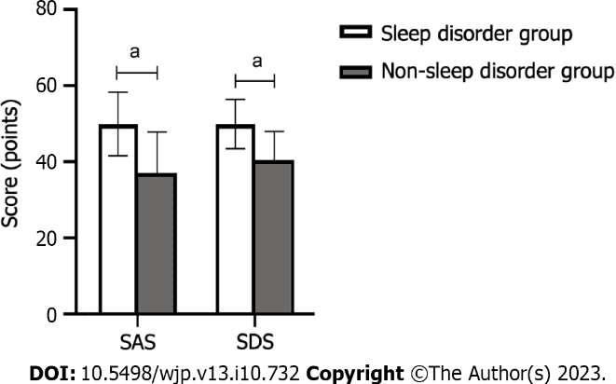
Figure 1 Comparison of both groups’ self-rating depression scale and self-rating anxiety scale scores. ªP < 0.05 vs non-sleep disorder group. SDS: Self-rating depression scale; SAS: Self-rating anxiety scale.

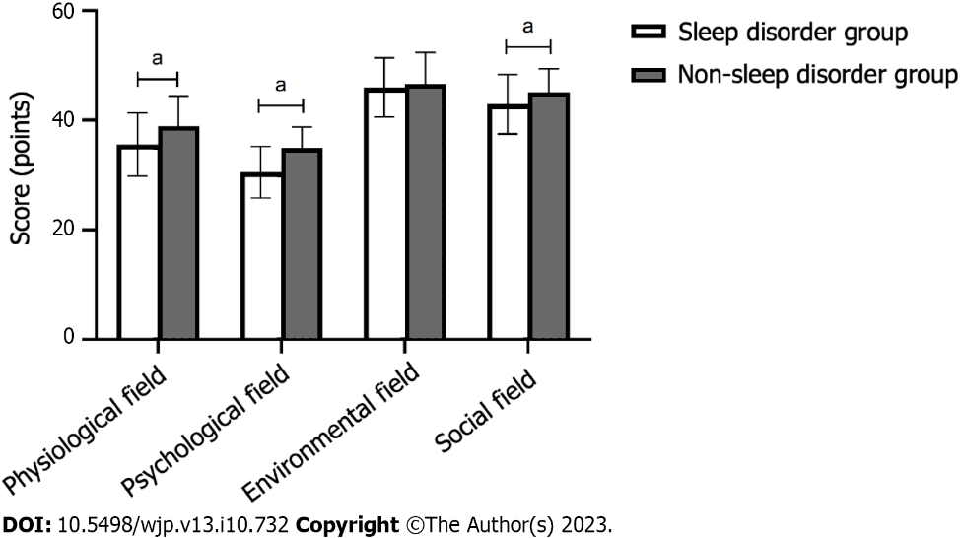
Figure 2 Comparison of both groups’ quality of life scores. ªP < 0.05 vs non-sleep disorder group.

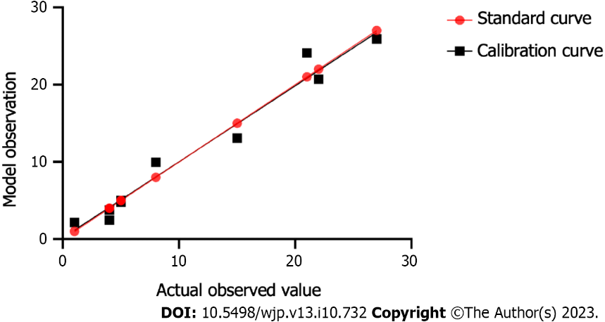
Figure 3 Calibration degree of the logistic regression model.
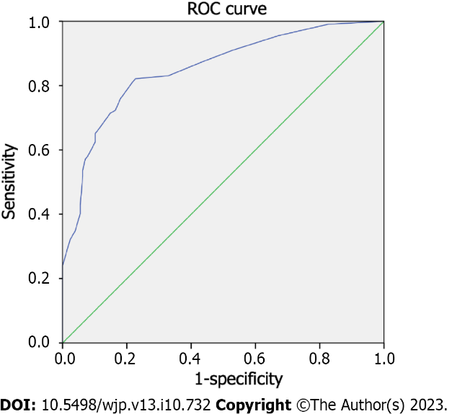
Figure 4 Prediction efficiency of the logistic regression model. ROC: Receiver operating characteristic.

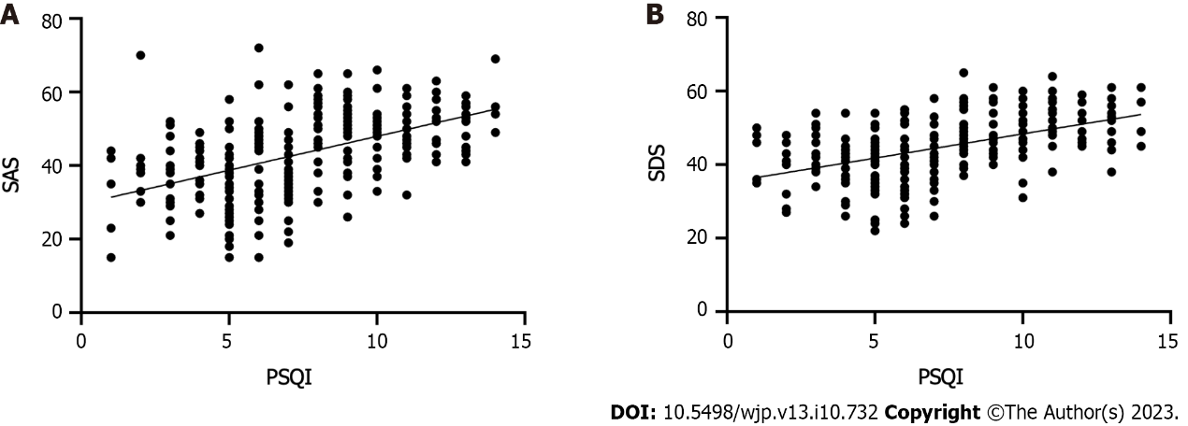
Figure 5 Correlation between sleep disorders and anxiety and depression. A: Pittsburgh sleep quality index (PSQI) is correlated with physiological field; B: The correlation between PSQI and self-rating depression scale. SAS: Self-rating anxiety scale; SDS: Self-rating depression scale.

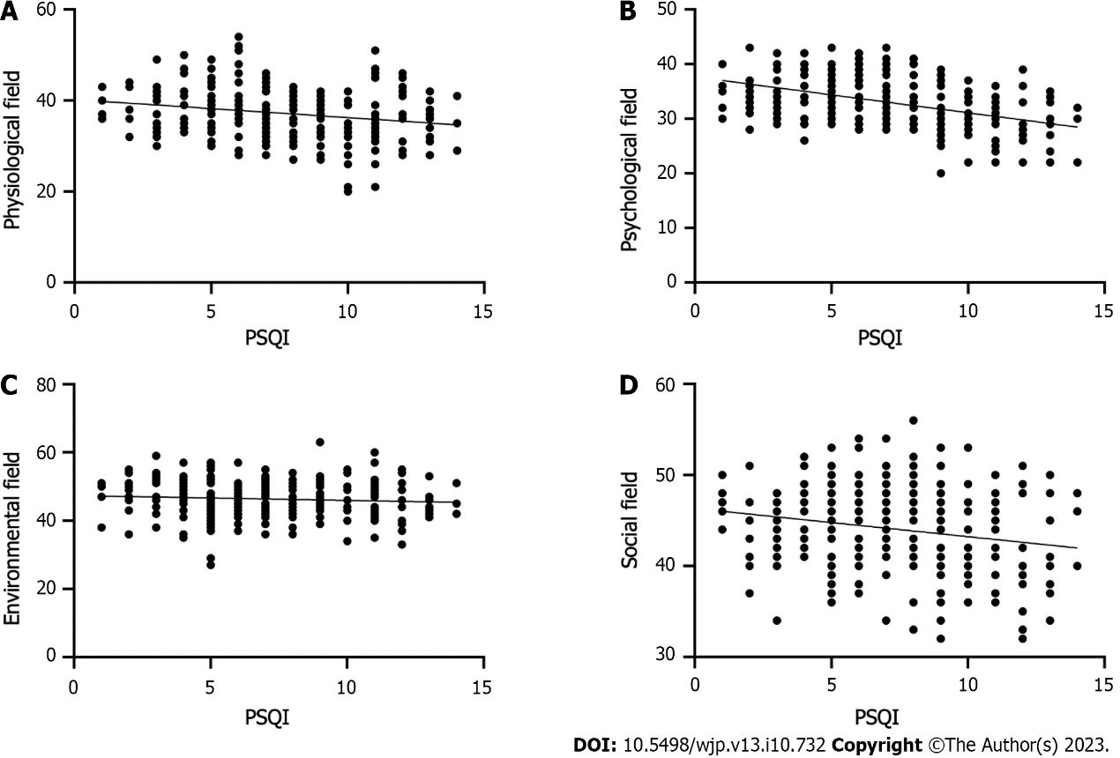
Figure 6 Correlation between sleep disorders and quality of life. A: Pittsburgh sleep quality index (PSQI) is correlated with physiological field; B: PSQI is related to psychological field; C: Correlation between PSQI and environmental field; D: Correlation between PSQI and social field.
Table 1 Comparison of quality of life, depression, and anxiety scores of patients with coronary heart disease with and without sleep disorders
Group | SAS score | SDS score
Sleep disorder group, n = 112 | 49.93 ± 8.37ª | 49.89 ± 6.47ª
Non-sleep disorder group, n = 128 | 37.02 ± 10.84 | 40.45 ± 7.53
t value | 10.389 | 10.336
P value | < 0.001 | < 0.001
ªP < 0.05 vs non-sleep disorder group.
SAS: Self-rating anxiety scale; SDS: Self-rating depression scale. Data (points) are mean ± SD.

Table 2 Comparison of the quality of life scores of patients with coronary heart disease with and without sleep disorders
Group | Physiological field | Psychological field | Environmental field | Social relation
Sleep disorder group, n = 112 | 35.58 ± 5.75ª | 30.52 ± 4.72ª | 45.98 ± 5.40 | 42.93 ± 5.45ª
Non-sleep disorder group, n = 128 | 38.88 ± 5.52 | 34.92 ± 3.82 | 46.63 ± 5.74 | 45.06 ± 4.30
t value | 4.524 | 7.869 | 0.901 | 3.334
P value | < 0.001 | < 0.001 | 0.369 | 0.001
ªP < 0.05 vs non-sleep disorder group.
Data (points) are mean ± SD.

Table 3 Single factor analysis of sleep disorders in patients with coronary heart disease
Factor | Sleep disorder group, n = 112 | Non-sleep disorder group, n = 128 | χ^{2/}t value | P value
Sex
Male | 47 (41.69)ª | 79 (61.27) | 9.347 | 0.002
Female | 65 (58.04)ª | 49 (38.28)
Age in yr | 62.56 ± 7.18ª | 60.72 ± 6.61 | 2.070 | 0.040
≥ 60 | 56 (50.00) | 30 (23.44)
< 60 | 56 (50.00) | 98 (76.56)
Disease type
Stable angina pectoris | 57 (50.89) | 67 (52.34) | 0.050 | 0.822
Acute coronary syndrome | 55 (49.11) | 61 (47.66)
Smoking
Yes | 44 (39.29) | 46 (35.94) | 0.286 | 0.593
No | 68 (60.71) | 82 (64.06)
Marital status
Single | 6 (5.36) | 9 (7.03) | 0.286 | 0.593
Married | 106 (94.64) | 119 (92.97)
Hypertension
Yes | 68 (60.71) | 74 (57.81) | 0.208 | 0.648
No | 44 (47.89) | 54 (42.19)
Diabetes
Yes | 31 (27.68) | 29 (22.66) | 0.804 | 0.370
No | 81 (72.32) | 99 (77.34)
Family history of CHD
Yes | 25 (22.32) | 22 (17.19) | 1.000 | 0.317
No | 87 (77.68) | 106 (82.81)
History of dyslipidemia
Yes | 32 (28.57) | 39 (30.47) | 0.103 | 0.748
No | 80 (71.43) | 89 (69.53)
Education level
High school and below | 54 (48.21) | 62 (48.44) | 0.001 | 0.972
College or above | 58 (51.79) | 66 (51.56)
Working status
On-the-job | 26 (23.21) | 42 (32.81) | 3.023 | 0.221
Waiting for employment | 6 (5.36) | 8 (6.25)
Retired | 80 (71.43) | 78 (60.94)
Medical insurance type
Medical insurance for urban workers | 45 (40.18)ª | 85 (66.41) | 16.551 | < 0.001
New rural cooperative medical insurance | 67 (59.82)ª | 43 (33.59)
Anxiety, ≥ 50 points
Yes | 65 (58.04)ª | 14 (10.94) | 60.006 | < 0.001
No | 47 (41.96)ª | 114 (89.06)
Depression, ≥ 53 points
Yes | 41 (36.16)ª | 7 (5.47) | 36.1987 | < 0.001
No | 71 (63.39)ª | 121 (94.53)
ªP < 0.05 vs non-sleep disorder group.
CHD: Coronary heart disease. Data are mean ± SD or n (%).

Table 4 Assignment
Factor | Assignment method
Age in yr | ≥ 60 yr = 1, < 60 yr = 0
Sex | Male = 0, Female = 1
Medical insurance type | New rural cooperative medical insurance = 1
 | Medical insurance for urban workers = 0
Anxiety | Yes = 1, No = 0
Depression | Yes = 1, No = 0

Table 5 Analysis of sleep disorders in patients with coronary heart disease using multiple logistic regression models
Variable | β value | SE | Wals χ² | OR value | 95%CI | P value
Sex | 0.989 | 0.338 | 8.548 | 2.688 | 1.385-5.215 | 0.003
Age in yr | -0.108 | 0.342 | 0.099 | 0.898 | 0.459-1.755 | 0.753
Medical insurance type | 1.176 | 0.338 | 12.098 | 0.001 | 1.671-6.291 | 0.001
Anxiety | 2.219 | 0.380 | 34.020 | 9.200 | 4.365-19.394 | < 0.001
Depression | 2.157 | 0.493 | 19.143 | 8.647 | 3.290-22.726 | < 0.001
Constant | -2.160 | 0.383 | 31.714 | 0.115 |  | < 0.001
CI: Confidence interval; OR: Odds ratio; SE: Standard error.

Table 6 Correlation between sleep disorders and quality of life, depression, and anxiety
Group | r value | P value
SAS | 0.500 | < 0.001
SDS | 0.493 | < 0.001
Physiological field | -0.215 | < 0.001
Psychological field | -0.434 | < 0.001
Environmental field | -0.080 | 0.217
Social relations | -0.198 | 0.002
SAS: Self-rating anxiety scale; SDS: Self-rating depression scale.

Published by Baishideng Publishing Group Inc
7041 Koll Center Parkway, Suite 160, Pleasanton, CA 94566, USA
Telephone: +19253991568
Email: bpgoffice@wjgnet.com
Help Desk: https://www.f6publishing.com/helpdesk
https://www.wjgnet.com

© 2023 Baishideng Publishing Group Inc. All rights reserved.

