Name of Journal: World Journal of Clinical Cases
Manuscript NO: 63602
Manuscript Type: CASE REPORT

Delayed pseudoaneurysm formation of the carotid artery following the oral cavity injury in a child: A case report

Chung BH et al. Delayed pseudoaneurysm formation of the carotid artery

Byeoung Hoon Chung, Mi Rin Lee, Jae Do Yang, Hee Chul Yu, Yong Tae Hong, Hong Pil Hwang

Byeoung Hoon Chung, Mi Rin Lee, Jae Do Yang, Hee Chul Yu, Hong Pil Hwang, Department of Surgery, Jeonbuk National University Hospital, Jeonju 54907, South Korea

Byeoung Hoon Chung, Mi Rin Lee, Jae Do Yang, Hee Chul Yu, Yong Tae Hong, Hong Pil Hwang, Research Institute of Clinical Medicine, Jeonbuk National University, Jeonju 54907, South Korea

Byeoung Hoon Chung, Mi Rin Lee, Jae Do Yang, Hee Chul Yu, Yong Tae Hong, Hong Pil Hwang, Biomedical Research Institute, Jeonbuk University Hospital, Jeonju 54907, South Korea

Yong Tae Hong, Department of Otolaryngology-Head-Neck-Surgery, Jeonbuk National University Hospital, Jeonju 54907, South Korea

Author contributions: Hong YT and Lee MR conducted data planning; Lee MR, Yang JD and Hwang HP structured the introduction and methods; Hwang HP, Chung BH, and Yu HC conducted visualization; Chung BH and Hwang HP wrote the manuscript; Yu HC and Hwang HP conducted review and editing.

Corresponding author: Hong Pil Hwang, MD, PhD, Professor, Department of Surgery, Jeonbuk National University Hospital, Gungiro 20, Deok Jin Gu, Jeonju 54907, South Korea. h2p@jbnu.ac.kr

Received: February 1, 2021
Revised: March 15, 2021
Accepted: April 12, 2021
Published online:

Abstract
BACKGROUND
An impalement injury of the oral cavity is a common traumatic injury in children. In most cases, it is not accompanied by sequelae, but if foreign body residues are not found due to a minor injury, they may result in inflammatory responses and delayed vascular injuries in the surrounding tissues. Without early diagnosis and appropriate initial management, residual foreign bodies can cause serious complications and even mortality in some cases.

CASE SUMMARY
A 9-year-old boy suffered an intra-oral injury by a wooden chopstick, and the patient was discharged from the hospital after receiving conservative treatment for the injury. However, the patient was readmitted to the hospital due to intra-oral bleeding, and since neck hematoma and right internal carotid artery pseudoaneurysm formation were detected on computed tomography, emergency surgery was performed. A remnant fragment of a wooden chopstick was found during the operation, and a delayed rupture of the internal carotid artery caused by the foreign body was also found.

CONCLUSION
The failure of early detection and diagnosis of a residual foreign body may result in delayed vascular rupture.

Key Words: Pseudoaneurysm; Carotid artery injury; Oral cavity; Wooden chopsticks; Case report

Chung BH, Lee MR, Yang JD, Yu HC, Hong YT, Hwang HP. Delayed pseudoaneurysm formation of the carotid artery following the oral cavity injury in a child: A case report. World J Clin Cases 2021; In press

Core Tip: Preschool children often provide inappropriate descriptions or cannot express their pain clearly, and if a foreign body is not visible on initial physical examination and a remnant foreign body remains hidden, it could be a high possibility of life-threatening complications and sequelae due to delayed diagnosis and treatment. This case report may provide an appropriate treatment for traumatic carotid artery injury in children.

INTRODUCTION
An intraoral trauma and a residual foreign body from the injury may be very dangerous because they can cause life-threatening complications. Impalement injuries occurring in children are mostly caused by pencils, sticks, cylindrical toys, straws, and toothbrushes^{[1,2]}. If the wound or the foreign body is clearly visible, treatment can be started immediately. However, preschool children often provide inaccurate descriptions or cannot express their pain clearly, and if a foreign body is not visible on initial physical examination and a remnant foreign body remains hidden, there is a high possibility of life-threatening complications and sequelae due to delayed diagnosis and treatment^{[3,4]}. In this case report, we describe a case of a 9-year-old boy who suffered an oral cavity penetrating injury by a wooden chopstick when he fell riding a scooter with a wooden chopstick in his mouth. The patient was admitted to the hospital for treatment, but a residual fragment of the broken wooden chopstick was not found on initial computed tomography (CT) scan. As a result, it was necessary to perform surgical treatment due to delayed pseudoaneurysm formation at internal carotid artery.

CASE PRESENTATION
Chief complaints
The child was brought to the emergency department of our institution, presenting with the chief complaint of right neck pain and swelling, because retropharyngeal, peri-tonsillar abscess was suspected at another institution.

History of present illness
A 9-year-old male patient had sustained an impalement injury of the neck by a wooden chopstick when he fell riding on a scooter with a wooden chopstick in his mouth two days before hospital admission.

History of past illness
The patient has never had an accident on his neck before.

Personal and family history
In his past medical history, no specific features were found except for the fact that he had received the treatment of attention deficit hyperactivity disorder for the previous six months.

Physical examination
A physical examination showed no symptoms of respiratory distress, and no obvious foreign body or bleeding in the oral cavity was found.

Laboratory examinations
Although the hemoglobin level dropped to 7.9 g/dL, there were no significant changes in blood pressure and heart rate, and swelling around the neck did not abate.

Imaging examinations
CT and MR angiography (MRA) revealed traumatic pseudoaneurysm formation accompanied by hematoma collection in the right proximal internal carotid artery about 5 mm above the right carotid bifurcation, and no active arterial extravasation was observed (Figure 1). As in the results of neck CT performed one week before, contrast-enhanced CT and MRA did not show a residual foreign body that was suspected to be a wooden chopstick fragment.

FINAL DIAGNOSIS
Pseudoaneurysm formation with hematoma collection in the right proximal internal carotid artery.

TREATMENT
Emergent neck exploration.
Since there were no findings indicating the presence of any intraoral wounds or bleeding, under general anesthesia with orotracheal intubation. Right neck extension was performed and exploration of the area around the right carotid artery was conducted. Inflammation and adhesion accompanied by moderate hematoma formation were observed around the right carotid bifurcation. They were accompanied by pseudoaneurysmal changes, focal thrombus, and pus like discharge at the proximal right internal carotid artery (ICA) posterior wall (Figure 2). The broken tip of a wooden chopstick with a length of about 5 cm, which had not been detected by imaging tests, was thought to have caused injury to right ICA (Figure 3). After dissection of the right common carotid artery, external carotid artery, and ICA, vessel loops were used for controlling each artery, and the wooden chopstick fragment was removed. The defect of the right ICA posterior wall was about 4mm long, and the surrounding tissues were clear, so the primary closure was performed using 6-0 prolene sutures. Then, after massive irrigation using warm saline and drainage tube insertion, skin closure was performed using nylon sutures.

OUTCOME AND FOLLOW-UP
No neurologic defects were found after surgery, and no postoperative complications such as voice changes or respiratory failure were observed. After surgery, intravenous antibiotics were continuously administered, and gargle and ibuprofen syrup for oral hygiene were also continuously administered. The drainage tube was removed at postoperative day 4, and the follow-up neck CT at postoperative day 7 showed that the Rt. ICA injury site was intact, so the patient was discharged without any signs of complications at postoperative day 8.

DISCUSSION
A residual foreign body in the neck can cause life-threatening complications. It is not uncommon for patients to develop potentially serious sequelae after the occurrence of this type of injury. Deep neck abscess, multiple emphyema, arterial or venous thrombosis, and stroke may occur^{[4-7]}. in this case, symptoms such as ICA pseudoaneurysm formation accompanied by intraoral bleeding and inflammatory responses in the surrounding tissues were observed about 10 d after the occurrence of the injury. A remnant foreign body can cause damage to tunica media with intact adventitia, resulting in the pseudoaneurysm formation of arteries. Reaching a definite diagnosis may be delayed during this period, and hematoma and abscess formation due to bleeding may eventually be life-threatening conditions^{[8]}.
Delayed vascular injury caused by a residual foreign body can be explained by several mechanisms. First, it may occur as a result of movements such as continuous swallowing or coughing, which can cause the broken wooden chopstick fragment to continuously cause trauma to adjacent blood vessels, damaging blood vessel walls. In addition, pseudoaneurysm may be formed due to the remnant wooden chopstick fragment, which may cause massive bleeding due to the delayed rupture of the neck vessel^{[9]}.
The broken chopstick fragment was not found until surgery was performed after the patient’s readmission to the hospital through the emergency department due to bleeding when one week elapsed after the accidental injury. One possible reason for delayed diagnosis and treatment is that detailed history taking on the accident situation regarding how the patient’s injury occurred may not have been carried out. The injury may not have been regarded as a serious one since the impalement injury of the oral cavity was accompanied only by slight bleeding, and no additional bleeding or injury to surrounding tissues and important structures were observed. In addition, although the patient received inpatient treatment for 3 d after his first visit to the emergency department, it seemed that the possibility of the presence of a residual foreign body was overlooked based only on the fact that no foreign body was found on initial CT scans without performing additional examinations of the lesion, such as ultrasound and MRA. As a result, the cause of neck trauma was not clearly elucidated, and the evaluation of remnant foreign bodies was not carried out.
It is known to be very difficult to detect or identify a wooden material penetrating an area around the neck by using plain x-ray and conventional radiogram because of the interference due to the opacity of cervical vertebra or soft tissue around the neck^{[10]}. On the other hand, CT scan or ultrasonography is the most effective method to detect and identify the relationship of radiation-transmitting foreign bodies in soft tissue. Cross-sectional imaging by CT scan is useful for identifying the location of the foreign body and its relationship with the important structures of the neck^{[11]}. Ultrasonography has been demonstrated to be an effective diagnostic method, and its sensitivities for 2.5 mm and 5 mm long wooden foreign bodies have been reported to be 86.7% and 93.3%, respectively^{[12]}. In this case of impalement injury, CT scan was performed during the initial examination of the injury, but the method had limitations for making a definite diagnosis. However, the use of additional examination methods such as ultrasonography could have resulted in early diagnosis and treatment in this case.

CONCLUSION
Delayed rupture and pseudoaneurysm formation of the carotid artery in preschool children are rare, but they are potentially life-threatening diseases, and they can be caused by a residual foreign body after trauma. For child patients, from whom it is difficult to obtain a clear and accurate trauma history, a thorough physical examination and a careful clinical examination are essentially required. In addition, residual foreign bodies can be detected by imaging tests such as CT or ultrasonography in an early stage after injury, and thereby an opportunity for appropriate treatment can be obtained.

REFERENCES
1 Lee JA, Lee HY. A case of retained wooden foreign body in orbit. Korean J Ophthalmol 2002; 16: 114-118 [PMID: 12546450 DOI: 10.3341/kjo.2002.16.2.114]
2 Shirali GN, Savant RA, Uppal PK, Bhargava KB. Toothbrush: an unusual foreign body in ENT practice. J Laryngol Otol 1988; 102: 1068-1069 [PMID: 3209948 DOI: 10.1017/s0022215100107303]
3 Bar T, Zagury A, Nahlieli O, London D, Yoffe B, Bibi H. Delayed signs and symptoms after oropharyngeal trauma in a child. Oral Surg Oral Med Oral Pathol Oral Radiol Endod 2002; 94: 15-17 [PMID: 12193887 DOI: 10.1067/moe.2002.124860]
4 Moriarty KP, Harris BH, Benitez-Marchand K. Carotid artery thrombosis and stroke after blunt pharyngeal injury. J Trauma 1997; 42: 541-543 [PMID: 9095125 DOI: 10.1097/00005373-199703000-00025]
5 Law RC, Fouque CA, Waddell A, Cusick E. Lesson of the week. Penetrating intra-oral trauma in children. BMJ 1997; 314: 50-51 [PMID: 9001483 DOI: 10.1136/bmj.314.7073.50]
6 Rowley H, Christian J, Dennis A. Pharyngeal perforation: an easily missed finding following intra-oral injury. J Accid Emerg Med 1995; 12: 145-146 [PMID: 7582414 DOI: 10.1136/emj.12.2.145]
7 Borges G, Bonilha L, Santos SF, Carelli EF, Fernandes YB, Ramina R, Zanardi V, Menezes JR, Nogueira RJ. Thrombosis of the internal carotid artery secondary to soft palate injury in children and childhood. Report of two cases. Pediatr Neurosurg 2000; 32: 150-153 [PMID: 10867563 DOI: 10.1159/000028921]
8 Thakore N, Abbas S, Vanniasingham P. Delayed rupture of common carotid artery following rugby tackle injury: a case report. World J Emerg Surg 2008; 3: 14 [PMID: 18355416 DOI: 10.1186/1749-7922-3-14]
9 Luo Y, Yuan H, Cao ZS. Residual foreign body in the neck after trauma results in the delayed rupture of the common carotid and internal jugular vein: a case report. J Med Case Rep 2013; 7: 13 [PMID: 23305419 DOI: 10.1186/1752-1947-7-13]
10 Kantarci M, Ogul H, Karasen RM. Detection of a giant wooden foreign body with multidetector computed tomography and multiplanar reconstruction imaging. Am J Emerg Med 2007; 25: 211-213 [PMID: 17276819 DOI: 10.1016/j.ajem.2006.08.006]
11 Mohammadi A, Ghasemi-Rad M, Khodabakhsh M. Non-opaque soft tissue foreign body: sonographic findings. BMC Med Imaging 2011; 11: 9 [PMID: 21477360 DOI: 10.1186/1471-2342-11-9]
12 Jacobson JA, Powell A, Craig JG, Bouffard JA, van Holsbeeck MT. Wooden foreign bodies in soft tissue: detection at US. Radiology 1998; 206: 45-48 [PMID: 9423650 DOI: 10.1148/radiology.206.1.9423650]

Footnotes
Informed consent statement: All study participants, or their legal guardian, provided informed written consent prior to study enrollment.

Conflict-of-interest statement: The authors declare having no conflicts of interest in relation to these cases and their treatment or publication.

CARE Checklist (2016) statement: The authors have read the CARE Checklist (2016), and the manuscript was prepared and revised according to the CARE Checklist (2016).

Open-Access: This article is an open-access article that was selected by an in-house editor and fully peer-reviewed by external reviewers. It is distributed in accordance with the Creative Commons Attribution NonCommercial (CC BY-NC 4.0) license, which permits others to distribute, remix, adapt, build upon this work non-commercially, and license their derivative works on different terms, provided the original work is properly cited and the use is non-commercial. See: http://creativecommons.org/Licenses/by-nc/4.0/

Manuscript source: Unsolicited manuscript

Peer-review started: February 1, 2021
First decision: March 11, 2021
Article in press:

Specialty type: Medicine, research and experimental
Country/Territory of origin: South Korea
Peer-review report’s scientific quality classification
Grade A (Excellent): 0
Grade B (Very good): 0
Grade C (Good): C, C
Grade D (Fair): 0
Grade E (Poor): 0

P-Reviewer: Huang L S-Editor: Fan JR L-Editor: P-Editor:
Figure Legends
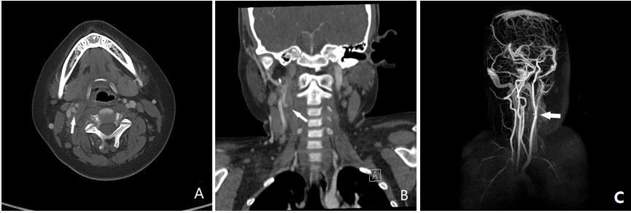
Figure 1 Computed tomography scan and the magnetic resonance angiography of the neck obtained on the second visit of hospital. A and B: Transverse (A) and coronal section (B) showing the hematoma with pseudoaneurysmal formation of right internal carotid artery (arrow); C: Reconstruction image also showing the pesudoaneurysmal changed right internal carotid artery (arrow).
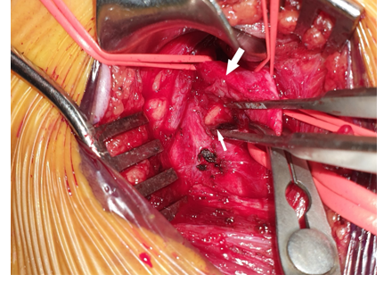
Figure 2 Intra-operative picture showing remnant wooden chopsticks (narrow arrow); penetrated injury at posterolateral aspect of right internal carotid artery (bold arrow). The common, external, internal carotid artery were dissected and temporarily clamped.
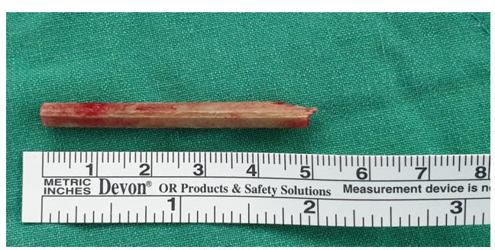
Figure 3 Wooden remnant foreign body was totally removed.

