Name of Journal: World Journal of Hepatology
ESPS Manuscript NO: 28659
Manuscript Type: Original Article

Retrospective Cohort Study

Factors associated with long term survival after liver transplantation: A retrospective cohort study

Pischke S et al. Predictors of long-term survival after LTx

Sven Pischke, Marie C Lege, Moritz von Wulffen, Antonio Galante, Benjamin Otto, Malte H Wehmeyer, Uta Herden, Lutz Fischer, Björn Nashan, Ansgar W Lohse, Martina Sterneck

Sven Pischke, Marie C Lege, Moritz von Wulffen, Antonio Galante, Benjamin Otto, Malte H Wehmeyer, Ansgar W Lohse, Martina Sterneck, Department of Medicine I, University Medical Center Hamburg-Eppendorf, 20246 Hamburg, Germany

Uta Herden, Lutz Fischer, Björn Nashan, Department of Hepatobiliary and Transplant Surgery, University Medical Center Hamburg-Eppendorf, 20246 Hamburg, Germany

Author contributions: All the authors contributed to the manuscript.

Institutional review board statement: Not needed due to the non-clinical study design.

Informed consent statement: For this retrospective, observational study neither informed consent nor approval of the ethics committee was needed according to the Professional Code of the German Medical Association (article B.III. § 15.1) and to the recommendations of our local ethical committee (Ethikkommission der Ärztekammer Hamburg).

Conflict-of-interest statement: The authors declare no conflicts of interest regarding this manuscript.

Data sharing statement: No data were created no data are available.

Open-Access: This article is an open-access article which was selected by an in-house editor and fully peer-reviewed by external reviewers. It is distributed in accordance with the Creative Commons Attribution Non Commercial (CC BY-NC 4.0) license, which permits others to distribute, remix, adapt, build upon this work non-commercially, and license their derivative works on different terms, provided the original work is properly cited and the use is non-commercial. See: http://creativecommons.org/licenses/by-nc/4.0/

Manuscript source: Invited manuscript

Correspondence to: Dr. Martina Sterneck, Professor, Department of Medicine I, University Medical Center Hamburg-Eppendorf, Martinistrasse 52, 20246 Hamburg, Germany. sterneck@uke.de
Telephone: +49-68-06920285

Received: August 7, 2016
Peer-review started: August 8, 2016
First decision: September 28, 2016
Revised: December 2, 2016
Accepted: December 13, 2016
Article in press:
Published online:

Abstract
AIM
To identify predictive factors associated with long term patient and graft survival (> 15 years) in liver transplant recipients.

METHODS
Medical charts of all de novo adult liver transplant recipients (n = 140) who were transplanted in Hamburg between 1997 and 1999 were retrospectively reviewed (Figure 1). In total, 155 transplantations were identified in this time period (15 re-transplantations). 26 OLT-recipients were early lost to follow up due to moving to other places within one year after transplantation. All remaining 114 patients were included in the analysis. The following recipient factors were analysed: Age, sex, underlying liver disease, pre-OLT body mass index (BMI), Alanine Aminotransferase (ALT), bilirubin-, creatinine- and Gamma-Glutamyltransferase (gamma-GT) level as well as warm and cold ischemia time. Furthermore the following donor factors were assessed: Age, BMI, cold ischemia time and warm ischemia time. All surviving patients were followed until December 2014. We divided patients into groups according to their underlying diagnosis (Table 1): (1) Hepatocellular Carcinoma (HCC) (n = 5, 4%); (2) Alcohol toxic liver disease (n = 25, 22.0%); (3) Primary sclerosing cholangitis (PSC) (n = 6, 5%); (4) Autoimmune liver diseases (n = 7, 6%); (5) Hepatitis C virus (HCV) caused cirrhosis (n = 15, 13%); (6) Hepatitis B virus (HBV) cirrhosis (n = 21, 19%); (7) Other (n = 35, 31%). The group “Other” included rare diagnoses, such as acute liver failure, unknown liver failure, stenosis and thrombosis of the Arteria hepatica, polycystic liver disease, Morbus Osler and Caroli disease.

RESULTS
The majority of patients were male (n = 70, 61%). Age and BMI at the time point of transplantation ranged from 16 to 69 years (median: 53 years) and from 15 to 33 kg/m² (median: 24), respectively. 66 OLT (58%) experienced a follow-up of 15 years after transplantation. Recipient’s age (P = 0.009) and BMI (P = 0.029) were identified as risk factors for death by χ²-test. Kaplan-Meier-analysis confirmed BMI or age above the median as predictors of decreased long-term survival (P = 0.008 and P = 0.020). Hepatitis B as underlying disease showed a trend for improved long-term survival (P = 0.049, χ²-test, P = 0.055 Kaplan-Meier-analysis; Log rank). Pre-transplant bilirubin, creatinine, ALT and gamma-GT were not associated with survival in these patients of the pre era of the model of end stage liver disease.

CONCLUSION
The recipients’ age and BMI were predictors of long-term survival after OLT, as well as hepatitis B as underlying disease. In contrast, donors’ age and BMI were not associated with decreased survival. These findings indicate that especially recipient factors have a high impact on long term outcome after liver transplantation.

Key words: Liver transplantation; Age; Body mass index; Long-term survival; Hepatitis B

© The Author(s) 2016. Published by Baishideng Publishing Group Inc. All rights reserved.

Core tip: Due to organ shortage and epidemiological developments, the number of older potential orthotopic liver (OLT) transplant recipients increased greatly over the last decades. In order to identify predictors for long term survival after liver transplantation we analysed all adult, first orthotopic liver transplantationss performed at the University Medical Center Hamburg-Eppendorf between 1997 and 1999 and compared these findings with the Eurotransplant database. Our study shows that recipient’s age and body mass index, as well as hepatitis B as underlying disease are predictors of long-term survival after OLT.

Pischke S, Lege MC, von Wulffen M, Galante A, Otto B, Wehmeyer MH, Herden U, Fischer L, Nashan B, Lohse AW, Sterneck M. Factors associated with long term survival after liver transplantation: A retrospective cohort study. World J Hepatol 2016; In press
INTRODUCTION
Survival after liver transplantation has strongly improved in the last decades, but factors associated with long term survival have not been well defined yet. Research on the factors associated with best long term outcome is therefore essential for an optimal use of the donated organs.
This is even more relevant sinceage of donors and recipients is increasing. This development is mostly due to the organ shortage as well as epidemiological developments.
The majority of deaths after older potential orthotopic liver (OLT) occur within the first months after transplantation. This is predominantly caused by pulmonary infections, sepsis or multiple organ failure^{[1]}. An analysis of a large cohort from the Eurotransplant database included more than 90000 patients liver transplanted between 1968 and 2009^{[1]}. Within this cohort the early mortality was 6%, 9% and 12% for one, three and 6-mo mortality in patients liver transplanted after the year 2000^{[1]}.
Although several transplant centers worldwide now have more than 20 years of clinical experience in the field of liver transplantation only few studies have analyzed the long-term outcomes in orthotopic liver transplant recipients^{[2,3]}.
Several donor and recipient factors, including age and body mass index (BMI), are well-known to influence short-term survival^{[4]}. Their relevance for long-term outcome has not been studied in detail yet. However, the negative influence of obesity on survival in non transplant recipients is a well-known fact since the Framingham study of the 1990^{[5]}. The World Health Organization has defined obesity as a condition of excessive accumulation of body fat, causing severe damage to health (www.who.org). In fact, the prevalence of obesity is increasing worldwide and is a major threat on liver transplant recipients’ as well as general population health. Common co-morbidities associated with obesity are hypertension, coronary heart disease, heart failure, stroke, hyperuricemia, dyslipidemia, insulin resistance and glucose intolerance. In addition, within the Framingham study it has been shown that fluctuations in body weight in non-transplant patients were associated with an increased mortality independent of obesity and the trend of body weight over time^{[5]}.
In contrast to the general population in liver transplant recipients the role of bodyweight is less clear. Werneck et al^{[6]} demonstrated in a study including 136 liver transplant recipients that there was no significant difference between obese and normal-weight patients regarding length of ICU stay or 2-year survival. On the other hand Sawyer et al^{[4]} demonstrated a decreased short-term survival in obese patients in comparison to normal-weight liver transplant recipients.
In addition to BMI age of donor and recipient has been discussed controversially within the last years^{[7]}.
Recipients’ age is also known to have an influence on the outcome of liver transplantation. Schoening et al^{[2]} studied the 20 year survival of 313 liver transplant recipients. They divided their cohort into three sub-groups: patients below the age of 30, between 30 and 55 years and above 55 years. Patients below the age of 30 lived significantly longer after transplantation as compared to the other two groups. However, no analysis was performed in which the patients were divided according to the median age in their study. Furthermore, the long-time survival of transplant recipients was compared with a “virtual control group”, based on the life expectancy in the general population. While patients younger than 55 years showed a decreased survival as compared to the general population, there was no difference in life expectancy between patients older than 55 years and the general population.
The aim of the present study was to identify factors associated with long term patient and graft survival (>15 years) in liver transplant recipients and compare these to the Eurotransplant database. This study focusses specific on recipient’s age and BMI, as the influence of these factors is still not well defined.

MATERIALS AND METHODS
This study has been performed at the University Medical Center Hamburg-Eppendorf, a tertiary center in North Germany. Since the first liver transplantation in Hamburg in 1984 more than 2000 liver transplantations have been performed at this center.
Medical charts of all de novo adult liver transplant recipients (n = 140) who were transplanted in Hamburg between 1997 and 1999 were retrospectively reviewed (Figure 1). In total, 155 transplantations were identified in this time period (15 re-transplantations). 26 OLT-recipients were early lost to follow up due to moving to other places within one year after transplantation (Figure 1). All remaining 114 patients were included in the analysis. The following recipient factors were analyzed: Age, sex, underlying liver disease, pre-OLT BMI, Alanine Aminotransferase (ALT), bilirubin-, creatinine- and Gamma-Glutamyltransferase (gamma-GT) level as well as warm and cold ischemia time. Furthermore the following donor factors were assessed: Age, BMI, cold ischemia time and warm ischemia time. All surviving patients were followed up until December 2014. We divided patients into groups according to their underlying condition (Table 1): (1) Hepatocellular Carcinoma (HCC) (n = 5, 4%); (2) Alcohol toxic liver disease (n = 25, 22.0%); (3) Primary sclerosing cholangitis (PSC) (n = 6, 5%); (4) Autoimmune liver diseases (n = 7, 6%); (5) Hepatitis C virus (HCV) caused cirrhosis (n = 15, 13%); (6) Hepatitis B virus (HBV) cirrhosis (n = 21, 19%); (7) Other (n = 35, 31%). The group “Other” included rare diagnoses, such as acute liver failure, unknown liver failure, stenosis and thrombosis of the Arteria hepatica, polycystic liver disease, Morbus Osler and Caroli disease.
In addition to patient survival also the graft survival was analyzed. By definition graft loss resulted in re-transplantation or death. The factors that were significantly associated with graft survival in our cohort were then compared with a large cohort of 2971 patients from Eurotransplant, which has been transplanted within the same period (1997-199).

Statistics
Categorical variables were compared using χ²-Test. Metric data were compared using nonparametric Mann-Whitney-Test. Survival analysis was performed utilizing Kaplan-Meier analysis. All investigated factors were tested utilizing univariate and multivariate models.
As metric values did not fulfill the criteria for a normal distribution (Kolmogorov Smirnov test P < 0.01) median values instead of mean values were depicted. All statistical analyses were performed utilizing SPSS (version 13.0) and P-values < 0.05 were considered to be statistically significant.
For this retrospective, observational study neither informed consent nor approval of the ethics committee was needed according to the Professional Code of the German Medical Association (article B.III. § 15.1) and to the recommendations of our local ethical committee (Ethikkommission der Ärztekammer Hamburg).

Control cohort
To discuss the survival of transplant patients with an age below an above the median of age (53 years) we constructed an imaginary control cohort. Therefore we analysed the survival of historical data www.destatis.de of an age matched cohort of the healthy German population.
In addition, to improve reliability of data we compared our results with data from a cross-sectional Eurotransplant cohort including 2971 patients who underwent liver transplantation between 1997 and 1999. Eurotransplant kindly supported us with de-personalized data already arranged and categorized according to our median values of age and BMI and to status of HBV positivity. To compare this cohort with our own cohort, survival of these patients was annalysed up to the same time point until December 2014.

RESULTS
Patient characteristics
Overall 114 OLT recipients were included in the study (Table 1). The majority of the patients were male (n = 70, 61%).The age and the BMI at the time of transplantation ranged from 16 to 69 years (median: 53 years) and from 15.1 to 33.3 kg/m² (median: 24), respectively. See Table 1 for an overview over all investigated factors. The median follow-up was 5139 days. Sixty-six (58%) OLT-recipients experienced a follow-up of 15 years after OLT (Figure 1). The 1, 5 and 10 year patient survival rates were 78%, 74% and 64% (Figure 1).

Follow-up and graft survival
Graft survival 15 years post OLT was 53%. Fifty-three patients experienced a graft loss either by death (34%) or re-transplantation (13%). Characteristics of patients with graft survival and those with graft loss are depicted in Table 1.

Association between patient survival and recipient’s age
During the observational period the mortality rate was significantly higher in patients with an age above the median (53 years) at transplantation as compared to patients younger than the median (P = 0.009). The Kaplan-Meier-analysis confirmed that older patients had a decreased patient survival rate (P = 0.008; Figure 2). Furthermore, the median age at the time of transplantation was higher in patients who deceased within 15 years of follow-up in comparison to patients who were still alive at the end of the study period (P = 0.006, Mann-Whitney test, Figure 3). These findings were confirmed in the cross-sectional Eurotransplant cohort (n = 2973) transplanted in the same period with a follow up rate of 15-17 years. In this cohort 625/ 1145 (55%) patients with an age above 53 years died within the 15-17 years follow-up period while only 653/1809 (36%) patients with an age below 53 years died (P < 0.001, Table 2).
In a sub-analysis we defined age above 60 years as “old” and analyzed the groups of transplant younger (n = 89) and older (n = 25) than this threshold, separately. In patients older than 60 years patient survival rate was significantly lower as compared to younger patients (χ²-test P = 0.007, Kaplan-Meier analysis P = 0.002). Donor age (12-75 years, median 40) was not significantly correlated with patient survival. A multivariate analysis confirmed age as independent factor to be associated with graft survival (P < 0.01).

Association between graft survival and age
Patient with an older age at the time of transplantation had a significantly worse graft survival compared to patients younger than the median, Figure 4).This was confirmed by χ²- test (P = 0.017) and Mann-Whitney (P = 0.017). Looking at the subgroup of patients older than 60 years there was a significantly lower graft survival according to Kaplan-Meier survival analysis (P = 0.05), but not according to the χ²-test. Donor age was not related to graft survival in this study (P = ns). There was no significant association between patients who survived more than 1 year and age above the median (χ² test P = 0.498).

Association of patient survival and BMI
Patients with a BMI above the median (24 kg/m²) displayed a higher mortality than patients with a BMI below the median (P = 0.029). This reduced survival rate was confirmed by the Kaplan-Meier-analysis (P = 0.020, Figure 2). Additionally, BMI at the time of transplantation was higher in patients who died within 15 years of follow up in comparison to patients who survived (P = 0.014, Figure 3). This was confirmed in the Eurotransplant control cohort (n = 2971).Patients with a BMI below 24 kg/m² showed an improved survival rate in comparison with patients with a BMI above this threshold (P ≤ 0.001). In detail 61% with a BMI below 24 kg/m² survived while 53% with a BMI above 24 kg/m² survived (Table 2).
A sub-analysis of patients with severe obesity and a BMI above 30 kg/m² was not possible as only two patients fulfilled this criterion.
There was no significant association between patients who survived more than 1 year and BMI above the median (χ² test P = 0.449). Notably, there was no significant association between age and BMI of the recipient (R = 0.114, P = 0.278), so that BMI seemed to be independent of age. Unfortunately a multivariate analysis did not confirm BMI as an independent factor associated with decreased survival, perhaps significance was missing due to the limited number of factors.
In contrast the BMI of the donor was not associated with survival of the recipient (P = ns).

Association of graft survival and BMI
Patients having a BMI above the median (24 kg/m²) had a significantly worse graft survival compared to patients with a BMI lower than the median (χ²-test: 0.009, Mann-Whitney: 0.047). On the other hand in this study donor BMI did not have an influence on graft survival.

Association of patient and graft survival with the underlying liver diseases
The only underlying etiology of cirrhosis which was statistically significantly associated with outcome was hepatitis B. Patients with hepatitis B as an underlying disease tended to have an improved patient survival in comparison to patients with other underlying diseases (P = 0.049 in the categorical analysis and P = 0.055 in Kaplan-Meier-analysis, Figure 2c). Three out of 21 liver transplant recipients with hepatitis B suffered from acute, fulminant hepatitis B, leading to acute liver failure and transplantation, while the majority (n = 18) had been transplanted due to chronic hepatitis B with cirrhosis. Regarding the BMI there was no difference between HBV positive and negative patients (t-Test, 2-sided, unequal variance, P = 0.38), so that other reasons must be responsible for the survival benefit.
All hepatitis B positive liver transplant recipients received intravenous immunoglobulines, HBIG, to avoid reinfection of the graft.
In addition to patient survival also graft survival of patients with hepatitis B as underlying disease was improved compared to patients with other diagnoses (χ²-test: 0.018, Mann-Whitney: 0.018). The Eurotransplant control cohort confirmed that patients with hepatitis B had an improved survival in comparison to the remaining patients (Table 2).

Remaining factors
Neither recipient’s laboratory parameters prior to transplantation (ALT, gamma-GT, bilirubin, creatinine), nor warm ischemia time or cold ischemia time influenced patient survival significantly.

DISCUSSION
In the current situation of tremendous organ shortage it is important to identify patients who benefit most from a liver transplantation and also to detect risk factors associated with poor outcome. The main findings of this study were that recipients’ age and BMI are relevant for prediction of long-term patient survival as well as graft survival. Interestingly, neither other recipient factors such as biliriubin, creatinine, ALT nor donor factors, such as age and BMI were associated with decreased survival. Another interesting finding was that OLT recipients with hepatitis B as underlying disease had improved survival rates.
The association of recipients’ age and BMI and patient and graft survival was proven by univariate analysis for both factors. However in multivariate analysis only age remained a significant predictor. On the other hand, it was unexpected that there was no significant association between survival of recipient anddonor age and BMI. This finding is in contrast to numerous previous studies which demonstrated a significantly decreased survival in recipients of older donations within a large ET-DRI study^{[8]}. Recently, a large analysis of more than 41000 liver transplant recipients receiving a donation after circulatory death showed that recipients of livers from donors with an age below 50 years had a higher survival rate compared to recipients of livers from donors with an age above 60. However, several studies indicated that older grafts can be used safely with a careful selection of patient and donor in the majority of cases^{[9-13]}. Based on the published literature strict recommendations for the acceptance or refusal of potential liver donors cannot be made. The authors concluded that careful donor organ and recipient selection can lead to excellent results^{[14]}.
In contrast to donor’s age our study highlighted the value of recipient’s age as predictor of survival. We identified a threshold of 53 years for recipient’s age and a BMI of 24 kg/m² as relevant risk factors. These findings were confirmed in the analysis of the Eurotransplant-cohort of 2971 patients. Perhaps a larger cohort might also confirm a relevant aspect of donor age on survival. However our study did not find such an association.
Within a previous German study with a follow-up period of 20 years and 313 liver transplant recipients the survival of elderly transplant recipients (> 55 years) was reduced within the first year after transplantation, but long-term survival was similar to the general population^{[2]}. Our observation that there is a relevant difference regarding survival between OLT recipients above and below the median age of 53 years (Figure 2a) is well in line with this study. However, we could not find a significant association between one year patient survival and age or BMI above the median. Therefore these factors might be associated with long term, but not with short-term survival. Further studies are needed to elucidate this aspect.
Earlier studies showed inconsistent results concerning BMI and survival: A study of Fujikawa et al^{[15]} investigated the impact of obesity on clinical and financial outcome after liver transplantation and showed no influence on either patient survival or hospital costs. Also it is conceivable that obese recipients were selected more carefully with respect to other risk factors. In contrast the study of Rustgi et al^{[16]} observed a worse survival rate in patients having a BMI > 35. Our study confirms the finding that a higher BMI of the recipient is associated with a decreased survival. Only three of the patients in our study displayed malnutrition with a BMI < 18, thus no interpretation of a possible effect of malnutrition and survival was possible for our cohort.
In order to strengthen our data we compared the survival rate of our patients (younger or older than the median of 53 years) with two control groups (as described in the methods). There were no significant differences between all three groups (Figure 5, Table 2). However, these are hypothetical control cohorts and more detailed statistical analyses were not possible.
Three independent statistical tests (Kaplan-Meier survival analysis/Log rank, χ²-test, Mann-Whitney-test) confirmed the association between recipient’s age or BMI and decreased patient and graft survival. However, there was no correlation between age and BMI indicating that these factors are independently associated with lower survival. Unfortunately a multivariate analysis makes no sense due to the low number of significant factors in the univariate analysis. It is not surprising that older or overweight patients depict a shorter survival. This is a well-known fact for many years.
Interestingly, hepatitis B was associated with an improved long-term patient survival in our cohort. This should be interpreted carefully as there are only 21 HBV-patients in our study population. However, this observation might be due to the regularly applied immunoglobulin preparations, HBIG, these patients still get at our institution^{[17-19]}. However, currently this is only one hypothetical explanation of the observed survival benefit of hepatitis B patients.
In addition to our study cohort analysis of the Eurotransplant control cohort also shows an increased survival for transplant recipients with underlying hepatitis B in comparison to the remaining patients (P < 0.001). This observation is in line with an analysis of the survival of liver transplant recipients with hepatitis B, basing on the European liver transplant registry^{[20]}. Within this study investigating the outcome of liver transplant recipients with hepatitis B as underlying disease within a period of approximately 20 years (1988-2010) it could been shown that the survival of hepatitis B virus positive transplant recipients strongly improved within these two decades^{[20]}. This has been assumed to be caused by the prevention of hepatitis B re-infection by immunoglobulins^{[20]}. However, hypothesis still needs to be confirmed by further studies.
The results of this study might be helpful to identify patients with better chances of long-term survival. Our overall 15 years patient survival rate (Figure 1) of 58 % is well in line with previous reports depicting a 20 year survival rate of approximately 50% after liver transplantation^{[2,3]}. However, in the current era of Model of End Stage Liver Disease (MELD)-allocation which favors the sickest patients such survival rates might not be met in future studies. Upcoming studies are needed to investigate not only short, but also long-term survival of patients who received a liver transplantation in the MELD-era. Perhaps the MELD score is a valuable tool for identifying the sickest patients, but it might not be the best predictor of long-term outcome. Furthermore, according to previous studies it has been shown that prognosis of patient is far more related to clinical parameters than laboratory data^{[17]}. The study of Aloia et al^{[18]} also showed a decreased value of the MELD-Score in contrast to parameters such as ventilator status, diabetes mellitus, hepatitis C virus, creatinine levels and recipient’s and donor’s age.
Our study has some limitations. It is based on patients who underwent liver transplantation in the pre-MELD era and at a time when less patients received organs with extended donor criteria. Furthermore, the number of patients with hepatocellular carcinoma was only 4% (5/114, 4%). In our study, at present these numbers are much higher.
Unfortunately multivariate analysis of our data was prone to errors due to the small number of patients in comparison to the multiple variables. Thus, it can be said that the analyzed cohort was too small for the investigation of the variables. It is a retrospective analysis and therefore there is some lack of information considering the long time period of observation (15-17 years). However, there are not many studies dealing with such long-term data as presented in this collective. In the future more research especially on the potential influence of immunglobulins on the HBV-patient’s outcome is necessary.
In conclusion, age and BMI of OLT recipients were predictors of long term survival, while pre transplant bilirubin, creatinine, ALT and gamma-GT were not associated with patient survival or graft survival (pre-MELD era). Age and BMI of the donor had no relevant influence on patient or graft survival in this cohort. OLT recipients with hepatitis B as underlying disease displayed an improved survival. The relevance of this observation still needs to be determined.

ACKNOWLEDGEMENTS
We thank Eurotransplant for providing data for the control cohort of 2971 patients.

COMMENTS
Background
Predictive factors associated with long term patient and graft survival (> 15 years) in liver transplant recipients are not well defined. This study evaluates the possible association between various factors and survival.

Research frontiers
The role of age and body mass index (BMI) for the outcome of liver transplant recipients still needed to be shown.

Innovations and breakthroughs
This is the first study demonstrating a relevant association between age above 53 years or a BMI above 24 kg/m² with decreased graft survival. These thresholds were confirmed in an independent large Eurotransplant cohort to be associated with decreased graft survival. Furthermore there was a weaker association between underlying hepatitis B and improved graft survival. The pathological mechanism and relevance of this finding still needs to be shown.

Applications
Future studies will focus in detail on patients with an age above 53 years or a BMI above 24 kg/m² to verify the authors’ findings. If their date can be confirmed, this will help transplant physicians worldwide to predict the risk of liver transplant recipients.

Terminology
Liver transplant recipients and their survival as well as graft survival, defined as period until death or retransplantation were studied.

Peer-review
The comments of the peer reviewers, especially their advice to enlarge their cohort, motivated us to study a Eurotransplant control cohort, which resulted in a confirmation of their findings.

REFERENCES
1 Adam R, Karam V, Delvart V, O'Grady J, Mirza D, Klempnauer J, Castaing D, Neuhaus P, Jamieson N, Salizzoni M, Pollard S, Lerut J, Paul A, Garcia-Valdecasas JC, Rodríguez FS, Burroughs A. Evolution of indications and results of liver transplantation in Europe. A report from the European Liver Transplant Registry (ELTR). J Hepatol 2012; 57: 675-688 [PMID: 22609307 DOI: 10.1016/j.jhep.2012.04.015]
2 Schoening WN, Buescher N, Rademacher S, Andreou A, Kuehn S, Neuhaus R, Guckelberger O, Puhl G, Seehofer D, Neuhaus P. Twenty-year longitudinal follow-up after orthotopic liver transplantation: a single-center experience of 313 consecutive cases. Am J Transplant 2013; 13: 2384-2394 [PMID: 23915357 DOI: 10.1111/ajt.12384]
3 Dopazo C, Bilbao I, Castells LL, Sapisochin G, Moreiras C, Campos-Varela I, Echeverri J, Caralt M, Lázaro JL, Charco R. Analysis of adult 20-year survivors after liver transplantation. Hepatol Int 2015; 9: 461-470 [PMID: 25788182 DOI: 10.1007/s12072-014-9577-x]
4 Sawyer RG, Pelletier SJ, Pruett TL. Increased early morbidity and mortality with acceptable long-term function in severely obese patients undergoing liver transplantation. Clin Transplant 1999; 13: 126-130 [PMID: 10081649]
5 Lissner L, Odell PM, D'Agostino RB, Stokes J, Kreger BE, Belanger AJ, Brownell KD. Variability of body weight and health outcomes in the Framingham population. N Engl J Med 1991; 324: 1839-1844 [PMID: 2041550 DOI: 10.1056/NEJM199106273242602]
6 Werneck M, Afonso RC, Coelho GR, Sboarini C, Coelho MP, Thomé T, Lisboa LF, Ferraz Neto BH. Obese and nonobese recipients had similar need for ventilatory support after liver transplantation. Transplant Proc 2011; 43: 165-169 [PMID: 21335178 DOI: 10.1016/j.transproceed.2010.12.004]
7 Anderson CD, Vachharajani N, Doyle M, Lowell JA, Wellen JR, Shenoy S, Lisker-Melman M, Korenblat K, Crippin J, Chapman WC. Advanced donor age alone does not affect patient or graft survival after liver transplantation. J Am Coll Surg 2008; 207: 847-852 [PMID: 19183530 DOI: 10.1016/j.jamcollsurg.2008.08.009]
8 Braat AE, Blok JJ, Putter H, Adam R, Burroughs AK, Rahmel AO, Porte RJ, Rogiers X, Ringers J. The Eurotransplant donor risk index in liver transplantation: ET-DRI. Am J Transplant 2012; 12: 2789-2796 [PMID: 22823098 DOI: 10.1111/j.1600-6143.2012.04195.x]
9 Borchert D, Glanemann M, Mogl M, Langrehr JM, Neuhaus P. Older liver graft transplantation, cholestasis and synthetic graft function. Transpl Int 2005; 18: 709-715 [PMID: 15910298 DOI: 10.1111/j.1432-2277.2005.00128.x]
10 Borchert DH, Glanemann M, Mogl M, Langrehr J, Neuhaus P. Adult liver transplantation using liver grafts from donors over 70 years of age. Transplant Proc 2005; 37: 1186-1187 [PMID: 15848664 DOI: 10.1016/j.transproceed.2004.12.261]
11 Cescon M, Grazi GL, Cucchetti A, Ravaioli M, Ercolani G, Vivarelli M, D'Errico A, Del Gaudio M, Pinna AD. Improving the outcome of liver transplantation with very old donors with updated selection and management criteria. Liver Transpl 2008; 14: 672-679 [PMID: 18433035 DOI: 10.1002/lt.21433]
12 Serrano MT, Garcia-Gil A, Arenas J, Ber Y, Cortes L, Valiente C, Araiz JJ. Outcome of liver transplantation using donors older than 60 years of age. Clin Transplant 2010; 24: 543-549 [PMID: 19925474 DOI: 10.1111/j.1399-0012.2009.01135.x]
13 Dudek K, Kornasiewicz O, Remiszewski P, Zieniewicz K, Wróblewski T, Krawczyk M. Results of liver transplantation from old donors. Transplant Proc 2014; 46: 2762-2765 [PMID: 25380912 DOI: 10.1016/j.transproceed.2014.09.022]
14 Scalea JR, Redfield RR, Foley DP. Liver transplant outcomes using ideal donation after circulatory death livers are superior to using older donation after brain death donor livers. Liver Transpl 2016; 22: 1197-1204 [PMID: 27314220 DOI: 10.1002/lt.24494]
15 Fujikawa T, Fujita S, Mizuno S, Shenkman E, Vogel B, Lipori P, Hemming AW, Nelson D, Reed AI. Clinical and financial impact of obesity on the outcome of liver transplantation. Transplant Proc 2006; 38: 3612-3614 [PMID: 17175347 DOI: 10.1016/j.transproceed.2006.10.188]
16 Rustgi VK, Marino G, Rustgi S, Halpern MT, Johnson LB, Tolleris C, Taddei TH. Impact of body mass index on graft failure and overall survival following liver transplant. Clin Transplant 2004; 18: 634-637 [PMID: 15516235 DOI: 10.1111/j.1399-0012.2004.00141.x]
17 Patkowski W, Zieniewicz K, Skalski M, Krawczyk M. Correlation between selected prognostic factors and postoperative course in liver transplant recipients. Transplant Proc 2009; 41: 3091-3102 [PMID: 19857685 DOI: 10.1016/j.transproceed.2009.09.038]
18 Aloia TA, Knight R, Gaber AO, Ghobrial RM, Goss JA. Analysis of liver transplant outcomes for United Network for Organ Sharing recipients 60 years old or older identifies multiple model for end-stage liver disease-independent prognostic factors. Liver Transpl 2010; 16: 950-959 [PMID: 20589647 DOI: 10.1002/lt.22098]
19 Lin CC, Yong CC, Chen CL. Active vaccination to prevent de novo hepatitis B virus infection in liver transplantation. World J Gastroenterol 2015; 21: 11112-11117 [PMID: 26494965 DOI: 10.3748/wjg.v21.i39.11112]
20 Burra P, Germani G, Adam R, Karam V, Marzano A, Lampertico P, Salizzoni M, Filipponi F, Klempnauer JL, Castaing D, Kilic M, Carlis LD, Neuhaus P, Yilmaz S, Paul A, Pinna AD, Burroughs AK, Russo FP. Liver transplantation for HBV-related cirrhosis in Europe: an ELTR study on evolution and outcomes. J Hepatol 2013; 58: 287-296 [PMID: 23099188 DOI: 10.1016/j.jhep.2012.10.016]

P-Reviewer: Komatsu H, Sugawara Y, Yin DP S-Editor: Qiu S L-Editor: E-Editor:

Table 1 Patient characteristics directly before transplantation
 | Patients who survived (n = 68) | Patients who died (n = 46) | P-value (χ²-test)
Male | 39 (57%) | 31 (67%) | NS
Age, years (median, SD) | 16-65, (50.5, 13) | 17-69, (56.0, 12) | 0.009
BMI, range kg/m² (median, SD) | 18-33, (23.1, 3) | 15-29 (25.9, 4) | 0.029
Pre LTx Creatinine, mg/dl (median, SD) | 0.4-3.5, (1.0, 0.5) | 0,3-2,9, (1.1, 0.6) | NS
GFR ml/min (median, SD) | 15.3-230.2, (73.3, 38.1) | 22,6- 240,4, (62.5, 48.0) | NS
ALT, U/L (median, SD) | 4-2610, (35.5, 449.5) | 6-1566, (19.5, 339.0) | NS
Gamma GT, U/L (median, SD) | 7-374, (47.0, 8) | 13-184, (43.0, 45) | NS
Bilirubin, mg/dL (median, SD) | 0.4- 28.1, (2.4, 5.7) | 0.4-28.3, (2.4, 5.8) | NS
Warm ischemia time, minutes (median, SD) | 25-100, (50.0, 18) | 22-75, (54.0, 15) | NS
Cold ischemia time, minutes(median, SD) | 242-940, (542.5, 157) | 174-825, (521.0, 146) | NS
Donor age, years (median, SD) | 12-70, (36.5, 16) | 13-75, (41.0, 1) | NS
Donor BMI, kg/m² (median, SD) | 17- 30, (23.5, 3) | 18-31 (24.2, 2) | NS
Underlying diagnosis  HCC  Alcohol toxic liver cirrhosis  PSC  Autoimmune  HCV-cirrhosis  HBV-infection  Other | 2 (3%)  12 (18%)  4 (6%)  5 (8%)  9 (14%)  16 (24%)  18 (27%) | 3 (6%)  13 (27%)  2 (4%)  2 (4%)  6 (13%)  5 (10%)  17 (35%) | NS  NS  NS  NS  NS  0.049  NS

ALT: Alanine Aminotransferase; AST: Aspartat Aminotransferase; MELD: Model of Endstage Liver Diasease; BMI: Body Mass Index; OLT: Orthotopic Liver transplantation.

Table 2 Comparison of survival according to age, body mass index and hepatitis B virus status in a Eurotransplant control cohort (n = 2973)¹

 | Patients who survived | Patients who died | P-value (χ²-test)
Age below 53 years (n = 1809) | 1156 (64%) | 653 (36%) | < 0.001
Age above 53 years (n = 1145) | 520 (45%) | 625 (55%)
BMI below 24 kg/m² (n = 1454) | 880 (61%) | 574 (39%) | < 0.001
BMI above 24 kg/m² (n = 1493) | 796 (53%) | 697 (47%)
Hepatitis B as underlying disease (n = 255) | 170 (67%) | 85 (33) | < 0.001
Non hepatitis B patients (n = 1705) | 946 (55%) | 759 (45%)
¹Data for age, BMI and HBV status were not available for the total cohort. ALT: Alanine Aminotransferase; AST: Aspartat Aminotransferase; MELD: Model of Endstage Liver Diasease; BMI: Body Mass Index; OLT: Orthotopic Liver transplantation.

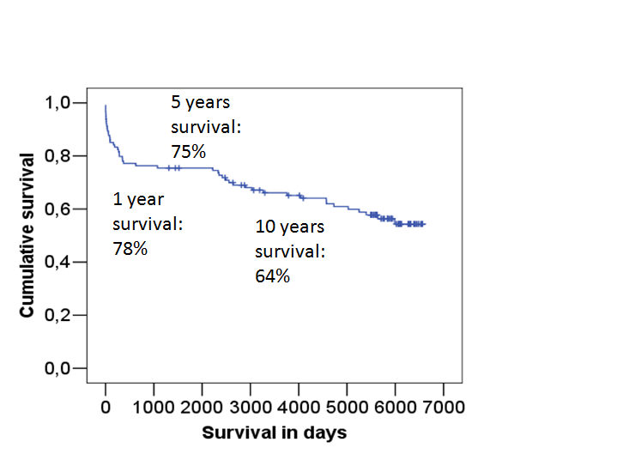
Figure 1 Overall survival of liver transplant recipients, monitored for 15 years.

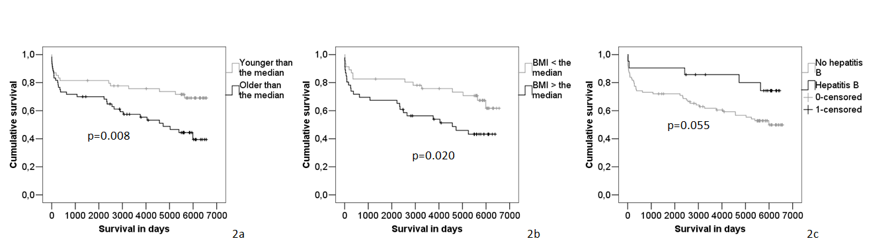Figure 2 Kaplan-Meyer survival analysis reveals increased survival for patients younger than the median (53 years) (A), with body mass index lower than the median (24 kg/m²) (B) and hepatitis B as underlying disease (C).

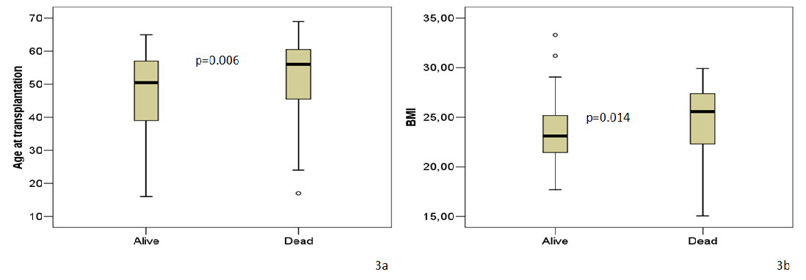
Figure 3 Age and body mass index at the time point of transplantation were higher in deceased patients in comparison to patients who survived.

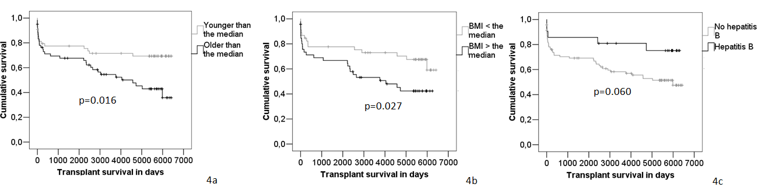
Figure 4 Kaplan-Meyer survival analysis reveals increased transplant survival for patients younger than the median (53 years) (A), with body mass index lower than the median (24 kg/m²) (B) and hepatitis B as underlying disease (C).

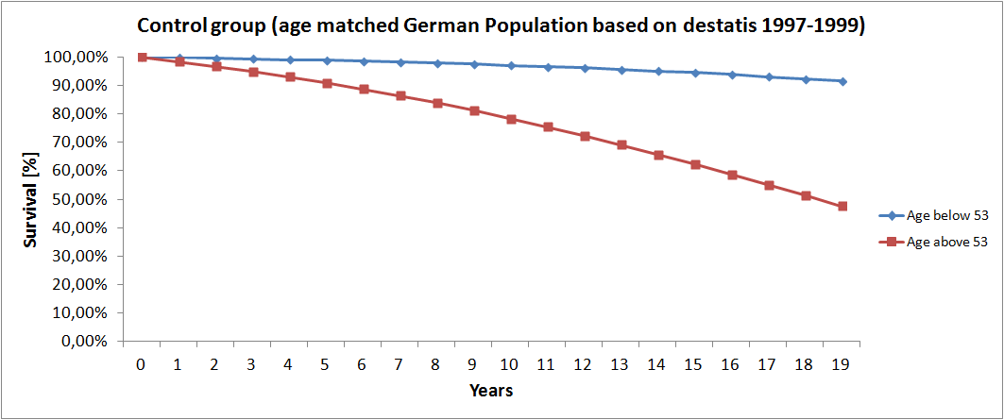
Figure 5 Percentage of survival in an age-matched control of the German general population (age range 18-67 years). This age matched control cohort was constructed basing on historical data about the German healthy population (www.destatis.de).

