Name of Journal: World Journal of Hepatology
Manuscript NO: 86968
Manuscript Type: META-ANALYSIS

Corrected QT interval in cirrhosis: A systematic review and meta-analysis

Papadopoulos VP et al. QTc in cirrhosis: A meta-analysis

Vasileios Periklis Papadopoulos, Konstantinos Mimidis

Vasileios Periklis Papadopoulos, Dialysis, AKESIOS Dialysis Center, Xanthi 67150, Greece

Konstantinos Mimidis, Department of Internal Medicine, Democritus University of Thrace, Alexandroupolis 68100, Greece

Author contributions: Papadopoulos VP contributed to design of the study; Papadopoulos VP and Mimidis K contributed to conception of the study, acquisition, analysis and interpretation of the data, and drafting of the manuscript; and all authors gave final approval of the manuscript.

Corresponding author: Vasileios Periklis Papadopoulos, MD, MSc, PhD, Consultant Physician-Scientist, Research Fellow, Dialysis, AKESIOS Dialysis Center, Vaniano, Xanthi 67150, Greece. vaspapmd@gmail.com

Received: July 16, 2023
Revised: August 13, 2023
Accepted: August 29, 2023
Published online: September 27, 2023

Abstract
BACKGROUND
Corrected QT (QTc) interval is prolonged in patients with liver cirrhosis and has been proposed to correlate with the severity of the disease. However, the effects of sex, age, severity, and etiology of cirrhosis on QTc have not been elucidated. At the same time, the role of treatment, acute illness, and liver transplantation (Tx) remains largely unknown.

AIM
To determine the mean QTc in patients with cirrhosis, assess whether QTc is prolonged in patients with cirrhosis, and investigate whether QTc is affected by factors such as sex, age, severity, etiology, treatment, acute illness, and liver Tx.

METHODS
In the present systematic review and meta-analysis, the searching protocol “{[QTc] OR [QT interval] OR [QT-interval] OR [Q-T syndrome]} AND {[cirrhosis] OR [Child-Pugh] OR [MELD]}” was applied in PubMed, EMBASE, and Google Scholar databases to identify studies that reported QTc in patients with cirrhosis and published after 1998. Seventy-three studies were considered eligible. Data concerning first author, year of publication, type of study, method used, sample size, mean age, female ratio, alcoholic etiology of cirrhosis ratio, Child-Pugh A/B/C ratio, mean model for end-stage liver disease (MELD) score, treatment with β-blockers, episode of acute gastrointestinal bleeding, formula for QT correction, mean pulse rate, QTc in patients with cirrhosis and controls, and QTc according to etiology of cirrhosis, sex, Child-Pugh stage, MELD score, and liver Tx status (pre-Tx/post-Tx) were retrieved. The Newcastle-Ottawa quality assessment scale appraised the quality of the eligible studies. Effect estimates, expressed as proportions or standardized mean differences, were combined using the random-effects, generic inverse variance method of DerSimonian and Laird. Subgroup, sensitivity analysis, and meta-regressions were applied to assess heterogeneity. The study has been registered in the PROSPERO database (CRD42023416595).

RESULTS
QTc combined mean in patients with cirrhosis was 444.8 ms [95% confidence interval (CI): 440.4-449.2; P < 0.001 when compared with the upper normal limit of 440 ms], presenting high heterogeneity (I² = 97.5%; 95%CI: 97.2%-97.8%); both Egger’s and Begg’s tests showed non-significance. QTc was elongated in patients with cirrhosis compared with controls (P < 0.001). QTc was longer in patients with Child-Pugh C cirrhosis when compared with Child-Pugh B and A (P < 0.001); Child-Pugh B patients presented longer QTc when compared with Child-Pugh A patients (P = 0.003). The MELD score was higher in patients with cirrhosis with QTc > 440 ms when compared with QTc ≤ 440 ms (P < 0.001). No correlation of QTc with age (P = 0.693), sex (P = 0.753), or etiology (P = 0.418) was detected. β-blockers shortened QTc (P< 0.001). QTc was prolonged during acute gastrointestinal bleeding (P = 0.020). Tx tended to improve QTc (P < 0.001). No other sources of QTc heterogeneity were revealed.

CONCLUSION
QTc is prolonged in cirrhosis independently of sex, age, and etiology but is correlated with severity and affected by β-blockers and acute gastrointestinal bleeding. QTc is improved after liver Tx.

Key Words: Liver cirrhosis; Corrected QT interval; Child-Pugh stage; Model for end-stage liver disease score; Liver transplantation; Meta-analysis

©The Author(s) 2023. Published by Baishideng Publishing Group Inc. All rights reserved.

Citation: Papadopoulos VP, Mimidis K. Corrected QT interval in cirrhosis: A systematic review and meta-analysis. World J Hepatol 2023; 15(9): 1060-1085
URL: https://www.wjgnet.com/1948-5182/full/v15/i9/1060.htm
DOI: https://dx.doi.org/10.4254/wjh.v15.i9.1060

Core Tip: Corrected QT (QTc) interval is prolonged in patients with liver cirrhosis and has been proposed to correlate with the severity of the disease. The QTc upper normal limit in cirrhosis is widely debated. Moreover, the effects of sex, age, Child-Pugh stage, model for end-stage liver disease score, and etiology of cirrhosis have not been elucidated, while the role of liver transplantation has been largely unknown. The present study is the first systematic review and meta-analysis focusing on the topics mentioned above, thus aiming to determine whether QTc interval is a useful, easy, and inexpensive tool in the assessment of liver cirrhosis by clinicians.

INTRODUCTION
The prolongation of ventricular repolarization, as reflected in rate-corrected QT (QTc) electrocardiogram interval, was first reported in 44% of patients with cirrhosis of alcoholic etiology^{[1,2]}. QTc prolongation was soon recognized as a frequent electrocardiographic abnormality in patients with cirrhosis, regardless of the subsequent etiology^{[3,4]}. QTc prolongation has been historically attributed to a broad spectrum of pathophysiological mechanisms involving electrolyte imbalance, sympathetic nervous system hyperactivity, portal hypertension, elevated bile salt plasma concentrations, direct alcohol toxicity, regimens such as β-blockers and diuretics, and stressful events such as acute gastrointestinal bleeding^{[1,3,5-10]}. However, QTc prolongation is currently considered to reflect delayed ventricular repolarization in the presence of cirrhotic cardiomyopathy, an entity characterized mainly by ventricular diastolic dysfunction associated with liver cirrhosis in the absence of other known cardiac disease^{[11-19]}. Of note, some contradictory evidence support that QTc prolongation is independent of the structural and functional abnormalities that characterize cirrhotic cardiomyopathy^{[20]}. Moreover, it is debatable whether taming the gonadal hormone metabolism in cirrhosis might blur QTc sex-dependence observed in patients without cirrhosis^{[21]}. Interestingly, liver transplantation (Tx) has been demonstrated to at least partly restore prolonged QTc^{[4,21-25]}.
QTc prolongation > 440 ms has been correlated with shortened overall survival in cirrhosis^{[3,26,27]}; however, there is contradictory evidence obscuring this proposal^{[28]}. More commonly, QTc length has been considered to reflect the severity of the disease in terms of either Child-Pugh stage^{[26,29-37]} or model for end-stage liver disease (MELD) score^{[27,37-40]}. On the contrary, several studies support dissimilar conclusions^{[4,41-45]}. Additionally, the direct (due to alcoholic cardiomyopathy) and indirect (due to the aggravated course of the disease) role of alcohol in QTc cirrhosis-linked prolongation is still debatable^{[1]}. Whether QTc abnormalities are more pronounced in alcoholic cirrhosis has not been elucidated yet, as there is contradictory evidence either for^{[33,46]} or against^{[24,25,47]} that possibility. Finally, QTc sex dependence might be less evident or even absent in patients with cirrhosis^{[3,21,23,25,30,38-41]}.
The present systematic review and meta-analysis was conducted to provide further evidence regarding a potential correlation between QTc length in patients with cirrhosis and age, sex, etiology of cirrhosis, severity of the disease in terms of Child-Pugh stage, and MELD score, treatment with β-blockers, episode of acute gastrointestinal bleeding, as well as liver Tx by identifying all relevant studies and summarizing their results.

MATERIALS AND METHODS
Literature search
The study was conducted following Preferred Reporting in Systematic and Meta-Analysis (PRISMA) guidelines^{[48]}. We used the PubMed and EMBASE databases to identify studies that reported QTc in patients with cirrhosis and were published between January 1998 and April 2023. We also utilized the Google Scholar database to retrieve any additional published or unpublished data, such as conference proceedings and other grey literature. We performed an iterative search until we could trace no additional publications. Moreover, a search for unpublished dissertations as well as other unpublished work was completed. The literature search was performed by both authors (Papadopoulos VP and Mimidis K). The study has been registered in the PROSPERO database (CRD42023416595); PROSPERO data were revised on August 8, 2023^{[49]}.

Study selection
The present systematic review was conducted following a search strategy that included the terms {[QTc] OR [QT interval] OR [QT-interval] OR [Q-T syndrome]} AND {[cirrhosis] OR [Child-Pugh] OR [MELD]}. Pre-specified eligibility criteria used the PICO strategy [P: Populations/people/patient/problem: Patients who have cirrhosis and healthy individuals (controls), I: Intervention(s): Liver Tx, C: Comparison: QTc in (1) Patients with cirrhosis vs upper normal limit; (2) Patients with cirrhosis vs controls; (3) Males with cirrhosis vs females with cirrhosis; (4) Patients with cirrhosis of Child-Pugh stage A vs B vs C; (5) Patients with cirrhosis of alcoholic etiology vs viral etiology; (6) Relation with age; (7) Relation with MELD score; (8) Patients with cirrhosis before vs after liver Tx; (9) Relation with β-blockers; (10) Relation with episode of acute gastrointestinal bleeding; and (11) Relation with age, sex, and etiology of cirrhosis in transplanted patients, O: Outcome: Combined mean, percentage; standardized mean difference (SMD)]^{[50]}. Exclusion criteria were: (1) Review articles, case reports, and letters; (2) Duplicated or overlapping studies (if that was the case, only the most recent or the highest level of study or the most informative study was included); and (3) Studies published only as abstracts. The process was performed independently by both authors. Mimidis K was responsible for resolving any discordance. The Cohen kappa statistic was preferred to assess the level of agreement between the two investigators. No software was used for study retrieval. Sources of financial support were traced where possible.

Data extraction
Data concerning first author, year of publication, type of study, method used, sample size, mean age, female ratio, alcoholic etiology of cirrhosis ratio, Child-Pugh A/B/C ratio, mean MELD score, use of β-blockers, formula for QT correction, mean pulse rate, QTc in patients with cirrhosis and controls, and QTc according to etiology of cirrhosis, sex, Child-Pugh stage, and Tx status (pre-Tx/post-Tx) were retrieved independently by both authors. Mimidis K supervised the process and resolved any potential discordance.

Risk of bias
Funnel plots assessed the risk of publication bias. Trim-and-fill analysis was used to impute missing studies in cases of significant publication bias. The Newcastle-Ottawa Scale (NOS) evaluated the risk of bias assessment of the eligible studies; scores ≥ 7-9, 4-6, and < 4 were considered to reflect low, intermediate, and high risk, respectively^{[51]}. Furthermore, the GRADE assessment was used to evaluate evidence certainty rating risk of bias, imprecision, inconsistency, indirectness, publication bias, and effect size for every endpoint^{[52]}. When comparing hazard ratios (HRs) between two groups, small, medium, and large effect sizes were considered to be approximately 1.3, 1.9, and 2.8, respectively^{[53]}.

Statistical analysis
Data were synthesized using MedCalc Statistical Software version 20.218 (MedCalc Software bv, Ostend, Belgium; https://www.medcalc.org; 2023). Effect estimates, expressed as QTc/upper normal limit percentage or SMD, were extracted from every study possible and combined using the random-effects, generic inverse variance method of DerSimonian and Laird^{[54]}, which assigned the weight of each study in the pooled analysis inversely to its variance. Combination of means and standard deviations (SDs) were performed using the freely available online tool located at https://www.statstodo.com/CombineMeansSDs.php. Means and estimates based on sample size, median, range, and interquartile range were calculated using the freely available online tool located at https://www.math.hkbu.edu.hk/~tongt/papers/median2mean.html^{[55-57]}. SD estimates were computed from the mean, confidence interval (CI), and sample size using the freely available online tool https://www.omnicalculator.com/statistics/confidence-interval. Effect size Cohen’s d was calculated from 2² contingency data using the freely available online tool https://www.psychometrica.de/effect_size.html. The correlation coefficient was calculated for paired data using the formula (SD_{baseline}² + SD_{final}² - SD_{change}²)/(2 × SD_{baseline} × SD_{final}). A subgroup analysis was performed to investigate the potential effect of hospitalization, comorbidities, and treatments affecting QT. Sensitivity analysis assessed the correlation coefficient r concerning pre-Tx and post-Tx status. HR was calculated from time-to-event data and log-rank P value as described elsewhere^{[58]}. The NORMSINV function, freely available from MedCalc software, was used for that purpose. The formula QT_{Bazett} = QT_{Fridericia} × RR^{-1/6} was used to convert QT_{Fridericia} (QTc corrected with the use of Fridericia formula) to QT_{Bazett} (QTc corrected with the use of Bazett formula) given that the mean heart rate was 60-100 beats/min. Heterogeneity was approached using the Q test and I² statistic; Q test P value < 0.10 was indicative of a statistically significant result. Furthermore, a value of I² ≤ 25% was indicative of insignificant heterogeneity, 26%-50% of low heterogeneity, 51%-75% of moderate heterogeneity, and > 75% of high heterogeneity^{[59,60]}. Heterogeneity was analyzed through meta-regressions and derived standardized coefficients beta (bSD) focusing separately on study characteristics and quality assessment. Multivariate analysis was omitted in cases where the available studies numbered less than 10. Meta-regressions were performed using SPSS 26.0 software (IBM Corp., Armonk, NY, United States). Synthesis of effect sizes was performed using the MedCalc® Statistical Software version 20.218 and Meta-Essentials Excel-based software^{[61]}.

RESULTS
Study selection
Four hundred and sixty-eight potentially relevant publications (PubMed: 213, EMBASE: 255, Google Scholar: 6) were identified. No unpublished data of interest were detected. The authors removed duplicates and critically appraised the title, the abstract, and the full text of the remaining publications (Figure 1). Finally, 73 studies, including 14495 patients, were eligible for qualitative and quantitative meta-analyses (Table 1)[3,4,6,7,10-15,17,18,21,23-47,62-96].

QTc interval in patients with cirrhosis
QTc was elongated in patients with cirrhosis when compared with controls (SMD = 1.187; 95%CI: 0.804-1.570; P < 0.001). The I² was 88.8% (95%CI: 81.0%-93.4%; P < 0.001) (Figure 2A). QTc combined mean in patients with cirrhosis (n = 7715) was 444.8 ms (95%CI: 440.4-449.2; P < 0.001 when compared with the upper normal limit of 440 ms), presenting high heterogeneity (I²: 97.5%; 95%CI: 97.2%-97.8%; P < 0.001) (Figure 2B).
A subgroup analysis was performed to investigate the potential effect of hospitalization, comorbidities, and treatments affecting QT. Thus, when non-hospitalized patients with cirrhosis without any other comorbid condition or treatment with known effect of QT were considered (n = 1448), the QTc combined mean was 444.0 ms (95%CI: 437.8-450.1) with an I² of 92.4% (95%CI: 89.6%-94.5%; P < 0.001). When patients with cirrhosis who either might have been hospitalized or presented other comorbidities or were treated with regimens affecting QT were considered (n = 6267), the QTc combined mean was 445.3 ms (95%CI: 439.6-450.6) with an I² of 98.1% (95%CI: 97.9%-98.4%; P < 0.001). These two groups yielded comparable results (P = 0.823) (Supplementary Figures 1 and 2).
The pre-specified upper normal limit for QTc was higher for females (median: 440 ms; range: 440-470 ms) when compared with males (median: 440 ms; range: 420-462 ms). The related samples Wilcoxon signed rank test showed statistical significance (P < 0.001) (Figure 3).

Effect of sex and age on QTc interval
QTc was comparable between male and female patients (SMD = -0.032; 95%CI: -0.229 to 0.165; P = 0.753); I² was 78.5% (95%CI: 62.0%-87.8%; P < 0.001) (Figure 4A). Moreover, no correlation of QTc with age (P = 0.974) was detected, even after adjustment for alcoholic etiology rate and MELD score (P_{adj} = 0.160).

Effect of etiology of cirrhosis on QTc interval
Patients with cirrhosis of alcoholic etiology exhibited comparable QTc with those of viral etiology (SMD = 0.095; 95%CI: -0.109 to 0.264; P = 0.418). Heterogeneity was moderate (I²: 47.8%; 95%CI: 0.0%-74.8%; P = 0.045) (Figure 4B).

Effect of Child-Pugh stage and MELD score on QTc interval
QTc was longer in patients with Child-Pugh C cirrhosis when compared with Child-Pugh A (SMD = 0.860; 95%CI: 0.547-1.173; P < 0.001) and B (SMD = 0.474; 95%CI: 0.344-0.6003; P < 0.001); I² was 80.8% (95%CI: 71.5%-87.1%; P < 0.001) and 24.9% (95%CI: 0.0%-55.4%; P = 0.647), respectively (Figures 5A and B). Moreover, Child-Pugh B patients with cirrhosis were characterized by longer QTc when compared with Child-Pugh A patients (SMD = 0.372; 95%CI: 0.126-0.619; P = 0.003); I² was 76.0% (95%CI: 63.5%-84.2%; P < 0.001) (Figure 5C). Considering the effect of the Child-Pugh score on QTc, a significant dose-response gradient was observed using Spearman’s non-parametric correlation coefficient (rho = 0.526, P < 0.001). The MELD score was higher in patients with cirrhosis with QTc > 440 ms when compared with patients with QTc ≤ 440 ms (SMD = 0.509; 95%CI: 0.249-0.769; P < 0.001); I² was 78.1% (95%CI: 47.4%-90.9%; P = 0.001) (Figure 6A).

Role of liver Tx regarding QTc interval
Liver Tx tended to improve QTc (pre-Tx vs post-Tx QTc SMD = 0.808; 95%CI: 0.488-1.129; P < 0.001). I² was 93.9% (95%CI: 90.1%-96.2%; P < 0.001) (Figure 6B). Since pre-Tx and post-Tx QTc values were correlated, the correlation coefficient r was 0.7, using two separate approaches: (1) Sensitivity analysis for r = 0.1 to r = 0.9 (step 0.1), which suggested that the combined Hedges’g (0.714; 95%CI: 0.645-0.783) with I²: 0.00% (P = 0.988) corresponded to 0.7 < r < 0.8; and (2) Direct calculation from Finucci et al^{[4]}, which resulted in r = 0.642 (Figure 7). QTc improvement after Tx remained unaffected by age (P = 0.417) and was negatively correlated with female ratio (P = 0.002), alcoholic etiology of cirrhosis ratio (P < 0.001), and age of the study (P = 0.019) (Figures 8A-D).

Pharmacological effects on QTc: The paradigm of β-blockers
The effect of β-blockers on QTc was investigated using data from three relevant studies. Patients with cirrhosis who were treated with β-blockers presented shorter QTc than those who were not (SMD = -0.540; 95%CI: -0.836 to -0.243; P < 0.001); I² was 0.0% (95%CI: 0.0%-92.1%; P = 0.653) (Supplementary Figure 3).

Acute gastrointestinal bleeding
QTc was prolonged during acute gastrointestinal bleeding, as deduced from two studies providing paired data (SMD = 1.800; 95%CI: 0.287-3.313; P = 0.020); I² was 96.7% (95%CI: 91.1%-98.8%; P < 0.001) (Supplementary Figure 4). Moreover, QTc was restored among survivors of an episode of gastrointestinal bleeding (SMD = 0.183; 95%CI: -0.051 to 0.417; P = 0.124); I² was 0.0% (95%CI: 0.0%-0.0%; P = 0.770) (Supplementary Figure 5).

Other potential sources of QTc heterogeneity
Meta-regression over 54 studies providing complete data revealed no independent correlation of QTc with study type (prospective vs others; bSD = -0.089; P = 0.517), device used (electrocardiograph vs Holter; bSD = 0.164; P = 0.237), or year of publication (bSD = 0.218; P = 0.118).

Overall survival according to QTc
Patients with cirrhosis with QTc ≤ 440 ms (n = 46) when compared with those with QTc > 440 ms (n = 40) had a survival HR of 2.666 [95%CI: 1.131-6.284; P = 0.025; standard error (SE) = 0.4375]^{[3]}. Similarly, patients with cirrhosis with QTc ≤ 440 ms (n = 247) when compared with those with QTc > 440 ms (n = 162) had a survival HR of 1.727 (95%CI: 1.054-2.828; P = 0.030; SE = 0.2518)^{[26]}. Lastly, patients with cirrhosis with QTc ≤ 440 ms (n = 55) when compared with those with QTc > 440 ms (n = 55) had a survival HR of 2.464 (95%CI: 1.407-4.313; P = 0.0016; SE = 0.2858)^{[27]}. These data demonstrated that patients with cirrhosis with QTc ≤ 440 ms when compared with those with QTc > 440 ms had a survival HR of 2.228 (95%CI: 1.640-2.815; P < 0.001) with an I² of 63.1% (95%CI: 0.0%-89.5%; P = 0.067) (Figure 9A).

Risk of bias assessment
The funnel plot referring to QTc/440 ratio combined mean was symmetric (Figure 9B). Moreover, both Egger’s and Begg’s tests showed non-significance (P = 0.151 and P = 0.985, respectively). The risk of bias assessment with the aid of the NOS and evaluation of evidence certainty derived from GRADE assessment are provided in Tables 2 and 3, respectively. Of note, no correlation of QTc with NOS low, intermediate, and high risk (P = 0.772) was detected, even after adjustment for alcoholic etiology rate and MELD score (P_{adj} = 0.651).

DISCUSSION
The present work represents the first systematic review and meta-analysis of QTc interval in cirrhosis. We demonstrated that QTc is prolonged in patients with cirrhosis compared with the most commonly used upper normal limit for QT interval (440 ms). Moreover, we showed that QTc prolongation in cirrhosis is linked with overall survival and is more evident in severe forms of the disease, as described by Child-Pugh stage, as well as in cases where alcohol as the etiology factor prevails when compared with viral hepatitis B or C. Interestingly, the fact that QTc prolongation in cirrhosis is a potentially reversible electrocardiographic abnormality is reflected by the fact that is at least partly restored after liver Tx.
Evidence of high quality indicates that liver Tx exerts a large beneficial effect in QTc. In contrast with Adigun et al^{[21]}, this amelioration has been shown to be negatively associated with age, male sex, and alcohol as the etiology of cirrhosis. This phenomenon could be partly attributed to the redefinition of QTc-affecting drugs, such as β-blockers and diuretics^{[77]}. Moreover, both restoration of hepatocellular function and remission of portal hypertension might be considered helpful^{[6,32,92]}. However, as portal decompression following transjugular intrahepatic portosystemic shunt increases QTc, the beneficial effect of liver Tx reflects only the amelioration of liver function^{[3,6,90]}. Therefore, this compensatory mechanism might be compromised in patients with cirrhosis of alcohol etiology in cases that alcohol consumption persists. Moreover, diastolic dysfunction reflecting cirrhotic cardiomyopathy persists after liver Tx^{[77]}. Patients with persistent QTc prolongation after liver Tx exhibit a worse prognosis^{[39]}.
High certainty of evidence has been also demonstrated that QTc prolongation in cirrhosis is more pronounced in severe forms of the disease, revealing a dose-response gradient effect of Child-Pugh score on QTc. It has been shown that patients with cirrhosis with QTc > 440 ms had higher MELD scores when compared with patients with QTc ≤ 440 ms. The correlation between the severity of cirrhosis and QTc prolongation might reflect the key role that aggravating hyperdynamic circulation leading to cirrhotic cardiomyopathy plays in the pathophysiology of the disease as well as the electrolyte imbalance superimposed by diuretic administration^{[80]}.
We have also concluded that alcohol, compared to the viral etiology of cirrhosis, leads to comparable QTc prolongation. This finding is in contrast with the fact that patients with cirrhosis related to alcoholic liver disease have been reported to present a worse outcome than those with cirrhosis related to chronic hepatitis C virus infection or non-alcoholic fatty liver disease^{[97]}. Moreover, considering that alcohol causes cardiomyopathy per se, it could be argued that alcohol might well contribute to an inextricably intertwined entity involving alcoholic and cirrhotic cardiomyopathy in cases that it constitutes the unique or dominant cause of cirrhosis^{[62,64]}. However, our result suggests that the contribution of alcohol in the pathophysiology of cirrhotic cardiomyopathy might be limited, if any.
Of note, other factors such as β-blockers, electrolyte imbalance due to diuretic treatment, and a recent episode of gastrointestinal bleeding might affect QTc. Similar to previous studies, we have demonstrated that β-blockers exert a negative effect on QTc^{[31,88,95]}. Moreover, we showed that QTc is prolonged during acute gastrointestinal bleeding and is restored among survivors. This finding is also similar to recent studies^{[40,72]}. However, the overall effect of treatments affecting QT, hospitalization for acute illness, and comorbidities on QTc prolongation in patients with cirrhosis is debatable if not negligible as suggested by the relevant sensitivity analysis carried out in the present study.
In line with Adigun et al^{[21]}, we found no essential effect of sex or age on QTc of patients with cirrhosis. However, sex-dependent QTc prespecified upper normal limits are often adopted in the overall relevant literature, as demonstrated in the present meta-analysis and Figure 3. The QTc prolongation ratio recorded in studies that do not share a common QTc upper normal limit for both males and females might be erroneous. According to our findings, using sex-specific or age-specific QTc upper normal values in this group of patients is not justified.
It is widely debated which upper normal limit should be used for QTc in patients with cirrhosis. In contrast with what is considered as QTc upper normal limit for patients without cirrhosis, namely < 430 ms for males and < 450 ms for females, 440 ms was adopted as the upper normal limit for QTc for both male and female patients with cirrhosis by the majority of the studies included (38/60; 63.3%; Figure 3)^{[98,99]}. This choice was further supported by our result that patients with cirrhosis with QTc ≤ 440 ms, when compared with those with QTc > 440 ms, have at least twice the probability of surviving, thus conveying a clear-cut clinical meaning. The evidence above suggests that QTc ≤ 440 ms can be introduced as a surrogate prognostic marker for prolonged overall survival in cirrhosis.
Most studies adopted the Bazett formula (QT_{Bazett} = QT/RR^{1/2}), while the second most common formula was Fridericia (QT_{Fridericia} = QT/RR^{1/3}). In cases where the heart rate was 60-100 beats/min, QT_{Fridericia} can be safely converted to QT_{Bazett} using the formula QT_{Bazett} = QT_{Fridericia}/RR^{-1/6}, given that QT_{Bazett} and QT_{Fridericia} produce comparable QT corrections under these circumstances^{[100]}. There is still much debate regarding the procedure that should be selected for the correction of QT in patients with cirrhosis, as there is evidence that they may lead to different clinical conclusions^{[31]}. However, QT_{Bazett} was selected as the formula of choice in most of the included studies (68/73; 93.2%). Therefore, all current evidence derived from combining relevant effect sizes and summarized in Table 3 was based on QT_{Bazett}. Hence, authors should consider using the QT_{Bazett} as an at least additional formula to correct QT.
Interestingly, QTc length was not correlated with study type, year of publication, or even device used (electrocardiograph or Holter). This finding underlies that since no confounding parameters have been detected, the quality of evidence concerning QTc length remains very high, having been upgraded by two levels due to the very high relevant effect size.

Limitations
Apart from the apparent strengths regarding the quantitative and qualitative assessment of endpoints, the present study also had some limitations. First, the literature review was conducted by only two authors; while no different coauthor was available to resolve any discrepancies, the most experienced author (Mimidis K) undertook the latter task. Second, high heterogeneity was detected, which was not attributed to any specified potential confounder, such as publication bias, NOS scoring, study type, device used, year of publication, hospitalization for acute illness, comorbidities, and treatments affecting QT except β-blockers. Third, the effect of drugs on QTc could not be explicitly determined as detailed information concerning the use of medications, other than β-blockers, affecting QTc (including diuretics, anti-rejection regimens such as tacrolimus, antibiotics, antipsychotics, antidepressants, antiemetics, analgesics, antihistamines, and the direct antiviral agents lepidasvir and sofosbuvir) are lacking. Last, it might be claimed that performing meta-analysis with very few studies, as in the cases of the effect of β-blockers on QTc, acute gastrointestinal bleeding effect on QTc, and QTc prolongation effect on overall survival in cirrhosis, might be a limitation. However, when the results are not inconclusive, a quantitative meta-analysis is an acceptable approach^{[101]}.

CONCLUSION
QTc is prolonged in cirrhosis independent of sex, age, and etiology. QTc is correlated with severity and is affected by β-blockers and acute gastrointestinal bleeding. QTc is improved after liver Tx.

ARTICLE HIGHLIGHTS
Research background
The effects of sex, age, severity, and etiology, as well as the role of treatment, acute illness, and liver transplantation (Tx) are largely unknown regarding corrected QT (QTc) in cirrhosis.

Research motivation
It is unknown whether QTc is prolonged in patients with cirrhosis and whether QTc is affected by factors such as sex, age, severity, etiology, regimens, acute illness, and liver Tx.

Research objectives
To investigate QTc clinical usefulness in cirrhosis.

Research methods
Seventy-three studies were considered eligible, as identified by application of the search protocol “{[QTc] OR [QT interval] OR [QT-interval] OR [Q-T syndrome]} AND {[cirrhosis] OR [Child-Pugh] OR [MELD]}” in PubMed, EMBASE, and Google Scholar databases.

Research results
QTc was prolonged in patients with cirrhosis independent of sex and age (444.8 ± 4.4 ms). QTc correlated with Child-Pugh stage and model for end-stage liver disease score. QTc improved after liver Tx.

Research conclusions
QT prolongation in cirrhosis is independent of sex and age, is aggravated in severe cases, and benefited by liver Tx.

Research perspectives
QTc interval could be further evaluated as a tool in the assessment of liver cirrhosis by clinicians.

REFERENCES
1 Wehr M, Hess J, Noll B, Bode JC. [Cardiac findings in alcoholic liver disease]. Med Klin (Munich) 1990; 85: 629-636, 681 [PMID: 2266911]
2 Day CP, James OF, Butler TJ, Campbell RW. QT prolongation and sudden cardiac death in patients with alcoholic liver disease. Lancet 1993; 341: 1423-1428 [PMID: 8099138 DOI: 10.1016/0140-6736(93)90879-l]
3 Bernardi M, Calandra S, Colantoni A, Trevisani F, Raimondo ML, Sica G, Schepis F, Mandini M, Simoni P, Contin M, Raimondo G. Q-T interval prolongation in cirrhosis: prevalence, relationship with severity, and etiology of the disease and possible pathogenetic factors. Hepatology 1998; 27: 28-34 [PMID: 9425913 DOI: 10.1002/hep.510270106]
4 Finucci G, Lunardi F, Sacerdoti D, Volpin R, Bortoluzzi A, Bombonato G, Angeli P, Gatta A. Q-T interval prolongation in liver cirrhosis. Reversibility after orthotopic liver transplantation. Jpn Heart J 1998; 39: 321-329 [PMID: 9711183 DOI: 10.1536/ihj.39.321]
5 Kempler P, Szalay F, Váradi A, Keresztes K, Kádár E, Tánczos E, Petrik J. Prolongation of the QTc-interval reflects the severity of autonomic neuropathy in primary biliary cirrhosis and in other non-alcoholic liver diseases. Z Gastroenterol 1993; 31 Suppl 2: 96-98 [PMID: 7483730]
6 Trevisani F, Merli M, Savelli F, Valeriano V, Zambruni A, Riggio O, Caraceni P, Domenicali M, Bernardi M. QT interval in patients with non-cirrhotic portal hypertension and in cirrhotic patients treated with transjugular intrahepatic porto-systemic shunt. J Hepatol 2003; 38: 461-467 [PMID: 12663238 DOI: 10.1016/s0168-8278(03)00057-6]
7 Ytting H, Henriksen JH, Fuglsang S, Bendtsen F, Møller S. Prolonged Q-T(c) interval in mild portal hypertensive cirrhosis. J Hepatol 2005; 43: 637-644 [PMID: 16083986 DOI: 10.1016/j.jhep.2005.04.015]
8 Mozos I. Arrhythmia risk in liver cirrhosis. World J Hepatol 2015; 7: 662-672 [PMID: 25866603 DOI: 10.4254/wjh.v7.i4.662]
9 Lehmann M, Bruns T, Stallmach A. Risk factors for QT interval prolongation owing to acute gastrointestinal haemorrhage in patients with cirrhosis. Liver Int 2013; 33: 321 [PMID: 23121501 DOI: 10.1111/liv.12010]
10 Bilous Z, Abrahamovych O, Abrahamovych M, Fayura O, Fedets A. Characteristics of the autonomic nervous system state, assessed by the heart rate variability study in cirrhotic patients with syntropic cardiomyopathy and its features depending on the qt interval duration. Georgian Med News 2023: 78-82 [PMID: 36864797]
11 Henriksen JH, Fuglsang S, Bendtsen F, Christensen E, Møller S. Dyssynchronous electrical and mechanical systole in patients with cirrhosis. J Hepatol 2002; 36: 513-520 [PMID: 11943423 DOI: 10.1016/s0168-8278(02)00010-7]
12 Hansen S, Møller S, Bendtsen F, Jensen G, Henriksen JH. Diurnal variation and dispersion in QT interval in cirrhosis: relation to haemodynamic changes. J Hepatol 2007; 47: 373-380 [PMID: 17459513 DOI: 10.1016/j.jhep.2007.03.013]
13 Lossnitzer D, Steen H, Zahn A, Lehrke S, Weiss C, Weiss KH, Giannitsis E, Stremmel W, Sauer P, Katus HA, Gotthardt DN. Myocardial late gadolinium enhancement cardiovascular magnetic resonance in patients with cirrhosis. J Cardiovasc Magn Reson 2010; 12: 47 [PMID: 20704762 DOI: 10.1186/1532-429X-12-47]
14 Karagiannakis DS, Vlachogiannakos J, Anastasiadis G, Vafiadis-Zouboulis I, Ladas SD. Diastolic cardiac dysfunction is a predictor of dismal prognosis in patients with liver cirrhosis. Hepatol Int 2014; 8: 588-594 [PMID: 26202764 DOI: 10.1007/s12072-014-9544-6]
15 Moaref A, Zamirian M, Yazdani M, Salehi O, Sayadi M, Aghasadeghi K. The Correlation between Echocardiographic Findings and QT Interval in Cirrhotic Patients. Int Cardiovasc Res J 2014; 8: 39-43 [PMID: 24936479]
16 Ruiz-del-Árbol L, Serradilla R. Cirrhotic cardiomyopathy. World J Gastroenterol 2015; 21: 11502-11521 [PMID: 26556983 DOI: 10.3748/wjg.v21.i41.11502]
17 Barbosa M, Guardado J, Marinho C, Rosa B, Quelhas I, Lourenço A, Cotter J. Cirrhotic cardiomyopathy: Isn't stress evaluation always required for the diagnosis? World J Hepatol 2016; 8: 200-206 [PMID: 26839643 DOI: 10.4254/wjh.v8.i3.200]
18 Rimbaş RC, Baldea SM, Guerra RDGA, Visoiu SI, Rimbaş M, Pop CS, Vinereanu D. New Definition Criteria of Myocardial Dysfunction in Patients with Liver Cirrhosis: A Speckle Tracking and Tissue Doppler Imaging Study. Ultrasound Med Biol 2018; 44: 562-574 [PMID: 29306590 DOI: 10.1016/j.ultrasmedbio.2017.11.013]
19 Carvalho MVH, Kroll PC, Kroll RTM, Carvalho VN. Cirrhotic cardiomyopathy: the liver affects the heart. Braz J Med Biol Res 2019; 52: e7809 [PMID: 30785477 DOI: 10.1590/1414-431X20187809]
20 Koshy AN, Gow PJ, Testro A, Teh AW, Ko J, Lim HS, Han HC, Weinberg L, VanWagner LB, Farouque O. Relationship between QT interval prolongation and structural abnormalities in cirrhotic cardiomyopathy: A change in the current paradigm. Am J Transplant 2021; 21: 2240-2245 [PMID: 33453141 DOI: 10.1111/ajt.16500]
21 Adigun AQ, Pinto AG, Flockhart DA, Gorski JC, Li L, Hall SD, Chalasani N. Effect of cirrhosis and liver transplantation on the gender difference in QT interval. Am J Cardiol 2005; 95: 691-694 [PMID: 15721125 DOI: 10.1016/j.amjcard.2004.10.054]
22 Mohamed R, Forsey PR, Davies MK, Neuberger JM. Effect of liver transplantation on QT interval prolongation and autonomic dysfunction in end-stage liver disease. Hepatology 1996; 23: 1128-1134 [PMID: 8621144 DOI: 10.1002/hep.510230529]
23 Zurick AO 3rd, Spier BJ, Teelin TC, Lorenze KR, Alberte C, Zacks S, Lindstrom MJ, Pfau PR, Selzman K. Alterations in corrected QT interval following liver transplant in patients with end-stage liver disease. Clin Cardiol 2010; 33: 672-677 [PMID: 21089111 DOI: 10.1002/clc.20801]
24 Zamirian M, Tavassoli M, Aghasadeghi K. Corrected QT interval and QT dispersion in cirrhotic patients before and after liver transplantation. Arch Iran Med 2012; 15: 375-377 [PMID: 22642249]
25 Ko J, Koshy AN, Han HC, Weinberg L, Gow P, Testro A, Lim HS, Farouque O, Teh AW. Effect of liver transplantation on QT-interval prolongation and impact on mortality. Int J Cardiol 2021; 326: 158-163 [PMID: 33186663 DOI: 10.1016/j.ijcard.2020.11.017]
26 Bal JS, Thuluvath PJ. Prolongation of QTc interval: relationship with etiology and severity of liver disease, mortality and liver transplantation. Liver Int 2003; 23: 243-248 [PMID: 12895263 DOI: 10.1034/j.1600-0676.2003.00833.x]
27 Li S, Hao X, Liu S, Gong Y, Niu W, Tang Y. Prolonged QTc interval predicts long-term mortality in cirrhosis: a propensity score matching analysis. Scand J Gastroenterol 2021; 56: 570-577 [PMID: 33792461 DOI: 10.1080/00365521.2021.1901307]
28 Kazankov K, Jensen HK, Watson H, Vilstrup H, Bernardi M, Jepsen P. QT interval corrected for heart rate is not associated with mortality in patients with cirrhosis and ascites. Scand J Gastroenterol 2019; 54: 1376-1378 [PMID: 31609144 DOI: 10.1080/00365521.2019.1677767]
29 Puthumana L, Chaudhry V, Thuluvath PJ. Prolonged QTc interval and its relationship to autonomic cardiovascular reflexes in patients with cirrhosis. J Hepatol 2001; 35: 733-738 [PMID: 11738100 DOI: 10.1016/s0168-8278(01)00217-3]
30 Mimidis K, Papadopoulos V, Thomopoulos K, Tziakas D, Ritis K, Dalla V, Kotsiou S, Nikolopoulou V, Hatseras D, Kartalis G. Prolongation of the QTc interval in patients with cirrhosis. Ann Gastroenterol 2003; 16: 155-158
31 Zambruni A, Trevisani F, Di Micoli A, Savelli F, Berzigotti A, Bracci E, Caraceni P, Domenicali M, Felline P, Zoli M, Bernardi M. Effect of chronic beta-blockade on QT interval in patients with liver cirrhosis. J Hepatol 2008; 48: 415-421 [PMID: 18194821 DOI: 10.1016/j.jhep.2007.11.012]
32 Genovesi S, Prata Pizzala DM, Pozzi M, Ratti L, Milanese M, Pieruzzi F, Vincenti A, Stella A, Mancia G, Stramba-Badiale M. QT interval prolongation and decreased heart rate variability in cirrhotic patients: relevance of hepatic venous pressure gradient and serum calcium. Clin Sci (Lond) 2009; 116: 851-859 [PMID: 19076059 DOI: 10.1042/CS20080325]
33 Mozos I, Costea C, Serban C, Susan L. Factors associated with a prolonged QT interval in liver cirrhosis patients. J Electrocardiol 2011; 44: 105-108 [PMID: 21146831 DOI: 10.1016/j.jelectrocard.2010.10.034]
34 Naqvi IH, Mahmood K, Naeem M, Vashwani AS, Ziaullah S. The heart matters when the liver shatters! Cirrhotic cardiomyopathy: frequency, comparison, and correlation with severity of disease. Prz Gastroenterol 2016; 11: 247-256 [PMID: 28053679 DOI: 10.5114/pg.2016.57962]
35 Kim HJ, Kang MJ, Chung LY, Lee SH, Chung EJ, Jung WT, Hwang JY, Cho JH. Clinical usefulness of corrected QT interval as an index of the severity of liver cirrhosis. Kor J Gastroenterol 2020; 35: 334-342
36 Héla E, Sofien K, Kamel L, Asma O, Dalila G, Sondos K, Jamel K. QT interval abnormalities and heart rate variability in patients with cirrhosis. Arab J Gastroenterol 2020; 21: 246-252 [PMID: 33012676 DOI: 10.1016/j.ajg.2020.08.001]
37 Barutcu S, Inanc I, Sabanoglu C, Polat E. Predictive value of Tp-e interval, Tp-e/QT, and Tp-e/QTc for disease severity in patients with liver cirrhosis. Eur Rev Med Pharmacol Sci 2023; 27: 1110-1120 [PMID: 36808359 DOI: 10.26355/eurrev_202302_31214]
38 Zhao J, Qi X, Hou F, Ning Z, Zhang X, Deng H, Peng Y, Li J, Wang X, Li H, Guo X. Prevalence, Risk Factors and In-hospital Outcomes of QTc Interval Prolongation in Liver Cirrhosis. Am J Med Sci 2016; 352: 285-295 [PMID: 27650234 DOI: 10.1016/j.amjms.2016.06.012]
39 Lee SH, Park M, Park KM, Gwag HB, Park J, Kim J, Choi GS, Lee SK, Kim GS. Corrected QT interval on the electrocardiogram after liver transplantation: Surrogate marker of poor clinical outcomes? PLoS One 2018; 13: e0206463 [PMID: 30365563 DOI: 10.1371/journal.pone.0206463]
40 Ou M, Tian Y, Zhuang G, Peng Y. QTc interval prolongation in liver cirrhosis with upper gastrointestinal bleeding. Med Clin (Barc) 2021; 156: 68-75 [PMID: 33309043 DOI: 10.1016/j.medcli.2020.06.059]
41 Yataco ML, Difato T, Bargehr J, Rosser BG, Patel T, Trejo-Gutierrez JF, Pungpapong S, Taner CB, Aranda-Michel J. Reversible non-ischaemic cardiomyopathy and left ventricular dysfunction after liver transplantation: a single-centre experience. Liver Int 2014; 34: e105-e110 [PMID: 24529030 DOI: 10.1111/liv.12501]
42 Salgado AA, Barbosa PRB, Ferreira AG, Reis CASS, Terra C. Prognostic Value of a New Marker of Ventricular Repolarization in Cirrhotic Patients. Arq Bras Cardiol 2016; 107: 523-531 [PMID: 28558079 DOI: 10.5935/abc.20160181]
43 Yap EML, Supe MGS, Yu II. Cardiac Profile of Filipino Patients With Liver Cirrhosis: A 10-Year Study. Cardiol Res 2018; 9: 358-363 [PMID: 30627286 DOI: 10.14740/cr804]
44 Główczyńska R, Galas M, Ołdakowska-Jedynak U, Peller M, Tomaniak M, Raszeja-Wyszomirska J, Milkiewicz P, Krawczyk M, Zieniewicz K, Opolski G. Pretransplant QT Interval: The Relationship with Severity and Etiology of Liver Disease and Prognostic Value After Liver Transplantation. Ann Transplant 2018; 23: 622-630 [PMID: 30177675 DOI: 10.12659/AOT.908769]
45 Țieranu E, Donoiu I, Istrătoaie O, Găman AE, Țieranu LM, Gheonea DI, Ciurea T. Q-T Interval Prolongation in Patients with Liver Cirrhosis. Curr Health Sci J 2018; 44: 274-279 [PMID: 30647948 DOI: 10.12865/CHSJ.44.03.11]
46 Lu LH, Lv XY, Wu QM, Dong Q, Wang Z, Zhang SJ, Fu L, Wang Q, Song YQ. Comparison of Electrocardiogram and QT Interval between Viral Hepatitis Cirrhosis and Alcoholic Cirrhosis. Cardiol Res Pract 2022; 2022: 6934418 [PMID: 36304796 DOI: 10.1155/2022/6934418]
47 Zambruni A, Di Micoli A, Lubisco A, Domenicali M, Trevisani F, Bernardi M. QT interval correction in patients with cirrhosis. J Cardiovasc Electrophysiol 2007; 18: 77-82 [PMID: 17229304 DOI: 10.1111/j.1540-8167.2006.00622.x]
48 Page MJ, McKenzie JE, Bossuyt PM, Boutron I, Hoffmann TC, Mulrow CD, Shamseer L, Tetzlaff JM, Akl EA, Brennan SE, Chou R, Glanville J, Grimshaw JM, Hróbjartsson A, Lalu MM, Li T, Loder EW, Mayo-Wilson E, McDonald S, McGuinness LA, Stewart LA, Thomas J, Tricco AC, Welch VA, Whiting P, Moher D. The PRISMA 2020 statement: an updated guideline for reporting systematic reviews. BMJ 2021; 372: n71 [PMID: 33782057 DOI: 10.1136/bmj.n71]
49 Page MJ, Shamseer L, Tricco AC. Registration of systematic reviews in PROSPERO: 30,000 records and counting. Syst Rev 2018; 7: 32 [PMID: 29463298 DOI: 10.1186/s13643-018-0699-4]
50 Brown D. A Review of the PubMed PICO Tool: Using Evidence-Based Practice in Health Education. Health Promot Pract 2020; 21: 496-498 [PMID: 31874567 DOI: 10.1177/1524839919893361]
51 Stang A. Critical evaluation of the Newcastle-Ottawa scale for the assessment of the quality of nonrandomized studies in meta-analyses. Eur J Epidemiol 2010; 25: 603-605 [PMID: 20652370 DOI: 10.1007/s10654-010-9491-z]
52 Guyatt G, Oxman AD, Akl EA, Kunz R, Vist G, Brozek J, Norris S, Falck-Ytter Y, Glasziou P, DeBeer H, Jaeschke R, Rind D, Meerpohl J, Dahm P, Schünemann HJ. GRADE guidelines: 1. Introduction-GRADE evidence profiles and summary of findings tables. J Clin Epidemiol 2011; 64: 383-394 [PMID: 21195583 DOI: 10.1016/j.jclinepi.2010.04.026]
53 Azuero A. A note on the magnitude of hazard ratios. Cancer 2016; 122: 1298-1299 [PMID: 26882217 DOI: 10.1002/cncr.29924]
54 DerSimonian R, Laird N. Meta-analysis in clinical trials. Control Clin Trials 1986; 7: 177-188 [PMID: 3802833 DOI: 10.1016/0197-2456(86)90046-2]
55 Wan X, Wang W, Liu J, Tong T. Estimating the sample mean and standard deviation from the sample size, median, range and/or interquartile range. BMC Med Res Methodol 2014; 14: 135 [PMID: 25524443 DOI: 10.1186/1471-2288-14-135]
56 Luo D, Wan X, Liu J, Tong T. Optimally estimating the sample mean from the sample size, median, mid-range, and/or mid-quartile range. Stat Methods Med Res 2018; 27: 1785-1805 [PMID: 27683581 DOI: 10.1177/0962280216669183]
57 Shi J, Luo D, Weng H, Zeng XT, Lin L, Chu H, Tong T. Optimally estimating the sample standard deviation from the five-number summary. Res Synth Methods 2020; 11: 641-654 [PMID: 32562361 DOI: 10.1002/jrsm.1429]
58 Hebert AE, Kreaden US, Yankovsky A, Guo D, Li Y, Lee SH, Liu Y, Soito AB, Massachi S, Slee AE. Methodology to standardize heterogeneous statistical data presentations for combining time-to-event oncologic outcomes. PLoS One 2022; 17: e0263661 [PMID: 35202406 DOI: 10.1371/journal.pone.0263661]
59 Higgins JP, Thompson SG. Quantifying heterogeneity in a meta-analysis. Stat Med 2002; 21: 1539-1558 [PMID: 12111919 DOI: 10.1002/sim.1186]
60 Higgins JP, Thompson SG, Deeks JJ, Altman DG. Measuring inconsistency in meta-analyses. BMJ 2003; 327: 557-560 [PMID: 12958120 DOI: 10.1136/bmj.327.7414.557]
61 Suurmond R, van Rhee H, Hak T. Introduction, comparison, and validation of Meta-Essentials: A free and simple tool for meta-analysis. Res Synth Methods 2017; 8: 537-553 [PMID: 28801932 DOI: 10.1002/jrsm.1260]
62 Wang C, Gao H, Liu W, Chen J, Guo Y, Zhao P. Alcoholic cardiomyopathy in patients with alcoholic liver cirrhosis: a study across 10 years. Eur J Gastroenterol Hepatol 2023; 35: 600-603 [PMID: 36966758 DOI: 10.1097/MEG.0000000000002541]
63 Wang Z, Qian R, Wang Y, Mo L, Ju B, Hu N, Wang P, He L, Wang J. QTc interval prolongation in the patients with primary biliary cholangitis. Ann Noninvasive Electrocardiol 2022; 27: e12925 [PMID: 34854522 DOI: 10.1111/anec.12925]
64 Abrahamovych M, Tolopko S, Farmaha M, Ferko M, Bilous Z. Criteria for diagnosis of cardiomyopathy in patients with alcoholic liver cirrhosis before the onset of heart damage clinical signs. Georgian Med News 2020: 81-85 [PMID: 32383707]
65 Ibrahim MG, Sharafeldin AA, Mousa NI, Mousa TK, El Missiri AM. Effect of direct-acting antivirals on corrected QT interval and cardiac functions in patients with chronic hepatitis C virus infection. Egypt Heart J 2020; 72: 7 [PMID: 32030482 DOI: 10.1186/s43044-020-0042-y]
66 Hussain KH, Singh D, Nizamani S. Comparison of Heart Rate and QTc Interval in Patients of Cirrhosis of Liver with Non Cirrhotic Controls. Ann Pak Inst Med Sci 2020; 16 [DOI: 10.48036/apims.v16i1.365]
67 Toma L, Stanciu AM, Zgura A, Bacalbasa N, Diaconu C, Iliescu L. Electrocardiographic Changes in Liver Cirrhosis-Clues for Cirrhotic Cardiomyopathy. Medicina (Kaunas) 2020; 56 [PMID: 32050594 DOI: 10.3390/medicina56020068]
68 Bhardwaj A, Joshi S, Sharma R, Bhardwaj S, Agrawal R, Gupta N. QTc prolongation in patients of cirrhosis and its relation with disease severity: An observational study from a rural teaching hospital. J Family Med Prim Care 2020; 9: 3020-3024 [PMID: 32984166 DOI: 10.4103/jfmpc.jfmpc_341_20]
69 Gaafar AE, Abd El-Aal A, Alboraie M, Hassan HM, ElTahan A, AbdelRahman Y, Wifi MN, Omran D, Mansour SA, Hassan WM, Ismail M, El Kassas M. Prevalence of prolonged QT interval in patients with HCV-related chronic liver disease. Egypt Heart J 2019; 71: 15 [PMID: 31659581 DOI: 10.1186/s43044-019-0016-0]
70 Moaref A, Zamirian M, Mirzaei H, Attar A, Nasrollahi E, Bahramvand Y. Myocardial contractile dispersion: A new marker for the severity of cirrhosis? J Cardiovasc Thorac Res 2019; 11: 147-151 [PMID: 31384410 DOI: 10.15171/jcvtr.2019.25]
71 Santeusanio AD, Dunsky KG, Pan S, Schiano TD. The Impact of Cirrhosis and Prescription Medications on QTc Interval Before and After Liver Transplantation. J Pharm Pract 2019; 32: 48-53 [PMID: 29092657 DOI: 10.1177/0897190017737896]
72 Biselli M, Gramenzi A, Lenzi B, Dall'Agata M, Pierro ML, Perricone G, Tonon M, Bellettato L, D'Amico G, Angeli P, Boffelli S, Bonavita ME, Domenicali M, Caraceni P, Bernardi M, Trevisani F. Development and Validation of a Scoring System That Includes Corrected QT Interval for Risk Analysis of Patients With Cirrhosis and Gastrointestinal Bleeding. Clin Gastroenterol Hepatol 2019; 17: 1388-1397.e1 [PMID: 30557740 DOI: 10.1016/j.cgh.2018.12.006]
73 Hajiaghamohammadi AA, Daee MM, Zargar A, Ahmadi-Gooraji S, Rahban A, Attaran F. Q-T interval prolongation in cirrhosis: Relationship and severity. Caspian J Intern Med 2018; 9: 239-243 [PMID: 30197768 DOI: 10.22088/cjim.9.3.239]
74 Tahata Y, Sakamori R, Urabe A, Morishita N, Yamada R, Yakushijin T, Hiramatsu N, Doi Y, Kaneko A, Hagiwara H, Yamada Y, Hijioka T, Inada M, Tamura S, Imai Y, Furuta K, Kodama T, Hikita H, Tatsumi T, Takehara T. Liver Fibrosis Is Associated With Corrected QT Prolongation During Ledipasvir/Sofosbuvir Treatment for Patients With Chronic Hepatitis C. Hepatol Commun 2018; 2: 884-892 [PMID: 30094400 DOI: 10.1002/hep4.1206]
75 Tsiompanidis E, Siakavellas SI, Tentolouris A, Eleftheriadou I, Chorepsima S, Manolakis A, Oikonomou K, Tentolouris N. Liver cirrhosis-effect on QT interval and cardiac autonomic nervous system activity. World J Gastrointest Pathophysiol 2018; 9: 28-36 [PMID: 29487764 DOI: 10.4291/wjgp.v9.i1.28]
76 Kim SM, George B, Alcivar-Franco D, Campbell CL, Charnigo R, Delisle B, Hundley J, Darrat Y, Morales G, Elayi SC, Bailey AL. QT prolongation is associated with increased mortality in end stage liver disease. World J Cardiol 2017; 9: 347-354 [PMID: 28515853 DOI: 10.4330/wjc.v9.i4.347]
77 Sonny A, Ibrahim A, Schuster A, Jaber WA, Cywinski JB. Impact and persistence of cirrhotic cardiomyopathy after liver transplantation. Clin Transplant 2016; 30: 986-993 [PMID: 27292629 DOI: 10.1111/ctr.12778]
78 Carvalheiro F, Rodrigues C, Adrego T, Viana J, Vieira H, Seco C, Pereira L, Pinto F, Eufrásio A, Bento C, Furtado E. Diastolic Dysfunction in Liver Cirrhosis: Prognostic Predictor in Liver Transplantation? Transplant Proc 2016; 48: 128-131 [PMID: 26915857 DOI: 10.1016/j.transproceed.2016.01.010]
79 Pourafkari L, Ghaffari S, Nazeri L, Lee JB, Masnadi-Shirazi K, Tajlil A, Nader ND. Electrocardiographic findings in hepatic cirrhosis and their association with the severity of disease. Cor et Vasa 2016 [DOI: 10.1016/j.crvasa.2016.01.010]
80 Barakat AA, Metwaly AA, Nasr FM, El-Ghannam M, El-Talkawy MD, Taleb HA. Impact of hyponatremia on frequency of complications in patients with decompensated liver cirrhosis. Electron Physician 2015; 7: 1349-1358 [PMID: 26516441 DOI: 10.14661/1349]
81 Voiosu AM, Daha IC, Voiosu TA, Mateescu BR, Dan GA, Băicuş CR, Voiosu MR, Diculescu MM. Prevalence and impact on survival of hepatopulmonary syndrome and cirrhotic cardiomyopathy in a cohort of cirrhotic patients. Liver Int 2015; 35: 2547-2555 [PMID: 25974637 DOI: 10.1111/liv.12866]
82 Cichoż-Lach H, Tomaszewski M, Kowalik A, Lis E, Tomaszewski A, Lach T, Boczkowska S, Celiński K. QT Interval Prolongation and QRS Voltage Reduction in Patients with Liver Cirrhosis. Adv Clin Exp Med 2015; 24: 615-622 [PMID: 26469105 DOI: 10.17219/acem/28681]
83 Peter G, George PC, Villyoth MP, Sivaraman S, Hamza RE, Bahuleyan S, Srijith K, Haridas A, Abdul Sathar S, Sreesh S, Narayanan P, Vinayakumar KR. QT interval prolongation: a risk factor for development of hepatorenal syndrome in cirrhotic patients with acute variceal bleeding. Trop Gastroenterol 2014; 35: 157-163 [PMID: 26012319 DOI: 10.7869/tg.203]
84 Josefsson A, Fu M, Björnsson E, Castedal M, Kalaitzakis E. Pre-transplant renal impairment predicts posttransplant cardiac events in patients with liver cirrhosis. Transplantation 2014; 98: 107-114 [PMID: 24621533 DOI: 10.1097/01.TP.0000442781.31885.a2]
85 Bhatti AB, Ali F, Satti SA. Prolonged QTc Interval Is an Electrophysiological Hallmark of Cirrhotic Cardiomyopathy. Open J Internal Med 2014; 4: 33-39 [DOI: 10.4236/ojim.2014.41006]
86 Møller S, Mortensen C, Bendtsen F, Jensen LT, Gøtze JP, Madsen JL. Cardiac sympathetic imaging with mIBG in cirrhosis and portal hypertension: relation to autonomic and cardiac function. Am J Physiol Gastrointest Liver Physiol 2012; 303: G1228-G1235 [PMID: 23019196 DOI: 10.1152/ajpgi.00303.2012]
87 Trevisani F, Di Micoli A, Zambruni A, Biselli M, Santi V, Erroi V, Lenzi B, Caraceni P, Domenicali M, Cavazza M, Bernardi M. QT interval prolongation by acute gastrointestinal bleeding in patients with cirrhosis. Liver Int 2012; 32: 1510-1515 [PMID: 22776742 DOI: 10.1111/j.1478-3231.2012.02847.x]
88 Kim YK, Hwang GS, Shin WJ, Bang JY, Cho SK, Han SM. Effect of propranolol on the relationship between QT interval and vagal modulation of heart rate variability in cirrhotic patients awaiting liver transplantation. Transplant Proc 2011; 43: 1654-1659 [PMID: 21693252 DOI: 10.1016/j.transproceed.2011.02.017]
89 Shin WJ, Kim YK, Song JG, Kim SH, Choi SS, Song JH, Hwang GS. Alterations in QT interval in patients undergoing living donor liver transplantation. Transplant Proc 2011; 43: 170-173 [PMID: 21335179 DOI: 10.1016/j.transproceed.2010.12.002]
90 Vuppalanchi R, Juluri R, Ghabril M, Kim S, Thong N, Gorski JC, Chalasani N, Hall SD. Drug-induced QT prolongation in cirrhotic patients with transjugular intrahepatic portosystemic shunt. J Clin Gastroenterol 2011; 45: 638-642 [PMID: 20962670 DOI: 10.1097/MCG.0b013e3181f8c522]
91 Møller S, Iversen JS, Krag A, Bie P, Kjaer A, Bendtsen F. Reduced baroreflex sensitivity and pulmonary dysfunction in alcoholic cirrhosis: effect of hyperoxia. Am J Physiol Gastrointest Liver Physiol 2010; 299: G784-G790 [PMID: 20616307 DOI: 10.1152/ajpgi.00078.2010]
92 Henriksen JH, Gülberg V, Fuglsang S, Schifter S, Bendtsen F, Gerbes AL, Møller S. Q-T interval (QT(C)) in patients with cirrhosis: relation to vasoactive peptides and heart rate. Scand J Clin Lab Invest 2007; 67: 643-653 [PMID: 17852825 DOI: 10.1080/00365510601182634]
93 Kosar F, Ates F, Sahin I, Karincaoglu M, Yildirim B. QT interval analysis in patients with chronic liver disease: a prospective study. Angiology 2007; 58: 218-224 [PMID: 17495272 DOI: 10.1177/0003319707300368]
94 Zuberi BF, Ahmed S, Faisal N, Afsar S, Memon AR, Baloch I, Qadeer R. Comparison of heart rate and QTc duration in patients of cirrhosis of liver with non-cirrhotic controls. J Coll Physicians Surg Pak 2007; 17: 69-71 [PMID: 17288849]
95 Henriksen JH, Bendtsen F, Hansen EF, Møller S. Acute non-selective beta-adrenergic blockade reduces prolonged frequency-adjusted Q-T interval (QTc) in patients with cirrhosis. J Hepatol 2004; 40: 239-246 [PMID: 14739094 DOI: 10.1016/j.jhep.2003.10.026]
96 Quera R, Madrid AM, Ugalde H, Defilippi C. [Cisapride does not modify prolonged Q-T interval in patients with liver cirrhosis]. Rev Med Chil 2000; 128: 847-852 [PMID: 11129545]
97 Marot A, Henrion J, Knebel JF, Moreno C, Deltenre P. Alcoholic liver disease confers a worse prognosis than HCV infection and non-alcoholic fatty liver disease among patients with cirrhosis: An observational study. PLoS One 2017; 12: e0186715 [PMID: 29077714 DOI: 10.1371/journal.pone.0186715]
98 Johnson JN, Ackerman MJ. QTc: how long is too long? Br J Sports Med 2009; 43: 657-662 [PMID: 19734499 DOI: 10.1136/bjsm.2008.054734]
99 Lee W, Vandenberk B, Raj SR, Lee SS. Prolonged QT Interval in Cirrhosis: Twisting Time? Gut Liver 2022; 16: 849-860 [PMID: 35864808 DOI: 10.5009/gnl210537]
100 Postema PG, Wilde AA. The measurement of the QT interval. Curr Cardiol Rev 2014; 10: 287-294 [PMID: 24827793 DOI: 10.2174/1573403X10666140514103612]
101 Schulz A, Schürmann C, Skipka G, Bender R. Performing Meta-analyses with Very Few Studies. Methods Mol Biol 2022; 2345: 91-102 [PMID: 34550585 DOI: 10.1007/978-1-0716-1566-9_5]

Footnotes
Conflict-of-interest statement: All the authors report no relevant conflicts of interest for this article.

PRISMA 2009 Checklist statement: The authors have read the PRISMA 2009 Checklist, and the manuscript was prepared and revised according to the PRISMA 2009 Checklist.

Open-Access: This article is an open-access article that was selected by an in-house editor and fully peer-reviewed by external reviewers. It is distributed in accordance with the Creative Commons Attribution NonCommercial (CC BY-NC 4.0) license, which permits others to distribute, remix, adapt, build upon this work non-commercially, and license their derivative works on different terms, provided the original work is properly cited and the use is non-commercial. See: https://creativecommons.org/Licenses/by-nc/4.0/

Provenance and peer review: Invited article; Externally peer reviewed.
Peer-review model: Single blind

Peer-review started: July 16, 2023
First decision: August 4, 2023
Article in press: August 29, 2023

Specialty type: Gastroenterology and hepatology
Country/Territory of origin: Greece
Peer-review report’s scientific quality classification
Grade A (Excellent): 0
Grade B (Very good): 0
Grade C (Good): C, C
Grade D (Fair): 0
Grade E (Poor): 0

P-Reviewer: Moreno-Gómez-Toledano R, Spain; Sholkamy A, Egypt S-Editor: Wang JJ L-Editor: Filipodia P-Editor: Cai YX

Figure Legends
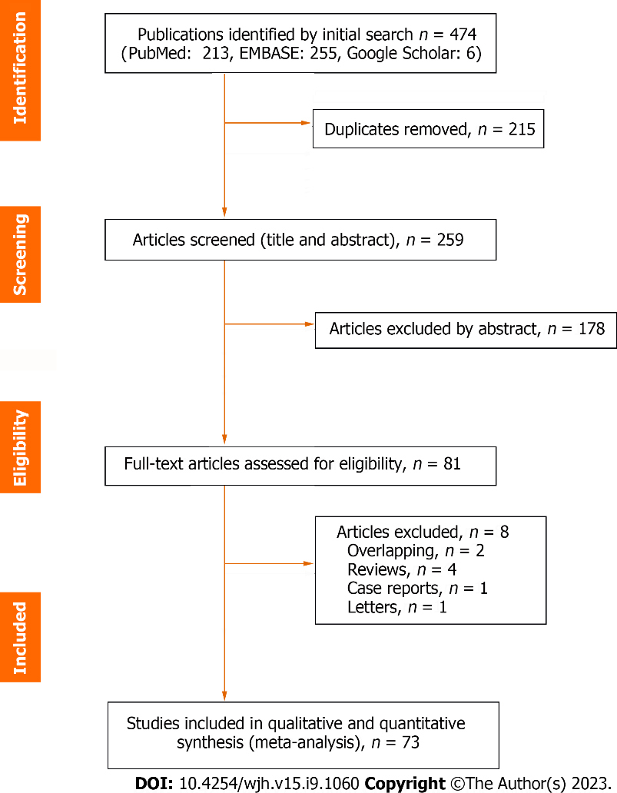
Figure 1 Study selection.

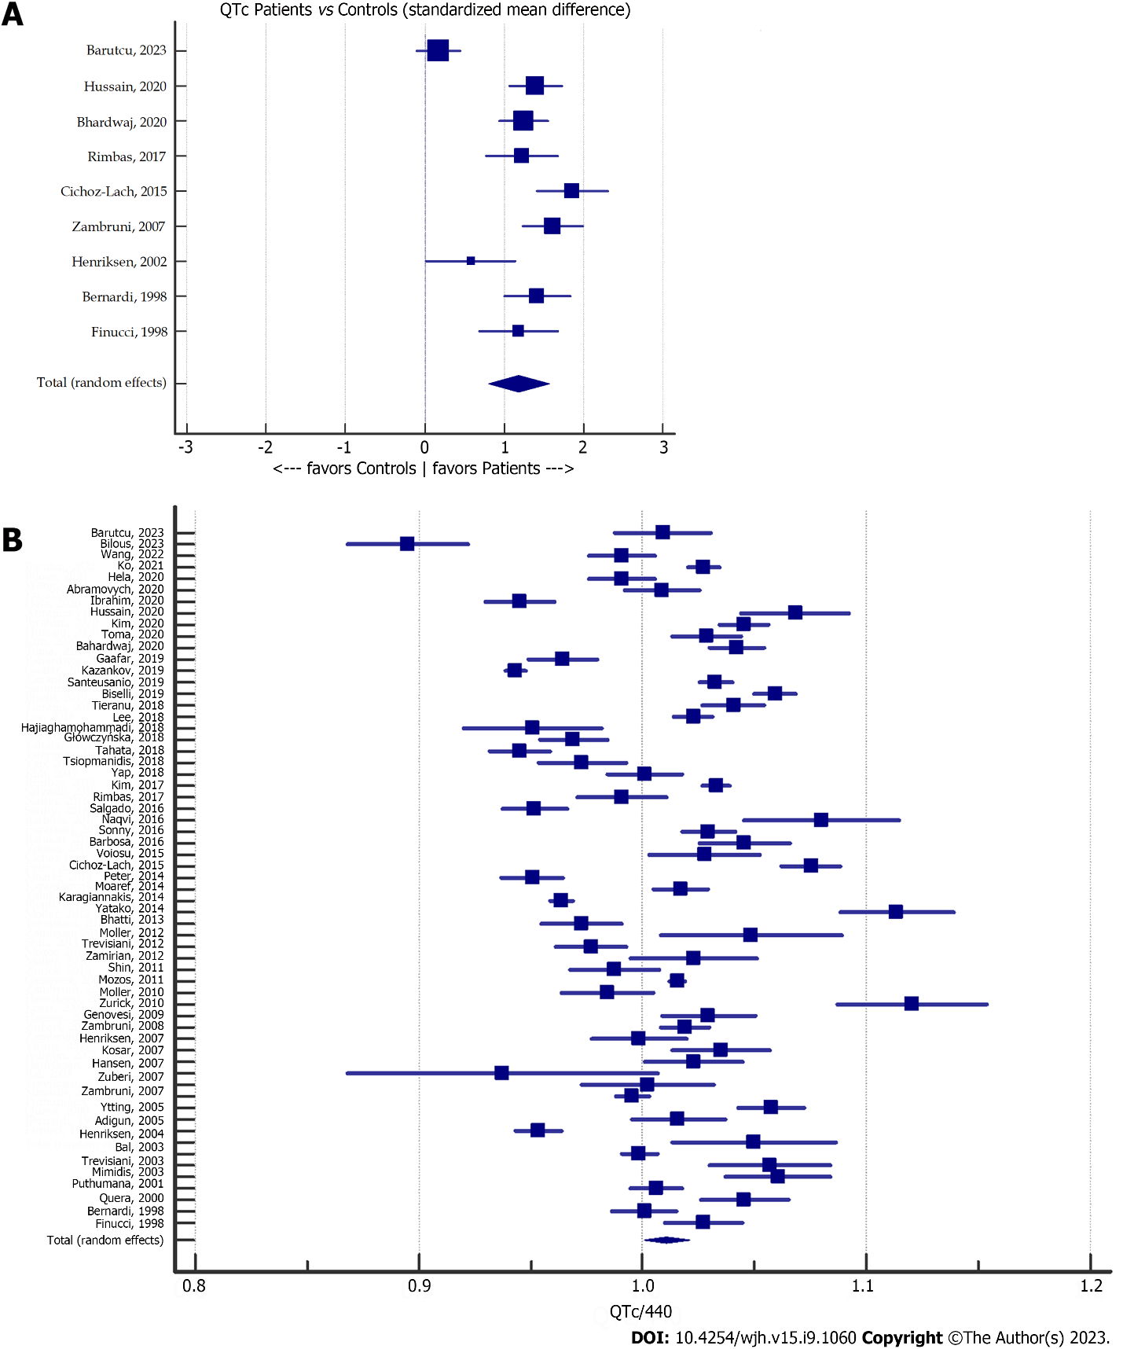
Figure 2 Meta-analysis forest plot. A: Corrected QT (QTc) in patients with cirrhosis vs controls; B: QTc compared with the upper normal limit (440 ms) ratio in patients with cirrhosis. QTc: Corrected QT.

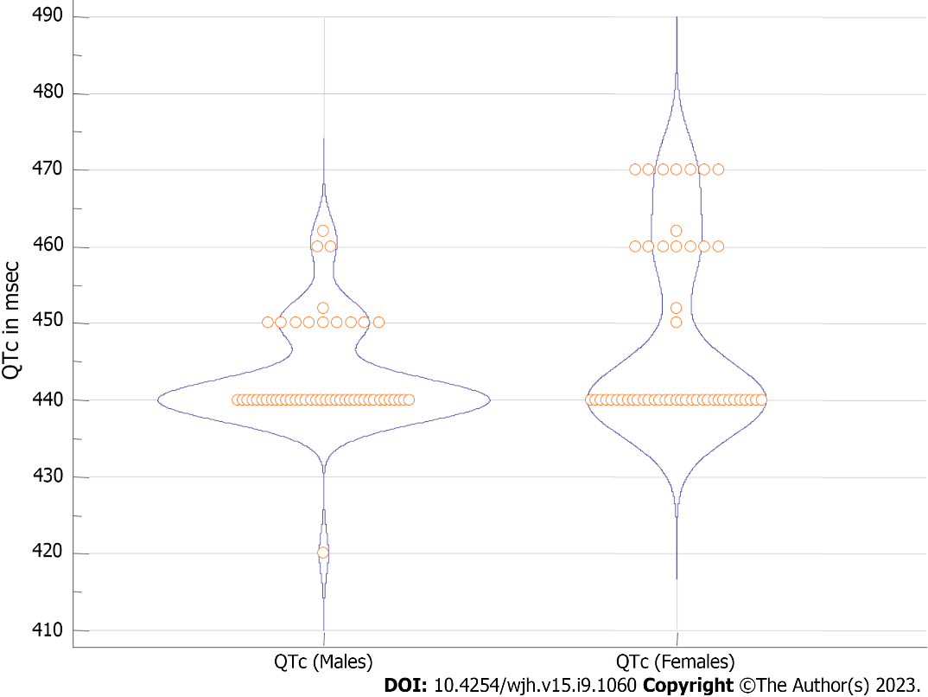
Figure 3 Violi plot for corrected QT upper normal limit used in the included studies. QTc: Corrected QT.

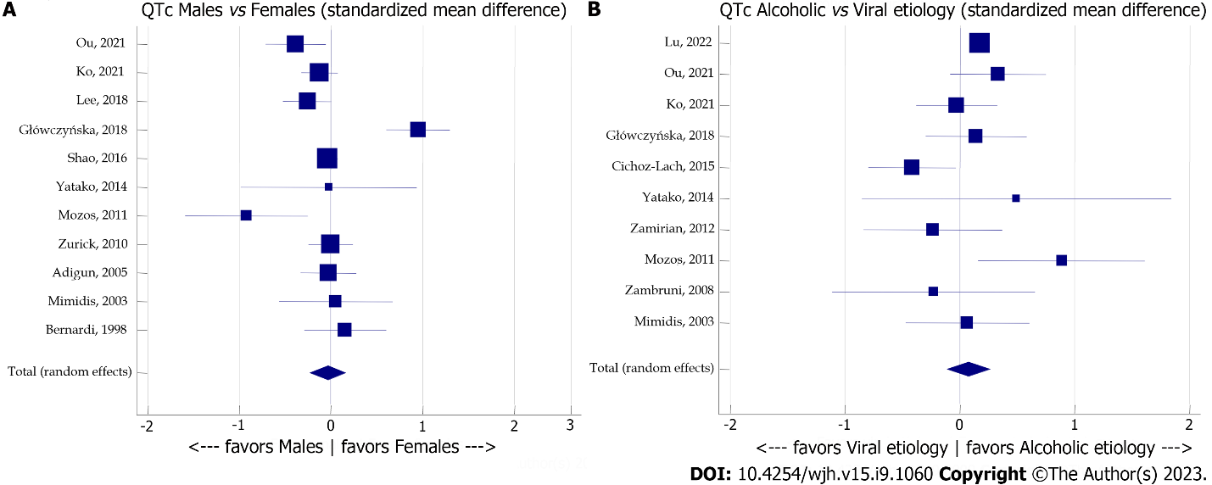
Figure 4 Meta-analysis forest plot concerning the effect of sex and etiology of cirrhosis on corrected QT. A: The effect of sex on corrected QT (QTc) in patients with cirrhosis; B: The effect of etiology of cirrhosis on QTc. QTc: Corrected QT.

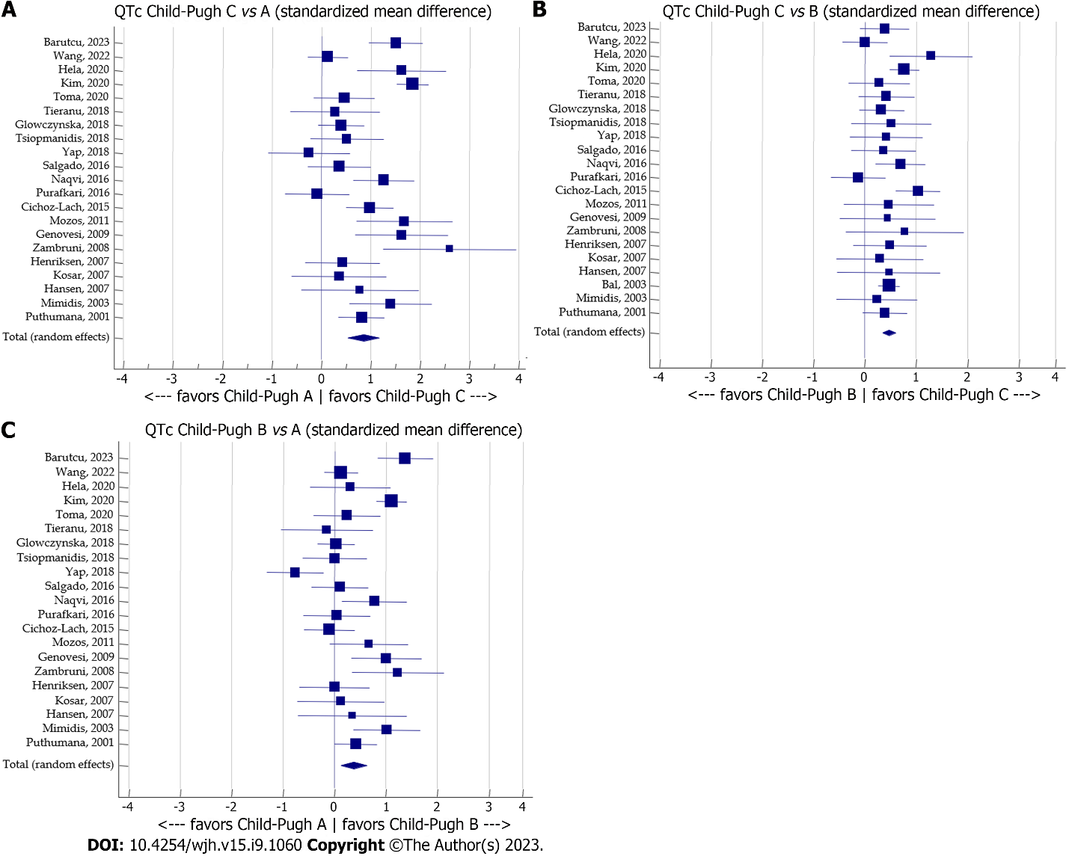
Figure 5 Meta-analysis forest plots concerning the effect of the Child-Pugh stage on corrected QT. A: Child-Pugh stage C vs A; B: Child-Pugh stage C vs B; C: Child-Pugh stage B vs A. QTc: Corrected QT.

Figure 6 Meta-analysis forest plot concerning the effect of the model for end-stage liver disease score and liver transplantation on corrected QT. A: The effect of the model for end-stage liver disease score on corrected QT (QTc); B: The effect of liver transplantation on QTc. Tx: Transplantation; MELD: Model for end-stage liver disease; QTc: Corrected QT.

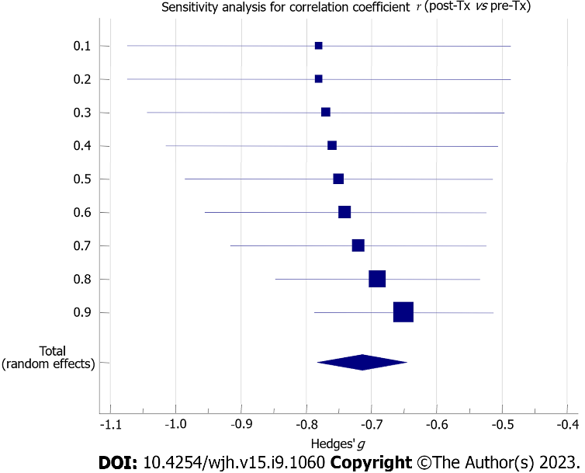
Figure 7 Sensitivity analysis forest plot concerning the estimation of the correlation coefficient between post-transplantation and pre-transplantation corrected QT values. Tx: Transplantation.

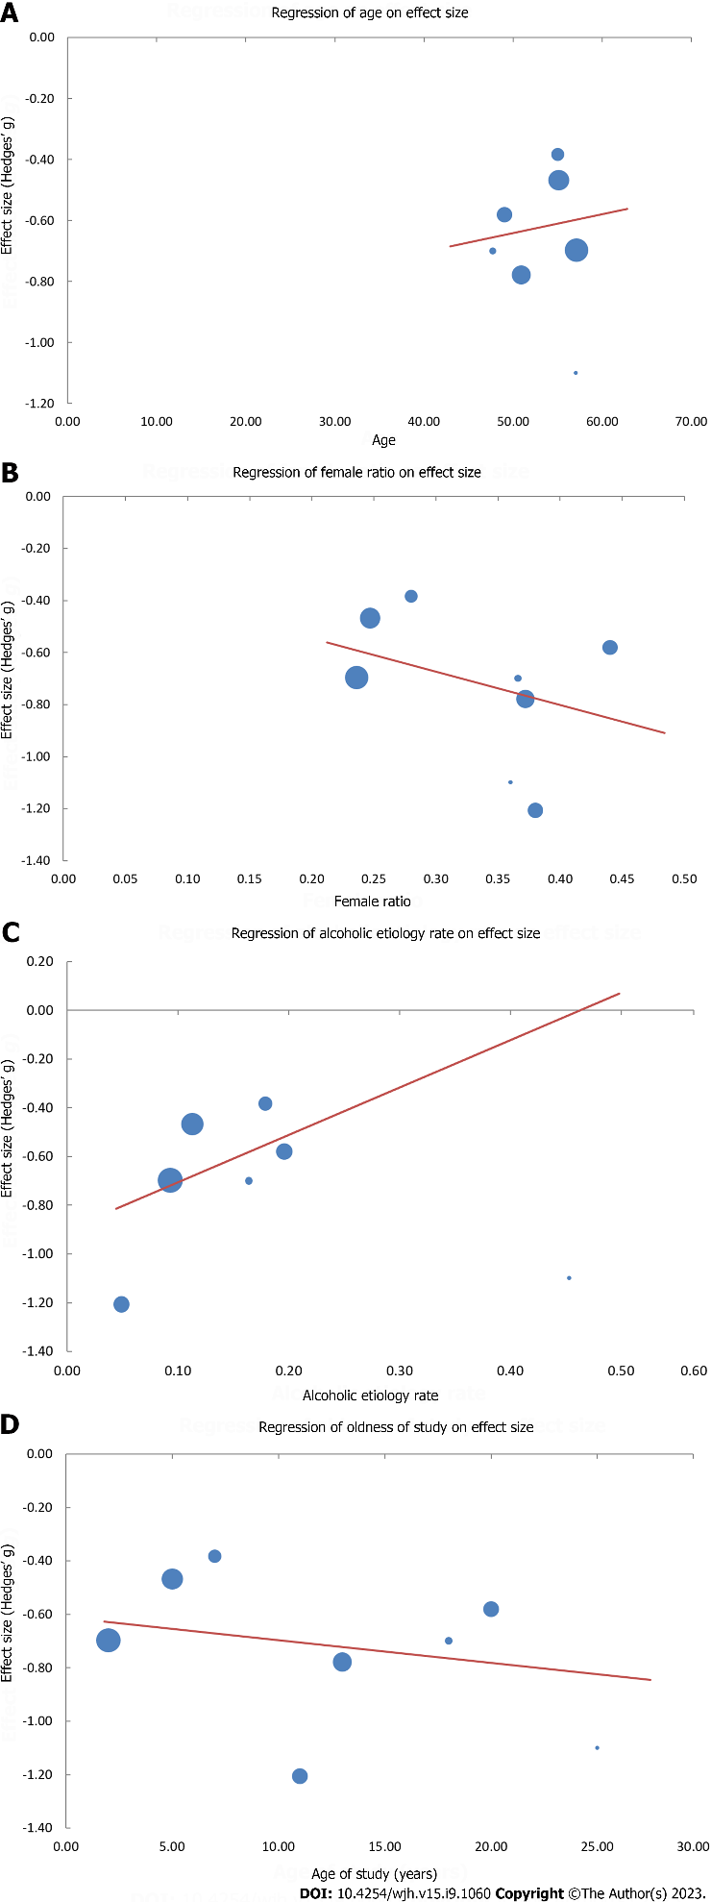
Figure 8 Plot points and regression lines on effect size, namely Hedges’ g, reflecting correlations of pre-transplantation vs post-transplantation corrected QT. A: Age [H_{g} = -0.95 + 0.01 (yr); P = 0.417]; B: Female ratio [H_{g} = -0.29 - 1.28 (female ratio); P < 0.001]; C: Alcoholic etiology rate [H_{g} = -0.90 - 1.95 (alcoholic etiology rate); P < 0.001]; D: Age of study [H_{g} = -0.61 - 0.01 (age of study); P = 0.019]. H_{g} refers to Hedges’g.

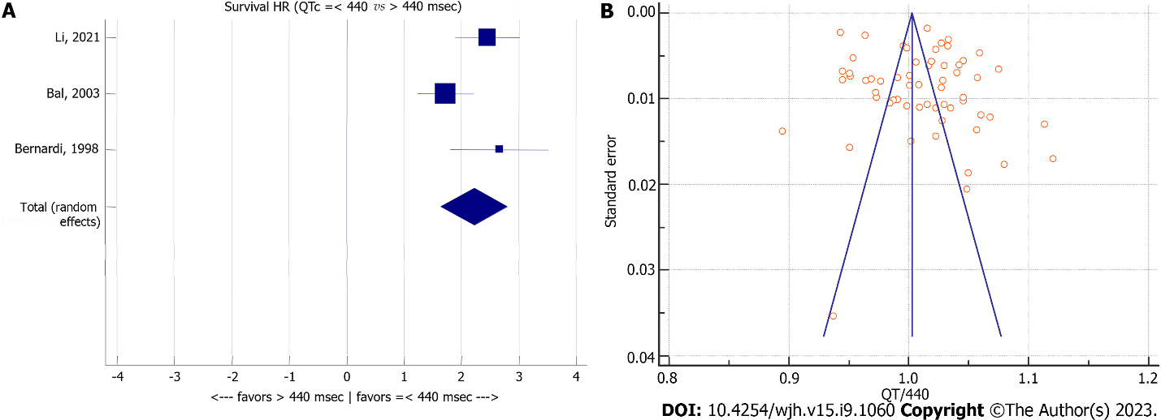
Figure 9 Meta-analysis forest plot concerning overall survival of patients with cirrhosis relating to corrected QT and corrected QT to upper normal limit (440 ms) ratio in patients with cirrhosis. A: Overall survival of patients with cirrhosis relating to corrected QT (QTc); B: QTc to upper normal limit (440 ms) ratio in patients with cirrhosis. QTc: Corrected QT; HR: Hazard ratio.

Table 1 Characteristics of eligible studies
Ref. | Type of study | Device | Formula | Patients, n | Controls, n | Female ratio | Alcoholic etiology ratio | Child-Pugh |  |  | MELD score | Age in yr | QTc
 |  |  |  |  |  |  |  | A, n | B, n | C, n |  |  |  | Prolongation ratio | Controls | Females | Viral etiology | Acohol etiology | Child-Pugh A | Child-Pugh B | Child-Pugh C | Tx pre | Tx post
Wang et al^{[62]}, 2023 | R | E | B | 1022 |  | 0.095 | 1 |  |  |  |  | 52.6 ± 11.6 |  | 0.107
Bilous et al^{[10]}, 2023 | P | H | B | 33 |  | 0.394 |  | 8 | 14 | 11 |  | 48.0 ± 12.0 | 393.7 ± 35.0
Barutcu et al^{[37]}, 2023 | R | E | B | 100 | 100 | 0.440 |  | 32 | 34 | 34 | 16 ± 8 | 60.0 ± 42.2 | 446.3 ± 49.3 |  | 439 ± 33 |  |  |  | 410 ± 23 | 455 ± 39 | 473 ± 53
Lu et al^{[46]}, 2022 | R | E | B | 3529 |  | 0.233 | 0.182 |  |  |  |  | 55.0 ± 11.0 |  | 0.158
Wang et al^{[63]}, 2022 | R | E | B | 189 |  | 0.783 |  | 102 | 56 | 31 |  | 59.4 ± 11.8 | 435.9 ± 46.1 | 0.243 |  |  |  |  | 433 ± 45 | 439 ± 47 | 439 ± 47
Li et al^{[27]}, 2021 | P | E | F | 274 |  | 0.456 |  | 108 | 122 | 44 | 12 ± 4 | 61.8 ± 12.8 |  | 0.328
Ou et al^{[40]}, 2021 | R | E | B | 167 |  | 0.281 | 0.168 | 70 | 81 | 16 | 11 ± 4 | 52.9 ± 10.8 |  | 0.665
Ko et al^{[25]}, 2021 | R | E | B | 408 |  | 0.236 | 0.093 |  |  |  |  | 57.1 ± 12.0 | 452.0 ± 31.0 | 0.650 |  |  |  |  |  |  |  | 452 ± 31 | 430 ± 32
Héla et al^{[36]}, 2020 | P | H | B | 42 |  | 0.429 | 0.095 | 12 | 15 | 15 |  | 60.0 ± 13.2 | 435.9 ± 21.8 | 0.476 |  |  |  |  | 423 ± 19 | 429 ± 17 | 453 ± 17
Abrahamovych et al^{[64]}, 2020 | R | H | B | 87 |  | 0.276 | 1 |  |  |  |  | 44.5 ± 4.3 | 443.8 ± 34.4
Ibrahim et al^{[65]}, 2020 | P | E | B | 50 |  | 0.580 | 0 | 38 | 12 | 0 |  | 52.0 ± 12.0 | 415.8 ± 24.4
Hussain et al^{[66]}, 2020 | P | E | B | 87 | 87 | 0.460 | 0.316 |  |  |  |  | 47.0 ± 13.3 | 470.0 ± 50.0 | 0.218 | 400 ± 50
Kim et al^{[35]}, 2020 | R | E | B | 310 |  | 0.274 | 0.274 | 105 | 94 | 111 |  | 46.0 ± 17.0 | 450.0 ± 43.0 |  |  |  |  | 460 ± 44 | 417 ± 29 | 452 ± 34 | 480 ± 38
Toma et al^{[67]}, 2020 | P | E | B | 63 |  | 0.508 | 0 | 18 | 20 | 25 |  | 56.2 ± 13.5 | 452.5 ± 27.7 | 0.460 |  |  | 453 ± 28 |  | 445 ± 27 | 451 ± 23 | 459 ± 31
Bhardwaj et al^{[68]}, 2020 | P | E | B | 100 | 100 | 0.150 | 0.530 | 4 | 35 | 61 |  | 49.8 ± 13.6 | 458.5 ± 27.0 |  | 424 ± 28
Gaafar et al^{[69]}, 2019 | P | E | B | 112 |  |  | 0 |  |  |  |  |  | 424.4 ± 36.6
Kazankov et al^{[28]}, 2019 | R | E | B | 915 |  |  |  |  |  |  |  |  | 415.0 ± 30.0
Moaref et al^{[70]}, 2019 | P | E | B | 30 |  | 0.367 |  |  |  |  | 16 ± 5 | 41.0 ± 6.6
Santeusanio et al^{[71]}, 2019 | R | E | B | 258 |  | 0.337 | 0.097 |  |  |  | 18 ± 10 | 59.5 ± 9.7 | 454.4 ± 27.9 | 0.403
Biselli et al^{[72]}, 2019 | R | E | F | 474 |  | 0.352 | 0.236 |  |  |  | 13 ± 5 | 61.7 ± 12.6 | 438.0 ± 42.0
Tieranu et al^{[45]}, 2018 | P | E | B | 60 |  | 0.433 |  | 6 | 28 | 26 |  | 59.4 ± 7.3 | 457.8 ± 23.9 |  |  |  |  |  | 456 ± 27 | 452 ± 26 | 462 ± 20
Lee et al^{[39]}, 2018 | R | E | B | 283 |  | 0.247 | 0.113 |  |  |  | 17 ± 11 | 55.1 ± 7.7 | 449.9 ± 31.6 | 0.636 |  |  |  |  |  |  |  | 450 ± 32 | 435 ± 32
Hajiaghamohammadi et al^{[73]}, 2018 | P | E | B | 37 |  | 0.432 |  | 12 | 12 | 13 |  | 58.8 ± 11.5 | 418.5 ± 41.9
Główczyńska et al^{[44]}, 2018 | R | E | B | 151 |  | 0.371 | 0.179 | 50 | 73 | 28 | 12 ± 5 | 49.0 ± 12.3 | 426.3 ± 41.6 | 0.338 |  |  | 426 ± 41 | 432 ± 45 | 423 ± 38 | 424 ± 46 | 438 ± 34
Tahata et al^{[74]}, 2018 | P | E | B | 104 |  | 0.654 |  | 104 | 0 | 0 |  | 71.1 ± 8.4 | 415.9 ± 30.6 |  |  |  |  |  | 416 ± 31
Tsiompanidis et al^{[75]}, 2018 | P | E | B | 51 |  | 0.373 | 0.333 | 22 | 18 | 11 | 28 ± 19 | 55.2 ± 14.2 | 428.1 ± 31.0 | 0.431 |  |  |  | 437 ± 31 | 419 ± 30 | 419 ± 30 | 435 ± 30
Yap et al^{[43]}, 2018 | R | E | B | 148 |  | 0.527 | 0.155 | 17 | 57 | 9 |  | 72.4 ± 14.0 | 440.3 ± 45.6 |  |  |  |  |  | 464 ± 63 | 432 ± 33 | 448 ± 63
Kim et al^{[76]}, 2017 | R | E | B | 406 |  | 0.404 | 0.389 |  |  |  | 18 ± 9 | 56.4 ± 9.0 | 454.5 ± 27.8 | 0.510
Rimbaş et al^{[18]}, 2018 | P | E | B | 46 | 46 | 0.348 | 0.522 | 23 | 16 | 7 | 13 ± 5 | 57.0 ± 9.0 | 436.0 ± 30.0 | 0.413 | 404 ± 21 |  |  | 438 ± 35
Salgado et al^{[42]}, 2016 | P | E | B | 67 |  | 0.478 | 0.239 | 25 | 26 | 16 |  | 54.0 ± 12.9 | 418.7 ± 26.6 | 0.224 |  |  |  |  | 415 ± 34 | 418 ± 21 | 426 ± 22
Naqvi et al^{[34]}, 2016 | P | E | B | 89 |  | 0.438 | 0 | 17 | 29 | 43 |  | 51.5 ± 12.4 | 475.1 ± 73.3 | 0.461 |  |  |  |  | 420 ± 36 | 459 ± 56 | 508 ± 78
Zhao et al^{[38]}, 2016 | R | E | B | 1268 |  | 0.347 | 0.253 | 497 | 528 | 140 | 6 ± 7 | 56.0 ± 12.1 |  | 0.382
Sonny et al^{[77]}, 2016 | R | E | B | 106 |  | 0.280 | 0.179 |  |  |  | 17 ± 8 | 55.0 ± 9.0 | 453.0 ± 28.0 |  |  |  |  |  |  |  |  | 453 ± 28 | 442 ± 29
Barbosa et al^{[17]}, 2016 | C | E | B | 26 |  | 0.154 | 0.769 | 17 | 8 | 1 | 9 ± 5 | 54.6 ± 10.4 | 460.0 ± 23.0 | 0.769
Carvalheiro et al^{[78]}, 2016 | R | E | F | 106 |  | 0.198 | 0.651 | 23 | 24 | 59 | 17 ± 8 | 54.8 ± 8.5 |  | 0.189
Pourafkari et al^{[79]}, 2016 | R | E | B | 69 |  | 0.348 | 0.217 | 14 | 28 | 27 | 17 ± 7 | 56.8 ± 16.0 | 452.2 ± 46.0 | 0.507 |  |  |  |  | 453 ± 52 | 455 ± 40 | 449 ± 50
Barakat et al^{[80]}, 2015 | P | E | B | 74 |  | 0.324 | 0 |  |  |  | 19 ± 26 |  | 473.1 ± 25.1
Voiosu et al^{[81]}, 2015 | P | E | F | 74 |  | 0.378 | 0.378 | 43 | 12 | 19 | 13 ± 5 | 58.0 ± 11.0 | 418.3 ± 26.8
Cichoż-Lach et al^{[82]}, 2015 | R | E | B | 122 | 32 | 0.344 | 0.664 | 28 | 40 | 54 |  | 42.1 ± 12.7 | 447.5 ± 29.9 |  | 394 ± 23 |  | 465 ± 50 | 443 ± 7 | 438 ± 35 | 434 ± 40 | 476 ± 40
Peter et al^{[83]}, 2014 | P | E | B | 78 |  | 0.154 | 0.538 |  |  |  | 15 ± 5 | 51.2 ± 11.9 | 424.0 ± 10.2
Moaref et al^{[15]}, 2014 | P | E | B | 80 |  | 0.375 |  | 0 | 0 | 80 |  | 41.0 ± 14.0 | 490.0 ± 51.0 |  |  |  |  |  |  |  | 490 ± 51
Josefsson et al^{[84]}, 2014 | R | E | B | 202 |  | 0.307 |  | 22 | 91 | 89 | 17 ± 6 | 52.0 ± 11.0 |  | 0.262
Karagiannakis et al^{[14]}, 2014 | P | E | B | 45 |  | 0.267 | 0.444 | 26 | 15 | 3 | 12 ± 4 | 57.2 ± 12.4 | 428.0 ± 27.5
Yataco et al^{[41]}, 2014 | R | E | B | 17 |  | 0.471 | 0.235 | 0 | 1 | 16 | 29 ± 7 | 57.9 ± 7.9 | 461.4 ± 37.4 | 0.529 |  | 461 ± 38 | 459 ± 31 | 479 ± 42
Bhatti et al^{[85]}, 2014 | C | E | B | 166 |  | 0.422 | 0 | 22 | 69 | 75 |  | 57.1 ± 12.0 | 429.9 ± 45.1 | 0.247
Møller et al^{[86]}, 2012 | P | E | B | 10 |  | 0.500 |  |  |  |  |  | 55.6 ± 10.0 | 450.0 ± 20.0
Trevisani et al^{[87]}, 2012 | R | E | F | 70 |  | 0.329 | 0.186 |  |  |  | 16 ± 1 | 61.7 ± 12.5 | 415.9 ± 36.0 | 0.243
Zamirian et al^{[24]}, 2012 | P | E | B | 243 |  | 0.380 | 0.049 |  |  |  |  |  | 446.9 ± 12.5 | 0.432 |  |  | 483 ± 20 | 478 ± 25 |  |  |  | 447 ± 13 | 383 ± 49
Kim et al^{[88]}, 2011 | P | E | B | 100 |  | 0.140 |  | 18 | 48 | 34 | 14 ± 8 | 52.3 ± 8.3
Shin et al^{[89]}, 2011 | P | E | B | 50 |  | 0.200 |  | 14 | 19 | 17 |  | 52.0 ± 7.0 | 433.2 ± 32.7 | 0.440
Mozos et al^{[33]}, 2011 | P | E | B | 38 |  | 0.500 | 0.395 | 16 | 13 | 9 |  | 58.0 ± 12.0 | 493.0 ± 46.0 | 0.711 |  |  | 481 ± 51 | 527 ± 50 | 462 ± 25 | 493 ± 62 | 520 ± 45
Vuppalanchi et al^{[90]}, 2011 | P | E | B | 14 |  | 0.286 | 0.500 |  |  |  | 11 ± 2 | 53.9 ± 9.6
Møller et al^{[91]}, 2010 | P | E | B | 43 |  | 0.326 | 1 | 17 | 18 | 8 | 11 ± 3 | 57.4 ± 9.1 | 453.0 ± 31.0
Zurick et al^{[23]}, 2010 | R | E | B | 269 |  | 0.372 |  |  |  |  | 21 | 50.9 | 448.3 ± 41.3 | 0.502 |  | 449 ± 11 |  |  |  |  |  | 449 ± 41 | 417 ± 41
Lossnitzer et al^{[13]}, 2010 | P | E | B | 20 |  | 0.450 | 0.600 |  |  |  | 15 ± 6 | 52.4 ± 9.4 |  | 0.250
Genovesi et al^{[32]}, 2009 | P | H | B | 40 |  | 0.000 | 0.450 | 26 | 15 | 7 |  | 56.1 ± 11.2 | 439.3 ± 30.2 | 0.525 |  |  |  |  | 425 ± 24 | 452 ± 30 | 465 ± 24
Zambruni et al^{[31]}, 2008 | P | E | B | 30 |  | 0.167 | 0.233 | 15 | 10 | 5 | 13 ± 1 | 58.8 ± 11.0 | 455.4 ± 26.8 | 0.367 |  |  | 459 ± 38 | 450 ± 38 | 440 ± 16 | 466 ± 26 | 486 ± 20
Henriksen et al^{[92]}, 2007 | P | E | B | 48 |  | 0.354 | 0.917 | 15 | 19 | 14 |  | 52.1 ± 11.1 | 450.0 ± 33.9 | 0.563 |  |  |  |  | 441 ± 53 | 441 ± 39 | 470 ± 76
Kosar et al^{[93]}, 2007 | R | E | B | 33 |  | 0.455 |  | 9 | 15 | 9 |  | 53.0 ± 11.0 | 412.5 ± 89.6 |  |  |  |  |  | 405 ± 51 | 411 ± 46 | 427 ± 64
Hansen et al^{[12]}, 2007 | P | H | B | 23 |  | 0.261 | 0.609 | 6 | 10 | 7 |  | 55.0 ± 8.6 | 441.0 ± 31.7 | 0.478 |  |  |  |  | 420 ± 53 | 438 ± 48 | 461 ± 45
Zuberi et al^{[94]}, 2007 | C | E | B | 78 |  | 0.269 |  | 6 | 19 | 53 |  | 34.4 | 438.0 ± 15.0 | 0.192
Zambruni et al^{[47]}, 2007 | P | E | B | 100 | 53 | 0.370 | 0.210 | 34 | 39 | 27 |  | 57.2 ± 7.6 | 465.2 ± 33.3 | 0.520 | 416 ± 24
Ytting et al^{[7]}, 2005 | P | E | B | 80 |  | 0.263 | 0.488 | 33 | 33 | 14 |  | 51.0 ± 10.4 | 447.0 ± 42.3 | 0.513
Adigun et al^{[21]}, 2005 | P | E | B | 183 |  | 0.366 | 0.164 | 7 | 143 | 33 |  | 47.7 ± 7.4 | 419.6 ± 31.8 | 0.279 |  | 419 ± 35 |  |  |  |  |  | 436 ± 21 | 421 ± 21
Henriksen et al^{[95]}, 2004 | P | E | B | 24 |  | 0.125 | 1 | 3 | 12 | 9 |  | 58.3 ± 11.0 | 462.0 ± 40.3 | 0.583 |  |  |  | 462 ± 40
Bal and Thuluvath^{[26]}, 2003 | R | E | B | 409 |  | 0.440 | 0.196 | 0 | 273 | 136 |  | 49.0 ± 14.2 | 439.4 ± 36.4 | 0.396 |  |  |  | 456 ± 42 |  | 434 ± 31 | 451 ± 43 | 450 ± 39 | 429 ± 29
Trevisani et al^{[6]}, 2003 | P | E | B | 19 |  | 0.474 |  |  |  |  |  | 61.2 ± 6.5 | 465.0 ± 26.2 | 0.842
Mimidis et al^{[30]}, 2005 | R | E | B | 52 |  | 0.250 | 0.558 | 23 | 19 | 10 |  | 61.3 ± 11.1 | 466.6 ± 37.8 | 0.596 |  | 468 ± 15 | 466 ± 43 | 468 ± 15 | 446 ± 27 | 480 ± 39 | 489 ± 36
Henriksen et al^{[11]}, 2002 | P | E | B | 24 | 17 | 0.125 | 1 | 3 | 12 | 9 |  | 58.3 ± 11.0 | 462.0 ± 40.3 | 0.375 | 410 ± 41 |  |  | 462 ± 40
Puthumana et al^{[29]}, 2001 | R | E | B | 130 |  | 0.469 |  | 42 | 53 | 35 |  | 52.0 ± 10.0 | 442.7 ± 29.3 | 0.446 |  |  |  |  | 432 ± 23 | 443 ± 29 | 455 ± 33
Quera et al^{[96]}, 2000 | R | E | B | 47 |  |  |  |  |  |  |  |  | 460.0 ± 30.0 | 0.723
Bernardi et al^{[3]}, 1998 | P | E | B | 94 | 37 | 0.277 | 0.074 | 24 | 45 | 25 |  | 53.1 ± 13.6 | 440.3 ± 31.0 | 0.468 | 394 ± 36 | 444 ± 25 |  | 453 ± 25
Finucci et al^{[4]}, 1998 | P | E | B | 75 | 24 | 0.360 | 0.453 | 23 | 37 | 15 |  | 57.0 ± 11.0 | 452.0 ± 33.0 | 0.600 | 414 ± 28 |  |  | 463 ± 31 |  |  |  | 449 ± 31 | 415 ± 26
C: Case-control; NOS: Newcastle-Ottawa scale; P: Prospective; R: Retrospective; E: Electrocardiography; B: Bazett’s formula; H: Holter; F: Fridericia’s formula; QTc: Corrected QT; MELD: Model for end-stage liver disease; Tx: Transplantation.

Table 2 Newcastle-Ottawa risk of bias assessment tool for all eligible studies
Ref. | Type | NOS selection | NOS comparability | NOS exposure¹ or outcome of interest² | Risk of bias
Wang et al^{[62]}, 2023 | Retrospective study | ** | * | *** | Intermediate
Bilous et al^{[10]}, 2023 | Prospective study | ** | * | *** | Intermediate
Barutcu et al^{[37]}, 2023 | Retrospective study | *** | ** | *** | Low
Lu et al^{[46]}, 2022 | Retrospective study | *** | * | *** | Low
Wang et al^{[63]}, 2022 | Retrospective study | ** | ** | *** | Low
Li et al^{[27]}, 2021 | Prospective study | **** | ** | *** | Low
Ou et al^{[40]}, 2021 | Retrospective study | **** | * | *** | Low
Ko et al^{[25]}, 2021 | Retrospective study | **** | ** | *** | Low
Héla et al^{[36]}, 2020 | Prospective study | ** | ** | *** | Low
Abrahamovych et al^{[64]}, 2020 | Retrospective study | *** | * | *** | Low
Ibrahim et al^{[65]}, 2020 | Prospective study | **** | * | *** | Low
Hussain et al^{[66]}, 2020 | Prospective study | *** | * | *** | Low
Kim et al^{[35]}, 2020 | Retrospective study | *** | ** | *** | Low
Toma et al^{[67]}, 2020 | Prospective study | *** | ** | *** | Low
Bhardwaj et al^{[68]}, 2020 | Prospective study | *** | * | *** | Low
Gaafar et al^{[69]}, 2019 | Prospective study | *** | * | *** | Low
Kazankov et al^{[28]}, 2019 | Retrospective study | **** | * | *** | Low
Moaref et al^{[70]}, 2019 | Prospective study | *** | * | *** | Low
Santeusanio et al^{[71]}, 2019 | Retrospective study | **** | * | *** | Low
Biselli et al^{[72]}, 2019 | Retrospective study | **** | * | ** | Low
Tieranu et al^{[45]}, 2018 | Prospective study | *** | ** | *** | Low
Lee et al^{[39]}, 2018 | Retrospective study | **** | ** | *** | Low
Hajiaghamohammadi et al^{[73]}, 2018 | Prospective study | *** | * | ** | Intermediate
Główczyńska et al^{[44]}, 2018 | Retrospective study | *** | ** | *** | Low
Tahata et al^{[74]}, 2018 | Prospective study | **** | * | *** | Low
Tsiompanidis et al^{[75]}, 2018 | Prospective study | *** | ** | *** | Low
Yap et al^{[43]}, 2018 | Retrospective study | ** | ** | *** | Low
Kim et al^{[76]}, 2017 | Retrospective study | *** | * | ** | Intermediate
Rimbaş et al^{[18]}, 2018 | Prospective study | **** | * | *** | Low
Salgado et al^{[42]}, 2016 | Prospective study | **** | ** | *** | Low
Naqvi et al^{[34]}, 2016 | Prospective study | *** | ** | *** | Low
Zhao et al^{[38]}, 2016 | Retrospective study | *** | * | *** | Low
Sonny et al^{[77]}, 2016 | Retrospective study | *** | ** | *** | Low
Barbosa et al^{[17]}, 2016 | Case-control study | *** | * | *** | Low
Carvalheiro et al^{[78]}, 2016 | Retrospective study | *** | * | *** | Low
Pourafkari et al^{[79]}, 2016 | Retrospective study | *** | ** | *** | Low
Barakat et al^{[80]}, 2015 | Prospective study | ** | * | *** | Intermediate
Voiosu et al^{[81]}, 2015 | Prospective study | *** | * | *** | Low
Cichoż-Lach et al^{[82]}, 2015 | Retrospective study | ** | ** | *** | Low
Peter et al^{[83]}, 2014 | Prospective study | ** | * | *** | Intermediate
Moaref et al^{[15]}, 2014 | Prospective study | ** | * | *** | Intermediate
Josefsson et al^{[84]}, 2014 | Retrospective study | *** | * | *** | Low
Karagiannakis et al^{[14]}, 2014 | Prospective study | *** | * | *** | Low
Yataco et al^{[41]}, 2014 | Retrospective study | *** | ** | *** | Low
Bhatti et al^{[85]}, 2014 | Case-control study | ** | * | *** | Intermediate
Møller et al^{[86]}, 2012 | Prospective study | *** | * | *** | Low
Trevisani et al^{[87]}, 2012 | Retrospective study | **** | * | *** | Low
Zamirian et al^{[24]}, 2012 | Prospective study | ** | * | *** | Intermediate
Kim et al^{[88]}, 2011 | Prospective study | **** | * | *** | Low
Shin et al^{[89]}, 2011 | Prospective study | *** | * | *** | Low
Mozos et al^{[33]}, 2011 | Prospective study | *** | ** | *** | Low
Vuppalanchi et al^{[90]}, 2011 | Prospective study | ** | * | *** | Intermediate
Møller et al^{[91]}, 2010 | Prospective study | *** | * | *** | Low
Zurick et al^{[23]}, 2010 | Retrospective study | **** | ** | *** | Low
Lossnitzer et al^{[13]}, 2010 | Prospective study | *** | * | *** | Low
Genovesi et al^{[32]}, 2009 | Prospective study | **** | ** | *** | Low
Zambruni et al^{[31]}, 2008 | Prospective study | **** | ** | ** | Low
Henriksen et al^{[92]}, 2007 | Prospective study | **** | ** | *** | Low
Kosar et al^{[93]}, 2007 | Retrospective study | **** | ** | *** | Low
Hansen et al^{[12]}, 2007 | Prospective study | ** | ** | *** | Low
Zuberi et al^{[94]}, 2007 | Case-control study | *** | * | ** | Intermediate
Zambruni et al^{[47]}, 2007 | Prospective study | **** | * | *** | Low
Ytting et al^{[7]}, 2005 | Prospective study | *** | * | *** | Low
Adigun et al^{[21]}, 2005 | Prospective study | *** | ** | *** | Low
Henriksen et al^{[95]}, 2004 | Prospective study | *** | * | *** | Low
Bal and Thuluvath^{[26]}, 2003 | Retrospective study | **** | ** | *** | Low
Trevisani et al^{[6]}, 2003 | Prospective study | *** | * | *** | Low
Mimidis et al^{[30]}, 2005 | Retrospective study | *** | ** | *** | Low
Henriksen et al^{[11]}, 2002 | Prospective study | *** | * | *** | Low
Puthumana et al^{[29]}, 2001 | Retrospective study | *** | ** | *** | Low
Quera et al^{[96]}, 2000 | Retrospective study | *** | * | ** | Intermediate
Bernardi et al^{[3]}, 1998 | Prospective study | **** | ** | *** | Low
Finucci et al^{[4]}, 1998 | Prospective study | **** | ** | *** | Low
¹For case-control studies.
²For cross-sectional studies.
NOS: Newcastle-Ottawa scale.

Table 3 GRADE assessment of evidence certainty (quality) for every endpoint
Endpoint | Risk of bias | Imprecision | Inconsistency | Indirectness | Publication bias | Effect size | Quality
Cirrhosis effect (patients vs controls) on QTc | No important risk of bias | No important imprecision | No important inconsistency | No important indirectness | No important publication bias | Very large | Very high
QTc prolongation in cirrhosis (QTc vs 440 ms) | No important risk of bias | No important imprecision | No important inconsistency | No important indirectness | No important publication bias | Very large | Very high
Sex effect on QTc in cirrhosis | No important risk of bias | No important imprecision | Serious inconsistency | No important indirectness | No important publication bias | Trivial | Very low
Etiology of cirrhosis (alcohol vs viral) effect on QTc | No important risk of bias | No important imprecision | Serious inconsistency | No important indirectness | No important publication bias | Trivial | Very low
Child-Pugh stage (C vs B vs A) effect on QTc | No important risk of bias | No important imprecision | No important inconsistency | No important indirectness | No important publication bias | Medium with dose-response gradient | High
MELD score effect on QTc prolongation | No important risk of bias | No important imprecision | No important inconsistency | No important indirectness | No important publication bias | Medium | Low
β-blockers effect on QTc | No important risk of bias | No important imprecision | No important inconsistency | No important indirectness | No important publication bias | Medium | Low
Acute gastrointestinal bleeding effect on QTc | No important risk of bias | No important imprecision | Serious inconsistency | No important indirectness | No important publication bias | Very large | High
Liver transplantation effect on QTc | No important risk of bias | No important imprecision | No important inconsistency | No important indirectness | No important publication bias | Large | High
QTc prolongation effect on overall survival in cirrhosis | No important risk of bias | No important imprecision | No important inconsistency | No important indirectness | No important publication bias | Medium | Low
MELD: Model for end-stage liver disease; QTc: Corrected QT.

Published by Baishideng Publishing Group Inc
7041 Koll Center Parkway, Suite 160, Pleasanton, CA 94566, USA
Telephone: +1-925-3991568
E-mail: bpgoffice@wjgnet.com
Help Desk: https://www.f6publishing.com/helpdesk
https://www.wjgnet.com

© 2023 Baishideng Publishing Group Inc. All rights reserved.

