Name of journal: World Journal of Clinical Oncology
ESPS Manuscript NO: 17025
Columns: Case Report

Unusual case of malignant peripheral nerve sheath tumor of proximal third tibia

Rao A et al. MPNST of tibia

Arunkumar Rao, Sachin B Ingle, Pawan Rajurkar, Vishav Goyal, Nikhil Dokrimare

Arunkumar Rao, Pawan Rajurkar, Vishav Goyal, Nikhil Dokrimare, Department of Orthopedics, Maharashtra Institute of Medical Sciences and Research, Medical College, Latur 413512, Maharashtra, India

Sachin B Ingle, Department of Pathology, Secretary Research and Development and Institutional Review Board, Maharashtra Institute of Medical Sciences and Research, Medical College, Latur 413531, Maharashtra, India

Author contributions: Rao A and Rajurkar P the study design; Goyal V and Dokrimare N prepared the first draft of manuscript; Ingle SB done the Pathological diagnosis and critically revised the intellectual content, done final approval of manuscript.

Ethics approval: Approved by Institutional Review board of MIMSR Medical College, Latur.

Informed consent: As we are not disclosing any identity of the patient, so it is need not to be submitted.

Conflict-of-interest: All authors clear that they have no any conflicts of interests to be declared.

Open-Access: This article is an open-access article which was selected by an in-house editor and fully peer-reviewed by external reviewers. It is distributed in accordance with the Creative Commons Attribution Non Commercial (CC BY-NC 4.0) license, which permits others to distribute, remix, adapt, build upon this work non-commercially, and license their derivative works on different terms, provided the original work is properly cited and the use is non-commercial. See: http://creativecommons.org/licenses/by-nc/4.0/

Correspondence to: Sachin B Ingle, Professor, Department of Pathology, Secretary Research and Development and Institutional Review Board, Maharashtra Institute of Medical Sciences and Research Medical College, Vishwanathpuram, Ambajogai Road, Latur 413531, Maharashtra, India. dr.sachiningle@gmail.com
Telephone: +91-2382-227424
Fax: +91-2382-228939

Received: February 7, 2015
Peer-review started: February 8, 2015
First decision: May 14, 2015
Revised: June 8, 2015
Accepted: June 18, 2015
Article in press:
Published online:

Abstract
In this case study 16 year/male having swelling over anterior aspect of proximal 1/3 tibia since one year which was peanut in size initially and progressively increased to present size. Patient had undergone Fine Needle Aspiration Cytology (FNAC) twice during this period and reported as spindle cell sarcoma. Malignant peripheral nerve sheath tumour (MPNST) is a malignancy of the connective tissue surrounding the nerves. Previously MPNST is also called as neurofibrosarcoma, malignant schwannoma; neurogenic sarcoma. We are reporting this case for its rarity and peculiar mode of presentation. FNAC/Core biopsy can be used as an effective diagnostic tool to hit the correct pathological diagnosis.

Key words: Tibial malignant peripheral nerve sheath tumour; Fine Needle Aspiration Cytology; Histopathology; Treatment

© The Author(s) 2015. Published by Baishideng Publishing Group Inc. All rights reserved.

Core tip: In cases of malignant peripheral nerve sheath tumour of tibia Fine Needle Aspiration Cytology/core biopsy can be used as an effective diagnostic tool to hit the correct pathological diagnosis. In such cases enblock resection is the treatment of choice. Adjuvant radiotherapy/chemotherapy plays vital role for the better outcome of the patients.

Rao A, Ingle SB, Rajurkar P, Goyal V, Dokrimare N. Unusual case of malignant peripheral nerve sheath tumor of proximal third tibia. World J Clin Oncol 2015; In press

INTRODUCTION
Malignant peripheral nerve sheath tumours (MPNSTs) are sarcomas originating from cells associated with the nerve sheath. The lifetime risk of MPNST has a 0.001% in the general population. As MPNSTs arise from different types of cells associated with nerve sheath, i.e., Schwann cells, fibroblasts etc., the clinical presentation and histopathological features varies from case to case. So it’s a real challenge to diagnose and classify this rare entity. Generally, a sarcoma originating from a peripheral nerve or a neurofibroma is assumed clinically as MPNST^{[1,2]}.

CASE REPORT
A 16yrs year old boy admitted in YCR hospital Latur,with swelling which was peanut size when he first noticed and progressively increased to present size (10 cm × 8 cm) and pain which was intermittent in nature in right Proximal tibia with tingling sensation of right leg for the last one year.
On examination revealed a swelling over the anterior aspect of proximal end of tibia around 10 cm × 8 cm in size (Figure 1), shiny skin, scab in the center of swelling, dilated veins seen over swelling, local temperature raised with tenderness, it was mobile and not attached to underlying structures and range of movements of right knee joint were full and free with intact neurovascular status. No history of exposure to radiation. No evidence of signs and symptoms of Neurofibromatosis (Figure 2).

Management
Anteroposterior and lateral radiograph of the Right Knee with tibia shows an expansile soft tissue mass destroying adjacent cortex on lateral view but does not extent in to medullary cavity, congruency of knee joint is well maintained (Figure 3).
MRI showed a lobulated mass lesion (7.5 cm × 3.9 cm × 1.6 cm) along anterior surface of shaft of tibia causing periosteal elevation. There is no extension of lesion within the medullary space of tibia and no significant marrow edema in adjacent tibia (Figures 4-7).

Considering the nature of growth and high clinical propensity for malignancy, treated by en-bloc resection and immobilization for two weeks.
In this procedure through antero-medial approach around 20 cm “Elliptical “shaped incision from margin taken and radical en-bloc resection of tumor (measuring 15 cm × 8 cm × 4 cm) removed out. On Gross examination, cut section was grayish whitish mass with yellowish cut surface (Figure 8).
Care was taken to preserve the neurovascular bundle while resection of the tumor mass from the surrounding soft tissue. Thorough wound wash was given with H₂O₂ and wound closed over drain.
En-bloc section of excised mass sent for histo-pathological examination, report was malignant spindle cell sarcoma, i.e., Low grade MPNST (Figure 9). The tumor cells were immunopositive for S-100, thus the final diagnosis of MPNST was confirmed (Figure 10).
The limb was immobilized in a longmedium knee brace for 2 wk and followed by active knee mobilization. Patient discharged and advised monthly review. Patient also advised to consult oncologist for chemotherapy/radiotherapy. In our case considerable delay in the treatment was observed by looking at the size of swelling. Near total excision was done. Stitch gaping of the wound of about 1.5 cm noted which healed eventually.

DISCUSSION
Malignant Peripheral Nerve Sheath Tumors constitutes 5%-10% of all soft tissue malignancies. They are associated with neurofibromatosis-1 (NF1) or may occur independently in a spontaneous manner.
The cause is not known but strongly associated with history of exposure to radiation^{[3,4]}. Fifty percent of the cases occur in patients with NF1^{[5-7]}. They usually occur in the preexisting neurofibroma.
The genesis of MPNST has been associated with genetic mutations in p53 and p16 genes^{[8-10]}. While NF1 gene activity acts as a predisposing factor.
They are commonly seen in adultshood, age group varies between 20-50 years. In first 2 decades of life the incidence is 10%-20%^{[6]}, with exceptionally seen in infants also^{[11]}.
The plan of treatment for MPNSTs is surgical excision with wide margins. Adjuvant chemotherapy or radiotherapy has not been shown to be effective for better outcome of patients^{[12,13]}.
It has been clearly stated that these tumors have tendency to spread for considerable distances along nerves. In such scenario, frozen section can be advised to ensure clear margins^{[14]}.
In a 10 year institutional review for chemotherapy, it did not seem to reduce mortality, so its effectiveness is questionable. Although with recent approaches with the molecular biology of MPNSTs, new therapies and prognostic factors are being examined^{[15]}.

COMMENTS
Case characteristics
A 16 years old boy presented with swelling which was peanut size when he first noticed and progressively increased to present size (10 cm × 8 cm) and pain which was intermittent in nature in Right Proximal tibia with tingling sensation of right leg for the last one year.

Clinical diagnosis
Clinically the case was diagnosed as soft tissue sarcoma.

Differential diagnosis
Soft tissue sarcomas, i.e., fibrosarcoma, malignant fibrous histiocytoma and malignant peripheral nerve sheath tumour (MPNST).

Laboratory diagnosis
On Fine Needle Aspiration Cytology (FNAC) case was diagnosed as spindle cell sarcoma which was confirmed on histopathology and immunostaining.

Imaging diagnosis
X-ray: Anteroposterior and lateral radiograph of the Right Knee with tibia shows an expansile soft tissue mass destroying adjacent cortex on lateral view but does not extent in to medullary cavity, congruency of knee joint is well maintained. MRI showed a lobulated mass lesion (7.5 cm × 3.9 cm × 1.6 cm) along anterior surface of shaft of tibia causing periosteal elevation. There is no extention of lesion within the medullary space of tibia and no significant marrow edema in adjacent tibia.

Pathological diagnosis
Malignant peripheral nerve sheath tumor confirmed on immunohistochemistry.

Treatment
Enblock resection followed by chemotherapy/radiotherapy.

Experiences and lessons
FNAC/Core biopsy can be used as an effective diagnostic tool to arrive at early diagnosis.

Peer-review
It is a well written paper describing an interesting case report of MPNST of proximal third tibia treated by en-bloc resection.

REFERENCES
1 Adamson DC, Cummings TJ, Friedman AH. Malignant peripheral nerve sheath tumor of the spine after radiation therapy for Hodgkin's lymphoma. Clin Neuropathol 2004; 23: 245-255 [PMID: 15581029]
2 Amin A, Saifuddin A, Flanagan A, Patterson D, Lehovsky J. Radiotherapy-induced malignant peripheral nerve sheath tumor of the cauda equina. Spine (Phila Pa 1976) 2004; 29: E506-E509 [PMID: 15507791]
3 Ducatman BS, Scheithauer BW, Piepgras DG, Reiman HM, Ilstrup DM. Malignant peripheral nerve sheath tumors. A clinicopathologic study of 120 cases. Cancer 1986; 57: 2006-2021 [PMID: 3082508]
4 Loree TR, North JH, Werness BA, Nangia R, Mullins AP, Hicks WL. Malignant peripheral nerve sheath tumors of the head and neck: analysis of prognostic factors. Otolaryngol Head Neck Surg 2000; 122: 667-672 [PMID: 10793343]
5 D'Agostino AN, Soule EH, Miller RH. Sarcomas of the peripheral nerves and somatic soft tissues associated with multiple neurofibromatosis (von recklinghausen's disease). Cancer 1963; 16: 1015-1027 [PMID: 14050005]
6 King AA, Debaun MR, Riccardi VM, Gutmann DH. Malignant peripheral nerve sheath tumors in neurofibromatosis 1. Am J Med Genet 2000; 93: 388-392 [PMID: 10951462]
7 Weiss SW, Folpe AL. Enzinger and Weiss's Soft Tissue Tumors. Edited, St. Louis, Mosby, Inc., 2001
8 Cichowski K, Shih TS, Schmitt E, Santiago S, Reilly K, McLaughlin ME, Bronson RT, Jacks T. Mouse models of tumor development in neurofibromatosis type 1. Science 1999; 286: 2172-2176 [PMID: 10591652]
9 Sabah M, Cummins R, Leader M, Kay E. Loss of p16 (INK4A) expression is associated with allelic imbalance/loss of heterozygosity of chromosome 9p21 in microdissected malignant peripheral nerve sheath tumors. Appl Immunohistochem Mol Morphol 2006; 14: 97-102 [PMID: 16540739]
10 Vogel KS, Klesse LJ, Velasco-Miguel S, Meyers K, Rushing EJ, Parada LF. Mouse tumor model for neurofibromatosis type 1. Science 1999; 286: 2176-2179 [PMID: 10591653]
11 Ellison DA, Corredor-Buchmann J, Parham DM, Jackson RJ. Malignant triton tumor presenting as a rectal mass in an 11-month-old. Pediatr Dev Pathol 2005; 8: 235-239 [PMID: 15827834]
12 Cashen DV, Parisien RC, Raskin K, Hornicek FJ, Gebhardt MC, Mankin HJ. Survival data for patients with malignant schwannoma. Clin Orthop Relat Res 2004; 426: 69-73 [PMID: 15346054]
13 Leroy K, Dumas V, Martin-Garcia N, Falzone MC, Voisin MC, Wechsler J, Revuz J, Créange A, Levy E, Lantieri L, Zeller J, Wolkenstein P. Malignant peripheral nerve sheath tumors associated with neurofibromatosis type 1: a clinicopathologic and molecular study of 17 patients. Arch Dermatol 2001; 137: 908-913 [PMID: 11453810]
14 Levi AD, Ross AL, Cuartas E, Qadir R, Temple HT. The surgical management of symptomatic peripheral nerve sheath tumors. Neurosurgery 2010; 66: 833-840 [PMID: 20190660]
15 Neville H, Corpron C, Blakely ML, Andrassy R. Pediatric neurofibrosarcoma. J Pediatr Surg 2003; 38: 343-346; discussion 343-346 [PMID: 12632346]

P-Reviewer: Chin Tan G, Moschovi M S-Editor: Ji FF L-Editor: E-Editor:

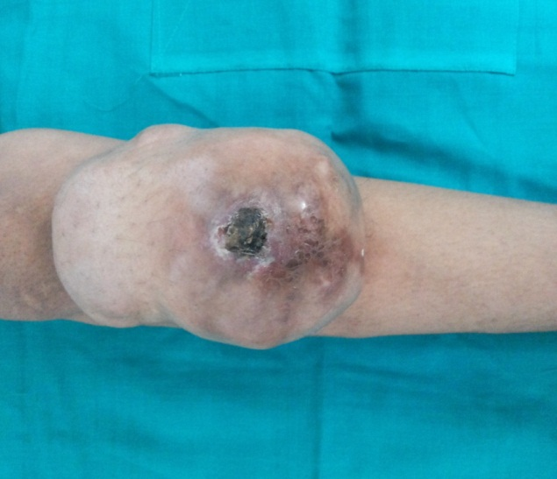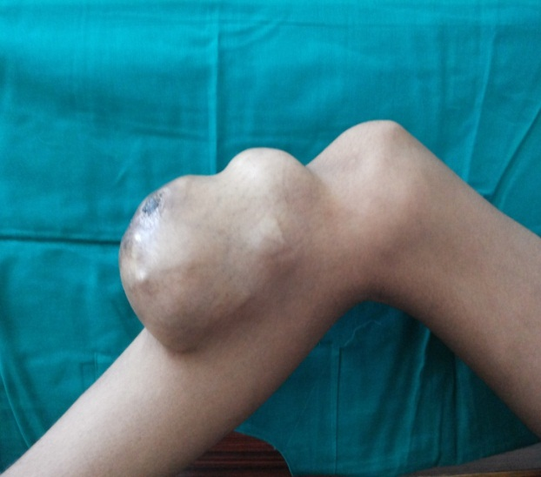
Figure 1 Pre-operative clinical photographs.

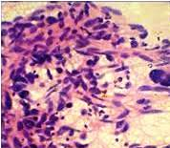
Figure 2 Fine Needle Aspiration Cytology Showingloosely scattered malignant spindle cells.

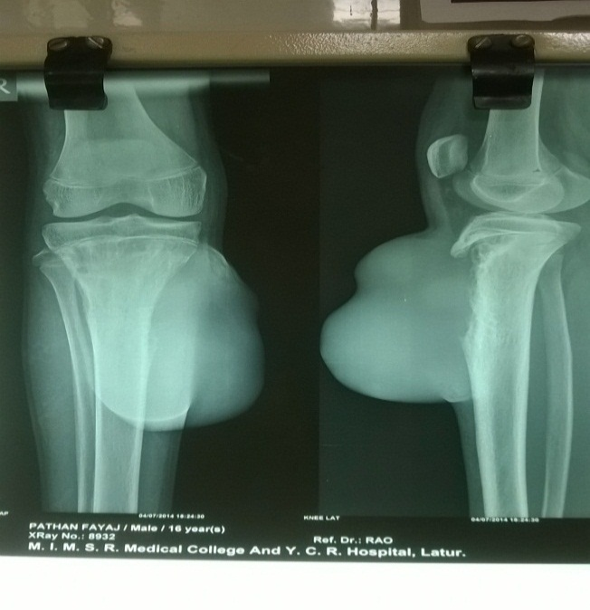
Figure 3 Pre-operative X-ray.

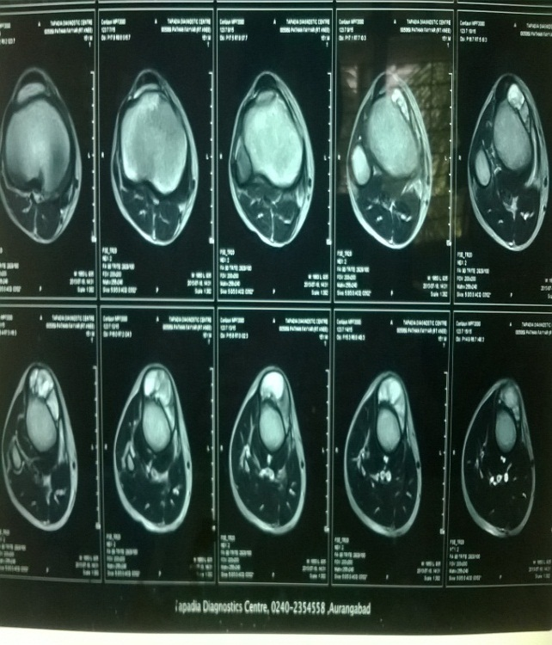
Figure 4 MRI transverse section.

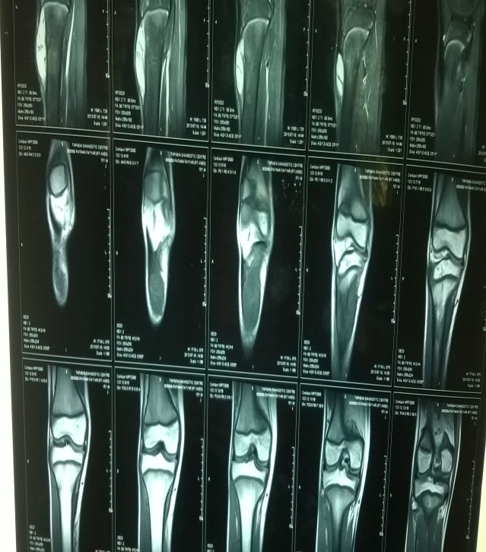
Figure 5 MRI coronal section

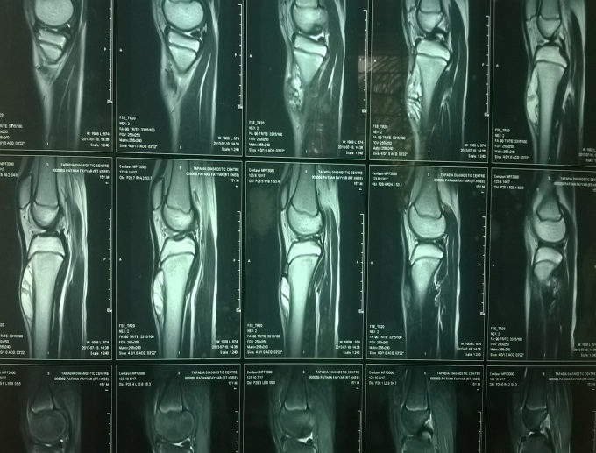
Figure 6 MRI saggital section.
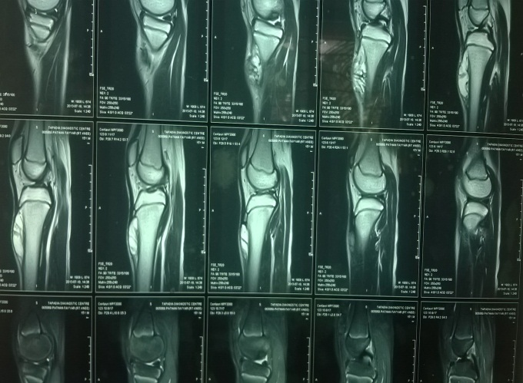
Figure 7 MRI saggital section.

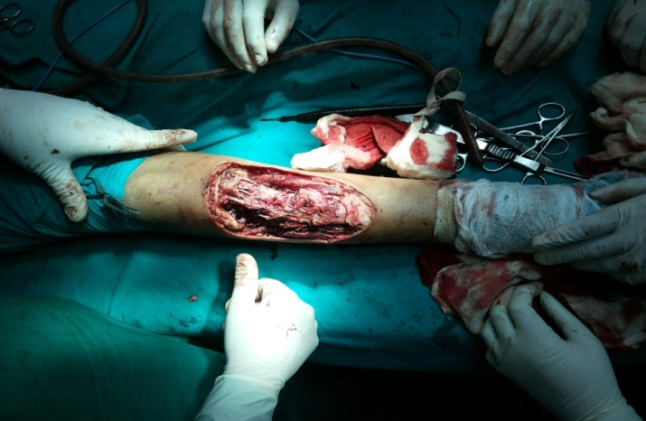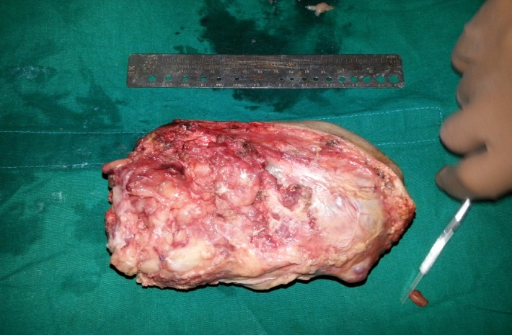
Figure 8 Intra operative photograph showing excised mass (Measuring 15 cm × 8 cm × 4 cm).

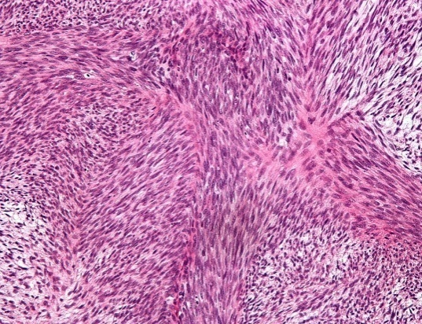
Figure 9 Showing MPNST on Microscopy (LP 10 ×).
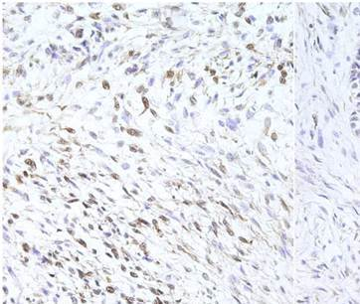
Figure 10 Showing S-100 immunopositive tumor cells.

