Name of Journal: World Journal of Gastroenterology
Manuscript NO: 60393
Manuscript Type: MINIREVIEWS

Clinical characteristics and outcomes of patients with hepatic angiomyolipoma: A literature review

Calame P et al. Hepatic angiomyolipoma

Paul Calame, Gaëlle Tyrode, Delphine Weil Verhoeven, Sophie Félix, Anne Julia Klompenhouwer, Vincent Di Martino, Eric Delabrousse, Thierry Thévenot

Paul Calame, Eric Delabrousse, Department of Radiology, Jean Minjoz University Hospital, Besançon 25030, France

Gaëlle Tyrode, Delphine Weil Verhoeven, Vincent Di Martino, Thierry Thévenot, Department of Hepatology, Jean Minjoz University Hospital, Besançon 25030, France

Sophie Félix, Department of Pathology, Jean Minjoz University Hospital, Besançon 25000, France

Anne Julia Klompenhouwer, Department of Surgery, Erasmus University Medical Center, Rotterdam PO Box 2040, The Netherlands

Author contributions: Thévenot T designed the research; Thévenot T, Calame P, and Félix S analyzed the data; Thévenot T, Calame P and Tyrode G wrote the paper; Thévenot T and Calame P made critical revisions related to important content of the revised manuscript; Weil Verhoeven D, Klompenhouwer AJ, Di Martino V, Delabrousse E and Thévenot T provided the final approval of the version to be published.

Corresponding author: Thierry Thévenot, PhD, Professor, Department of Hepatology, Jean Minjoz University Hospital, 3 Boulevard A. Fleming, Besançon 25030, France. tthevenot@chu-besancon.fr

Received: October 27, 2020
Revised: December 31, 2020
Accepted: March 18, 2021
Published online: May 21, 2021

Abstract
First reported in 1976, hepatic angiomyolipoma (HAML) is a rare mesenchymal liver tumor occurring mostly in middle-aged women. Diagnosis of the liver mass is often incidental on abdominal imaging due to the frequent absence of specific symptoms. Nearly 10% of HAMLs are associated with tuberous sclerosis complex. HAML contains variable proportions of blood vessels, smooth muscle cells and adipose tissue, which renders radiological diagnosis hazardous. Cells express positivity for HMB-45 and actin, thus these tumors are integrated into the group of perivascular epithelioid cell tumors. Typically, a HAML appears on magnetic resonance imaging (or computed tomography scan) as a hypervascular solid tumor with fatty areas and with washout, and can easily be misdiagnosed as other liver tumors, particularly hepatocellular carcinoma. The therapeutic strategy is not clearly defined, but surgical resection is indicated for symptomatic patients, for tumors showing an aggressive pattern (i.e., changes in size on imaging or high proliferation activity and atypical epithelioid pattern on liver biopsy), for large (> 5 cm) biopsy-proven HAML, and if doubts remain on imaging or histology. Conservative management may be justified in other conditions, since most cases follow a benign clinical course. In summary, the correct diagnosis of HAML is challenging on imaging and relies mainly on pathological findings.

Key Words: Angiomyolipoma; Liver; Tuberous sclerosis complex; Imaging; Pathology; Potentially malignant

©The Author(s) 2021. Published by Baishideng Publishing Group Inc. All rights reserved.

Citation: Calame P, Tyrode G, Weil Verhoeven D, Félix S, Klompenhouwer AJ, Di Martino V, Delabrousse E, Thévenot T. Clinical characteristics and outcomes of patients with hepatic angiomyolipoma: A literature review. World J Gastroenterol 2021; 27(19): 2299-2311
URL: https://www.wjgnet.com/1007-9327/full/v27/i19/2299.htm
DOI: https://dx.doi.org/10.3748/wjg.v27.i19.2299

Core Tip: Hepatic angiomyolipoma (HAML) is a rare, but not exceptional, mesenchymal liver tumor. HAML contains variable proportions of blood vessels, smooth muscle cells and adipose tissue, which renders its radiological diagnosis challenging. In most cases, this tumor follows a benign clinical course but more aggressive behavior may complicate management, which remains poorly codified. This review presents the main demographic and histological characteristics of HAML, summarizes reported cases of HAML with spontaneous rupture and aggressive behavior, and finally proposes a pragmatic algorithm for the management of HAML based on the most recent knowledge.
INTRODUCTION
Angiomyolipoma (AML) is a solid mesenchymal tumor, mainly described in the kidney, and belongs to the group of perivascular epithelioid cell tumors (PEComas)^{[1]}. Hepatic localization of AML, described for the first time in 1976^{[2]}, is rare, since only around 600 cases were reported after an exhaustive search of the literature up to the year 2017^{[3]}. Hepatic AML (HAML) poses a veritable diagnostic challenge in radiological terms, especially when fat content is low, because this type of tumor may appear as a hypervascular tumor associated with a washout phase that mimics other, more common hypervascular hepatic tumors, such as hepatocellular carcinoma^{[4-7]}. The natural course of HAML is mostly benign, although several cases have been reported to exhibit aggressive behavior with metastasis or recurrence after surgery^{[8-24]}, or spontaneous rupture^{[8,25-33]}. These rare but dramatic observations unavoidably compound the complexity of managing patients with HAML. Due to its difficult radiological diagnosis, its potentially aggressive behavior, and its poorly codified management, we aimed to analyze the recent literature regarding this rare, but not exceptional liver tumor, and to provide a pragmatic algorithm for its management according to the most recent knowledge.

Patient characteristics
HAML is a tumor usually occurring in a non-cirrhotic liver, and mainly affects middle-aged women. A retrospective analysis of the literature carried out up to 2016 identified 292 patients with one or more HAML, and most of them (nearly 74%) were women, with a median age ranging between 24 years and 53 years across studies^{[3]}. HAML mainly locates in the right liver (60% of cases^{[7]}), is unique in 84% of cases, and median size ranges from 2 cm to 12.7 cm^{[3,34]}. This type of tumor is often detected incidentally during medical check-ups (42% to 72% of cases) since most subjects are asymptomatic^{[3,34,35]}. Symptoms revealing HAML may include abdominal pain or discomfort, bloating, weight loss or, more rarely, discovery of an abdominal mass on palpation^{[35]}. A few cases of spontaneous rupture of HAML have been reported (Table 1)^{[8,25-33]}. Tumor size (≥ 4 cm) and pregnancy are two recognized conditions favoring rupture of renal AML^{[36,37]}, but the small number of reported cases of HAML rupture precludes identification of predictors of rupture in the liver. In the ten cases reported in Table 1, tumor size was usually large, between 5 cm and 12 cm (except for one case due to an inflammatory variant of HAML with a subcapsular location^{[32]}), and there was no age preference (mean age: 48 years; range: 22 years to 77 years). All patients underwent emergent or delayed resection of the tumor, sometimes preceded by preoperative embolization. Routine laboratory tests (including liver tests) are usually normal, as are serum tumor markers (alpha-fetoprotein, carcinoembryonic antigen and carbohydrate antigen 19-9^{[38]}.
The association between tuberous sclerosis complex (TSC) and renal AML, first described in 1911^{[39]}, is observed in 50% of cases, while the association between TSC and HAML is only observed in 5% to 15% of cases^{[3,40]}. TSC is an autosomal dominant genetic disorder with a birth incidence of 1:6000^{[41]}, although sporadic cases due to de novo mutation are the most frequent presentation in the absence of a family history. TSC results from a mutation of TSC1 or TSC2, which code for hamartin and tuberin, respectively^{[42]}. These proteins are critical regulators of cell growth and proliferation, potentially through their upstream modulator, mammalian target of rapamycin (mTOR). Loss of function or dysfunction of either protein results in the development of hamartomas in numerous organ systems, including the brain, kidneys, heart and liver^{[43]}. In patients with TSC, HAML is frequently associated with renal AML. A recent retrospective study showed that among 25 patients with HAML, 88% also had renal AML, and TSC2 patients had a higher frequency of HAML compared to TSC1 patients (18% vs 5%; P = 0.037)^{[42]}. In contrast to previous reports, the predominance of female gender observed in patients with HAML but no TSC was not observed in patients with the TSC-HAML association^{[42,44]}.

Immunohistological characteristics of HAML
Histological examination is the gold standard for HAML diagnosis, since diagnosis by imaging is difficult. Of note, even histological analysis of liver biopsy was shown to misdiagnose HAML in about 15% of cases in a recent multicenter study^{[34]}. The World Health Organization defines PEComas as “mesenchymal tumors containing distinctive perivascular epithelioid cells”. AML, which belongs to the PEComa group, is composed of adipose tissue, smooth muscle and vessels with dystrophic walls (Figure 1). The histological and immunohistochemical characteristics class HAML in the group of PEComas, an entity that brings together tumors of different histology, but with a common immunohistochemical signature, namely co-expression of melanocytic and muscle markers (see below)^{[1,40,45]}. The PEComa family includes AML, clear cell “sugar” tumor of the lung, lymphangioleiomyomatosis (LAM), and a variety of unusual visceral, intra-abdominal, and soft tissue/bone tumors, described under the term “clear cell myomelanocytic tumor of the falciform ligament/Ligamentum teres”^{[46]}. There is a strong association between AML and TSC, and between LAM and TSC^{[47]}, although the link is less marked for other members of the PEComa family^{[46]}.
Perivascular epithelioid cells are characterized by their perivascular location, often with a radial arrangement of cells around vessels. Typically, these cells are mostly epithelioid when they are just around the vessels, whereas spindle cells resembling smooth muscle are seen further away from the vessels. In the liver, the aspect is most often only epithelioid without spindle cells. Adipose cells are usually found distant from the blood vessels. Wide variation is seen in the relative proportion of epithelioid, spindle, and lipid-distended cells. Depending on the relative proportion of these different tissues, there are, on the one hand, conventional AMLs with a predominance of lipomatous or myomatous cells or vessels, and, on the other hand, epithelioid AMLs containing at least 10% epithelioid cells^{[48]}. Mixed and myomatous AMLs are the most frequent (respectively 36% and 42% of the 151 HAML cases with informative data)^{[3]}. Another subtype of HAML, namely inflammatory HAML, has also been recognized, although only 14 cases have been reported in the English-language literature^{[49]}. Overall, this tumor is characterized by inflammatory infiltration exceeding 50% of tumor area, and the main types of inflammatory cells are lymphocytes (100%), plasma cells (93%) and histiocytes (71%)^{[49]}.
Macroscopically, HAML is well circumscribed, unencapsulated, smooth and brownish in color; however, the existence of hemorrhage or intra-tumor necrosis can change its appearance. On microscopic examination, cells typically have clear or slightly eosinophilic cytoplasms, small, central, round or oval nuclei, with a small nucleolus. "Atypical" AML presents cytological atypia, a multinucleated nucleus, focal necrosis and an increase in the number of mitoses^{[48]}.
By immunohistochemistry, these tumors are positive for both melanocytic markers (HBM-45 and melan-A are the more sensitive markers) and smooth muscle markers (actin and/or desmin) with variable extent of staining^{[46,50]}. HBM-45 is the most specific marker of AML^{[38]}. Actin non-immunoreactivity does not exclude a tumor from the PEComa group^{[51]}. Classically, AML does not express epithelial markers (like cytokeratin), S100 protein or alpha-fetoprotein^{[52]}. Estrogen and progesterone receptors are frequently positive in classic renal AML but are only rarely positive in extrarenal PEComas, including HAML, suggesting the absence of the role of sex hormones in the pathogenesis and growth of HAML, despite a clear predominance in women^{[45,53]}.
There are numerous possible differential diagnoses of PEComas depending on the location and the predominant tissue composing the tumor. Given their uniform expression of melanocytic markers, PEComas may be confused with both conventional melanoma and clear cell sarcoma, but these latter typically have strong expression of S100 protein, and do not stain with smooth muscle actin. Due to its preferential abdominal location, the presence of epithelioid and spindle cells, and the occasional positive KIT (CD117) staining in HAML, the diagnosis of gastrointestinal stromal tumor is sometimes discussed. Depending on the size of the contingent of epithelioid cells, spindle-shaped cells or adipocytes, AML can also be confused with carcinoma, smooth muscle neoplasm or adipocytic tumor^{[45,54]}.

Prognosis
The scarcity of PEComas precludes the identification of robust criteria to discriminate benign AML from other tumors with more aggressive behavior. The first description of a likely “malignant” HAML is recent^{[55]}, and although the authors do not clearly indicate the malignant nature of this tumor, the reported characteristics (i.e., large size, cytological atypia and presence of necrosis) and the tumor-related death of the patient are robust arguments in favor of a “malignant” case. From a series of 24 PEComas of the soft tissue and gynecologic tract (not including AML) with a median follow-up of 30 mo (range: 10-84), Folpe et al observed 3 local recurrences and 5 distant metastases (8/24, 33% of cases), 2 deaths (8%), 4 patients (17%) alive with metastatic or unresectable local disease, and 18 patients (75%) alive with no evidence of disease^{[46]}. A combined analysis of these 24 cases plus 45 other reported cases in the literature with sufficient available follow-up information identified the following variables associated with an increased risk of recurrence or metastasis: tumor size greater than 5 cm, infiltrative growth pattern, high nuclear grade, necrosis, and mitotic activity > 1/50 high power field. Consequently, these authors developed a provisional classification of PEComas with increasing aggressive potential (Table 2). Cases of HAML with aggressive behavior are reported in Table 3^{[8-24]}. Regarding HAML, it is mainly the epithelioid type that confers a risk of aggressive behavior^{[34]}. In the review published in 2017, the mortality rate associated with HAML was 0.8%^{[3]}.

Imaging findings
The imaging features of HAML vary greatly depending on the highly variable proportion of fat, smooth muscle and vascular elements. Diagnosis can be challenging, and depends mainly on the amount of fat present, which is the key to HAML diagnosis. On ultrasound, the lesion is usually well circumscribed, hyperechoic or mixed echoic and after injection of ultrasound contrast, presents rapid enhancement in the arterial phase compared to the adjacent liver. In the portal and delayed phase, HAML can display either hypo, iso or hyperenhancement^{[4]}. Computed tomography (CT) shows a hypodense tumor with fatty areas within the lesion (density around -50 HU). Classically, this solid tumor is hypervascular (Figure 2) with wash-out in the portal and late portal phase [CT or magnetic resonance imaging (MRI)]. HAML with few or no vessels on histologic examination show persistent portal and late-phase enhancement, whereas HAML with richly vascularized tissue is more likely to show wash-out^{[5]}. The tumor signal on MRI is hyperintense in T2 weighted sequences and variable in T1 weighted sequences. MRI is the most sensitive imaging technique to detect liver fat using in-phase and opposed-phase T1 gradient echo sequences. The drop-out signal within a liver lesion on the opposed-phase sequences indicates the presence of fat within the lesion (Figure 3A and B). The imaging features on MRI after injection of contrast medium are similar to those observed on CT scan. When using a hepatocyte specific agent (gadoxetic acid or gadobenate dimeglumine), the lesion shows a hyposignal in the hepatobiliary phase (Figure 4).
Data regarding HAML evaluation using fluorine-18-fluorodeoxyglucose positron emission tomography (¹⁸F-FDG-PET) are limited. FDG uptake in HAML is variable and the value of ¹⁸F-FDG-PET for diagnosing or managing this type of tumor is unclear^{[56]}.
Given the imaging characteristics of HAML (hypervascular lesion with a fat component in a healthy liver and with frequent wash-out), differential diagnoses are benign hepatocytic tumors (steatotic or telangiectasia adenoma, fat focal nodular hyperplasia) and malignant hepatocytic tumors (mainly hepatocellular carcinoma). When the diagnosis is challenging, especially with hepatocellular carcinoma, the absence of a capsule and the visualization of a drainage vein are two useful radiological features that can be helpful for HAML diagnosis when they are present^{[6]}.

Management of HAML
Due to its rarity, the diagnosis of HAML on imaging (and even histological examination^{[34]}) is difficult. Consequently, the clinical management of HAML patients should take place in expert centers for a multidisciplinary work-up involving radiologists, pathologists and hepatologists. Obtaining a liver biopsy is strongly advised to better balance the risk of surgery (resection of centrohepatic tumor will be at higher risk, for instance) against the risk of tumor-related complications. Thus, in the presence of asymptomatic HAML, without cytological atypia on biopsy, but at high risk of complicated resection, regular radiological monitoring will be preferred^{[34]}.
Analysis of the literature shows that the majority of patients are treated with surgical resection (84% and 76% of patients in two large case series^{[3,34]}). For other patients, regular radiological monitoring is justified by the uncertainty surrounding the risk of HAML progression. Although the risk of tumor recurrence after resection or metastases has rarely been described, the identification of radiological and especially histological factors predicting an unfavorable course (Table 1) is essential for a collegial therapeutic decision. Furthermore, patient compliance with regular radiological monitoring will also be an important argument in decision-making^{[3,35]}.
The optimal radiological follow-up is not well defined, but the first radiological evaluation may take place at one year, since HAMLs were described to increase by only 0.77 cm per year in a series of 29 patients followed radiologically^{[3]}, and radiological progression affected only 6 of the 29 patients (20%). Later, radiological monitoring could be performed twice a year^{[3]}, but the frequency will depend on the magnitude of tumor progression during the first years of monitoring. Evidently, persistent tumor progression on successive imaging will require a surgical approach. Surgical resection is therefore recommended when there is uncertainty regarding the histological nature of the lesion after liver biopsy, tumor progression on imaging, tumor-related symptoms, and when the tumor exceeds 5 cm^{[34,38]}. The recurrence rate after surgical resection was 2.4% (6 of 246 patients in the series reported by Klompenhouwer et al^{[3]}). The local or distant post-resection recurrence rate is 10% in the case of epithelioid-type HAML^{[52]}.
Liver transplantation (LT) has sometimes been erroneously performed for a suspected diagnosis of cholangiocarcinoma or hemangiosarcoma mimicking a hepatocellular carcinoma^{[3,34]}. These flawed diagnoses further underline the interest of systematic liver biopsy as well as radiological and anatomopathological expertise. Since the first reported case of LT for HAML in 2010^{[57]}, other exceptional cases have been added^{[21,58]}. LT was performed as a last resort treatment for unresectable HAML due to excessive size or a significant number of hepatic tumors.
Other therapeutic alternatives have been reported, such as radiofrequency ablation, arterial embolization or the use of sirolimus^{[35,42]}. mTOR inhibitors, which include sirolimus and everolimus, are immunosuppressive molecules used in transplantation, and which also have antiproliferative properties. In a multicenter, double-blind, placebo-controlled, phase 3 trial (EXIST-2), 118 patients with at least one renal AML larger than 3 cm associated with a definite TSC diagnosis or sporadic LAM were randomized to receive oral everolimus 10 mg/d (n = 79, mean dosage: 8.6 mg/d, median duration: 38 wk) or placebo (n = 39). The trial showed a beneficial effect of everolimus in reducing the size of AML (response rate: 42% vs 0% in the placebo group; P < 0.0001). Response was evaluated as a composite endpoint including a reduction ≥ 50% of the AML volume^{[59]}.
The favorable outcomes reported in the EXIST-2 trial led to an open label extension undertaken by the same authors. This study demonstrated a pronounced benefit of everolimus for the patients who continued on this drug. The response rate improved from 42% in the primary analysis (median exposure 8.7 mo)^{[59]} to 54% (median exposure 28.9 mo), and the long-term use of everolimus appeared safe^{[60]}.
The pooled analysis of two randomized trials^{[59,61]} comparing 109 and 53 patients with renal AML treated respectively with everolimus and placebo for 6 mo confirmed the efficacy of everolimus in reducing tumor volume by 50% or more (risk ratio = 24.69; P = 0.001)^{[62]}. Everolimus is currently indicated for the treatment of adult patients with renal AML and TSC not requiring immediate surgery. Some patients with HAML associated with TSC have been treated with sirolimus, which also proved efficacious in reducing tumor volume^{[54]}. The role of mTOR inhibitors for patients with HAML remains undefined, but these molecules could be used, as for the kidney, in a palliative context. The long-term safety profile is consistent with that previously reported and no new safety issues have raised concern^{[60]}.
In a retrospective Chinese series (2009-2016) of 92 patients diagnosed with histologically proven HAML measuring between 2 cm and 5 cm, ultrasonography-guided radiofrequency ablation after liver biopsy was used in 22/92 patients. No tumor recurrence was reported, but the duration of follow-up was not indicated^{[35]}. Radiofrequency ablation can therefore advantageously compete with surgery when HAML is relatively small (< 5 cm), and when the location in the liver or the patient’s comorbidities are not amenable to safe hepatic surgery.
Arterial embolization^{[33]} is sometimes necessary in the presence of hemorrhagic HAML. There are only eight reported cases of HAML presenting as spontaneous rupture and hemorrhage; the median size of these tumors was 8.5 cm (range: 2.5 cm to 12.5 cm) and three of them were treated with arterial embolization followed by liver resection enabling formal diagnosis of HAML. The main differential diagnosis of hemorrhagic liver tumor in a non-cirrhotic liver is adenoma, which is outside the scope of this review. Therapeutic arterial embolization was used in three other patients with histologically proven HAML (size: 11, 12 and 17 cm) in a retrospective American series^{[19]}, and no progression was observed after an average follow-up of 12.7 mo (range, 1-36 mo). The risk of spontaneous hemorrhage seems to be lower for HAML than for kidney AML, which are usually supplied by a single vessel and associated with aneurysms^{[19]}. We propose a decisional algorithm for the management of HAML (Figure 5).

CONCLUSION
HAML is a rare but not exceptional tumor, and usually has a benign course. However, this tumor may display more aggressive behavior with recurrence or metastasis, although there are no robust histological or radiological characteristics to predict the natural course of this type of tumor. Radiological diagnosis is often hazardous due to the variable proportions of the tissues that comprise HAML. Therefore, histological analysis of the tumor and multidisciplinary consultation, whenever possible in an expert center, are essential for optimal care of these patients.

REFERENCES
1 World Health Organization Classification of Tumours Editorial Board. Digestive System Tumours. 5th ed. World Health Organization: International Agency for Research on Cancer Publications, 2019
2 Ishak K. Mesenchymal tumors of the liver. In: Okuda K, Peter R. Hepatocellular carcinoma. New York: John Wiley & Sons, 1976: 247-275
3 Klompenhouwer AJ, Verver D, Janki S, Bramer WM, Doukas M, Dwarkasing RS, de Man RA, IJzermans JNM. Management of hepatic angiomyolipoma: A systematic review. Liver Int 2017; 37: 1272-1280 [PMID: 28177188 DOI: 10.1111/liv.13381]
4 Huang Z, Zhou P, Li S, Li K. Hepatic Angiomyolipoma: Clinical Features and Imaging Findings of Quantitative Contrast-Enhanced Ultrasound Perfusion Analysis and Magnetic Resonance Imaging. J Ultrasound Med 2020; 39: 2111-2122 [PMID: 32383807 DOI: 10.1002/jum.15316]
5 Jung DH, Hwang S, Hong SM, Kim KH, Ahn CS, Moon DB, Alshahrani AA, Lee SG. Clinico-pathological correlation of hepatic angiomyolipoma: a series of 23 resection cases. ANZ J Surg 2018; 88: E60-E65 [PMID: 28122404 DOI: 10.1111/ans.13880]
6 Seow J, McGill M, Wang W, Smith P, Goodwin M. Imaging hepatic angiomyolipomas: key features and avoiding errors. Clin Radiol 2020; 75: 88-99 [PMID: 31677881 DOI: 10.1016/j.crad.2019.09.135]
7 Liu W, Wang J, Huang Q, Lu Q, Liang W. Comparison of MRI Features of Epithelioid Hepatic Angiomyolipoma and Hepatocellular Carcinoma: Imaging Data From Two Centers. Front Oncol 2018; 8: 600 [PMID: 30619742 DOI: 10.3389/fonc.2018.00600]
8 Ding GH, Liu Y, Wu MC, Yang GS, Yang JM, Cong WM. Diagnosis and treatment of hepatic angiomyolipoma. J Surg Oncol 2011; 103: 807-812 [PMID: 21283992 DOI: 10.1002/jso.21814]
9 Croquet V, Pilette C, Aubé C, Bouju B, Oberti F, Cervi C, Arnaud JP, Rousselet MC, Boyer J, Calès P. Late recurrence of a hepatic angiomyolipoma. Eur J Gastroenterol Hepatol 2000; 12: 579-582 [PMID: 10833105 DOI: 10.1097/00042737-200012050-00018]
10 Dalle I, Sciot R, de Vos R, Aerts R, van Damme B, Desmet V, Roskams T. Malignant angiomyolipoma of the liver: a hitherto unreported variant. Histopathology 2000; 36: 443-450 [PMID: 10792486 DOI: 10.1046/j.1365-2559.2000.00891.x]
11 Flemming P, Lehmann U, Becker T, Klempnauer J, Kreipe H. Common and epithelioid variants of hepatic angiomyolipoma exhibit clonal growth and share a distinctive immunophenotype. Hepatology 2000; 32: 213-217 [PMID: 10915726 DOI: 10.1053/jhep.2000.9142]
12 McKinney CA, Geiger JD, Castle VP, Ruiz RE, Strouse PJ. Aggressive hepatic angiomyolipoma in a child. Pediatr Hematol Oncol 2005; 22: 17-24 [PMID: 15770828 DOI: 10.1080/08880010590896206]
13 Parfitt JR, Bella AJ, Izawa JI, Wehrli BM. Malignant neoplasm of perivascular epithelioid cells of the liver. Arch Pathol Lab Med 2006; 130: 1219-1222 [PMID: 16879028]
14 Yang CY, Ho MC, Jeng YM, Hu RH, Wu YM, Lee PH. Management of hepatic angiomyolipoma. J Gastrointest Surg 2007; 11: 452-457 [PMID: 17436129 DOI: 10.1007/s11605-006-0037-3]
15 Deng YF, Lin Q, Zhang SH, Ling YM, He JK, Chen XF. Malignant angiomyolipoma in the liver: a case report with pathological and molecular analysis. Pathol Res Pract 2008; 204: 911-918 [PMID: 18723294 DOI: 10.1016/j.prp.2008.06.007]
16 Nguyen TT, Gorman B, Shields D, Goodman Z. Malignant hepatic angiomyolipoma: report of a case and review of literature. Am J Surg Pathol 2008; 32: 793-798 [PMID: 18391749 DOI: 10.1097/PAS.0b013e3181607349]
17 Xu PJ, Shan Y, Yan FH, Ji Y, Ding Y, Zhou ML. Epithelioid angiomyolipoma of the liver: cross-sectional imaging findings of 10 immunohistochemically-verified cases. World J Gastroenterol 2009; 15: 4576-4581 [PMID: 19777618 DOI: 10.3748/wjg.15.4576]
18 Zeng JP, Dong JH, Zhang WZ, Wang J, Pang XP. Hepatic angiomyolipoma: a clinical experience in diagnosis and treatment. Dig Dis Sci 2010; 55: 3235-3240 [PMID: 20165978 DOI: 10.1007/s10620-010-1144-2]
19 Butte JM, Do RK, Shia J, Gönen M, D'Angelica MI, Getrajdman GI, Allen PJ, Fong Y, Dematteo RP, Klimstra DS, Jarnagin WR. Liver angiomyolipomas: a clinical, radiologic, and pathologic analysis of 22 patients from a single center. Surgery 2011; 150: 557-567 [PMID: 21621235 DOI: 10.1016/j.surg.2011.03.006]
20 Hu WG, Lai EC, Liu H, Li AJ, Zhou WP, Fu SY, Pan ZY, Huang G, Lei Y, Lau WY, Wu MC. Diagnostic difficulties and treatment strategy of hepatic angiomyolipoma. Asian J Surg 2011; 34: 158-162 [PMID: 22464831 DOI: 10.1016/j.asjsur.2011.11.005]
21 Wang WT, Li ZQ, Zhang GH, Guo Y, Teng MJ. Liver transplantation for recurrent posthepatectomy malignant hepatic angiomyolipoma: a case report. World J Gastroenterol 2015; 21: 3755-3758 [PMID: 25834347 DOI: 10.3748/wjg.v21.i12.3755]
22 Fukuda Y, Omiya H, Takami K, Mori K, Kodama Y, Mano M, Nomura Y, Akiba J, Yano H, Nakashima O, Ogawara M, Mita E, Nakamori S, Sekimoto M. Malignant hepatic epithelioid angiomyolipoma with recurrence in the lung 7 years after hepatectomy: a case report and literature review. Surg Case Rep 2016; 2: 31 [PMID: 27037804 DOI: 10.1186/s40792-016-0158-1]
23 Marcuzzi A, Haider EA, Salmi ISA. Hepatic epithelioid angiomyolipoma with renal metastasis: radiologic-pathologic correlation. Radiol Case Rep 2018; 13: 829-833 [PMID: 29955240 DOI: 10.1016/j.radcr.2018.05.007]
24 Yan Z, Grenert JP, Joseph NM, Ren C, Chen X, Shafizadeh N, Kakar S. Hepatic angiomyolipoma: mutation analysis and immunohistochemical pitfalls in diagnosis. Histopathology 2018; 73: 101-108 [PMID: 29512829 DOI: 10.1111/his.13509]
25 Huber C, Treutner KH, Steinau G, Schumpelick V. Ruptured hepatic angiolipoma in tuberous sclerosis complex. Langenbecks Arch Chir 1996; 381: 7-9 [PMID: 8717168 DOI: 10.1007/BF00184248]
26 Guidi G, Catalano O, Rotondo A. Spontaneous rupture of a hepatic angiomyolipoma: CT findings and literature review. Eur Radiol 1997; 7: 335-337 [PMID: 9087353 DOI: 10.1007/s003300050162]
27 Tsui WM, Colombari R, Portmann BC, Bonetti F, Thung SN, Ferrell LD, Nakanuma Y, Snover DC, Bioulac-Sage P, Dhillon AP. Hepatic angiomyolipoma: a clinicopathologic study of 30 cases and delineation of unusual morphologic variants. Am J Surg Pathol 1999; 23: 34-48 [PMID: 9888702 DOI: 10.1097/00000478-199901000-00004]
28 Zhou YM, Li B, Xu F, Wang B, Li DQ, Zhang XF, Liu P, Yang JM. Clinical features of hepatic angiomyolipoma. Hepatobiliary Pancreat Dis Int 2008; 7: 284-287 [PMID: 18522883]
29 Occhionorelli S, Dellachiesa L, Stano R, Cappellari L, Tartarini D, Severi S, Palini GM, Pansini GC, Vasquez G. Spontaneous rupture of a hepatic epithelioid angiomyolipoma: damage control surgery. A case report. G Chir 2013; 34: 320-322 [PMID: 24342160]
30 Aoki H, Arata T, Morihiro T, Kanaya N, Takeda S, Sui K, Shigeyasu K, Katsuda K, Tanakaya K, Takeuchi H. Spontaneous rupture of a hepatic angiomyolipoma: Report of a case. Clin J Gastroenterol 2014; 7: 429-433 [PMID: 26184024 DOI: 10.1007/s12328-014-0517-z]
31 Tajima S, Suzuki A, Suzumura K. Ruptured hepatic epithelioid angiomyolipoma: a case report and literature review. Case Rep Oncol 2014; 7: 369-375 [PMID: 24987358 DOI: 10.1159/000363690]
32 Kai K, Miyosh A, Aishima S, Wakiyama K, Nakashita S, Iwane S, Azama S, Irie H, Noshiro H. Granulomatous reaction in hepatic inflammatory angiomyolipoma after chemoembolization and spontaneous rupture. World J Gastroenterol 2015; 21: 9675-9682 [PMID: 26327777 DOI: 10.3748/wjg.v21.i32.9675]
33 Kim SH, Kang TW, Lim K, Joh HS, Kang J, Sinn DH. A case of ruptured hepatic angiomyolipoma in a young male. Clin Mol Hepatol 2017; 23: 179-183 [PMID: 28449573 DOI: 10.3350/cmh.2016.0027]
34 Klompenhouwer AJ, Dwarkasing RS, Doukas M, Pellegrino S, Vilgrain V, Paradis V, Soubrane O, Beane JD, Geller DA, Nalesnik MA, Tripke V, Lang H, Schmelzle M, Pratschke J, Schöning W, Beal E, Sun S, Pawlik TM, de Man RA, Ijzermans JNM. Hepatic angiomyolipoma: an international multicenter analysis on diagnosis, management and outcome. HPB (Oxford) 2020; 22: 622-629 [PMID: 31619346 DOI: 10.1016/j.hpb.2019.09.004]
35 Yang X, Lei C, Qiu Y, Shen S, Lu C, Yan L, Wang W. Selecting a suitable surgical treatment for hepatic angiomyolipoma: a retrospective analysis of 92 cases. ANZ J Surg 2018; 88: E664-E669 [PMID: 29241297 DOI: 10.1111/ans.14323]
36 Pontis A, Piras B, Meloni A, De Lisa A, Melis GB, Angioni S. Rupture of renal angiomyolipoma in pregnancy. J Obstet Gynaecol 2013; 33: 628-629 [PMID: 23919867 DOI: 10.3109/01443615.2013.810201]
37 Yamakado K, Tanaka N, Nakagawa T, Kobayashi S, Yanagawa M, Takeda K. Renal angiomyolipoma: relationships between tumor size, aneurysm formation, and rupture. Radiology 2002; 225: 78-82 [PMID: 12354988 DOI: 10.1148/radiol.2251011477]
38 Chang Z, Zhang JM, Ying JQ, Ge YP. Characteristics and treatment strategy of hepatic angiomyolipoma: a series of 94 patients collected from four institutions. J Gastrointestin Liver Dis 2011; 20: 65-69 [PMID: 21451800 DOI: 10.1007/s11749-010-0230-2]
39 Eble JN. Angiomyolipoma of kidney. Semin Diagn Pathol 1998; 15: 21-40 [PMID: 9503504]
40 Kamimura K, Nomoto M, Aoyagi Y. Hepatic angiomyolipoma: diagnostic findings and management. Int J Hepatol 2012; 2012: 410781 [PMID: 23320180 DOI: 10.1155/2012/410781]
41 Osborne JP, Fryer A, Webb D. Epidemiology of tuberous sclerosis. Ann N Y Acad Sci 1991; 615: 125-127 [PMID: 2039137 DOI: 10.1111/j.1749-6632.1991.tb37754.x]
42 Black ME, Hedgire SS, Camposano S, Paul E, Harisinghani M, Thiele EA. Hepatic manifestations of tuberous sclerosis complex: a genotypic and phenotypic analysis. Clin Genet 2012; 82: 552-557 [PMID: 22251200 DOI: 10.1111/j.1399-0004.2012.01845.x]
43 Orlova KA, Crino PB. The tuberous sclerosis complex. Ann N Y Acad Sci 2010; 1184: 87-105 [PMID: 20146692 DOI: 10.1111/j.1749-6632.2009.05117.x]
44 Fricke BL, Donnelly LF, Casper KA, Bissler JJ. Frequency and imaging appearance of hepatic angiomyolipomas in pediatric and adult patients with tuberous sclerosis. AJR Am J Roentgenol 2004; 182: 1027-1030 [PMID: 15039181 DOI: 10.2214/ajr.182.4.1821027]
45 Folpe AL, Kwiatkowski DJ. Perivascular epithelioid cell neoplasms: pathology and pathogenesis. Hum Pathol 2010; 41: 1-15 [PMID: 19604538 DOI: 10.1016/j.humpath.2009.05.011]
46 Folpe AL, Mentzel T, Lehr HA, Fisher C, Balzer BL, Weiss SW. Perivascular epithelioid cell neoplasms of soft tissue and gynecologic origin: a clinicopathologic study of 26 cases and review of the literature. Am J Surg Pathol 2005; 29: 1558-1575 [PMID: 16327428 DOI: 10.1097/01.pas.0000173232.22117.37]
47 Roach ES, Gomez MR, Northrup H. Tuberous sclerosis complex consensus conference: revised clinical diagnostic criteria. J Child Neurol 1998; 13: 624-628 [PMID: 9881533 DOI: 10.1177/088307389801301206]
48 Aydin H, Magi-Galluzzi C, Lane BR, Sercia L, Lopez JI, Rini BI, Zhou M. Renal angiomyolipoma: clinicopathologic study of 194 cases with emphasis on the epithelioid histology and tuberous sclerosis association. Am J Surg Pathol 2009; 33: 289-297 [PMID: 18852677 DOI: 10.1097/PAS.0b013e31817ed7a6]
49 Mao JX, Yuan H, Sun KY, Liu C, Fu H, Ding GS, Guo WY, Teng F. Pooled analysis of hepatic inflammatory angiomyolipoma. Clin Res Hepatol Gastroenterol 2020; 44: e145-e151 [PMID: 32482543 DOI: 10.1016/j.clinre.2020.04.005]
50 Bonetti F, Pea M, Martignoni G, Zamboni G. PEC and sugar. Am J Surg Pathol 1992; 16: 307-308 [PMID: 1599021 DOI: 10.1097/00000478-199203000-00013]
51 Hornick JL, Fletcher CD. Sclerosing PEComa: clinicopathologic analysis of a distinctive variant with a predilection for the retroperitoneum. Am J Surg Pathol 2008; 32: 493-501 [PMID: 18223480 DOI: 10.1097/PAS.0b013e318161dc34]
52 Liu J, Zhang CW, Hong DF, Tao R, Chen Y, Shang MJ, Zhang YH. Primary hepatic epithelioid angiomyolipoma: A malignant potential tumor which should be recognized. World J Gastroenterol 2016; 22: 4908-4917 [PMID: 27239117 DOI: 10.3748/wjg.v22.i20.4908]
53 Yeh CN, Lee KF, Chen MF. Immunohistochemical study of hepatic angiomyolipoma. Hepatogastroenterology 2005; 52: 1151-1153 [PMID: 16001650]
54 L'Hostis H, Deminiere C, Ferriere JM, Coindre JM. Renal angiomyolipoma: a clinicopathologic, immunohistochemical, and follow-up study of 46 cases. Am J Surg Pathol 1999; 23: 1011-1020 [PMID: 10478660 DOI: 10.1097/00000478-199909000-00003]
55 Ohmori T, Arita N, Uraga N, Tabei R, Yamamoto M, Kataoka M, Hamamoto K. Giant hepatic angiomyolipoma. Histopathology 1989; 15: 540-543 [PMID: 2599515 DOI: 10.1111/j.1365-2559.1989.tb01615.x]
56 Kumasaka S, Arisaka Y, Tokue A, Higuchi T, Nakajima T, Tsushima Y. A case of multiple hepatic angiomyolipomas with high (18) F-fluorodeoxyglucose uptake. BMC Med Imaging 2014; 14: 17 [PMID: 24885757 DOI: 10.1186/1471-2342-14-17]
57 Dumortier J, Guillaud O, Walter T, Ber CE, Partensky C, Boillot O, Scoazec JY. Liver transplantation for multiple angiomyolipomas complicating tuberous sclerosis complex. Gastroenterol Clin Biol 2010; 34: 494-498 [PMID: 20674202 DOI: 10.1016/j.gcb.2010.06.005]
58 Vagefi PA, Eilers H, Hiniker A, Freise CE. Liver transplantation for giant hepatic angiomyolipoma. Liver Transpl 2011; 17: 985-986 [PMID: 21462294 DOI: 10.1002/lt.22310]
59 Bissler JJ, Kingswood JC, Radzikowska E, Zonnenberg BA, Frost M, Belousova E, Sauter M, Nonomura N, Brakemeier S, de Vries PJ, Whittemore VH, Chen D, Sahmoud T, Shah G, Lincy J, Lebwohl D, Budde K. Everolimus for angiomyolipoma associated with tuberous sclerosis complex or sporadic lymphangioleiomyomatosis (EXIST-2): a multicentre, randomised, double-blind, placebo-controlled trial. Lancet 2013; 381: 817-824 [PMID: 23312829 DOI: 10.1016/S0140-6736(12)61767-X]
60 Bissler JJ, Kingswood JC, Radzikowska E, Zonnenberg BA, Frost M, Belousova E, Sauter M, Nonomura N, Brakemeier S, de Vries PJ, Berkowitz N, Miao S, Segal S, Peyrard S, Budde K. Everolimus for renal angiomyolipoma in patients with tuberous sclerosis complex or sporadic lymphangioleiomyomatosis: extension of a randomized controlled trial. Nephrol Dial Transplant 2016; 31: 111-119 [PMID: 26156073 DOI: 10.1093/ndt/gfv249]
61 Franz DN. Everolimus in the treatment of subependymal giant cell astrocytomas, angiomyolipomas, and pulmonary and skin lesions associated with tuberous sclerosis complex. Biologics 2013; 7: 211-221 [PMID: 24143074 DOI: 10.2147/BTT.S25095]
62 Li M, Zhou Y, Chen C, Yang T, Zhou S, Chen S, Wu Y, Cui Y. Efficacy and safety of mTOR inhibitors (rapamycin and its analogues) for tuberous sclerosis complex: a meta-analysis. Orphanet J Rare Dis 2019; 14: 39 [PMID: 30760308 DOI: 10.1186/s13023-019-1012-x]

Footnotes
Conflict-of-interest statement: No conflicts of interest exist.

Open-Access: This article is an open-access article that was selected by an in-house editor and fully peer-reviewed by external reviewers. It is distributed in accordance with the Creative Commons Attribution NonCommercial (CC BY-NC 4.0) license, which permits others to distribute, remix, adapt, build upon this work non-commercially, and license their derivative works on different terms, provided the original work is properly cited and the use is non-commercial. See: http://creativecommons.org/Licenses/by-nc/4.0/

Manuscript source: Unsolicited manuscript

Peer-review started: October 27, 2020
First decision: December 18, 2020
Article in press: March 18, 2021

Specialty type: Gastroenterology and hepatology
Country/Territory of origin: France
Peer-review report’s scientific quality classification
Grade A (Excellent): 0
Grade B (Very good): B
Grade C (Good): C
Grade D (Fair): 0
Grade E (Poor): 0

P-Reviewer: Alshami A, Lan C S-Editor: Gao CC L-Editor: Webster JR P-Editor: Liu JH

Figure Legends
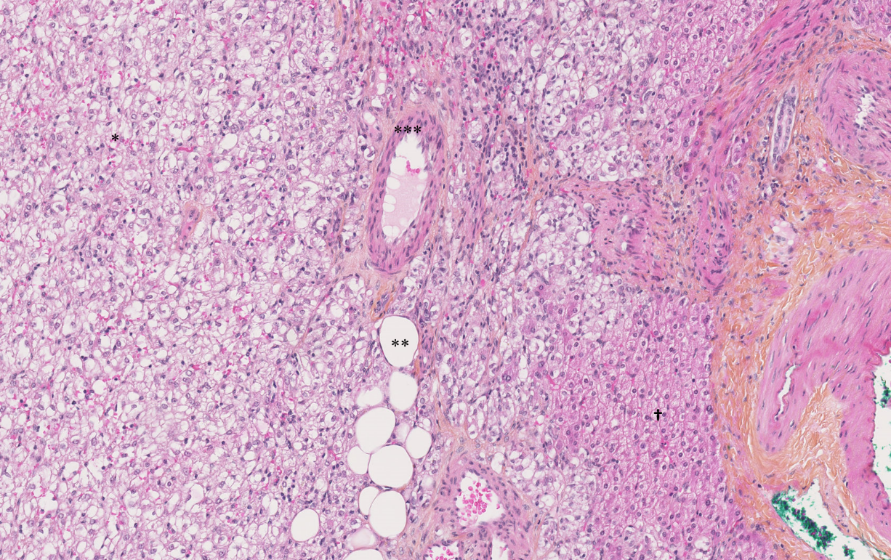
Figure 1 The Hematoxylin-Eosin-Saffron staining image of hepatic angiomyolipoma. There are three components of hepatic angiomyolipoma: vessel (*), adipocytes (**) and numerous epithelioid cells (***). There are fewer hepatocytes (†) (magnification × 10).
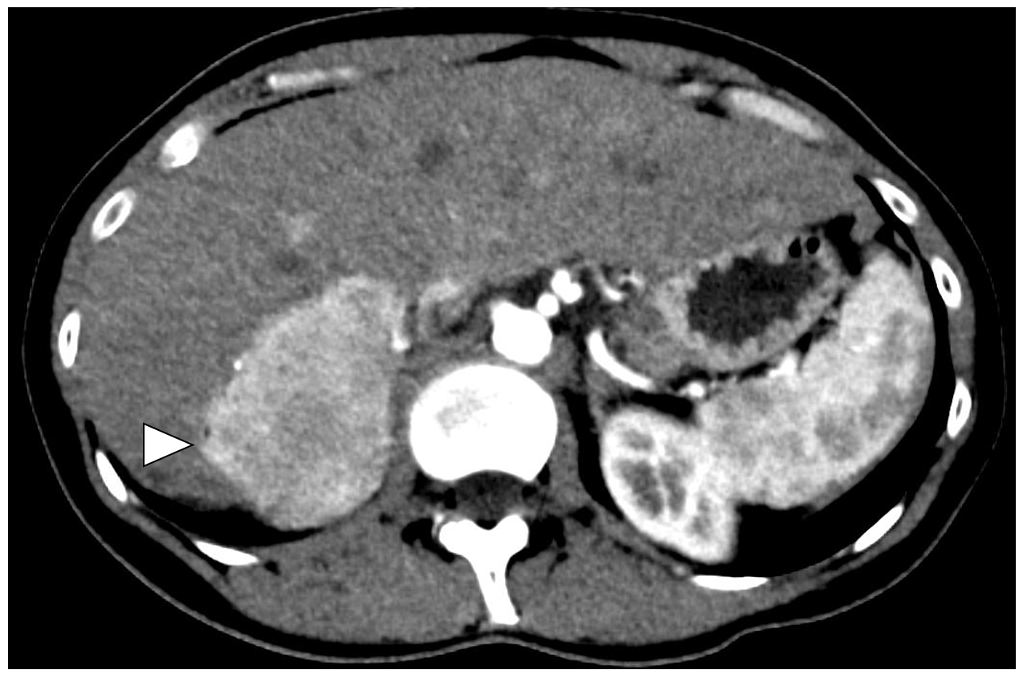
Figure 2 Angiomyolipoma in a healthy 33-year-old woman. Abdominal computed tomography on arterial phase showed a hypervascular solid tumor localized in the right posterior segment (arrowheads).
A
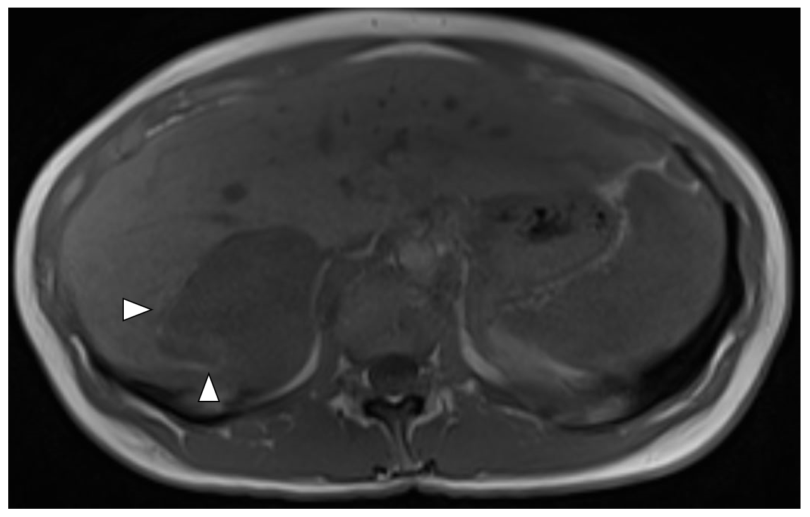
B
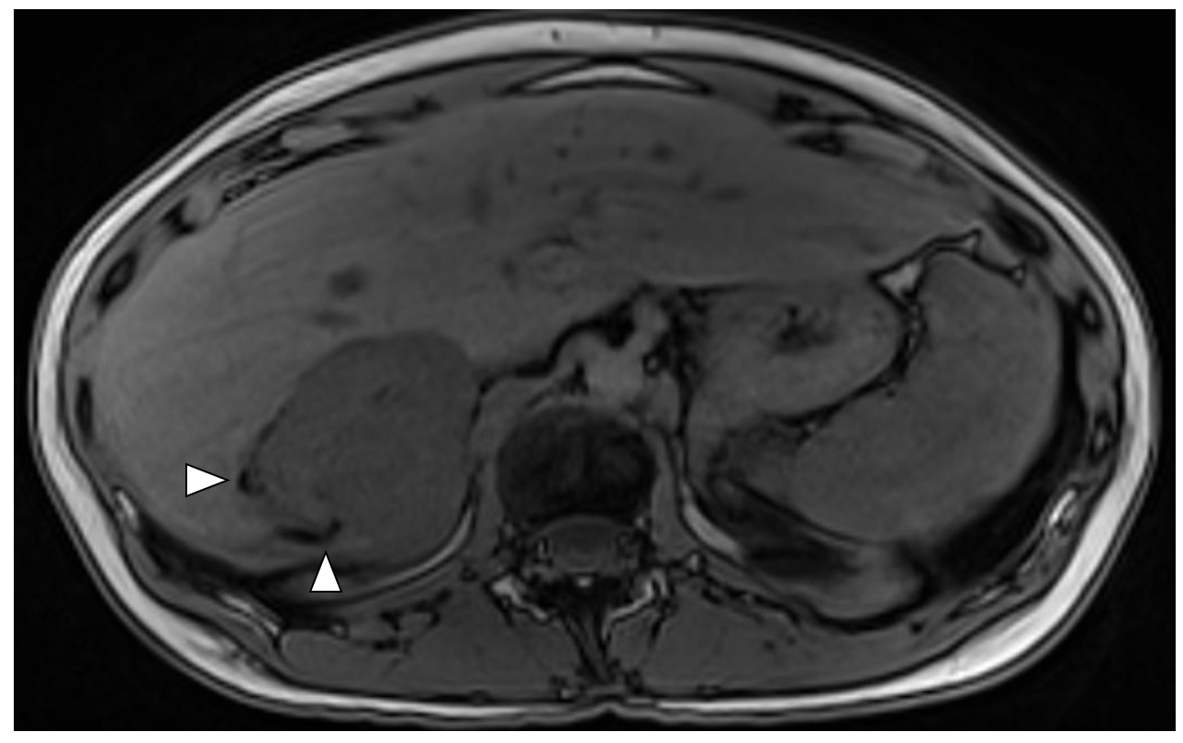
Figure 3 T1 weighted magnetic resonance images. Signal dropout at the periphery of the lesion due to fat contingents (arrowhead). A: In-phase; B: Opposed-phase.
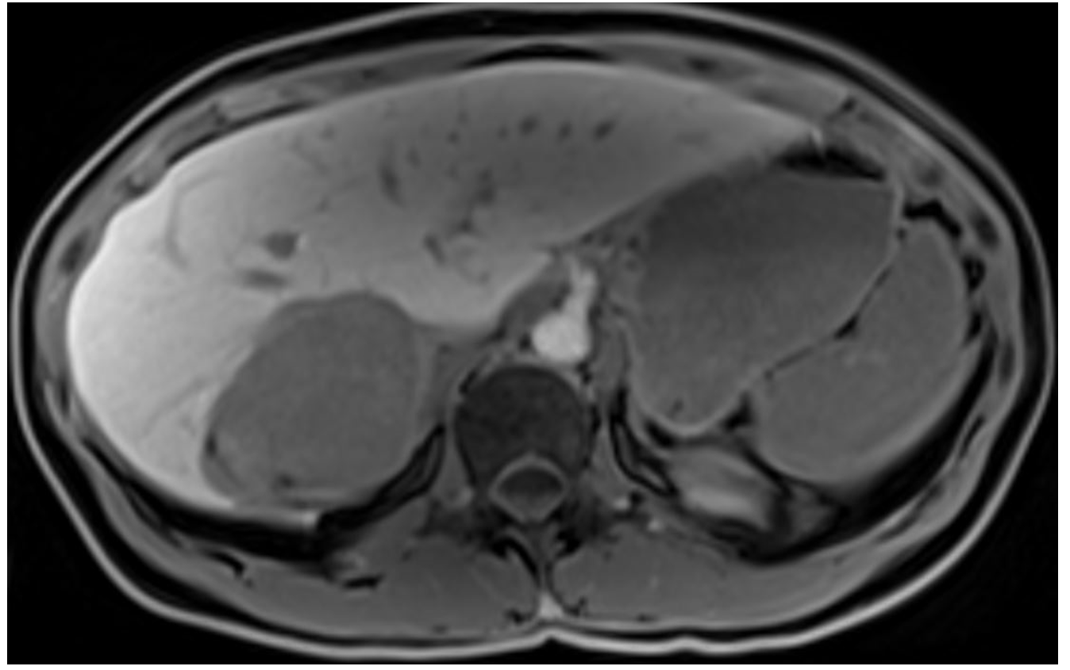
Figure 4 T1 weighted images one hour after hepatocyte-specific agent injection (gadobenate dimeglumine). Hyposignal of the lesion indicates that this is not a hepatocytic tumor.
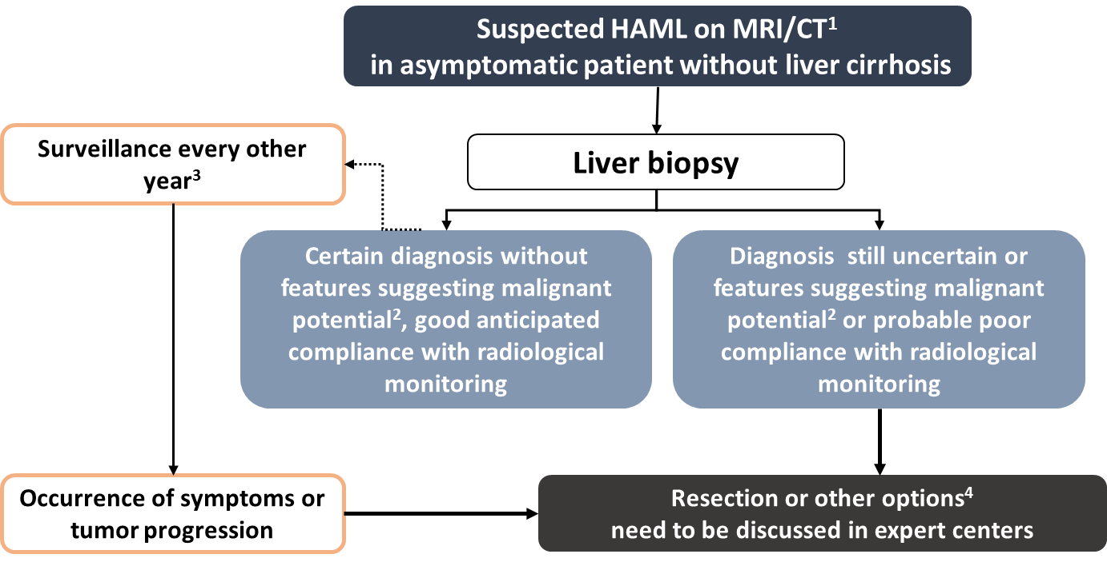
Figure 5 Management algorithm for suspected hepatic angiomyolipoma on imaging. ¹Hepatic angiomyolipoma diagnosis is suggested in the presence of fatty tissue within the solid lesion or presence of wash-out. In the presence of tumor-related symptoms, surgical resection is considered first. ²Features suggesting malignant potential are reported in Table 2. Some authors also recommend surgery in the case of epithelioid-type hepatic angiomyolipoma, which would be at greater risk of progression. Likewise, an association with tuberous sclerosis complex is a condition that increases the risk of malignant transformation, by analogy with renal angiomyolipoma^{[3]}. ³Monitoring maintained despite the benign nature of the initial diagnosis because the aggressive behavior of the tumor is difficult to predict. ⁴Other possible therapeutic options include mTOR inhibitors, radiofrequency ablation, arterial embolization in cases of hemorrhagic rupture, and liver transplantation. Citation: Klompenhouwer AJ, Verver D, Janki S, Bramer WM, Doukas M, Dwarkasing RS, de Man RA, IJzermans JNM. Management of hepatic angiomyolipoma: A systematic review. Liver Int 2017; 37(9): 1272-1280. Copyright ©The Author(s) 2017. Published by John Wiley and Sons^{[3]}. MRI: Magnetic resonance imaging; CT: Computed tomography.

Table 1 Cases of spontaneous rupture of hepatic angiomyolipoma
Ref. | Sex | Age, yr | Symptoms | Abdominal radiological findings | Treatment | Outcomes
Huber et al^{[25]} 1996 | F | 22 | Hemorrhagic shock with clinical symptoms of acute abdomen | CT scan: multiple tumors of the liver (the largest in segment III measured 8 cm) and both kidneys and a splenic lesion with a diameter of 4 cm | Surgical resection of segments II and III | Postoperative course was uneventful. Discharge from hospital 12 d later
Guidi et al^{[26]} 1997 | M | 74 | Sudden onset of upper-quadrant pain | CT scan: liver tumor of 10 cm × 8 cm in the segments I and V and another small mass of 4 cm × 3 cm in segment IV. Fluid was present in the upper abdominal compartments | Surgical resection of the hemorrhagic hepatic mass | Postoperative course was uneventful. Discharge from hospital 8 d later
Tsui et al^{[27]} 1999 | F | 41 | Acute rupture of a subcapsular tumor | 9 cm | Surgical resection | Patient in healthy condition 4 yr after surgery
Zhou et al^{[28]} 2008 | ND | ND | Hemorrhagic shock | Ultrasonography showed a 5-cm "cavernous hemangioma" in the right hepatic lobe | Emergency laparotomy for hemostasis | No tumor recurrence or metastasis was found during follow-up of 2-3 yr
Ding et al^{[8]} 2011 | F | 56 | ND | A rupture of the tumor measuring 6 cm × 6 cm in segment VI was confirmed by emergent laparotomy | Liver suture followed by segmentectomy | No serious morbidity in the postoperative course
Occhionorelli et al^{[29]} 2013 | F | 25 | Sudden onset of abdominal upper-quadrant pain and hypotension, after two recent syncopal episodes | CT scan showed a hepatic tumor in the left lobe (8.6 cm × 7.2 cm) with suspected peritoneal blood leakage | Hemorrhage initially managed by manual compression, followed by deep and pro-coagulant tissue adhesives. After 48 hours, the patient underwent left-liver lobectomy | Postoperative course was uneventful. Discharge from hospital 9 d later
Aoki et al^{[30]} 2014 | F | 70 | Sudden onset of back pain on the right side | CT scan: hepatic tumor in segment VII measuring 7 cm in diameter accompanied by subcapsular hematoma with extravasation | Transcatheter arterial embolization. Right hepatic lobectomy was carried out 39 d later | Five days after surgery, she had thrombi in the left popliteal vein and the left pulmonary artery. Insertion of an IVC filter which was removed due to sepsis. She was discharged 24 d after surgery. There was no recurrence 42 mo following surgery
Tajima et al^{[31]} 2014 | M | 38 | Upper abdominal pain | CT scan showed a tumor measuring 10.5 cm × 9.5 cm × 7 cm in the posterior segment of the right hepatic lobe that had ruptured into the space between the liver and the diaphragm | Transcatheter arterial embolization was performed. The patient developed fever and the hematoma surrounding the liver was drained. No infection was confirmed but right lobectomy was performed | ND
Kai et al^{[32]} 2015 | F | 77 | Sudden abdominal pain and transient loss of consciousness | CT scan: hemoperitoneum with subcapsular hematoma at the left lobe and a hepatic nodule measuring 2.3 cm in diameter in segment II | Conservative initial treatment with periodic imaging studies. Transcatheter arterial chemoembolization was performed because a diagnosis of HCC was suggested. Surgical resection (laparoscopic left lateral segmentectomy) was performed 4 mo later | Postoperative course was uneventful. Discharge from hospital 7 d later No signs of recurrence at 3.5 yr after surgery
Kim et al^{[33]} 2017 | M | 31 | Sudden onset severe abdominal pain in the right upper quadrant area | CT scan: mass of approximately 12 cm in the right hepatic lobe with hemorrhage along the perihepatic space | Emergent angiography with embolization.  Hepatic resection was performed 15 d later | Postoperative course was uneventful
F: Female; M: Male. ND: Not determined; CT: Computed tomography; HCC: Hepatocellular carcinoma; IVC: Inferior vena cava.

Table 2 Classification of perivascular epithelioid cell tumors according to their malignant potential^{[1,27]}
Classification | Criteria
Benign | No worrisome features: (1) Tumor size < 5 cm; (2) No infiltration; (3) Non-high nuclear grade and cellularity; (4) Mitotic activity ≤ 1/50 HPF; (5) No necrosis; And (6) no vascular invasion
Uncertain malignant potential | Tumor with: (1) Pleomorphism/multinucleated giant cells only; or (2) Size > 5 cm only
Aggressive behavior | Two or more worrisome features: (1) Size > 5 cm; (2) Peripheral infiltration; (3) High nuclear grade and cellularity; (4) Mitotic activity > 1/50 HPF; (5) Ischemic tumor necrosis for large tumor; And (6) vascular invasion
According to the WHO classification of tumors^{[1]} | As with GISTs, the main predictors of a risk of metastatic behavior are marked nuclear atypia, diffuse pleomorphism and mitotic activity of more than 1 mitosis per 1 mm²
GIST: Gastrointestinal stromal tumor; HPF: High-power field.

Table 3 Reported cases of hepatic angiomyolipoma with aggressive behavior
Ref. | Sex | Age, yr | Size | Types | Treatment | Duration of follow-up | Outcome
Croquet et al^{[9]} 2000 | F | 16 | 19 cm × 12 cm × 8 cm | Epithelioid | SR | 6 yr | Recurrence in the liver, associated with renal angiomyolipoma
Dalle et al^{[10]} 2000 | F | 70 | 15 cm | Epithelioid | SR | 5 mo | Recurrence in the liver with a lesion measuring 15 cm and presence of multiple metastases in the liver
Flemming et al^{[11]} 2000 | F | 51 | 2 nodules: 0.5 cm and 15 cm | Epithelioid | SR | 3 yr | Recurrence in the right hepatic lobe and presence of multiple metastases
McKinney et al^{[12]} 2005 | F | 14 | 11 cm × 7 cm × 8 cm | NS | SR, interferon α | 1 yr | Recurrence with a hepatic lesion measuring 9 cm × 6 cm × 14 cm, appearance of lymph nodes and hepatic metastases. Death after disease progression
Parfitt et al^{[13]} 2007 | F | 60 | 14 cm × 11 cm | Epithelioid | SR | 9 yr | Recurrence in the liver and appearance of metastases in the trapezius muscle, the left lung and the tail of the pancreas
Yang et al^{[14]} 2007 | F | 37 | 13 cm × 9 cm × 9 cm | Classic | SR | 14 mo | Recurrence in the right hepatic lobe 6 months after SR, appearance of pulmonary metastases 11 mo after SR and death occurred at 14 mo
Deng et al^{[15]} 2008 | M | 30 | 18 cm × 14 cm | Classic | SR, Chemotherapy | 3 yr and 4 mo | Recurrence with a hepatic lesion measuring 11 cm and metastases in pancreatic tail and portal vein thrombosis 3 yr after SR. Chemotherapy was initiated but 4 mo later pulmonary metastases appeared. Death occurred after disease progression
Nguyen et al^{[16]} 2008 | F | 43 | 11 cm × 7.5 cm × 7.5 cm | Classic | SR | 6 mo | Recurrence in the liver 6 mo after SR, together with metastases in the peritoneum, omentum, stomach and spleen. Death after disease progression
Xu et al^{[17]} 2009 | F | 33 | 2 nodules: 1 cm and 6 cm | Epithelioid | SR | 1 yr | Recurrence in the left hepatic lobe
Zeng et al^{[18]} 2010 | NS | NS | 6 cm | NS | SR | 9 yr | Recurrence in the right hepatic lobe with a lesion measuring 6 cm
Butte et al^{[19]} 2011 | F;M | 54; 41 | NS; 9 cm | NS; Epithelioid | SR; SR | 53 mo; 41 mo | Recurrence in the liver 53 mo after SR; Occurrence of pulmonary and retroperitoneal metastases 41 mo after SR
Hu et al^{[20]} 2011 | F | NS | NS | NS | SR | 14 mo | Appearance of local and distant metastases 6 mo after SR. Death occurred 14 mo after SR
Ding et al^{[8]} 2011 | F | 31 | 8 cm × 8 cm | NS | SR | 7 yr | Recurrence in the right hepatic lobe 6 yr after SR and death occurred one year later
Wang et al^{[21]} 2015 | F | 37 | 7 cm × 9 cm | Classic | SR | 3 yr | Recurrence of two hepatic nodules in the right lobe (13 cm × 12 cm and 2.3 cm × 1.8 cm) 3 yr after SR. Arterial chemoembolization was performed, followed by liver transplantation
Fukuda et al^{[22]} 2016 | M | 58 | 6.3 cm | Epithelioid | SR | 9 yr | Metastases occurred in the right lung 7 yr after SR and were treated by pneumonectomy. No recurrence was observed after 2 yr of follow-up
Marcuzzi et al^{[23]} 2018 | F | 47 | 3.8 cm × 4.6 cm × 4.7 cm  + 2 hepatic lesions measuring 6 mm and 5 mm | Epithelioid | SR | 8 yr and 8 mo | CT scan was performed 6 yr and 4 mo after the initial presentation: the hepatic lesion had grown in size to an estimated 10.9 cm × 9.7 cm × 11.2 cm and the adjacent lesions had grown to 1.9 cm and 2.4 cm with a new lesion on the kidney of 4.6 cm × 5.1 cm. 16 mo later, MRI showed an increase in size of the hepatic lesion (12 cm × 11 cm), and kidney lesion (6.2 cm × 5.6 cm). SR performed 2 mo later. 6 mo after SR, recurrence in the resection line and in the hepatic segment II
Yan et al^{[24]} 2018 | NS | NS | 15 cm | Epithelioid | SR | 9 yr | Recurrence in the liver 9 yr after SR with invasion of the inferior vena cava and diaphragm, and appearance of pulmonary metastases
F: Female; M: Male; NS: Not specified; SR: Surgical resection; CT: Computed tomography; MRI: Magnetic resonance imaging.

Published by Baishideng Publishing Group Inc
7041 Koll Center Parkway, Suite 160, Pleasanton, CA 94566, USA
Telephone: +1-925-3991568
E-mail: bpgoffice@wjgnet.com
Help Desk: https://www.f6publishing.com/helpdesk
https://www.wjgnet.com

© 2021 Baishideng Publishing Group Inc. All rights reserved.

