Name of journal: World Journal of Gastroenterology
ESPS Manuscript NO: 35945
Manuscript Type: ORIGINAL ARTICLE

Basic Study
Novel D-galactosamine-induced cynomolgus monkey model of acute liver failure

Feng L et al. Cynomolgus monkey model of ALF

Lei Feng, Lei Cai, Guo-Lin He, Jun Weng, Yang Li, Ming-Xin Pan, Ze-Sheng Jiang, Qing Peng, Yi Gao

Lei Feng, Lei Cai, Guo-Lin He, Jun Weng, Yang Li, Ming-Xin Pan, Ze-Sheng Jiang, Qing Peng, Yi Gao, Department of Hepatobiliary Surgery II, Guangdong Provincial Research Center for Artificial Organ and Tissue Engineering, Guangzhou Clinical Research and Transformation Center for Artificial Liver, Institute of Regenerative Medicine, Zhujiang Hospital, Southern Medical University, Guangzhou510282, Guangdong Province, China

Yi Gao, State Key Laboratory of Organ Failure Research, Southern Medical University, Guangzhou 510282, Guangdong Province, China

ORCID number: Lei Feng (0000-0001-6053-8417); Lei Cai (0000-0003-1658-7996); Guo-Lin He (0000-0001-8032-1434); Jun Weng (0000-0003-0792-1526); Yang Li (0000-0003-4718-1825); Ming-Xin Pan (0000-0002-3979-5571); Ze-Sheng Jiang (0000-0002-2170-2031); Qing Peng (0000-0002-7790-6455); Yi Gao (0000-0003-3525-0133).

Author contributions: Gao Y, Pan MX and Jiang ZS designed research; Feng L, Cai L, He GL, Weng J, Li Y performed research; Feng L, Cai L and He GL analyzed data; Feng L wrote the paper; Gao Y and Peng Q revised the paper.

Supported by The National Natural Science Foundation of China, No.81470875; The Natural Science Foundation of Guangdong Province, China No.2014A030312013; The Science and Technology Planning Project of Guangdong Province, China No. 2014B020227002, No. 2015B090903069 and No. 2015B020229002; and The Science and Technology Program of Guangzhou, China, No.201604020002.

Institutional review board statement: The study was reviewed and approved by the Zhujiang Hospital Institutional Review Board.

Institutional animal care and use committee statement: All procedures involving animals were reviewed and approved by the Institutional Animal Care and Use Committee of the Guangdong province (IACUC protocol number: SCXK (Guangdong) 2014-0010).

Conflict-of-interest statement: No conflict of interest exists.

Open-Access: This article is an open-access article which was selected by an in-house editor and fully peer-reviewed by external reviewers. It is distributed in accordance with the Creative Commons Attribution Non Commercial (CC BY-NC 4.0) license, which permits others to distribute, remix, adapt, build upon this work non-commercially, and license their derivative works on different terms, provided the original work is properly cited and the use is non-commercial. See: http://creativecommons.org/licenses/by-nc/4.0/

Manuscript source: Unsolicited manuscript

Correspondence to: Yi Gao, MD, Professor, Surgeon, Department of Hepatobiliary Surgery II, Guangdong Provincial Research Center for Artificial Organ and Tissue Engineering, Guangzhou Clinical Research and Transformation Center for Artificial Liver, Institute of Regenerative Medicine, Zhujiang Hospital, Southern Medical University, 253 Industry Road, Hai Zhu District, Guangzhou 510280, Guangdong Province, China. drgaoy@126.com
Telephone: +86-20-62782560
Fax: +86-20-61643207

Received: August 21, 2017
Peer-review started: August 24, 2017
First decision: September 13, 2017
Revised: September 17, 2017
Accepted: October 18, 2017
Article in press:
Published online:

Abstract
AIM
To establish a simplified, reproducible, D-galactosamine-induced, cynomolgus monkey model of acute liver failure having an appropriate treatment window.

METHODS
Sixteen cynomolgus monkeys were randomly divided into four groups (A, B, C, D) after ICP sensor implantation, then D-galactosamine at 0.3, 0.25, 0.20 + 0.05 (24 h interval) and 0.20 g/kg body weight, respectively, was injected through the small saphenous vein. Vital signs, intracranial pressure, biochemical indices, inflammation factors were recorded at 0 h, 12 h, 24 h, 36 h, 48 h, 72 h, 96 h and 120 h after D-galactosamine administration. Progression of clinical manifestations, survival times and results of H&E staining, Tunel and Masson assays were recorded.

RESULTS
Cynomolgus monkeys developed different degrees of debilitation, loss of appetite and jaundice after D-galactosamine administration. Survival times of groups A, B and C were 56 ± 8.7 h, 95 ± 5.5 h and 99 ± 2.2 h, respectively, and in group D all monkeys survived the 144 h observation period except for one, which died at 136h. Blood levels of ALT, AST, CK, LDH, TBiL, Cr, BUN, and Amm, the PT, ICP, Endotoxin and inflammation marker (TNF-α, IL-1β, IL-6) levels significantly (P < 0.05) increased compared with baseline in the different groups. Pathological results showed obvious liver cell necrosis positively correlated to the dose of D-galactosamine.

CONCLUSION
We successfully established a simplified, reproducible, D-galactosamine-induced, cynomolgus monkey model of acute liver failure, and we think the single or divided dosage of 0.25 g/kg is optimal.

Key words: Cynomolgus monkey; D-galactosamine; Acute liver failure; Artificial liver support systems; Intracranial pressure

© The Author(s) 2017. Published by Baishideng Publishing Group Inc. All rights reserved.

Core tip: This is an article about a novel D-galactosamine-induced cynomolgus monkey model of ALF. In this study, we used small saphenous vein puncture instead of jugular vein intubation for different doses of D-gal administration, which not only effectively avoided the trauma caused by intubation, but also significantly reduced the anesthesia time and greatly improved the convenience of operation. This study concluded that a simplified, reproducible, D-gal-induced, large-animal ALF model with an appropriate treatment window had been established successfully, which is suitable to further assess the safety and efficacy of ALSS or to studying the pathogenesis of ALF and developing new drugs.

Feng L, Cai L, He GL, Weng J, Li Y, Pan MX, Jiang ZS, Peng Q, Gao Y. Novel D-galactosamine-induced cynomolgus monkey model of acute liver failure. World J Gastroenterol 2017; In press

INTRODUCTION
Acute liver failure (ALF) results from various causes and is a serious threat to human health^{[1-3]}. Therefore, the establishment of an ALF animal model is of great significance for studying the pathogenesis of ALF, the development of new drugs, and determining the comprehensive treatment of ALF^{[4]}. In recent years, artificial liver technology has become a topic of great interest to researchers in the ALF field^{[5-8]}. Artificial liver support systems (ALSS) can significantly improve the clinical manifestations and prolong the survival time of patients with liver failure or those awaiting liver transplantation^{[9]}. The safety and efficacy of ALSS must be verified before clinical application because they contain biological substances, such as liver cells; at this point, an ideal animal model of ALF would be an indispensable verification platform^{[10,11]}. Therefore, it is necessary to establish a simplified and reproducible animal model of ALF with an appropriate treatment window.
There are current literature reports of many drugs that have been used to induce animal models of ALF^{[5,12-14]}. D-galactosamine (D-gal) is a disruptor of uridine triphosphate of hepatocytes, causing diffuse hepatic necrosis and an inflammatory response, similar to the pathological changes of clinical viral hepatitis^{[15,16]}. Compared with other drugs, D-gal has many advantages, including better reproducibility and easier dosage control; it is generally accepted as the ideal drug to induce ALF.
At present, large animals used to establish liver failure models are mainly pigs and dogs^{[15,17,18]}, but their physiological and biochemical characteristics are dissimilar from those of humans, and results are relatively poor for guiding clinical treatment. As for the methods of drug administration, the main method used is intubation through the jugular vein^{[8]}, which is complex and increases the trauma to experimental animals.
In this study, we used different doses of D-gal administered through the small saphenous vein of cynomolgus monkeys, and then observed the clinical manifestations, survival times, changes in biochemical indices, intracranial pressure (ICP) changes, and resulting pathological and histological characteristics, in order to establish a simplified, reproducible, D-gal-induced, large-animal ALF model with an appropriate treatment window, suitable to further assess the safety and efficacy of ALSS or to studying the pathogenesis of ALF and developing new drugs.

MATERIALS AND METHODS
Animals
Sixteen male cynomolgus monkeys, 6-9 years old and weighing 9.4-11 kg, were purchased from Guangdong Landao Biological Technology Co. Ltd. (No 33, Guanghua Road, Huangpu District, Guangzhou, Guangdong, China) (Certificate of Conformity SCXK [Guangdong] 2014-0010) (Table 1). The experimental protocol was reviewed and approved by the Institutional Review Board of Zhujiang Hospital, Southern Medical University, China (No. ZJYY-2014-GDEK-003).

Experimental drugs and preparation
D-gal was purchased from Sigma-Aldrich (Inc, United States) was dissolved in 5% glucose solution to a concentration of 1.0g/10 mL and pH was adjusted to 6.8 with 1.0 mol/L NaOH solution; Then, the solution was sterilized by filtration through a bore diameter of 0.22 μm and administrated within 2 h after preparation.

Experimental groups
The study design is presented in Figure 1. The 16 monkeys were randomly divided into 4 groups after the ICP sensor was implanted and then were given different doses of D-gal according to the results of our previous study^{[19]}. The study groups and dosages given were as follows: group A (n = 4), 0.30 g/kg D-gal; group B (n = 4), 0.25 g/kg D-gal; group C (n = 4), 0.20 g/kg D-gal plus 0.05 g/kg D-gal after 24h; group D (n = 4), 0.20 g/kg D-gal.

Anesthesia and preparation
Basic anesthesia was induced by intramuscular injection of Zoletil (Virbac Laboratory, Carros, France) (15 mg/kg) and atropine (0.5 mg/kg). The experimental monkey was placed on an operating table with a hot blanket after basic anesthesia. After peroral endotracheal intubation, spontaneous breathing was maintained by continuous inhalation of isoflurane (1%-2%) and O₂ (2 L/min) during implantation of the ICP sensor. Animals were placed on the operating table in the prone position; the limbs and head were fixed in place after anesthesia. Skin preparation of the head (for ICP sensor implantation), arms (collecting blood samples) and hind legs (for drug administration) was performed using an electric shaver and cleansing with soap and water.

ICP sensor implantation
The detail surgical procedure to implant ICP sensor in cynomolgus monkeys is shown in supplementary material 1 and Figure S1.

Establishing the ALF model
Study monkeys were fasted (free access to water) for 12 h before drug administration. Anesthesia was induced by intramuscular injection of Zoletil (15 mg/kg) and atropine (0.5 mg/kg). Blood samples were collected from the forearm and vital signs and ICP were measured as baseline values (0 h). Finally, the prepared D-gal solution was drawn into a 50 mL syringe connected to a disposable needle, air was expelled from the syringe, and then the D-gal solution was administered slowly through the small saphenous vein (supplementary material Figure S2). After D-gal administration, animals were given regular feed and free access to water and fresh fruit.

Parameters
The general condition of study animals were monitored during the experiment and the subsequent observation period, as follows: the ability to stand, to walk and to eat; the response to sight, sound and stimulation; and presence of cramps or convulsions. When the animal was conscious, these were recorded every 12 h, whereas the animals were observed every 2 h after unconsciousness occurred. The recorded survival time was defined as the time interval from completion of injection of D-gal to death, and surviving animals were observed for 144 h in total.
ICP, ammonia level, and levels of inflammation markers (TNF-α, IL-1β) and IL-6) and endotoxin were recorded at 0 h, and at 12, 24, 36, 48, 72, 96, and 120 h after D-gal administration. An ammonia determination kit (end-point method) purchased from Sysmex Corporation (Inc, Japan) was used to measure whole blood ammonia levels. TNF-α、IL-1β and IL-6 levels were determined by ELISA kits purchased from Sigma-Aldrich. Endotoxin levels were determined by Tachypleus Amebocyte Lysate (TAL) purchased from Sigma-Aldrich.
Vital signs were measured and blood samples to measure liver function indices (AST, ALT, ALB, TBiL, CK, LDH), renal function indices (BUN, Cr), blood glucose, prothrombin time (PT) and routine blood chemistry tests were collected at 0 h and at 12, 24, 36, 48, 72, 96, and 120 h after drug administration. All tests of blood samples were conducted in the clinical laboratory of Zhujiang Hospital, Southern Medical University, China.

Histopathological examination
From each of the 4 study groups, 1 monkey was randomly selected for liver biopsy, which was conducted under ultrasound guidance before D-gal administration (supplementary material Figure S3). Pathological and histological examination was performed as the control.
Animals surviving at 144 h were sacrificed with a lethal intravenous injection of pentobarbital and KCl, and a detailed autopsy was performed immediately after animal death. Each animal’s liver, heart, kidneys, spleen, lungs, large intestine, small intestine, brain, and pancreas were collected, and all tissue specimens were fixed in 10% formalin solution, cut into 5 mm³ blocks which were paraffin embedded and thin-sectioned. Subsequently, slides underwent stepwise alcohol dehydration before hematoxylin-eosin (HE) staining for observation under a light microscope. In addition, liver specimens were collected from all 4 groups and Tunel assays were performed to assess cell apoptosis and necrosis. Finally, liver specimens from all 4 groups also underwent Masson assays to assess the extent of ALF fibrosis.

Animal care and use statement
The monkeys were cared for in strict accordance with the institution’s guidelines for experimental animals. Each animal was kept individually in a special iron cage under standard conditions and fed 3 times a day with free access to water. Animals surviving at 144 h were sacrificed with a lethal intravenous injection of pentobarbital and KCl for tissue collection.

Statistical analysis
Data were expressed as mean ± SD and were analyzed using the SPSS 21.0 statistical package. Differences between baseline values and values at the different study time points were analyzed using Student’s t-test and ANOVA for multiple comparisons. Animal survival was analyzed using the Kaplan-Meier log rank method. A P value < 0.05 were considered significant.

RESULTS
General condition
The general condition of the experimental monkeys before D-gal administrate are shown in Table 1. After D-gal injection, the experimental monkeys in group A began to eat less at 12 h, responded slowly to the sound stimulus, and 2 were apparently vomiting at 16 h and 21 h. All animals in group A had jaundice and very yellow urine after 24 h; their general condition subsequently declined rapidly into a persistent coma, and all animals died within 68 hours. In group B, 1 monkey appeared nauseated and was vomiting at 48 h, while another was discovered to have convulsions and liver coma at 96 h and died a short time later. In group C, 2 monkeys had nausea, vomiting and very yellow urine at 72 h after D-gal administration. Group D monkeys eat less and had slower responses at 48 h after D-gal administration, but they were recovering slowly after 96 h.

Survival
All experimental animals in groups A, B and C died within 5 days. Compared with group D, the survival times of groups A, B, and C animals were significantly shortened, at 56 ± 8.7h, 95 ± 5.5 h and 99 ± 2.2 h, respectively (all P values < 0.01), whereas 3 monkeys in group D survived until the end of the 144 h observation, and 1 died at 136 h. Kaplan-Meier survival analysis suggested that the survival time of each group of monkeys was significantly different (χ² = 22.42, P < 0.001) (Figure 2).

Changes of ICP and ammonia
Significantly increased levels of ICP and ammonia were observed after D-gal administration in all study groups, compared with baseline values (all P values < 0.05). The ICP and ammonia levels in group A increased to their peaks at 48 h to about 3-fold and 4-fold of baseline, respectively, whereas in groups B and C had no significant increases (P > 0.05) except at 72 h and 96 h, when they all increased to a peak. In group D, ICP and ammonia levels increased slowly and declined after peaking at 96 h (Figure 3A, B).

Changes of inflammation markers and endotoxin levels
As shown in Figure 3C-F, compared with baseline values, IL-1β, IL-6, TNF-α and endotoxin all significantly increased in group A at all-time points except at 12 h (all P values < 0.05). IL-1β and TNF-α levels were not significantly different between groups B and C at any time point (all P values > 0.05); IL-6 and endotoxin were not significantly different between groups B and C except for at 48 h and 72 h. In group D, these values were all lower than in the other groups.

Biochemical parameters
The progressive increases in the level of liver enzymes (ALT, AST, LDH, CK), and TBiL indicated serious liver damage after D-gal administration. The liver enzymes and TBiL in group A significantly increased compared with baseline levels and those of the other groups (all P values < 0.05). However, the liver enzymes in groups B and C were not significantly different (P > 0.05), and neither were levels of TBiL except for at 72 h and 96 h (Figure 4A-C, Figure 4F, G).
The PT in all monkeys was prolonged significantly and there were significant differences between different time points after D-gal administration (all P values < 0.05). The PT in group A increased to a peak at 48 h, about 4-fold of baseline; that of groups B and C significantly increased to a peak at 96 h, about 5-fold and 6-fold of baseline, respectively; whereas in group D, the PT increased slowly (Figure 4D).
Significant reductions in the plasma levels of ALB were also observed after D-gal administration in groups A, B, and C, to 37.50 ± 1.29 g/L at 48 h, and 33.50 ± 0.71 and 32.50 ± 2.38 g/L at 96 h, respectively. The plasma level of ALB in group D did not change significantly (Figure 4E).
The BUN and Cr levels of all experimental monkeys significantly increased after D-gal administration. The BUN and Cr in group A increased to a peak at 48 h to about 6-fold and 4-fold compared with baseline levels. In groups B and C, increases were progressive. In group D, increases were slow and declined after peaking at 72 h to the baseline level at 120 h (Figure 4H, I).

Histopathology
The histopathology of normal liver clearly showed the expected findings of central vein, portal area, liver cords and liver lobules. No swelling, vacuoles or necrosis of liver cells was observed. In group A after D-gal administration, liver cells were present in large areas of necrosis had visible nuclear fragments and a large number of vacuolar structures. The situation in groups B and C was similar, with areas of necrotic lesions with diffuse swelling of liver cells having cytoplasmic and vacuolar degeneration. In group D, liver cells had mainly degenerative edema and the liver sinus structure was visible. The Tunel assay demonstrated obvious positive cells in group A, while in groups B and C positive cells were present in comparatively lower quantities. No positive cells were detected in group D samples. Masson staining revealed mild fibrosis in groups A, B, and C, and no obvious abnormality in group D animals (Figure 5).
Results of examination of gross specimens of the other organs are shown in Figure 6. The results of HE staining of other organs are shown in Figure 7.

DISCUSSION
A simplified, reproducible, D-gal-induced, cynomolgus monkey model of ALF that is suitable for use to assess the safety and efficacy of ALSS has been successfully established. The ideal criteria for animal models were first proposed by Terblanche J and Hickman R^{[20]}, which were promoted and supplemented as a result of subsequent studies^{[14]}. They mainly comprise the following points: reversibility; reproducibility; death from liver failure; suitable treatment window; large animals; cause minimal harm to environment and researchers; consciousness level making hepatic encephalopathy easy to evaluate; similarity to human beings; ethically acceptable.
At present, large animal models of ALF meeting the above criteria mainly include drug-induced models^{[5]} and surgery-induced models^{[21]}. Drug-induced models are easy to create, having short anesthesia times, and can be accomplished without use of the highly skilled technical work required to establish surgery-induced models. Although sometimes drug-induced models are unstable because of great individual differences in drug tolerance and metabolic function, these models are of great interest to research scholars because the most common reason for ALF in clinical setting is drug toxicity^{[4]}.
Current literature reports of drugs that can induce ALF include those for D-gal, acetaminophen (APAP), and carbon tetrachloride, to name a few^{[12-14]}. Yu et al^{[22]} reported on the pharmacokinetics, drug metabolism and hepatic toxicity of APAP in cynomolgus monkeys and found significant tolerance to APAP; therefore, APAP is not suitable to create a cynomolgus monkey model to study related hepatic injury. Compared with other drugs, D-gal has many advantages for this purpose, including better reproducibility and easier control of the dosage; it is generally accepted as the ideal drug to induce ALF.
For this study, we chose cynomolgus monkeys because their anatomy, physiology, biochemical metabolism and immune system characteristics are very similar to those of human beings, making them the ideal animal to establish an ALF model. Given the rarity of primate species and the instability of other models, there are few relevant published reports of primate models of ALF. Zhou et al^{[23]} established fulminant hepatic failure in the Macaca mulatta by intraperitoneal injection of amatoxin and endotoxin, and evaluated the animal model by progressive analysis of clinical features, biochemical indices and histopathology. But this study only included two monkeys, so the stability and reproducibility needs further verification, and the effective treatment window of this model would make the study of use of ALSS difficult.
Drug dosages and the administration methods are important for establishing drug-induced models. The method of drug administration affects the convenience of using a model. Various ALF studies have different requirements for the survival time, which usually means exploring the optimal dosage and induction methods for different purposes. Glorioso et al^{[8]} successfully established a pig model of ALF by injecting 0.75g/kg D-gal through the external jugular vein, which was successfully used in the study of artificial livers. Li et al^{[7, 24]} established a pig model of FHF by intravenous injection of 1.3 g/kgand 1.5 g/kg^{[25]} D-gal, which was used in studies to verify the safety and efficacy of ALSS. Ding et al^{[26]} established a pig model of ALF by injecting 0.45g/kg D-gal intravenously to study treatment with a novel bio-artificial liver.
Currently, D-gal is usually administered through the external jugular vein or the abdominal cavity^{[23-25, 27]}. The abdominal cavity injection is simple and convenient, but resulting models are unstable, while administration through the external jugular vein and portal vein usually requires a long anesthesia time and surgical venous intubation, so the method is more complicated.
In our early study, we administered 0.45, 0.3 and 0.15 g/kg of D-gal through the external jugular vein to establish the ALF model to explore the optimal basic dosage to establish the primate model of ALF^{[19]}. However, venous intubation is not only inconvenient, but also brings certain trauma to the experimental animal. In this study, we used small saphenous vein puncture instead of jugular vein intubation for D-gal administration, which not only effectively avoided the trauma caused by intubation, but also significantly reduced the anesthesia time and greatly improved the convenience of operation. Moreover, we further adjusted and optimized the dosage of D-gal using the previous dose of 0.3 g/kg, as well as a 0.25 g/kg single dose, 0.25 g/kg as a divided dose (0.20 + 0.05 g/kg) and a single 0.20 g/kg dose, and then compared in the different groups for changes of clinical manifestation, survival time, liver function, inflammatory factors, PT, ICP and histopathology.
The results showed that the experimental monkeys developed different levels of anorexia, anemic, jaundice and coagulopathy after intravenous injection of different doses of D-gal that were similar to the various degrees of clinical ALF. The animals administered 0.30 g/kg D-gal had the shortest survival time (56 ± 8.7 h), and there were no significant difference in survival time after 0.25 g/kg given as a single or divided dose (95 ± 5.5 h and 99 ± 2.2 h, respectively). In our study, 81.3% (13/16) experimental monkeys died, and the survival time of experimental animals was positively correlated to the dose of D-gal.
D-gal can cause liver cell necrosis and lead to ALF, as well as abnormally elevated serum TNF-α, which then trigger the cascade of inflammatory mediators and is closely related to the pathophysiology of ALF^{[28,29]}. In our study, a strong inflammatory response was observed, as evidenced by markedly increased levels of TNF-α, IL-1β, IL-6 and endotoxin, all of which were positively correlated to the dose of D-gal.
Liver enzymes are important indices to assess clinical liver injury. When liver cells are necrotic, inflammation and toxicity can cause damage to the liver cell membrane, leading to serum transaminase elevations; transaminase levels 10-fold higher than the baseline indicates acute liver damage^{[30]}. In this study, ALT, AST, CK and LDH increased rapidly a short time after injection of D-gal, with results demonstrating that acute liver injury and the degree of damage was positively correlated to the dose of D-gal.
ALB and PT are important indicators of liver synthesis and reserve function. In our study, serum ALB levels showed progressive decline after D-gal administration except for in group D, and this may explain the anomalous finding of abdominal and pleural effusions on autopsy of the study animals. The PT in the four groups was significantly prolonged, with the peak times 4-, 5-, 6- and 1.5-fold of the baseline time in groups A, B, C, and D, respectively. At autopsy, the livers in groups A and B had obviously ecchymosis, and 4 lung specimens had obvious bleeding; these findings are likely associated with the coagulation dysfunction caused by liver failure.
Hepatic encephalopathy is a serious complication of acute liver failure and is closely related to the blood ammonia level, elevations of which cause brain edema, oxidative stress, and inflammation^{[31,32]}. In our study, we measured the progression of ammonia levels and ICP to monitor for hepatic encephalopathy. Ammonia and ICP were significantly increased in groups A and B, and were combined with the clinical manifestations of consciousness changes and hepatic coma before death, as well as histopathological changes, all indicating that the experimental animals developed hepatic encephalopathy before death.
The model established in our study has some limitations. First, we used Zoletil to induce anesthesia before administering D-gal, and although Zoletil has many advantages, including short induction time, minimal side effects, and maximum security compared with ketamine, whether it can affect the effect of D-gal is unknown. In addition, the number of animals used was small, and further studies with larger experimental groups are warranted to verify our results.
In conclusion, we successfully established a simplified, reproducible, D-gal-induced, cynomolgus monkey model of acute liver failure that is suitable to assess the safety and efficacy of ALSS or to studying the pathogenesis of ALF and developing new drugs, and we think the dosage of 0.25g/kg as either a single or divided dose is optimal.

ARTICLE HIGHLIGHTS
Research Background
Acute liver failure (ALF) is a serious threat to human health. Artificial liver support system (ALSS) is a novel method to deal with ALF. However, the safety and efficacy of ALSS must be verified before clinical application. Therefore, the establishment of an ALF animal model is of great significance for testing ALSS, studying the pathogenesis of ALF and determining the comprehensive treatment of ALF. Nowadays, there have a lot of studies about the acute liver failure in large animal, such as pigs and dogs. But there has been few previous reported study of acute liver failure model in cynomolgus monkey. Furthermore, the methods of drug administration are complex and increase the trauma to experimental animals.

Research motivation
In this study, our motivation is to establish an ideal animal model of ALF with an appropriate treatment window which is suitable to further assess the safety and efficacy of ALSS or to studying the pathogenesis of ALF, developing new drugs, and determining the comprehensive treatment of ALF.

Research objectives
The primary objective in this study is to establish a simplified, reproducible, D-gal-induced, large-animal ALF model with an appropriate treatment window. In addition, we want to explore the optimal dosage of D-gal to induce ALF in cynomolgus monkey.

Research methods
In this study, we used small saphenous vein puncture instead of jugular vein intubation for different doses of D-gal administration, and then observed the clinical manifestations, survival times, changes in biochemical indices, intracranial pressure changes, and resulting pathological and histological characteristics. This method not only effectively avoided the trauma caused by intubation, but also significantly reduced the anesthesia time and greatly improved the convenience of operation. All experimental data were analyzed using the SPSS 21.0 statistical package.

Research results
The results showed that the experimental monkeys developed different levels of anorexia, anemic, jaundice and coagulopathy after intravenous injection of different doses of D-gal that were similar to the various degrees of clinical ALF. The animals administered 0.30 g/kg D-gal had the shortest survival time, and there were no significant difference in survival time after 0.25 g/kg given as a single or divided dose. The degree of acute liver damage and the survival time of experimental animals were positively correlated to the dose of D-gal. The experimental animals in 0.25 g/kg given as a single or divided dose had an appropriate treatment window. Otherwise, the number of animals used was limited, and further studies with larger experimental groups are warranted to verify our results.

Research conclusions
The authors successfully established a simplified, reproducible, D-gal-induced, cynomolgus monkey model of ALF and we find the optimal dosage to induce ALF in cynomolgus monkey is 0.25g/kg as either a single or divided dose.

Research perspectives
From this study, we think drug dosages and the administration methods are important for establishing drug-induced models. The method of drug administration affects the convenience of using a model. In addition, we think small saphenous vein puncture for D-gal administration is the best method to induce ALF in cynomolgus monkey and the dosage of 0.25g/kg as either a single or divided dose is optimal. Furthermore, we can use this method and dosage to induce ALF in cynomolgus monkey to testing ALSS or studying the pathogenesis of ALF in the future.

ACKOWLEDGEMENTS
The authors appreciate Mr. Yue-feng Li and Mr. Xing-wen Qin at the Department of Experimental Animals in Guangdong Landao Biological Technology Co. who kindly provided anesthesia assistance, blood sample collection and animal care services.

REFERENCES
1 Cardoso FS, Marcelino P, Bagulho L, Karvellas CJ. Acute liver failure: An up-to-date approach. J Crit Care 2017; 39: 25-30 [PMID: 28131021 DOI: 10.1016/j.jcrc.2017.01.003]
2 Isik A, Firat D. Bilateral intra-areolar polythelia. Breast J 2017; Epub ahead of print [PMID: 28590581 DOI: 10.1111/tbj.12838]
3 Isik A, Idiz O, Firat D. Novel Approaches in Pilonidal Sinus Treatment. Prague Med Rep 2016; 117: 145-152 [PMID: 27930892 DOI: 10.14712/23362936.2016.15]
4 Tuñón MJ, Alvarez M, Culebras JM, González-Gallego J. An overview of animal models for investigating the pathogenesis and therapeutic strategies in acute hepatic failure. World J Gastroenterol 2009; 15: 3086-3098 [PMID: 19575487 DOI: 10.3748/wjg.15.3086]
5 Lee KC, Palacios Jimenez C, Alibhai H, Chang YM, Leckie PJ, Baker LA, Stanzani G, L Priestnall S, Mookerjee RP, Jalan R, Davies NA. A reproducible, clinically relevant, intensively managed, pig model of acute liver failure for testing of therapies aimed to prolong survival. Liver Int 2013; 33: 544-551 [PMID: 23331547 DOI: 10.1111/liv.12042]
6 Saliba F, Samuel D. Artificial liver support: a real step forward. Minerva Med 2015; 106: 35-43 [PMID: 25367058]
7 Zhou N, Li J, Zhang Y, Lu J, Chen E, Du W, Wang J, Pan X, Zhu D, Yang Y, Chen Y, Cao H, Li L. Efficacy of coupled low-volume plasma exchange with plasma filtration adsorption in treating pigs with acute liver failure: A randomised study. J Hepatol 2015; 63: 378-387 [PMID: 25814048 DOI: 10.1016/j.jhep.2015.03.018]
8 Glorioso JM, Mao SA, Rodysill B, Mounajjed T, Kremers WK, Elgilani F, Hickey RD, Haugaa H, Rose CF, Amiot B, Nyberg SL. Pivotal preclinical trial of the spheroid reservoir bioartificial liver. J Hepatol 2015; 63: 388-398 [PMID: 25817557 DOI: 10.1016/j.jhep.2015.03.021]
9 Nicolas CT, Hickey RD, Chen HS, Mao SA, Lopera Higuita M, Wang Y, Nyberg SL. Concise Review: Liver Regenerative Medicine: From Hepatocyte Transplantation to Bioartificial Livers and Bioengineered Grafts. Stem Cells 2017; 35: 42-50 [PMID: 27641427 DOI: 10.1002/stem.2500]
10 Al-Chalabi A, Matevossian E, V Thaden AK, Luppa P, Neiss A, Schuster T, Yang Z, Schreiber C, Schimmel P, Nairz E, Perren A, Radermacher P, Huber W, Schmid RM, Kreymann B. Evaluation of the Hepa Wash® treatment in pigs with acute liver failure. BMC Gastroenterol 2013; 13: 83 [PMID: 23668774 DOI: 10.1186/1471-230X-13-83]
11 Chen Z, Ding YT. Functional evaluation of a new bioartificial liver system in vitro and in vitro. World J Gastroenterol 2006; 12: 1312-1316 [PMID: 16534893 DOI: 10.3748/wjg.v12.i8.1857]
12 He GL, Feng L, Cai L, Zhou CJ, Cheng Y, Jiang ZS, Pan MX, Gao Y. Artificial liver support in pigs with acetaminophen-induced acute liver failure. World J Gastroenterol 2017; 23: 3262-3268 [PMID: 28566885 DOI: 10.3748/wjg.v23.i18.3262]
13 Ning Y, Kim JK, Min HK, Ren S. Cholesterol metabolites alleviate injured liver function and decrease mortality in an LPS-induced mouse model. Metabolism 2017; 71: 83-93 [PMID: 28521882 DOI: 10.1016/j.metabol.2016.12.007]
14 Maes M, Vinken M, Jaeschke H. Experimental models of hepatotoxicity related to acute liver failure. Toxicol Appl Pharmacol 2016; 290: 86-97 [PMID: 26631581 DOI: 10.1016/j.taap.2015.11.016]
15 Awad SS, Hemmila MR, Soldes OS, Sawada S, Rich PB, Mahler S, Gargulinski M, Hirschl RB, Bartlett RH. A novel stable reproducible model of hepatic failure in canines. J Surg Res 2000; 94: 167-171 [PMID: 11104657 DOI: 10.1006/jsre.2000.5997]
16 Xiong Q, Hase K, Tezuka Y, Namba T, Kadota S. Acteoside inhibits apoptosis in D-galactosamine and lipopolysaccharide-induced liver injury. Life Sci 1999; 65: 421-430 [PMID: 10421428 DOI: 10.1016/S0024-3205(99)00263-5]
17 de Groot GH, Reuvers CB, Schalm SW, Boks AL, Terpstra OT, Jeekel H, ten Kate FW, Bruinvels J. A reproducible model of acute hepatic failure by transient ischemia in the pig. J Surg Res 1987; 42: 92-100 [PMID: 3807358 DOI: 10.1016/0022-4804(87)90070-9]
18 Benoist S, Sarkis R, Baudrimont M, Delelo R, Robert A, Vaubourdolle M, Balladur P, Calmus Y, Capeau J, Nordlinger B. A reversible model of acute hepatic failure by temporary hepatic ischemia in the pig. J Surg Res 2000; 88: 63-69 [PMID: 10644469 DOI: 10.1006/jsre.1999.5778]
19 Zhang Z, Zhao YC, Cheng Y, Jian GD, Pan MX, Gao Y. Hybrid bioartificial liver support in cynomolgus monkeys with D-galactosamine-induced acute liver failure. World J Gastroenterol 2014; 20: 17399-17406 [PMID: 25516651 DOI: 10.3748/wjg.v20.i46.17399]
20 Terblanche J, Hickman R. Animal models of fulminant hepatic failure. Dig Dis Sci 1991; 36: 770-774 [PMID: 2032519 DOI: 10.1007/BF01311235]
21 Cai L, Weng J, Feng L, He G, Qin J, Zhang Z, Li Y, Peng Q, Jiang Z, Pan M, Gao Y. Establishment of a Novel Simplified Surgical Model of Acute Liver Failure in the Cynomolgus Monkey. Biomed Res Int 2016; 2016: 3518989 [PMID: 28097130 DOI: 10.1155/2016/3518989]
22 Yu H, Barrass N, Gales S, Lenz E, Parry T, Powell H, Thurman D, Hutchison M, Wilson ID, Bi L, Qiao J, Qin Q, Ren J. Metabolism by conjugation appears to confer resistance to paracetamol (acetaminophen) hepatotoxicity in the cynomolgus monkey. Xenobiotica 2015; 45: 270-277 [PMID: 25335570 DOI: 10.3109/00498254.2014.973000]
23 Zhou P, Xia J, Guo G, Huang ZX, Lu Q, Li L, Li HX, Shi YJ, Bu H. A Macaca mulatta model of fulminant hepatic failure. World J Gastroenterol 2012; 18: 435-444 [PMID: 22346249 DOI: 10.3748/wjg.v18.i5.435]
24 Li LJ, Du WB, Zhang YM, Li J, Pan XP, Chen JJ, Cao HC, Chen Y, Chen YM. Evaluation of a bioartificial liver based on a nonwoven fabric bioreactor with porcine hepatocytes in pigs. J Hepatol 2006; 44: 317-324 [PMID: 16356580 DOI: 10.1016/j.jhep.2005.08.006]
25 Lv G, Zhao L, Zhang A, Du W, Chen Y, Yu C, Pan X, Zhang Y, Song T, Xu J, Chen Y, Li L. Bioartificial liver system based on choanoid fluidized bed bioreactor improve the survival time of fulminant hepatic failure pigs. Biotechnol Bioeng2011; 108: 2229-2236 [PMID: 21455934 DOI: 10.1002/bit.23150]
26 Shi XL, Gao Y, Yan Y, Ma H, Sun L, Huang P, Ni X, Zhang L, Zhao X, Ren H, Hu D, Zhou Y, Tian F, Ji Y, Cheng X, Pan G, Ding YT, Hui L. Improved survival of porcine acute liver failure by a bioartificial liver device implanted with induced human functional hepatocytes. Cell Res 2016; 26: 206-216 [PMID: 26768767 DOI: 10.1038/cr.2016.6]
27 Zhou P, Shao L, Zhao L, Lv G, Pan X, Zhang A, Li J, Zhou N, Chen D, Li L. Efficacy of Fluidized Bed Bioartificial Liver in Treating Fulminant Hepatic Failure in Pigs: A Metabolomics Study. Sci Rep 2016; 6: 26070 [PMID: 27194381 DOI: 10.1038/srep26070]
28 Puengel T, Tacke F. Repair macrophages in acute liver failure. Gut 2017; Epub ahead of print [PMID: 28483781 DOI: 10.1136/gutjnl-2017-314245]
29 Li J, Zhong L, Zhu H, Wang F. The Protective Effect of Cordycepin on D-Galactosamine/Lipopolysaccharide-Induced Acute Liver Injury. Mediators Inflamm 2017; 2017: 3946706 [PMID: 28522898 DOI: 10.1155/2017/3946706]
30 Shehu AI, Ma X, Venkataramanan R. Mechanisms of Drug-Induced Hepatotoxicity. Clin Liver Dis 2017; 21: 35-54 [PMID: 27842774 DOI: 10.1016/j.cld.2016.08.002]
31 Weiss N, Jalan R, Thabut D. Understanding hepatic encephalopathy. Intensive Care Med 2017; Epub ahead of print [PMID: 28547522 DOI: 10.1007/s00134-017-4845-6]
32 Jamshidzadeh A, Heidari R, Abasvali M, Zarei M, Ommati MM, Abdoli N, Khodaei F, Yeganeh Y, Jafari F, Zarei A, Latifpour Z, Mardani E, Azarpira N, Asadi B, Najibi A. Taurine treatment preserves brain and liver mitochondrial function in a rat model of fulminant hepatic failure and hyperammonemia. Biomed Pharmacother 2017; 86: 514-520 [PMID: 28024286 DOI: 10.1016/j.biopha.2016.11.095]

P-Reviewer: Isik A S-Editor: Qi Y L-Editor: E-Editor:

Specialty type: Gastroenterology and hepatology
Country of origin: China
Peer-review report classification
Grade A (Excellent): A
Grade B (Very good): 0
Grade C (Good): 0
Grade D (Fair): 0
Grade E (Poor): 0

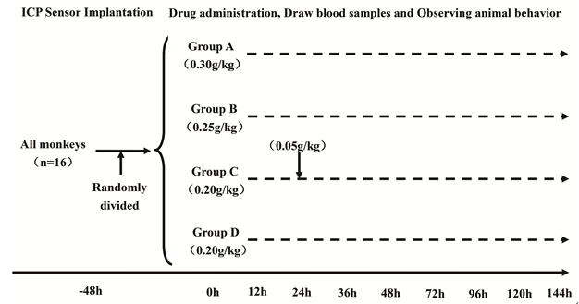
Figure 1 Study design. All monkeys were randomly divided into four groups after ICP sensor implantation; the interval of D-gal administration to group C was 24 h. ICP: Intracranial pressure.

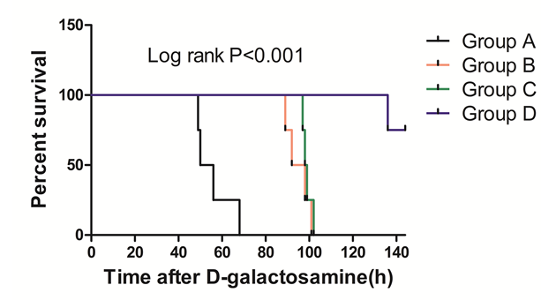
Figure 2 Survival times of study groups. Group A vs group B: P = 0.007; group A vs group C: P = 0.007; Group A vs group D: P < 0.001; Group B vs group C: P = 0.375.

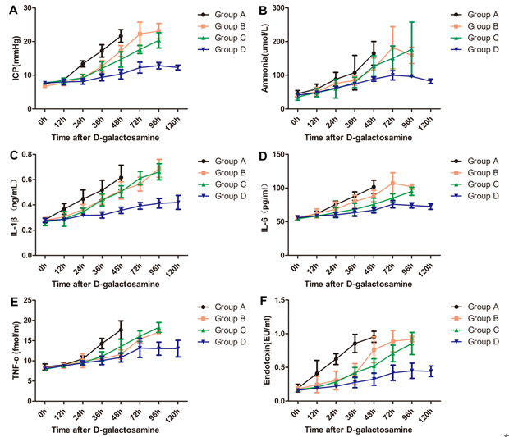
Figure 3 Changes of intracranial pressure, ammonia, inflammation markers and endotoxin at different time points in each group. All data points are mean ± SD, n = 4. ICP: Intracranial Pressure; Amm: Ammonia; IL-1β: Interleukin-1β; IL-6: Interleukin-6; TNF-α: Tumor Necrosis Factor-α.

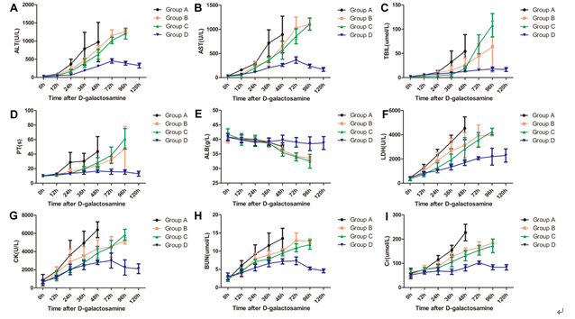
Figure 4 Changes of biochemical indices at different time points in each group. All data points are mean ± SD, n = 4. ALT: Alanine aminotransferase; AST: Aspartate aminotransferase; TBIL: Total bilirubin; PT: Prothrombin time; ALB: Albumin; LDH: Lactic dehydrogenase; CK: Creatine kinase; BUN: Blood urea nitrogen; Cr: Creaninine.

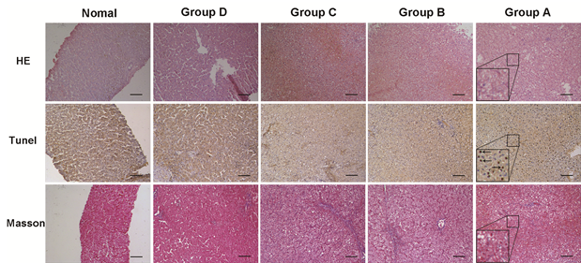
Figure 5 H&E staining, Tunel and Masson assays of post-mortem liver specimens from different groups. H&E: hematoxylin-eosin staining; Tunel: terminal -deoxynucleotidyl transferase mediated nick end labeling; Arrows: apoptotic bodies. Lower left corner detail: enlarged scale for group A (× 100 magnification, 200 μm scale bars).

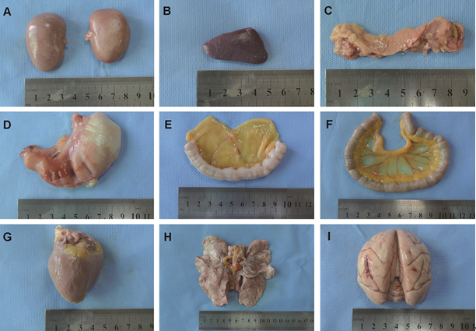
Figure 6 Gross specimens of other organs post-mortem (in group C). A: Renal; B: Spleen; C: Pancreas; D: Stomach; E: Large intestine; F: Small intestine；G: Heart; H: Lung; I: Brain.

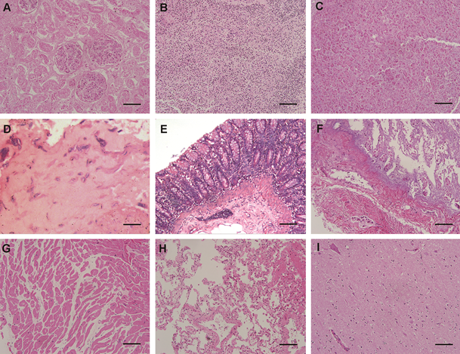
Figure 7 HE staining of other organs post-mortem (in group C). A: The renal tissue profile was clear, and the glomerular capillaries and renal interstitial blood vessels were slightly dilated and congested; B: The splenic sinusoids were mildly to moderately expanded with a large number of red blood cells; C: Pancreas, no abnormalities; D: Stomach, no abnormalities; E: Large intestine, no abnormalities; F: Small intestine, no abnormalities; G: Heart, no abnormalities; H: Lung, the bronchial and alveolar structures of pulmonary tissues were complete, and the interstitial capillaries were diffusely expanded and congested with few red blood cells; I: Brain, the nerve cells were diffusely enlarged with mild degenerative changes (× 100 magnification, 200 μm scale bars).

Table 1 The general condition of cynomolgus monkeys before drug administration
No. | Age  (yr) | Weight  (kg) | Sexual  (F/M) | Dose  (g/kg) | BP  (mmHg) | T  (℃) | Amm  (umol/L) | PT  (s)
1 | 6.0 | 9.5 | M | 0.20 | 110/68 | 37.3 | 37 | 10.3
2 | 9.0 | 10.2 | M | 0.25 | 101/76 | 37.0 | 43 | 10.7
3 | 7.5 | 9.4 | M | 0.20 | 108/79 | 36.3 | 41 | 11.3
4 | 8.0 | 9.8 | M | 0.30 | 100/58 | 36.4 | 37 | 10.5
5 | 6.5 | 9.4 | M | 0.30 | 121/54 | 36.5 | 41 | 10.3
6 | 8.5 | 11.0 | M | 0.25 | 104/70 | 37.9 | 41 | 11.7
7 | 6.5 | 9.7 | M | 0.20+0.05 | 123/67 | 36.6 | 49 | 10.2
8 | 7.0 | 9.6 | M | 0.25 | 123/74 | 36.9 | 46 | 10.6
9 | 8.5 | 10.4 | M | 0.30 | 103/56 | 36.6 | 45 | 9.5
10 | 9.0 | 10.6 | M | 0.20 | 102/79 | 37.4 | 39 | 9.6
11 | 8.5 | 10.3 | M | 0.25 | 116/64 | 36.6 | 34 | 10.0
12 | 9.0 | 10.7 | M | 0.20+0.05 | 113/77 | 36.7 | 29 | 9.9
13 | 7.8 | 10.3 | M | 0.30 | 105/73 | 37.4 | 58 | 10.2
14 | 6.5 | 11.0 | M | 0.20+0.05 | 118/67 | 36.6 | 32 | 9.8
15 | 7.5 | 9.5 | M | 0.20 | 112/69 | 37.3 | 45 | 9.8
16 | 8.5 | 10.1 | M | 0.20+0.05 | 113/63 | 36.8 | 31 | 9.9
F: Female; M: Male; BP: Blood Pressure; T: Body Temperature; Amm: Ammonia; PT: Prothrombin Time.

