Name of Journal: World Journal of Diabetes
Manuscript NO: 79615
Manuscript Type: MINIREVIEWS

Advances in microfluidic chips based on islet hormone-sensing techniques

Li W et al. Advances in islet secretome microfluidic chips

Wei Li, You-Fan Peng

Wei Li, Department of Endocrinology, Suzhou Hospital of Anhui Medical University, Suzhou 234000, Anhui Province, China

You-Fan Peng, Department of Respiratory and Critical Care Medicine, The Affiliated Hospital of Youjiang Medical University for Nationalities, Baise 533000, Guangxi Zhuang Autonomous Region, China

Author contributions: Li W and Peng YF designed the study; Li W wrote the manuscript; Li W and Peng YF revised the manuscript; and all authors approved the final version of the manuscript.

Supported by the Project of Suzhou Hospital of Anhui Medical University, No. 2020A1; and Natural Science Project of North Anhui Health Vocational College, No. WZK201907.

Corresponding author: You-Fan Peng, MD, PhD, Department of Respiratory and Critical Care Medicine, The Affiliated Hospital of Youjiang Medical University for Nationalities, No. 18 Zhongshan Er Road, Baise 533000, Guangxi Zhuang Autonomous Region, China. youfanpeng@yeah.net

Received: August 29, 2022
Revised: November 11, 2022
Accepted: December 7, 2022
Published online:

Abstract
Diabetes mellitus is a global health problem resulting from islet dysfunction or insulin resistance. The mechanisms of islet dysfunction are still under investigation. Islet hormone secretion is the main function of islets, and serves an important role in the homeostasis of blood glucose. Elucidating the detailed mechanism of islet hormone secretome distortion can provide clues for the treatment of diabetes. Therefore, it is crucial to develop accurate, real-time, labor-saving, high-throughput, automated, and cost-effective techniques for the sensing of islet secretome. Microfluidic chips, an elegant platform that combines biology, engineering, computer science, and biomaterials, have attracted tremendous interest from scientists in the field of diabetes worldwide. These tiny devices are miniatures of traditional experimental systems with more advantages of time-saving, reagent-minimization, automation, high-throughput, and online detection. These features of microfluidic chips meet the demands of islet secretome analysis and a variety of chips have been designed in the past 20 years. In this review, we present a brief introduction of microfluidic chips, and three microfluidic chips-based islet hormone sensing techniques. We focus mainly on the theory of these techniques, and provide detailed examples based on these theories with the hope of providing some insights into the design of future chips or whole detection systems.

Key Words: Microfluidic chips; Islet hormone; Secretome; Diabetes; Sensing

Li W, Peng YF. Advances in microfluidic chips based on islet hormone-sensing techniques. World J Diabetes 2022; In press

Core Tip: Islet hormone secretome distortion is one of the main mechanisms of diabetes mellitus. How to detect the islet secretome in an accurate, real-time, labor-saving, high-throughput, automated, and cost-effective way is still challenging. Microfluidic chip technique has become popular and has demonstrated great advantages in hormone sensing and shown huge potential in resolving the above challenge. Here, we discuss three elegant microfluidic chips-based islet hormone-sensing techniques.

INTRODUCTION
Diabetic mellitus is a global disease involving one-tenth of adults worldwide^{[1]}, and is mainly caused by insulin deficiency or insulin acting deficiency. This distortion of islet secretion results in the elevation of blood glucose levels, which subsequently leads to diabetic complications including diabetic nephropathy, retinopathy, neuropathy, foot and cardiovascular diseases^{[2]}. The International Diabetes Federation estimates that the number of diabetic patients will reach783 million by 2045^{[1]}. These data revealed the necessity for clinical and basic research to further elucidate the mechanism of diabetes and islet function.
Langerhans islets are round or ellipse-shaped three-dimensional (3D) structures, which are randomly distributed in the pancreas and account for 1% to 2% of the total pancreas mass^{[3]}. These microscale structures composed of α, β, δ, PP, and ε cells have a diameter ranging from 50 μm to 500 μm, and play a pivotal role in the regulation of blood glucose by the secretion of insulin and glucagon^{[4]}. Apart from these two glucose-regulating hormones, amylin, somatostatin, and ghrelin can also be secreted by islets in response to various metabolic changes^{[5]}. The collection of multifarious hormones secreted by the islets can be defined as the islet secretome^{[6]}. This islet secretome, which is involved in a multitude of biological processes, was recently accepted in the clinical or basic research area for the identification of novel biomarkers or therapeutic targets^{[7]}.
Islet perfusion, as a classical method for the study of islet secretome, has been widely accepted around the world^{[8]}. There are some commercial platforms for determining islet perfusion such as the Biorep islet perfusion system^{[9]} or Brandel Suprafusion system^{[10]}. With the assistance of these systems, the dynamics of islet hormone release can be explored in a time-resolved manner. However, these platforms still have some limitations: (1) A number of islets need to be pooled together to achieve a measurable concentration of islet secretions; thus, the secretome at a single islet level is not practical; (2) The supernatant collected by these platforms is usually measured by the traditional enzyme linked immunosorbent assay or a radioimmunoassay in a delayed manner, and these measurements are just a rough reflection of islet secretome in time resolution; and (3) The procedure for these platforms is often time-consuming and laborious. Given the above shortcomings, a more delicate and innovative tool with a high resolution reflecting the real-time islet secretome is necessary for understanding islet secretome physiology and pathophysiology.

MICROFLUIDIC CHIPS
With the development of new high technology, a platform named microfluidic chips or organ-on-a-chip system has been developed. Microfluidic chips, usually referred to as a system or device with a designed pattern of micro-channels, which allow fluids to pass through to fulfill different types of research needs such as cell culture, organ-on-a-chip simulation, secretion analysis, and shear stress simulation^{[11]}.
The history of microfluidic chips dates back to 1979 with the invention of a microscale gas chromatography system using photolithography and an etching technique^{[12]}. Then in 1990, the concept of “miniaturized Total Analysis System (μTAS)” was first proposed by Manz et al^{[13]}, drawing knowledge from the integrated circuit. The investigator demonstrated the potential of the microfluidic chips technique and introduced a method for the future development of μTAS. Subsequently, with the support of the Defense Advanced Projects Research Agency and the human genome project, the first generation of glass chips was developed in 1994 for DNA sequencing and hugely improved the speed and efficiency of the sequencing technique^{[14]}. Six years later, poly(dimethylsiloxane) (PDMS) was introduced to microfluidic chips because of its economical, convenient, optical transparent, nontoxic, elastomeric, surface modifiable advantages, and easiness to bond with a wide range of materials^{[15]}. Thereafter, PDMS became the most popular material in microfluidic chips. With the rapid expansion of this area, numerous novel microfluidic chips such as droplet microfluidics^{[16]}, paper microfluidics^{[17]}, open microfluidics^{[18]}, and organ-on-a-chip^{[19]} systems were developed in this field. The brilliance of these ingenious chips is beyond the scope of this review, a more dedicated and splendid summary by Convery and Gadegaard^{[20]} may offer more inspirations. With the rapid advances in 3D printing techniques, especially the Stereo Lithography Appearance strategy^{[21]}, this technique fully meets the demands of resolution required for the manufacture of microfluidics. In 2002, Cooper first described the fabrication of microfluidic devices with PDMS using the solid-object printer, and this method gives the lowest resolution of 250 μm^{[22]}. The low cost, time-saving, high precision of 3D structures, and surface finishing features of 3D printing were soon popularized in the field of microfluidic chips^{[23]}. In addition, some commercial 3D printers with ultra-high resolution^{[24]} (2 μm, nanoArch S130; BMF Precision Tech Inc., Chongqing, China) further narrowed the gap between 3D printing and the traditional soft lithography fabrication technique.
Compared with traditional analytical platforms, the advantages of microfluidic chips are obvious. First, because of the microscale of miniaturized systems, the Reynolds number (Re) is usually less than 2000^{[25]}. This Re means the fluid in these systems demonstrates a laminar flow state with high predictability in mathematical modeling in some commercial software such as COMSOL Multiphysics. Second, the minimized channels provide a decreased diffusion time in an exponential manner^{[26]}, which guarantees an excellent mix efficiency and reduced reaction time. Third, the reduced size of these microsystems requires less reaction buffer, which markedly decreases the need for expensive reagents. Apart from the above benefits, the optical transparent feature of microfluidic chips provides an outstanding platform for detections based on optical measurements. The advantages summarized here are just a glimpse of the benefits for these systems. With the advances in prospective studies, systems with increasingly convenient features such as continuous flow culture^{[27]}, 3D culture^{[28]}, and electrochemical sensor coupling^{[29-31]} have been sequentially developed.
Possessing these advantages, microfluidic chips seem to be a promising platform for the study of islet function. Over the last 20 years, numerous microfluidic chips have been designed for islet study, which have involved islet separation^{[32,33]}, islet imaging^{[34]}, islet hormone monitoring^{[35]}, islet microencapsulation^{[36]}, islet adenoviral transduction^{[37]}, and pseudoislet formation^{[28]}. This review focuses on the islet secretome-sensing techniques based on microfluidic chips.

CAPILLARY ELECTROPHORESIS-BASED TECHNIQUE
In 2003, the first microfluidic chip for islet insulin detection was designed by Roper et al^{[38]} in the University of Michigan. Their study reported a chip using the electrokinetic injection technique^{[39]}. This chip consisted of the fluid channel and the electrical circuit (Figure 1A, the solid black line represents the fluid channel and the blue dashed line indicates the electrical circuit). In microfluidic chips, the islet, insulin antibody, and fluorescein isothiocyanate-labeled (FITC)-insulin port are grounded. The waste channel is connected to a negative high voltage. The voltage of the gate port is floated by a computer-controlled high-voltage relay with the relay off for 10 s and on for 1 s periodically. The operation procedure for the microfluidic chip can be summarized as follows: A single islet is loaded into the islet port, and the supernatant of the islet together with insulin antibody as well as FITC-insulin flow into the reaction channel at the crossroad on the chip (Figure 1A, red dashed circle). When the relay is off or the gate port connects with the ground, the electrical field will push the sample fluid (Figure 1B, upper left, white fluid) from the reaction channel to the waste channel, then the relay is opened for 1 s, thus changing the electric potential difference between the gate port and waste port allowing about 100 pL of the sample fluid to enter the separation channel (Figure 1B, middle panel). Then the relay is closed again and the sample fluid in the separation channel is excited by a 488 nm Ar⁺ laser, and the emission light is collected for the calculation of insulin content. As the insulin secreted by the islet competes with FITC-insulin for the insulin antibody, the concentration in the islet insulin can be reflected by the ratio of emission peak of FITC-insulin-antibody to FITC-insulin (B/F). The relationship between B/F and insulin is modeled by a four-parameter logistic equation with an excellent fitting efficiency for islet insulin even in real-time. A more detailed protocol for this chip can be found in Lu and Kennedy^{[40]}.
Based on the above theory, Kennedy’s group subsequently developed a series of similar chips. In 2005, this electrophoresis islet chip was applied to quantitatively monitor the classical biphasic and oscillatory insulin secretion in a single islet online^{[41]}. Then the more complicated and highly integrated electrophoresis-based chips were separately developed, making the secretome analysis of 4 islets^{[42]} or 15 islets^{[43]} in parallel possible. This chip was then further employed for the online measurement of glucagon in 2012^{[44]}. Next, Guillo and Roper^{[45]} upgraded this chip for the measurement of both glucagon and insulin, both islet amyloid polypeptide (IAPP) and insulin^{[46]}, and insulin, glucagon and IAPP^{[47]} simultaneously using a multicolor-labeled method.
By summarizing these achievements, the advantages of electrophoresis-based islet microfluidic chips are as follows: A real-time measurement of islet secretome, single analysis of islet secretome in parallel, high automation by computer-assisted programs, simultaneous detection of multiple islet hormones by applying different fluorophore-labeled substrates, and long-term monitoring of the islet secretome^{[48]}. Despite the various advantages mentioned above, the shortcomings of the devices should also be noted such as: A deep understanding of fluid operation, circuit design, and computer-assisted programming is needed for this system, which limits the popularization of this chip; and the influence of the electrical field on islet function and antibody combination should be considered.

FLUORESCENCE ANISOTROPY METHODS
Fluorescence anisotropy also known as fluorescence polarization is a measurement of the changing orientation of a molecule after excitation by linearly polarized light^{[49]}. By measuring the orientation change, it can reflect the concentration of molecule. This phenomenon has been applied in the detection of antigens and antibodies for decades^{[50]}. However, the theory of this method is not complicated.
Figure 2 gives a detailed example of how fluorescence anisotropy is applied in the measurement of insulin concentration^{[51]}. As shown in Figure 2, when only FITC-labeled insulin exists or insulin antibodies are all occupied by islet secreted insulin, the FITC-labeled insulin will generate a high rotation angle (because of low molar volume) and an opposite anisotropy value with excitation by linearly polarized light. The rotation or anisotropy: Can be calculated by the parallel, and perpendicular emission fluorescence intensities sensed by photomultiplier tubes (Figure 2) using Perrin’s equation^{[52]}:
$r=\frac{I_{||}-I_{┴}}{I_{||}+2I_{┴}}$ (1)
Where I|| represents the parallel emission fluorescence intensity and I┴ represents the perpendicular emission fluorescence intensity. When the FITC-labeled insulin is all combined with the antibodies or there is no unlabeled insulin, the rotation angle will be smallest with a large anisotropy value. The third state is when the insulin antibodies are both combined with a proportion of free insulin (p_{f}) and another proportion of fluorophore-labeled insulin (p_{c}, c represents the complex of FITC-ins-Ab). The total anisotropy (r_{t}) is a linear combination of anisotropy of Ab-FITC-labeled insulin (r_{c}) and the anisotropy of free FITC-labeled insulin. The equation for anisotropy is as follows:
$r_{t}=p_{f}r_{f}+p_{c}r_{c}$ (2)
Where p_{f} and p_{c} are the proportion of free FITC-labeled insulin and the proportion of Ab-FITC-labeled insulin, respectively. According to this equation, there should be a unique mapping relationship between r_{t} and the non-labeled insulin concentration.
According to the above theory, Schrell et al^{[53]} first designed a gravity-based microfluidic chip for online monitoring of insulin secretion, by utilizing this theory, this chip achieved a 4 nM limit of insulin detection with < 1% relative standard deviation of anisotropy value. Then in 2019, Glieberman et al^{[51]} at Harvard University developed a more complicated two-layer chip for islet loading, trapping, shunting, stimulating and online insulin sensing, a maximum of 16 islets are allowed in the chip and the secretome is measured using FITC-labeled insulin. As anisotropy is highly determined by fluorophore lifetime, different fluorophores will generate different anisotropy ranges and varied detection resolution. Adablah, in the same group as Schrell, replaced the Cy5 with SeTAu-647 characterized by a longer lifetime and higher brightness, and the alteration resulted in a 45% increase in anisotropy range and a significant improvement in signal-to-noise ratio^{[54]}. With the development of this technology, a highly integrated chip for separately sensing up to 12 islet secretomes was designed by Wang et al^{[55]}, this integration ensures the possibility of high-throughput single islet secretome monitoring, and the procedure for islet heterogeneity study is markedly simplified.
The advantages of fluorescence anisotropy-based chip technology are generally similar to electrophoresis-based methods. However, there is no complicated electrical circuit and separation step in fluorescence anisotropy-based chip technology; thus, it is more convenient and time-saving. Therefore, the future development direction may be the multicolor and high-throughput anisotropy measurement technique.

LOCALIZED SURFACE PLASMON RESONANCE SENSING TECHNIQUE
Localized surface plasmon resonance (LSPR) is a physical phenomenon where metal nanoparticles will resonate by a light wave under the conditions of: The wavelength of light is larger than the diameter of nanoparticles; and the frequency of light is equal to the oscillation frequency of nanoparticles^{[56]}. This resonant frequency is strongly correlated with nanoparticle size, geometry, material, dielectric environment, and particle-particle separation distance^{[57]}. In addition, this resonant phenomenon can trap light and generate a special scattering spectrum. Tiny changes of nanoparticles such as a combination of antigen to antibody conjugated nanoparticles will cause a spectral shift^{[58]} (Figure 3A). This spectral shift is strongly correlated with the determinant’s concentration. By measuring the peak LSPR wavelength, the spectral shift can be easily calculated. The equation used to calculate peak LSPR^{[56]} is as follows:
$λ_{max}=λ_{p}\sqrt{2ε_{m}+1}$ (3)
Where λ_{max} is the LSPR peak wavelength and ε_{m} represents a dielectric constant of metal nanoparticles. This ε_{m} is changeable according to the surface modification of the nanoparticles. When the nanoparticles are combined with biomolecules, the ε_{m} changes causing a shift in λ_{max}. By measuring the shift, the concentration of the biomolecules can be modeled. Applying this theory, numerous biomolecules including DNA^{[59]} and protein^{[60,61]} can be measured.
Ortega et al^{[62]} reported the first, and currently only, application of LSPR in insulin sensing. In this study, the two-chip combined system was designed, this system contains an islet trapping/perfusion chip and LSPR-based online insulin detection chip, the islets are trapped in the islet-trapping chip by a cellulose-based cryogel skeleton and perfused by stimulus, the islet secretions flow into the LSPR chip^{[61]}, which contains insulin antibody coupled to a gold nanoparticle array and insulin concentrations are observed in a real-time readout by measuring the spectral shift (Figure 3B).
Although LSPR-based islet hormone-sensing microfluidics is in the initial stage, the future of this technique is very promising. Unlike traditional fluorescence-based methods, the plasmonics of metal nanoparticles are photobleached thus making it a robust label for immunoassays^{[63]}. In addition, nanoparticles are small enough to be easily arranged into different arrays and can be labeled with different antibodies, enabling high-throughput and multiparametric measurements^{[60,64]}. With meticulous design and further study, LSPR-based chips will soon become prominent in islet studies.

CONCLUSION
In this review, several microfluidic chips based on islet hormone detection systems are described and discussed. Although these techniques are not widely used as the learning curve is relatively steep, but with advances in high-resolution 3D printers, it has become easier and more cost-effective to design and manufacture microfluidic chips. With the assistance of modularized circuits such as Arduino, the automation of these chips and the detection can be designed to provide more efficiency even in small laboratories. These breakthroughs have greatly liberated scientists from traditional manual and time-consuming procedures, and have brought islet secretome analysis into the high-throughput era. Combining genomics, proteomics, bioinformatics, and other technologies, we will further unravel the mysteries of islets and diabetes.

REFERENCES
1 International Diabetes Federation. IDF Diabetes Atlas, 10th ed. Brussels, Belgium: International Diabetes Federation, 2021
2 Zheng Y, Ley SH, Hu FB. Global aetiology and epidemiology of type 2 diabetes mellitus and its complications. Nat Rev Endocrinol 2018; 14: 88-98 [PMID: 29219149 DOI: 10.1038/nrendo.2017.151]
3 Ionescu-Tirgoviste C, Gagniuc PA, Gubceac E, Mardare L, Popescu I, Dima S, Militaru M. A 3D map of the islet routes throughout the healthy human pancreas. Sci Rep 2015; 5: 14634 [PMID: 26417671 DOI: 10.1038/srep14634]
4 Jansson L, Barbu A, Bodin B, Drott CJ, Espes D, Gao X, Grapensparr L, Källskog Ö, Lau J, Liljebäck H, Palm F, Quach M, Sandberg M, Strömberg V, Ullsten S, Carlsson PO. Pancreatic islet blood flow and its measurement. Ups J Med Sci 2016; 121: 81-95 [PMID: 27124642 DOI: 10.3109/03009734.2016.1164769]
5 Walker JT, Saunders DC, Brissova M, Powers AC. The Human Islet: Mini-Organ With Mega-Impact. Endocr Rev 2021; 42: 605-657 [PMID: 33844836 DOI: 10.1210/endrev/bnab010]
6 Agrawal GK, Jwa NS, Lebrun MH, Job D, Rakwal R. Plant secretome: unlocking secrets of the secreted proteins. Proteomics 2010; 10: 799-827 [PMID: 19953550 DOI: 10.1002/pmic.200900514]
7 Castiello FR, Heileman K, Tabrizian M. Microfluidic perfusion systems for secretion fingerprint analysis of pancreatic islets: applications, challenges and opportunities. Lab Chip 2016; 16: 409-431 [PMID: 26732665 DOI: 10.1039/c5lc01046b]
8 Shao JQ, Gu P, DU H, Lu B, Peng L, Li J, Wang YY, Zhao M, Wang J. [Islet perifusion: a new method to evaluate first-phase insulin secretory function of beta-cell in vitro]. Zhonghua Yi Xue Za Zhi 2010; 90: 119-122 [PMID: 20356497]
9 Cabrera O, Jacques-Silva MC, Berman DM, Fachado A, Echeverri F, Poo R, Khan A, Kenyon NS, Ricordi C, Berggren PO, Caicedo A. Automated, High-Throughput Assays for Evaluation of Human Pancreatic Islet Function. Cell Transplant 2007; 16: 1039-1048 [PMID: 28866924 DOI: 10.3727/000000007783472408]
10 Delle Donne KT, Sonsalla PK. Modifications of the Brandel Superfusion 600 system and other revisions in superfusion technique improve the measurement of endogenous dopamine release in vitro. J Neurosci Methods 1996; 68: 289-296 [PMID: 8912203 DOI: 10.1016/0165-0270(96)00095-7]
11 Feng X, Du W, Luo Q, Liu BF. Microfluidic chip: next-generation platform for systems biology. Anal Chim Acta 2009; 650: 83-97 [PMID: 19720178 DOI: 10.1016/j.aca.2009.04.051]
12 Terry SC, Jerman H, Angell JB. A gas chromatographic air analyzer fabricated on a silicon wafer. T-ED 1979; 26: 1880-1886 [DOI: 10.1109/T-ED.1979.19791]
13 Manz A, Graber N, Widmer HM. Miniaturized total chemical analysis systems: A novel concept for chemical sensing. Sens Actuator B Chem 1990; 1: 244-248 [DOI: 10.1016/0925-4005(90)80209-I]
14 Woolley AT, Mathies RA. Ultra-high-speed DNA fragment separations using microfabricated capillary array electrophoresis chips. Proc Natl Acad Sci U S A 1994; 91: 11348-11352 [PMID: 7972062 DOI: 10.1073/pnas.91.24.11348]
15 McDonald JC, Duffy DC, Anderson JR, Chiu DT, Wu H, Schueller OJ, Whitesides GM. Fabrication of microfluidic systems in poly(dimethylsiloxane). Electrophoresis 2000; 21: 27-40 [PMID: 10634468 DOI: 10.1002/(SICI)1522-2683(20000101)21:1<27::AID-ELPS27>3.0.CO;2-C]
16 Shang L, Cheng Y, Zhao Y. Emerging Droplet Microfluidics. Chem Rev 2017; 117: 7964-8040 [PMID: 28537383 DOI: 10.1021/acs.chemrev.6b00848]
17 Yetisen AK, Akram MS, Lowe CR. Paper-based microfluidic point-of-care diagnostic devices. Lab Chip 2013; 13: 2210-2251 [PMID: 23652632 DOI: 10.1039/c3lc50169h]
18 Kaigala GV, Lovchik RD, Delamarche E. Microfluidics in the "open space" for performing localized chemistry on biological interfaces. Angew Chem Int Ed Engl 2012; 51: 11224-11240 [PMID: 23111955 DOI: 10.1002/anie.201201798]
19 Bhatia SN, Ingber DE. Microfluidic organs-on-chips. Nat Biotechnol 2014; 32: 760-772 [PMID: 25093883 DOI: 10.1038/nbt.2989]
20 Convery N, Gadegaard N. 30 years of microfluidics. MNE 2019; 2: 76-91 [DOI: 10.1016/j.mne.2019.01.003]
21 Su A, Al’Aref SJ. History of 3D Printing. In: Al’Aref SJ, Mosadegh B, Dunham S, Min JK. 3D Printing Applications in Cardiovascular Medicine. Boston: Academic Press, 2018: 1-10
22 McDonald JC, Chabinyc ML, Metallo SJ, Anderson JR, Stroock AD, Whitesides GM. Prototyping of microfluidic devices in poly(dimethylsiloxane) using solid-object printing. Anal Chem 2002; 74: 1537-1545 [PMID: 12033242 DOI: 10.1021/ac010938q]
23 Phung SC, Zhu Q, Plevniak K, He M. 3D printed microfluidic devices and applications. In: Li X, Zhou Y. Microfluidic Devices for Biomedical Applications (Second Edition). Cambridge: Woodhead Publishing, 2021: 659-679
24 Li H, Zhang T. Imaging and characterizing fluid invasion in micro-3D printed porous devices with variable surface wettability. Soft Matter 2019; 15: 6978-6987 [PMID: 31432880 DOI: 10.1039/c9sm01182j]
25 Reynolds O. An Experimental Investigation of the Circumstances Which Determine Whether the Motion of Water Shall Be Direct or Sinuous, and of the Law of Resistance in Parallel Channels. Phil Trans 1883; 35: 84-99 [DOI: 10.1098/rspl.1883.0018]
26 Fan J, Li S, Wu Z, Chen Z. Diffusion and mixing in microfluidic devices. In: Santos HA, Liu D, Zhang H. Microfluidics for Pharmaceutical Applications. Norwich: William Andrew Publishing, 2019: 79-100
27 Jun Y, Lee J, Choi S, Yang JH, Sander M, Chung S, Lee SH. In vivo-mimicking microfluidic perfusion culture of pancreatic islet spheroids. Sci Adv 2019; 5: eaax4520 [PMID: 31807701 DOI: 10.1126/sciadv.aax4520]
28 Tao T, Wang Y, Chen W, Li Z, Su W, Guo Y, Deng P, Qin J. Engineering human islet organoids from iPSCs using an organ-on-chip platform. Lab Chip 2019; 19: 948-958 [PMID: 30719525 DOI: 10.1039/c8lc01298a]
29 Yáñez-Sedeño P, Campuzano S, Pingarrón JM. Multiplexed Electrochemical Immunosensors for Clinical Biomarkers. Sensors (Basel) 2017; 17 [PMID: 28448466 DOI: 10.3390/s17050965]
30 Chikkaveeraiah BV, Bhirde AA, Morgan NY, Eden HS, Chen X. Electrochemical immunosensors for detection of cancer protein biomarkers. ACS Nano 2012; 6: 6546-6561 [PMID: 22835068 DOI: 10.1021/nn3023969]
31 Singh A, Kaushik A, Kumar R, Nair M, Bhansali S. Electrochemical sensing of cortisol: a recent update. Appl Biochem Biotechnol 2014; 174: 1115-1126 [PMID: 24723204 DOI: 10.1007/s12010-014-0894-2]
32 Nam KH, Yong W, Harvat T, Adewola A, Wang S, Oberholzer J, Eddington DT. Size-based separation and collection of mouse pancreatic islets for functional analysis. Biomed Microdevices 2010; 12: 865-874 [PMID: 20549367 DOI: 10.1007/s10544-010-9441-2]
33 Varhue WB, Langman L, Kelly-Goss M, Lataillade M, Brayman KL, Peirce-Cottler S, Swami NS. Deformability-based microfluidic separation of pancreatic islets from exocrine acinar tissue for transplant applications. Lab Chip 2017; 17: 3682-3691 [PMID: 28975176 DOI: 10.1039/c7lc00890b]
34 Lee D, Wang Y, Mendoza-Elias JE, Adewola AF, Harvat TA, Kinzer K, Gutierrez D, Qi M, Eddington DT, Oberholzer J. Dual microfluidic perifusion networks for concurrent islet perifusion and optical imaging. Biomed Microdevices 2012; 14: 7-16 [PMID: 21850483 DOI: 10.1007/s10544-011-9580-0]
35 Ozhikandathil J, Badilescu S, Packirisamy M. A brief review on microfluidic platforms for hormones detection. J Neural Transm (Vienna) 2017; 124: 47-55 [PMID: 27567900 DOI: 10.1007/s00702-016-1610-x]
36 Tendulkar S, McQuilling JP, Childers C, Pareta R, Opara EC, Ramasubramanian MK. A scalable microfluidic device for the mass production of microencapsulated islets. Transplant Proc 2011; 43: 3184-3187 [PMID: 22099752 DOI: 10.1016/j.transproceed.2011.10.023]
37 Wang X, Yi L, Roper MG. Microfluidic Device for the Measurement of Amino Acid Secretion Dynamics from Murine and Human Islets of Langerhans. Anal Chem 2016; 88: 3369-3375 [PMID: 26891222 DOI: 10.1021/acs.analchem.6b00071]
38 Roper MG, Shackman JG, Dahlgren GM, Kennedy RT. Microfluidic chip for continuous monitoring of hormone secretion from live cells using an electrophoresis-based immunoassay. Anal Chem 2003; 75: 4711-4717 [PMID: 14674445 DOI: 10.1021/ac0346813]
39 Ermakov SV, Jacobson SC, Ramsey JM. Computer simulations of electrokinetic injection techniques in microfluidic devices. Anal Chem 2000; 72: 3512-3517 [PMID: 10952536 DOI: 10.1021/ac991474n]
40 Lu S, Kennedy RT. Using Electrophoretic Immunoassay to Monitor Hormone Secretion. Methods Mol Biol 2017; 1547: 57-67 [PMID: 28044287 DOI: 10.1007/978-1-4939-6734-6_5]
41 Shackman JG, Dahlgren GM, Peters JL, Kennedy RT. Perfusion and chemical monitoring of living cells on a microfluidic chip. Lab Chip 2005; 5: 56-63 [PMID: 15616741 DOI: 10.1039/b404974h]
42 Dishinger JF, Kennedy RT. Serial immunoassays in parallel on a microfluidic chip for monitoring hormone secretion from living cells. Anal Chem 2007; 79: 947-954 [PMID: 17263320 DOI: 10.1021/ac061425s]
43 Dishinger JF, Reid KR, Kennedy RT. Quantitative monitoring of insulin secretion from single islets of Langerhans in parallel on a microfluidic chip. Anal Chem 2009; 81: 3119-3127 [PMID: 19364142 DOI: 10.1021/ac900109t]
44 Shackman JG, Reid KR, Dugan CE, Kennedy RT. Dynamic monitoring of glucagon secretion from living cells on a microfluidic chip. Anal Bioanal Chem 2012; 402: 2797-2803 [PMID: 22286080 DOI: 10.1007/s00216-012-5755-7]
45 Guillo C, Roper MG. Two-color electrophoretic immunoassay for simultaneous measurement of insulin and glucagon content in islets of Langerhans. Electrophoresis 2008; 29: 410-416 [PMID: 18080249 DOI: 10.1002/elps.200700399]
46 Lomasney AR, Yi L, Roper MG. Simultaneous monitoring of insulin and islet amyloid polypeptide secretion from islets of Langerhans on a microfluidic device. Anal Chem 2013; 85: 7919-7925 [PMID: 23848226 DOI: 10.1021/ac401625g]
47 Guillo C, Truong TM, Roper MG. Simultaneous capillary electrophoresis competitive immunoassay for insulin, glucagon, and islet amyloid polypeptide secretion from mouse islets of Langerhans. J Chromatogr A 2011; 1218: 4059-4064 [PMID: 21620410 DOI: 10.1016/j.chroma.2011.05.006]
48 Reid KR, Kennedy RT. Continuous operation of microfabricated electrophoresis devices for 24 hours and application to chemical monitoring of living cells. Anal Chem 2009; 81: 6837-6842 [PMID: 19621896 DOI: 10.1021/ac901114k]
49 Lakowicz JR. Principles of Fluorescence Spectroscopy, 3rd ed. New York: Springer, 2006; 53-382
50 Jameson DM, Ross JA. Fluorescence polarization/anisotropy in diagnostics and imaging. Chem Rev 2010; 110: 2685-2708 [PMID: 20232898 DOI: 10.1021/cr900267p]
51 Glieberman AL, Pope BD, Zimmerman JF, Liu Q, Ferrier JP, Kenty JHR, Schrell AM, Mukhitov N, Shores KL, Tepole AB, Melton DA, Roper MG, Parker KK. Synchronized stimulation and continuous insulin sensing in a microfluidic human Islet on a Chip designed for scalable manufacturing. Lab Chip 2019; 19: 2993-3010 [PMID: 31464325 DOI: 10.1039/c9lc00253g]
52 Jablonski A. On the notion of emission anisotropy. 1960. [cited 10 July 2022]. Available from: https://kpbc.umk.pl//dlibra/metadatasearch?action=AdvancedSearchAction&type=-3&val1=Source:%22Bull.+Acad.+Polon.+Sci.%2C+Ser.+sci.+math.+astr.+phys.%2C+8%2C+259%5C-264+%5C(1960%5C)%22
53 Schrell AM, Mukhitov N, Yi L, Adablah JE, Menezes J, Roper MG. Online fluorescence anisotropy immunoassay for monitoring insulin secretion from islets of Langerhans. Anal Methods 2017; 9: 38-45 [PMID: 28458724 DOI: 10.1039/C6AY02899C]
54 Adablah JE, Wang Y, Donohue M, Roper MG. Profiling Glucose-Stimulated and M3 Receptor-Activated Insulin Secretion Dynamics from Islets of Langerhans Using an Extended-Lifetime Fluorescence Dye. Anal Chem 2020; 92: 8464-8471 [PMID: 32429660 DOI: 10.1021/acs.analchem.0c01226]
55 Wang Y, Adeoye DI, Wang YJ, Roper MG. Increasing insulin measurement throughput by fluorescence anisotropy imaging immunoassays. Anal Chim Acta 2022; 1212: 339942 [PMID: 35623790 DOI: 10.1016/j.aca.2022.339942]
56 Mayer KM, Hafner JH. Localized surface plasmon resonance sensors. Chem Rev 2011; 111: 3828-3857 [PMID: 21648956 DOI: 10.1021/cr100313v]
57 Liz-Marzán LM. Tailoring surface plasmons through the morphology and assembly of metal nanoparticles. Langmuir 2006; 22: 32-41 [PMID: 16378396 DOI: 10.1021/la0513353]
58 Frederix F, Friedt JM, Choi KH, Laureyn W, Campitelli A, Mondelaers D, Maes G, Borghs G. Biosensing based on light absorption of nanoscaled gold and silver particles. Anal Chem 2003; 75: 6894-6900 [PMID: 14670050 DOI: 10.1021/ac0346609]
59 Yoo SY, Kim DK, Park TJ, Kim EK, Tamiya E, Lee SY. Detection of the most common corneal dystrophies caused by BIGH3 gene point mutations using a multispot gold-capped nanoparticle array chip. Anal Chem 2010; 82: 1349-1357 [PMID: 20092310 DOI: 10.1021/ac902410z]
60 Yavas O, Aćimović SS, Garcia-Guirado J, Berthelot J, Dobosz P, Sanz V, Quidant R. Self-Calibrating On-Chip Localized Surface Plasmon Resonance Sensing for Quantitative and Multiplexed Detection of Cancer Markers in Human Serum. ACS Sens 2018; 3: 1376-1384 [PMID: 29947221 DOI: 10.1021/acssensors.8b00305]
61 Aćimović SS, Ortega MA, Sanz V, Berthelot J, Garcia-Cordero JL, Renger J, Maerkl SJ, Kreuzer MP, Quidant R. LSPR chip for parallel, rapid, and sensitive detection of cancer markers in serum. Nano Lett 2014; 14: 2636-2641 [PMID: 24730454 DOI: 10.1021/nl500574n]
62 Ortega MA, Rodríguez-Comas J, Yavas O, Velasco-Mallorquí F, Balaguer-Trias J, Parra V, Novials A, Servitja JM, Quidant R, Ramón-Azcón J. In Situ LSPR Sensing of Secreted Insulin in Organ-on-Chip. Biosensors (Basel) 2021; 11 [PMID: 33924867 DOI: 10.3390/bios11050138]
63 Choi Y, Kang T, Lee LP. Plasmon resonance energy transfer (PRET)-based molecular imaging of cytochrome c in living cells. Nano Lett 2009; 9: 85-90 [PMID: 19093833 DOI: 10.1021/nl802511z]
64 Chen JS, Chen PF, Lin HT, Huang NT. A Localized surface plasmon resonance (LSPR) sensor integrated automated microfluidic system for multiplex inflammatory biomarker detection. Analyst 2020; 145: 7654-7661 [PMID: 32966364 DOI: 10.1039/d0an01201g]

Footnotes
Conflict-of-interest statement: All the authors report no relevant conflicts of interest for this article.

Open-Access: This article is an open-access article that was selected by an in-house editor and fully peer-reviewed by external reviewers. It is distributed in accordance with the Creative Commons Attribution NonCommercial (CC BY-NC 4.0) license, which permits others to distribute, remix, adapt, build upon this work non-commercially, and license their derivative works on different terms, provided the original work is properly cited and the use is non-commercial. See: https://creativecommons.org/Licenses/by-nc/4.0/

Provenance and peer review: Invited article; Externally peer reviewed
Peer-review model: Single blind

Peer-review started: August 29, 2022
First decision: October 30, 2022
Article in press:

Specialty type: Endocrinology and metabolism
Country/Territory of origin: China
Peer-review report’s scientific quality classification
Grade A (Excellent): 0
Grade B (Very good): B
Grade C (Good): C, C
Grade D (Fair): 0
Grade E (Poor): 0

P-Reviewer: Dabbakuti JRKKK, India; Shalaby MN, Egypt S-Editor: Wang JJ L-Editor: Filipodia P-Editor:
Figure Legends
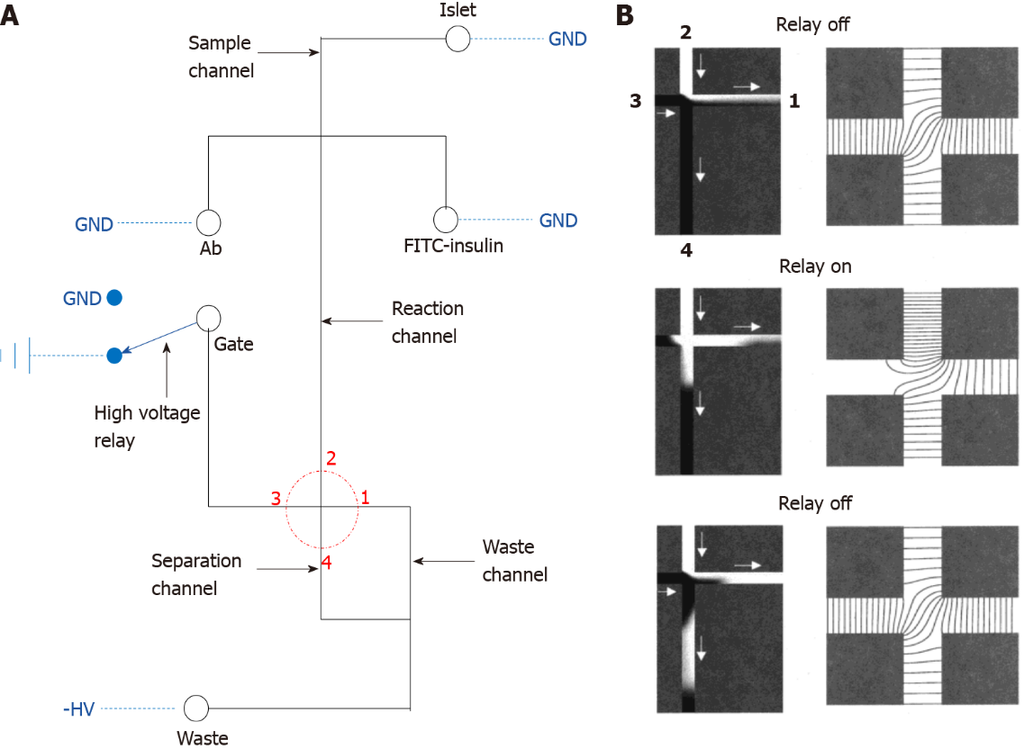
Figure 1 Diagram of the classical electrophoresis-based immunoassay microfluidic chip. A: The fluid channel and electric circuit on the microfluidic device. The solid black line represents the fluid channel and the blue dashed line indicates the electric connection, the fluid part consists of the sample, immunoassay buffer, gate and waste port, these ports are separately connected to the ground, high voltage relay or a negative high voltage, the red dotted circle highlights the key separation crossroad on the device; B: Larger image of the red dotted circle. The left panel represents the fluid simulation, white fluid represents the sample, black fluid represents the fluid from the gate port, and the right panel demonstrates the equipotential lines. GND: Ground. A: Citation: Roper MG, Shackman JG, Dahlgren GM, Kennedy RT. Microfluidic chip for continuous monitoring of hormone secretion from live cells using an electrophoresis-based immunoassay. Anal Chem 2003; 75: 4711-4717. Copyright© American Chemical Society 2003. Published by ACS Publications. The authors have obtained the permission for figure using from the American Chemical Society (Supplementary material); B: Citation: Ermakov SV, Jacobson SC, Ramsey JM. Computer simulations of electrokinetic injection techniques in microfluidic devices. Anal Chem 2000; 72: 3512-3517. Copyright© American Chemical Society 2000. Published by ACS Publications. The authors have obtained the permission for figure using from the American Chemical Society (Supplementary material).

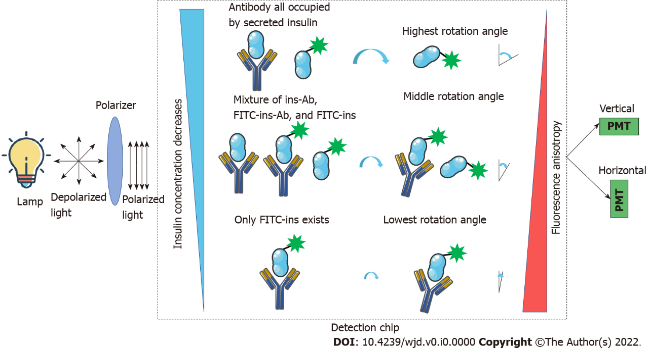
Figure 2 Theory of fluorescence anisotropy-based insulin sensing. The lamp generates depolarized light and goes through the polarizer, and after polarization, the polarized light is used as the excitation source for the fluorophores. Different concentrations of non-labeled insulin will compete with fluorescein isothiocyanate-labeled-insulin for insulin antibodies, thus, generating different fluorescence anisotropy which can be sensed by a vertical and horizontal photomultiplier. The sensed signal is used for the calculation of non-labeled insulin concentration. FITC: Fluorescein isothiocyanate; PMT: Photomultiplier.

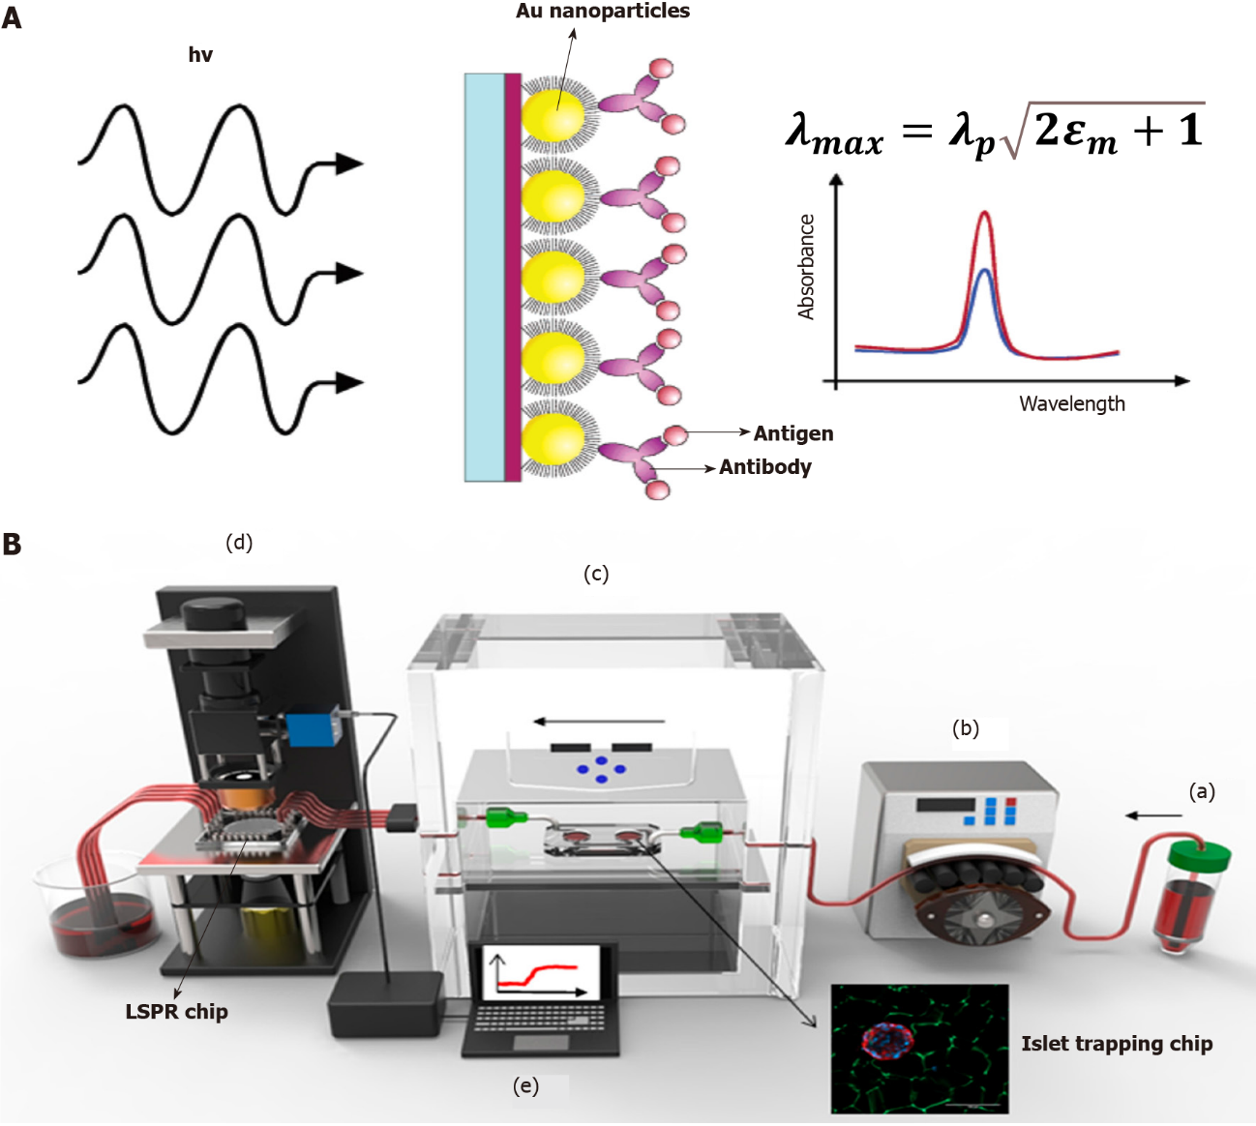
Figure 3 Localized surface plasmon resonance-based islet secretome sensing. A: Theory of localized surface plasmon resonance (LSPR) and spectral curve before and after antigen binding; B: A real-world system for online islet trapping, perfusion and islet secretome monitoring. In general, the perfusate is pumped into the islet trapping chip by the peristaltic pump, and islet secretions are pumped out to the LSPR chip for further measurement; a: Culture medium or perfusate for islets; b: Peristaltic pump provide force for buffer; c: Islet trapping chip with tissue culture module; d: The LSPR detection module for spectral shift signal capturing; e: Work station for real-time signal transducing. LSPR: Localized surface plasmon resonance. A: Citation: Frederix F, Friedt JM, Choi KH, Laureyn W, Campitelli A, Mondelaers D, Maes G, Borghs G. Biosensing based on light absorption of nanoscaled gold and silver particles. Anal Chem 2003; 75: 6894-6900. Copyright© American Chemical Society 2003. Published by ACS Publications. The authors have obtained the permission for figure using from the American Chemical Society (Supplementary material); B: Citation: Ortega MA, Rodríguez-Comas J, Yavas O, Velasco-Mallorquí F, Balaguer-Trias J, Parra V, Novials A, Servitja JM, Quidant R, Ramón-Azcón J. In Situ LSPR Sensing of Secreted Insulin in Organ-on-Chip. Biosensors (Basel) 2021; 11. Copyright© 2021 by the authors. Published by MDPI. No special permission is required to reuse all or part of article published by MDPI, including figures and tables (https://www.mdpi.com/openaccess).

