Name of Journal: World Journal of Clinical Pediatrics
ESPS Manuscript NO: 18778
Manuscript Type: REVIEW

Single-incision pediatric endosurgery in newborns and infants

Kozlov Y et al. Single-incision pediatric endosurgery in newborns and infants

Yury Kozlov, Vladimir Novozhilov, Polina Baradieva, Pavel Krasnov, Konstantin Kovalkov, Oliver J Muensterer

Yury Kozlov, Vladimir Novozhilov, Polina Baradieva, Pavel Krasnov, Department of Neonatal Surgery, Pediatric Hospital Irkutsk, 664009 Irkutsk, Russia

Yury Kozlov, Vladimir Novozhilov, Polina Baradieva, State Medical University Irkutsk, 664025 Irkutsk, Russia

Yury Kozlov, Vladimir Novozhilov, Polina Baradieva, Pavel Krasnov, State Medical Academy of Continuing Education Irkutsk, 664000 Irkutsk, Russia

Konstantin Kovalkov, Pediatric Hospital Kemerovo, 650056 Kemerovo, Russia

Oliver J Muensterer, Pediatric Surgery, University Medicine of the Johannes Gutenberg University, 55131 Mainz, Germany

Author contributions: All authors contributed to this manuscript.

Conflict-of-interest statement: No conflict-of-interest.

Open-Access: This article is an open-access article which was selected by an in-house editor and fully peer-reviewed by external reviewers. It is distributed in accordance with the Creative Commons Attribution Non Commercial (CC BY-NC 4.0) license, which permits others to distribute, remix, adapt, build upon this work non-commercially, and license their derivative works on different terms, provided the original work is properly cited and the use is non-commercial. See: http://creativecommons.org/licenses/by-nc/4.0/

Correspondence to: Yury Kozlov, MD, Department of Neonatal Surgery, Pediatric Hospital Irkutsk, 57 Sovetskaya Str, 664009 Irkutsk, Russia. yuriherz@hotmail.com
Telephone: +7-395-2291635
Fax: +7-395-2291566

Received: April 27, 2015
Peer-review started: April 29, 2015
First decision: May 19, 2015
Revised: September 27, 2015
Accepted: October 16, 2015
Article in press:
Published online:

Abstract
This study focuses on the successful application of single-incision pediatric endosurgery in the treatment of congenital anomalies and acquired diseases in neonates and infants. The purpose of this scientific review consists in highlighting the spectrum, indications, applicability, and effectiveness of single-port endosurgery in children during the first 3 postnatal months.

Key words: Laparoscopy; Neonates; Infants; Single-incision laparoscopic surgery; Single-incision pediatric endosurgery

© The Author(s) 2015. Published by Baishideng Publishing Group Inc. All rights reserved.

Core tip: Consequently, reports on a successful use of single-incision endosurgical technique in the treatment of congenital malformations and diseases in neonates and infants are still not numerous and often sporadic. Advanced skills and a high technical demand, along with the lack of specialized surgical equipment are factors limiting the popularity and availability of single-incision pediatric endosurgery (SIPES) for pediatric surgery in first 3 mo of life. However, the current body of evidence shows that a SIPES is indeed applicable in infants with outcome comparable to that of standard laparoscopy, and that it results in minimal post-operative surgical trauma and superb cosmesis.

Kozlov Y, Novozhilov V, Baradieva P, Krasnov P, Kovalkov K, Muensterer OJ. Single-incision pediatric endosurgery in newborns and infants. World J Clin Pediatr 2015; In press
INTRODUCTION
The success of minimally invasive surgery resulted in significant changes of operative techniques that are mutually beneficial for the patient as well as the surgeon. The reduction of postoperative discomfort, quicker recovery, and improved cosmetic results became ubiquitously known advantages of laparoscopic surgery. Laparoscopy and thoracoscopy have further evolved with the purpose of making the operation virtually scarless. The first single-incision endosurgical intervention was a tubal ligation performed by Wheeless^{[1]} in 1969. In the early nineteen nineties, Pelosi et al^{[2]} described the first single-incision laparoscopic appendectomy. A few years later, the first transumbilical endoscopic appendectomy was performed in a child^{[3]}. Single-site laparoscopic surgery developed in parallel to the idea of performing endoscopic surgery entirely via natural orifices (so-called natural orifice transluminal endoscopic surgery, abbreviated as NOTES) and appeared as an alternative to conventional, multi-port laparoscopy. NOTES involves extensive investment in expensive specialized equipment, and involves the risk of intra-abdominal infection due to access into the abdominal cavity via a usually colonized hollow viscus. To solve this problem, surgeons began using a natural embryonic orifice - the umbilicus - as a “door” to the abdominal cavity, giving rise to the development of single-incision endosurgery. Just a few years ago, single-port surgery has been limited to routine operations, including appendectomy and cholecystectomy. Later, a variety of innovative methods were developed on the basis of complex endosurgical procedures that include nephrectomy, splenectomy, adrenalectomy and intestinal resection and subsequent intracorporeal anastomoses^{[4-7]}. In children, the procedure was coined single-incision pediatric endosurgery or single-incision pediatric endosurgery (SIPES). SIPES is an alternative to triangulated multiport laparoscopy in the surgical therapy of a spectrum of entities. Despite an extensive use of single-incision endosurgery in adult patients, the implementation of this type of surgery for treating children was somewhat slower. A possible explanation is that pediatric minimally invasive techniques have historically lacked behind those of adults. Size-appropriate laparoscopic instrumentation for infants and children has been produced only by select companies due to the smaller potential market share and profit margins.

TERMINOLOGY AND DEFINITION
Currently, single-incision endosurgery is defined as minimally invasive surgery performed via a single incision in the abdomen, chest, or retroperitoneal space (Figure 1). Many terms have been used to describe this approach: The term Single-incision laparoscopic surgery (SILSTM) is quite prevalent, but has been trademarked by a large device company. To avoid any conflicts of interest, we generally avoid it. One-port umbilical surgery (OPUS)^{[8]}, transumbilical endoscopic surgery (TUES)^{[9]}, embryonic natural orifice transumbilical endoscopic surgery (e-NOTES)^{[10]} have been proposed. Other abbreviations are single-port access (SPA), laparoendoscopic single-site (LESS), single laparoscopic-incision transumbilical (SLIT) surgery. Nevertheless, many pediatric surgeons prefer of the abbreviation SIPES^{[11,12]} since this term comprises all laparoscopy, thoracoscopy, and retroperitoneoscopy performed in children by means of a single incision. It also is a clear statement that this type of surgery indeed is performed in children, and that device companies should make an effort to develop size-appropriate equipment for this special application.
Single-port endosurgery was employed in infants much later than in older children. This lag appeared due to misconceptions of surgeons concerning the fact that miniature but visible scars left after conventional pediatric laparoscopy, were perfectly acceptable for patients as well as for their parents. However, scars grow proportionally along with the individual, so that even small scars in infancy may translate into larger ones visible later in life. Moreover, some surgeons were very concerned about compromised maneuverability of endosurgical instruments in a small abdomen of neonates and infants. Despite this concern, pediatric surgeons explored surgical procedures in which SIPES may provide advantages superior to those of multiport access in infants. Soon enough, gastrostomy in children placed via a single access was proposed and compared favorably with the three-port technique^{[13]}.
Several pediatric surgical centers that use modern laparoscopy showed interest in SIPES and promptly expanded surgical indications for it. Over the last decade, this technique was applied for many new indications (Table 1). Despite the growing popularity of SIPES, it is still not widely used in the newborn and infant population^{[14-27]}. Ponsky et al^{[28]}, in one of their first scientific reviews, rejected in the strongest terms a capability to perform single-port surgery in children in the first three months of life. The number of scientific publications on the application of SIPES in this age group remains small and mostly devoted to a narrow circle of diseases where single-port surgery has demonstrated its effectiveness. A recent systematic review^{[29]} analyzed all publications of the National Library of Medicine and National Institutes of Health on the website http://www.ncbi.nlm.nih.gov.pubmed, appeared before March 2012 and related to single-incision endosurgery in children. The study identified only 99 neonates among the 4212 pediatric patients. Children in the first month of life mostly underwent operations for congenital pyloric stenosis, Hirschsprung disease, ovarian cysts, inguinal hernias and ventriculoperitoneal shunt placements.

APPLICATION OF SIPES IN SMALL BABIES
Consequently, reports on a successful use of single-incision endosurgical technique in the treatment of congenital malformations and diseases in neonates and infants are still not numerous and often sporadic. We have limited data on possible areas of application of SIPES and weak evidence of its prevalence among infant populations.

Inguinal herniorrhaphy
Over the last decade single-port techniques for laparoscopic inguinal hernia repair were developed. Currently, the literature contains a limited number of reports on single-port laparoscopic surgery in neonates and infants with inguinal hernia^{[19,30-32]}.
A variety of SIPES procedures has been described, mostly including atransperitoneal dissection and percutaneous ligature without direct manipulation. Methods including LPEC^{[33]}, SEAL^{[34]} and PIRS^{[35]} perform the extraperitoneal ligation of the hernia sac under laparoscopic vision devoide of additional ports. These methods have specific drawbacks, however. For instance, the LPEC method (Laparoscopic Percutaneous Extraperitoneal Closure) as described by some authors requires the use of special LPEC-needle, which is not approved surgery in premature and low birth weight children. Other authors have described the use of a spinal (Touhy) needle for the dissection, an item that is widely available in most hospitals^{[36,37]}.
While using the PIRS method (percutaneous internal ring suturing), closure of the internal inguinal ringis incomplete, since the parts of the peritoneum over the spermatic cord and spermatic vessels are generally spared. Theoretically, the rate of recurrence and hydrocele formation may therefore be higher after these interventions. The SEAL method impliesa type of extraperitoneal hernia repair in babies without the need for special devices. In this technique a large-diameter needle is driven around the internal inguinal ring, throught the skin at another location, and in a retrograde fashion through the initial skin incision (Figure 2). SEAL allows a complete peritoneal hernia sac closure, possibly decreasing the risk of hydrocele formation^{[36]}. Currently, there are only a few comparative studies of single-port and multi-port laparoscopic methods for pediatric inguinal hernia repair^{[37,38]}. The Russian study^{[37]} shows that periopioperative results of single-port herniorrhaphy are similar to those of the multi-port approach. The Indian study^{[38]} compared results of the two discussed methods of endoscopic treatment of inguinal hernias and found superiority of the single-port laparoscopic method in the form of reduced operation time (15 min vs 25 min in cases of unilateral localization). This study, however, confers grave limitations in that the control group and the intervention group were subjected to different techniques of herniorrhaphy - extracorporeal and intracorporeal, respectively. This may explain the lack of superiority of the single-port approach. Both studies demonstrate the one main advantage of single-incision laparoscopic method - the impeccable cosmesis, dut to the hidden scar in the navel.

Pyloromyotomy
The first single-port pyloromyotomy without a use of special equipment or instruments was performed in Birmingham, Alabama^{[11]}. The operation was completed through multiple puncture holes in the abdominal fascia after the umbilical skin incision was stretched. Perforation of gastric mucosa occurred in 3.2% of cases, and SIPES was converted into a three-port laparoscopy in 4.7% of cases. As a result, the authors assumed that SIPES pyloromyotomy is feasible, but a demonstration of its safety is still under an investigation due to a high number of perforations. Since presenting their initial results, the group has changed to a cross-technique single-incision pyloromyotomy, with no further mucosal perforations so far^{[12]}. Another group of patients^{[39]} contained 12 patients who underwent a SIPES pyloromyotomy. That comparative study found no significant difference in operative time or length of hospitalization, as well as an uncomplicated postoperative course in the SIPES group.

Nephrectomy
A single-port laparoscopic approach for nephrectomy is not widely used in newborns and infants. Primarily, this is due to the fact that the majority of pediatric surgeons are satisfied with the cosmetic results of the multi-port endoscopic techniques. Another explanation of this phenomenon is the lack of technology and practical skills to implement SIPES in small babies. Park et al^{[17]} and Johnson et al^{[40]} were the first, who reported on single-incision nephrectomy in children. Publications regarding this method of nephrectomy in infants are considerably rare and limited by low case numbers^{[41-44]}. These case series, which included 4 to 11 pediatric patients, demonstrated the possibility of removing a kidney laparoscopically through a single incision. The lowest average weight and age of patients in these scientific reports was 10.6 kg and 12 mo, respectively^{[44]}.

Nissen fundoplication
The largest series of truly single-incision laparoscopic fundoplications in children was published in 2011 and consisted of 3 infants^{[23]}. Despite the limited number of patients and the inconsistent techniques employed, this study highlights many important aspects, challenges, and solutions of SIPES Nissen fundoplication. For one, the dissection phase of the operation is easily accomplished, whereas the reconstruction part can be quite difficult. Suturing with instruments in parallel alignment turned out to be the most complex task of the operation. The authors concluded that the so-called “Magic Wand technique” was the quickest way of tying the knots. Liver retraction during single-incision laparoscopic fundoplication is problematic. In this series, a dynamic grasper was used to hold the liver away when necessary in some cases. In the remainder, a 2-mm trocarless instrument (Mini-Lap Technologies Inc., Dobbs Ferry, NY) was passed under the liver and anchored in the diaphragm above the hiatus, suspending the liver on its shaft. At this time, the advantages of performing SIPES over conventional laparoscopic Nissen fundoplication are mainly cosmetic in nature. The benefit of virtually scarless surgery in neurologically impaired children who also require a gastrostomy is at least debatable.

Ovarian cystectomy
The relative proximity of the ovaries of newborn to the umbilical region became the object of attention of surgeons practicing single-port endoscopic techniques^{[45-50]}. This approach allowed the surgeons to extract and resect pathological ovarian tissue through one incision made in the umbilical ring. The use of such technical innovations as transparietal aspiration and subsequent extraction of the cyst through a single but larger umbilical incision, provide the surgeon with a quick and comfortable means to remove pathological tissue from the ovaries. Ovarian cystectomy is the most common SIPES procedure reported and has been performed in patients in infancy. Prospective studies are required to demonstrate SIPES benefits in pediatric gynecology.

Other procedures
Only one report demonstrates the use of SIPES for endorectal pull-through for Hirschsprung disease in infants^{[51]}. Though the procedure is technically complex, as it turned out, it can be safely performed with good postoperative results and without complications. Later, publications appeared on individual cases of duodenal web resection in patients with duodenal atresia^{[52]}, and resection of a NEC stricture in a premature infant^{[53]}.

ACCESS DEVICES
In the beginning of the SIPES era, there was a lack of proper tools to provide access to the abdominal cavity in infants. Enthusiastic pediatric surgeons looked for new methods and put innovative ideas into life. Originally, as an alternative to currently known port systems, they used homemade devices^{[17,54]}. The use of surgical gloves (Glove port), introduced through, was one of the examples. Every finger of the glove was used for a individual laparoscopic tools^{[55]}. The increasing demand for an optimal platform for single-port access has led to a large number of inventions of multichannel devices such as the X-Cone, S-Cone and EndoCone (Karl Storz GmbH, Germany), KeyPort (Richard Wolf GmbH, Germany), TriPort and QuadPort (Advanced Surgical Concepts, Olympus, Japan), SILS-port (Covidien Inc., Switzerland), Uni-X (Pnavel Systems, United States), AirSeal (SurgiQuest, United States), GelPort (Applied Medical, United States). However, none are particularly suitable in newborns or infants. The idea of an introducing multiple instruments through a single device was appreciated by specialists dealing with a single-port surgery^{[56-61]}. However, a generally large size of the multiport systems, which may require a 2-3 cm fascial incision, often restricts a use in small children. Rothenberg et al^{[62]} reported on a use of a special device for the performing of SIPES cholecystectomy. The technique of S. Rothenberg involved the use of an operating laparoscope with an accessory channel through which was introduced a single working tool. However, such devices for the performing of SIPES also did not gain widespread popularity in children, mostly due to their large diameter. The only exception to the above-mentioned multichannel systems are those that rely on a ringed “sleeve” such as the TriPort or QuadPort devices (Advanced Surgical Concepts, Olympus, Japan), or the GelPoint (Applied Medical, United States), which require only a 1.5 cm fascial incision, feasible even in neonates (Figure 3). Soon after the invention of multiport devices, the access to the abdominal cavity was achieved using several three to five millimeter trocars introduced individual, closely-spaced umbilical access points. That is the technique commonly used nowadays in young patients (Figure 4). When a working space is limited, for instance in infants, laparoscopic instruments are installed directly through the fascia without a use of trocars^{[63]}. As expected, the leak of carbon dioxide became more significant using this technique^{[64]}. However, an increased risk of postoperative umbilical hernias as a result of the “Swiss cheese” effect resulting from placing multiple trocars through the fascia in one are was not confirmed in studies^{[65-68]}.
Having considered the technical aspects of single-port technique, there are some peculiarities for its application in young children. Some authors found that the majority of SIPES operations in infants, in fact, could be done without the use of expensive proprietary multi-port systems. Placement of separate laparoscopic trocars through a single-incision provides good ergonomics and excellent cosmetic results, at no additional costs necessary for the purchase of multi-port systems^{[69]}. Furthermore, long telescopes, instruments with a different working length (Figure 5), transparietal stitches, and a crossed manipulation system allows surgeons to perform surgical maneuvers and to avoid a collision of instruments, were all beneficial.

INSTRUMENTS AND TECHNIQUES OF MANIPULATION
Just as there are no special devices for umbilical access made specifically for small children, the available selection of instruments for SIPES in small children is limited. The lack of triangulation of instruments is a major hurdle to SIPES. To overcome these inconveniences, Hansen E made a point of using different length graspers, separating the working hands along the Z-axis. This avoids collision of the surgeon’s hands and instrument handles that result from employing the usual, nonbent laparoscopic devices^{[64]}. New instruments with a flexible distal part, or a so-called “roticulation”, have an advantage in terms of their ability to avoid collision^{[70]}. Unfortunately, the use of these modern devices is limited, since their cost is high, and application in small children is precluded by their large size.
The technique of the “cross-handed” manipulation (cross-instrumentation), proposed by Hansen et al^{[64]} in 2011, gained popularity in young children due to an absence of special instruments (Figure 6). Also, to ensure the retraction of internal organs, some surgeons place an additional 2 mm diameter grasper through the abdominal wall (MiniLap, Stryker, United States)^{[71]}. Whether this is still “single” incision laparoscopy is open to debate. A group from Argentina, led by Padilla et al^{[26]}, designed and manufactured mini alligator-graspers connected to a strong magnet. They were placed into the abdominal cavity at the beginning of the case, placed on the tissue to be retracted, and managed from the outside by an external sterile magnet on the surgical field. These magnet-graspers can retract abdominal organs and thereby augment the working space.
Together with above-mentioned devices for retraction, many surgeons also have started to apply transparietal stitches to fix internal organs. There are several types of such stitches described, and they are especially applicable in neonates and infants. Some of them are sutured around the ligamentum teres hepatis (Figure 7) to elevate the liver and provide access to the pylorus or to the gastroesophageal junction^{[64]}. Others bite the seromuscular layer of hollow organs and are intended to stabilize the stomach, parts of intestine, gallbladder^{[63,72]}. Finally, telescopes underwent further evolution. Many surgeons use laparoscopes with a length of 45-50 cm. This allows better visualization and spatial separation between the surgeon and the assistant^{[28]}.

TISSUE DIVISION
Modern minimally invasive surgery relies on innovative means of a tissue dissection. These comprise the traditional mechanical and physical ways using “cold” steel instruments along with the more advanced types of energy - high frequency, ultrasound, laser. The application of an endoscopic knife or scissors has limited application for neonates and infants and usually is employed for standard procedures - pyloromyotomy, pyeloplasty, duodenal anastomosis^{[11,12,73,74]}.
An ideal dissector and coagulator for patients of all ages does not exist. Application of a certain type of energy may be effective in adults and older children, but it may be dangerous or undesirable in small babies. Advanced energy cutting tools either use monopolar or bipolar coagulation. Monopolar tissue dissection is more commonly used in infants, because the energy of a monopolar source is sufficient enough for the delicate dissection of small diameter vessels. A 3 mm diameter monopolar hook is an ideal dissection device in an infant. Bipolar coagulation has the advantage that the current flows only through the target tissue and not the entire body of the patient. However, it is usually delivered through a clamp, mostly of 5 mm diameter or more.
In infants, tissue dissection is mostly achieved by the “pull and coagulate” principle^{[66]}. It entails the combination of traction and countertraction of the tissue placed between two endoscopic clamps. One often, an atraumatic clamp such as the “duckbill” is employed. In the authors experience, the tissue is fixed and held with the left hand. The right hand grasps an endoscopic Kelly- or Maryland-type grasper connected to the monopolar electrosurgical source, and is used to dissect and coagulate the tissues of the patient under traction. This setup minimizes the time necessary for dissection of the tissues, and provides complete control over bleeding. In case of an intraoperative hemorrhage, having two clamps simultaneously in the abdomen allows the surgeon to stop it immediately by mechanical compression and to coagulate it with the monopolar clamp without changing tools.
The limits of bipolar dissection and coagulation in children of the first three months of life are surgical interventions requiring extensive tissue dissection, operations on parenchymal organs, and those procedures with a need of alloying vessels of big diameter - short gastric vessels, renal and suprarenal arteries and veins. The ultrasound dissector (Harmonic scalpel, Ethicon, United States) and BiClamp technology (ERBE, Germany) are the energy resources usually used for performing SIPES in infants. These devices simplify dissection of tissue planes and reduce the lateral thermal damage on adjacent tissues^{[28,75]}. The unique design of the BiClamp allows very exact manipulations in the limited spaces of an infant body. The other benefit of this tool is the possibility of resterilization.

SUTURING
Suturing in parallel alignment turns out to be extremely challenging. Different SIPES approaches for intracorporal suturing have been^{[23]}. In the “Magic Wand technique”, the needle is grasped by the tip and used as an angulation device that helps wrap the suture around the tip of the counterinstrument. Extracorporeal knot tying is an attractive alternative for those that want to avoid the difficulties of intracorporal suturing in parallel. The “Spaghetti technique” can be performed using just one instrument, which grasps the suture close to, but not quite at the needle. The surgeon then twists the instrument around its axis so that the suture wraps around the shaft like around a fork loading up on spaghetti. After the wrapping, the instrument opens and grasps the free suture end, pulling it through the loops while the other instrument provides countertraction. Automatic suturing devices such as the Ti-knot (LSI Solutions, New York, United States) secure the suture by a metal clamp.

ADVANTAGES OF SIPES
Disputes over SIPES still exist and mainly focus on the fact that many surgical interventions are much more difficult to perform through a single access site^{[24,69]}. Also, it has not been shown so far that single-port techniques are safer or more effective than standard laparoscopy. In addition, the aesthetic advantage has not been evaluated objectively and the “improved cosmetic result” remains a subjective outcome.
There is no doubt that a better cosmesis is the primary advantage of SIPES, which uses the umbilicus as a “keyhole” to hide the postoperative scar (Figures 8). An umbilical incision is also valuable since it can easily be converted into a multiport laparoscopy or into an extended umbilical incision, for example, for “hybrid” operations that combine principles of laparoscopic and open surgery.
Currently, there is no clear advantage of SIPES over the other methods due to a weak level of evidences in most publications, except for reports on single-port appendectomy and cholecystectomy. There are odd bits of information concerning the children of older age groups, which are discrepant.

POSTOPERATIVE PAIN
Initially, Chandler et al^{[76]} reported on a decrease in the need for intravenous drugs after SIPES appendectomy in comparison with conventional multiport laparoscopy performed on 110 children. However, in 2011 St Peter et al^{[77]} found the opposite - patients require more analgesia during their hospital stay after a single-port appendectomy in comparison to those who underwent conventional laparoscopic appendectomy. The postoperative length of children's hospital stay after the cholecystectomy was equal to that of a standard single-port laparoscopy^{[78]}. However, a recent study of patients, who underwent single-incision endosurgical cholecystectomy, showed that they had a lower level of postoperative pain and required less analgesics than patients that underwent a multiport endoscopy. The same study also showed a reduction of the length of hospital stay^{[79]}.
As soon as special equipment is required, SIPES becomes less profitable. Some of the special instruments and proprietary multi-ports significantly increase expenses of these operations. Though experienced surgeons have used conventional laparoscopic instruments for SIPES, and have comparable results with regard to operative time, it must be noted that the learning curve of these techniques is quite long and requires at least 40 cases to reach a plateau^{[80,81]}.
A definitive advantage of SIPES vs conventional laparoscopic surgery becomes apparent when ablative procedures are performed. It is much easier to extract a large Spleen or even a gallbladder full of stones through a single 2 cm incision than it is to do it through a 5 or even 10 mm trocar site. The other advantage is that a finger can be inserted through the larger single umbilical access site, allowing the surgeon to obtain tactile information, something impossible through several 3, 5, or even 10 mm incisions. Therefore, SIPES may be an ideal technique for ablative and oncologic indications.

COMPLICATIONS AND CONVERSIONS
Rare complications after application SIPES in neonates and infants have been reported in the literature, including intestinal perforation, trauma of adjacent organs, and wound infection^{[64]}. In the first series of single-port pyloromyotomy, the complication rate was 6%, including perforations of the pyloric mucosa and duodenal mucosa. Although the perforations were immediately recognized, repaired, and the patients suffered no postoperative sequellae, the relatively high perforation rates prompted the authors to change their technique to the cross-technique instead.
Initial reports also raised concern over an increasing risk of wound infections after SIPES. However, later studies showed a decrease of the wound infection rate, corresponding to increased experience in handling tissues around the navel. Studies have shown that the wound infection rate (2.3%) did not differ from that of the conventional laparoscopic procedures^{[77]}. Another concern is the possibility that a large umbilical incision may theoretically increase the risk of postoperative umbilical hernia. However, cases of this complication were not found in the existing literature.
There is no consensus in the literature concerning the definition of “conversion” in SIPES. Analyzing the available publications, it has been defined as^{[28,68]}: (1) a need to use one or more additional ports to complete single-port procedure; or (2) a switch to the open surgery. Conversion to conventional laparoscopy or placement of additional trocarss should not be considered a failure of SIPES. A surgeon must not endanger the patient safety, must use sane judgment, and add ports as necessary. Ponsky et al^{[28]} reported their experience of more than 70 cases of SIPES in children. They reported on an acceptable level of conversions to standard laparoscopy and few perioperative complications. In other studies, including that of older children, SIPES results were similar to those of conventional laparoscopic procedures, with a conversion rate of 2%-11%^{[63,68,76,82-84]}.

CONCLUSION
General interest in the umbilical ring as a “keyhole” for single-incision access to the abdominal cavity organs, has promoted the development of modern endoscopic surgery towards the development of a “stealth” techniques, those that leave no visible scar behind. We believe that SIPES, despite its initial success, still has huge obstacles to overcome in order to be recognized as a universal, standard surgical approach in children in the first 3 mo of life. Modern laparoscopic instruments of a small diameter with multidirectional roticulation and abilities to move in several planes may soon let pediatric surgeons perform complex laparoscopic procedures more efficiently. With their introduction, the limited triangulation and reduced degrees of freedom will no longer be a problem. Moreover, in the near future one could expect the introduction of single-incision port devices that are more appropriate for small children. Advanced skills and a high technical demand, along with the lack of specialized surgical equipment are factors limiting the popularity and availability of SIPES for pediatric surgery in first 3 mo of life. However, the current body of evidence shows that a SIPES is indeed applicable in infants with outcome comparable to that of standard laparoscopy, and that it results in minimal post-operative surgical trauma and superb cosmesis.
Summarizing our review, we conclude that: (1) The current experience with SIPES in children in first 3 mo of life shows good outcomes, few complications, and a low conversion rate; (2) Special costly proprietary devices and instruments are not required to perform SIPES; (3) Most surgeons perform these procedures with conventional laparoscopic instruments, standard energy devices, and some have improvised to build their own low-cost access ports; (4) Superb postoperative long-term cosmesis is the biggest advantage of the SIPES, although there is no objective evaluation of this in the literature so far studies comparing the cosmetic outcome should be performed in the future; and (5) Most endoscopic surgeons that practice SIPES believe that it is an evolutionary continuation of traditional laparoscopy. However, the prospective controlled studies must be performed to determine the real advantages of this novel approach.
Although we have made every effort to include all relevant studies in our review on SIPES in the newborn and infant, it must be remembered that published data on the subject at this time is insufficient to perform a formal meta-analysis. Most publications at this time are case series or retrospective analyses. A well-defined control group is mostly absent. Therefore, formal scientific scrutiny of SIPES techniques in infants at this time is limited. We encourage pediatric surgeons to prospectively evaluate their results with SIPES interventions in the future.
Despite these recognized limitations, our review highlights the immense creative potential of pediatric surgeons in search for less invasive methods, which might eventually develop and turn SIPES into a preferred method for endosurgical operations in infants and children.

REFERENCES
1 Wheeless CR. A rapid, inexpensive and effective method of surgical sterilization by laparoscopy. J Reprod Med 1969; 3: 65-96
2 Pelosi MA, Pelosi MA. Laparoscopic appendectomy using a single umbilical puncture (minilaparoscopy). J Reprod Med 1992; 37: 588-594 [PMID: 1387906]
3 Esposito C. One-trocar appendectomy in pediatric surgery. Surg Endosc 1998; 12: 177-178 [PMID: 9479738 DOI: 10.1007/s004649900624]
4 Desai MM, Rao PP, Aron M, Pascal-Haber G, Desai MR, Mishra S, Kaouk JH, Gill IS. Scarless single port transumbilical nephrectomy and pyeloplasty: first clinical report. BJU Int 2008; 101: 83-88 [PMID: 18086101 DOI: 10.1111/j.1464-410X.2007.07359.x]
5 Kaouk JH, Palmer JS. Single-port laparoscopic surgery: initial experience in children for varicocelectomy. BJU Int 2008; 102: 97-99 [PMID: 18325060 DOI: 10.1111/j.1464-410X.2008.07584.x]
6 Podolsky ER, Curcillo PG. Single port access (SPA) surgery--a 24-month experience. J Gastrointest Surg 2010; 14: 759-767 [PMID: 20155330 DOI: 10.1007/s11605-009-1081-6]
7 Morales-Conde S, Moreno JG, Gómez JC, Socas M, Barranco A, Alarcón I, Casado M, Cadet JM, Martín-Cartes J. Total intracorporeal anastomosis during single-port laparoscopic right hemicolectomy for carcinoma of colon: a new step forward. Surg Innov 2010; 17: 226-228 [PMID: 20542952 DOI: 10.1177/1553350610372378]
8 Rané A, Rao P, Rao P. Single-port-access nephrectomy and other laparoscopic urologic procedures using a novel laparoscopic port (R-port). Urology 2008; 72: 260-263; discussion 260-263; [PMID: 18468664 DOI: 10.1016/j.urology.2008.01.078]
9 Zhu JF, Hu H, Ma YZ, Xu MZ, Li F. Transumbilical endoscopic surgery: a preliminary clinical report. Surg Endosc 2009; 23: 813-817 [PMID: 18649097 DOI: 10.1007/s00464-008-0086-7]
10 Gill IS, Canes D, Aron M, Haber GP, Goldfarb DA, Flechner S, Desai MR, Kaouk JH, Desai MM. Single port transumbilical (E-NOTES) donor nephrectomy. J Urol 2008; 180: 637-641; discussion 641 [PMID: 18554653 DOI: 10.1016/j.juro.2008.04.028]
11 Muensterer OJ, Adibe OO, Harmon CM, Chong A, Hansen EN, Bartle D, Georgeson KE. Single-incision laparoscopic pyloromyotomy: initial experience. Surg Endosc 2010; 24: 1589-1593 [PMID: 20033707 DOI: 10.1007/s00464-009-0816-5]
12 Muensterer OJ, Chong AJ, Georgeson KE, Harmon CM. The Cross-technique for single-incision pediatric endosurgical pyloromyotomy. Surg Endosc 2011; 25: 3414-3418 [PMID: 21487868 DOI: 10.1007/s00464-011-1677-2]
13 Ponsky TA, Lukish JR. Single site laparoscopic gastrostomy with a 4-mm bronchoscopic optical grasper. J Pediatr Surg 2008; 43: 412-414 [PMID: 18280304 DOI: 10.1016/j.jpedsurg.2007.11.009]
14 Takehara H, Yakabe S, Kameoka K. Laparoscopic percutaneous extraperitoneal closure for inguinal hernia in children: clinical outcome of 972 repairs done in 3 pediatric surgical institutions. J Pediatr Surg 2006; 41: 1999-2003 [PMID: 17161191 DOI: 10.1016/j.jpedsurg.2006.08.032]
15 Lima M, Tursini S, Ruggeri G, Gargano T, Libri M, Domini M. One trocar assisted pyeloplasty (OTAP): initial experience and codification of a technique. Pediatr Med Chir 2007; 29: 108-111 [PMID: 17461099]
16 Clark JM, Koontz CS, Smith LA, Kelley JE. Am Surg 2008; 74: 327–329 [PMID: 18453298]
17 Park YH, Kang MY, Jeong MS, Choi H, Kim HH. Laparoendoscopic single-site nephrectomy using a homemade single-port device for single-system ectopic ureter in a child: initial case report. J Endourol 2009; 23: 833-835 [PMID: 19397431 DOI: 10.1089/end.2009.0025]
18 Wong KK, Chung PH, Lan LC, Chan IH, Tam PK. The first report of a single-port laparoscopic nephrectomy in a child. Hong Kong Med J 2010; 16: 153-154 [PMID: 20354253]
19 Dutta S. Early experience with single incision laparoscopic surgery: eliminating the scar from abdominal operations. J Pediatr Surg 2009; 44: 1741-1745 [PMID: 19735818 DOI: 10.1016/j.jpedsurg.2008.12.024]
20 Hansen EN, Muensterer OJ. Single incision laparoscopic splenectomy in a 5-year-old with hereditary spherocytosis. JSLS 2010; 14: 286-288 [PMID: 20932387 DOI: 10.4293/108680810X12785289144809]
21 Raju GA, Norris RD, Su RR, Docimo SG. Single-site laparoscopic orchidopexy in an infant. Urology 2010; 76: 143-144 [PMID: 20303149 DOI: 10.1016/j.urology.2009.12.046]
22 Danielson PD, Chandler NM. Single-port laparoscopic repair of a Morgagni diaphragmatic hernia in a pediatric patient: advancement in single-port technology allows effective intracorporeal suturing. J Pediatr Surg 2010; 45: E21-E24 [PMID: 20223304 DOI: 10.1016/j.jpedsurg.2009.12.029]
23 Muensterer OJ, Perger L, Hansen EN, Lacher M, Harmon CM. Single-incision pediatric endosurgical Nissen fundoplication. J Laparoendosc Adv Surg Tech A 2011; 21: 641-645 [PMID: 21443443 DOI: 10.1089/lap.2010.0524]
24 Diao M, Li L, Dong N, Li Q, Cheng W. Single-incision laparoscopic Roux-en-Y hepaticojejunostomy using conventional instruments for children with choledochal cysts. Surg Endosc 2012; 26: 1784-1790 [PMID: 22207309 DOI: 10.1007/s00464-011-2110-6]
25 Tormenti MJ, Adamo MA, Prince JM, Kane TD, Spinks TJ. Single-incision laparoscopic transumbilical shunt placement. J Neurosurg Pediatr 2011; 8: 390-393 [PMID: 21961546 DOI: 10.3171/2011.7.PEDS115]
26 Padilla BE, Dominguez G, Millan C, Martinez-Ferro M. The use of magnets with single-site umbilical laparoscopic surgery. Semin Pediatr Surg 2011; 20: 224-231 [PMID: 21968159 DOI: 10.1053/j.sempedsurg.2011.05.007]
27 Potter DD, Tung J, Faubion WA, Moir C. Single-incision laparoscopic colon and rectal surgery for pediatric inflammatory bowel disease and polyposis syndromes. J Laparoendosc Adv Surg Tech A 2012; 22: 203-207 [PMID: 22047143 DOI: 10.1089/lap.2011.0117]
28 Ponsky TA, Diluciano J, Chwals W, Parry R, Boulanger S. Early experience with single-port laparoscopic surgery in children. J Laparoendosc Adv Surg Tech A 2009; 19: 551-553 [PMID: 19575633 DOI: 10.1089/lap.2009.0092]
29 Saldaña LJ, Targarona EM. Single-incision pediatric endosurgery: a systematic review. J Laparoendosc Adv Surg Tech A 2013; 23: 467-480 [PMID: 23560658 DOI: 10.1089/lap.2012.0467]
30 Chang YT, Lee JY, Tsai CJ, Chiu WC, Chiou CS. Preliminary experience of one-trocar laparoscopic herniorrhaphy in infants and children. J Laparoendosc Adv Surg Tech A 2011; 21: 277-282 [PMID: 21254878 DOI: 10.1089/lap.2010.0132]
31 Clarke S. Pediatric inguinal hernia and hydrocele: an evidence-based review in the era of minimal access surgery. J Laparoendosc Adv Surg Tech A 2010; 20: 305-309 [PMID: 20374016 DOI: 10.1089/lap.2010.9997]
32 Muensterer OJ, Georgeson KE. Multimedia manuscript: inguinal hernia repair by single-incision pediatric endosurgery (SIPES) using the hydrodissection-lasso technique. Surg Endosc 2011; 25: 3438-3439 [PMID: 21638190 DOI: 10.1007/s00464-011-1713-2]
33 Takahara H, Ishibashi H, Satoh H, Fukuyama T, Iwata T, Tashiro S. Laparoscopic surgery for inguinal lesions of pediatric patients. In: Proceedings of 7th World Congress of Endoscopic Surgery. Singapore, 2000: 537–541
34 Ozgediz D, Roayaie K, Lee H, Nobuhara KK, Farmer DL, Bratton B, Harrison MR. Subcutaneous endoscopically assisted ligation (SEAL) of the internal ring for repair of inguinal hernias in children: report of a new technique and early results. Surg Endosc 2007; 21: 1327-1331 [PMID: 17356946 DOI: 10.1007/s00464-007-9202-3]
35 Patkowski D, Czernik J, Chrzan R, Jaworski W, Apoznański W. Percutaneous internal ring suturing: a simple minimally invasive technique for inguinal hernia repair in children. J Laparoendosc Adv Surg Tech A 2006; 16: 513-517 [PMID: 17004880 DOI: 10.1089/lap.2006.16.513]
36 Tatekawa Y. Laparoscopic extracorporeal ligation of hernia defects using an epidural needle and preperitoneal hydrodissection. J Endourol 2012; 26: 474-477 [PMID: 22168769 DOI: 10.1089/end.2011.0498]
37 Kozlov Y, Novozhilov V, Rasputin A, Krasnov P. Technology of single-incision laparoscopic approach in treatment of inguinal hernias in young children. (Article in Russian) Ann Surg 2013; 6: 31-38
38 Bharathi RS, Dabas AK, Arora M, Baskaran V. Laparoscopic ligation of internal ring-three ports versus single-port technique: are working ports necessary? J Laparoendosc Adv Surg Tech A 2008; 18: 891-894 [PMID: 19105676 DOI: 10.1089/lap.2007.0246]
39 Kozlov Y, Novogilov V, Podkamenev A, Rasputin A, Weber I, Solovjev A, Yurkov P. Single-incision laparoscopic surgery for pyloric stenosis. Pediatr Surg Int 2012; 28: 347-350 [PMID: 22179488 DOI: 10.1007/s00383-011-3029-7]
40 Johnson KC, Cha DY, DaJusta DG, Barone JG, Ankem MK. Pediatric single-port-access nephrectomy for a multicystic, dysplastic kidney. J Pediatr Urol 2009; 5: 402-404 [PMID: 19403335 DOI: 10.1016/j.jpurol.2009.03.011]
41 Koh CJ, De Filippo RE, Chang AY, Hardy BE, Berger A, Eisenberg M, Patil M, Aron M, Gill IS, Desai MM. Laparoendoscopic single-site nephrectomy in pediatric patients: initial clinical series of infants to adolescents. Urology 2010; 76: 1457-1461 [PMID: 20970837 DOI: 10.1016/j.urology.2010.06.066]
42 Ham WS, Im YJ, Jung HJ, Hong CH, Han WK, Han SW. Initial experience with laparoendoscopic single-site nephrectomy and nephroureterectomy in children. Urology 2011; 77: 1204-1208 [PMID: 21131028 DOI: 10.1016/j.urology.2010.07.535]
43 Luithle T, Szavay P, Fuchs J. Single-incision laparoscopic nephroureterectomy in children of all age groups. J Pediatr Surg 2013; 48: 1142-1146 [PMID: 23701796 DOI: 10.1016/j.jpedsurg.2013.01.040]
44 Cabezalí Barbancho D, Gómez Fraile A, López Vázquez F, Aransay Bramtot A. Single-port nephrectomy in infants: Initial experience. J Pediatr Urol 2011; 7: 396-398 [PMID: 21398185 DOI: 10.1016/j.jpurol.2011.01.016]
45 Bailez M, Martinez Ferro M. Endosurgical postnatal approach to fetal ovarian cysts. Pediatr Endosurg Innovat Tech 1997; 1: 111-116 [DOI: 10.1089/pei.1997.1.111]
46 Tseng D, Curran TJ, Silen ML. Minimally invasive management of the prenatally torsed ovarian cyst. J Pediatr Surg 2002; 37: 1467-1469 [PMID: 12378456 DOI: 10.1053/jpsu.2002.35415]
47 Prasad S, Chui CH. Laparoscopic-assisted transumbilical ovarian cystectomy in a neonate. JSLS 2007; 11: 138-141 [PMID: 17651577]
48 Schenkman L, Weiner TM, Phillips JD. Evolution of the surgical management of neonatal ovarian cysts: laparoscopic-assisted transumbilical extracorporeal ovarian cystectomy (LATEC). J Laparoendosc Adv Surg Tech A 2008; 18: 635-640 [PMID: 18721022 DOI: 10.1089/lap.2007.0193]
49 Cimador M, Sireci F, Di Pace MR, De Grazia E. One-trocar, video-assisted stripping technique for use in the treatment of large ovarian cysts in infants. J Pediatr Adolesc Gynecol 2010; 23: 168-171 [PMID: 20149976 DOI: 10.1016/j.jpag.2009.11.007]
50 Kozlov IuA, Novozhilov VA, Rasputin AA, Syrkin NV, Podkamenev AV, Iurkov PS, Solov'ev AA, Radikevich OV. [Hybrid surgery for the treatment of ovarial cysts in newborns]. Khirurgiia (Mosk) 2013; 11: 40-45 [PMID: 24300610]
51 Muensterer OJ, Chong A, Hansen EN, Georgeson KE. Single-incision laparoscopic endorectal pull-through (SILEP) for hirschsprung disease. J Gastrointest Surg 2010; 14: 1950-1954 [PMID: 20717739 DOI: 10.1007/s11605-010-1299-3]
52 Muensterer OJ, Hansen EN. Resection of a duodenal web using single-incision pediatric endosurgery. J Pediatr Surg 2011; 46: 989-993 [PMID: 21616267 DOI: 10.1016/j.jpedsurg.2011.01.010]
53 Muensterer OJ, Keijzer R. Single-incision pediatric endosurgery-assisted ileocecectomy for resection of a NEC stricture. Pediatr Surg Int 2011; 27: 1351-1353 [PMID: 21461885 DOI: 10.1007/s00383-011-2884-6]
54 Yu HS, Ham WS, Rha KH, Han SW, Choi YD, Han WK, Chang WS. Laparoendoscopic single-site nephrectomy using a modified umbilical incision and a home-made transumbilical port. Yonsei Med J 2011; 52: 307-313 [PMID: 21319351 DOI: 10.3349/ymj.2011.52.2.307]
55 Kim HJ, Lee JI, Lee YS, Lee IK, Park JH, Lee SK, Kang WK, Cho HM, You YK, Oh ST. Single-port transumbilical laparoscopic appendectomy: 43 consecutive cases. Surg Endosc 2010; 24: 2765-2769 [PMID: 20396909 DOI: 10.1007/s00464-010-1043-9]
56 Romanelli JR, Mark L, Omotosho PA. Single port laparoscopic cholecystectomy with the TriPort system: a case report. Surg Innov 2008; 15: 223-228 [PMID: 18757383 DOI: 10.1177/1553350608322700]
57 Kroh M, Rosenblatt S. Single-port, laparoscopic cholecystectomy and inguinal hernia repair: first clinical report of a new device. J Laparoendosc Adv Surg Tech A 2009; 19: 215-217 [PMID: 19215215 DOI: 10.1089/lap.2008.0081]
58 Podolsky ER, Rottman SJ, Poblete H, King SA, Curcillo PG. Single port access (SPA) cholecystectomy: a completely transumbilical approach. J Laparoendosc Adv Surg Tech A 2009; 19: 219-222 [PMID: 19260790 DOI: 10.1089/lap.2008.0275]
59 Chow A, Purkayastha S, Paraskeva P. Appendicectomy and cholecystectomy using single-incision laparoscopic surgery (SILS): the first UK experience. Surg Innov 2009; 16: 211-217 [PMID: 19723692 DOI: 10.1177/1553350609344413]
60 Saber AA, El-Ghazaly TH, Minnick DB. Single port access transumbilical laparoscopic Roux-en-Y gastric bypass using the SILS Port: first reported case. Surg Innov 2009; 16: 343-347 [PMID: 20031939 DOI: 10.1177/1553350609354604]
61 Gigirey Castro O, Berlanga González L, Sánchez Gómez E. [Single port thorascopic surgery using the SILS tool as a novel method in the surgical treatment of pneumothorax]. Arch Bronconeumol 2010; 46: 439-441 [PMID: 20092928 DOI: 10.1016/j.arbres.2009.11.013]
62 Rothenberg SS, Shipman K, Yoder S. Experience with modified single-port laparoscopic procedures in children. J Laparoendosc Adv Surg Tech A 2009; 19: 695-698 [PMID: 19694566 DOI: 10.1089/lap.2009.0148]
63 Garcia-Henriquez N, Shah SR, Kane TD. Single-incision laparoscopic cholecystectomy in children using standard straight instruments: a surgeon's early experience. J Laparoendosc Adv Surg Tech A 2011; 21: 555-559 [PMID: 21476928 DOI: 10.1089/lap.2010.0512]
64 Hansen EN, Muensterer OJ, Georgeson KE, Harmon CM. Single-incision pediatric endosurgery: lessons learned from our first 224 laparoendoscopic single-site procedures in children. Pediatr Surg Int 2011; 27: 643-648 [PMID: 20859633 DOI: 10.1007/s00383-010-2735-x]
65 Cobellis G, Torino G, Noviello C, Cruccetti A, Mastroianni L, Amici G, Martino A. Versatility of one-trocar surgery in children. J Laparoendosc Adv Surg Tech A 2011; 21: 549-554 [PMID: 21443436 DOI: 10.1089/lap.2010.0063]
66 Kozlov Y, Novozhilov V, Makhov A. Single-incision laparoscopic surgery by children at first 3 months of life. Endoscopic Surgery 2014; 2: 45-55 [Article in Russian]
67 Rich BS, Creasy J, Afaneh C, Muensterer OJ. The international experience of single-incision pediatric endosurgery: current state of the art. J Laparoendosc Adv Surg Tech A 2014; 24: 43-49 [PMID: 24147902 DOI: 10.1089/lap.2013.0294]
68 Seims AD, Nice TR, Mortellaro VE, Lacher M, Ba'Ath ME, Anderson SA, Beierle EA, Martin CA, Rogers DA, Harmon CM, Chen MK, Russell RT. Routine utilization of single-incision pediatric endosurgery (SIPES): a 5-year institutional experience. J Laparoendosc Adv Surg Tech A 2015; 25: 252-255 [PMID: 25594666 DOI: 10.1089/lap.2014.0492]
69 Krpata DM, Ponsky TA. Instrumentation and equipment for single-site umbilical laparoscopic surgery. Semin Pediatr Surg 2011; 20: 190-195 [PMID: 21968153 DOI: 10.1053/j.sempedsurg.2011.05.002]
70 Ponsky TA. Single port laparoscopic cholecystectomy in adults and children: tools and techniques. J Am Coll Surg 2009; 209: e1-e6 [PMID: 19854392 DOI: 10.1016/j.jamcollsurg.2009.07.025]
71 Ponsky TA, Krpata DM. Single-port laparoscopy: Considerations in children. J Minim Access Surg 2011; 7: 96-98 [PMID: 21197252 DOI: 10.4103/0972-9941.72395]
72 Ateş O, Hakgüder G, Olguner M, Akgür FM. Single-port laparoscopic appendectomy conducted intracorporeally with the aid of a transabdominal sling suture. J Pediatr Surg 2007; 42: 1071-1074 [PMID: 17560223]
73 Kozlov Y, Rasputin A, Podkamenev A. First experience with use of single-incision laparoscopic pyloromyotomy at neonates: preliminary results. Russian Messenger of Pediatric Surgery. Anaesth Intens Care 2011; 2: 15-20 [Article in Russian]
74 Kozlov Y, Novozhilov V, Rasputin A. Use og single-incision approach in treatment patients with congenital hypertrophed pyloric stenosis. Endoscopic Surgery 2013; 5: 11-15 [Article in Russian]
75 Joshi M, Kurhade S, Peethambaram MS, Kalghatgi S, Narsimhan M, Ardhanari R. Single-incision laparoscopic splenectomy. J Minim Access Surg 2011; 7: 65-67 [PMID: 21197245 DOI: 10.4103/0972-9941.72385]
76 Chandler NM, Danielson PD. Single-incision laparoscopic cholecystectomy in children: a retrospective comparison with traditional laparoscopic cholecystectomy. J Pediatr Surg 2011; 46: 1695-1699 [PMID: 21929976 DOI: 10.1016/j.jpedsurg.2011.02.044]
77 St Peter SD, Adibe OO, Juang D, Sharp SW, Garey CL, Laituri CA, Murphy JP, Andrews WS, Sharp RJ, Snyder CL, Holcomb GW, Ostlie DJ. Single incision versus standard 3-port laparoscopic appendectomy: a prospective randomized trial. Ann Surg 2011; 254: 586-590 [PMID: 21946218 DOI: 10.1097/SLA.0b013e31823003b5]
78 Emami CN, Garrett D, Anselmo D, Torres M, Nguyen NX. Single-incision laparoscopic cholecystectomy in children: a feasible alternative to the standard laparoscopic approach. J Pediatr Surg 2011; 46: 1909-1912 [PMID: 22008326 DOI: 10.1016/j.jpedsurg.2011.03.066]
79 Tsimoyiannis EC, Tsimogiannis KE, Pappas-Gogos G, Farantos C, Benetatos N, Mavridou P, Manataki A. Different pain scores in single transumbilical incision laparoscopic cholecystectomy versus classic laparoscopic cholecystectomy: a randomized controlled trial. Surg Endosc 2010; 24: 1842-1848 [PMID: 20174950 DOI: 10.1007/s00464-010-0887-3]
80 Kravetz AJ, Iddings D, Basson MD, Kia MA. The learning curve with single-port cholecystectomy. JSLS 2009; 13: 332-336 [PMID: 19793472]
81 Solomon D, Bell RL, Duffy AJ, Roberts KE. Single-port cholecystectomy: small scar, short learning curve. Surg Endosc 2010; 24: 2954-2957 [PMID: 20401494 DOI: 10.1007/s00464-010-1070-6]
82 Erbella J, Bunch GM. Single-incision laparoscopic cholecystectomy: the first 100 outpatients. Surg Endosc 2010; 24: 1958-1961 [PMID: 20112110 DOI: 10.1007/s00464-010-0886-4]
83 Curcillo PG, Wu AS, Podolsky ER, Graybeal C, Katkhouda N, Saenz A, Dunham R, Fendley S, Neff M, Copper C, Bessler M, Gumbs AA, Norton M, Iannelli A, Mason R, Moazzez A, Cohen L, Mouhlas A, Poor A. Single-port-access (SPA) cholecystectomy: a multi-institutional report of the first 297 cases. Surg Endosc 2010; 24: 1854-1860 [PMID: 20135180 DOI: 10.1007/s00464-009-0856-x]
84 Blanco FC, Kane TD. Single-port laparoscopic surgery in children: concept and controversies of the new technique. Minim Invasive Surg 2012; 2012: 232347 [PMID: 22778945 DOI: 10.1155/2012/232347]

P-Reviewer: Tam PKH, Watanabe T S-Editor: Ji FF L-Editor: E-Editor:

Table 1 Indications for single-incision pediatric endosurgery
Indication | Year introduced | Comments
Inguinal herniorrhaphy^{[14]} | 2006 | No intraoperative complications. Recurrence rate 0.73% in 711 children
Pyeloplasty^{[15]} | 2007 | One small anastomotic leak that closed spontaneously occurred in 16 cases
Meckel diverticulectomy^{[16]} | 2008 | Single-incision approach was faster than multitrocar laparoscopy
Nephrectomy^{[17,18]} | 2009, 2010 | Independent case reports, technically feasible
Splenectomy^{[19,20]} | 2009, 2010 | Extraction of the spleen facilitated by a larger single incision compared to standard laparoscopic surgery
Pyloromyotomy^{[11,12]} | 2010, 2011 | Crossing instruments and stabilizing the antrum rather than the duodenum associated with fewer complications
Orchidopexy^{[21]} | 2010 | Case report, feasible
Morgagni diaphragmatic hernia repair^{[22]} | 2010 | Case report, intracorporal knot tying challenging
Fundoplication^{[23]} | 2011 | SIPES intracorporal suturing is technically demanding. Several alternative techniques available
Hepaticojejunostomy^{[24]} | 2012 | One bile leak early in the series of 19 patients. Two conversions to multiport laparoscopy. Operative time, length of stay, other outcome parameters same as conventional laparoscopy
Ventriculoperitoneal shunt placement^{[25]} | 2011 | Successful placement of the distal shunt limb in a series of 5 patients
Total colectomy^{[26,27]} | 2011, 2012 | Results similar to those after open and multiport laparoscopic surgery

SIPES: Single-incision pediatric endosurgery.

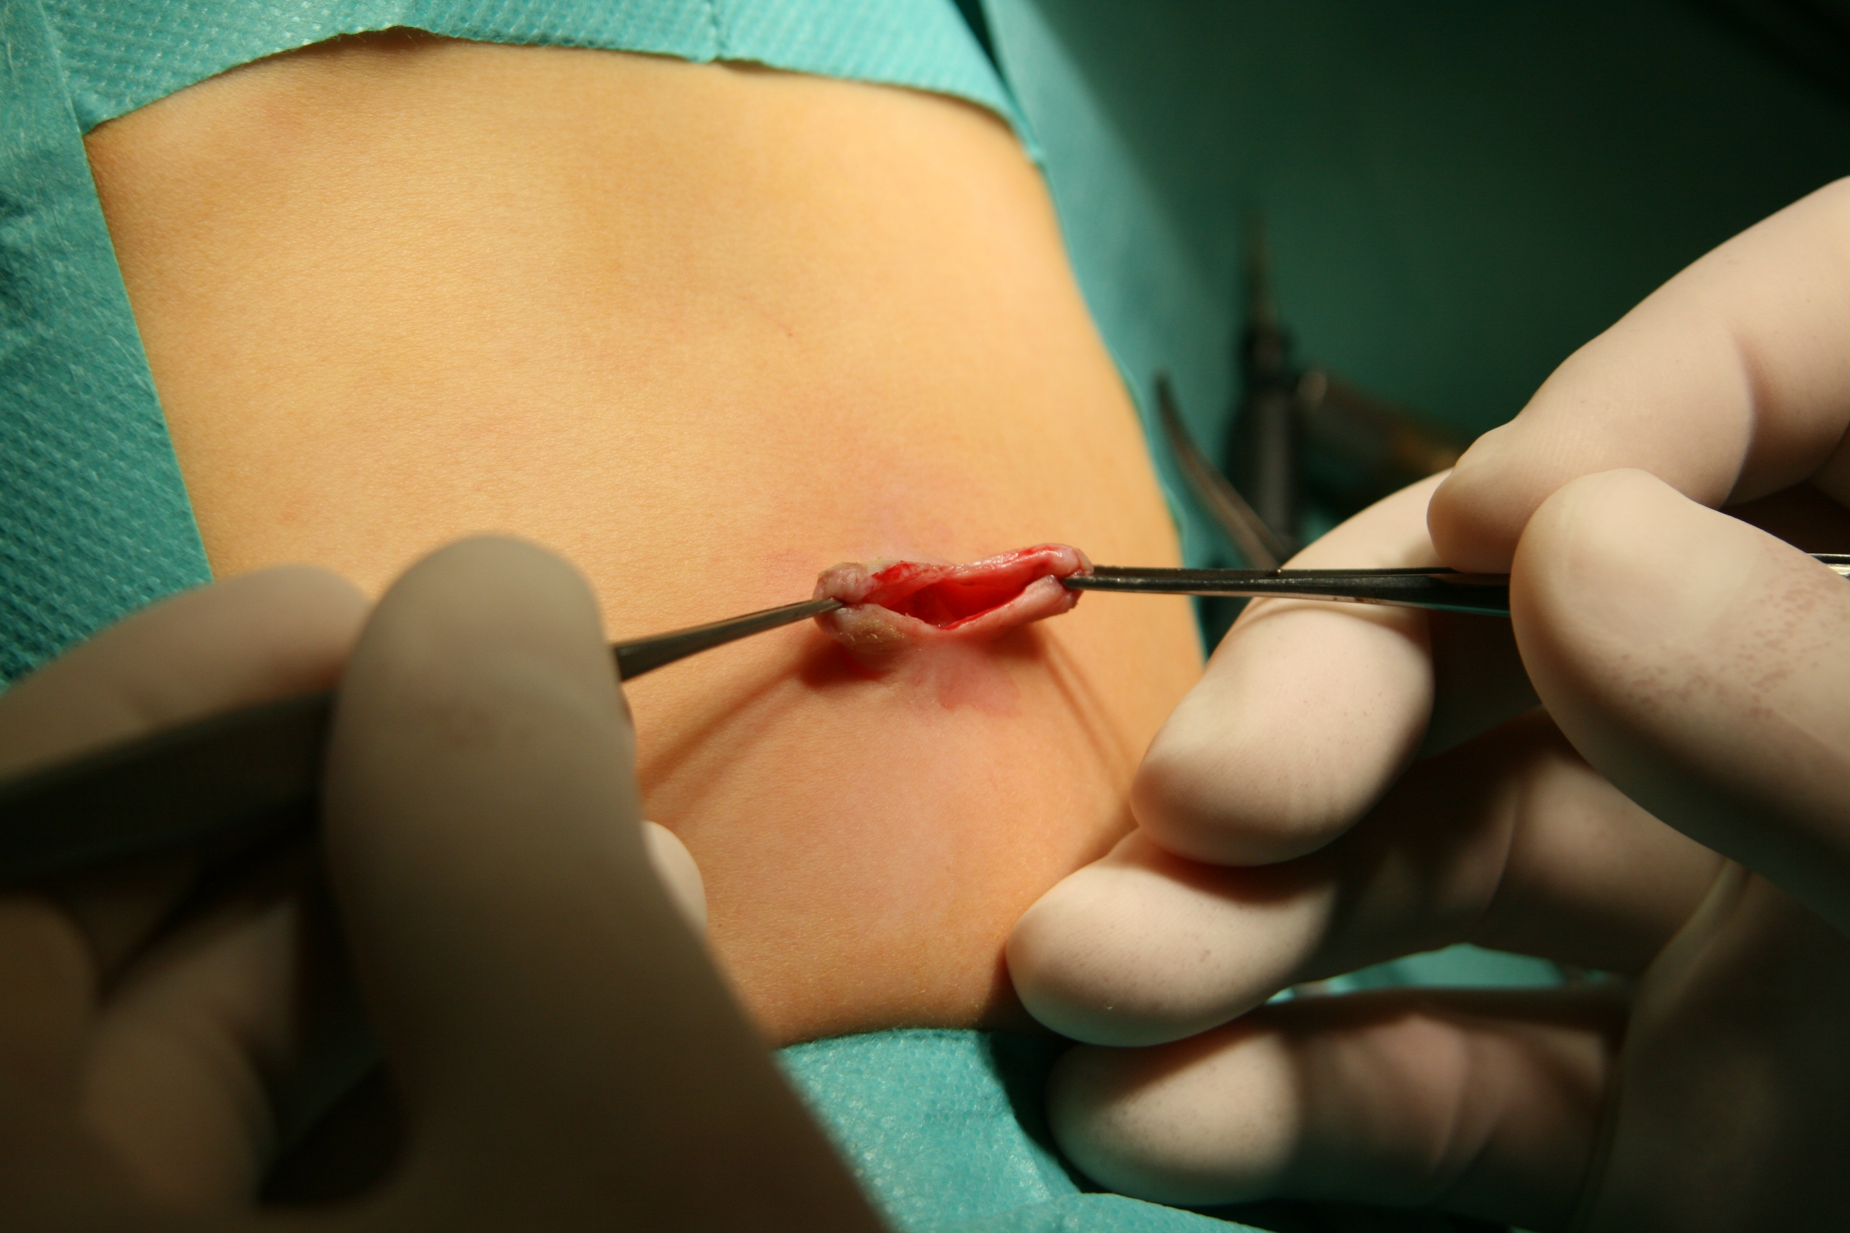
Figure 1 Creation of single umbilical incision.

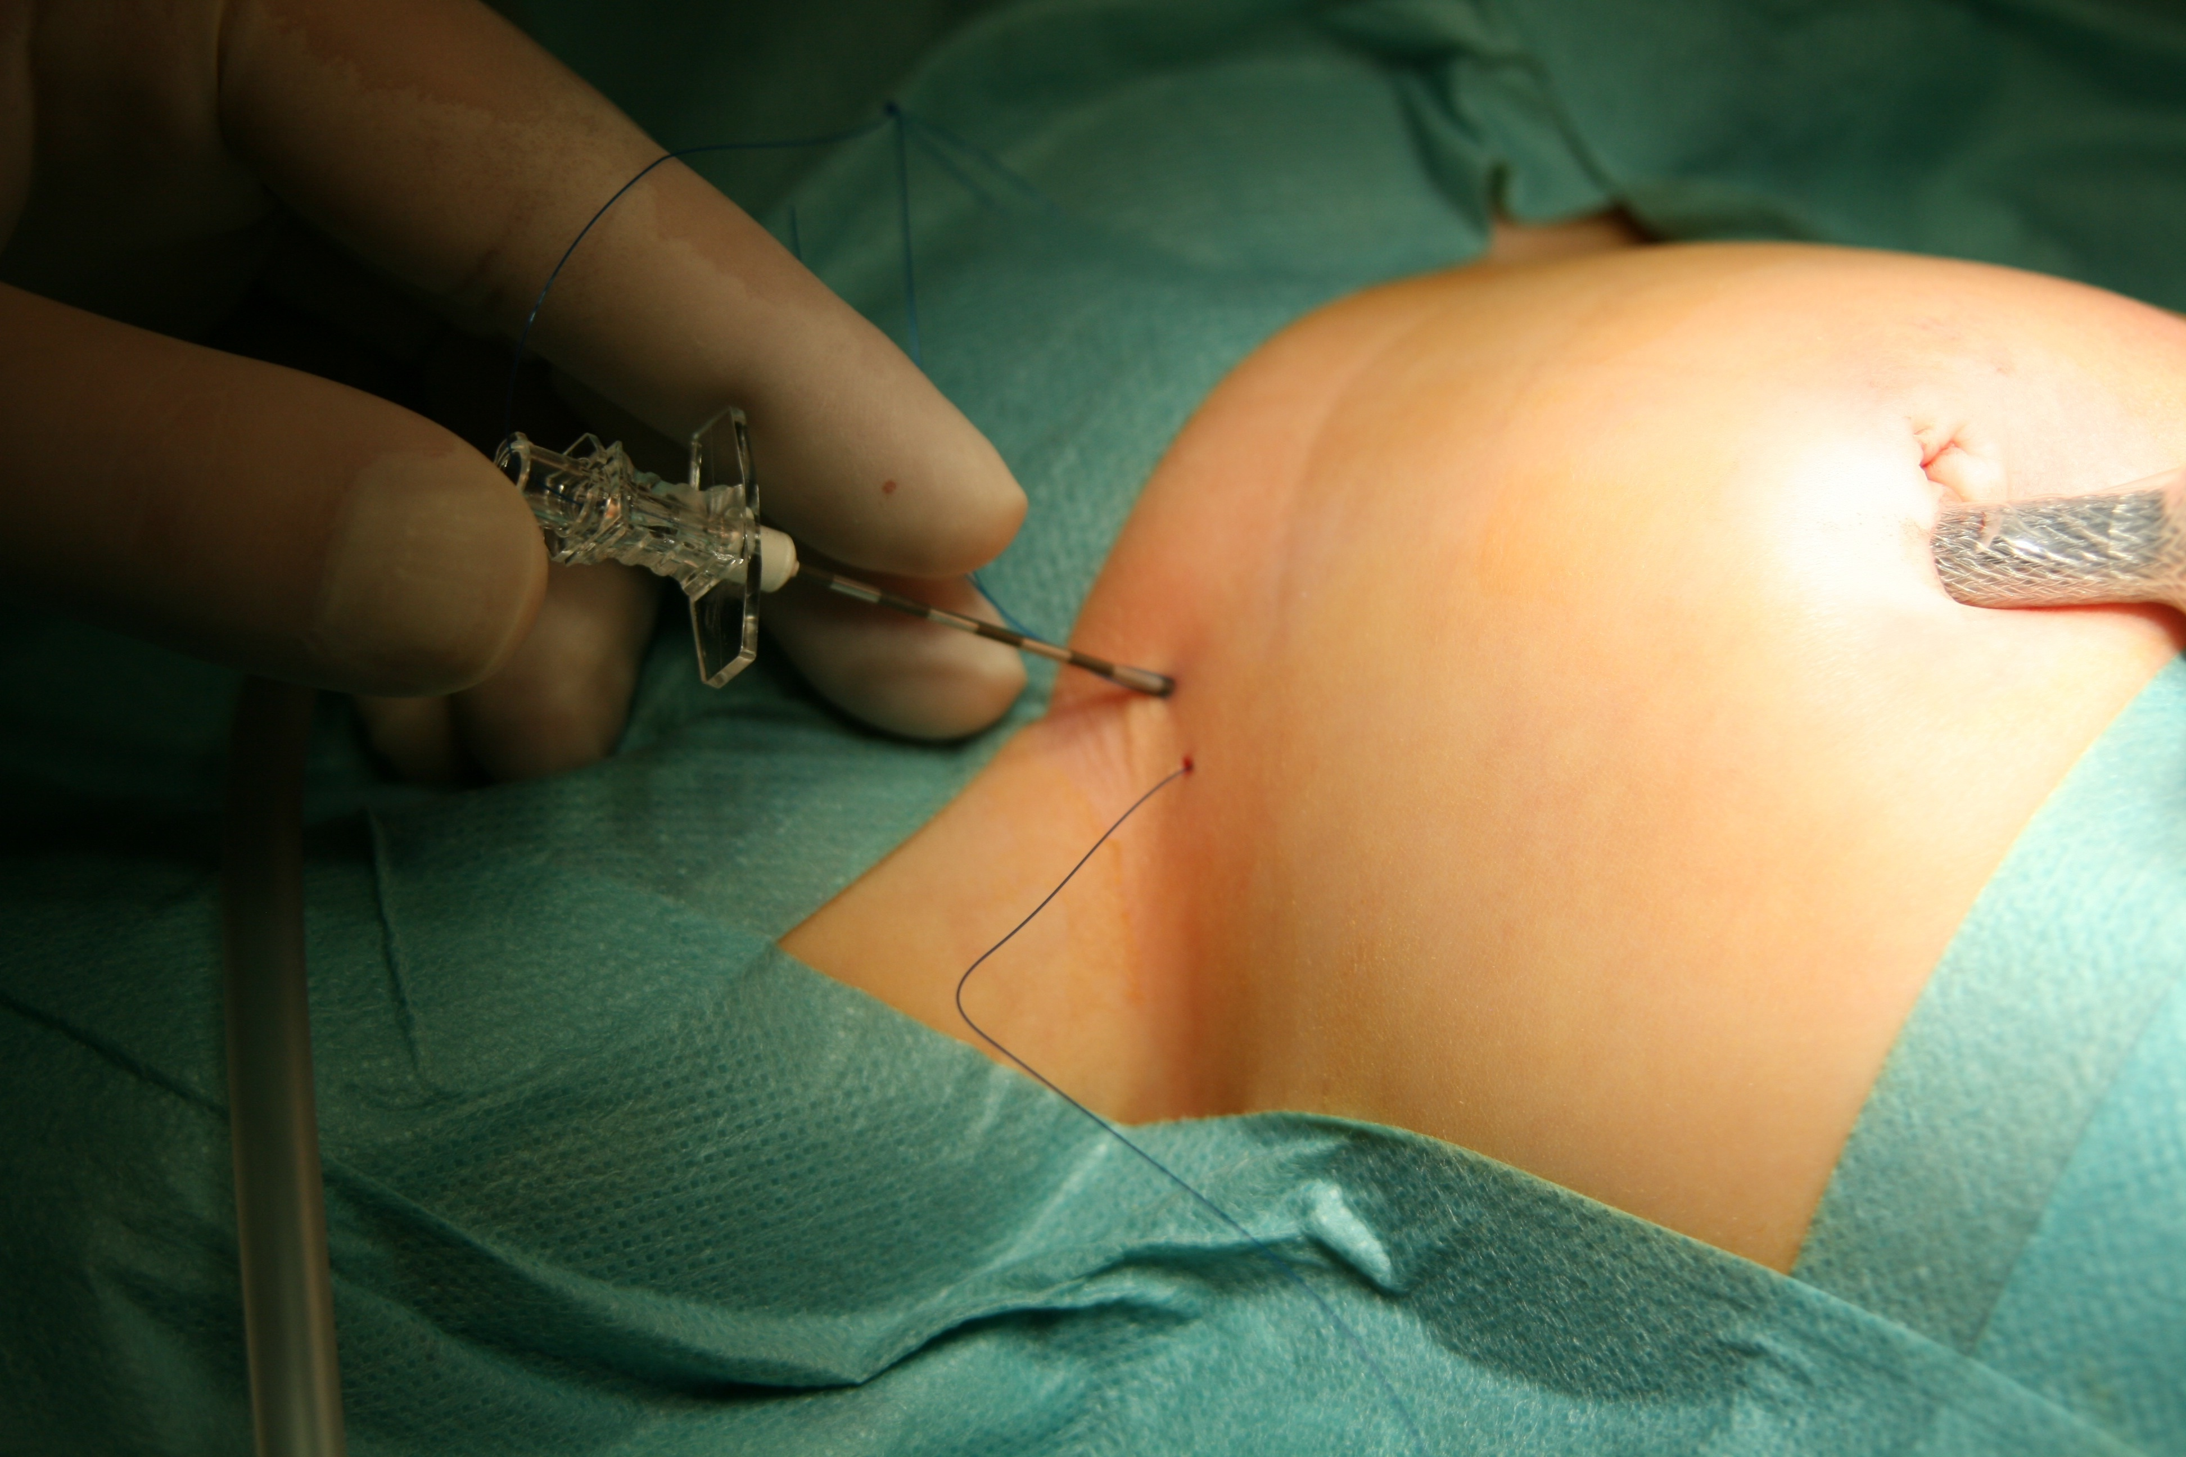
Figure 2 Position of the endoscope and Tuohy needle during SEAL inguinal herniorrhaphy.

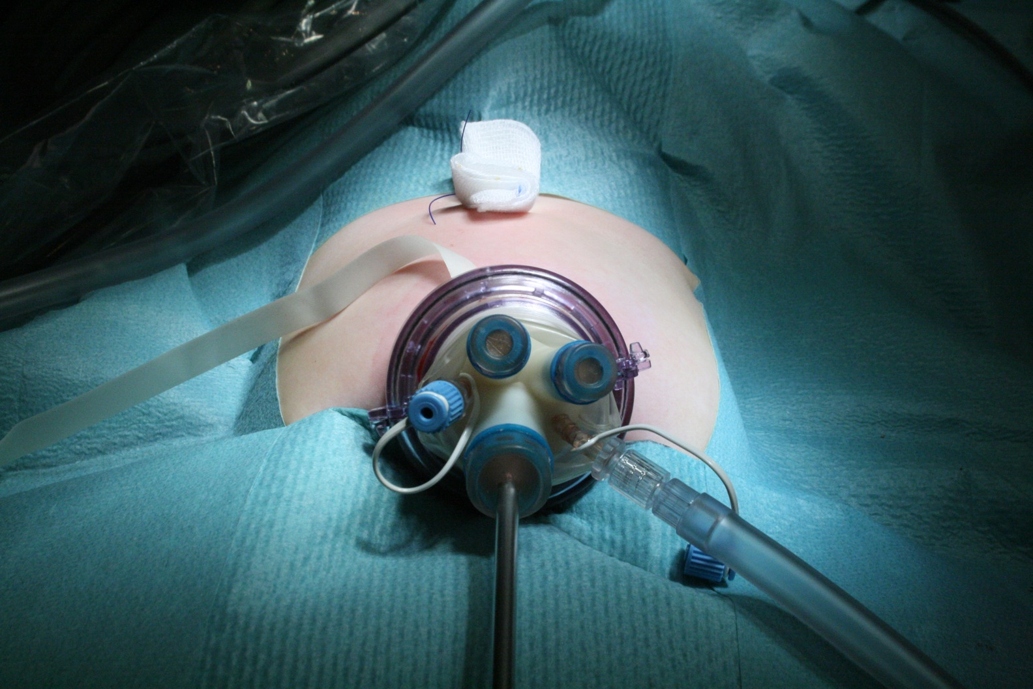
Figure 3 Placement TriPort single-port device (Advanced Surgical Concepts, Olympus, Japan) into abdominal cavity.

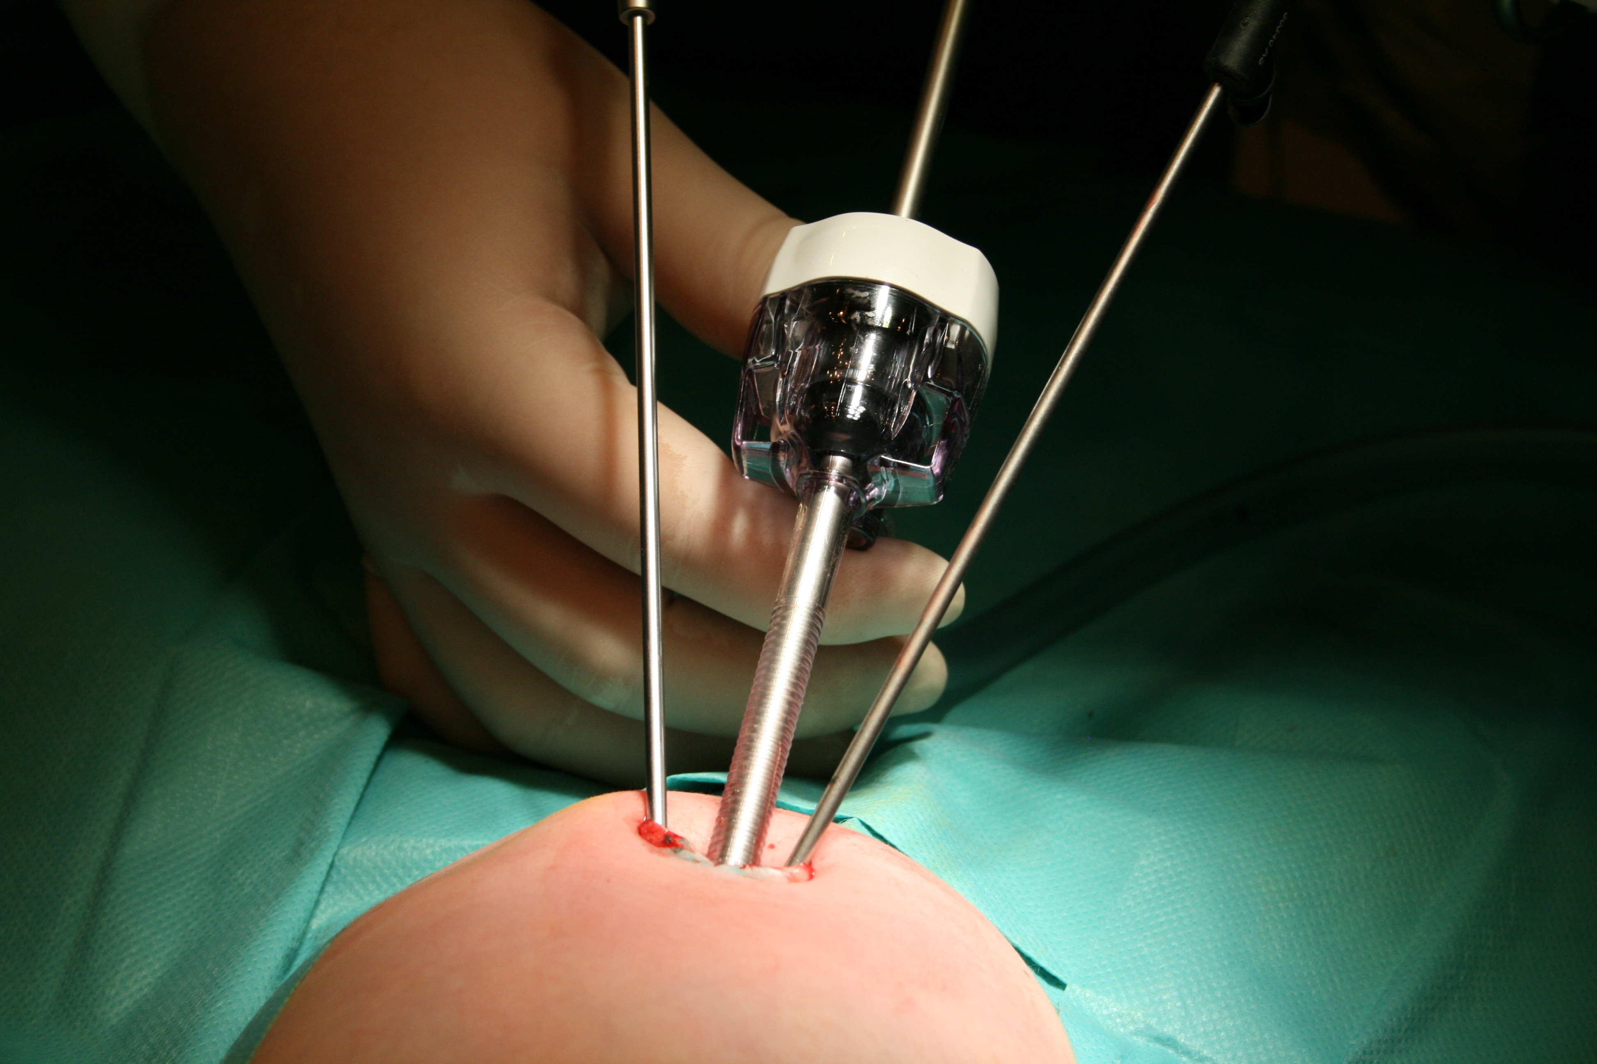
Figure 4 Installation of laparoscopic instruments through fascial wounds without a use of trocars.

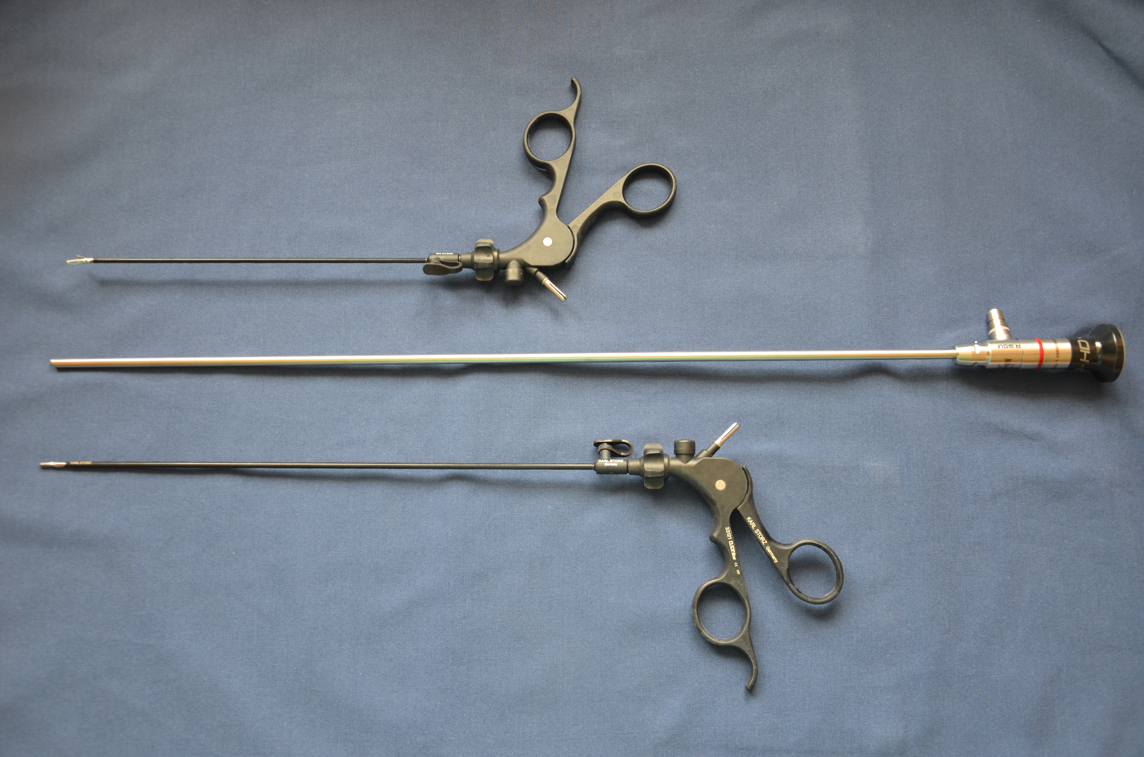
Figure 5 Laparoscopic instruments for single-incision pediatric endosurgery - a 5 mm endoscope with a length of 45 cm and 3 mm instruments with different lengths (20 and 30 cm).

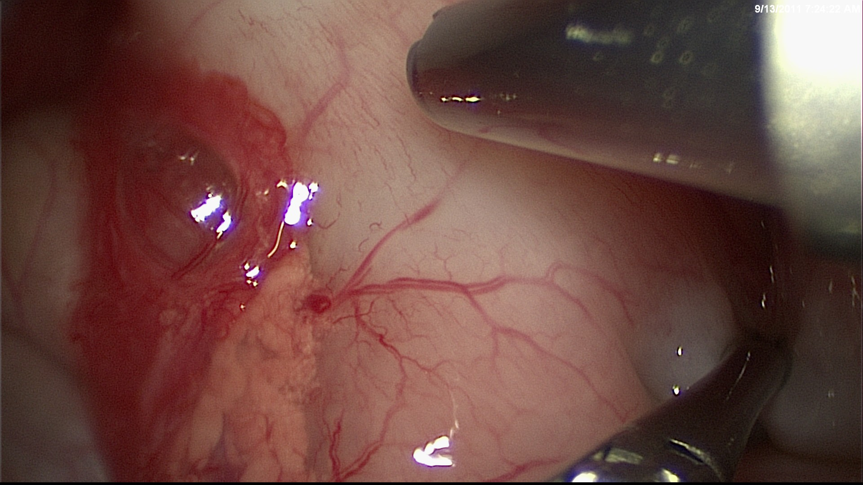
Figure 6 The technique of the “cross-handed” manipulation (cross instrumentation) during pyloromyotomy.

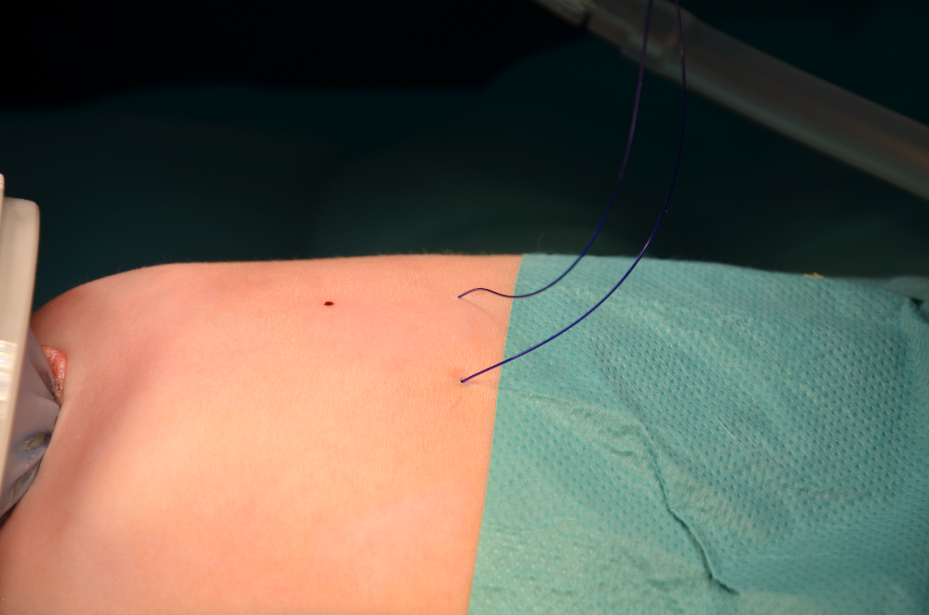
Figure 7 Transparietal stich sutured around the ligamentum teres hepatis.

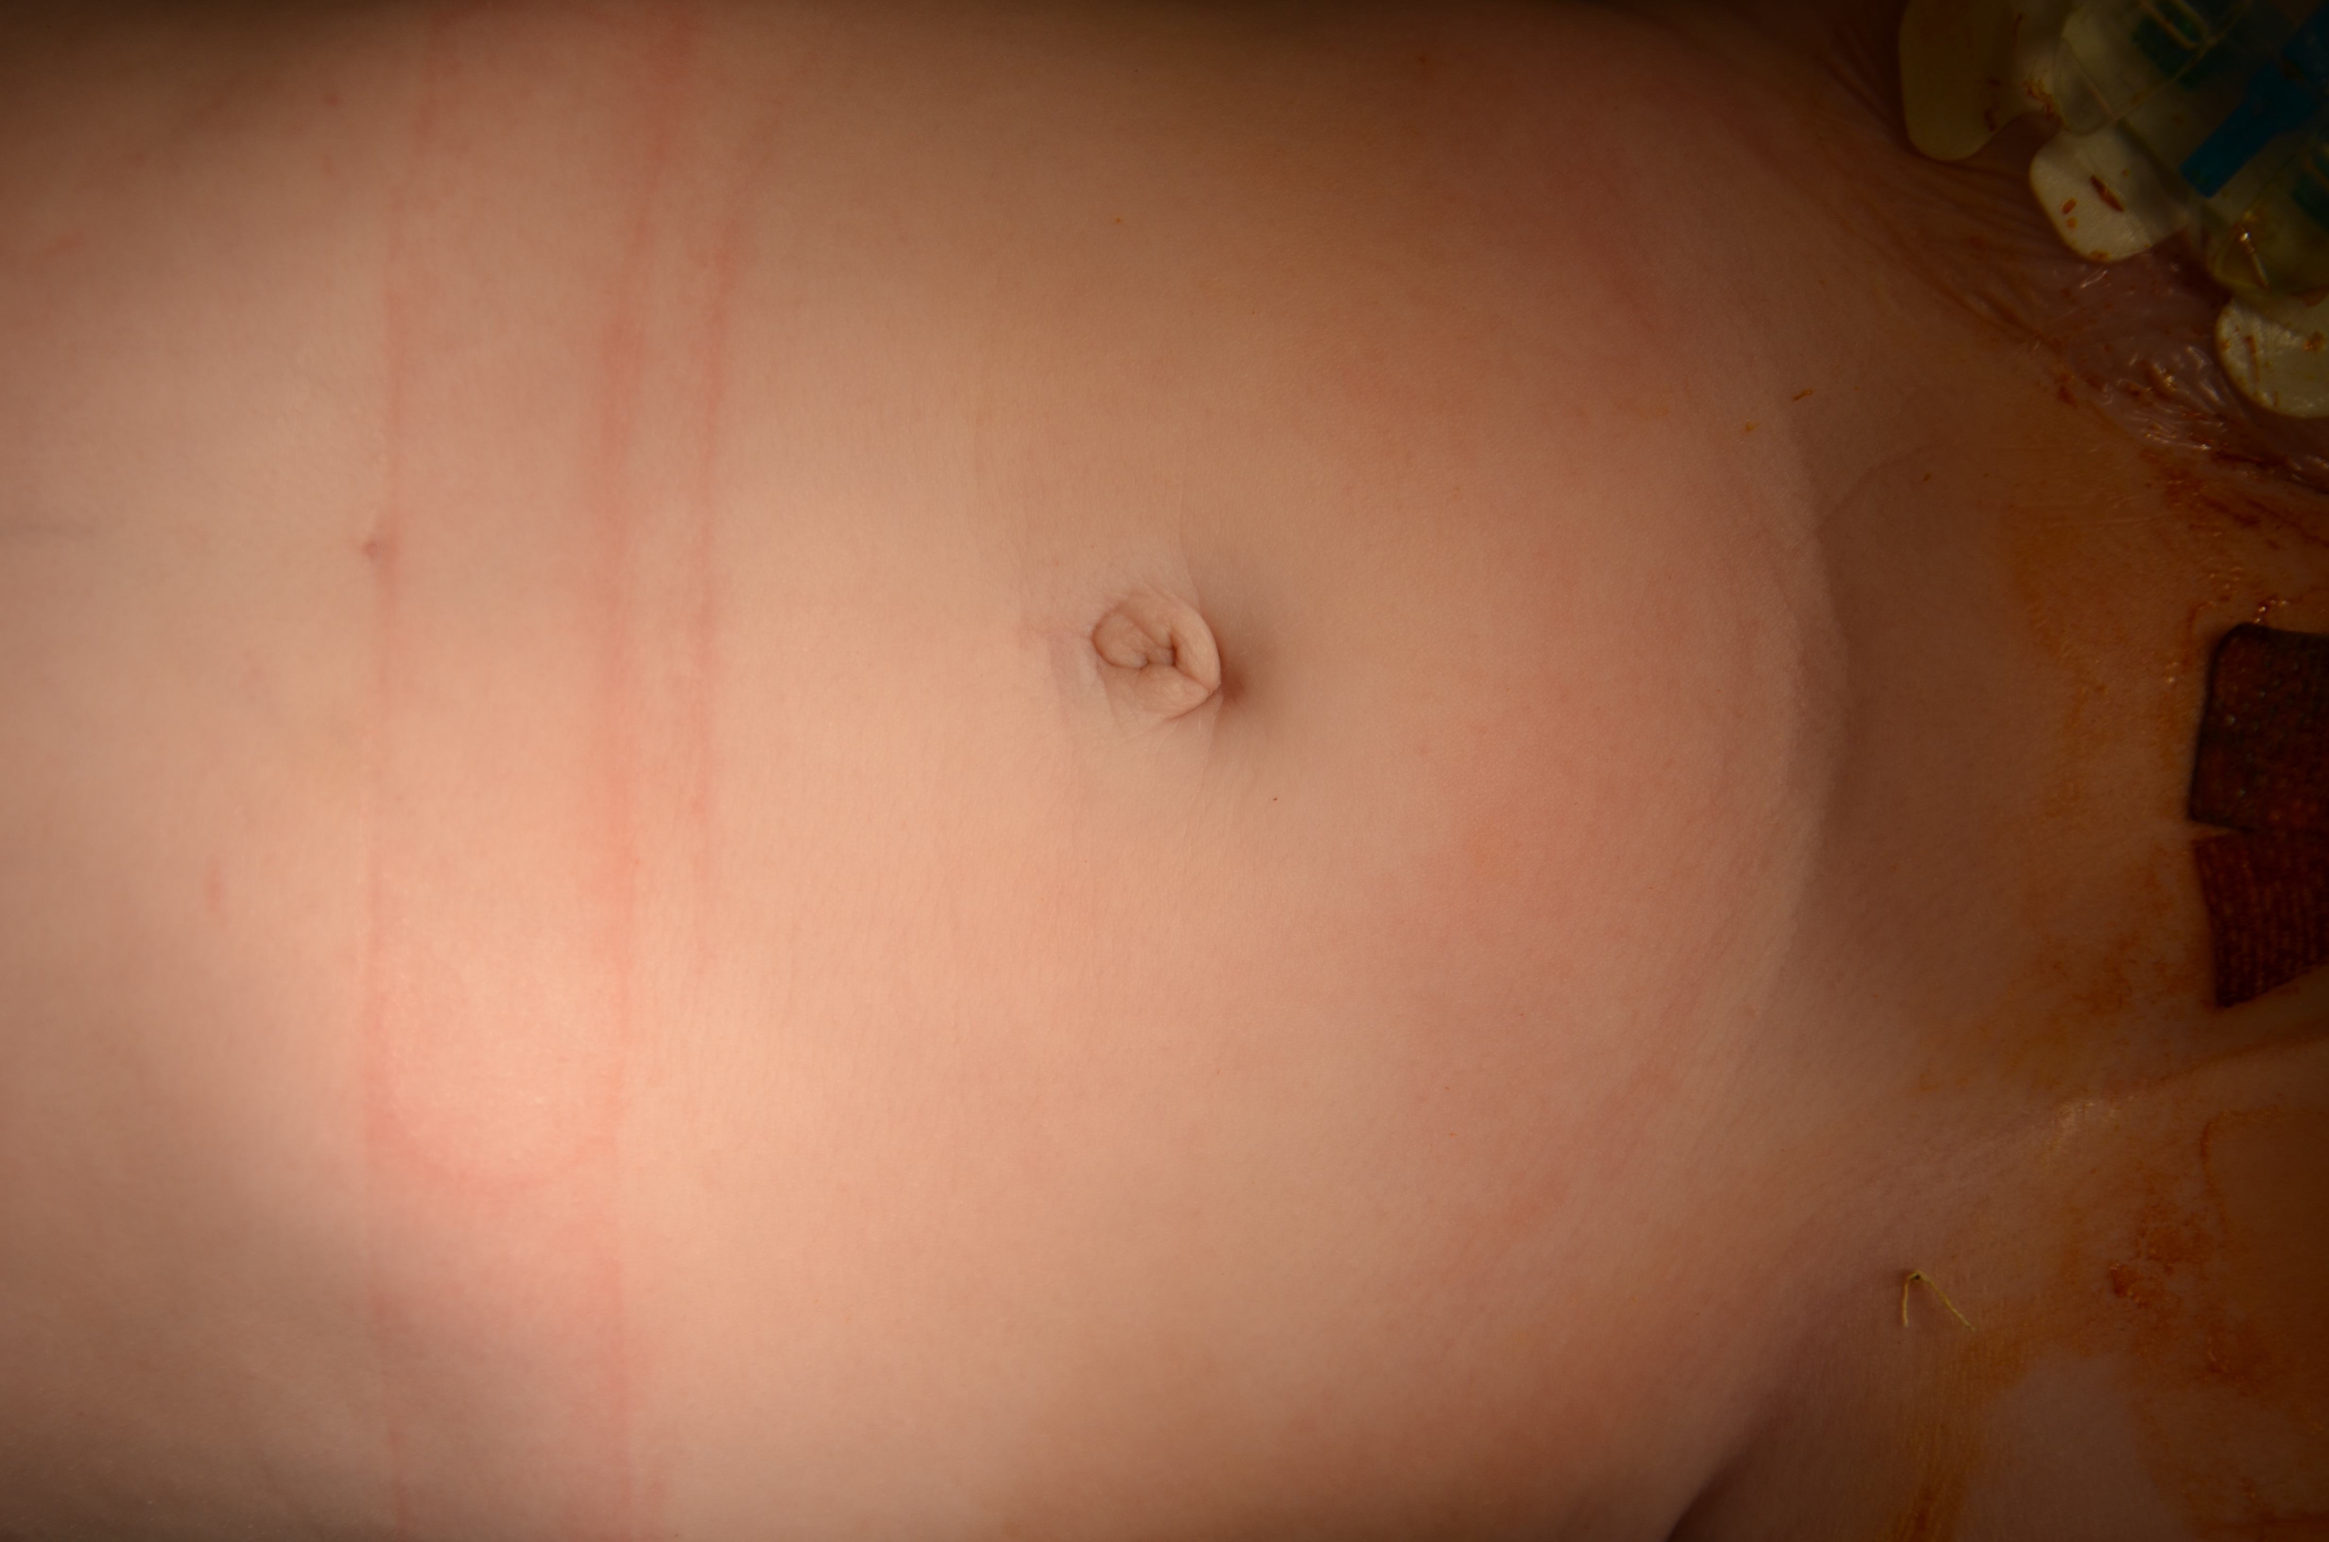
Figure 8 Cosmetic result. A: Cosmetic result after 7 d from a single-incision laparoscopic right nephrectomy; B: Cosmetic result after 1 mo from a single-incision laparoscopic right nephrectomy (same patient).

