Name of Journal: World Journal of Gastroenterology
Manuscript NO: 83301
Manuscript Type: CASE REPORT

Eosinophilic enteritis requiring differentiation from chronic enteropathy associated with SLCO2A1 gene: A case report

Kimura K et al. EoN requiring differentiation from CEAS

Kantaro Kimura, Keisuke Jimbo, Nobuyasu Arai, Masamichi Sato, Mitsuyoshi Suzuki, Takahiro Kudo, Tomonori Yano, Toshiaki Shimizu

Kantaro Kimura, Keisuke Jimbo, Nobuyasu Arai, Masamichi Sato, Mitsuyoshi Suzuki, Takahiro Kudo, Toshiaki Shimizu, Department of Pediatrics, Juntendo University Faculty of Medicine, Tokyo 113-8421, Japan

Tomonori Yano, Department of Medicine, Jichi Medical University, Tochigi 329-0498, Japan

Author contributions: Kimura K, Jimbo K, and Arai N contributed to manuscript writing and editing, and data collection; Jimbo K, Sato M, and Suzuki M contributed to data analysis; Kudo T, Yano T, and Shimizu T contributed to conceptualization and supervision; all authors have read and approved the final manuscript.

Supported by a Japan Society for the Promotion of Science KAKENHI Grant-in-Aid for Young Scientists, No. 20K16905.

Corresponding author: Keisuke Jimbo, MD, PhD, Assistant Professor, Department of Pediatrics, Juntendo University Faculty of Medicine, 2-1-1 Hongo, Bunkyo-ku, Tokyo 113-8421, Japan. kjinbo@juntendo.ac.jp

Received: January 16, 2023
Revised: February 6, 2023
Accepted: February 27, 2023
Published online: March 21, 2023

Abstract
BACKGROUND
Eosinophilic gastrointestinal disease (EGID) is a disorder characterized by infiltration of eosinophils causing mucosal damage and dysfunction of the gastrointestinal tract. The endoscopic findings of eosinophilic enteritis (EoN), an EGID variant, are nonspecific and occasionally difficult to diagnose. In contrast, chronic enteropathy associated with SLCO2A1 (CEAS) is a chronic persistent small intestinal disorder characterized by endoscopic findings such as multiple oblique and circular ulcers.

CASE SUMMARY
We report the case of a 10-year-old boy who had suffered abdominal pain and fatigue for the preceding 6 mo. He was referred to our institute for investigation of suspected gastrointestinal bleeding because of severe anemia with hypoproteinemia and positive fecal human hemoglobin. The upper and lower gastrointestinal endoscopic findings were normal; however, double-balloon small bowel endoscopy showed multiple oblique and circular ulcers with discrete margins and mild constriction of the intestinal lumen in the ileum. The findings were highly consistent with CEAS, but urine prostaglandin metabolites were within normal limits, and no previously reported mutations in the SLCO2A1 gene were identified. Histological evaluation demonstrated moderate to severe eosinophilic infiltration localized to the small intestine suggesting a diagnosis of EoN. Clinical remission was maintained with montelukast and a partial elemental diet, but emergent surgery for bowel obstruction due to small intestinal stenosis was performed two years after the initial treatment.

CONCLUSION
EoN should be considered in the differential diagnosis of CEAS-like small intestinal ulcerative lesions and normal urinary prostaglandin metabolite levels.

Key Words: Anemia; Chronic enteropathy associated with SLCO2A1; Double-balloon endoscopy; Eosinophilic gastrointestinal disease; Hypoproteinemia; Case report

©The Author(s) 2023. Published by Baishideng Publishing Group Inc. All rights reserved.

Citation: Kimura K, Jimbo K, Arai N, Sato M, Suzuki M, Kudo T, Yano T, Shimizu T. Eosinophilic enteritis requiring differentiation from chronic enteropathy associated with SLCO2A1 gene: A case report. World J Gastroenterol 2023; 29(11): 1757-1764
URL: https://www.wjgnet.com/1007-9327/full/v29/i11/1757.htm
DOI: https://dx.doi.org/10.3748/wjg.v29.i11.1757

Core Tip: Eosinophilic enteritis (EoN), a form of eosinophilic gastrointestinal disease localized to the small intestine, is extremely rare in children. The present pediatric case of EoN displayed multiple ulcerative lesions mimicking chronic enteropathy associated with SLCO2A1 and bowel obstruction due to small intestinal stenosis. The diagnosis was confirmed by small intestinal biopsy using double-balloon enteroscopy and analysis of urine prostaglandin metabolites.

INTRODUCTION
In eosinophilic gastrointestinal disease (EGID), tissue and functional disorders of the gastrointestinal tract are caused by inflammation due to abnormal infiltration of eosinophils within the gastrointestinal wall^{[1]}. EGID can occur in any location between the esophagus and the colon, but localization to the small intestine is extremely rare^{[2]}. The disease was re-classified from eosinophilic gastroenteritis (EGE) to eosinophilic enteritis (EoN) in 2022^{[3]}. In addition, the nonspecific gastrointestinal endoscopic findings of EGID (edema, erythema, erosions, and ulcers) lead to difficulty in differentiating EGID from other digestive disorders^{[4]}.
In contrast, chronic enteropathy associated with SLCO2A1 (CEAS) is a chronic persistent small bowel disease characterized by multiple oblique and circular ulcers with discrete margins in the ileum endoscopically. It is complicated by small intestinal obstruction due to ulcerative scarring and stenosis in the natural course^{[5]}.
Herein, we report a pediatric case of EoN involving multiple ulcerative lesions mimicking CEAS with diagnostic and therapeutic difficulties.

CASE PRESENTATION
Chief complaints
A 10-year-old Japanese boy presented to his family pediatrician with the complaints of easy fatigue and abdominal pain for 6 mo.

History of present illness
The patient presented to the family pediatrician with facial pallor and severe anemia (Hb: 2.9 g/dL) and was referred to his previous physician for admission. He then received red blood cell transfusion and iron supplementation. Further analysis also showed positive fecal human hemoglobin, indicating anemia due to gastrointestinal bleeding, and the patient was transferred to our institution for further evaluation.

History of past illness
The patient had no previous medical history.

Personal and family history
Prior to the patient's birth, the father had been treated with antibiotics for iron deficiency anemia caused by Helicobacter pylori infection.

Physical examination
On physical examination, vital signs were as follows: Temperature, 36.8 °C; blood pressure, 99/60 mmHg; heart rate, 80 beats per min; respiratory rate, 18 breaths per min. His height was 122.7 cm (-1.63 standard deviation), and his weight was 24.1 kg (-0.92 standard deviation), with no significant growth disturbance on the growth curve and no other abnormal physical findings other than pale eyelid conjunctiva.

Laboratory examinations
Blood analysis demonstrated low levels of hemoglobin (9.7 g/dL) and albumin (2.9 g/dL), and fecal analysis showed elevated levels of human hemoglobin (2018 ng/mL) and calprotectin (510 μg/g). No elevation of inflammatory markers and no eosinophilia were observed (Table 1).

Imaging examinations
Upper and lower gastrointestinal endoscopy showed normal mucosal findings. Small intestinal capsule endoscopy was not performed because of the patency capsule retention in the stomach, and transanal double-balloon enteroscopy (DBE) was performed. DBE showed multiple oblique and circular ulcers with discrete margins at 70-100 cm proximal from the ileocecal valve with slight constriction of the small intestinal lumen (Figure 1).

Further diagnostic work-up
No histological abnormalities were identified on biopsies conducted by upper and lower gastrointestinal endoscopy. The ileal biopsy with DBE showed moderate to severe histological eosinophilic infiltration [maximum 80 eosinophils/high-power field (HPF)] and cryptitis within the mucosa (Figure 2). Of the urine prostaglandin metabolites that are elevated in CEAS, the levels in the present patient were as follows: Prostaglandin F2α metabolite, 3.2 (normal range: 3.0-4.0) ng/mg Cre; prostaglandin E2 metabolite, 2.09 (normal range: 2.0-3.0) ng/mg Cre; and prostaglandin D2 metabolite, 8.5 (normal range: 9.0-10) ng/mg Cre, all of which were within the normal ranges^{[6,7]}. No previously reported mutations in the SLCO2A1 gene or in the targeted gene panels for very early-onset inflammatory bowel disease were identified^{[8]}.

FINAL DIAGNOSIS
The diagnostic findings and medical history indicated a final diagnosis of EoN.

TREATMENT
The patient was treated with montelukast (10 mg/d for a total of 26 mo), which reduced the frequency of abdominal pain. Partial elemental diet therapy (600 kcal/day for a total of 24 mo) was also implemented due to insufficient response of hypoalbuminemia and anemia^{[9]}. Corticosteroids were not administered because the patient's family preferred that steroids be avoided.

OUTCOME AND FOLLOW-UP
The abdominal pain resolved completely 2 mo after the administration of montelukast and the partial elemental diet, and improvement of hemoglobin (11.2 g/dL) and hypoalbuminemia (3.5 g/dL) and normalization of fecal human hemoglobin (56 ng/mL) were observed after 4 mo. At follow-up of the small intestine by DBE performed 1 year later, mucosal healing was achieved, except for the oblique ulcer and scars at 70 cm proximal to the ileal valve, and no intestinal stenosis caused by the healing ulcer was observed (Figure 1). Eosinophilic infiltration had also disappeared on biopsy, suggesting histological remission. The patient was in clinical remission thereafter, but 2 years and 2 mo after the first visit, sudden bowel obstruction was induced by small intestinal stenosis, and emergent surgery was performed. The ileal macroscopic findings showed strictures at 40 cm and 44 cm proximal to the ileocecal valve, leading to ileal resection of the strictures and ileostomy (Figure 3). The histological findings of the resected specimen were of ulcer formation and peri-ulcer mucosal damage, suggesting intestinal stenosis in the process of ulcerative scarring. No significant granuloma or eosinophilic infiltration was observed (Figure 3). The patient’s postoperative course was uneventful. Ileostomy closure was performed 2 mo later, and the patient is currently being followed on an outpatient basis. An ileal resection specimen obtained at ileostomy closure showed marked eosinophilic infiltration (> 50/HPF) in the subserosa (Figure 3).

DISCUSSION
The incidence of EGE in the United States is 2.5-30 cases per 100000 people, whereas the incidence in Japan is estimated to be 5.5 times higher^{[10]}. EGE is usually difficult to diagnose because of the variety of gastrointestinal symptoms, as well as the extremely nonspecific findings of gastrointestinal endoscopy^{[11]}. A case series that reported the small intestinal capsule endoscopic findings in 10 EGE cases found small intestinal lesions such as multiple erythematous lesions in 6 cases, erosions and ulcers in 5 cases, flattened or missing villi in 4 cases, and intestinal stenosis in 7 cases^{[9]}. In that study, EGE was defined as EGID with extensive lesions extending from the stomach to the large intestine; however, only one pediatric and 6 adult cases of EoN localized to the small intestine have been reported (Table 2)^{[12-17]}. These reports described various forms of ulcerative lesions and strictures in the small intestine, but all patients were diagnosed with EGE because of the difficulty of distinguishing EGE from CEAS based on the endoscopic images, as in the present case, and the patients had histologically significant eosinophilic infiltrates^{[12-17]}. In contrast, the present case showed hypoproteinemia and iron deficiency anemia combined with multiple oblique and circular ileal ulcers, consistent with the diagnostic criteria for CEAS^{[18]}.
CEAS was first reported in Japan in 1968 as "nonspecific multiple ulcers of the small intestine"^{[5]} and is caused by SLCO2A1 germline variants encoding a prostaglandin transporter. The identification of hot spots of SLCO2A1 variants is thus valuable for diagnosis but not currently included in the definitive diagnostic guidelines^{[5,7,18]}. In addition, the clinical manifestations of CEAS are chronic and intractable nonspecific gastrointestinal symptoms comparable to EGID, and no effective treatment for these disorders has been established^{[18]}. Ulcers of CEAS have been described as shallow oblique, circular, or longitudinal with discrete margins in case series of the endoscopic findings of CEAS^{[13,19]}. CEAS-like diseases without SLCO2A1 mutations have also been reported, including inherited eicosanoid metabolic disorders, inherited human cPLA2α deficiency, and cryptogenic multifocal ulcerous stenosing enteritis; histologically, however, these diseases show nonspecific inflammatory cell infiltration predominantly by neutrophils, rather than eosinophils^{[20,21]}. The present case thus meets the diagnostic criteria for CEAS, but the diagnosis of EoN was reasonable based on the histological findings and the therapeutic course and responsiveness.
The patient developed bowel obstruction induced by small bowel stricture during the clinical course. Most cases of CEAS manifest with small bowel stricture associated with the healing of ulcers and require long-term endoscopic follow-up and treatment, whereas few cases of small bowel stricture have been reported in EGID^{[16,17,22,23]}. In particular, two EoN cases with stricture showed a transmural eosinophilic infiltration at the resected intestinal tract^{[16,17]}, suggesting that the eosinophilic infiltration in the muscle layer and serosa is a risk factor for intestinal stricture. However, identification of these by endoscopic mucosal biopsy may be extremely difficult. In the present case, the mucosal eosinophilic infiltration at the time of the small bowel resection was insignificant compared to that at the ileostomy closure, in which insufficient therapeutic agents were regularly administered, suggesting the treatment for EoN was unlikely to be inadequate. This fact indicates that periodic endoscopic follow-up with consideration of the possibility of small bowel stricture would be required in EoN localized to the small bowel with CEAS-like ulcerative lesions.

CONCLUSION
EoN should be included in the differential diagnosis of patients who exhibit CEAS-like ulcerative lesions localized to the small intestine and have normal urinary prostaglandin metabolites. In addition, EoN with CEAS-like ulcerative lesions may require periodic endoscopic follow-up taking into account the potential complication of small bowel stricture.

ACKNOWLEDGEMENTS
The authors would like to thank the patient’s family for permission to publish this case report.

REFERENCES
1 Rothenberg ME. Eosinophilic gastrointestinal disorders (EGID). J Allergy Clin Immunol 2004; 113: 11-28; quiz 29 [PMID: 14713902 DOI: 10.1016/j.jaci.2003.10.047]
2 Ingle SB, Hinge Ingle CR. Eosinophilic gastroenteritis: an unusual type of gastroenteritis. World J Gastroenterol 2013; 19: 5061-5066 [PMID: 23964139 DOI: 10.3748/wjg.v19.i31.5061]
3 Dellon ES, Gonsalves N, Abonia JP, Alexander JA, Arva NC, Atkins D, Attwood SE, Auth MKH, Bailey DD, Biederman L, Blanchard C, Bonis PA, Bose P, Bredenoord AJ, Chang JW, Chehade M, Collins MH, Di Lorenzo C, Dias JA, Dohil R, Dupont C, Falk GW, Ferreira CT, Fox AT, Genta RM, Greuter T, Gupta SK, Hirano I, Hiremath GS, Horsley-Silva JL, Ishihara S, Ishimura N, Jensen ET, Gutiérrez-Junquera C, Katzka DA, Khoury P, Kinoshita Y, Kliewer KL, Koletzko S, Leung J, Liacouras CA, Lucendo AJ, Martin LJ, McGowan EC, Menard-Katcher C, Metz DC, Miller TL, Moawad FJ, Muir AB, Mukkada VA, Murch S, Nhu QM, Nomura I, Nurko S, Ohtsuka Y, Oliva S, Orel R, Papadopoulou A, Patel DA, Pesek RD, Peterson KA, Philpott H, Putnam PE, Richter JE, Rosen R, Ruffner MA, Safroneeva E, Schreiner P, Schoepfer A, Schroeder SR, Shah N, Souza RF, Spechler SJ, Spergel JM, Straumann A, Talley NJ, Thapar N, Vandenplas Y, Venkatesh RD, Vieira MC, von Arnim U, Walker MM, Wechsler JB, Wershil BK, Wright BL, Yamada Y, Yang GY, Zevit N, Rothenberg ME, Furuta GT, Aceves SS. International Consensus Recommendations for Eosinophilic Gastrointestinal Disease Nomenclature. Clin Gastroenterol Hepatol 2022; 20: 2474-2484.e3 [PMID: 35181570 DOI: 10.1016/j.cgh.2022.02.017]
4 Chen MJ, Chu CH, Lin SC, Shih SC, Wang TE. Eosinophilic gastroenteritis: clinical experience with 15 patients. World J Gastroenterol 2003; 9: 2813-2816 [PMID: 14669340 DOI: 10.3748/wjg.v9.i12.2813]
5 Umeno J, Hisamatsu T, Esaki M, Hirano A, Kubokura N, Asano K, Kochi S, Yanai S, Fuyuno Y, Shimamura K, Hosoe N, Ogata H, Watanabe T, Aoyagi K, Ooi H, Watanabe K, Yasukawa S, Hirai F, Matsui T, Iida M, Yao T, Hibi T, Kosaki K, Kanai T, Kitazono T, Matsumoto T. A Hereditary Enteropathy Caused by Mutations in the SLCO2A1 Gene, Encoding a Prostaglandin Transporter. PLoS Genet 2015; 11: e1005581 [PMID: 26539716 DOI: 10.1371/journal.pgen.1005581]
6 Matsuno Y, Umeno J, Esaki M, Hirakawa Y, Fuyuno Y, Okamoto Y, Hirano A, Yasukawa S, Hirai F, Matsui T, Hosomi S, Watanabe K, Hosoe N, Ogata H, Hisamatsu T, Yanai S, Kochi S, Kurahara K, Yao T, Torisu T, Kitazono T, Matsumoto T. Measurement of prostaglandin metabolites is useful in diagnosis of small bowel ulcerations. World J Gastroenterol 2019; 25: 1753-1763 [PMID: 31011259 DOI: 10.3748/wjg.v25.i14.1753]
7 Jimbo K, Okuno T, Ohgaki R, Nishikubo K, Kitamura Y, Sakurai Y, Quan L, Shoji H, Kanai Y, Shimizu T, Yokomizo T. A novel mutation in the SLCO2A1 gene, encoding a prostaglandin transporter, induces chronic enteropathy. PLoS One 2020; 15: e0241869 [PMID: 33166338 DOI: 10.1371/journal.pone.0241869]
8 Arai K. Very Early-Onset Inflammatory Bowel Disease: A Challenging Field for Pediatric Gastroenterologists. Pediatr Gastroenterol Hepatol Nutr 2020; 23: 411-422 [PMID: 32953636 DOI: 10.5223/pghn.2020.23.5.411]
9 Higuchi T, Tokunaga M, Murai T, Takeuchi K, Nakayama Y. Elemental diet therapy for eosinophilic gastroenteritis and dietary habits. Pediatr Int 2022; 64: e14894 [PMID: 34157188 DOI: 10.1111/ped.14894]
10 Zhang M, Li Y. Eosinophilic gastroenteritis: A state-of-the-art review. J Gastroenterol Hepatol 2017; 32: 64-72 [PMID: 27253425 DOI: 10.1111/jgh.13463]
11 Kinoshita Y, Furuta K, Ishimaura N, Ishihara S, Sato S, Maruyama R, Ohara S, Matsumoto T, Sakamoto C, Matsui T, Ishikawa S, Chiba T. Clinical characteristics of Japanese patients with eosinophilic esophagitis and eosinophilic gastroenteritis. J Gastroenterol 2013; 48: 333-339 [PMID: 22847555 DOI: 10.1007/s00535-012-0640-x]
12 Mizumoto N, Sasaki Y, Abe Y, Yagi M, Kon T, Onozato Y, Sakai T, Ito M, Umehara M, Ueno Y. Small-bowel Capsule Endoscopic Features in Patients with Eosinophilic Gastroenteritis: Three Case Reports. Intern Med 2021; 60: 2961-2965 [PMID: 33776012 DOI: 10.2169/internalmedicine.6935-20]
13 Okuda K, Daimon Y, Iwase T, Mitsufuji S. Novel findings of capsule endoscopy and double-balloon enteroscopy in a case of eosinophilic gastroenteritis. Clin J Gastroenterol 2013; 6: 16-19 [PMID: 26181398 DOI: 10.1007/s12328-012-0344-z]
14 Nguyen N, Kramer RE, Friedlander JA. Videocapsule Endoscopy Identifies Small Bowel Lesions in Patients With Eosinophilic Enteritis. Clin Gastroenterol Hepatol 2018; 16: e64-e65 [PMID: 28870663 DOI: 10.1016/j.cgh.2017.08.043]
15 Yamaga Y, Mizuno M, Okae S, Nio-Tamaoki M, Masuo K, Mashimo-Matsuo Y, Tanaka J, Nabeshima M. Eosinophilic enteritis accompanied by cytomegalovirus disease: a case report. BMC Gastroenterol 2022; 22: 209 [PMID: 35484485 DOI: 10.1186/s12876-022-02274-1]
16 Jagtap SV, Nikumbh DB, Kshirsagar AY, Ahuja N. Unusual presentation of eosinophilic enteritis as multiple strictures of small intestine. Clin Pract 2012; 2: e24 [PMID: 24765423 DOI: 10.4081/cp.2012.e24]
17 Shivathirthan N, Maheshwari G, Kamath D, Haldar P. Enterolithiasis complicating eosinophilic enteritis: A case report and review of literature. World J Gastrointest Surg 2009; 1: 68-70 [PMID: 21160800 DOI: 10.4240/wjgs.v1.i1.68]
18 Hosoe N, Ohmiya N, Hirai F, Umeno J, Esaki M, Yamagami H, Onodera K, Bamba S, Imaeda H, Yanai S, Hisamatsu T, Ogata H, Matsumoto T; CEAS Atlas Group. Chronic Enteropathy Associated With SLCO2A1 Gene [CEAS]-Characterisation of an Enteric Disorder to be Considered in the Differential Diagnosis of Crohn's Disease. J Crohns Colitis 2017; 11: 1277-1281 [PMID: 28510689 DOI: 10.1093/ecco-jcc/jjx068]
19 Umeno J, Esaki M, Hirano A, Fuyuno Y, Ohmiya N, Yasukawa S, Hirai F, Kochi S, Kurahara K, Yanai S, Uchida K, Hosomi S, Watanabe K, Hosoe N, Ogata H, Hisamatsu T, Nagayama M, Yamamoto H, Abukawa D, Kakuta F, Onodera K, Matsui T, Hibi T, Yao T, Kitazono T, Matsumoto T; CEAS study group. Clinical features of chronic enteropathy associated with SLCO2A1 gene: a new entity clinically distinct from Crohn's disease. J Gastroenterol 2018; 53: 907-915 [PMID: 29313109 DOI: 10.1007/s00535-017-1426-y]
20 Chang C, Jiang C, Miao Y, Fang B, Zhang L. A case report of intestinal obstruction caused by cryptogenic multifocal ulcerous stenosing enteritis. BMC Gastroenterol 2020; 20: 300 [PMID: 32933476 DOI: 10.1186/s12876-020-01450-5]
21 Adler DH, Cogan JD, Phillips JA 3rd, Schnetz-Boutaud N, Milne GL, Iverson T, Stein JA, Brenner DA, Morrow JD, Boutaud O, Oates JA. Inherited human cPLA(2alpha) deficiency is associated with impaired eicosanoid biosynthesis, small intestinal ulceration, and platelet dysfunction. J Clin Invest 2008; 118: 2121-2131 [PMID: 18451993 DOI: 10.1172/JCI30473]
22 Tan HL, Sithasanan N, Foley P, Davidson GP. The successful medical management of severe duodenal strictures secondary to eosinophilic gastroenteritis in an infant. Pediatr Surg Int 2003; 19: 562-563 [PMID: 12905002 DOI: 10.1007/s00383-003-0995-4]
23 Attar A, Cazals-Hatem D, Ponsot P. Videocapsule endoscopy identifies stenoses missed by other imaging techniques in a patient with eosinophilic gastroenteritis. Clin Gastroenterol Hepatol 2011; 9: A28 [PMID: 20728576 DOI: 10.1016/j.cgh.2010.07.021]

Footnotes
Informed consent statement: Informed written consent was obtained from the patient for publication of this report and any accompanying images.

Conflict-of-interest statement: The authors declare that they have no conflict of interest to disclose.

CARE Checklist (2016) statement: The authors have read the CARE Checklist (2016), and the manuscript was prepared and revised according to the CARE Checklist (2016).

Open-Access: This article is an open-access article that was selected by an in-house editor and fully peer-reviewed by external reviewers. It is distributed in accordance with the Creative Commons Attribution NonCommercial (CC BY-NC 4.0) license, which permits others to distribute, remix, adapt, build upon this work non-commercially, and license their derivative works on different terms, provided the original work is properly cited and the use is non-commercial. See: https://creativecommons.org/Licenses/by-nc/4.0/

Provenance and peer review: Unsolicited article; Externally peer reviewed.
Peer-review model: Single blind

Peer-review started: January 16, 2023
First decision: January 30, 2023
Article in press: February 27, 2023

Specialty type: Gastroenterology and hepatology
Country/Territory of origin: Japan
Peer-review report’s scientific quality classification
Grade A (Excellent): 0
Grade B (Very good): B, B, B
Grade C (Good): C
Grade D (Fair): 0
Grade E (Poor): 0

P-Reviewer: Anand A, Nepal; Bernabe-Ortiz JC, Peru; Hakimi T, Afghanistan; Paparoupa M, Germany S-Editor: Yan JP L-Editor: A P-Editor: Yan JP

Figure Legends
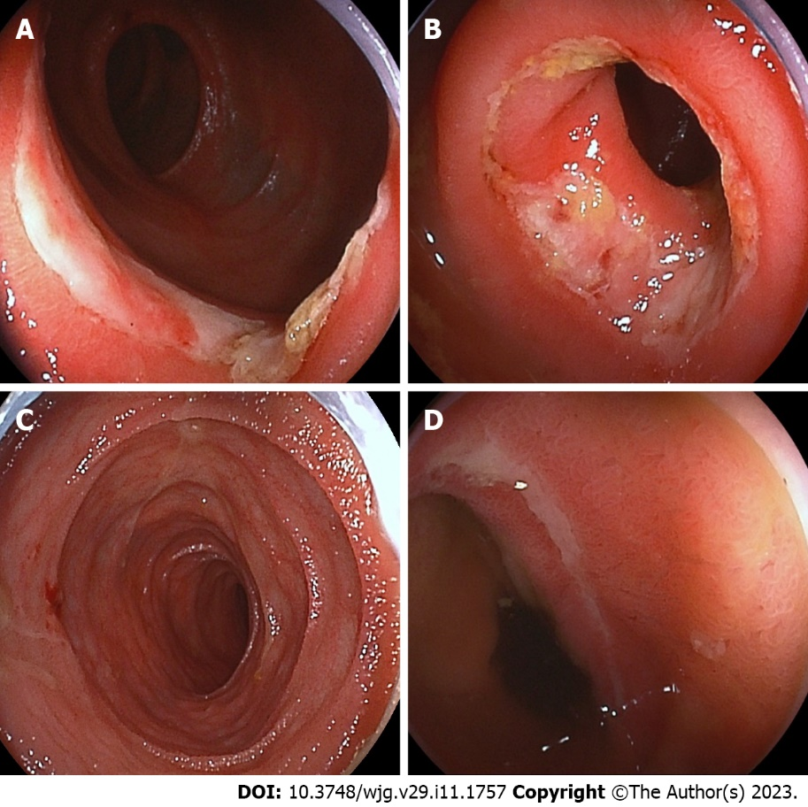
Figure 1 Findings of initial double-balloon small intestinal endoscopy. A: Initial double-balloon enteroscopy (DBE) shows multiple oblique ulcers with discrete margins, 70-100 cm proximal to the ileal valve; B: The circular ulcers with slight constriction of the small intestinal lumen at initial DBE; C: Follow-up DBE performed 1 year later shows mucosal healing; D: The oblique ulcer and scars at 70 cm proximal to the ileal valve at follow-up DBE.

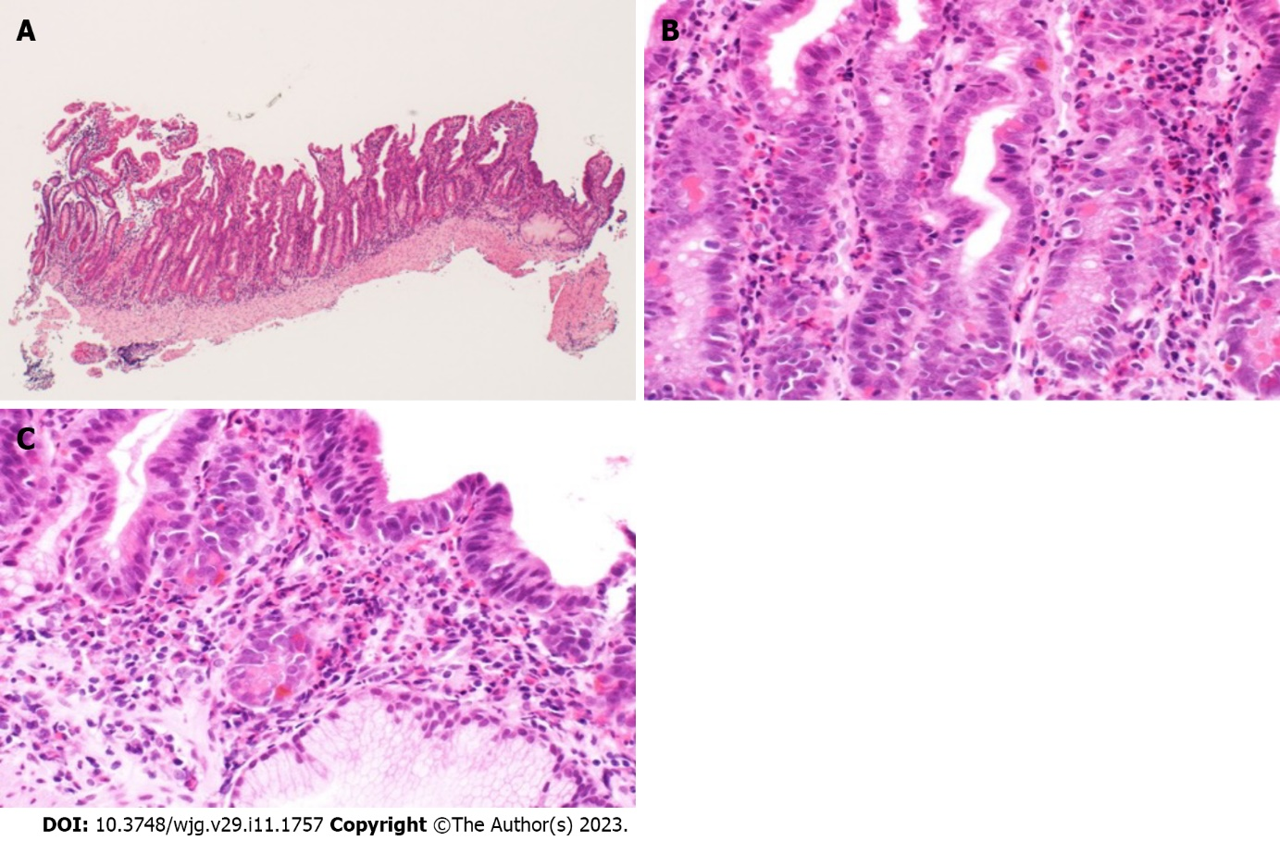
Figure 2 Histopathological findings of ileal tissue obtained from double-balloon enteroscopy. A: Hematoxylin and eosin staining (× 100) shows mild villous atrophy; B: Hematoxylin and eosin staining (× 400) shows moderate to severe histological eosinophilic infiltration (maximum 80 eosinophils/high-power field); C: Hematoxylin and eosin staining (× 400) shows crypt destruction (cryptitis).

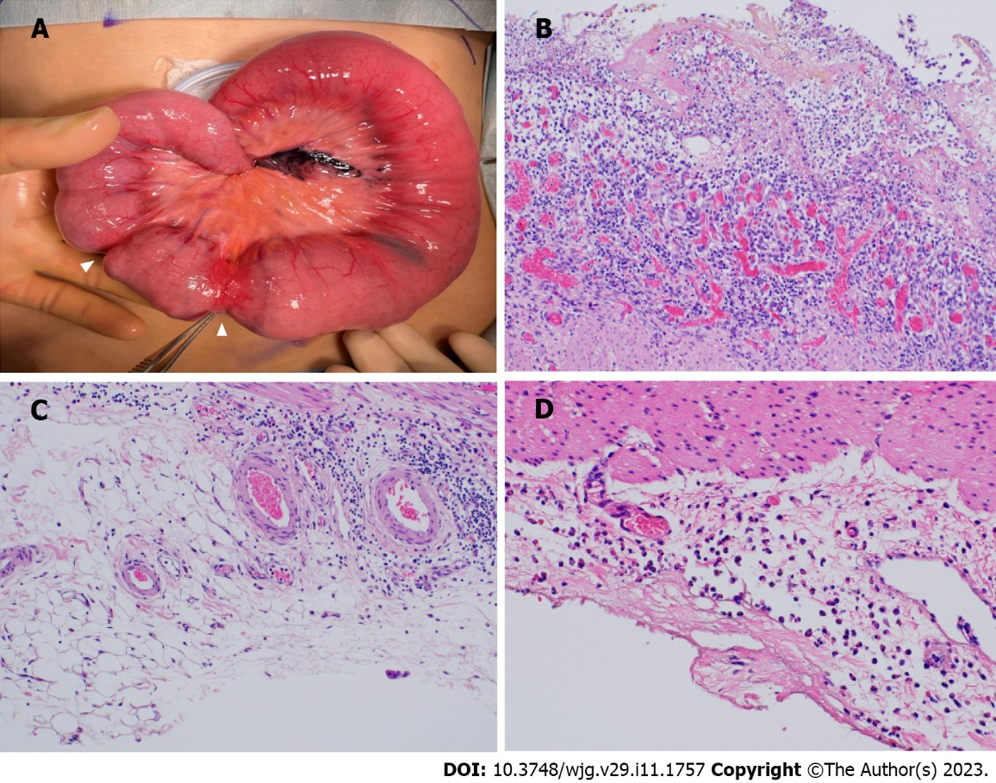
Figure 3 Macroscopic and microscopic histological findings of the resected ileum. A: Macroscopically, strictures are observed 40 cm and 44 cm proximal to the ileocecal valve (arrowhead); B: Resected ileum shows ulcer formation and peri-ulcer mucosal damage histologically; C: No significant eosinophilic infiltration is observed transmurally; D: Resected ileum at the ileostomy closure shows marked eosinophilic infiltration (> 50/high-power field) in the subserosa.

Table 1 Laboratory findings on admission
 | Laboratory data | Reference range
White blood cell count (/μL) | 5300 | 4000-8000
Differential (percent)
Neutrophils | 2597 (49.0) | 1800-4800
Lymphocytes | 2067 (39.0) | 1000-3600
Eosinophils | 53 (1.0) | 40-400
Hemoglobin (g/dL) | 9.7 | 14-18
Hematocrit (%) | 35.0 | 40-48
MCV (fL) | 74.9 | 84-99
MCHC (g/dL) | 27.7 | 32-36
Ferrum (μg/dL) | 39 | 50-190
Ferritin (ng/mL) | 23 | 30-400
Total protein (g/dL) | 6.1 | 6.7-8.3
Albumin (g/dL) | 2.9 | 3.9-4.9
Creatinine (mg/dL) | 0.34 | 0.61-1.04
C-reactive protein (mg/dL) | 0.1 | < 0.3
Erythrocyte sedimentation rate (mm/h) | 4 | 0-15
IgG (mg/dL) | 665 | 870-1700
IgE (IU/mL) | 515 | 0-173
Fecal human hemoglobin (ng/mL) | 2018 | < 50
Fecal calprotectin (μg/g) | 510 | < 50
MCV: Mean corpuscular volume; MCHC: Mean corpuscular hemoglobin concentration; IgM: Immunoglobulin M; IgE: Immunoglobulin E.

Table 2 Summary of four previous cases of eosinophilic enteritis
Case | Age/  sex | Location | Endoscopic findings |  |  |  | Laboratory findings
 |  |  | Multiple erythema | Erosions | Ulcer | Stricture | Anemia | Hypoproteinemia
1 | 62/F | Throughout | - | + | + | - | NR | NR
2 | 66/F | Throughout | - | + | + | - | NR | NR
3 | 48/M | Upper jejunum/ileum | - | - | + | - | - | -
4 | 2/M | Jejunum/proximal ileum | + | - | - | - | - | NR
5 | 70/F | Ileum | - | - | - | - | - | +
6 | 54/M | Ileum | - | - | - | + | - | -
7 | 68/M | Distal jejunum/proximal ileum | - | - | - | + | - | -
F: Female; M: Male; NR: No record.

Published by Baishideng Publishing Group Inc
7041 Koll Center Parkway, Suite 160, Pleasanton, CA 94566, USA
Telephone: +1-925-3991568
E-mail: bpgoffice@wjgnet.com
Help Desk: https://www.f6publishing.com/helpdesk
https://www.wjgnet.com

© 2023 Baishideng Publishing Group Inc. All rights reserved.

