The ARRIVE Guidelines Checklist
Animal Research: Reporting In Vivo Experiments
Carol Kilkenny¹, William J Browne², Innes C Cuthill³, Michael Emerson⁴ and Douglas G Altman⁵
1The National Centre for the Replacement, Refinement and Reduction of Animals in Research, London, UK, ²School of Veterinary Science, University of Bristol, Bristol, UK, ³School of Biological Sciences, University of Bristol, Bristol, UK, ⁴National Heart and Lung Institute, Imperial College London, UK, ⁵Centre for Statistics in Medicine, University of Oxford, Oxford, UK.

ITEM | RECOMMENDATION | Reported on page #
Page 1

Page 3
INTRODUCTION
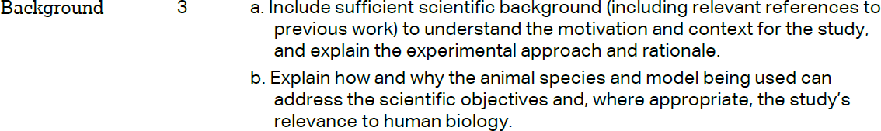 |  | Pages 5, 6
 |  | Page 7
METHODS
 |  | Page 7
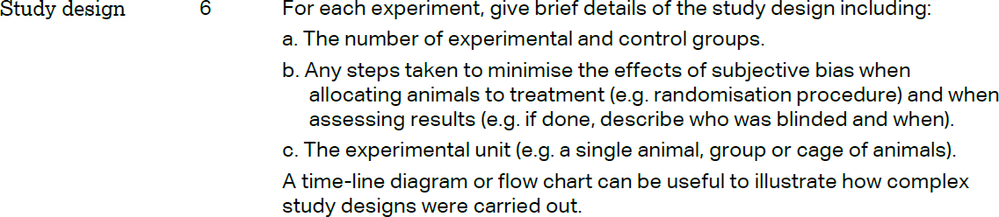 |  | Pages 10, 11
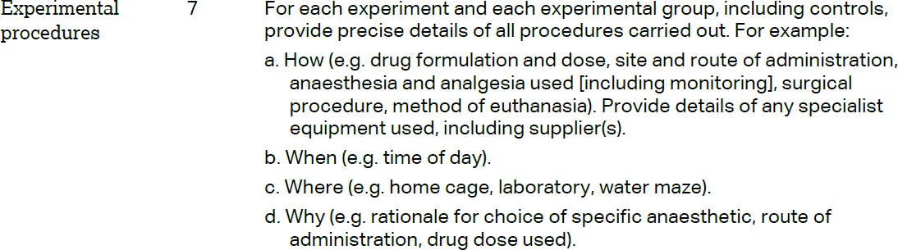 |  | Page 10
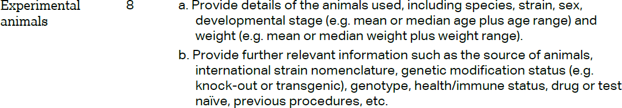 |  | Page 7

The ARRIVE guidelines. Originally published in PLoS Biology, June 2010¹

Pages 7, 8

Page 7

Page 8

Page 11

Page 12

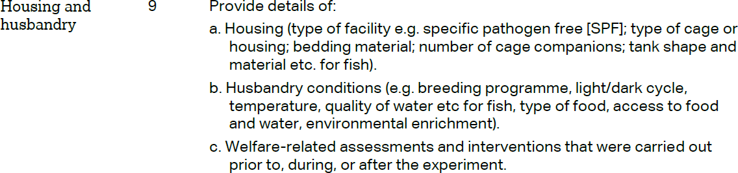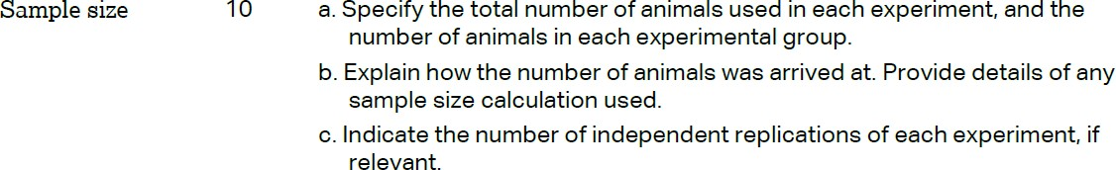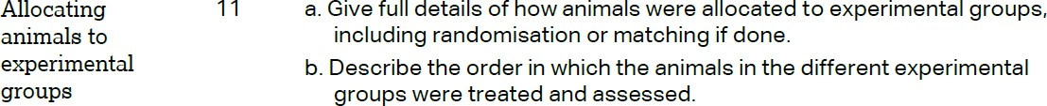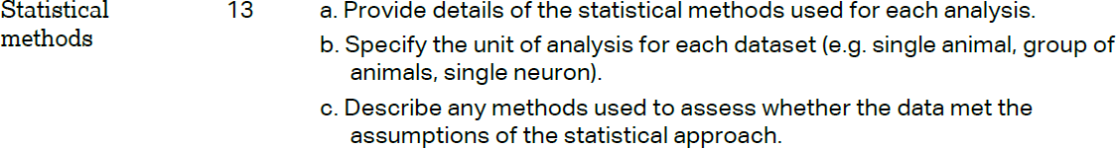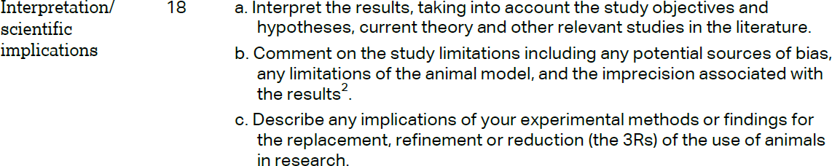RESULTS

Pages 12-16

Pages 12-16

Pages 12-16

Pages 12-16
DISCUSSION

Pages 16-18

Pages 16-18

Page 1

