Name of Journal: World Journal of Gastrointestinal Surgery
Manuscript NO: 53588
Manuscript Type: OPINION REVIEW

Crucial anatomy and technical cues for laparoscopic transabdominal preperitoneal repair: Advanced manipulation for groin hernias in adults

Yasukawa D et al. Laparoscopic TAPP repair

Daiki Yasukawa, Yuki Aisu, Tomohide Hori

Daiki Yasukawa, Department of Surgery, Shiga University of Medical Science, Otsu 520-2192, Japan

Yuki Aisu, Tomohide Hori, Department of Surgery, Kyoto University Graduate School of Medicine, Kyoto 606-8507, Japan

Author contributions: Yasukawa D and Hori T wrote this review; Yasukawa D originally drew all illustrations and schemas; Yasukawa D, Aisu Y and Hori T performed laparoscopic surgeries, assessed important papers, and provided academic opinions; Hori T supervised this review; Yasukawa D and Hori T contributed equally to this work.

Corresponding author: Tomohide Hori, PhD, MD, FACS, Associate Professor, Attending Doctor, Surgeon, Department of Surgery, Kyoto University Graduate School of Medicine, 54 Shogoinkawara-cho, Sakyo-ku, Kyoto 606-8507, Japan. horitomo55office@yahoo.co.jp

Received: December 25, 2019
Revised: April 8, 2020
Accepted: May 12, 2020
Published online: July 27, 2020

Abstract
Groin hernias include indirect inguinal, direct inguinal, and femoral hernias. Obturator and supravesical hernias appear very close to the groin. High-quality repairs are required for groin hernias. The concept of “tension-free repair” is generally accepted, and surgical repairs with mesh are categorized as “hernioplasties”. Surgeons should have good knowledge of the relevant anatomy. Physicians generally focus on the preperitoneal space, myopectineal orifice, topographic nerves, and regional vessels. Currently, laparoscopic surgery has therapeutic potential in the surgical setting for hernioplasty, with laparoscopic transabdominal preperitoneal (TAPP) repair appearing to be a powerful tool for use in adult hernia patients. TAPP offers the advantages of accurate diagnoses, repair of bilateral and recurrent hernias, less postoperative pain, early recovery allowing work and activities, tension-free repair of the preperitoneal (posterior) space, ability to cover obturator hernias, and avoidance of potential injury to the spermatic cord. The disadvantages of TAPP are the need for general anesthesia, adhering to a learning curve, higher cost, unexpected complications related to abdominal organs, adhesion to the mesh, unexpected injuries to vessels, prolonged operative time, and as-yet-unknown long-term outcomes. Both technical skill and anatomical familiarity are important for safe, reliable surgery. With increasing awareness of the importance of anatomy during TAPP repair, we address the skills and pitfalls during laparoscopic TAPP repair in adult patients using illustrations and schemas. We also address debatable points on this subject.

Key words: Inguinal hernia; Femoral hernia; Obturator hernia; Laparoscopic surgery; Laparoscope; Anatomy

Citation: Yasukawa D, Aisu Y, Hori T. Crucial anatomy and technical cues for laparoscopic transabdominal preperitoneal repair: Advanced manipulation for groin hernias in adults. World J Gastrointest Surg 2020; 12(7): 307-325
URL: https://www.wjgnet.com/1948-9366/full/v12/i7/307.htm
DOI: https://dx.doi.org/10.4240/wjgs.v12.i7.307

Core tip: A high-quality hernia repair is seriously required for groin hernias. Surgeons should have good knowledge of the relevant anatomy (e.g., the preperitoneal space, myopectineal orifice, topographic nerves, regional vessels). Currently, laparoscopic surgery has therapeutic potential for hernioplasty, and laparoscopic transabdominal preperitoneal repair seems to be a powerful technique for use in adult patients. Both technical skill and anatomical familiarity are important for safe, reliable hernioplasty.

INTRODUCTION
The term “groin hernia” was first used by Stoppa and Fruchaud during the early 1950s^{[1]}. Hernias in the groin include indirect inguinal, direct inguinal, and femoral hernias^{[2]}. Obturator and supravesical hernias anatomically appear very close to the groin^{[2]}. We therefore focus on indirect inguinal, direct inguinal, femoral, obturator, and supravesical hernias as groin hernias. Herniorrhaphy had been performed to repair inguinal and femoral hernias since the eighteenth century. Basssini devised and reported a more modern herniorrhaphy^{[3,4]}, and thereafter groin herniorrhaphy became the most common surgery performed^{[2]}. With the addition of mesh, Lichtenstein established the concept of a “tension-free repair” (TFR)^{[5,6]}, a technique now categorized as “hernioplasty”. To date, many physicians have focused on the preperitoneal (posterior) space (PPS)^{[1,7-16]}, myopectineal orifice (MO)^{[1,2,17-20]}, topographic nerves^{[21-30]}, and regional vessels^{[2,31-33]}.
Currently, laparoscopy and endoscopy have therapeutic potential for improving these procedures. Although international guidelines for groin hernia management are documented^{[34,35]}, some physicians may not believe that definitive criteria for selecting these surgical procedures have been established. In fact, the physician’s preferences, the technique’s commercial basis, or its cost-effectiveness may be the underlying reasoning for choosing the technique, which then goes unchallenged. Laparoscopic transabdominal preperitoneal (TAPP) repair seems to be a powerful technique for adult patients^{[34]}, even though general anesthesia is required^{[36,37]}.
Both technical skill and anatomical familiarity are important for ensuring safe, reliable surgery. Here, we focus on laparoscopic TAPP repair in adult patients and review previous reports regarding the anatomy of groin hernias and the surgical techniques required for TAPP repair. Using illustrations and schemas, we summarize the current knowledge of anatomy that is important for successful TAPP repair, clarify the knacks and pitfalls during surgery, and discuss debatable points.

LAYERS

The abdominal wall at the groin is classically identified as the “nine layers”^{[38]}. These layers consist of the skin; subcutaneous fat; superficial fasciae (Camper’s and Scarpa’s fasciae); innominate (untitled) fascia, which is a thin membrane on the inguinal ligament; the inguinal ligament (IL) itself; internal abdominal oblique muscle (AOM); transversalis fascia (TF); preperitoneal space (PPS), including the superficial parietal layer (SPL) and the deep visceral layer (DVL); and the peritoneum. Familiarity with the anatomy of the SPL and DVL in the PPS is especially important for successful TAPP repair (Figure 1).

PPS AND MO
All hernias at the groin result from a defect of the TF and pass through an MO^{[1,2]} (Figure 2). The importance of an “underlay” (inlay) patch placed between the TF and peritoneum is widely recognized, and general surgeons commonly accept the concept of optimal repair at the PPS^{[18-20]}, although an “onlay patch”, placed at the anterior side of the TF, has been used in the past. The PPS is observed between the TF and peritoneum. Adequate creation of an extended PPS is important for optimal outcomes^{[39,40]}. Some early physicians mentioned this important space^{[1,7-16]}. In particular, recognition of the SPL and DVL was a milestone for further developments in these surgical repairs^{[41]}. The SPL is comprised of anterior subperitoneal fascia and the DVL of posterior subperitoneal fascia^{[27]}. Some physicians investigated in detail the layer where the bladder exists^{[14,16,42]} (Figure 3). Adequate surgical mesh should be placed in an appropriate layer to avoid hernia recurrence and bladder injury (Figure 4).
Laparoscopic exploration easily reveals the MO. Anatomical familiarity with this orifice^{[2]} is crucial for reliable treatment^{[18-20]}. Full coverage of the MO creates the optimal condition^{[18-20]}. According to the TFR concept, the orifice should be fully reinforced to prevent recurrence of all indirect and direct inguinal hernias as well as femoral hernias^{[18-20]}.

PLICAE AND FOSSA
Hernia presentation can be more easily evaluated on a laparoscopic view than on an endoscopic or anterior view^{[2,33]} (Figure 5). The initial laparoscopic view of the groin identifies five plicae (perineal folds), which serve as guidance landmarks^{[2,33]}. The median umbilical plica observed in the midline contains the obliterated urachus, which has little clinical relevance for this surgical repair^{[2,33]}. In contrast, the medial umbilical plica (MUP) is the most prominent landmark seen on the initial view^{[2,33]}. It is easily recognized and contains remnant umbilical vessels^{[2,33]}. The MUP should not be routinely cut because the umbilical vessels may still be patent, which would result in bleeding^{[2,33]}. Although the lateral umbilical plica (LUP) may be difficult to identify based on the body habitus and fat distribution, its identification is most important^{[2,33]}. The LUP contains the inferior epigastric vessels, which divide the groin into a medial compartment (space of Retzius) and a lateral compartment (space of Bogros)^{[2,33]}. External palpation of the surface anatomy allows precise localization of the anterosuperior iliac spine and pubic tubercle, thereby delineating the iliopubic tract (IPT), which divides the groin into the upper and (most critical) lower parts^{[2,33]}. Briefly, the space of Bogros extends laterally from the space of Retzius toward the anterosuperior iliac spine^{[2]}. These spaces must be developed to allow adequate room for the hernia repair and mesh placement^{[2]}.
The plicae make three flat fossae recognizable on each side, corresponding to possible hernial defects^{[2,33]}. The lateral fossa, in the triangle between the LUP and IPT, corresponds to the location of the internal (deep) inguinal ring (IIR) from which an indirect (external or lateral) inguinal hernia originates^{[2,33]}. The medial fossa, located between the LUP and MUP, is limited inferiorly by the IPT^{[2,33]}. A direct (internal or inner) inguinal hernia is found in this region as it passes through Hesselbach’s triangle^{[2,33]}. The supravesical fossa is located medial to the MUP and cranial to the IPT, pubic bone, and urinary bladder^{[2,33]}. This weak point is rarely the origin of a supravesical hernia^{[2,33]}, which may be classified as an internal or external supravesical hernia based on its pathway. Femoral hernias develop within the region of the femoral canal (the triangle below the IPT, which is medial to the femoral vein and superior to the pubic bone and Cooper’s ligament)^{[2,33]}.

CURRENT SURGERY USING LAPAROSCOPY OR ENDOSCOPY
In accord with the TFR concept, prosthetic mesh has been used routinely since the latter half of the twentieth century, at which time surgeons began to recognize the importance of the PPS. Laparoscopy and endoscopy thus have therapeutic potential in the surgical setting.
Laparoscopic TAPP repair is based on the same principle as the technique reported by Tait’s group in 1891^{[43]}. That is, pneumoperitoneum is established, peritoneal flaps are created, anatomical landmarks are identified, and the hernial sac is dissected. The mesh is then deployed and anchored, after which the peritoneum is closed after confirming mesh fixation. Fletcher first employed a laparoscope to repair a groin hernia in 1979, laparoscopically closing the neck of the hernial sac^{[44]}. In 1982, Gel performed laparoscopic hernia repair by simply closing the peritoneal opening with staples—without dissection, ligation, or reduction of the sac^{[45]}. In 1989, Bogojavalensky revived this procedure with a mesh plug^{[46]}. Schultz et al^{[47]} plugged the IL with polypropylene mesh and published the first series on laparoscopic surgery in 1990. Arregui et al^{[48,49]} described the transabdominal preperitoneal technique in 1992 and 1993.
The endoscopic totally extraperitoneal (TEP) repair depends on the preperitoneal anatomy, which was clarified by Stoppa and Fruchaud in 1956^{[1]}. The PPS is extended by the pneumo-preperitoneum (pneumoperitoneum established in the PPS), after which the inguinal sac could be identified. The mesh is then deployed and anchored. Dulucq first reported mesh implantation into the PPS in 1991^{[50]}, which was followed by the reports of Ferzli et al^{[51]} in 1992, Himpens in 1992^{[52]}, and McKernan and Laws in 1993^{[53]}. Phillips et al^{[54]} documented the TEP procedure in 1993.
Laparoscopic intraperitoneal onlay mesh repair does not involve dissection of the groin. Toy and Smoot documented this procedure in 1991^{[55]}, and the Fitzgibbons group used it initially that same year^{[56]}.
There are many therapeutic options in the approach (i.e., open vs laparoscopic/endoscopic, anterior vs preperitoneal), the plane where the mesh is placed (i.e., the layer in front of the TF vs the PPS), and the fixation device (i.e., sutures, sutureless, tacks, glue). There is also a wide range of prostheses (e.g., soft vs hard mesh, sheeted vs three-dimensional mesh)^{[57]}.

COMPARISON OF TAPP AND TEP REPAIRS
TAPP and TEP repairs have advantages and disadvantages^{[2]}. Briefly, TEP repair (i.e., endoscopic approach) causes less pain, is associated with fewer intraperitoneal complications, and is technically less difficult^{[2]}. TAPP repair (i.e., laparoscopic approach) offers a better view of the anatomy and similar laparoscopic equipment across manufacturers, but it is more costly^{[2,58]}.
TAPP offers the advantages of accurate diagnoses^{[2,33]}, repair of bilateral and recurrent hernias^{[2]}, less postoperative pain^{[2]}, early recovery allowing work and activities^{[2]}, TFR of the PPS^{[2]}, ability to cover obturator hernias^{[59]}, and avoidance of potential injury to the spermatic cord (SC)^{[2]}. The disadvantages of TAPP are the need for general anesthesia^{[2,36,37]}, adhering to a learning curve^{[2]}, higher cost^{[60]}, unexpected complications related to abdominal organs^{[60,61]}, adhesion to the mesh^{[2,61]}, unexpected injuries to vessels^{[2]}, prolonged operative time^{[60]} and port-site hernia^{[2]}. A concern of current advanced surgeries (e.g., TAPP and TEP) is as-yet-unknown long-term outcomes^{[62]}.

MESH MATERIAL
Many mesh types are currently available^{[63]}. Hernia repair with mesh is called hernioplasty, whereas traditional repairs without mesh are called herniorrhaphy. The TFR concept, devised by Lichtenstein, was a breakthrough idea^{[5,6,40]}, with the addition of surgical mesh proving to be superior to other techniques^{[64]}. Mesh, however, is inherently a foreign body, and postoperative removal may be required for some reasons (e.g., refractory infection)^{[65]}. Biological mesh is currently available that has biocompatibility superior to that of other meshes. Hence, it does not trigger an inflammatory response in the body, although higher cost has hampered its wide acceptance^{[63]}. Nevertheless, although the cost is high^{[63,66,67]}, only biological mesh can resolve critical problems associated with synthetic mesh (e.g., female agenesis, male sterility, neuropathy, chronic pain)^{[68,69]}. To date, we are still awaiting a less expensive biological mesh that has been developed with ethical responsibility.

RECURRENT HERNIAS
Postoperative hernia recurrence is a critical issue^{[70,71]}. Especially for recurrent hernias, the type of repair chosen seems to depend on the surgeon’s assessment of what is appropriate for that particular case and patient. Thus, the decision is made on a case-by-case basis — i.e., an “anything-goes” situation. The optimal procedure, however, should be chosen based on the primary surgery. TAPP repair by a skilled laparoscopic surgeon is clearly recommended as the first choice, especially for recurrent hernias after conventional open repair^{[71,72]}. The laparoscopic view allows surgeons to not only diagnose the recurrent hernia accurately with some ease but also to repair it from an intact, untouched dissection plane. Clinical results of the TAPP repair for recurrent hernias has been well investigated, and excellent outcomes have been documented^{[71,73,74]}. TAPP repair is also useful for supravesical hernias (e.g., inguinal bladder hernia)^{[75]}. Paradoxically, a failed TAPP may cause a bladder hernia in the suprapubic area^{[76]}.

OBTURATOR HERNIAS
Obturator hernias are internal herniations through the obturator foramen, bordered by the obturator vessels and nerve^{[77]}. An obturator hernia should be considered bilateral disease^{[78]}. Hence, unilateral repair may not be sufficient^{[79,80]}. The normal diameter of the obturator foramen is approximately 1.0 cm^{[81]}. The bilateral obturator foramina should be routinely checked intraoperatively as bilateral repairs are required even if there is only subtle dilation of the opposite side of the obturator foramen.
TAPP repair is advantageous in that the bilateral obturator foramina is easily checked^{[2]} and obturator hernias fully covered if necessary^{[59]}. Surgical procedures in the reverse direction, however, are technically difficult. Preperitoneal placement of surgical mesh in the direction of the obturator foramina may be possible during a TAPP repair, with the peritoneum closed to avoid contact with the mesh.

AGENESIS
Postoperative agenesis is a critical issue. Especially in boys and men, both the surgical technique and the mesh material have an impact on the integrity of the SC and on testicular function^{[82-84]}. Contact with mesh material may cause sterility in male patients^{[85]}. Mesh inherently causes postoperative atrophy of varying degrees, so biomechanical stability is important^{[86]}. Soft and hard meshes may result in unidirectional or matrix-like atrophy^{[63,87,88]}. Biological mesh will likely be a powerful tool in the near future, although the cost is still high^{[63,66,67]}. Testicular necrosis induces the action of autoimmune antibody against the patient’s own sperm^{[89]}, subsequently causing male sterility^{[90]}.

NEUROPATHY
Precise knowledge of the topography of the nerves in this anatomical area is essential for performing a high-quality repair with optimal patient outcomes^{[2,21-30,33]}. Although the incidence of postoperative pain and/or discomfort was reportedly approximately 15%^{[33,91]}, anatomical ignorance and thoughtless procedures could result in poor outcomes with refractory neuropathy and intractable chronic pain^{[2,21-30,33]}. There have been extensive reports describing the anatomy of the nerves located in the groin^{[21-30]}. Overall, only six nerves—iliohypogastric nerve, ilioinguinal nerve, femoral nerve, genitofemoral nerve (genital and femoral branches), lateral femoral cutaneous nerve (LFCN), obturator nerve — are of interest in the field of groin hernias^{[2,21-30,33]} (Figure 6A and B).
Anatomically, some nerves are not directly involved in the dissection and repair planes utilized during hernia repair^{[33]}. Nerves that typically exit the retroperitoneum and enter the anterior abdominal wall and inguinal canal (IC) may not be skeletonized during TAPP repairs^{[33]}. Moreover, as a rule, there is great variability in the lumbar plexus neuroanatomy, especially when progressing distally along branches from the spinal origin^{[25,33]}.
The femoral nerve is usually well protected by the psoas tendon, surrounding fat and lymphatic tissue, and the spermatic sheath or iliac fascia. Hence, femoral nerve injury during surgery is rare^{[33]}. Also, intraoperative injury of the obturator nerve is anecdotal because the nerve is well hidden^{[33]}.
Although the genitofemoral nerves run to the lower limbs, the more common injuries, unfortunately, are seen in the genitofemoral nerve (GFN) and LFCN^{[2,33]} (Figure 7). The risks of intraoperative injuries have been estimated at approximately 80% in the LFCN, approximately 30% in the femoral branch of the genitofemoral nerve (Fb-GFN), and approximately 5% in the genital branch of the genitofemoral nerve (Gb-GFN)^{[34]}. Although the frequency is not more than 0.3%^{[92,93]}, each of these serious injuries has disastrous consequences for the patient, including intractable pain^{[33]}.
The LFCN arises from the dorsal divisions of the second and third lumbar nerves^{[2,33]}. The anterior branch divides into further branches that are distributed to the skin of the anterior and lateral parts of the thigh, reaching as far as the knee^{[2,33]}. The posterior branch supplies the skin from the level of the greater trochanter to the middle of the thigh^{[2,33]}. General surgeons should be aware that the LFCN typically crosses the middle of the surgical field during TAPP, although multiple nerve trunks may be identified^{[2,33]}.
The GFN arises from the first and second lumbar spines^{[2,33]}, passes downward, and emerges from the anterior surface of the psoas muscle^{[2,33]}. The nerve continues on the surface of the psoas muscle, progressing caudally toward the IC and divides into two branches (i.e., Gb-GFN and Fb-GFN)^{[2,33]}. The Gb-GFN continues downward (supplying the scrotal skin), accompanying the round ligament (supplying the pubic mound and labia major in female patients). General surgeons should understand the wide variation during the course of this nerve. In contrast to what has been described in classic papers, the Gb-GFN runs through the IC in only 14% of cases. Multiple branches have been observed in 44% of cases, and the nerve perforates the abdominal wall through the IIR and IPT in 49% of cases^{[25]}. The Fb-GFN passes underneath the IL and IPT, traveling adjacent to the external iliac artery (EIA). It supplies the skin of the upper and anterior thighs^{[2,33]}. Multiple branches, observed in 58% of cases, perforated the abdominal wall through the IPT with a wide variation in 73% of cases^{[25]}. This nerve rarely runs near the anterosuperior iliac spine or through the IC^{[25]}. Wide variations in the number and course of sensory nerves that traverse the PPS creates significant potential for overlap with the Gb-GFN, Fb-GFN, LFCN^{[2,33]}, and even the ilioinguinal nerve, with a wide area in which injury can occur^{[2,33]}. Respecting these dissection planes and understanding the neuroanatomy minimizes contact and risk^{[2,33]}.
Nerve preservation during surgery requires a well-considered approach^{[2,33,94]}. Even subtle factors during surgery (e.g., skeletonization, direct detection, counter-traction, mesh contact) could cause postoperative neuropathy and chronic pain^{[33,94-96]}. Unnecessary procedures for nerve identification should be avoided as much as possible, and anatomical knowledge of the pathways of each nerve without direct explosion and complete skeletonization should be enough during surgery^{[2,33,94]}.
Although the courses of the obturator and femoral motor nerves are largely predictable and constant, the courses of the sensory nerves (e.g., GFN and LFCN) show great variability, with refractory symptoms^{[33]}. Injury of the iliohypogastric nerve results in postoperative neuralgia and muscular atrophy^{[97]}. Ilioinguinal nerve injury may cause intractable neuropathy^{[2,33]}.

SIGNATURE TRIANGLES
Important nerves on the lateral side of the IIR run from the interior pelvis to the thigh, which is considered the IPT^{[2,33]}. In contrast, the most important vessels run on the internal side of the IIR^{[2,33]}.
The VD travels downward, crossing the iliac vessels medially^{[2,33]}. Hence, the VD runs as the preperitoneal loop in the DVL^{[2,33]}. Note that injury of the SC or VD results in refractory pain with burning^{[98]}.
The basic anatomical principles of the laparoscopic view were first described by Spaw and Spaw in 1991 based on human cadaveric dissection^{[99]}. They coined the term “triangle of doom” for the region between the VD and spermatic vessels. However, neuroanatomy in the PPS was not considered^{[99]}. Thereafter, Rosser was the first to describe inguinal neuroanatomy in 1994, roughly delineating the anatomical course of the inguinal nerves^{[21]}. Seid and Amos provided a more precise description of the nerves^{[22]} and postulated that the triangle of doom should be extended farther laterally to the anterosuperior iliac spine. Currently, the triangle of doom is shown as an inverted V-shaped area bound laterally by the gonadal vessels and medially by the VD in male individuals and by the round ligament in female individuals^{[2,31-33]}. The EIA, external iliac vein, deep circumflex iliac vein, Gb-GFN, and femoral nerve are all in this area^{[2,31-33]} (Figure 8).
In 1993, the most comprehensive analysis of inguinal neuroanatomy was performed by Annibali et al^{[23,24]}, who defined the “triangle of pain” as the area lateral to the testicular vessels and inferior to the IPT. Bittner used the term “trapezoid of disaster” for this area^{[33]}. Recently, the course of the nerves and their variations were described in detail^{[25-27]}. The area of the triangle of pain involved the Fb-GFN, LFCN, femoral nerve, and anterior cutaneous branch of the femoral nerve^{[2,31-33]}. Even a subtle injury of nerves located within the triangle of pain was considered a risk for intractable pain^{[2,31-33]} (Figure 8).
Brisk bleeding is difficult to control because of the dual vascular supply from the obturator and iliac vessels^{[2,31-33]}. Dissection of the region around iliac vessels should be performed with special caution, carefully looking for the presence of a corona mortis, a vascular connection between the epigastric and obturator vessels^{[2,31-33]}. Corona mortis is classically defined as an arterial anastomosis between the obturator artery and the inferior epigastric artery (IEA) via the ectopic obturator artery^{[2,31-33]}. Due to the existence of the obturator artery, the IEA, common iliac artery, internal iliac artery, EIA, and obturator artery communicate annularly^{[2,31-33]} (Figure 9). The incidence of this variant was documented at 20%–30%^{[33]}. In addition, there may be several variants of anastomosing vascular branches between the pubic artery/vein and the epigastric and obturator vessels^{[2,31-33]}. Collectively, this variable deep venous circle is called “the circulation of Bendavid” and is composed of the suprapubic, retropubic, deep inferior epigastric, and rectusial veins^{[2]}. These small vascular tributaries may form a network that invests the pubic bone, Cooper’s ligament, and the direct and femoral spaces^{[2,31-33]}. These vessels and the underlying pubic bone are covered by a very thin membrane (i.e., deeper visceral layer) that should not be disrupted^{[2,31-33]}.

LAPAROSCOPIC TAPP REPAIR TECHNIQUE: KNACKS AND PITFALLS
The patient is placed in the supine position. The Trendelenburg’s or lateral position is not required unless the bowel disrupts the surgical field. Initially, carbon dioxide pneumoperitoneum at 8-12 mmHg is achieved through an umbilical port. Pneumoperitoneum stability is highly important for pneumo-preperitoneum. Carbon dioxide infiltration smoothly extends the PPS and adequately dissects each layer. Laparoscopic procedures are performed under various angled views. Although a flexible laparoscope is required, a strong light source is not. Hence, a 5-mm laparoscope (Endoeye Flex; Olympus, Tokyo, Japan) is sufficient. Two working ports (3- and 5-mm ports) are placed, and two forceps are inserted at adequate angles to the target site. The port on the side opposite the target site is set lower than the umbilicus (Figure 10). The 5-mm port is used by the dominant arm of the main surgeon.
To avoid unexpected injury, the bladder is collapsed by a urinary catheter, although a line demarcating the bladder is confirmed through the peritoneum. The IEA, femoral artery, and abdominal rectus muscle (ARM) are also identified through the peritoneum. The laparoscopic view with pneumoperitoneum makes an accurate diagnosis easy without any missed evaluations^{[2,33]} because the plicae and fossae precisely indicate the hernial defect^{[2,33]} (Figure 5). The laparoscopic view with pneumoperitoneum immediately identifies any overlooked hernias during the preoperative clinical examination.
The peritoneum should be sharply cut without thermal damage because a pinched peritoneum caused by electric cautery or a coagulating scalpel makes closure of the peritoneum difficult after mesh placement. The VD and gonadal vessels should be completely preserved without any subtle damage. The VD crosses the IEA as the preperitoneal loop in the DVL. The VD and gonadal vessels are sharply dissected from the peritoneum without use of electric cautery or a coagulating scalpel from an adequate overhead view (Figure 11).
During exposure of Cooper’s ligament, all maneuvers should be performed gently and carefully. We should not forget the communicating vessels between the epigastric and obturator vessels (i.e., corona mortis) on Cooper’s ligament (Figures 7 and 9), and employ a blunt dissector (Endo Peanut; Medtronic plc, Dublin, Ireland) and/or soft surgical gauze for surgical procedures.
All topographic nerves should be preserved. Especially at the triangle of pain, tack fixation of the mesh is completed without involving nerves, thereby preventing neuropathy and chronic pain (Figure 8). Carelessness at the triangle of doom could cause brisk bleeding. Inconsiderate tacking to vessels could result in a dire situation during the surgery. The triangle of doom and triangle of pain configure a unique rhombus around the IEA (Figure 8), pulling important nerves and risky vessels aside as a curtain to safely fix the mesh.
We used three-dimensional polypropylene mesh (3DMax mesh, M size; BD Bard, Franklin Lakes, NJ, United States). The PPS is extended enough for mesh placement, and the dissected layer should be adequately switched between the SPL and DVL (Figure 3). To prevent mesh contact with the bladder, the dissection is performed between the SPL and DVL on the inner side, although the peritoneum is removed from the DVL on the outer side (Figure 4). Tack fixation in the direction of the bladder is never indicated. The demarcation line of the ARM and the conjunctive tendon of the AOM to the pubic bone are carefully confirmed (Figure 12), after which mesh placement is complete. Because tangential tacking is difficult, intentional compression of the abdominal wall is generally performed in a counter direction. The MO should be fully reinforced by mesh placed at the PPS (Figures 2 and 12). The obturator foramen can be covered during the TAPP repair.
The peritoneum should be closed to prevent any contact of the mesh with visceral organs. Decreasing the pneumoperitoneum pressure allows adequate deflection of the peritoneum to accommodate the running suture. Stitches are tightly inserted on the inside, although the peritoneum on the outside can be roughly sutured. To avoid pneumatic swelling at the groin due to a temporal increase of intraperitoneal pressure when the patient awakes from general anesthesia, the peritoneal cavity should be completely deflated before abdominal closure.

COST-EFFECTIVENESS
Each country has its own health insurance system. The Japanese government employs a universal system. In Japan, surgery using laparoscopy or endoscopy for bilateral groin hernias is authorized by the governmental council, whereas robotic surgery is not allowed. Conventional repairs without general anesthesia have lower compensation, so only TAPP and TEP repairs offer hospital revenue in Japan. Although TAPP and TEP repairs are more expensive than conventional repairs^{[2,58]}, the cost-effectiveness of the TAPP repair has been documented in other countries^{[100,101]}.
Robotic surgery is also employed in the field of hernia surgery^{[102-104]}, and the articulated arms have a large advantage for approaches without visual disturbance by the MUP and bowel. Moreover, single­port robotic surgery (Single Port Robotic Surgical System, da Vinci Sp; Intuitive Surgical, Inc., Sunnyvale, CA, United States) is currently available. The direct cost and contribution margin are nearly equivalent between robotic and laparoscopic surgery^{[105]}, although robotic surgery had the higher cost for unilateral groin hernia^{[106]}.

DISCUSSION
The surgical procedure should be carefully chosen in each case based on the patient’s sex and age (pediatric, virile, senile). From the viewpoint of female fertility and male virility, anything causing female agenesis or male sterility should be avoided. Mesh material inherently causes postoperative atrophy in varying degrees^{[63,86-88,107]}. Mesh contact with organs is associated with female agenesis, male sterility, neuropathy, and chronic pain^{[65,82-85,107]}. Direct contact with mesh may cause obstruction of the VD and SC^{[107]}. Only biological mesh can resolve these critical problems^{[68,69]}. Although the TFR concept is important^{[6,40,108]}, thoughtless handling of synthetic mesh should be avoided in fecund young patients^{[82-85]}. Potts’s repair (accompanied by Koop’s fixation in female patients) seems to be the first choice for this population of teenagers and children.
Based on the TFR concept and technical simplicity, hernioplasty with the mesh-plug and onlay patch has spread worldwide^{[109-111]}. However, the mesh should reinforce the entire MO. Incomplete cover of the MO has resulted in recurrent hernias during long-term follow-ups after hernioplasty^{[17]}. Direct inguinal and femoral hernias reappear as recurrent hernias, especially in female patients, who intrinsically have a wide pelvic space^{[17]}. Surgical repairs at the PPS that fully covers not only the entire MO but also the obturator foramen should be chosen, especially for female patients^{[17]}, even though easy hernioplasty with a mesh plug and onlay patch works well in elderly men^{[106]}. TAPP repair is advantageous as it covers both the MO and obturator foramen.
The triangle of doom and triangle of pain configure a unique rhombus around the IEA. Laparoscopists should ensure an adequate laparoscopic view during the TAPP repair. Although downward view requires safe preservation of the VD and gonadal vessels and sure exposure of Cooper’s ligament, downward view may easily mislead surgeons causing unexpected injuries of topographic nerves and vessels (e.g., GFN and femoral artery). Generally, a unique rhombus around the IEA seems to be a triangle on the upward view, and the ARM which is observed at the tangential wall is simultaneously observed at the roof (Figure 13). Thus, intraperitoneal anatomy including the ARM should be simultaneously recognized by upward view, for adequate mesh placement during TAPP. Optimal change of laparoscopic view during TAPP is very important.
TAPP repair may cause a bladder hernia at the suprapubic area^{[76]} because surgical dissection produces a new weak area. To avoid an iatrogenic hernia related to a TAPP repair, complete mesh placement around the AOM should be confirmed by the demarcation line of the ARM and the conjunctive tendon of the AOM to the pubic bone, even though tangential tacking is difficult.
Interestingly, from the viewpoint of technical skills, pediatric herniorrhaphy reflects the individual ability of each surgeon or resident^{[112]}. Sir William Heneage Ogilvie (1887-1971) postulated that, “I know more than a hundred surgeons whom I would cheerfully allow to remove my gallbladder but only one to whom I should like to expose my IC”^{[113]}. Familiarity with inguinal anatomy is mandatory for successful hernioplasty^{[70]}. In-depth anatomical knowledge of nerves and vessels at the PPS and MO is especially important. Astley Cooper (1768–1841) stated that, “No disease of (the) human body, belonging to the province of surgeons, requires in its treatment, a better combination of accurate anatomical knowledge with surgical skill than hernia in all its varieties”^{[7]}. The combination of anatomical knowledge with surgical skill is important for successful outcomes^{[7]}. High-quality repair is seriously required for groin hernia.

CONCLUSION

Both anatomical knowledge and skillful technique are essential for successful herniorrhaphy and hernioplasty for groin hernias. To date, laparoscopic TAPP repair with biological mesh seems to be a powerful technique for adult patients.

REFERENCES
1 Stoppa R. [Henri Fruchaud (1894-1960), man of courage, anatomist and surgeon]. Hist Sci Med 1997; 31: 281-286 [PMID: 11625212]
2 Nguyen H. Laparoscopic inguinal herniorrhaphy. In: Cameron J, Cameron A. Current Surgical Therapy. Philadelphia: Elsevier Saunders, 2014: 1325-1334
3 Bassini E. Sulla cura radicale dell'ernia inguinale. Arch Soc Ital Chir 1887; 4: 380
4 Bassini E. Nuovo metodo per la cura radicale dell’ernia inguinale. Atti Congr Assoc Med ltal 1887; 2: 179-182
5 Shulman AG, Amid PK, Lichtenstein IL. The 'plug' repair of 1402 recurrent inguinal hernias. 20-year experience. Arch Surg 1990; 125: 265-267 [PMID: 2302067 DOI: 10.1001/archsurg.1990.01410140143025]
6 Legutko J, Pach R, Solecki R, Matyja A, Kulig J. [The history of treatment of groin hernia]. Folia Med Cracov 2008; 49: 57-74 [PMID: 19140492]
7 Cooper A. The anatomy and surgical treatment of crural and umbilical hernia. Lodon: Longman, 1807
8 Lytle W. The internal inguinal hernia. Br J Surg 1945; 32: 441-445 [DOI: 10.1002/bjs.18003212802]
9 Shouldice E. The treatment of hernia. Ontario Med Review 1953; 20: 670-684
10 Nyhus LM, Stevenson JK, Listerud MB, Harkins HN. Preperitoneal herniorrhaphy; a preliminary report in fifty patients. West J Surg Obstet Gynecol 1959; 67: 48-54 [PMID: 13636181]
11 Rives J, Nicaise H. A propos du traitement chirurgical des hernies de l'aine et de leurs recidives. Semin Hop 1965; 31: 1932-1934
12 Fowler R. The applied surgical anatomy of the peritoneal fascia of the groin and the "secondary" internal inguinal ring. Aust N Z J Surg 1975; 45: 8-14 [PMID: 239671 DOI: 10.1111/j.1445-2197.1975.tb05714.x]
13 Diarra B, Stoppa R, Venhaeghe P, Mertl P. About prolongation of the urogenital fascia into the pelvis. Hernia 1977; 1: 191-196 [DOI: 10.1007/BF01234757]
14 Stoppa R, Diarra B, Mertl P. The retroperitoneal spermatic sheath - An anatomical structures of surgical interest. Hernia 1997; 1: 55-59 [DOI: 10.1007/BF02426390]
15 Read RC. Cooper's posterior lamina of transversalis fascia. Surg Gynecol Obstet 1992; 174: 426-434 [PMID: 1570623]
16 Arregui ME. Surgical anatomy of the preperitoneal fascia and posterior transversalis in the inguinal hernia. Hernia 1997; 1: 101-110 [DOI: 10.1007/BF02427673]
17 Wantz GE. Giant prosthetic reinforcement of the visceral sac. The Stoppa groin hernia repair. Surg Clin North Am 1998; 78: 1075-1087 [PMID: 9927985 DOI: 10.1016/S0039-6109(05)70370-4]
18 Daes J, Felix E. Critical View of the Myopectineal Orifice. Ann Surg 2017; 266: e1-e2 [PMID: 27984213 DOI: 10.1097/SLA.0000000000002104]
19 Wolloscheck T, Konerding MA. Dimensions of the myopectineal orifice: a human cadaver study. Hernia 2009; 13: 639-642 [PMID: 19763741 DOI: 10.1007/s10029-009-0559-1]
20 Zanella S, Vassiliadis A, Buccelleti F, Ricci F, Verma S, Bali RS, Agarwal PN, Singh R, Popkiewicz F, Williams S, Garrett W, Ndungu B, Koech A, Tharao M, Morrison J, Iuamoto L, Kato J, Meyer A, Lalán JG, Fernández EM, Vázquez LL. Topic: Inguinal Hernia - Influence of guidelines on daily practice. Hernia 2015; 19 Suppl 1: S261-S263 [PMID: 26518819 DOI: 10.1007/BF03355367]
21 Rosser J. The anatomical basis for laparoscopic hernia repair revisited. Surg Laparosc Endosc 1994; 4: 36-44 [PMID: 8167862]
22 Seid AS, Amos E. Entrapment neuropathy in laparoscopic herniorrhaphy. Surg Endosc 1994; 8: 1050-1053 [PMID: 7992173 DOI: 10.1007/BF00705717]
23 Annibali R, Quinn T, Fitzgibbons RJ. Nerve injury in the course of laparoscopic hernia repair: Introducing the ‘triangle of pain’. Clin Anat 1993; 6: 370-371
24 Annibali R. Anatomy of the groin-transperitoneal (laparoscopic) perspektive. In: Bittner R. Laparoskopische Hernioplastik. Stuttgart: Hippokratis Verlag, 1995: 41-62
25 Rosenberger RJ, Loeweneck H, Meyer G. The cutaneous nerves encountered during laparoscopic repair of inguinal hernia: new anatomical findings for the surgeon. Surg Endosc 2000; 14: 731-735 [PMID: 10954819 DOI: 10.1007/s004640000137]
26 Loeweneck H. Neuroanatomy of the groin with special reference to laparoendoscopic operation techniques. In: Bittner R, Leibl B, Ulrich M. Chirurgie der Leistenhernie. Basel: Karger Verlag, 2006: 1-19
27 Reinpold W, Schroeder AD, Schroeder M, Berger C, Rohr M, Wehrenberg U. Retroperitoneal anatomy of the iliohypogastric, ilioinguinal, genitofemoral, and lateral femoral cutaneous nerve: consequences for prevention and treatment of chronic inguinodynia. Hernia 2015; 19: 539-548 [PMID: 26082397 DOI: 10.1007/s10029-015-1396-z]
28 Kalra A, Tuma F. Anatomy, Abdomen and Pelvis, Peritoneum. Treasure Island: StatPearls, 2019
29 Sheehan D. The Afferent Nerve Supply of the Mesentery and its Significance in the Causation of Abdominal Pain. J Anat 1933; 67: 233-249 [PMID: 17104420]
30 Yang XF, Liu JL. Anatomy essentials for laparoscopic inguinal hernia repair. Ann Transl Med 2016; 4: 372 [PMID: 27826575 DOI: 10.21037/atm.2016.09.32]
31 Colborn GL, Skandalakis JE. Laparoscopic cadaveric anatomy of the inguinal area. Problems in General Surgery 1995; 12: 13-20
32 Brick WG, Colborn GL, Gadacz TR, Skandalakis JE. Crucial anatomic lessons for laparoscopic herniorrhaphy. Am Surg 1995; 61: 172-177 [PMID: 7856981]
33 Bittner R. Laparoscopic view of surgical anatomy of the groin. Int J Abdom Wall Hernia Surg 2018; 1: 24-31 [DOI: 10.4103/ijawhs.ijawhs_1_18]
34 Simons MP, Aufenacker T, Bay-Nielsen M, Bouillot JL, Campanelli G, Conze J, de Lange D, Fortelny R, Heikkinen T, Kingsnorth A, Kukleta J, Morales-Conde S, Nordin P, Schumpelick V, Smedberg S, Smietanski M, Weber G, Miserez M. European Hernia Society guidelines on the treatment of inguinal hernia in adult patients. Hernia 2009; 13: 343-403 [PMID: 19636493 DOI: 10.1007/s10029-009-0529-7]
35 HerniaSurge Group. International guidelines for groin hernia management. Hernia 2018; 22: 1-165 [PMID: 29330835 DOI: 10.1007/s10029-017-1668-x]
36 Ginelliová A, Farkaš D, Farkašová Iannaccone S, Vyhnálková V. Unexpected fatal outcome of laparoscopic inguinal hernia repair. Forensic Sci Med Pathol 2016; 12: 178-180 [PMID: 27076122 DOI: 10.1007/s12024-016-9775-z]
37 Yang C, Zhu L. Sudden death caused by acute pulmonary embolism after laparoscopic total extraperitoneal inguinal hernia repair: a case report and literature review. Hernia 2017; 21: 481-486 [PMID: 28176033 DOI: 10.1007/s10029-017-1587-x]
38 Francis D. Hernias. In: Tjandra J, Clunie G, Kanye A, Smith J. Textbook of Surgery. New York: John Wiley Sons, 2006: 345-359 [DOI: 10.1002/9780470757819.ch40]
39 Ferzli GS, Rim S, Edwards ED. Combined laparoscopic and open extraperitoneal approach to scrotal hernias. Hernia 2013; 17: 223-228 [PMID: 22843081 DOI: 10.1007/s10029-012-0970-x]
40 Read RC. Herniology: past, present, and future. Hernia 2009; 13: 577-580 [PMID: 19908107 DOI: 10.1007/s10029-009-0582-]
41 Mirilas P, Colborn GL, McClusky DA 3rd, Skandalakis LJ, Skandalakis PN, Skandalakis JE. The history of anatomy and surgery of the preperitoneal space. Arch Surg 2005; 140: 90-94 [PMID: 15655212 DOI: 10.1001/archsurg.140.1.90]
42 Kux M. Anatomy of the groin: A view from the surgeon. Hernia 2002; 5: 45-53
43 Glenn J, Irvine LM. Dr Robert Lawson Tait: the forgotten gynaecologist. J Obstet Gynaecol 2011; 31: 695-696 [PMID: 22085056 DOI: 10.3109/01443615.2011.613497]
44 Lau WY. History of treatment of groin hernia. World J Surg 2002; 26: 748-759 [PMID: 12053232 DOI: 10.1007/s00268-002-6297-5]
45 Ger R. The management of certain abdominal herniae by intra-abdominal closure of the neck of the sac. Preliminary communication. Ann R Coll Surg Engl 1982; 64: 342-344 [PMID: 7114772]
46 Bogojavlensky S, editor. Laparoscopic treatment of inguinal and femoral hernias. Proceedings of the 18th Annual meeting of the American Association of Gynecological Laparoscopists; Washington, D.C.: 1989
47 Schultz L, Graber J, Pietrafitta J, Hickok D. Laser laparoscopic herniorraphy: a clinical trial preliminary results. J Laparoendosc Surg 1990; 1: 41-45 [PMID: 2151857 DOI: 10.1089/lps.1990.1.41]
48 Arregui ME, Davis CJ, Yucel O, Nagan RF. Laparoscopic mesh repair of inguinal hernia using a preperitoneal approach: a preliminary report. Surg Laparosc Endosc 1992; 2: 53-58 [PMID: 1341501]
49 Arregui ME, Navarrete J, Davis CJ, Castro D, Nagan RF. Laparoscopic inguinal herniorrhaphy. Techniques and controversies. Surg Clin North Am 1993; 73: 513-527 [PMID: 8497800 DOI: 10.1016/S0039-6109(16)46034-2]
50 Dulucq J. Traitement des hernies de l’aine par la mise en place d’un patch prothetique par laparoscopie. Voi totalement extraperitoneale. Cah Chir 1991; 79: 15-16
51 Ferzli GS, Massad A, Albert P. Extraperitoneal endoscopic inguinal hernia repair. J Laparoendosc Surg 1992; 2: 281-286 [PMID: 1489992 DOI: 10.1089/lps.1992.2.281]
52 Himpens JM. Laparoscopic hernioplasty using a self-expandable (umbrella-like) prosthetic patch. Surg Laparosc Endosc 1992; 2: 312-316 [PMID: 1341552]
53 McKernan JB, Laws HL. Laparoscopic repair of inguinal hernias using a totally extraperitoneal prosthetic approach. Surg Endosc 1993; 7: 26-28 [PMID: 8424228 DOI: 10.1007/BF00591232]
54 Phillips EH, Carroll BJ, Fallas MJ. Laparoscopic preperitoneal inguinal hernia repair without peritoneal incision. Technique and early clinical results. Surg Endosc 1993; 7: 159-162 [PMID: 8503071 DOI: 10.1007/BF00594098]
55 Toy FK, Smoot RT Jr. Toy-Smooth laparoscopic hernioplasty. Surg Laparosc Endosc 1991; 1: 151-155 [PMID: 1669394]
56 Memon MA, Feliu X, Sallent EF, Camps J, Fitzgibbons RJ Jr. Laparoscopic repair of recurrent hernias. Surg Endosc 1999; 13: 807-810 [PMID: 10430691 DOI: 10.1007/s004649901105]
57 Campanelli G, Canziani M, Frattini F, Cavalli M, Agrusti S. Inguinal hernia: state of the art. Int J Surg 2008; 6 Suppl 1: S26-S28 [PMID: 19186115 DOI: 10.1016/j.ijsu.2008.12.021]
58 Mongelli F, Ferrario di Tor Vajana A, FitzGerald M, Cafarotti S, Lucchelli M, Proietti F, Di Giuseppe M, La Regina D. Open and Laparoscopic Inguinal Hernia Surgery: A Cost Analysis. J Laparoendosc Adv Surg Tech A 2019; 29: 608-613 [PMID: 30807244 DOI: 10.1089/lap.2018.0805]
59 Yokoyama T, Kobayashi A, Kikuchi T, Hayashi K, Miyagawa S. Transabdominal preperitoneal repair for obturator hernia. World J Surg 2011; 35: 2323-2327 [PMID: 21858557 DOI: 10.1007/s00268-011-1211-7]
60 Holzheimer RG. Inguinal Hernia: classification, diagnosis and treatment--classic, traumatic and Sportsman's hernia. Eur J Med Res 2005; 10: 121-134 [PMID: 15851379]
61 Peach G, Tan LC. Small bowel obstruction and perforation due to a displaced spiral tacker: a rare complication of laparoscopic inguinal hernia repair. Hernia 2008; 12: 303-305 [PMID: 18026897 DOI: 10.1007/s10029-007-0289-1]
62 Kane ED, Leduc M, Schlosser K, Parentela N, Wilson D, Romanelli JR. Comparison of peritoneal closure versus non-closure in laparoscopic trans-abdominal preperitoneal inguinal hernia repair with coated mesh. Surg Endosc 2018; 32: 627-637 [PMID: 28779253 DOI: 10.1007/s00464-017-5712-9]
63 Baylón K, Rodríguez-Camarillo P, Elías-Zúñiga A, Díaz-Elizondo JA, Gilkerson R, Lozano K. Past, Present and Future of Surgical Meshes: A Review. Membranes (Basel) 2017; 7: 47 [PMID: 28829367 DOI: 10.3390/membranes7030047]
64 EU Hernia Trialists Collaboration. Repair of groin hernia with synthetic mesh: meta-analysis of randomized controlled trials. Ann Surg 2002; 235: 322-332 [PMID: 11882753 DOI: 10.1097/00000658-200203000-00003]
65 Sharma R, Fadaee N, Zarrinkhoo E, Towfigh S. Why we remove mesh. Hernia 2018; 22: 953-959 [PMID: 30382481 DOI: 10.1007/s10029-018-1839-4]
66 Hodde J, Hiles M. Constructive soft tissue remodelling with a biologic extracellular matrix graft: overview and review of the clinical literature. Acta Chir Belg 2007; 107: 641-647 [PMID: 18274177 DOI: 10.1080/00015458.2007.11680139]
67 Seefeldt CS, Meyer JS, Knievel J, Rieger A, Geißen R, Lefering R, Heiss MM. BIOLAP: biological versus synthetic mesh in laparo-endoscopic inguinal hernia repair: study protocol for a randomized, multicenter, self-controlled clinical trial. Trials 2019; 20: 55 [PMID: 30651127 DOI: 10.1186/s13063-018-3122-5]
68 Majumder A, Winder JS, Wen Y, Pauli EM, Belyansky I, Novitsky YW. Comparative analysis of biologic versus synthetic mesh outcomes in contaminated hernia repairs. Surgery 2016; 160: 828-838 [PMID: 27452954 DOI: 10.1016/j.surg.2016.04.041]
69 Antoniou SA, Köhler G, Antoniou GA, Muysoms FE, Pointner R, Granderath FA. Meta-analysis of randomized trials comparing nonpenetrating vs mechanical mesh fixation in laparoscopic inguinal hernia repair. Am J Surg 2016; 211: 239-249.e2 [PMID: 26316363 DOI: 10.1016/j.amjsurg.2015.06.008]
70 Burcharth J. The epidemiology and risk factors for recurrence after inguinal hernia surgery. Dan Med J 2014; 61: B4846 [PMID: 24814748]
71 Fathi A, Novitsky Y. Laparoscopic repair of recurrent inguinal hernias. In: Cameron J, Cameron A. Current Surgical Therapy. Philadelphia: Elsevier Saunders, 2014: 1334-1337
72 Japanese Hernia Society. Practice guideline for inguinal hernia. Tokyo: Kanehara, 2015
73 Gass M, Scheiwiller A, Sykora M, Metzger J. TAPP or TEP for Recurrent Inguinal Hernia? Population-Based Analysis of Prospective Data on 1309 Patients Undergoing Endoscopic Repair for Recurrent Inguinal Hernia. World J Surg 2016; 40: 2348-2352 [PMID: 27150604 DOI: 10.1007/s00268-016-3545-7]
74 Köckerling F, Bittner R, Kuthe A, Hukauf M, Mayer F, Fortelny R, Schug-Pass C. TEP or TAPP for recurrent inguinal hernia repair-register-based comparison of the outcome. Surg Endosc 2017; 31: 3872-3882 [PMID: 28160069 DOI: 10.1007/s00464-017-5416-1]
75 Umemura A, Suto T, Fujuwara H, Nakamura S, Nitta H, Takahara T, Hasegawa Y, Sasaki A. Laparoscopic Repair for Recurrent Bilateral Inguinal Bladder Hernia following Bilateral Transabdominal Preperitoneal Repair. Case Rep Surg 2018; 2018: 4904093 [PMID: 30631632 DOI: 10.1155/2018/4904093]
76 Konik RD, Narh-Martey P, Bogen G. Recurrence of an inguinal hernia containing the dome of the bladder following laparoscopic repair with mesh: A case report. Int J Surg Case Rep 2016; 25: 218-220 [PMID: 27394397 DOI: 10.1016/j.ijscr.2016.06.050]
77 Losanoff JE, Richman BW, Jones JW. Obturator hernia. J Am Coll Surg 2002; 194: 657-663 [PMID: 12022607 DOI: 10.1016/S1072-7515(02)01137-7]
78 Bernardé A, Rochereau P, Matres-Lorenzo L, Brissot H. Surgical findings and clinical outcome after bilateral repair of apparently unilateral perineal hernias in dogs. J Small Anim Pract 2018; 59: 734-741 [PMID: 30259995 DOI: 10.1111/jsap.12920]
79 Hatipoğlu E, Dal F, Umman V, Demiryas S, Demirkıran O, Ertem M, Ergüney S, Pekmezci S. Rare case of bilateral incarcerated obturator hernia: a case report. Ulus Travma Acil Cerrahi Derg 2018; 24: 278-280 [PMID: 29786826 DOI: 10.5505/tjtes.2018.36559]
80 Abdulfattah Abdullah AS, Abdelhady A, Alhammoud A. Bilateral asymmetrical hip dislocation with one side obturator intra-pelvic dislocation. Case report. Int J Surg Case Rep 2017; 33: 27-30 [PMID: 28262592 DOI: 10.1016/j.ijscr.2017.02.012]
81 Kenmotsu M, Sato Y, Morishita N, Ishii H, Murakami T, Tsunemitsu K. Computed tomographic diagnosis of non strangulated obturator hernia. J Japan Surg Assoc 2001; 62: 353-357 [DOI: 10.3919/jjsa.62.2_353]
82 Junge K, Binnebösel M, Kauffmann C, Rosch R, Klink C, von Trotha K, Schoth F, Schumpelick V, Klinge U. Damage to the spermatic cord by the Lichtenstein and TAPP procedures in a pig model. Surg Endosc 2011; 25: 146-152 [PMID: 20532568 DOI: 10.1007/s00464-010-1148-1]
83 Lee SL, DuBois JJ, Rishi M. Testicular damage after surgical groin exploration for elective herniorrhaphy. J Pediatr Surg 2000; 35: 327-330 [PMID: 10693689 DOI: 10.1016/S0022-3468(00)90033-2]
84 Peiper C, Junge K, Klinge U, Strehlau E, Ottinger A, Schumpelick V. Is there a risk of infertility after inguinal mesh repair? Experimental studies in the pig and the rabbit. Hernia 2006; 10: 7-12 [PMID: 16362230 DOI: 10.1007/s10029-005-0055-1]
85 Dilek ON. Hernioplasty and testicular perfusion. Springerplus 2014; 3: 107 [PMid: 24616842 DOI: 10.1186/2193-1801-3-107]
86 Schwab R, Schumacher O, Junge K, Binnebösel M, Klinge U, Becker HP, Schumpelick V. Biomechanical analyses of mesh fixation in TAPP and TEP hernia repair. Surg Endosc 2008; 22: 731-738 [PMID: 17623239 DOI: 10.1007/s00464-007-9476-5]
87 Gonzalez R, Ramshaw BJ. Comparison of tissue integration between polyester and polypropylene prostheses in the preperitoneal space. Am Surg 2003; 69: 471-476; discussion 476-477 [PMID: 12852503]
88 Guérin G, Bourges X, Turquier F. Biomechanical evaluation of three fixation modalities for preperitoneal inguinal hernia repair: a 24-hour postoperative study in pigs. Med Devices (Auckl) 2014; 7: 437-444 [PMID: 25525396 DOI: 10.2147/MDER.S71035]
89 Deysine M. Inguinal herniorrhaphy: 25-year results of technical improvements leading to reduced morbidity in 4,029 patients. Hernia 2006; 10: 207-212 [PMID: 16758149 DOI: 10.1007/s10029-006-0091-5]
90 MacDonald C, Kronfli R, Carachi R, O'Toole S. A systematic review and meta-analysis revealing realistic outcomes following paediatric torsion of testes. J Pediatr Urol 2018; 14: 503-509 [PMID: 30404723 DOI: 10.1016/j.jpurol.2018.09.017]
91 Inaba T, Okinaga K, Fukushima R, Ikeda Y, Yamazaki E, Koide T, Horikawa M, Inoue T, Ogawa E. Chronic pain and discomfort after inguinal hernia repair. Surg Today 2012; 42: 825-829 [PMID: 22382853 DOI: 10.1007/s00595-012-0153-5]
92 Bittner R, Schmedt CG, Schwarz J, Kraft K, Leibl BJ. Laparoscopic transperitoneal procedure for routine repair of groin hernia. Br J Surg 2002; 89: 1062-1066 [PMID: 12153636 DOI: 10.1046/j.1365-2168.2002.02178.x]
93 Tamme C, Scheidbach H, Hampe C, Schneider C, Köckerling F. Totally extraperitoneal endoscopic inguinal hernia repair (TEP). Surg Endosc 2003; 17: 190-195 [PMID: 12457220 DOI: 10.1007/s00464-002-8905-8]
94 Bischoff JM, Aasvang EK, Kehlet H, Werner MU. Does nerve identification during open inguinal herniorrhaphy reduce the risk of nerve damage and persistent pain? Hernia 2012; 16: 573-577 [PMID: 22782363 DOI: 10.1007/s10029-012-0946-x]
95 Charalambous MP, Charalambous CP. Incidence of chronic groin pain following open mesh inguinal hernia repair, and effect of elective division of the ilioinguinal nerve: meta-analysis of randomized controlled trials. Hernia 2018; 22: 401-409 [PMID: 29550948 DOI: 10.1007/s10029-018-1753-9]
96 Nikkolo C, Lepner U. Chronic pain after open inguinal hernia repair. Postgrad Med 2016; 128: 69-75 [PMID: 26567717 DOI: 10.1080/00325481.2016.1121090]
97 Shadhu K, Ramlagun D, Chen S, Liu L. Neuralgia due to iliohypogastric nerve injury after inguinal hernioplasty: a case report. BMC Surg 2018; 18: 59 [PMID: 30115060 DOI: 10.1186/s12893-018-0391-6]
98 Sampath P, Yeo CJ, Campbell JN. Nerve injury associated with laparoscopic inguinal herniorrhaphy. Surgery 1995; 118: 829-833 [PMID: 7482269 DOI: 10.1016/S0039-6060(05)80272-7]
99 Spaw AT, Ennis BW, Spaw LP. Laparoscopic hernia repair: the anatomic basis. J Laparoendosc Surg 1991; 1: 269-277 [PMID: 1834279 DOI: 10.1089/lps.1991.1.269]
100 Rana G, Armijo PR, Khan S, Bills N, Morien M, Zhang J, Oleynikov D. Outcomes and impact of laparoscopic inguinal hernia repair versus open inguinal hernia repair on healthcare spending and employee absenteeism. Surg Endosc 2020; 34: 821-828 [PMID: 31139991 DOI: 10.1007/s00464-019-06835-6]
101 Ielpo B, Nuñez-Alfonsel J, Duran H, Diaz E, Fabra I, Caruso R, Malavé L, Ferri V, Barzola E, Quijano Y, Vicente E. Cost-effectiveness of Randomized Study of Laparoscopic Versus Open Bilateral Inguinal Hernia Repair. Ann Surg 2018; 268: 725-730 [PMID: 30095476 DOI: 10.1097/SLA.0000000000002894]
102 Aiolfi A, Cavalli M, Micheletto G, Bruni PG, Lombardo F, Perali C, Bonitta G, Bona D. Robotic inguinal hernia repair: is technology taking over? Systematic review and meta-analysis. Hernia 2019; 23: 509-519 [PMID: 31093778 DOI: 10.1007/s10029-019-01965-1]
103 Pokala B, Armijo PR, Flores L, Hennings D, Oleynikov D. Minimally invasive inguinal hernia repair is superior to open: a national database review. Hernia 2019; 23: 593-599 [PMID: 31073960 DOI: 10.1007/s10029-019-01934-8]
104 Huerta S, Timmerman C, Argo M, Favela J, Pham T, Kukreja S, Yan J, Zhu H. Open, Laparoscopic, and Robotic Inguinal Hernia Repair: Outcomes and Predictors of Complications. J Surg Res 2019; 241: 119-127 [PMID: 31022677 DOI: 10.1016/j.jss.2019.03.046]
105 Waite KE, Herman MA, Doyle PJ. Comparison of robotic versus laparoscopic transabdominal preperitoneal (TAPP) inguinal hernia repair. J Robot Surg 2016; 10: 239-244 [PMID: 27112781 DOI: 10.1007/s11701-016-0580-1]
106 Abdelmoaty WF, Dunst CM, Neighorn C, Swanstrom LL, Hammill CW. Robotic-assisted versus laparoscopic unilateral inguinal hernia repair: a comprehensive cost analysis. Surg Endosc 2019; 33: 3436-3443 [PMID: 30535936 DOI: 10.1007/s00464-018-06606-9]
107 Shin D, Lipshultz LI, Goldstein M, Barmé GA, Fuchs EF, Nagler HM, McCallum SW, Niederberger CS, Schoor RA, Brugh VM 3rd, Honig SC. Herniorrhaphy with polypropylene mesh causing inguinal vasal obstruction: a preventable cause of obstructive azoospermia. Ann Surg 2005; 241: 553-558 [PMID: 15798455 DOI: 10.1097/01.sla.0000157318.13975.2a]
108 Lichtenstein IL, Shulman AG, Amid PK, Montllor MM. The tension-free hernioplasty. Am J Surg 1989; 157: 188-193 [PMID: 2916733 DOI: 10.1016/0002-9610(89)90526-6]
109 Gossetti F, Massa S, Abbonante F, Calabria M, Ceci F, Viarengo MA, Manzi E, D'Amore L, Negro P. New "all-in-one" device for mesh plug hernioplasty: the Trabucco repair. Ann Ital Chir 2015; 86: 570-574 [PMID: 26900048]
110 Robbins AW, Rutkow IM. The mesh-plug hernioplasty. Surg Clin North Am 1993; 73: 501-512 [PMID: 8497799 DOI: 10.1016/S0039-6109(16)46033-0]
111 Pangeni A, Shakya VC, Shrestha ARM, Pandit R, Byanjankar B, Rai S. Femoral hernia: reappraisal of low repair with the conical mesh plug. Hernia 2017; 21: 73-77 [PMID: 27169589 DOI: 10.1007/s10029-016-1500-z]
112 Okinaga K, Inaba T. [Inguinal hernia repair]. Nihon Geka Gakkai Zasshi 2006; 107: 146-149 [PMID: 16734274]
113 Goel A, Bansal A, Kumar D, Pathak A. A comparison of Lichtenstein repair versus posterior wall repair plus mesh repair for direct inguinal hernias. Int Surg J 2018; 5: 228-231 [DOI: 10.18203/2349-2902.isj20175900]

Footnotes
Conflict-of-interest statement: Neither author has a potential conflict of interest.

Open-Access: This article is an open-access article that was selected by an in-house editor and fully peer-reviewed by external reviewers. It is distributed in accordance with the Creative Commons Attribution NonCommercial (CC BY-NC 4.0) license, which permits others to distribute, remix, adapt, build upon this work non-commercially, and license their derivative works on different terms, provided the original work is properly cited and the use is non-commercial. See: http://creativecommons.org/licenses/by-nc/4.0/

Manuscript source: Unsolicited manuscript

Peer-review started: December 25, 2019
First decision: March 24, 2020
Article in press: May 12, 2020

Specialty type: Gastroenterology and hepatology
Country/Territory of origin: Japan
Peer-review report’s scientific quality classification
Grade A (Excellent): 0
Grade B (Very good): B
Grade C (Good): C, C
Grade D (Fair): 0
Grade E (Poor): 0

P- Reviewer: Cianci P, Filippou D, Wang Y S- Editor: Gong ZM L- Editor: Webster JR E- Editor: Wang LL

Figure Legends

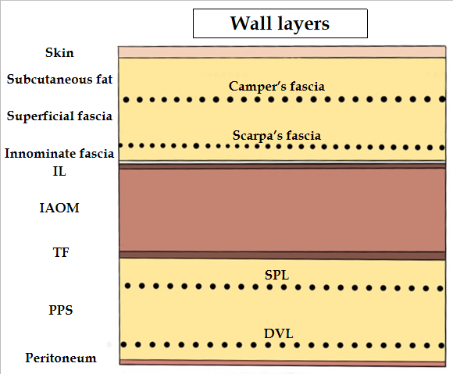

Figure 1 Abdominal wall at the groin. The nine layers include the skin, subcutaneous fat, superficial fasciae (Camper’s and Scarpa’s fasciae), innominate (untitled) fascia, inguinal ligament, internal abdominal oblique muscle, transversalis fascia, preperitoneal space [superficial parietal layer (anterior subperitoneal fascia) and deeper visceral layer (posterior subperitoneal fascia)] and peritoneum. DVL: Deeper visceral layer; IAOM: Internal abdominal oblique muscle; IL: Inguinal ligament; PPS: Preperitoneal space; SPL: Superficial parietal layer; TF: Transversalis fascia.

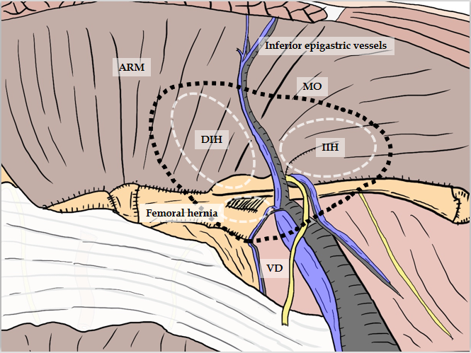
Figure 2 Relation between myopectineal orifice and all hernias (direct inguinal hernia, indirect inguinal hernia, femoral hernia) at the groin. The oval myopectineal orifice (black dotted circle) is the origin of all groin hernias (white dotted circles). ARM: Abdominal rectal muscle; DIH: Direct inguinal hernia; IIH: Indirect inguinal hernia; MO: Myopectineal orifice; VD: Vas deferens.

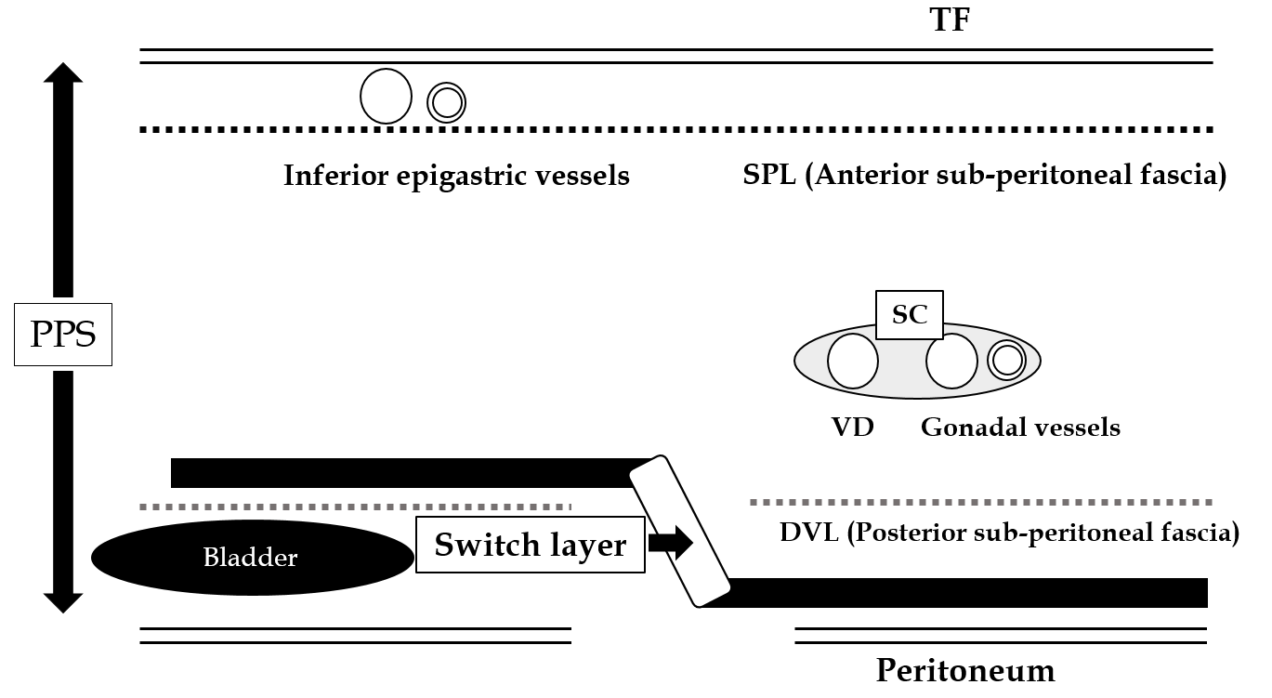
Figure 3 Current knowledge of the preperitoneal space and the adequate position of mesh placement during the transabdominal preperitoneal repair. Anatomical identification of the superficial parietal layer (SPL) and deeper visceral layer (DVL) was a milestone for further developments in surgical repairs. The dissected layer should be adequately switched between the SPL and DVL. DVL: Deeper visceral layer; PPS: Preperitoneal space; SC: Spermatic cord; SPL: Superficial parietal layer; TAPP: Transabdominal preperitoneal; TF: Transversalis fascia; VD: Vas deferens.

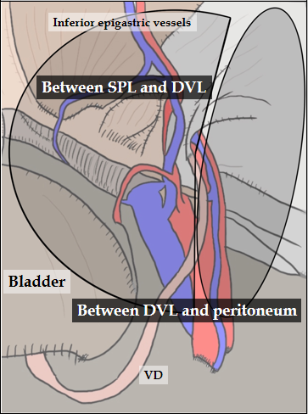
Figure 4 Appropriate layer and adequate mesh placement during a transabdominal preperitoneal repair. Surgical mesh should be adequately placed in an appropriate layer to avoid hernia recurrence and bladder injury. The layer is dissected between the superficial parietal layer and deeper visceral layer (DVL) on the inner side, whereas it is dissected between the DVL and peritoneum on the outer side. DVL: Deeper visceral layer; SPL: Superficial parietal layer; VD: Vas deferens.

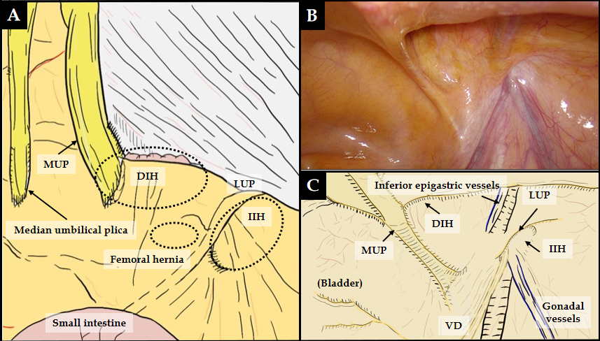
Figure 5 Laparoscopic view at the groin. A: Laparoscopic view focused on the relation between the plicae and the hernial defect. B and C: The actual view (B) and schema (C) are shown. Laparoscopic view with pneumoperitoneum has a significant advantage for easy, accurate diagnosis without any missed evaluations because the plicae and fossae precisely indicate hernia defects. DIH: Direct inguinal hernia; IIH: Indirect inguinal hernia; MUP: Medial umbilical plica; LUP: Lateral umbilical plica; VD: Vas deferens.

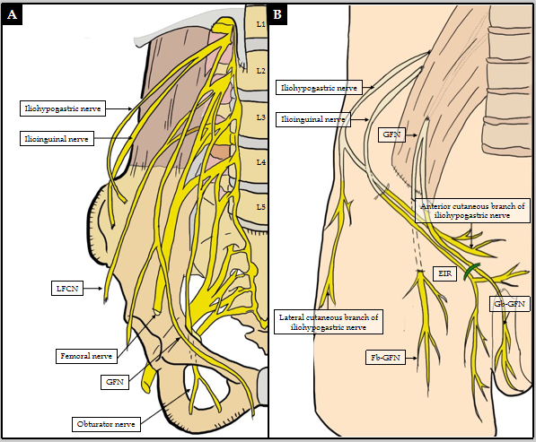
Figure 6 Critical nerves distributed in the field of the groin (A and B). These six nerves of interest are the iliohypogastric nerve, ilioinguinal nerve, femoral nerve (including the anterior cutaneous branch), genitofemoral nerve (femoral and genital branches), lateral femoral cutaneous nerve of the thigh, and obturator nerve. EIR: External inguinal ring; Fb-GFN: The femoral branch of the GFN; Gb-GFN: Genital branch of the GFN; GFN: Genitofemoral nerve; LFCN: Lateral femoral cutaneous nerve.
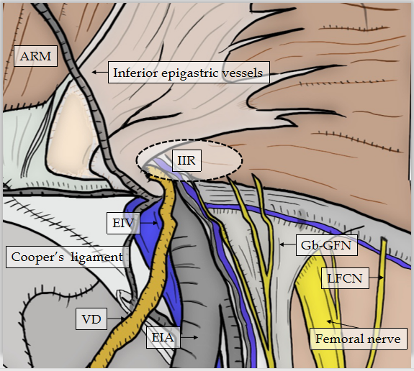
Figure 7 Critical nerves and other structures. Laparoscopic view in the groin area focused on the relation between the critical nerves [especially genital branch of the genitofemoral nerve and lateral femoral cutaneous nerve (LFCN)] and the other structures. Although the genitofemoral nerves run to the lower limbs, the more common nerve injuries are unfortunately to the genitofemoral nerve and LFCN. Each of these serious injuries has disastrous consequences for the patient with intractable pain. ARM: Abdominal rectal muscle; EIA: External iliac artery; EIV: External iliac vein; Gb-GFN: Genital branch of the genitofemoral nerve; IIR: Indirect inguinal ring; LFCN: Lateral femoral cutaneous nerve; VD: Vas deferens.

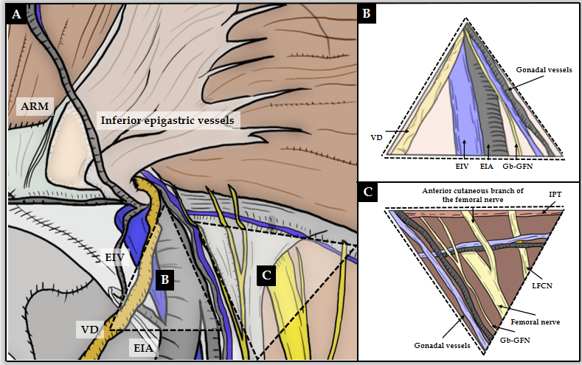
Figure 8 Triangle of doom and triangle of pain. Triangle of doom and triangle of pain should be adequately recognized by the surgeon. Triangle of doom is an inverted V-shaped area bound laterally by the gonadal vessels and medially by the vas deferens in male patients, or the round ligament in female patients. The EIA, external iliac vein, deep circumflex iliac vein, genital branch of the genitofemoral nerve, and femoral nerve are involved in this area. Area of the triangle of pain involves the femoral branch of the genitofemoral nerve, lateral femoral cutaneous nerve, femoral nerve, and the anterior cutaneous branch of the femoral nerve. Even a subtle injury to the nerves located within the triangle of pain is a risk factor for intractable pain. ARM: Abdominal rectal muscle; EIA: External iliac artery; EIV: External iliac vein; Gb-GFN: Genital branch of the genitofemoral nerve; IPT: Iliopubic tract; LFCN: Lateral femoral cutaneous nerve; VD: Vas deferens.
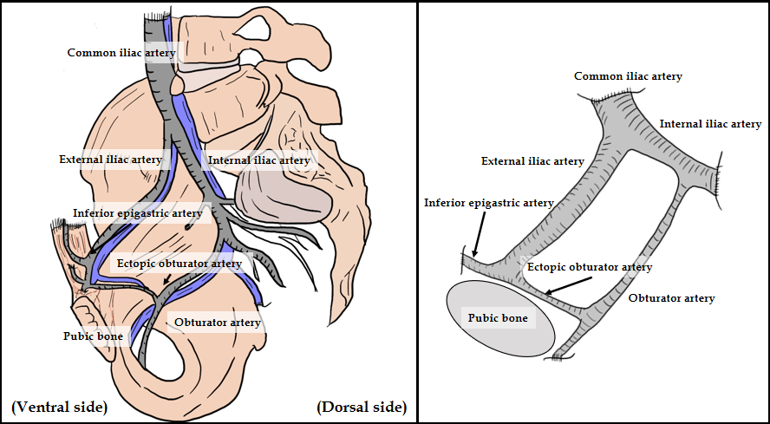
Figure 9 Corona mortis. Corona mortis and complicated vascular connection between the epigastric and obturator vessels. The corona mortis is classically defined as the arterial anastomosis between the obturator artery and the inferior epigastric artery via the ectopic obturator artery. The existence of the obturator artery results in annular communication between the inferior epigastric artery, common iliac artery, internal iliac artery, external iliac artery, and obturator artery. There may be several variants of anastomosing vascular branches. Brisk bleeding is difficult to control because of the dual vascular supply from the obturator and iliac vessels.

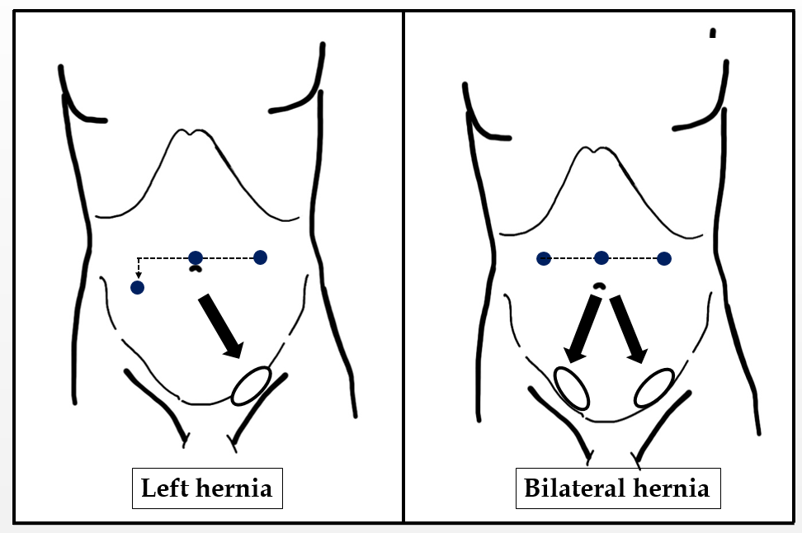
Figure 10 Port placement. Placement of surgical ports recommended for transabdominal preperitoneal repair. Pneumoperitoneum is achieved through an umbilical port. Two working ports (3- and 5-mm ports) are placed, and forceps are inserted in each at adequate angles to the target site. The port at the side opposite the target site is set lower than the umbilicus. The 5-mm port is used by the dominant arm of the main surgeon.

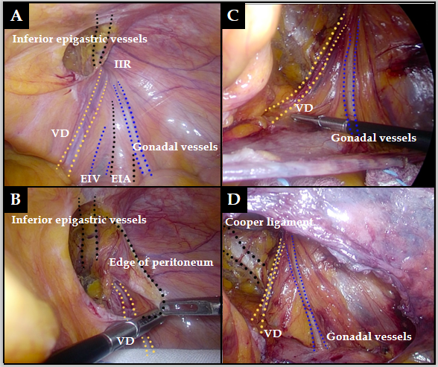
Figure 11 Complete preservation of the vas deferens and gonadal vessels. A: Surgical procedure during dissection around the vas deferens (VD) and gonadal vessels. Familiarity with the important structures should be required. B and C: The VD and gonadal vessels should be completely preserved without any subtle damage. D: The VD and gonadal vessels are sharply dissected from the peritoneum without use of electric cautery or a coagulating scalpel, under an adequate overhead view. EIA: External iliac artery; EIV: External iliac vein; IIR: Indirect inguinal ring; VD: Vas deferens.

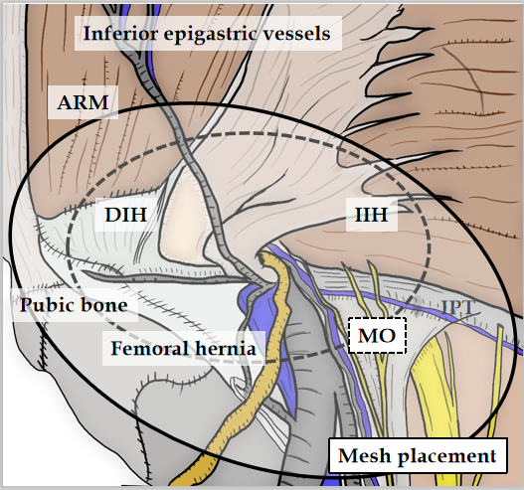
Figure 12 Adequate area covered by mesh. The relation between the myopectineal orifice (MO) and an area adequately covered by mesh. The MO should be fully reinforced by mesh placed at the preperitoneal space during transabdominal preperitoneal repair. ARM: Abdominal rectal muscle; DIH: Direct inguinal hernia; IIH: Indirect inguinal hernia; MO: Myopectineal orifice.

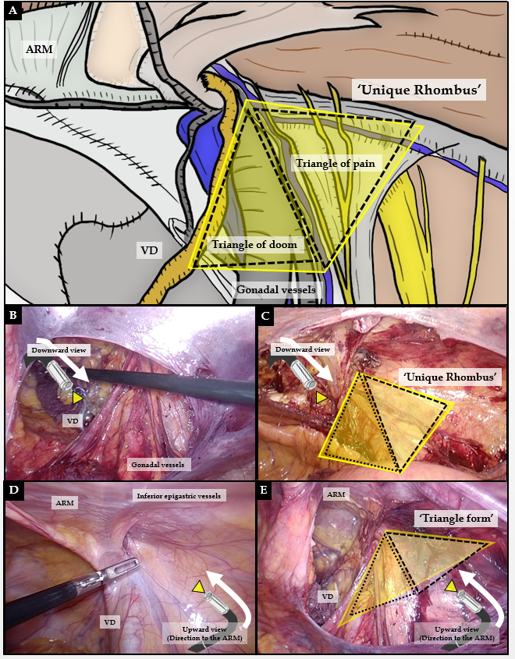
Figure 13 Importance of upward view. A: The triangle of doom and triangle of pain configure a unique rhombus around the inferior epigastric artery (IEA). Adequate change of laparoscopic view during transabdominal preperitoneal (TAPP) is very important. B and C: Although downward view requires safe preservation of the vas deferens and gonadal vessels and sure exposure of Cooper’s ligament, downward view may easily mislead surgeons causing unexpected injuries of topographic nerves and vessels. D and E: Generally, a unique rhombus around the IEA seems to be a triangle on the upward view, and the abdominal rectal muscle (ARM) is simultaneously observed at the roof. Thus, intraperitoneal anatomy including the ARM should be simultaneously recognized by upward view, for optimal mesh placement during TAPP. ARM: Abdominal rectal muscle; VD: Vas deferens.

