Name of Journal: World Journal of Hepatology
Manuscript NO: 34331
Manuscript Type: Case Report

Case of primary biliary cholangitis metachronously complicated with combined hepatocellular carcinoma-cholangiocellular carcinoma and hepatocellular carcinoma

Ide R et al. PBC complicated with cHCC-CCC and HCC

Ryuta Ide, Akihiko Oshita, Takashi Nishisaka, Hideki Nakahara, Shiomi Aimitsu, Toshiyuki Itamoto

Ryuta Ide, Akihiko Oshita, Hideki Nakahara, Toshiyuki Itamoto, Department of Gastroenterological Surgery, Hiroshima Prefectural Hospital, Hiroshima 734-8530, Japan

Akihiko Oshita, Toshiyuki Itamoto, Department of Gastroenterological and Transplant Surgery, Applied Life Sciences, Institute of Biomedical and Health Sciences, Hiroshima University, Hiroshima 734-8551, Japan

Takashi Nishisaka, Department of Pathology Clinical Laboratory, Hiroshima Prefectural Hospital, Hiroshima 734-8530, Japan

Shiomi Aimitsu, Department of Hepatology, Hiroshima General Hospital of West Japan Railway Company, Hiroshima 732-0057, Japan

ORCID number: Ryuta Ide (0000-0002-7263-2213); Akihiko Oshita (0000-0001-8417-7599); Takashi Nishisaka (0000-0003-1978-4717); Hideki Nakahara (0000-0003-1629-6259); Shiomi Aimitsu (0000-0002-1281-0380); Toshiyuki Itamoto (0000-0002-8353-4782).

Author contributions: Ide R and Oshita A made conception and design of this case report. Authors other than Ide R and Oshita A, Nishisaka T, Nakahara H, Aimitsu S and Itamoto T contributed to collection and interpretation of data. Ide R and Oshita A wrote the draft manuscript, and other authors performed critical revision of the manuscript. All authors gave final approval of the version to be published. Oshita A has overall responsibility, and guarantees the scientific integrity.

Informed consent statement: The patient provided informed consent for the publication of this manuscript and accompanying images.

Conflict-of-interest statement: The authors have no conflict-of-interest to disclose concerning this manuscript.

Open-Access: This article is an open-access article which was selected by an in-house editor and fully peer-reviewed by external reviewers. It is distributed in accordance with the Creative Commons Attribution Non Commercial (CC BY-NC 4.0) license, which permits others to distribute, remix, adapt, build upon this work non-commercially, and license their derivative works on different terms, provided the original work is properly cited and the use is non-commercial. See: http://creativecommons.org/licenses/by-nc/4.0/

Manuscript source: Invited manuscript

Correspondence to: Akihiko Oshita, MD, PhD, Department of Gastroenterological Surgery, Hiroshima Prefectural Hospital, 1-5-54 Ujina-kanda, Minami-ku, Hiroshima 734-8530, Japan, oshita-akihiko@umin.ac.jp
Telephone: +81-82-2541818
Fax: +81-82-2526932

Received: June 17, 2017
Peer-review started: June 19, 2017
First decision: July 20, 2017
Revised: November 8, 2017
Accepted: November 19, 2017
Article in press:
Published online:

Abstract
Primary biliary cholangitis (PBC) is a progressive cholestatic liver disease characterized by the presence of highly specific antimitochondrial antibodies, portal inflammation and lymphocyte-dominated destruction of the intrahepatic bile ducts, which leads to cirrhosis. While its pathogenesis remains unclear, PBC that shows histological progression to fibrosis carries a high risk of carcinogenesis; the same is true of viral liver diseases. In patients with PBC, the development of hepatocellular carcinoma (HCC) is rare; the development of combined hepatocellular carcinoma and cholangiocellular carcinoma (cHCC-CCC) is extraordinary. Herein, we report a rare case of PBC metachronously complicated by cHCC-CCC and HCC; which, to the best of our knowledge, has never been reported. We present a case report of a 74-year-old Japanese woman who was diagnosed as PBC in her 40’s by using blood tests and was admitted to our department for further management of an asymptomatic liver mass. She had a tumor of 15 mm in size in segment 8 of the liver and underwent a partial resection of the liver. Subsequent pathological findings resulted in the diagnosis of cHCC-CCC, arising from stage 3 PBC. One year after the initial hepatectomy, a second tumor of 10 mm in diameter was found in segment 5 of the liver; a partial resection of the liver was performed. Subsequent pathological findings led to HCC diagnosis. The component of HCC in the initial tumor displayed a trabecular growth pattern while the second HCC showed a pseudoglandular growth pattern, suggesting that metachronous tumors that arise from PBC are multicentric.

Key words: Primary biliary cholangitis; Combined hepatocellular carcinoma and cholangiocellular carcinoma; Hepatocellular carcinoma

© The Author(s) 2017. Published by Baishideng Publishing Group Inc. All rights reserved.

Core tip: Primary biliary cholangitis (PBC) is a progressive cholestatic liver disease characterized by the presence of highly specific antimitochondrial antibodies, portal inflammation and lymphocyte-dominated destruction of the intrahepatic bile ducts, which leads to cirrhosis. While its pathogenesis remains unclear, PBC that shows histological progression to fibrosis carries a high risk of carcinogenesis; the same is true of viral liver diseases. In patients with PBC, the development of hepatocellular carcinoma is rare; the development of combined hepatocellular carcinoma and cholangiocellular carcinoma (cHCC-CCC) is extraordinary. Herein, we report a rare case of PBC metachronously complicated by cHCC-CCC and HCC; which, to the best of our knowledge, has never been reported.

Ide R, Oshita A, Nishisaka T, Nakahara H, Aimitsu S, Itamoto T. Case of primary biliary cholangitis metachronously complicated with combined hepatocellular carcinoma-cholangiocellular carcinoma and hepatocellular carcinoma. World J Hepatol 2017; In press

INTRODUCTION
Primary biliary cholangitis (PBC)^{[1]} is a progressive cholestatic liver disease characterized by the presence of a highly specific antimitochondrial antibody, portal inflammation, and lymphocyte-dominated destruction of the intralobular bile ducts, which lead to cirrhosis. According to recent and relatively large cohort studies conducted in European countries, the United States, and Japan, the development of hepatocellular carcinoma (HCC) is estimated to be 0.7%-3.6%; this frequency increases as histological stages progress^{[2]}. While its pathogenesis remains unclear, PBC cases that display histological progression to fibrosis are at a high risk of carcinogenesis; the same is true of viral liver diseases^{[3,4]}. Although some cases of PBC complicated by HCC have been reported^{[5-8]}, to our knowledge, a case of PBC with cholangiocellular carcinoma (CCC) has never been described. In patients with PBC, the development of combined hepatocellular carcinoma and cholangiocellular carcinoma (cHCC-CCC) is extremely rare^{[9]}. Herein, we report a case of PBC metachronously complicated by cHCC-CCC and HCC.

CASE REPORT
A 74-year-old Japanese woman was diagnosed as PBC in her 40’s by using blood tests. Imaging studies, including abdominal ultrasonography (US) and computed tomography (CT), and tumor markers consisting of alpha fetoprotein (AFP) and protein induced by vitamin K absence (PIVKA-II) were checked up every 6 to 12 mo^{[4]}. She was admitted to our department for further management of an asymptomatic liver mass. The patient denied alcohol consumption; hepatitis B virus antigen and anti-hepatitis C virus antibody tests were negative; liver function test results, with daily intake of 600 mg of ursodeoxycholic acid, were stable; serum levels of AFP, PIVKA-II, carcinoembryonic antigen (CEA), carbohydrate antigen (CA) 19-9, and the L3 fraction of AFP were all within normal limits (Table 1). Abdominal US, dynamic CT, and magnetic resonance imaging (MRI) showed a liver tumor of 15 mm in size in segment 8 of the liver. Since the tumor was located in the peripheral lesion and was in contact with the middle hepatic vein (MHV), we performed partial resection of the liver in segment 8 including partial resection of MHV. Hematoxylin-eosin (HE) staining revealed two components consisting of the trabecular type of HCC and CCC, resulting in the definitive diagnosis of cHCC-CCC. According to the classification for the severity of PBC^{[10,11]}, the hepatic parenchyma, excluding carcinomatous tissue, showed stage 3 PBC (Figure 1). In the immunohistochemistry, the component of HCC was negative for AFP but positive for cytokeratin (CK) 18 and hepatocyte while that of CCC was positive for CK7 and CK19. The components of both HCC and CCC are positive for the epithelial cell adhesion molecule (EpCAM) (Figure 2). One year after the initial hepatectomy, tumor marker levels for AFP, PIVKA-II, CEA, and CA 19-9 were within normal limits; only AFP-L3 isoform level was elevated (Table 2). Dynamic CT and MRI showed a peripheral tumor of 10 mm in diameter in segment 5 of the liver. Since it was not possible to detect the tumor with intraoperative ultrasonography, partial resection of the liver on the basis of the anatomical structure including the Glissonean sheath and the hepatic vein was performed, and HE staining revealed a pseudoglandular pattern of HCC (Figure 3). In the immunohistochemistry, recurrent HCC was negative for AFP and EpCAM but positive for CK18 and hepatocyte (data not shown). There was no recurrence and/or metastasis 10 mo after re-hepatectomy.

DISCUSSION
While some cases of PBC complicated by HCC have been reported^{[5-8]}, only one case of PBC with cHCC-CCC has been reported^{[9]}. The present case of PBC was metachronously complicated by both cHCC-CCC and HCC; to the best of our knowledge, such a case has never been reported.
While the etiology of PBC remains unknown, it is well known that the intrahepatic bile ducts are to be destructed slowly and progressively, leading to cirrhosis^{[12]}. PBC occurs more often in middle-aged women and is often asymptomatic in its early stage^{[13,14]}. The frequency of HCC development in patients with PBC is estimated to be 0.7%-3.6%. While this frequency increases as the histological stages progress^{[2,5,6,9,11,15-20]}, the carcinogenic mechanism of primary liver cancer in PBC remains unclear. Although her PBC progressed to stage 3 of 4, when primary liver cancer was found, she had no liver cirrhosis symptoms.
Few studies have evaluated the imaging characteristics of cHCC-CCC, and no studies have evaluated the ability of preoperative imaging to determine diagnosis. The appearance of HCC and CCC is well known on contrast-enhanced MRI and CT. The histological composition and relative ratio of CCC and HCC components within cHCC-CCC appear to dictate the imaging appearance. Tumors may show features typical of HCC, such as arterial enhancement, washout, and pseudocapsule, whereas other regions within the tumor show progressive or delayed enhancement, necrosis, and possible ductal dilation more akin to CCC^{[21]}. The cHCC-CCC display enhancement patterns resembling CCC or HCC in comparable proportion on both contrast-enhanced ultrasonography (CEUS) and CT^{[22]}. Some suggest that the combination of imaging features and tumor markers may be helpful in preoperative diagnosis of cHCC-CCC^{[23]}. In our case, since dynamic computed tomography showed arterial enhancement and washout imaging, we performed initial hepatectomy expected for HCC.
Allen et al^{[24]} classiﬁed cHCC-CCC into three subtypes: Type A, "double cancer" represents cases in which HCC and CCC exist separately; type B, "combined" type, HCC and CCC components exist contiguously, but independently; and type C, "mixed" type, consisting of truly combined HCC and CCC components originating from the same tumor. Based on the morphological findings from HE staining, the present case was classiﬁed as mixed type cHCC-CCC. In recent years, the ability of hepatic precursor cells to differentiate into hepatocytes and bile duct cells and hepatic stem cells to proliferate and differentiate have been proposed. As candidate stem cells, cells derived from the Herring duct or small oval cells may be able to differentiate into hepatocytes and bile duct cells^{[25-27]}. Carcinogenesis of the precursor cells has been suggested as a developmental mechanism for cHCC-CCC with tissue components of HCC and CCC. In the present case, as Theise et al^{[28]} indicated, the result of EpCAM immunohistochemistry (a stem cell marker), might be consistent with that of mixed type cHCC-CCC.
The pathological results of the initial tumor showed the trabecular pattern in the component of HCC while that of the second tumor showed the pseudoglandular pattern in HCC. Immunohistochemistry also revealed the different pattern, which led the authors to speculate that the second tumor did not recur from the HCC component of cHCC-CCC, but the multicentric development of PBC-derived metachronous tumors.
In conclusion, we herein report a rare case of PBC metachronously complicated by both cHCC-CCC and HCC. In patients with PBC, it is necessary to check up not only liver function but also carcinogenesis including HCC, CCC and cHCC-CCC.

ARTICLE HIGHLIGHTS
Case characteristics
A 74-year-old Japanese woman was diagnosed as %rimary biliary cholangitis (PBC) in her 40’s by using blood tests. Imaging studies, including abdominal ultrasonography (US) and computed tomography (CT), and tumor markers consisting of alpha fetoprotein (AFP) and protein induced by vitamin K absence (PIVKA-II) were checked up every 6 to 12 mo. She was admitted to the authors’ department for further management of an asymptomatic liver mass.

Differential diagnosis
Combined hepatocellular carcinoma and cholangiocellular carcinoma, hepatocellular carcinoma and holangiocellular carcinoma were considered from imaging tests.

Laboratory diagnosis
In the initial surgery, serum levels of AFP, PIVKA-II, CEA, CA19-9, and the L3 fraction of AFP were all within normal limits. One year after the initial hepatectomy, tumor marker levels for AFP, PIVKA-II, CEA, and CA 19-9 were within normal limits; only AFP-L3 isoform level was elevated.

Imaging diagnosis
The authors diagnosed as HCC both the first and second tumors from the imaging findings.

Pathological diagnosis
First, HE staining revealed two components consisting of the trabecular type of HCC and CCC, resulting in the definitive diagnosis of cHCC-CCC. Second, HE staining revealed a pseudoglandular pattern of HCC.

Treatment
The first one was that the tumor was involved in MHV. If RFA was performed, the cooling effect around MHV would have occurred, leading to the insufficient ablation. The second one was that the tumor was not detected using ultrasonography preoperatively. Moreover, the tumor was not detected even with intraoperative CEUS. Therefore, the authors performed partial resection on the basis of the anatomical structure including the Glissonean sheath and the hepatic vein.

Related reports
This report relates to this reference: Kobayashi M, Furuta K, Kitamura H, Oguchi K, Arai M, Koike S, Nakazawa K. A case of primary biliary cirrhosis that complicated with combined hepatocellular and cholangiocellular carcinoma. Clin J Gastroenterol 2011; 4: 236-241.

Term explanation
PBC: Primary biliary cholangitis, is marked by slow progressive destruction of the intrahepatic bile ducts, which leads to cirrhosis.

Experiences and lessons
In patients with PBC, it is necessary to check up not only liver function but also carcinogenesis including HCC, CCC and cHCC-CCC.

REFERENCES
- Beuers U, Gershwin ME, Gish RG, Invernizzi P, Jones DE, Lindor K, Ma X, Mackay IR, Parés A, Tanaka A, Vierling JM, Poupon R. Changing nomenclature for PBC: From 'cirrhosis' to 'cholangitis'. Clin Res Hepatol Gastroenterol 2015; 39: e57-e59 [PMID: 26433440 DOI: 10.1016/j.clinre.2015.08.001]
- Abe M, Onji M. Natural history of primary biliary cirrhosis. Hepatol Res 2008; 38: 639-645 [PMID: 18462379 DOI: 10.1111/j.1872-034X.2008.00351.x]
- Bruix J, Sherman M; Practice Guidelines Committee, American Association for the Study of Liver Diseases. Management of hepatocellular carcinoma. Hepatology 2005; 42: 1208-1236 [PMID: 16250051 DOI: 10.1002/hep.20933]
- Silveira MG, Suzuki A, Lindor KD. Surveillance for hepatocellular carcinoma in patients with primary biliary cirrhosis. Hepatology 2008; 48: 1149-1156 [PMID: 18785621 DOI: 10.1002/hep.22458]
- Nijhawan PK, Therneau TM, Dickson ER, Boynton J, Lindor KD. Incidence of cancer in primary biliary cirrhosis: the Mayo experience. Hepatology 1999; 29: 1396-1398 [PMID: 10216121 DOI: 10.1002/hep.510290511]
- Jones DE, Metcalf JV, Collier JD, Bassendine MF, James OF. Hepatocellular carcinoma in primary biliary cirrhosis and its impact on outcomes. Hepatology 1997; 26: 1138-1142 [PMID: 9362353 DOI: 10.1002/hep.510260508]
- Lööf L, Adami HO, Sparén P, Danielsson A, Eriksson LS, Hultcrantz R, Lindgren S, Olsson R, Prytz H, Ryden BO. Cancer risk in primary biliary cirrhosis: a population-based study from Sweden. Hepatology 1994; 20: 101-104 [PMID: 8020878]
- Yano Y, Yoon S, Seo Y, Ninomiya T, Nagano H, Nakaji M, Hayashi Y, Kasuga M. A case of well-differentiated hepatocellular carcinoma arising in primary biliary cirrhosis. Kobe J Med Sci 2003; 49: 39-43 [PMID: 12796567]
- Kobayashi M, Furuta K, Kitamura H, Oguchi K, Arai M, Koike S, Nakazawa K. A case of primary biliary cirrhosis that complicated with combined hepatocellular and cholangiocellular carcinoma. Clin J Gastroenterol 2011; 4: 236-241 [PMID: 26189527 DOI: 10.1007/s12328-011-0223-z]
- Scheuer P. Primary biliary cirrhosis. Proc R Soc Med 1967; 60: 1257-1260 [PMID: 6066569]
- Nakamura M, Kondo H, Mori T, Komori A, Matsuyama M, Ito M, Takii Y, Koyabu M, Yokoyama T, Migita K, Daikoku M, Abiru S, Yatsuhashi H, Takezaki E, Masaki N, Sugi K, Honda K, Adachi H, Nishi H, Watanabe Y, Nakamura Y, Shimada M, Komatsu T, Saito A, Saoshiro T, Harada H, Sodeyama T, Hayashi S, Masumoto A, Sando T, Yamamoto T, Sakai H, Kobayashi M, Muro T, Koga M, Shums Z, Norman GL, Ishibashi H. Anti-gp210 and anti-centromere antibodies are different risk factors for the progression of primary biliary cirrhosis. Hepatology 2007; 45: 118-127 [PMID: 17187436 DOI: 10.1002/hep.21472]
- Kaplan MM, Gershwin ME. Primary biliary cirrhosis. N Engl J Med 2005; 353: 1261-1273 [PMID: 16177252 DOI: 10.1056/NEJMra043898]
- Heathcote EJ. Management of primary biliary cirrhosis. The American Association for the Study of Liver Diseases practice guidelines. Hepatology 2000; 31: 1005-1013 [PMID: 10733559 DOI: 10.1053/he.2000.5984]
- Kadokawa Y, Omagari K, Ohba K, Kitamura S, Ohara H, Takeshima F, Mizuta Y, Nanashima A, Yamaguchi H, Kohno S. Hepatocellular carcinoma in a male patient with early stage (stage I) primary biliary cirrhosis. Intern Med 2005; 44: 207-211 [PMID: 15805708 DOI: 10.2169/internalmedicine.44.207]
- Caballería L, Parés A, Castells A, Ginés A, Bru C, Rodés J. Hepatocellular carcinoma in primary biliary cirrhosis: similar incidence to that in hepatitis C virus-related cirrhosis. Am J Gastroenterol 2001; 96: 1160-1163 [PMID: 11316164 DOI: 10.1111/j.1572-0241.2001.03695.x]
- Cavazza A, Caballería L, Floreani A, Farinati F, Bruguera M, Caroli D, Parés A. Incidence, risk factors, and survival of hepatocellular carcinoma in primary biliary cirrhosis: comparative analysis from two centers. Hepatology 2009; 50: 1162-1168 [PMID: 19585656 DOI: 10.1002/hep.23095]
- Floreani A, Baragiotta A, Baldo V, Menegon T, Farinati F, Naccarato R. Hepatic and extrahepatic malignancies in primary biliary cirrhosis. Hepatology 1999; 29: 1425-1428 [PMID: 10216125 DOI: 10.1002/hep.510290501]
- Harada K, Hirohara J, Ueno Y, Nakano T, Kakuda Y, Tsubouchi H, Ichida T, Nakanuma Y. Incidence of and risk factors for hepatocellular carcinoma in primary biliary cirrhosis: national data from Japan. Hepatology 2013; 57: 1942-1949 [PMID: 23197466 DOI: 10.1002/hep.26176]
- Howel D, Metcalf JV, Gray J, Newman WL, Jones DE, James OF. Cancer risk in primary biliary cirrhosis: a study in northern England. Gut 1999; 45: 756-760 [PMID: 10517916 DOI: 10.1136/gut.45.5.756]
- Shibuya A, Tanaka K, Miyakawa H, Shibata M, Takatori M, Sekiyama K, Hashimoto N, Amaki S, Komatsu T, Morizane T. Hepatocellular carcinoma and survival in patients with primary biliary cirrhosis. Hepatology 2002; 35: 1172-1178 [PMID: 11981767 DOI: 10.1053/jhep.2002.33157]
- Fowler KJ, Sheybani A, Parker RA 3rd, Doherty S, M Brunt E, Chapman WC, Menias CO. Combined hepatocellular and cholangiocarcinoma (biphenotypic) tumors: imaging features and diagnostic accuracy of contrast-enhanced CT and MRI. AJR Am J Roentgenol 2013; 201: 332-339 [PMID: 23883213 DOI: 10.2214/ajr.12.9488]
- Li R, Yang D, Tang CL, Cai P, Ma KS, Ding SY, Zhang XH, Guo DY, Yan XC. Combined hepatocellular carcinoma and cholangiocarcinoma (biphenotypic) tumors: clinical characteristics, imaging features of contrast-enhanced ultrasound and computed tomography. BMC Cancer 2016; 16: 158 [PMID: 26917546 DOI: 10.1186/s12885-016-2156-x]
- Jarnagin WR, Weber S, Tickoo SK, Koea JB, Obiekwe S, Fong Y, DeMatteo RP, Blumgart LH, Klimstra D. Combined hepatocellular and cholangiocarcinoma: demographic, clinical, and prognostic factors. Cancer 2002; 94: 2040-2046 [PMID: 11932907 DOI: 10.1002/cncr.10392]
- Allen RA, Lisa JR. Combined liver cell and bile duct carcinoma. Am J Pathol 1949; 25: 647-655 [PMID: 18152860]
- Kofman AV, Morgan G, Kirschenbaum A, Osbeck J, Hussain M, Swenson S, Theise ND. Dose- and time-dependent oval cell reaction in acetaminophen-induced murine liver injury. Hepatology 2005; 41: 1252-1261 [PMID: 15880565 DOI: 10.1002/hep.20696]
- Tan J, Hytiroglou P, Wieczorek R, Park YN, Thung SN, Arias B, Theise ND. Immunohistochemical evidence for hepatic progenitor cells in liver diseases. Liver 2002; 22: 365-373 [PMID: 12390471 DOI: 10.1034/j.1600-0676.2002.01622.x]
- Zuckerman E, Misselevich I, Boss JH. Oval cell hyperplasia in asparaginase--induced liver damage. Liver 2002; 22: 363-364 [PMID: 12296971 DOI: 10.1034/j.1600-0676.2002.01612.x]
- Theise ND, Yao JL, Harada K, Hytiroglou P, Portmann B, Thung SN, Tsui W, Ohta H, Nakanuma Y. Hepatic 'stem cell' malignancies in adults: four cases. Histopathology 2003; 43: 263-271 [PMID: 12940779 DOI: 10.1046/j.1365-2559.2003.01707.x]

P-Reviewer: Bhatti ABH, Bessone FO, Giorgio A, Yu WB
S-Editor: Kong JX L-Editor: E-Editor:

Specialty type: Gastroenterology and hepatology
Country of origin: Japan
Peer-review report classification
Grade A (Excellent): 0
Grade B (Very good): 0
Grade C (Good): C, C, C, C
Grade D (Fair): 0
Grade E (Poor): 0

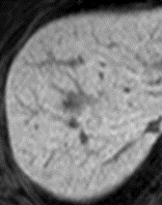
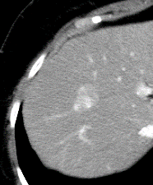
C
D
Bbb
A
ｄ
a
ｄ
c
b

H
F
G
E
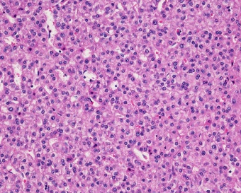
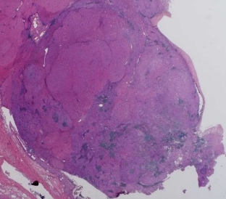
c
b

g
e
Figure 1 The initial tumor. A: Low-echoic tumor of 15 mm in size in segment 8 in US; B: The enhanced tumor on the early phase in dynamic CT; C: Low-intensity tumor on the hepatocyte phase in MRI; D: The cut surface of 15-mm solid mass in segment 8; E: HE staining of the resected specimen; F: Adenocarcinoma in the component of CCC; G: HCC with a trabecular pattern; H: Dense fibrous tissue was formed and intrahepatic biliary ducts were destructive, while a loose lymphoid aggregated, indicating stage 3 of primary biliary cirrhosis. MRI: Magnetic resonance imaging; US: Ultrasonography; CT: Computed tomography; HE: Hematoxylin-eosin; HCC: Hepatocellular carcinoma; CCC: Cholangiocellular carcinoma.

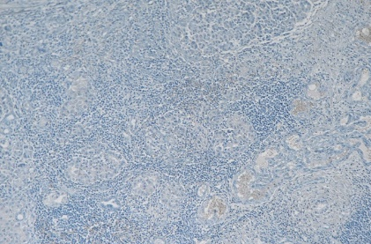
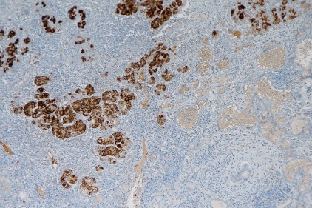
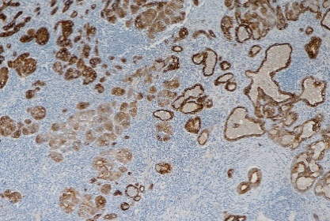
C
B
A

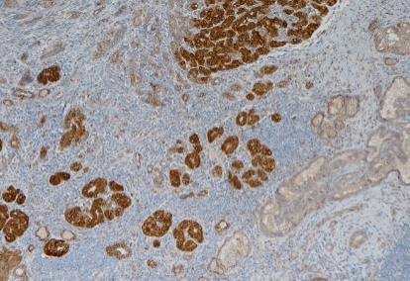
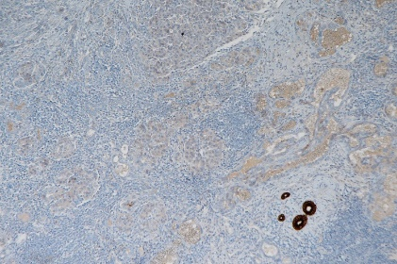
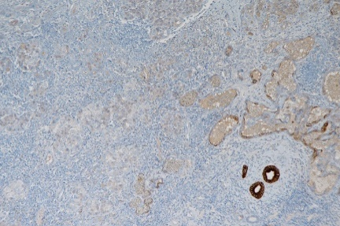
F
D
E

Figure 2 The immunohistochemistry of the initial tumor. A: HCC component stained positive for hepatocyte; B: HCC component stained positive for Cytokeratin 18; C: Both HCC and CCC component stained negative for Alpha fetoprotein; D: CCC component stained positive for CK7; E: CCC component stained positive for CK19; F: Epithelial cell adhesion molecule stained positive for HCC component and weakly positive for CCC component. HCC: Hepatocellular carcinoma; CCC: Cholangiocellular carcinoma.
e
a
d
f

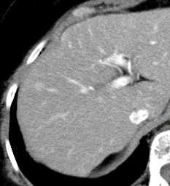
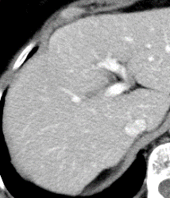
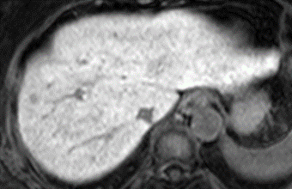
B
C
A
c
a
b
d

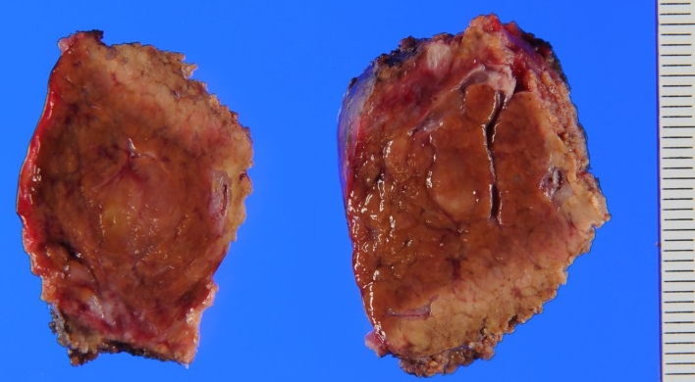
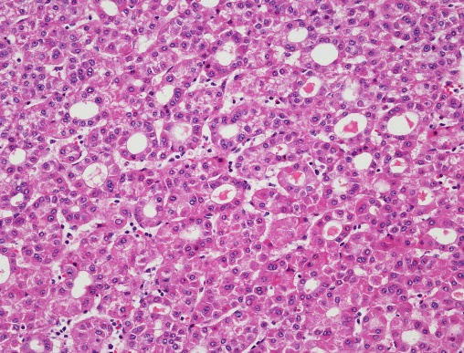
D
E

Figure 3 The second tumor. A: The enhanced tumor of 10 mm in diameter in segment 5 on the early phase in dynamic CT; B: The iso-density tumor on the delayed phase; C: Low intensity tumor on the hepatocyte phase in MRI; D: The cut surface of 10-mm solid mass in segment 5; E: HE staining showing a pseudoglandular pattern of HCC. MRI: Magnetic resonance imaging; CT: Computed tomography; HE: Hematoxylin-eosin; HCC: Hepatocellular carcinoma.

Table 1 Laboratory data on the initial hepatectomy
WBC | 5800/μL | ALP | 228 U/L | PIVKA-II | 18 mAU/mL
RBC | 432×10⁴/μL | γ-GTP | 65 U/L | AFP | 3 ng/mL
Hb | 13.0 g/dL | ChE | 280 IU/L | AFP-L3 | 0.5%
Ht | 38% | BUN | 14.5 mg/dL | CEA | 1.2 ng/mL
Plt | 22.6 × 10⁴/μL | Cr | 0.54 mg/dL | CA19-9 | 7 U/mL
PT | 77.3% | T.Chol | 203 mg/dL | ANA | × 40
PT-INR | 1.04 | T.G. | 77 mg/dL | AMA | × 640
TP | 7.9 g/dL | ICG-R15 | 8.3% | AMA-M2 | 158 Index
Alb | 4.2 g/dL | Glucose | 109 mg/dL | HBs Ag | (-)
T-Bil | 0.5 mg/dL | CRP | 0.2 mg/dL | HBs Ab | (-)
AST | 19 U/L | IgG | 1760 mg/dL | HBc Ab | (-)
ALT | 14 U/L | IgM | 305 mg/dL | HCV Ab | (-)
LDH | 183 U/L
WBC: White blood cell count; RBC: Red blood cell count; Hb: Hemoglobin; Ht: Hematocrit; Plt: Platelet; PT: Prothrombin time; PT-INR: Prothrombin time international normalized ratio; TP: Total protein; Alb: Albumin; T.Bil: Total bilirubin; AST: Aspartate aminotransferase; ALT: Alanine aminotransferase; LDH: Lactate dehydrogenase; ALP: Alkaline phosphatase; γ-GTP: Gamma-glutamyltransferase; ChE: Cholinesterase; BUN: Blood urea nitrogen; Cr: Creatinine; T.Chol: Total cholesterol; TG: Triglyceride; ICG-R15: 15-min retention rates of indocyanine green test; CRP: C-reactive protein; IgG: Immune globulin G; IgM: Immune globulin M; PIVKA-II: Prothrombin-induced vitamin K absence II; AFP: Alpha-fetoprotein; AFP-L3: A Lens culinaris agglutinin-reactive fraction of alpha-fetoprotein; CEA: Carcinoembryonic antigen; CA19-9: Carbohydrate antigen 19-9; ANA: Antinuclear antibodies; AMA: Antimitochondrial antibody; AMA-M2: Anti-mitochondrial M2 antibody; HBsAg: Hepatitis B virus antigen; HBsAb: Hepatitis B surface antibody; HBcAb: Hepatitis B core antibody; HCVAb: Hepatitis C virus antibody.

Table 2 Laboratory data on the re-hepatectomy
WBC | 3600/μL | AST | 29 U/L | PIVKA-II | 28 mAU/mL
RBC | 397 × 10⁴/μL | ALT | 18 U/L | AFP | 5 ng/mL
Hb | 12.0 g/dL | LDH | 186 U/L | AFP-L3 | 11.7%
Ht | 35.9% | ALP | 300 U/L | CEA | 1.0 ng/mL
Plt | 22.3 × 10⁴/μL | γ-GTP | 79 U/L | CA19-9 | 29 U/mL
PT | 77.3% | ChE | 211 IU/L | ICG-R15 | 7.4%
PT-INR | 1.12 | BUN | 16.1 mg/dL | Glucose | 138 mg/dL
TP | 7.3 g/dL | Cr | 0.6 mg/dL | CRP | 0.2 mg/dL
Alb | 3.8 g/dL | T-Bil | 0.4 mg/dL
WBC: White blood cell count; RBC: Red blood cell count; Hb: Hemoglobin; Ht: Hematocrit; Plt: Platelet; PT: Prothrombin time; PT-INR: Prothrombin time international normalized ratio; TP: Total protein; Alb: Albumin; T.Bil: Total bilirubin; AST: Aspartate aminotransferase; ALT: Alanine aminotransferase; LDH: Lactate dehydrogenase; ALP: Alkaline phosphatase; γ-GTP: Gamma-glutamyltransferase; ChE: Cholinesterase; BUN: Blood urea nitrogen; Cr: Creatinine; ICG-R15: 15-min retention rates of indocyanine green test; CRP: C-reactive protein; PIVKA-II: Prothrombin-induced vitamin K absence II; AFP: Alpha-fetoprotein; AFP-L3: A Lens culinaris agglutinin-reactive fraction of alpha-fetoprotein; CEA: Carcinoembryonic antigen; CA19-9: Carbohydrate antigen 19-9.

