Name of Journal: World Journal of Gastroenterology
Manuscript NO: 44829
Manuscript Type: ORIGINAL ARTICLE

Basic Study

Integrated network analysis of transcriptomic and protein–protein interaction data in taurine-treated hepatic stellate cells

Liang XQ et al. Network analysis shows mechanism of taurine

Xing-Qiu Liang, Jian Liang, Xiao-Fang Zhao, Xin-Yuan Wang, Xin Deng

Xing-Qiu Liang, Xiao-Fang Zhao, Department of science and technology, Ruikang Hospital Affiliated to Guangxi University of Chinese Medicine, Nanning 530011, Guangxi Zhuang Autonomous Region, China

Jian Liang, College of medical, Guangxi University, Nanning 530004, Guangxi Zhuang Autonomous Region, China

Xin-Yuan Wang, Xin Deng, School of basic sciences, Guangxi University of Chinese Medicine, Nanning 530200, Guangxi Zhuang Autonomous Region, China

ORCID number: Xing-Qiu Liang (0000-0003-3378-1336); Jian Liang (0000-0002-6084-3849); Xiao-Fang Zhao (0000-0003-4697-9157); Xin-Yuan Wang (0000-0003-4697-1157); Xin Deng (0000-0002-3924-7225).

Author contributions: Deng X and Liang XQ contributed equally to the study, performed the majority of experiments, and analyzed the data; Liang XQ wrote the paper; Zhao XF and Wang XY performed the treatment of HSCs; Liang J designed and coordinated the research.

Supported by the National Natural Science Foundation of China, No. 81360595 and No. 81860790; Guangxi Natural Science Foundation Program, No. KJT13066; the Bagui Scholars Foundation Program of Guangxi; the Special-term Experts Foundation Program of Guangxi; and the Project of Guangxi Young Teacher Fundamental Ability Promotion, No. 2017KY0298.

Institutional review board statement: The study was approved by the institutional review board of our hospital.

Institutional animal care and use committee statement: We did not use animals in our present study.

Conflict-of-interest statement: To the best of our knowledge, no conflict of interest exists.

ARRIVE guidelines statement: The authors have read the ARRIVE guidelines, and the manuscript was prepared and revised according to the ARRIVE guidelines.

Open-Access: This article is an open-access article which was selected by an in-house editor and fully peer-reviewed by external reviewers. It is distributed in accordance with the Creative Commons Attribution Non Commercial (CC BY-NC 4.0) license, which permits others to distribute, remix, adapt, build upon this work non-commercially, and license their derivative works on different terms, provided the original work is properly cited and the use is non-commercial. See: http://creativecommons.org/licenses/by-nc/4.0/

Manuscript source: Unsolicited manuscript

Corresponding author: Xin Deng, MD, PhD, Professor, School of Basic Science, Guangxi University of Chinese Medicine, 13 Xianhu Avenue, Nanning 530200, Guangxi Zhuang Autonomous Region, China. 260446391@qq.com
Telephone: +86-771-2239080
Fax: +86-771-2239080

Received: December 5, 2018
Peer-review started: December 6, 2018
First decision: January 11, 2019
Revised: January 24, 2019
Accepted: January 26, 2019
Article in press: January 26, 2019
Published online: March 7, 2019

Abstract
BACKGROUND
Studies show that the antifibrotic mechanism of taurine may involve its inhibition of the activation and proliferation of hepatic stellate cells (HSCs). Since the molecular mechanism of taurine-mediated antifibrotic activity has not been fully unveiled and is little studied, it is imperative to use “omics” methods to systematically investigate the molecular mechanism by which taurine inhibits liver fibrosis.

AIM
To establish a network including transcriptomic and protein–protein interaction data to elucidate the molecular mechanism of taurine-induced HSC apoptosis.

METHODS
We used microarrays, bioinformatics, protein-protein interaction (PPI) network, and sub-modules to investigate taurine-induced changes in gene expression in human HSCs (LX-2). Subsequently, all of the differentially expressed genes (DEGs) were subjected to gene ontology function and Kyoto encyclopedia of genes and genomes pathway enrichment analysis. Furthermore, the interactions of DEGs were explored in a human PPI network, and sub-modules of the DEGs interaction network were analyzed using Cytoscape software.

RESULTS
A total of 635 DEGs were identified in taurine-treated HSCs when compared with the controls. Of these, 304 genes were statistically significantly up-regulated, and 331 down-regulated. Most of these DEGs were mainly located on the membrane and extracellular region, and are involved in the biological processes of signal transduction, cell proliferation, positive regulation of extracellular regulated protein kinases 1 (ERK1) and ERK2 cascade, extrinsic apoptotic signaling pathway and so on. Fifteen significantly enriched pathways with DEGs were identified, including mitogen-activated protein kinase (MAPK) signaling pathway, peroxisome proliferators-activated receptor signaling pathway, estrogen signaling pathway, Th1 and Th2 cell differentiation, cyclic adenosine monophosphate signaling pathway and so on. By integrating the transcriptomics and human PPI data, nine critical genes, including MMP2, MMP9, MMP21, TIMP3, KLF10, CX3CR1, TGFB1, VEGFB, and EGF, were identified in the PPI network analysis.

CONCLUSION
Taurine promotes the apoptosis of HSCs via up-regulating TGFB1 and then activating the p38 MAPK-JNK-Caspase9/8/3 pathway. These findings enhance the understanding of the molecular mechanism of taurine-induced HSC apoptosis and provide references for liver disorder therapy.

Key words: Taurine; Hepatic stellate cells; Differentially expressed genes; Liver fibrogenesis; Transcriptomic; Protein–protein interaction network

© The Author(s) 2019. Published by Baishideng Publishing Group Inc. All rights reserved.

Core tip: We report our results derived from integrating transcriptomic and protein–protein interaction data by methods of microarrays, bioinformatics, protein-protein interaction network, and sub-modules, which allowed us to identify the key targets genes involved in taurine-promoted hepatic stellate cell (HSC) apoptosis. This study demonstrates for the first time that taurine promotes the apoptosis of HSCs via up-regulating TGFB1 and then activating the p38 MAPK-JNK-Caspase9/8/3 pathway. MMP2, MMP9, MMP21, TIMP3, KLF10, CX3CR1, TGFB1, VEGFB, and EGF may be the important targets of taurine in HSCs.

Citation: Liang XQ, Liang J, Zhao XF, Wang XY, Deng X. Integrated network analysis of transcriptomic and protein-protein interaction data in taurine-treated hepatic stellate cells. World J Gastroenterol 2019; 25(9): 1067-1079

URL: https://www.wjgnet.com/1007-9327/full/v25/i9/1067.htm

DOI: https://dx.doi.org/10.3748/wjg.v25.i9.1067

INTRODUCTION
Hepatic fibrosis is a pathological condition that may gradually develop into liver cirrhosis or even hepatocellular carcinoma (HCC) if left without effective treatment^{[1,2]}. Unfortunately, effective clinical therapies to halt disease progression are still lacking. In the development of liver ﬁbrosis, the central event is that quiescent hepatic stellate cells (HSCs) become activated and then transdifferentiate into myofibroblast-like cells. The process of HSC activation may be the important target to halt the development of hepatic fibrosis, but it occurs quickly. Accordingly, researchers have focused on the regulatory pathways of HSC activation upon injurious stimuli by activating or repressing gene transcription, epigenetic regulation, and post-transcriptional control. To date, they have identified many target genes implicated in HSC activation, including TGFB1, Foxf1, JunD, and C/EBP^{[3,4]}. It is reported that deletion of one Foxf1 allele can slow down or inhibit HSC activation^{[5]}. Similarly, knockout of JunD, which encodes a functional component of the AP1 transcription factor complex^{[6]}, alleviated CCl4-induced hepatic fibrosis via the reduction of activated HSCs and down-regulation of hepatic TIMP-1 expression^{[7]}. Furthermore, phosphorylation of the transcription factor C/EBP by RSK kinase promoted the survival of quiescent HSC^{[8]}. There could be no doubt that the regulatory pathways and key genes included in the process of HSC activation would be essential to develop therapeutic strategies against fibrogenic diseases.
Taurine, also known as 2-aminoethanesulfonic acid (C₂H₇NO₃S), is a beta amino acid with a simple structure and mostly appears in the free state in organism. It plays a protective role in various cells and tissues^{[9]}. It is reported that taurine can protect the liver against several forms of hepatic damage, including ischemia-reperfusion injury, hepatic carcinoma, and hepatic abnormality, which were demonstrated by animal experiments^{[10-15]}. Furthermore, Miyazaki et al^{[13]} investigated how taurine influences the hepatic fibrogenesis in rats or HSCs, and finally discovered that taurine could inhibit the proliferation of activated HSCs. In our previous studies, the methods of microculture tetrazolium and flow cytometry were performed to compare the apoptosis rate between taurine-treated and non-treated HSCs, and the results showed that taurine can inhibit cell proliferation and promote cell apoptosis significantly^{[16,17]}. Thus, supplementation with taurine should be considered a therapeutic approach to lessen the severity of liver injury and hepatic fibrosis. However, life is so complex that the therapeutic mechanism of any drug may involve a variety of genes and pathways in regulating biological networks. The molecular mechanism of taurine remains unclear, and therefore, it is difficult to use taurine for precision therapies in liver diseases. With the discovery and development of high-throughput research methods, the technology of microarray and bioinformatics give us an opportunity to analyze a number of genes related to complex refractory effects of traditional Chinese medicine. It is well known that the phenotype of a cell, ranging from the components to the functions, is ultimately up to its gene expression profiles. Analyzing the changes of gene expression profiles after treatment by medicine may help reveal their action mechanisms.
In the current study, we performed gene microarray and bioinformatics methods on taurine-treated human HSCs and control HSCs, which revealed differentially expressed genes (DEGs) between taurine-treated HSCs and control cells. Subsequently, the DEGs were subjected to the analysis of gene ontology (GO) function and Kyoto encyclopedia of genes and genomes (KEGG) pathway. And then, we further explored the interactions of DEGs in a human protein-protein interaction (PPI) network and sub-modules via Cytoscape software. The overall goals were to provide therapeutic targets of taurine and to have an in-depth insight into the molecular mechanisms by which taurine protects the liver.

MATERIALS AND METHODS
Materials
Human HSCs (LX-2) were purchased from XiangYa Central Experiment Laboratory, Central South University, Changsha, Hunan Province, China. Taurine was provided by Yuanlong Pearl Co. Ltd., Beihai, Guangxi Zhuang Autonomous Region, China. Dulbecco’s minimum essential medium (DMEM) was obtained from Hyclone (Logan, UT, United States). Fetal bovine serum (FBS) was purchased from Biochrom AG (Berlin, Germany). Streptomycin sulfate and penicillin were supplied by North China Pharmaceutical, China. Distilled water was ﬁltered through a Milli-Q system (Millipore, Bedford, MA, United States).

Culture and treatment of HSCs
HSCs were cultured in DMEM supplemented with 10% FBS, 100 U/mL penicillin, and 100 U/mL streptomycin in an incubator at 37 °C and 5% CO₂. The fresh culture medium was replaced every other day. When the cell density achieved approximately 80% confluence, cells were trypsinized and resuspended in DMEM at a density of 1 × 10⁵/mL. For taurine-treated cells, the supernatant was discarded after centrifugation, and the cells were incubated for 48 h in DMEM containing 40 mmol/L taurine, while the control group was incubated in DMEM containing the same concentration of HSCs without taurine.

Illumina microarray chip analysis
Illumina Bead Chip (San Diego, CA, United States) was constructed as a gene expression microarray chip. Each slide (HumanHT-12_V4) contained 47323 DNA probes (887 controls, 46436 tests). Total RNA from HSCs was extracted with Trizol (Invitrogen, Carlsbad, CA, USA) according to the manufacturer's instructions. RNA samples, with an A260/A280 ratio ranging between 1.7 and 2.1, were subjected to denatured agarose gel electrophoresis for testing RNA integrity, followed by labeling through an Illumina® RNA Amplification kit (Ambion, Austin, TX, United States) according to the instructions of the manufacturers. RNA was converted to labeled cRNA and quantified as previously described^{[18]}.
Hybridization, washing, and detection were performed using the Illumina Gene Expression System Buffer Kit for HumanHT-12_V4 Bead-Chips (Illumina, San Diego, CA, United States) according to the manufacturer’s protocol. Briefly, an aliquot (11.3 μL) containing 850 ng cRNA was mixed with Hybridization Mix (22.7 μL), followed by incubating at 65 °C for 5 min. And then 34 μL reaction solution was transferred to Human HT-12_V4 Bead-Chip array, and incubated for 16 h at 55 °C with rotation. After hybridization, Bead-Chips were fully washed in supplied wash solutions 5-10 times on a shaker. For detection, Bead-Chips were transferred to a fresh wash tray containing streptavidin-Cy3 (1 μg/mL; Amersham Biosciences, Piscataway, NJ, United States) and rocked for 10 min, and then dried by centrifugation at 275 g for 4 min at 20 °C after washing. Arrays were scanned using Illumina Bead Array Reader and Bead Scan software, and subsequently analyzed using the software of Illumina Bead Studio Application (San Diego, CA, United States).

Microarray data acquisition and preprocessing
Raw data was obtained as “.IDAT” and “.SDF” format using Genome Studio software (Illumina, San Diego, CA, United States), and then imported into the R environment for further processing. Subsequently, quantile normalization was carried out in R using the lumi package with the Bioconductor open source software (http://www.bioconductor.org/).

Microarray data quality control and analysis
Text or excel files for each RNA hybridization were created by the Illumina® GenomeStudio Gene Expression Module (Version 1.0), and then analyzed in R3.2.5 (http://www.R-project.org/). The Limma package^{[19]} (http://www.ncbi.nlm.nih.gov/pubmed/16646809) was used to perform background adjustment, summarization, and quantile normalization. Normalization was made using the robust multichip average (RMA) pre-normalization algorithm^{[20]}. Data quality assessment was accomplished by using various quality control measures. Specifically, box plots are utilized to compare probe intensity levels among the arrays of the dataset. The median lines were not significantly different from each other after normalization. For each replicate array, gene expression ratios were generated by comparing each probe-set signal value from taurine-treated samples to that from control samples. DEGs were then identified by the Limma package with multiple testing correction using the Benjamini-Hochberg false discovery rate. The statistically significant DEGs were calculated using volcano plot analysis with the absolute value of log2 fold change (FC) (|log2FC| ≥ 1.5) and a P-value < 0.05. Moreover, DEGs were visualized by hierarchical clustering analysis.

Gene ontology function and Kyoto encyclopedia of genes and genomes pathway enrichment analysis
In order to explore their function, the DEGs with known identities or homologous sequences and known functional definitions were categorized using the Database for Annotation, Visualization and Integrated Discovery (https://david-d.ncifcrf.gov, ver. 6.8) that is applied based on three categories of GO, namely, biological process (BP), molecular function (MF), and cell component (CC). Genes were excluded if they were only with expressed sequence tag identification or genomic coordinates that could not be annotated. Pathway enrichment analysis was performed via the KEGG database to identify functional categories of statistically significant genes, which were defined as pathways exhibiting significant P-values (P < 0.05) with at least three overlapping genes. The biological networks were generated by comparing the input list of DEGs to a reference list from human databases.

PPI network
Human PPI networks were downloaded from the Human Protein Reference Database^{[21]}. The human PPI network was then used to construct an interaction network of DEGs, and Cytoscape (http://cytoscape.org/, ver. 3.4.0) was used to mine the function modules. The sub-module in the interaction network was further explored using the MCODE plug-in in Cytoscape (the cut-off was set at 3).

Statistical analysis
Microarray data processing and normalization were analyzed in R3.2.5 (http://www.R-project.org/), applying an RMA algorithm. Significance was calculated using a t-test without multiple testing correction, selecting all transcripts with a minimum change in expression level of 1.5-fold together with a P-value less than 0.05. PPI network was analyzed using CytoNCA, which is a plugin of Cytoscape for network evaluation and topological analysis, including degree centrality, betweenness centrality, and closeness centrality, for hub gene screening. Proteins were defined as nodes, and PPI associations were defined as edges in the PPI network.

RESULTS
Effects of taurine on gene expression in HSCs
The results were consistent with our previous findings which demonstrated that taurine could up- and down-regulate gene expression in HSCs^{[22]}. In the present study, 635 genes showed significantly differential expression in taurine-treated HSCs as compared with the control under the threshold of |log2FC| ≥ 1.5 and P < 0.05. Of these, 304 (47.87%) were found to be up-regulated, while 331 (52.13%) were down-regulated.

GO analysis of differential genes in taurine-treated HSCs
GO enrichment analyses were conducted on 304 differentially up-regulated and 331 down-regulated transcribed genes, which were classified into three main GO categories, including BP, MF, and CC. The distribution of annotated genes across different GO categories is shown in Table 1. The results indicated that DEGs were mainly involved in the MF of identical protein, calmodulin, protease, hormone, peptidoglycan, beta-amyloid, and calcium ion binding activity; olfactory receptor, steroid hormone receptor, and transmembrane signaling receptor activity; protein kinase, metalloendopeptidase, protein tyrosine kinase, metallopeptidase, serine-type peptidase, and transferase activity. In the light of the BP analysis, DEGs were involved in the processes of signal transduction, positive regulation of transcription from RNA polymerase II promoter, proteolysis, positive regulation of transcription, DNA-templated, negative regulation of cell proliferation, positive regulation of ERK1 and ERK2 cascade, and regulation of apoptotic process. In addition, DEGs were mainly located in the plasma membrane, integral component of plasma membrane, external side of plasma membrane, basement membrane, apical plasma membrane, integral component of membrane, extracellular region, presynapse, cell surface, and proteinaceous extracellular matrix.

Pathway analysis of DEGs in taurine-treated HSCs
In order to further identify the specific biological pathways of differential genes associated with taurine treatment, the KEGG database was applied. As a result, 30 significantly enriched pathways with DEGs were identified (P < 0.05) and are listed in the Figures 1 and 2, which included mitogen-activated protein kinase (MAPK) signaling pathway, peroxisome proliferators-activated receptor signaling pathway, estrogen signaling pathway, Th1 and Th2 cell differentiation, cyclic adenosine monophosphate signaling pathway and so on (P < 0.05).

Analysis of the PPI network of DEGs
The interaction between protein and protein plays an important role in various BP. In the PPI network, the protein and the interaction are defined as the node and the edge, respectively. The present PPI network is comprised of 371 nodes and 882 edges (Figure 3). In this network, the ellipse nodes have higher degrees, the second is the triangle nodes, and the diamond nodes is the least. The ellipse nodes include 64 genes, such as JAK2, PRKACB, MAPK14, CYP19A1, RAP1A, TGFB1, ESR1, NPS, NR3C1, DNAH8, PIKFYVE, EGF, EGFR, BDNF, MMP9, and SRC. Of these, 32 were up-regulated, and 32 down-regulated. The number of edges of each node is quite large (for example, 45 in SRC, 41 in PRKACB, MAPK14, and EGF, 40 in EGFR, and 33 in PIKFYVE). Thus, it indicated that the genes with more nodes are more important to the protective mechanism of taurine. Subsequently, we analyzed the network with a plugin of Cytoscape named MCODE, and obtained 11 clusters, which are showed in Table 2 and Figure 4.

DISCUSSION
In the present study, we explored the mechanism of taurine on human HSCs in more details based on the gene microarray data, identified the DEGs in the taurine-treated samples by a SAM-based method, analyzed the GO functions and KEGG pathways of DEGs, and further investigated the DEGs by interaction network and sub-module analysis.
The DEGs identified included matrix metalloproteinases (MMP2, MMP9, and MMP21), and their specific tissue inhibitor (TIMP3). It is generally recognized that metalloproteinases enhance cancer cell growth while their specific tissue inhibitor suppress. A collection of studies has indicated that TIMP3 could regulate the bioavailability of cytokines and growth factors to control inflammation and modulate the survival of cells in the liver. Studies targeting the hepatic fate, including liver regeneration^{[23]}, systemic inflammation^{[24]}, Fas-dependent hepatotoxicity^{[25]}, and high-fat diet-induced nonalcoholic fatty liver disease^{[26]} or steatohepatitis^{[24]}, have confirmed TIMP3 as a key controller of inflammation, cell death, and cell survival in the liver, again suggesting it as a tumor suppressor gene. It is noteworthy that TIMP3 is also found silenced in human cancers. Meanwhile, convincing evidence showed that TIMP3 loss slowed the progression of hepatic tumorigenesis and the development of malignancy despite eliciting heightened inflammation in response to carcinogen. Notably, gene deletion of TIMP3 could be dispensable by the immediate engagement of several tumor suppressor pathways to protect from carcinogen-induced HCC. These pathways include tumor necrosis factor signaling^{[27]}. It will be seen from these that changes of these genes may be directly related to the protective effect of taurine against liver disease.
Moreover, Kruppel-like factor 10 (KLF10) is found to be up-regulated by taurine with an FC value of 2.83. It is a tumor suppressor, directly inhibits the expression of collagen I and PDGFRβ, and promotes HSCs apoptosis. Evidence indicates that haploinsufficiency of KLF10 led to fibrosis worsening in rats^{[28]}. The up-regulation of KLFs by statins promoted the expression of the vasoprotective gene via a KLF2-nitric oxide-guanylate cyclase-mediated paracrine mechanism^{[29]}. It is suggested that taurine-increased apoptosis of HSCs may be associated with the function that up-regulates KLF10 and then directly represses collagen I and PDGFRβ expression.
Immune regulation, one of the cellular events in injured/inflamed hepatic tissue microenvironment, is also well known to directly lead to the activation of HSCs in a etiology-specific or -independent manner^{[30]}. Investigation into the divergent immunomodulatory activities of quiescent and activated HSCs in vitro has revealed that activated HSCs induce T-cell hyporesponsiveness^{[31]}. The identified DEGs also include pro-fibrogenic inflammatory chemokines and their receptors such as C-X3-C motif chemokine receptor 1, which could increase activated HSC apoptosis^{[32]}. These processes are fundamental to promote HSC apoptosis and the action mechanism of taurine may be directly associated with these regulation processes.
Based on the BP analysis of GO function, it is demonstrated that the DEGs were mainly involved in negative regulation of the cell proliferation, epidermal growth factor receptor signaling pathway, and regulation of apoptotic process. Several important pathways have been identified, including the MAPK signaling pathway, calcium signaling pathway, GnRH signaling pathway, and inflammatory mediator regulation of TRP channels. The MAPK signaling pathway is an intracellular signaling transduction pathway, including extracellular signal regulated kinase (ERK), Jun N-terminal kinase (JNK), p38, and ERK-5, and its major function is to control gene expression in response to cell proliferation, differentiation, and migration. In this intracellular signaling transduction pathway, JNK and p38 MAPK family members take effects in a cell context- and cell type-specific manner to integrate signals that affect proliferation, differentiation, survival, and migration^{[33]}. Indeed, previous studies showed that ERK, JNK, and p38 MAPK regulate the activation of HSCs during the development process of liver fibrosis^{[30]}. Moreover, it is reported that JNK may be involved in regulating activated HSC apoptosis by death receptors DR4/DR5 and pro-apoptosis factor CHOP^{[34]}. JNK activity is also affected by inhibition of NF-κB, which may result in an increase of cell death and cytokine-driven compensatory proliferation^{[35]}. Furthermore, Al-Azayzih et al^{[36]} studied how TGFB1 affected the cancer cell survival and proliferation, and found that TGFB1 decreased cell viability and induced cancer cell apoptosis via activation of the p38 MAPK-JNK-Caspase9/8/3 pathway. It is well known that TGFβ is an inhibitor of epithelial and lymphoid cell proliferation, and therefore considered to have an inhibitory effect on tumor. It is also included in the identified DEGs and was up-regulated by taurine with an FC value of 2.33 (P < 0.01). The conclusion was that taurine promotes the apoptosis of HSCs via up-regulating TGFB1 and then activating the p38 MAPK-JNK-Caspase9/8/3 pathway.
The PPI sub-network consisted of VEGFB, EGF, BDNF, TGFB1, FIGF, TIMP3, FGB, EGFR, F7, MMP9, MMRN1, and TCOF1. The GO function analysis demonstrated that these DEGs are mainly involved in positive regulation of protein kinase B signaling, ERK1 and ERK2 cascade, MAP kinase activity, MAPK cascade, cell migration, and cell proliferation based on analysis of the BP. Meanwhile, it was also shown that these genes are mainly located on the plasma membrane. Furthermore, the KEGG pathway analysis indicated that these genes are mainly included in the MAPK signaling pathway, FoxO signaling pathway, Focal adhesion, Rap1 signaling pathway, Ras signaling pathway, and PI3K-Akt signaling pathway. VEGF is a member of PDGF/VEGF family that is related to the physiology of endothelial cells and responsible for blood vessel formation. VEGF is differentially spliced to form two isoforms: VEGF and VEGFb. Whereas VEGF stimulates angiogenesis, VEGFb is anti-angiogenic^{[37]}. Multiple factors can lead to up-regulation of VEGF expression, including hypoxia, oncogenic stimuli, and growth factors. The increased VEGF expression induces PI3K- and MAPK-dependent stimulation of HIF-1α. In addition to provoking autophagic-mediated HSC activation, HIF-1α feeds back to further stimulate VEGF production and continue the cycle^{[38]}. EGF receptor is different between activated HSCs and quiescent HSCs. In the process that quiescent HSCs transdifferentiate into activated HSCs, ECM molecules would be secreted to accumulate and form scar tissue in the space of Disse, therefore EGF receptor is overexpressed and phosphorylated in activated HSCs. Pharmacological inhibition of EGF receptor could suppress hepatic fibrosis and HCC nodules^{[39]}. In the present study, EGF is down-regulated. In general, the above findings suggested that VEGFB, EGF, BDNF, TGFB1, FIGF, TIMP3, FGB, EGFR, F7, MMP9, MMRN1, and TCOF1 play key roles in the action mechanism of taurine.
The analyses described here provide some basis for a better understanding of the molecular mechanism of taurine and for the development of treatment strategies for liver disorders. However, further experiments are required for validation. We would conduct the validation experiments in the following studies, including the differentially expressed genes and the p38 MAPK-JNK-Caspase9/8/3 pathway by using blockers via the method of PCR and Western blot.

ARTICLE HIGHLIGHTS
Research background
Taurine is a beta amino acid with a simple structure and mostly appears in the free state in organism, and it plays a protective role against several forms of hepatic damage, including hepatic fibrosis. However, the molecular mechanism of taurine remains unclear, and therefore, it is difficult to use taurine for precision therapies in liver diseases.

Research motivation
The main topics of this study included investigating taurine-induced changes in gene expression in human HSCs, subjecting all of the differential expressed genes to gene ontology function and Kyoto encyclopedia of genes and genomes pathway enrichment analysis, exploring the interactions of differentially expressed genes (DEGs) in a human protein-protein interaction (PPI) network, and clarifying the mechanism of taurine on human hepatic stellate cells (HSCs). The findings enhance the understanding of the molecular mechanism of taurine-induced HSC apoptosis and provide references for liver disorder therapy.

Research objectives
The present study aimed to establish a network including transcriptomic and protein–protein interaction data, and to elucidate the molecular mechanism of taurine-induced HSC apoptosis.

Research methods
Raw microarray data were obtained as “.IDAT” and “.SDF” format using Genome Studio software (Illumina, San Diego, CA, United States), and then imported into the R environment for further processing. Subsequently, quantile normalization was carried out in R using the lumi package with Bioconductor open source software (http://www.bioconductor.org/). Significance was calculated using a t-test without multiple testing correction, selecting all transcripts with a minimum change in expression level of 1.5-fold together with a P-value less than 0.05. An enrichment analysis was then conducted using the Database for Annotation, Visualization and Integrated Discovery online tool, and the PPI network was constructed using Cytoscape software. Furthermore, the MCODE plug-in of Cytoscape was used to conduct a sub-module analysis.

Research results
It was found that nine critical genes, including MMP2, MMP9, MMP21, TIMP3, KLF10, CX3CR1, TGFB1, VEGFB, and EGF, were screened in the PPI network analysis.

Research conclusions
The present study showed that VEGFB, EGF, BDNF, TGFB1, FIGF, TIMP3, FGB, EGFR, F7, MMP9, MMRN1, and TCOF1 play key roles in the action mechanism of taurine, and these DEGs are mainly involved in positive regulation of protein kinase B signaling, ERK1 and ERK2 cascade, MAP kinase activity, MAPK cascade, cell migration, and cell proliferation.

Research perspectives
This study preliminarily explored the molecular mechanism of taurine on HSCs. Future studies should focus on the following aspects. First, the present study had no validation data and the findings could not be generalized to other conditions. As a result, future research should conduct the validate experiments, including the differentially expressed genes and the p38 MAPK-JNK-Caspase9/8/3 pathway by using blockers via the method of PCR and Western blot. Second, the characters of active and quiescent HSCs are different and the two subtypes should be studied separately in the future.

REFERENCES
1 Duval F, Moreno-Cuevas JE, González-Garza MT, Maldonado-Bernal C, Cruz-Vega DE. Liver fibrosis and mechanisms of the protective action of medicinal plants targeting inflammation and the immune response. Int J Inflam 2015; 2015: 943497 [PMID: 25954568 DOI: 10.1155/2015/943497]
2 Tan Z, Liu Q, Jiang R, Lv L, Shoto SS, Maillet I, Quesniaux V, Tang J, Zhang W, Sun B, Ryffel B. Interleukin-33 drives hepatic fibrosis through activation of hepatic stellate cells. Cell Mol Immunol 2018; 15: 388-398 [PMID: 28194023 DOI: 10.1038/cmi.2016.63]
3 Puche JE, Saiman Y, Friedman SL. Hepatic stellate cells and liver fibrosis. Compr Physiol 2013; 3: 1473-1492 [PMID: 24265236 DOI: 10.1002/cphy.c120035]
4 Nagatsuma K, Hano H, Murakami K, Shindo D, Matsumoto Y, Mitobe J, Tanaka K, Saito M, Maehashi H, Owada M, Ikegami M, Tsubota A, Ohkusa T, Aizawa Y, Takagi I, Tajiri H, Matsuura T. Hepatic stellate cells that coexpress LRAT and CRBP-1 partially contribute to portal fibrogenesis in patients with human viral hepatitis. Liver Int 2014; 34: 243-252 [PMID: 23890161 DOI: 10.1111/liv.12255]
5 Kalinichenko VV, Bhattacharyya D, Zhou Y, Gusarova GA, Kim W, Shin B, Costa RH. Foxf1 +/- mice exhibit defective stellate cell activation and abnormal liver regeneration following CCl4 injury. Hepatology 2003; 37: 107-117 [PMID: 12500195 DOI: 10.1053/jhep.2003.50005]
6 Jochum W, Passegué E, Wagner EF. AP-1 in mouse development and tumorigenesis. Oncogene 2001; 20: 2401-2412 [PMID: 11402336 DOI: 10.1038/sj.onc.1204389]
7 Smart DE, Green K, Oakley F, Weitzman JB, Yaniv M, Reynolds G, Mann J, Millward-Sadler H, Mann DA. JunD is a profibrogenic transcription factor regulated by Jun N-terminal kinase-independent phosphorylation. Hepatology 2006; 44: 1432-1440 [PMID: 17133482 DOI: 10.1002/hep.21436]
8 Buck M, Poli V, Hunter T, Chojkier M. C/EBPbeta phosphorylation by RSK creates a functional XEXD caspase inhibitory box critical for cell survival. Mol Cell 2001; 8: 807-816 [PMID: 11684016 DOI: 10.1016/S1097-2765(01)00374-4]
9 Tao L, Harris AL. Biochemical requirements for inhibition of Connexin26-containing channels by natural and synthetic taurine analogs. J Biol Chem 2004; 279: 38544-38554 [PMID: 15234974 DOI: 10.1074/jbc.M405654200]
10 Hsu TC, Chen YC, Tsai CC, Wu JH, Li SL, Tzang BS. Protective effects of taurine against hepatic abnormality in NZB/W F1 mice fed a hypercholesterolemic diet. Food Chem 2010; 119: 62-68 [DOI: 10.1016/j.foodchem.2009.05.088]
11 Fan J, Yu YQ, Wu ZQ, Lu JZ, Liu KD. Protective effect of taurine on hepatic ischemia reperfusion injury in rats. Shanghai Yixue 1997; 20: 521-524
12 Liu Yu, Qian XZ, Liang RF, Wang Y, Zhang MS. Protection of Taurine on Hepatic Cells in Rats with Hepatic Carcinoma. Shijie Zhongxiyi Jiehe Zazhi 2009; 3: 166-168
13 Miyazaki T, Bouscarel B, Ikegami T, Honda A, Matsuzaki Y. The protective effect of taurine against hepatic damage in a model of liver disease and hepatic stellate cells. Adv Exp Med Biol 2009; 643: 293-303 [PMID: 19239160 DOI: 10.1007/978-0-387-75681-3_30]
14 Liang J, Deng X, Lin ZX, Zhao LC, Zhang XL. Attenuation of portal hypertension by natural taurine in rats with liver cirrhosis. World J Gastroenterol 2009; 15: 4529-4537 [PMID: 19777611 DOI: 10.3748/wjg.15.4529]
15 Deng X, Liang J, Huang B, Li YZ, Qin LK, Zhang XL. Effects of natural taurine on TGF-β1/Smad singaling pathway in rats of hepatic fibrosis. Dalian Yike Daxue Xuebao 2007; 4: 336-339
16 Liang J, Deng X, Wu FS, Tang YF. Transcriptomic and proteomic analysis of human hepatic stellate cells treated with natural taurine. Mol Med Rep 2013; 7: 1442-1452 [PMID: 23525364 DOI: 10.3892/mmr.2013.1389]
17 Deng X, Liang J, Lin ZX, Wu FS, Zhang YP, Zhang ZW. Natural taurine promotes apoptosis of human hepatic stellate cells in proteomics analysis. World J Gastroenterol 2010; 16: 1916-1923 [PMID: 20397272 DOI: 10.3748/wjg.v16.i15.1916]
18 McHale CM, Zhang L, Lan Q, Li G, Hubbard AE, Forrest MS, Vermeulen R, Chen J, Shen M, Rappaport SM, Yin S, Smith MT, Rothman N. Changes in the peripheral blood transcriptome associated with occupational benzene exposure identified by cross-comparison on two microarray platforms. Genomics 2009; 93: 343-349 [PMID: 19162166 DOI: 10.1016/j.ygeno.2008.12.006]
19 Smyth GK. Linear models and empirical bayes methods for assessing differential expression in microarray experiments. Stat Appl Genet Mol Biol 2004; 3: Article3 [PMID: 16646809 DOI: 10.2202/1544-6115.1027]
20 Irizarry RA, Hobbs B, Collin F, Beazer-Barclay YD, Antonellis KJ, Scherf U, Speed TP. Exploration, normalization, and summaries of high density oligonucleotide array probe level data. Biostatistics 2003; 4: 249-264 [PMID: 12925520 DOI: 10.1093/biostatistics/4.2.249]
21 Keshava Prasad TS, Goel R, Kandasamy K, Keerthikumar S, Kumar S, Mathivanan S, Telikicherla D, Raju R, Shafreen B, Venugopal A, Balakrishnan L, Marimuthu A, Banerjee S, Somanathan DS, Sebastian A, Rani S, Ray S, Harrys Kishore CJ, Kanth S, Ahmed M, Kashyap MK, Mohmood R, Ramachandra YL, Krishna V, Rahiman BA, Mohan S, Ranganathan P, Ramabadran S, Chaerkady R, Pandey A. Human Protein Reference Database--2009 update. Nucleic Acids Res 2009; 37: D767-D772 [PMID: 18988627 DOI: 10.1093/nar/gkn892]
22 Xia Y, Chen R, Ye SL, Sun R, Chen J, Zhao Y. Inhibition of T-cell responses by intratumoral hepatic stellate cells contribute to migration and invasion of hepatocellular carcinoma. Clin Exp Metastasis 2011; 28: 661-674 [PMID: 21717117 DOI: 10.1007/s10585-011-9399-3]
23 Mohammed FF, Smookler DS, Taylor SE, Fingleton B, Kassiri Z, Sanchez OH, English JL, Matrisian LM, Au B, Yeh WC, Khokha R. Abnormal TNF activity in Timp3-/- mice leads to chronic hepatic inflammation and failure of liver regeneration. Nat Genet 2004; 36: 969-977 [PMID: 15322543 DOI: 10.1038/ng1413]
24 Menghini R, Menini S, Amoruso R, Fiorentino L, Casagrande V, Marzano V, Tornei F, Bertucci P, Iacobini C, Serino M, Porzio O, Hribal ML, Folli F, Khokha R, Urbani A, Lauro R, Pugliese G, Federici M. Tissue inhibitor of metalloproteinase 3 deficiency causes hepatic steatosis and adipose tissue inflammation in mice. Gastroenterology 2009; 136: 663-72.e4 [PMID: 19027012 DOI: 10.1053/j.gastro.2008.10.079]
25 Murthy A, Defamie V, Smookler DS, Di Grappa MA, Horiuchi K, Federici M, Sibilia M, Blobel CP, Khokha R. Ectodomain shedding of EGFR ligands and TNFR1 dictates hepatocyte apoptosis during fulminant hepatitis in mice. J Clin Invest 2010; 120: 2731-2744 [PMID: 20628198 DOI: 10.1172/JCI42686]
26 Fiorentino L, Vivanti A, Cavalera M, Marzano V, Ronci M, Fabrizi M, Menini S, Pugliese G, Menghini R, Khokha R, Lauro R, Urbani A, Federici M. Increased tumor necrosis factor alpha-converting enzyme activity induces insulin resistance and hepatosteatosis in mice. Hepatology 2010; 51: 103-110 [PMID: 19877183 DOI: 10.1002/hep.23250]
27 Defamie V, Sanchez O, Murthy A, Khokha R. TIMP3 controls cell fate to confer hepatocellular carcinoma resistance. Oncogene 2015; 34: 4098-4108 [PMID: 25347747 DOI: 10.1038/onc.2014.339]
28 Ghiassi-Nejad Z, Hernandez-Gea V, Woodrell C, Lang UE, Dumic K, Kwong A, Friedman SL. Reduced hepatic stellate cell expression of Kruppel-like factor 6 tumor suppressor isoforms amplifies fibrosis during acute and chronic rodent liver injury. Hepatology 2013; 57: 786-796 [PMID: 22961688 DOI: 10.1002/hep.26056]
29 Marrone G, Russo L, Rosado E, Hide D, García-Cardeña G, García-Pagán JC, Bosch J, Gracia-Sancho J. The transcription factor KLF2 mediates hepatic endothelial protection and paracrine endothelial-stellate cell deactivation induced by statins. J Hepatol 2013; 58: 98-103 [PMID: 22989565 DOI: 10.1016/j.jhep.2012.08.026]
30 Parsons CJ, Takashima M, Rippe RA. Molecular mechanisms of hepatic fibrogenesis. J Gastroenterol Hepatol 2007; 22 Suppl 1: S79-S84 [PMID: 17567474 DOI: 10.1111/j.1440-1746.2006.04659.x]
31 Zhao W, Su W, Kuang P, Zhang L, Liu J, Yin Z, Wang X. The role of hepatic stellate cells in the regulation of T-cell function and the promotion of hepatocellular carcinoma. Int J Oncol 2012; 41: 457-464 [PMID: 22641338 DOI: 10.3892/ijo.2012.1497]
32 Pellicoro A, Aucott RL, Ramachandran P, Robson AJ, Fallowfield JA, Snowdon VK, Hartland SN, Vernon M, Duffield JS, Benyon RC, Forbes SJ, Iredale JP. Elastin accumulation is regulated at the level of degradation by macrophage metalloelastase (MMP-12) during experimental liver fibrosis. Hepatology 2012; 55: 1965-1975 [PMID: 22223197 DOI: 10.1002/hep.25567]
33 Wagner EF, Nebreda AR. Signal integration by JNK and p38 MAPK pathways in cancer development. Nat Rev Cancer 2009; 9: 537-549 [PMID: 19629069 DOI: 10.1038/nrc2694]
34 Xie JL, Li J, Huang Y, Huang C, Zhang SM, Lin Z, Ji JH. The expression of endoplasmic reticulum stress in recovery of CCl_4 induced liver fibrosis in rat. Anhui Yike Daxue Xuebao 2012; 9:1028-1032
35 Maeda S, Kamata H, Luo J.L, Leffert H, Karin M. IKKβ Couples Hepatocyte Death to Cytokine-Driven Compensatory Proliferation that Promotes Chemical Hepatocarcinogenesis. Cell 2005; 121: 977-990 [DOI: 10.1016/j.cell.2005.04.014]
36 Al-Azayzih A, Gao F, Goc A, Somanath PR. TGFβ1 induces apoptosis in invasive prostate cancer and bladder cancer cells via Akt-independent, p38 MAPK and JNK/SAPK-mediated activation of caspases. Biochem Biophys Res Commun 2012; 427: 165-170 [PMID: 22989755 DOI: 10.1016/j.bbrc.2012.09.035]
37 Glass CA, Harper SJ, Bates DO. The anti-angiogenic VEGF isoform VEGF165b transiently increases hydraulic conductivity, probably through VEGF receptor 1 in vivo. J Physiol 2006; 572: 243-257 [PMID: 16423853 DOI: 10.1113/jphysiol.2005.103127]
38 Zhan L, Huang C, Meng XM, Song Y, Wu XQ, Yang Y, Li J. Hypoxia-inducible factor-1alpha in hepatic fibrosis: A promising therapeutic target. Biochimie 2015; 108: 1-7 [PMID: 25447141 DOI: 10.1016/j.biochi.2014.10.013]
39 Higashi T, Friedman SL, Hoshida Y. Hepatic stellate cells as key target in liver fibrosis. Adv Drug Deliv Rev 2017; 121: 27-42 [PMID: 28506744 DOI: 10.1016/j.addr.2017.05.007]
P-Reviewer: Al-Gayyar M, Chen YK, Liu HK S-Editor: Yan JP
L-Editor: Wang TQ E-Editor: Huang Y
Specialty type: Gastroenterology and hepatology
Country of origin: China
Peer-review report classification
Grade A (Excellent): 0
Grade B (Very good): B, B
Grade C (Good): C
Grade D (Fair): 0
Grade E (Poor): 0

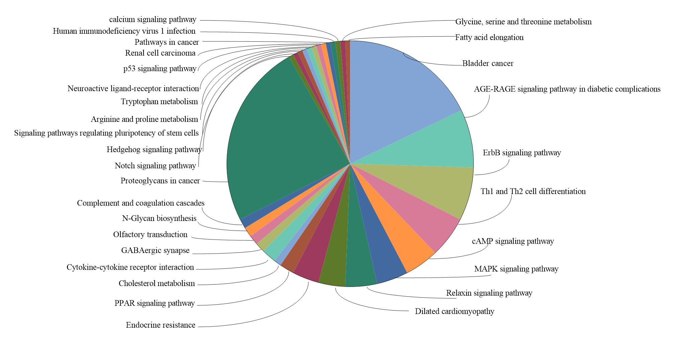
Figure 1 Kyoto encyclopedia of genes and genomes pathway analysis of the differentially expressed genes. The color represents different pathways. The larger area represents more DEGs enriched in the pathway. DEGs: Differentially expressed genes; cMAP: Cyclic adenosine monophosphate; MAPK: Mitogen-activated protein kinase; PPAR: Peroxisome proliferator-activated receptor.
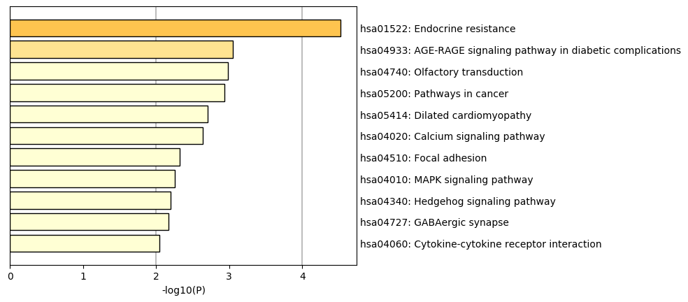
Figure 2 Heatmap of enriched terms across the differentially expressed genes, colored by P-values. MAPK: Mitogen-activated protein kinase.
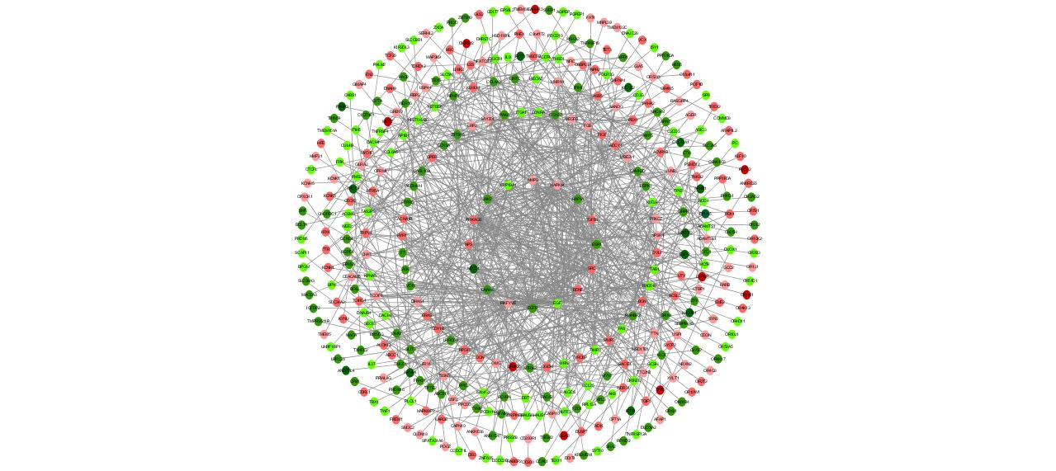
Figure 3 Protein–protein interaction network of differentially expressed genes in taurine-treated hepatic stellate cell samples. The nearer the center, the higher the degrees; red coloring represents up-regulated genes; green coloring represents down-regulated genes; purple coloring represents genes from database; the shade is related to the change fold (darker colors indicate more apparent differences).
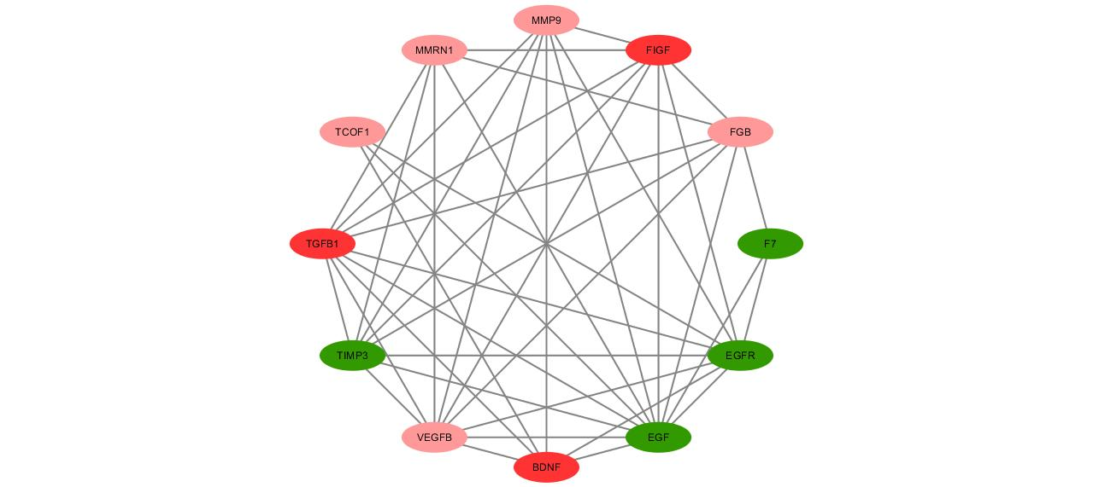
Figure 4 Functional sub-modules in the protein–protein interaction network of differentially expressed genes in the taurine-treated hepatic stellate cells. Red coloring represents up-regulated genes; green coloring represents down-regulated genes; purple coloring represents genes from database; the shade is related to the change fold (darker colors indicate more apparent differences).
Table 1 Gene ontology enrichment results of differentially expressed genes
GO | Count | P-value | Description
Enriched GO biological process of DEGs
GO:0007165 | 52 | 0.001 | Signal transduction
GO:0006508 | 24 | 0.015 | Proteolysis
GO:0008283 | 18 | 0.03 | Cell proliferation
GO:0070374 | 13 | 0.004 | Positive regulation of ERK1 and ERK2 cascade
GO:0001666 | 12 | 0.009 | Response to hypoxia
GO:0018108 | 10 | 0.029 | Peptidyl-tyrosine phosphorylation
GO:0001501 | 9 | 0.04 | Skeletal system development
GO:0050907 | 8 | 0.018 | Detection of chemical stimulus involved in sensory perception
GO:0002576 | 8 | 0.026 | Platelet degranulation
GO:0006302 | 7 | 0.011 | Double-strand break repair
GO:0050731 | 7 | 0.028 | Positive regulation of peptidyl-tyrosine phosphorylation
GO:0097191 | 6 | 0.006 | Extrinsic apoptotic signaling pathway
GO:0007269 | 6 | 0.014 | Neurotransmitter secretion
GO:0043406 | 6 | 0.025 | Positive regulation of MAP kinase activity
Enriched GO chemical component of DEGs
GO:0005886 | 148 | 0.000 | Plasma membrane
GO:0005887 | 66 | 0.000 | Integral component of plasma membrane
GO:0005576 | 59 | 0.027 | Extracellular region
GO:0009897 | 13 | 0.017 | External side of plasma membrane
GO:0005604 | 7 | 0.023 | Basement membrane
GO:0098793 | 6 | 0.033 | Presynapse
Enriched GO molecular function of DEGs
GO:0042802 | 33 | 0.010 | Identical protein binding
GO:0005509 | 32 | 0.009 | Calcium ion binding
GO:0004888 | 14 | 0.007 | Transmembrane signaling receptor activity
GO:0005516 | 12 | 0.016 | Calmodulin binding
GO:0005215 | 12 | 0.025 | Transporter activity
GO:0004222 | 9 | 0.013 | Metalloendopeptidase activity
GO:0004713 | 9 | 0.031 | Protein tyrosine kinase activity
GO:0008237 | 8 | 0.007 | Metallopeptidase activity
GO:0002020 | 8 | 0.022 | Protease binding
GO:0003707 | 6 | 0.019 | Steroid hormone receptor activity
GO:0008236 | 6 | 0.030 | Serine-type peptidase activity
GO:0003705 | 6 | 0.036 | Transcription factor activity, RNA polymerase II distal enhancer sequence-specific binding
GO:0001540 | 5 | 0.014 | Hormone binding
GO:0001206 | 4 | 0.002 | Peptidoglycan binding
GO: Gene ontology; DEGs: Differentially expressed genes.
Table 2 Cluster of differentially expressed genes in the protein-protein interaction network
Cluster | Score | Nodes | Edges | Genes
1 | 7.818 | 12 | 43 | TCOF1, MMRN1, TGFB1, FIGF, VEGFB, TIMP3, FGB, EGFR, F7, EGF, BDNF, MMP9
2 | 5.556 | 10 | 25 | ESR1, DNAH8, MMP2, JAK2, SRC, ESR2, CYP19A1, GPER, NPS, NR3C1
3 | 4.286 | 29 | 60 | NPSR1, PIKFYVE, KLHL11, KBTBD8, PMS2, XRCC4, RCVRN, TAS2R9, CACNA1B, RAD52, OGN, NPFFR2, WRN, GRPR, CABP2, RYR1, ZBTB16, ASB5, CAMK2D, BGN, RAD51B, CCL25, UBE2V1, HECW2, OPRM1, PRKACB, TAB1, HTR5A, ADCY4
4 | 4 | 4 | 6 | ALDH4A1, GCSH, DBT, OGDH
5 | 4 | 4 | 6 | THSD7B, ADAMTSL1, ADAMTS1, THSD1
6 | 4 | 4 | 6 | C2CD3, NPHP1, HAUS6, HAUS1
7 | 3.429 | 8 | 12 | RASL10A, FRYL, LRRC69, DIRAS1, ERAS, RAP1A, RANBP2, OMG
8 | 3 | 3 | 3 | RGPD1, NUTF2, KPNA5
9 | 3 | 3 | 3 | UTY, ZFY, CECR2
10 | 3 | 3 | 3 | TBX5, CFC1, GJA5
11 | 3 | 3 | 3 | SYCP2, POT1, HIST1H2BD

