Name of Journal: World Journal of Clinical Cases
Manuscript NO: 76717
Manuscript Type: CASE REPORT

Bladder paraganglioma after kidney transplantation: A case report

Wang L et al. Bladder paraganglioma after kidney transplantation

Lin Wang, Yan-Ning Zhang, Guang-Yong Chen

Lin Wang, Yan-Ning Zhang, Guang-Yong Chen, Department of Pathology, Beijing Friendship Hospital, Capital Medical University, Beijing 100050, China

Author contributions: Wang L designed and wrote this case report; Zhang YN helped in the research; Chen GY analyzed the data and guided the writing; all authors have read and approved the final manuscript.

Corresponding author: Guang-Yong Chen, PhD, Chief Doctor, Department of Pathology, Beijing Friendship Hospital, Capital Medical University, No. 59 Yong’an Road, Xicheng District, Beijing 100050, China. 13120193382@163.com

Received: March 31, 2022
Revised: May 25, 2022
Accepted: July 29, 2022
Published online:

Abstract
BACKGROUND
Kidney transplantation is associated with an increased risk of tumors in the urinary bladder. Among all the pathological types of tumors in the bladder, paraganglioma, which arises from extra-adrenal paraganglia and consists of chromaffin cells, is rare. Paragangliomas might cause severe clinical symptoms due to catecholamine hypersecretion or mass compression. Bladder paragangliomas are rare, especially those appearing after kidney transplantation. Here, we report a case of bladder paraganglioma developing after kidney transplantation.

CASE SUMMARY
A 63-year-old woman received a kidney transplant 12 years ago and took oral immunosuppressants (cyclosporine, mizoribine, and methylprednisolone) for regular post-transplant treatment. The patient felt no discomfort and she came to the hospital for a routine checkup. A mass located in the bladder was incidentally discovered by computed tomography, and she underwent surgical treatment. A 2 cm × 2 cm invasive mass was found in the trigone of the bladder and the mass was removed. The diagnosis of paraganglioma was confirmed by morphology and immunophenotyping. The patient had a good prognosis and is still alive.

CONCLUSION
Paraganglioma can grow in the bladder, which might cause no clinical symptoms. The diagnosis mainly depends on morphology and immunophenotyping. Surgical resection is an important treatment option for such patients.

Key Words: Paraganglioma; Urinary bladder tumor; Kidney transplantation; Case report

Wang L, Zhang YN, Chen GY. Bladder paraganglioma after kidney transplantation: A case report. World J Clin Cases 2022; In press

Core Tip: Paraganglioma is a rare neuroendocrine carcinoma with a morbidity of 2-8 cases per million. Paraganglioma in the urinary bladder is an infrequent condition, and it is even more rarely reported in kidney transplant recipients. The clinical manifestations of paraganglioma lack specificity. The tumor might cause severe clinical symptoms, such as hypertension and hematuria, or no symptoms, making an accurate preoperative diagnosis difficult. Pathology is essential for diagnosis. Although there is still no standard therapeutic consensus, surgical resection is an important treatment. Here, we report a case of paraganglioma in the bladder of a patient after kidney transplantation.

INTRODUCTION
In recent years, with the development and application of new types of immunosuppressants, the survival rate of kidney transplantation has been significantly improved. However, long-term use of immunosuppressants increases the risk of tumors in kidney transplantation recipients. Malignant tumor is one of the common long-term complications after kidney transplantation, with a reported incidence of 7.6%-10.9%^{[1]}. The most common tumors in kidney transplant recipients are Kaposi’s sarcoma, skin cancer, non-Hodgkin’s lymphoma, colorectal cancer, renal cell cancer, and anogenital tract cancer^{[2]}. Although kidney transplantation has been proved to increase the incidence of bladder tumors^{[3]}, the incidence is low. A large study showed that the incidence of bladder malignancies was only 1.9% in the population who received kidney transplantation^{[4]}. Paragangliomas were even more rarely found in such situations.
Paragangliomas are nonepithelial tumours originating from neural crest-derived paraganglion cells situated in the region of the autonomic nervous system ganglia and accompanying nerves^{[5]}. It has been reported that the morbidity is only 2-8 per million population^{[6]}. The first case of bladder paraganglioma was reported by Zimmerman et al^{[7]} in 1953, and more cases were then reported. Current data show that paraganglioma arising in the urinary bladder is extremely rare, and accounts for only 0.06% of all bladder cancers^{[8]}. Due to the rarity, the diagnostic and therapeutic methods are still not well established. Here, we report a pathologically confirmed bladder paraganglioma that arose after kidney transplantation, which is a rare clinical entity.

CASE PRESENTATION
Chief complaints
A 63-year-old female patient was hospitalized to the Urology Department of our hospital in October 2016. She was admitted to hospital just for a regular post-transplantation physical examination.

History of present illness
The patient underwent right allograft kidney transplantation 12 years ago at our hospital due to kidney failure caused by chronic nephritis. After transplantation, she had regularly taken cyclosporine (50 mg bid), mizoribine (150 mg qd), and methylprednisolone (5 mg qd). Her physical condition was good after transplantation. Also, she underwent medical examination at a local hospital or our hospital and the last examination occurred 2 years ago. The follow-up protocol included routine blood tests, serum biochemical indexes and tumor markers, and abdominal imaging [ultrasonography and computed tomography (CT)]. The results of the examination showed no abnormalities.

Physical examination
No positive sign.

Laboratory examinations
Routine blood tests and blood coagulation function tests were normal. Blood glucose and lipid levels, transaminase levels, and tumor markers [carcinoembryonic antigen, alpha-fetoprotein, carbohydrate antigen (CA) 12-5, and CA 19-9] were within normal ranges. Blood urea (9.2 mmol/L) and creatinine (132 mmol/L) were slightly elevated.

Imaging examinations
CT revealed a decrease in size of both kidneys. Also, a shadow with heterogeneous soft tissue density was found on the upper bladder wall (Figure 1). The shape of the tissue was irregular with indistinct edges. CT suggested a malignant tumor. No enhanced imaging was performed because non-contrast CT had already indicated a tumor and surgical excision was chosen for treatment.

FINAL DIAGNOSIS
Paraganglioma.

TREATMENT
The patient underwent transurethral resection of the bladder tumor after preoperative risk assessment. First, cystoscopy was performed to excise the tumor in the bladder. The invasive mass was observed in the trigone of the bladder under cystoscopy, with a size of 2 cm × 2 cm. It was observed that the tumor had invaded to the muscle layer of the bladder. Then, the tumor was removed with an electric scalpel. The excised neoplasm was sent for pathological examination. The operation was successful. The gross morphology of the excised bladder neoplasm presented irregular gray–white tissue with a diameter of 1.5 cm. Microscopically, the tumor cells were arranged like sheets and nests (Figure 2A). The cytoplasm was eosinophilic to amphophilic after hematoxylin and eosin staining (Figure 2B). The nuclei had a hyperchromatic and irregular shape without mitotic figures. The neoplasm infiltrated the muscle layer (Figure 2C). For further characterization, immunohistochemical staining was performed. The tumor cells were positive for CD56, Syn, CgA, and S-100, and negative for CK, SDHB, and CK7 (Figure 2D-F). Ki-67 staining revealed a proliferative index of approximately 1%. The pathological diagnosis supported paraganglioma.

OUTCOME AND FOLLOW-UP
The patient recovered well after surgery and was followed by telephone. At the 6-year follow-up visit, she reported that her health condition was good without discomfort. The patient is still alive when this case report is written.

DISCUSSION
Although paragangliomas can arise in a variety of locations, the majority are found in predictable regions, including the middle ear, jugular foramen, carotid body, mediastinum, and para-aortic region^{[9]}. However, paragangliomas arising in the bladder are rare. It is reported that the proportion of bladder paragangliomas among all catecholamine-secreting neoplasms is < 1% and only 0.5% of all bladder tumors^{[10]}. The main clinical manifestations of bladder paraganglioma are tumor mass effects, such as micturition, hematuria, dysuria, and bladder irritation^{[11]}. Paragangliomas secreting catecholamines may also show clinical presentation of hyperfunctioning adrenal pheochromocytoma, such as hypertension, headache, palpitations, cold sweats, dizziness, and headaches^{[12]}. Paragangliomas that are not hormonally active show normal catecholamine levels and the clinical manifestations are not specific, which makes it difficult to distinguish them from other bladder tumors. The patient in our report showed no clinical symptoms, which indicated that the paraganglioma did not secrete catecholamine. The tumor was located in the trigone and no mass effect could be attributed to the small size of the tumor.
Kidney transplantation gives patients with end-stage renal failure a longer life expectancy, with the help of immunosuppression. However, life-long immunosuppression has caused serious complications in this patient group, including tumors. It is now recognized that kidney-transplant recipients have a 2-4-fold increased risk of tumors compared with the age- and gender-matched general population. Immunosuppressive therapy might impair immunosurveillance and cause an inadequate immune response and immunological control of oncogenic viral infections, which might lead to an increased risk of tumorigenesis^{[13]}. In China, statistics show that the total incidence of malignant tumors in post-kidney transplant patients is 2.95%, which is 3-5 times higher than that in the gender- and age-matched general population^{[14]}. Kaposi’s sarcoma and skin cancer are the most common tumors in such patient groups outside China. In China, urinary tract tumors are the most common, followed by digestive system tumors^{[15]}. The top ten most common tumors in post-kidney transplant patients are urothelial carcinoma, hepatocellular carcinoma, renal cell carcinoma, gastrointestinal cancer, lymphoma, breast cancer, lung cancer, cervical cancer, prostate cancer, Kaposi sarcoma, and squamous cell carcinoma of the skin^{[14]}. Paragangliomas are rare post-kidney transplantation tumors. Despite the low morbidity of paragangliomas in the genitourinary system, the bladder is the most common site for paragangliomas, followed by the urethra, pelvis, and ureter^{[16]}. Hence, the possibility of paragangliomas should be suspected for tumors occurring in the bladder. However, paragangliomas of the bladder in post-kidney transplant patients are extremely rare. Until now, we have only found one such case reported^{[17]}. As far as we know, this is the first reported case of post-kidney transplantation paraganglioma of the bladder in the Chinese population.
Paraganglioma is a neuroendocrine tumor originating from neural crest cells. According to the site of occurrence, tumors in the adrenal medulla are called pheochromocytomas, while those outside the adrenal glands are generally referred to as paragangliomas^{[18]}. The diagnosis of paraganglioma mostly relies on the morphological characteristics and immunophenotype, including immunohistochemical staining with neuroendocrine markers^{[19]}. In the 2017 edition of the WHO Classification of Endocrine Organ Tumors^{[5]}, the definition of paraganglioma has been updated. This kind of tumor is considered malignant and has the potential to metastasize, and the previous benign classification has been removed. Paraganglioma in this case was invasive in the muscularis mucosae of the trigone of the bladder and was malignant.
Genetic studies have found that mutations of succinate dehydrogenase (SDH) are associated with prognosis. Three types of SDH mutations in bladder paragangliomas have been found: SDHA, SDHB, and SDHD. Bladder paraganglioma with SDHB gene mutation has the highest probability of distant metastasis and malignant change, which means that it might have the worst prognosis^{[20,21]}. No mutations of SDHB protein were found in this case, suggesting a low risk of metastasis. Indeed, no metastasis was found in the later follow-up, and the patient is in good condition currently, which is consistent with the inspection results.
Given that the most common bladder tumor is urothelial carcinoma, this case should be distinguished from it. The diffuse and invasive growth pattern of bladder paraganglioma might be easily misdiagnosed as urothelial carcinoma, especially when the tissue is broken and has been compressed and burned. In addition, urothelial carcinoma may also present with a nest-like growth pattern that is similar to that of paraganglioma. The main differences between the two tumors are the immunophenotypes. CK is negative, neuroendocrine markers are positively expressed in the paraganglioma tumor cells, and S-100 is positively expressed in the supporting cells. Urothelial carcinoma tumor cells express CK7, P63, PAX-8, and GATA-3. The immunophenotypes of this case supported the diagnosis of paraganglioma.

CONCLUSION
The incidence of bladder paraganglioma after kidney transplantation is rare and few cases have been reported. As far as we know, this is the first reported case in the Chinese population. Paraganglioma in the bladder might cause no clinical symptoms and the diagnosis mainly depends on morphology and immunophenotyping. Surgical resection is an important treatment option for such patients. The exact pathogenesis of paraganglioma of the urinary bladder after kidney transplantation is still unclear because of the low incidence, and long-term use of immunosuppressant might be the cause.

REFERENCES
1 Kleine-Döpke D, Oelke M, Schwarz A, Schwager Y, Lehner F, Klempnauer J, Schrem H. Renal cell cancer after kidney transplantation. Langenbecks Arch Surg 2018; 403: 631-641 [PMID: 30003323 DOI: 10.1007/s00423-018-1694-x]
2 Manickavasagar R, Thuraisingham R. Post renal-transplant malignancy surveillance. Clin Med (Lond) 2020; 20: 142-145 [PMID: 32188647 DOI: 10.7861/clinmed.2019-0423]
3 Yan L, Chen P, Chen EZ, Gu A, Jiang ZY. Risk of bladder cancer in renal transplant recipients: a meta-analysis. Br J Cancer 2014; 110: 1871-1877 [PMID: 24496458 DOI: 10.1038/bjc.2014.44]
4 Besarani D, Cranston D. Urological malignancy after renal transplantation. BJU Int 2007; 100: 502-505 [PMID: 17669141 DOI: 10.1111/j.1464-410X.2007.07049.x]
5 Asa SL, Mete O, Perry A, Osamura RY. Overview of the 2022 WHO Classification of Pituitary Tumors. Endocr Pathol 2022; 33: 6-26 [PMID: 35291028 DOI: 10.1007/s12022-022-09703-7]
6 Lin S, Peng L, Huang S, Li Y, Xiao W. Primary pancreatic paraganglioma: a case report and literature review. World J Surg Oncol 2016; 14: 19 [PMID: 26801079 DOI: 10.1186/s12957-016-0771-2]
7 Zimmerman IJ, Biron RE, Macmahon HE. Pheochromocytoma of the urinary bladder. N Engl J Med 1953; 249: 25-26 [PMID: 13063676 DOI: 10.1056/nejm195307022490106]
8 Bhalani SM, Casalino DD, Manvar AM. Paraganglioma of the bladder. J Urol 2011; 186: 279-280 [PMID: 21600612 DOI: 10.1016/j.juro.2011.04.032]
9 Lee KY, Oh YW, Noh HJ, Lee YJ, Yong HS, Kang EY, Kim KA, Lee NJ. Extraadrenal paragangliomas of the body: imaging features. AJR Am J Roentgenol 2006; 187: 492-504 [PMID: 16861555 DOI: 10.2214/ajr.05.0370]
10 Siatelis A, Konstantinidis C, Volanis D, Leontara V, Thoma-Tsagli E, Delakas D. Pheochromocytoma of the urinary bladder: report of 2 cases and review of literature. Minerva Urol Nefrol 2008; 60: 137-140 [PMID: 18500228]
11 Martinez Rodriguez RH, Buisan Rueda O, Ibarz L. Bladder cancer: Present and future. Med Clin (Barc) 2017; 149: 449-455 [PMID: 28736063 DOI: 10.1016/j.medcli.2017.06.009]
12 Williams P, Siref L, Feloney M. Pheochromocytoma of the bladder. JAAPA 2017; 30: 23-25 [PMID: 28953019 DOI: 10.1097/01.JAA.0000522134.68445.50]
13 Elserwy NA, Lotfy EE, Fouda MA, Mahmoud MI, Donia AF, Mashaly ME, Abbas MH, Abuelmagd MM, Abouelenein RK, Ismail MI, Bakr MA. Postrenal transplant malignancy: Incidence, risk factors, and prognosis. Saudi J Kidney Dis Transpl 2017; 28: 579-588 [PMID: 28540896 DOI: 10.4103/1319-2442.206456]
14 Li L, Sun Q. Renal transplantation in China: ten years of experience at Nanjing Jinling Hospital. Clin Transpl 2006: 71-77 [PMID: 18365369]
15 Zhang J, Ma L, Xie Z, Guo Y, Sun W, Zhang L, Lin J, Xiao J, Zhu Y, Tian Y. Epidemiology of post-transplant malignancy in Chinese renal transplant recipients: a single-center experience and literature review. Med Oncol 2014; 31: 32 [PMID: 24908063 DOI: 10.1007/s12032-014-0032-6]
16 Beilan JA, Lawton A, Hajdenberg J, Rosser CJ. Pheochromocytoma of the urinary bladder: a systematic review of the contemporary literature. BMC Urol 2013; 13: 22 [PMID: 23627260 DOI: 10.1186/1471-2490-13-22]
17 Lazareth H, Cohen D, Vasiliu V, Tinel C, Martinez F, Grünfeld JP, Mamzer MF, Legendre C, Sberro-Soussan R. Paraganglioma of the bladder in a kidney transplant recipient: A case report. Mol Clin Oncol 2017; 6: 553-555 [PMID: 28413667 DOI: 10.3892/mco.2017.1182]
18 Capatina C, Ntali G, Karavitaki N, Grossman AB. The management of head-and-neck paragangliomas. Endocr Relat Cancer 2013; 20: R291-R305 [PMID: 23921204 DOI: 10.1530/ERC-13-0223]
19 Cheung VKY, Gill AJ, Chou A. Old, New, and Emerging Immunohistochemical Markers in Pheochromocytoma and Paraganglioma. Endocr Pathol 2018; 29: 169-175 [PMID: 29779206 DOI: 10.1007/s12022-018-9534-7]
20 Rijken JA, van Hulsteijn LT, Dekkers OM, Niemeijer ND, Leemans CR, Eijkelenkamp K, van der Horst-Schrivers ANA, Kerstens MN, van Berkel A, Timmers HJLM, Kunst HPM, Bisschop PHLT, Dreijerink KMA, van Dooren MF, Hes FJ, Jansen JC, Corssmit EPM, Hensen EF. Increased Mortality in SDHB but Not in SDHD Pathogenic Variant Carriers. Cancers (Basel) 2019; 11 [PMID: 30658386 DOI: 10.3390/cancers11010103]
21 Niemeijer ND, Rijken JA, Eijkelenkamp K, van der Horst-Schrivers ANA, Kerstens MN, Tops CMJ, van Berkel A, Timmers HJLM, Kunst HPM, Leemans CR, Bisschop PH, Dreijerink KMA, van Dooren MF, Bayley JP, Pereira AM, Jansen JC, Hes FJ, Hensen EF, Corssmit EPM. The phenotype of SDHB germline mutation carriers: a nationwide study. Eur J Endocrinol 2017; 177: 115-125 [PMID: 28490599 DOI: 10.1530/EJE-17-0074]

Footnotes
Informed consent statement: Written informed consent was obtained from the patient for publishing this report in accordance with the journal's patient consent policy.

Conflict-of-interest statement: There is no conflict of interest to disclose.

CARE Checklist (2016) statement: The authors have read the CARE Checklist (2016), and the manuscript was prepared and revised according to the CARE Checklist (2016).

Open-Access: This article is an open-access article that was selected by an in-house editor and fully peer-reviewed by external reviewers. It is distributed in accordance with the Creative Commons Attribution NonCommercial (CC BY-NC 4.0) license, which permits others to distribute, remix, adapt, build upon this work non-commercially, and license their derivative works on different terms, provided the original work is properly cited and the use is non-commercial. See: https://creativecommons.org/Licenses/by-nc/4.0/

Provenance and peer review: Unsolicited article; Externally peer reviewed.
Peer-review model: Single blind

Peer-review started: March 31, 2022
First decision: May 12, 2022
Article in press:

Specialty type: Pathology
Country/Territory of origin: China
Peer-review report’s scientific quality classification
Grade A (Excellent): 0
Grade B (Very good): 0
Grade C (Good): C, C
Grade D (Fair): 0
Grade E (Poor): E

P-Reviewer: Ghazanfar A, United Kingdom; Gofrit O, Israel; Tieranu CG, Romania S-Editor: Yan JP L-Editor: Wang TQ P-Editor: Yan JP

Figure Legends
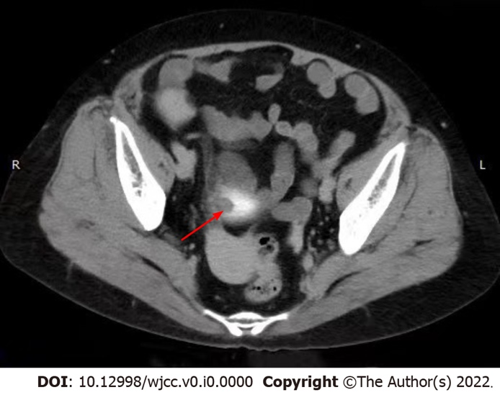
Figure 1 Computed tomography image. A soft tissue shadow was found on the upper bladder wall (arrow).

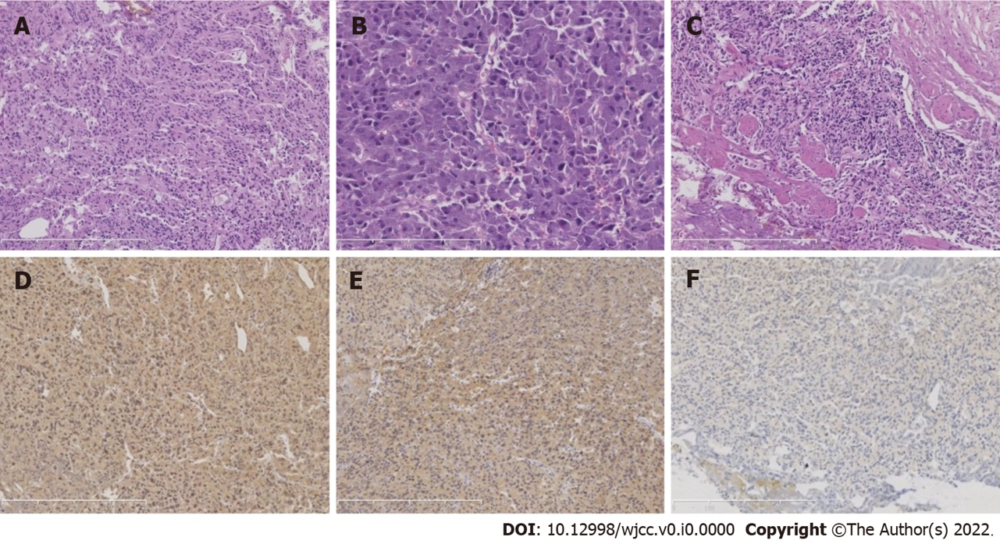
Figure 2 Histological examination and immunohistochemical staining. A: Histological examination of the resected vesical polyp revealed that the cells were arranged in sheets and nests [hematoxylin and eosin (H&E) staining]; B: The cytoplasm was eosinophilic to amphophilic (H&E staining); C: The neoplasm infiltrated the muscle layer (H&E staining); D-F: Homogeneous immunoreactivity to neuroendocrine markers such as synaptophysin (D), chromogranin A (E), and S-100 (F) (immunohistochemical staining).

