Name of Journal: World Journal of Gastroenterology
Manuscript NO: 48428
Manuscript Type: ORIGINAL ARTICLE

Basic Study
High expression of APC is an unfavorable prognostic biomarker in T4 gastric cancer patients

Du WB et al. APC in T4 gastric cancer

Wei-Bo Du, Chen-Hong Lin, Wen-Biao Chen

Wei-Bo Du, Chen-Hong Lin, Wen-Biao Chen, State Key Laboratory for Diagnosis and Treatment of Infectious Diseases, The First Affiliated Hospital, College of Medicine, Zhejiang University, Hangzhou 310003, Zhejiang Province, China

ORCID number: Wei-Bo Du (0000-0001-5779-6159); Chen-Hong Lin (0000-0002-9730-5614); Wen-Biao Chen (0000-0002-1028-6319).

Author contributions: Chen WB designed and supervised the research; Du WB, Lin CH, and Chen WB interpreted the data; Du WB wrote the manuscript; Lin CH constructed the figures and tables; Chen WB revised the manuscript.

Supported by the Major National S&T Projects for Infectious Diseases, No. 2018ZX10301401-005; the National Key Research and Development Program of China, No. 2018YFC2000500; the Key Research and Development Plan of Zhejiang Province, No. 2019C04005; and the National Natural Science Foundation of China, No. 81571953.

Institutional review board statement: The study was approved by the Clinical Research Ethics Committee of College of Medicine, Zhejiang University.

Conflict-of-interest statement: The authors declare that they have no competing interests.

Data sharing statement: All research data can be downloaded from public databases.

ARRIVE guidelines statement: The authors have read the ARRIVE guidelines, and the manuscript was prepared and revised according to the ARRIVE guidelines.

Open-Access: This is an open-access article that was selected by an in-house editor and fully peer-reviewed by external reviewers. It is distributed in accordance with the Creative Commons Attribution Non Commercial (CC BY-NC 4.0) license, which permits others to distribute, remix, adapt, build upon this work non-commercially, and license their derivative works on different terms, provided the original work is properly cited and the use is non-commercial. See: http://creativecommons.org/licenses/by-nc/4.0/

Manuscript source: Unsolicited manuscript

Corresponding author: Wen-Biao Chen, PhD, Doctor, Postdoctoral Fellow, State Key Laboratory for Diagnosis and Treatment of Infectious Diseases, The First Affiliated Hospital, College of Medicine, Zhejiang University. No. 79, Qingchun Road, Hangzhou 310003, Zhejiang Province, China. chenwenbiao@sina.com
Telephone: +86-18320993293
Fax: +86-571-87236114

Received: April 18, 2019
Peer-review started: April 18, 2019
First decision: June 16, 2019
Revised: July 18, 2019
Accepted: August 7, 2019
Article in press:
Published online:

Abstract
Background
Adenoma polyposis coli (APC) mutation is associated with tumorigenesis via the Wnt signaling pathway.

Aim
To investigate the clinical features and mechanism of APC expression in gastric cancer (GC).

Methods
Based on APC expression profile, the related genome-wide mRNA expression, microRNA (miRNA) expression, and methylation profile in GC, the relationship between APC and GC, as well as the prognostic significance of APC were systematically analyzed by multi-dimensional methods.

Results
We found that high expression of APC (APC^{high}) was significantly associated with adverse outcomes of T4 GC patients. Genome-wide gene expression analysis revealed that varying APC expression levels in GC were associated with some important oncogenes, and corresponding cellular functional pathways. Genome-wide miRNA expression analysis indicated that most of miRNAs associated with high APC expression were downregulated. The mRNA-miRNA regulatory network analysis revealed that down-regulated miRNAs affected their inhibitory effect on tumor genes. Genome-wide methylation profiles associated with APC expression showed that there was differential methylation between the APC^{high} and APC^{low} groups. The number of hypermethylation sites was larger than that of hypomethylation sites, and most of hypermethylation sites were enriched in CpG islands.

Conclusion
Our research demonstrated that high APC expression is an unfavorable prognostic factor for T4 GC patients and may be used as a novel biomarker for pathogenesis research, diagnosis, and treatment of GC.

Key words: Adenoma polyposis coli; Gastric cancer; Prognosis; mRNA; miRNA; Methylation

© The Author(s) 2019. Published by Baishideng Publishing Group Inc. All rights reserved.

Core tip: We found that high expression of adenoma polyposis coli (APC) was associated with a poor prognosis in T4 gastric cancer (GC) patients. There was differential expression of mRNAs and miRNAs as well as differential DNA methylation between the high expression of APC (APC^{high}) and low expression of APC (APC^{low}) groups. The link between APC^{high} and differential expression of mRNAs, miRNAs, and DNA methylation may contribute to the poor prognosis in T4 GC patients, and be involved in the pathogenesis of GC. APC could be used as a novel biomarker for clinical diagnosis, therapy, and assessment of prognosis in T4 GC patients, as well as for further research of the pathogenesis of GC.

Du WB, Lin CH, Chen WB. High expression of APC is an unfavorable prognostic biomarker in T4 gastric cancer patients. World J Gastroenterol 2019; In press

INTRODUCTION
Gastric cancer (GC) is one of the most common malignant tumors in China, and its morbidity and mortality rank first in digestive tract tumors^{[1]}. As the early detection rate of GC is low, most patients are initially diagnosed at an advanced stage, which seriously affects the prognosis and survival rate of the patients. With the development of endoscopic technique and the improvement of medical technology, the 5-year survival rate of GC has increased to 90%^{[2, 3]}. However, recurrence, metastasis, and drug resistance limit the therapeutic effect. There are still about 350000 deaths due to GC in China every year^{[4]}. Therefore, the early prevention, diagnosis, and anti-tumor comprehensive treatment of GC have attracted more and more attention.
GC is a complex multi-factorial, multi-step progressive process involving coding or non-coding genes and epigenetic change^{[5]}. Many kinds of molecular events, such as DNA mutations^{[6]}, aberrant expression of mRNAs^{[7]} and microRNAs (miRNAs)^{[8]}, and abnormal proteomes^{[9]}, have been found to participate in the pathogenesis of GC. Currently, these molecular events have been extensively studied as biomarkers for the prognosis, diagnosis, and therapy of GC. Li et al^{[10]} found that MUC16 gene mutation was associated with a higher load of tumor mutations and improved prognosis in patients with GC. These findings may have an impact on prognosis prediction and treatment guidance for GC. MiR-1265 inhibits the progression and carcinogenic autophagy of GC by reducing the expression of CAB39 and regulating the AMPK-mTOR signal transduction pathway. Therefore, it was speculated that miR-1265 may represent a potential therapeutic target for GC^{[11]}. DNA methylation is common in non-neoplastic gastric mucosa infected with Helicobacter pylori, which is associated with a high risk of GC. Therefore, DNA methylation could be used as a useful diagnostic tool for GC risk assessment^{[12]}. Despite these, the molecular mechanism of GC is currently still unclear, and the identification of biomarkers is of great significance for the clinical prognosis, diagnosis, and treatment of GC.
Adenoma polyposis coli (APC) encodes a tumor suppressor protein that can inhibit the Wnt signal pathway in tumor, and mutation and inactivation of APC are unique key and early events in tumorigenesis, especially colorectal cancer. The diagnostic and prognostic value of APC in colorectal cancer is high^{[13,14]}. Compared with colorectal cancer, there have been much fewer studies on APC in GC. However, some successful studies have initially shown that APC could be used as a biomarker for GC. Through research and analysis of big data, Bria et al^{[15]} defined a risk classification system comprising biomolecular (including APC) and clinicopathological predictors, which could divide resected GC patients into three types of risk for guiding treatment. By statistically analyzing a large number of GC samples, Merchant et al^{[16]} revealed that the incidence of APC-related GC in young Hispanic men has been rising in the United States. And the high expression of APC was correlated with advanced stage and low differentiation of GC. Therefore, we speculated that APC may have an important role in the pathogenesis and clinical application of GC.
In this study, we demonstrated that APC was a biomarker for poor prognosis in T4 GC patient, and identified APC-related mRNA and miRNA expression changes, and DNA methylation profile on a genome-wide scale by multi-dimensional methods. Our findings indicated the value of APC as a new target for the diagnosis and treatment of T4 GC patients and highlighted the important role of APC in the pathogenesis of GC.

MATERIALS AND METHODS
Research data source
The research data, including high throughput RNA sequencing (RNA-Seq), miRNA-Seq, Illumina Infinium Human Methylation 450, and clinical follow-up information data, which provided all mRNA and miRNA expression and methylation profiles for followed GC patients, were downloaded from the Cancer Genome Atlas (TCGA)^{[17]} on October 31, 2018. Samples with more than 30 d of follow-up were screened from clinical follow-up data to further match the RNAseq expression profile, miRNA expression profile, and methylation profile. We obtained 387 samples and 2173 miRNAs, 335 samples and 19754 mRNAs, and 364 samples and 358418 methylation sites, respectively. The study was approved by the Clinical Research Ethics Committee of College of Medicine, Zhejiang University.

Statistical analysis
Overall survival (OS) was defined as the time from randomization to death for any reason, while relapse-free survival rate (RFS) was defined as complete remission (approximately one month after diagnosis) to recurrence or the end of follow-up. In order to evaluate the prognostic value of APC in GC samples, we selected the appropriate cut-off value for subdivision. The optimal cut-off was defined by the statistical distribution of APC expression. APC expression was normally distributed in GC samples, and there was a significantly evident distinction along the median value. Therefore, GC samples were divided into APC^{high} and APC^{low} groups by the median APC expression (Supplemental Figure 1A). Next, the T4 GC patients were classified in to four groups according to quartiles of APC expression: Q1, <25%; Q2, 25%–50%; Q3, 50%–75%; Q4, >75%). The results showed that Q4 had the worst prognosis both in OS and RFS. Also, a significant difference was observed between Q2 vs Q4 and Q2 vs Q4 in OS and RFS (Supplemental Figure 1B and 1C). Then, the relationship between APC expression and OS and RFS was evaluated by the Kaplan-Meier (KM) method and further examined by log-rank test. To investigate the association between APC and clinical and molecular characteristics, we divided the T4 GC patients into APC^{high} and APC^{low} groups according to median APC expression value and used the t-test and chi-square tests to compare the clinical and molecular characteristics between the two groups. The t-test and false discovery rate (FDR) were applied to reveal the differential expression of genome-wide genes, miRNAs, and methylation between APC^{high} and APC^{low} groups. The significantly statistical cut-off values were fold-change (FC) > 2 and FDR < 0.05 for genes, FC > 1.5 or < 0.66 and P < 0.05 for miRNAs, and FC > 2 and P < 0.05 for methylation. In order to observe the relationship between APC expression and cellular functional pathways based on the differential expression of genome-wide genes, we screened all GC samples with gene expression profiles, and used Gene Set Enrichment Analysis (GSEA) tools^{[18]} to perform KEGG pathway enrichment analysis on samples from APC^{high} and APC^{low} groups with a selection threshold of P < 0.05. KEGG pathway enrichment of methylation was performed using R ClusterProfiler with a selection threshold of P < 0.05. To observe the relationship between APC expression and related miRNAs, we screened miRNAs with expression levels greater than 0 and ratios greater than 50% in each sample, and used the Pearson correlation coefficient to estimate the correlation between miRNA expression profiles and APC expression. The significantly statistical cut-off was P < 0.05 and a correlation coefficient > 0.3 or < -0.3 to determine the correlation of APC with related miRNAs. In additional, we used the miRWalk database to predict miRNA target genes and constructed mRNA-miRNA regulatory networks in conjunction with the most significantly related miRNAs.

RESULTS
APC is related to an unfavorable prognosis of T4 GC
Analysis of OS and RFS was performed based on the 335 GC samples to investigate the association between APC expression and prognosis. The results showed that there was no significant relationship between APC expression and OS (P = 0.58) and RFS (P = 0.98) in the overall population (Figure 1A and 1B). Subsequently, we analyzed the association between APC expression and prognosis in GC of different stages and found that the expression of APC in T4 samples was high in the middle and low on both sides with a median value of 10.53 (Figure 1C). According to this median value, the 88 T4 GC samples were divided into either an APC^{high} (n = 44) or APC^{low} group (n = 44). It was found that patients with APC^{high} GC showed significantly shorter RFS than those with APC^{low} GC (log-rank P = 0.037) (Figure 1D). These results suggested that high expression of APC was associated with a poor prognosis in T4 GC patients.

Association of APC with clinical characteristics and known prognostic genes
The proportions of GC patients with tumor stages III and IV, tumor grades 2 and 3, and lymph node metastases N2 and N3 were significantly higher in the APC^{high} group than in the APC^{low} group (P = 0.043, 0.047, 0.039, 0.031, and 0.035, respectively). In addition, APC^{high} was associated with a greater chance of high expression of some known prognostic biomarkers, such as KIT, PIK3CA, KRAS, and MLH1 (P = 0.031, P < 0.001, P = 0.038, and P = 0.038, respectively), all of which are associated with an unfavorable prognosis (Table 1). Kit, a cell surface receptor of stem cell factor, is considered to be a oncogenic signal and has a acquired functional mutation in human gastrointestinal stromal tumors^{[19]}. The frequency of PIK3CA mutation was low in GC, but the prognosis of GC patients with PIK3CA mutation was poor^{[20]}. Fu et al^{[21]} found that KRAS mutation was a poor prognostic factor in Chinese CG patients. MLH1 methylation was associated with oxaliplatin resistance in GC patients^{[22]}. Collectively, these results indicated that APC may be a biomarker of poor prognosis in T4 GC patients.

Differentially expressed mRNAs associated with APC expression
To observe the association between APC expression and other genes, we made a comparison between the APC^{high} and APC^{low} groups by genome-wide microarray analysis. Twelve significantly differentially expressed mRNAs were revealed to be associated with APC expression by the t-test and Wilcoxon rank sum test (FC > 2 and FDR < 0.05) (Figure 2A, Table 2). The heat map of these 12 mRNAs is presented in Figure 2B. Previous studies have revealed that most of these 12 mRNAs are closely related to tumorigenesis. ARID5B plays a role in the growth and differentiation of B-lymphocyte progenitor cells that are associated with acute lymphoblastic leukemia^{[23]}. JMY has strong carcinogenic characteristics, whose expression was elevated in primary colorectal cancer and head and neck cancer in response to DNA damage in cells^{[24]}. MAP3K14 is involved in the induction of NF-kappaB signaling in cancer cell invasion^{[25]}. IL6ST is a signal transduction factor common to many cytokine activators, and it is involved in the STAT3 pathway in sub-groups of primary lung cancer and is associated with tumor progression and a poor prognosis^{[26]}. Rev3L plays an important role in regulating the response of cervical cancer cells to cisplatin^{[27]}. Genetic variation of estrogen receptor PPARGC1B is important in familial breast cancer^{[28]}. PARD3 plays an important role in invasiveness and metastasis of lung squamous cell carcinoma because of its repeated inactivation of cell polarity regulator^{[29]}. PDE4D acts as a promoter of cell proliferation in prostate cancer^{[30]}.
In order to further analyze the cell molecular function of APC related genes, we investigated the association between cellular functional pathways of APC related genes with APC expression. The results revealed that 18 pathways were associated with APC^{high}, including 6 upregulated and 12 downregulated pathways (P < 0.05) (Table 3). The APC related genes were enriched in upregulated pathways such as receptor signaling (Figure 3A), pancreatic cancer (Figure 3B), and prostate cancer of upregulated pathway, whereas downregulated pathways such as ascorbate and aldarate metabolism (Figure 3C), PPAR signaling (Figure 3D), drug metabolism other enzymes, and steroid hormone biosynthesis are closely related to tumor signaling, drug resistance, hormone receptor, and metabolism. These results indicated that APC^{high} associated genes are closely related to the occurrence and development of GC.

Relationship between APC^{high} expression and genome-wide miRNA sequencing
In order to further understand the relationship between biological diversities of GC and different levels of APC expression, we conducted a full-genome analysis of miRNA sequencing data to identify the miRNA profiles with a significant correlation with APC expression. We found that 674 miRNA expression profiles were correlated with APC expression. After Pearson correlation coefficient calculation, a total of 35 miRNAs with a P-value < 0.05 and a correlation coefficient > 0.3 or < -0.3 were identified. The relationship between the correlation coefficient and the distribution of P-value is shown in Figure 4A. The heatmap of the 35 miRNAs is presented in Figure 4B, from which we can see that most of miRNA were negatively correlated with APC, and a few were positively correlated with APC. Most of the 35 miRNAs have been previously found to be involved in tumorigenesis mechanisms or be targets for clinical diagnosis and treatment, prognostic markers, and mediators of tumor drug resistance. Hsa-miR-636 may affect the tumorigenesis of hepatocellular carcinoma by downregulating the Ras signaling pathway^{[31]}. The enrichment of hsa-miR-200c-3p secreted in urine was a non-invasive marker for the diagnosis of endometrial carcinoma^{[32]}. The downregulated expression of has-miR-130b-3p was predicted to be associated with cell proliferation, colony formation, anti-apoptosis, and self-renewal in hepatocellular carcinoma^{[33]}. Hsa-miR-339-5p plays a key role in the regulation of lung cancer and may be used as a biomarker to predict the progression of lung cancer^{[34]}. The upregulated expression of miR-451 in papillary thyroid carcinoma with lymph node metastasis is a unique marker for prognosis and progression of thyroid papillary carcinoma^{[35]}. Increasing expression of hsa-miR-103a-3p predicted improved breast cancer survival^{[36]}. Overexpression of miR-940 in breast cancer cells induced extensive osteoblast damage in metastatic bone tumors by promoting osteogenic differentiation of host mesenchymal cells^{[37]}. LncRNA LINC00460 could upregulate IL6 through sponging tumor suppressor gene miR-149-5p to promote the carcinogenesis of nasopharyngeal carcinoma^{[38]}. Ectopic expression of has-let-7c-5p promoted the efficacy of all-trans retinoic acid in the treatment of acute myeloid leukemia cells^{[39]}. Low expression of miR-100-5p endowed lung cancer cells with cisplatin drug resistance^{[40]}. These APC related miRNAs, together with APC, may be associated with the pathogenesis of GC, which further supports APC as a marker for the poor prognosis of T4 GC.
Furthermore, we combined the most significantly related miRNAs, using the miRWalk database, to predict the miRNA target genes to construct the mRNA-miRNA regulatory network (Figure 4C). The regulatory network included 6 upregulated miRNAs, 24 downregulated miRNAs, and 11 genes. It can be seen that some downregulated miRNAs may affect the inhibition of oncogenes, thus aggravating the result of deterioration. For example, hsa-miR-200c-3p, a member of miR-200 family, targets ARID5B and plays an important role in inhibiting tumor epithelial-mesenchymal transition (EMT)^{[41]}. Has-miR-940 targeted PDE4D and ZNF81 were downregulated in prostate cancer and can inhibited the migratory and invasive potential of cancer cell^{[42]}. In the meantime, some upregulated miRNAs decreased the function of tumor suppressor genes, thus promoting tumorigenesis. For example, ARID5B is targeted by has-miR-150-5p, and the upregulated expression of has-miR-150-5p increased the response of multiple myeloma to glucocorticoid specific therapy^{[43]}. Hsa-miR-195-3p, regarded as one of colon cancer metastasis biomarkers, targeted PARD3B and other genes that are associated with protein binding, cell adhesion, and cancer metastasis^{[44]}. Taken together, these findings may contribute to understanding why APC^{high} could predict a poor prognosis of T4 GC.

Relationship between APC^{high} and genome-wide DNA methylation sequencing
DNA methylation is a common and important epigenetic change and plays an important role in the occurrence, development, and prognosis of many malignant tumors. Also, DNA methylation can regulate gene expression and the differentiation of cancer cells to different directions via DNA methyltransferase, including DNMT1, DNMT3A, and DNMT3B^{[45]}. Therefore, we analyzed the differences in transcription levels of the three methyltransferase between APC^{high} and APC^{low}. DNMT1 and DNMT3A were found to be significantly higher in APC^{high} than in APC^{low} (Figure 5), which suggested that there may be different methylation patterns in APC^{high} and APC^{low}. Five hundred and forty-three differential methylation sites, including 530 hypermethylation sites and 13 hypomethylation sites, were identified after making a comparison between APC^{high} and APC^{low} (FC > 2 and P < 0.05) (Figure 6A). Since hypermethylation of tumor suppressor genes and hypomethylation of oncogenes were associated with carcinogenesis^{[46]}, our finding that there were more hypermethylation sites than hypomethylation sites may suggest that DNA hypermethylation regulated APC expression is involved in T4 GC. In addition, we analyzed the distribution of these 543 different methylation sites around CPG islands, and found that there was a significant difference in the distribution of differential DNA methylation sites around CPG islands, i.e., the hypermethylation sites are mainly distributed on the CPG islands (Figure 6B), which is consistent with the view that the methylation of DNA methylation-regulated genes involved in tumorigenesis occurs mainly on CPG islands^{[47]}. Furthermore, we analyzed the distribution of transcription initiation site (TSS) distance between these differential DNA methylation sites and the nearest genes. Most of the DNA methylation sites are located between 600 bp upstream and 1200 bp downstream of TSS (Figure 6C), and the hypermethylation sites tend to be located upstream of TSS, which is related to an important regulatory area. Moreover, the genes corresponding to the nearest TSS of the differential DNA methylation were extracted for KEGG pathway analysis. There were ten significant KEGG pathways, including six upregulated and four downregulated items. The upregulated DNA methylation-related genes were mainly enriched in pathways such as basal cell carcinoma, Hippo signaling pathway, mTOR signaling pathway, and signaling pathways regulating pluripotency of stem cells, which are associated with the pathogenesis of GC (Figure 6D). Whereas, the downregulated DNA methylation-related genes participate in viral carcinogenesis, herpes simplex infection, alcoholism, and systemic lupus erythematosus, which were regarded as inducers of tumorigenesis (Figure 6E).

DISCUSSION
The identification of prognostic factors for GC is important for its diagnosis and treatment as well as the development of new targeted therapy. Especially, for precise treatment strategy based on the risk stratification, the prognostic factors for GC can not only provide clinicians with the earliest diagnostic markers and definite prognosis prediction, but also can help them select the best treatment plan. The aim of our research was to identify novel biomarkers for GC prognosis. APC encodes an important negative regulator that serves as an antagonist of the Wnt signaling pathway, which is closely related to cancer cell proliferation, metastasis, invasion, adhesion, and activation^{[48]}. Here, our results showed that the expression of APC was an independent and useful factor for poor prognosis of T4 GC. KM analysis showed that APC^{high} was associated with a shorter RFS in T4 GC patients. In addition, APC^{high} was found to be associated with advanced tumor stage and high tumor grade in GC and have significant relevance to some known prognostic biomarkers (KIT, PIK3CA, KRAS, and MLH1). However, previous research revealed that APC is a tumor suppressor gene, and upregulating APC expression can inactivate the Wnt/β-catenin pathway in tumorigenesis^{[49,50]}. However, APC was found as a poor prognostic marker in patients with T4 GC, although there was no significant association between APC and OS or RFS in the overall GC population. Such discrepancy may be due to a combination of the following reasons. On one hand, APC, as a tumor suppressor gene, was verified by experimental evidence, not by statistical analysis of a large number of clinical samples. On the other hand, a study showed that Wnt receptor (Fzd7) can be responsible for mediating Wnt signaling in human GC cells both in the presence and absence of APC mutations^{[51]}. Therefore, we hypothesize that APC is not the only crucial molecule involved in Wnt signaling, and other molecules are also involved in this pathway to promote tumorigenesis. Although the high expression of APC has antitumor effects, it is not enough to counteract the carcinogenic effects of other molecules involved in Wnt signaling. However, this hypothesis needs to be confirmed by further research. Our finding that APC is an unfavorable prognostic biomarker for T4 GC suggests that fine stratification of GC will be helpful for clinical precision treatment and prognosis evaluation.
In order to further study the mechanism of the association between the high expression of APC and the unfavorable prognosis of T4 GC, we comprehensively analyzed that genome-wide genes, miRNAs, and DNA methylation. Tumorigenesis is the result of the interaction of genetic and epigenetic changes. Genetic changes are mainly regulated by gene expression, while epigenetic changes are mainly regulated by non-coding RNAs and DNA modifications^{[52]}. APC associated genome-wide gene analysis revealed that high expression of APC was related to 12 genes, which were reported to play important roles in the pathogenesis of cancer or be regarded as biomarkers for cancer diagnosis, treatment, and prognosis. Several studies have found that the interaction between proteins produced by some coding genes and APC is involved in the promotion or inhibition of tumor proliferation via the Wnt pathway. Zhan et al^{[53]} found that targeting MEK strongly synergized with APC in enhancing Wnt responses to the development of GC. Sox2 as a tumor suppressor gene, restrained stomach adenoma formation through modulation of APC/Wnt-responsive and intestinal genes^{[54]}. We speculate that the interaction between the 12 genes identified in this study and APC may promote the occurrence of GC through the Wnt pathway. The further study of 12 genes will be helpful to further explore the pathogenesis of GC.
In addition, APC related genes are involved in metabolic pathways, which play an important role in tumorigenesis. Recent research has advanced the understanding of the relationship between metabolic regulation and GC. Also, APC-dependent changes in the expression of genes influencing metabolism are linked to gastric carcinogenesis. Gerner et al^{[55]} found that APC alteration results in dysregulation of the pathway for production of polyamines, which are ubiquitous cations essential for cancer cell growth. Metabolism increases the synthesis of nitric oxide synthase 2, which could enhance the risk of APC-dependent gastric carcinogenesis in mouse models^{[56]}. In our study, we identified several metabolism related pathways, e.g., cytochrome P450 and arachidonic acid pathways. A member of the cytochrome P450 family has been found to be overexpressed in a variety of tumors and associated with angiogenesis^{[57]}. The metabolic process of linoleic acid derivatives can regulate tumor-related inflammation^{[58]}, and there was a positive correlation between alpha linolenic acid metabolite and invasive prostate cancer^{[59]}. The arachidonic acid pathway is a metabolic process that plays a key role in carcinogenesis, and arachidonic acid pathway enzyme are considered as new targets for the prevention and treatment of cancer^{[60]}. Metabolic reprogramming can contribute to tumor development, and drugs designed according to the metabolic target have become a clinically effective treatment for cancer^{[61]}. Our study suggests that high expression of APC may play an important role in tumor metabolism and may be a target for the design of chemotherapy drugs.
In the genome-wide miRNA analysis, we identified several tumorigenesis associated miRNAs that were associated with APC expression. Interestingly, most of these miRNAs were negatively correlated with APC in the associational analysis and mRNA-miRNA regulatory network. Previous studies have showed that most of miRNAs identified in our study were downregulated in GC. This finding, together with our result that high expression of the APC gene was associated with a poor prognosis in T4 GC patients, suggested that there was a ceRNA mechanism^{[62]} between the APC gene and miRNAs. The upregulated expression of upstream lncRNA can sponge miRNAs and thereby upregulate APC, thus promoting the proliferation of cancer cells. There is increasing evidence that the imbalance of ceRNA interaction, including miRNAs, cirRNAs, and lncRNAs, promotes the development of GC^{[63]}. The ceRNA mechanism of APC and miR-135b-5p as well as APC and miR-106a-3p has been reported to promote the carcinogenesis of GC. Our research further proved that APC^{high}, together with miRNAs, contributed to the carcinogenesis of GC and that APC^{high} was a robust unfavorable prognostic biomarker for T4 GC patients.
Finally, the relationship between APC^{high} and genome-wide DNA methylation was explored. We found not only differential methylation between APC^{high} and APC^{low}, but also different distribution of differential DNA methylation. Our results showed that there were more hypermethylation sites than hypomethylation sites that were associated with APC expression. Possibly, hypermethylation of tumor suppressor genes^{[46]} and high expression of APC act together to promote the occurrence and deterioration of GC, thereby bring an unfavorable prognosis for T4 GC patients. In addition, the distribution of DNA methylation showed that hypermethylation sites were more frequently located on CpG islands and upstream of TSS. DNA methylation of the CpG islands has been associated with tumor development, cell cycle, DNA repair, angiogenesis, and apoptosis^{[47]}, while tumorigenesis was associated with DNA methylated in the region around the TSS^{[64]}. Together, our research suggested that high expression of APC was regulated by DNA methylation.
In conclusion, our research demonstrated that APC^{high} may be a useful adverse prognostic biomarker for T4 GC patients. The finding that APC^{high} is associated with distinctive genome-wide gene/miRNA/methylation expression and related cellular functional pathways could well explain why APC acts as an adverse prognostic biomarker for T4 GC patients as well as the mechanism underlying its molecular biological function in GC. As a novel potential biological target, APC may be used to study the pathogenesis of GC and guide the clinical diagnosis, treatment, and prognosis evaluation of T4 GC patients.

Article Highlights
Research background
Adenoma polyposis coli (APC) mutation is associated with tumorigenesis via the Wnt signaling pathway.

Research motivation
APC acts as a tumor suppressor gene in Wnt signal pathway, and mutation and inactivation of APC are unique key and early events in tumorigenesis, especially colorectal cancer. Compared with colorectal cancer, there have been much fewer studies on APC in other cancers. However, some successful studies have initially shown that APC could be used as a biomarker for GC. This inspired us to investigate the clinical features and mechanism of APC expression in GC.

Research objectives
The research objective was to validate that APC is associated with the pathogenesis and clinical features of GC. We demonstrated that high expression of APC is a biomarker for poor prognosis in T4 GC patient. Our research suggested that APC may be used as a novel biomarker for pathogenesis research, diagnosis, and treatment of GC.

Research methods
Based on RNA-Seq, miRNA-Seq, Illumina Infinium Human Methylation 450, and clinical follow-up data from TCGA, we systematically analyzed the APC-related mRNA and miRNA expression and DNA methylation profile on a genome-wide scale by multi-dimensional methods. The novel application of resource-sharing databases provided us with the opportunity to investigate more reliable biomarkers for GC.

Research results
We found that high expression of APC was a biomarker for poor prognosis in T4 GC patient. Our research brings new perspective to the APC gene in tumors, namely, APC is an oncogene in T4 GC patients and the high expression of APC indicates a poor prognosis in T4 GC patients. However, why high expression of APC predicts a poor prognosis only in T4 GC patients remains to be further studied.

Research conclusions
Our research demonstrated that APC^{high} may be a useful adverse prognostic biomarker for T4 GC patients. The finding that APC^{high} is associated with distinctive genome-wide gene/miRNA/methylation expression and related cellular functional pathways could well explain why APC acts as an adverse prognostic biomarker for T4 GC patients as well as the mechanism underlying its molecular biological function in GC.

Research perspectives
As a novel potential biological target, APC may be used to study the pathogenesis of GC and guide the clinical diagnosis, treatment, and prognosis evaluation of T4 GC patients.

REFERENCES
1 Chen W, Zheng R, Baade PD, Zhang S, Zeng H, Bray F, Jemal A, Yu XQ, He J. Cancer statistics in China, 2015. CA Cancer J Clin 2016; 66: 115-132 [PMID: 26808342 DOI: 10.3322/caac.21338]
2 Ren G, Cai R, Zhang WJ, Ou JM, Jin YN, Li WH. Prediction of risk factors for lymph node metastasis in early gastric cancer. World J Gastroenterol 2013; 19: 3096-3107 [PMID: 23716990 DOI: 10.3748/wjg.v19.i20.3096]
3 Saito T, Kurokawa Y, Takiguchi S, Miyazaki Y, Takahashi T, Yamasaki M, Miyata H, Nakajima K, Mori M, Doki Y. Accuracy of multidetector-row CT in diagnosing lymph node metastasis in patients with gastric cancer. Eur Radiol 2015; 25: 368-374 [PMID: 25097136 DOI: 10.1007/s00330-014-3373-9]
4 Chen WQ, Li H, Sun KX, Zheng RS, Zhang SW, Zeng HM, Zou XN, Gu XY, He J. Report of Cancer Incidence and Mortality in China, 2014. Zhonghua Zhongliu Zazhi 2018; 40: 5-13 [PMID: 29365411 DOI: 10.3760/cma.j.issn.0253-3766.2018.01.002]
5 Figueiredo C, Camargo MC, Leite M, Fuentes-Pananá EM, Rabkin CS, Machado JC. Pathogenesis of Gastric Cancer: Genetics and Molecular Classification. Curr Top Microbiol Immunol 2017; 400: 277-304 [PMID: 28124158 DOI: 10.1007/978-3-319-50520-6_12]
6 Fang WL, Lan YT, Huang KH, Liu CA, Hung YP, Lin CH, Jhang FY, Chang SC, Chen MH, Chao Y, Lin WC, Lo SS, Fen-Yau Li A, Wu CW, Chiou SH, Shyr YM. Clinical significance of circulating plasma DNA in gastric cancer. Int J Cancer 2016; 138: 2974-2983 [PMID: 26815009 DOI: 10.1002/ijc.30018]
7 Setia N, Agoston AT, Han HS, Mullen JT, Duda DG, Clark JW, Deshpande V, Mino-Kenudson M, Srivastava A, Lennerz JK, Hong TS, Kwak EL, Lauwers GY. A protein and mRNA expression-based classification of gastric cancer. Mod Pathol 2016; 29: 772-784 [PMID: 27032689 DOI: 10.1038/modpathol.2016.55]
8 Link A, Kupcinskas J. MicroRNAs as non-invasive diagnostic biomarkers for gastric cancer: Current insights and future perspectives. World J Gastroenterol 2018; 24: 3313-3329 [PMID: 30122873 DOI: 10.3748/wjg.v24.i30.3313]
9 Mohri Y, Toiyama Y, Kusunoki M. Progress and prospects for the discovery of biomarkers for gastric cancer: a focus on proteomics. Expert Rev Proteomics 2016; 13: 1131-1139 [PMID: 27744719 DOI: 10.1080/14789450.2016.1249469]
10 Li X, Pasche B, Zhang W, Chen K. Association of MUC16 Mutation With Tumor Mutation Load and Outcomes in Patients With Gastric Cancer. JAMA Oncol 2018; 4: 1691-1698 [PMID: 30098163 DOI: 10.1001/jamaoncol.2018.2805]
11 Xu Z, Li Z, Wang W, Xia Y, He Z, Li B, Wang S, Huang X, Sun G, Xu J, Wang L, Zhang Q, Li Q, Lv J, Wang L, Zhang L, Zhang D, Xu H, Xu Z. MIR-1265 regulates cellular proliferation and apoptosis by targeting calcium binding protein 39 in gastric cancer and, thereby, impairing oncogenic autophagy. Cancer Lett 2019; 449: 226-236 [PMID: 30779944 DOI: 10.1016/j.canlet.2019.02.026]
12 Tahara T, Arisawa T. DNA methylation as a molecular biomarker in gastric cancer. Epigenomics 2015; 7: 475-486 [PMID: 26077432 DOI: 10.2217/epi.15.4]
13 Zhang L, Shay JW. Multiple Roles of APC and its Therapeutic Implications in Colorectal Cancer. J Natl Cancer Inst 2017; 109: [PMID: 28423402 DOI: 10.1093/jnci/djw332]
14 Aghabozorgi AS, Bahreyni A, Soleimani A, Bahrami A, Khazaei M, Ferns GA, Avan A, Hassanian SM. Role of adenomatous polyposis coli (APC) gene mutations in the pathogenesis of colorectal cancer; current status and perspectives. Biochimie 2019; 157: 64-71 [PMID: 30414835 DOI: 10.1016/j.biochi.2018.11.003]
15 Bria E, De Manzoni G, Beghelli S, Tomezzoli A, Barbi S, Di Gregorio C, Scardoni M, Amato E, Frizziero M, Sperduti I, Corbo V, Brunelli M, Bersani S, Tortora G, Scarpa A. A clinical-biological risk stratification model for resected gastric cancer: prognostic impact of Her2, Fhit, and APC expression status. Ann Oncol 2013; 24: 693-701 [PMID: 23131390 DOI: 10.1093/annonc/mds506]
16 Merchant SJ, Kim J, Choi AH, Sun V, Chao J, Nelson R. A rising trend in the incidence of advanced gastric cancer in young Hispanic men. Gastric Cancer 2017; 20: 226-234 [PMID: 26924751 DOI: 10.1007/s10120-016-0603-7]
17 Cancer Genome Atlas Research Network., Weinstein JN, Collisson EA, Mills GB, Shaw KR, Ozenberger BA, Ellrott K, Shmulevich I, Sander C, Stuart JM. The Cancer Genome Atlas Pan-Cancer analysis project. Nat Genet 2013; 45: 1113-1120 [PMID: 24071849 DOI: 10.1038/ng.2764]
18 Zhang Y, Topham DJ, Thakar J, Qiu X. FUNNEL-GSEA: FUNctioNal ELastic-net regression in time-course gene set enrichment analysis. Bioinformatics 2017; 33: 1944-1952 [PMID: 28334094 DOI: 10.1093/bioinformatics/btx104]
19 Hirota S, Isozaki K, Moriyama Y, Hashimoto K, Nishida T, Ishiguro S, Kawano K, Hanada M, Kurata A, Takeda M, Muhammad Tunio G, Matsuzawa Y, Kanakura Y, Shinomura Y, Kitamura Y. Gain-of-function mutations of c-kit in human gastrointestinal stromal tumors. Science 1998; 279: 577-580 [PMID: 9438854 DOI: 10.1126/science.279.5350.577]
20 Ito C, Nishizuka SS, Ishida K, Uesugi N, Sugai T, Tamura G, Koeda K, Sasaki A. Analysis of PIK3CA mutations and PI3K pathway proteins in advanced gastric cancer. J Surg Res 2017; 212: 195-204 [PMID: 28550907 DOI: 10.1016/j.jss.2017.01.018]
21 Fu XH, Chen ZT, Wang WH, Fan XJ, Huang Y, Wu XB, Huang JL, Wang JX, Lin HJ, Tan XL, Wang L, Wang JP. KRAS G12V Mutation is an Adverse Prognostic Factor of Chinese Gastric Cancer Patients. J Cancer 2019; 10: 821-828 [PMID: 30854087 DOI: 10.7150/jca.27899]
22 Li Y, Yang Y, Lu Y, Herman JG, Brock MV, Zhao P, Guo M. Predictive value of CHFR and MLH1 methylation in human gastric cancer. Gastric Cancer 2015; 18: 280-287 [PMID: 24748501 DOI: 10.1007/s10120-014-0370-2]
23 Leong WZ, Tan SH, Ngoc PCT, Amanda S, Yam AWY, Liau WS, Gong Z, Lawton LN, Tenen DG, Sanda T. ARID5B as a critical downstream target of the TAL1 complex that activates the oncogenic transcriptional program and promotes T-cell leukemogenesis. Genes Dev 2017; 31: 2343-2360 [PMID: 29326336 DOI: 10.1101/gad.302646.117]
24 Adighibe O, Turley H, Leek R, Harris A, Coutts AS, La Thangue N, Gatter K, Pezzella F. JMY protein, a regulator of P53 and cytoplasmic actin filaments, is expressed in normal and neoplastic tissues. Virchows Arch 2014; 465: 715-722 [PMID: 25280461 DOI: 10.1007/s00428-014-1660-0]
25 Jung JU, Ravi S, Lee DW, McFadden K, Kamradt ML, Toussaint LG, Sitcheran R. NIK/MAP3K14 Regulates Mitochondrial Dynamics and Trafficking to Promote Cell Invasion. Curr Biol 2016; 26: 3288-3302 [PMID: 27889261 DOI: 10.1016/j.cub.2016.10.009]
26 Sun L, Sui L, Cong X, Ma K, Ma X, Huang Y, Fan C, Fu X, Ma K. Low incidence of IL6ST (gp130) mutations in exon 6 in lung cancer of a Chinese cohort. Cancer Genet 2014; 207: 291-298 [PMID: 25242236 DOI: 10.1016/j.cancergen.2014.07.003]
27 Yang L, Shi T, Liu F, Ren C, Wang Z, Li Y, Tu X, Yang G, Cheng X. REV3L, a promising target in regulating the chemosensitivity of cervical cancer cells. PLoS One 2015; 10: e0120334 [PMID: 25781640 DOI: 10.1371/journal.pone.0120334]
28 Wirtenberger M, Tchatchou S, Hemminki K, Schmutzhard J, Sutter C, Schmutzler RK, Meindl A, Wappenschmidt B, Kiechle M, Arnold N, Weber BH, Niederacher D, Bartram CR, Burwinkel B. Associations of genetic variants in the estrogen receptor coactivators PPARGC1A, PPARGC1B and EP300 with familial breast cancer. Carcinogenesis 2006; 27: 2201-2208 [PMID: 16704985 DOI: 10.1093/carcin/bgl067]
29 Bonastre E, Verdura S, Zondervan I, Facchinetti F, Lantuejoul S, Chiara MD, Rodrigo JP, Carretero J, Condom E, Vidal A, Sidransky D, Villanueva A, Roz L, Brambilla E, Savola S, Sanchez-Cespedes M. PARD3 Inactivation in Lung Squamous Cell Carcinomas Impairs STAT3 and Promotes Malignant Invasion. Cancer Res 2015; 75: 1287-1297 [PMID: 25833829 DOI: 10.1158/0008-5472.CAN-14-2444]
30 Rahrmann EP, Collier LS, Knutson TP, Doyal ME, Kuslak SL, Green LE, Malinowski RL, Roethe L, Akagi K, Waknitz M, Huang W, Largaespada DA, Marker PC. Identification of PDE4D as a proliferation promoting factor in prostate cancer using a Sleeping Beauty transposon-based somatic mutagenesis screen. Cancer Res 2009; 69: 4388-4397 [PMID: 19401450 DOI: 10.1158/0008-5472.CAN-08-3901]
31 Jang JY, Lee YS, Jeon YK, Lee K, Jang JJ, Kim CW. ANT2 suppression by shRNA restores miR-636 expression, thereby downregulating Ras and inhibiting tumorigenesis of hepatocellular carcinoma. Exp Mol Med 2013; 45: e3 [PMID: 23306701 DOI: 10.1038/emm.2013.1]
32 Srivastava A, Moxley K, Ruskin R, Dhanasekaran DN, Zhao YD, Ramesh R. A Non-invasive Liquid Biopsy Screening of Urine-Derived Exosomes for miRNAs as Biomarkers in Endometrial Cancer Patients. AAPS J 2018; 20: 82 [PMID: 29987691 DOI: 10.1208/s12248-018-0220-y]
33 Jiang Y, Gao H, Liu M, Mao Q. Sorting and biological characteristics analysis for side population cells in human primary hepatocellular carcinoma. Am J Cancer Res 2016; 6: 1890-1905 [PMID: 27725897]
34 Guo WG, Zhang Y, Ge D, Zhang YX, Lu CL, Wang Q, Fan H. Bioinformatics analyses combined microarray identify the desregulated microRNAs in lung cancer. Eur Rev Med Pharmacol Sci 2013; 17: 1509-1516 [PMID: 23771539]
35 Wang Z, Zhang H, Zhang P, Li J, Shan Z, Teng W. Upregulation of miR-2861 and miR-451 expression in papillary thyroid carcinoma with lymph node metastasis. Med Oncol 2013; 30: 577 [PMID: 23609190 DOI: 10.1007/s12032-013-0577-9]
36 Chang JT, Wang F, Chapin W, Huang RS. Identification of MicroRNAs as Breast Cancer Prognosis Markers through the Cancer Genome Atlas. PLoS One 2016; 11: e0168284 [PMID: 27959953 DOI: 10.1371/journal.pone.0168284]
37 Hashimoto K, Ochi H, Sunamura S, Kosaka N, Mabuchi Y, Fukuda T, Yao K, Kanda H, Ae K, Okawa A, Akazawa C, Ochiya T, Futakuchi M, Takeda S, Sato S. Cancer-secreted hsa-miR-940 induces an osteoblastic phenotype in the bone metastatic microenvironment via targeting ARHGAP1 and FAM134A. Proc Natl Acad Sci USA 2018; 115: 2204-2209 [PMID: 29440427 DOI: 10.1073/pnas.1717363115]
38 Kong YG, Cui M, Chen SM, Xu Y, Xu Y, Tao ZZ. LncRNA-LINC00460 facilitates nasopharyngeal carcinoma tumorigenesis through sponging miR-149-5p to up-regulate IL6. Gene 2018; 639: 77-84 [PMID: 28987345 DOI: 10.1016/j.gene.2017.10.006]
39 Pelosi A, Careccia S, Lulli V, Romania P, Marziali G, Testa U, Lavorgna S, Lo-Coco F, Petti MC, Calabretta B, Levrero M, Piaggio G, Rizzo MG. miRNA let-7c promotes granulocytic differentiation in acute myeloid leukemia. Oncogene 2013; 32: 3648-3654 [PMID: 22964640 DOI: 10.1038/onc.2012.398]
40 Qin X, Yu S, Zhou L, Shi M, Hu Y, Xu X, Shen B, Liu S, Yan D, Feng J. Cisplatin-resistant lung cancer cell-derived exosomes increase cisplatin resistance of recipient cells in exosomal miR-100-5p-dependent manner. Int J Nanomedicine 2017; 12: 3721-3733 [PMID: 28553110 DOI: 10.2147/IJN.S131516]
41 Feng X, Wang Z, Fillmore R, Xi Y. MiR-200, a new star miRNA in human cancer. Cancer Lett 2014; 344: 166-173 [PMID: 24262661 DOI: 10.1016/j.canlet.2013.11.004]
42 Rajendiran S, Parwani AV, Hare RJ, Dasgupta S, Roby RK, Vishwanatha JK. MicroRNA-940 suppresses prostate cancer migration and invasion by regulating MIEN1. Mol Cancer 2014; 13: 250 [PMID: 25406943 DOI: 10.1186/1476-4598-13-250]
43 Palagani A, Op de Beeck K, Naulaerts S, Diddens J, Sekhar Chirumamilla C, Van Camp G, Laukens K, Heyninck K, Gerlo S, Mestdagh P, Vandesompele J, Berghe WV. Ectopic microRNA-150-5p transcription sensitizes glucocorticoid therapy response in MM1S multiple myeloma cells but fails to overcome hormone therapy resistance in MM1R cells. PLoS One 2014; 9: e113842 [PMID: 25474406 DOI: 10.1371/journal.pone.0113842]
44 Yan W, Yang W, Liu Z, Wu G. Characterization of microRNA expression in primary human colon adenocarcinoma cells (SW480) and their lymph node metastatic derivatives (SW620). Onco Targets Ther 2018; 11: 4701-4709 [PMID: 30127618 DOI: 10.2147/OTT.S169233]
45 Klutstein M, Nejman D, Greenfield R, Cedar H. DNA Methylation in Cancer and Aging. Cancer Res 2016; 76: 3446-3450 [PMID: 27256564 DOI: 10.1158/0008-5472.CAN-15-3278]
46 Hamidi T, Singh AK, Chen T. Genetic alterations of DNA methylation machinery in human diseases. Epigenomics 2015; 7: 247-265 [PMID: 25942534 DOI: 10.2217/epi.14.80]
47 Yamashita K, Hosoda K, Nishizawa N, Katoh H, Watanabe M. Epigenetic biomarkers of promoter DNA methylation in the new era of cancer treatment. Cancer Sci 2018; 109: 3695-3706 [PMID: 30264476 DOI: 10.1111/cas.13812]
48 Clevers H, Nusse R. Wnt/β-catenin signaling and disease. Cell 2012; 149: 1192-1205 [PMID: 22682243 DOI: 10.1016/j.cell.2012.05.012]
49 Zhao CC, Jiao Y, Zhang YY, Ning J, Zhang YR, Xu J, Wei W, Kang-Sheng G. Lnc SMAD5-AS1 as ceRNA inhibit proliferation of diffuse large B cell lymphoma via Wnt/β-catenin pathway by sponging miR-135b-5p to elevate expression of APC. Cell Death Dis 2019; 10: 252 [PMID: 30874550 DOI: 10.1038/s41419-019-1479-3]
50 Yang XZ, Cheng TT, He QJ, Lei ZY, Chi J, Tang Z, Liao QX, Zhang H, Zeng LS, Cui SZ. LINC01133 as ceRNA inhibits gastric cancer progression by sponging miR-106a-3p to regulate APC expression and the Wnt/β-catenin pathway. Mol Cancer 2018; 17: 126 [PMID: 30134915 DOI: 10.1186/s12943-018-0874-1]
51 Flanagan DJ, Barker N, Costanzo NSD, Mason EA, Gurney A, Meniel VS, Koushyar S, Austin CR, Ernst M, Pearson HB, Boussioutas A, Clevers H, Phesse TJ, Vincan E. Frizzled-7 Is Required for Wnt Signaling in Gastric Tumors with and Without APC Mutations. Cancer Res 2019; 79: 970-981 [PMID: 30622113 DOI: 10.1158/0008-5472.CAN-18-2095]
52 Liang Y, Xu P, Zou Q, Luo H, Yu W. An epigenetic perspective on tumorigenesis: Loss of cell identity, enhancer switching, and NamiRNA network. Semin Cancer Biol 2018; 18: 30080-30084 [PMID: 30213688 DOI: 10.1016/j.semcancer.2018.09.001]
53 Zhan T, Ambrosi G, Wandmacher AM, Rauscher B, Betge J, Rindtorff N, Häussler RS, Hinsenkamp I, Bamberg L, Hessling B, Müller-Decker K, Erdmann G, Burgermeister E, Ebert MP, Boutros M. MEK inhibitors activate Wnt signalling and induce stem cell plasticity in colorectal cancer. Nat Commun 2019; 10: 2197 [PMID: 31097693 DOI: 10.1038/s41467-019-09898-0]
54 Sarkar A, Huebner AJ, Sulahian R, Anselmo A, Xu X, Flattery K, Desai N, Sebastian C, Yram MA, Arnold K, Rivera M, Mostoslavsky R, Bronson R, Bass AJ, Sadreyev R, Shivdasani RA, Hochedlinger K. Sox2 Suppresses Gastric Tumorigenesis in Mice. Cell Rep 2016; 16: 1929-1941 [PMID: 27498859 DOI: 10.1016/j.celrep.2016.07.034]
55 Gerner EW, Bruckheimer E, Cohen A. Cancer pharmacoprevention: Targeting polyamine metabolism to manage risk factors for colon cancer. J Biol Chem 2018; 293: 18770-18778 [PMID: 30355737 DOI: 10.1074/jbc.TM118.003343]
56 Gerner EW. Impact of dietary amino acids and polyamines on intestinal carcinogenesis and chemoprevention in mouse models. Biochem Soc Trans 2007; 35: 322-325 [PMID: 17371270 DOI: 10.1042/BST0350322]
57 D'Uva G, Baci D, Albini A, Noonan DM. Cancer chemoprevention revisited: Cytochrome P450 family 1B1 as a target in the tumor and the microenvironment. Cancer Treat Rev 2018; 63: 1-18 [PMID: 29197745 DOI: 10.1016/j.ctrv.2017.10.013]
58 Vangaveti VN, Jansen H, Kennedy RL, Malabu UH. Hydroxyoctadecadienoic acids: Oxidised derivatives of linoleic acid and their role in inflammation associated with metabolic syndrome and cancer. Eur J Pharmacol 2016; 785: 70-76 [PMID: 25987423 DOI: 10.1016/j.ejphar.2015.03.096]
59 Azrad M, Zhang K, Vollmer RT, Madden J, Polascik TJ, Snyder DC, Ruffin MT, Moul JW, Brenner D, Hardy RW, Demark-Wahnefried W. Prostatic alpha-linolenic acid (ALA) is positively associated with aggressive prostate cancer: a relationship which may depend on genetic variation in ALA metabolism. PLoS One 2012; 7: e53104 [PMID: 23285256 DOI: 10.1371/journal.pone.0053104]
60 Yarla NS, Bishayee A, Sethi G, Reddanna P, Kalle AM, Dhananjaya BL, Dowluru KS, Chintala R, Duddukuri GR. Targeting arachidonic acid pathway by natural products for cancer prevention and therapy. Semin Cancer Biol 2016; 40-41: 48-81 [PMID: 26853158 DOI: 10.1016/j.semcancer.2016.02.001]
61 Luengo A, Gui DY, Vander Heiden MG. Targeting Metabolism for Cancer Therapy. Cell Chem Biol 2017; 24: 1161-1180 [PMID: 28938091 DOI: 10.1016/j.chembiol.2017.08.028]
62 Salmena L, Poliseno L, Tay Y, Kats L, Pandolfi PP. A ceRNA hypothesis: the Rosetta Stone of a hidden RNA language? Cell 2011; 146: 353-358 [PMID: 21802130 DOI: 10.1016/j.cell.2011.07.014]
63 Guo LL, Song CH, Wang P, Dai LP, Zhang JY, Wang KJ. Competing endogenous RNA networks and gastric cancer. World J Gastroenterol 2015; 21: 11680-11687 [PMID: 26556995 DOI: 10.3748/wjg.v21.i41.11680]
64 Zinn RL, Pruitt K, Eguchi S, Baylin SB, Herman JG. hTERT is expressed in cancer cell lines despite promoter DNA methylation by preservation of unmethylated DNA and active chromatin around the transcription start site. Cancer Res 2007; 67: 194-201 [PMID: 17210699 DOI: 10.1158/0008-5472.CAN-06-3396]
P-Reviewer: Bordonaro M, Tanabe K
S-Editor: Ma RY L-Editor: Wang TQ E-Editor:
Specialty type: Gastroenterology and hepatology
Country of origin: China
Peer-review report classification
Grade A (Excellent): 0
Grade B (Very good): B
Grade C (Good): C
Grade D (Fair): 0
Grade E (Poor): 0

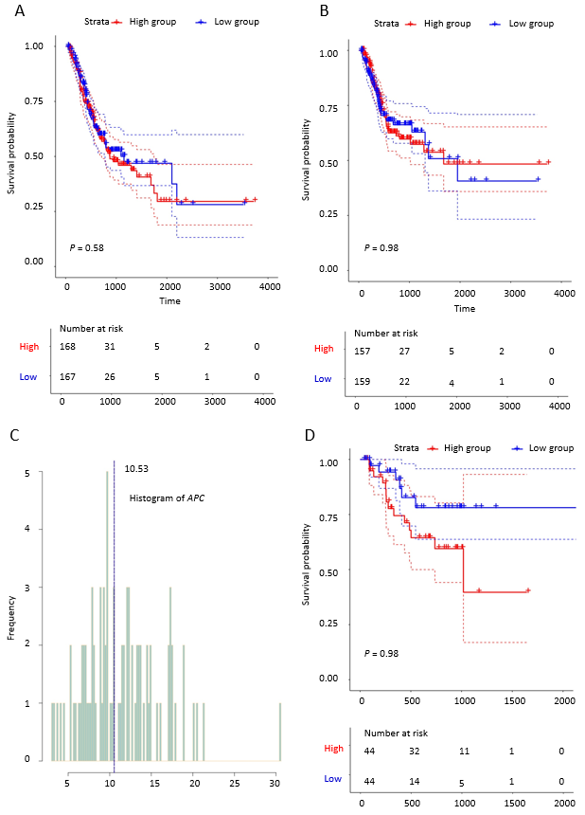
Figure 1 Prognostic value of APC expression in gastric cancer patients. A: Overall survival of gastric cancer patients with high APC expression and those with low expression (based on median value); B: Relapse-free survival of gastric cancer patients with high APC expression and those with low expression; C: Distribution of APC expression; D: Relapse-free survival of T4 gastric cancer patients with high APC expression and those with low expression. APC: Adenoma polyposis coli; GC: Gastric cancer.
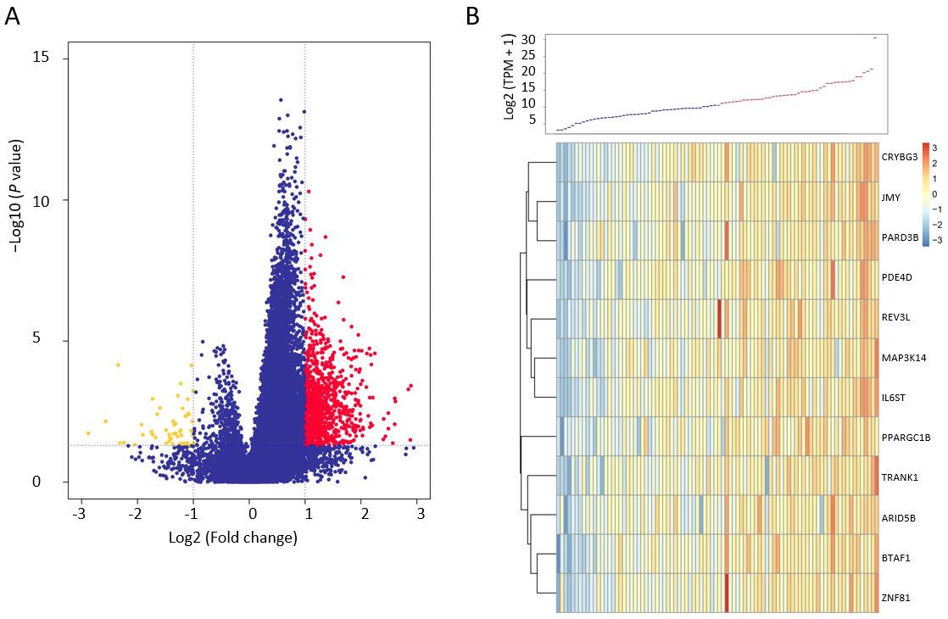
Figure 2 Differentially expressed mRNAs associated with APC^{high}. A: Volcanic map of differentially expressed mRNAs associated with APC^{high}; (B) Heatmap of differentially expressed mRNAs associated with APC^{high}. APC: Adenoma polyposis coli.

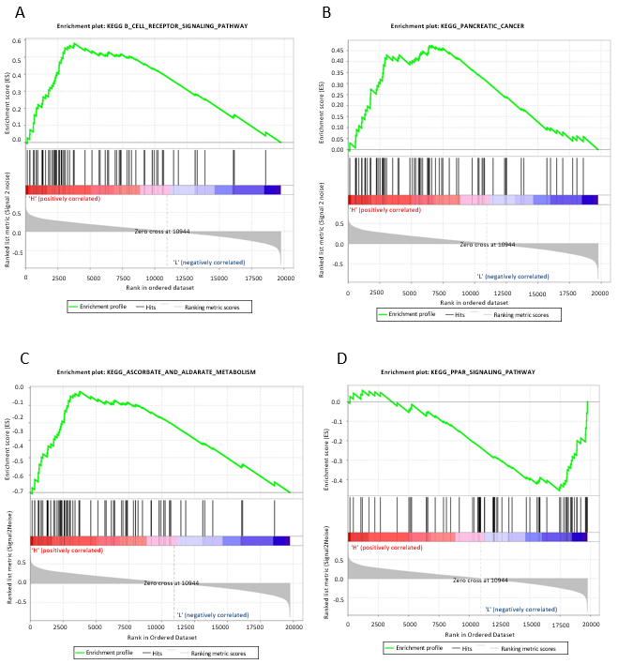
Figure 3 KEGG pathways of differentially expressed mRNAs associated with APC^{high}. Upregulated pathways of (A) cell receptor signaling and (B) pancreatic cancer and downregulated pathways of (C) ascorbate and aldarate metabolism and (D) PPAR signaling pathway are shown. APC: Adenoma polyposis coli.

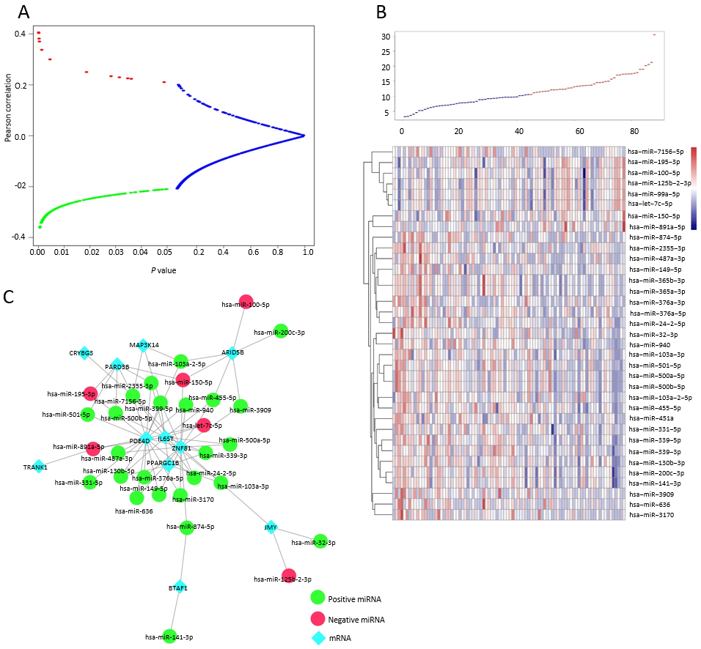
Figure 4 Genome-wide analysis of miRNAs associated with APC^{high}. A: Relationship between the correlation coefficient and correlation P-value; B: MiRNAs that were significantly positively correlated (red), negatively correlated (green), and had no correlation (blue) with APC^{high}, as well as the heatmap of miRNAs associated with APC^{high}; C: mRNA-miRNA regulatory network. APC: Adenoma polyposis coli.

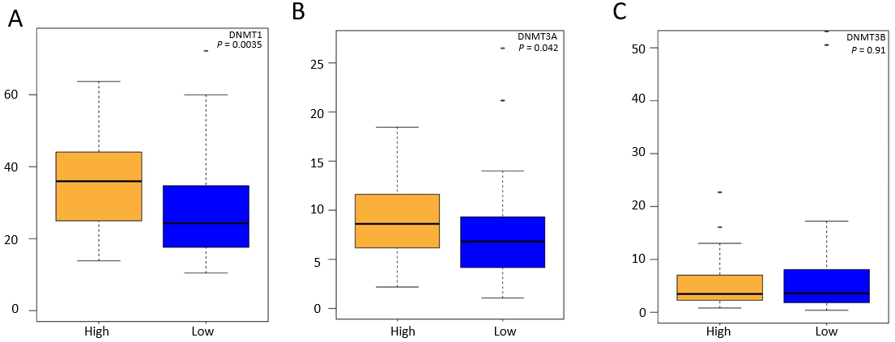
Figure 5 Differential expression of DNMT1, DNMT3A, and DNMT3B between APC^{high} and APC^{low}. APC: Adenoma polyposis coli; DNMT: DNA methyltransferase.

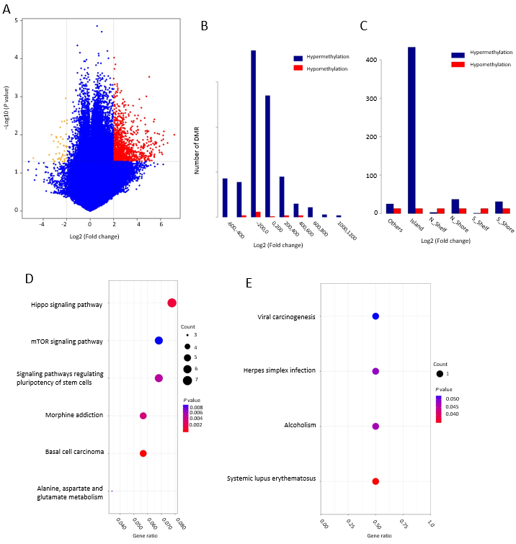
Figure 6 Analysis of relationship between APC^{high} and genome-wide DNA methylation. A: Volcanic map of differential DNA methylation associated with APC^{high}; B: Distribution of DNA methylation associated with APC^{high} based on CPG islands; C: Distribution of DNA methylation associated with APC^{high} based on transcription initiation site; D: Upregulated KEGG pathways of genes corresponding to the nearest transcription initiation site of differential DNA methylation; E: Downregulated KEGG pathways of genes corresponding to the nearest transcription initiation site of differential DNA methylation. APC: Adenoma polyposis coli.

Table 1 Relationship between APC^{high} and clinical characteristic and known prognostic genes
Characteristic | APC^{high} | APC^{low} | P-value
Age | 66 ± 8 | 61 ± 9 | 0.084
Stage
I | 5 | 25 | 0.031
II | 10 | 12 | 1
III + IV | 29 | 7 | 0.043
Grade
1 | 4 | 33 | 0.031
2 | 15 | 5 | 0.047
3 | 25 | 6 | 0.039
Lymph node metastasis
N0 | 7 | 23 | 0.027
N1 | 10 | 12 | 1
N2 | 11 | 4 | 0.031
N3 | 16 | 5 | 0.035
Distant metastasis
M0 | 7 | 9 | 0.781
M1 | 37 | 35 | 0.812
Gene
KIT | 29 | 15 | 0.031
PIK3CA | 32 | 12 | <0.001
KRAS | 28 | 16 | 0.038
MLH1 | 28 | 16 | 0.038
APC: Adenoma polyposis coli.

Table 2 Association between differential mRNAs and APC^{high}
mRNA | P-value (t-test) | P-value (Wilcoxon test) | Fold change | Regulation
BTAF1 | 1.45E-08 | 4.81E-10 | 2.00561 | Up-regulation
ARID5B | 1.20E-06 | 1.30E-07 | 2.011267 | Up-regulation
ZNF81 | 2.04E-06 | 3.84E-09 | 2.175277 | Up-regulation
JMY | 1.60E-09 | 4.99E-11 | 2.094035 | Up-regulation
MAP3K14 | 7.83E-07 | 3.00E-07 | 2.092268 | Up-regulation
PDE4D | 5.58E-07 | 4.33E-08 | 2.151154 | Up-regulation
CRYBG3 | 4.92E-07 | 1.10E-07 | 2.242404 | Up-regulation
PARD3B | 2.59E-06 | 9.38E-08 | 2.007173 | Up-regulation
PPARGC1B | 1.76E-08 | 2.04E-09 | 2.576507 | Up-regulation
TRANK1 | 6.01E-07 | 1.15E-08 | 2.165217 | Up-regulation
REV3L | 6.32E-07 | 1.14E-09 | 2.13368 | Up-regulation
IL6ST | 3.07E-07 | 1.30E-07 | 2.168223 | Up-regulation
APC: Adenoma polyposis coli.

Table 3 APC^{high} associated KEGG pathways
MSigDB | Size | ES | NES | P-value | Group
KEGG_B_CELL_RECEPTOR_SIGNALING_PATHWAY | 74 | 0.579 | 1.712 | 0.012 | High
KEGG_PANCREATIC_CANCER | 70 | 0.472 | 1.597 | 0.025 | High
KEGG_PROSTATE_CANCER | 89 | 0.450 | 1.570 | 0.025 | High
KEGG_REGULATION_OF_ACTIN_CYTOSKELETON | 211 | 0.396 | 1.541 | 0.032 | High
KEGG_NEUROTROPHIN_SIGNALING_PATHWAY | 126 | 0.437 | 1.533 | 0.046 | High
KEGG_PROGESTERONE_MEDIATED_OOCYTE_MATURATION | 85 | 0.412 | 1.491 | 0.040 | High
KEGG_ASCORBATE_AND_ALDARATE_METABOLISM | 25 | -0.674 | -1.851 | 0.002 | Low
KEGG_PPAR_SIGNALING_PATHWAY | 69 | -0.456 | -1.621 | 0.003 | Low
KEGG_DRUG_METABOLISM_OTHER_ENZYMES | 51 | -0.590 | -1.789 | 0.003 | Low
KEGG_STEROID_HORMONE_BIOSYNTHESIS | 55 | -0.595 | -1.853 | 0.004 | Low
KEGG_PORPHYRIN_AND_CHLOROPHYLL_METABOLISM | 41 | -0.617 | -1.833 | 0.004 | Low
KEGG_DRUG_METABOLISM_CYTOCHROME_P450 | 70 | -0.569 | -1.776 | 0.012 | Low
KEGG_RETINOL_METABOLISM | 63 | -0.556 | -1.687 | 0.012 | Low
KEGG_METABOLISM_OF_XENOBIOTICS_BY_CYTOCHROME_P450 | 68 | -0.572 | -1.782 | 0.014 | Low
KEGG_PENTOSE_AND_GLUCURONATE_INTERCONVERSIONS | 27 | -0.638 | -1.734 | 0.016 | Low
KEGG_LINOLEIC_ACID_METABOLISM | 29 | -0.589 | -1.691 | 0.019 | Low
KEGG_ALPHA_LINOLENIC_ACID_METABOLISM | 19 | -0.565 | -1.662 | 0.020 | Low
KEGG_ARACHIDONIC_ACID_METABOLISM | 58 | -0.424 | -1.541 | 0.031 | Low
APC: Adenoma polyposis coli.

