Name of Journal: World Journal of Clinical Cases
Manuscript NO: 61518
Manuscript Type: CASE REPORT

Pheochromocytoma with abdominal aortic aneurysm presenting as recurrent dyspnea, hemoptysis, and hypotension: A case report

Zhao HY et al. Pheochromocytoma presenting as dyspnea, hemoptysis, and hypotension

Hai-Yang Zhao, Yong-Zhen Zhao, Yu-Mei Jia, Xue Mei, Shu-Bin Guo

Hai-Yang Zhao, Yong-Zhen Zhao, Xue Mei, Shu-Bin Guo, Emergency Medicine Clinical Research Center, Beijing Chaoyang Hospital, Capital Medical University & Beijing Key Laboratory of Cardiopulmonary Cerebral Resuscitation, Beijing 100020, China

Yu-Mei Jia, Department of Endocrinology, Beijing Chaoyang Hospital, Capital Medical University, Beijing 100020, China

Author contributions: Zhao HY and Zhao YZ contributed equally to this work and should be considered as co-first authors; Zhao HY reviewed the data and consulted the authors; Zhao HY and Zhao YZ wrote the article and extracted the data; Jia YM, Mei X, and Guo SB revised and edited the article; all authors have read and approved the final manuscript.

Supported by the Peking Union Medical Foundation-Rui E (Rui Yi) Emergency Medical Research Special Fund, No. R2018001; and the Beijing Science and Technology Association Jinqiao Project Seed Fund, No. JQ18057.

Corresponding author: Shu-Bin Guo, MD, Professor, Emergency Medicine Clinical Research Center, Beijing Chao-Yang Hospital, Capital Medical University & Beijing Key Laboratory of Cardiopulmonary Cerebral Resuscitation, No. 8 Gongren Tiyuchang South Road, Chaoyang District, Beijing 100020, China. 443912880@qq.com

Received: December 17, 2020
Revised: April 7, 2021
Accepted: May 7, 2021
Published online:

Abstract
BACKGROUND
Pheochromocytomas are rare endocrine tumors with various clinical manifestations, and few of them might present with profound, life-threatening conditions.

CASE SUMMARY
We report the case of a 65-year-old man who complained of sudden dyspnea and hemoptysis for half a day. There was no obvious cause for the patient to have dyspnea, coughing, or coughing up to approximately 100 mL of fresh blood. Finally, he was diagnosed with pheochromocytoma crisis (PCC), coexisting with an abdominal aortic aneurysm (AAA).

CONCLUSION
We report a case of pheochromocytoma presenting with recurrent hemoptysis, dyspnea and hypotension coexisting with an AAA. It not only proved the uncommon manifestations of pheochromocytoma but also directed clinicians to consider PCC among the possible diagnoses when meeting similar cases. Moreover, surgical excision is the most beneficial method for the treatment of pheochromocytoma coexisting with AAA when the situation is stable.

Key Words: Emergency; Hemoptysis; Hypotension; Pheochromocytoma crisis; Abdominal aortic aneurysm; Case report

Zhao HY, Zhao YZ, Jia YM, Mei X, Guo SB. Pheochromocytoma with abdominal aortic aneurysm presenting as recurrent dyspnea, hemoptysis, and hypotension: A case report. World J Clin Cases 2021; In press

Core Tip: We report a case of pheochromocytoma presenting with recurrent hemoptysis, dyspnea, and hypotension coexisting with an abdominal aortic aneurysm. It not only proved the uncommon manifestations of pheochromocytoma but also directed clinicians to consider pheochromocytoma crisis among the possible diagnoses when meeting similar cases.
INTRODUCTION
Pheochromocytomas are rare endocrine tumors with various clinical manifestations, and a small number of them might present with profound, life-threatening conditions. We report a case of pheochromocytoma presenting with recurrent hemoptysis, dyspnea, and hypotension, coexisting with an abdominal aortic aneurysm, and with a positive outcome. We discuss the management and treatment of the patient in this case report and the proposed mechanisms.

CASE PRESENTATION
Chief complaints
A 65-year-old man was taken to our emergency department, complaining of sudden dyspnea and hemoptysis for half a day. There was no obvious cause for the patient to have dyspnea, coughing, or coughing up to approximately 100 mL of fresh blood.

History of present illness
The patient had four episodes of similar symptoms in the past 10 years. The first three episodes had dyspnea accompanied by hypertension, without hemoptysis, and only the symptoms were treated; the cause had not been identified. Dyspnea, hemoptysis, and hypotension occurred 5 years ago. He was hospitalized at our hospital, and a left adrenal mass and an abdominal aortic aneurysm (AAA) were found. An abdominal computed tomography (CT) scan showed a left adrenal mass measuring 3.2 cm × 3.6 cm and an AAA with a maximum diameter of 5.3 cm. Surgical treatment was not performed because the patient worried about the risks of surgery.

History of past illness
The patient was healthy.

Personal and family history
The patient had a disease-free personal and family history.

Physical examination
On physical examination, the patient was dyspneic, in distress, and sweating profusely. His blood pressure was 87/50 mmHg, heart rate was 107 beats/min, respiratory rate was 35 breaths/min, body temperature was 36 °C, and oxyhemoglobin saturation was 88% while breathing a 50% oxygen concentration with a face mask.

Laboratory examinations
Initial laboratory tests demonstrated leukocytosis (25.73 × 10⁹/L, with 93.6% neutrophils) and significantly increased serum procalcitonin at 58.4 ng/mL (normal value: < 0.05 ng/mL). Blood gas analysis revealed lactate 11.0 mmol/L, pH 7.31, PaO₂ 72.1 mmHg, PaCO₂ 32.3 mmHg, and HCO₃– 18.9 mmol/L while breathing 100% oxygen concentration with noninvasive positive pressure ventilation (NIPPV). His liver and renal function was also abnormal (alanine transaminase 145 U/L, glutamic-oxaloacetic transaminase 156 U/L, and creatinine 126 µmol/L), and D-dimer was 28.85 mg/L (normal value: ≤ 0.55 mg/L). Electrocardiogram showed sinus tachycardia and ST segment depression in the V2-V6 leads.

Imaging examinations
The patient’s chest X-ray manifestations were characterized by multiple plaques in both lungs, chest CT scans showed little ground glass shadow under the pleura of both lungs (Figure 1), and abdominal CT scans showed a left adrenal mass measuring 4.4 cm × 4.3 cm and an AAA with a maximum diameter of 7.3 cm (Figure 2). Echocardiography showed enlargement of the left atrium, aortic sinus, and ascending aorta. Systolic left ventricular function was impaired (ejection fraction 55%), but there was no pulmonary hypertension and no sign of diastolic dysfunction (left ventricular end diastolic diameter 55 mm).

FINAL DIAGNOSIS
The final diagnosis of the present case was pheochromocytoma crisis (PCC) and abdominal aortic aneurysm.

TREATMENT
Although PCC was considered, septic shock cannot be excluded. After treatment with antibiotic (imipenem), fluid resuscitation, and NIPPV for relieving dyspnea, the patient’s condition improved on the second day, except for blood pressure. Dopamine (5-10 μg/kg/min) was used to support blood pressure. On the third day, the patient completely stopped hemoptysis and the leukocyte count recovered to normal. Considering that there was no evidence of infection and no fever, which did not fit with the diagnosis of sepsis, step-down treatment was adopted for anti-infection. Tests of plasma and urine catecholamines and metabolites were performed. The levels of dopamine and methoxyepinephrines were increased in both the urine and 24-h urine. To our surprise, the level of plasma adrenocorticotropic hormone (ACTH) was decreased (Table 1). In addition, the blood cortisol level was slightly reduced. Magnetic resonance imaging of the pituitary gland was normal. The levels of angiotensin II, aldosterone, and renin were normal. One week later, the patient had no obvious discomfort, and blood pressure returned to normal. He was discharged. The repeated tests were performed 7 d after discharge (Table 1). Persuaded by us and his family, the patient finally made up his mind to undergo operation. The abdominal aortic aneurysm was repaired first by endovascular exclusion of abdominal aortic aneurysm, and 1 mo later, he underwent laparoscopic left adrenal tumor resection. Pathological examination confirmed the diagnosis of left adrenal pheochromocytoma.

OUTCOME AND FOLLOW-UP
The patient was followed for 5 mo and showed no signs of recurrence.

DISCUSSION
Pheochromocytomas are catecholamine-secreting tumors arising from chromaffin cells of the adrenal medulla and the sympathetic ganglia. The typical clinical presentation consists of episodic headache, diaphoresis, and tachycardia accompanied by paroxysmal or essential hypertension^{[1]}. However, PCC has dramatic and fulminant clinical expression and is usually associated with significant mortality. PCC as an endocrine emergency has been defined as the acute severe presentation of catecholamine-induced hemodynamic instability causing end-organ damage or dysfunction, usually associated with significant mortality^{[2]}. However, due to catecholamine overrelease, PCC can mimic other common conditions and thus frequently is initially misdiagnosed^{[3]}. As the clinical manifestations of the present case were featured by hypotension, hemoptysis, dyspnea, and multiple organ dysfunction syndrome on admission, we may easily miss the diagnosis of pheochromocytoma. Many patients choose surgery after the first attack of PCC. In this case, the patient did not undergo surgery; therefore, he had recurrent PCC. The patient’s medical history contributed to our diagnosis. However, hemoptysis, dyspnea, and hypotension were nonspecific signs. Bedside echocardiography helped us rule out heart disease and pulmonary embolism. Due to the widespread actions of catecholamines, pheochromocytomas may present with numerous conditions or diseases. Massive hemoptysis can be the main manifestation^{[4,5]}. Pulmonary venous hypertension secondary to severe paroxysmal hypertension was thought to be a possible cause of hemoptysis^{[4]}. In addition, Kimura et al^{[6]} reported that increased activation of the coagulation cascade and endothelial or platelet stimulation, evidenced by increased plasma von Willebrand factor, may have contributed to hemoptysis. The patient had recurrent PCC five times; the first three had hypertension, but the next two had sustained hypotension. Whitelaw et al^{[7]} suggest that a PCC without sustained hypotension is classified as a type A crisis, whereas a severe presentation with sustained hypotension, shock, and multiorgan dysfunction is classified as a type B crisis. However, the pathological processes of hypotension are not well understood. Norepinephrine and epinephrine are hypothesized to be the primary causes of tumor-induced alterations in hypotension. The primary mechanism seems to be excess plasma epinephrine stimulating β2 receptors to cause vasodilation^{[8]}, and norepinephrine is thought to be related to myocardial dysfunction, hypovolemia, and desensitization of baroreflexes^{[9,10]}. In addition, ACTH secretion should increase under stress, but the ACTH and cortisol levels in this case were relatively reduced. We suspect that the reason may be related to ischemia-reperfusion after the severe contraction of pituitary blood vessels caused by pheochromocytoma hormone storm. Such insufficient stress may also be one of the reasons for hypotension. Many reports describe the use of various inotropes and vasopressors (including adrenaline, noradrenaline, dopamine, dobutamine, vasopressin, and levosimendan) to manage sustained hypotension and circulatory compromise^{[11-13]}. We used dopamine for a week. The results of related tests might be affected by the use of this drug. It is unclear if any of these provide significant benefit in the circumstances, but the literature more generally supports the use of vasopressin^{[14]}. The coexistence of pheochromocytoma and AAA poses certain problems, and surgical intervention in these patients carries a significant risk of myocardial infarction, cerebrovascular accident, and cardiovascular collapse. In the preoperative period, there is an increased risk of rupture of the aneurysm, caused by excess catecholamine and hypertension^{[15]}. Also, resecting the pheochromocytoma places the aneurysm at an increased risk of rupture in the postoperative period. Taking these factors into consideration, our patient was subjected to endovascular exclusion of abdominal aortic aneurysm first, and 1 mo later, the patient underwent laparoscopic left adrenal tumor resection. Further studies are needed to determine whether it is possible to repair adrenal tumors and aneurysms at the same time, and the intraoperative management will be a challenging issue.

CONCLUSION
We report a case of pheochromocytoma presenting with recurrent hemoptysis, dyspnea, and hypotension coexisting with an abdominal aortic aneurysm. It not only proved the uncommon manifestations of pheochromocytoma but also directed clinicians to consider PCC among the possible diagnoses when meeting similar cases. Moreover, surgical excision is the most beneficial method for the treatment of pheochromocytoma coexisting with AAA when the situation is stable.

REFERENCES
1 Fassnacht M, Arlt W, Bancos I, Dralle H, Newell-Price J, Sahdev A, Tabarin A, Terzolo M, Tsagarakis S, Dekkers OM. Management of adrenal incidentalomas: European Society of Endocrinology Clinical Practice Guideline in collaboration with the European Network for the Study of Adrenal Tumors. Eur J Endocrinol 2016; 175: G1-G34 [PMID: 27390021 DOI: 10.1530/EJE-16-0467]
2 Mittendorf EA, Evans DB, Lee JE, Perrier ND. Pheochromocytoma: advances in genetics, diagnosis, localization, and treatment. Hematol Oncol Clin North Am 2007; 21: 509-25; ix [PMID: 17548037 DOI: 10.1016/j.hoc.2007.04.012]
3 Lee TW, Lin KH, Chang CJ, Lew WH, Lee TI. Pheochromocytoma mimicking both acute coronary syndrome and sepsis: a case report. Med Princ Pract 2013; 22: 405-407 [PMID: 23107814 DOI: 10.1159/000343578]
4 Yoshida T, Ishihara H. Pheochromocytoma presenting as massive hemoptysis and acute respiratory failure. Am J Emerg Med 2009; 27: 626.e3-626.e4 [PMID: 19497475 DOI: 10.1016/j.ajem.2008.08.023]
5 Frymoyer PA, Anderson GH Jr, Blair DC. Hemoptysis as a presenting symptom of pheochromocytoma. J Clin Hypertens 1986; 2: 65-67 [PMID: 3723160]
6 Kimura Y, Ozawa H, Igarashi M, Iwamoto T, Nishiya K, Urano T, Goto S. A pheochromocytoma causing limited coagulopathy with hemoptysis. Tokai J Exp Clin Med 2005; 30: 35-39 [PMID: 15952297]
7 Whitelaw BC, Prague JK, Mustafa OG, Schulte KM, Hopkins PA, Gilbert JA, McGregor AM, Aylwin SJ. Phaeochromocytoma [corrected] crisis. Clin Endocrinol (Oxf) 2014; 80: 13-22 [PMID: 24102156 DOI: 10.1111/cen.12324]
8 Ueda T, Oka N, Matsumoto A, Miyazaki H, Ohmura H, Kikuchi T, Nakayama M, Kato S, Imaizumi T. Pheochromocytoma presenting as recurrent hypotension and syncope. Intern Med 2005; 44: 222-227 [PMID: 15805711 DOI: 10.2169/internalmedicine.44.222]
9 de Leeuw PW, Waltman FL, Birkenhäger WH. Noncardiogenic pulmonary edema as the sole manifestation of pheochromocytoma. Hypertension 1986; 8: 810-812 [PMID: 3744472 DOI: 10.1161/01.hyp.8.9.810]
10 Graillon T, Fuentes S, Régis J, Metellus P, Brunel H, Roche PH, Dufour H. Multidisciplinary management of giant functional petrous bone paraganglioma. Acta Neurochir (Wien) 2011; 153: 85-9; discussion 89 [PMID: 20931241 DOI: 10.1007/s00701-010-0818-z]
11 Chao A, Yeh YC, Yen TS, Chen YS. Phaeochromocytoma crisis--a rare indication for extracorporeal membrane oxygenation. Anaesthesia 2008; 63: 86-88 [PMID: 18086076 DOI: 10.1111/j.1365-2044.2007.05251.x]
12 Park SM, Kim DH, Kwak YT, Jeong IK, Cho JM, Jin ES, Kim CJ. Pheochromocytoma-induced cardiogenic shock rescued by percutaneous cardiopulmonary bypass system. Circ J 2009; 73: 1753-1755 [PMID: 19145042 DOI: 10.1253/circj.cj-08-0287]
13 Westaby S, Shahir A, Sadler G, Flynn F, Ormerod O. Mechanical bridge to recovery in pheochromocytoma myocarditis. Nat Rev Cardiol 2009; 6: 482-487 [PMID: 19554007 DOI: 10.1038/nrcardio.2009.58]
14 Russell JA, Walley KR, Singer J, Gordon AC, Hébert PC, Cooper DJ, Holmes CL, Mehta S, Granton JT, Storms MM, Cook DJ, Presneill JJ, Ayers D; VASST Investigators. Vasopressin vs norepinephrine infusion in patients with septic shock. N Engl J Med 2008; 358: 877-887 [PMID: 18305265 DOI: 10.1056/NEJMoa067373]
15 van der Horst-Schrivers AN, Kerstens MN, Wolffenbuttel BH. Preoperative pharmacological management of phaeochromocytoma. Neth J Med 2006; 64: 290-295 [PMID: 16990692]

Footnotes
Informed consent statement: Informed written consent was obtained from the patient for publication of this report and any accompanying images.

Conflict-of-interest statement: We declare that we have no financial and personal relationships with other people or organizations that can inappropriately influence our work, and there is no professional or other personal interest of any nature or kind in any product, service and/or company that could be construed as influencing the position presented in, or the review of, the manuscript entitled “Pheochromocytoma with abdominal aortic aneurysm presenting as recurrent dyspnea, hemoptysis, and hypotension”.

CARE Checklist (2016) statement: The authors have read the CARE Checklist (2016), and the manuscript was prepared and revised according to the CARE Checklist (2016).

Open-Access: This article is an open-access article that was selected by an in-house editor and fully peer-reviewed by external reviewers. It is distributed in accordance with the Creative Commons Attribution NonCommercial (CC BY-NC 4.0) license, which permits others to distribute, remix, adapt, build upon this work non-commercially, and license their derivative works on different terms, provided the original work is properly cited and the use is non-commercial. See: http://creativecommons.org/Licenses/by-nc/4.0/

Manuscript source: Unsolicited manuscript

Peer-review started: December 17, 2020
First decision: March 11, 2021
Article in press:

Specialty type: Emergency medicine
Country/Territory of origin: China
Peer-review report’s scientific quality classification
Grade A (Excellent): 0
Grade B (Very good): B
Grade C (Good): C
Grade D (Fair): 0
Grade E (Poor): 0

P-Reviewer: Shorrab AA S-Editor: Zhang H L-Editor: Wang TQ P-Editor:
Figure Legends
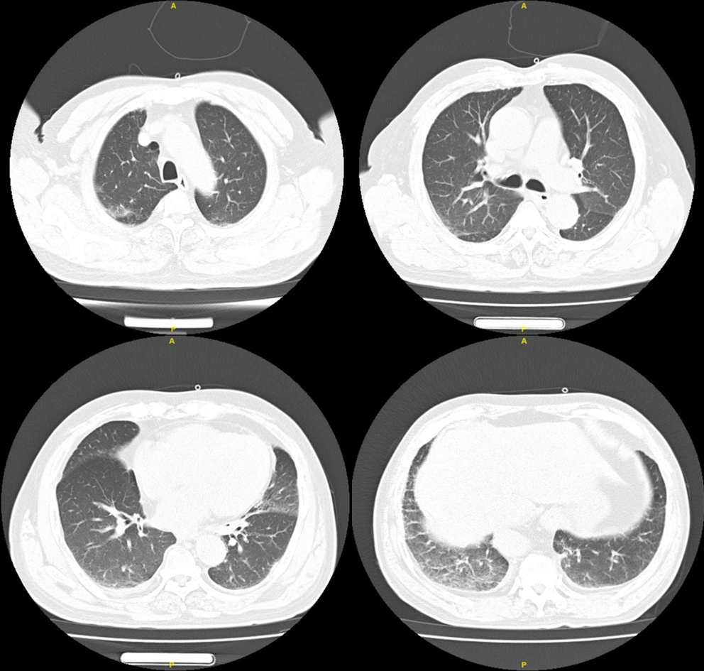
Figure 1 Chest computed tomography scans showing little ground glass shadow under the pleura of both lungs.
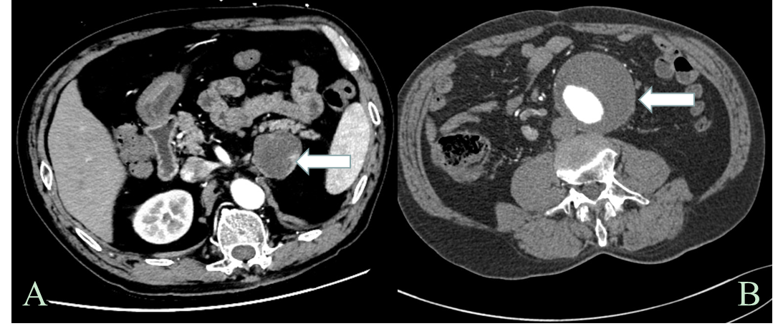
Figure 2 Enhanced computed tomography images. A: Enhanced computed tomography (CT) of the abdomen showing a round-like mass (4.4 cm × 4.3 cm) (white arrowhead); B: Enhanced CT of the abdomen depicting a 7.0 cm × 7.3 cm abdominal aortic aneurysm (white arrowhead).
Table 1 The patient’s catecholamine, methoxyepinephrines, and adrenocorticotropic hormone levels
Laboratory test | On admission | Seven days out of hospital | Normal range
Serum catecholamine
AD (pg/mL) | 31.77 | 47.95 | 0.00-100.00
NA (pg/mL) | 141.48 | 600.53 | 0.00-600.00
DOP (pg/mL) | 243.55 | 52.09 | 0.00-100.00
Serum methoxyepinephrines
3-MT (nmol/L) | 55.89 | < 0.08 | < 0.18
NMN (nmol/L) | 0.66 | 0.71 | ≤ 0.50
MN (nmol/L) | 1.95 | 3.64 | ≤ 0.90
24-h urinary catecholamine
24 h AD(μg/d) | 11.65 | 8.38 | 0.00-20.00
24 h NA (μg/d) | 24.55 | 48.34 | 0.00-90.00
24h DOP (μg/d) | 1448.71 | 53.57 | 0.00-600.00
24-h urinary methoxyepinephrines
24 h 3-MT (nmol/d) | 14443 | 266 | < 216
24 h NMN (nmol/d) | 579 | 682 | < 216
24 h MN (nmol/d) | 276 | 169 | < 382
ACTH (pg/mL) | 5.0 | 26.0 | 7.2-63.3
AD: Adrenaline; NA: Noradrenaline; DOP: Dopamine; 3MT: 3-methoxytyramine; NMN: Normetanephrin; MN: Metanephrine; ACTH: Adrenocorticotropic hormone.

