Name of Journal: World Journal of Gastroenterology
Manuscript NO: 75978
Manuscript Type: CORRECTION

Correction to “Inhibiting heme oxygenase-1 attenuates rat liver fibrosis by removing iron accumulation”

Wang QM et al. Correction to removing iron lightens ﬁbrosis

Qiu-Ming Wang, Jian-Ling Du, Zhi-Jun Duan, Shi-Bin Guo, Xiao-Yu Sun, Zhen Liu

Qiu-Ming Wang, Zhi-Jun Duan, Shi-Bin Guo, Xiao-Yu Sun, Zhen Liu, Department of Gastroenterology, The First Affiliated Hospital of Dalian Medical University, Dalian 116011, Liaoning Province, China

Jian-Ling Du, Department of Endocrinology, The First Affiliated Hospital of Dalian Medical University, Dalian 116011, Liaoning Province, China

Author contributions: Wang QM and Du JL performed the experiments, analyzed the data and wrote the manuscript; Duan ZJ and Wang QM designed the experiments; Wang QM performed the experiments, analyzed the data and wrote the manuscript; Duan ZJ and Guo SB revised the manuscript.

Corresponding author: Zhi-Jun Duan, MD, Chief Doctor, Department of Gastroenterology, The First Affiliated Hospital of Dalian Medical University, Dalian 116011, Liaoning Province, China. cathydoctor@sina.com

Received: February 24, 2022
Revised: July 4, 2022
Accepted: August 16, 2022
Published online:

Abstract
We found a mistake in Figure 6. Panels A (Sham group) and F (DFX group) (180 degrees rotated) is same images. We have replaced the incorrect images (Panels F) with the correct Figure. This error does not change the meaning of the picture or the conclusion of the manuscript. We apologize for our unintentional mistakes, which caused great inconvenience.

Key Words: Heme oxygenase-1; Hepcidin; Iron accumulation; Oxidative stress; Portal vein pressure; Carboxyhemoglobin; Bile duct ligation

Wang QM, Du JL, Duan ZJ, Guo SB, Sun XY, Liu Z. Correction to “Inhibiting heme oxygenase-1 attenuates rat liver fibrosis by removing iron accumulation. World J Gastroenterol 2022; In press

Core Tip: We found a mistake in Figure 6. Panels A (Sham group) and F (DFX group) (180 degrees rotated) is same images. We have replaced the incorrect images (Panels F) with the correct Figure. This error does not change the meaning of the picture or the conclusion of the manuscript. We apologize for our unintentional mistakes, which caused great inconvenience.

TO THE EDITOR
We found a mistake in Figure 6. Panels A (Sham group) and F (DFX group) (180 degrees rotated) is same images. We have replaced the incorrect images (Panels F) with the correct Figure 1. We only revised the incorrect figure, and the Manuscript NO: 75978 don't need to revise^{[1]}.

REFERENCES
1 Wang QM, Du JL, Duan ZJ, Guo SB, Sun XY, Liu Z. Inhibiting heme oxygenase-1 attenuates rat liver fibrosis by removing iron accumulation. World J Gastroenterol 2013; 19: 2921-2934 [PMID: 23704825 DOI: 10.3748/wjg.v19.i19.2921]

Footnotes
Conflict-of-interest statement: We declare that we have no conflict of interest.

Open-Access: This article is an open-access article that was selected by an in-house editor and fully peer-reviewed by external reviewers. It is distributed in accordance with the Creative Commons Attribution NonCommercial (CC BY-NC 4.0) license, which permits others to distribute, remix, adapt, build upon this work non-commercially, and license their derivative works on different terms, provided the original work is properly cited and the use is non-commercial. See: https://creativecommons.org/Licenses/by-nc/4.0/

Provenance and peer review: Unsolicited article; Externally peer reviewed.
Peer-review model: Single blind

Peer-review started: February 24, 2022
First decision: June 11, 2022
Article in press:

Specialty type: Gastroenterology and hepatology
Country/Territory of origin: China
Peer-review report’s scientific quality classification
Grade A (Excellent): A
Grade B (Very good): B
Grade C (Good): 0
Grade D (Fair): 0
Grade E (Poor): 0

P-Reviewer: Buechler C, Germany; Gorrell MD, Australia S-Editor: Liu JH L-Editor: A P-Editor: Liu JH
Figure Legends
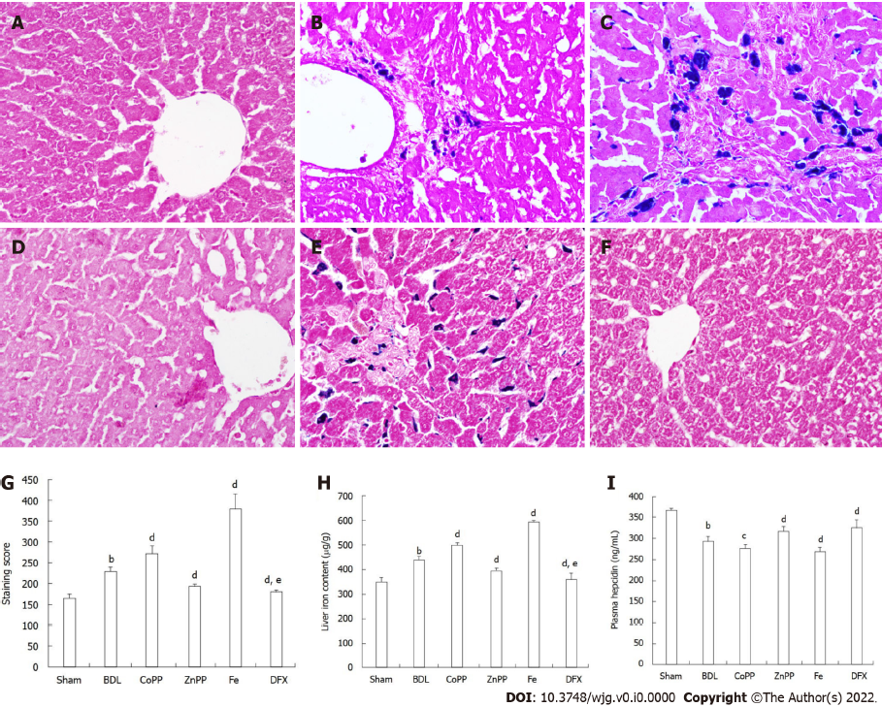
Figure 1Perl’s Prussian blue staining, levels of hepcidin, serum and liver iron. A: No iron accumulated in the Sham group; B: A small amount of iron mainly accumulated on Kupffer cells in the bile duct ligation (BDL) group; C: Much more iron accumulation was found in interlobular and macrophagocytes in the cobalt protoporphyrin (CoPP) group; D and F: Almost no iron accumulation was detected in the zinc protoporphyrin (ZnPP) group and deferoxamine (DFX) group; E: Massive iron accumulation was observed in the Fe group; G and H: There were no differences in the hepatic and serum iron content of these six groups; I: Plasma hepcidin also was measured by enzyme-linked immuno sorbent assay (magnification × 400). Values are expressed as mean ± SE (n = 6). ^{b}P < 0.01 vs Sham group; ^{c}P < 0.05, ^{d}P < 0.01 vs BDL group; ^{e}P < 0.05 vs ZnPP group.

