Name of Journal: World Journal of Diabetes
Manuscript NO: 82219
Manuscript Type: ORIGINAL ARTICLE

Basic Study
Comprehensive analysis of endoplasmic reticulum stress-related mechanisms in type 2 diabetes mellitus

Liang B et al. Comprehensive analysis of ERS-related mechanisms in T2DM

Bo Liang, Shu-Wen Chen, Yuan-Yuan Li, Shun-Xiao Zhang, Yan Zhang

Bo Liang, Department of Nephrology, The Key Laboratory for the Prevention and Treatment of Chronic Kidney Disease of Chongqing, Chongqing Clinical Research Center of Kidney and Urology Diseases, Xinqiao Hospital, Army Medical University (Third Military Medical University), Chongqing 400037, China

Shu-Wen Chen, Yuan-Yuan Li, Shun-Xiao Zhang, Yan Zhang, Department of Endocrinology, Shanghai Baoshan Hospital of Integrated Traditional Chinese and Western Medicine, Shanghai 200000, China

Author contributions: Liang B and Zhang Y conceived, designed, and planned the study; Liang B, Chen SW, and Li YY analyzed the data; Liang B, Chen SW, and Zhang SX interpreted the data; Liang B drafted the manuscript; Zhang Y revised the manuscript; All authors collected the data, they all read and approved the final manuscript.

Corresponding author: Yan Zhang, MD, PhD, Academic Editor, Professor, Department of Endocrinology, Shanghai Baoshan Hospital of Integrated Traditional Chinese and Western Medicine, No. 181 Youyi Road, Baoshan District, Shanghai 200000, China. yan_2999bs@163.com

Received: December 10, 2022
Revised: December 27, 2022
Accepted: April 4, 2023
Published online: June 15, 2023

Abstract
BACKGROUND
The endoplasmic reticulum (ER) is closely related to a wide range of cellular functions and is a key component to maintain and restore metabolic health. Type 2 diabetes mellitus (T2DM) is a serious threat to human health, but the ER stress (ERS)-related mechanisms in T2DM have not been fully elucidated.

AIM
To identify potential ERS-related mechanisms and crucial biomarkers in T2DM.

METHODS
We conducted gene set enrichment analysis (GSEA) and gene set variation analysis (GSVA) in myoblast and myotube form GSE166502, and obtained the differentially expressed genes (DEGs). After intersecting with ERS-related genes, we obtained ERS-related DEGs. Finally, functional analyses, immune infiltration, and several networks were established.

RESULTS
Through GSEA and GSVA, we identified several metabolic and immune-related pathways. We obtained 227 ERS-related DEGs and constructed several important networks that help to understand the mechanisms and treatment of T2DM. Finally, memory CD4⁺ T cells accounted for the largest proportion of immune cells.

CONCLUSION
This study revealed ERS-related mechanisms in T2DM, which might contribute to new ideas and insights into the mechanisms and treatment of T2DM.

Key Words: Endoplasmic reticulum stress; Type 2 diabetes mellitus; Biomarkers; Memory CD4⁺ T cells

©The Author(s) 2023. Published by Baishideng Publishing Group Inc. All rights reserved.

Citation: Liang B, Chen SW, Li YY, Zhang SX, Zhang Y. Comprehensive analysis of endoplasmic reticulum stress-related mechanisms in type 2 diabetes mellitus. World J Diabetes 2023; 14(6): 820-845
URL: https://www.wjgnet.com/1948-9358/full/v14/i6/820.htm
DOI: https://dx.doi.org/10.4239/wjd.v14.i6.820

Core Tip: This study revealed endoplasmic reticulum stress-related mechanisms in type 2 diabetes mellitus (T2DM), which might contribute to new ideas and insights for the mechanisms and treatment of T2DM.

INTRODUCTION
Diabetes is a chronic disease that occurs either when the pancreas does not produce enough insulin or when the body cannot effectively use the insulin it produces^{[1,2]}. Hyperglycemia is a common effect of uncontrolled diabetes and over time leads to serious damage to many of the body’s systems, especially the heart, blood vessels, eyes, kidneys, and nerves^{[3,4]}. Recently, the estimated prevalence of diabetes among children, adolescents, and adults has increased^{[5,6]}. The majority of people with diabetes have type 2 diabetes mellitus (T2DM)^{[7]}. Simple lifestyle measures have been shown to be effective in preventing or delaying the onset of T2DM^{[8]}. Recently, with the in-depth understanding of the mechanisms of T2DM, many new drugs, such as sodium-glucose cotransporter-2 inhibitors, glucagon-like peptide-1 analogs, and dipeptidyl peptidase-4 inhibitors, have been gradually applied to clinical practice and achieved good results^{[9-11]}. However, the residual risk of these populations remains high, especially when combined with other diseases^{[12]}.
The endoplasmic reticulum (ER) is closely related to a wide range of cellular functions and is a key component to maintain and restore metabolic health^{[13]}. Protein handling, modification, and folding in the ER are tightly regulated processes that determine cell function, fate, and survival^{[14]}. Many genetic and environmental damages hinder the ability of cells to correctly fold and post-translationally modify secreted and transmembrane proteins in the ER, resulting in the accumulation of misfolded proteins in this organelle, which is called ER stress (ERS)^{[15]}. Chronic ERS is becoming a key factor in more human diseases, including T2DM^{[16,17]}. Recently, the biological mechanisms of ERS in T2DM have been gradually explored. YIPF5 mutations can disrupt the ER-to-Golgi trafficking, thereby resulting in T2DM^{[16]}. Inositol-requiring enzyme 1alpha upregulates miR-200a degradation and stimulates TXINP/NLRP3-pathway-mediated pyroptosis and renal damage in T2DM^{[18]}. Mfn2 plays an important role in ERS, and Mfn2 silencing prevents mitochondrial Ca2⁺ overload-mediated mitochondrial dysfunction^{[19]}. ATF5 is a regulator of ERS and β-cell apoptosis in different models of diabetes mellitus^{[20]}. Lactogens modulate the ERS pathway, causing enhanced β-cell survival and reduced T2DM incidence^{[21]}. The development of ERS for the treatment of T2DM has also emerged in clinical trials. A randomized placebo-controlled crossover trial indicated that decreased ERS may lead to improvement of insulin sensitivity mediated by hyperbaric oxygen^{[22]}. Nevertheless, the role of ERS in T2DM, especially the related markers and mechanisms, is still lacking.
Here, we conducted gene set enrichment analysis (GSEA) and gene set variation analysis (GSVA) in both proliferating myoblasts and differentiated myotubes, which are important in T2DM. Then, the differentially expressed genes (DEGs) and ERS-related DEGs between T2DM patients and healthy populations were investigated, sequentially. Furthermore, functional enrichment analysis [Gene Ontology (GO), and Kyoto Encyclopedia of Genes and Genomes (KEGG], immune infiltration analysis, and three networks [transcription factor (TF)–mRNA, miRNA–mRNA, and drug–mRNA] were detected to explore the mechanisms and potential therapeutic agents of ERS in T2DM. The flow chart is shown in Figure 1.

MATERIALS AND METHODS
Acquisition and processing of raw data
The raw data of the microarray expression dataset GSE166502^{[23]} and its annotation file GPL10558 (Illumina HumanHT-12 V4.0 Expression BeadChip) were obtained from Gene Expression Omnibus^{[24]}. GSE166502 holds the mRNA expression in proliferating myoblasts and differentiated myotubes in patients with T2DM (n = 13) or controls (n = 13).

GSEA and GSVA
We selected and downloaded c2.cp.v7.2.symbols.gmt gene set data through the GSEA database^{[25]}, and conducted GSEA on the proliferating myoblasts and differentiated myotubes through the clusterProfiler package (version 3.14.3)^{[26]}. The statistical process of GSEA was to calculate the enrichment score, estimate the significance, and correct the multiple hypothesis tests. We also selected the same data from GSEA and conducted GSVA. The different pathways were obtained through the limma package (version 3.42.2)^{[27]}.

Identification of DEGs
After the processing of raw data, we analyzed the data using the limma package with a fold change and P for DEGs. The threshold of DEGs was |log₂fold change| > 0.263 and P < 0.05 as described previously, and the results were visualized as a heat map and volcano map using the pheatmap package (version 1.0.12).

Acquisition of ERS-related DEGs
GeneCards provides annotated and predicted human gene information, which integrates gene data from about 150 network sources, including genomics, transcriptomics, proteomics, genetics, and clinical and functional information^{[28]}. In this study, ERS-related genes were downloaded through GeneCards with “endoplasmic reticulum stress” as the search keyword. Taking the intersection of DEGs and ERS-elated genes, we got the ERS-related DEGs and the Venn diagram was drawn through the Venndiagram package (version 1.6.20).

Functional enrichment analysis
GO and KEGG pathway analysis can contribute to the interpretation of system-level data and enable discoveries^{[29,30]}. In this work, GO terms and KEGG analysis of ERS-related DEGs and potential molecular complex were carried out using the clusterProfiler package with P < 0.05, and then visualized by the ggplot2 package (version 3.3.3), as described previously^{[31]}.

Protein–protein interaction analysis
Protein–protein interaction (PPI) is one of the cores of cellular processing. The analysis of PPI makes the relationships among proteins clear and helps the function explanation of potential protein complexes or functional modules. In this work, PPI information was surveyed using the String database (version 11.0)^{[32]}. The PPI network of ERS-related DEGs was uploaded to Cytoscape (version 3.8.2)^{[33]} and the NetworkAnalyzer plugin was used to further processing and analysis. The cytoHubba plugin was used to select the top 20 key genes^{[34]}.

Network analysis
Transcriptional Regulatory Relationships Unraveled by Sentence-based Text mining (TRRUST, version 2) manually curated database of human and mouse transcriptional regulatory networks^{[35]}. Current TRRUST contains 8444 and 6552 TF-target regulatory relationships of 800 human and 828 mouse TFs. TRRUST database also provides information on the mode of regulation (activation or repression). miRWalk (version 3.0) stores predicted data obtained with a machine-learning algorithm including experimentally verified miRNA–target interactions^{[36]}. The drug–gene interaction database (DGIdb, version 4.2.0) builds drug–gene interactions mined from DrugBank, PharmGKB, Chembl, Drug Target Commons, Therapeutic Target Database, and others^{[37]}. DGIdb contains > 40000 genes and > 10000 drugs involved in > 100000 drug–gene interactions or belonging to one of 42 potentially druggable gene categories. We obtained the TFs, miRNAs, and drugs of ERS-related DGEs, respectively, and then constructed the regulation relationship networks through Cytoscape.

Correlation analysis of immune infiltration
CIBERSORT (version 1.03) calculates the proportion of different types of cells according to LM22^{[38]}. The proportion of different cell types can be calculated after the nonnegative matrix decomposition of the expression matrix. In this study, the immune infiltration of GSE166502 was analyzed by CIBERSORT, and the infiltration of 22 kinds of immune cells in the sample was analyzed. Finally, we analyzed the correlation between the expression of the top 20 key genes in the PPI network and the immune infiltration.

RESULTS
GSEA and GSVA
Through GSEA, we found that neuroactive ligand–receptor interaction, hypertrophic cardiomyopathy, DNA replication, cell cycle, and cardiac muscle contraction were the top five pathways in proliferating myoblasts (Figure 2A–F). DNA replication, cell cycle, cardiac muscle contraction, neuroactive ligand–receptor interaction, and hypertrophic cardiomyopathy were activated, whereas glycosaminoglycan biosynthesis heparan sulfate, glycosaminoglycan biosynthesis chondroitin sulfate, glycosaminoglycan degradation, other glycan degradation, and lysosome were suppressed (Figure 2G). Other pathways, such as arachidonic acid metabolism, mismatch repair, P53 signaling pathway, metabolism of xenobiotics by cytochrome P450, and prion diseases, were also enriched (Figure 2H). Similarly, we found that viral myocarditis, steroid hormone biosynthesis, hematopoietic cell lineage, focal adhesion, and extracellular matrix (ECM) receptor interaction were the top five pathways in differentiated myotubes (Figure 2I–N). Neuroactive ligand–receptor interaction, gap junction, pathways in cancer, focal adhesion, and ECM receptor interaction were activated, whereas steroid hormone biosynthesis, cardiac muscle contraction, viral myocarditis, hematopoietic cell lineage, and steroid biosynthesis were suppressed (Figure 2O). Vascular endothelial growth factor (VEGF) signaling pathway, cell adhesion molecules cams, mitogen-activated protein kinase (MAPK) signaling pathway, and apoptosis were also enriched (Figure 2P).
Through GSVA, eight pathways were enriched in proliferating myoblasts (Figure 3A and B). RNA degradation, DNA replication, and mismatch repair were upregulated, and glycosaminoglycan biosynthesis chondroitin sulfate, other glycan degradation, lysosome, glycosaminoglycan biosynthesis heparan sulfate, and steroid biosynthesis were downregulated. Two pathways (steroid hormone biosynthesis and steroid biosynthesis) were enriched in differentiated myotubes (Figure 3C and D).

Identification of ERS-related DEGs
We performed DEG analysis on proliferating myoblasts and differentiated myotubes. We obtained 426 DEGs (188 upregulated and 238 downregulated, Figure 4A and B) and 281 DEGs (135 upregulated and 146 downregulated, Figure 4C and D) from proliferating myoblasts and differentiated myotubes, respectively. Through intersecting with 6893 ERS-related genes, we obtained 227 ERS-related DEGs (Figure 4E).

Function enrichment analysis
GO terms include biological processes, molecular functions, and cellular components. There were 227 ERS-related DEGs enriched in 875 biological process terms, 103 molecular function terms, and 81 cellular component terms. The results indicated that numerous biological processes were involved in extracellular structure organization, collagen fibril organization, ECM organization, cellular response to external stimulus, response to ketone, cellular response to fatty acid, cellular response to prostaglandin stimulus, response to fatty acid, response to mechanical stimulus, respiratory tube development, cellular response to extracellular stimulus, response to alcohol, and cell–substrate adhesion (Figure 5A). The results indicated that numerous cellular components were involved in the collagen-containing ECM, ECM component, collagen trimer, ER lumen, ER–Golgi intermediate compartment, Golgi-associated vesicle membrane, the complex of collagen trimers, membrane raft, membrane microdomain, membrane region, phagocytic vesicle, neuronal cell body, Golgi-associated vesicle, focal adhesion, cell–substrate adherens junction, cell–substrate junction, postsynaptic endosome, transport vesicle, COPII-coated ER to Golgi transport vesicle, and ER to Golgi transport vesicle membrane (Figure 5B). The results indicated that numerous molecular functions were involved in prostaglandin receptor activity, ECM structural constituent, prostanoid receptor activity, icosanoid receptor activity, growth factor binding, ECM structural constituent conferring tensile strength, platelet-derived growth factor binding, transmembrane receptor protein kinase activity, heat shock protein binding, sulfur compound transmembrane transporter activity, transmembrane receptor protein tyrosine kinase activity, transmembrane-ephrin receptor activity, oxidoreductase activity, ephrin receptor activity, virus receptor activity, and hijacked molecular function (Figure 5C). Through KEGG function enrichment analysis, 26 pathways were significant, such as axon guidance, protein digestion and absorption, focal adhesion, protein processing in the ER, cortisol synthesis and secretion, Fc gamma R-mediated phagocytosis, renin secretion, glutathione metabolism, AMPK signaling pathway, ECM–receptor interaction, DNA replication, calcium signaling pathway, thyroid cancer, aldosterone synthesis, and secretion, lipid and atherosclerosis, P53 signaling pathway, other glycan degradation, biosynthesis of amino acids, ABC transporters, phospholipase D signaling pathway, and steroid biosynthesis (Figure 5D).

PPI analysis
The network consisted of 227 nodes and 416 edges (Figure 6A). We used the NetworkAnalyzer plugin to calculate the degree and combine the score (Figure 6B). We obtained 20 key genes (2 modules with 67 interactions) via the cytoHubba plugin (Table 1 and Figure 6C).

Network analysis
We obtained 27 TFs and 49 target genes from TRRUST to build the TF–mRNA network (Figure 7A). We obtained 51 miRNAs and 25 target genes from miRWalk to build the miRNA–mRNA network (Figure 7B). We also obtained 59 drugs and 22 target genes from DGIdb to build the drug–mRNA network (Figure 7C).

Correlation analysis of immune infiltration
We demonstrated that memory CD4⁺ T cells accounted for the largest proportion of 22 immune cell types (Figure 8A). Figure 8B showed the distribution of different immune cells in each sample. Moreover, we evaluated the correlation between immune infiltration and each sample (Figure 8C). In 20 key genes, the enrichment degree of each immune cell was different (Figure 8D).

DISCUSSION
T2DM is a complex metabolic disease driven by interactions among diverse environmental and genetic susceptibilities^{[39]}. Although environmental and epigenetic factors clearly play a contributory role in the pathogenesis of T2DM, genetic factors appear to be the primary contributors to the recent rise in T2DM prevalence^{[40]}. More studies have shown that ERS is involved in T2DM^{[41]}. In the present study, we first explored the potential pathways in proliferating myoblasts and differentiated myotubes, and obtained 227 ERS-related DEGs in T2DM, which may contribute to the occurrence and development of T2DM. Later enrichment analysis, immune infiltration, TF–mRNA network, and miRNA–mRNA network revealed the mechanisms of T2DM, which provided a way for clinical treatment of T2DM. In particular, the drug–mRNA network provided new insights and perspectives into the therapeutic reagents.
In GSEA and GSVA, we confirmed that DNA replication, cell cycle, neuroactive ligand–receptor interaction, glycosaminoglycan biosynthesis heparan sulfate, glycosaminoglycan biosynthesis chondroitin sulfate, glycosaminoglycan degradation, other glycan degradation, lysosome, arachidonic acid metabolism, mismatch repair, metabolism of xenobiotics by cytochrome P450, steroid hormone biosynthesis, focal adhesion, and ECM–receptor interaction, neuroactive ligand–receptor interaction, gap junction, steroid biosynthesis, and cell adhesion molecules were enriched. Moreover, the P53 signaling pathway, VEGF signaling pathway, MAPK signaling pathway, and apoptosis may contribute to T2DM. Previous studies have indicated that these biological processes are related to T2DM^{[42-44]}. SRT2104 enhanced renal SIRT1 expression and activity, deacetylated P53, and activated NRF2 antioxidant signaling, providing remarkable protection against T2DM^{[45]}. The p-ERK/p-JNK/VEGF/PKC signaling pathway may play an important role in pathological T2DM conditions^{[46]}. TREM-2 negatively regulates p38 MAPK-mediated inflammatory response in T2DM^{[47]}. These previous findings are consistent with our findings in this study.
We identified 227 ERS-related DEGs and later function enrichment analysis demonstrated that the enriched biological processes and pathways are highly consistent with the previous GSEA and GSVA results. The immune infiltration analysis revealed that memory CD4⁺ T cells accounted for the largest proportion of 22 immune cell types. T2DM patients are present with self-reactive T cells with a memory phenotype^{[48]}. The memory CD4⁺ T cells develop directly from effector cells and thereby preserve features of their effector precursors are reserved^{[49]}. Depending on the immune context, memory CD4⁺ T cells can contribute to immune protection, pathology, or tissue remodeling^{[50]}. The memory CD4⁺ T cells could act as immunological markers for predicting change in β-cell function in T2DM^{[51]}. TFs recognize specific DNA sequences to control chromatin and transcription, forming a complex system that guides the expression of the genome^{[52]}. Here we obtained 27 TFs, which may contribute to T2DM. MiRNA is a class of endogenous noncoding RNA encoding 19–25 nucleotides, which is involved in the post-transcriptional regulation of genes^{[53]}. Most of them have high sequence conservation, expression timing, and tissue specificity^{[54]}. Recent studies have shown that miRNA is involved in a variety of regulatory pathways, we here identified 51 miRNAs to further explain the mechanisms of T2DM. Importantly, we also established a drug–mRNA network map to provide new ideas and directions for the treatment of T2DM. Immune infiltration plays an important role in the occurrence and development of T2DM^{[55,56]}. The memory CD4⁺ T cells play central roles in immunity in health and disease^{[57]}. We also explored the relationship between immune infiltration and T2DM, and we found that memory CD4⁺ T cells were the most numerous types of immune cells in T2DM. Previous studies indicated that CD4⁺ T cells contribute to the destruction of insulin-producing β-cells in type 1 diabetes mellitus^{[58,59]}, which confirmed our results.
This study has some limitations. First, all the results of the analysis were derived from previous data. Despite the efforts we have made in the present, our results still need verification experimentally and clinically. Moreover, the TF–mRNA, miRNA–mRNA, and drug–mRNA networks we built in this study provided some new ideas and insights for the mechanisms and treatment of T2DM. However, this is only the beginning, and more work is still needed in the follow-up.

CONCLUSION
This study revealed ERS-related mechanisms in T2DM, which might contribute to new ideas and insights for the mechanisms and treatment of T2DM.

ARTICLE HIGHLIGHTS
Research background
The endoplasmic reticulum (ER) is closely related to a wide range of cellular functions and is a key component to maintain and restore metabolic health.

Research motivation
Type 2 diabetes mellitus (T2DM) is a serious threat to human health, but knowledge of the ER stress (ERS)-related mechanisms in T2DM is lacking.

Research objectives
Here, we conducted a bioinformatics analysis to identify potential ERS-related mechanisms and crucial biomarkers in T2DM.

Research methods
We conducted gene set enrichment analysis (GSEA) and gene set variation analysis (GSVA) in myoblast and myotube form GSE166502, and obtained the differentially expressed genes (DEGs). After intersecting with ERS-related genes, we obtained ERS-related DEGs. Finally, functional analyses, immune infiltration, and several networks were established.

Research results
Through GSEA and GSVA, we identified several metabolic and immune-related pathways. We obtained 227 ERS-related DEGs and constructed several important networks that help to understand the mechanisms and treatment of T2DM. Finally, memory CD4⁺ T cells accounted for the largest proportion of immune cells.

Research conclusions
This study revealed ERS-related mechanisms in T2DM.

Research perspectives
Our study might contribute to new ideas and insights for the mechanisms and treatment of T2DM.

REFERENCES
1 Stumvoll M, Goldstein BJ, van Haeften TW. Type 2 diabetes: principles of pathogenesis and therapy. Lancet 2005; 365: 1333-1346 [PMID: 15823385 DOI: 10.1016/S0140-6736(05)61032-X]
2 O'Brien BJ, Faraoni EY, Strickland LN, Ma Z, Mota V, Mota S, Chen X, Mills T, Eltzschig HK, DelGiorno KE, Bailey-Lundberg JM. CD73-generated extracellular adenosine promotes resolution of neutrophil-mediated tissue injury and restrains metaplasia in pancreatitis. FASEB J 2023; 37: e22684 [PMID: 36468677 DOI: 10.1096/fj.202201537R]
3 International Hypoglycaemia Study Group. Hypoglycaemia, cardiovascular disease, and mortality in diabetes: epidemiology, pathogenesis, and management. Lancet Diabetes Endocrinol 2019; 7: 385-396 [PMID: 30926258 DOI: 10.1016/S2213-8587(18)30315-2]
4 Hahr AJ, Molitch ME. Management of Diabetes Mellitus in Patients With CKD: Core Curriculum 2022. Am J Kidney Dis 2022; 79: 728-736 [PMID: 34600745 DOI: 10.1053/j.ajkd.2021.05.023]
5 Wang L, Peng W, Zhao Z, Zhang M, Shi Z, Song Z, Zhang X, Li C, Huang Z, Sun X, Wang L, Zhou M, Wu J, Wang Y. Prevalence and Treatment of Diabetes in China, 2013-2018. JAMA 2021; 326: 2498-2506 [PMID: 34962526 DOI: 10.1001/jama.2021.22208]
6 Lawrence JM, Divers J, Isom S, Saydah S, Imperatore G, Pihoker C, Marcovina SM, Mayer-Davis EJ, Hamman RF, Dolan L, Dabelea D, Pettitt DJ, Liese AD; SEARCH for Diabetes in Youth Study Group. Trends in Prevalence of Type 1 and Type 2 Diabetes in Children and Adolescents in the US, 2001-2017. JAMA 2021; 326: 717-727 [PMID: 34427600 DOI: 10.1001/jama.2021.11165]
7 Stefan N, Cusi K. A global view of the interplay between non-alcoholic fatty liver disease and diabetes. Lancet Diabetes Endocrinol 2022; 10: 284-296 [PMID: 35183303 DOI: 10.1016/S2213-8587(22)00003-1]
8 Einarson TR, Acs A, Ludwig C, Panton UH. Prevalence of cardiovascular disease in type 2 diabetes: a systematic literature review of scientific evidence from across the world in 2007-2017. Cardiovasc Diabetol 2018; 17: 83 [PMID: 29884191 DOI: 10.1186/s12933-018-0728-6]
9 Liang B, Zhao YX, Zhang XX, Liao HL, Gu N. Reappraisal on pharmacological and mechanical treatments of heart failure. Cardiovasc Diabetol 2020; 19: 55 [PMID: 32375806 DOI: 10.1186/s12933-020-01024-5]
10 Wu CY, Shapiro L, Ouk M, MacIntosh BJ, Black SE, Shah BR, Swardfager W. Glucose-lowering drugs, cognition, and dementia: The clinical evidence. Neurosci Biobehav Rev 2022; 137: 104654 [PMID: 35398114 DOI: 10.1016/j.neubiorev.2022.104654]
11 Søndergaard CS, Esquivel PN, Dalamaga M, Magkos F. Use of Antihyperglycemic Drugs and Risk of Cancer in Patients with Diabetes. Curr Oncol Rep 2023; 25: 29-40 [PMID: 36445570 DOI: 10.1007/s11912-022-01344-7]
12 Ling J, Ng JKC, Chan JCN, Chow E. Use of Continuous Glucose Monitoring in the Assessment and Management of Patients With Diabetes and Chronic Kidney Disease. Front Endocrinol (Lausanne) 2022; 13: 869899 [PMID: 35528010 DOI: 10.3389/fendo.2022.869899]
13 Lemmer IL, Willemsen N, Hilal N, Bartelt A. A guide to understanding endoplasmic reticulum stress in metabolic disorders. Mol Metab 2021; 47: 101169 [PMID: 33484951 DOI: 10.1016/j.molmet.2021.101169]
14 Chen X, Cubillos-Ruiz JR. Endoplasmic reticulum stress signals in the tumour and its microenvironment. Nat Rev Cancer 2021; 21: 71-88 [PMID: 33214692 DOI: 10.1038/s41568-020-00312-2]
15 Oakes SA, Papa FR. The role of endoplasmic reticulum stress in human pathology. Annu Rev Pathol 2015; 10: 173-194 [PMID: 25387057 DOI: 10.1146/annurev-pathol-012513-104649]
16 De Franco E, Lytrivi M, Ibrahim H, Montaser H, Wakeling MN, Fantuzzi F, Patel K, Demarez C, Cai Y, Igoillo-Esteve M, Cosentino C, Lithovius V, Vihinen H, Jokitalo E, Laver TW, Johnson MB, Sawatani T, Shakeri H, Pachera N, Haliloglu B, Ozbek MN, Unal E, Yıldırım R, Godbole T, Yildiz M, Aydin B, Bilheu A, Suzuki I, Flanagan SE, Vanderhaeghen P, Senée V, Julier C, Marchetti P, Eizirik DL, Ellard S, Saarimäki-Vire J, Otonkoski T, Cnop M, Hattersley AT. YIPF5 mutations cause neonatal diabetes and microcephaly through endoplasmic reticulum stress. J Clin Invest 2020; 130: 6338-6353 [PMID: 33164986 DOI: 10.1172/JCI141455]
17 Sahin E, Saglam N, Erdem S, Alvuroglu E, Abidin I, Yulug E, Alver A. 7,8-Dihydroxyflavone alleviates Endoplasmic Reticulum Stress in cafeteria diet-induced metabolic syndrome. Life Sci 2022; 306: 120781 [PMID: 35835252 DOI: 10.1016/j.lfs.2022.120781]
18 Ke R, Wang Y, Hong S, Xiao L. Endoplasmic reticulum stress related factor IRE1α regulates TXNIP/NLRP3-mediated pyroptosis in diabetic nephropathy. Exp Cell Res 2020; 396: 112293 [PMID: 32950473 DOI: 10.1016/j.yexcr.2020.112293]
19 Yuan M, Gong M, Zhang Z, Meng L, Tse G, Zhao Y, Bao Q, Zhang Y, Yuan M, Liu X, Li G, Liu T. Hyperglycemia Induces Endoplasmic Reticulum Stress in Atrial Cardiomyocytes, and Mitofusin-2 Downregulation Prevents Mitochondrial Dysfunction and Subsequent Cell Death. Oxid Med Cell Longev 2020; 2020: 6569728 [PMID: 33149811 DOI: 10.1155/2020/6569728]
20 Ma J, Liu Y, Valladolid-Acebes I, Recio-López P, Peng G, Li J, Berggren PO, Juntti-Berggren L, Tong N. ATF5 is a regulator of ER stress and β-cell apoptosis in different mouse models of genetic- and diet-induced obesity and diabetes mellitus. Cell Signal 2023; 102: 110535 [PMID: 36436799 DOI: 10.1016/j.cellsig.2022.110535]
21 Li R, Kondegowda NG, Filipowska J, Hampton RF, Leblanc S, Garcia-Ocana A, Vasavada RC. Lactogens Reduce Endoplasmic Reticulum Stress-Induced Rodent and Human β-Cell Death and Diabetes Incidence in Akita Mice. Diabetes 2020; 69: 1463-1475 [PMID: 32332156 DOI: 10.2337/db19-0909]
22 Sarabhai T, Mastrototaro L, Kahl S, Bönhof GJ, Jonuscheit M, Bobrov P, Katsuyama H, Guthoff R, Wolkersdorfer M, Herder C, Meuth SG, Dreyer S, Roden M. Hyperbaric oxygen rapidly improves tissue-specific insulin sensitivity and mitochondrial capacity in humans with type 2 diabetes: a randomised placebo-controlled crossover trial. Diabetologia 2023; 66: 57-69 [PMID: 36178534 DOI: 10.1007/s00125-022-05797-0]
23 Davegårdh C, Säll J, Benrick A, Broholm C, Volkov P, Perfilyev A, Henriksen TI, Wu Y, Hjort L, Brøns C, Hansson O, Pedersen M, Würthner JU, Pfeffer K, Nilsson E, Vaag A, Stener-Victorin E, Pircs K, Scheele C, Ling C. VPS39-deficiency observed in type 2 diabetes impairs muscle stem cell differentiation via altered autophagy and epigenetics. Nat Commun 2021; 12: 2431 [PMID: 33893273 DOI: 10.1038/s41467-021-22068-5]
24 Edgar R, Domrachev M, Lash AE. Gene Expression Omnibus: NCBI gene expression and hybridization array data repository. Nucleic Acids Res 2002; 30: 207-210 [PMID: 11752295 DOI: 10.1093/nar/30.1.207]
25 Subramanian A, Tamayo P, Mootha VK, Mukherjee S, Ebert BL, Gillette MA, Paulovich A, Pomeroy SL, Golub TR, Lander ES, Mesirov JP. Gene set enrichment analysis: a knowledge-based approach for interpreting genome-wide expression profiles. Proc Natl Acad Sci U S A 2005; 102: 15545-15550 [PMID: 16199517 DOI: 10.1073/pnas.0506580102]
26 Yu G, Wang LG, Han Y, He QY. clusterProfiler: an R package for comparing biological themes among gene clusters. OMICS 2012; 16: 284-287 [PMID: 22455463 DOI: 10.1089/omi.2011.0118]
27 Ritchie ME, Phipson B, Wu D, Hu Y, Law CW, Shi W, Smyth GK. limma powers differential expression analyses for RNA-sequencing and microarray studies. Nucleic Acids Res 2015; 43: e47 [PMID: 25605792 DOI: 10.1093/nar/gkv007]
28 Stelzer G, Rosen N, Plaschkes I, Zimmerman S, Twik M, Fishilevich S, Stein TI, Nudel R, Lieder I, Mazor Y, Kaplan S, Dahary D, Warshawsky D, Guan-Golan Y, Kohn A, Rappaport N, Safran M, Lancet D. The GeneCards Suite: From Gene Data Mining to Disease Genome Sequence Analyses. Curr Protoc Bioinformatics 2016; 54: 1.30.1-1.30.33 [PMID: 27322403 DOI: 10.1002/cpbi.5]
29 The Gene Ontology Consortium. The Gene Ontology Resource: 20 years and still GOing strong. Nucleic Acids Res 2019; 47: D330-D338 [PMID: 30395331 DOI: 10.1093/nar/gky1055]
30 Kanehisa M, Goto S. KEGG: kyoto encyclopedia of genes and genomes. Nucleic Acids Res 2000; 28: 27-30 [PMID: 10592173 DOI: 10.1093/nar/28.1.27]
31 Zhou JG, Liang B, Jin SH, Liao HL, Du GB, Cheng L, Ma H, Gaipl US. Development and Validation of an RNA-Seq-Based Prognostic Signature in Neuroblastoma. Front Oncol 2019; 9: 1361 [PMID: 31867276 DOI: 10.3389/fonc.2019.01361]
32 Szklarczyk D, Gable AL, Lyon D, Junge A, Wyder S, Huerta-Cepas J, Simonovic M, Doncheva NT, Morris JH, Bork P, Jensen LJ, Mering CV. STRING v11: protein-protein association networks with increased coverage, supporting functional discovery in genome-wide experimental datasets. Nucleic Acids Res 2019; 47: D607-D613 [PMID: 30476243 DOI: 10.1093/nar/gky1131]
33 Shannon P, Markiel A, Ozier O, Baliga NS, Wang JT, Ramage D, Amin N, Schwikowski B, Ideker T. Cytoscape: a software environment for integrated models of biomolecular interaction networks. Genome Res 2003; 13: 2498-2504 [PMID: 14597658 DOI: 10.1101/gr.1239303]
34 Chin CH, Chen SH, Wu HH, Ho CW, Ko MT, Lin CY. cytoHubba: identifying hub objects and sub-networks from complex interactome. BMC Syst Biol 2014; 8 Suppl 4: S11 [PMID: 25521941 DOI: 10.1186/1752-0509-8-S4-S11]
35 Han H, Cho JW, Lee S, Yun A, Kim H, Bae D, Yang S, Kim CY, Lee M, Kim E, Lee S, Kang B, Jeong D, Kim Y, Jeon HN, Jung H, Nam S, Chung M, Kim JH, Lee I. TRRUST v2: an expanded reference database of human and mouse transcriptional regulatory interactions. Nucleic Acids Res 2018; 46: D380-D386 [PMID: 29087512 DOI: 10.1093/nar/gkx1013]
36 Sticht C, De La Torre C, Parveen A, Gretz N. miRWalk: An online resource for prediction of microRNA binding sites. PLoS One 2018; 13: e0206239 [PMID: 30335862 DOI: 10.1371/journal.pone.0206239]
37 Freshour SL, Kiwala S, Cotto KC, Coffman AC, McMichael JF, Song JJ, Griffith M, Griffith OL, Wagner AH. Integration of the Drug-Gene Interaction Database (DGIdb 4.0) with open crowdsource efforts. Nucleic Acids Res 2021; 49: D1144-D1151 [PMID: 33237278 DOI: 10.1093/nar/gkaa1084]
38 Newman AM, Liu CL, Green MR, Gentles AJ, Feng W, Xu Y, Hoang CD, Diehn M, Alizadeh AA. Robust enumeration of cell subsets from tissue expression profiles. Nat Methods 2015; 12: 453-457 [PMID: 25822800 DOI: 10.1038/nmeth.3337]
39 Smushkin G, Vella A. Genetics of type 2 diabetes. Curr Opin Clin Nutr Metab Care 2010; 13: 471-477 [PMID: 20473152 DOI: 10.1097/MCO.0b013e32833a558d]
40 Franks PW, McCarthy MI. Exposing the exposures responsible for type 2 diabetes and obesity. Science 2016; 354: 69-73 [PMID: 27846494 DOI: 10.1126/science.aaf5094]
41 Li W, Li W, Leng Y, Xiong Y, Xia Z. Ferroptosis Is Involved in Diabetes Myocardial Ischemia/Reperfusion Injury Through Endoplasmic Reticulum Stress. DNA Cell Biol 2020; 39: 210-225 [PMID: 31809190 DOI: 10.1089/dna.2019.5097]
42 Koh JH, Johnson ML, Dasari S, LeBrasseur NK, Vuckovic I, Henderson GC, Cooper SA, Manjunatha S, Ruegsegger GN, Shulman GI, Lanza IR, Nair KS. TFAM Enhances Fat Oxidation and Attenuates High-Fat Diet-Induced Insulin Resistance in Skeletal Muscle. Diabetes 2019; 68: 1552-1564 [PMID: 31088855 DOI: 10.2337/db19-0088]
43 Kehm R, Jähnert M, Deubel S, Flore T, König J, Jung T, Stadion M, Jonas W, Schürmann A, Grune T, Höhn A. Redox homeostasis and cell cycle activation mediate beta-cell mass expansion in aged, diabetes-prone mice under metabolic stress conditions: Role of thioredoxin-interacting protein (TXNIP). Redox Biol 2020; 37: 101748 [PMID: 33128997 DOI: 10.1016/j.redox.2020.101748]
44 Liu P, Pu J, Zhang J, Chen Z, Wei K, Shi L. Bioinformatic analysis of miR-4792 regulates Radix Tetrastigma hemsleyani flavone to inhibit proliferation, invasion, and induce apoptosis of A549 cells. Onco Targets Ther 2019; 12: 1401-1412 [PMID: 30863107 DOI: 10.2147/OTT.S182525]
45 Ma F, Wu J, Jiang Z, Huang W, Jia Y, Sun W, Wu H. P53/NRF2 mediates SIRT1's protective effect on diabetic nephropathy. Biochim Biophys Acta Mol Cell Res 2019; 1866: 1272-1281 [PMID: 30959066 DOI: 10.1016/j.bbamcr.2019.04.006]
46 Choi T, Lee JW, Kim SK, Yoo KH. Diabetes Mellitus Promotes Smooth Muscle Cell Proliferation in Mouse Ureteral Tissue through the P-ERK/P-JNK/VEGF/PKC Signaling Pathway. Medicina (Kaunas) 2021; 57 [PMID: 34206139 DOI: 10.3390/medicina57060560]
47 Zhang J, Liu Y, Zheng Y, Luo Y, Du Y, Zhao Y, Guan J, Zhang X, Fu J. TREM-2-p38 MAPK signaling regulates neuroinflammation during chronic cerebral hypoperfusion combined with diabetes mellitus. J Neuroinflammation 2020; 17: 2 [PMID: 31900229 DOI: 10.1186/s12974-019-1688-9]
48 Ehlers MR, Rigby MR. Targeting memory T cells in type 1 diabetes. Curr Diab Rep 2015; 15: 84 [PMID: 26370695 DOI: 10.1007/s11892-015-0659-5]
49 Soon MS, Engel JA, Lee HJ, Haque A. Development of circulating CD4(+) T-cell memory. Immunol Cell Biol 2019; 97: 617-624 [PMID: 31120158 DOI: 10.1111/imcb.12272]
50 Schreiner D, King CG. CD4+ Memory T Cells at Home in the Tissue: Mechanisms for Health and Disease. Front Immunol 2018; 9: 2394 [PMID: 30386342 DOI: 10.3389/fimmu.2018.02394]
51 Eichmann M, Baptista R, Ellis RJ, Heck S, Peakman M, Beam CA. Costimulation Blockade Disrupts CD4(+) T Cell Memory Pathways and Uncouples Their Link to Decline in β-Cell Function in Type 1 Diabetes. J Immunol 2020; 204: 3129-3138 [PMID: 32404353 DOI: 10.4049/jimmunol.1901439]
52 Lambert SA, Jolma A, Campitelli LF, Das PK, Yin Y, Albu M, Chen X, Taipale J, Hughes TR, Weirauch MT. The Human Transcription Factors. Cell 2018; 172: 650-665 [PMID: 29425488 DOI: 10.1016/j.cell.2018.01.029]
53 Liang B, He X, Zhao YX, Zhang XX, Gu N. Advances in Exosomes Derived from Different Cell Sources and Cardiovascular Diseases. Biomed Res Int 2020; 2020: 7298687 [PMID: 32724810 DOI: 10.1155/2020/7298687]
54 Mead B, Tomarev S. The role of miRNA in retinal ganglion cell health and disease. Neural Regen Res 2022; 17: 516-522 [PMID: 34380881 DOI: 10.4103/1673-5374.320974]
55 Pearson JA, Wong FS, Wen L. The importance of the Non Obese Diabetic (NOD) mouse model in autoimmune diabetes. J Autoimmun 2016; 66: 76-88 [PMID: 26403950 DOI: 10.1016/j.jaut.2015.08.019]
56 Guzik TJ, Cosentino F. Epigenetics and Immunometabolism in Diabetes and Aging. Antioxid Redox Signal 2018; 29: 257-274 [PMID: 28891325 DOI: 10.1089/ars.2017.7299]
57 Raphael I, Joern RR, Forsthuber TG. Memory CD4(+) T Cells in Immunity and Autoimmune Diseases. Cells 2020; 9 [PMID: 32106536 DOI: 10.3390/cells9030531]
58 Oling V, Reijonen H, Simell O, Knip M, Ilonen J. Autoantigen-specific memory CD4+ T cells are prevalent early in progression to Type 1 diabetes. Cell Immunol 2012; 273: 133-139 [PMID: 22270037 DOI: 10.1016/j.cellimm.2011.12.008]
59 Spanier JA, Sahli NL, Wilson JC, Martinov T, Dileepan T, Burrack AL, Finger EB, Blazar BR, Michels AW, Moran A, Jenkins MK, Fife BT. Increased Effector Memory Insulin-Specific CD4(+) T Cells Correlate With Insulin Autoantibodies in Patients With Recent-Onset Type 1 Diabetes. Diabetes 2017; 66: 3051-3060 [PMID: 28842400 DOI: 10.2337/db17-0666]

Footnotes
Institutional review board statement: The research does not involve ethics and animal experiments.

Conflict-of-interest statement: All the authors report no relevant conflicts of interest for this article.

Data sharing statement: Publicly available datasets were analyzed in this study. This data can be found here: https://www.ncbi.nlm.nih.gov/geo/query/acc.cgi?acc=GSE166502 and GPL10558

Open-Access: This article is an open-access article that was selected by an in-house editor and fully peer-reviewed by external reviewers. It is distributed in accordance with the Creative Commons Attribution NonCommercial (CC BY-NC 4.0) license, which permits others to distribute, remix, adapt, build upon this work non-commercially, and license their derivative works on different terms, provided the original work is properly cited and the use is non-commercial. See: https://creativecommons.org/Licenses/by-nc/4.0/

Provenance and peer review: Unsolicited article; Externally peer reviewed.

Peer-review model: Single blind

Peer-review started: December 10, 2022
First decision: December 26, 2022
Article in press: April 4, 2023

Specialty type: Endocrinology and metabolism
Country/Territory of origin: China
Peer-review report’s scientific quality classification
Grade A (Excellent): 0
Grade B (Very good): B
Grade C (Good): C, C
Grade D (Fair): 0
Grade E (Poor): 0

P-Reviewer: Adela R, India; Hassan FE, Egypt; Islam S, South Africa S-Editor: Fan JR L-Editor: A P-Editor: Chen YX

Figure Legends
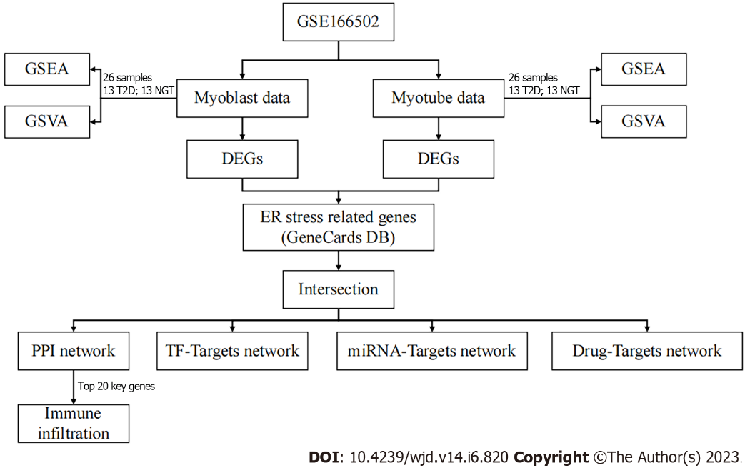
Figure 1 Study flow chart. GSEA: Gene set enrichment analysis; GSVA: Gene set variation analysis; ER: Endoplasmic reticulum; DEG: Differentially expressed genes; PPI: Protein–protein interaction; TF: Transcription factor.

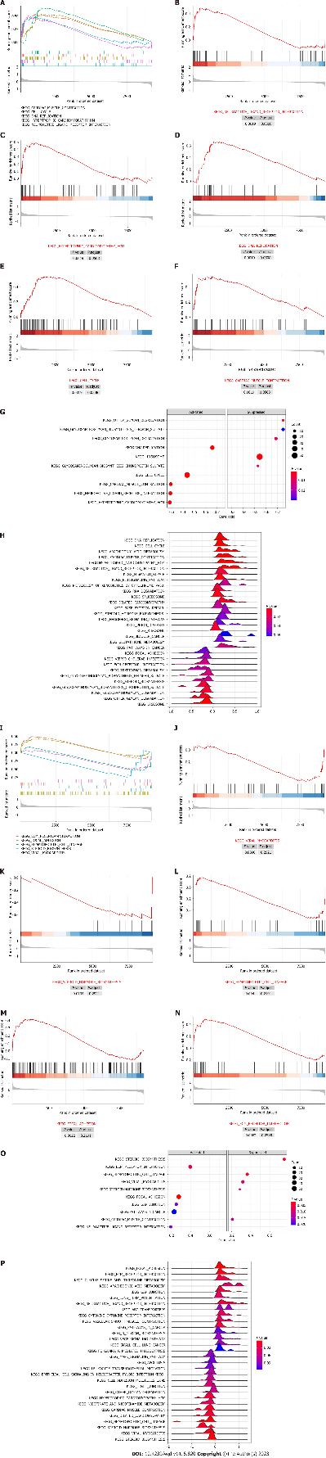
Figure 2 Gene set enrichment analysis. A: Top five gene set enrichment analysis in proliferating myoblasts; B: Neuroactive ligand–receptor interaction; C: Hypertrophic cardiomyopathy; D: DNA replication; E: Cell cycle; F: Cardiac muscle contraction; G: Bubble plot in proliferating myoblasts; H: Ridgeline plot in proliferating myoblasts; I: Top 5 gene set enrichment analysis in differentiated myotubes; J: Viral myocarditis; K: Steroid hormone biosynthesis; L: Hematopoietic cell lineage; M: Focal adhesion; N: Extracellular matrix–receptor interaction; O: Bubble plot in differentiated myotubes; P: Ridgeline plot in differentiated myotubes.

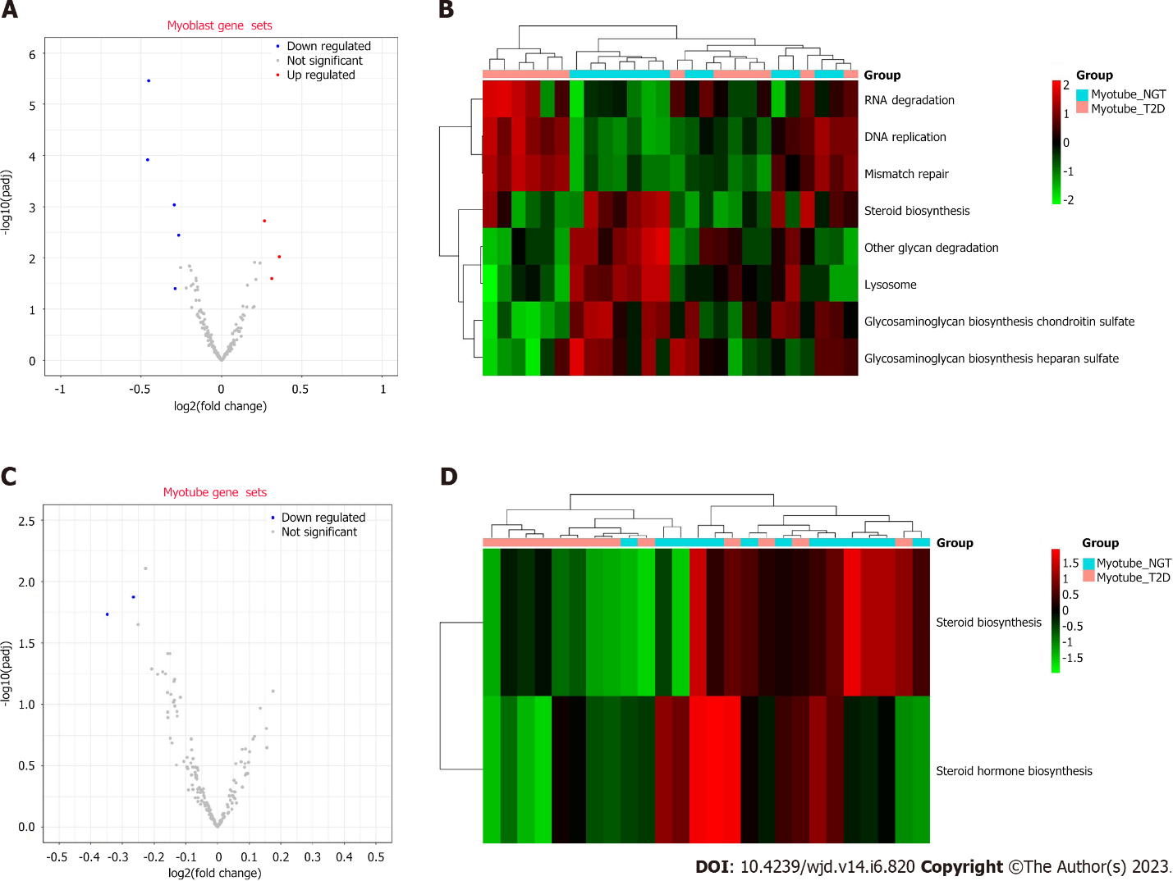
Figure 3 Gene set variation analysis. A: Volcano plot of proliferating myoblasts; B: Volcano plot of differentiated myotubes; C: Heat map of proliferating myoblasts; D: Heat map of differentiated myotubes.

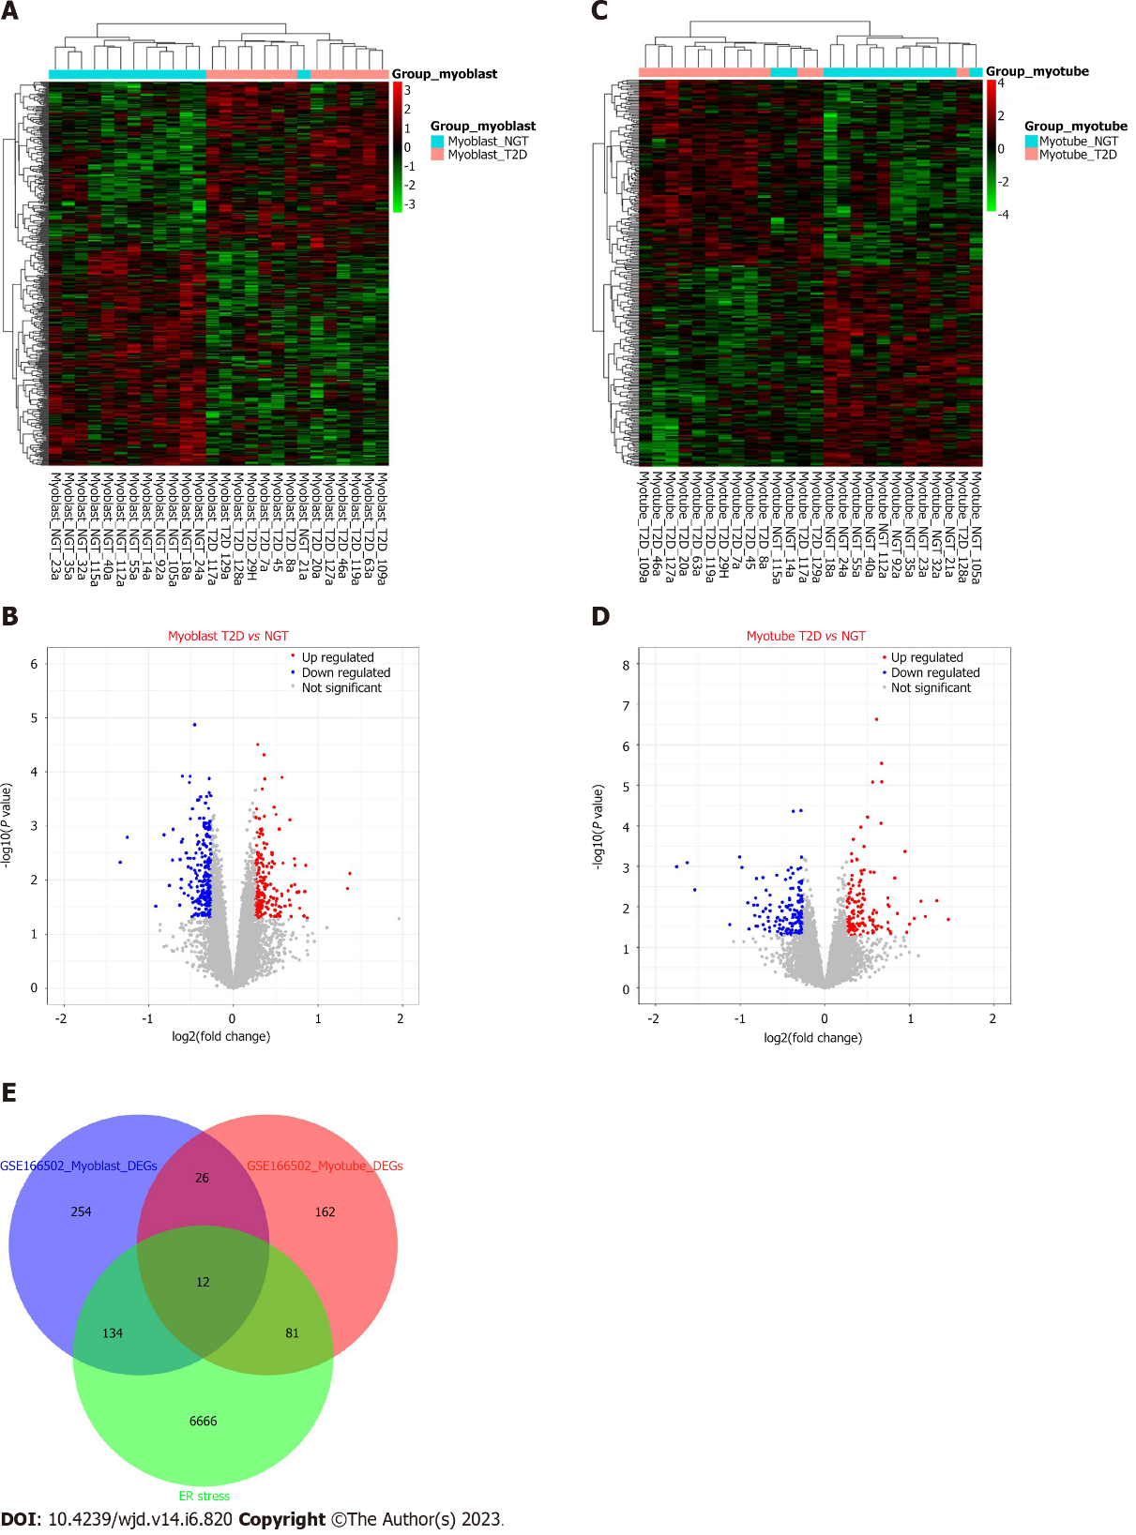
Figure 4 Endoplasmic reticulum stress-related differentially expressed genes. A: Heat map of proliferating myoblasts; B: Volcano plot of proliferating myoblasts; C: Heat map of differentiated myotubes; D: Volcano plot of differentiated myotubes; E: Endoplasmic reticulum stress-related differentially expressed genes. ER: Endoplasmic reticulum.
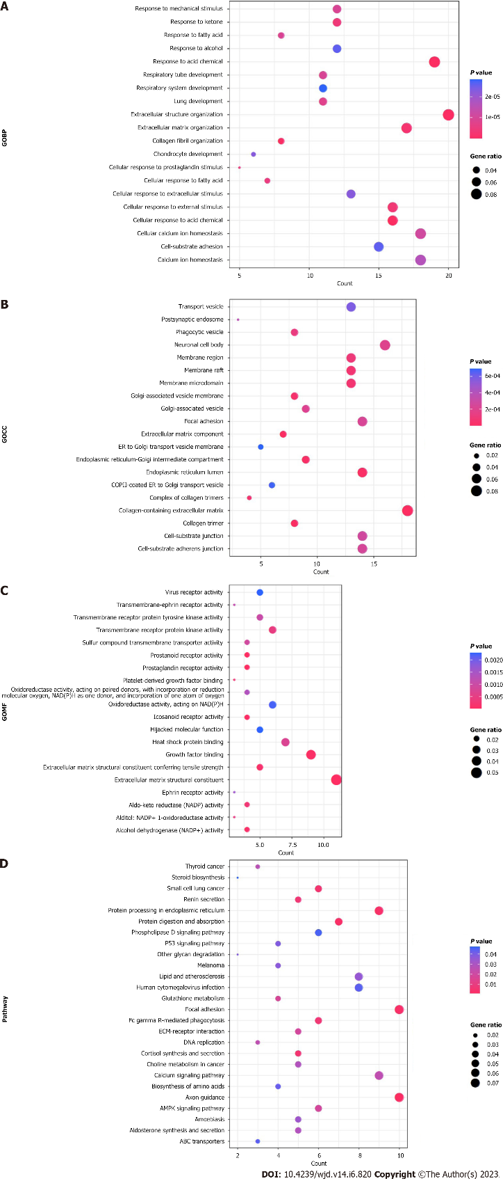
Figure 5 Functional enrichment analysis. A: Gene Ontogeny biological processes; B: Gene Ontogeny cellular components; C: Gene Ontogeny molecular function; D: Kyoto Encyclopedia of Genes and Genomes.

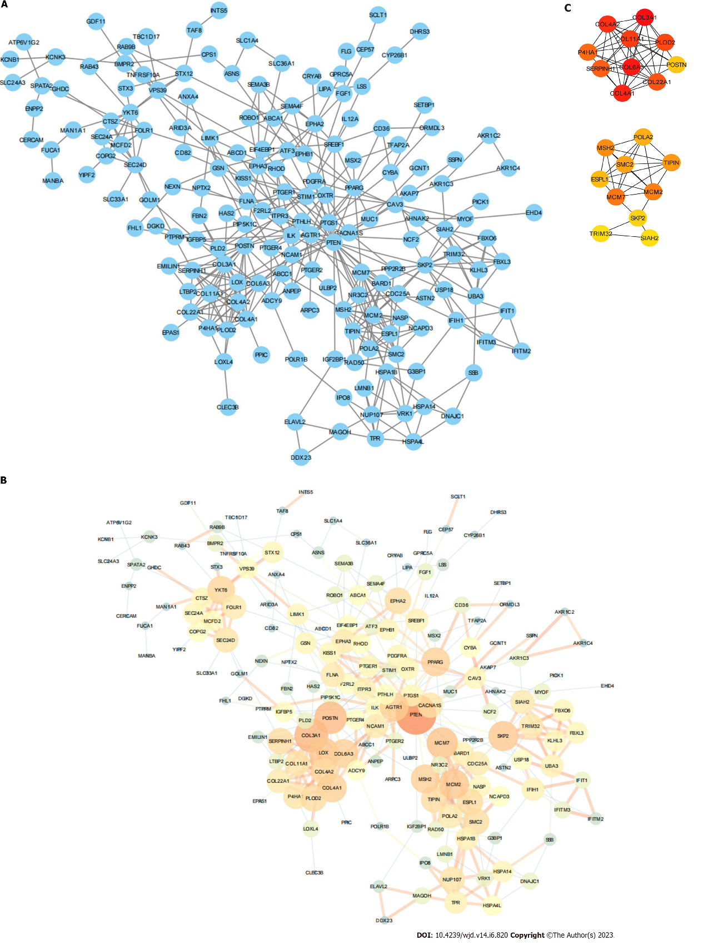
Figure 6 Protein–protein interaction network. A: Protein–protein interaction (PPI) network; B: PPI network by NetworkAnalyzer; C: PPI network of 20 key genes.

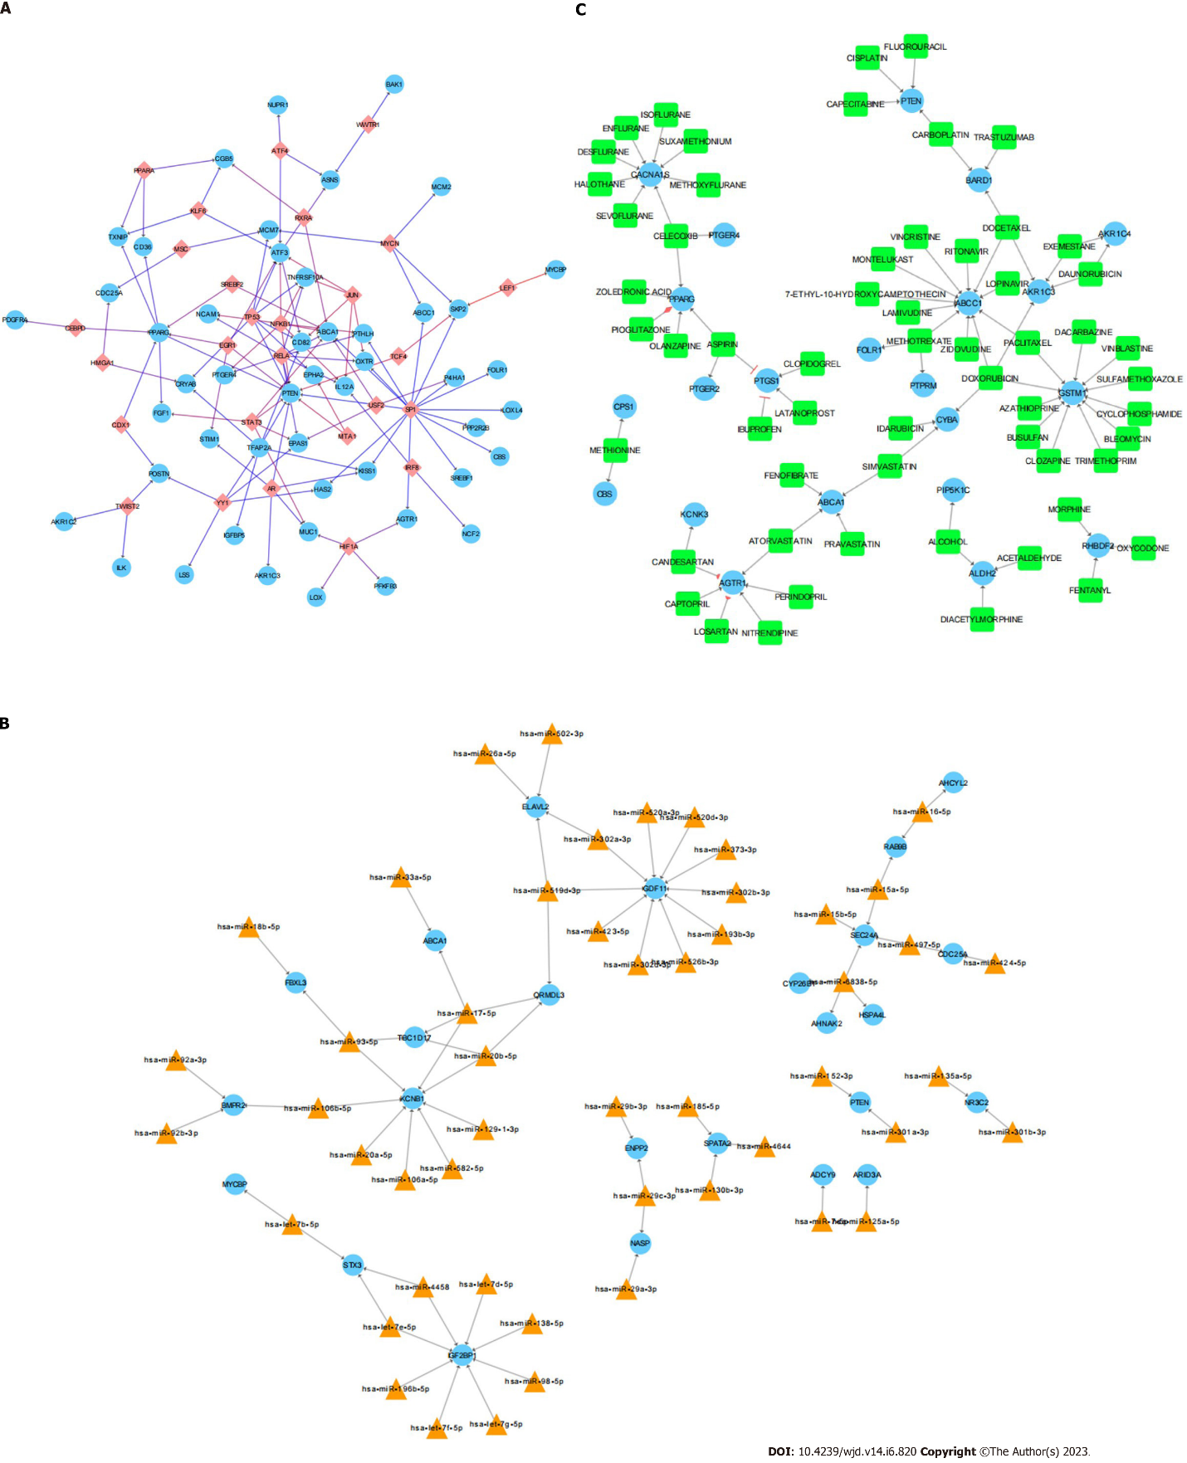
Figure 7 Networks. A: Transcription factor–mRNA network; B: miRNA–mRNA network; C: Drug–mRNA network.

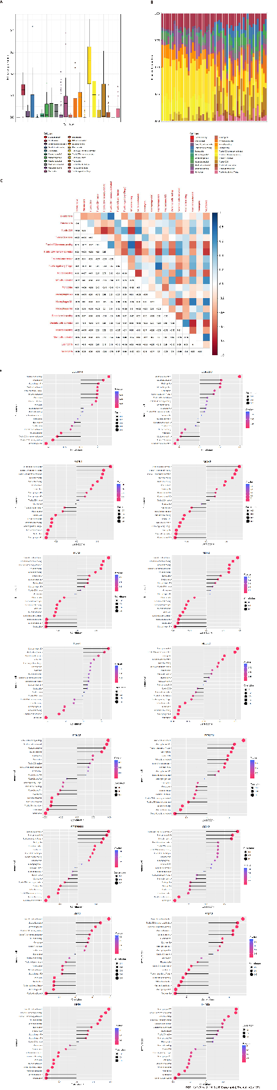
Figure 8 Immune infiltration. A: Histogram of immune infiltration distribution; B: Histogram of immune infiltration sample distribution; C: Heat map of immune infiltration correlation; D: Correlation diagram of 20 key genes.

Table 1 20 key genes
Gene | Description | MCC-score | Degree | Closeness | Betweenness
COL3A1 | Collagen Type III Alpha 1 Chain | 11179 | 16 | 64.5 | 1189.37723
COL6A3 | Collagen Type VI Alpha 3 Chain | 11168 | 12 | 62.03333 | 567.89507
COL4A1 | Collagen Type IV Alpha 1 Chain | 11167 | 12 | 59.91667 | 480.86034
COL4A2 | Collagen Type IV Alpha 2 Chain | 10806 | 10 | 56.23333 | 84.68666
COL11A1 | Collagen Type XI Alpha 1 Chain | 10800 | 9 | 54.5 | 18.34225
PLOD2 | Procollagen-Lysine,2-Oxoglutarate 5-Dioxygenase 2 | 10326 | 10 | 56.88333 | 112.4573
COL22A1 | Collagen Type XXII Alpha 1 Chain | 10080 | 8 | 51.80952 | 4.88333
SERPINH1 | Serpin Family H Member 1 | 6001 | 10 | 60.3 | 1308.02191
P4HA1 | Prolyl 4-Hydroxylase Subunit Alpha 1 | 5166 | 9 | 55.07857 | 68.74063
MCM7 | Minichromosome Maintenance Complex Component 7 | 1804 | 14 | 68.24286 | 1418.45764
MCM2 | Minichromosome Maintenance Complex Component 2 | 1801 | 13 | 63.94524 | 784.74991
MSH2 | MutS Homolog 2 | 1645 | 12 | 62.22619 | 646.66407
TIPIN | TIMELESS Interacting Protein | 1596 | 10 | 54.1631 | 37.22401
SMC2 | Structural Maintenance of Chromosomes 2 | 1567 | 10 | 53.77976 | 230.10198
POLA2 | DNA Polymerase Alpha 2, Accessory Subunit | 1560 | 8 | 52.6131 | 4.22778
ESPL1 | Extra Spindle Pole Bodies Like 1, Separase | 962 | 10 | 56.52976 | 455.86734
POSTN | Periostin | 860 | 15 | 66.51667 | 1995.77049
SKP2 | S-Phase Kinase Associated Protein 2 | 771 | 13 | 64.5619 | 1861.813
TRIM32 | Tripartite Motif Containing 32 | 722 | 8 | 54.52976 | 282.93712
SIAH2 | Siah E3 Ubiquitin Protein Ligase 2 | 722 | 8 | 57.06905 | 982.96735
MCC: McCormick.

Published by Baishideng Publishing Group Inc
7041 Koll Center Parkway, Suite 160, Pleasanton, CA 94566, USA
Telephone: +19253991568
Email: bpgoffice@wjgnet.com
Help Desk: https://www.f6publishing.com/helpdesk
https://www.wjgnet.com

© 2023 Baishideng Publishing Group Inc. All rights reserved.

