Name of journal: World Journal of Gastroenterology
ESPS Manuscript NO: 5314
Columns: Research report

Caspase-1 inhibitors alleviate acute renal injury in rats with severe acute pancreatitis

Zhang XH et al. Caspase-1 inhibitors and SAP

Xiao-Hua Zhang, Min-Li Li, Bin Wang, Mei-Xia Guo, Ren-Min Zhu
Xiao-Hua Zhang, Min-Li Li, Bin Wang, Mei-Xia Guo, Ren-Min Zhu, Department of Gastroenterology, Jinling Hospital, Jiangsu Province, Nanjing 210002, Jiangsu Province, China

Author contributions: Zhang XH designed and wrote the paper; Li ML and Wang B performed the research; Guo MX and Zhu RM contributed analytic tools.

Supported by funding from Jinling Hospital

Correspondence to: Dr. Xiao-Hua Zhang, Department of Gastroenterology, Jinling Hospital, 305 Zhongshan Donglu, Jiangsu Province, Nanjing 210002, Jiangsu Province, China. jszhxh@sina.com

Telephone: +86-25-80860027 Fax: +86-25-80860127
Received: August 28, 2013 Revised: November 4, 2013
Accepted: May 28, 2014
Published online:

Abstract
AIM: To assess inhibition of caspase-1 on acute renal injury in rats with severe acute pancreatitis (SAP).

METHODS: Forty-two Sprague-Dawley rats were randomly divided into three groups: controls (C, n = 6), SAP treated with saline (SAP-S, n = 18), or SAP treated with a caspase-1/IL-1β-converting-enzyme (ICE) inhibitor (SAP-I-ICE, n = 18). SAP was induced by retrograde infusion of 5% sodium taurocholate into the bile-pancreatic duct. C rats were subjected to identical treatment and surgical procedures without sodium taurocholate. Rats received an intraperitoneal injection of isotonic saline (SAP-S) or the inhibitor (SAP-ICE-I) at two and twelve h after induction of acute pancreatitis. Surviving rats were sacrificed at different time points after SAP induction; all samples were obtained and stored for subsequent analyses. The levels of blood urea nitrogen (BUN) and creatinine (Cr) were measured using automatic methods, and serum IL-1β concentrations were measured by an enzyme-linked immunosorbent assay. Intrarenal expression of IL-1β, IL-18 and caspase-1 mRNA was detected by RT-PCR. IL-1β protein expression and the pathologic changes in kidney tissues were observed by microscopy after immunohistochemical or hematoxylin and eosin staining, respectively.

RESULTS: The serum levels of BUN and Cr in the SAP-S group were 12.48 ± 2.30 mmol/l and 82.83 ± 13.89 μmol/L at 6 h, 23.53 ± 2.58 mmol/l and 123.67 ± 17.67 μmol/L at 12 h, and 23.60 ± 3.33 mmol/L and 125.33 ± 21.09 μmol/L at 18 h, respectively. All were significantly increased compared to HC rats (Ps < 0.01). Levels in SAP-ICE-I rats were significantly decreased compared to SAP-S at both 12 and 18 h (Ps < 0.01). The IL-1β levels of Serum in the SAP-S were 276.77 ± 44.92 pg/mL at 6 h, 308.99 ± 34.95 pg/mL at 12 h, and 311.60 ± 46.51 pg/mL at 18 h; all significantly higher than the HC and SAP-ICE-I groups (Ps < 0.01). Intrarenal expression of IL-1β mRNA expression was weak in HC rats, but grew significantly in the SAP-S (P < 0.01). ICE inhibition significantly decreased the expression of IL-1β and IL-18 mRNA (Ps < 0.05 vs SAP-S), whereas caspase-1 mRNA expression was not significantly different. Weak IL-1β immunostaining was observed in HC animals, and marked staining was found in the SAP-S group mainly in renal tubular epithelial cells. IL-1β immunostaining was significantly descended in the SAP-ICE-I compared to the SAP-S (P < 0.05). Caspase-1 inhibition had no effect on the severity of kidney tissue destruction.

CONCLUSION: The expression of the caspase-1-activated cytokines IL-1β and IL-18 play a pivotal role in acute renal injury in experimental SAP. Caspase-1 inhibitors improve renal function effectively.

© 2014 Baishideng Publishing Group Inc. All rights reserved.

Key words: Severe acute pancreatitis; Caspase-1; Interleukin-1β; Interleukin-18; Acute renal injury

Core tip: Activation of caspase-1/IL-1β-converting-enzyme (ICE) and the over-production of IL-18 and IL-1β in the kidney play a pivotal role during the process of acute renal injury in severe acute pancreatitis. Furthermore, ICE inhibitors are effective in improving renal function. The mechanisms of ICE inhibition may be associated with descended cytokine mediated injury and decreased renal cell apoptosis. Therefore, the study of the mechanism of acute renal injury in severe acute pancreatitis may help identify measures for the prevention and treatment, as well as supply novel information to further our understanding of systemic inflammatory response syndrome and multiple system organ failure.

Zhang XH, Li ML, Wang B, Guo MX, Zhu RM. Caspase-1 inhibitors alleviate acute renal injury in rats with severe acute pancreatitis. World J Gastroenterol 2014; In press

INTRODUCTION
A large series of experimental and clinical studies have shown that interleukin (IL)-1β and tumor necrosis factor (TNF)-α play a pivotal role in encouraging tissue destruction and organ failure during the course of severe acute pancreatitis (SAP)^{[1,2]}. Caspase-1, a member of the caspase family of cysteine proteases that is also known as interleukin (IL)-1β-converting- enzyme (ICE), functions by proteolytically cleaving precursors of IL-1β and IL-18, a structurally and functionally homologous proinflammatory cytokine, into their active forms^{[3]}. In addition, ICE also interferes with the process of apoptotic cell death. The inhibition of ICE, and in turn, the inhibition of proper maturation of IL-1β and IL-18, may have significance for the development of SAP and SIRS. In this research, an rat model of SAP was used to assess the effect of ICE inhibition on renal function by measuring serum levels of blood urea nitrogen (BUN), creatinine (Cr), and IL-1β. In addition, intrarenal expression of caspase-1, IL-1β and IL-18, as well as pathologic changes in kidney tissues were measured after SAP with or without ICE inhibition.

MATERIAL AND METHODS
Experimental animal model
The Experimental Animal Center of Jinling Hospital in Nanjing provided healthy normal adult male Sprague-Dawley rats weighing 240 - 250 g. All 42 animals were randomly divided into one of three groups: healthy controls (HC; n = 6), SAP with saline (SAP-S; n = 18), and SAP with ICE inhibition (SAP-I-ICE; n = 18). The other two groups were divided into 6, 12, and 18 h time-points groups, each containing six rats. 5% sodium taurocholate was infused retrogradely into the bile-pancreatic duct ot induce SAP as previously described^{[4-8]}. C group rats underwent the same operative procedures in the absence of sodium taurocholate. In SAP-S , rats received an isotonic saline injection of intraperitoneal (ip) at 2 and 12 h after SAP induction. In the SAP-ICE-I group, rats were given and ip injection of the ICE inhibitor Ac-Tyr-Val-Ala-Asp-2,6-dimethylbenzoyloxymethylketone of 0.25 mg dissolved in 2 ml phosphate-buffered saline (PBS) first at 2 h and again at 12 h post-SAP induction. Surviving rats were sacrificed at 6, 12 and 18 h, and samples were obtained for subsequent analyses.

Measurement of serum BUN and Cr levels
An automated HITACHI-7150 analyzer was used to measure serum BUN and Cr concentrations and evaluate the severity of acute renal injury.

IL-1β levels of serum
IL-1β levels of serum were measured using a enzyme-linked immunosorbent assay (ELISA) kit according to the manufacturer’s instructions (Sigma-Aldrich, St. Louis, MO, United States). All samples were tested in duplicate and averaged.

RNA extraction and real-time polymerase chain reaction analyses
TRIzol reagent (Gibco of Thermo Fisher Scientific, Waltham, MA, United States) was used to extract total RNA from kidney tissue (100 mg total) according to the manufacturer’s protocol. Briefly, kidney tissue was homogenized in 2 mL of TRIzol reagent, and the homogenate was centrifuged at 12000 r/min for 10 min at 4 ºC to remove the insoluble material . Homogenized samples were incubated with 0.2 mL chloroform at room temperature for 5 min. Samples were mixed for 15 s, and incubated at room temperature for 3 min, followed by centrifugation at 12000 r/min for 15 min at 4 ºC. The upper aqueous phase was transferred to a fresh tube and incubated for 10 min with 0.5 ml of isopropyl alcohol. The tissue sample was again centrifuged at 12000 r/min for 10 min at 4 ºC, and the pellet was washed in 1 mL of 75% ethanol. Finally, the tissue sample was vortexed and centrifuged at 7000 r/min for 5 min at 4 ºC, briefly air-dried, dissolved in 50 μL of diethylpyrocarbonate-treated water, and stored at -80 ºC. Absorbance readings at 260 and 280 nm from an ultraviolet spectrophotometer were used to determine the RNA concentration.
The RT-PCR was carried out using a One Step RNA PCR Kit (AMV; Takara Bio Inc., Otsu, Shiga, Japan). Each 50 μL reaction consisted of: 5 μL of 10 × One Step RNA PCR Buffer, 10 μL of MgCl₂ (25 mmol/L), 5 μL of dNTPs (10 mmol/L each), 1 μL of RNase Inhibitor (40 U/μL), 1μl of AMV RTase XL (5U/μL), 1 μL of AMV-Optimized Taq polymerase (5 U/μL), 1 μL of upstream specific primer, 1 μL of downstream specific primer, 1 μL of experimental sample (≤ 1 μg total RNA), and 24 μL of RNase-free dH₂O. The sequences of IL-18, IL-1β and β-actin primers ( synthesized by Sangon Biotechnology Co., Shanghai, China,designed by Primer 3 software) were as follows (upstream and downstream primer): caspase-1, 5′-GTG TTG CAG ATA ATG AGG GC-3′ and 5′-AAG GTC CTG AGG GCA AAG AG-3′ (500 bp product); IL-1β,5′-TTG GGA TCC ACA CTC TCC AG-3′and 5′-AGA AGC TGT GGC AGC TAC CT-3′ (400 bp product); IL-18, 5′-AGA TAG GGT CAC AGC CAG TC-3′ and 5′-GCT GCA ATA CCA GAA GAA GG-3′ (300 bp product); β-actin, 5′-CAT AGC TCT TCT CCA GGG AG-3′ and 5′-AGG GTG TGA TGG TGG GTA TG-3′ (600 bp product). The following protocol was used for each RT-PCR reaction: 30 min at 50 ºC for the reverse transcription reaction followed by enzyme inactivation for 2 min at 94 ºC, and 30 cycles of 30 s at 94 ºC, 30 s at 51 ºC (caspase-1), 53 ºC (IL-1β) or 55 ºC (IL-18), and 90 s at 72 ºC, or 30 s at 55 ºC, 30 s at 94 ºC, 90 s for 35 cycles at 72 ºC (β-actin). All RT-PCR reactions were terminated with an elongation step for 5 min at 72 ºC and the PT-PCR products were stored at 4 ºC. Reaction products (5 μL) were resolved by electrophoresis in 2% agarose and visualized using ethidium bromide and digitally photographed. Band intensity was determined by optical density, and quantified as ratio of individual PCR product/β-actin.

Histopathology and immunohistochemistry of IL-1β in kidney tissues
For histopathology, paraffin embedded tissue blocks were cut into 4 µm sections and stained by hematoxylin and eosin according to established protocols. For immunohistochemistry, tissue sections underwent antigen-retrieval by heating for 25 min in 0.01 mol/L sodium citrate (pH 6.0), washed in PBS and pre-incubated with 10% normal goat serum and 10% fetal calf serum in PBS for 20 min. Consecutive sections were then incubated with a rabbit anti-rat IL-1β polyclonal antibody (1:200; Santa Cruz Bio. Inc., Dallas, TX, United States) at 37 ºC for 120 min, washed three times in PBS, and incubated with a secondary antibody (EnVision System, anti-rabbit HRP; Dako, Glostrup, Denmark) at 37 ºC for 40 min, and washed again in PBS. Tissue staining was visualized using a diaminobenzidine substrate-chromogen solution. Slides were counterstained with hematoxylin, dehydrated, and mounted. Two slides per rat were visualized using a BH-2 microscope at 400 × magnification, and five 0.5 cm x 1.0 cm fields were selected randomly from each slide. The average gray value (AGV) was calculated using color image analysis and was inversely associated with IL-1β protein expression.

Statistical analysis
Analysis of variance (ANOVA) statistical analyses were performed using SPSS 17.0 statistical software. All values are presented as mean ± SD, with a value of P < 0.05 considered as statistically significant.

RESULTS
Renal function in rats
Serum levels of BUN and Cr were significantly higher in the SAP-S group compared to the HC group at 6, 12 and 18 h (Ps < 0.05). Treatment with the ICE inhibitor significantly reduced these levels at 12 and 18 h (Ps < 0.05 vs SAP-S) (Table 1).

Serum IL-1β levels
Serum IL-1β levels were significantly higher in each SAP experimental group when compared to the HC group at all time points (Ps < 0.05). In addition, IL-1β levels of serum were significantly lower in SAP-I-ICE group compared to the SAP-S (Ps < 0.05) (Table 1).

Intrarenal mRNA expression of IL-18, caspase-1 and IL-1β
IL-1β,IL-18 and caspase-1, mRNA levels were detectable in samples from the C group, though expression of IL-1β mRNA was weak. All transcript levels were significantly higher in samples from the SAP-S group when compared to HC rats (Ps < 0.05). IL-1β mRNA expression was restored to normal healthy control levels, and IL-18 mRNA expression was significantly descended following ICE inhibition (Ps < 0.05), whereas the expression of caspase-1 mRNA was not significantly different (Figure 1, Table 2).

IL-1β protein expression in rat kidney tissue
Immunohistochemical staining demonstrated weak IL-1β expression in normal kidney tissue and strong IL-1β expression in cortical renal tubular epithelial cells from SAP-S kidney tissue. Quantification of the IL-1β immunoreactivity showed that the increase in IL-1β staining with SAP was significant (P < 0.05), and this increase was significantly attenuated with ICE inhibition (P < 0.05 vs SAP-S) (Figure 2, Table 1).

Histopathology in kidney tissue
Light microscopy revealed normal kidney tissue morphology in the HC group, whereas morphological changes occurred in the SAP-S and SAP-ICE-I groups at 12 and 18 h, observed as marked capillary congestion in renal glomeruli, swelling, blurry boundaries and scattered necrosis in renal tubular epithelial cells, stenosis or atresia of lumens, visible protein casts, interstitial edema, and inflammatory cell infiltration (Figure 2). Interestingly, caspase-1 inhibition had no effect on the severity of kidney tissue injury as measured by these morphological changes.

DISCUSSION
Individuals diagnosed with SAP often face complications including multiple system organ failure, and especially respiratory and acute renal failure (ARF), which are the major causes of death^{[9]}. ARF is a frequent and early complication of SAP, often coinciding with a worse prognosis; mortality rates are 71.2% in patients with ARF and 6.8% in those without^{[10]}. Previous studies suggest that the activation of caspase-1/ICE is an important step in the pathophysiologic process of complicated acute pancreatitis, with evidence demonstrating reduced overall severity and mortality following ICE inhibition^{[11,12]}. The mechanism behind this change, however, remains poorly understood.
A number of studies have shown expression of IL-1β mRNA in normal mouse, rat and human kidneys^{[13,14]}, whereas others have reported difficulty in detecting expression in normal human kidney and normal glomeruli isolated from rats^{[15-17]}. In this study, expression of IL-1β mRNA and protein was detected, though weak, in the normal rat kidney. The reason for this difference is not clear and could be explained by a difference in species or technique. Tesch et al^{[18]} demonstrated that intrinsic renal cells constitutively express IL-1β and are the major source of the increased IL-1β production seen during rat anti-glomerular basement membrane glomerulonephritis, suggesting IL-1β production is likely to play an important role in renal injury in experimental glomerulonephritis.
Caspase-1/ICE is a member of cysteine proteases of the caspase family . The proteolytic cleavage of the 31 kD IL-1β precursor into its biologically active 17 kD form is one of the major functions of ICE. Activated lymphocytes and monocytes produce IL-1β. IL-6 and IL-8 produced IL-1β and TNF-α primarily, which could cause cardiac dysfunction, circulatory collapse, hypoperfusion,metabolic acidosis, fever, shock and production of acute respiratory distress syndrome. In this research, a specific competitive highly and irreversible inhibitor of ICE was injected into rats 2 h after SAP induction, which is known to alter serum levels of amylase in the pancreas and lungs^{[11,19]}, and a remarkable elevation of serum BUN, Cr and IL-1β was observed. In addition, SAP induced an upregulation of intrarenal IL-1β and caspase-1 mRNA, corresponding to increased IL-1β immunostaining and obvious pathologic changes in kidney tissues. ICE inhibition significantly decreased serum and intrarenal IL-1β expression levels, and improved renal function. These data suggest that ICE inhibition alleviates IL-1β-mediated renal injury in SAP.
In addition to generating large amounts of active IL-1β, The precursor of IL-18 was processed into its bioactive form by ICE^{[3]}. IL-18, which was called interferon (IFN)-γ-inducing factor, is a new pro-inflammatory 18000 kD cytokine, sharing structural and functional similarities with IL-1β. The gene expression and synthesis of IL-1,TNF, and some chemokinesis are induced by IL-18. Also, IL-18 plays a part in the Th-1 response to the stimulation of viral antigen, firstly because natural killer cells and T cells of IFN-γ production could be induced by IL-18. Baumgart K et al^{[20]} reported IL-18 concentrations in patients with SAP are significantly elevated, and that The development of pancreatic necrosis and organ failure are closely correlate with the IL-18 concentrations in serum . In this research, marked upregulation of expression of IL-18 mRNA in the kidney was observed after induction of SAP, which was significantly decreased with ICE inhibition.
It is confirmed that TNF-α,IL-18and IL-1β induce the synthesis of each other^{[3,21,22]}. Tomosugi et al^{[23]} demonstrated that TNF and IL-1 can increase the severity of glomerular injury in nephritis. Furthermore, Faubel et al^{[24]} demonstrated that cisplatin-induced ARF is associated with increases in IL-1β, IL-18, and IL-6 and neutrophil infiltration in the kidney. Therefore, we hypothesize that intrarenal overproduction of IL-18 plays a part during the course of SAP complicated with acute renal injury, and that the alleviation of acute renal injury by ICE inhibition may be due to the decrease in IL-18 expression. Additionally, ICE interferes with the process of apoptotic cell death and triggers TNF-α and Fas-mediated apoptosis. Therefore, the improvement of renal function observed in this study by ICE inhibition may be associated with a decrease in renal cell apoptosis. As the results also revealed no morphological changes in rat kidneys following ICE inhibition, we speculate that these may be associated with extra-pancreatic organ-specific injury and other mechanisms of acute renal injury in SAP.
In conclusion, overproduction of IL-1β and activation of caspase-1/ICE and IL-18 in kidney play a pivotal role during the course of acute renal injury in SAP, and the ICE inhibition is effective in improving renal function. Mechanisms of the effects of ICE inhibition may share a close relationship with the injury of decreased cytokine-mediated and with decreased renal cell apoptosis. Therefore, these results supply novel ideas that may help to further understand systemic inflammatory response syndrome and multiple system organ failure, and to explore measures for the prevention and treatment of SAP.

COMMENTS
Background
Interleukin (IL)-1β and tumor necrosis factor (TNF)-α play pivotal roles in inducing local tissue destruction and organ failure during the course of severe acute pancreatitis. IL-18 is a pro-inflammatory cytokine, structurally and functionally similar to IL-1β. Caspase-1, termed as IL-1β-converting-enzyme (ICE), functions to proteolytically cleave IL-1β and IL-18 into their active forms and interferes with apoptotic cell death. Therefore, ICE inhibition may have play an important role in the treatment of SAP and SIRS. In this research, the effects of ICE inhibition on acute renal injury were assessed in an experimental model of SAP by examining pathologic kidney changes and measuring levels of blood urea nitrogen, creatinine, IL-1β, and IL-18.

Research frontiers
A number of studies have shown expression of IL-1β mRNA in normal mouse, rat and human kidney, whereas other studies have failed to detect it. Results from this study confirm expression of IL-1β mRNA is weak in normal rat kidney, and increased with SAP.

Innovations and breakthroughs
The results of this study demonstrate that ICE inhibition alleviates SAP-induced renal injury by regulating the expression of IL-Iβ and IL-18. However, treatment with an ICE inhibitor did not affect gross morphological changes to kidney tissue, suggesting that there are additional extra-pancreatic organ-specific injury mechanisms in SAP.

Applications
This study suggests that ICE activity is a novel mechanism in systemic inflammatory response syndrome and multiple system organ failure and that ICE inhibition may be beneficial for the prevention and treatment of SAP.

Terminology
Caspase-1, termed as IL-1β-converting-enzyme, is a member of the family of cysteine proteases known as caspases.

Peer review
The authors examined the expression of caspase-1 during the course of acute renal injury in SAP. They show that ICE inhibition attenuates SAP-induced increases in IL-1β and IL-18 mRNA and alleviates renal injury. The results are interesting and may supply novel ideas to further understand the mechanisms of systemic inflammatory response syndrome and multiple system organ failure, and to explore measures for prevention and treatment of SAP.
REFERENCES
1 Papachristou GI. Prediction of severe acute pancreatitis: current knowledge and novel insights. World J Gastroenterol 2008; 14: 6273-6275 [PMID: 19009638 DOI: 10.3748/wjg.14.6273]
2 Luan ZG, Zhang J, Yin XH, Ma XC, Guo RX. Ethyl pyruvate significantly inhibits tumour necrosis factor-α, interleukin-1β and high mobility group box 1 releasing and attenuates sodium taurocholate-induced severe acute pancreatitis associated with acute lung injury. Clin Exp Immunol 2013; 172: 417-426 [PMID: 23600830 DOI: 10.1111/cei.12062]
3 Fantuzzi G, Dinarello CA. Interleukin-18 and interleukin-1 beta: two cytokine substrates for ICE (caspase-1). J Clin Immunol 1999; 19: 1-11 [PMID: 10080100 DOI: 10.1023/A:1020506300324]
4 Wang H, Tang AM, Liu D, Li G, Ye L, Li X, Li C, Chen L. Renoprotective activity of sivelestat in severe acute pancreatitis in rats. Exp Ther Med 2013; 6: 29-32 [PMID: 23935713 DOI: 10.3892/etm.2013.1075]
5 Zhou MT, Chen BC, Sun HW, Jin YP, Yang FJ, Zhang X, Andersson R, Zhang QY. Continuous regional arterial infusion with fluorouracil and octreotide attenuates severe acute pancreatitis in a canine model. PLoS One 2012; 7: e37347 [PMID: 22655040 DOI: 10.1371/journal.pone.0037347]
6 Nakamura H, Honda H, Tashiro M, Taguchi M, Yoshikawa H, Otsuki M. Increased expression of 19-kD interacting protein-3-like protein and the relationship to apoptosis in the lung of rats with severe acute pancreatitis. Crit Care Med 2003; 31: 2527-2534 [PMID: 14530762 DOI: 10.1097/01.CCM.0000090006.49055.6D]
7 Xu P, Zhou XJ, Chen LQ, Chen J, Xie Y, Lv LH, Hou XH. Pioglitazone attenuates the severity of sodium taurocholate-induced severe acute pancreatitis. World J Gastroenterol 2007; 13: 1983-1988 [PMID: 17461502]
8 Müller CA, Belyaev O, Burr W, Munding J, McArthur N, Bergmann U, Werner J, Tannapfel A, Uhl W. Effects of FTY720 and rapamycin on inflammation in taurocholate-induced acute pancreatitis in the rat. Pancreas 2012; 41: 1086-1091 [PMID: 22481287 DOI: 10.1097/MPA.0b013e3182496fd7]
9 Compañy L, Sáez J, Martínez J, Aparicio JR, Laveda R, Griñó P, Pérez-Mateo M. Factors predicting mortality in severe acute pancreatitis. Pancreatology 2003; 3: 144-148 [PMID: 12748423 DOI: 10.1159/000070083]
10 Herrera Gutiérrez ME, Seller Pérez G, de La Rubia De Gracia C, Chaparro Sánchez MJ, Nacle López B. [Acute renal failure profile and prognostic value in severe acute pancreatitis]. Med Clin (Barc) 2000; 115: 721-725 [PMID: 11141437 DOI: 10.1016/S0025-7753(00)71674-5]
11 Paszkowski AS, Rau B, Mayer JM, Möller P, Beger HG. Therapeutic application of caspase 1/interleukin-1beta-converting enzyme inhibitor decreases the death rate in severe acute experimental pancreatitis. Ann Surg 2002; 235: 68-76 [PMID: 11753044 DOI: 10.1097/00000658-200201000-00009]
12 Rau B, Paszkowski A, Lillich S, Baumgart K, Möller P, Beger HG. Differential effects of caspase-1/interleukin-1beta-converting enzyme on acinar cell necrosis and apoptosis in severe acute experimental pancreatitis. Lab Invest 2001; 81: 1001-1013 [PMID: 11454989 DOI: 10.1038/labinvest.3780312]
13 Boswell JM, Yui MA, Endres S, Burt DW, Kelley VE. Novel and enhanced IL-1 gene expression in autoimmune mice with lupus. J Immunol 1988; 141: 118-124 [PMID: 3259964]
14 Tovey MG, Content J, Gresser I, Gugenheim J, Blanchard B, Guymarho J, Poupart P, Gigou M, Shaw A, Fiers W. Genes for IFN-beta-2 (IL-6), tumor necrosis factor, and IL-1 are expressed at high levels in the organs of normal individuals. J Immunol 1988; 141: 3106-3110 [PMID: 3262680]
15 Noronha IL, Krüger C, Andrassy K, Ritz E, Waldherr R. In situ production of TNF-alpha, IL-1 beta and IL-2R in ANCA-positive glomerulonephritis. Kidney Int 1993; 43: 682-692 [PMID: 8455368 DOI: 10.1038/ki.1993.98]
16 Jenkins DA, Wojtacha DR, Swan P, Fleming S, Cumming AD. Intrarenal localization of interleukin-1 beta mRNA in crescentic glomerulonephritis. Nephrol Dial Transplant 1994; 9: 1228-1233 [PMID: 7816281]
17 Tam FW, Smith J, Cashman SJ, Wang Y, Thompson EM, Rees AJ. Glomerular expression of interleukin-1 receptor antagonist and interleukin-1 beta genes in antibody-mediated glomerulonephritis. Am J Pathol 1994; 145: 126-136 [PMID: 8030744]
18 Tesch GH, Yang N, Yu H, Lan HY, Foti R, Chadban SJ, Atkins RC, Nikolic-Paterson DJ. Intrinsic renal cells are the major source of interleukin-1 beta synthesis in normal and diseased rat kidney. Nephrol Dial Transplant 1997; 12: 1109-1115 [PMID: 9198037 DOI: 10.1093/ndt/12.6.1109]
19 Zhang XH, Zhu RM, Xu WA, Wan HJ, Lu H. Therapeutic effects of caspase-1 inhibitors on acute lung injury in experimental severe acute pancreatitis. World J Gastroenterol 2007; 13: 623-627 [PMID: 17278232]
20 Rau B, Baumgart K, Paszkowski AS, Mayer JM, Beger HG. Clinical relevance of caspase-1 activated cytokines in acute pancreatitis: high correlation of serum interleukin-18 with pancreatic necrosis and systemic complications. Crit Care Med 2001; 29: 1556-1562 [PMID: 11505126 DOI: 10.1097/00003246-200108000-00010]
21 Antonopoulos C, Cumberbatch M, Mee JB, Dearman RJ, Wei XQ, Liew FY, Kimber I, Groves RW. IL-18 is a key proximal mediator of contact hypersensitivity and allergen-induced Langerhans cell migration in murine epidermis. J Leukoc Biol 2008; 83: 361-367 [PMID: 17984289]
22 Meng H, Gong J, Fang L, Song Z, Wu F, Zhou B, Qian M. Effect of interferon-γ on NF-κB and cytokine IL-18 and IL-27 in acute pancreatitis. Bosn J Basic Med Sci 2013; 13: 114-118 [PMID: 23725508]
23 Tomosugi NI, Cashman SJ, Hay H, Pusey CD, Evans DJ, Shaw A, Rees AJ. Modulation of antibody-mediated glomerular injury in vivo by bacterial lipopolysaccharide, tumor necrosis factor, and IL-1. J Immunol 1989; 142: 3083-3090 [PMID: 2785133]
24 Faubel S, Lewis EC, Reznikov L, Ljubanovic D, Hoke TS, Somerset H, Oh DJ, Lu L, Klein CL, Dinarello CA, Edelstein CL. Cisplatin-induced acute renal failure is associated with an increase in the cytokines interleukin (IL)-1beta, IL-18, IL-6, and neutrophil infiltration in the kidney. J Pharmacol Exp Ther 2007; 322: 8-15 [PMID: 17400889 DOI: 10.1124/jpet.107.119792]

P-Reviewer: Pezzilli R S-Editor: Ma YJ L-Editor: E-Editor:
1 2 3 4 5 6 7 8 bp 1 2 3 4 5 6 7 8
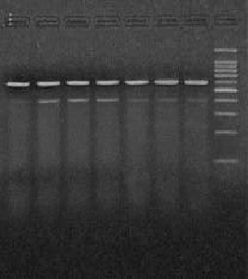
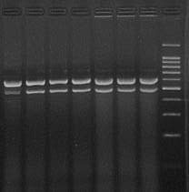

1500
1000
800

500
400

300

200

β-actin (600 bp)

β-actin(600bp)
IL-1β(400 bp)
ICE (500 bp)

A B

1 2 3 4 5 6 7 8
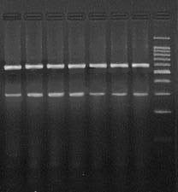

β-actin(600bp)

IL-18 (300 bp)

C

Figure 1 Expression levels of renal caspase-1, interleukin-1β and interleukin-18 mRNA in cases of acute pancreatitis. Agarose gel electrophoresis revealed mobility and size of RT-PCR products for A: Caspase-1; B: interleukin (IL)-1β; and C: IL-18 in kidney tissues from healthy controls (HC), with saline treatment after the induction of severe acute pancreatitis (SAP-S), and caspase-1 inhibition after SAP (SAP-ICE-I). The DNA fragments from each group were of expected size. Lane 1: HC; lanes 2-4: SAP-S; lanes 5-7: SAP-ICE-I; lane 8: marker.

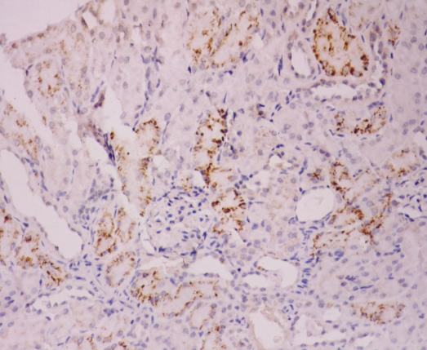
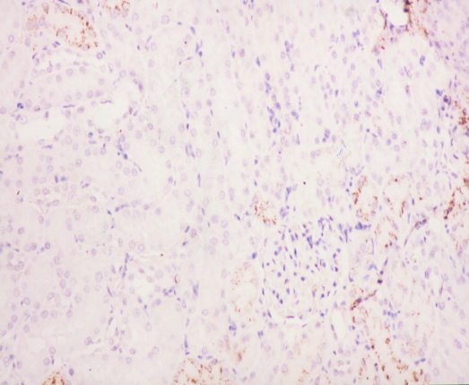
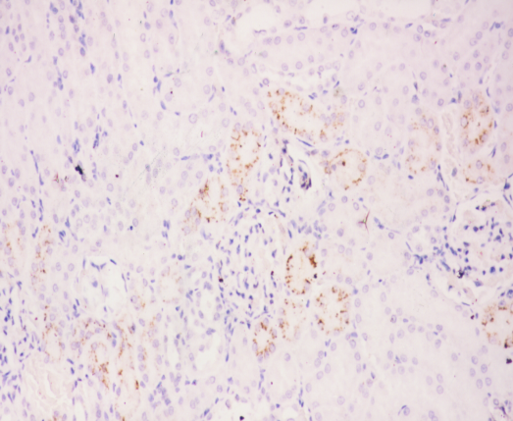
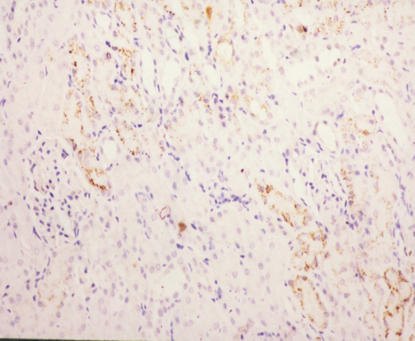
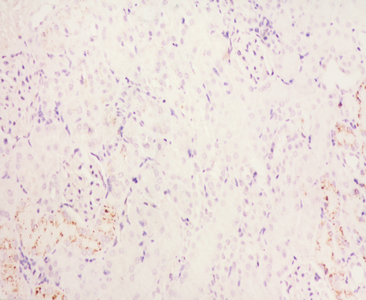
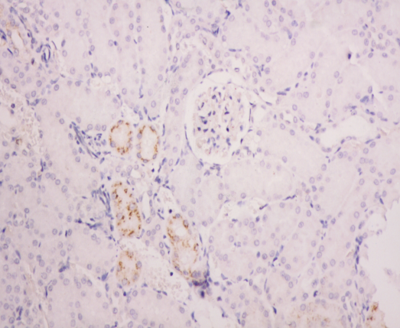
Figure 2 Immunohistochemical detection of interleukin-1β. Representative micrographs showing interleukin (IL)-1β immunoreactivity in hematoxylin counterstained kidney sections from animals with severe acute pancreatitis (SAP) (magnification × 200). Saline treatment A: 6 h; C: 12 h; and E: 18 h after SAP induction. Caspase-1 inhibitor treatment B: 6 h; D: 12 h; and F: 18 h after SAP induction.
A
B
C
D
E
F

Table 1 Serum levels of blood urea nitrogen, creatinine, interleukin-1β and average gray value of interleukin-1β
Group | n | BUN  (mmol/L) | Cr  (μmol/L) |  | IL-1β  (pg/mL) |  |  | IL-1β staining  (AGV)
HC | 6 | 5.02 ± 0.42 |  | 41.17 ± 2.48 |  | 90.13 ± 21.13 | 63.67 ± 6.19
SAP-S
6 h | 6 | 12.48 ± 2.30^{b} |  | 82.83 ± 13.89^{b} |  | 276.77 ± 44.92^{b} | 45.00 ± 4.98^{b}
12 h | 6 | 23.53 ± 2.58^{b} |  | 123.67 ± 17.67^{b} |  | 308.99 ± 34.95^{b} | 42.33 ± 4.89^{b}
18 h | 6 | 23.60 ± 3.33^{b} |  | 125.33 ± 21.09^{b} |  | 311.60 ± 46.51^{b} | 38.33 ± 5.13^{b}
SAP-ICE-I
6 h | 6 | 11.17 ± 1.71^{b} |  | 73.50 ± 11.62^{b} |  | 151.42 ± 27.26^{b,d} | 53.00 ± 6.60^{b,c}
12 h | 6 | 18.45 ± 2.66^{b,d} |  | 75.67 ± 14.11^{b,d} |  | 152.47 ± 29.60^{b,d} | 49.67 ± 5.39^{b,c}
18 h | 6 | 19.23 ± 2.18^{b,d} |  | 77.50 ± 13.90^{b,d} |  | 175.45 ± 29.72^{b,d} | 46.50 ± 5.24^{b,c}
Values are mean ± SD; ^{b}P < 0.01 vs HC; ^{c}P < 0.05 and ^{d}P < 0.01 vs SAP-S. AGV: Average grey value; BUN: Blood urea nitrogen; Cr: Creatinine; HC: Healthy controls; SAP: Severe acute pancreatitis; SAP-ICE-I: SAP with IL-1β-converting-enzyme inhibition; SAP-S: SAP with saline.
Table 2 Intrarenal expression of caspase-1, interleukin-1β and interleukin-18 mRNA
Group | n | Caspase-1 | IL-1β | IL-18
HC | 6 | 0.36 ± 0.03 | 0.13 ± 0.01 | 0.38 ± 0.03
SAP-S
6 h | 6 | 0.45 ± 0.03^{b} | 0.19 ± 0.02^{b} | 0.57 ± 0.04^{b}
12 h | 6 | 0.46 ± 0.04^{b} | 0.20 ± 0.03^{b} | 0.58 ± 0.05^{b}
18 h | 5 | 0.43 ± 0.04^{b} | 0.20 ± 0.03^{b} | 0.55 ± 0.04^{b}
SAP-ICE-I
6 h | 6 | 0.45 ± 0.03^{b} | 0.15 ± 0.02^{d} | 0.45 ± 0.04^{b,d}
12 h | 6 | 0.44 ± 0.03^{b} | 0.15 ± 0.02^{d} | 0.45 ± 0.04^{b,d}
18 h | 5 | 0.45 ± 0.02^{b} | 0.15 ± 0.02^{d} | 0.44 ± 0.04^{b,d}
Values are mean ± SD; ^{b}P < 0.01 vs HC; ^{d}P < 0.01 vs SAP-S. HC: Healthy controls; SAP: Severe acute pancreatitis; SAP-ICE-I: SAP with IL-1β-converting-enzyme inhibition; SAP-S: SAP with saline.

