Name of Journal: World Journal of Clinical Cases
Manuscript NO: 53494
Manuscript Type: ORIGINAL ARTICLE

Retrospective Study
Incidental anal ¹⁸fluorodeoxyglucose uptake: Should we further examine the patient?

Moussaddaq AS et al. Incidental anal ¹⁸FDG uptake

Anne-Sophie Moussaddaq, Charlène Brochard, Xavier Palard-Novello, Etienne Garin, Timothée Wallenhorst, Eric Le Balc’h, Alexandre Merlini L’heritier, Thomas Grainville, Laurent Siproudhis, Astrid Lievre

Anne-Sophie Moussaddaq, Charlène Brochard, Timothée Wallenhorst, Eric Le Balc’h, Alexandre Merlini L’heritier, Thomas Grainville, Laurent Siproudhis, Astrid Lievre, Department of Gastroenterology, University Hospital of Rennes, Pontchaillou, Rennes 35000, France

Charlène Brochard, Laurent Siproudhis, Inphy CIC 1414 University Hospital of Rennes, Pontchaillou, Rennes 35000, France

Xavier Palard-Novello, Department of Nuclear Medicine, Cancer Institute Eugène Marquis, Rennes 35000, France

Etienne Garin, Department of Nuclear Medicine, Cancer Institute Eugène Marquis, Rennes 35000, France

Etienne Garin, Laboratoire Traitement du Signal et de l'Image-UMR1099, University of Rennes, Inserm, Rennes 35000, France

Astrid Lièvre, French National Institute of Health and Medical Research U1242, Chemistry Oncogenesis Stress Signaling, University of Rennes 1, Rennes 35000, France

Author contributions: Moussaddaq AS, Brochard C and Lièvre AM designed research; Moussaddaq AS, Brochard C, Palard-Novello X, Garin E, Wallenhorst, T, Le Balch E, Merlini L’Héritier A, Grainville T and Siproudhis L performed research; Moussaddaq AS, Brochard C, Palard-Novello X and Siproudhis L contributed analytic tools; Moussaddaq AS, Brochard C and Lièvre A analyzed data; Moussaddaq AS, Brochard C and Lièvre A wrote the paper.

Corresponding author: Charlène Brochard, MD, PhD, Doctor, Department of Gastroenterology, University Hospital of Rennes, Pontchaillou, 2 rue Henri Le Guillou, Rennes 35000, France. charlene.brochard@chu-rennes.fr

Received: January 3, 2020
Revised: May 15, 2020
Accepted: August 1, 2020
Published online:

Abstract
BACKGROUND
There are no studies on incidental anal ¹⁸F-fluorodeoxyglucose (¹⁸FDG) uptake.

AIM
To assess the rate and aetiologies of incidental anal ¹⁸FDG uptake and to evaluate the correlation between ¹⁸FDG positron-emission tomography/computed tomography (PET/CT) parameters and the diagnosis of an anorectal disease.

METHODS
The data from patients with incidental anal ¹⁸FDG uptake were retrospectively analysed. Patients who underwent anorectal examinations were identified and compared to those who did not undergo examinations. Patients who were offered treatment were then identified and compared to those who did not receive treatment.

RESULTS
Among the 43 020 ¹⁸FDG PET/CT scans performed, 197 ¹⁸FDG PET/CT scans of 146 patients (0.45%) reported incidental anal uptake. Among the 134 patients included, 48 (35.8%) patients underwent anorectal examinations, and anorectal diseases were diagnosed in 33 (69.0%) of these patients and treated in 18/48 (37.5%) patients. Among the examined patients, those with a pathology requiring treatment had significantly smaller metabolic volumes (MV) 30 and MV41 values and higher maximal and mean standardized uptake value measurements than those who did not require treatment.

CONCLUSION
Incidental anal ¹⁸FDG uptake is rare, but a reliable anorectal diagnosis is commonly obtained when an anorectal examination is performed. The diagnosis of an anorectal disease induces treatment in more than one-third of the patients. These data should encourage practitioners to explore incidental anal ¹⁸FDG uptake systematically.

Key words: Incidental anal ¹⁸fluorodeoxyglucose uptake; Anorectal disease; Rare

Moussaddaq AS, Brochard C, Palard-Novello X, Garin E, Wallenhorst T, Le Balc’h E, Merlini l’Héritier A, Grainville T, Siproudhis L, Lievre A. Incidental anal ¹⁸fluorodeoxyglucose uptake: Should we further examine the patient? World J Clin Cases 2020; In press

Core tip: This is a retrospective study to assess the rate and aetiologies of incidental anal ¹⁸F-fluorodeoxyglucose (¹⁸FDG) uptake and to evaluate the correlation between ¹⁸FDG positron-emission tomography/computed tomography parameters and the diagnosis of an anorectal disease. Incidental anal ¹⁸FDG uptake is rare, but a reliable anorectal diagnosis is commonly obtained when an anorectal examination is performed. The diagnosis of an anorectal disease induces treatment in more than one-third of the patients. These data should encourage practitioners to explore incidental anal ¹⁸FDG uptake systematically.
INTRODUCTION
¹⁸F-fluorodeoxyglucose (¹⁸FDG) positron-emission tomography/computed tomography (PET/CT) is a medical imaging technique based on the study of glucose metabolism. The use of this method has increased in oncology for the initial staging of cancer, monitoring treatment response and detecting early recurrence of a previously treated malignant tumour^{[1]}. It is also used in the management of infectious or inflammatory diseases^{[2]}. As a result of the increased indications for and availability of ¹⁸FDG PET/CT, unexpected ¹⁸FDG uptake has been identified in a variety of sites^{[3–6]}. In the field of gastroenterology, several studies have focused on colorectal locations^{[7–17]}. Incidental focal colorectal ¹⁸FDG uptake on ¹⁸FDG PET/CT imaging was associated with endoscopic lesions in two-thirds of the cases, with a high rate of advanced neoplasms^{[7]}, but no metabolic parameter has been identified to distinguish neoplasms from benign lesions^{[7,18]}. Thus, a complete colonoscopy tends to be recommended for all patients.
Within the field of gastroenterology, no studies to date have investigated incidental anal ¹⁸FDG uptake. However, anorectal examinations are nevertheless simple and minimally invasive, and the diagnosis of anal pathologies is often based on the patient’s history or data obtained during the clinical examination. It seems important then to assess the rate of incidental anal ¹⁸FDG uptake and to identify their aetiologies. Finally, no recommendations have been established in this particular situation.
The aims of this study were as follows: (1) to assess the rate of incidental anal ¹⁸FDG uptake; (2) to identify the aetiologies of incidental anal ¹⁸FDG uptake; and (3) to evaluate the correlation between ¹⁸FDG PET/CT parameters and the diagnosis of an anorectal disease and the management of the disease.

MATERIALS AND METHODS
Patients
The database of ¹⁸FDG PET/CT scans from a tertiary referral centre of nuclear medicine (January 2005 and December 2018) was reviewed. Among 43020 ¹⁸FDG PET/CT reports, those containing the terms “anal” or “anus” were identified. Then, we selected examinations with incidental anal ¹⁸FDG uptake. Patients with personal histories of anal cancer were excluded. Patients with a history of pelvic radiation within 3 months or anal surgery within 6 weeks before the ¹⁸FDG PET/CT were also excluded. The patient demographic data, past medical histories, indications for ¹⁸FDG PET/CT and results concerning the initial oncological pathology report were extracted from the database.

¹⁸FDG PET/CT imaging protocol and analysis
The patients fasted for at least 4 hours before ¹⁸FDG PET/CT imaging. The blood glucose level was controlled before the FDG injection. The acquisition ranged from the base of the skull to the proximal thighs and was performed 60 to 90 min after an intravenous injection of FDG. From January 2005 to May 2016, ¹⁸FDG PET/CT exams were performed with a hybrid PET/CT scanner (Discovery LS, GE Medical Systems Inc., Waukesha, WI, United States) after an intravenous injection of 4 MBq/kg FDG. From June 2016 to December 2018, ¹⁸FDG PET/CT exams were performed with a hybrid PET/CT scanner (Siemens Biograph system, Siemens, Knoxville, TN, United States) after an intravenous injection of 3 MBq/kg FDG. For both PET systems, the data were reconstructed using an ordered-subsets expectation maximization iterative algorithm with corrections (attenuation, dead time, randoms, scatter, and decay). The standardized uptake value (SUV) was calculated and adjusted by the mean injected dose according to the tissue activity concentration and patient body weight. To include patients with focal incidental anal ¹⁸FDG uptake, all ¹⁸FDG PET/CT images from patients identified with incidental anal uptake were retrospectively reassessed by a nuclear medicine physician at the Department of Nuclear Medicine who was blinded to the anorectal findings. Anal ¹⁸FDG uptake was defined as uptake located in the anal canal relative to the background activity. Incidental anal ¹⁸FDG uptake was defined by the existence of anal hyperfixation in patients with no known anal pathology before the ¹⁸FDG PET/CT. A 3-D volume of interest (VOI) was manually drawn to extract metabolic parameters (Syngo.via software; Siemens). The metabolic parameters extracted were the SUV_{max} (the highest SUV of all SUVs measured in the VOI), SUV_{mean} (the mean of all SUV_{mean} measurements from the tumour VOIs with a local SUV_{max} threshold of 41%), and different metabolic volumes (MVs) defined as the volume produced by segmentation at the following fixed SUV_{max} thresholds: 50% (MV50), 41% (MV41), and 30% (MV30)^{[1,14]}. In patients with anal uptake described on several ¹⁸FDG PET/CT scans, the metabolic parameters selected were those that corresponded to the ¹⁸FDG PET/CT with the largest SUV_{max}.

Management of incidental anal ¹⁸FDG uptake
The data about management after the discovery of incidental anal ¹⁸FDG uptake were collected from the patient records from the Department of Nuclear Medicine. The data were compared with the patient records from the general practitioner and/or the specialist, if applicable.
The data collected from patients who further investigated were as follows: symptoms, practitioner who performed the evaluation (oncologist, radiotherapist, surgeon, gastroenterologist, or colorectal specialist), evaluation modality (rectal examination, anoscopy), further examinations (CT scan, magnetic resonance imaging, endoanal ultrasound, and examinations under general anaesthesia, colonoscopy, or histology) and results, if available. The diagnosis was recorded and classified as follows: haemorrhoidal disease, anal fissure, neoplasia, fistula, anal condyloma, or other diagnosis. Each proctologic report was reviewed by a specialist in proctology from the University Hospital of Rennes. Treatments were offered in case of symptomatic disease or if there was a risk of extension and/or aggravation of the disease. The treatment was chosen according to the habits of the practitioner. Patients who were offered treatment were identified and compared to those who were not treated. The proposed treatments were collected.
Among the patients with incidental anal ¹⁸FDG uptake, the patient data were compared according to the occurrence of anorectal investigations.

Statistical analyses
The quantitative variables are presented as means and percentiles (interquartile range of 25% and 75%). The qualitative variables are presented as numbers and percentages. The qualitative variables were compared using χ² tests or Fischer’s exact tests, as appropriate. The quantitative variables were compared using the non-parametric Wilcoxon’s test. Comparisons between patients who underwent examinations with those who had not were performed using the Wilcoxon test and the χ² test or Fisher’s exact test, as appropriate. The same tests were applied to compare patients who were offered treatment with those who were not. A P value < 0.05 was considered statistically significant. To measure the discriminatory accuracy of SUV and MV for diagnostic and therapeutic management, a receiver operating characteristic (ROC) analysis was performed, and the area under the ROC curve (AUROC) was calculated. Logistic regression analysis was performed with independent categorical items obtained at P < 0.05 by univariate analysis using a forward method to identify factors associated to treatment. Pearson correlation coefficients and Fisher tests were performed to verify whether the Pearson coefficients were significantly different from 0. The tests were performed using JMP Pro software, version 13.0.0 (SAS, Cary, NC, United States).

RESULTS
Overall study population
Among the 43020 ¹⁸FDG PET/CT scans performed between January 2005 and December 2018, 197 ¹⁸FDG PET/CT of 146 patients reported incidental anal uptake. Twelve patients were excluded; finally, 134 patients were included in the study (Figure 1). The patient characteristics and ¹⁸FDG PET/CT indications are summarized in Table 1. Twenty-one (15.7%) patients had the following past anorectal histories: haemorrhoidal disease (7.8%), anal fistula (4.7%), anal fissure (1.6%), anal condyloma (1.6%), and faecal incontinence (0.7%).

Patients who underwent anorectal examinations
Among the 134 patients with incidental anal ¹⁸FDG uptake, 48 (35.8%) underwent anorectal examinations to explore the anomaly. The characteristics of the patients who underwent examinations are depicted in Table 1 and Table 2. The patients were examined most frequently by a colorectal specialist (62.5%) or a gastroenterologist (20.8%). The clinical examinations ranged from a simple inspection of the anal margin (95.8%) to anoscopy (51.1%). More than half (54.2%) of the patients had at least one other examination. Patients who underwent examinations were compared with those who did not undergo examinations (Table 1). The two groups were comparable in terms of age, sex, indication for ¹⁸FDG PET/CT, primitive cancer, history of pelvic radiotherapy and ¹⁸FDG PET/CT metabolic parameters. Patients who underwent examinations more frequently had a past history of anorectal disease than those who did not undergo examinations (P = 0.0002). Among the 48 patients who underwent examinations, 33 (69%) had the following anorectal diseases: haemorrhoidal disease (n = 19), anal fissure (n = 6), recurrence of rectal adenocarcinoma on the coloanal anastomosis (n = 2), condyloma (n = 3), faecal impaction (n = 1), suppuration (n = 1) and solitary rectal ulcer syndrome (n = 1) (Figure 2).
In our study group, no metabolic parameters were significantly associated with the presence or absence of a diagnosis; likewise, there were no significant differences between anorectal diseases according to the metabolic parameters.

Treated patients and therapeutic impact of metabolic parameters
Among the 48 patients who underwent examinations, 18 (37.5%) were offered treatment (Table 3). The characteristics of the treated patients were compared with those of the untreated patients and are depicted in Table 2. All patients who received treatment had more frequent complaints than those who did not receive treatment and were examined by colorectal specialists or gastroenterologists. Of the asymptomatic patients, 18/29 were diagnosed [haemorrhoidal disease (n = 12), anal fissure (n = 2), condyloma (n = 3) and solitary rectal ulcer syndrome (n = 1)] and 8/29 were offered treatment. Among the 29 asymptomatic patients, the ¹⁸FDG PET/CT metabolic parameters differed significantly between treated and untreated patients. The group of asymptomatic patients that was offered treatment had higher SUV_{max} and SUV_{mean} measurements (P = 0.03 for both) and lower MV41 and MV30 values than the group asymptomatic patients without treatment (P = 0.02 and P = 0.03, respectively). Among the 15 patients with progressive PET-CT (considered poor prognosis), 8 had treatment and 7 had no treatment (P = 0.46). The ¹⁸FDG PET/CT metabolic parameters differed significantly between treated and untreated patients. The group of patients that was offered treatment had higher SUV_{max} and SUV_{mean} measurements (P = 0.02 for both) and lower MV41 and MV30 values than the group without treatment (P = 0.05 and P = 0.03, respectively). The ROC curves of the SUV_{max}, SUV_{mean}, MV41 and MV30 as predictive factors for the treatment of examined incidental anal ¹⁸FDG uptake are shown in Figure 3. According to the ROC curves, the optimal cut-off for SUV_{max}, SUV_{mean}, MV41 and MV30 were 9.6, 6.1, 3.1 cm³ and 7.4 cm³, respectively. The SUV_{max} measurements were inversely correlated with MV41 (r = -0.27, P = 0.0006) and MV30 (r = -0.18, P = 0.0002). In a multivariate analysis including the presence of symptoms, the diagnosis (yes) and the SUV _{mean} > 6.1 cm³, the factor significantly associated with the treatment was the SUV _{mean} > 6.1 cm³ [OR = 6.87 (1.18-29.9), P = 0.03].

DISCUSSION
To the best of our knowledge, this is the first study to evaluate the rate of incidental anal ¹⁸FDG uptake and its diagnostic and therapeutic impact in a large series of ¹⁸FDG PET/CT scans performed over a 14-year period.
The present work highlights that incidental anal ¹⁸FDG uptake is a rare event (0.45%) and is not systematically explored (36%). When examinations are performed, an anorectal disease was diagnosed in more than two-thirds of the patients (69%), and a specific treatment was proposed in almost 40% of these patients. Finally, we identified some metabolic parameters (SUV_{max}, SUV_{mean}, MV41 and MV30) significantly associated with anorectal treatment, with SUV_{max} having the best accuracy. Taken together, our data suggest that, although it is not frequent, incidental anal ¹⁸FDG uptake should require anorectal examinations given its high diagnostic and therapeutic impact.
The main strengths of this work are the inclusion of a large number of ¹⁸FDG PET/CT scans requested for various indications over a long period of time, reassessment of ¹⁸FDG PET/CT images by a physician who was blinded to anorectal findings and exhaustiveness of the anorectal data collection. As previously mentioned, this is also, to the best of our knowledge, the first study to investigate the rate and management of incidental anal ¹⁸FDG uptake.
In our series, incidental anal ¹⁸FDG uptake was investigated in 36% of the patients, which means that it was not been taken into account in almost two-thirds of the patients. Several explanations are possible. First, incidental anal ¹⁸FDG uptake was not mentioned in the conclusion but only in the details of the ¹⁸FDG PET/CT report of many patients (58%), which suggests that many nuclear physicians considered this ¹⁸FDG uptake to be non-clinically significant in the absence of data in the current literature. Furthermore, very few reports of consultations with the referring physician who prescribed the ¹⁸FDG PET/CT mentioned the anal ¹⁸FDG uptake, which may be explained by the following points: (1) no mention of the anal ¹⁸FDG uptake in the conclusion of the ¹⁸FDG/PET CT report; (2) the physician (an oncologist in the majority of cases) considered that the anal ¹⁸FDG uptake was secondary compared to the pathology that motivated the ¹⁸FDG PET/CT (tumour diagnosis, recurrence or progression), regardless of whether the patients underwent examinations, and was comparable in each setting and (3) the physician did not dare to discuss this abnormality with the patient or the patient refused to be examined, as we know that anorectal complaints and examinations remain a taboo subject for both patients and physicians.
Importantly, patients who were examined underwent a specific anorectal treatment in almost 40% of the cases, including surgery in 28% (5/18) of these cases. Therefore, it seems justified to systematically seek anorectal complaints and propose an anorectal examination, which should include at least an anal margin and rectal digital examination. This first assessment is simple and minimally invasive and makes it possible to evaluate if the patient needs to be referred to a specialist. However, this strategy cannot assess haemorrhoidal diseases with enough sensitivity. Notably, 40% of the examined patients in the present study had anorectal symptoms, which emphasizes the importance of a obtaining a good patient history to identify those who need to be directly addressed to a colorectal specialist.
Our study identified SUV and MV measurements as factors associated with the anorectal examination having a therapeutic impact, with SUV_{max} having the best accuracy. Interestingly, patients who received treatment had significantly lower MV30 and MV41 values and higher SUV_{max} and SUV_{mean} measurements than patients who did not receive treatment. These conclusions are different from those of colorectal positive uptake. In the studies on incidental focal colorectal ¹⁸FDG uptake on ¹⁸FDG PET/CT images, the metabolic parameters could not differentiate between true positives and false positives, with acceptable sensitivity and specificity, and therefore had no diagnostic or therapeutic impact^{[7,17–19]}.
In our study, the diagnoses correspond more to inflammatory or infectious processes than to other conditions. In this field, the diagnostic, therapeutic or prognostic impact of metabolic parameters has not been identified, except for SUV_{max,} which has been shown to have a prognostic impact on cardiovascular events and corticosteroid response in patients with cardiac sarcoidosis^{[20]}. However, in oncology, the metabolic tumour volume (MTV) has a prognostic impact on diseases in several locations (head and neck cancers or anal cancers, for example), with a prognosis that worsens as the MTV increases^{[1,21–27]}, which is sometimes also the case for SUV_{max}^{[28–31]}. These parameters also have a role in monitoring therapy response^{[1,32-34]}. Paradoxically, our results showed that smaller MVs are associated with treatment. We have not found any similar cases in the literature. Additionally, a lesion does not necessarily require more treatment because it has a larger volume.
Our study results, however, should be interpreted with caution for several reasons. The main limitations of this study are its retrospective and monocentric design. Moreover, it is possible that the rate of anal ¹⁸FDG uptake we reported is underestimated because it cannot be excluded that this anomaly is not systematically described by all nuclear physicians, given the lack of clinical significance described so far. In addition, 62% of the patients included did not undergo anorectal examinations; thus, the aetiology of their anal ¹⁸FDG uptake remains unknown. It would have also been interesting to investigate a control group of patients without anal ¹⁸FDG uptake to better demonstrate the diagnostic and therapeutic impact of anal ¹⁸FDG uptake. In our study, the proportions of patients who underwent examinations and those who received treatment were low, which led to a lack of power, even though this is the largest series reported. Due to the small sample size, we were unable to analyse the relationship between metabolic parameters and a precise diagnosis. The role of haemorrhoidal disease in anal ¹⁸FDG uptake remains somewhat speculative since haemorrhoids cushions are a normal compound of anal anatomy. Finally, symptomatic complaints not recorded (retrospective analyses) may bias the results (high proportion of treated anorectal lesions).
In conclusion, incidental anal ¹⁸FDG uptake is a rare event and is rarely explored. However, when explored, a diagnosis is made in more than two-thirds of the cases, and treatment is proposed in more than one-third of the cases. Some metabolic parameters associated with a therapeutic impact have been identified. These data should encourage practitioners to explore incidental anal ¹⁸FDG uptake systematically because some patients may recover well from an anal pathology.

ARTICLE HIGHLIGHTS
Research background
The use of ¹⁸F-fluorodeoxyglucose (¹⁸FDG) positron-emission tomography/computed tomography (PET/CT) has increased in oncology and in the management of infectious or inflammatory diseases. As a result of the increased indications for and availability of ¹⁸FDG PET/CT, unexpected ¹⁸FDG uptake has been identified in a variety of sites. In the field of gastroenterology, several studies have focused on incidental focal colorectal ¹⁸FDG uptake. No studies to date have investigated incidental anal ¹⁸FDG uptake. Anorectal examinations are nevertheless simple and minimally invasive, and the diagnosis of anal pathologies is often based on the patient’s history or data obtained during the clinical examination.

Research motivation
It seems important to assess the rate of incidental anal ¹⁸FDG uptake and to identify their aetiologies. Finally, no recommendations have been established in this particular situation.

Research objectives
The objectives of this study were as follows to assess the rate of incidental anal ¹⁸FDG uptake, to identify the aetiologies of incidental anal ¹⁸FDG uptake, and to evaluate the correlation between ¹⁸FDG PET/CT parameters and the diagnosis of an anorectal disease and the management of the disease.

Research methods
We carried out a retrospective observational single-centre study. The data from patients with incidental anal ¹⁸FDG uptake were analysed. Patients who underwent anorectal examinations were identified and compared to those who did not undergo examinations. Patients who were offered treatment were then identified and compared to those who did not receive treatment. Comparisons between patients were performed using the Wilcoxon test and the chi-squared test or Fisher’s exact test, as appropriate. A P value < 0.05 was considered statistically significant.

Research results
Among the 43020 ¹⁸FDG PET/CT scans performed, 197 ¹⁸FDG PET/CT scans of 146 patients reported incidental anal uptake: the rate of incidental anal ¹⁸FDG uptake was 0.45%. Among the 134 patients included, 48 (35.8%) patients underwent anorectal examinations and anorectal diseases were diagnosed in 33 (69.0%) of these patients haemorrhoidal disease (n = 22), anal fissure (n = 6), recurrence of rectal adenocarcinoma on the coloanal anastomosis (n = 1), condyloma (n = 3), faecal impaction (n = 1), suppuration (n = 2) and solitary rectal ulcer syndrome (n = 1). Eighteen/48 (37.5%) received treatment. Among the examined patients, those with a pathology requiring treatment had significantly smaller metabolic volumes (MV) 30 and MV41 values and higher maximal and mean standardized uptake value measurements than those who did not require treatment.

Research conclusions
Incidental anal ¹⁸FDG uptake is a rare event and is rarely explored. However, when explored, a diagnosis is made in more than two-thirds of the cases, and treatment is proposed in more than one-third of the cases. Some metabolic parameters associated with a therapeutic impact have been identified. These data should encourage practitioners to explore incidental anal ¹⁸FDG uptake systematically because some patients may recover well from an anal pathology.

Research perspectives
Further large-scale prospective studies are needed. We would like to investigate a control group of patients without anal ¹⁸FDG uptake to better demonstrate the diagnostic and therapeutic impact of anal ¹⁸FDG uptake.

REFERENCES
1 Boellaard R, Delgado-Bolton R, Oyen WJ, Giammarile F, Tatsch K, Eschner W, Verzijlbergen FJ, Barrington SF, Pike LC, Weber WA, Stroobants S, Delbeke D, Donohoe KJ, Holbrook S, Graham MM, Testanera G, Hoekstra OS, Zijlstra J, Visser E, Hoekstra CJ, Pruim J, Willemsen A, Arends B, Kotzerke J, Bockisch A, Beyer T, Chiti A, Krause BJ; European Association of Nuclear Medicine (EANM). FDG PET/CT: EANM procedure guidelines for tumour imaging: version 2.0. Eur J Nucl Med Mol Imaging 2015; 42: 328-354 [PMID: 25452219 DOI: 10.1007/s00259-014-2961-x]
2 Jamar F, Buscombe J, Chiti A, Christian PE, Delbeke D, Donohoe KJ, Israel O, Martin-Comin J, Signore A. EANM/SNMMI guideline for 18F-FDG use in inflammation and infection. J Nucl Med 2013; 54: 647-658 [PMID: 23359660 DOI: 10.2967/jnumed.112.112524]
3 Agress H Jr, Cooper BZ. Detection of clinically unexpected malignant and premalignant tumors with whole-body FDG PET: histopathologic comparison. Radiology 2004; 230: 417-422 [PMID: 14699176 DOI: 10.1148/radiol.2302021685]
4 Even-Sapir E, Lerman H, Gutman M, Lievshitz G, Zuriel L, Polliack A, Inbar M, Metser U. The presentation of malignant tumours and pre-malignant lesions incidentally found on PET-CT. Eur J Nucl Med Mol Imaging 2006; 33: 541-552 [PMID: 16491423 DOI: 10.1007/s00259-005-0056-4]
5 Ishimori T, Patel PV, Wahl RL. Detection of unexpected additional primary malignancies with PET/CT. J Nucl Med 2005; 46: 752-757 [PMID: 15872346]
6 Pencharz D, Nathan M, Wagner TL. Evidence-based management of incidental focal uptake of fluorodeoxyglucose on PET-CT. Br J Radiol 2018; 91: 20170774 [PMID: 29243502 DOI: 10.1259/bjr.20170774]
7 Rigault E, Lenoir L, Bouguen G, Pagenault M, Lièvre A, Garin E, Siproudhis L, Bretagne JF. Incidental colorectal focal ¹⁸ F-FDG uptake: a novel indication for colonoscopy. Endosc Int Open 2017; 5: E924-E930 [PMID: 28924601 DOI: 10.1055/s-0043-116384]
8 Şimşek FS, İspiroğlu M, Taşdemir B, Köroğlu R, Ünal K, Özercan IH, Entok E, Kuşlu D, Karabulut K. What approach should we take for the incidental finding of increased 18F-FDG uptake foci in the colon on PET/CT? Nucl Med Commun 2015; 36: 1195-1201 [PMID: 26426964 DOI: 10.1097/MNM.0000000000000388]
9 Tatlidil R, Jadvar H, Bading JR, Conti PS. Incidental colonic fluorodeoxyglucose uptake: correlation with colonoscopic and histopathologic findings. Radiology 2002; 224: 783-787 [PMID: 12202714 DOI: 10.1148/radiol.2243011214]
10 Salazar Andía G, Prieto Soriano A, Ortega Candil A, Cabrera Martín MN, González Roiz C, Ortiz Zapata JJ, Cardona Arboniés J, Lapeña Gutiérrez L, Carreras Delgado JL. Clinical relevance of incidental finding of focal uptakes in the colon during 18F-FDG PET/CT studies in oncology patients without known colorectal carcinoma and evaluation of the impact on management. Rev Esp Med Nucl Imagen Mol 2012; 31: 15-21 [PMID: 21640441 DOI: 10.1016/j.remn.2011.03.014]
11 Goldin E, Mahamid M, Koslowsky B, Shteingart S, Dubner Y, Lalazar G, Wengrower D. Unexpected FDG-PET uptake in the gastrointestinal tract: endoscopic and histopathological correlations. World J Gastroenterol 2014; 20: 4377-4381 [PMID: 24764676 DOI: 10.3748/wjg.v20.i15.4377]
12 Israel O, Yefremov N, Bar-Shalom R, Kagana O, Frenkel A, Keidar Z, Fischer D. PET/CT detection of unexpected gastrointestinal foci of 18F-FDG uptake: incidence, localization patterns, and clinical significance. J Nucl Med 2005; 46: 758-762 [PMID: 15872347]
13 Treglia G, Taralli S, Salsano M, Muoio B, Sadeghi R, Giovanella L. Prevalence and malignancy risk of focal colorectal incidental uptake detected by (18)F-FDG-PET or PET/CT: a meta-analysis. Radiol Oncol 2014; 48: 99-104 [PMID: 24991198 DOI: 10.2478/raon-2013-0035]
14 Keyzer C, Dhaene B, Blocklet D, De Maertelaer V, Goldman S, Gevenois PA. Colonoscopic Findings in Patients With Incidental Colonic Focal FDG Uptake. AJR Am J Roentgenol 2015; 204: W586-W591 [PMID: 25905966 DOI: 10.2214/AJR.14.12817]
15 Shmidt E, Nehra V, Lowe V, Oxentenko AS. Clinical significance of incidental [18 F]FDG uptake in the gastrointestinal tract on PET/CT imaging: a retrospective cohort study. BMC Gastroenterol 2016; 16: 125 [PMID: 27716085 DOI: 10.1186/s12876-016-0545-x]
16 Kamel EM, Thumshirn M, Truninger K, Schiesser M, Fried M, Padberg B, Schneiter D, Stoeckli SJ, von Schulthess GK, Stumpe KD. Significance of incidental 18F-FDG accumulations in the gastrointestinal tract in PET/CT: correlation with endoscopic and histopathologic results. J Nucl Med 2004; 45: 1804-1810 [PMID: 15534047]
17 Gauthé M, Richard-Molard M, Cacheux W, Michel P, Jouve JL, Mitry E, Alberini JL, Lièvre A; Fédération Francophone de Cancérologie Digestive (FFCD). Role of fluorine 18 fluorodeoxyglucose positron emission tomography/computed tomography in gastrointestinal cancers. Dig Liver Dis 2015; 47: 443-454 [PMID: 25766918 DOI: 10.1016/j.dld.2015.02.005]
18 Gutman F, Alberini JL, Wartski M, Vilain D, Le Stanc E, Sarandi F, Corone C, Tainturier C, Pecking AP. Incidental colonic focal lesions detected by FDG PET/CT. AJR Am J Roentgenol 2005; 185: 495-500 [PMID: 16037527 DOI: 10.2214/ajr.185.2.01850495]
19 van Hoeij FB, Keijsers RG, Loffeld BC, Dun G, Stadhouders PH, Weusten BL. Incidental colonic focal FDG uptake on PET/CT: can the maximum standardized uptake value (SUVmax) guide us in the timing of colonoscopy? Eur J Nucl Med Mol Imaging 2015; 42: 66-71 [PMID: 25139518 DOI: 10.1007/s00259-014-2887-3]
20 Tuominen H, Haarala A, Tikkakoski A, Kähönen M, Nikus K, Sipilä K. FDG-PET in possible cardiac sarcoidosis: Right ventricular uptake and high total cardiac metabolic activity predict cardiovascular events. J Nucl Cardiol 2019; : [PMID: 30815833 DOI: 10.1007/s12350-019-01659-2]
21 Gauthé M, Richard-Molard M, Fayard J, Alberini JL, Cacheux W, Lièvre A. Prognostic impact of tumour burden assessed by metabolic tumour volume on FDG PET/CT in anal canal cancer. Eur J Nucl Med Mol Imaging 2017; 44: 63-70 [PMID: 27503193 DOI: 10.1007/s00259-016-3475-5]
22 Dibble EH, Alvarez AC, Truong MT, Mercier G, Cook EF, Subramaniam RM. 18F-FDG metabolic tumor volume and total glycolytic activity of oral cavity and oropharyngeal squamous cell cancer: adding value to clinical staging. J Nucl Med 2012; 53: 709-715 [PMID: 22492732 DOI: 10.2967/jnumed.111.099531]
23 Liu J, Dong M, Sun X, Li W, Xing L, Yu J. Prognostic Value of 18F-FDG PET/CT in Surgical Non-Small Cell Lung Cancer: A Meta-Analysis. PLoS One 2016; 11: e0146195 [PMID: 26727114 DOI: 10.1371/journal.pone.0146195]
24 Bazan JG, Koong AC, Kapp DS, Quon A, Graves EE, Loo BW Jr, Chang DT. Metabolic tumor volume predicts disease progression and survival in patients with squamous cell carcinoma of the anal canal. J Nucl Med 2013; 54: 27-32 [PMID: 23236018 DOI: 10.2967/jnumed.112.109470]
25 Lee JW, Kang CM, Choi HJ, Lee WJ, Song SY, Lee JH, Lee JD. Prognostic Value of Metabolic Tumor Volume and Total Lesion Glycolysis on Preoperative ¹⁸F-FDG PET/CT in Patients with Pancreatic Cancer. J Nucl Med 2014; 55: 898-904 [PMID: 24711649 DOI: 10.2967/jnumed.113.131847]
26 Ryu IS, Kim JS, Roh JL, Lee JH, Cho KJ, Choi SH, Nam SY, Kim SY. Prognostic value of preoperative metabolic tumor volume and total lesion glycolysis measured by 18F-FDG PET/CT in salivary gland carcinomas. J Nucl Med 2013; 54: 1032-1038 [PMID: 23670902 DOI: 10.2967/jnumed.112.116053]
27 Meignan M, Cottereau AS, Versari A, Chartier L, Dupuis J, Boussetta S, Grassi I, Casasnovas RO, Haioun C, Tilly H, Tarantino V, Dubreuil J, Federico M, Salles G, Luminari S, Trotman J. Baseline Metabolic Tumor Volume Predicts Outcome in High-Tumor-Burden Follicular Lymphoma: A Pooled Analysis of Three Multicenter Studies. J Clin Oncol 2016; 34: 3618-3626 [PMID: 27551111 DOI: 10.1200/JCO.2016.66.9440]
28 de Geus-Oei LF, van der Heijden HF, Corstens FH, Oyen WJ. Predictive and prognostic value of FDG-PET in nonsmall-cell lung cancer: a systematic review. Cancer 2007; 110: 1654-1664 [PMID: 17879371 DOI: 10.1002/cncr.22979]
29 Pan L, Gu P, Huang G, Xue H, Wu S. Prognostic significance of SUV on PET/CT in patients with esophageal cancer: a systematic review and meta-analysis. Eur J Gastroenterol Hepatol 2009; 21: 1008-1015 [PMID: 19352191 DOI: 10.1097/MEG.0b013e328323d6fa]
30 Sperti C, Pasquali C, Chierichetti F, Ferronato A, Decet G, Pedrazzoli S. 18-Fluorodeoxyglucose positron emission tomography in predicting survival of patients with pancreatic carcinoma. J Gastrointest Surg 2003; 7: 953-959; discussion 959-960 [PMID: 14675704 DOI: 10.1016/j.gassur.2003.09.002]
31 Diao W, Tian F, Jia Z. The prognostic value of SUV_{max} measuring on primary lesion and ALN by ¹⁸F-FDG PET or PET/CT in patients with breast cancer. Eur J Radiol 2018; 105: 1-7 [PMID: 30017264 DOI: 10.1016/j.ejrad.2018.05.014]
32 Mistrangelo M, Pelosi E, Bellò M, Ricardi U, Milanesi E, Cassoni P, Baccega M, Filippini C, Racca P, Lesca A, Munoz FH, Fora G, Skanjeti A, Cravero F, Morino M. Role of positron emission tomography-computed tomography in the management of anal cancer. Int J Radiat Oncol Biol Phys 2012; 84: 66-72 [PMID: 22592047 DOI: 10.1016/j.ijrobp.2011.10.048]
33 Whitman GJ. 1–15 Early Prediction of Response to Chemotherapy in Metastatic Breast Cancer Using Sequential 18F-FDG PET. Breast Diseases: A Year Book Quarterly 2007; 18: 41-42 [DOI: 10.1016/S1043-321X(07)80025-7]
34 Galt RH. The opiate anomalies--another possible explanation? J Pharm Pharmacol 1977; 29: 711-714 [PMID: 22614 DOI: 10.1097/RLU.0b013e318239245d]
Footnotes
Institutional review board statement: This study was reviewed and approved by the Hospital Ethics Committee of Rennes (n° 19.38) on April 4, 2019.

Informed consent statement: Patients were informed and did not express their opposition to participate in the study.

Conflict-of-interest statement: Charlène Brochard received lecture fees from Ipsen. Laurent Siproudhis received lecture fees from Abbvie, Ferring and MSD. Laurent Siproudhis received consultant fees from Takeda and Ferring. Others have no conflicts of interest.

Data sharing statement: Not applicable.

Open-Access: This article is an open-access article that was selected by an in-house editor and fully peer-reviewed by external reviewers. It is distributed in accordance with the Creative Commons Attribution NonCommercial (CC BY-NC 4.0) license, which permits others to distribute, remix, adapt, build upon this work non-commercially, and license their derivative works on different terms, provided the original work is properly cited and the use is non-commercial. See: http://creativecommons.org/licenses/by-nc/4.0/

Manuscript source: Unsolicited manuscript

Peer-review started: January 3, 2020
First decision: January 18, 2020
Article in press:

Specialty type: Medicine, research and experimental
Country/Territory of origin: France
Peer-review report’s scientific quality classification
Grade A (Excellent): 0
Grade B (Very good): 0
Grade C (Good): C, C
Grade D (Fair): 0
Grade E (Poor): 0

P-Reviewer: Afzal M, Kuwai T S-Editor: Zhang H L-Editor: E-Editor:

Figure Legends
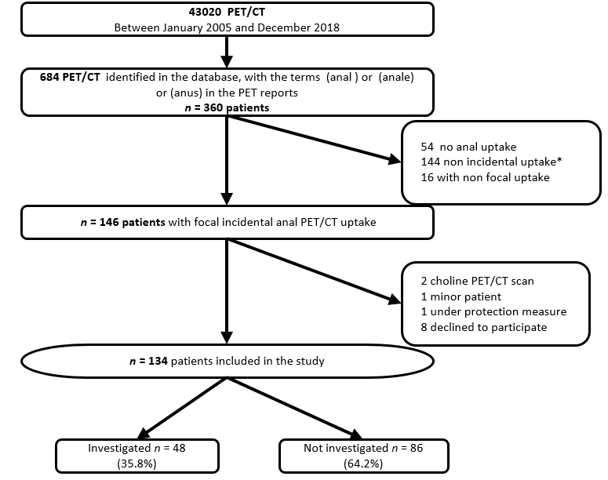
Figure 1 Flow chart. Among the 144 patients with non-incidental uptake, 121 had known anal cancer; 14 had pelvic cancer with known anal extension; 2 had a known abnormality on anorectal examination at the time of the positron emission tomography with computed tomography; 7 had recent pelvic radiotherapy or surgery. PET/CT: Positron emission tomography with computed tomography.
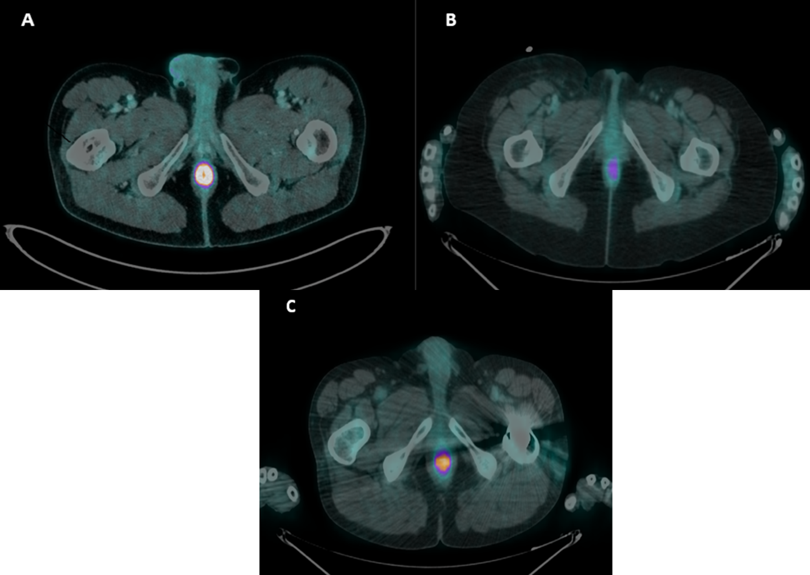Figure 2 Incidental anal ¹⁸F-fluorodeoxyglucose uptake. A: An incidental anal ¹⁸F-fluorodeoxyglucose uptake in 1 study patient with hemo rrhoidal disease that required medical treatment (standardized uptake value max = 18.1); B: An incidental anal ¹⁸F-fluorodeoxyglucose uptake in 1 study patient without proctological diagnosis (standardized uptake value max = 4.9); C: An incidental anal ¹⁸F-fluorodeoxyglucose uptake in 1 study patient with hemorrhoidal disease that did not require treatment (standardized uptake value max = 8.8).

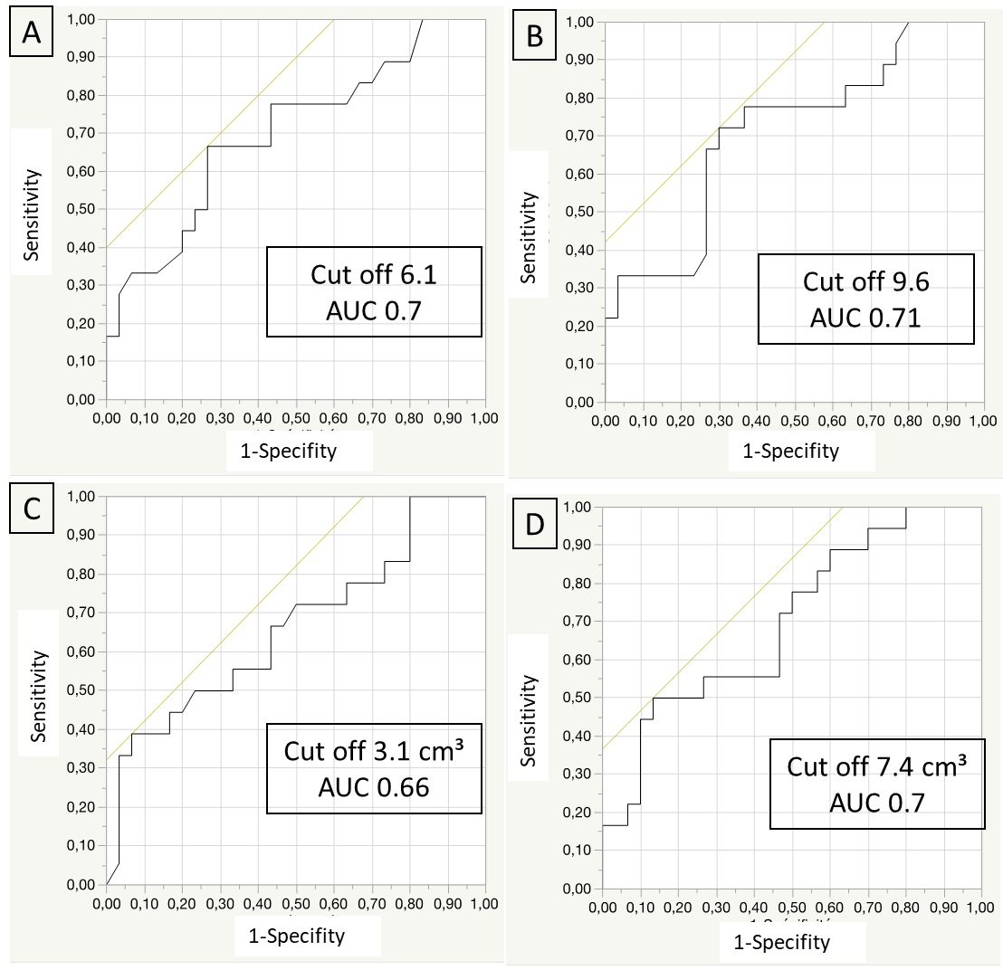
Figure 3 Receiver operating characteristic curve. A: Standardized uptake value mean; B: Standardized uptake value max; C: Metabolic volumes 41; D: Metabolic volumes 30, to differentiate patients requiring treatment from others. AUC: Area under the curve.

Table 1 Characteristics of the global population (n = 134)
Variables | Global population | Patients non investigated | Patients investigated | P value
 | n (%) or mean ± SD | n (%) or mean ± SD | n (%) or mean ± SD
 | n = 134 | n = 86 | n = 48
Age (yr) | 61.3 (12.8) | 61.0 (12.1) | 61.9 (14.1) | 0.69
Gender (male) | 84 (62.7) | 56 (65.1) | 28 (58.3) | 0.43
¹⁸FDG PET/CT indications |  |  |  | 0.42
Diagnosis | 20 (14.9) | 10 (11.6) | 10 (20.8)
Follow-up of a known cancer | 47 (35.1) | 32 (37.2) | 15 (31.3)
Staging of a known cancer | 45 (33.6) | 32 (37.2) | 13 (27.1)
Suspicion of cancer recurrence | 17 (12.7) | 9 (10.5) | 8 (16.7)
Diagnosis of infectious/inflammatory disease | 5 (3.7) | 3 (3.5) | 2 (4.2)
Primitive cancer |  |  |  | 0.13
Hematological cancer | 22 (16.4) | 17 (20.0) | 5 (10.5)
Head and neck cancer | 14 (10.4) | 9 (10.5) | 5 (10.4)
Lung cancer | 25 (18.6) | 21 (24.4) | 4 (8.3)
Gynecological cancer | 22 (16.4) | 13 (15.1) | 9 (18.8)
Urological cancer | 4 (3.0) | 1 (1.1) | 3 (6.3)
Digestive cancer | 14 (10.5) | 8 (3.5) | 6 (12.5)
Melanoma | 9 (6.7) | 5 (5.8) | 4 (8.3)
Others¹ | 7 (5.2) | 3 (3.5) | 4 (8.3)
Past history of pelvic radiotherapy² | 13 (9.7) | 8 (9.3) | 5 (10.4) | 0.83
Past history of proctologic disease^{b} | 21 (15.7) | 6 (7.0) | 15 (31.3) | 0.0002
¹⁸FDG PET/CT
SUV mean | 5.5 (2.3) | 5.3 (2.1) | 5.9 (2.6) | 0.15
SUV max | 9.6 (3.9) | 9.2 (3.5) | 10.2 (4.5) | 0.13
MV50 (cm³) | 4.1 (2.8) | 4.2 (3.0) | 4.0 (2.3) | 0.65
MV41 (cm³) | 6.6 (4.2) | 6.7 (4.6) | 6.4 (3.5) | 0.64
MV 30 (cm³) | 11.9 (7.1) | 12.2 (7.7) | 11.4 (5.9) | 0.51
^{b}P < 0.01. ¹Others: sarcoma, neuroendocrine carcinoma, neurological cancer, carcinoma unknown primary syndrome. ²> 3 mo before fluorodeoxyglucose positron emission tomography with computed tomography.¹⁸F-FDG PET/CT: Fluorine-18-fluorodeoxyglucose positron emission tomography with computed tomography; SUV: Maximum standardized uptake value; MV: Metabolic volume.

Table 2 Characteristics of population investigated (n = 48)
 | All | No treatment offered | Treatment offered | P value
 | n (%) or mean ± SD | n (%) or mean ± SD | n (%) or mean ± SD
 | n = 48 | n = 30 | n = 18
Assessmentª by |  |  |  | 0.0457
Proctologist | 30 (62.5) | 15 (50.0) | 15 (83.3)
Gastroenterologist | 10 (20.8) | 7 (23.3) | 3 (16.7)
Oncologist | 2 (4.2) | 2 (6.7)
Radiotherapist | 5 (10.4) | 5 (16.7)
Surgeon | 1 (2.1) | 1 (3.3)
Examination
Anal margin | 46 (95.8) | 29 (96.7) | 17 (94.4) | 0.71
rectal digital examination | 40 (85.2) | 25 (86.2) | 15 (83.3) | 0.78
Anoscopy | 24 (51.1) | 12 (41.4) | 12 (66.7) | 0.09
Colonoscopy | 17 (36.2) | 11 (38.0) | 6 (33.3) | 0.75
Examination under general anesthesiaª | 5 (10.6) | 1 (3.5) | 4 (22.2) | 0.04
Biopsies | 8 (17.0) | 3 (10.3) | 5 (27.8) | 0.12
Endoanal ultrasound | 7 (14.9) | 5 (17.2) | 2 (11.1) | 0.56
Pelvic MRI | 2 (4.3) | 1 (3.5) | 1 (5.6) | 0.73
Symptom | 19 (40.4) | 9 (31.0) | 10 (58.8) | 0.06
¹⁸FDG PET/CT
SUV meanª | 5.9 (2.6) | 5.2 (1.9) | 7.2 (3.2) | 0.02
SUV maxª | 10.2 (4.5) | 9.0 (3.3) | 12.4 (5.4) | 0.02
MV50 | 4.0 (2.3) | 4.4 (2.4) | 3.3 (2.0) | 0.13
MV41 | 6.4 (3.5) | 7.2 (3.6) | 5.1 (3.0) | 0.05
MV 30ª | 11.4 (6.0) | 12.9 (6.3) | 8.9 (4.4) | 0.03
Diagnosis of a proctological disease^{b} | 33 (68.8) | 15 (50.0) | 18 (100.0) | 0.003
Haemorrhoidal disease | 19 | 2 | 12
Anal fissure | 6 | 1 | 5
Recurrence of rectal adenocarcinoma | 2 | 0 | 2
Condyloma | 3 | 1 | 2
Fecal impaction | 1 | 1 | 0
Anal suppuration | 1 | 0 | 1
Solitary rectal ulcer syndrome | 1 | 0 | 1
Treatment | 18 (37.5) |  | 18 (100)
Medical treatment |  |  | 11 (61.1)
Surgical treatment |  |  | 5 (27.8)
Medical and instrumental treatments |  |  | 1 (5.6)
Endoscopic treatment |  |  | 1 (5.6)
ªP < 0.05; ^{b}P < 0.01. MRI: Magnetic resonance imaging; ¹⁸F-FDG PET/CT: Fluorine-18-fluorodeoxyglucose positron emission tomography with computed tomography; SUV: Maximum standardized uptake value; MV: metabolic volume.

Table 3 Treatments
 | n (%)
Total | 18 (100)
Medical treatment | 11 (61.1)
Transit regulator | 4 (22.2)
Oral analgesic treatment | 1 (5.6)
Topical treatment | 8 (44.4)
Treatment of hemorrhoids | 4 (22.2)
5-aminosalicylic acid | 1 (5.6)
Antibiotic (metronidazole) | 1 (5.6)
Botulinum toxin injection | 1 (5.6)
Healing cream | 1 (5.6)
Surgical treatment | 5 (27.9)
Electrocoagulation of condyloma | 1 (5.6)
Surgery of hemorrhoids | 2 (11.1)
Fissurectomy | 1 (5.6)
Posterior pelvectomy | 1 (5.6)
Instrumental and medical treatment
Infrared coagulation and imiquimod | 1 (5.6)
Endoscopic treatment
Hydraulic dilatation | 1 (5.6)

