Name of Journal: World Journal of Clinical Cases
Manuscript NO: 60928
Manuscript Type: CASE REPORT

Tenosynovial giant cell tumor involving the cervical spine: A case report

Zhu JH et al. TGCT involving the cervical spine

Jing-Hui Zhu, Miao Li, Yan Liang, Jian-Huang Wu

Jing-Hui Zhu, Miao Li, Yan Liang, Jian-Huang Wu, Department of Spine Surgery, Xiangya Hospital, Central South University, Changsha 410008, Hunan Province, China

Author contributions: Zhu JH reviewed the literature and drafted the manuscript; Li M analyzed and interpreted the imaging findings; Liang Y contributed to manuscript drafting; Wu JH was responsible for the revision of the manuscript for important intellectual content; all authors have read and approved the final manuscript.

Supported by the National Natural Science Foundation of China (General Program), No. 81472073; and the Natural Science Foundation of Hunan Province of China, No. 2019JJ40518.

Corresponding author: Jian-Huang Wu, PhD, Chief Physician, Department of Spine Surgery, Xiangya Hospital, Central South University, No. 87 Xiangya Road, Changsha 410008, Hunan Province, China. jianhuangwu11@163.com

Received: December 30, 2020
Revised: February 21, 2021
Accepted: March 3, 2021
Published online: May 16, 2021

Abstract
BACKGROUND
Tenosynovial giant cell tumors (TGCTs) are a frequent benign proliferative disease originating from the synovial membrane. However, TGCTs rarely occur in the spine. The purpose of this paper is to report a case of TGCT occurring in the cervical spine. Although the disease is rare, it is essential to consider the possibility of TGCT in axial skeletal lesions. Awareness of spinal TGCTs is important because their characteristics are similar to common spinal tumor lesions.

CASE SUMMARY
A 49-year-old man with a 2-year history of neck pain and weakness in both lower extremities was referred to our ward. Imaging revealed a mass extending from the left epidural space to the C4-5 paravertebral muscles with uneven enhancement. The tumor originated in the synovium of the C4-5 lesser joint and eroded mainly the C4-5 vertebral arch and spine. Puncture biopsy was suggestive of a giant cell-rich lesion. The patient had pulmonary tuberculosis, and we first administered anti-tuberculosis treatment. After the preoperative requirements of the anti-tuberculosis treatment were met, we used a posterior cervical approach to completely remove the mass after fixation with eight pedicle screws. The mass was identified as a TGCT by postoperative immunohistochemical analysis. Recurrence was not detected after 1 year of follow-up.

CONCLUSION
Spinal TGCTs are often misdiagnosed. The radiological changes are not specific. The ideal treatment comprises complete excision with proper internal fixation, which can significantly reduce postoperative recurrence.

Key Words: Tenosynovial giant cell tumors; Cervical vertebrae; Spinal diseases; Tumor; Spine; Case report

©The Author(s) 2021. Published by Baishideng Publishing Group Inc. All rights reserved.

Citation: Zhu JH, Li M, Liang Y, Wu JH. Tenosynovial giant cell tumors involving the cervical spine: A case report. World J Clin Cases 2021; 9(14): 3394-3402
URL: https://www.wjgnet.com/2307-8960/full/v9/i14/3394.htm
DOI: https://dx.doi.org/10.12998/wjcc.v9.i14.3394

Core Tip: This paper reviews a rare case of a tenosynovial giant cell tumor (TGCT) growing in the spine, eroding the C4-5 vertebral arches and the spinous processes, the radiological features of which mimic those of other neoplastic lesions. The definitive diagnosis of TGCT is made by immunohistochemistry. The ideal treatment comprised complete resection of the mass and appropriate internal fixation. By reviewing the diagnostic and therapeutic history and analyzing the clinical and radiological manifestations, a better understanding of the characteristics of TGCTs of the spine can be achieved, helping to improve their diagnosis and treatment.

INTRODUCTION
Tenosynovial giant cell tumors (TGCTs) are fibrous histiocytic tumors originating from the tendon sheath, synovium, or sac. The pathological features are mononuclear synovial cell proliferation, osteoclast-like multinucleated giant cells, and hemosiderin macrophages, and TGCTs rarely cause bone destruction^{[1]}. In most cases, TGCTs involve the small joints of the fingers and hands (approximately 90%), and they can also occur in the elbows and knees (approximately 10%). In rare cases, TGCTs appear on the synovial membrane of the spinal accessory joints^{[2]}.
Here, we report the case of a patient with paralysis of both lower limbs caused by compression of the spinal cord due to bone destruction caused by a TGCT behind C4-5, which we surgically treated.
By reviewing the diagnostic and therapeutic history of this case and analyzing the clinical and radiological manifestations, a better understanding of the characteristics of TGCTs of the spine can be achieved, helping to improve their diagnosis and treatment. Although TGCTs are rare in the spine, they are similar to common spinal tumors in many features and TGCTs should be considered in the differential diagnosis when we diagnose axial skeletal lesions.

CASE PRESENTATION
Chief complaints
A 49-year-old man with a 2-year history of neck pain and weakness in both lower extremities was referred to our ward.

History of present illness
The patient was treated conservatively at the outpatient clinic of Xiangya Hospital, Central South University, over the previous four months. After 4 mo of strict conservative treatment, including nutritional support, pain relief, and herbal medicine interventions, the patient's symptoms were not relieved, and the weakness in both lower limbs progressed even more.

History of past illness
The patient had a history of pulmonary tuberculosis in both upper lungs for 4 years and was not on regular anti-tuberculosis medication.

Personal and family history
The patient had no specific personal or family history.

Physical examination
The patient had decreased muscle strength (grade 3) in both lower extremities, significant sensory loss in the left thumb and index finger, active bilateral tendon reflexes, no Hoffmann's sign, and no significant abnormalities in the remaining extremities on physical examination.

Laboratory examinations
The tuberculosis infection T-cell spotting test was positive, but sputum smears on three consecutive days were negative for acid-fast bacilli. The erythrocyte sedimentation rate was increased, at 48 mm/h (normal range < 15 mm/h), and the results of other routine laboratory tests were normal.

Imaging examinations
Plain X-ray radiography of the cervical spine showed destructive lesions in the appendage area of the C4-5 vertebrae (Figure 1A). A computed tomography (CT) scan of the cervical spine showed bone destruction and a soft tissue mass in the appendage area of the C4-5 vertebrae (Figure 1B). Spiral CT three-dimensional reconstruction showed the outline of bone destruction in the appendage area of C4-5 (Figure 1C). The nature of the mass was to be determined, considering the possibility of a benign bone tumor. A contrast-enhanced magnetic resonance imaging (MRI) scan revealed a neoplastic lesion extending from the left epidural space to the paravertebral muscles at C4-5. The lesion was isointense on T1-weighted imaging (T1WI) and heterogeneously hypointense on T2-weighted imaging (T2WI) and showed heterogeneous enhancement (Figure 1D). There were no obvious abnormalities in the signals of the remaining cervical vertebrae, and no obvious abnormally enhanced foci were observed after enhancement, suggesting that osteoblastoma was likely. A total bone single-photon emission computed tomography (SPECT) scan showed a slight increase in bone metabolism in the upper cervical vertebrae and the 9th thoracic vertebra, suggesting that positive changes were likely.

FINAL DIAGNOSIS
The patient was diagnosed with a TGCT.

TREATMENT
After the preoperative requirements of the antituberculosis treatment were met, we were ready to perform surgery. After anesthesia was successfully induced, cranial ring arch traction was established. The operation was performed via the posterior approach of the cervical spine. The posterior structure of C2-C7 was exposed by incision and dissection to the paravertebral muscles on both sides. Bilateral pedicle screws were implanted at C2 and C7, and a pair of lateral mass screws were implanted bilaterally at C3, on the left side at C4, on the right side at C5, and bilaterally at C6. After that, titanium rods were connected to the screws. After fixation, the corresponding lamina was removed, and the egg-sized mass was visible, with an obvious boundary at the lower edge of C3, at C4/5, and at the upper edge of the C6 spinous process (Figure 2A). The cervical spinal canal as well as the nerve roots was decompressed until the spinal cord was relaxed and free of pressure; spinal cord pulsations were observed to return, and exploration of the spinal canal showed patency (Figure 2B). The surgical field was then soaked in distilled water, rinsed with saline, and thoroughly hemostatic. Next, an autologous cancellous bone graft was placed, and a silicone drain was left in place. Finally, the wound was sutured layer by layer and covered with a sterile dressing, the circumference of the neck was protected, the cranial ring arch was removed, and the patient was sent to the postanesthesia care unit and returned to the ward. The entire procedure took 4.5 h.

OUTCOME AND FOLLOW-UP
The tumor and adjacent normal tissue were completely removed and sent for cryosection and routine pathological examinations (Figure 2C). Lymphatic, plasma-like, and multinucleated cellular infiltrates were seen in the spine at the C4-5 level, and routine pathology and immunohistochemistry were needed to exclude hematopoietic tumors (Langerhans’ histiocytic hyperplasia, etc.), as shown by the cryosection examination results. Tumor tissues were taken for routine pathology combined with immunohistochemistry, with the following results: CD138 (-), CD68 (+), H3.3G34W (-), EMA (-), SATB2 (-), vimentin (+), S-100 (+), CD1a (-), Langerin (-), CD163 (-), and Ki67 (+, 10%), suggesting tendon sheath giant cells (Figure 3). Comprehensive consideration of the histopathological and immunohistochemical findings indicated that the tumor was a TGCT.
X-ray radiography performed 4 d after the surgery showed that the screws and titanium rods were in a good position, with no obvious loosening. The neck pain disappeared, the muscle strength of both lower extremities returned to grade 4, and limb sensation returned to normal after 2 wk of postoperative rehabilitation. There were no signs of internal fixation loosening on X-ray examination and no signs of local recurrence on MRI at the follow-up 1 year postoperatively (Figure 4).

DISCUSSION
TGCTs generally occur in the fingers, as well as in the ankles, wrists, and small joints of the lower limbs, but rarely in the spine^{[3]}. Kleinman et al^{[3]} first reported the case of a 65-year-old woman with a TGCT located in the cervical spine in 1980^{[3]}. According to Wang et al^{[4]}, the cervical spine is the most common site of spinal TGCTs, followed by the lumbar spine and thoracic spine^{[4]}. TGCTs of the spine usually originate from the synovium of the facet joints, grow diffusely outside the joints, and invade nearby vertebrae^{[5]}.
The most common origin of TGCTs has been reported to be the synovial membranes of the facet joints and bursa, depending on the location and growth characteristics, which can be classified as localized or diffused^{[6]}. The diffuse type of TGCT affects the synovial membranes of large joints, such as the knees, hips, ankles, and elbows, while the localized type usually involves the tendons of the hands and feet^{[6]}. TGCTs are also divided into intraarticular and extraarticular according to the site of growth. Intraarticular, diffuse TGCTs are also known as hyperpigmented villous nodular synovitis (PVNS); extraarticular tumors are slowly growing lesions with an excellent prognosis and can usually be removed completely. The etiology of PVNS is still controversial. Some scholars believe that it is an abnormality in lipid metabolism secondary to inflammatory trauma, others insist that it is a response to chronic trauma and recurrent bleeding, and others insist that it is a tumor^{[7-9]}. The different types of TGCTs share the same morphological features on microscopy, mainly consisting of large synovial-like monocytes, small mononuclear histiocytes, and osteoclast-like giant cells.
Although there is no conclusive evidence regarding the cell of origin of TGCTs, most authors agree that TGCTs originate from fibroblasts and histiocytes of the synovium^{[10]}. West et al^{[11]} determined that the colony-stimulating factor 1 (CSF1) gene encoding the CSF1 receptor ligand is translocated in only 2% to 16% of tumor cells, suggesting that only a minority of TGCT cells are tumor cells^{[11]}. By reviewing 81 cases of TGCT, Rao et al^{[12]} demonstrated that the process of diffuse TGCT (also known as PVNS) formation is neoplastic^{[12]}. TGCTs have been classified as fibrous histiocytic tumors in the World Health Organization (2012) classification of soft tissue and bone tumors.
TGCTs of the cervical spine originate in the synovium of the trabecular joint and grow out of the joint, but in one case, it was reported that the tumor bulged into the trabecular joint^{[6]}. In our case, the tumor most likely originated in the cervical facet joints in the corresponding segments and grew slowly extra-articularly, eroding the spinous processes and vertebral plates, with clear borders of the lesion observed intraoperatively. Typically, giant cell tumors of the tendon sheaths present as slow-growing, extraarticular masses with clear borders that cause little discomfort^{[13]}. If the tumor does not compress the spinal cord, the patient may be asymptomatic, but if it compresses the spinal cord and nerve roots, it may manifest as a series of neurological symptoms, so the size and location of the tumor determine whether the tumor can be detected at an early stage^{[14]}. In our case, the patient initially developed a series of symptoms related to compression of the spinal cord and the C6 nerve root, which led to the discovery of a giant cell tumor of the cervical spine.
The classical appearance of tenosynovial cell tumors on X-rays is only a soft tissue mass, but sometimes they can also show calcification and, in rare cases, a periosteal reaction, which is not classical and makes the differential diagnosis difficult^{[15]}. CT images of TGCTs show low soft tissue density; lesions may occasionally show high density with iron-containing heme, and images of eroded bone may be seen incidentally. In terms of MRI, TGCTs presented hypointense or isointense signals on T1WI and moderate hypointense signals on T2WI. The hypointense signals on T2WI are particularly affected by the amount of iron-containing heme, but other influences include lipids, fibrous tissue, cyst formation, and cellular components^{[2,16]}.
In our reported case, CT revealed bone destruction and a soft tissue mass of an undetermined nature in the C4-5 adnexal region, and a benign bone tumor was considered likely. MRI indicated bone destruction and soft tissue formation in the C4-5 adnexal region, and a benign bone tumor with aggressive manifestations was considered likely (most likely an osteoblastoma). SPECT demonstrated slightly increased bone metabolism in the high cervical and 9th thoracic vertebrae, with a high likelihood of the lesion being benign. None of the radiographs could confirm the diagnosis of a TGCT, and we considered the differential diagnosis to include a giant cell tumor of bone, nerve sheath tumor, neurofibroma, tendinous fibroma, synovial sarcoma, and osteoblastoma, so we chose to perform a biopsy to help confirm the diagnosis. The pathological results of preoperative CT-guided biopsy showed only a small amount of giant cell-rich tissue, and the final mass dissected intraoperatively was sent for routine pathological testing and further immunohistochemistry to confirm the diagnosis of a TGCT. This suggests that single-modality imaging and preoperative and intraoperative pathological examinations may not always confirm the diagnosis and that further immunohistochemical analysis will ultimately lead to accurate conclusions and provide better guidance for further postoperative treatment.
Currently, the primary treatment for TGCTs of the spine is surgery, and internal fixation is not necessary due to the absence of bone destruction and intervertebral instability. In our case, there was significant bone destruction, and to remove the tumor completely, a portion of the posterior cervical column had to be removed, so we performed internal fixation after tumor removal. The primary consideration for surgical intervention is its propensity for local recurrence, which is closely related to the extent of surgical resection. Furlong et al^{[17]} showed that in the follow-up of patients with TGCTs of the spine, no recurrence was found from 4 mo to 9 years after major or extensive tumor resection in five of the patients, while four of them experienced recurrence after incomplete resection for various reasons and thus also underwent secondary resection^{[17]}. Furlong et al^{[17]} also concluded that the diffuse growth pattern, the number of osteoclast-like giant cells, and the degree of epidural involvement were all associated with local recurrence, whereas the size and location of the tumor at the time of resection, patient sex, collagen content, and presence or absence of trabecular joint involvement were not associated with patient prognosis^{[17]}. The complete removal of TGCTs is usually considered to be of paramount importance for the prognosis, and every effort should be made to achieve major total resection during the first surgery. However, in the spine, especially spinal attachments, it is not possible to perform complete total resection, so in cases where total resection is not possible, performing subtotal resection has the potential for early recurrence. This suggests the importance of postoperative follow-up. The local recurrence rate of TGCTs in the spinal region is estimated to be approximately 20%, which is comparable to the recurrence rate of TGCTs in the adnexal skeleton^{[6]}. Patients are usually advised to be followed at regular intervals of 3 mo, 6 mo, 1 year, 2 years, 3 years, and 5 years, during which a timely reoperation to remove the TGCT is necessary once recurrence is detected.
There is no clear data in the literature to support whether radiation therapy after primary tumor resection helps prevent postoperative recurrence. The current consensus is that radiotherapy is given only to patients who, for various reasons, are unable to have their lesions removed^{[17]}. TGCTs express high levels of CSF1R, which suggests that some chemotherapy regimens may also be effective for treatment. 1p11-13 is the most common region of structural rearrangement in TGCTs, and the most common chromosomal translocation is t(1:2)(p13:q37), where genetic fusions of CSF1 to COL6A3 were identified in molecular pathology studies^{[11,18]}. CSF1, also known as macrophage colony-stimulating factor, is an important inflammatory mediator of inflammatory arthritis, and CSF1 expression is upregulated in both chronic inflammation and tumors^{[19]}. CSF1 regulates the growth, proliferation, and differentiation of mononuclear macrophages and the generation of osteoclasts while facilitating the migration of endothelial progenitor cells from the bone marrow into the peripheral blood. The CSF1 chromosomal translocation in tumor cells allows the accumulation of a large number of reactive CD68-positive macrophages^{[19]}. CSF1R is a tyrosine kinase class III receptor encoded by the tumor suppressor gene c-fms and is primarily expressed in mononuclear macrophages, which require CSF1 to function via CSF1R. West et al^{[11]} concluded that the COL6A3-CSF1 gene fusion resulted in the overexpression of CSF1 and that CSF1 was only expressed in cells in which a COL6A3-CSF1 chromosomal translocation had occurred^{[11]}. Conversely, Cupp et al^{[20]} found that CSF1 expression was also upregulated in cases of TGCTs without a COL6A3-CSF1 chromosomal translocation, indicating that the upregulation of CSF1 expression was not related to the occurrence of a chromosomal translocation at the CSF1 locus, and suggested that targeting CSF1/CSF1R may be the most promising treatment for TGCTs^{[20,21]}. Several publications have reported favorable results when imatinib is used in patients with incomplete tumor resection and recurrence^{[22-24]}. Imatinib inhibits tumor growth by inducing CSF1R activation^{[24]}. Cassier et al^{[24]} conducted an international multicenter retrospective study to evaluate the efficacy of imatinib in locally advanced/metastatic PVNS/TGCTs, with 1 case of complete remission, 2 cases of partial remission, and 8 cases of stable disease among 16 patients, and these results fully confirm the efficacy of imatinib in PVNS/TGCTs^{[24]}. In addition, many scholars have applied nilotinib and emactuzumab in recurrent cases and achieved good therapeutic results, indicating that molecularly targeted therapies are promising^{[21,25-28]}. On August 2, 2020, the Food and Drug Administration announced the approval of the novel oral drug pexidartinib (Turalio, Daiichi Sankyo) for the treatment of adult patients with symptomatic TGCTs who are severely limited in physical function and whose condition cannot be improved by surgery. This new oral drug is also effective in inhibiting CSF1R to produce therapeutic effects^{[29]}.

CONCLUSION
We report a rare case of TGCT originating from the synovium of the C4-5 facet joint. The radiological changes were not specific and puncture biopsy was only informative; immunohistochemistry was needed for final confirmation of the diagnosis. The ideal treatment comprised complete resection of the mass and appropriate internal fixation, with complete resection or incomplete resection determining the likelihood of postoperative revision. Adjuvant radiotherapy and chemotherapy are currently used in cases of unresectable, residual, or recurrent disease. A review of this case will provide a better understanding of the characteristics of TGCTs of the spine and improve their diagnosis and treatment.

ACKNOWLEDGEMENTS
We would like to thank our patient for generously allowing us to share his case and Dr. Zhou JY for providing the pathological images.

REFERENCES
1 Jo VY, Fletcher CD. WHO classification of soft tissue tumours: an update based on the 2013 (4th) edition. Pathology 2014; 46: 95-104 [PMID: 24378391 DOI: 10.1097/PAT.0000000000000050]
2 Bui-Mansfield LT, Youngberg RA, Coughlin W, Chooljian D. MRI of giant cell tumor of the tendon sheath in the cervical spine. J Comput Assist Tomogr 1996; 20: 113-115 [PMID: 8576459 DOI: 10.1097/00004728-199601000-00020]
3 Kleinman GM, Dagi TF, Poletti CE. Villonodular synovitis in the spinal canal: case report. J Neurosurg 1980; 52: 846-848 [PMID: 7381545 DOI: 10.3171/jns.1980.52.6.0846]
4 Wang K, Zhu B, Yang S, Liu Z, Yu M, Liu X. Primary diffuse-type tenosynovial giant cell tumor of the spine: a report of 3 cases and systemic review of the literature. Turk Neurosurg 2014; 24: 804-813 [PMID: 25269059 DOI: 10.5137/1019-5149.JTN.9594-13.1]
5 Furuhata R, Iwanami A, Tsuji O, Nagoshi N, Suzuki S, Okada E, Fujita N, Yagi M, Matsumoto M, Nakamura M, Watanabe K. Tenosynovial giant cell tumor of the cervical spine: a case report. Spinal Cord Ser Cases 2019; 5: 23 [PMID: 31240119 DOI: 10.1038/s41394-019-0172-1]
6 Yamada S, Oshima K, Hamada K, Sotobori T, Joyama S, Hashimoto N, Outani H, Tanaka Y, Nakanishi K, Araki N. Giant cell tumor of the tendon sheath arising from a membrane surrounding the posterior arch of C1: a case report. Spine J 2016; 16: e353-e357 [PMID: 26776240 DOI: 10.1016/j.spinee.2015.12.081]
7 Gezen F, Akay KM, Aksu AY, Bedük A, Seber N. Spinal pigmented villonodular synovitis: a case report. Spine (Phila Pa 1976) 1996; 21: 642-645 [PMID: 8852323 DOI: 10.1097/00007632-199603010-00021]
8 Granowitz SP, D'Antonio J, Mankin HL. The pathogenesis and long-term end results of pigmented villonodular synovitis. Clin Orthop Relat Res 1976: 335-351 [PMID: 770040 DOI: 10.1097/00003086-197601000-00042]
9 Weidner N, Challa VR, Bonsib SM, Davis CH Jr, Carrol TJ Jr. Giant cell tumors of synovium (Pigmented villonodular synovitis) involving the vertebral column. Cancer 1986; 57: 2030-2036 [PMID: 3955510 DOI: 10.1002/1097-0142(19860515)57:10<2030::aid-cncr2820571025>3.0.co;2-c]
10 O'Connell JX, Fanburg JC, Rosenberg AE. Giant cell tumor of tendon sheath and pigmented villonodular synovitis: immunophenotype suggests a synovial cell origin. Hum Pathol 1995; 26: 771-775 [PMID: 7628850 DOI: 10.1016/0046-8177(95)90226-0]
11 West RB, Rubin BP, Miller MA, Subramanian S, Kaygusuz G, Montgomery K, Zhu S, Marinelli RJ, De Luca A, Downs-Kelly E, Goldblum JR, Corless CL, Brown PO, Gilks CB, Nielsen TO, Huntsman D, van de Rijn M. A landscape effect in tenosynovial giant-cell tumor from activation of CSF1 expression by a translocation in a minority of tumor cells. Proc Natl Acad Sci USA 2006; 103: 690-695 [PMID: 16407111 DOI: 10.1073/pnas.0507321103]
12 Rao AS, Vigorita VJ. Pigmented villonodular synovitis (giant-cell tumor of the tendon sheath and synovial membrane). A review of eighty-one cases. J Bone Joint Surg Am 1984; 66: 76-94 [PMID: 6317696 DOI: 10.2106/00004623-198466010-00012]
13 Ushijima M, Hashimoto H, Tsuneyoshi M, Enjoji M. Giant cell tumor of the tendon sheath (nodular tenosynovitis). A study of 207 cases to compare the large joint group with the common digit group. Cancer 1986; 57: 875-884 [PMID: 3943019 DOI: 10.1002/1097-0142(19860215)57:4<875::aid-cncr2820570432>3.0.co;2-y]
14 Motamedi K, Murphey MD, Fetsch JF, Furlong MA, Vinh TN, Laskin WB, Sweet DE. Villonodular synovitis (PVNS) of the spine. Skeletal Radiol 2005; 34: 185-195 [PMID: 15703944 DOI: 10.1007/s00256-004-0880-9]
15 Karasick D, Karasick S. Giant cell tumor of tendon sheath: spectrum of radiologic findings. Skeletal Radiol 1992; 21: 219-224 [PMID: 1320777 DOI: 10.1007/BF00243061]
16 Parmar HA, Sitoh YY, Tan KK, Teo J, Ibet S M, Hui F. MR imaging features of pigmented villonodular synovitis of the cervical spine. AJNR Am J Neuroradiol 2004; 25: 146-149 [PMID: 14729546 DOI: 10.5035/nishiseisai.29.443]
17 Furlong MA, Motamedi K, Laskin WB, Vinh TN, Murphey M, Sweet DE, Fetsch JF. Synovial-type giant cell tumors of the vertebral column: a clinicopathologic study of 15 cases, with a review of the literature and discussion of the differential diagnosis. Hum Pathol 2003; 34: 670-679 [PMID: 12874763 DOI: 10.1016/s0046-8177(03)00250-8]
18 Nilsson M, Höglund M, Panagopoulos I, Sciot R, Dal Cin P, Debiec-Rychter M, Mertens F, Mandahl N. Molecular cytogenetic mapping of recurrent chromosomal breakpoints in tenosynovial giant cell tumors. Virchows Arch 2002; 441: 475-480 [PMID: 12447678 DOI: 10.1007/s00428-002-0640-y]
19 Douglass TG, Driggers L, Zhang JG, Hoa N, Delgado C, Williams CC, Dan Q, Sanchez R, Jeffes EW, Wepsic HT, Myers MP, Koths K, Jadus MR. Macrophage colony stimulating factor: not just for macrophages anymore! A gateway into complex biologies. Int Immunopharmacol 2008; 8: 1354-1376 [PMID: 18687298 DOI: 10.1016/j.intimp.2008.04.016]
20 Cupp JS, Miller MA, Montgomery KD, Nielsen TO, O'Connell JX, Huntsman D, van de Rijn M, Gilks CB, West RB. Translocation and expression of CSF1 in pigmented villonodular synovitis, tenosynovial giant cell tumor, rheumatoid arthritis and other reactive synovitides. Am J Surg Pathol 2007; 31: 970-976 [PMID: 17527089 DOI: 10.1097/PAS.0b013e31802b86f8]
21 Fiocco U, Sfriso P, Lunardi F, Pagnin E, Oliviero F, Scagliori E, Cozzi L, Vezzù M, Molena B, Scanu A, Panziera C, Nardacchione R, Rubaltelli L, Dayer JM, Calabrese F, Punzi L. Molecular pathways involved in synovial cell inflammation and tumoral proliferation in diffuse pigmented villonodular synovitis. Autoimmun Rev 2010; 9: 780-784 [PMID: 20620241 DOI: 10.1016/j.autrev.2010.07.001]
22 Blay JY, El Sayadi H, Thiesse P, Garret J, Ray-Coquard I. Complete response to imatinib in relapsing pigmented villonodular synovitis/tenosynovial giant cell tumor (PVNS/TGCT). Ann Oncol 2008; 19: 821-822 [PMID: 18296418 DOI: 10.1093/annonc/mdn033]
23 Ravi V, Wang WL, Lewis VO. Treatment of tenosynovial giant cell tumor and pigmented villonodular synovitis. Curr Opin Oncol 2011; 23: 361-366 [PMID: 21577109 DOI: 10.1097/CCO.0b013e328347e1e3]
24 Cassier PA, Gelderblom H, Stacchiotti S, Thomas D, Maki RG, Kroep JR, van der Graaf WT, Italiano A, Seddon B, Dômont J, Bompas E, Wagner AJ, Blay JY. Efficacy of imatinib mesylate for the treatment of locally advanced and/or metastatic tenosynovial giant cell tumor/pigmented villonodular synovitis. Cancer 2012; 118: 1649-1655 [PMID: 21823110 DOI: 10.1002/cncr.26409]
25 Brownlow N, Russell AE, Saravanapavan H, Wiesmann M, Murray JM, Manley PW, Dibb NJ. Comparison of nilotinib and imatinib inhibition of FMS receptor signaling, macrophage production and osteoclastogenesis. Leukemia 2008; 22: 649-652 [PMID: 17851554 DOI: 10.1038/sj.leu.2404944]
26 Cassier PA, Italiano A, Gomez-Roca CA, Le Tourneau C, Toulmonde M, Cannarile MA, Ries C, Brillouet A, Müller C, Jegg AM, Bröske AM, Dembowski M, Bray-French K, Freilinger C, Meneses-Lorente G, Baehner M, Harding R, Ratnayake J, Abiraj K, Gass N, Noh K, Christen RD, Ukarma L, Bompas E, Delord JP, Blay JY, Rüttinger D. CSF1R inhibition with emactuzumab in locally advanced diffuse-type tenosynovial giant cell tumours of the soft tissue: a dose-escalation and dose-expansion phase 1 study. Lancet Oncol 2015; 16: 949-956 [PMID: 26179200 DOI: 10.1016/S1470-2045(15)00132-1]
27 Tap WD, Wainberg ZA, Anthony SP, Ibrahim PN, Zhang C, Healey JH, Chmielowski B, Staddon AP, Cohn AL, Shapiro GI, Keedy VL, Singh AS, Puzanov I, Kwak EL, Wagner AJ, Von Hoff DD, Weiss GJ, Ramanathan RK, Zhang J, Habets G, Zhang Y, Burton EA, Visor G, Sanftner L, Severson P, Nguyen H, Kim MJ, Marimuthu A, Tsang G, Shellooe R, Gee C, West BL, Hirth P, Nolop K, van de Rijn M, Hsu HH, Peterfy C, Lin PS, Tong-Starksen S, Bollag G. Structure-Guided Blockade of CSF1R Kinase in Tenosynovial Giant-Cell Tumor. N Engl J Med 2015; 373: 428-437 [PMID: 26222558 DOI: 10.1056/NEJMoa1411366]
28 Brahmi M, Vinceneux A, Cassier PA. Current Systemic Treatment Options for Tenosynovial Giant Cell Tumor/Pigmented Villonodular Synovitis: Targeting the CSF1/CSF1R Axis. Curr Treat Options Oncol 2016; 17: 10 [PMID: 26820289 DOI: 10.1007/s11864-015-0385-x]
29 Lamb YN. Pexidartinib: First Approval. Drugs 2019; 79: 1805-1812 [PMID: 31602563 DOI: 10.1007/s40265-019-01210-0]

Footnotes
Informed consent statement: Informed written consent was obtained from the patient for publication of this report and any accompanying images.

Conflict-of-interest statement: The authors declare that they have no conflict of interest to report.

CARE Checklist (2016) statement: The authors have read the CARE Checklist (2016), and the manuscript was prepared and revised according to the CARE Checklist (2016).

Open-Access: This article is an open-access article that was selected by an in-house editor and fully peer-reviewed by external reviewers. It is distributed in accordance with the Creative Commons Attribution NonCommercial (CC BY-NC 4.0) license, which permits others to distribute, remix, adapt, build upon this work non-commercially, and license their derivative works on different terms, provided the original work is properly cited and the use is non-commercial. See: http://creativecommons.org/Licenses/by-nc/4.0/

Manuscript source: Unsolicited manuscript

Peer-review started: December 30, 2020
First decision: February 12, 2021
Article in press: March 3, 2021

Specialty type: Orthopedics
Country/Territory of origin: China
Peer-review report’s scientific quality classification
Grade A (Excellent): 0
Grade B (Very good): B
Grade C (Good): 0
Grade D (Fair): 0
Grade E (Poor): 0

P-Reviewer: Sabouri AS S-Editor: Zhang H L-Editor: Wang TQ P-Editor: Yuan YY
Figure Legends
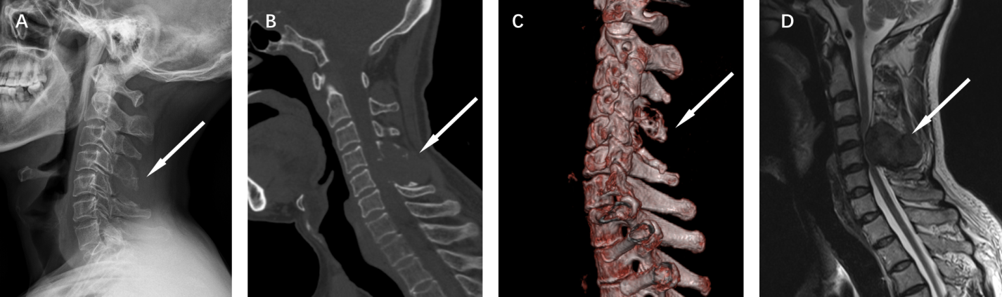
Figure 1 Preoperative X-ray, computed tomography, and magnetic resonance imaging images. A: Plain X-ray of the cervical spine showing destructive lesions (orange arrow) in the appendage area of the C4-5 vertebras; B: Plain computed tomography (CT) of the cervical spine showing bone destruction (orange arrow) and a soft tissue mass in the appendage area of the C4-5 vertebras; C: CT three-dimensional imaging of the cervical spine showing the outline of bone destruction (orange arrow) in the appendage area of C4-5; D: Magnetic resonance imaging showing bone destruction and soft tissue formation (orange arrow) in the C4-C5 accessory region, suggesting the possibility of an invasive, benign bone tumor (e.g., osteoblastoma), and significant compression of the spinal cord and stenosis at the corresponding plane.
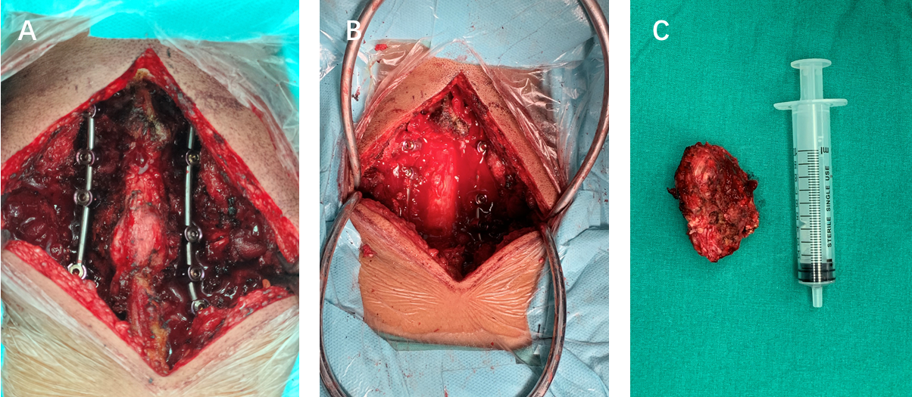
Figure 2 Intraoperative images. A: Operative view of the lesion between the C3 and C6 spinous process lamina; B: View of the surgeon after lesion removal and spinal canal and nerve root canal decompression; C: Nodular fragment of tissue, measuring 7.2 cm × 6.5 cm × 5.4 cm after resection.
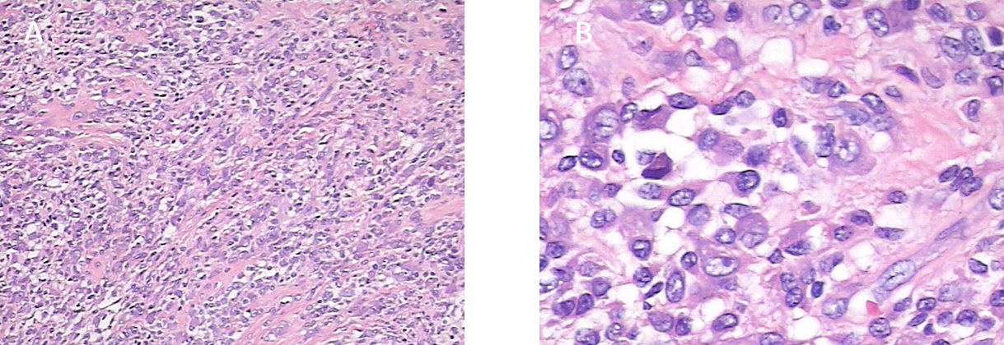
Figure 3 Pathological images of the mass. The histopathological analysis mainly showed proliferating monocytes and osteoclastic multinucleated giant cells. A: Image at 40 × magnification; B: Image at 200 × magnification.
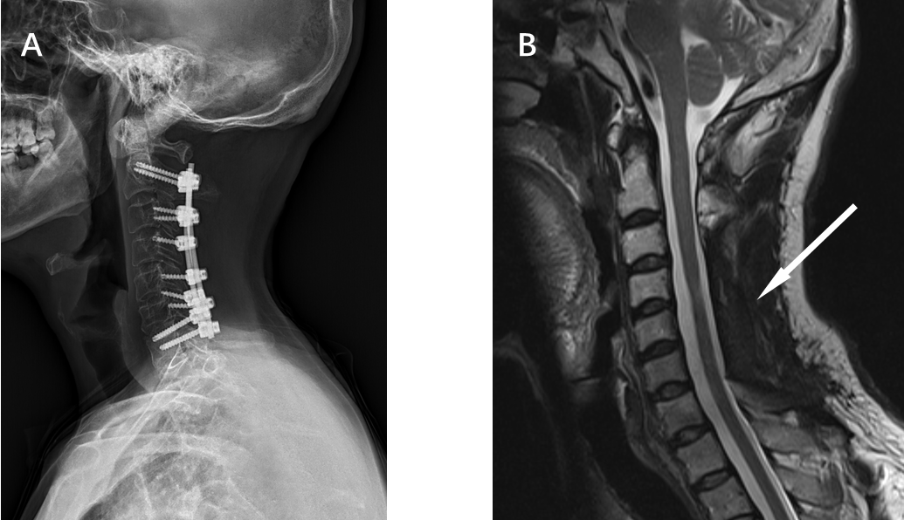
Figure 4 X-ray and magnetic resonance imaging review images at 1 year postoperatively. A: X-ray showing good fixation with no loosening of the internal fixation; B: Magnetic resonance imaging showing no signs of recurrence (orange arrow).

Published by Baishideng Publishing Group Inc
7041 Koll Center Parkway, Suite 160, Pleasanton, CA 94566, USA
Telephone: +1-925-3991568
E-mail: bpgoffice@wjgnet.com
Help Desk: https://www.f6publishing.com/helpdesk
https://www.wjgnet.com

© 2021 Baishideng Publishing Group Inc. All rights reserved.

