Name of Journal: World Journal of Clinical Cases
Manuscript NO: 79485
Manuscript Type: CASE REPORT

How to manage isolated tension non-surgical pneumoperitonium during bronchoscopy? A case report

Baima YJ et al. Non-surgical pneumoperitonium during bronchoscopy

Yang-Jin Baima, Dan-Dan Shi, Xing-Ya Shi, Li Yang, Yun-Tao Zhang, Ba-Sang Xiao, He-Yan Wang, Hang-Yong He

Yang-Jin Baima, Dan-Dan Shi, Xing-Ya Shi, Li Yang, Yun-Tao Zhang, Ba-Sang Xiao, Department of Pulmonary Medicine, Lhasa People’s Hospital, Lhasa 850013, Tibet Autonomous Region, China

He-Yan Wang, Department of Critical Care Medicine, The Sixth Hospital of Guiyang, School of Basic Medicine, Guizhou University of Traditional Chinese Medicine, Guiyang 550002, Guizhou Province, China

Hang-Yong He, Department of Respiratory and Critical Care Medicine, Beijing Institute of Respiratory Medicine, Beijing Key Laboratory of Respiratory and Pulmonary Circulation, Beijing Chao-Yang Hospital, Capital Medical University, Beijing 100020, China

Author contributions: All authors made substantial contributions to conception and design, acquisition of data, or analysis and interpretation of data, reviewed and approved the final manuscript, contributed significantly to this study; Wang HY and He HY take full responsibility for the integrity of the submission and publication, and are involved in the study design; Shi DD, Baima YJ, Wang HY and He HY had full access to all the data in the study and took responsibility for the integrity of the data and the accuracy of the data analysis, and were responsible for data verification, analysis, and drafting of the manuscript; Zhang YT, Yang L and Xiao BS had full access to all the data in the study and took responsibility for the integrity of the data and the accuracy of the data analysis; Shi DD and Baima YJ were responsible for the data collection; Baima YJ and Shi DD made equal contributions.

Supported by Science and Technology Program of Tibet Autonomous Region, No. XZ202201ZY0037G.

Corresponding author: Hang-Yong He, MD, Chief Physician, Department of Respiratory and Critical Care Medicine, Beijing Institute of Respiratory Medicine, Beijing Key Laboratory of Respiratory and Pulmonary Circulation, Beijing Chao-Yang Hospital, Capital Medical University, No. 8 Gongren Tiyuchang Nanlu, Chaoyang District, Beijing 100020, China. yonghang2004@sina.com

Received: August 31, 2022
Revised: October 5, 2022
Accepted: October 31, 2022
Published online: December 6, 2022

Abstract
BACKGROUND
Tension pneumoperitonium is a rare complication during bronchoscopy that can cause acute respiratory and hemodynamic failure, with fatal consequences. Isolated pneumoperitonium during bronchoscopy usually results from ruptures of the abdominal viscera that need surgical repair. Non-surgical pneumoperitoneum (NSP) refers to some pneumoperitoneum that could be relieved without surgery and only by conservative therapy. However, the clinical experience of managing tension pneumoperitonium during bronchoscopy is limited and controversial.

CASE SUMMARY
A 51-year-old female was admitted to our hospital for cough with bloody sputum of seven days. On the 8th day of her admission, a bronchoscopy was arranged for bronchial-alveolar lavage to detect possible pathogens in the lower respiratory tract, as oxygen was delivered via a 12 F nasopharyngeal cannula, approximately 5-6 cm from the tip of the catheter, with a flow rate of 5-10 L/min. After four minutes of bronchoscopy, the patient suddenly vomited 20 mL of water, followed by severe abdominal pain, while physical examination revealed obvious abdominal distension, as well as hardness and tenderness of the whole abdomen, which was considered pneumoperitonium, and the bronchoscopy was terminated immediately. A computer tomography scan indicated isolated tension pneumoperitonium, and abdominal decompression was performed with a drainage tube, after which her symptoms were relieved. A multidisciplinary expert consultation discussed her situation and a laparotomy was suggested, but finally refused by her family. She had no signs of peritonitis and was finally discharged 5 d after bronchoscopy with a good recovery.

CONCLUSION
The possibility of tension pneumoperitonium during bronchoscopy should be guarded against, and given its serious clinical consequences, cardiopulmonary instability should be treated immediately. Varied strategies could be adopted according to whether it is complicated with pneumothorax or pneumomediastinum, and the presence of peritonitis. When considering NSP, conservative therapy maybe a reasonable option with good recovery. An algorithm for the management of pneumoperitonium during bronchoscopy is proposed, based on the features of the case series reviewed and our case reported.

Key Words: Pneumoperitonium; Tension; Isolated; Non-surgical; Bronchoscopy; Case report

©The Author(s) 2022. Published by Baishideng Publishing Group Inc. All rights reserved.

Citation: Baima YJ, Shi DD, Shi XY, Yang L, Zhang YT, Xiao BS, Wang HY, He HY. How to manage isolated tension non-surgical pneumoperitonium during bronchoscopy? A case report. World J Clin Cases 2022; 10(34):12717-12725
URL: https://www.wjgnet.com/2307-8960/full/v10/i34/12717.htm
DOI: https://dx.doi.org/10.12998/wjcc.v10.i34.12717

Core Tip: Tension pneumoperitonium is a rare complication during bronchoscopy that can cause serious consequences. Isolated pneumoperitonium during bronchoscopy usually results from ruptures of the abdominal viscera that need surgical repair. Nonsurgical pneumoperitoneum (NSP) refers to some pneumoperitonium that could be relieved without surgery and only by conservative therapy. However, the clinical experience of managing tension pneumoperitonium during bronchoscopy is limited and controversial. Herein, we describe a rare case of isolated tension pneumoperitonium during bronchoscopy, which was recovered with no signs of peritonitis by conservative therapy. An algorithm for the management of pneumoperitonium during bronchoscopy is proposed.

INTRODUCTION
Pneumoperitonium is a rare complication during bronchoscopy^{[1,2]}. Tension pneumoperitonium may cause acute respiratory and hemodynamic failure^{[1,2]}, and can give rise to fatal consequences^{[3,4]}. When pneumoperitonium is complicated with pneumothorax or pneumomediastinum, it is usually due to high positive pressure ventilation or airway/alveolar rupture^{[2,5]}. Isolated pneumoperitonium during bronchoscopy is usually caused by ruptures of the abdominal viscera that need surgical repair^{[3,6]}. Some pneumoperitonium could be relieved without surgery and only by conservative therapy, which is known as non-surgical pneumoperitoneum (NSP)^{[6]}. When tension pneumoperitonium occurs during bronchoscopy, prompt diagnosis and life support should be performed, and whether it is an NSP should be confirmed, which may help the patient avoid surgical procedures and get a good recovery with conservative treatment^{[7]}. However, given the limited and controversial clinical experience in the management of tension pneumoperitonium during bronchoscopy, we recount a rare case of isolated tension pneumoperitonium during bronchoscopy that was relieved by conservative therapy.

CASE PRESENTATION
Chief complaints
A 51-year-old female was admitted to our hospital for cough with bloody sputum of seven days.

History of present illness
A 51-year-old female was admitted to our hospital for cough with bloody sputum for 7 d, with chest pain, dyspnea after exercise, and with no fever.

History of past illness
Her past medical history includes right knee arthroplasty one month before admission, and tubal ligation for twenty-seven years.

Personal and family history
She had no trauma history, no other special diseases, or family genetic history.

Physical examination
Vital signs at admission: Temperature 36.3 ℃, Pulse 98 bpm, respiratory rate (RR) 20 bpm, blood pressure (BP) 131/96 mmHg, pulse oxygen saturation (SPO₂) 81% (at room air), body mass index 28. She was alert, with moist rales in both lower lobe.

Laboratory examinations
At admission, her C reactive protein was 189.66 mg/L, Arterial Blood Gas showed pH 7.44, PaCO₂ 32.2 mmHg, PaO₂ 45 mmHg; Fibrinogen 5.59 g/L, D-dimer 2.41 mg/L. Her blood cell count, procalcitonin and brain natriuretic peptide were in normal range.

Imaging examinations
Her chest computer tomography (CT) showed infiltrates in the bilateral pulmonary lobes, localized consolidation in the right lower pulmonary lobe, and bilateral basal pleural effusions (Figure 1A and B).

FINAL DIAGNOSIS
Community-acquired pneumonia.

TREATMENT
She was treated with Amoxicillin-clavulanate 1.2 g every eight hours for one week. Sputum cultures were obtained prior to antibiotic treatment and were not found to be positive. And as the patient did not have a high fever on admission, no blood culture was obtained. On the 8th day of her admission, a bronchoscopy was arranged for bronchial-alveolar lavage to detect the possible pathogens in the lower respiratory tract. Local anesthesia was initially administered with lidocaine 2% aerosol inhalation for 30 min. Midazolam 3 mg was injected intravenously 1 min before the operation, and oxygen was supplied via a 12 F nasopharyngeal cannula (NPC), approximately 5-6 cm from the tip of the catheter to the nostril, with the oxygen flow rate of 5-10 L/min. Preoperative vital signs were BP 125/86 mmHg, pulse 90 bpm, RR 16 bpm, SpO₂ 88% (with NPC 5 L/min). After four minutes of bronchoscopy, the patient suddenly vomited 20 mL of water, followed by severe abdominal pain. Vital signs were BP 195/91 mmHg, pulse 135 bpm, RR 25 bpm, SpO₂ 89%. She was immediately given nimodipine, and the flow of oxygen was increased to 15 L/min, with consideration of treatment in the intensive care unit, including ventilator management. Physical examination revealed obvious abdominal distension, as well as hardness and tenderness of the whole abdomen. Pneumoperitonium was considered and the bronchoscopy was stopped immediately, followed by emergency decompression by inserting a gastric tube for gastrointestinal (GI) decompression. Ultrasound of the abdomen indicated a tension pneumoperitonium with no significant effusion, while thoracic and abdominal CT scans indicate massive gas accumulation in the abdominal cavity with no pneumothorax or pneumomediastinum (Figure 1C-F). An abdominal decompression with a drainage tube into the abdominal cavity was therefore performed. The drainage tube was a single lumen catheter (8 Fr) inserted percutaneously with a needle and guidewire, and was kept in place for 2 d. And the patient was sent back to the general ward with relief of symptoms. Six hours after which, the patient presented with approximately 20 mL of coffee-colored vomit with no signs of peritonitis. A multidisciplinary expert consultation discussed her situation and a laparotomy was suggested, but finally refused by her family. A contrast abdominal CT scan was done the following day (Day 9), which showed much less gas in the abdominal cavity than on the previous day's CT (Figure 1G and H).

OUTCOME AND FOLLOW-UP
The subsequent clinical course was uneventful. Her bronchoalveolar lavage fluid sample was negative for metagenomic next generation sequencing (mNGS), ruling out corona virus disease 2019, tuberculosis, or nontuberculous mycobacterial infection. With mycoplasma pneumonia detected by mNGS, moxifloxacin was given to her. And the patient was eventually discharged 5 d after bronchoscopy and recovered well.

DISCUSSION
Pneumoperitonium was a rare complication during bronchoscopy. We searched Pubmed data base and found only eight cases were reported during the last 20 years. As shown in Table 1, eight previously published cases and the current case with pneumoperitonium during bronchoscopy were reviewed. A total of nine cases were reported, including eight adults and one child. 22% (2/9) of the patients had pneumoperitonium during rigid bronchoscopy, while 78% had it at fiberoptic bronchoscopy. Four patients (44%) underwent transbronchial lung biopsy (TBLB) or transbronchial needle aspiration (TBNA). NPC was the most common oxygen supply method in six patients (66%), while the remaining one and two patients used a bag mask and mechanical ventilation (MV), respectively. In addition, sudden onset of abdominal pain or distension was the most common clinical presentation, as shown in three and five patients, respectively. However, a cardiorespiratory arrest was present in one case. Only 4 (44%) patients had isolated pneumoperitonium, and pneumothorax/pneumomediastinum were complicated with pneumoperitonium in the other 5 cases. Most of the reported cases were tension pneumoperitonium. Hypotension and respiratory failure were also present in five cases. Six patients were intubated after pneumoperitonium, while only one patient died after pneumoperitonium and the other eight recovered well. Four patients had laparotomy/laparoscopy, and gastric ruptures were found in only 3 cases.
The mechanism of pneumoperitonium during bronchoscopy is manifested by high-pressure air in the ruptured airway, alveoli, or hollow viscus^{[5,8,9]}. In some cases, such as rigid bronchoscopy^{[5,8]}, TBLB^{[1]}, TBNA^{[2,6]}, or foreign body removal^{[5]}, pneumoperitonium occurs as an intro-airway procedural complication. Damage to the airway or the alveoli may occur due to these procedures, leading to pneumoperitonium^{[10]}. Also, pneumothorax and pneumomediastinum could be found more frequently in these types of pneumoperitonium^{[11-15]}. Additionally, the “Macklin” effect is one of the mechanisms related to pneumothorax or pneumomediastinum complicated with pneumoperitonium^{[16]}.
Isolated pneumoperitonium without complicated pneumothorax or pneumomediastinum is more likely to be associated with an air source from the lesion of GI tract^{[3,8]}. However, one previously reported case showed that isolated pneumoperitonium could also be seen after TBNA^{[6]}. Therefore, when isolated pneumoperitonium was present during bronchoscopy without an intro-airway procedure, it should be considered that there is a high possibility that the pneumoperitonium is of GI source. It was described^{[17]} that some patients undergoing bronchoscopy under sedation and oxygen delivery by NPC experienced the development of pneumoperitoneum secondary to gastric rupture due to multiple factors, such as the reduced muscle tone in the pharynx induced by anesthesia, and thus air entering the stomach with one-way valve mechanism, resulting in NPC dislocation in the esophagus. With these risk factors, the large amounts of air supplied by the oxygen supply tube may enter the GI tract, inducing high air pressure in the hollow viscus and eventually leading to perforation at its most vulnerable site of the gastriointestinal wall. And it was speculated that when the perforation occurs in the ventral side of the GI tract, and most patients have very little content left in the GI tract after the bronchoscopy preparation, air could be the only substance that leaks into the peritoneum, with no other GI content entering into the peritoneum and causing peritonitis.
Tension pneumoperitonium was reported in the majority of the cases we reviewed, and in more than half of these cases there was acute circulatory or respiratory failure^{[3,4,6,8]} or cardiopulmonary arrest^{[9]}, which may lead to a fatal outcome^{[18]}. The initial step in treatment should be prompt resuscitation and life support. Tension barotrauma should be confirmed by radiological examination as soon as possible after the patient's vital signs have stabilized. At the same time, a needle or tube decompression should be considered for a better venous return and respiratory compliance, which could further improve the cardiopulmonary status. If a tension pneumoperitonium is caused by gastric or intestinal microperforation, showing only pneumoperitoneum during bronchoscopy without signs of peritonitis, non-surgical pneumoperitonium should be considered, and it could be cured by a needle or tube decompression^{[6]}.
Only four out of the nine patients with pneumoperitonium eventually underwent laparotomy or laparoscopy in our review. Three of the patients who underwent laparotomy that were confirmed gastric rupture but got repaired and recovered well, while the other patient died when his family refused the laparotomy. In addition to this, four patients who were radiologically found negative to have visceral rupture were closely monitored and eventually diagnosed with NSP and recovered with conservative therapy. Therefore, it should always be borne in mind that NSP is a form of pneumoperitonium complicated with bronchoscopy, for which surgical procedure could be avoided with a good outcome^{[6,7,19]}.
High flow oxygen supply or high positive pressure ventilation maybe a significant cause of pneumoperitonium during bronchoscopy^{[20]}. Besides, mechanical ventilation, bag-mask ventilation, and high flow NPC have also been reported as causes of pneumoperitonium in other clinical circumstances, such as sedation or surgical procedures^{[14,20]}. NPC was considered the most probable cause of isolated pneumoperitonium during bronchoscopy without biopsy in three cases, based on our review of previous cases, including the case we report here. Therefore, clinicians should be aware of the risk of pneumoperitonium when a high flow NPC oxygen supply is used during bronchoscopy and should monitor this complication closely during the procedure. And furthermore, not only should cardiopulmonary monitoring and resuscitation kits be prepared, but decompression kits should be prepared at the bedside during bronchoscopy for high-risk patients undergoing, for example, high flow NPC, positive ventilation, deep sedation, and invasive procedures. And when using NPC oxygenation, confirm the position of the catheter.
A protocol for the management of pneumoperitonium during bronchoscopy is proposed in Figure 2, based on the features of the case series reviewed and our case reported.

CONCLUSION
In summary, due to the serious clinical consequences, attention should be paid to the possibility of tension pneumoperitonium during bronchoscopy while the unstable cardiopulmonary status should be treated immediately. And meanwhile, varied treatments could be adopted according to whether pneumoperitonium is complicated with pneumothorax or pneumomediastinum, and whether there are signs of persistent peritonitis. When NSP is considered, conservative therapy maybe a reasonable option with good recovery. Furthermore, patients at high risk should be closely monitored.

REFERENCES
1 Nikolaev IS, Zamir D, Weiler Z. Pneumoperitoneum complicating bronchoscopy. Isr Med Assoc J 2003; 5: 131-132 [PMID: 12674668]
2 Abraham GE 3rd, Sumrall BH, Bowling MR. The air apparent: a rare complication during flexible bronchoscopy. Am J Med Sci 2011; 341: 243-245 [PMID: 21446082 DOI: 10.1097/maj.0b013e3182019f7a]
3 El-Kersh K, Karnib H. Tension Pneumoperitoneum Associated with Nasopharyngeal Catheter Oxygen Delivery during Bronchoscopy. Am J Respir Crit Care Med 2017; 196: 785-786 [PMID: 28661180 DOI: 10.1164/rccm.201701-0181IM]
4 Po PL, Bai HF, Lin CH, Lin CC. Pneumomediastinum that progression to tension pneumoperitoneum after bronchioloalveolar lavage: A case report. Respir Med Case Rep 2021; 32: 101341 [PMID: 33489748 DOI: 10.1016/j.rmcr.2021.101341]
5 Dastidar A. Pneumomediastinum, pneumoperitoneum and pneumothorax following iatrogenic perforation of bronchus: successful conservative management of a potentially serious complication. J Pediatr Surg 2013; 48: 456-458 [PMID: 23414886 DOI: 10.1016/j.jpedsurg.2012.11.042]
6 Muriana P, Carretta A, Ciriaco P, Rossetti F, Negri G. Isolated tension pneumoperitoneum following endobronchial ultrasound-guided transbronchial needle aspiration complicated by cardiac peri-arrest: A case report. Monaldi Arch Chest Dis 2018; 88: 999 [PMID: 30539597 DOI: 10.4081/monaldi.2018.999]
7 Ahmed K, Amine EG, Abdelbaki A, Jihene A, Khaoula M, Yamina H, Mohamed B. Airway management: induced tension pneumoperitoneum. Pan Afr Med J 2016; 25: 125 [PMID: 28292087 DOI: 10.11604/pamj.2016.25.125.9038]
8 Bednarz S, Filipovic M, Schoch O, Mauermann E. Gastric rupture after bag-mask-ventilation. Respir Med Case Rep 2015; 16: 1-2 [PMID: 26744639 DOI: 10.1016/j.rmcr.2015.05.014]
9 Pereira IS, Ferreira L, Tinoco E, Shiang T, Oliveira A, Pereira AI. Gastric rupture during fiberoptic bronchoscopy, a rare complication of oxygen administration by nasopharyngeal cannula: a case report. Braz J Anesthesiol 2021 [PMID: 34973305 DOI: 10.1016/j.bjane.2021.12.009]
10 Mancino L, Michieletto L, Trani B, Zamperlin A, Ceron L. Pneumomediastinum after transbronchial lung biopsy. J Bronchology Interv Pulmonol 2010; 17: 167-168 [PMID: 23168738 DOI: 10.1097/LBR.0b013e3181da29ea]
11 Naughton M, Irving L, McKenzie A. Pneumomediastinum after a transbronchial biopsy. Thorax 1991; 46: 606-607 [PMID: 1926036 DOI: 10.1136/thx.46.8.606]
12 Lantsberg L, Rosenzweig V. Pneumomediastinum causing pneumoperitoneum. Chest 1992; 101: 1176 [PMID: 1555448 DOI: 10.1378/chest.101.4.1176]
13 Kourounis G, Lim QX, Rashid T, Gurunathan S. A rare case of simultaneous pneumoperitoneum and pneumomediastinum with a review of the literature. Ann R Coll Surg Engl 2017; 99: e241-e243 [PMID: 29022798 DOI: 10.1308/rcsann.2017.0165]
14 Fraipont V, Lambermont B, Ghaye B, Moonen M, Edzang L, D'Orio V, Marcelle R. Unusual complication after percutaneous dilatational tracheostomy: pneumoperitoneum with abdominal compartment syndrome. Intensive Care Med 1999; 25: 1334-1335 [PMID: 10654224 DOI: 10.1007/s001340051071]
15 Madan K, Mehta S, Gupta N, Hadda V, Mohan A, Guleria R. Pneumomediastinum and Extensive Subcutaneous Emphysema after Cryoprobe Transbronchial Lung Biopsy. Ann Am Thorac Soc 2016; 13: 2101-2103 [PMID: 27831814 DOI: 10.1513/AnnalsATS.201605-395LE]
16 Romero KJ, Trujillo MH. Spontaneous pneumomediastinum and subcutaneous emphysema in asthma exacerbation: The Macklin effect. Heart Lung 2010; 39: 444-447 [PMID: 20561891 DOI: 10.1016/j.hrtlng.2009.10.001]
17 Giménez Velando A, Rodriguez Nieto MJ, Flandes Aldeyturriaga J. Gastric Perforation During Bronchoscopy For The Delivery Of Oxygen Therapy By Nasopharyngeal Cannula. Arch Bronconeumol (Engl Ed) 2018; 54: 293-294 [PMID: 29198602 DOI: 10.1016/j.arbres.2017.10.010]
18 Gross A, Diacon AH. Cardiac tamponade following transbronchial needle aspiration. Respiration 2011; 82: 56-59 [PMID: 21430355 DOI: 10.1159/000323870]
19 Mularski RA, Sippel JM, Osborne ML. Pneumoperitoneum: a review of nonsurgical causes. Crit Care Med 2000; 28: 2638-2644 [PMID: 10921609 DOI: 10.1097/00003246-200007000-00078]
20 Chapman N. Gastric rupture and pneumoperitoneum caused by oxygen insufflation via a fiberoptic bronchoscope. Anesth Analg 2008; 106: 1592 [PMID: 18420894 DOI: 10.1213/ane.0b013e31816a3111]

Footnotes
Informed consent statement: Informed written consent was obtained from the patient for publication of this report and any accompanying images.

Conflict-of-interest statement: All the authors report no relevant conflicts of interest for this article.

CARE Checklist (2016) statement: The authors have read the CARE Checklist (2016), and the manuscript was prepared and revised according to the CARE Checklist (2016).

Open-Access: This article is an open-access article that was selected by an in-house editor and fully peer-reviewed by external reviewers. It is distributed in accordance with the Creative Commons Attribution NonCommercial (CC BY-NC 4.0) license, which permits others to distribute, remix, adapt, build upon this work non-commercially, and license their derivative works on different terms, provided the original work is properly cited and the use is non-commercial. See: https://creativecommons.org/Licenses/by-nc/4.0/

Provenance and peer review: Unsolicited article; Externally peer reviewed.

Peer-review model: Single blind

Peer-review started: August 29, 2022
First decision: September 26, 2022
Article in press: October 31, 2022

Specialty type: Medicine, research and experimental
Country/Territory of origin: China
Peer-review report’s scientific quality classification
Grade A (Excellent): 0
Grade B (Very good): B
Grade C (Good): C, C, C
Grade D (Fair): 0
Grade E (Poor): 0

P-Reviewer: Agrawal P, United States; Ferreira GSA, Brazil; Ishida T, Japan S-Editor: Wei ZH L-Editor: A P-Editor: Wei ZH

Figure Legends
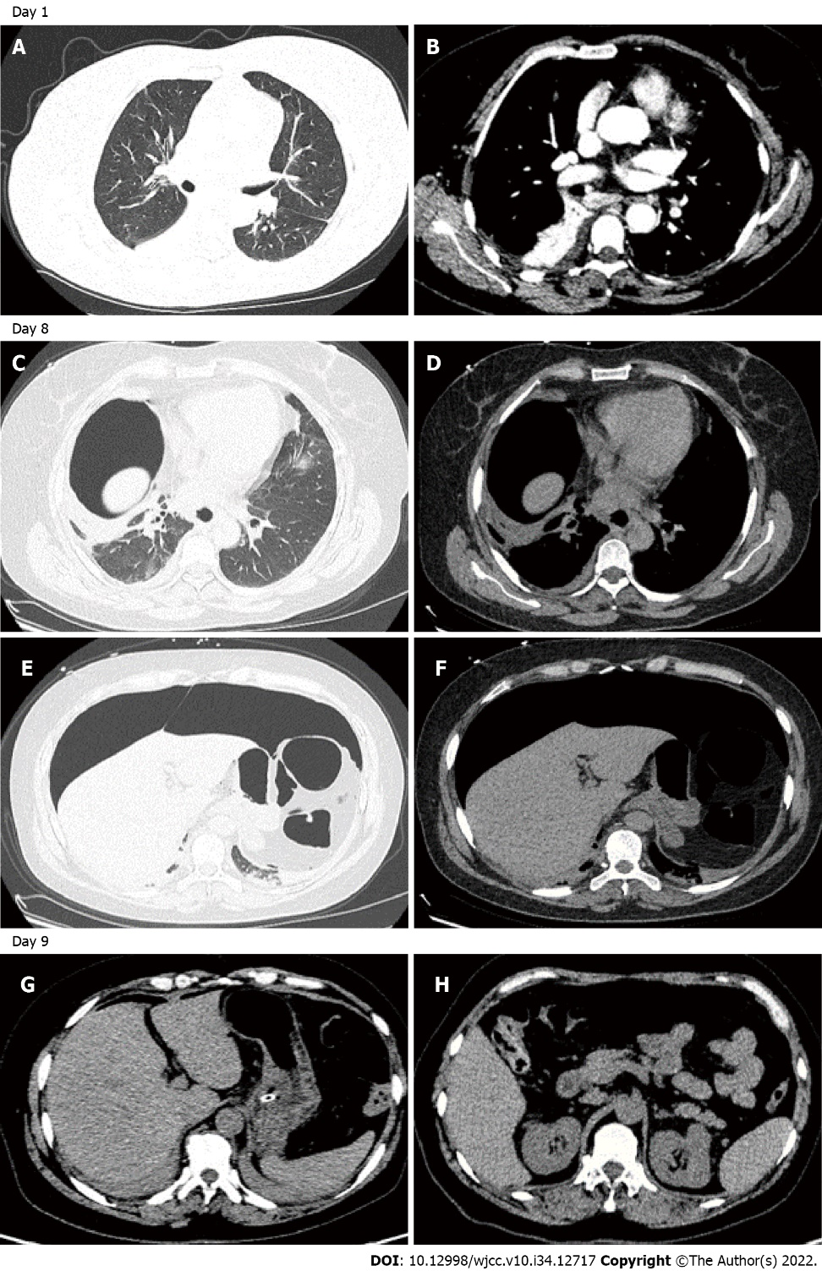
Figure 1 Chest and abdominal computed tomography scan of the patient on day 1, day 8, and day 9. A and B: Thoracic enhanced computed tomography (CT)-scan on admission showed infiltration and fibrotic foci were scattered in the bilateral pulmonary lobe, with localized consolidation of the right lower lobe, and bilateral pleural effusions; C-F: Thoracic and abdominal CT-scan on day 8 taken after needle decompression demonstrating the presence of a large anterior pneumoperitoneum without fluid collections and pneumothorax or pneumomediastinium; G and H: Abdominal enhanced CT-scan on day 9 showed gas accumulation in the right abdominal wall, free gas in the abdominal cavity is less than in the previous CT exam.

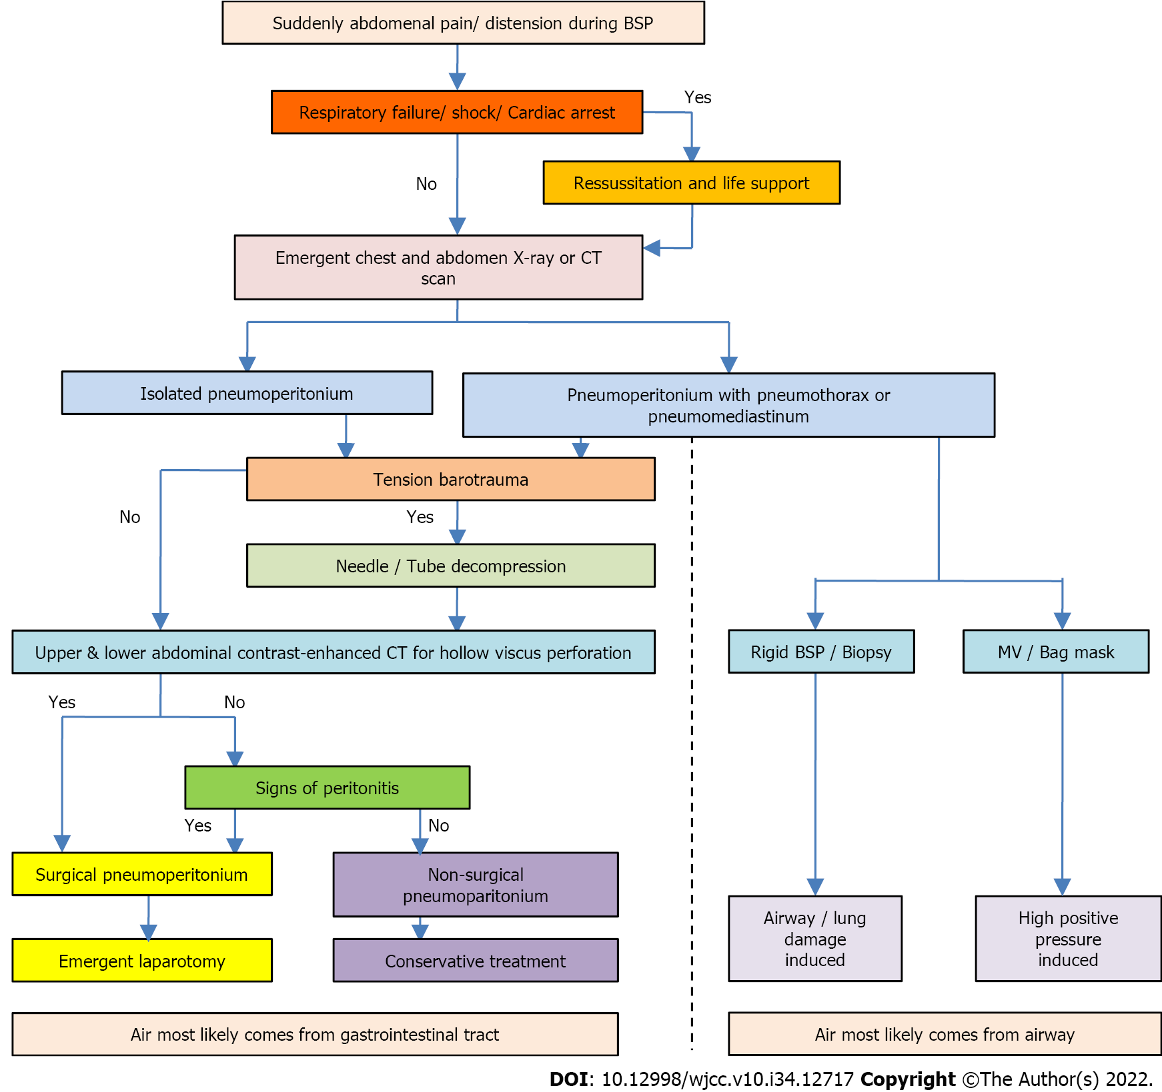
Figure 2 Protocol for the management of pneumoperitonium during bronchoscopy. BSP: Bronchoscopy; MV: Mechanical ventilation; CT: Computed tomography.

Table 1 Case series reported pneumoperitoneum associated with bronchoscopy
Ref. | Age | Sex | BSP type | Biopsy procedure | O2 supply | Symptoms during BSP | PT or PM | Isolated PP | Tension PP | Respiratory or hemodynamic failure | Intubaion and MV | Viscus rupture | Laparotomy or Conservative treatment | Outcome
Nikolaev et al^{[1]}, 2003 | 82 | F | Fiberoptic | TBLB | NPC | Sudden stuporotic bradycardic | PT + PM | No | Yes | No | Intubation air-bag | No | Laparoscopy | Discharged 3 d later
Abraham et al^{[2]}, 2011 | 76 | F | Fiberoptic | TBNA | NPC | Abdominal pain | PM | No | Yes | No | No | No | Conservative observation in ICU | Discharged 2 d later
Dastidar^{[5]}, 2013 | 14 mo | M | Rigid | Foreign body removal | MV | Distended abdomen | PT + PM | No | No | No | Aborted | No | Conservative observation in ICU | Discharged 1 d later
Bednarz et al^{[8]}, 2015 | 42 | F | Rigid | No | Bag mask | Respiratory arrest distended abdomen | No | Yes | Yes | RF and shock | Intubation | Gastric rupture | Emergent laparotomy | Recovered
El-kersh and Karnib^{[3]}, 2017 | 61 | F | Fiberoptic | No | NPC | Abdominal pain tachycardia tachypnea | No | Yes | Yes | RF | Intubation | Gastric rupture | Emergent laparotomy | Recovered
Muriana et al^{[6]}, 2018 | 80 | M | Fiberoptic | EBUS TBNA | NPC | Distended abdomen severe bradycardia arterial hypotension | No | Yes | Yes | RF and shock | Intubation | No | Needle decompression | Discharged 13 d later
Po et al^{[4]}, 2021 | 80 | M | Fiberoptic | BALF | MV | Distended abdomen persistent hypotension | PM | No | Yes | Shock | Intubation | NA | Refused laparotomy by family | Died
Pereira et al^{[9]}, 2021 | 61 | F | Fiberoptic | No | NPC | Sudden abdominal distension; cardiorespiratory arrest | PT + PM | No | Yes | RF and shock | Bag-mask ventilation & intubation | Gastric laceration | Needle decompression exploratory laparotomy | Discharged 4 d later
This case | 51 | F | Fiberoptic | No | NPC | Abdominal pain | No | Yes | Yes | No | No | No | Needle decompression | Discharged 5 d later
In summary | 42-82 yr | F 6 M 3 | Fiberoptic 7 Rigid 2 | TBLB 1 TBNA 2 Foreign body 1 | NPC 6 MV 2 bag mask 1 | Abdominal pain 3 Distended abdomen 5 hypotension 2 cardiorespiratory arrest 1 | PT + PM 3 PM 2 No 4 | No 5 Yes 4 | Yes 9 No 1 | RF + shock 3 RF 1 Shock 1 No 4 | Intubation 6 No 2 | Gastric rupture 3 No 6 | Conservative observation 2 Laparotomy 4 Needle decompression3 | Discharged 8 Died 1
BSP: Bronchoscopy; IV: Intravenous; TBLB: Transbronchial lung biopsy; PT: Pneumothorax; PM: Pneumomediastinum; PP: Pneumoperitonium; MV: Mechanical ventilation; EBUS: Endobronchial ultrasound guidance; TBNA: Tranbronchila needle aspiration; NA: Not available; NPC: Nasopharyngeal cannula; RF: Respiratory failure.

Published by Baishideng Publishing Group Inc
7041 Koll Center Parkway, Suite 160, Pleasanton, CA 94566, USA
Telephone: +1-925-3991568
E-mail: bpgoffice@wjgnet.com
Help Desk: https://www.f6publishing.com/helpdesk
https://www.wjgnet.com

© 2022 Baishideng Publishing Group Inc. All rights reserved.

