SUPPLEMENTARY FIGURES
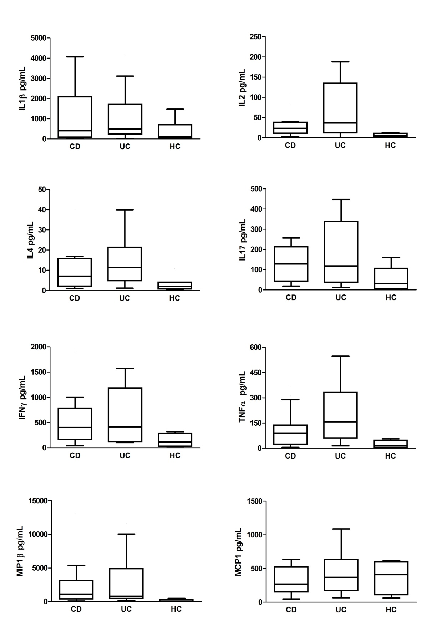

Supplementary Figure 1: Basal levels of cytokine secretion by colonic biopsies from IBD patients. Levels of cytokine secretion by colonic biopsies from IBD patients in active phase (Crohn’s Disease, CD; Ulcerative Colitis, UC) and healthy controls (HC) in basal condition (Live Bacteria). No statistical significance was found.
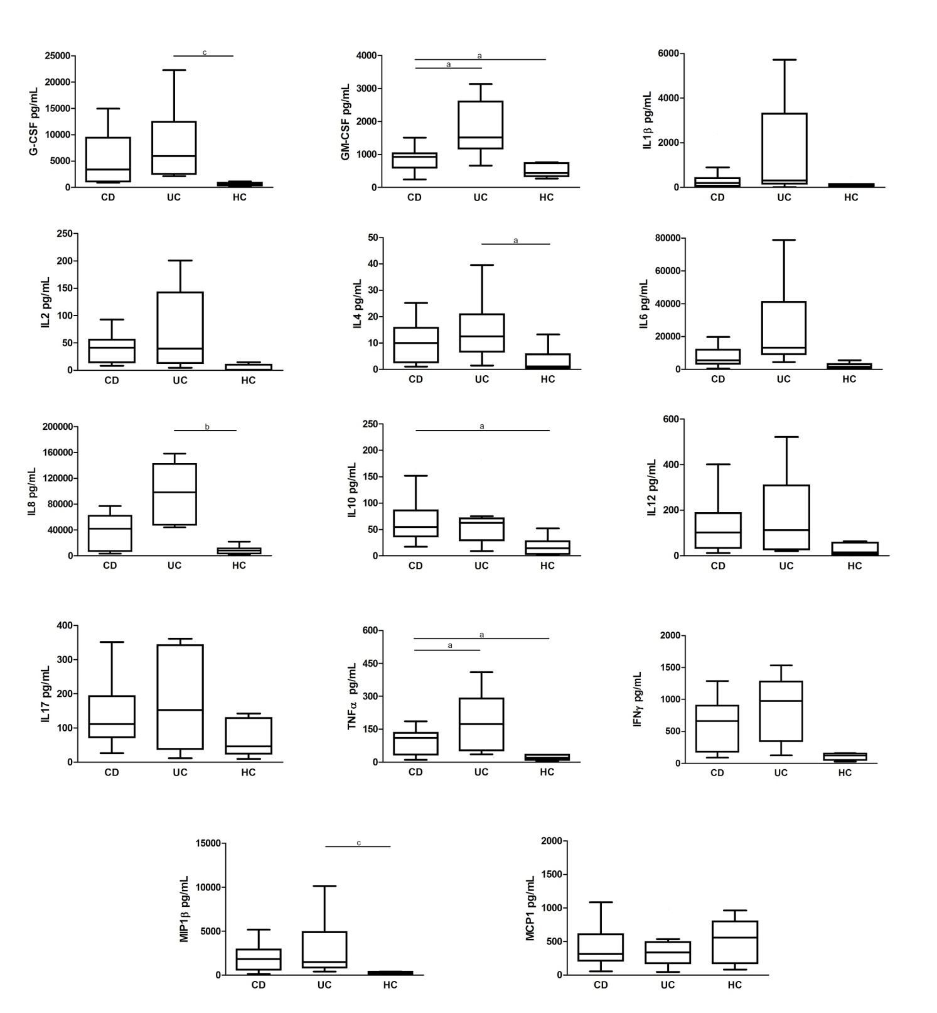
Supplementary Figure 2: Levels of cytokine secretion by colonic biopsies from IBD patients, in the presence of antibiotics. Levels of cytokine secretion by colonic biopsies from IBD patients in active phase (Crohn’s Disease, CD; Ulcerative Colitis, UC) and from healthy controls (HC) in the presence of antibiotic mixture (+PS). Statistical significances are denoted using alphabetical letters ( a=p < 0.05; b=p < 0.01; c=p< 0.001).

SUPPLEMENTARY TABLES
Supplementary Table 1. Clinical characteristics of patients suffering from Inflammatory Bowel Disease
Clinical characteristics |  |  |  |  |  |  |  |  |  |  |  |  |  |  |  |  |  | Inflammatory markers
PATIENT |  | SEX/AGE | DIAGNOSIS | AGE AT DIAGNOSIS |  |  | DISEASE ACTIVITY |  |  | THERAPIES |  |  |  | PUCAI/PCDAI |  | DISEASE LOCATION |  | CRP | ESR | FECAL CALPROTECTIN
01 |  | M/17 | UC | 12 |  |  | ACTIVE |  |  | AZA. 5-ASA |  |  |  | 0 |  | LEFT-SIDED UC |  | 0.06 | 9 | -
02 |  | M/7 | UC | 6 |  |  | ACTIVE |  |  | - |  |  |  | 20 |  | PANCOLITIS |  | 0.82 | 47 | 1522
03 |  | M/17 | UC | 17 |  |  | ACTIVE |  |  | CIPX |  |  |  | 45 |  | LEFT-SIDED UC |  | 0.4 | 10 | -
04 |  | F/14 | UC | 12 |  |  | ACTIVE |  |  | 5-ASA. CS |  |  |  | 30 |  | LEFT-SIDED UC |  | 0.3 | 44 | -
05 |  | M/17 | UC | 13 |  |  | ACTIVE |  |  | Sulfasalzine |  |  |  | 25 |  | PANCOLITIS |  | 2.05 | 67 | 2060
06 |  | F/15 | UC | 14 |  |  | ACTIVE |  |  | CS. 5-ASA. AZA |  |  |  | 40 |  | LEFT-SIDED UC |  | 0.04 | 33 | 2120
07 |  | F/11 | UC | 2 |  |  | ACTIVE |  |  | CS. 5-ASA. AZA |  |  |  | 40 |  | PANCOLITIS |  | 0.59 | 108 | 1648
08 |  | F/14 | UC | 9 |  |  | ACTIVE |  |  | AZA |  |  |  | 5 |  | PANCOLITIS |  | 0.26 | 94 | 33
09 |  | M/17 | UC | 7 |  |  | ACTIVE |  |  | AZA |  |  |  | 5 |  | PANCOLITIS |  | 0.03 | 4 | -
10 |  | F/12 | UC | 7 |  |  | ACTIVE |  |  | AZA 5-ASA |  |  |  | 20 |  | ULCERATIVE PROCTITIS |  | 0.02 | 12 | 1746
11 |  | M/12 | UC | 10 |  |  | ACTIVE |  |  | 5-ASA |  |  |  | 20 |  | ULCERATIVE PROCTITIS |  | 0.03 | 6 | 21
12 |  | M/18 | UC | 17 |  |  | ACTIVE |  |  | 5-ASA |  |  |  | 65 |  | LEFT-SIDED UC |  | 0.16 | 17 | -
13 |  | M/18 | UC | 18 |  |  | ACTIVE |  |  | 5-ASA. MNZ |  |  |  | 15 |  | PANCOLITIS |  | 0.18 | 3 | -
Clinical characteristics |  |  |  |  |  |  |  |  |  |  |  |  |  |  |  |  |  | Inflammatory markers
PATIENT |  | SEX/AGE | DIAGNOSIS | AGE AT DIAGNOSIS |  |  | DISEASE ACTIVITY |  |  | THERAPIES |  |  |  | PUCAI/PCDAI |  | DISEASE LOCATION |  | CRP | ESR | FECAL CALPROTECTIN
14 |  | F/18 | UC | 17 |  |  | ACTIVE |  |  | - |  |  |  | 30 |  | LEFT-SIDED UC |  | 0.12 | 27 | 50
15 |  | M/13 | UC | 11 |  |  | ACTIVE |  |  | - |  |  |  | 30 |  | PANCOLITIS |  | 0.19 | 31 | 1600
16 |  | F/10 | UC | 9 |  |  | REMISSION |  |  | 5-ASA |  |  |  | 5 |  | LEFT-SIDED UC |  | 0.01 | 4 | 602
17 |  | F/14 | UC | 12 |  |  | REMISSION |  |  | CS. 5-ASA |  |  |  | 0 |  | LEFT-SIDED UC |  | 0.01 | 8 | 126
18 |  | F/18 | UC | 13 |  |  | REMISSION |  |  | AZA. 5-ASA |  |  |  | 0 |  | PANCOLITIS |  | 0.06 | 13 | -
19 |  | M/17 | UC | 11 |  |  | REMISSION |  |  | 5-ASA |  |  |  | 0 |  | PANCOLITIS |  | 0.11 | 10 | 124
20 |  | M/10 | UC | 6 |  |  | REMISSION |  |  | AZA. 5-ASA |  |  |  | 0 |  | PANCOLITIS |  | 0.01 | 11 | 35
21 |  | M/20 | UC | 17 |  |  | REMISSION |  |  | 5-ASA. IFX |  |  |  | 0 |  | LEFT-SIDED UC |  | 0.06 | 6 | -
22 |  | F/24 | UC | 13 |  |  | REMISSION |  |  | CS. 5-ASA. AZA |  |  |  | 0 |  | PANCOLITIS |  | 0.02 | 6 | -
23 |  | M/13 | CD | 13 |  |  | ACTIVE |  |  | - |  |  |  | 15 |  | PANENTERIC CD |  | 3.1 | 92 | 1915
24 |  | F/11 | CD | 9 |  |  | ACTIVE |  |  | ADA |  |  |  | 15 |  | PANENTERIC CD |  | 0.08 | 11 | 1080
25 |  | F/10 | CD | 9 |  |  | ACTIVE |  |  | IFX |  |  |  | 2.5 |  | PANENTERIC CD |  | 0.53 | 35 | -
26 |  | F/13 | CD | 9 |  |  | ACTIVE |  |  | ADA |  |  |  | 10 |  | PANENTERIC CD |  | 0.71 | 66 | -
Clinical characteristics |  |  |  |  |  |  |  |  |  |  |  |  |  |  |  |  |  | Inflammatory markers
PATIENT |  | SEX/AGE | DIAGNOSIS |  | AGE AT DIAGNOSIS |  |  | DISEASE ACTIVITY |  |  | THERAPIES |  | PUCAI/PCDAI |  | DISEASE LOCATION |  |  | CRP | ESR | FECAL CALPROTECTIN
27 |  | M/11 | CD |  | 9 |  |  | ACTIVE |  |  | 5-ASA |  | 12.5 |  | ILEOCOLONIC CD |  |  | 0.4 | 27 | 475
28 |  | M/10 | CD |  | 10 |  |  | ACTIVE |  |  | CIPX |  | 27.5 |  | PANENTERIC CD |  |  | 5.01 | 33 | 8688
29 |  | M/15 | CD |  | 14 |  |  | ACTIVE |  |  | - |  | 0 |  | PANENTERIC CD |  |  | 0.04 | 5 | 0
30 |  | M/10 | CD |  | 10 |  |  | ACTIVE |  |  | MNZ |  | 35 |  | ILEOCOLONIC CD |  |  | 2.88 | 51 | 2772
31 |  | M/15 | CD |  | 12 |  |  | ACTIVE |  |  | IFX |  | 17.5 |  | GASTRIC AND ILEOCOLONIC CD |  |  | 2.64 | 38 | 1295
32 |  | M/16 | CD |  | 12 |  |  | ACTIVE |  |  | CS. SSZ |  | 45 |  | GASTRIC AND ILEOCOLONIC CD |  |  | 4.9 | 75 | -
33 |  | F/11 | CD |  | 9 |  |  | ACTIVE |  |  | - |  | 32.5 |  | PANENTERIC CD |  |  | 2.96 | 120 | 1372
34 |  | F/16 | CD |  | 11 |  |  | ACTIVE |  |  | MTX. SSZ |  | 40 |  | ILEOCOLONIC CD |  |  | 0.2 | 46 | 55483
35 |  | M/11 | CD |  | 5 |  |  | ACTIVE |  |  | IFX |  | 25 |  | ILEOCOLONIC CD |  |  | 1.0 | 37 | 1050
36 |  | F/10 | CD |  | 9 |  |  | ACTIVE |  |  | - |  | 25 |  | GASTRIC AND ILEOCOLONIC CD |  |  | 2.07 | 56 | 2079
37 |  | F/11 | CD |  | 11 |  |  | ACTIVE |  |  | CS |  | 30 |  | COLONIC CD |  |  | 5.76 | 88 | 2083
38 |  | F/11 | CD |  | 11 |  |  | ACTIVE |  |  | IFX. SSZ |  | 0 |  | COLONIC CD |  |  | 0.03 | 15 | 402
39 |  | F/10 | CD |  | 10 |  |  | ACTIVE |  |  | - |  | 20 |  | COLONIC CD |  |  | 3.18 | 77 | 1477
Clinical characteristics |  |  |  |  |  |  |  |  |  |  |  |  |  |  |  |  |  | Inflammatory markers
PATIENT | SEX/AGE |  | DIAGNOSIS |  |  | AGE AT DIAGNOSIS |  |  | DISEASE ACTIVITY |  |  | THERAPIES | PUCAI/PCDAI |  | DISEASE LOCATION |  |  | CRP | ESR | FECAL CALPROTECTIN
40 | F/10 |  | CD |  |  | 9 |  |  | ACTIVE |  |  | Thd. SSZ | 30 |  | GASTRIC AND ILEOCOLONIC CD |  |  | 1.6 | 25 | 2175
41 | M/6 |  | CD |  |  | 6 |  |  | ACTIVE |  |  | - | 20 |  | COLITIS IN CGD |  |  | 3.12 | 88 | 28311
42 | M/7 |  | CD |  |  | 6 |  |  | ACTIVE |  |  | 5-ASA | 17.5 |  | COLITIS IN CGD |  |  | 0.42 | 35 | 3305
43 | M/7 |  | CD |  |  | 6 |  |  | ACTIVE |  |  | MNZ | 52.5 |  | JEJUNAL  ILEOCOLONIC CD |  |  | 1.04 | 98 | 648
44 | M/12 |  | CD |  |  | 10 |  |  | ACTIVE |  |  | MNZ | 17.5 |  | PANENTERIC CD |  |  | 0.19 | 41 | 807
45 | M/16 |  | CD |  |  | 16 |  |  | ACTIVE |  |  | MNZ, CIPX | 17.5 |  | PANENTERIC CD |  |  | 2.19 | 34 | 1087
46 | M/18 |  | CD |  |  | 15 |  |  | REMISSION |  |  | IFX | 10 |  | PANENTERIC CD |  |  | 0.35 | 18 | 151
47 | M/11 |  | CD |  |  | 6 |  |  | REMISSION |  |  | AZA | 0 |  | ILEOCOLONIC CD |  |  | 0.03 | 8 | -
48 | M/7 |  | CD |  |  | 1 |  |  | REMISSION |  |  | Thd | 0 |  | NASAL, COLONIC CD |  |  | 0.05 | 13 | -
49 | F/16 |  | APHTHOSIS, AUTOIMMUNE GASTRITIS |  |  | - |  |  | NORMAL COL |  |  | - | - |  | - |  |  | 0.05 | 40 | 25
50 | M/15 |  | PREVIOUS INTESTINAL POLYP |  |  | - |  |  | NORMAL COL |  |  | - | - |  | - |  |  | 0.14 | 5 | -
Clinical characteristics |  |  |  |  |  |  |  |  |  |  |  |  |  |  |  |  |  | Inflammatory markers
PATIENT | SEX/AGE |  | DIAGNOSIS |  |  | AGE AT DIAGNOSIS |  |  | DISEASE ACTIVITY |  |  | THERAPIES | PUCAI/PCDAI |  | DISEASE LOCATION |  |  | CRP | ESR | FECAL CALPROTECTIN
51 | M/10 |  | JUVENILE INTESTINAL POLYPOSIS |  |  | - |  |  | INTESTINAL POLYPS |  |  | - | - |  | COLON |  |  | - | - | -
52 | M/11 |  | FUNCTIONAL ABDOMINAL PAIN |  |  | - |  |  | NORMAL COL |  |  | - | - |  | - |  |  | 0.24 | 39 | -
53 | M/3 |  | JUVENILE INTESTINAL POLYP |  |  | - |  |  | INTESTINAL POLYPS |  |  | - | - |  | COLON |  |  | 0.03 | 21 | -
54 | F/11 |  | VIRAL INFECTION |  |  | - |  |  | NORMAL COL |  |  | - | - |  | - |  |  | 4.86 | 110 | 22
55 | F/4 |  | FUNCTIONAL ABDOMINAL PAIN |  |  | - |  |  | NORMAL COL |  |  | - | - |  | - |  |  | 0.03 | 19 | 6.5
56 | F/10 |  | FUNCTIONAL ABDOMINAL PAIN |  |  | - |  |  | NORMAL COL |  |  | - | - |  | - |  |  | 0.09 | 8 | -
M: Male; F: Female; CD: Crohn’s disease; UC: Ulcerative colitis; AZA: azathioprine; ADA: Adalimumab; Thd: Thalidomide; 5-ASA: mesalamine; IFX: Infliximab;
CS: corticosteroids; CIPX: ciprofloxacin; SSZ: sulfasalazine; MZN: metronidazole; COL: Colonoscopy.
Age (year); CRP (mg/dl), ESR (mm/h); Fecal Calprotectin (mg/Kg)

Supplementary Table 2. Clinical characteristics of patients suffering from Inflammatory Bowel Disease
PATIENT | SEX/AGE | DIAGNOSIS | DISEASE ACTIVITY | BMI | BMI PERCENTILE
01 | M/17 | UC | ACTIVE | 21 | 36
02 | M/7 | UC | ACTIVE | 15.4 | 50
03 | M/17 | UC | ACTIVE | 24 | 80
04 | F/14 | UC | ACTIVE | 17.5 | 23
05 | M/17 | UC | ACTIVE | 23 | 70
06 | F/15 | UC | ACTIVE | 23.8 | 80
07 | F/11 | UC | ACTIVE | 14 | 5
08 | F/14 | UC | ACTIVE | 16.5 | 10
09 | M/17 | UC | ACTIVE | 19.9 | 40
10 | F/12 | UC | ACTIVE | 16.6 | 25
11 | M/12 | UC | ACTIVE | 15.6 | 12
12 | M/18 | UC | ACTIVE | 22.8 | 60
13 | M/18 | UC | ACTIVE | 24.4 | 75
14 | F/18 | UC | ACTIVE | 23.5 | 75
15 | M/13 | UC | ACTIVE | 16.6 | 15
16 | F/10 | UC | REMISSION | 12 | 1
17 | F/14 | UC | REMISSION | 20.3 | 62
18 | F/18 | UC | REMISSION | 24 | 75
19 | M/17 | UC | REMISSION | 25.8 | 92
20 | M/10 | UC | REMISSION | 17.5 | 65
21 | M/20 | UC | REMISSION | 24 | 60
22 | F/24 | UC | REMISSION | 21.5 | 50
PATIENT | SEX/AGE | DIAGNOSIS | DISEASE ACTIVITY | BMI | BMI PERCENTILE
23 | M/13 | CD | ACTIVE | 16 | 10
24 | F/11 | CD | ACTIVE | 16 | 28
25 | F/10 | CD | ACTIVE | 20.6 | 90
26 | F/13 | CD | ACTIVE | 23.8 | 91
27 | M/11 | CD | ACTIVE | 15.7 | 23
28 | M/10 | CD | ACTIVE | 17.6 | 66
29 | M/15 | CD | ACTIVE | 19 | 35
30 | M/10 | CD | ACTIVE | 16 |  | 40
31 | M/15 | CD | ACTIVE | 20 |  | 50
32 | M/16 | CD | ACTIVE | 19 |  | 25
33 | F/11 | CD | ACTIVE | 15 |  | 10
34 | F/16 | CD | ACTIVE | 20.7 |  | 50
35 | M/11 | CD | ACTIVE | 17.8 |  | 60
36 | F/10 | CD | ACTIVE | 15.5 |  | 30
37 | F/11 | CD | ACTIVE | 15.8 |  | 22
38 | F/11 | CD | ACTIVE | 16 |  | 25
39 | F/10 | CD | ACTIVE | 17.1 |  | 50
40 | F/10 | CD | ACTIVE | 14.9 |  | 22
41 | M/6 | CD | ACTIVE | 14.5 |  | 20
42 | M/7 | CD | ACTIVE | 14.1 |  | 10
43 | M/7 | CD | ACTIVE | 13.1 |  | 2
44 | M/12 | CD | ACTIVE | 24.8 |  | 96
45 | M/16 | CD | ACTIVE | 20.2 |  | 50
46 | M/18 | CD | REMISSION | 20.5 |  | 45
47 | M/11 | CD | REMISSION | 16.9 |  | 45
48 | M/7 | CD | REMISSION | 14.2 |  | 15
PATIENT | SEX/AGE | DIAGNOSIS | DISEASE ACTIVITY | BMI |  | BMI PERCENTILE
49 | F/16 | APHTHOSIS, AUTOIMMUNE GASTRITIS | NORMAL COL | 21.5 |  | 60
50 | M/15 | PREVIOUS INTESTINAL POLYP | NORMAL COL | 16.2 |  | 30
51 | M/10 | JUVENILE INTESTINAL POLYPOSIS | INTESTINAL POLYPS | 16.4 |  | 25
52 | M/11 | FUNCTIONAL ABDOMINAL PAIN | NORMAL COL | 16.4 |  | 33
53 | M/3 | JUVENILE INTESTINAL POLYP | INTESTINAL POLYPS | 16 |  | 50
54 | F/11 | VIRAL INFECTION | NORMAL COL | 16 |  | 25
55 | F/4 | FUNCTIONAL ABDOMINAL PAIN | NORMAL COL | 14.2 |  | 15
56 | F/10 | FUNCTIONAL ABDOMINAL PAIN | NORMAL COL | 18 |  | 45
M: Male; F: Female; CD: Crohn’s disease; UC: Ulcerative colitis; COL: Colonoscopy.
Age (year); BMI: Body Mass Index; BMI Percentile: underweight (<5); healthy (5-85);
overweight (85-95); obese (>95).

Supplementary Table 3. Cytokine values in the absence of antibiotics, with or without the addition of MDP
 |  | CD |  |  | UC |  |  | HC
 |  | -MDP | +MDP |  | -MDP | +MDP |  | -MDP | +MDP
G-CSF |  | 2192 (3745±3282) | 2580 (6738±10109) |  | 4536 (7301±7694) | 7525 (9804±8562) |  | 436 (645.8±572.4) | 385.5 (364.2±220.4)
GM-CSF |  | 748.1 (883.4±712.1) | 775 (1217±1247) |  | 1247 (1549±867.3) | 1717 (1715±759.7) |  | 504.4 (495.8±215) | 393.2 (505.9±206.1)
IFNγ |  | 402.7 (510.5±434.3) | 377.6 (526.8±427.4) |  | 414.6 (620.6±525.3) | 1121 (909.7±479.1) |  | 115.4 (144.6±139.2) | 72.89 (122.8±107.5)
IL1β |  | 408.8 (1275±1535) | 215.8 (843.6±1238) |  | 502.8 (1627±2835) | 498.3 (1741±2217) |  | 97.27 (377.9±536.2) | 126.8 (235.5±335.5)
IL2 |  | 23.69 (33.92±32.62) | 22.82 (35.17±37.17) |  | 36.64 (65.21±66.51) | 86.3 (85.65±60.97) |  | 6.405 (6.74±4.601) | 1.875 (2.508±2.258)
IL4 |  | 7.08 (10.25±12.55) | 7.76 (10.34±9.249) |  | 11.41 (14.07±11.09) | 15.42 (18.61±13.08) |  | 1.93 (3.267±3.687) | 1.02 (2.917±2.898)
IL6 |  | 5512 (8428±8573) | 5774 (11007±14697 |  | 10788 (20660±28559) | 17345 (28516±31326) |  | 2015 (1775±1576) | 793.2 (1096±848.6)
IL8 |  | 34163 (35988±26282) | 19170 (44152±48640) |  | 21678 (37553±33836) | 73990 (81093±63573) |  | 3408 (8853±14711) | 5080 (6931±6421)
IL10 |  | 32.44 (62.44±75) | 46.69 (69.82±73.54) |  | 65.98 (68.16±48.2) | 57.28 (63.06±29.97) |  | 10.57 (12.81±8.041) | 12.36 (14.09±6.162)
IL12 |  | 92.17 (155.8±140.5) | 94.54 (141.3±143.8) |  | 78.12 (161.9±169.6) | 97.51 (221.1±223.7) |  | 11.98 (21.91±24.42) | 20.35 (23.26±23.46)
IL17 |  | 128 (134.3±82.9) | 104.8 (131.3±96.54) |  | 118.2 (175.4±159.7) | 234.1 (204.8±157) |  | 30.21 (59.22±60.62) | 47 (53.88±53.89)
MCP1 |  | 268.9 (645.9±1333) | 268.1 (308.8±195.3) |  | 370.7 (435.6±323) | 408.5 (572.4±498.1) |  | 412.4 (370.9±238.5) | 273.7 (439.1±479.9)
MIP1β |  | 1121 (2564±3640) | 2864 (2519±2220) |  | 797.1 (3139±3655) | 2081 (3531±3241) |  | 59.58 (131.4±194.5) | 80.83 (155.1±165.6)
TNFα |  | 90.83 (135.7±163.6) | 72.83 (91.8±82.98) |  | 158 (184±161.7) | 170.9 (182.2±109.5) |  | 15.03 (21.79±21.48) | 27.27 (21.66±14.89)
Values (pg/ml) are expressed as Median (Mean±SD). CD: Crohn’s disease; UC: Ulcerative Colitis; HC: Healthy Controls;
MDP: Muramyl dipeptide

Supplementary Table 4. Cytokine values in the presence of antibiotics, with or without the addition of MDP
 |  | CD |  |  | UC |  |  | HC
 |  | -MDP | +MDP |  | -MDP | +MDP |  | -MDP | +MDP
G-CSF |  | 3377 (6330±7510) | 2407 (3133±2371) |  | 5954 (10270±12725) | 8187 (9128±8209) |  | 675.3 (642.9±354.8) | 1224 (1199±1080
GM-CSF |  | 927.1 (921.3±489.6) | 853.1 (1186±1804) |  | 1515 (1788±853.7) | 1457 (1615±933.3) |  | 436.7 (519±202.1) | 526.1 (550.5±258.6)
IFNγ |  | 660.3 (599.3±399.4) | 365.6 (434.6±294) |  | 977.2 (835.3±521.5) | 452.8 (645.9±509.6) |  | 123 (108.9±56.97) | 161.3 (162.1±85)
IL1β |  | 199.2 (373.2±567.8) | 363.2 (759.3±947.7) |  | 308.5 (1475±2023) | 478.1 (1606±2436) |  | 89.52 (136±154.5) | 53.66 (87.21±112)
IL2 |  | 41.21 (40.66±27.39) | 21.05 (27.43±27.43) |  | 39.33 (75.02±74.49) | 59.79 (76.39±66.97) |  | 1.18 (4.608±6.054) | 9.56 (10.25±4.785)
IL4 |  | 10.02 (11.25±9.659) | 7.64 (9.761±10.29) |  | 12.51 (14.41±11.08) | 11.1 (13.55±10.45) |  | 1.13 (3.491±4.66) | 1.13 (3.818±6.83)
IL6 |  | 5550 (9737±11609) | 5576 (9543±11874) |  | 13072 (24974±26737) | 14588 (22221±22516) |  | 1704 (2144±1789) | 2610 (2934±3254)
IL8 |  | 42294 (36328±27994) | 46697 (57161±67755) |  | 98115 (95571±48577) | 23748 (63080±95386) |  | 8075 (8773±6897) | 7501 (19984±28397)
IL10 |  | 54.94 (68.84±45.13) | 28.17 (85.95±209.8) |  | 62.33 (61.6±48.43) | 58.75 (75.9±60.62) |  | 14.55 (17.88±18.22) | 25.55 (27.85±18.57)
IL12 |  | 102.4 (129.1±111.6) | 80.86 (133.3±123) |  | 112.5 (179.3±175.2) | 119.2 (146.5±123.5) |  | 14.94 (26.19±25.67 | 18.92 (28.33±29.12)
IL17 |  | 111.7 (138.2±86.12) | 103.7 (140.6±108.2) |  | 152.9 (174.5±146.2) | 134.6 (177.8±129.1) |  | 46.3 (66.64±54.21) | 44.29 (67.46±72.89)
MCP1 |  | 314.8 (394.6±265.4) | 254 (848.3±2575) |  | 337.3 (360±264.3) | 235.1 (678.1±1112) |  | 560.2 (519±333.5) | 608.9 (1228±1730)
MIP1β |  | 1844 (1965±1521) | 2723 (3683±3561) |  | 1502 (3167±3530) | 3570 (4325±3739) |  | 195.5 (218.4±175.7) | 273.2 (408.3±429.1)
TNFα |  | 110.1 (92.81±57.47) | 64.84 (98.78±110.3) |  | 173.7 (183.3±135.9) | 165.9 (188.6±161.3) |  | 19.89 (27.02±26.79) | 16.73 (25.36±31.78)
Values (pg/ml) are expressed as Median (Mean±SD). CD: Crohn’s disease; UC: Ulcerative Colitis; HC: Healthy Controls;
MDP: Muramyl dipeptide

