Name of journal: World Journal of Radiology
ESPS Manuscript NO: 3674
Columns: CASE REPORT

Ectopic insertion of the ureter into the seminal vesicle

El-Ghar MA et al. Ectopic ureteic insertion

Mohamed Abou El-Ghar, Tarek El-Diasty

Mohamed Abou El-Ghar, Tarek El-Diasty, Radiology Department, Urology and Nephrology Center, Mansoura University, Mansoura 35516, Egypt

Authors contributions: Both authors contributed equally to the preparation of the manuscript.

Correspondence to: Dr. Mohamed Abou El-Ghar, Professor of Radiodiagnosis, Radiology Department, Urology and Nephrology Center, Mansoura University, Mansoura 35516, Egypt

Telephone: +20-502-262222 Fax: +20-502-263717
Received: May 13, 2013 Revised: July 30, 2013
Accepted: August 12, 2013

Published online:

Abstract
We present a case of left ectopic ureter insertion into the left seminal vesicle which is a rare anomaly. Incidence of ectopic insertion of the ureter is more common in females and usually associated with incontinence leading to the diagnosis while in male it is present with infection. Ectopic ureter is defined as abnormal insertion of the ureter, in male occurring in posterior urethra approximately 50% of cases. Other sites include the seminal vesicle (approximately one-third), vas deferens, bladder neck, prostate and epididymis, while the urethra and vagina affected commonly in female. Management usually addressed to the upper tract only, if there is incontinence it requires removal of the ureteric stump. Our case is initially diagnosed by magnetic resonance imaging and the diagnosis confirmed by computed tomography (CT) guided seminal vesiculography as transrectal guidance for seminal vesiculography refused by the patient. CT guided seminal vesiculography is less painful and more tolerable than transrectal route.

© 2013 Baishideng. All rights reserved.

Key words: Seminal vesicle; Ectopic; Ureter; Magnetic resonance imaging; Computed tomography; Seminal vesiculography

Core tip: We present the role of the traditional technique of the computed tomography seminal vesiculography in the diagnosis of the rare anomaly of ectopic insertion of the ureter into the seminal vesicle in male patient.

El-Ghar MA, El-Diasty T. Ectopic insertion of the ureter into the seminal vesicle. World J Radiol 2013;
Available from: URL: http://www.wjgnet.com/esps/
DOI: http://dx.doi.org/10.4329/wjr.v0.i0.0000

INTRODUCTION
Ectopic insertion of the ureter is defined as abnormal insertion of the ureter usually distal to the trigon into the urethra in male occurring in approximately 50% of cases^{[1]}. Other sites include the seminal vesicle (approximately one-third), vas deferens, bladder neck, prostate, and epididymis, urethra and vagina affected commonly in female. Ectopic insertion of the ureter in the genital tract is a rare anomaly. Its incidence as reported by Fraser about 1:130000. It is more common in females and usually associated with incontinence leading to the diagnosis while in male it is present with infection

CASE REPORT
We present a case of ectopic insertion of the left ureter into the seminal vesicle (SV). It is initially diagnosed by magnetic resonance imaging (MRI) and confirmed by computed tomography (CT) seminal vesiculography.
Twenty eight years male presented with terminal hematuria of one month duration with history of left simple nephrectomy 25 years ago and open heart surgery for ventricular septal defect 15 years ago. Clinical examination and laboratory investigations were free.
Pelvic ultrasound (US) showed a multilocular cystic lesion posterior to the bladder to the left (Figure 1). Ascending cystogram was free. MRI showed a tubular structure at the left representing ureteric stump of the nephrectomized left kidney inserted into the dilated left seminal vesicle (Figure 2A). The left seminal vesicle showed altered fluid content (Figure 2B). CT guided puncture of the dilated left SV was done with injection of contrast inside (Figure 3A). Imaging of the abdomen and pelvis after SV puncture showed opacification of the left SV, the left ureter stump and the left vas deference (Figure 3B).

DISCUSSION
There is association between the congenital anomalies of the seminal vesicle and the urinary tract anomalies due to their close embryologic relationship^{[2]}. CT and MRI are used for accurate delineation of the ureter insertion while MRI is the modality of choice for seminal vesicles evaluation. The difficulties in the diagnosis of ectopic insertion of the ureter usually occurs when it is not dilated and its insertion could be identified, in this cases the CT or MRI with contrast are required to confirm the diagnosis
In case of ectopic ureter pelvic US can show the dilated SV as a cystic mass at the pelvis posterior to the bladder with dilated ipsilateral ureter also if there is associated kidney anomaly. Transrectal ultrasound (TRUS) allows better delineation of the cystic lesion wall and its relation to the adjacent structures^{[3,4]}. TRUS can also used in puncture of the SV with contrast injection for further CT imaging.
Intravenous urography (IVU) may be of no value if the affected kidney is non-functioning. There may be smooth indentation of the bladder by the cystic lesion at IVU and Ascending cystogram^{[3,4]}. In our case the seminal vesicle not enlarged enough to indent the bladder at the cystogram.
CT shows the cystic lesion with low fluid density posterior to the bladder with no post-contrast enhancement, it can also diagnose the associated renal anomalies^{[3-5]}.
MRI has superior soft tissue contrast that allows easily differentiation of the pelvic structures and the associated pelvic anomalies. At MRI the seminal vesicles appear as elongated cystic structures with thin septa. It displays low signal intensity (SI) at T1-weighted and high SI at T2-weighted MRI. The SI may be altered if the SV fluid contains high protein^{[3,4]}. MRI with gadolinium can delineate the ureteric course in the normal functioning kidney in the excretory phase and also can diagnose the associated seminal vesicle abnormalities.

REFERENCES
1 Cooper CS, Snyder HM. The ureter. In: Adult and Pediatric Urology, 4th ed, Gillenwater JY, Grayhack JT, Howards SS, Mitchell ME (Eds), Lippincott Williams and Wilkins, Philadelphia, 2002: 2155
2 Berrocal T, López-Pereira P, Arjonilla A, Gutiérrez J. Anomalies of the distal ureter, bladder, and urethra in children: embryologic, radiologic, and pathologic features. Radiographics ; 22: 1139-1164 [PMID: 12235344]
3 Lebowitz RL, Olbing H, Parkkulainen KV, Smellie JM, Tamminen-Möbius TE. International system of radiographic grading of vesicoureteric reflux. International Reflux Study in Children. Pediatr Radiol 1985; 15: 105-109 [PMID: 3975102 DOI: 10.1007/BF02388714]
4 Rizzoni G, Perale R, Bui F, Pitter M, Pavanello L, Boscolo R, Passerini Glazel G, Macri C. Radionuclide voiding cystography in intrarenal reflux detection. Ann Radiol (Paris) 1986; 29: 415-420 [PMID: 3752881]
5 Darge K, Troeger J, Duetting T, Zieger B, Rohrschneider W, Moehring K, Weber C, Toenshoff B. Reflux in young patients: comparison of voiding US of the bladder and retrovesical space with echo enhancement versus voiding cystourethrography for diagnosis. Radiology 1999; 210: 201-207 [PMID: 9885609]
P-Reviewers Chen HW, Kaya C, Triantopoulou C, Wang PH S-Editor Gou SX L-Editor E-Editor

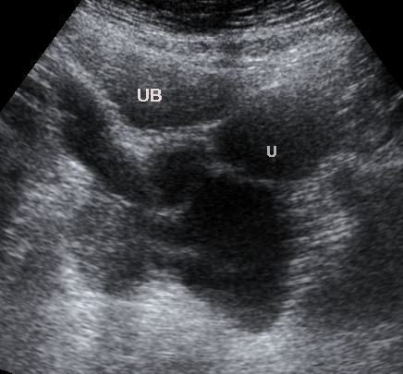
Figure 1 Ultrasound of the pelvis shows multilocular cystic lesion posterior to the bladder to the left. U: Uterus; UB: Urinary bladder.

A B
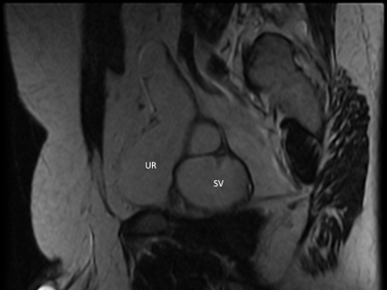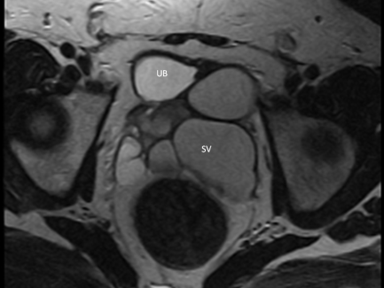
Figure 2 Sagittal T2-weighted magnetic resonance imaging. A: The left ureter stump with ectopic insertion into the dilated left seminal vesicle (SV); B: Altered fluid content at the dilated left seminal vesicle with relative low small intestine. UB: Urinary bladder.

A B
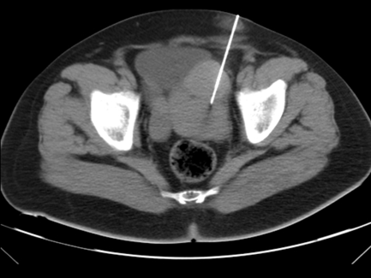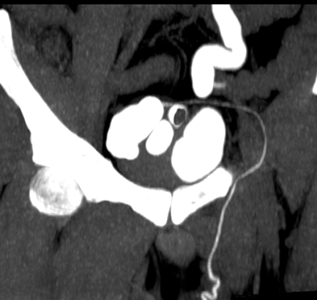
Figure 3 Axial computed tonmography. A: The pelvis with needle punctures of the left seminal vesicle; B: Contrast opacification of the seminal vesicle, vas deference and left ureter stump.

