Name of Journal: World Journal of Hepatology
Manuscript NO: 57567
Manuscript Type: ORIGINAL ARTICLE

Basic Study
Inhibition of vascular adhesion protein-1 modifies hepatic steatosis in vitro and in vivo

Shepherd EL et al. Role of VAP-1 in hepatic steatosis

Emma L Shepherd, Sumera Karim, Philip N Newsome, Patricia F Lalor

Emma L Shepherd, Sumera Karim, Philip N Newsome, Patricia F Lalor, Centre for Liver and Gastroenterology Research, Birmingham National Institute for Health Research, Birmingham Biomedical Research Centre, Institute of Immunology and Immunotherapy, University of Birmingham, Birmingham B15 2TT, West Midlands, United Kingdom

Philip N Newsome, Liver Unit, Queen Elizabeth Hospital, University Hospitals Birmingham, Birmingham B15 2TT, West Midlands, United Kingdom

Author contributions: Shepherd EL, Karim S, Newsome PN and Lalor PF contributed to the writing and revising of the manuscript.

Corresponding author: Patricia F Lalor, BSc, PhD, Academic Research, Reader (Associate Professor), Centre for Liver and Gastroenterology Research, Birmingham National Institute for Health Research, Birmingham Biomedical Research Centre, Institute of Immunology and Immunotherapy, University of Birmingham, Edgbaston, Birmingham B15 2TT, West Midlands, United Kingdom. p.f.lalor@bham.ac.uk

Received: June 15, 2020
Revised: July 23, 2020
Accepted: September 15, 2020
Published online:

Abstract
BACKGROUND
Non-alcoholic fatty liver disease (NAFLD) is associated with obesity, insulin resistance and dyslipidaemia and currently is estimated to affect up to a third of all individuals in developed countries. Current standard of care for patients varies according to disease stage, but includes lifestyle interventions common insulin sensitizers, antioxidants and lipid modifiers. However, to date specific therapies have shown little histological or fibrosis stage improvement in large clinical trials, and there is still no licensed therapy for NAFLD. Given the high prevalence, limited treatment options and significant screening costs for the general population, new treatments are urgently required.

AIM
To assess the potential for inhibition of the amine oxidase enzyme vascular adhesion protein-1 (VAP-1) to modify hepatic lipid accumulation in NAFLD.

METHODS
We have used immunochemical and qPCR analysis to document expression of VAP-1 and key functional proteins and transporters across the NAFLD spectrum. We then utilised hepatocytes in culture and human precision cut liver slices in concert with selective enzyme activity inhibitors to test the effects of activating the semicarbazide-sensitive amine oxidase activity of VAP-1 on hepatic lipid uptake and triglyceride export. A murine model of NAFLD was also used to determine the consequences of VAP-1 knockout and gene expression arrays were used to quantify the effects of VAP-1 activity on key lipid modifying and proinflammatory gene expression.

RESULTS
We confirmed that increasing severity of NAFLD and progression to cirrhosis was associated with a significant increase in hepatocellular VAP-1 expression. Hepatocytes in vitro exposed to recombinant VAP-1 and its substrate methylamine showed increased lipid accumulation as determined by quantification of Oil Red O uptake. This was recapitulated using hydrogen peroxide, and lipid accumulation was accompanied by changes in expression of the lipid transporter molecules FABP3, FATP6, insulin receptor subunits and PPARα. Human liver tissue exposed to recombinant VAP-1 or substrates for endo/exogenous VAP-1 produced less triglyceride than untreated tissue and demonstrated an increase in steatosis. This response could be inhibited by using bromoethylamine to inhibit the SSAO activity of VAP-1, and mice deficient in VAP-1/AOC3 also demonstrated reduced steatosis on high fat diet. Exposure of human liver tissue to methylamine to activate VAP-1 resulted in increased expression of FABP2 and 4, FATP3-5, caveolin-1, VLDLR, PPARGC1 and genes associated with the inflammatory response.

CONCLUSION
Our data confirm that the elevations in hepatic VAP-1 expression reported in nonalcoholic steatohepatitis can contribute to steatosis, metabolic disturbance and inflammation. This suggests that targeting the semicarbazide sensitive amine oxidase capacity of VAP-1 may represent a useful adjunct to other therapeutic strategies in NAFLD.

Key words: Non-alcoholic fatty liver disease; Hepatocyte; Lipid; Cell biology; Vascular adhesion protein-1; Steatosis

Shepherd EL, Karim S, Newsome PN, Lalor PF. Inhibition of vascular adhesion protein-1 modifies hepatic steatosis in vitro and in vivo. World J Hepatol 2020; In press

Core tip: Incidence of non-alcoholic fatty liver disease (NAFLD) is dramatically increasing worldwide but to date there are no licenced therapies. The challenge remains management of the diverse pathophysiology from simple steatosis, through inflammation and fibrosis and the systemic complications of the metabolic syndrome. Vascular adhesion protein-1 (VAP-1) is an enzyme with proven contributions to systemic and hepatic glucose handling, inflammation and fibrosis. We now show an additional role in hepatic steatosis. Thus our important data suggests that targeting the semicarbazide sensitive amine oxidase capacity of VAP-1 may represent a useful adjunct to other therapeutic strategies in NAFLD.

INTRODUCTION
Non-alcoholic fatty liver disease (NAFLD) is associated with obesity, insulin resistance and dyslipidaemia^{[1]} and currently is estimated to affect up to a third of all individuals in developed countries^{[2]}. Although a systemic disease, within the liver NAFLD occurs as a disease spectrum ranging from steatosis alone, to steatohepatitis (NASH) which ultimately drives the development of significant fibrosis and cirrhosis. Patients with NAFLD have high mortality and in particular are at increased risk of suffering adverse cardiovascular events^{[3]}. The current standard of care for management of patients is stratified according to disease stage, with lifestyle interventions common in simple steatosis but more extensive clinical intervention using insulin sensitizers, antioxidants and lipid modifiers in NASH^{[4]}. However, to date specific therapies for NASH such as obeticholic acid^{[5]} and apoptosis signal regulating kinase 1 (ASK1) inhibition have shown little histological or fibrosis stage^{[6]} improvement and there is still no licenced therapy for NASH. Transplantation is an option in some centres but as NASH will soon overtake hepatitis C infection as the major indication for liver transplantation, the demand far outstrips clinical capacity. Given the high prevalence, limited treatment options and significant cost associated with screening at risk patients, new treatments are urgently required.
VAP-1 (Semicarbazide Sensitive Amine Oxidase, SSAO, AOC3, EC 1.4.3.6) may present a novel avenue for therapeutic intervention. This molecule is a transmembrane protein and member of the copper containing amine oxidase enzyme family that is sensitive to inhibition by the urea derivative semicarbazide. It is structurally similar to other copper containing amine oxidases^{[7]} such as lysyl oxidase (LOX). It is expressed on diverse cells including adipocytes, smooth muscle cells^{[8]} and some endothelial cells^{[9]}, and can be secreted as a soluble protein into serum^{[10]}. Serum concentrations of VAP-1 increase in obesity^{[11]}, diabetes^{[12,13]} and inflammatory liver disease^{[14]} and the molecule has promise as a serological indicator of disease severity in inflammatory liver disease^{[15]}. Of note in patients with NASH, serum VAP-1 Levels correlate with severity of obesity and NASH, and more importantly fibrosis stage^{[16]}. VAP-1 and other amine oxidase enzymes catalyse the deamination of amines to yield the corresponding aldehyde and hydrogen peroxide. Thus VAP-1 catalyses the oxidative deamination of both endogenous (methylamine and aminoacetone)^{[17]} and exogenous (benzylamine)^{[18]} amines. This enzymatic capacity is key in the context of diabetes and inflammation since the products of the reaction have been shown to alter glucose uptake^{[19]}, and administration of substrate modifies the effects of insulin^{[20]} and activates NFκB to drive hepatic inflammation^{[21]}. There is also evidence suggesting that serological lipid profiles^{[22]} and atheroma risk^{[23]} are linked to VAP-1 activity, since the insulinomimetic effects of the molecule alter lipid metabolism and storage^{[24]} and prime adipocyte differentiation and lipolysis^{[25]}. Since transgenic mice overexpressing VAP-1/SSAO show increased BMI and abdominal fat pad weight if exposed to methylamine^{[26]} it is likely that VAP-1 contributes to the storage and distribution of lipids in NAFLD. In support of this recent studies from our group have demonstrated that wild type mice given an anti-VAP-1 therapeutic antibody, show reduced steatosis on MCD diet^{[16]}. However, to date the mechanisms underlying this response have not been characterised, particularly in a human context. Therefore, in the current investigation we aimed to assess the potential for VAP-1 inhibition to modify hepatic lipid accumulation.

MATERIALS AND METHODS
Human and murine tissue samples
All human tissue used was collected at the Liver and Hepatobiliary Unit, Queen Elizabeth Hospital, Birmingham, with prior written informed patient consent and local research ethics committee approval (06/Q702/61). Normal and steatotic donor tissue was surplus to requirement for transplantation, whilst NASH and ALD tissue was collected from end-stage fibrotic explanted livers upon transplantation. Tissue was immediately snap frozen and stored at -80 ℃ or formalin-fixed and paraffin-embedded. For functional assays and generation of tissue slices, tissue samples of approximately 30 g were cut from the periphery of freshly collected livers and immediately placed into (DMEM) prior to use.
All mice were maintained and housed under conventional conditions in the Biomedical Services Unit at the University of Birmingham, United Kingdom. All animal experiments were performed under a Home Office project license in accordance with United Kingdom legislation and welfare guidelines, and studies were approved by the local ethical review board. Male 8-10 wk old WT (Charles Rivers Laboratories Margate, United Kingdom) or VAP-1^{-/-} mice (AOC3 constitutive KO, Taconic, Denmark) were fed a high fat diet (HFD, Special Diets Services, Essex, United Kingdom) for 12 wk. Mice were sacrificed and the liver was removed and immediately snap frozen and stored at -80 ℃ for subsequent analysis.

Immunohistochemistry and histological analysis
Haematoxylin and eosin staining was performed on Formalin fixed, paraffin embedded sections from human or mouse liver using standard protocols. To quantify lipid content in hepatocytes, fresh frozen tissue sections were incubated in 60% isopropanol for 5 min followed by Oil Red O reagent for 15 min at room temperature. This was tipped off and 60% isopropanol was added for another 5 min. Slides were washed twice with water and finally mounted using aqueous mountant (Thermoscientific, Shandon). Sections were imaged using brightfield microscopy and % staining area was determined using morphometric analysis via Image J software version 1.42 (NIH), using 5 non-overlapping fields selected at random from each mouse (at × 20 magnification). 7 mm sections of formalin-fixed or snap frozen human or murine liver tissue were stained with haematoxylin and eosin or Van Geison’s stain^{[27]} according to standard protocols. For analysis of VAP-1 expression fixed tissue sections were stained using standard indirect immunohistochemical methods as described previously^{[16]}.

Generation of precision-cut liver slices
To generate precision-cut liver slices (PCLS), 8 mm tissue cores from fresh tissue samples were aseptically obtained and placed in DMEM (Invitrogen, United Kingdom) at 4 ℃ prior to slicing^{[28]}. A Krumdieck tissue slicer (Alabama Research and Development, United States) was set up aseptically in a class II microflow tissue safety hood according to the manufacturers instructions. Tissue cores were placed into the Krumdieck tissue slicer assembly and aseptic 240 μm thick PCLS were cut with a blade cycle speed ranging from 20-70/min depending on the type of tissue used (fatty or normal). PCLS were then immediately transferred to tissue culture media consisting of Williams E media (Sigma, United Kingdom) supplemented with 2% FCS (Invitrogen, United Kingdom), 0.1 μmol/L dexamethasone (Sigma, United Kingdom), and 0.5 μmol/L insulin (Novo-Nordisk) unless otherwise noted for specific assays. PCLS were cultured for up to 48 h ex vivo in static culture at 37 ℃ in 5% CO₂ in a humidified atmosphere.

Maintenance of Huh7.5 cells
The human hepatoma-derived hepatocyte cell line Huh7.5 was also used in this study. The cells were seeded in to a T75 cm² flask (Corning, United Kingdom) cultured in complete Dulbecco’s modified eagle medium (DMEM, GIBCO®, Invitrogen) containing 2 mmol/L L-Glutamine, 100 U/mL Penicillin and 100 µg/mL Streptomycin (Sigma, Dorset, United Kingdom). The medium was also supplemented with 10% foetal calf serum (FCS, Invitrogen, Paisley, United Kingdom) and 1 mL of non-essential amino acids (GIBCO®, Invitrogen). The cells were maintained in a 5% CO₂ humidified atmosphere at 37 ℃.

Assessment of lipid uptake in PCLS or cultured cells after VAP-1 treatment
In order to study the effects of rVAP-1 activity on lipid uptake in an intact organ culture system, PCLS were cultured in 24 well plates in Williams E media (Sigma, United Kingdom) supplemented with 2% FCS (Invitrogen, United Kingdom) and 0.1 μmol/L dexamethasone (Sigma, United Kingdom). Insulin was removed from the culture media unless specifically being studied. Similarly Huh7.5 cells subcultured into 24 well plates were used to quantify effects of VAP-1 activity on lipid uptake and retention. PCLS or cells were then treated with SSAO substrates (methylamine 200 μm, benzylamine 200 μm), recombinant VAP-1 (rVAP-1 500 ng/mL Biotie Therapeutics, Finland), insulin (0.10 IU), hydrogen peroxide (10 μm) or specific enzyme activity inhibitors (VAP-1 activity inhibitor 2-bromoethylamine hydrobromide (BEA) 400 μm, or MOA inhibitor clorgyline 200 μm, MAOB inhibitor pargyline 200 μm, or the lysyl oxidase inhibitor β-aminopropionitrile BAPN, 250 μm) alone or in combination for 18 h. Media alone was used as the control condition. This was followed by a 6-h incubation with 0.25 μm palmitic acid. When using cultured Huh7.5 cells, duplicate plates were treated identically and fixed and stained with Hoechst dye upon termination of experiment for signal normalisation after treatment.
PCLS or Huh7.5 cells were then stained with Oil Red O to permit lipid quantification. Here cells or PCLS were fixed briefly in 60% isopropanol for 5 min followed by a 45 min incubation with Oil Red O solution. After a brief rinse in isopropanol and water, the Oil Red O reagent was solubilized out of the treated cells in order for spectrophotometric quantification. Here 300 µL of isopropanol was incubated in each well on a plate shaker for 5 min. 100 µL of solubilised solution from each well or isopropanol control was added to triplicate wells in a 96 well falcon plate, and the plate was read at an absorbance of 500-520 nm. For PCLS signal was expressed per 500 mg of tissue. For cell enumeration, data from Huh7.5 treated with Oil red O and Hoechst dye was manipulated to express the amount of Oil red O per 100000 cells.

Assessment of triglyceride secretion from PCLS
To quantify triglyceride secreted into the culture supernatant of PCLS under different conditions we used a chromogenic assay (Cayman Chemical Company: Colorimetric TG assay CAT10010303) according to manufacturer’s instructions.

RNA extraction from human liver tissue
Human liver tissue samples, roughly 2 cm/2 cm, were preserved in RNA later and stored at -80 ℃. To isolate total RNA, blocks were removed from -80 ℃ storage and placed on ice, approximately 30 mg of tissue was excised. RNA was also extracted from treated PCLS and here the PCLS were submerged in buffer RLT + β-mercaptoethanol immediately after treatment. Total RNA was isolated from 30 mg liver tissue using RNeasy kit (Qiagen). Tissue was dissociated in RLT lysis buffer, placed in gentleMACS™ M Tubes (Miltenyi Biotech) and homogenized by gentleMACS ™Dissociator using program RNA_01.01. RNA concentration and purity were measured using a Nanophotometer™ (IMPLEN).

Quantitative real-time PCR
To investigate the relative expression of the major lipid transporters in primary cells and human liver tissue the Fluidigm® 96.96 Dynamic ArrayTM was used. Taqman fluorogenic 5’ nuclease assays using gene-specific 5’FAM labeled probes were used in this array. All RNA samples were diluted to 125 ng/μL and approximately 1 μL of total RNA was transcribed to cDNA using the superscript TM III first strand synthesis supermix kit (Invitrogen) according to the manufacturer’s instructions. All cDNA samples were then preamplified with the TaqMan PreAmp Master Mix (Applied Biosystems) according to manufacturers instructions. The Preamp thermocycling parameters were as follows: 95 ℃ for 10 min, 14 cycles at 95 ℃ for 15 s followed by 60 ℃ for 4 min. The PreAmplified template was diluted (at least 1:5 dilution) with 20 μL of 1 × Tris-EDTA buffer 100 × (Sigma) and stored at -20 ℃ until further use.

Fluidigm® 96.96 Dynamic ArrayTM Integrated Fluidic Circuit chip preparation
The 96.96 syringes containing 150 μL of control line fluid were gently inserted into the dynamic array. The plate was then primed for 20 min on the IFC loader (136 × script), before 5 μL of each sample and probe were dispensed on to the 96.96 dynamic array on respective inlets on the plate. The plate was loaded on the IFC for 1 h and 30 min on the load mix (136 ×) script. The plate was then run in the fluidigm for two hours and 10 min. All conditions were run in triplicate for each tissue or cell sample (Supplementary Table 1).

Statistical analysis
Independent student’s t tests were used to compare means of two samples unless otherwise stated. Analysis was performed using Graphpad Prizm. For gene array data results are expressed as mean of five replicate samples per tissue ± SEM run on triplicate arrays and normalized to pooled endogenous controls (B-actin and GAPDH). Data was log transformed using 2-delta CT. The relative expression values were used to calculate fold changes within each matched tissue sample. Thus for each patient/liver, the mean of the replicates were calculated and expressed as fold change vs the control condition.

RESULTS
Expression of VAP-1 increases in chronic liver disease
Several studies have previously demonstrated that VAP-1 is expressed on hepatic cells^{[29,30]} and contributes to inflammation and fibrogenesis^{[16]} in the context of disease. We wished to confirm its presence in our tissue samples and thus selected livers across the spectrum of disease from normal tissue, through steatosis to end stage cirrhosis in NASH. Figure 1A shows example of the typical histological appearance of selected livers within these categories. Fatty donor material demonstrated predominantly macrovesicular steatosis with little evidence of inflammation or fibrosis (Figure 1A). In contrast material from end-stage NASH cirrhosis contained significant lobular and scar associated inflammation. Van Geison’s staining confirmed the presence of significant bridging fibrosis and presence of regenerative nodules in the cirrhotic samples as expected. Histochemical staining with antibody directed against VAP-1 (Figure 1B) confirmed staining was localised predominantly to perivascular structures in normal liver and that expression increased dramatically in fibrotic tissue and was localised within fibrotic tissue and sinusoidal areas. QPCR analysis of AOC3 gene expression confirmed these findings (Figure 1C) with VAP-1 mRNA increasing significantly in the context of NASH. This was similar to the picture seen in alcohol-related cirrhosis (ALD, Figure 1C).

Uptake of fatty acids by hepatocytes is increased in the context of VAP-1 activity
Next we used HuH7.5 cells to determine whether the amine oxidase activity of VAP-1 impacts upon hepatocyte lipid handling. Figure 2 shows that exposure of Huh7.5 cells to Oleic acid for 18 h, leads to accumulation of lipid within the cells that can be extracted and quantified or visualised using Oil red O (Figure 2A). Co-incubation of cells with recombinant Vap-1 and its substrate methylamine, increased uptake whilst methylamine alone had no effect. Importantly addition of exogenous H₂O₂ the recreate the generation via the SSAO activity of VAP-1 recapitulated the response (Figure 2B). We also used qPCR arrays to determine the consequences of oleic acid uptake on gene expression by Huh7.5 cells. Figure 2C shows that we observed notable changes in expression of genes linked to lipid transport and partitioning (FABP3, FATP6), and lipid metabolism (PPARA and PPARg) after treatment. To test if the same response would occur in primary hepatocytes we utilised precision cut liver tissue. Slices of approximately 250um thickness were generated from donor liver tissue, and reproducibility of cutting and viability in culture were confirmed (Supplementary Figure 1). PCLS exposed to OA for 24 h maintained morphological integrity and accumulated lipid within hepatocytes (Supplemental Figure 2B). As there was a gradual decline in viability over time, all experiments were performed on PCLS cultured for a maximum of 24 h. Figure 3A shows quantification of triglyceride content in supernatant from treated slices and reveals that exposure of liver tissue to methylamine, VAP-1 or H₂O₂ led to a reduction in triglyceride secretion (Figure 3A) Exposure of cultured normal human liver tissue to VAP-1 also induced a modest but significant lipid accumulation (Figure 3B). In agreement with our data with HuH7.5 cells, exposure to substrate for the SSAO activity of VAP-1 in the form of methylamine also increased lipid accumulation in tissue. However, addition of exogenous recombinant VAP-1 and methylamine resulted in the most dramatic increase. Bromoethylamine (VAP-1 inhibitor) reduced accumulation to control levels, whilst inhibitors of other monoamine oxidases A and B (MAOA and MAOB) did not reduce the uptake seen in the presence of VAP-1 plus substrate. We did note however that use of the lysyl oxidase inhibitor β-aminopropionitrile also reduced lipid accumulation.

Mice deficient in VAP-1 show reduced hepatic steatosis on high fat diet.
To confirm our observation that VAP-1 contributes to hepatic lipid accumulation in a more physiological context we utilised mice deficient in SSAO activity and exposed them to a high fat diet for 12 wk. Figure 3C shows that whilst wild type livers demonstrated extensive macrovesicular hepatic steatosis, this was significantly reduced in SSAO knockout animals. Thus Oil Red O staining quantification showed a significant decrease in knockout animals after 12 wk on diet.

SSAO activity alters expression of hepatic lipid transporters
Finally, in order to determine the possible molecular mechanism of our response we assessed changes in lipid transporter and key metabolic response gene expression following exposure of liver tissue to SSAO substrate. We documented the baseline expression of transporter molecule RNA in normal, steatotic and NASH cirrhotic livers (Supplementary Figure 2). Simple steatosis was associated with modest changes in members of the FABP, and FATP families. In contrast the development of NASH or alcohol related cirrhosis was associated with more profound increases in transporter expression along with changes in proinflammatory mediators and signalling molecules (Supplementary Figure 2). We next used precision cut liver slices used to assess the impact of SSAO activity on transporter molecule gene expression and noted that there were indeed selective changes in expression. Figure 4 shows that in general activation of the endogenous enzymatic capacity of VAP-1within tissue resulted in a modest but significant upregulation of lipid transporter molecules with the notable examples of FABP2, and 4 in addition to FATP4 and 5. We also report increased expression of caveolin 1, VLDLR, IRS1, VEGFc and PPARGC1 (Figure 4 and Supplementary Tables 2 and 3).

DISCUSSION
Recent evidence has implicated the semicarbazide sensitive amine oxidase VAP-1 as a potential therapeutic target in metabolic^{[23]} and liver disease^{[16]} and indicate that levels of soluble VAP-1 in serum^{[15,31-33]} have value as a prognostic marker. We have previously demonstrated that VAP-1 function supports key pathophysiological processes in the progression from NAFLD to NASH through its contribution to glucose homeostasis^{[34]} hepatic inflammation^{[18,29,30]} and fibrosis^{[16]}. In this study we suggest that VAP-1 expression in the human liver is not significantly changed by steatosis, which is similar to the reported similarity in SSAO activity in adipose tissue in obese vs lean individuals^{[35]}. However we note a profound increase in hepatic expression of VAP-1 in NASH and other cirrhotic disease in agreement with previous evidence^{[16,19,33]}. We have also previously demonstrated that induction of hepatic steatohepatitis in murine models, leads to increased hepatic VAP-1 expression^{[16]}. There are well described roles of VAP-1 in supporting leukocyte^{[30,36]} and particularly monocyte^{[23,29]} recruitment into tissue, and studies suggesting that inhibition of hepatic monocyte recruitment improves steatohepatitis and fibrosis^{[37]}. Thus targeting VAP-1 may have effects on multiple contributing pathways in the pathogenesis of NAFLD.
One of the hallmarks of NAFLD is the presence of hepatic steatosis which is driven by increased abundance of free fatty acids from diet and adipocytes^{[38]} and as a consequence of hepatic de novo lipogenesis^{[39]}. In particular accumulation of the saturated free fatty acid palmitic acid (PA) is associated with disease progression^{[40]} and hepatocyte lipotoxicity, which are a precursor to development of inflammation and fibrosis in NASH. We saw evidence of steatosis in Huh7.5 cells after exposure to OA (Figure 2), but no significant effect of exposure to methylamine, a substrate for VAP-1. Whilst this amine has been widely demonstrated to drive lipid accumulation and differentiation in adipocytes^{[41,42]}, the lack of response here likely reflects the absence of VAP-1 expression in this cell line. However, the combination of recombinant VAP-1 and methylamine induced an accumulation of lipid in these cells. This is likely linked to peroxide generation as a consequence of amine oxidase activity, since addition of exogenous hydrogen peroxide recapitulated the response (Figure 2) and the effect was reduced in the presence of bromoethylamine but not MAOA or B inhibitor (clorgylline and pargyline). Hydrogen peroxide is a known adipocyte lipolysis inhibitor^{[43]}, and insulin mimic which increases hepatic glucose uptake^{[19]}. Thus enhanced lipid accumulation within our cells in culture may reflect increased free fatty acid and glucose uptake and reduced lipolysis and export. In support of this concept we performed additional experiments using precision cut liver tissue slices. Here an endogenous supply of both VAP-1 and physiological amines would be present. Once again the administration of oleic acid induced a modest hepatocyte-specific lipid accumulation, but we also confirmed that methylamine induced lipid accumulation within the tissue, most likely due to activation of endogenous VAP-1. Similar results have been reported in vivo where benzylamine increases adipose tissue fat deposition in diabetic rats^{[44]}, and transgenic mice overexpressing VAP-1/SSAO supplemented with methylamine have increased BMI and abdominal fat pad weight^{[26]} however this is the first observation in human liver tissue. Interestingly addition of exogenous VAP-1 caused a profound steatosis, suggesting the presence of exogenous substrates within tissue such as tyramine, histamine or dopamine^{[45]}. When both VAP-1 + MA were added, the stimulatory effect was less marked which may suggest preferential or competitive use of methylamine or benzylamine over endogenous substrates. This also suggests the endogenous substrates may have multiple or more potent effects. In agreement Salmi et al^{[46]}, have shown that addition of BA reduces VAP-1-dependent lymphocyte binding to endothelial cells. Thus they suggested BA was a competitor for an endogenous substrate for VAP-1^{[46]}. Regardless of substrate specificity, the observation that BEA specifically inhibited the MA/BA + VAP-1 effect, and that H₂O₂ recapitulates the response confirms that VAP-1/SSAO alters lipid accumulation in PCLS. We also observed reduced triglyceride export from treated slices in the context of VAP-1 activation which suggests that net accumulation of lipid is linked to both increased FFA uptake and reduced triglyceride export.
Our studies with mice deficient in VAP-1 suggested that this protected the animals from hepatic steatosis induced by high-fat diet exposure. To explain this, and our reductions in TG export and increased steatosis when SSAO activity was primed, we performed PCR arrays on cultured cells and liver tissue slices to quantify changes in expression of key lipid transporters and proinflammatory molecules. This also shed light on mechanisms which underpin the characteristic insulin resistance and altered sugar handling that are also a feature of metabolic syndrome and have previously been attributed at least in part to VAP-1 activity^{[8,47,48]}. Our baseline analysis of liver tissue across the spectrum of NAFLD (Supplementary Figure 2) confirmed increasing dysregulation of insulin responses, PPAR activity and lipid transport and metabolism^{[49]} as disease progresses, in keeping with altered fatty acid partitioning and binding, and lipolysis. For example FATP6 is known to play a role in the uptake of long chain fatty acids such as oleic and palmitic acid^{[50]} and as such our increased expression in oleic acid exposed hepatocytes, or methylamine treated PCLS makes sense. Similarly, CD36 increases on hepatocytes during diet induced obesity in rodent models, and correlates with extent of hepatic triglyceride storage and secretion^{[51]}. We observed increased RNA expression in liver samples from patients with steatosis in NASH and ALD. In conditions of lipid excess, this transmembrane scavenger receptor can operate to transport long chain fatty acids into the cell for transition into lipid droplets or use as an energy source. Mice with CD36-deficient hepatocytes are protected from high fat diet induced hepatic steatosis and have improved insulin sensitivity^{[52]}. Thus our altered CD36 expression in diseased liver tissue may reflect a compensatory response to nutrient excess.
The dramatic upregulation of FABP2 on steatotic tissue slices after even a short exposure to methylamine is in agreement with studies suggesting that FABP2 upregulation on cell lines is associated with reduced lipoprotein export. FABP4 was also increased in both treated cells and slices and was particularly elevated in NASH^{[49]} and ALD liver tissue. FABP4 is shed from adipose tissue and plasma FABP4 Levels are considered an early indicator in the development of the metabolic syndrome^{[53]}. Given the reported regulation of adipocyte FABP4 expression by PPARϒ^{[54]}, and the acquisition of an adipocyte-like phenotype by hepatocytes during steatotic liver injury this may also relate to PPARϒ activation^{[55]} following VAP-1 engagement. Thus it is possible that similar regulatory mechanisms govern expression of FABP4 in hepatocytes. Increasing clinical evidence for targeting hepatic fat metabolism via PPAR blockade^{[56]} is in keeping with our elevated expression in diseased tissue and after priming of VAP-1 activity in vitro.
We also noted early changes in expression of mRNA for Caveolin-1, an integral membrane protein found in caveoli that has been linked to formation and function of these intracellular structures^{[57]}. In particular the molecule has been linked to insulin signalling and translocation of GLUT4 to the cell membrane^{[19]}, and is increased during adipogenesis^{[58]}. Our reported increases in treated PCLS and diseased liver fit with the ability of hydrogen peroxide generated as a consequence of the enzyme activity of VAP-1 to prime uptake of glucose as a fuel for de novo lipogenesis. Our reported alterations in insulin receptor subunit expression are also suggestive of altered insulin-dependent responses in NAFLD and fit with the changes in insulin receptor expression when tissue slices are exposed to methylamine. Importantly the changes in gene expression reported in our tissue slice studies, occurred after a relatively short period of in vitro VAP-1 activation (4.5 h). Thus it is perhaps not surprising that we see only small but significant magnitude changes in expression of genes involved in the early stages of nutrient handling such as FABP2, VLDLR, caveolin and Insulin receptor subunits at this timepoint. We also note that it would be important to utilize specific VAP-1 inhibitors such as semicarbazide or bromoethylamine to confirm that the gene expression changes we report when cells and tissue slices are exposed to methylamine do indeed relate to its specific metabolism by VAP-1.
The contribution of other amine oxidase enzymes was tested through addition of BAPN, Clorgylline or Pargylline in combination with MA/BA + VAP-1. These inhibitors did not lead to inhibition of lipid accumulation, and if anything caused an increase. We observed the same effect in Huh7.5 exposed to methylamine (Figure 2) suggesting substrate, and possibly cell-specific effects of inhibitors. Interestingly when clorgylline and pargyline were added in combination with exogenouse VAP-1 we observed an increase in lipid accumulation compared to OA alone. This may suggest that monoamine oxidase blockade leads to upregulation of VAP-1 activity, or these inhibitors may be causing allosteric effects in VAP-1 thus increasing enzyme activity and lipid accumulation. Of note, presence of the LOX inhibitor BAPN did alter liver lipid accumulation when VAP-1 and methylamine were also present. Since administration of BAPN does not reduce weight gain in atherogenic rat models^{[59]} it is unlikely that LOX has a significant role in systemic lipid handling. There are also reports suggesting that this agent is not specific for LOX and may also have a moderate inhibitory effect on VAP-1 in some cells^{[41,60]}. Thus our response may reflect SSAO inhibition by BAPN. However oxidation of lysine by LOX leads to collagen and elastin crosslinking and ECM remodelling, and thus increased expression in fibrotic NASH livers is in keeping with previous reports of increases on hepatic stellate cells and myofibroblasts in disease^{[61]}, and antifibrotic benefit of lysyl oxidase blockade^{[62]}.

conclusion
Thus, in conclusion we have used human and murine model systems to demonstrate that metabolic features of NAFLD, linked to altered glucose and insulin responses, steatosis and lipid uptake and altered triglyceride export are all influenced by the amine oxidase activity of VAP-1. These findings are summarized in Figure 5. In light of previous evidence showing that VAP-1 also plays a role in M2 macrophage infiltration^{[63]} and IL-1b function in steatosis, has roles in atheroma development^{[23]} and influences hepatic inflammation and fibrogenesis^{[16]} we would argue that the increased pharmaceutical interest in amine oxidase inhibitors is well placed^{[64]}.

ARTICLE HIGHLIGHTS
Research background
Current standard of care for non-alcoholic fatty liver disease (NAFLD) patients varies according to disease stage, but includes lifestyle interventions common insulin sensitizers, antioxidants and lipid modifiers. However, to date specific therapies for have shown little histological or fibrosis stage improvement in large clinical trials and there is still no licensed therapy for NAFLD. Given the high prevalence, limited treatment options and significant screening costs for the general population, new treatments are urgently required.

Research motivation
Vascular adhesion protein-1 (VAP-1) is an enzyme with proven contributions to systemic and hepatic glucose handling, inflammation and fibrosis. We now show an additional role in hepatic steatosis.

Research objectives
In the current investigation, we aimed to assess the potential for inhibition of the amine oxidase enzyme VAP-1 to modify hepatic lipid accumulation in NAFLD.

Research methods
We have used a combination of human cell cultures, a murine model and human precision cut liver slices to understand the contribution of the semicarbazide sensitive amine oxidase enzyme VAP-1 to lipid handling in NAFLD. This molecule is of increasing therapeutic interest due to its ability to regulate hepatic inflammation and fibrosis.

Research results
VAP-1 increases lipid accumulation and reduces triglyceride export by hepatocytes. This is linked to alterations in expression of key lipid transporters including FABP1, 2 and 4, FATP2-5 and LRP1 and key regulators such as PPARa. In agreement, VAP-1 deficient mice are protected against steatosis on high fat diet.

Research conclusions
We suggest the multifaceted effects of VAP-1 within the liver in NAFLD make it an interesting target for pharmacological intervention.

Research perspectives
We would argue that the increased pharmaceutical interest in amine oxidase inhibitors is well placed.

ACKNOWLEDGEMENTS
We acknowledge the supervisory support of Katrina McAulay at Unilever, Lee Claridge and Chris Weston in the Centre for Liver Research and staff at the Birmingham Biomedical Services Facility for assisting with murine studies. We are also grateful to Janine Fear for cryo-sectioning liver samples and PCLS.

REFERENCES
1 Than NN, Newsome PN. A concise review of non-alcoholic fatty liver disease. Atherosclerosis 2015; 239: 192-202 [PMID: 25617860 DOI: 10.1016/j.atherosclerosis.2015.01.001]
2 Chiu S, Sievenpiper JL, de Souza RJ, Cozma AI, Mirrahimi A, Carleton AJ, Ha V, Di Buono M, Jenkins AL, Leiter LA, Wolever TM, Don-Wauchope AC, Beyene J, Kendall CW, Jenkins DJ. Effect of fructose on markers of non-alcoholic fatty liver disease (NAFLD): a systematic review and meta-analysis of controlled feeding trials. Eur J Clin Nutr 2014; 68: 416-423 [PMID: 24569542 DOI: 10.1038/ejcn.2014.8]
3 Wu S, Wu F, Ding Y, Hou J, Bi J, Zhang Z. Association of non-alcoholic fatty liver disease with major adverse cardiovascular events: A systematic review and meta-analysis. Sci Rep 2016; 6: 33386 [PMID: 27633274 DOI: 10.1038/srep33386]
4 European Association for the Study of the Liver (EASL); European Association for the Study of Diabetes (EASD); European Association for the Study of Obesity (EASO). EASL-EASD-EASO Clinical Practice Guidelines for the management of non-alcoholic fatty liver disease. J Hepatol 2016; 64: 1388-1402 [PMID: 27062661 DOI: 10.1016/j.jhep.2015.11.004]
5 Leuschner UF, Lindenthal B, Herrmann G, Arnold JC, Rössle M, Cordes HJ, Zeuzem S, Hein J, Berg T; NASH Study Group. High-dose ursodeoxycholic acid therapy for nonalcoholic steatohepatitis: a double-blind, randomized, placebo-controlled trial. Hepatology 2010; 52: 472-479 [PMID: 20683947 DOI: 10.1002/hep.23727]
6 Harrison SA, Wong VW, Okanoue T, Bzowej N, Vuppalanchi R, Younes Z, Kohli A, Sarin S, Caldwell SH, Alkhouri N, Shiffman ML, Camargo M, Li G, Kersey K, Jia C, Zhu Y, Djedjos CS, Subramanian GM, Myers RP, Gunn N, Sheikh A, Anstee QM, Romero-Gomez M, Trauner M, Goodman Z, Lawitz EJ, Younossi Z; STELLAR-3 and STELLAR-4 Investigators. Selonsertib for patients with bridging fibrosis or compensated cirrhosis due to NASH: Results from randomized phase III STELLAR trials. J Hepatol 2020; 73: 26-39 [PMID: 32147362 DOI: 10.1016/j.jhep.2020.02.027]
7 Smith DJ, Salmi M, Bono P, Hellman J, Leu T, Jalkanen S. Cloning of vascular adhesion protein 1 reveals a novel multifunctional adhesion molecule. J Exp Med 1998; 188: 17-27 [PMID: 9653080 DOI: 10.1084/jem.188.1.17]
8 Enrique-Tarancón G, Marti L, Morin N, Lizcano JM, Unzeta M, Sevilla L, Camps M, Palacín M, Testar X, Carpéné C, Zorzano A. Role of semicarbazide-sensitive amine oxidase on glucose transport and GLUT4 recruitment to the cell surface in adipose cells. J Biol Chem 1998; 273: 8025-8032 [PMID: 9525902 DOI: 10.1074/jbc.273.14.8025]
9 Valente T, Solé M, Unzeta M. SSAO/VAP-1 protein expression during mouse embryonic development. Dev Dyn 2008; 237: 2585-2593 [PMID: 18729210 DOI: 10.1002/dvdy.21682]
10 Stolen CM, Yegutkin GG, Kurkijärvi R, Bono P, Alitalo K, Jalkanen S. Origins of serum semicarbazide-sensitive amine oxidase. Circ Res 2004; 95: 50-57 [PMID: 15178639 DOI: 10.1161/01.RES.0000134630.68877.2F]
11 Li HY, Lee WJ, Chen MJ, Chuang LM. Change in vascular adhesion protein-1 and metabolic phenotypes after vertical banded gastroplasty for morbid obesity. Obes Res 2005; 13: 855-861 [PMID: 15919838 DOI: 10.1038/oby.2005.98]
12 Boomsma F, van den Meiracker AH, Winkel S, Aanstoot HJ, Batstra MR, Man in 't Veld AJ, Bruining GJ. Circulating semicarbazide-sensitive amine oxidase is raised both in type I (insulin-dependent), in type II (non-insulin-dependent) diabetes mellitus and even in childhood type I diabetes at first clinical diagnosis. Diabetologia 1999; 42: 233-237 [PMID: 10064104 DOI: 10.1007/s001250051143]
13 Salmi M, Stolen C, Jousilahti P, Yegutkin GG, Tapanainen P, Janatuinen T, Knip M, Jalkanen S, Salomaa V. Insulin-regulated increase of soluble vascular adhesion protein-1 in diabetes. Am J Pathol 2002; 161: 2255-2262 [PMID: 12466139 DOI: 10.1016/S0002-9440(10)64501-4]
14 Kurkijärvi R, Adams DH, Leino R, Möttönen T, Jalkanen S, Salmi M. Circulating form of human vascular adhesion protein-1 (VAP-1): increased serum levels in inflammatory liver diseases. J Immunol 1998; 161: 1549-1557 [PMID: 9686623]
15 Trivedi PJ, Tickle J, Vesterhus MN, Eddowes PJ, Bruns T, Vainio J, Parker R, Smith D, Liaskou E, Thorbjørnsen LW, Hirschfield GM, Auvinen K, Hubscher SG, Salmi M, Adams DH, Weston CJ. Vascular adhesion protein-1 is elevated in primary sclerosing cholangitis, is predictive of clinical outcome and facilitates recruitment of gut-tropic lymphocytes to liver in a substrate-dependent manner. Gut 2018; 67: 1135-1145 [PMID: 28428344 DOI: 10.1136/gutjnl-2016-312354]
16 Weston CJ, Shepherd EL, Claridge LC, Rantakari P, Curbishley SM, Tomlinson JW, Hubscher SG, Reynolds GM, Aalto K, Anstee QM, Jalkanen S, Salmi M, Smith DJ, Day CP, Adams DH. Vascular adhesion protein-1 promotes liver inflammation and drives hepatic fibrosis. J Clin Invest 2015; 125: 501-520 [PMID: 25562318 DOI: 10.1172/JCI73722]
17 Bonaiuto E, Lunelli M, Scarpa M, Vettor R, Milan G, Di Paolo ML. A structure-activity study to identify novel and efficient substrates of the human semicarbazide-sensitive amine oxidase/VAP-1 enzyme. Biochimie 2010; 92: 858-868 [PMID: 20298739 DOI: 10.1016/j.biochi.2010.03.006]
18 Lalor PF, Sun PJ, Weston CJ, Martin-Santos A, Wakelam MJ, Adams DH. Activation of vascular adhesion protein-1 on liver endothelium results in an NF-kappaB-dependent increase in lymphocyte adhesion. Hepatology 2007; 45: 465-474 [PMID: 17256751 DOI: 10.1002/hep.21497]
19 Karim S, Liaskou E, Fear J, Garg A, Reynolds G, Claridge L, Adams DH, Newsome PN, Lalor PF. Dysregulated hepatic expression of glucose transporters in chronic disease: contribution of semicarbazide-sensitive amine oxidase to hepatic glucose uptake. Am J Physiol Gastrointest Liver Physiol 2014; 307: G1180-G1190 [PMID: 25342050 DOI: 10.1152/ajpgi.00377.2013]
20 Abella A, Marti L, Camps M, Claret M, Fernández-Alvarez J, Gomis R, Gumà A, Viguerie N, Carpéné C, Palacín M, Testar X, Zorzano A. Semicarbazide-sensitive amine oxidase/vascular adhesion protein-1 activity exerts an antidiabetic action in Goto-Kakizaki rats. Diabetes 2003; 52: 1004-1013 [PMID: 12663473 DOI: 10.2337/diabetes.52.4.1004]
21 Lalor PF, Tuncer C, Weston C, Martin-Santos A, Smith DJ, Adams DH. Vascular adhesion protein-1 as a potential therapeutic target in liver disease. Ann N Y Acad Sci 2007; 1110: 485-496 [PMID: 17911464 DOI: 10.1196/annals.1423.051]
22 Mészáros Z, Szombathy T, Raimondi L, Karádi I, Romics L, Magyar K. Elevated serum semicarbazide-sensitive amine oxidase activity in non-insulin-dependent diabetes mellitus: correlation with body mass index and serum triglyceride. Metabolism 1999; 48: 113-117 [PMID: 9920154 DOI: 10.1016/s0026-0495(99)90019-7]
23 Wang SH, Yu TY, Hung CS, Yang CY, Lin MS, Su CY, Chen YL, Kao HL, Chuang LM, Tsai FC, Li HY. Inhibition of Semicarbazide-sensitive Amine Oxidase Reduces Atherosclerosis in Cholesterol-fed New Zealand White Rabbits. Sci Rep 2018; 8: 9249 [PMID: 29915377 DOI: 10.1038/s41598-018-27551-6]
24 Morin N, Lizcano JM, Fontana E, Marti L, Smih F, Rouet P, Prévot D, Zorzano A, Unzeta M, Carpéné C. Semicarbazide-sensitive amine oxidase substrates stimulate glucose transport and inhibit lipolysis in human adipocytes. J Pharmacol Exp Ther 2001; 297: 563-572 [PMID: 11303044]
25 Carpéné C, Daviaud D, Boucher J, Bour S, Visentin V, Grès S, Duffaut C, Fontana E, Testar X, Saulnier-Blache JS, Valet P. Short- and long-term insulin-like effects of monoamine oxidases and semicarbazide-sensitive amine oxidase substrates in cultured adipocytes. Metabolism 2006; 55: 1397-1405 [PMID: 16979412 DOI: 10.1016/j.metabol.2006.06.011]
26 Stolen CM, Madanat R, Marti L, Kari S, Yegutkin GG, Sariola H, Zorzano A, Jalkanen S. Semicarbazide sensitive amine oxidase overexpression has dual consequences: insulin mimicry and diabetes-like complications. FASEB J 2004; 18: 702-704 [PMID: 14977883 DOI: 10.1096/fj.03-0562fje]
27 Boyd A, Cain O, Chauhan A, Webb GJ. Medical liver biopsy: background, indications, procedure and histopathology. Frontline Gastroenterol 2020; 11: 40-47 [PMID: 31885839 DOI: 10.1136/flgastro-2018-101139]
28 Karim S, Liaskou E, Hadley S, Youster J, Faint J, Adams DH, Lalor PF. An in vitro model of human acute ethanol exposure that incorporates CXCR3- and CXCR4-dependent recruitment of immune cells. Toxicol Sci 2013; 132: 131-141 [PMID: 23300006 DOI: 10.1093/toxsci/kfs337]
29 Aspinall AI, Curbishley SM, Lalor PF, Weston CJ, Blahova M, Liaskou E, Adams RM, Holt AP, Adams DH. CX(3)CR1 and vascular adhesion protein-1-dependent recruitment of CD16(+) monocytes across human liver sinusoidal endothelium. Hepatology 2010; 51: 2030-2039 [PMID: 20512991 DOI: 10.1002/hep.23591]
30 Lalor PF, Edwards S, McNab G, Salmi M, Jalkanen S, Adams DH. Vascular adhesion protein-1 mediates adhesion and transmigration of lymphocytes on human hepatic endothelial cells. J Immunol 2002; 169: 983-992 [PMID: 12097405 DOI: 10.4049/jimmunol.169.2.983]
31 Kraemer M, Krawczyk M, Noor F, Grünhage F, Lammert F, Schneider JG. Increased Circulating VAP-1 Levels Are Associated with Liver Fibrosis in Chronic Hepatitis C Infection. J Clin Med 2019; 8: [PMID: 30658395 DOI: 10.3390/jcm8010103]
32 Claridge LC, Westerlund N, Haughton EL, Weston CJ, Lalor PF, Smith DJ, Day CP, Adams DH. Vascular Adhesion Protein-1 (VAP-1) is A Novel Biomarker and A Potential Anti-Inflammatory and Anti-Fibrotic Target in Non-Alcoholic Fatty Liver Disease (NAFLD). Hepatology 2009; 50: 783A-784B
33 Kurkijärvi R, Yegutkin GG, Gunson BK, Jalkanen S, Salmi M, Adams DH. Circulating soluble vascular adhesion protein 1 accounts for the increased serum monoamine oxidase activity in chronic liver disease. Gastroenterology 2000; 119: 1096-1103 [PMID: 11040196 DOI: 10.1053/gast.2000.18163]
34 Karim S, Youster J, Lim FL, MacAulay K, Jalkanen ST, Adams DH, Lalor PF. Vascular adhesion protein-1 (VAP-1) modulates glucose and lipid uptake in non alcoholic fatty liver disease (NAFLD). Hepatology 2011; 52: 1174A
35 Visentin V, Prévot D, De Saint Front VD, Morin-Cussac N, Thalamas C, Galitzky J, Valet P, Zorzano A, Carpéné C. Alteration of amine oxidase activity in the adipose tissue of obese subjects. Obes Res 2004; 12: 547-555 [PMID: 15044673 DOI: 10.1038/oby.2004.62]
36 Liaskou E, Karikoski M, Reynolds GM, Lalor PF, Weston CJ, Pullen N, Salmi M, Jalkanen S, Adams DH. Regulation of mucosal addressin cell adhesion molecule 1 expression in human and mice by vascular adhesion protein 1 amine oxidase activity. Hepatology 2011; 53: 661-672 [PMID: 21225644 DOI: 10.1002/hep.24085]
37 Wang X, Rao H, Zhao J, Wee A, Li X, Fei R, Huang R, Wu C, Liu F, Wei L. STING expression in monocyte-derived macrophages is associated with the progression of liver inflammation and fibrosis in patients with nonalcoholic fatty liver disease. Lab Invest 2020; 100: 542-552 [PMID: 31745210 DOI: 10.1038/s41374-019-0342-6]
38 Donnelly KL, Smith CI, Schwarzenberg SJ, Jessurun J, Boldt MD, Parks EJ. Sources of fatty acids stored in liver and secreted via lipoproteins in patients with nonalcoholic fatty liver disease. J Clin Invest 2005; 115: 1343-1351 [PMID: 15864352 DOI: 10.1172/JCI23621]
39 Kawano Y, Cohen DE. Mechanisms of hepatic triglyceride accumulation in non-alcoholic fatty liver disease. J Gastroenterol 2013; 48: 434-441 [PMID: 23397118 DOI: 10.1007/s00535-013-0758-5]
40 Malhi H, Gores GJ. Molecular mechanisms of lipotoxicity in nonalcoholic fatty liver disease. Semin Liver Dis 2008; 28: 360-369 [PMID: 18956292 DOI: 10.1055/s-0028-1091980]
41 Mercier N, Moldes M, El Hadri K, Fève B. Semicarbazide-sensitive amine oxidase activation promotes adipose conversion of 3T3-L1 cells. Biochem J 2001; 358: 335-342 [PMID: 11513731 DOI: 10.1042/0264-6021:3580335]
42 Fontana E, Boucher J, Marti L, Lizcano JM, Testar X, Zorzano A, Carpéné C. Amine oxidase substrates mimic several of the insulin effects on adipocyte differentiation in 3T3 F442A cells. Biochem J 2001; 356: 769-777 [PMID: 11389684 DOI: 10.1042/0264-6021:3560769]
43 Müller G, Wied S, Jung C, Over S. Hydrogen peroxide-induced translocation of glycolipid-anchored (c)AMP-hydrolases to lipid droplets mediates inhibition of lipolysis in rat adipocytes. Br J Pharmacol 2008; 154: 901-913 [PMID: 18454169 DOI: 10.1038/bjp.2008.146]
44 Marti L, Abella A, Carpéné C, Palacín M, Testar X, Zorzano A. Combined treatment with benzylamine and low dosages of vanadate enhances glucose tolerance and reduces hyperglycemia in streptozotocin-induced diabetic rats. Diabetes 2001; 50: 2061-2068 [PMID: 11522672 DOI: 10.2337/diabetes.50.9.2061]
45 Lyles GA. Substrate-specificity of mammalian tissue-bound semicarbazide-sensitive amine oxidase. Prog Brain Res 1995; 106: 293-303 [PMID: 8584666 DOI: 10.1016/s0079-6123(08)61226-1]
46 Salmi M, Yegutkin GG, Lehvonen R, Koskinen K, Salminen T, Jalkanen S. A cell surface amine oxidase directly controls lymphocyte migration. Immunity 2001; 14: 265-276 [PMID: 11290336 DOI: 10.1016/s1074-7613(01)00108-x]
47 Carpéné C, Fontana E, Morin N, Visentin V, Prévot D, Castan I. Substrates of semicarbazide-sensitive amine oxidase mimic diverse insulin effects in adipocytes. Inflamm Res 2001; 50 Suppl 2: S142-S143 [PMID: 11411594 DOI: 10.1007/PL00022398]
48 Enrique-Tarancón G, Castan I, Morin N, Marti L, Abella A, Camps M, Casamitjana R, Palacín M, Testar X, Degerman E, Carpéné C, Zorzano A. Substrates of semicarbazide-sensitive amine oxidase co-operate with vanadate to stimulate tyrosine phosphorylation of insulin-receptor-substrate proteins, phosphoinositide 3-kinase activity and GLUT4 translocation in adipose cells. Biochem J 2000; 350 Pt 1: 171-180 [PMID: 10926841]
49 Westerbacka J, Kolak M, Kiviluoto T, Arkkila P, Sirén J, Hamsten A, Fisher RM, Yki-Järvinen H. Genes involved in fatty acid partitioning and binding, lipolysis, monocyte/macrophage recruitment, and inflammation are overexpressed in the human fatty liver of insulin-resistant subjects. Diabetes 2007; 56: 2759-2765 [PMID: 17704301 DOI: 10.2337/db07-0156]
50 Díaz P, Harris J, Rosario FJ, Powell TL, Jansson T. Increased placental fatty acid transporter 6 and binding protein 3 expression and fetal liver lipid accumulation in a mouse model of obesity in pregnancy. Am J Physiol Regul Integr Comp Physiol 2015; 309: R1569-R1577 [PMID: 26491104 DOI: 10.1152/ajpregu.00385.2015]
51 Koonen DP, Jacobs RL, Febbraio M, Young ME, Soltys CL, Ong H, Vance DE, Dyck JR. Increased hepatic CD36 expression contributes to dyslipidemia associated with diet-induced obesity. Diabetes 2007; 56: 2863-2871 [PMID: 17728375 DOI: 10.2337/db07-0907]
52 Wilson CG, Tran JL, Erion DM, Vera NB, Febbraio M, Weiss EJ. Hepatocyte-Specific Disruption of CD36 Attenuates Fatty Liver and Improves Insulin Sensitivity in HFD-Fed Mice. Endocrinology 2016; 157: 570-585 [PMID: 26650570 DOI: 10.1210/en.2015-1866]
53 Xu A, Tso AW, Cheung BM, Wang Y, Wat NM, Fong CH, Yeung DC, Janus ED, Sham PC, Lam KS. Circulating adipocyte-fatty acid binding protein levels predict the development of the metabolic syndrome: a 5-year prospective study. Circulation 2007; 115: 1537-1543 [PMID: 17389279 DOI: 10.1161/CIRCULATIONAHA.106.647503]
54 Rival Y, Stennevin A, Puech L, Rouquette A, Cathala C, Lestienne F, Dupont-Passelaigue E, Patoiseau JF, Wurch T, Junquéro D. Human adipocyte fatty acid-binding protein (aP2) gene promoter-driven reporter assay discriminates nonlipogenic peroxisome proliferator-activated receptor gamma ligands. J Pharmacol Exp Ther 2004; 311: 467-475 [PMID: 15273253 DOI: 10.1124/jpet.104.068254]
55 Larter CZ, Yeh MM. Animal models of NASH: getting both pathology and metabolic context right. J Gastroenterol Hepatol 2008; 23: 1635-1648 [PMID: 18752564 DOI: 10.1111/j.1440-1746.2008.05543.x]
56 Rotman Y, Sanyal AJ. Current and upcoming pharmacotherapy for non-alcoholic fatty liver disease. Gut 2017; 66: 180-190 [PMID: 27646933 DOI: 10.1136/gutjnl-2016-312431]
57 Fridolfsson HN, Roth DM, Insel PA, Patel HH. Regulation of intracellular signaling and function by caveolin. FASEB J 2014; 28: 3823-3831 [PMID: 24858278 DOI: 10.1096/fj.14-252320]
58 Scherer PE, Lisanti MP, Baldini G, Sargiacomo M, Mastick CC, Lodish HF. Induction of caveolin during adipogenesis and association of GLUT4 with caveolin-rich vesicles. J Cell Biol 1994; 127: 1233-1243 [PMID: 7962086 DOI: 10.1083/jcb.127.5.1233]
59 Mercier N, Kakou A, Challande P, Lacolley P, Osborne-Pellegrin M. Comparison of the effects of semicarbazide and beta-aminopropionitrile on the arterial extracellular matrix in the Brown Norway rat. Toxicol Appl Pharmacol 2009; 239: 258-267 [PMID: 19524603 DOI: 10.1016/j.taap.2009.06.005]
60 Lyles GA, Singh I. Vascular smooth muscle cells: a major source of the semicarbazide-sensitive amine oxidase of the rat aorta. J Pharm Pharmacol 1985; 37: 637-643 [PMID: 2867184 DOI: 10.1111/j.2042-7158.1985.tb05100.x]
61 Perepelyuk M, Terajima M, Wang AY, Georges PC, Janmey PA, Yamauchi M, Wells RG. Hepatic stellate cells and portal fibroblasts are the major cellular sources of collagens and lysyl oxidases in normal liver and early after injury. Am J Physiol Gastrointest Liver Physiol 2013; 304: G605-G614 [PMID: 23328207 DOI: 10.1152/ajpgi.00222.2012]
62 Schilter H, Findlay AD, Perryman L, Yow TT, Moses J, Zahoor A, Turner CI, Deodhar M, Foot JS, Zhou W, Greco A, Joshi A, Rayner B, Townsend S, Buson A, Jarolimek W. The lysyl oxidase like 2/3 enzymatic inhibitor, PXS-5153A, reduces crosslinks and ameliorates fibrosis. J Cell Mol Med 2019; 23: 1759-1770 [PMID: 30536539 DOI: 10.1111/jcmm.14074]
63 Nakao S, Noda K, Zandi S, Sun D, Taher M, Schering A, Xie F, Mashima Y, Hafezi-Moghadam A. VAP-1-mediated M2 macrophage infiltration underlies IL-1β- but not VEGF-A-induced lymph- and angiogenesis. Am J Pathol 2011; 178: 1913-1921 [PMID: 21435467 DOI: 10.1016/j.ajpath.2011.01.011]
64 Salmi M, Jalkanen S. Vascular Adhesion Protein-1: A Cell Surface Amine Oxidase in Translation. Antioxid Redox Signal 2019; 30: 314-332 [PMID: 29065711 DOI: 10.1089/ars.2017.7418]

Footnotes
Institutional review board statement: The study was reviewed and approved by The Black Country Research Ethics Committee (06/Q702/61).

Institutional animal care and use committee statement: All mice were maintained and housed under conventional conditions in the Biomedical Services Unit at the University of Birmingham, United Kingdom. All animal experiments were performed under a Home Office project license in accordance with United Kingdom legislation and welfare guidelines, and studies were approved by the local ethical review board.

Conflict-of-interest statement: This study includes independent research supported by the Birmingham National Institute for Health Research (NIHR) Birmingham Biomedical Research Centre based at the University of Birmingham. The views expressed are those of the authors and not necessarily those of the NHS, the National Institute of Health Research or the Department of Health and Social Science. These studies were in part funded by a Biotechnology and Biosciences Research Council case studentship (BB/G529824/1) to P. F. Lalor for S. Karim. No other conflict of interest.

Data sharing statement: No additional data are available.

ARRIVE guidelines statement: The authors have read the ARRIVE guidelines, and the manuscript was prepared and revised according to the ARRIVE guidelines.

Open-Access: This article is an open-access article that was selected by an in-house editor and fully peer-reviewed by external reviewers. It is distributed in accordance with the Creative Commons Attribution NonCommercial (CC BY-NC 4.0) license, which permits others to distribute, remix, adapt, build upon this work non-commercially, and license their derivative works on different terms, provided the original work is properly cited and the use is non-commercial. See: http://creativecommons.org/Licenses/by-nc/4.0/

Manuscript source: Invited manuscript

Peer-review started: June 15, 2020
First decision: June 20, 2020
Article in press:

Specialty type: Gastroenterology and hepatology
Country/Territory of origin: United Kingdom
Peer-review report’s scientific quality classification
Grade A (Excellent): A
Grade B (Very good): 0
Grade C (Good): 0
Grade D (Fair): D
Grade E (Poor): 0

P-Reviewer: Mocchegiani F, Tan N S-Editor: Gong ZM L-Editor: P-Editor:
Figure Legends
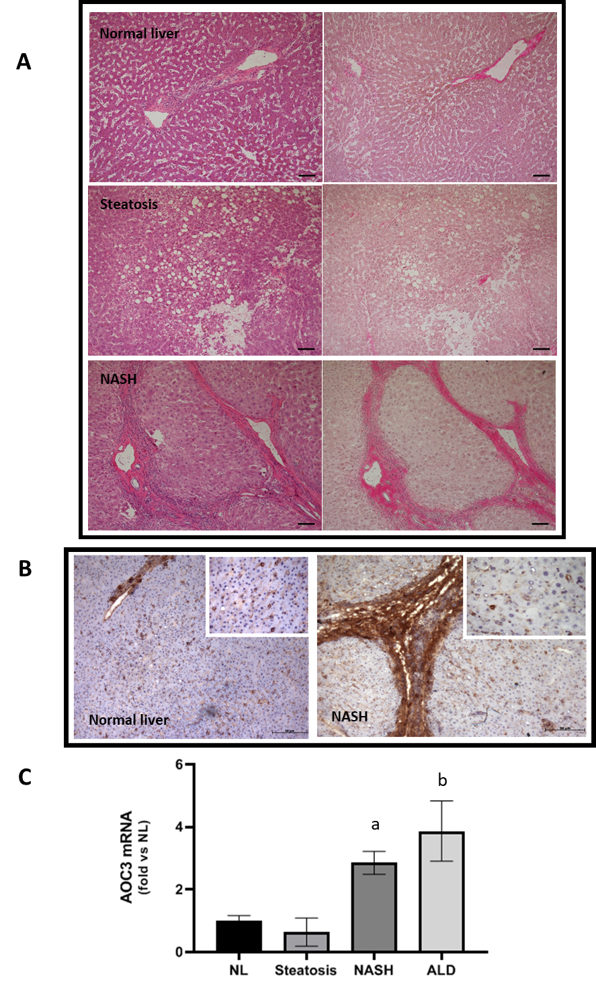
Figure 1 Hepatocellular expression of vascular adhesion protein-1 increases in nonalcoholic steatohepatitis. A: Representative brightfield images of sections from indicated disease types stained with Hematoxylin and Eosin (left panels) and Van Geison’s Stain (right panels). Original magnification 10 ×, images representative of multiple fields of view from n = 3 Livers of each disease type. Scale bar is 100 µmol/L; B Immunohistochemical staining for vascular adhesion protein-1 (VAP-1) in representative acetone fixed frozen sections from normal and nonalcoholic steatohepatitis (NASH) livers. Isotype matched control antibody was negative (not shown). Fields were captured at 10 × original magnification with inset pictures captured at 40 × original magnification; C: Analysis of VAP-1 (AOC3) expression by quantitative qPCR analysis. mRNA expression of AOC3 in whole liver RNA from normal, steatotic, NASH, and alcohol-related cirrhosis (ALD) livers using fluidigm qPCR array®, run on triplicate arrays. Results are expressed as the mean fold change in gene expression normalized to pooled endogenous controls β-actin and GAPDH relative to normal livers defined as 1 ± SEM with means from five normal l, four steatotic, three NASH, and four ALD livers. ªP < 0.05 or ^{b}P < 0.01 using a one way ANOVA with Bonferroni correction. NASH: nonalcoholic steatohepatitis; ALD: Alcohol-related cirrhosis.
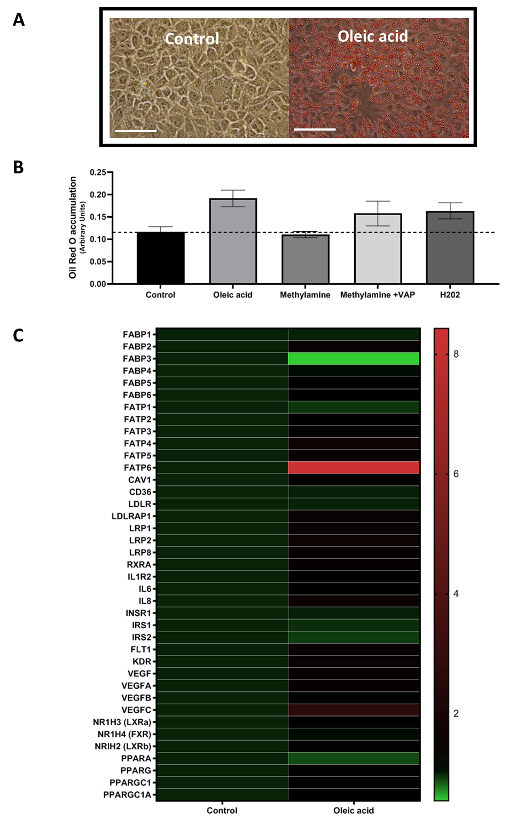
Figure 2 Exposure of Huh7.5 cells to products of vascular adhesion protein-1 enzyme activity leads to lipid accumulation and gene expression changes. A: Representative phase contrast images of confluent control Huh7.5 (left) or cells pretreated with 250 μm Oleic Acid for 6 h. All wells were fixed and stained with Oil Red O, and images were captured at 40 × original magnification (representative of n = 3 samples per condition). Bar is 50 mm; B: Quantification of oleic acid accumulation after vascular adhesion protein-1 (VAP-1) stimulation. Huh7.5 were pretreated with either methylamine (200 μm) alone, or in combination with recombinant VAP-1 (500 ng/mL) or H₂O₂ (10 μmol/L), for approximately 18 h. This was followed by incubation for 6 h with 250 μm OA. Cells were fixed and stained with Oil Red O and solubilized. Signal is expressed in arbitrary units. Data are mean ± SEM of triplicate experiments; C: Analysis of mRNA expression in HuH7.5 cells after exposure to oleic acid by quantitative qPCR analysis. mRNA expression for indicated genes was assessed using fluidigm qPCR array® according to manufacturer’s instructions. Data is expressed as fold changes in relative gene expression compared to pooled housekeeping genes in control (untreated cells). Data are representative of triplicate conditions run on triplicate gene array plates.
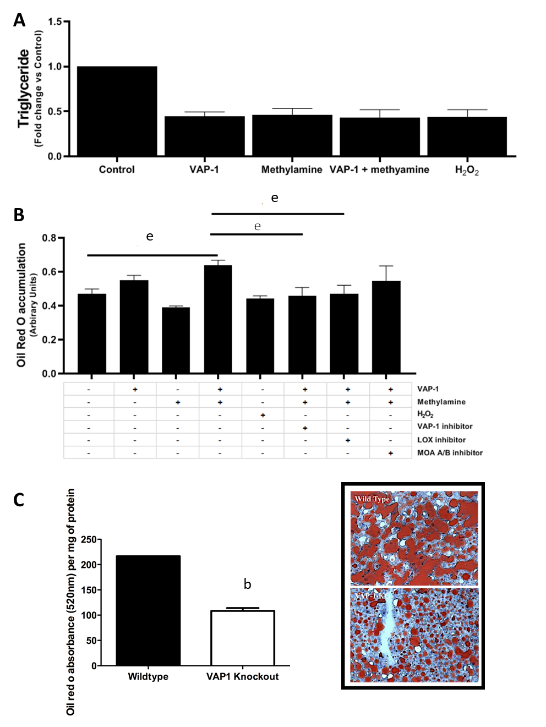
Figure 3 Activation of vascular adhesion protein-1 enzyme activity results in reduced triglyceride export and increased steatosis in human liver tissue and VAP-1/AOC3 knockout protects against high fat diet induced steatosis in mice. A: PCLS were pretreated with either, methylamine 200 μm, vascular adhesion protein-1 (VAP-1) 500 ng, H₂O₂ 10 μmol/L, or a combination of methylamine + VAP-1, benzylamine+VAP-1 for approximately 18 h and then 6 h with 250 μm fatty acid. Supernatants were collected after treatments and triglyceride secretion was quantified using a commercial assay (Cayman Chemical Company) according to manufacturer’s instructions. Data are triplicate samples from n = 2 normal livers ± SEM. P < 0.01 for all using a one way ANOVA; B: Lipid uptake in PCLS from normal liver tissue pretreated with either methylamine 200 μm, and rVAP1 500 ng/mL alone or in combination, or, H₂O₂ 10 μmol/L. Some slices were exposed to the combination of methylamine and VAP-1 plus selective enzyme inhibitors: Bromoethylamine (VAP-1 inhibitor 400 μm), β-aminopropionitrile (lysyl oxidase inhibitor, BAPN 250 μm) or the Monoamine oxidase A and B inhibitors Clorgylline and Pargylline (both at 200 μm). After approximately 18 h incubation, slices were exposed to 250 μm oleic acid for 6 h. PCLS were fixed and stained with Oil RedO, which was solubilized and signal normalized to per 500 mg of tissue. Data are mean of triplicate samples from n = 2 normal livers ± SEM. Significance expressed as ^{e}P < 0.001 in one way ANOVA with Tukeys correction for multiple comparisons; C: Left - Accumulation of lipid in WT and VAP-1 KO mice fed on a high fat diet for 12 wk. 7um cryosections from WT and VAP-1 KO mouse livers were stained with ORO, which was then solubilized and signal expressed relative to protein concentration for each group of mice, Data are mean ± SEM of three mice per group. Significance expressed as ^{b}P < 0.01 one way ANOVA. Right – representative brightfield microscopy images of Oil red O stained cryosections from WT and VAP-1 KO mice.
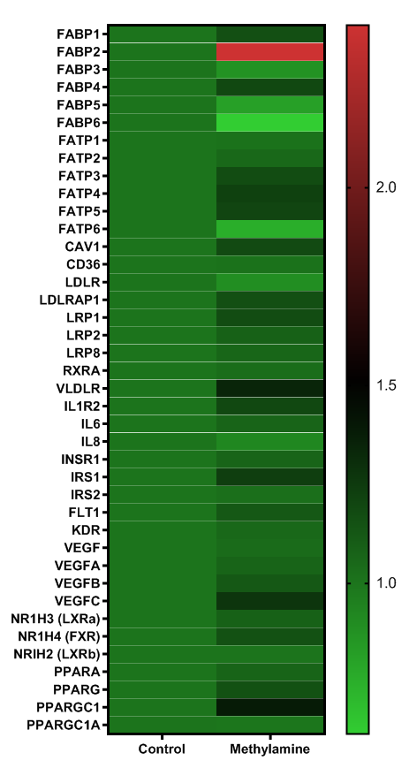
Figure 4 Exposure of precision-cut liver slices from human donor liver tissue cells to substrate for vascular adhesion protein-1 enzyme activity leads to gene expression changes. Precision-cut liver slices were treated with methylamine 200 μm for approximately 4.5 h. RNA was extracted and mRNA expression was carried out using a fluidigm qPCR array® run on triplicate arrays. Results are expressed as the mean fold change in gene expression normalized to pooled endogenous controls β-actin and GAPDH relative to untreated control livers. Data are indicative of triplicate arrays prepared from 2 donor livers.
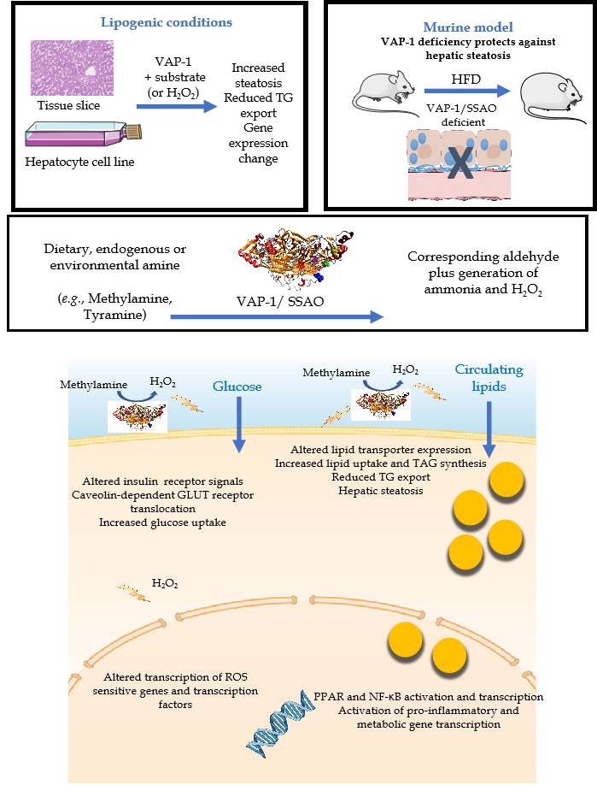
Figure 5 Graphical summary the impact of vascular adhesion protein-1 on the hepatic pathogenesis of non-alcoholic fatty liver disease. Exposure of human liver tissue or hepatocytes in culture to vascular adhesion protein-1 (VAP-1) in the presence of endogenous or exogenous (methylamine) substrate led to a reduction in TG export and increased steatosis. In tissue this was accompanied by changes in metabolic gene expression. VAP-1 deficient mice are protected against hepatic steatosis when fed a high fat diet. These findings can be explained by the enzymatic capacity of VAP-1 to reduce amine substrates to the corresponding aldehyde accompanied by generation of potent signaling molecules such as hydrogen peroxide. Addition of hydrogen peroxide to our culture systems recapitulated the effects of VAP-1 activation. Our previous studies suggest that increased inflammation, steatosis and fibrosis in the context of non-alcoholic fatty liver disease in part relate to the ability of VAP-1 to support leukocyte recruitment across endothelial cells, to prime hepatic glucose uptake and to activate hepatic stellate cells. We now show additional effects on transcription of key lipid transporter molecules and transcription factors. The upregulation of FABP4, FABP2, FATP3-5 and LRP1 along with the VLDLR which alter uptake and intracellular targeting of lipid molecules, Transport of fatty acids to the nucleus by receptors such as FABP2 will also activate nuclear receptors such as PPARs and NF-κB, hence influencing gene transcription. VAP-1: vascular adhesion protein-1; HFD: high fat diet.

