Name of Journal: World Journal of Gastroenterology

Manuscript NO: 38158

Manuscript Type: META-ANALYSIS

Application of enhanced recovery after gastric cancer surgery: An updated meta-analysis

Wang LH et al. Enhanced recovery after gastrectomy: A meta-analysis

Liu-Hua Wang, Ren-Fei Zhu, Cheng Gao, Shou-Lin Wang, Li-Zong Shen

Liu-Hua Wang, Ren-Fei Zhu, Cheng Gao, Li-Zong Shen, Division of Gastrointestinal Surgery, Department of General Surgery, First Affiliated Hospital, Nanjing Medical University, Nanjing 210029, Jiangsu Province, China

Liu-Hua Wang, Department of General Surgery, Yizheng People’s Hospital, Yangzhou 211400, Jiangsu Province, China

Shou-Lin Wang, School of Public Health, Nanjing Medical University, Nanjing 211166, Jiangsu Province, China

ORCID number: Liu-Hua Wang (0000-0003-1124-0707); Ren-Fei Zhu (0000-0003-1351-0096); Cheng Gao (0000-0001-5549-1327); Shou-Lin Wang (0000-0003-3070-7560); Li-Zong Shen (0000-0002-9046-6140).

Author contributions: Wang LH, Zhu RF and Gao C contributed equally to this work; Wang LH and Shen LZ conceived and designed the updated meta-analysis; Wang LH, Zhu RF and Gao C carried out the literature search, data extraction, statistical analysis and drafted this manuscript; Wang SL and Shen LZ were responsible for retrieval strategy, assessment of the risk of bias, and provided critical supervision and revision of this article; all authors conducted detailed review and revision for the data and approved the final version of the manuscript.

Supported by the National Natural Science Foundation of China, No. 81272711 to Shen LZ; the Priority Academic Program Development of Jiangsu Higher Education Institutions, No. JX10231801 to Shen LZ; and the Key Medical Talents Program of Jiangsu Province, No. ZDRCA2016014 to Shen LZ.

Conflict-of-interest statement: The authors declare that they have no conflict of interest.

PRISMA 2009 Checklist statement: All authors have read the PRISMA 2009 Checklist, and the manuscript was carefully prepared and revised based on the PRISMA 2009 Checklist.

Open-Access: This article is an open-access article which was selected by an in-house editor and fully peer-reviewed by external reviewers. It is distributed in accordance with the Creative Commons Attribution Non Commercial (CC BY-NC 4.0) license, which permits others to distribute, remix, adapt, build upon this work non-commercially, and license their derivative works on different terms, provided the original work is properly cited and the use is non-commercial. See: http://creativecommons.org/licenses/by-nc/4.0/

Manuscript source: Unsolicited manuscript

Correspondence to: Li-Zong Shen, MD, PhD, Chief Doctor, Professor, Division of Gastrointestinal Surgery, Department of General Surgery, First Affiliated Hospital, Nanjing Medical University, 300 Guangzhou Road, Nanjing 210029, Jiangsu Province, China. shenlz@njmu.edu.cn
Telephone: +86-25-83724440

Received: February 5, 2018
Peer-review started: February 6, 2018
First decision: February 26, 2018
Revised: March 3, 2018
Accepted: March 7, 2018
Article in press:
Published online:

Abstract
AIM
To provide an updated assessment of the safety and efficacy of enhanced recovery after surgery (ERAS) protocols in elective gastric cancer (GC) surgery.

METHODS
PubMed, Medline, EMBASE, WHO International Trial Register, and Cochrane Library were searched up to June 2017 for all available randomized controlled trials (RCTs) comparing ERAS protocols and standard care (SC) in GC surgery. Thirteen RCTs with a total of 1092 participants were analyzed in this study, of whom 545 underwent ERAS protocols and 547 received SC treatment.

RESULTS
No significant difference was observed between ERAS and control groups regarding total complications (P = 0.88), mortality (P = 0.50), and reoperation (P = 0.49). The incidence of pulmonary infection was significantly reduced (P = 0.03) following gastrectomy. However, the readmission rate after GC surgery nearly tripled under ERAS (P = 0.009). ERAS protocols significantly decreased the length of postoperative hospital stay (P < 0.00001) and medical costs (P < 0.00001), and accelerated bowel function recovery, as measured by earlier time to the first flatus (P = 0.0004) and the first defecation (P < 0.0001). Moreover, ERAS protocols were associated with a lower level of serum inflammatory response, higher serum albumin, and superior short-term quality of life (QOL).

CONCLUSION
Collectively, ERAS results in accelerated convalescence, reduction of surgical stress and medical costs, improved nutritional status, and better QOL for GC patients. However, high-quality multicenter RCTs with large samples and long-term follow-up are needed to more precisely evaluate ERAS in radical gastrectomy.

Key words: Enhanced recovery after surgery; Gastric cancer; Safety; Efficacy; Meta-analysis

© The Author(s) 2018. Published by Baishideng Publishing Group Inc. All rights reserved.

Core tip: Enhanced recovery after surgery (ERAS) has emerged as an optimal perioperative strategy for improving clinical outcomes in gastric cancer (GC) surgery. However, numerous controversies exist with regard to ERAS practice after gastrectomy. To our knowledge, this study is the largest meta-analysis of randomized controlled trials to date, incorporating 1092 participants, of whom 545 received ERAS protocols and 547 received standard care to assess the role of ERAS for radical gastrectomy. Our review clarified that ERAS results in accelerated convalescence, reduction of surgical stress and medical costs, improved nutritional status, and better quality of life for GC patients.

Wang LH, Zhu RF, Gao C, Wang SL, Shen LZ. Application of enhanced recovery after gastric cancer surgery: An updated meta-analysis. World J Gastroenterol 2018; In press

INTRODUCTION
Enhanced recovery after surgery (ERAS), or fast-track surgery program, which was pioneered by Kehlet and Wilmore in the late 1990s, intends to attenuate surgical stress and accelerate postoperative functional recovery^{[1,2]}. ERAS protocols involve a series of perioperative evidence-based interventions, the core elements of which include preoperative short fasting and carbohydrate-loaded fluids, intraoperative epidural anesthesia, minimally invasive procedures and fluid restriction, postoperative pain management, nutritional care, and early ambulation^{[3-5]}. Multimodal optimizing perioperative procedures were explored initially in the setting of elective colorectal resections, resulting in a significant reduction in overall hospital stay from 8-12 d to 2-5 d under the standard discharge criteria for conventional care^{[6,7]}. Since then, ERAS concepts have become widely recognized and applied gradually to clinical practice. Currently, accumulating evidence highlights that the implementation of ERAS protocols in multiple surgical disciplines significantly reduces morbidity and mortality, while improving clinical outcomes without compromising patient safety^{[8-10]}.
Gastric cancer (GC) remains a major health problem in China and worldwide, and radical gastrectomy remains the most likely approach to cure GC. However, conventional perioperative care is associated with a high risk of morbidity after radical surgery, ranging from 12.5% to 39%^{[11-13]}. Moreover, due to malnutrition of patients with gastric neoplasms and chronic comorbidities, perioperative mortality can reach up to 8.8%^{[14]}. Postoperative complications result in prolonged inflammatory response, which is considered to have a negative influence not only on the overall survival (OS) but also on the disease-specific mortality of patients undergoing gastrectomy, even if the carcinoma is radically resected^{[15]}. Given the strong evidence and recommendations for colorectal cancer, the application of ERAS protocols for gastrectomy procedures has been investigated in several studies^{[16-19]}. ERAS principles combined with laparoscopic treatment for GC lead to satisfactory clinical outcomes^{[20-22]}, even in elderly patients^{[23,24]}. Several meta-analyses have revealed that ERAS pathways in GC patients reduce the duration of hospital stay and medical costs without significantly increasing complications and hospital readmission^{[25-28]}, and the ERAS Society issued consensus guidelines for perioperative care after gastrectomy for elective GC in 2014^{[29]}.
However, there still remain numerous controversies, limitations, and difficulties in ERAS practice after gastrectomy. Following the recent publication of two related high-level randomized controlled trials (RCTs)^{[22,30]}, We conducted an updated systematic review and meta-analysis to thoroughly assess the safety and efficacy of ERAS application in GC patients.

MATERIALS AND METHODS
Literature search
A comprehensive literature search in PubMed, Medline, EMBASE, WHO International Trial Registry platform, and Cochrane Library until June 2017 was performed independently to identify all available publications comparing the ERAS program with standard perioperative care (SC) for GC patients undergoing gastrectomy. Medical Subject Headings (MeSH) terms and free text terms searched for individually and in combination were as follows: “fast track surgery” OR “accelerated rehabilitation” OR “enhanced recovery” OR “ERAS” OR “multimodal perioperative care” AND “gastric cancer” OR “stomach carcinoma” OR “gastrectomy” OR “gastric resection.” This search strategy was able to identify all potential publications involving humans, without language restriction. Reference lists of all eligible articles were also scrutinized to identify any other related studies. Furthermore, bibliographies of systematic reviews or meta-analyses on this issue were hand-searched for additional articles that the electronic retrieval failed to capture.

Inclusion and exclusion criteria
The inclusion criteria for this study were: (1) evaluation of ERAS in comparison with traditional standard care; (2) RCTs; (3) detailed patient data and outcomes available; (4) ERAS protocols composed of at least eight elements from consensus guidelines^{[29]}; and (5) followed up for at least 14 d after discharge. When more than one study reporting the same patient cohort was included in several publications, only the most recent or complete study was included.
The exclusion criteria were as follows: (1) non-comparative studies; (2) case-controlled trials, cohort studies, or retrospective studies; (3) applied less than eight items of ERAS; (4) no follow-up after discharge; and (5) other documentations that did not meet the inclusion criteria.

Study selection and data extraction
Following identification of citations from all potentially eligible studies, two investigators independently retrieved the full-text articles according to the inclusive criteria. Any discrepancies or divergences concerning inclusion were settled through discussion with a third reviewer until reaching consensus.
Data were extracted using a double-extraction method from each eligible study by the two investigators. Outcomes included morbidity, mortality, rates of readmission and reoperation, length of postoperative hospital stay (POHS), duration of flatus and defecation, medical costs, and postoperative inflammatory response and nutritional status, such as serum C-reactive protein (CRP), interleukin-6 (IL-6), and serum albumin (ALB) concentration.

Assessment of risk of bias
Another two investigators assessed separately the quality of identified RCTs using the criteria addressed in the Cochrane Collaboration^{[31]}. The evaluation indices contained several aspects across randomization, allocation concealment, blinding of participants and personnel, blinding of outcome assessment, incomplete outcome data, selective outcome reporting, and other bias. Risk of bias in each domain listed was graded as “high risk,” “low risk,” or “unclear.”

Statistical analysis
Statistical analysis was performed using the software package Review Manager Version 5.3.3 (Nordic Cochrane Centre, The Cochrane Collaboration, Copenhagen, Denmark) and STATA version 12 (Stata Corp LP, College Station, TX, United States). Pooled risk ratio (RR) with 95% confidence interval (CI) was utilized to analyze dichotomous data, while continuous data were analyzed as mean differences (MDs) with 95%CIs. Heterogeneity was evaluated using the Chi-square test, for which P < 0.1 was considered statistically significant. The I² value was used to quantify the impact of heterogeneity on each analysis. If the test of heterogeneity was statistically significant, the random-effects model was used; otherwise a fixed-effects model was used. When the study did not report specific values for mean and standard deviation (SD), these were estimated using median and range based on the methods previously described^{[32]}. In short, the median was used as a substitute for the mean. When the sample size was greater than 70, SD was estimated as range/6, and sample size was 15-69, SD was calculated as range/4. In the case where the interquartile range (IQR) was available, the range was estimated to be the median ± IQR.

RESULTS
Included studies
The flow chart for the selection of literature according to the predefined retrieval strategies is shown in Figure 1. Ten studies^{[21-24,30,33-37]} published between 2010 and 2017 met the inclusion criteria. Two studies^{[24,34]} consisted of four groups comparing ERAS protocols and standard care (SC) in laparoscopic or open radical gastrectomy, respectively, for stomach cancer, while another^{[23]} comprised four groups comparing ERAS protocols and SC in adults (aged 45-74 years) or elderly individuals (aged 75-89 years) undergoing open gastrectomy for GC. These three studies were considered to be six independent studies with reference to previous reports^{[26,28]}. Consequently, 13 RCTs from these ten studies were included in the current systematic review and meta-analysis.

Characteristics and methodological quality
The main characteristics of the included studies are detailed in Table 1. All studies were from a single center involving a total of 1092 participants, of whom 545 underwent the ERAS protocol and 547 received SC treatment. The sample size ranged from 41 to 256, and four studies contained more than 100 patients^{[22,23,30,33]}. Table 2 lists the relevant elements involved in these studies regarding the implementation of ERAS pathways based on the consensus conducted in RCTs. Surgical procedures for GC with curative intent involved proximal gastrectomy, distal gastrectomy, and total gastrectomy. These included studies were implemented predominantly in Asia (China, South Korea, and Japan). Assessment of the risk of bias across all included studies is presented in Figure 2, most of which were of moderate quality. Blinding was the main risk of bias among these RCTs, as it was not easy to comply with double blinding in such procedural trials.

Postoperative morbidity and short-term mortality
Total complications: No significant difference was demonstrated between ERAS and the control group in the 13 RCTs regarding the incidence of total complications following gastrectomy (RR: 1.03, 95%CI: 0.73-1.44, P = 0.88) (Figure 3, Table 3), but there was significant heterogeneity among these studies (χ² = 47.12, I² = 75%, P < 0.00001). In five RCTs reporting a laparoscopic approach for GC^{[21,22,24,34,35]}, no significant difference in postoperative morbidity was found between the ERAS and SC groups (RR: 1.44, 95%CI: 0.93-2.23, P = 0.10), and no heterogeneity was observed (χ² = 2.18, P = 0.70; I² = 0). Similarly, in the open surgery RCTs^{[23,24,33,34,36,37]}, ERAS pathways did not increase the surgical complications (RR: 1.05, 95%CI: 0.68-1.63, P = 0.81), and significant heterogeneity was observed (χ² = 31.10, P < 0.0001; I² = 81%). However, three RCTs in the elderly^{[23,24]} demonstrated that the incidence of complications was significantly higher in the ERAS arm than in the SC arm (RR: 1.45, 95%CI: 1.23-1.70, P < 0.00001), and no heterogeneity was found in the elderly (χ² = 1.51, P = 0.47; I² = 0).

Anastomotic leak: Ten RCTs^{[21-23,30,33,34,36,37]} (964 patients) provided data on anastomotic leaks, whereby 2.3% (11/481 patients) in the ERAS group and 1.7% (8/483) in the SC group had an anastomotic leak. Pooling the results indicated that ERAS did not increase the incidence of anastomotic leaks compared with conventional care (RR: 1.36, 95%CI: 0.54-3.45, P = 0.51) (Figure 3), and heterogeneity was excluded among these trials (χ² = 2.35, P = 0.50; I² = 0).

Ileus: Twelve RCTs^{[21-24,30,33,34,36,37]} (1048 patients) provided data regarding ileus: 3.3% (17/523 patients) in the ERAS group and 1.9% (10/525) in the SC group had ileus. Pooling the results indicated that ERAS did not increase ileus compared with standard care (RR: 1.62, 95%CI: 0.75-3.52, P = 0.22) (Figure 3), and no heterogeneity was observed among these trials (χ² = 5.76, P = 0.57; I² = 0).

Incision infection: Eleven RCTs^{[21-24,30,33,34,36,37]} (1007 patients) reported incision infection, amounting to 2.8% (14/504 patients) in the ERAS group and 3.6% (18/503) in the SC group. Pooling the results indicated that ERAS did not increase incision infection compared with conventional care (RR: 0.79, 95%CI: 0.39-1.60, P = 0.52) (Figure 3), and there was no heterogeneity among these studies (χ² = 4.52, P = 0.87; I² = 0).

Urinary tract infection: Nine RCTs^{[23,24,33-37]} (699 patients) provided data regarding urinary tract infection, which was observed in 2.6% (9/350 patients) in the ERAS group and 5.4% (19/349) in the SC group. Pooling the results indicated that ERAS did not increase urinary tract infection compared with conventional care (RR: 0.53, 95%CI: 0.26-1.08, P = 0.08) (Figure 3), and heterogeneity was excluded among these studies (χ² = 1.61, P = 0.99; I² = 0).

Pulmonary infection: Nine RCTs^{[23,24,30,33,34,37]} (775 patients) reported pulmonary infection, which affected 3.4% (13/387 patients) in the ERAS group and 7.2% (28/388) in the SC group. Pooling the results indicated that ERAS decreased significantly the incidence of pulmonary infection compared with conventional care (RR: 0.52, 95%CI: 0.28-0.94, P = 0.03) (Figure 3), and there was no heterogeneity among these studies (χ² = 1.09, P = 0.99; I² = 0).

Short-term mortality
All studies reported short-term mortality after GC surgery; one patient (1/64) died of severe abdominal cavity infection in the elderly group^{[23]}. No cases of death associated with surgery occurred in other studies during short-term follow-up. Pooling the results suggested that ERAS did not increase mortality compared with conventional care (RR: 3.0, 95%CI: 0.12-72.29, P = 0.50) (Figure 4).

Length of postoperative hospital stay
All included RCTs (1092 patients) reported POHS. Ten of these studies reported a significant reduction of POHS in the ERAS group, and three reported no significant difference. The elderly group in Bu’s report^{[23]}, the laparoscopic group in Chen Hu’s study^{[34]}, and the open group of Liu’s report^{[24]} demonstrated that patients receiving rapid rehabilitation care had POHS similar to that of the traditional care protocol. Meta-analysis revealed a significant reduction in POHS by 1.65 d with the application of the ERAS schemes compared with traditional perioperative care in pooled analysis (MD: -1.65, 95%CI: -2.09 to -1.21, P < 0.00001) (Figure 5), and the heterogeneity was significant among these studies (χ² = 105.17, P < 0.00001; I² = 89%). Laparoscopic surgery combined with ERAS^{[21,22,24,34,35]} markedly reduced POHS compared with laparoscopic surgery alone (MD: -1.49, 95%CI: -2.25 to -0.74, P < 0.0001), and the heterogeneity was significant (χ² = 18.21, P = 0.001; I² = 78%). Similarly, there was a significant reduction in POHS observed in open surgery with ERAS^{[23,24,33,34,36,37]} compared with open surgery alone (MD: -1.89, 95%CI: -2.69 to -1.09, P < 0.00001), and the heterogeneity was also significant (χ² = 61.54, P < 0.00001; I² = 90%).

Duration of intestinal function recovery
Eleven RCTs^{[23,24,30,33-37]} (882 patients) analyzed the duration of first flatus. Recovery of gut function was earlier in ERAS groups, as shown by shorter duration of the first flatus and first defecation. The MD for duration of first flatus was -12.70 (95%CI: -19.71 to -5.69, P = 0.0004), but the heterogeneity was significant among these studies (χ² = 119.74, I² = 92%, P < 0.0001) (Figure 6). In the patients undergoing laparoscopic gastrectomy^{[24,34,35]}, the duration of the first flatus of patients in the ERAS group was 7.20 h less than that in the control group (MD: -7.20, 95%CI: -11.70 to -2.70, P = 0.002), and there was no heterogeneity among these studies (χ² = 0.64, P = 0.73; I² = 0). Similarly, the first flatus was significantly earlier in the ERAS group than in the SC group (MD: -14.47, 95%CI: -23.61 to -5.33, P = 0.002) among patients undergoing open surgery^{[23,24,33,34,36,37]}, but the heterogeneity was significant (χ² = 116.69, P < 0.00001; I² = 94%). Four RCTs^{[21,22,30,33]} (471 patients) reported the duration of first defecation. The MD was -28.07 (95%CI: -41.48 to -14.67, P < 0.0001) (Figure 6), and there was significant heterogeneity among the studies (χ² = 30.21, P < 0.00001; I² = 90%).

Medical costs
Ten RCTs^{[23,24,30,33-35,37]} (819 patients) provided data regarding medical costs. The costs of hospitalization were reported in US dollars (USD) in one trial^{[37]}, Japanese yen in one trial^{[30]}, and Chinese RMB in six trials. All of the medical care expenses were converted to USD (http://www.xe.com) by use of the exchange rates of the aforementioned currencies on June 28, 2017. The medical costs were significantly lower with ERAS than with traditional care (MD: -5000 USD, 95%CI: -6900 to -3000, P < 0.00001) (Figure 7), and there was significant heterogeneity among trials by using the random-effects model (χ² = 59.55, P < 0.00001; I² = 85%). In laparoscopic groups^{[24,34,35]}, ERAS significantly decreased the medical costs compared with traditional care (MD: -5200 USD, 95%CI: -8000 to -2500, P = 0.0002), and the heterogeneity was significant (χ² = 5.58, P = 0.06; I² = 64%). Similarly, there was a significant reduction in medical costs in open surgery with ERAS^{[23,24,33,34,37]} compared with open surgery alone (MD: -5300, 95%CI: -8300 to -2300, P = 0.0005), and significant heterogeneity was observed (χ² = 37.63, P < 0.00001; I² = 87%).

Readmission
Eight RCTs^{[21,23,30,34-37]} (777 patients) reported data concerning the readmission rate after discharge, whereby 5.6% (22/390) from ERAS groups and 1.8% (7/387) from SC groups had to be readmitted. A higher readmission rate was perceived in the ERAS group than in the control group (RR: 2.86, 95%CI: 1.31-6.24, P = 0.009) (Figure 8). There was no significant heterogeneity observed among these studies (χ² = 1.44, P = 0.92; I²=0). However, sensitivity analysis showed no significant difference in readmission (RR: 2.17, 95%CI: 0.77-6.14, P = 0.14) when excluding the elderly group in Bu’s study^{[23]}, and no heterogeneity was observed (χ² = 0.85, P = 0.93; I² = 0).

Reoperation
Three RCTs^{[23,30,36]} (517 patients) reported reoperation rates after discharge. Two patients (0.8%) in ERAS groups and four patients (1.6%) in conventional protocol groups had to undergo reoperation because of serious complications including abdominal infection, intra-abdominal bleeding, and pancreatic ﬁstula. There was no statistical difference in the rate of reoperation between two groups (RR: 0.62, 95%CI: 0.17-2.35, P = 0.49) (Figure 8). Heterogeneity among these studies remained moderate (χ² = 3.01, P = 0.22; I² = 33%).

Inflammatory response indicators and nutritional status
Eight RCTs^{[22,24,34-37]} (514 patients) and four RCTs^{[24,36,37]} (239 patients) reported CRP and IL-6 levels after gastrectomy, respectively. As markers of surgical stress-associated response, levels of CRP and IL-6 were significantly elevated after surgery. Compared with patients in the conventional care group, a milder acute-phase response was detected in the ERAS group after gastrectomy. The pooled MD using a random-effects model for serum CRP was -14.81 (95%CI: -21.42 to -8.21, P < 0.0001), -19.81 (95%CI: -29.64 to -9.98, P < 0.0001), and -21.36 (95%CI: -28.81 to -13.91, P < 0.00001) on days 1, 4, and 7 after surgery, respectively (Figure 9), and significant heterogeneity was observed among these studies (I² = 72%, 64%, and 74% on day 1, 4, and 7 after surgery, respectively). The level of pooled MD for IL-6 was -61.22 (95%CI: -114.58 to -7.86, P = 0.02), -31.50 (95%CI: -55.63 to -7.38, P = 0.01), and -26.62 (95%CI: -34.23 to -19.01, P < 0.0001) on days 1, 4, and 7 after surgery, respectively (Figure 10), and there was a high degree of heterogeneity among these studies (I² = 99%, 96%, and 89% on day 1, 4, and 7 after surgery, respectively).
Four RCTs^{[24,32]} reported serum ALB. In general, ALB concentration dropped significantly compared with preoperative parameters. On postoperative day (POD) 1, there was no significant difference regarding the level of ALB between the ERAS and conventional care groups (MD 0.24, 95%CI: -0.89 to 1.36, P = 0.68) (Figure 11). On PODs 4 and 7, the level of ALB was higher in the ERAS group than in the control group (MD: 3.27, 95%CI: 2.24-4.30, P < 0.00001; MD: 5.68, 95%CI: 3.31-8.05, P < 0.00001, respectively). Mild heterogeneity was detected on POD 4 (χ² = 3.90, P = 0.27; I² = 23%). However, there was significant heterogeneity in the outcomes on POD 7 (χ² = 17.54, P = 0.0005; I² = 83%) (Figure 11).

Quality of life
Health-related QOL was reported in two trials^{[35,37]}. One trial checked health-related QOL with the European Organization for Research and Treatment of Cancer quality-of-life questionnaire (EORTCQLQ) C-30 and STO-22 at 14 d after discharge^{[35]}, while the other measured the QOL score using questionnaires at the time of discharge^{[37]}. A significant superiority was found in the fast-track surgery protocol group compared with the conventional care program group in terms of short-term QOL using the fixed-effects model. The pooled standardized MD was -0.46 (95%CI: -0.80 to -0.12, P = 0.008) (Figure 12), and there was a mild degree of heterogeneity in the outcomes (χ² = 1.56, P = 0.21; I² = 36%).

Publication bias
Potential publication bias was appraised graphically by using funnel plots, Begg’s test and Egger’s test. No obvious asymmetry was revealed by visual indication of the Begg’s funnel plot for postoperative total complications including all studies (Figure 13), and Begg’s test and Egger’s test indicated no significant bias was associated with publication for this meta-analysis (P = 0.55 and P = 0.435, respectively).

DISCUSSION
ERAS protocols have been gradually accepted as being able to optimize clinical outcomes, value, and experience for patients with GC^{[22-29]}. The present study is the largest meta-analysis to date, incorporating 13 RCTs enrolling 1092 participants, of whom 545 received ERAS protocols and 547 received SC for GC. Our results demonstrated that the optimized multimodal strategies significantly expedite bowel function recovery, shorten the length of POHS, and reduce medical costs, and that ERAS pathways maintain comparable total complications, reoperation rates, and mortality rates. The present analysis indicates that the implementation of ERAS approaches accelerates recovery, and is feasible and safe for patients with GC undergoing radical gastrectomy.
The core mechanism of ERAS is that multimodal interventions may lead to a major reduction in the undesirable sequelae of surgical injury, and stress-free surgery is the key goal of ERAS^{[1]}. Robust evidence suggested that ERAS played an important role in attenuating the surgical stress response and accelerating the return to baseline in colorectal cancer surgery^{[38,39]}, which was afforded eloquent proof in GC surgery. The inflammatory factors, such as CRP, IL-6, and tumor necrosis factor α, are related to the extent of tissue injury caused by surgery^{[40,41]}. In the present study, the ERAS approaches significantly reduced the concentration of CRP and IL-6 in comparison with SC on day 1, 4, and 7 after gastrectomy for GC, which was consistent with accelerated recovery. More importantly, our study suggests that the level of serum ALB after surgery in ERAS patients was significantly higher and steadier than that in SC patients, which fully demonstrates that the ERAS program could serve to improve the nutritional status of patients with GC. Good nutritional status and rapid rehabilitation after surgery allow patients to receive early postoperative multimodality therapy, including chemotherapy, thereby potentially improving their oncological outcome.
The main characteristic of ERAS is faster postoperative recovery and early discharge. However, it is noteworthy that this accelerated recovery does not come at the cost of increased medical expense. In our study, ten RCTs reported data on medical costs and identified a mean reduction of 5000 USD in the ERAS group. If the trial with mean and imputed SD were excluded, medical expenses would be reduced by 5300 USD. Therefore, implementation of ERAS appears to have an advantage when combining clinical efficacy and cost effectiveness, which is consistent with previous reports^{[42,43]}.
More importantly, our study shows that ERAS pathways increased the readmission rate for GC patients after gastrectomy, a radically different result from previous meta-analyses^{[25-27]}. However, sensitivity analysis, excluding the elderly patients in Bu’s study^{[23]}, indicated that there was no significant difference in readmission rates between ERAS and SC groups. To date, the evidence on the application of ERAS procedures in elderly patients with GC, especially if older than 75 years, is sparse. Only two RCTs have reported ERAS care in elderly patients with GC to date, and the age criterion for inclusion was inconsistent. Liu et al^{[24]} confirmed that the use of ERAS in elderly patients (60-80 years) was safe and feasible, effectively reducing the stress response, speeding up the recovery of intestinal function, and improving postoperative nutritional status without increasing the complications. However, Bu et al^{[23]} showed that implementation of the multimodal procedure in older patients (75-89 years) undergoing distal or total gastrectomy increased significantly the incidence of nausea and vomiting, gastric retention, and ileus, as well as the readmission rate, in comparison with the SC group. These inconsistent results may be due to inclusion of age criterion, surgical type, and element selection. The gerontal patients often experience underlying comorbidities and low physiological reserve, usually resulting in a high incidence of complications and delayed convalescence. Therefore, tailored perioperative care should be conducted in such a specific patient population. It was reported that a high degree of ERAS compliance was associated with fewer complications and shorter hospital stay^{[44,45]}. Feroci et al^{[46]} reported that male gender, advanced age (>75 years), and ASA grade 3 and above were correlated with lower compliance to enhanced recovery with specific reference to early removal of the urethral catheter, early oral feeding, and early ambulation in patients undergoing colorectal surgery. In our study, protocol compliance was only mentioned in studies by Feng et al^{[33]} and Liu et al^{[24]}. Whether the compliance of elderly GC patients with ERAS regimens affects the outcomes remains to be further investigated, although several studies have indicated that ERAS in colorectal surgery was safe and feasible, with postoperative outcomes similar to those of the younger group^{[47-49]}.
In our meta-analysis, two RCTs provided QOL data at the time of discharge^{[37]} or 14 d after discharge^{[35]}, whereby ERAS approaches showed significant superiority in QOL over SC groups. However, many investigators prefer postoperative recovery to assess the efficacy of ERAS, which begins at the time of surgery and is complete only when the patient returns (recovers) to their baseline function or to population norms^{[50]}. Therefore, functional status and QOL attracts more interest.
The introduction of laparoscopic surgery has dramatically lessened the impact of surgical traumas on patients and accelerated their recovery. In the past two decades，minimally invasive surgery and the implementation of ERAS have been considered two major revolutions in elective major abdominal surgery, both intending to minimize the surgical stress and improve patient outcomes^{[51]}. Meta-analyses of RCTs in laparoscopic colorectal surgery have demonstrated that application of the ERAS approaches is associated with fewer complications, faster recovery of bowel function, and shorter hospitalization, without increased readmissions^{[52,53]}. Laparoscopic surgery has been recommended in the guidelines for enhanced recovery after gastrectomy^{[29]}. In this study, we observed that laparoscopic surgery combined with ERAS markedly reduced POHS and medical costs, and speeded up the return of intestinal function in patients with GC; however, laparoscopic surgery with ERAS did not increase total complications compared with laparoscopic surgery alone.
There are undoubtedly several limitations in the present study. First, several included RCTs were smaller in size, although the total sample size of the study was greater than 1000, and a multicenter trial was lacking. Second, among the included studies there was considerable heterogeneity. No remarkable heterogeneity was found with regard to the incidence of complications (including anastomotic leaks, ileus, incision infection, urinary tract infection, and pulmonary infection), rates of readmission and reoperation, and postoperative serum ALB level (POD1 and POD4) and QOL. However, there was significant heterogeneity for overall complications, POHS, intestinal function recovery, medical costs, and inflammatory response indicators (I² = 64-99%). This substantial heterogeneity may be attributable to the clinical heterogeneity, including technical status of each institution, inclusion criteria, surgical approach, inconsistent evaluation of the outcomes, and ERAS elements used. Third, most studies excluded patients receiving neoadjuvant chemotherapy, which may increase the potential bias to a certain extent.
In conclusion, this updated meta-analysis and systematic review provide a comprehensive assessment of ERAS following gastrectomy, and demonstrates that ERAS protocols lead to accelerated recovery, reduction of surgical stress and medical costs, improved nutritional status, and better health-related QOL for GC patients. However, it appears to be associated with increased readmission rates. Further high-quality, large-sample, multicenter RCTs with long-term follow-up are needed to more precisely evaluate ERAS pathways in GC surgery.

ARTICLE HIGHLIGHTS
Research background
Enhanced recovery after surgery (ERAS) has emerged as an optimal perioperative strategy for improving clinical outcomes in elective gastric cancer (GC) surgery. However, numerous controversies exist with regard to ERAS practice after radical gastrectomy.

Research motivation
Accumulating studies highlights that implementation of ERAS protocols reduces overall hospital stay, morbidity and mortality significantly, without compromising patient safety in multiple surgical disciplines. However, the safety and feasibility of applying ERAS in its current form in radical gastrectomy still remains to be proven by performing an updated meta-analysis.

Research objectives
This meta-analysis aims to provide an updated assessment of the safety and efficacy of ERAS protocols in GC surgery.

Research methods
A comprehensive literature search in PubMed, Medline, EMBASE, WHO International Trial Registry platform, and Cochrane Library until June 2017 was performed independently to identify all available randomized controlled trials (RCTs) comparing the ERAS program with standard perioperative care (SC) in GC surgery. Non-comparative studies, case-controlled trials, cohort studies, retrospective studies, items of ERAS applied less than four, and no follow-up after discharge were excluded.

Research results
Thirteen RCTs with a total of 1092 participants were analyzed in this study, of whom 545 underwent ERAS protocols and 547 received SC treatment. ERAS protocols significantly decreased the length of postoperative hospital stay and medical costs, and accelerated bowel function recovery. Moreover, ERAS protocols were associated with a lower level of serum inflammatory response, higher serum albumin, and superior short-term quality of life (QOL). There were no significant differences regarding the incidence of total complications, mortality and reoperation following gastrectomy. However, the readmission rate after GC surgery nearly tripled under ERAS.

Research conclusions
ERAS results in accelerated convalescence, reduction of surgical stress and medical costs, improved nutritional status, and better QOL for GC patients, but increased the readmission rate. Furthermore, the significant heterogeneity of some results is a major limitation of this study. ERAS investigators need to proceed with caution as far as ERAS is concerned beyond colorectal cancer surgery.

Research perspectives
This study provides an updated assessment of ERAS in GC surgery and is expected to provide guidance and reference for clinical practice, and also provide high-level evidence for evidence-based medicine. High-quality multicenter RCTs with large samples and long-term follow-up are needed to more precisely evaluate ERAS in radical gastrectomy.

ACKNOWLEDGMENTS
We would like to thank Dr. Mu-long Du, a member of the Biostatistic Service from the School of Public Health, Nanjing Medical University for reviewing the statistical methods in this study.

REFERENCES
1 Kehlet H. Multimodal approach to control postoperative pathophysiology and rehabilitation. Br J Anaesth 1997; 78: 606-617 [PMID: 9175983]
2 Wilmore DW, Kehlet H. Management of patients in fast track surgery. BMJ 2001; 322: 473-476 [PMID: 11222424]
3 Lassen K, Soop M, Nygren J, Cox PB, Hendry PO, Spies C, von Meyenfeldt MF, Fearon KC, Revhaug A, Norderval S, Ljungqvist O, Lobo DN, Dejong CH; Enhanced Recovery After Surgery (ERAS) Group. Consensus review of optimal perioperative care in colorectal surgery: Enhanced Recovery After Surgery (ERAS) Group recommendations. Arch Surg 2009; 144: 961-969 [PMID: 19841366 DOI: 10.1001/archsurg.2009.170]
4 Ramírez JM, Blasco JA, Roig JV, Maeso-Martínez S, Casal JE, Esteban F, Lic DC; Spanish working group on fast track surgery. Enhanced recovery in colorectal surgery: a multicentre study. BMC Surg 2011; 11: 9 [PMID: 21489315 DOI: 10.1186/1471-2482-11-9]
5 Kehlet H. Fast-track colonic surgery: status and perspectives. Recent Results Cancer Res 2005; 165: 8-13 [PMID: 15865015]
6 Kehlet H. Fast-track colorectal surgery. Lancet 2008; 371: 791-793 [PMID: 18328911 DOI: 10.1016/S0140-6736(08)60357-8]
7 Kehlet H, Dahl JB. Anaesthesia, surgery, and challenges in postoperative recovery. Lancet 2003; 362: 1921-1928 [PMID: 14667752 DOI: 10.1016/S0140-6736(03)14966-5]
8 Faucheron JL, Trilling B. Laparoscopy in combination with fast-track management is the best surgical strategy in patients undergoing colorectal resection for cancer. Tech Coloproctol 2015; 19: 379-380 [PMID: 25995151 DOI: 10.1007/s10151-015-1309-2]
9 Muallem MZ, Dimitrova D, Pietzner K, Richter R, Feldheiser A, Scharfe I, Schmeil I, Hösl TM, Mustea A, Wimberger P, Burges A, Kimmig R, Sehouli J. Implementation of Enhanced Recovery After Surgery (ERAS) Pathways in Gynecologic Oncology. A NOGGO-AGO* survey of 144 Gynecological Departments in Germany. Anticancer Res 2016; 36: 4227-4232 [PMID: 27466536]
10 Auyong DB, Allen CJ, Pahang JA, Clabeaux JJ, MacDonald KM, Hanson NA. Reduced Length of Hospitalization in Primary Total Knee Arthroplasty Patients Using an Updated Enhanced Recovery After Orthopedic Surgery (ERAS) Pathway. J Arthroplasty 2015; 30: 1705-1709 [PMID: 26024988 DOI: 10.1016/j.arth.2015.05.007]
11 Bösing NM, Goretzki PE, Röher HD. Gastric cancer: which patients benefit from systematic lymphadenectomy? Eur J Surg Oncol 2000; 26: 498-505 [PMID: 11016473 DOI: 10.1053/ejso.1999.0930]
12 Sano T, Sasako M, Yamamoto S, Nashimoto A, Kurita A, Hiratsuka M, Tsujinaka T, Kinoshita T, Arai K, Yamamura Y, Okajima K. Gastric cancer surgery: morbidity and mortality results from a prospective randomized controlled trial comparing D2 and extended para-aortic lymphadenectomy--Japan Clinical Oncology Group study 9501. J Clin Oncol 2004; 22: 2767-2773 [PMID: 15199090 DOI: 10.1200/JCO.2004.10.184]
13 Kim HH, Han SU, Kim MC, Hyung WJ, Kim W, Lee HJ, Ryu SW, Cho GS, Song KY, Ryu SY. Long-term results of laparoscopic gastrectomy for gastric cancer: a large-scale case-control and case-matched Korean multicenter study. J Clin Oncol 2014; 32: 627-633 [PMID: 24470012 DOI: 10.1200/JCO.2013.48.8551]
14 Damhuis RA, Wijnhoven BP, Plaisier PW, Kirkels WJ, Kranse R, van Lanschot JJ. Comparison of 30-day, 90-day and in-hospital postoperative mortality for eight different cancer types. Br J Surg 2012; 99: 1149-1154 [PMID: 22718521 DOI: 10.1002/bjs.8813]
15 Kubota T, Hiki N, Sano T, Nomura S, Nunobe S, Kumagai K, Aikou S, Watanabe R, Kosuga T, Yamaguchi T. Prognostic significance of complications after curative surgery for gastric cancer. Ann Surg Oncol 2014; 21: 891-898 [PMID: 24254205 DOI: 10.1245/s10434-013-3384-9]
16 Grantcharov TP, Kehlet H. Laparoscopic gastric surgery in an enhanced recovery programme. Br J Surg 2010; 97: 1547-1551 [PMID: 20665480 DOI: 10.1002/bjs.7184]
17 Yamada T, Hayashi T, Cho H, Yoshikawa T, Taniguchi H, Fukushima R, Tsuburaya A. Usefulness of enhanced recovery after surgery protocol as compared with conventional perioperative care in gastric surgery. Gastric Cancer 2012; 15: 34-41 [PMID: 21573918 DOI: 10.1007/s10120-011-0057-x]
18 Yamada T, Hayashi T, Aoyama T, Shirai J, Fujikawa H, Cho H, Yoshikawa T, Rino Y, Masuda M, Taniguchi H, Fukushima R, Tsuburaya A. Feasibility of enhanced recovery after surgery in gastric surgery: a retrospective study. BMC Surg 2014; 14: 41 [PMID: 25001198 DOI: 10.1186/1471-2482-14-41]
19 Liu XX, Pan HF, Jiang ZW, Zhang S, Wang ZM, Chen P, Zhao Y, Wang G, Zhao K, Li JS. "Fast-track" and "Minimally Invasive" Surgery for Gastric Cancer. Chin Med J (Engl) 2016; 129: 2294-2300 [PMID: 27647187 DOI: 10.4103/0366-6999.190659]
20 Fang F, Gao J, Bi X, Han F, Wang HJ. Effect and clinical significance of fast-track surgery combined with laparoscopic radical gastrectomy on the plasma level of vascular endothelial growth factor in gastric antrum cancer. Springerplus 2016; 5: 50 [PMID: 26835230 DOI: 10.1186/s40064-016-1699-2]
21 Abdikarim I, Cao XY, Li SZ, Zhao YQ, Taupyk Y, Wang Q. Enhanced recovery after surgery with laparoscopic radical gastrectomy for stomach carcinomas. World J Gastroenterol 2015; 21: 13339-13344 [PMID: 26715818 DOI: 10.3748/wjg.v21.i47.13339]
22 Mingjie X, Luyao Z, Ze T, YinQuan Z, Quan W. Laparoscopic Radical Gastrectomy for Resectable Advanced Gastric Cancer Within Enhanced Recovery Programs: A Prospective Randomized Controlled Trial. J Laparoendosc Adv Surg Tech A 2017; 27: 959-964 [PMID: 27875094 DOI: 10.1089/lap.2016.0057]
23 Bu J, Li N, Huang X, He S, Wen J, Wu X. Feasibility of Fast-Track Surgery in Elderly Patients with Gastric Cancer. J Gastrointest Surg 2015; 19: 1391-1398 [PMID: 25943912 DOI: 10.1007/s11605-015-2839-7]
24 Liu G, Jian F, Wang X, Chen L. Fast-track surgery protocol in elderly patients undergoing laparoscopic radical gastrectomy for gastric cancer: a randomized controlled trial. Onco Targets Ther 2016; 9: 3345-3351 [PMID: 27330314 DOI: 10.2147/OTT.S107443]
25 Chen ZX, Liu AH, Cen Y. Fast-track program vs traditional care in surgery for gastric cancer. World J Gastroenterol 2014; 20: 578-583 [PMID: 24574728 DOI: 10.3748/wjg.v20.i2.578]
26 Beamish AJ, Chan DS, Blake PA, Karran A, Lewis WG. Systematic review and meta-analysis of enhanced recovery programmes in gastric cancer surgery. Int J Surg 2015; 19: 46-54 [PMID: 26004350 DOI: 10.1016/j.ijsu.2015.05.021]
27 Chen S, Zou Z, Chen F, Huang Z, Li G. A meta-analysis of fast track surgery for patients with gastric cancer undergoing gastrectomy. Ann R Coll Surg Engl 2015; 97: 3-10 [PMID: 25519256 DOI: 10.1308/rcsann.2015.97.1.3]
28 Ding J, Sun B, Song P, Liu S, Chen H, Feng M, Guan W. The application of enhanced recovery after surgery (ERAS)/fast-track surgery in gastrectomy for gastric cancer: a systematic review and meta-analysis. Oncotarget 2017; 8: 75699-75711 [PMID: 29088903 DOI: 10.18632/oncotarget.18581]
29 Mortensen K, Nilsson M, Slim K, Schäfer M, Mariette C, Braga M, Carli F, Demartines N, Griffin SM, Lassen K; Enhanced Recovery After Surgery (ERAS®) Group. Consensus guidelines for enhanced recovery after gastrectomy: Enhanced Recovery After Surgery (ERAS®) Society recommendations. Br J Surg 2014; 101: 1209-1229 [PMID: 25047143 DOI: 10.1002/bjs.9582]
30 Tanaka R, Lee SW, Kawai M, Tashiro K, Kawashima S, Kagota S, Honda K, Uchiyama K. Protocol for enhanced recovery after surgery improves short-term outcomes for patients with gastric cancer: a randomized clinical trial. Gastric Cancer 2017; 20: 861-871 [PMID: 28062937 DOI: 10.1007/s10120-016-0686-1]
31 Higgins JP, Altman DG, Gøtzsche PC, Jüni P, Moher D, Oxman AD, Savovic J, Schulz KF, Weeks L, Sterne JA; Cochrane Bias Methods Group; Cochrane Statistical Methods Group. The Cochrane Collaboration's tool for assessing risk of bias in randomised trials. BMJ 2011; 343: d5928 [PMID: 22008217]
32 Hozo SP, Djulbegovic B, Hozo I. Estimating the mean and variance from the median, range, and the size of a sample. BMC Med Res Methodol 2005; 5: 13 [PMID: 15840177 DOI: 10.1186/1471-2288-5-13]
33 Feng F, Ji G, Li JP, Li XH, Shi H, Zhao ZW, Wu GS, Liu XN, Zhao QC. Fast-track surgery could improve postoperative recovery in radical total gastrectomy patients. World J Gastroenterol 2013; 19: 3642-3648 [PMID: 23801867 DOI: 10.3748/wjg.v19.i23.3642]
34 Chen Hu J, Xin Jiang L, Cai L, Tao Zheng H, Yuan Hu S, Bing Chen H, Chang Wu G, Fei Zhang Y, Chuan Lv Z. Preliminary experience of fast-track surgery combined with laparoscopy-assisted radical distal gastrectomy for gastric cancer. J Gastrointest Surg 2012; 16: 1830-1839 [PMID: 22854954 DOI: 10.1007/s11605-012-1969-4]
35 Kim JW, Kim WS, Cheong JH, Hyung WJ, Choi SH, Noh SH. Safety and efficacy of fast-track surgery in laparoscopic distal gastrectomy for gastric cancer: a randomized clinical trial. World J Surg 2012; 36: 2879-2887 [PMID: 22941233 DOI: 10.1007/s00268-012-1741-7]
36 Liu XX, Jiang ZW, Wang ZM, Li JS. Multimodal optimization of surgical care shows beneficial outcome in gastrectomy surgery. JPEN J Parenter Enteral Nutr 2010; 34: 313-321 [PMID: 20467014 DOI: 10.1177/0148607110362583]
37 Wang D, Kong Y, Zhong B, Zhou X, Zhou Y. Fast-track surgery improves postoperative recovery in patients with gastric cancer: a randomized comparison with conventional postoperative care. J Gastrointest Surg 2010; 14: 620-627 [PMID: 20108171 DOI: 10.1007/s11605-009-1139-5]
38 Ren L, Zhu D, Wei Y, Pan X, Liang L, Xu J, Zhong Y, Xue Z, Jin L, Zhan S, Niu W, Qin X, Wu Z, Wu Z. Enhanced Recovery After Surgery (ERAS) program attenuates stress and accelerates recovery in patients after radical resection for colorectal cancer: a prospective randomized controlled trial. World J Surg 2012; 36: 407-414 [PMID: 22102090 DOI: 10.1007/s00268-011-1348-4]
39 Carli F. Physiologic considerations of Enhanced Recovery After Surgery (ERAS) programs: implications of the stress response. Can J Anaesth 2015; 62: 110-119 [PMID: 25501695 DOI: 10.1007/s12630-014-0264-0]
40 Feng J, Li K, Li L, Wang X, Huang M, Yang J, Hu Y. The effects of fast-track surgery on inflammation and immunity in patients undergoing colorectal surgery. Int J Colorectal Dis 2016; 31: 1675-1682 [PMID: 27517680 DOI: 10.1007/s00384-016-2630-6]
41 Mari G, Crippa J, Costanzi A, Mazzola M, Rossi M, Maggioni D. ERAS Protocol Reduces IL-6 Secretion in Colorectal Laparoscopic Surgery: Results From a Randomized Clinical Trial. Surg Laparosc Endosc Percutan Tech 2016; 26: 444-448 [PMID: 27783027 DOI: 10.1097/SLE.0000000000000324]
42 Stowers MD, Lemanu DP, Hill AG. Health economics in Enhanced Recovery After Surgery programs. Can J Anaesth 2015; 62: 219-230 [PMID: 25391739 DOI: 10.1007/s12630-014-0272-0]
43 Nelson G, Kiyang LN, Chuck A, Thanh NX, Gramlich LM. Cost impact analysis of Enhanced Recovery After Surgery program implementation in Alberta colon cancer patients. Curr Oncol 2016; 23: e221-e227 [PMID: 27330358 DOI: 10.3747/co.23.2980]
44 ERAS Compliance Group.. The Impact of Enhanced Recovery Protocol Compliance on Elective Colorectal Cancer Resection: Results From an International Registry. Ann Surg 2015; 261: 1153-1159 [PMID: 25671587 DOI: 10.1097/SLA.0000000000001029]
45 Alcántara-Moral M, Serra-Aracil X, Gil-Egea MJ, Frasson M, Flor-Lorente B, Garcia-Granero E; E.B.S.Q.-C on behalf of the collaborative Group of Coloproctology Section of The Spanish Association of Surgeons. Observational cross-sectional study of compliance with the fast track protocol in elective surgery for colon cancer in Spain. Int J Colorectal Dis 2014; 29: 477-483 [PMID: 24435243 DOI: 10.1007/s00384-013-1825-3]
46 Feroci F, Lenzi E, Baraghini M, Garzi A, Vannucchi A, Cantafio S, Scatizzi M. Fast-track surgery in real life: how patient factors influence outcomes and compliance with an enhanced recovery clinical pathway after colorectal surgery. Surg Laparosc Endosc Percutan Tech 2013; 23: 259-265 [PMID: 23751989 DOI: 10.1097/SLE.0b013e31828ba16f]
47 Bardram L, Funch-Jensen P, Kehlet H. Rapid rehabilitation in elderly patients after laparoscopic colonic resection. Br J Surg 2000; 87: 1540-1545 [PMID: 11091243 DOI: 10.1046/j.1365-2168.2000.01559.x]
48 Pawa N, Cathcart PL, Arulampalam TH, Tutton MG, Motson RW. Enhanced recovery program following colorectal resection in the elderly patient. World J Surg 2012; 36: 415-423 [PMID: 22146943 DOI: 10.1007/s00268-011-1328-8]
49 Baek SJ, Kim SH, Kim SY, Shin JW, Kwak JM, Kim J. The safety of a "fast-track" program after laparoscopic colorectal surgery is comparable in older patients as in younger patients. Surg Endosc 2013; 27: 1225-1232 [PMID: 23232990 DOI: 10.1007/s00464-012-2579-7]
50 Neville A, Lee L, Antonescu I, Mayo NE, Vassiliou MC, Fried GM, Feldman LS. Systematic review of outcomes used to evaluate enhanced recovery after surgery. Br J Surg 2014; 101: 159-170 [PMID: 24469616 DOI: 10.1002/bjs.9324]
51 Feldman LS, Delaney CP. Laparoscopy plus enhanced recovery: optimizing the benefits of MIS through SAGES 'SMART' program. Surg Endosc 2014; 28: 1403-1406 [PMID: 24651892 DOI: 10.1007/s00464-013-3415-4]
52 Lei QC, Wang XY, Zheng HZ, Xia XF, Bi JC, Gao XJ, Li N. Laparoscopic Versus Open Colorectal Resection Within Fast Track Programs: An Update Meta-Analysis Based on Randomized Controlled Trials. J Clin Med Res 2015; 7: 594-601 [PMID: 26124904 DOI: 10.14740/jocmr2177w]
53 Zhao JH, Sun JX, Huang XZ, Gao P, Chen XW, Song YX, Liu J, Cai CZ, Xu HM, Wang ZN. Meta-analysis of the laparoscopic versus open colorectal surgery within fast track surgery. Int J Colorectal Dis 2016; 31: 613-622 [PMID: 26732262 DOI: 10.1007/s00384-015-2493-2]
P-Reviewer: Aoyagi K, Bona S, Dai ZJ, Muhammad JS
S-Editor: Wang XJ L-Editor: E-Editor:

Specialty type: Gastroenterology and hepatology
Country of origin: China
Peer-review report classification
Grade A (Excellent): 0
Grade B (Very good): B, B
Grade C (Good): C, C
Grade D (Fair): 0
Grade E (Poor): 0

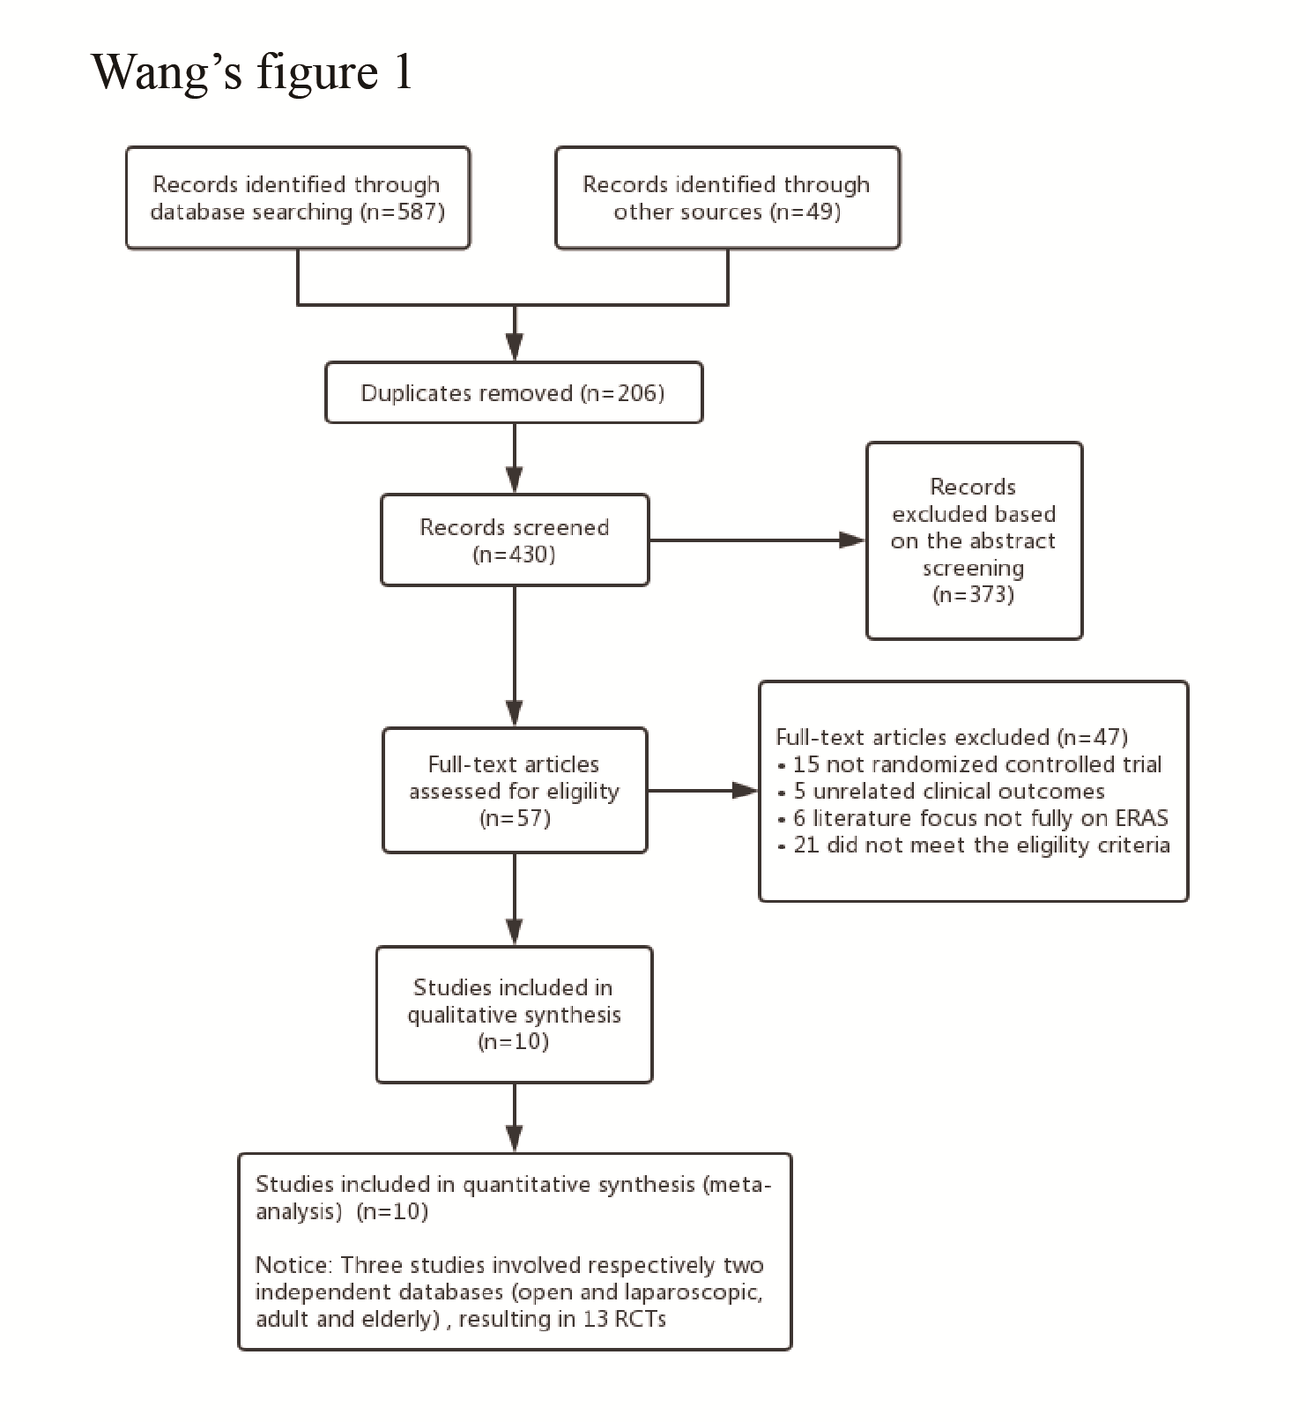
Figure 1 Study flow diagram: enhanced recovery after surgery in gastric cancer. ERAS: Enhanced recovery after surgery; RCTs: Randomized controlled trials.

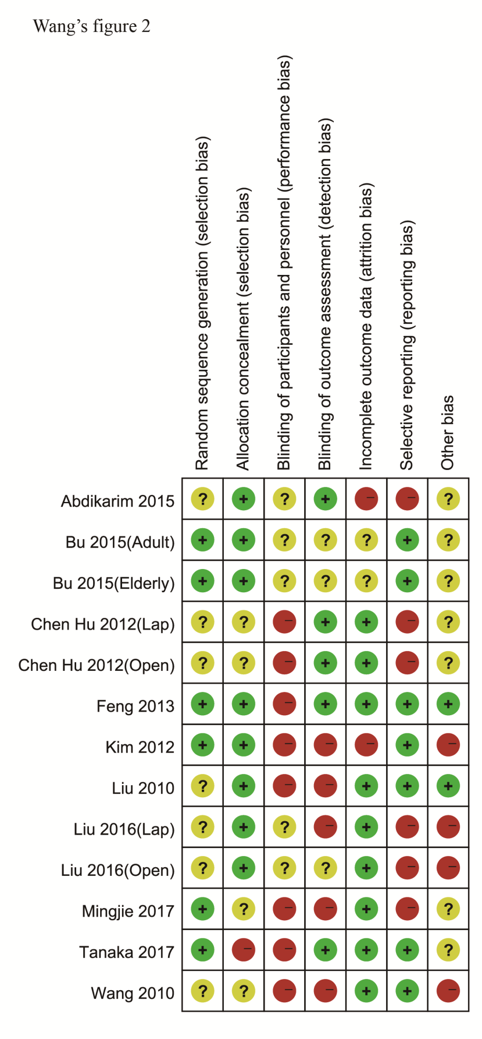
Figure 2 Risk of bias summary: Review of authors' judgments concerning each risk-of-bias item for each included study.

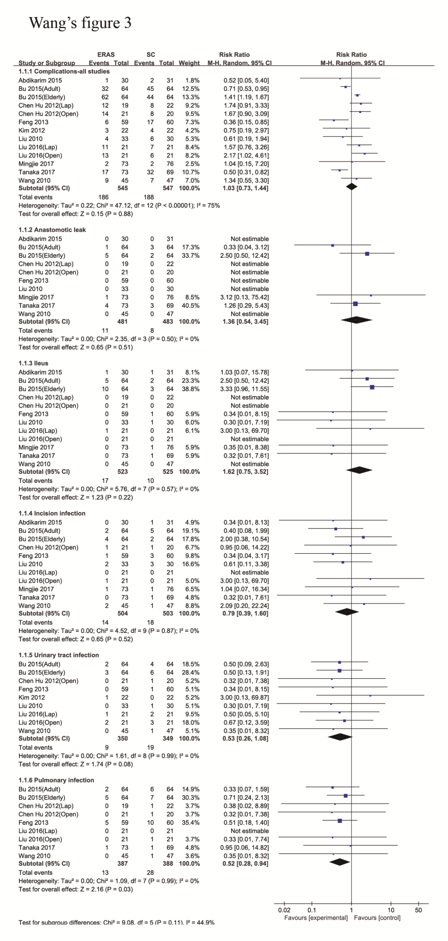
Figure 3 Forest plot evaluating the relative risk of surgical complications: Enhanced recovery after surgery vs standard care.

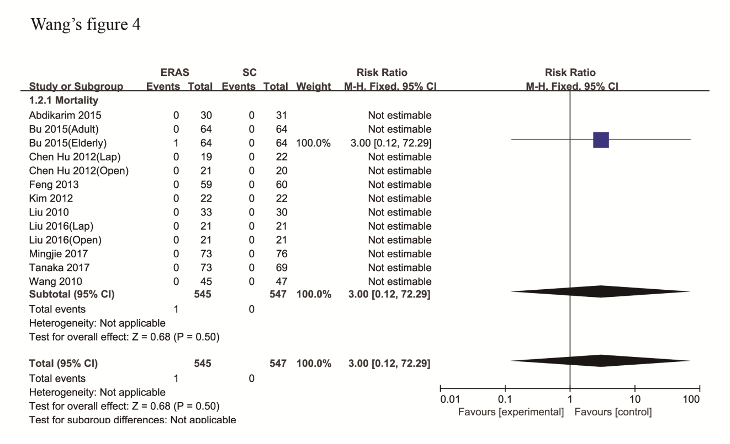
Figure 4 Forest plot evaluating the relative risk of short-term mortality: Enhanced recovery after surgery vs standard care.

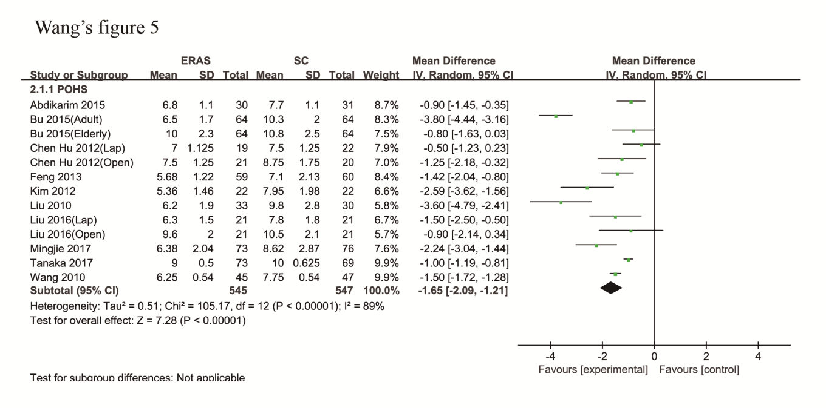
Figure 5 Forest plot evaluating the length of postoperative hospital stay: Enhanced recovery after surgery vs standard care.

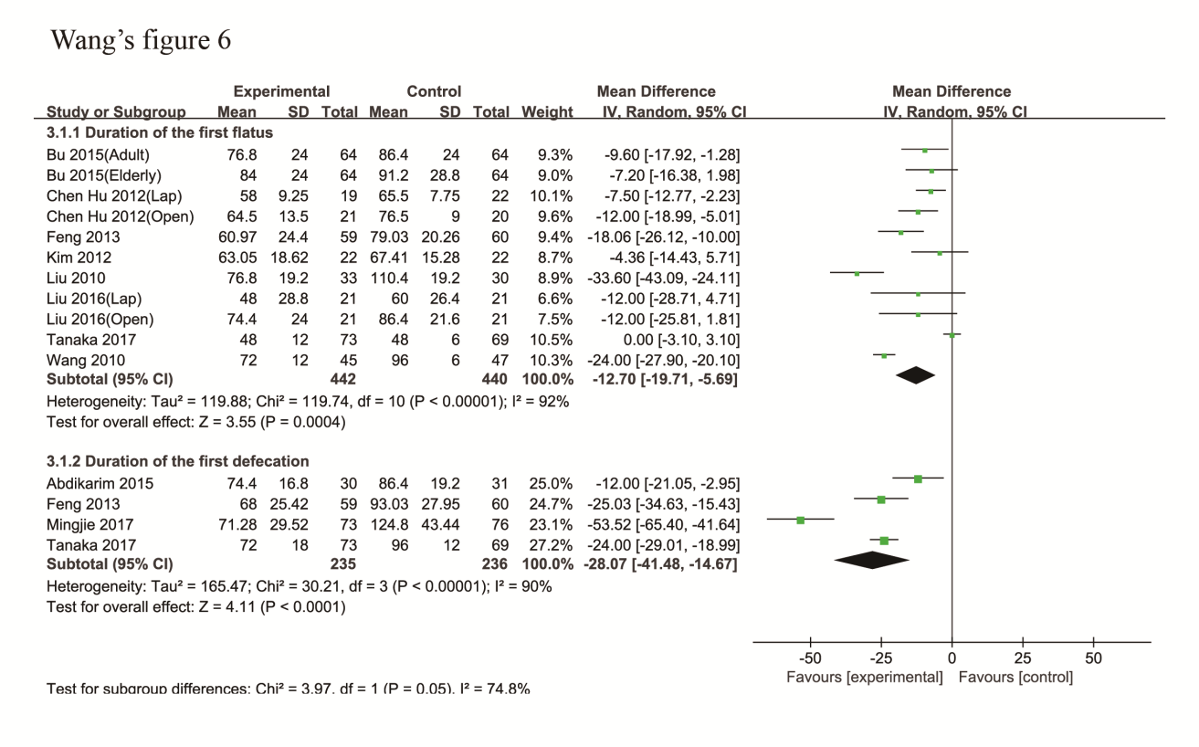
Figure 6 Forest plot evaluating the duration of intestinal function recovery: Enhanced recovery after surgery vs standard care.

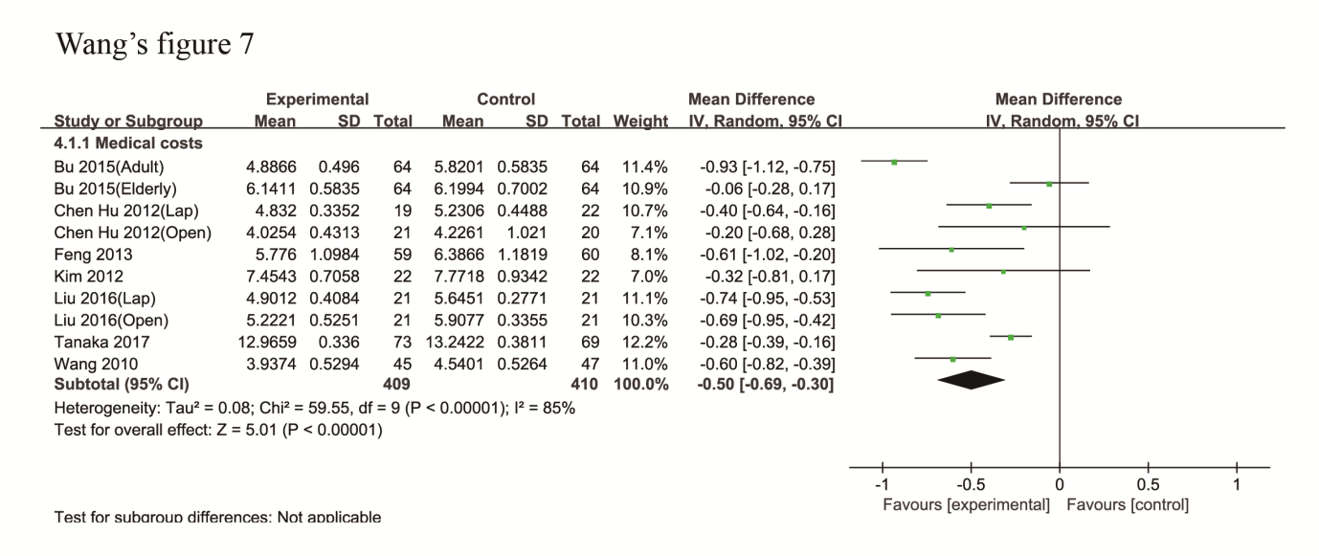
Figure 7 Forest plot evaluating the difference in total medical costs: Enhanced recovery after surgery vs standard care.

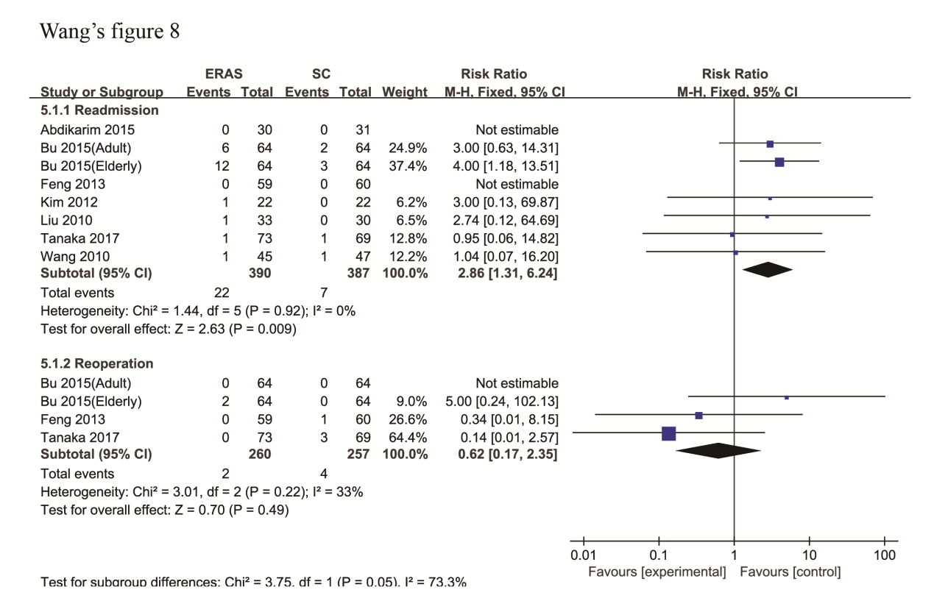
Figure 8 Forest plot evaluating the incidence of readmission and reoperation within 30 d: Enhanced recovery after surgery vs standard care.

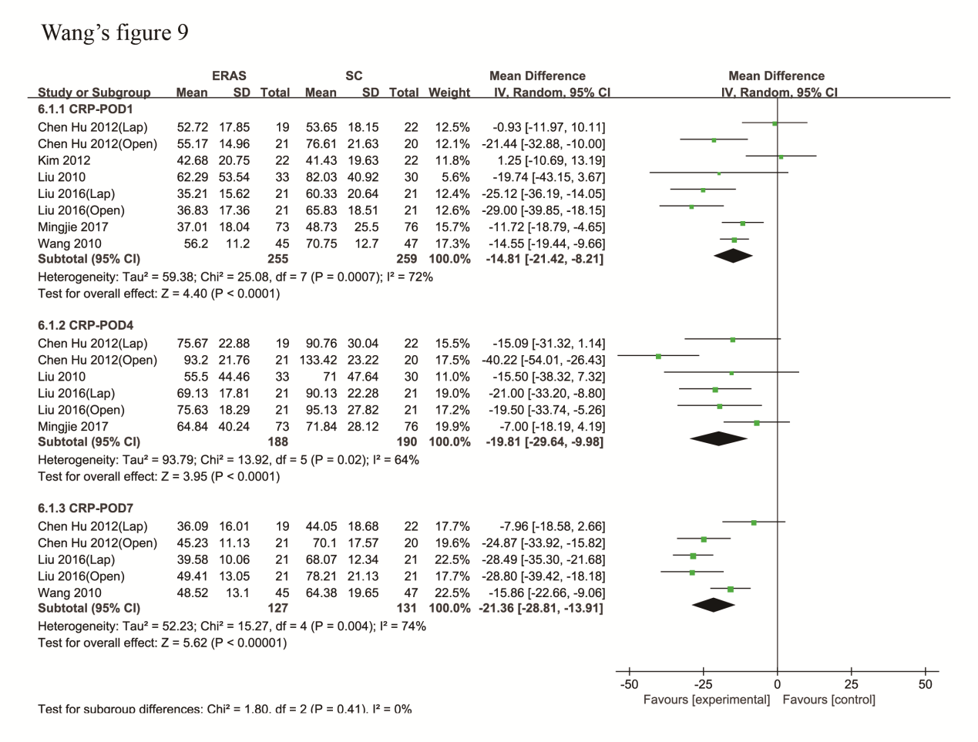
Figure 9 Forest plot evaluating the postoperative level of C-reactive protein: Enhanced recovery after surgery vs standard care.

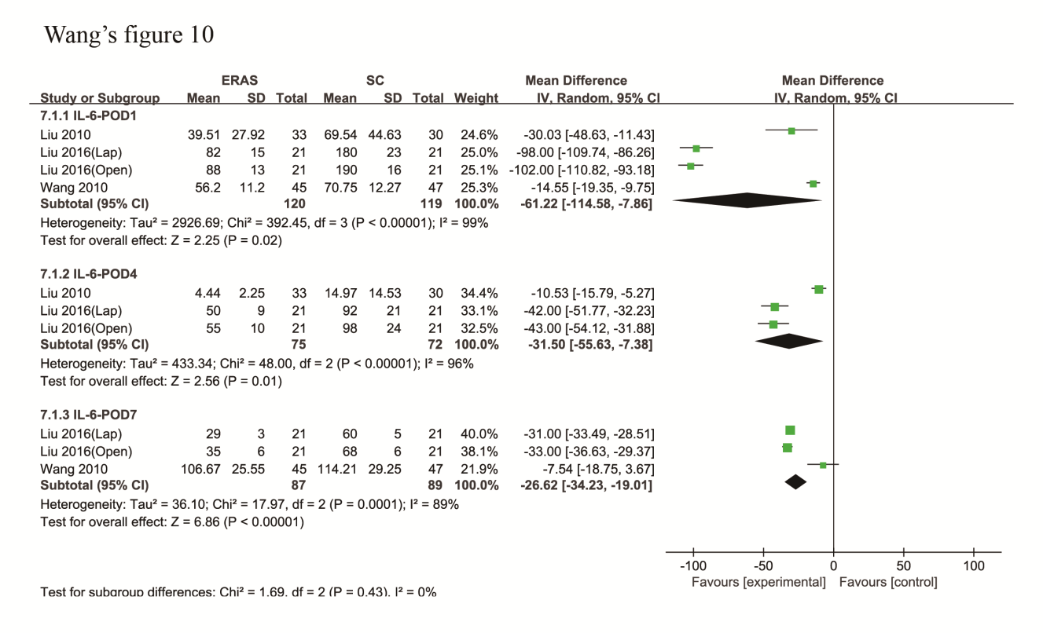
Figure 10 Forest plot evaluating the postoperative level of interleukin-6: Enhanced recovery after surgery vs standard care.

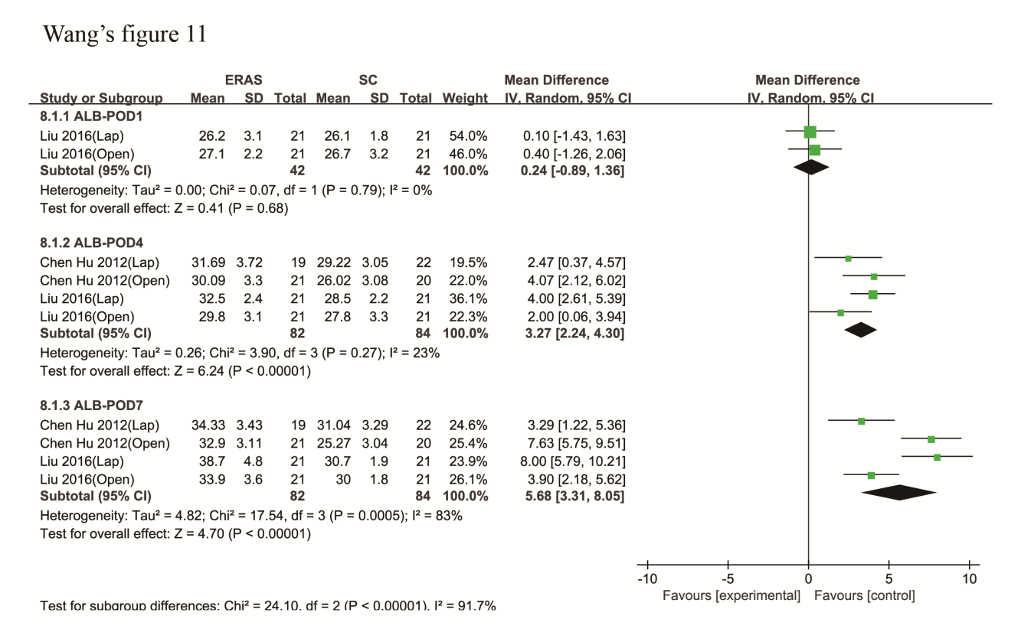
Figure 11 Forest plot evaluating the postoperative level of serum albumin: Enhanced recovery after surgery vs standard care.

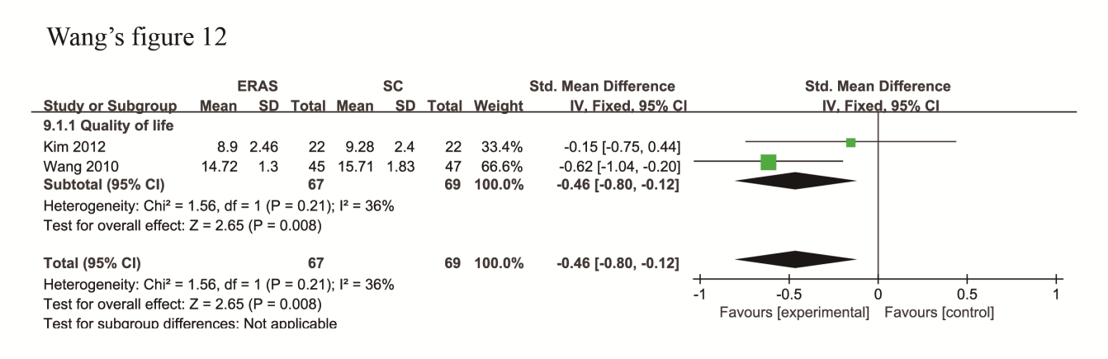
Figure 12 Forest plot evaluating health-related quality of life: Enhanced recovery after surgery vs standard care.

Figure 13 Begg’s funnel plot to explore publication bias of all the included studies.

Table 1 Main characteristics of the included studies
Study | Year | Sample size |  | Age (yr) |  | Gender (male/female) |  | Approach | Neoadjuvant chemotherapy | Follow-up (d)
 |  | ERAS | SC | ERAS | SC | ERAS | SC
Abdikarim et al^{[21]} | 2015 | 30 | 31 | 63 ± 12 | 62 ± 11 | 21/9 | 20/11 | Lap | No | 30
Bu et al^{[23]}-Adult | 2015 | 64 | 64 | 62.4 ± 7.8 | 63.0 ± 7.4 | 31/33 | 35/29 | Open | No | 30
Bu et al^{[23]}-Elderly | 2015 | 64 | 64 | 80.1 ± 4.0 | 79.6 ± 3.5 | 37/27 | 40/24 | Open | No | 30
Chen Hu et al^{[34]}-Lap | 2012 | 19 | 22 | 59 (49-71) | 62.5 (45-72) | 10/9 | 10/12 | Lap | No | 28
Chen Hu et al^{[34]}-Open | 2012 | 21 | 20 | 62.5 (45-72) | 64.5 (49-75) | 9/12 | 12/8 | Open | No | 28
Feng et al^{[33]} | 2013 | 59 | 60 | 55.0 ± 11.4 | 55.8 ± 10.1 | 41/18 | 44/16 | Open | No | 28
Kim et al^{[35]} | 2012 | 22 | 22 | 52.6 ± 11.6 | 57.5 ± 14.5 | 13/9 | 15/7 | Lap | - | 14
Liu et al^{[36]} | 2010 | 33 | 30 | 60.7 ± 9.7 | 61.9 ± 8.3 | 18/15 | 16/14 | Open | No | 30
Liu et al^{[24]}-Lap | 2016 | 21 | 21 | 69.2 ± 5.1 | 70.3 ± 5.8 | 10/11 | 12/9 | Lap | No | 30
Liu et al^{[24]}-Open | 2016 | 21 | 21 | 67.8 ± 3.9 | 68.6 ± 4.9 | 9/12 | 11/10 | Open | No | 30
Mingjie et al^{[22]} | 2017 | 73 | 76 | 61 (40-75) | 63 (35-75) | 48/25 | 50/26 | Lap | No | 30
Tanaka et al^{[30]} | 2017 | 73 | 69 | 68 (29-85) | 67 (44-85) | 49/24 | 49/20 | Lap/Open | No | 30
Wang et al^{[37]} | 2010 | 45 | 47 | 58.8 ± 9.7 | 56.9 ± 9.1 | 32/13 | 29/18 | Open | No | 28
Lap: laparoscopic surgery; Open: Open surgery; ERAS: Enhanced recovery after surgery; SC: Standard care.

Table 2 Elements of enhanced recovery after surgery protocol applied in the included studies
Study | Year | No bowel preparation | Carbohydrate loading | No routine use of abdominal drainage | Fluid Restriction | Pain management | Early mobilization | Early feeding | Others | No. of ERAS elements
Abdikarim et al^{[21]} | 2015 | Yes | Yes | Yes | Yes | Yes | Yes | Yes | Yes | 11
Bu et al^{[23]} | 2015 | Yes | Yes | Yes | Yes | Yes | Yes | Yes | Yes | 14
Chen Hu et al^{[34]} | 2012 | Yes | Yes | Yes | Yes | Yes | Yes | Yes | Yes | 13
Feng et al^{[33]} | 2013 | - | Yes | Yes | Yes | Yes | Yes | Yes | Yes | 9
Kim et al^{[35]} | 2012 | Yes | Yes | - | - | Yes | Yes | Yes | Yes | 10
Liu et al^{[36]} | 2010 | Yes | Yes | Yes | Yes | Yes | Yes | Yes | Yes | 12
Liu et al^{[24]} | 2016 | Yes | Yes | - | Yes | Yes | Yes | Yes | Yes | 11
Mingjie et al^{[22]} | 2017 | Yes | Yes | Yes | Yes | Yes | Yes | Yes | Yes | 13
Tanaka et al^{[30]} | 2017 | Yes | Yes | Yes | - | Yes | Yes | Yes | Yes | 22
Wang et al^{[37]} | 2010 | Yes | Yes | Yes | Yes | Yes | Yes | Yes | Yes | 14
ERAS: Enhanced recovery after surgery.

Table 3 Evaluation of the complications or outcomes in enhanced recovery after surgery vs standard care groups in the included studies
Subgroup | Studies (n) | Participants (n) | Statistical method | Effect estimate | Heterogeneity
 |  |  |  |  | I² | P value
Total complications | 13 | 1092 | Risk ratio (M-H, random, 95%CI) | 1.03 [0.73, 1.44] | 75% | < 0.00001
Anastomotic leak | 10 | 964 | Risk ratio (M-H, random, 95%CI) | 1.36 [0.54, 3.45] | 0 | 0.50
Ileus | 12 | 1048 | Risk ratio (M-H, random, 95%CI) | 1.62 [0.75, 3.52] | 0 | 0.57
Incision infection | 11 | 1007 | Risk ratio (M-H, random, 95%CI) | 0.79 [0.39, 1.60] | 0 | 0.87
Urinary tract infection | 9 | 699 | Risk ratio (M-H, random, 95%CI) | 0.53 [0.26, 1.08] | 0 | 0.99
Pulmonary infection | 9 | 775 | Risk ratio (M-H, random, 95%CI) | 0.52 [0.28, 0.94] | 0 | 0.99
Postoperative hospital stay | 13 | 1092 | Mean difference (IV, random, 95%CI) | -1.65 [-2.09, -1.21] | 89% | < 0.00001
Duration of first flatus | 11 | 882 | Mean difference (IV, random, 95%CI) | -12.70 [-19.71, -5.69] | 92% | < 0.00001
Duration of first defecation | 4 | 471 | Mean difference (IV, random, 95%CI) | -28.07 [-41.48, -14.67] | 90% | < 0.00001
Medical costs | 10 | 819 | Mean difference (IV, random, 95%CI) | -0.50 [-0.69, -0.30] | 85% | < 0.00001
CRP
POD1 | 8 | 514 | Mean difference (IV, random, 95%CI) | -14.81 [-21.42, -8.21] | 72% | 0.0007
POD4 | 6 | 378 | Mean difference (IV, random, 95%CI) | -19.81 [-29.64, -9.98] | 64% | 0.02
POD7 | 5 | 258 | Mean difference (IV, random, 95%CI) | -21.36 [-28.81, -13.91] | 74% | 0.004
IL-6
POD1 | 4 | 239 | Mean difference (IV, random, 95%CI) | -61.22 [-114.58, -7.86] | 99% | < 0.00001
POD4 | 3 | 147 | Mean difference (IV, random, 95%CI) | -31.50 [-55.63, -7.38] | 96% | < 0.00001
POD7 | 3 | 176 | Mean difference (IV, random, 95%CI) | -26.62 [-34.23, -19.01] | 89% | 0.0001
ALB
POD1 | 2 | 84 | Mean difference (IV, random, 95%CI) | 0.24 [-0.89, 1.36] | 0 | 0.79
POD4 | 4 | 166 | Mean difference (IV, random, 95%CI) | 3.27 [2.24, 4.30] | 23% | 0.27
POD7 | 4 | 166 | Mean difference (IV, random, 95%CI) | 5.68 [3.31, 8.05] | 83% | 0.0005
Readmission | 8 | 777 | Risk ratio (M-H, Fixed, 95%CI) | 2.86 [1.31, 6.24] | 0 | 0.92
Reoperation | 3 | 517 | Risk ratio (M-H, Fixed, 95%CI) | 0.62 [0.17, 2.35] | 33% | 0.22
Quality of life | 2 | 136 | Std. mean difference (IV, Fixed, 95%CI) | -0.46 [-0.80, -0.12] | 36% | 0.21
CRP: C-reactive protein; POD: Postoperative day; IL-6: interleukin-6; ALB: serum albumin; M-H: Mantel-Haenszel; IV: Inverse Variance.

