Name of Journal: World Journal of Cardiology
Manuscript NO: 68610
Manuscript Type: CASE REPORT

Sliding with the sines − fatal hyperkalemia: A case report

Soe KK et al. Sliding with the sines

Kyaw Khaing Soe, Arnold Hoo Seto

Kyaw Khaing Soe, Internal Medicine, Methodist Hospital of Southern California, Arcadia, CA 91007, United States

Kyaw Khaing Soe, Graduate Medical Education, St. Mary Medical Center, Long Beach, CA 90813, United States

Arnold Hoo Seto, Department of Medicine, University of California Irvine, Orange, CA 92868, United States

Arnold Hoo Seto, Interventional Cardiology, Long Beach VA Medical Center, Long Beach, CA 90822, United States

Author contributions: Soe KK prepared the manuscript; Seto AH edited the manuscript into the final version; and all authors have read and approved the final manuscript.

Corresponding author: Kyaw Khaing Soe, MBBS, MD, Attending Doctor, Internal Medicine, Methodist Hospital of Southern California, 300 W Huntington Dr. TCU #52, Arcadia, CA 91007, United States. kyawkhaings@gmail.com

Received: May 29, 2021
Revised: June 19, 2021
Accepted: July 6, 2021
Published online: July 26, 2021

Abstract
BACKGROUND
Classic electrocardiographic manifestations of hyperkalemia starting with peaked symmetrical T-waves are widely recognized in daily clinical practice but little evidence is documented how quickly it can evolve in real-time.

CASE SUMMARY
An elderly diabetic and hypertensive male presented with acute renal failure and rhabdomyolysis. He experienced cardiac arrest with moderate hyperkalemia despite medical treatment and hemodialysis. Telemetry changes were retrospectively studied and found to have significant rhythm changes that occurred just less than 10 minutes prior to the cardiac arrest.

CONCLUSION
In hyperkalemia, telemetry rhythm can change instantaneously in a significant way. Rapidly rising potassium could be life threatening and may require more than medical treatment.

Key Words: Electrocardiogram; Arrhythmia; Hyperkalemia; Electrolyte imbalance; Cardiac arrest; Case report

©The Author(s) 2021. Published by Baishideng Publishing Group Inc. All rights reserved.

Citation: Soe KK, Seto AH. Sliding with the sines − fatal hyperkalemia: A case report. World J Cardiol 2021; 13(7): 230-236
URL: https://www.wjgnet.com/1949-8462/full/v13/i7/230.htm
DOI: https://dx.doi.org/10.4330/wjc.v13.i7.230

Core Tip: We present a case of acute rhabdomyolysis and renal failure where the patient experienced cardiac arrest with moderate hyperkalemia despite medical treatment and hemodialysis. This case illustrates how quickly the telemetry rhythm can change in a short period of time (9 min).

INTRODUCTION
In rhabdomyolysis where massive tissue destruction could produce significant hyperkalemia, potassium levels are closely monitored and electrocardiographic changes would trigger immediate action even before the laboratory confirmation^{[1]}. Rapidly rising potassium levels are more likely to present with cardiac rhythm changes but the pace of those changes is rarely reported in the literature.

CASE PRESENTATION
Chief complaints
A 76-year old male presented to emergency department with generalized weakness and encephalopathy.

History of present illness
His generalized weakness gradually started over a few months and recently he was getting weaker and also confused for a few days.

History of past illness
His past medical history was significant for hypertension, diabetes and old ischemic stroke with residual right sided weakness.

Personal and family history
He was a non-smoker and non-drinker, and he lived in a house.

Physical examination
He was somnolent but arousable. He had dry mucous membranes and mild right hemiparesis which was his baseline.

Laboratory examinations
Laboratory results were significant for serum potassium 6.7 mmol/L, serum creatinine 10.76 mg/dL, and serum creatine kinase 40673 U/L.

Imaging examinations
Computed tomography of the brain without contrast showed no acute changes. Electrocardiography (Figure 1) did not show any classic changes associated with hyperkalemia.

FINAL DIAGNOSIS
Patient was diagnosed as hyperkalemia with acute renal failure possibly due to rhabdomyolysis.

TREATMENT
Initial treatment
The patient received intravenous calcium gluconate, furosemide, dextrose, insulin, and sodium bicarbonate, and albuterol by nebulizer. Emergent hemodialysis was arranged and performed in the intensive care unit uneventfully, resulting in potassium decreasing to 4.0 mmol/L. CK also trended down to 37586 U/L the following day. Further daily hemodialysis sessions were provided for oliguria.

Progress during hospital stay
On the third hospital day, CK increased to 206297 U/L but the potassium level remained stable at 4.7 mmol/L. Six hours after the hemodialysis session of the day, the repeat potassium was 6.9 mmol/L. The telemetry rhythm strip (Figure 2A) showed no hyperkalemic manifestations. The patient was again administered calcium gluconate, dextrose, insulin and sodium polystyrene. Despite these efforts, two hours later the patient suffered a cardiac arrest with pulseless electrical activity. The patient was resuscitated and the repeat potassium level which was taken just before the cardiac arrest was 7.4 mmol/L. On review of the telemetry, significant changes associated with hyperkalemia were noted just 9 min before the cardiac arrest (Figure 2B-G). The potassium levels, creatine kinase levels and the treatments patient received are summarized in Table 1.
Electrocardiography following the resuscitation still showed the typical sine waves of hyperkalemia (Figure 3) with a repeat potassium level of 7.9 mmol/L.

OUTCOME AND FOLLOW-UP
The patient was intubated and continuous renal replacement therapy (CRRT) was initiated. Despite these interventions, the hyperkalemia and metabolic acidosis continued to worsen and he eventually expired from ventricular fibrillation refractory to multiple defibrillation attempts. Repeat 12 Lead electrocardiography before the last cardiac arrest showed more pronounced sine waves from hyperkalemia with corresponding potassium level of 7.1 mmol/L (Figure 4).

DISCUSSION
Traditionally, the electrocardiographic manifestations of hyperkalemia are sufficient to make emergent interventions indicated even prior to laboratory confirmation^{[1-4]}. Continuous electrocardiographic telemetry is typically sufficient for monitoring cardiac rhythm. However, this patient did not demonstrate the classic peaked, symmetrical T waves on telemetry despite significant hyperkalemia. The amplitudes of T waves in lead II (Figure 2A) were less than half the height of QRS complexes and it had similar morphology on telemetry for the first three days. If a 12-lead electrocardiogram had been recorded prior to cardiac arrest, it might have shown some peaked T waves in the other non-monitoring leads.
Hyperkalemia is also associated with atrioventricular conduction disturbances^{[5,6]} and we observed the left bundle branch block morphology just 3 minutes prior to cardiac arrest (Figure 2F).
Hyperkalemia is generally classified as moderate for the level between 6.5 mmol/L to 8.0 mmol/L and severe for the level above 8.0 mmol/L. Rapidly progressive hyperkalemia is more likely to present with cardiac rhythm changes^{[7]}. This patient only experienced moderate hyperkalemia but suffered cardiac arrest likely because of a rapidly rising potassium. Moreover, it is also notable that the sine waves were more dramatic with potassium level of 7.1 mmol/L (Figure 4) when he eventually demised than with potassium level of 7.9 mmol/L (Figure 3) from his first cardiac arrest.
Intravenous regular insulin 5 units with dextrose can reduce the potassium level by 0.54-1.04 mmol/L at one hour^{[3]} and a systematic review showed regular insulin 10 units could reduce the potassium by average of 0.78 ± 0.25 mmol/L in an hour^{[8]}. The beta-2 agonist, salbutamol 10 mg nebulization, is also another potent agent that can reduce the potassium by 0.62 ± 0.09 mmol/L after 120 min of administration^{[9]} but with the possible side effect of severe tachycardia and is limited in patients with heart failure or coronary artery disease. However, all of these treatments influence the potassium level by intracellular transfer without actually reducing total body potassium. Intravenous loop diuretics are largely ineffective in relieving hyperkalemia in oliguric patients. Oral agents that increase gastrointestinal potassium excretion, including sodium polystyrene, patiromer and sodium zirconium, have a slow onset of action. Sodium zirconium could potentially have incremental effect in treatment of hyperkalemia with potassium reduction of 0.41 mmol/L as early as 4 h after administration^{[10]}.
In addition to the above medical intervention, it is warranted to initiate renal replacement therapy in the setting of hyperkalemic emergency with rhabdomyolysis. Our patient, however, was already on daily hemodialysis with potassium level under control for two days. Nevertheless, his rebound hyperkalemia should have been managed aggressively with immediate hemodialysis rather than medical management and wait for another two hours for response.
After the medical management, potassium level should be repeated one to two hour after treatment. In our patient, it was scheduled to be repeated two hour after treatment which was reasonable. More aggressive approach to repeat the potassium at one hour or earlier might have shown worsening hyperkalemia which would have prompted more intervention.
Hemodialysis is the mainstay for the emergency management of hyperkalemia but daily intermittent hemodialysis may be inadequate as shown in this case. There is not enough evidence to suggest that continuous renal replacement therapy (CRRT) is superior to intermittent hemodialysis in management of rhabdomyolysis but CRRT has been found to remove myoglobin more effectively and is more practical in the setting of hypotension^{[11]}. Early initiation of continuous veno-venous hemodialysis along with aggressive potassium monitoring may be necessary for severe cases of rhabdomyolysis.

CONCLUSION
Frequent 12-lead electrocardiograms in addition to the close attention to continuous telemetry monitoring are necessary for patient with hyperkalemia from rhabdomyolysis. Despite appropriate support with daily hemodialysis, this case demonstrates how rapidly acute hyperkalemia can worsen and cause an evolution of the cardiac rhythm. Timely intervention and reassessment for clinical response are critical in the management of hyperkalemia.

REFERENCES
1 Merrill JP, Levine HD, Somerville W, Smith S. Clinical recognition and treatment of acute potassium intoxication. Ann Intern Med 1950; 33: 797-830 [PMID: 14771753 DOI: 10.7326/0003-4819-33-4-797]
2 Rossignol P, Legrand M, Kosiborod M, Hollenberg SM, Peacock WF, Emmett M, Epstein M, Kovesdy CP, Yilmaz MB, Stough WG, Gayat E, Pitt B, Zannad F, Mebazaa A. Emergency management of severe hyperkalemia: Guideline for best practice and opportunities for the future. Pharmacol Res 2016; 113: 585-591 [PMID: 27693804 DOI: 10.1016/j.phrs.2016.09.039]
3 Dépret F, Peacock WF, Liu KD, Rafique Z, Rossignol P, Legrand M. Management of hyperkalemia in the acutely ill patient. Ann Intensive Care 2019; 9: 32 [PMID: 30820692 DOI: 10.1186/s13613-019-0509-8]
4 Coutrot M, Dépret F, Legrand M. Tailoring treatment of hyperkalemia. Nephrol Dial Transplant 2019; 34: iii62-iii68 [PMID: 31800081 DOI: 10.1093/ndt/gfz220]
5 Davidson S, Surawicz B. Ectopic beats and atrioventricular conduction disturbances. In patients with hypopotassemia. Arch Intern Med 1967; 120: 280-285 [PMID: 6038287 DOI: 10.1001/archinte.120.3.280]
6 Bashour T, Hsu I, Gorfinkel HJ, Wickramesekaran R, Rios JC. Atrioventricular and intraventricular conduction in hyperkalemia. Am J Cardiol 1975; 35: 199-203 [PMID: 1119378 DOI: 10.1016/0002-9149(75)90001-6]
7 Surawicz B, Chlebus H, Mazzoleni A. Hemodynamic and electrocardiographic effects of hyperpotassemia. Differences in response to slow and rapid increases in concentration of plasma K. Am Heart J 1967; 73: 647-664 [PMID: 6024862 DOI: 10.1016/0002-8703(67)90174-3]
8 Harel Z, Kamel KS. Optimal Dose and Method of Administration of Intravenous Insulin in the Management of Emergency Hyperkalemia: A Systematic Review. PLoS One 2016; 11: e0154963 [PMID: 27148740 DOI: 10.1371/journal.pone.0154963]
9 Allon M, Dunlay R, Copkney C. Nebulized albuterol for acute hyperkalemia in patients on hemodialysis. Ann Intern Med 1989; 110: 426-429 [PMID: 2919849 DOI: 10.7326/0003-4819-110-6-426]
10 Peacock WF, Rafique Z, Vishnevskiy K, Michelson E, Vishneva E, Zvereva T, Nahra R, Li D, Miller J. Emergency Potassium Normalization Treatment Including Sodium Zirconium Cyclosilicate: A Phase II, Randomized, Double-blind, Placebo-controlled Study (ENERGIZE). Acad Emerg Med 2020; 27: 475-486 [PMID: 32149451 DOI: 10.1111/acem.13954]
11 Zimmerman JL, Shen MC. Rhabdomyolysis. Chest 2013; 144: 1058-1065 [PMID: 24008958 DOI: 10.1378/chest.12-2016]

Footnotes
Informed consent statement: Informed written consent was obtained from the patient.

Conflict-of-interest statement: The authors declare that they have no conflict of interest.

CARE Checklist (2016) statement: The authors have read the CARE Checklist (2016), and the manuscript was prepared and revised according to the CARE Checklist (2016).

Open-Access: This article is an open-access article that was selected by an in-house editor and fully peer-reviewed by external reviewers. It is distributed in accordance with the Creative Commons Attribution NonCommercial (CC BY-NC 4.0) license, which permits others to distribute, remix, adapt, build upon this work non-commercially, and license their derivative works on different terms, provided the original work is properly cited and the use is non-commercial. See: http://creativecommons.org/Licenses/by-nc/4.0/

Manuscript source: Unsolicited manuscript

Peer-review started: May 29, 2021
First decision: June 17, 2021
Article in press: July 6, 2021

Specialty type: Cardiac and cardiovascular systems
Country/Territory of origin: United States
Peer-review report’s scientific quality classification
Grade A (Excellent): 0
Grade B (Very good): B
Grade C (Good): C, C, C
Grade D (Fair): 0
Grade E (Poor): 0

P-Reviewer: Esposito P, Salimi M S-Editor: Ma YJ L-Editor: A P-Editor: Yuan YY
Figure Legends
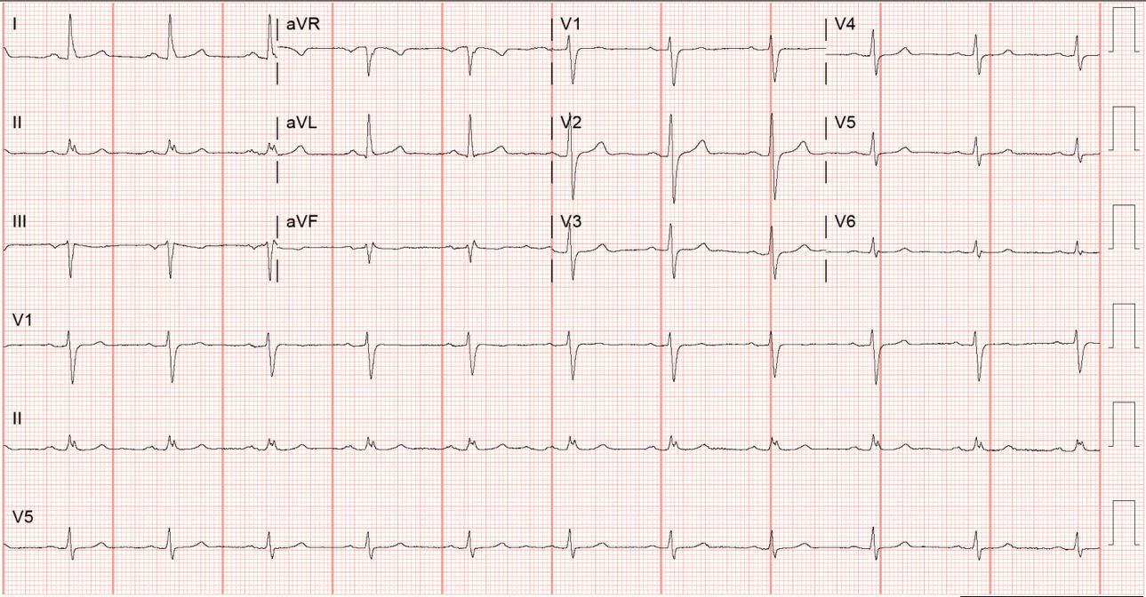
Figure 1 Electrocardiogram on admission. Twelve lead electrocardiogram without any hyperkalemic manifestations.
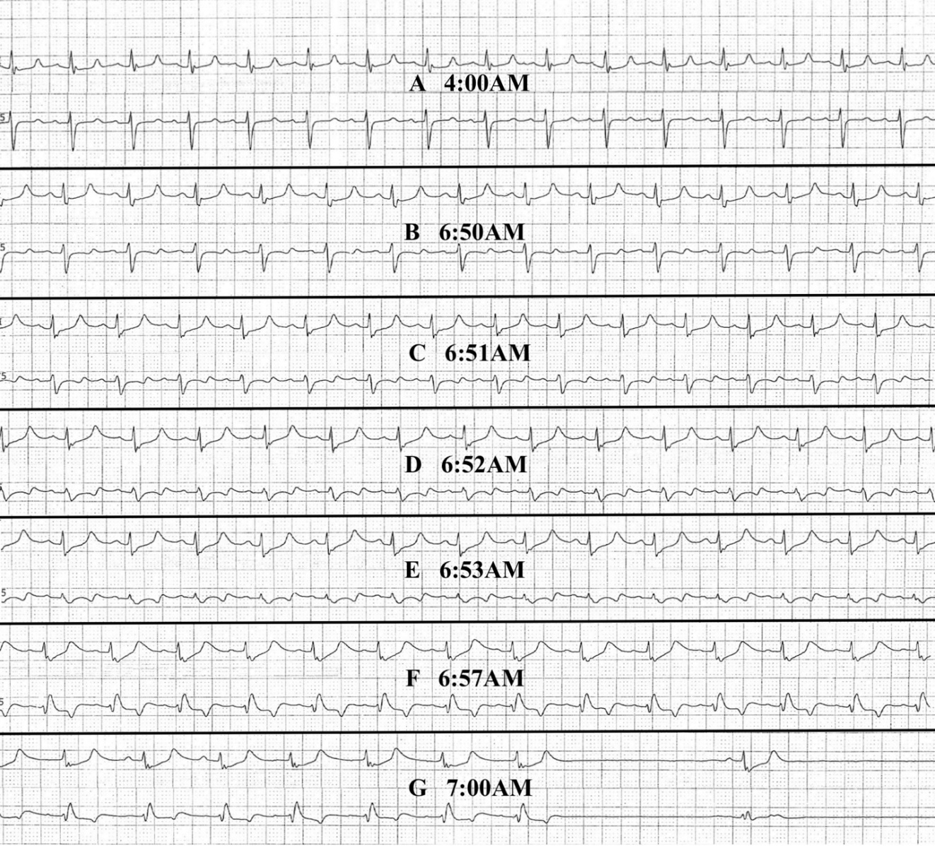
Figure 2 Telemetry strips (rate 25 mm/s). The upper rhythm is lead II and lower rhythm is lead V5. A: At 4:00 AM. when potassium level started rising. T wave amplitude measuring 2-2.5 mm in lead II. PR interval 0.16-0.20 s. QRS 0.1-0.12 s. QT prolongation from hypocalcemia; B: At 6:50 AM. T waves in lead II seems to be slightly taller, maybe about 0.5 mm (half small square) than Figure 2. Similar measurements for PR interval and QRS. Non-specific T waves changes in V5; C: At 6:51 AM. ST and T waves changes more pronounced in V5. ST depression by 0.5-1 mm in V5. QRS slightly widened beyond 0.12 s in both lead II and V5; D: At 6:52 AM. QRS widened more with further ST depression. Transitioning into sine wave, more obvious in lead V5; E: At 6:53 AM. Complete loss of original QRS morphology in lead V5 and transforming into sine waves. P waves still visible with PR interval 0.16 s in lead II; F: At 6:57 AM. QRS morphology in lead II deformed with marked ST depression, transitioning into sine waves. QRS in V5 is showing left bundle branch block morphology at the similar heart rate; G: At 7:00 AM. Sinus pause over 2 s and pulseless electrical activity cardiac arrest.
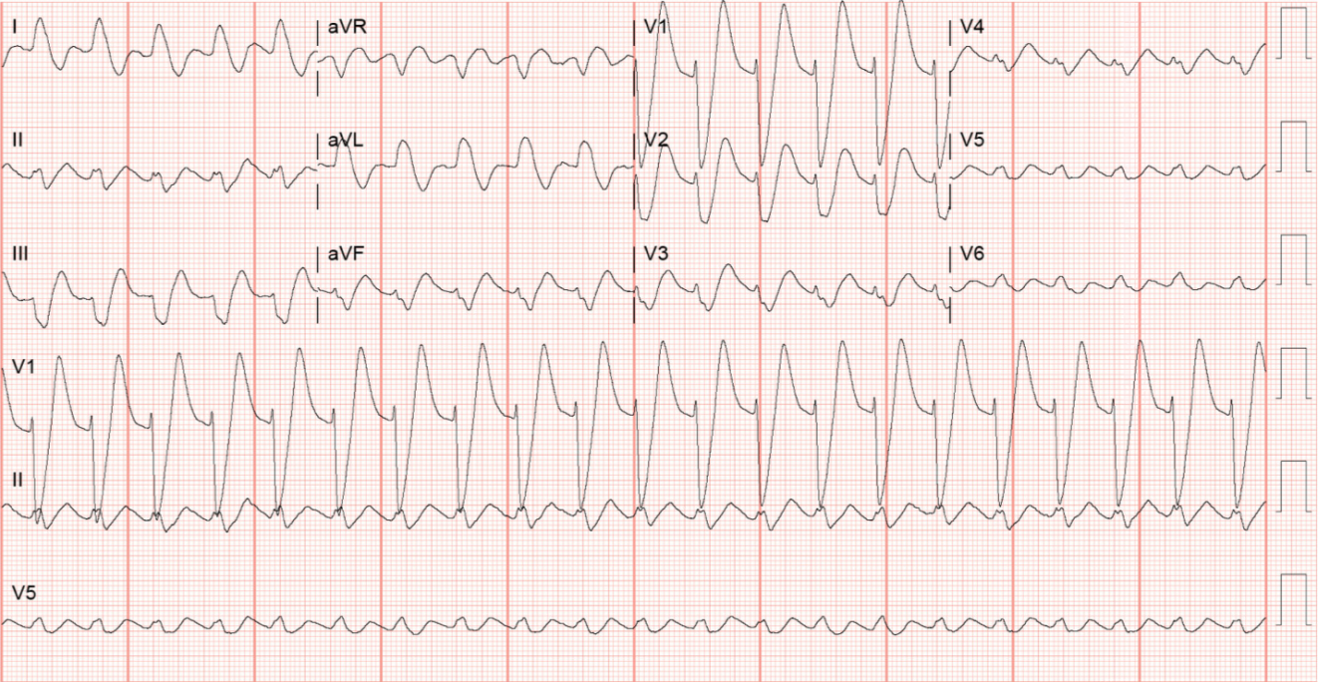
Figure 3 Electrocardiogram after resuscitation. Twelve lead electrocardiogram showing classic description of hyperkalemic manifestations, peaked T waves in V1, V2, widened QRS complexes, P waves not seen and sine waves in V4, V5, V6.
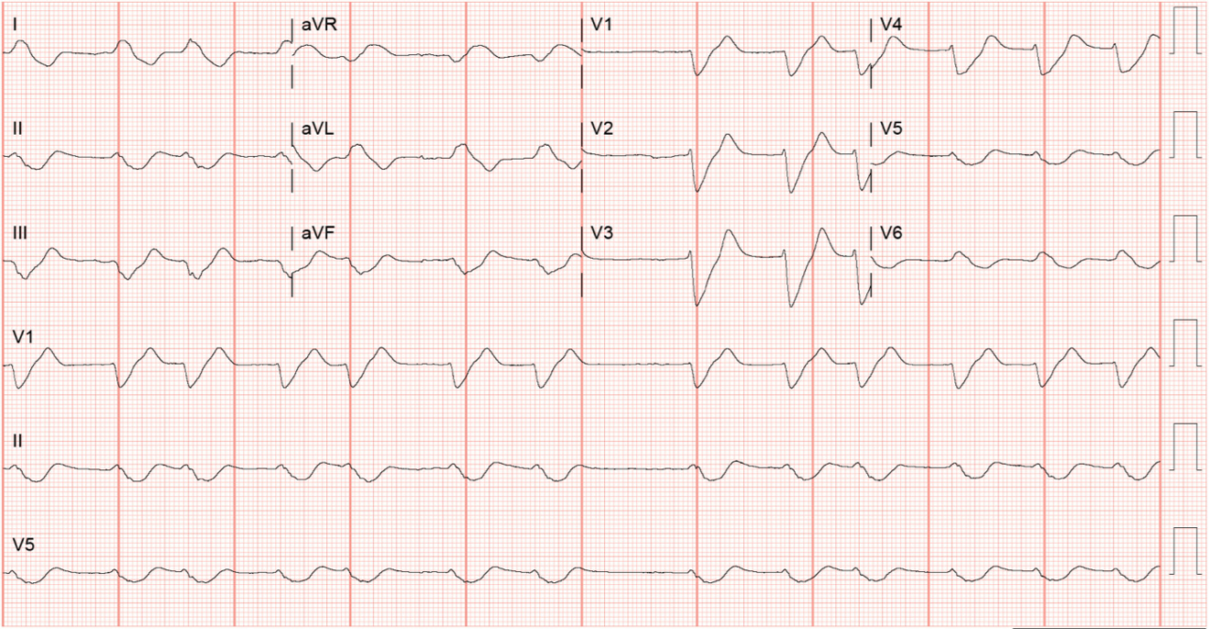
Figure 4 Electrocardiogram showing typical sine waves of hyperkalemia. Findings include loss of P waves, severe widening of QRS complexes resulting in fusion of QRS complexes and T waves, decrease in amplitudes of QRS complexes and T waves.
Table 1 Potassium levels, creatine kinase levels and treatments received
Timeline | Potassium levels (mmol/L) | CK levels (U/L) | Treatments received
Day 0 | 6.7 | 40673 | IV calcium gluconate 1 g once
 |  |  | Albuterol nebulization 10 mg once
 |  |  | IV furosemide 40 mg once
 |  |  | IV dextrose 50% 50 g once
 |  |  | IV regular insulin 5 units once
 |  |  | IV sodium bicarbonate 50 mEq once
 |  |  | IV sodium bicarbonate 8.4% continuous infusion was started
Day 0 (2 h) | 6.2 | - | Hemodialysis initiated
Day 1 | 4.0, 4.2 | 37586 | Daily intermittent hemodialysis continued
Day 2 | 4.2, 4.7 | 206297 | Daily intermittent hemodialysis continued
Day 3, 4 am | 6.9 | 198294 | IV calcium gluconate 1 g once
 |  |  | IV dextrose 50% 25 g once
 |  |  | IV regular insulin 5 units once
 |  |  | PO sodium polystyrene 30 g once
Day 3, 6 am | 7.4 | - | Cardiac arrest before result was out
 |  |  | IV epinephrine 1mg × 3
 |  |  | IV calcium chloride 1g × 2
 |  |  | IV sodium bicarbonate 50 mEq × 3
 |  |  | IV dextrose 50% 25 g once
 |  |  | IV regular insulin 10 units once
 |  |  | CRRT initiated after resuscitation
CK: creatine kinase; IV: intravenous; CRRT: continuous renal replacement therapy.

Published by Baishideng Publishing Group Inc
7041 Koll Center Parkway, Suite 160, Pleasanton, CA 94566, USA
Telephone: +1-925-3991568
E-mail: bpgoffice@wjgnet.com
Help Desk: https://www.f6publishing.com/helpdesk
https://www.wjgnet.com

© 2021 Baishideng Publishing Group Inc. All rights reserved.

