Name of Journal: World Journal of Clinical Cases
Manuscript NO: 79916
Manuscript Type: LETTER TO THE EDITOR

Commentary on “Gallstone associated celiac trunk thromboembolisms complicated with splenic infarction: A case report’’

Tokur O et al. To the editor

Oguzhan Tokur, Sonay Aydın, Mecit Kantarci

Oguzhan Tokur, Department of Radiology, Ankara Training and Research Hospital, Ankara 06230, Turkey

Sonay Aydın, Mecit Kantarci, Department of Radiology, Erzincan University Medicine Faculty, Erzincan 24100, Turkey

Author contributions: Tokur O contributed to this work; Tokur O, Aydin S, and Kantarci M designed the letter; Tokur O and Aydin S performed the research; Tokur O wrote the manuscript; all authors have read and approved the final manuscript.

Corresponding author: Oguzhan Tokur, MD, Attending Doctor, Department of Radiology, Ankara Training and Research Hospital, Hacettepe Mh. Ulucanlar Cd. No. 89 Altındağ/ANKARA, Ankara 06230, Turkey. oguzhantokur@gmail.com

Received: September 11, 2022
Revised: October 12, 2022
Accepted: October 20, 2022
Published online: November 16, 2022

Abstract
The present letter to the editor is related to the study titled “Gallstone associated celiac trunk thromboembolisms complicated with splenic infarction: A case report’’. Although gallstones are relatively common diseases, its association with thromboembolism is not fully understood. We aim to emphasize the potential mechanism of this relationship in this letter. In addition, we wanted to contribute to the causes of the spleen infarction and celiac trunk pathologies

Key Words: Gallstone; Spleen; Infarct; Thrombosis; Pain

©The Author(s) 2022. Published by Baishideng Publishing Group Inc. All rights reserved.

Citation: Tokur O, Aydın S, Kantarci M. Commentary on “Gallstone associated celiac trunk thromboembolisms complicated with splenic infarction: A case report’’. World J Clin Cases 2022; 10(32): 12059-12061
URL: https://www.wjgnet.com/2307-8960/full/v10/i32/12059.htm
DOI: https://dx.doi.org/10.12998/wjcc.v10.i32.12059

Core Tip: This letter to editor serves to present additional information regarding relationship between gallstone and thromboembolic disorders. We also emphasized some rare and interesting causes of splenic infarction and celiac trunk pathologies.

TO THE EDITOR
We read the article ‘’ Gallstone associated celiac trunk thromboembolisms complicated with splenic infarction: A case report’’^{[1]} and appreciated them for the interesting and educational case report. Gallstones can presented with uncommon symptoms such retrosternal, solely epigastric, or left upper quadrant pain which can cause diagnostic challenges^{[2]}. So we wanted to contribute the article by highlighting a few diseases that could cause confusion in the differential diagnosis. Besides, we also aimed to contribute to the differential diagnosis of spleen infarction observed in the case report.
In the literature, there are some studies that are compatible with the case report in terms of demonstrating the association between gallstones and vascular thromboembolism. A study of Chen et al^{[3]} revealed that the presence of gallstones increased the risk of venous thromboemboli (VTE), including deep venous thrombosis and pulmonary emboli, 1.35-fold, and the risk of VTE decreased after cholecystectomy. They also stated that gallstones may be considered a risk factor for VTE. In addition, Chiu et al^{[4]} revealed an increased association of extrahepatic portal vein thrombus and the presence of gallstones in children. According to studies, there is an association between the presence of gallstones and vascular pathologies. Although this association, gallstones should not be considered as an initial diagnose because accompanied diseases could be predisposing factor such as malignancies and coagulation disorders. So predisposing factors should be excluded before confirmation of the diagnosis of gallstone associated thromboembolism. Moreover; pathologies of the celiac trunk, other than gallstone related thromboembolism, can cause similar clinical scenarios with the presented. For instance, epigastic pain may be the only sign of another rare pathology; spontaneous solitary celiac and superior mesenteric artery dissections^{[5]}.
Splenic infarction represents a rare disorder that is frequently overlooked as the clinical findings could resemble those of other acute abdominal disorders^{[6]}. Patients can be presented with symptoms including left upper quadrant pain, fever, tachycardia, nausea, and vomiting. Splenic infarction can also be detected during the evaluation of a concominant pathology^{[7]}. The most frequent causes in non-traumatic patients are hematological disorders, septic embolism, cardioembolic diseases, and hypercoagulability^{[6]}. Splenectomy is usually not required in the treatment, but segmental splenectomy can be applied because the lobar branches of the splenic artery do not anastomose with each other. However, the blood flow can be totally obstructed in the case of a wandering spleen because of the instability^{[7]}. Therefore, splenopexy is recommended in these patients to prevent from infarction^{[8]} (Figure 1).
Finally, although gallstones are relatively common, they may cause atypical presentations as in this case report. In literature, some studies have demonstrated that gallstones are a risk factor for thromboembolic disorders. Physicians should take thromboembolic processes into account when evaluating patients for gallstones. Besides, there are several causes of splenic infarction and sometimes it can be clinically nonspecific. Therefore, it should be considered in the differential diagnosis in patients with upper abdominal pain.

REFERENCES
1 Wu CY, Su CC, Huang HH, Wang YT, Wang CC. Gallstone associated celiac trunk thromboembolisms complicated with splenic infarction: A case report. World J Clin Cases 2022; 10: 8968-8973 [PMID: 36157657 DOI: 10.12998/wjcc.v10.i25.8968]
2 Johnson CD. ABC of the upper gastrointestinal tract. Upper abdominal pain: Gall bladder. BMJ 2001; 323:1170-1173 [PMID: 11711412 DOI: 10.1136/bmj.323.7322.1170]
3 Chen CH, Lin CL, Kao CH. The Risk of Venous Thromboembolism in Patients with Gallstones. Int J Environ Res Public Health 2020; 17 [PMID: 32340378 DOI: 10.3390/ijerph17082930]
4 Chiu B, Superina R. Extrahepatic portal vein thrombosis is associated with an increased incidence of cholelithiasis. J Pediatr Surg 2004; 39: 1059-1061 [PMID: 15213899 DOI: 10.1016/j.jpedsurg.2004.03.051]
5 Aydin S, Ergun E, Fatihoglu E, Durhan G, Kosar PN. Spontaneous Isolated Celiac Artery and Superior Mesenteric Artery Dissections: A Rare Case. Pol J Radiol 2015; 80: 470-472 [PMID: 26543511 DOI: 10.12659/PJR.895048]
6 Antopolsky M, Hiller N, Salameh S, Goldshtein B, Stalnikowicz R. Splenic infarction: 10 years of experience. Am J Emerg Med 2009; 27: 262-265 [PMID: 19328367 DOI: 10.1016/j.ajem.2008.02.014]
7 Salvi PF, Stagnitti F, Mongardini M, Schillaci F, Stagnitti A, Chirletti P. Splenic infarction, rare cause of acute abdomen, only seldom requires splenectomy. Case report and literature review. Ann Ital Chir 2007; 78: 529-532 [PMID: 18510036]
8 Aydın S ÜÇGV. Wandering Spleen and Intestinal Malrotation. Arch Basic Clin Res 2020; 2: 111-112[DOI: 10.5152/abcr.2020.19001]

Footnotes
Conflict-of-interest statement: All the authors declare that they have no competing interests to disclose

Open-Access: This article is an open-access article that was selected by an in-house editor and fully peer-reviewed by external reviewers. It is distributed in accordance with the Creative Commons Attribution NonCommercial (CC BY-NC 4.0) license, which permits others to distribute, remix, adapt, build upon this work non-commercially, and license their derivative works on different terms, provided the original work is properly cited and the use is non-commercial. See: https://creativecommons.org/Licenses/by-nc/4.0/

Provenance and peer review: Unsolicited article; Externally peer reviewed.
Peer-review model: Single blind

Peer-review started: September 11, 2022
First decision: October 12, 2022
Article in press: October 20, 2022

Specialty type: Radiology, nuclear medicine and medical imaging
Country/Territory of origin: Turkey
Peer-review report’s scientific quality classification
Grade A (Excellent): A
Grade B (Very good): 0
Grade C (Good): C
Grade D (Fair): 0
Grade E (Poor): 0

P-Reviewer: Qin J, China; Ramesh PV, India S-Editor: Liu JH L-Editor: A P-Editor: Liu JH
Figure Legends
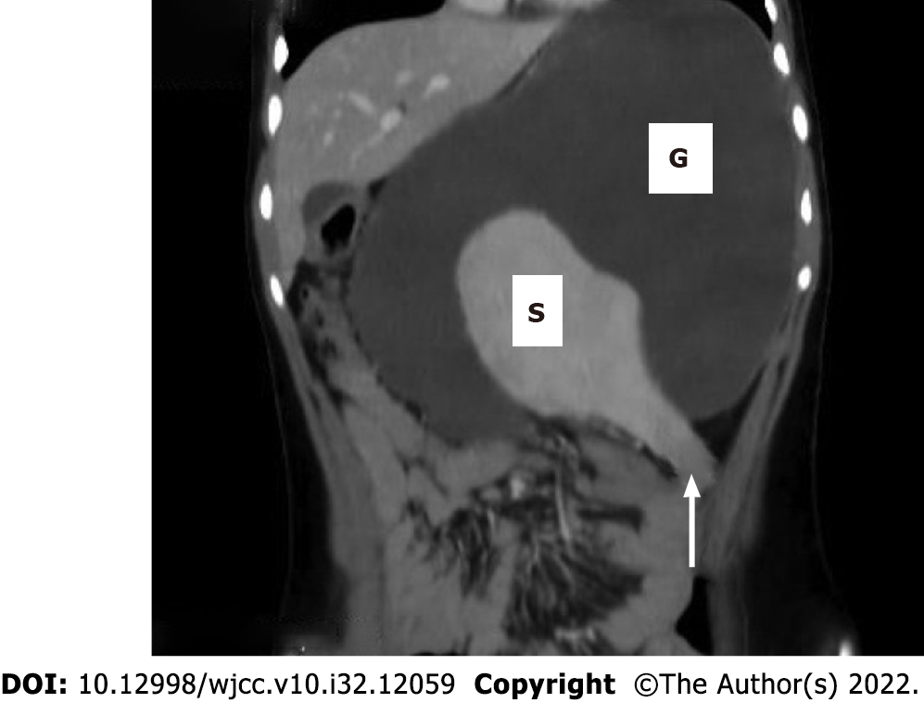
Figure 1 The patient has both a wandering spleen (S) and a gastric volvulus (G). There is also a focal hypoattenuation which represents a parenchymal infarct in the lower pole of the spleen (arrow).

Published by Baishideng Publishing Group Inc
7041 Koll Center Parkway, Suite 160, Pleasanton, CA 94566, USA
Telephone: +1-925-3991568
E-mail: bpgoffice@wjgnet.com
Help Desk: https://www.f6publishing.com/helpdesk
https://www.wjgnet.com

© 2022 Baishideng Publishing Group Inc. All rights reserved.

