Name of journal: World Journal of Stem Cells
ESPS Manuscript NO: 12691
Manuscript Type: MINIREVIEWS

Stem cells: Sources, and regenerative therapies in dental research and practice

Aly LAA. Stem cells in dental research and practice

Lobna Abdel Aziz Aly

Lobna Abdel Aziz Aly, Oral and Maxillofacial Surgery, Faculty of Dentistry, Future University, Cairo 11759, Egypt

Author contributions: Aly LAA solely contributed to this work.

Conflict-of-interest statement: None.

Open-Access: This article is an open-access article which selected by an in-house editor and fully peer-reviewed by external reviewers. It distributed in accordance with the Creative Commons Attribution Non Commercial (CC BY-NC 4.0) license, which permits others to distribute, remix, adapt, build upon this work non-commercially, and license their derivative works on different terms, provided the original work is properly cited and the use is non-commercial. See: http://creativecommons.org/licenses/by-nc/4.0/

Correspondence to: Lobna Abdel Aziz Aly, Associate Professor, Oral and Maxillofacial Surgery, Faculty of Dentistry, Future University, 90th st, New Cairo, Cairo 11759, Egypt. lobna72@gmail.com
Telephone: +2-2-26701496

Received: July 27, 2014
Peer-review started: July 27, 2014
First decision: August 14, 2014
Revised: June 21, 2015
Accepted: July 7, 2015
Article in press:
Published online:

Abstract
Stem cells are considered to be among the principle scientific breakthroughs of the twentieth century for the future of medicine, and considered to be an important weapon to fight against diseases, particularly those that have resisted the efforts of science for a long time. Human dental tissues have limited potentials to regenerate but the discovery of dental stem cells have developed new and surprising scenario in regenerative dentistry. Stem cell treatments are one example of the possibility using adult cells sourced from patients’ own bodies’ means that it can be expected that in the near future such treatments may become routine at dental practices. The hope is that it will become possible to regenerate bone and dental tissues including the periodontal ligament, dental pulp and enamel, and that the creation of new teeth may also become feasible. In view of this possibility of achieving restoration with regenerative medicine, it can be considered that a new era of dentistry is beginning. Thus the aim of this review is to give dental professionals a brief overview of different stem cells sources and the latest findings and their implications for improving oral health and treating certain conditions of the human mouth and face.

Key words: Stem cells; Regeneration; Dental research

© The Author(s) 2015. Published by Baishideng Publishing Group Inc. All rights reserved.

Core tip: Stem cells are considered to be among the principle scientific breakthroughs of the 20th century. Human dental tissue has limited potentials to regenerate but the discovery of dental stem cells have developed new and surprising scenario in regenerative dentistry. The hope is that it will become possible to regenerate bone and dental tissues and that the creation of new teeth may become feasible. Thus our review gives dental professionals a brief overview of different stem cells sources and the latest findings and their implications for improving oral health and treating certain conditions of the human mouth and face.

Aly LAA. Stem cells: Sources, and regenerative therapies in dental research and practice. World J Stem Cells 2015; In press

INTRODUCTION
Stem cell therapies could lead to novel cures and palliative treatments. Stem cell research has clinical implications considering cell repair, replacement or regeneration to improve organ function. Thus future studies will require the collaboration of researchers from different specialties, including stem cell biology, material science, and of course, basic and clinical dentistry.
The loss of hard or soft dental tissue not only harms the patient psychologically, but also causes atrophy of the tooth supporting tissues. Regeneration may define as restoring a deficient part by complete regeneration of its architecture and function. Dramatic tooth extraction, sever periodontitis, implant dehiscence defects, tumor, or congenital anomalies may lead to alveolar bone deficiencies^{[1]}. Alveolar bone defect regeneration techniques have many advances using minimally morbid techniques enhanced the success and patient acceptance^{[2,3]}. Successful regeneration techniques of the craniofacial bone deficiencies, are used to optimize therapeutic approaches to bone regeneration^{[4]}.
Autogenous bone graft remains the preferred reconstructive method but have some limitations such as increased operative time for bone graft harvesting, donor site morbidity, graft resorption, and limited availability. Various types of bone graft have become available to overcome these limitations^{[5,6]}. There have been recent interest in the development of new grafting materials using allogeneic, xenogeneic and synthetic bioimplants for reconstructive bony procedures, and have been used as alternative for autogenous bone grafts^{[7-9]}. A new combination of protein therapy, gene therapy and cell therapy and tissue engineering had been successfully developed and considered to be a more efficient and safer therapeutic system for bone and soft tissue regeneration^{[10]}.
Stem cells are nonspecific cells with powerful self-regeneration properties and they are capable of organizing other cell types in the body. They are also play an important role as those undifferentiated cells have precursor properties, capable of forming many different cell types and have the property of unlimited self-renewal. Within dentistry, the hope is to regenerate both bone and dental tissues, including the periodontal ligament, dental pulp and enamel, so that new teeth could even be created, even in the presence of caries, pulpitis and periapical diseases, which are the primary causes of tooth loss^{[11]}.
“Stem cells” are precursor cells that can give rise to multiple tissue types. Totipotent stem cells are cells that can give rise to a fully functional organism as well as to every cell type of the body. Pluripotent stem cells are capable of giving rise to virtually any tissue type, but not to a functioning organism. Multipotent stem cells are more differentiated cells that can give rise only to a limited number of tissues. For example, a specific type of multipotent stem cell called a mesenchymal stem cell has been shown to produce bone, muscle, cartilage, fat, and other connective tissues^{[12,13]}.
The effectiveness of stem cells can be attributed to many factors such as: stem cells can be expanded ex vivo, thus a small number of them can be sufficient to heal large defects or to treat diseases. Stem cells in the presence of vasculature may elaborate and organize tissues in vivo. Also they may play an important role in regulating local and systemic immune reactions of the host favoring tissue regeneration.

STEM CELL TYPES AND SOURCES
Stem cells have important criteria of self-renewable and the ability to differentiate into at least two different types of cell. Types of stem cells are determined based on their source and differ in regard to the types of cells into which they differentiate^{[14,15]}.
Embryonic stem cells, they are pluripotent cells that can differentiate into any other type of cell^{[14]}.
Adult stem cells, also called somatic stem cells, lack the potency of their embryonic counterparts, but have been used successfully to treat diseases. They can be harvested from an individual and, be used to regenerate tissue by autologous or allogeneic transplant^{[14]}.
Induced pluripotent stem cells - adult stem cells having the potential to serve as the source of a large number of autologous stem cells, but the main drawbacks are their capacity for proliferation and concomitant potential for carcinogenicity^{[16]}.
Bone marrow-derived mesenchymal stem cells can self-replicate and have been differentiated into osteoblasts, chondrocytes, myoblasts, adipocytes and other cell types. MSCs are often viewed as a yardstick of adult stem cells (Figure 1)^{[17]}.
Adipose-derived stem cells (AS) are typically isolated from lipectomy or liposuction aspirates. AS have been differentiated into adipocytes, chondrocytes, myocytes, neuronal and osteoblast lineages. They have many advantages over other adult stem cell populations, as adipose tissue is available in large number and become easily accessible^{[18]}.
Dental stem cells - recently these cells have been found in various dental tissues, such as Stem Cells from Human Exfoliated Deciduous teeth (SHED)^{[19]}, dental Pulp Stem Cells (DPSCs)^{[20]}, Periodontal Ligament Stem Cells (PDLSCs)^{[21,22]}, while in dental papilla of wisdom teeth Stem Cells from Apical Papilla (SCAP) is present^{[23]} and researchers termed stem cell found in dental follicles of developing wisdom teeth as Dental Follicle Precursor Cells (DFPCs )^{[24-26]}.

There are some advantages of dental stem cells: (1) They are readily accessible and provide an easy and least invasive way to obtain them; (2) Stem cell banking is a reasonable and simple alternative to harvesting stem cells^{[27]}; (3) They show good interaction with scaffolds^{[28]}; and (4) They have a high proliferative and multidifferentiation potential^{[29-31]}.

ROLE OF MESENCHYMAL STEM CELLS IN TISSUE REGENERATION
By chemotaxis Mesenchymal Stem Cells can migrate to tissues showing inflammation and injury in the organism^{[32]}. They can differentiate into different cell types, able to secrete a variety of cytokines, showing anti-inflammatory activity and create an anabolic microenvironment. Moreover, they play a role in regeneration of injured tissues by various means, as they directly differentiate into tissue-specific cells and thus substitute damaged or lost cells. On the other hand, they indirectly influence tissue regeneration by secretion of soluble factors. Thirdly, they are able to modulate the inflammatory response. So, they can effectively promote vascularization, cell proliferation, differentiation and modulate an inflammatory process^{[33,34]}.

CHALLENGES IN STEM CELL BIOLOGY
Notable increase in the applications of craniofacial tissue engineering, among them is: (1) Isolation of stem cells from several craniofacial tissues and their clinical therapeutic applications in the craniofacial structures; (2) Several prototypes of the human-shaped temporomandibular joint condyle have been engineered with integrated cartilage and bone layers from a single population of mesenchymal stem cells; (3) Cell-based or non-cell-based tissue engineering of periodontium elements, including the periodontal ligament and cementum; (4) The application of stem cells, growth factors, and/or biomaterials in craniofacial bone engineering; and (5)Adipose stem cells, with its efficient applications in facial soft and hard tissue reconstructive surgeries^{[35]}.

Tissue engineering of the temporomandibular joint
Current approaches for replacing degenerated mandibular condyles suffer from deficiencies such as donor site morbidity, immune-rejection, implant wear and tear, and pathogen transmission. So, advances in the management of temporomandibular joint degenerative diseases have been established: (1) To promote matrix synthesis and tissue maturation of stem cell- derived chondrogenic and osteogenic cells (Figure 2)^{[36]}; (2) To enhance the mechanical properties of a tissue engineered mandibular condyle for ultimate in situ implantation into the human temporomandibular joint (Figure 3)^{[37]}; and (3) To facilitate the remodeling potential of a tissue-engineered mandibular condyle.

Periodontal tissue engineering^{[35]}
The modulation of the exuberant host response to microbial contamination that plagues the periodontal wound is considered as the main challenge. It clarified the interactions of multiple cell lineages including cementogenic cells, fibroblasts, and osteogenic cells. Regeneration of severe periodontal defects necessitates the attraction of endogenous periodontal tissue forming cells by growth factors.
As regard the periodontal ligament (PDL) function, a recent report identified stem cells in human PDL (PDLSCs) and found that PDLSCs implanted into nude mice generated cementum/PDL-like structures that resemble the native PDL as a thin layer of cementum that interfaced with dense collagen fibers, similar to Sharpey's fibers (Figure 4)^{[38,39]}. Thus, the PDLSCs have the potential for forming periodontal structures, including the cementum and PDL.

Challenges in improving stem cell-based researches
Tissue engineered bone with customized shape and dimensions have the potential for the biological replacement of craniofacial bones, and segmental defects in the appendicular bones.
Stem cell therapy encompasses new technologies and therapies and posses many challenges in stem cell research, such as: (1) Biological challenges: Despite biological evidence showing that regeneration can occur in humans, complete and predictable regeneration still remains an elusive clinical goal (especially in advanced periodontal defects); (2) Technical challenges: The technical challenges in stem cell therapy are associated with cell manipulations, scaffold materials and delivery systems; and (3) Clinical challenges: Clinical challenges in stem cell-based periodontal therapy relate to immune rejection after administration, oncogenic properties of stem cells and functional integration of transplanted tissues into the host.

Stem cells for tooth engineering
Building a tooth logically requires the association/cooperation of odontogenic mesenchymal and epithelial cells. The recombination of dissociated dental epithelial and mesenchymal tissues leads to tooth formation both in vitro and in vivo (Figure 5). The bioengineered teeth have been produced in ectopic sites and with missing some essential elements such as the complete root and periodontal tissues that allow correct anchoring into the alveolar bone. Recently, a new approach has been proposed for growing teeth in the mouse mandible^{[40]}.

CONCLUSION
For dental applications, stem cell therapy and tissue engineering are gold solution for bone and soft tissue regeneration and provide hope of future application in humans within the next few years. Tissue engineering modalities will provide numerous clinical dental applications, including improved treatments for intraosseous periodontal defects, enhanced maxillary and mandibular grafting procedures, perhaps more biological methods to repair teeth after carious damage and possibly even re-growing lost teeth. This review highlights the sources and the regenerative therapies in the clinical practice of dentistry in the future.

REFERENCES
1 Petrungaro PS, Amar S. Localized ridge augmentation with allogenic block grafts prior to implant placement: case reports and histologic evaluations. Implant Dent 2005; 14: 139-148 [PMID: 15968185 DOI: 10.1097/01.id.0000163805.98577.ab]
2 Froum SJ, Gomez C, Breault MR. Current concepts of periodontal regeneration. A review of the literature. N Y State Dent J 2002; 68: 14-22 [PMID: 12442729]
3 Raghoebar GM, Louwerse C, Kalk WW, Vissink A. Morbidity of chin bone harvesting. Clin Oral Implants Res 2001; 12: 503-507 [PMID: 11564111 DOI: 10.1034/j.1600-0501.2001.120511.x]
4 Polimeni G, Albandar JM, Wikesjö UM. Prognostic factors for alveolar regeneration: osteogenic potential of resident bone. J Clin Periodontol 2004; 31: 840-844 [PMID: 15367186 DOI: 10.1111/j.1600-051X.2004.00590.x]
5 Manson PN, Crawley WA, Hoopes JE. Frontal cranioplasty: risk factors and choice of cranial vault reconstructive material. Plast Reconstr Surg 1986; 77: 888-904 [PMID: 3520618 DOI: 10.1097/00006534-198606000-00003]
6 Kübler N, Michel C, Zöller J, Bill J, Mühling J, Reuther J. Repair of human skull defects using osteoinductive bone alloimplants. J Craniomaxillofac Surg 1995; 23: 337-346 [PMID: 8839327 DOI: 10.1016/S1010-5182(05)80128-3]
7 Sàndor GK, Kainulainen VT, Queiroz JO, Carmichael RP, Oikarinen KS. Preservation of ridge dimensions following grafting with coral granules of 48 post-traumatic and post-extraction dento-alveolar defects. Dent Traumatol 2003; 19: 221-227 [PMID: 12848717 DOI: 10.1034/j.1600-9657.2003.00164.x]
8 Meijer GJ, de Bruijn JD, Koole R, van Blitterswijk CA. Cell-based bone tissue engineering. PLoS Med 2007; 4: e9 [PMID: 17311467 DOI: 10.1371/journal.pmed.0040009]
9 Taga ML, Granjeiro JM, Cestari TM, Taga R. Healing of critical-size cranial defects in guinea pigs using a bovine bone-derived resorbable membrane. Int J Oral Maxillofac Implants 2008; 23: 427-436 [PMID: 18700364]
10 Shanti RM, Li WJ, Nesti LJ, Wang X, Tuan RS. Adult mesenchymal stem cells: biological properties, characteristics, and applications in maxillofacial surgery. J Oral Maxillofac Surg 2007; 65: 1640-1647 [PMID: 17656295 DOI: 10.1016/j.joms.2007.04.008]
11 Javazon EH, Beggs KJ, Flake AW. Mesenchymal stem cells: paradoxes of passaging. Exp Hematol 2004; 32: 414-425 [PMID: 15145209 DOI: 10.1016/j.exphem.2004.02.004]
12 Thomson JA, Itskovitz-Eldor J, Shapiro SS, Waknitz MA, Swiergiel JJ, Marshall VS, Jones JM. Embryonic Stem Cell Lines Derived from Human Blastocysts. Science 1998; 282: 1145-1147 [PMID: 9804556]
13 Aflatoonian B, Moore H. Human primordial germ cells and embryonic germ cells, and their use in cell therapy. Curr Opin Biotechnol 2005; 16: 530-535 [PMID: 16154336]
14 Marion NW, Mao JJ. Mesenchymal stem cells and tissue engineering. Methods Enzymol 2006; 420: 339-361 [PMID: 17161705 DOI: 10.1016/S0076-6879(06)20016-8]
15 Lyahyai J, Mediano DR, Ranera B, Sanz A, Remacha AR, Bolea R, Zaragoza P, Rodellar C, Martín-Burriel I. Isolation and characterization of ovine mesenchymal stem cells derived from peripheral blood. BMC Vet Res 2012; 8: 169 [PMID: 22999337 DOI: 10.1186/1746-6148-8-169]
16 Alhadlaq A, Mao JJ. Mesenchymal stem cells: isolation and therapeutics. Stem Cells Dev 2004; 13: 436-448 [PMID: 15345137 DOI: 10.1089/scd.2004.13.436]
17 Schäffler A, Büchler C. Concise review: adipose tissue-derived stromal cells--basic and clinical implications for novel cell-based therapies. Stem Cells 2007; 25: 818-827 [PMID: 17420225 DOI: 10.1634/stemcells.2006-0589]
18 Miura M, Gronthos S, Zhao M, Lu B, Fisher LW, Robey PG, Shi S. SHED: stem cells from human exfoliated deciduous teeth. Proc Natl Acad Sci U S A 2003; 100: 5807-5812 [PMID: 12716973]
19 Gronthos S, Mankani M, Brahim J, Robey PG, Shi S. Postnatal human dental pulp stem cells (DPSCs) in vitro and in vivo. Proc Natl Acad Sci U S A 2000; 97: 13625-13630 [PMID: 11087820 DOI: 10.1073/pnas.240309797]
20 Morsczeck C, Moehl C, Götz W, Heredia A, Schäffer TE, Eckstein N, Sippel C, Hoffmann KH. In vitro differentiation of human dental follicle cells with dexamethasone and insulin. Cell Biol Int 2005; 29: 567-575 [PMID: 15951208 DOI: 10.1016/j.cellbi.2005.03.020]
21 Morsczeck C. Gene expression of runx2, Osterix, c-fos, DLX-3, DLX-5, and MSX-2 in dental follicle cells during osteogenic differentiation in vitro. Calcif Tissue Int 2006; 78: 98-102 [PMID: 16467978 DOI: 10.1007/s00223-005-0146-0]
22 Seo BM, Miura M, Sonoyama W, Coppe C, Stanyon R, Shi S. Recovery of stem cells from cryopreserved periodontal ligament. J Dent Res 2005; 84: 907-912 [PMID: 16183789 DOI: 10.1177/154405910508401007]
23 Sonoyama W, Liu Y, Yamaza T, Tuan RS, Wang S, Shi S, Huang GT. Characterization of Apical Papilla and its Residing Stem Cells from Human Immature Permanent Teeth: A Pilot Study. J Endod 2008; 34: 166-171 [PMID: 18215674 DOI: 10.1016/j.joen.2007.11.021]
24 Morsczeck C, Götz W, Schierholz J, Zeilhofer F, Kühn U, Möhl C, Sippel C, Hoffmann KH. Isolation of precursor cells (PCs) from human dental follicle of wisdom teeth. Matrix Biol 2005; 24: 155-165 [PMID: 15890265]
25 Tamaki Y, Nakahara T, Ishikawa H, Sato S. In vitro analysis of mesenchymal stem cells derived from human teeth and bone marrow. Odontology 2013; 101: 121-132 [PMID: 22772774]
26 Pan K, Sun Q, Zhang J, Ge S, Li S, Zhao Y, Yang P. Multilineage differentiation of dental follicle cells and the roles of Runx2 over-expression in enhancing osteoblast/cementoblast-related gene expression in dental follicle cells. Cell Prolif 2010; 43: 219-228 [PMID: 20546240 DOI: 10.1111/j.1365-2184.2010.00670.x]
27 Sunil P, Manikandhan R, Muthu M, Abraham S. Stem cell therapy in oral and maxillofacial region: An overview. J Oral Maxillofac Pathol 2012; 16: 58-63 [PMID: 22434942 DOI: 10.4103/0973-029X.92975]
28 Thirumala S, Goebel WS, Woods EJ. Clinical grade adult stem cell banking. Organogenesis 2009; 5: 143-154 [PMID: 20046678 DOI: 10.4161/org.5.3.9811]
29 Kémoun P, Laurencin-Dalicieux S, Rue J, Farges JC, Gennero I, Conte-Auriol F, Briand-Mesange F, Gadelorge M, Arzate H, Narayanan AS, Brunel G, Salles JP. Human dental follicle cells acquire cementoblast features under stimulation by BMP-2/-7 and enamel matrix derivatives (EMD) in vitro. Cell Tissue Res 2007; 329: 283-294 [PMID: 17443352]
30 Bakopoulou A, Leyhausen G, Volk J, Tsiftsoglou A, Garefis P, Koidis P, Geurtsen W. Comparative analysis of in vitro osteo/odontogenic differentiation potential of human dental pulp stem cells (DPSCs) and stem cells from the apical papilla (SCAP). Arch Oral Biol 2011; 56: 709-721 [PMID: 21227403 DOI: 10.1016/j.archoralbio.2010.12.008]
31 Honda MJ, Imaizumi M, Tsuchiya S, Morsczeck C. Dental follicle stem cells and tissue engineering. J Oral Sci 2010; 52: 541-552 [PMID: 21206155 DOI: 10.2334/josnusd.52.541]
32 Wang L, Li Y, Chen X, Chen J, Gautam SC, Xu Y, Chopp M. MCP-1, MIP-1, IL-8 and ischemic cerebral tissue enhance human bone marrow stromal cell migration in interface culture. Hematology 2002; 7: 113-117 [PMID: 12186702 DOI: 10.1080/10245330290028588]
33 Porada CD, Almeida-Porada G. Mesenchymal stem cells as therapeutics and vehicles for gene and drug delivery. Adv Drug Deliv Rev 2010; 62: 1156-1166 [PMID: 20828588 DOI: 10.1016/j.addr.2010.08.010]
34 El-Menoufy H, Aly LA, Aziz MT, Atta HM, Roshdy NK, Rashed LA, Sabry D. The role of bone marrow-derived mesenchymal stem cells in treating formocresol induced oral ulcers in dogs. J Oral Pathol Med 2010; 39: 281-289 [PMID: 19804505]
35 Aly LA, El-Menoufy H, Sadeq HS, Ragae A, Sabry D. Efficiency of systemic versus intralesional bone marrow-derived stem cells in regeneration of oral mucosa after induction of formocresol induced ulcers in dogs. Dent Res J (Isfahan) 2014; 11: 212-221 [PMID: 24932192]
36 Alhadlaq A, Mao JJ. Tissue-engineered neogenesis of human-shaped mandibular condyle from rat mesenchymal stem cells. J Dent Res 2003; 82: 951-956 [PMID: 14630893 DOI: 10.1177/154405910308201203]
37 Mao JJ, Giannobile WV, Helms JA, Hollister SJ, Krebsbach PH, Longaker MT, Shi S. Craniofacial tissue engineering by stem cells. J Dent Res 2006; 85: 966-979 [PMID: 17062735 DOI: 10.1177/154405910608501101]
38 Seo BM, Miura M, Gronthos S, Bartold PM, Batouli S, Brahim J, Young M, Robey PG, Wang CY, Shi S. Investigation of multipotent postnatal stem cells from human periodontal ligament. Lancet 2004; 364: 149-155 [PMID: 15246727 DOI: 10.1016/S0140-6736(04)16627-0]
39 Shi S, Gronthos S, Chen S, Reddi A, Counter CM, Robey PG, Wang CY. Bone formation by human postnatal bone marrow stromal stem cells is enhanced by telomerase expression. Nat Biotechnol 2002; 20: 587-591 [PMID: 12042862 DOI: 10.1038/nbt0602-587]
40 Nakao K, Morita R, Saji Y, Ishida K, Tomita Y, Ogawa M, Saitoh M, Tomooka Y, Tsuji T. The development of a bioengineered organ germ method. Nat Methods 2007; 4: 227-230 [PMID: 17322892 DOI: 10.1038/nmeth1012]
P-Reviewer: Chen S, Ferreira MM S-Editor: Tian YL
L-Editor: E-Editor:

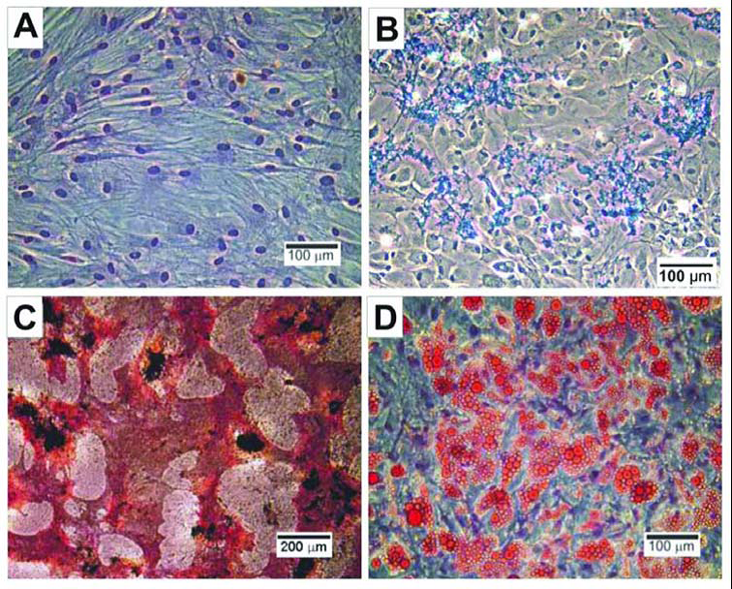
Figure 1 Mesenchymal stem cells (MSCs) are viewed as a yardstick of adult stem cells. A: Human MSCs isolated from anonymous adult human bone marrow donor after culture expansion (H and E staining); B: Chondrocytes derived from human mesenchymal stem cells showing positive staining to Alcian blue. Additional molecular and genetic markers can be used to further characterize MSC-derived chondrocytes; C: Osteoblasts derived from human mesenchymal stem cells showing positive von Kossa staining for calcium deposition (black) and active alkaline phosphatase enzyme (red). Additional molecular and genetic markers can be used to further characterize MSC-derived chondrocytes; D: Adipocytes derived from human mesenchymal stem cells showing positive Oil Red–O staining of intracellular lipids. Additional molecular and genetic markers can be used to further characterize MSC-derived chondrocytes^{[16]}.
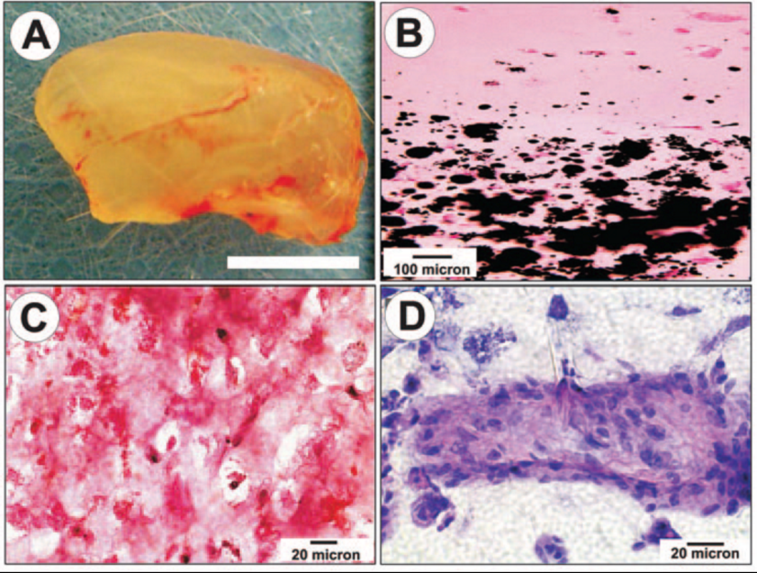
Figure 2 Engineered neogenesis of human-shaped mandibular condyle from mesenchymal stem cells. A: Harvested osteochondral construct retained the shape and dimension of the cadaver human mandibular condyle after in vivo implantation. Scale bar: 5 mm; B: Von Kossa-stained section showing the interface between stratified chondral and osseous layers. Multiple mineralization nodules are present in the osseous layer (lower half of the photomicrograph), but absent in the chondral layer; C: Positive safranin O staining of the chondrogenic layer indicates the synthesis of abundant glycosaminoglycans; D: H&E-stained section of the osteogenic layer showing a representative osseous island-like structure consisting of MSC-differentiated osteoblast-like cells on the surface and in the center. Reproduced with permission from Biomedical Engineering Society^{[36]}.

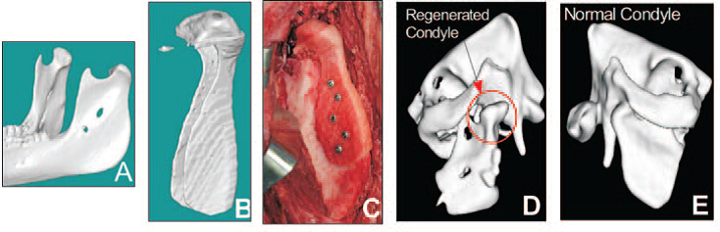
Figure 3 Design and engineering of minipig mandibular condyle. A: Original Computed Tomography (CT) scan of minipig mandible; B: Image-based design of condyle scaffold; C: PCL (polycaprolactone) degradable polymer scaffold fabricated with SLS (Selective Laser Sintering) attached to the ramus; D: Regrowth of condyle following 3 months' implantation (new condyle shown in red circle); E: Comparison with normal condyle from contralateral side in Yucatan minipig^{[37]}.

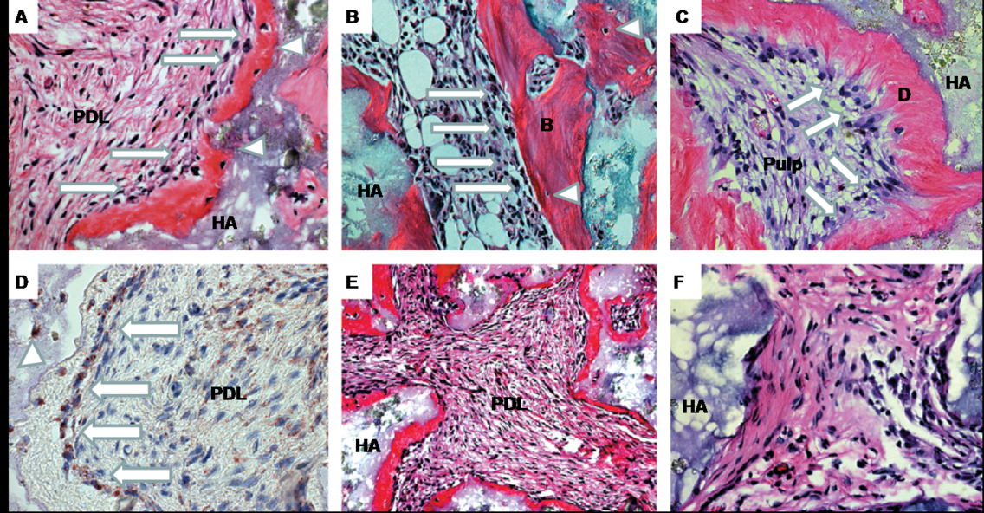
Figure 4 Generation of cementum-like and PDL-like structures in vivo by PDLSCs. A: After 8 wk of transplantation, PDLSCs differentiated into cementoblast-like cells (arrows) that formed a cementum-like structure (C) on the surface of the hydroxyapatite tricalcium phosphate (HA) carrier; cementocyte-like cells (triangles) and PDL-like tissue (PDL) were also generated; B: BMSSC transplant was used as control to show the formation of a bone/marrow structure containing osteoblasts (arrows), osteocytes (triangles), and elements of bone (B) and haemopoietic marrow (HP); C: DPSC transplant was also used as a control to show a dentin/pulp-like structure containing odontoblasts (arrows) and dentin like (D) and pulp-like (Pulp) tissue; D: Immunohistochemical staining showed that PDLSCs generated cementum-like structure (C) and differentiated into cementoblast-like cells (arrows) and cementocyte-like cells (triangles) that stained positive for human-specific mitochondria antibody. Part of the PDL-like tissue (PDL) also stained positive for human specific mitochondria antibody (within dashed line); E: Of 13 selected strains of single-colony derived PDLSC, only eight (61%) generated cementum/PDL-like structures in vivo as shown at lower magnification (approximately_20). New cementum-like structure (C) formed adjacent to the surfaces of the carrier (HA) and associated with PDL-like tissue (PDL); F: The other five strains did not generate mineralised or PDL-like tissues in vivo^{[38]}.

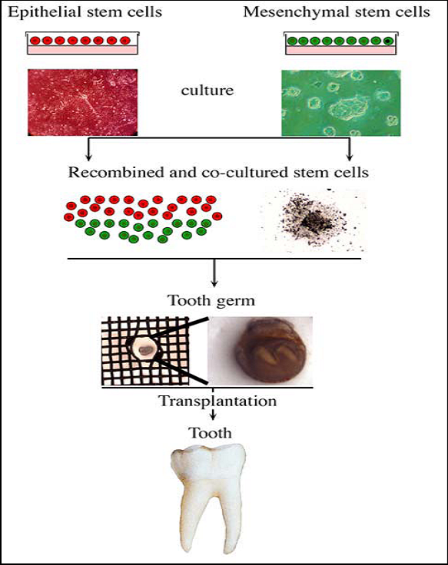

Figure 5 Use of stem cells for tooth formation in vitro and ex vivo. A tooth germ can be created in vitro after co-culture of isolated epithelial and mesenchymal stem cells. This germ could be implanted into the alveolar bone and finally develop into a fully functional tooth^{[40]}.

