Name of Journal: World Journal of Clinical Cases
Manuscript NO: 89800
Manuscript Type: ORIGINAL ARTICLE

Retrospective Study
Ultrasound diagnosis of congenital Morgagni hernias: Ten years of experience at two Chinese centers

Shi HQ et al. US in Morgagni hernias

Hui-Qing Shi, Wen-Juan Chen, Qiang Yin, Xue-Hua Zhang

Hui-Qing Shi, Xue-Hua Zhang, Department of Ultrasound, Fujian Children’s Hospital (Fujian Branch of Shanghai Children’s Medical Center), College of Clinical Medicine for Obstetrics & Gynecology and Pediatrics, Fujian Medical University, Fuzhou 350011, Fujian Province, China

Wen-Juan Chen, Department of Ultrasound, Hunan Children’s Hospital, University of South China, Changsha 410007, Hunan Province, China

Qiang Yin, Department of Pediatric Surgery, Hunan Children’s Hospital, University of South China, Changsha 410007, Hunan Province, China

Author contributions: Zhang XH designed research; Shi HQ, Chen WJ, Yin Q, and Zhang XH performed research; Zhang XH contributed analytic tools; Shi HQ and Zhang XH wrote paper.

Supported by Startup Fund for Scientific Research, Fujian Province Science and Technology Innovation Joint Fund Project, No. 2021Y9188.

Corresponding author: Xue-Hua Zhang, MD, PhD, Chief Doctor, Director, Doctor, Department of Ultrasound, Fujian Children’s Hospital (Fujian Branch of Shanghai Children’s Medical Center), College of Clinical Medicine for Obstetrics & Gynecology and Pediatrics, Fujian Medical University, No. 996 Hengyu Road, Fuzhou 350011, Fujian Province, China. 93225712@qq.com

Received: November 13, 2023
Revised: December 4, 2023
Accepted: January 2, 2024
Published online: January 26, 2024

Abstract
BACKGROUND
Morgagni hernias are rare anomalies that are easily misdiagnosed or missed.

AIM
To summarize the ultrasound (US) imaging characteristics of Morgagni hernias through a comparison of imaging and surgical results.

METHODS
The records of children with Morgagni hernias who were hospitalized at two hospitals between January 2013 and November 2023 were retrospectively reviewed in terms of clinical findings, US features, and operative details.

RESULTS
Between 2013 and 2023, we observed nine (five male and four female) children with Morgagni hernias. Upper abdominal scanning revealed a widening of the prehepatic space, with an abnormal channel extending from the xiphoid process to the right or left side of the thoracic cavity. The channel had intestinal duct and intestinal gas echoes. Hernia contents were found in the transverse colon (n = 6), the colon and small intestine (n = 2), and the colon and stomach (n = 1). Among the patients, seven had a right-sided lesion, two had a left-sided lesion, and all of them had hernial sacs.

CONCLUSION
US imaging can accurately determine the location, extent, and content of Morgagni hernias. For suspected Morgagni hernias, we recommend performing sonographic screening first.

Key Words: Children; Congenital diaphragmatic hernias; Morgagni hernia; Operation; Ultrasound; Gastrointestinal imaging

©The Author(s) 2024. Published by Baishideng Publishing Group Inc. All rights reserved.

Citation: Shi HQ, Chen WJ, Yin Q, Zhang XH. Ultrasound diagnosis of congenital Morgagni hernias: Ten years of experience at two Chinese centers. World J Clin Cases 2024; 12(3): 495-502
URL: https://www.wjgnet.com/2307-8960/full/v12/i3/495.htm
DOI: https://dx.doi.org/10.12998/wjcc.v12.i3.495

Core Tip: Morgagni hernias are rare and easily misdiagnosed or missed. In this report, retrosternal hernias accidentally discovered by ultrasound. The ultrasonic and clinical characteristics are summarized to provide a simple and effective basis for early diagnosis. Ultrasonic imaging can accurately determine the location, extent, and content of Morgagni hernias. For suspected Morgagni hernias, we recommend performing sonographic screening first.

INTRODUCTION
A Morgagni hernia is an unusual congenital herniation of the abdominal contents through the costochondral triangles of the anterior diaphragm^{[1]}. Few reports on Morgagni hernias in children are available. Morgagni hernias are easily misdiagnosed or missed because their symptoms are mild and atypical^{[2]}. In the present report, retrosternal hernias that were accidentally discovered by ultrasound (US) are described, and their ultrasonic manifestations are specified. The US and clinical characteristics are summarized to provide a simple and effective basis for early diagnosis.

MATERIALS AND METHODS
Patient population
The records of nine patients with Morgagni hernias diagnosed by US imaging and confirmed by surgery at two children’s hospitals between 2013 and 2023 were collected.

Ultrasonic scanning
US scans were performed by a team of experienced examiners by using Philips EPIQ 7C (Netherlands). The scans were acquired at convex and linear array transducer frequencies of 5-14 MHz. The upper abdomen and chest of each patient in the supine, lateral, or sitting position were scanned to reveal the whole diaphragm and the site in front of the liver and behind the sternum. The positions, contents, morphologies, structures, and connections of the hernias were recorded.

Gastrointestinal imaging and computed tomography
All nine patients underwent contrast gastrointestinal imaging (GI) (TOSHIBA, Japan). Two patients underwent chest computed tomography (CT) scans (PHILIP Brilliance 64 spiral CT-Netherlands). The patients were diagnosed with Morgagni hernias after US imaging, but their GI results did not show any signs of the disease.

Ethical permission
The study was approved by the Medical Ethics Committee of Fujian Children’s Hospital and Hunan Children’s Hospital, and waived of Informed Consent from parents. All methods were performed in accordance with the Declaration of Helsinki.

Statistical methods
SPSS 20.0 was used for statistical analysis. Counting data are expressed as cases and percentages. The agreement between US, and GI/CT and surgery results was calculated using cross - tabulation.

RESULTS
Basic data
Nine children (five male and four female) who were diagnosed with Morgagni hernias that were confirmed by surgery were included in this study (Table 1). The ages of the patients ranged from three months to three years and six months. The chief complaints were repeated coughing in five patients, vomiting in two patients, and constipation in one patient. In one patient, beating of the heart could be seen on the chest wall, which is one of the manifestations of Cantrell’s pentagonal syndrome (Table 1).

US imaging
All nine Morgagni hernias were first identified by US: (1) Upper abdominal scanning revealed a widening of the prehepatic space, with an abnormal channel extending from under the xiphoid process to the right or left side of the thoracic cavity. Two hernias were on the left side (Figure 1A), and seven were on the right side (Figure 1C, E, G and H). The abdominal intestinal tube and intestinal air echo crossed this area to the chest in all nine cases. In one patient, the stomach could be seen across this area towards the chest; and (2) Chest scanning showed echoes of the bowel and stomach, and gas was present in the left or right anterior chest on the side of the heart or mediastinum. Intestinal peristalsis and intestinal content movement were observed during the scans. The height of the hernia sac was at the level of the fourth rib in three patients, the fifth rib in four patients, the second rib in one patient, and the sixth rib in one patient.

GI and CT
The GI of seven patients showed herniation of the transverse colon or bowl into the thoracic cavity (Figures 1B, D, and F) and herniation of the stomach and colon into the thoracic cavity. Two patients showed no abnormalities (Figure 1I). A CT scan revealed a right Morgagni hernia with an intestinal tube in two patients (Figure 1J).

Surgical results
Seven patients underwent laparoscopic surgery, one underwent open diaphragmatic repair, and one (Cantrell’s pentalogy) underwent open diaphragmatic repair + pericardial repair. A hernia was found on the left side in two patients and on the right side in seven patients. Hernia sacs were found in all patients during the operations. The hernia sac areas were approximately 20-25 cm². The hernias consisted of the transverse colon and greater omentum in six patients, the colon and small intestine in two patients, and the stomach and colon in one patient (Table 1, Figure 2).

Diagnostic consistency analysis
The consistency between ultrasounic diagnosis and surgical results was 100%, and the consistency between GI diagnosis and surgical results was 77%.

DISCUSSION
In 1769, the Italian anatomist Giovanni Battista Morgagni described the herniation of abdominal contents through sternochondral triangles via cadaver observation. In 1828, Larrey described a surgical approach to the pericardial sac through the same triangles. Given the early work of Morgagni and Larrey, the right- and left-hand costochondral triangles have been designated as the foramen of Morgagni and the space of Larrey, respectively (Figure 3)^{[3]}. These triangles form when the pars sternalis and a costochondral arch fuse and close around the internal thoracic artery as it becomes the superior epigastric artery. Occasionally, these spaces fail to fully close, allowing the herniation of abdominal contents into the thorax. This type of herniation is referred to as a Morgagni hernia regardless of the laterality^{[1]}.
Morgagni hernias are confined to the posterior sternal triangle, so they are different from Bochdalek^{[4]} (mainly in the left posterolateral, with diaphragmatic defect) and hiatal (hiatal and adjacent hiatal holes) hernias. The symptoms of Morgagni hernias are not as typical as those of Bochdalek and hiatal hernias, and the onset of Morgagni hernias is occult and therefore easy to ignore clinically. A review of the literature showed that only a few reports on Morgagni hernias are available. Hosokawa et al^{[2]} performed a meta-analysis of all articles on Morgagni hernias published from 1997 to 2017, with a total of 296 cases. Most of the Morgagni hernias were found accidentally by X-ray or CT examination (240/298 cases), and only seven cases were detected accidentally by US examination^{[2]}. A few studies have summarized the characteristic US images of Morgagni hernias. In the current study, five children presented with repeated cough, and three children presented with vomiting and constipation. All hernia cases were found unintentionally by abdominal US. Therefore, in actual work on children with repeated cough, the prehepatic space must be scanned to rule out the existence of Morgagni hernias. Increasing the awareness of this disease or undergoing timely abdominal US examination is the key to diagnosing this disease. Compared with US examination of other thoracic and abdominal diseases, US examination of Morgagni hernias is simple, and the US sensitivity and specificity are high. It is important to understand this disease and its US characteristics.
The present study showed the US manifestations of nine children with Morgagni hernias. First, US examination could detect the position of the hernias (on the left or right). Among the nine patients, seven and two patients had hernias on the right and left sides, respectively, indicating that the incidence on the right side was higher than that on the left side. Similarly, a previous report showed that 90% of chest hernias are located on the right side, and 10% are on the left side^{[2]}.
Second, US examination could reveal the contents of the hernias. The surgical results showed herniation of the transverse colon in six patients, one patient with herniation of the colon and stomach and two patients with herniation of the small intestine and transverse colon. Hence, the herniated contents were all intestinal tubes without substantial organs. US examination could be employed to identify the herniated contents by using the intestinal canal through peristalsis and movement of the intestinal contents. In this case analysis, compared with GI and CT examination, US diagnosis of Morgagni hernias had the advantage of being able to slide the contents of the hernia (intestine) behind the sternum. GI requires contrast enhancement to capture a static image. In a few cases, a false-negative result can be obtained if the bowel slides back into the abdominal cavity during radiography. In the present work, two children with false-negative GI results were found to have Morgagni hernias by CT.
Third, US examination could measure the width of the hernia sac orifice, estimate the position of the hernia contents in the anterior thoracic cavity, determine its relationship with the surrounding anatomy, and provide a basis for further clinical treatment. In the present group, all nine patients had hernia sacs, with an average size of approximately 21-25 cm². These Morgagni hernias were small and had limited extension, a result that is consistent with those of previous reports^{[5,6]}. Therefore, this type of hernia does not easily compress the lungs or other organs and has mild clinical symptoms or lacks typical manifestations (respiratory distress, vomiting, etc.). In this study, five children presented with repeated cough, and three children presented with vomiting and constipation. All nine children were incidentally diagnosed through US and subjected to GI and CT scanning. Therefore, US examination is an important method for diagnosing Morgagni hernias.
US examination has limitations. Although US can roughly locate the height of the hernia sac, it cannot accurately evaluate the range of the whole hernia sac and has poor spatial resolution. In addition, US depends on the experience of the scanner, who should always keep in mind the US characteristics of Morgagni hernias. Direct signs, such as abnormal channels between the sternum and liver and intestinal tubes and gas entering the chest cavity through these channels, are key. Peristalsis occurs in the anterior chest cavity, and widening of the anterior hepatic space is suggestive of a Morgagni hernia.

CONCLUSION
Morgagni hernias in children are diagnosed by US detection of the peristalsis of the prehepatic area and intrathoracic intestine and the movement of intestinal contents. This study provides a new, reliable basis for the clinical diagnosis of this type of malformation.

ARTICLE HIGHLIGHTS
Research background
A Morgagni hernia is an unusual congenital herniation. It is easily misdiagnosed or missed because their symptoms are mild and atypical. In the present report, retrosternal hernias accidentally discovered by ultrasound (US) are described, and their ultrasonic manifestations are analyzed. The US and clinical characteristics are summarized to provide a simple and effective basis for early diagnosis.

Research motivation
Through this report, we can understand more about the clinical and ultrasonic characteristics of rare retrosternal hernia diseases. To add much new insightful information to the field.

Research objectives
To summarize the US imaging characteristics of Morgagni hernias through a comparison of imaging and surgical results.

Research methods
The records of nine patients with Morgagni hernias diagnosed by US imaging and confirmed by surgery at two children’s hospitals between 2013 and 2023 were collected. The clinical symptoms of the case were summarized. The location, contents and size of the hernia sac were recorded by ultrasound. The clinical and ultrasonic characteristics of the hernia were summarized by comparing with gastrointestinal imaging/computed tomography and surgery.

Research results
Between 2013 and 2023, we observed nine (five male and four female) children with Morgagni hernias. All nine Morgagni hernias were first identified by US: (1) Upper abdominal scanning revealed a widening of the prehepatic space, with an abnormal channel extending from under the xiphoid process to the right or left side of the thoracic cavity. Two hernias were on the left side, and seven were on the right side. The abdominal intestinal tube and intestinal air echo crossed this area to the chest in all nine cases; and (2) Chest scanning showed echoes of the bowel and stomach. Intestinal peristalsis and intestinal content movement were observed during the scans.

Research conclusions
US imaging can accurately determine the location, extent, and content of Morgagni hernias. Direct signs, such as abnormal channels between the sternum and liver and intestinal tubes and gas entering the chest cavity through these channels, are key. Peristalsis occurs in the anterior chest cavity, and widening of the anterior hepatic space is suggestive of a Morgagni hernia.

Research perspectives
The research perspective of this study is to analysed the clinical findings, US features, and operative details of children with Morgagni hernias. In the future studies, we will continue to increase the sample size for more in-depth research, and will analyze the postoperative recurrence rate of retrosternal hernia.

ACKNOWLEDGEMENTS
First, I would like to give my heartfelt thanks to my academic supervisor Prof. Xue-Hua Zhang for his invaluable instruction and inspiration. Without his previous advice and guidance, this study could not have been completed. Additionally, I must express my sincere thanks to all the authors in this research.

REFERENCES
1 Leshen M, Richardson R. Bilateral Morgagni Hernia: A Unique Presentation of a Rare Pathology. Case Rep Radiol 2016; 2016: 7505329 [PMID: 27403367 DOI: 10.1155/2016/7505329]
2 Hosokawa T, Takahashi H, Tanami Y, Sato Y, Hosokawa M, Kato R, Kawashima H, Oguma E. Usefulness of Ultrasound in Evaluating the Diaphragm in Neonates and Infants With Congenital Diaphragmatic Hernias. J Ultrasound Med 2019; 38: 1109-1113 [PMID: 30346045 DOI: 10.1002/jum.14777]
3 Chandrasekharan PK, Rawat M, Madappa R, Rothstein DH, Lakshminrusimha S. Congenital Diaphragmatic hernia - a review. Matern Health Neonatol Perinatol 2017; 3: 6 [PMID: 28331629 DOI: 10.1186/s40748-017-0045-1]
4 Zhang XH, Chen WJ, Zhou CG, Lei R, Wang J. [Ultrasound and clinical features of congenital diaphragmatic hernia in 31 children]. Chin J Ultrasound Med 2019; 35: 236-238
5 Slepov O, Kurinnyi S, Ponomarenko O, Migur M. Congenital retrosternal hernias of Morgagni: Manifestation and treatment in children. Afr J Paediatr Surg 2016; 13: 57-62 [PMID: 27251653 DOI: 10.4103/0189-6725.182557]
6 Golden J, Barry WE, Jang G, Nguyen N, Bliss D. Pediatric Morgagni diaphragmatic hernia: a descriptive study. Pediatr Surg Int 2017; 33: 771-775 [PMID: 28289880 DOI: 10.1007/s00383-017-4078-3]

Footnotes
Institutional review board statement: The study was approved by the Medical Ethics Committee of Fujian Children’s Hospital and Hunan Children’s Hospital.

Informed consent statement: Informed consent was waived from the parents.

Conflict-of-interest statement: All the authors report no relevant conflicts of interest for this article.

Data sharing statement: The data used for analysis in our study are available from the corresponding author on reasonable request.

Open-Access: This article is an open-access article that was selected by an in-house editor and fully peer-reviewed by external reviewers. It is distributed in accordance with the Creative Commons Attribution NonCommercial (CC BY-NC 4.0) license, which permits others to distribute, remix, adapt, build upon this work non-commercially, and license their derivative works on different terms, provided the original work is properly cited and the use is non-commercial. See: https://creativecommons.org/Licenses/by-nc/4.0/

Provenance and peer review: Unsolicited article; Externally peer reviewed.
Peer-review model: Single blind

Peer-review started: November 13, 2023
First decision: November 22, 2023
Article in press: January 2, 2024

Specialty type: Medicine, research and experimental
Country/Territory of origin: China
Peer-review report’s scientific quality classification
Grade A (Excellent): 0
Grade B (Very good): B
Grade C (Good): 0
Grade D (Fair): 0
Grade E (Poor): 0

P-Reviewer: Shalaby MN, Egypt S-Editor: Wang JJ L-Editor: A P-Editor: Xu ZH
Figure Legends
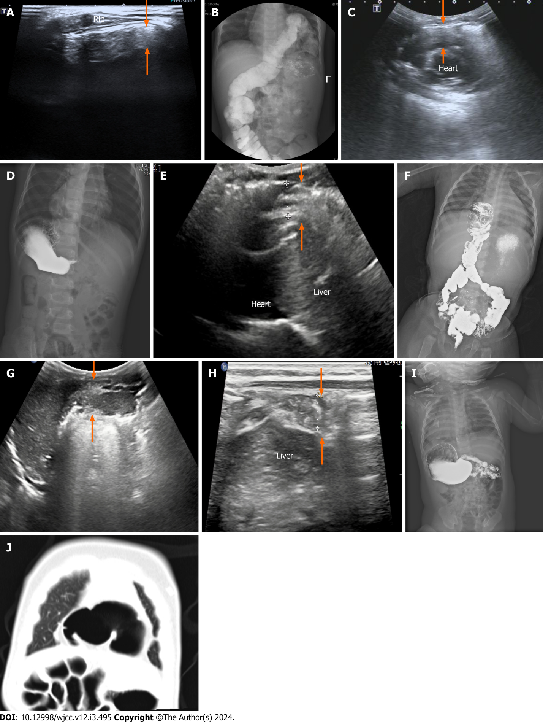

Figure 1 A ultrasound of Morgagni hernia. A: Case 1: Longitudinal ultrasound (US) scan beside the xiphoid: The intestinal tube and gas echo (arrows) can be seen in left Morgagnian foramina; B: Gastrointestinal imaging (GI) of Morgagni hernia (case 1). Contrast GI showing the herniation of the transverse colon into the left thoracic cavity; C: Case 2: Longitudinal US scan beside the iphoid: Intestinal tube and intestinal gas echo (arrows) between the sternum and the heart; D: GI of Morgagni hernia (case 2). GI suggesting the herniation of the bowel into the right side of the thorax; E: Case 3: Longitudinal US scan beside the xiphoid: Intestine and intestinal gas echoes (arrows) between the sternum and the liver; F: GI of Morgagni hernia (case 3). GI suggesting the herniation of the bowel into the right side of the thorax; G: Case 4: A: Longitudinal US scan of the anterior chest. The echo of intestinal tube and intestinal gas (arrows) can be seen in the right Morgagnian foramina; H: Ultrasound of Morgagni hernia (case 4). US of same patient as in Figure 1G Herniation of the bowel (arrows) into the right side of the thorax; I: GI of Morgagni hernia (case 4). GI showing no obvious abnormality; J: Computed tomography (CT) Morgagni hernia (case 4). Cross-sectional chest CT scan showing the herniation of the intestine into the right thoracic cavity.

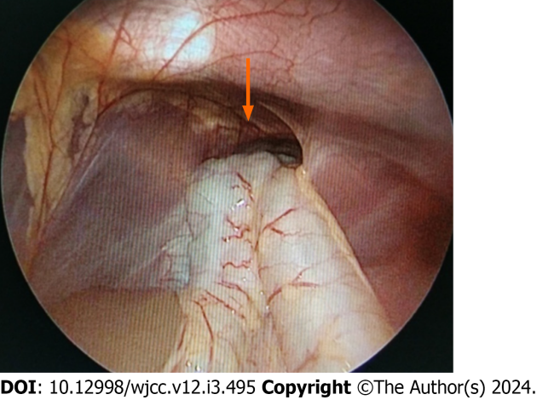
Figure 2 Depiction of laparoscopy surgery a Morgagni hernia and herniated bowel (arrow).

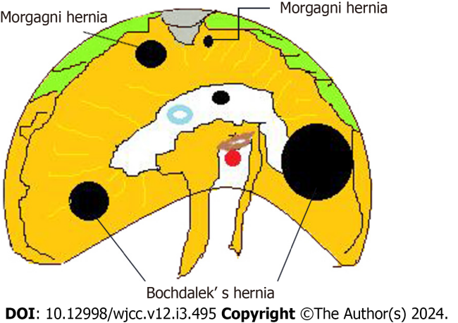
Figure 3 Drawing of the location of Morgagni hernia.

Table 1 Clinical characteristics of all the patients with Morgagni hernias
Sex | Age | Chief complaint | US | Contrast GI, contrast CT | Surgery
Male | 1 yr | Cough | Right/intestinal tract/fourth rib | Right/intestinal tract | Right/colon and small intestine
Female | 3 mo 4 d | Constipation | Right/intestinal tract/fifth rib | GI: Negative, no results of CT | Right/transverse colon
Female | 1 yr | Cough | Left/intestinal tract/second rib | Left/intestinal tract | Left/transverse colon and omentum
Female | 3 yr 6 mo | Cough | Right/intestinal tract/fourth rib | Right/intestinal tract | Right/transverse colon
Female | 9 mo | Vomiting | Right/intestinal tract/sixth rib | GI: Negative. CT: Right/intestinal tract | Right/transverse colon and omentum
Male | 1 yr 5 mo | Forechest fluctuating mass | Left/intestinal tract/fifth rib | Left/intestinal tract | Left/transverse colon
Male | 2 yr | Cough | Right/intestinal tract/fourth rib | Right/intestinal tract | Right/transverse colon
Male | 6 mo 16 d | Cough | Right/intestinal tract/fifth rib | Right/intestinal tract | Right/colon and small intestine
Male | 4 mo | Vomiting | Right/colon and stomach | Right/colon and stomach | Right/colon and stomach
US: Ultrasound; CT: Computed tomography; GI: Gastrointestinal imaging.

Published by Baishideng Publishing Group Inc
7041 Koll Center Parkway, Suite 160, Pleasanton, CA 94566, USA
Telephone: +1-925-3991568
E-mail: office@baishideng.com
Help Desk: https://www.f6publishing.com/helpdesk
https://www.wjgnet.com

© 2024 Baishideng Publishing Group Inc. All rights reserved.

