Name of Journal: World Journal of Hepatology
Manuscript NO: 58649
Manuscript Type: LETTER TO THE EDITOR

Autophagy related protein 9A increase in hepatitis B virus-associated hepatocellular carcinoma and the role in apoptosis

Kimkong I et al. ATG9A in HBV-associated hepatocellular carcinoma

Ingorn Kimkong, Areerat Kunanopparat

Ingorn Kimkong, Department of Microbiology, Faculty of Science, Kasetsart University, Center for Advanced Studies in Tropical Natural Resources, National Research University – Kasetsart University, Bangkok 10900, Thailand

Areerat Kunanopparat, Department of Microbiology, Center of Excellence in Immunology and Immune Mediated Diseases, Chulalongkorn University, Bangkok 10330, Thailand

Author contributions: Kimkong I designed the research, wrote the manuscript and edited the manuscript; Kunanopparat A performed the majority of experiments and analyzed the data.

Corresponding author: Ingorn Kimkong, PhD, Assistant Professor, Department of Microbiology, Faculty of Science, Kasetsart University, 50 Thanon Ngamwongwan, Lat Yao, Chatuchak, , Bangkok 10900, Thailand. fsciiok@ku.ac.th

Received: July 31, 2020
Revised: September 29, 2020
Accepted: October 19, 2020
Published online: December 27, 2020

Abstract
The majority of hepatocellular carcinoma (HCC) cases are associated with the hepatitis B virus (HBV) infection. Autophagy related protein 9A (ATG9A) is a transmembrane protein required for autophagosome formation. In order to investigate the role of ATG9A in HBV-associated HCC, ATG9A protein expression was determined in tumor liver tissues and compared with adjacent nontumor tissues from HCC patients with or without HBV infection. In HBV-associated HCC tissues, ATG9A protein level was increased in tumor liver tissues, but not in cases of non-HBV HCC. Our findings suggested that ATG9A might be involved in HBV and cancer cell survival. Therefore, we aimed to analyze the function of ATG9A in HBV replication using RNA interference to evaluate the HBV DNA level using real-time PCR. In the present study, there were no significant differences between shATG9A-transfected HepG2.2.15 cells and the mock control. However, we found that silencing ATG9A affected apoptosis in HepG2.2.15 and HepG2 cell lines. Our results indicated that ATG9A might be partly involved in the survival of HCC. Thus, the inhibition of ATG9A together with other targets might be a potential drug target for HCC treatment.

Key Words: Autophagy; Hepatitis B virus; Hepatocellular carcinoma; Autophagy related protein 9A; Apoptosis; HBx

Citation: Kimkong I, Kunanopparat A. Autophagy related protein 9A increase in hepatitis B virus-associated hepatocellular carcinoma and the role in apoptosis. World J Hepatol 2020; 12(12): 1367-1371
URL: https://www.wjgnet.com/1948-5182/full/v12/i12/1367.htm
DOI: https://dx.doi.org/10.4254/wjh.v12.i12.1367

Core Tip: Autophagy related protein 9A (ATG9A) protein expression was increased in tumor liver tissues compared to adjacent nontumor tissues from hepatocellular carcinoma (HCC) patients with hepatitis B virus infection. We showed that silencing ATG9A increased cell apoptosis of HepG2.2.15 and HepG2 cells. These results suggested that ATG9A protein is involved in the survival of HCC. The inhibition of ATG9A combined with other targets might be a potential drug target for HCC treatment.
TO THE EDITOR
Autophagy related protein 9A (ATG9A) is a transporter membrane molecule required for initial autophagosome formation in the autophagy pathway^{[1]}. ATG9A has been identified as having the function of a stimulator of interferon (IFN) genes (STING)inhibition. A loss of ATG9A results in enhanced assembly of STING/TANK-binding kinase 1 complexes in response to dsDNA, leading to an increase in innate immune responses^{[2]}. Silencing of ATG9A in macrophages increases STING-mediated IFN-β production and promotes cell viability^{[3]}. Our previous study reported that gene and protein expressions of ATG9A were upregulated in HepG2 and HepG2.2.15 cells compared with a THLE-2 hepatic cell line^{[4]}. Thus, in this study we investigated the role of ATG9A in hepatitis B virus (HBV)-associated hepatocellular carcinoma (HCC) tissues. We found that ATG9A protein levels were highly increased in tumor liver tissues in HBV-associated HCC (9 of the 10 sample pairs). In the case of non-HBV HCC, ATG9A protein levels were decreased or slightly increased in tumor liver tissues (Figure 1). Therefore, we hypothesized that HBV induces the upregulation of ATG9A to benefit its replication. To determine the effect of ATG9A on HBV replication, HBV DNA was quantified from shATG9A-transfected cells and compared to mock cells. We observed no significant difference in shATG9A transfected cells (Figure 2).
HBV induces autophagy via the HBx protein and is directly involved in starvation-induced autophagy via upregulation of Beclin-1 expression^{[5]}. HBx also binds and activates phosphatidylinositol 3-kinase class III for autophagy induction^{[6]}. Our study showed that overexpression of HBx did not affect ATG9A expression (Figure 3), suggesting that the function of ATG9A may not involve HBV replication or viral clearance.
Autophagy is involved in tumor progression and tumor suppression. Several studies have shown that HBV induces autophagy for cell survival in an unsuitable environment^{[7]}. In order to search for the effect of ATG9A on apoptosis, we performed flow cytometry in HepG2.2.15 cells and compared against HepG2 cells after ATG9A silencing. We found that silencing ATG9A increased apoptosis in both cell lines (Figure 4), suggesting that ATG9A is involved in cell apoptosis related to HCC.
In conclusion, we provide information that ATG9A is highly expressed in HBV-associated HCC tissue samples and plays a role in cell apoptosis. Further studies are needed to investigate the mechanism of ATG9A-mediated inhibition of apoptosis in HCC.

ACKNOWLEDGEMENTS
We are grateful to all the patients who participated in this study. We would like to thank Tangkijvanich P and Sirichindakul B for tissue biopsy collection and Hirankarn N for valuable advice.

REFERENCES
1 Zhuang X, Chung KP, Cui Y, Lin W, Gao C, Kang BH, Jiang L. ATG9 regulates autophagosome progression from the endoplasmic reticulum in Arabidopsis. Proc Natl Acad Sci U S A 2017; 114: E426-E435 [PMID: 28053229 DOI: 10.1073/pnas.1616299114]
2 Saitoh T, Fujita N, Hayashi T, Takahara K, Satoh T, Lee H, Matsunaga K, Kageyama S, Omori H, Noda T, Yamamoto N, Kawai T, Ishii K, Takeuchi O, Yoshimori T, Akira S. Atg9a controls dsDNA-driven dynamic translocation of STING and the innate immune response. Proc Natl Acad Sci U S A 2009; 106: 20842-20846 [PMID: 19926846 DOI: 10.1073/pnas.0911267106]
3 Mitzel DN, Lowry V, Shirali AC, Liu Y, Stout-Delgado HW. Age-enhanced endoplasmic reticulum stress contributes to increased Atg9A inhibition of STING-mediated IFN-β production during Streptococcus pneumoniae infection. J Immunol 2014; 192: 4273-4283 [PMID: 24670807 DOI: 10.4049/jimmunol.1303090]
4 Kunanopparat A, Kimkong I, Palaga T, Tangkijvanich P, Sirichindakul B, Hirankarn N. Increased ATG5-ATG12 in hepatitis B virus-associated hepatocellular carcinoma and their role in apoptosis. World J Gastroenterol 2016; 22: 8361-8374 [PMID: 27729742 DOI: 10.3748/wjg.v22.i37.8361]
5 Tang H, Da L, Mao Y, Li Y, Li D, Xu Z, Li F, Wang Y, Tiollais P, Li T, Zhao M. Hepatitis B virus X protein sensitizes cells to starvation-induced autophagy via up-regulation of beclin 1 expression. Hepatology 2009; 49: 60-71 [PMID: 19065679 DOI: 10.1002/hep.22581]
6 Sir D, Tian Y, Chen WL, Ann DK, Yen TS, Ou JH. The early autophagic pathway is activated by hepatitis B virus and required for viral DNA replication. Proc Natl Acad Sci U S A 2010; 107: 4383-4388 [PMID: 20142477 DOI: 10.1073/pnas.0911373107]
7 Ávalos Y, Canales J, Bravo-Sagua R, Criollo A, Lavandero S, Quest AF. Tumor suppression and promotion by autophagy. Biomed Res Int 2014; 2014: 603980 [PMID: 25328887 DOI: 10.1155/2014/603980]

Footnotes
Conflict-of-interest statement: The authors have no conflicts of interest to declare.

Open-Access: This article is an open-access article that was selected by an in-house editor and fully peer-reviewed by external reviewers. It is distributed in accordance with the Creative Commons Attribution NonCommercial (CC BY-NC 4.0) license, which permits others to distribute, remix, adapt, build upon this work non-commercially, and license their derivative works on different terms, provided the original work is properly cited and the use is non-commercial. See: http://creativecommons.org/Licenses/by-nc/4.0/

Manuscript source: Unsolicited manuscript

Peer-review started: July 31, 2020
First decision: September 21, 2020
Article in press: October 19, 2020

Specialty type: Gastroenterology and hepatology
Country/Territory of origin: Thailand
Peer-review report’s scientific quality classification
Grade A (Excellent): 0
Grade B (Very good): 0
Grade C (Good): C, C
Grade D (Fair): 0
Grade E (Poor): 0

P-Reviewer: Chung YH, Fan X S-Editor: Gao CC L-Editor: Filipodia P-Editor: Xing YX
Figure Legends
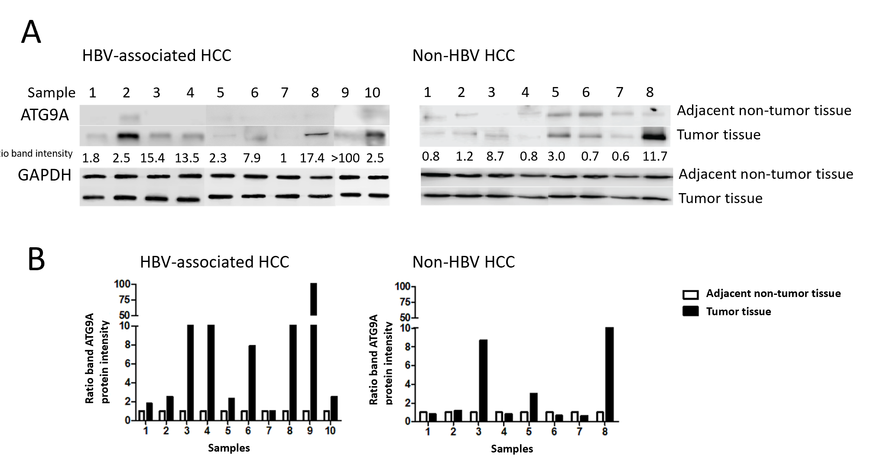
Figure 1 Quantification of autophagy related protein 9A protein levels from hepatitis B virus-infected hepatocellular carcinoma patients and nonhepatitis B virus hepatocellular carcinoma patients. A: Western blotting with specific antibodies was used to analyze autophagy related protein 9A (ATG9A) protein expression in hepatitis B virus (HBV)-associated hepatocellular carcinoma (HCC) and nonHBV-HCC. Glyceraldehyde-3-phosphate dehydrogenase (GADPH) was used as a protein loading control; B: Graphs showing the intensity band ratio (tumor tissue/adjacent nontumor tissue) quantified using the LI-COR® image system for western blot analysis.
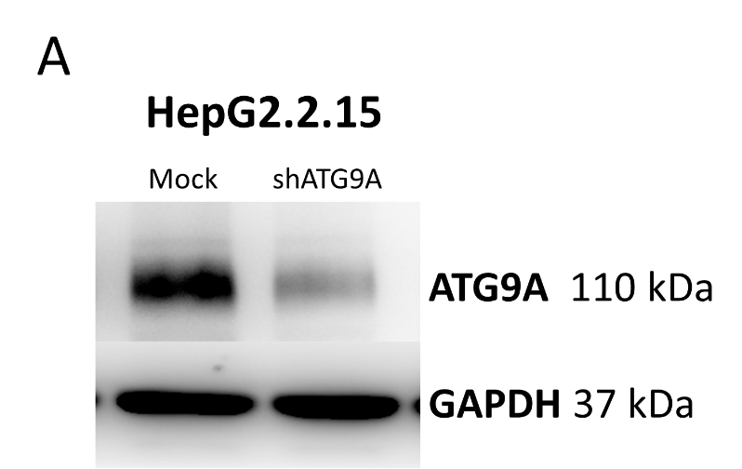
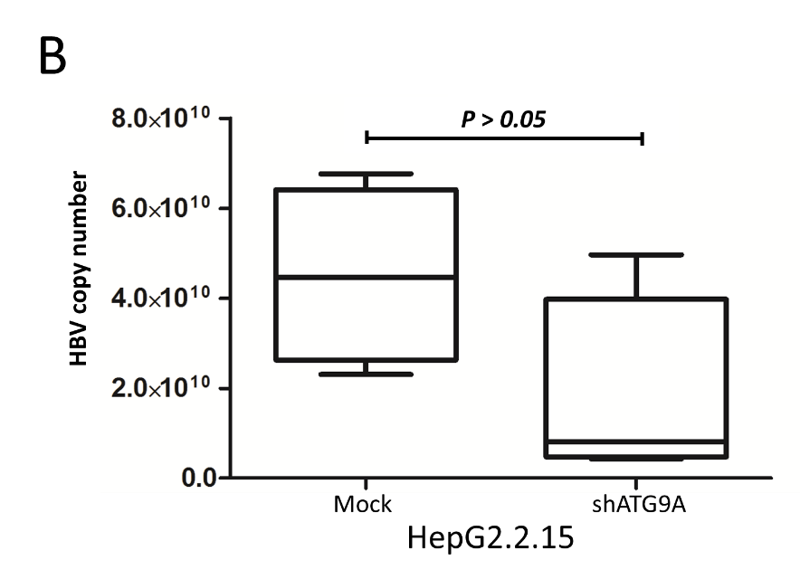
Figure 2 Silencing of autophagy related protein 9A by RNA interference and detection of hepatitis B virus DNA level. A: The western blot method was applied to analyze autophagy related protein 9 (ATG9A) protein levels against a mock treatment (control) and ATG9A knockdown (shATG9A) HepG2.2.15 cells; B: Quantitation of hepatitis B virus (HBV) DNA by real-time PCR. Total purified DNA from mock treatment (mock) and ATG9A knockdown (shATG9A) in HepG2.2.15 cells was amplified using preS1 specific primers. Hepatitis B virus preS1 plasmid was used as standard copy number. Data is shown as mean ± standard error of the four independent experiments. GAPDH: Glyceraldehyde-3-phosphate dehydrogenase.
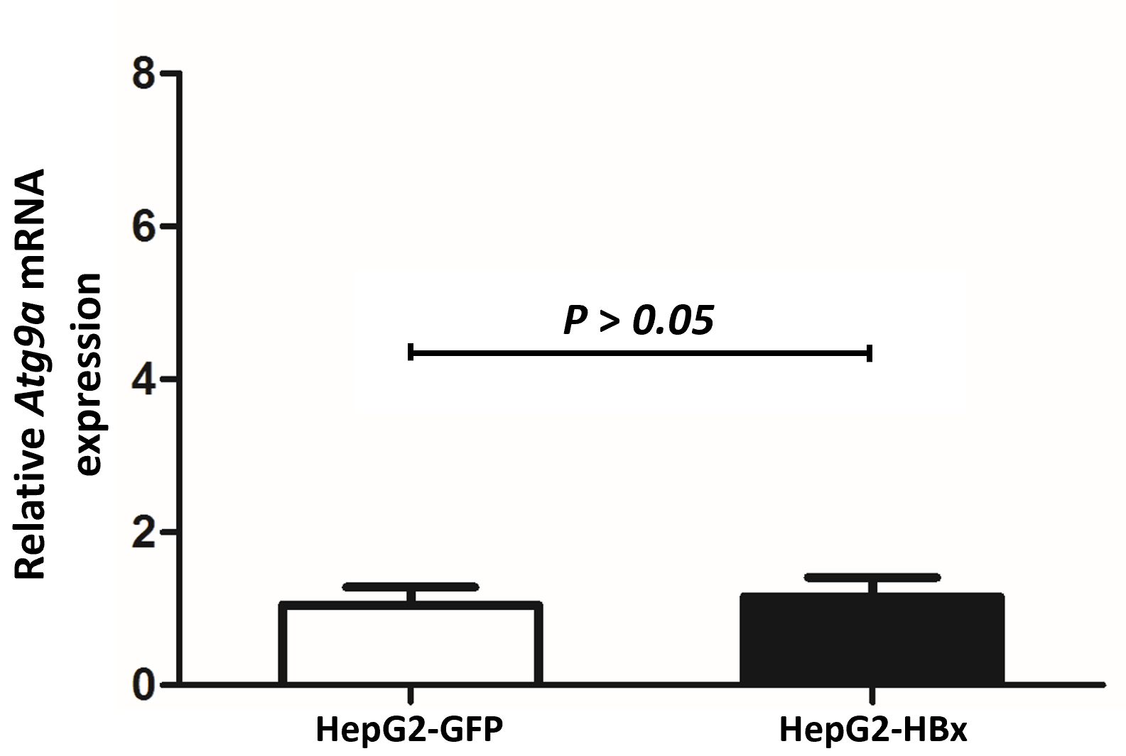
Figure 3 Quantitative real-time reverse transcriptase-PCR analysis of autophagy related protein 9A mRNA expression in HepG2-GFP and HepG2-HBx transfected cell lines. β-actin was used as an internal control. Data represent the mean ± standard error in the three independent experiments. ATG9A: Autophagy related protein 9A.
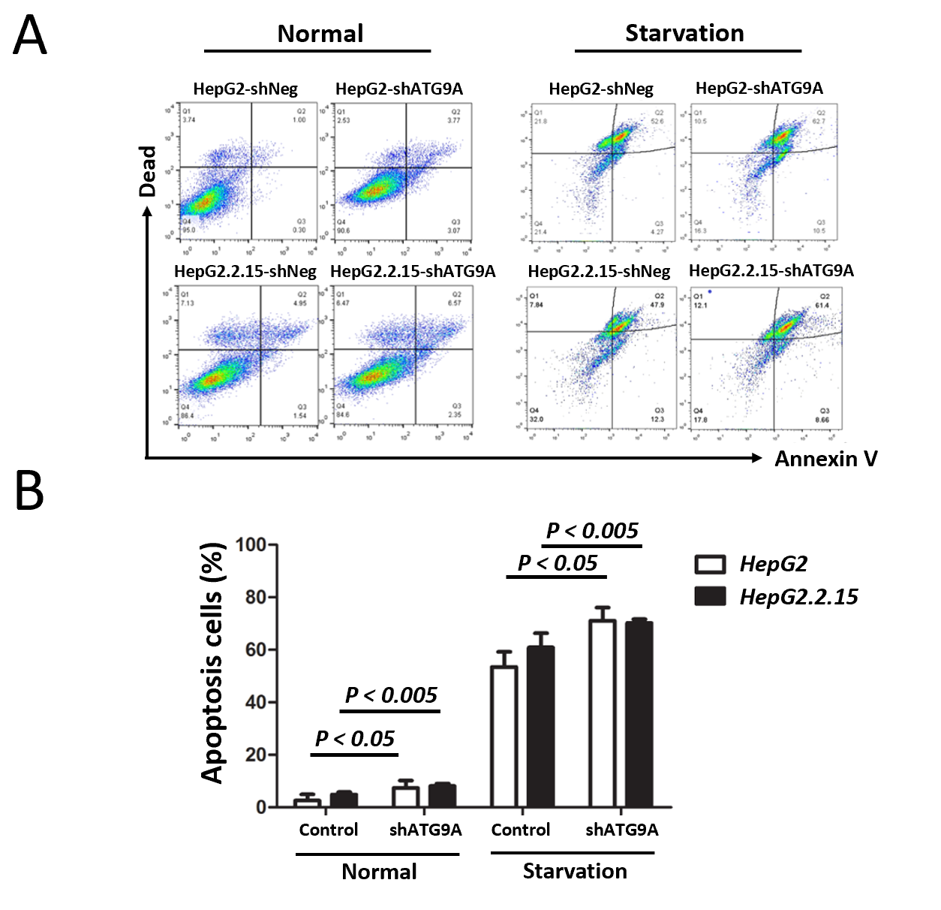
Figure 4 Apoptosis assays of HepG2 and HepG2.2.15 transfected with sh-autophagy related protein 9A or shNeg (control). A: Cells were transiently transfected with shRNA plasmids for 72 h and then cultured in starvation medium for 4 h; B: Bar graphs showing the percentage of total apoptotic cells detected by Annexin V binding. Data represent the mean ± standard error from the three independent experiments. ATG9A: Autophagy related protein 9A.

