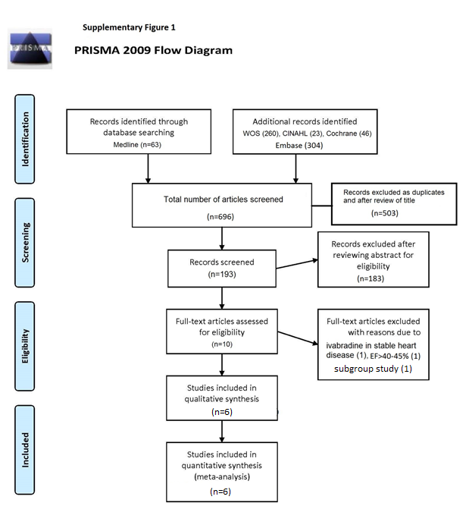

Supplementary Figure 1. PRISMA flow diagram

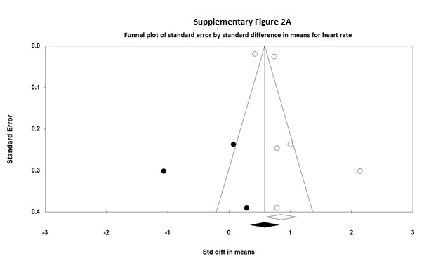
Supplementary Figure 2A. Funnel-plot of standard error by standard difference in means for heart rate.

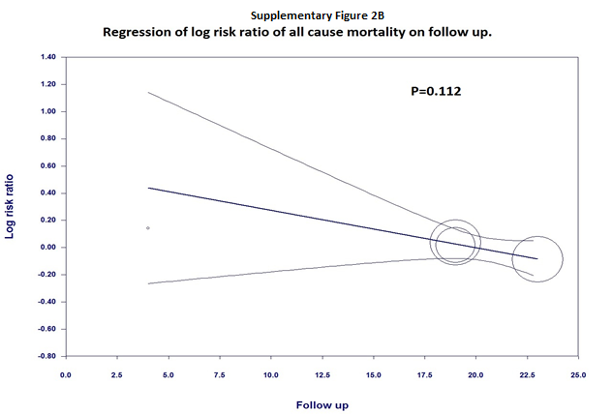
Supplementary Figure 2B. Regression of log risk ratio of all cause mortality on follow up time.

Supplementary Table 1. PRISMA-P (Preferred Reporting Items for Systematic review and Meta analysis Protocols) 2015 checklist: recommended items to address in a systematic review protocol*
Section and topic | Item No | Checklist item
ADMINISTRATIVE INFORMATION
Title:
Identification | 1a | Identified as meta analysis in the title.
Update | 1b | Not applicable
Registration | 2 | Not applicable
Authors:
Contact | 3a | Provided in the title page (page 1)
Contributions | 3b | Listed in the author contribution section. (page 14)
Amendments | 4 | Not applicable
Support:
Sources | 5a | Listed at the end of the manuscript (page 14)
Sponsor | 5b | Listed at the end of the manuscript (page 14)
Role of sponsor or funder | 5c | No funding obtained for the study protocol.
INTRODUCTION
Rationale | 6 | (page 4)
Objectives | 7 | We performed a meta analysis with available studies to date to compare outcomes of ivabradine combined with beta-blocker (BB) to BB therapy alone (page 5)
METHODS
Eligibility criteria | 8 | Randomized controlled trials, retrospective or prospective observational cohorts; all patients with heart failure with reduced ejection fraction of < 40%; compared two groups, one with ivabradine and beta blockers and the other with beta blockers alone. We included all adult patients (>16 years of age) of any gender and excluded non-English literature. (page 5)
Information sources | 9 | We searched searched PubMed, the Cochrane library, EMBASE, CINAHL and Google scholar databases from January 1960 to August 2016. We also performed hand-search by reviewing the reference sections of the included studies, review articles and editorials (page 5)
Search strategy | 10 | Presented Pubmed search strategy in the supplement. Initial search strategy from 5 databases yielded 392 studies. (page 5)
Study records:
Data management | 11a | Described in detail in the Literature search section (page 5)
Selection process | 11b | Two independent reviewers collected and abstracted the data after reviewing full text articles. Any disagreement was resolved by consensus (page 6)
Data collection process | 11c | We sought help from library to get full text articles in case if they were not available online (page 6)
Data items | 12 | Listed in detail in the demographic table. (Table 1)
Outcomes and prioritization | 13 | The primary outcome was combined end point of heart failure and cardiovascular death. Secondary end points are mean reduction in heart rate at follow up compared to baseline, all cause mortality, cardiovascular mortality, six-minute walking distance (6MWD) and ejection fraction (EF) at follow up (Page 6)
Risk of bias in individual studies | 14 | Funnel-plot included with outcomes when necessary for evaluating publication bias. Sensitivity analysis was included for outcomes when necessary excluding the study with maximum strength (pages 6,7)
Data synthesis | 15a | Described in detail in the methods section (pages 5,6)
 | 15b | The heterogeneity was evaluated by the use of I-squared. I² values of 25%, 50%, and 75% were considered as low, moderate, and high heterogeneity, respectively (page 6)
 | 15c | An exclusion sensitivity analysis was included when necessary (page 7)
 | 15d | Quantitative synthesis was completed with meta analysis
Meta-bias(es) | 16 | Heterogeneity between studies was evaluated by the use of I-squared. I² values of 25%, 50%, and 75% were considered as low, moderate, and high heterogeneity, respectively (page 6) and meta-regression (page 7)
Confidence cumulative evidence | 17 | 95% CI was used throughout the analysis.
Reference: Shamseer L, Moher D, Clarke M, Ghersi D, Liberati A, Petticrew M, Shekelle P, Stewart L, PRISMA-P Group. Preferred reporting items for systematic review and meta analysis protocols (PRISMA-P) 2015: elaboration and explanation. BMJ. 2015 Jan 2;349(jan02 1):g7647.

Supplementary Appendix 1:
Medline search:
(("ivabradine"[Supplementary Concept] OR "ivabradine"[All Fields]) AND ("heart failure"[MeSH Terms] OR ("heart"[All Fields] AND "failure"[All Fields]) OR "heart failure"[All Fields])) AND (("1960/01/01"[PDAT]: "2016/08/31"[PDAT]) AND "humans"[MeSH Terms])

