Name of journal: World Journal of Gastroenterology
ESPS Manuscript NO: 29708
Manuscript Type: ORIGINAL ARTICLE

Basic study
Mitochondrial carnitine palmitoyl transferase-II inactivity aggravates lipid accumulation in rat hepatocarcinogenesis

Gu JJ et al. CPT-II in NAFLD

Juan-Juan Gu, Min Yao, Jie Yang, Yin Cai, Wen-Ji Zheng, Li Wang, Deng-Bing Yao, Deng-Fu Yao

Juan-Juan Gu, Wen-Ji Zheng, Deng-Fu Yao, Research Center of Clinical Medicine, Affiliated Hospital of Nantong University, Nantong 226001, Jiangsu Province, China

Min Yao, Departments of Immunology, Medical College of Nantong University, Nantong 226001, Jiangsu Province, China

Jie Yang, Pharmacy College of Nantong University, Nantong 226001, Jiangsu Province, China

Li Wang, Department of Medical Informatics, Medical College of Nantong University, Nantong 226001, Jiangsu Province, China

Deng-Bing Yao, Departments of Biochemistry, School of Life Science, Nantong University, Nantong 226001, Jiangsu Province, China

Yin Cai, Department of Oncology, Affiliated Hospital of Nantong University, Nantong 226001, Jiangsu Province, China

Author contributions: Gu JJ, Yao M, and Zheng WJ contributed equally to this work; Yao M, Gu JJ, and Wang L designed and performed the research; Cai Y, Yang J, and Yao DB contributed new reagents/analytic tools; Wang L, Zheng WJ, and Yao M analyzed the data; Gu JJ and Yao DF wrote the paper; Yao DF is the guarantor; all authors have read and approved the final version to be published.

Supported by the National Natural Science Foundation, No. 81673241, No. 81200634, No. 81370982; the program of Jiangsu Key Research Plan No. BE2016698; and the International Science and Technology Cooperation Program No. 2013DFA32150 of China.

Institutional review board statement: The study was reviewed and approved by the Affiliated Hospital of Nantong University, China.

Institutional animal care and use committee statement: The study was reviewed and approved by Nantong University, China.

Conflict-of-interest statement: No potential conflict of interest.

Data sharing statement: No additional data are available.

Open-Access: This article is an open-access article which was selected by an in-house editor and fully peer-reviewed by external reviewers. It is distributed in accordance with the Creative Commons Attribution Non Commercial (CC BY-NC 4.0) license, which permits others to distribute, remix, adapt, build upon this work noncommercially, and license their derivative works on different terms, provided the original work is properly cited and the use is non-commercial. See: http: //creative commons. org/licenses/by-nc/4.0/）

Manuscript source: Unsolicited manuscript

Correspondence to: Deng-Fu Yao, MD, PhD, Professor, Research Center of Clinical Medicine, Affiliated Hospital of Nantong University, No. 20 West Temple Road, Nantong 226001, Jiangsu Province, China. yaodf@ahnmc.com
Telephone: +86-51385052297
Fax: +86-51385052523

Received: August 25, 2016
Peer-review started: August 28, 2016
First decision: September 21, 2016
Revised: September 29, 2016
Accepted: October 30, 2016
Article in press:
Published online:

Abstract
AIM
To investigate the dynamic alteration of mitochondrial carnitine palmitoyl transferase II (CPT-II) expression during malignant transformation of rat hepatocytes.

METHODS
Sprague-Dawley male rats were fed with normal, high fat (HF), and HF containing 2-fluorenylacetamide (2-FAA) diet, respectively. Rats according to the Hematoxylin and Eosin staining of livers were divided into control, fatty liver, degeneration, precancerous, and cancerous groups. Liver lipids were dyed with the Oil Red O, CPT-II alterations were analyzed by immunohistochemistry, and compared with CPT-II specific concentration (μg/mg protein). Levels of total cholesterol (Tch), triglyceride (TG), and amino-trans- ferase (ALT, AST) were determined by the routine methods.

RESULTS
After the rats intaked with HF and/or HF+2-FAA diets, the rat livers appeared mass lipid accumulation. The lipid levels in the control group was significantly lower than those in other groups. The changes of serum TG and Tch levels were abnormally increasing 2 - 3 times more than those in the controls (P < 0.05). During the rat liver morphological changes from normal to cancer development process with hepatocyte injury, serum AST and ALT levels were significantly higher (4 - 8 times, P < 0.05) than those in the control group. The specific concentration of CPT-II in liver tissues were progressively decreasing during hepatocyte malignant transformation, with the lowest CPT-Ⅱlevels in the cancer group than in any of other groups(P < 0.05).

CONCLUSION
The low CPT-II expression might lead to abnormal hepatic lipid accumulation, which should promote the malignant transformation of hepatocytes.

Key words: Fatty liver; Carnitine palmitoyl transferase-II; Malignant transformation of hepatocytes; Dynamic expression; Rat model

© The Author(s) 2016. Published by Baishideng Publishing Group Inc. All rights reserved.

Core tip: Nonalcoholic fatty liver disease (NAFLD) has been one of the main risk factors for HCC except for chronic infection with HBV or HCV as well as other non-viral liver diseases. However, the pathogenesis of NAFLD formation still need to be elucidated. We have successfully investigated the dynamic alteration of CPT-II expression located on mitochondrial inner membrane during malignant transformation of rat hepatocytes under lipid accumulation and first discovered that the progressively decreasing of CPT-II expression in hepatocarcinogenesis might lead to abnormal hepatic lipid accumulation and promote the malignant transformation of hepatocytes.

Gu JJ, Yao M, Yang J, Cai Y, Zheng WJ, Wang L, Yao DB, Yao DF. Mitochondrial Carnitine Palmitoyl Transferase-II Inactivity Aggravates Lipid Accumulation in Rat Hepatocarcinogenesis. World J Gastroenterol 2016; In press

INTRODUCTION
Hepatocellular carcinoma (HCC) is one of the most common and rapidly fatal malignancies worldwide^{[1,2]}, with a highly chemoresistant cancer with no effective systemic or well-established adjuvant therapies^{[3,4]}. HCC prognosis remains very poor because of its high recurrence. Nonalcoholic fatty liver disease (NAFLD) has been one of the primary causes of patients with chronic liver diseases or HCC in Europe, the United States, and Japan^{[5,6]}. Now, it is also one of the main risk factors for HCC in China except for chronic persistent infection with hepatitis B viruses (HBV) or hepatitis C viruses (HCV) as well as other non-viral liver diseases^{[7-9]}. NAFLD is a disease characterized by diffuse macrovesicular steatosis of hepatocyte without excessive drinking history or other factors of liver damage^{[10,11]}. It mainly includes simple fatty liver, nonalcoholic steatosis hepatitis (NASH), NASH-related cirrhosis, and even finally development of HCC^{[12,13]}. However, the pathogenesis of NAFLD formation is very complicated and the relationship between nonalcoholic fatty accumulation and hepatocyte injury or malignant transformation still need to be elucidated^{[14,15]}.
Fatty acids are a family of molecules classified within the lipid macronutrient class. One role of fatty acids within metabolism is energy production, captured in the form of adenosine triphosphate (ATP)^{[16]}. When they are completely oxidized to CO₂ and water by β-oxidation in mitochondria and the citric acid cycle. Carnitine palmitoyl transferase (CPT) system (EC 2.3.1.21) is a pivotal component of ATP generation through mitochondrial fatty acid oxidation^{[17]}. The CPT complex consists of two enzymes located in the outer (CPT-I) and inner (CPT-II) mitochondrial membranes^{[18]}. The rate-limiting step in the importation of long-chain fatty acids into the mitochondria is the transesterification of acyl-coenzyme A (CoA) to acylcarnitine by CPT-I, while CPT-II changes the imported acylcarnitine back to acyl-CoA^{[19]}. CPT II protein is a homotetramer encoded by a single gene (which spans 20kb, contains 5 exons ranging from 81 to 1305 bp), and is located on chromosome 1p32. Its activity has closely associated with energy metabolism and fatty acid oxidation^{[20]}. However, to our knowledge, the relationship between CPT-II activity and lipid accumulation has not been reported, especially in NAFLD or HCC^{[21,22]}. The objectives of this study were to investigate the dynamic alterations of hepatic mitochondrial inner membrane CPT-II activity and hepatic specific concentration during rat hepatocarcinogenesis under the statues of nonalcoholic lipid accumulation.

MATERIALS AND METHODS
Rats and animal models
Ninety-four male Sprague-Dawley (SD) rats (4-6-week-old, body weight 100-120g) provided by the Experimental Animal Center of Nantong University, China, were divided randomly into control (n = 10), fatty liver (n = 42), and inducing cancer groups (n = 42), and housed under bio-clean conditions at 22±2℃ environment with a 12-h light/dark cycle and 55% humidity according to the previous method^{[23]} . The starting time for the animal experiment was defined as week 0. The rats were then monitored daily for survival and weight loss, recorded their clinical signs and sacrificed at different time. All procedures performed on the animals were conducted in accordance with the guidelines for experimental animals approved by the Animal Care and Use Committee of Nantong University, China.

Pathological examination
Rat liver tissues were fixed by 10% (V/V) buffered formalin and then dehydrated, transparent, dipped wax, embedded, sliced, made of the paraffin sections. And then subjected to histological examination with the Hematoxylin and Eosin (H&E) staining which observed and photographed by light microscope (BX51, Olympus, Japan) anddivided into control, fatty liver, degeneration, precancerous, and cancerous groups.

Lipid accumulation model
The rats in the fatty liver group were fed with high fat diet (HF, 10% lard, 10% yolk, 4% cholesterol, 1% cholic acid, and 75% normal diet)^{[24, 25]}. The rats in the inducing cancer groups were fed with HF containing 0.05% 2-fluorenyl- acetamide (2-FAA, Sigma, United States) diet. The rats in the control group were fed with normal diet. The rats with one control, each of HF and HF-2-FAA group were sacrificed for drawn blood and collected livers in every two weeks. The morphological changes of rat livers were examined with the H&E staining. According the H&E results, the rats were divided into the control, fatty liver, degeneration, precancerous, and cancerous groups. The hepatic lipid accumulation of different livers were dyed with the Oil Red O method^{[26]}, the alterations of CPT-II expression were confirmed by immunohistochemistry, and compared with the CPT-II specific concentration (μg/mg liver protein) among the different groups.

Fat with oil red O staining
Rat liver tissues stored at −80℃were made of the frozen section, stained by the Oil Red O solution (0.5%, Nanjing Jiangcheng Bioengineering Institute, China) observed and photographed by light microscopy (IX71-A12FL/PH, Olympus, Japan).The ratio of red area to total tissue area in each microscopic field was determined by the Image Pro Plus 6.0. This ratio represents the relative content of fats in each liver tissue.

Total Protein in liver tissues
Liver tissues were rinsed in ice-cold PBS (0.01moL/L, PH 7.0 ~ 7.2) to remove excess blood thoroughly and weighted before homogenization. Minced the tissues to small pieces and homogenized them in 10 mL of PBS with a glass homogenizer on ice. The resulting suspension was subjected to two freeze-thaw cycle to further break the cell membranes. After that, the homogenates were centrifugated for 5 min at 5000×g. After then, removed the supernate and assay immediately or aliquot and stored under -20℃. The protein concentration was determined using a Biclnchoninic acid (BCA) protein assay kit (Beyotime Institute of Biotechnology, China).

CPT-II immunohistochemistry
Paraffin tissue slides of the rat liver tissues were dewaxed, rehydrated, and antigen retrieval. Slides were incubated with 3 % H₂O₂ for 10 min, washed with PBS, and then incubated with rabbit anti-rat monoclonal CPT-II antibody (ab181114, diluted 1:80; Abcam, United Kingdom) at 4 ℃ overnight. After washed with PBS, add reaction enhancement solution, incubated for 20 min and washed then incubated with horse reldish peroxidase (HRP)-conjugated goat antirabbit IgG for 30 min. In finally, the slides were reincubated with diaminobenzidine and counterstained with hematoxylin solution, dehydrated in ethanol, cleared in xylene, and cover-slipped. The relative quantitative levels of CPT-II expression were calculated using the Image-Pro Plus 6.0 software.

Biochemistry analysis
The levels of total cholesterol (Tch), triglyceride (TG), alanine aminotransferase (ALT), and aspartic aminotransferase (AST) in sera of rats were quantitatively detected by clinical routine methods according to the instruction of matched test kit provided by the Jiangcheng Bioengineering Institute (Nanjing, China). Then the absorbance (A) was determined and the result was calculated as concentration of Tch, TG, AST, and ALT from their standard curves, respectively.

ELISA
The levels of hepatic CPT-II expression were detected by using an ELISA kit (CLOUD-CLONE, USA) according to the manufacturer’s instructions with positive sample as quality control by two researches independently. For the study, added 100 μL each of dilutions of standard, blank and samples into the appropriate wells. After then, covered with the Plate sealer. Incubated for 2 h at 37 ℃, removed the liquid of each well, added 100 μL of biotin-conjugated antibody specific to CPT-II to each well, and incubated for 1 h at 37 ℃. Next, washed, and added 100 μL of avid in conjugated to HRP, and incubated for 30 min at 37 ℃. Then, washed, and added 90 μL of substrate solution to each well for 15 min at 37 ℃. Next, 50 μL of the stop solution was added to each well, and the A value was read at 450 nm of the microplate reader (Synergy HT, BioTek, United States). A standard curve was plotted based on the concentrations of different standards and their corrospedence A values. The CPT-II concentration of each sample were calculated according to its A value with the standard curve.

Statistical analysis
Statistical analysis was carried out by using SPSS software (version 20.0). Using ImagePro Plus 6.0 image analysis system for analysis. Data were presented in the mean ± SD and compared between two groups by t test. A P value less than 0.05 were set at the significance level for statistical analysis.

RESULTS
Pathological morphological alteration of rat livers
The alterations of morphology and pathology of rat livers are shown in Figure 1. The general specimen of the rat livers in the control group were observed with reddish brown, soft, and brittle (Figure 1A). The liver cells after the H&E staining showed the cords, prominent nucleoli, nuclear membrane clear, nuclear chromatin sparse, and dyeing shallow under microscopy (Figure 1 A1). Of the livers in the fatty liver group, the appearance volumes seem increasing slightly with tight membrane smooth, soft texture, color yellow, and greasy feeling (Figure 1B); the liver cells under microscopy showed the cytoplasm appeared in many ranging from the swollen size of the vacuoles (lipid droplets), nucleus clear, and intercellular boundary fuzzy (Figure 1 B1).
The rat liver morphological changes with the H&E staining after 2-FAA diet were divided into the degeneration, precancerous, and cancerous groups except of the control or fatty liver group. At early stage, the livers in the degeneration group tend to yellowish and microscopically, a large number of round vacuoles were seen around the nuclei of the liver, which can be fused into a large vacuole with mild hepatic fibrosis (Figure 1C, C1). At the medial stage, a small amount of nodules appeared on the liver surface in the precancerous group, and pseudolobuli formation was found under a microscope, with hyperchromatic nuclei, obvious nucleoli and dysplasia (Figure 1 D1). And at last stage, the liver surface in the cancerous groups diffusing small nodules and pathological observation suggested tumor cell showed disorder and nest, neoplastic cells with round, oval or irregular shape (Figure 1E, E1).

Lipid accumulation and hepatocyte malignant transformation
The lipid accumulation after liver sections stained with the Oil red O are shown in Figure 2. There was no obvious positive lipid staining in the livers of the control group (Figure 2A); and significant positive staining was found in each of the other groups with large amount of lipid accumulation. The lipid levels in the control group was significantly lower than those in the fatty liver (t = -11.556, P < 0.001, Figure 2B), denaturation (t = -4.847, P=0.04, Figure 2C), precancerous (t = -13.652, P = 0.005, Figure 2D), and cancerous group (t=-10.896, P=0.008, Figure 2E), respectively. The relative fat quantitative analysis in the liver tissues (Figure 2F) indicated that there was no obvious lipid staining in the control group, while the lipid accumulation of livers in the fatty liver group was the highest among different rats with the deepest red by the Oil Red O staining. The lipid content in the inducing cancer groups was about only 50% of the fatty liver group, the significantly difference (P < 0.05).

Lipid accumulation and hepatocyte injury
During the rat hepatocyte malignant transformation, the changes of circulating lipid levels and hepatic enzyme activities in the SD rats are shown in Table 1. The changes of serum TG and Tch levels were abnormally increasing 2 - 3 times more than those in the controls (P < 0.05). During the rat liver morphological changes from normal to cancer development process with hepatocyte injury, serum AST and ALT levels were significantly higher (4 - 8 times, P < 0.05) than those in the control group. All the data showed that, liver lipid accumulation were serious with hepatocyte injury in all groups except of the rats in the control group.

Significant decreasing of liver CPT-II specific concentration
The alterations of CPT-II concentration in liver tissues are shown in Figure 3. The meaning is the concentration of CPT-II/per mg of total protein in the supernatant of liver tissue homogenate (ng/mg P). The specific concentration of liver CPT-II was 124.08 ± 26.73 (ng/mg P) in the control group, 92.84 ± 11.18 (ng/mg P) in the fatty liver group, 39.29 ± 6.33 (ng/mg P) in the denaturation group, 50.49 ± 18.92 (ng/mg P) in the precancerous group, and 38.73 ± 14.95 (ng/mg P) in the cancerous group, respectively. The hepatic CPT-II levels was significantly higher in the control group than those in the fatty liver (t = 2.641, P = 0.035), denaturation (t = 7.559, P < 0.001), precancerous (t = 5.504, P < 0.001), and cancerous group (t = 6.825, P < 0.001), respectively. Besides, the CPT-II levels in the fatty liver group was significantly higher than those denaturation (t = 10.210, P < 0.001), precancerous (t = 4.721, P = 0.001), and cancerous group (t = 7.100, P < 0.001), respectively. It can be seen that the specific concentration of liver CPT-II expression was progressively decreasing during hepatocyte malignant transformation.

Immunohistochemical analysis of CPT-II expression
The immunohistochemical analysis of CPT-II expression in the different rat liver tissues are shown in Figure 4. The average optical density of hepatic CPT-II expression in the control group was significantly higher than those in the fatty liver (t = 2.648, P = 0.025), denaturation (t = 9.071, P < 0.001), precancerous (t = 8.397, P < 0.001), and cancerous group (t = 8.836, P < 0.001), respectively. Besides, the average optical density in the fatty liver group was significantly higher than those denaturation (t = 6.976, P < 0.001), precancerous (t = 6.166, P < 0.001), and cancerous group (t = 6.698, P < 0.001), respectively. From these data, the decreasing specific concentration of liver CPT-II expression was discovered during rat hepatocyte malignant transformation.

DISCUSSION
The formation mechanism of NAFLD is very complex, many related theories such as insulin resistance, lipid peroxidation, cellular factors over expression, lipid metabolism disorder, genetic, environmental, immune, drugs, iron overload and so on^{[25,27]}. The performance characteristic of NAFLD is metabolic
disorder of lipids, and CPT-II located on mitochondrial inner membraneis as the key enzyme of fatty acid metabolism^{[28,18]}. In normal lipid metabolism, the fatty acids in the body activated into acylCoA, are carried into the mitochondria by carnitine. In the mitochondrial outer membrane fatty acids and CoA must be converted to acyltransferases by CPT-I. Once inside the mitochondrial matrix, CPT-11 generates acyl-CoAs from acylcarnitines to initiate the β-oxidation of fatty acids to acetyl-CoA^{[28,29]}. And then carnitine crosses the mitochondrial inner membrane, bind with the endogenous or exogenous acyl CoA to prevent the accumulation of acyl CoA causing cell poisoning. Recently, although the association between NAFLD and HCC caused a high degree of clinical attention, however, the pathogensis of NAFLD occurrence still remains unclear^{[13-15]}. In this paper, we have successfully made a model in vivo under the lipid accumulation first time to investigate the dynamic alteration of CPT-II expression during hepatocyte malignant transformation.
Long chain fatty acid required to be transported by carnitine via mitochondrial inner membrane into the substrate for oxidation, thus enough carnitine are very important for fatty acids oxidation^{[30]}. After virus infection, competitive combination of endogenous metabolites and carnitine inhibited the CPT-II expression, which cause the lack of carnitine and the accumulation acyl CoA and fatty acid leading to mitochondrial damage and finally result in energy dysmetabolism^{[31,16]}. During the process, carnitine deficiency cause the decrease of serum free fatty acid, which resulting in visceral fat accumulation, abnormal endogenous metabolites (dicarboxylic acid) production results in more severe injury of mitochondria^{[17,18]}. After the SD rats intaked with the HF diets, the rat livers appeared mass lipid accumulation. The lipid levels in the control group was significantly lower than those in the fatty liver, denaturation, precancerous, and cancer group, respectively. The levels of serum TG and Tch were abnormally increasing 2 - 3 times more than those in the controls. During the rat liver morphological changes from normal to cancer development process with hepatocyte injury, serum AST and ALT levels were significantly higher (4 - 8 times) than those in the control group. The results indicated that the fat accumulation in the rat livers with hepatocyte damage could affect the fat oxidation in mitochondria.
Hepatic lipid accumulation is a complicated process with multi-factors, multi-steps, and multi-phases and closely related to the mitochondrial inner membrane CPT-II activity or function^{[32,33]}. Hepatic CPT-II controls the mitochondria lipid oxidation, and its activity is sensitive to temperature, regulated by peroxisome proliferators-activated receptors (PPARs)^{[17,18]}, and have multiple variation. Liver derangements in lipid metabolism, importing free fatty acids and manufacturing, storing and exporting lipids could lead to NAFLD development. Although the majority of NAFLD patients presented with steatosis only, about 20% of patients present with NASH (as defined by microscopic findings and consisting of liver injury, steatosis, parenchymal and portal inflammation, and distinctive fibrosis)^{[34,35]}. Loss of CPT-II catalytic function directly effect on lipid oxidation. Hepatic CPT-II level in the fatty liver group was significantly lower than that in the control group, indicated that CPT-II reduction could associate with the lipid accumulation or steatosis.
Systemic and genetic mechanisms involved in the malignant trans- formation of liver cells, as well as some biomarkers at early stage HCC have been investigated^{[23,36]}. Dysregulation of the hormonal axes and cytokines in patients with NAFLD promotes a greater impairment of the cycle between metabolic and inflammatory stimulus that might lead to malignant transformation of hepatocytes^{[37,38]}. However, the exact mechanisms underlying the interrelation of NAFLD and HCC remain largely unknown. In this study, the dynamic alteration of CPT-II expression were observed by the models of hepatocyte malignant transformation under nonalcoholic lipid accumulation. The rat hepatocyte developing presented from normal to malignant transformation after the fatty liver rat diets with chemical inducing cancer agent. The specific contents of hepatic CPT-II in the cancerous groups were significantly lower than those in the fatty liver group, which was negatively correlated with the cell malignancy degree. The present data suggested that decreasing CPT-II with lipid accumulation further damage liver cells and promote cell malignancy transformation.
In conclusion, to the best of our knowledge, this is the first report to investigate hepatic CPT-II expression in hepatocarcinogenesis and to indicate that it may be a novel important factor for NAFLD^{[39,14,40]}. Here, the findings are promising, and the initial evidence confirmed that CPT-II is one of the key molecules in the β-oxidation of fatty acids. Future studies should clarify the molecular mechanisms of the down- regulation of hepatic CPT-II expression and the relationship between NAFLD and HCC. Although the exact mechanisms underlying the NAFLD tumor-promoting mechanisms triggered by hypernutrition remain to be explored, it is well recognized that NAFLD with excessive fat deposition with loss CPT-II activity are at greater risk of tumor- promoting inflammation conditions and should be treated in time to avoid liver cell malignant transformation^{[41,42]}.

ACKNOWLEDGMENTS
The authors thank Dr. FitzGibbon T for comments on earlier drafts of the manuscript.

COMMENTS
Background
Systemic and genetic mechanisms involved in the malignant transformation of liver cells. Dysregulation of the hormonal axes and cytokines in patients with nonalcoholic fatty liver disease (NAFLD) promotes a greater impairment of the cycle between metabolic and inflammatory stimulus that might lead to malignant transformation of hepatocytes. However, the exact mechanisms underlying the interrelation of NAFLD and hepatocellular carcinoma (HCC) remain largely unknown.

Research frontiers
The formation mechanism of NAFLD is very complex, many related theories such as insulin resistance, lipid peroxidation, cellular factors over expression, lipid metabolism disorder, genetic, environmental, immune, drugs, iron overload and so on. The performance characteristic of NAFLD is metabolic disorder of lipids, and carnitine palmitoyl transferase II (CPT-II) located on mitochondrial inner membrane is as the key enzyme of fat metabolism.

Innovations and breakthroughs
This is the first report to investigate hepatic CPT-II expression in hepato- carcinogenesis and to indicate that it may be a novel important factor for NAFLD. Here, the findings are promising, and the initial evidence confirmed that CPT-II is one of the key molecules in the β-oxidation of fatty acids.

Applications
Although the exact mechanisms underlying the NAFLD tumor-promoting mechanisms triggered by hypernutrition remain to be explored, it is well recognized that NAFLD with excessive fat deposition with loss CPT-II activity are at greater risk of tumor- promoting inflammation conditions and should be treated in time to avoid liver cell malignant transformation.

Terminology
Carnitine palmitoyl transferase (CPT) consists of two enzymes located in the outer CPT-I and inner CPT-II of mitochondrial membranes. CPT II is a homotetramer encoded by a single gene (which spans 20kb, contains 5 exons ranging from 81 to 1305 bp) located on chromosome 1p32 and its activity has closely associated with energy metabolism and fatty acid oxidation.

Peer-review
The abnormality of mitochondrial CPT-II expression was progressively decreased in hepatocarcinogenesis, which might lead to abnormal hepatic lipid accumulation that should promote the malignant transformation of hepatocytes, and CPT-II should be an early useful marker for monitoring malignant transformation of rat hepatocytes.

REFERENCES
1 Singal AG, El-Serag HB. Hepatocellular Carcinoma From Epidemiology to Prevention: Translating Knowledge into Practice. Clin Gastroenterol Hepatol 2015; 13: 2140-2151 [PMID: 26284591 DOI: 10.1016/j.cgh.2015.08.014]
2 Ashtari S, Pourhoseingholi MA, Sharifian A, Zali MR. Hepatocellular carcinoma in Asia: Prevention strategy and planning. World J Hepatol 2015; 7: 1708-1717 [PMID: 26140091 DOI: 10.4254/wjh.v7.i12.1708]
3 Yao M, Wang L, Yao Y, Gu HB, Yao DF. Biomarker-based MicroRNA Therapeutic Strategies for Hepatocellular Carcinoma. J Clin Transl Hepatol 2014; 2: 253-258 [PMID: 26355266 DOI: 10.14218/JCTH.2014.00020]
4 Wu W, Yang JL, Wang YL, Wang H, Yao M, Wang L, Gu JJ, Cai Y, Shi Y, Yao DF. Reversal of multidrug resistance of hepatocellular carcinoma cells by metformin through inhibiting NF-κB gene transcription. World J Hepatol 2016; 8: 985-993 [PMID: 27621764 DOI: 10.4254/wjh.v8.i23.985]
5 Okanoue T, Umemura A, Yasui K, Itoh Y. Nonalcoholic fatty liver disease and nonalcoholic steatohepatitis in Japan. J Gastroenterol Hepatol 2011; 26 Suppl 1: 153-162 [PMID: 21199527 DOI: 10.1111/j.1440-1746.2010.06547.x]
6 van Meer S, van Erpecum KJ, Sprengers D, Klümpen HJ, Jansen PL, Ijzermans JN, Siersema PD, de Man RA, Verheij J. Hepatocellular carcinoma in noncirrhotic livers is associated with steatosis rather than steatohepatitis: potential implications for pathogenesis. Eur J Gastroenterol Hepatol 2016; 28: 955-962 [PMID: 27196679 DOI: 10.1097/]
7 de Martel C, Maucort-Boulch D, Plummer M, Franceschi S. World-wide relative contribution of hepatitis B and C viruses in hepatocellular carcinoma. Hepatology 2015; 62: 1190-1200 [PMID: 26146815 DOI: 10.1002/]
8 Seyda Seydel G, Kucukoglu O, Altinbasv A, Demir OO, Yilmaz S, Akkiz H, Otan E, Sowa JP, Canbay A. Economic growth leads to increase of obesity and associated hepatocellular carcinoma in developing countries. Ann Hepatol 2016; 15: 662-672 [PMID: 27493104 DOI: 10.5604/16652681.1212316]
9 Fan JG. Epidemiology of alcoholic and nonalcoholic fatty liver disease in China. J Gastroenterol Hepatol 2013; 28 Suppl 1: 11-17 [PMID: 23855290 DOI: 10.1111/]
10 Yki-Järvinen H. Diagnosis of non-alcoholic fatty liver disease (NAFLD). Diabetologia 2016; 59: 1104-1111 [PMID: 27091184 DOI: 10.1007/S00125-]
11 Ibrahim MA, Kelleni M, Geddawy A. Nonalcoholic fatty liver disease: current and potential therapies. Life Sci 2013; 92: 114-118 [PMID: 23159641 DOI: 10.1016/j.ifs.2012.11]
12 Bruix J, Gores GJ, Mazzaferro V. Hepatocellular carcinoma: clinical frontiers and perspectives. Gut 2014; 63: 844-855 [PMID: 24531850 DOI: 10.1136./gutjnl- 2013-306627]
13 Safaei A, Arefi Oskouie A, Mohebbi SR, Rezaei-Tavirani M, Mahboubi M, Peyvandi M, Okhovatian F, Zamanian-Azodi M. Metabolomic analysis of human cirrhosis, hepatocellular carcinoma, non-alcoholic fatty liver disease and non-alcoholic steatohepatitis diseases. Gastroenterol Hepatol Bed Bench 2016; 9: 158-173 [PMID: 27458508]
14 Gu J, Yao M, Yao D, Wang L, Yang X, Yao D. Nonalcoholic Lipid Accumulation and Hepatocyte Malignant Transformation. J Clin Transl Hepatol 2016; 4: 123-130 [PMID: 27350942 DOI: 10.14218/JCTH.2016.00010]
15 De Minicis S, Day C, Svegliati-Baroni G. From NAFLD to NASH and HCC: pathogenetic mechanisms and therapeutic insights. Curr Pharm Des 2013; 19: 5239-5249 [PMID: 23394093]
16 Yao M, Cai M, Yao D, Xu X, Yang R, Li Y, Zhang Y, Kido H, Yao D. Abbreviated half-lives and impaired fuel utilization in carnitine palmitoyltransferase II variant fibroblasts. PLoS One 2015; 10: e0119936 [PMID: 25781464 DOI: 10.1371/journal.pone.0119936]
17 Yao M, Yao D, Yamaguchi M, Chida J, Yao D, Kido H. Bezafibrate upregulates carnitine palmitoyltransferase II expression and promotes mitochondrial energy crisis dissipation in fibroblasts of patients with influenza-associated encephalopathy. Mol Genet Metab 2011; 104: 265-272 [PMID: 21816645 DOI: 10.1016/j.ymgme]
18 Yao D, Mizuguchi H, Yamaguchi M, Yamada H, Chida J, Shikata K, Kido H. Thermal instability of compound variants of carnitine palmitoyltransferase II and impaired mitochondrial fuel utilization in influenza-associated encephalopathy. Hum Mutat 2008; 29: 718-727 [PMID: 18306170 DOI: 10.1002/humu.20717]
19 Yao D, Kuwajima M, Chen Y, Shiota M, Okumura Y, Yamada H, Kido H. Impaired long-chain fatty acid metabolism in mitochondria causes brain vascular invasion by a non-neurotropic epidemic influenza A virus in the newborn/suckling period: implications for influenza-associated encephalopathy. Mol Cell Biochem 2007; 299: 85-92 [PMID: 16896540 DOI: 10.1007/]
20 Yao D, Yao M, Yamaguchi M, Chida J, Kido H. Characterization of compound missense mutation and deletion of carnitine palmitoyltransferase II in a patient with adenovirus-associated encephalopathy. J Med Invest 2011; 58: 210-218 [PMID: 21921422]
21 White DL, Kanwal F, El-Serag HB. Association between nonalcoholic fatty liver disease and risk for hepatocellular cancer, based on systematic review. Clin Gastroenterol Hepatol 2012; 10: 1342-1359.e2 [PMID: 23041539 DOI: 10.1016/j.cgh.2012.10.001]
22 Purohit V, Rapaka R, Shurtleff D. Role of cannabinoids in the development of fatty liver (steatosis). AAPS J 2010; 12: 233-237 [PMID: 20204561 DOI: 10.1208/s12248-010.9178-0]
23 Dong ZZ, Yao DF, Wu W, Yao M, Yu HB, Shen JJ, Qiu LW, Yao NH, Sai WL, Yang JL. Delayed hepatocarcinogenesis through antiangiogenic intervention in the nuclear factor-kappa B activation pathway in rats. Hepatobiliary Pancreat Dis Int 2010; 9: 169-174 [PMID: 20382589]
24 Hebbard L, George J. Animal models of nonalcoholic fatty liver disease. Nat Rev Gastroenterol Hepatol 2011; 8: 35-44 [PMID: 21119613 DOI: 10.1038/nrgastro.2010.191]
25 Yao P, Qi AL, Zhang Y, Su HJ, Ying M, Zhang J, Huang YF, Yao LB, Wang WQ, Li TY. Non-alcoholic fatty liver in mice experimental models of optimal feed ratio of programs. Med Innovation of China 2011; 8: 11-14
26 Yao M, Wang XY, Wang L, Yao DF, Yao DB. Antagonistic key molecule of mitochondrial carnitine shuttle system on effects of hepatic fat metabolism. J Nantong Uni (Med Sci) 2014; 34: 247-250
27 Gori M, Simonelli MC, Giannitelli SM, Businaro L, Trombetta M, Rainer A. Investigating Nonalcoholic Fatty Liver Disease in a Liver-on-a-Chip Microfluidic Device. PLoS One 2016; 11: e0159729 [PMID: 27438262 DOI: 10.1371/journal.pone.0159729]
28 Sagnelli E, Stroffolini T, Sagnelli C, Smedile A, Morisco F, Furlan C, Babudieri S, Brancaccio G, Coppola N, Gaeta GB, Almasio PL. Epidemiological and clinical scenario of chronic liver diseases in Italy: Data from a multicenter nationwide survey. Dig Liver Dis 2016; 48: 1066-1071 [PMID: 27291331 DOI: 10.1016/j.dld.2016.05.014]
29 Kanwar P, Kowdley KV. The Metabolic Syndrome and Its Influence on Nonalcoholic Steatohepatitis. Clin Liver Dis 2016; 20: 225-243 [PMID: 27063266 DOI: 10.1016/j.cld]
30 Chen Y, Mizuguchi H, Yao D, Ide M, Kuroda Y, Shigematsu Y, Yamaguchi S, Yamaguchi M, Kinoshita M, Kido H. Thermolabile phenotype of carnitine palmitoyltransferase II variations as a predisposing factor for influenza-associated encephalopathy. FEBS Lett 2005; 579: 2040-2044 [PMID: 15811315 DOI: 10.1016/j.febslet]
31 Knapp AC, Todesco L, Torok M, Beier K, Krähenbühl S. Effect of carnitine deprivation on carnitine homeostasis and energy metabolism in mice with systemic carnitine deficiency. Ann Nutr Metab 2008; 52: 136-144 [PMID: 18417958 DOI: 10.1159/000127390]
32 Stickel F, Hellerbrand C. Non-alcoholic fatty liver disease as a risk factor for hepatocellular carcinoma: mechanisms and implications. Gut 2010; 59: 1303-1307 [PMID: 20650925 DOI: 10.1136/gut.2009.199661]
33 Asgharpour A, Cazanave SC, Pacana T, Seneshaw M, Vincent R, Banini BA, Kumar DP, Daita K, Min HK, Mirshahi F, Bedossa P, Sun X, Hoshida Y, Koduru SV, Contaifer D, Warncke UO, Wijesinghe DS, Sanyal AJ. A diet-induced animal model of non-alcoholic fatty liver disease and hepatocellular cancer. J Hepatol 2016; 65: 579-588 [PMID: 27261415 DOI: 10.1016/j.jhep.2016.05.005]
34 Berlanga A, Guiu-Jurado E, Porras JA, Auguet T. Molecular pathways in non-alcoholic fatty liver disease. Clin Exp Gastroenterol 2014; 7: 221-239 [PMID: 25045276 DOI: 10.2147/CEG.S62831]
35 Streba LA, Vere CC, Rogoveanu I, Streba CT. Nonalcoholic fatty liver disease, metabolic risk factors, and hepatocellular carcinoma: an open question. World J Gastroenterol 2015; 21: 4103-4110 [PMID: 25892859 DOI: 10.3748/wjg.v21.i14.4103]
36 Wu XH, Yao DF, Su XQ, Tai BJ, Huang H, Qiu LW, Wu W, Shao YX. Dynamic expression of rat heat shock protein gp96 and its gene during development of hepatocellular carcinoma. Hepatobiliary Pancreat Dis Int 2007; 6: 616-621 [PMID: 18086628]
37 Jin J, Valanejad L, Nguyen TP, Lewis K, Wright M, Cast A, Stock L, Timchenko L, Timchenko NA. Activation of CDK4 Triggers Development of Non-alcoholic Fatty Liver Disease. Cell Rep 2016; 16: 744-756 [PMID: 27373160 DOI: 10.1016/j.celrep]
38 Kolly P, Dufour JF. Surveillance for Hepatocellular Carcinoma in Patients with NASH. Diagnostics (Basel) 2016; 6: [PMID: 27338480 DOI: 10.3390/diagnostics]
39 Cotrim HP, Oliveira CP, Coelho HS, Alvares-da-Silva MR, Nabuco L, Parise ER, Ivantes C, Martinelli AL, Galizzi-Filho J, Carrilho FJ. Nonalcoholic steatohepatitis and hepatocellular carcinoma: Brazilian survey. Clinics (Sao Paulo) 2016; 71: 281-284 [PMID: 27276398 DOI: 10.6061/clinics/2016(05)07]
40 Raff EJ, Kakati D, Bloomer JR, Shoreibah M, Rasheed K, Singal AK. Diabetes Mellitus Predicts Occurrence of Cirrhosis and Hepatocellular Cancer in Alcoholic Liver and Non-alcoholic Fatty Liver Diseases. J Clin Transl Hepatol 2015; 3: 9-16 [PMID: 26356325 DOI: 10.14218/JCTH.2015.00001]
41 Font-Burgada J, Sun B, Karin M. Obesity and Cancer: The Oil that Feeds the Flame. Cell Metab 2016; 23: 48-62 [PMID: 26771116 DOI: 10.1016/j.cmet]
42 Oda K, Uto H, Mawatari S, Ido A. Clinical features of hepatocellular carcinoma associated with nonalcoholic fatty liver disease: a review of human studies. Clin J Gastroenterol 2015; 8: 1-9 [PMID: 25575848 DOI: 10.1007/s12328-014-0548-5]

P-Reviewer: Blaner WS, Ramadan RA, Sarkar D S-Editor: Qi Y L-Editor: E-Editor:
Specialty type: Gastroenterology and hepatology
Country of origin: China
Peer-review report classification
Grade A (Excellent): 0
Grade B (Very good): B, B
Grade C (Good): 0
Grade D (Fair): D
Grade E (Poor): 0

Table 1 Biochemical alterations and liver cell injury in different rats
Groups | n | Tch  (mMol/L) | TG  (mMol/L) | ALT  (IU) | AST  (IU)
Control | 10 | 1.88 ± 0.42 | 1.09 ± 0.42 | 6.26 ± 2.76 | 8.15 ± 3.70
Fatty liver | 39 | 3.36 ± 1.43ª | 1.69 ± 1.12ª | 27.48 ± 21.64ª | 22.87 ± 17.51ª
Degeneration | 17 | 6.26 ± 1.79ª | 4.51 ± 3.10ª | 54.45 ± 33.82ª | 35.09 ± 14.72ª
Precancerous | 15 | 4.84 ± 1.37ª | 4.68 ± 2.20ª | 48.83 ± 29.30ª | 50.38 ± 22.65ª
Cancerous | 10 | 5.10 ± 1.18ª | 3.10 ± 1.76ª | 32.97 ± 21.34ª | 31.41 ± 16.13ª
ªP < 0.05 vs control group. Tch: Total cholesterol; TG: triglyceride; ALT: Alanine aminotransferase; AST: Aspartic ainotransferase.

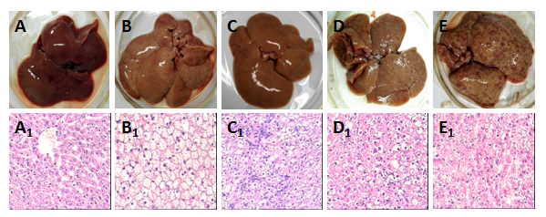
Figure 1 Rat liver tissues and their pathological examination. The liver alterations after the rats were sacrificed at different stages during hepatocyte malignant transformation. A: The general specimen in the control rats with the normal diet; B: The general specimen in the rats with high fat diet without 2-fluorenyl acetamide (2-FAA); C: The general specimen in the rats with high fat diet containing 2-FAA at early stage; D: The general specimen in the rats with high fat diet containing 2-FAA at interim stage; and E: The general specimen in the rats with high fat diet containing 2-FAA at later stage. The liver sections of the corresponding rats were examined with the Hematoxylin and Eosin (H&E) staining, and they were divided into the control (A1), fatty liver (B1), degeneration (C1), precancerous (D1), and cancerous (E1) groups, A1~ E1, the original magnification of the corresponding rat liver sections × 200.

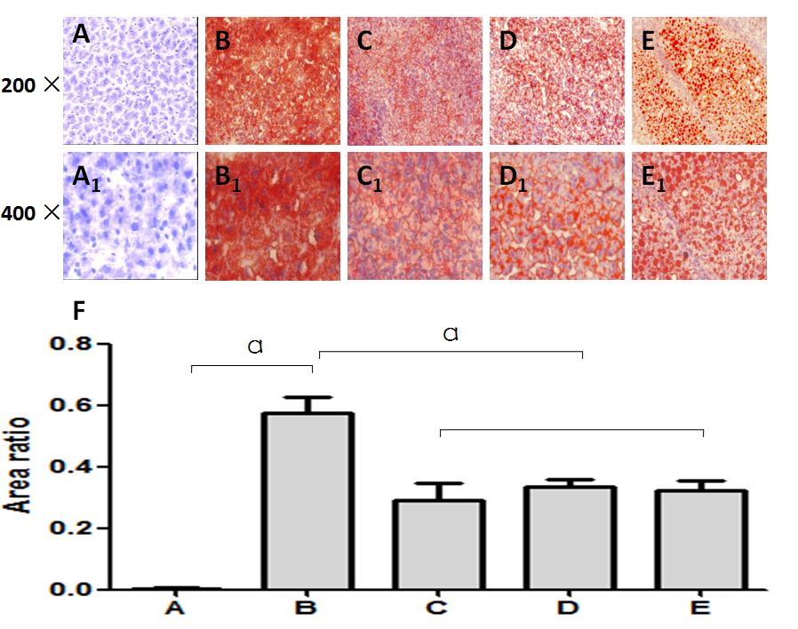
Figure 2 Rat hepatic lipid accumulation in the different groups after their liver section with the Oil red O staining. The statues of hepatic lipid accumulation in the different rat groups were analyzed after their liver section staining with the Oil red O method. A: The liver sections of control rats with the normal diet; B: The liver sections of the fatty liver rats with high fat diet without 2-fluorenylacetamide(2-FAA); C: The liver sections of the regeneration rats with high fat diet containing 2-FAA at early stage; D: The liver sections of precancerous rats with high fat diet containing 2-FAA at interim stage; and E: The liver sections of cancerous rats with high fat diet containing 2-FAA at later stage.F, therelative quantitative analysis on fats in the liver tissue; A ~ E, the original magnification× 200; A1~ E1, the original magnification× 400. ªP < 0.05.

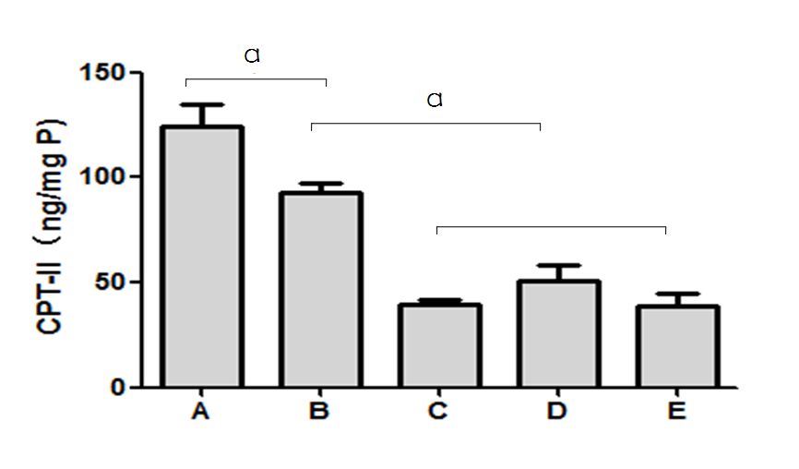
Figure 3 Dynamic alteration of carnitine palmitoyl transferase II expression in rat livers. The carnitine palmitoyl transferase II (CPT-II) contents of rat hepatic tissues in the different rat groups were analyzed during hepatocyte malignant transformation. A: The liver sections of control rats with the normal diet; B: The liver sections of the fatty liver rats with high fat diet without 2-fluorenylacetamide (2-FAA); C: The liver sections of the regeneration rats with high fat diet containing 2-FAA at early stage; D: The liver sections of precancerous rats with high fat diet containing 2-FAA at interim stage; and E, the liver sections of cancerous rats with high fat diet containing 2-FAA at later stage. ªP < 0.05.

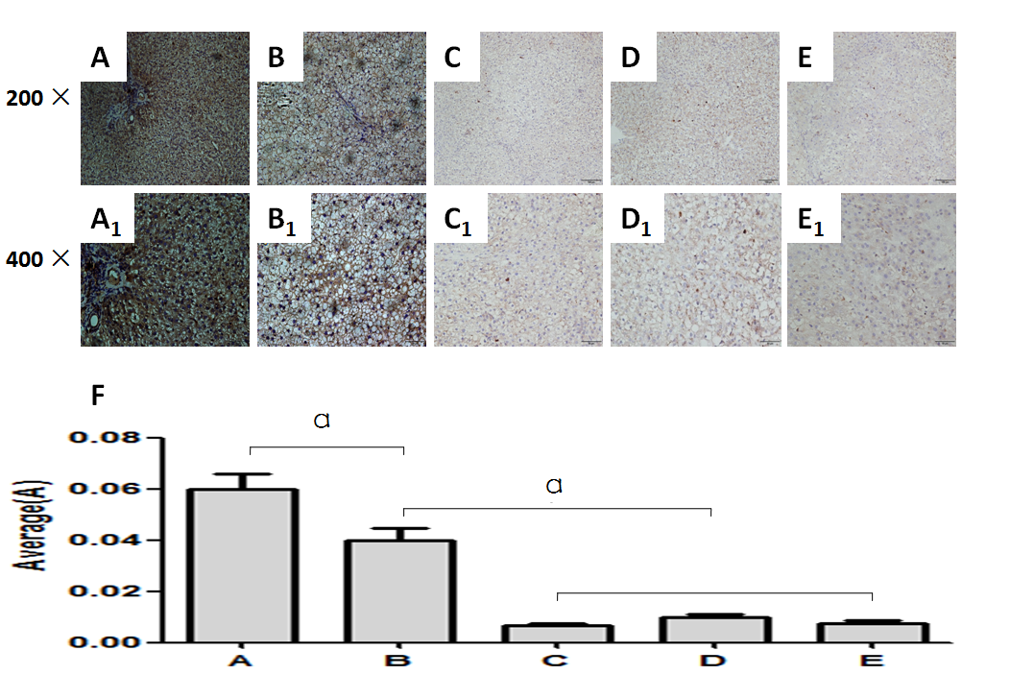
Figure 4 Immunohistochemical analysis of carnitine palmitoyl transferase II expression. The carnitine palmitoyl transferase II (CPT-II) contents of rat hepatic tissues in the different rat groups were analyzed by immunohistochemistry. A: the liver sections of control rats with the normal diet; B: the liver sections of the fatty liver rats with high fat diet without 2-fluorenyl acetamide (2-FAA); C: the liver sections of the regeneration rats with high fat diet containing 2-FAA at early stage; D: the liver sections of precancerous rats with high fat diet containing 2-FAA at interim stage; and E: the liver sections of cancerous rats with high fat diet containing 2-FAA at later stage. F, the relative quantitative analysis on CPT-II in the liver tissue; A – E: the original magnification× 200; A₁ - E₁: the original magnification× 400. ªP < 0.05.

