Name of journal: World Journal of Experimental Medicine
ESPS Manuscript NO: 13082
Columns: MINIREVIEWS

High-level disinfection of gastrointestinal endoscope reprocessing

Chiu KW et al. HLD of GI endoscope reprocessing

King-Wah Chiu, Lung-Sheng Lu, Shue-Shian Chiou

King-Wah Chiu, Lung-Sheng Lu, Shue-Shian Chiou, Division of Gastroenterology and Hepatology, Department of Internal Medicine, Kaohsiung Chang Gung Memorial Hospital, Kaohsiung 833, Taiwan

King-Wah Chiu, Lung-Sheng Lu, Shue-Shian Chiou, College of Medicine, Chang Gung University, Kaohsiung 833, Taiwan

Author contributions: Chiu KW and Lu LS contributed equally to this work; Chiu KW, Lu LS and Chiou SS designed the research; Chiu KW and Lu LS performed the research; Chiu KW and Chiou SS analyzed the data; and Chiu KW, Lu LS and Chiou SS wrote the paper.

Correspondence to: King-Wah Chiu, MD, Division of Gastroenterology and Hepatology, Department of Internal Medicine, Kaohsiung Chang Gung Memorial Hospital, 123 Ta-Pei Road, Niao-Sung, Kaohsiung 833, Taiwan. kwchu@adm.cgmh.org.tw

Telephone: +886-7-7317123-8190 Fax: +886-7-7336856
Received: August 4, 2014 Revised: September 19, 2014
Accepted: November 17, 2014

Published online:

Abstract
High level disinfection (HLD) of the gastrointestinal (GI) endoscope is not simply a slogan, but rather is a form of experimental monitoring-based medicine. By definition, GI endoscopy is a semicritical medical device. Hence, such medical devices require major quality assurance for disinfection. And because many of these items are temperature sensitive, low-temperature chemical methods, such as liquid chemical germicide, must be used rather than steam sterilization. In summarizing guidelines for infection prevention and control for GI endoscopy, there are three important steps that must be highlighted: manual washing, HLD with automated endoscope reprocessor, and drying. Strict adherence to current guidelines is required because compared to any other medical device, the GI endoscope is associated with more outbreaks linked to inadequate cleaning or disinfecting during HLD. Both experimental evaluation on the surveillance bacterial cultures and in-use clinical results have shown that, the monitoring of the stringent processes to prevent and control infection is an essential component of the broader strategy to ensure the delivery of safe endoscopy services, because endoscope reprocessing is a multistep procedure involving numerous factors that can interfere with its efficacy. Based on our years of experience in the surveillance of culture monitoring of endoscopic reprocessing, we aim in this study to carefully describe what details require attention in the GI endoscopy disinfection and to share our experience so that patients can be provided with high quality and safe medical practices. Quality management encompasses all aspects of pre- and post-procedural care including the efficiency of the endoscopy unit and reprocessing area, as well as the endoscopic procedure itself.

© 2014 Baishideng Publishing Group Inc. All rights reserved.

Key words: Automated endoscope reprocessor; Bacterial culture; Gastrointestinal endoscopy; High-level disinfection; Liquid chemical germicide

Core tip: High-level decontamination processes to ensure iatrogenic infection prevention in the delivery of high-quality gastrointestinal (GI) endoscopy services are essential. There are three important steps that must be highlighted: manual washing, automated endoscope washer reprocessing and adequate drying/storage after rinsing. Our experimental data demonstrated that surveillance culture monitoring that can detect unsuccessful decontamination provides a much greater assurance of quality control for high level disinfection. This monitoring should be taken into account in order to ensure safety when a patient receives GI endoscope service. Randomized surveillance culture monitoring of the reprocessing process in each month is important for quality control and in ensuring patients' safety.

Chiu KW, Lu LS, Chiou SS. High-level disinfection of gastrointestinal endoscope reprocessing. World J Exp Med 2014, In press

Introduction
Gastrointestinal (GI) endoscopy is a widely performed for the diagnosis and treatment tool in the patients with gastrointestinal diseases not only, but also in the healthy people with requests for physical exams or checkups. Because of the instruments are complicated in structures and reusable in the clinical practice, a standard disinfection procedure is requested^{[1]}. It is an essential requirement for patient safety during the medical service. Inadequate reprocessing of endoscopes or endoscopic accessories may result in infection outbreak. Although the incidence of iatrogenic infection during gastrointestinal endoscopy was only about 1/1.8 million procedures in the United States from the year 1988 to 1992^{[2]}, outbreak of bacterial/viral infection complicated with contamination of endoscopes and washer-disinfector instrument was also been individually reported^{[3-6]}. To supply a high quality medical environment, our institution adopt an idea of patient-centered approach, deliver a safety medical service, and we encourage innovations in teaching on the young physicians, new advance basic and clinical research and wonderful services in medical requirement. Herein, we would like to share with our years of experience on the surveillance of the culture monitoring of endoscopic reprocessing in our GI endoscope unit, particularly the detail process of the disinfection procedure of the GI endoscopes.
In the British Society of Gastroenterology guidelines (2008) and Public Health Agency of Canada and the Canadian Association of Gastroenterology (2010) emphasized the important of manual brushing all of the working channels in addition to decontamination with automatic endoscopic reprocessor^{[1,7,8]}. Adequate disinfection and decontamination of GI endoscopes involves manual cleaning and automatic high-level disinfection (HLD) followed by 75% ethanol rinsing and then hanging for endoscope drying before storage.

Disinfection classification of gastrointestinal instruments
According to the Spaulding classification^{[9,10]}, the GI endoscope belongs to the class of semicritical devices because the instruments may touch with mucous membranes during clinical procedure, thus bearing a relative degree of infection risk if contamination occurs during use. At the very minimum, they should receive HLD. In our previous large medical cohort study, we found that the average biopsy rate was17.3%, which meant about 200 thousand endoscopic procedures over 14.5 years^{[11]}. Furthermore, biopsy forceps or injection needles, for example, also require proper sterilization given that they frequently enter sterile tissues or the vascular system, and thus carry an absolute degree of infection risk if contaminated during use^{[12]}. The critical, semicritical and noncritical level of infection risks in GI instruments are listed on the Table 1. All of the GI endoscopes, including gastroendoscope, small intestinal scope, colonoscope, sigmoidoscope, endoscopic ultrasonography scope, and the more complicated structure such as endoscopic retrograde cholangiopancreatography scope and magnified endoscope have been recommended to receive HLD. It is vital to monitor adequate disinfection of endoscopes and to avoid an iatrogenic infection in patient after endoscopic service. The cautery plates and electrodes, however, belong to noncritical-level medical devices.

Reprocessing of gastrointestinal endoscopy
In recently, both of the American Multisociety Guideline and World Gastroenterology Organization Global Guideline are emphasize multistep in medical endoscopic reprocessing that includes not only the cleaning, disinfection and drying, but also the precleaning before the cleaning, first rinsing after the cleaning, followed by disinfection, and the second rinsing after disinfection, drying and then storage^{[10]}. These can be summarized into three important processes of GI endoscopic reprocessing step by step: manual washing including precleaning and cleaning, automated endoscope reprocessor (AER) with HLD and liquid chemical germicide (LCG), and drying/storing (Table 2). Under the recommendations for infection control, the GI endoscopic procedure room as a contaminated zone needs to be separated from the clean zone disinfection room, which requires suitable room ventilation with more than 12 air exchanges per hour for the prevention of toxic materials from leaking and endoscopic associated disease^{[13,14]}. This means that the GI endoscopic procedure room and GI endoscopic disinfection room are separated by an adequate distance, and that the hand case must be covered before it is transfer from the contaminated zone to the clean zone^{[15]}.

Manual washing in the procedure room
This process consists of the two important phases of precleaning and cleaning (Table 2). The beginning step is manual washing endoscopic instruments and should be performed at the procedure room. Precleaning focuses on enzymatic detergent washing to remove organic debris, such as blood, feces, mucus etc. In contrast to the precleaning, cleaning focuses on the brushing process with enzymatic detergent solution of the all the working channels, such as the biopsy, air and water channels of the GI endoscope. This step is also only to be performed at the GI endoscopic procedure room. Inadequate cleaning causing blood clot, body tissue retention in the GI endoscopes, it should be frequently contaminated with microorganisms transmission during the next endoscopic service. Our recent studies showed the importance of adequate cleaning with brushing processes for the longer small intestinal endoscopes and the more frequently contaminated colonoscopies^{[16,17]}.

Precleaning
After being taken from a patient, the outer surface of the GI endoscope is wiped immediately with enzymatic detergent gauze. Alternatively, 10-15 seconds of air and water flushing prevents leakage of mucus and blood from the dirt bucket. Enzymatic detergent cleaning solution needs to be suctioned until the suction tube returns clean, non-turbid, water. Water rinsing of the entire surface of the endoscope is very important. Immersion in enzymatic detergent solution for longer than 20 minutes is recommended if there is suspicion of highly infectious cases such as tuberculosis or human immunodeficiency virus^{[4,16]}.

Cleaning
The endoscope should be inspected for damage and a water-resistant cap should be attached. All active buttons, plugs, apex protection ring should be dismantled and manual washed with a soft bristle brush. Water irrigation and attract conduit working channels, then gauze and a soft short bristle brush with enzymatic detergent solution should be used to brush the orifices of the biopsy channel and to clean the air and water channels. For the cleaning of the longer and contaminated anus route scope for the small intestine, a long scrub brush with repeated and adequate brushing is very important due to the high rate of bacterial culture^{[16]}. Repeated cleaning with the brush head of a long scrub brush of at least 3 or more times is needed for all of the internal channel included biopsy channel, suction channel and air channel, and from the channel orifice to the fore-end of the endoscope^{[18]}.

Automatic endoscopic reprocessor in the disinfection room
Leak test
After initial manual washing, the GI endoscope should be moved to the disinfection area by a carrying case with cloth covered to prevent contamination of the clean zone. The disinfection room is separated into two isolated rooms, the lower GI endoscopic disinfection room and the upper GI endoscopic disinfection room each with a separate entrance. The first step in the disinfection is the leak test. The endoscope is an electronic instrument must be protect to prevent water damage. Therefore, a leak test must be completely inspected first of all before disinfection^{[19,20]}. The leak test consists of a manual leak test (Figure 2) and an automatic leak test in the AER. It is a very important step to protect the electronic endoscope fatal damage from the cleansing solution. No air bubbles should appear after the water-resistant cap is attached. Forgetting to attach the water-resistant cap when conducting the leak test is a very critical concern in the training of new nurses in clinical practice. The potential to reduce the cost of endoscope repairs with an AER device by reducing the amount of manual handling during reprocessing has been estimated at 34%; use of AER devices can result in fewer opportunities for the scope to be inadvertently mishandled^{[21]}.

Automatic endoscope reprocessor
AERs are strongly recommended by the World Gastroenterology Organization for the reprocessing of all GI endoscopic instruments to absolute complete all of the decontamination processes and to prevent the chemical contamination of the instruments^{[22,23]}. In our case, manual cleaning is performed by a trained GI endoscopic nurse before HLD. The AER was processed with Olympus ER-30 model (Aizu Olympus Co. Ltd, Fukushima, Japan) in our disinfection room. There are two important checking issues in the AER reprocessing. The first one is the inflow and outflow pressure monitor. According to the operator manual of Olympus ER-30 model, 1.85 ± 0.05 kgf/cm² of the normal relief valve pressure and 17 liter/minute in inflow water are required. The second checking issue is the concentration of LCG used in reprocessing. LCG is an effective disinfecting chemical agent for most of the microorganisms and spores. It is widely be used in the disinfection reprocess because of the no expensive in price, and no evidence for endoscope or equipment damage^{[22]}. Hence, AER with LCG can certainly be considered HLD. One of the most commonly used LCGs is 2.4% alkaline glutaraldehyde. In the AER, the endoscopes are soaked in this disinfectant for 20 min in every reprocess cycle. In our unit, alkaline glutaraldehyde is stored at 15-30 °C in the disinfection room. Depends on the reprocess loading, it will be replaced every 2 wk or less. The disinfectant is monitored by the GI endoscopic nurse every morning and every 5 cycles of AER process using test strips. The concentration is effective for the AER process if the test strip is purple in color. The disinfectant is discarded immediately or within 2 weeks when the test strip change to yellow. It is represent that the concentration of LCG drops below the minimum effective concentration. We performed a bacterial culture for surveillance monitoring. When a culture-positive to have determined, the numbered GI endoscope is no longer be clinical service, and the AER is reprocessed and can only be put back into clinical use when the re-culture becomes negative. In the AER, the LCG is forced and filled all of the working channels. The endoscopes are subsequently flushed with sterile distilled water and dried with 75% alcohol and forced air in the AER automatically. One important issue should be emphasized here: the servicing of the AER is carried out regularly, specifically every 3-6 mo, in our GI endoscope unit. Given that the longstanding use of the machine results in elasticity sclerosis and damage, the valve pressure can diminish beyond the standard value and the reduced amount of inflow sterilized water may not be able to disinfect the internal channel thoroughly in spite of the standard reprocessing procedure. Positive surveillance culture may put the quality of the HLD at risk^{[24]}. At the end of the disinfection, discarded the rinse water after each reprocess cycle, 75% ethanol rinsing the AER, disinfected and sterilized the water bottles at least once a day^{[25]}.

Drying/Storage in the store room
Drying
Mechanical drying all of the working channels with 75% ethanol rinsing, 25 L/min in airflow and 60 psi in blowing pressure of the GI endoscope is one of the important step at the end of HLD in the AER. In every cycle of the GI endoscope HLD, the endoscope is manually flushed with 30c.c. of 75% ethanol into the internal channel of the GI endoscopes for at least 2 minutes. At the end of the working day, the endoscope should be flushed with 200c.c. of 75% ethanol into the AER, and then forced air should be used for at least 10 minutes to dry the GI endoscope and to disinfect the AER. After the GI endoscope is removed from the AER, the outer surface needs to be carefully dried with a clean dry towel, and then the whole GI endoscope and lens should be wiped with a gauze with 75% ethanol. In our recent study, positive surveillance swab culture of the AER was still found incidentally after a full cycle HLD. In a high loading endoscopic unit with short drying cycle, GI endoscopes could be dry used with high pressure air jet blowing. At the end of the working day, an overnight endoscope hanging for completely drying should be required^{[22,26]}. This means that the drying of the AER overnight is also an important step that should not be overlooked for a standard HLD^{[27]}.

Storage
After a full reprocessing cycle, the cleaned GI endoscopes need to vertically hang in the of endoscopic protection cabinet in order to prevent residual water droplets from impacting on patient health. Overnight hanging for GI endoscope drying is necessary. For maintenance disinfection and decontamination of the GI endoscopes, storage with a dust-free drying cabinet is a major impact factor and should be recommended^{[22]}.

Surveillance culture for monitoring the quality of HLD
The recent study showed that the impact factor of the iatrogenic infection is the number of biofilm growth inside the endoscope in addition mucosa damage during endoscopic service especially in case with immune compromise^{[28]}. Therefore, microbiological surveillance is very important for monitoring the quality of the endoscope disinfection, and one of the best way to supply safely medical service in an academic teaching hospital^{[29]}. According to our experience, the surveillance culture is used with 50 mL sterile distilled water manual flushed the working channels under an aseptic procedure and preparation^{[16,24]}. The rinse sample is collected in a sterile container and plated on blood agar, MacConkey agar, and Lowenstein–Jensen medium for the endoscopic surveillance culture monitoring. At the same time, a swab culture is performed from the inside of the AERs at the end of the working day for the AER disinfection monitoring in every month. We used the liquid thioglycollate broth for swab culture^{[17,27]}. All of the culture are determined with colony forming units (CFU) with plate count method and incubated for 30 h at 37ºC and culture identified for aerobic and anaerobic bacteria and mycobacterium tuberculosis after 24h, 48h, and 6wk. By the definition, the bacterial culture plate counts greater than 10³CFU/mL is so-called culture-positive, in contrast or less is culture-negative. In our recent study, the Trimean biopsy rate was about 19.29% of 199877 GI endoscope procedures over a period of 14.5 years^{[11]}. Since endoscopic biopsy is very frequent procedure in the clinical practice^{[30]}, the biopsy channel is one of the most common contamination parts of the GI endoscope. It is thus very important that the surveillance microbiological culture from the biopsy channel be monitored for the quality of the HLD of GI endoscope reprocessing^{[17]}. In terms of the different clinical approaches of the GI endoscope, the complicated structure with the elevator design of the endoscopic retrograde cholangiopancreatography and the longer approach of double balloon small intestinal scope makes disinfection difficult. In our recent study, the positive culture rate was significant difference between the oral route (12.9%) and the anal route (19.2%) of the double balloon small intestinal scope^{[16]}. There was a linear trend observation between the positive culture rate and the length of the GI endoscopes: gastroendoscope, colonoscope, oral route and then anal route of the double balloon small intestinal scope (Table 3). The average positive surveillance culture of the upper GI tract was between 10.7 to 14.3%^{[16,17,24]}. The positive swab culture from the AER was 2.0% (6/300) for gastroendoscope and 0.8% (1/120) for colonoscope reprocessing; among the cultures from gastroendoscope reprocessing, 50% (3/6) were positive for aerobic bacteria, while the remaining 50% (3/6) showed fungal contamination. The positive culture rate was around 0.8 to 2.0% in our experiences^{[17,27]} (Table 3). Therefore, the surveillance culture from the AER may also benefit for the monitoring of the quality of the disinfection end point of the reprocessing. It should be kept in mind that 200 c.c. of 75% ethanol flushing should be used and the AER should be dried overnight at the end of the reprocessing of an endoscopic unit. The endoscope expertise recommended that the AER needs to be cleaning if the endoscopic procedures more than 50 times a week^{[31]}. Monthly regular randomized surveillance culture monitoring of the high quality endoscope service is very important for safety in endoscopic procedures.
In conclusion, for GI endoscope disinfection, there are three important steps that must be highlighted: manual washing, automated endoscope washer reprocessing and adequate drying/storage after rinsing. Our experimental data demonstrated that surveillance culture monitoring that can detect ineffective decontamination provides a much greater assurance of quality control for HLD. This monitoring should be taken into account in order to ensure safety when a patient receives GI endoscope service.

ACKNOWLEDGMENTS
All of the studies were supported by the gastrointestinal endoscopy unit of Kaohsiung Chang Gung Memorial Hospital, Taiwan. We thank Miss Ching-Yin Huang for her help with data collection, culture processing, and automatic endoscope reprocessing.

References
1 The British Society of Gastroenterology Endoscopy Committee. Guidelines for Decontamination of Equipment for Gastrointestinal Endoscopy. 2014. Available from: http://www.bsg.org.uk/clinical-guidance/general/guidelines-for-decontamination-of-equipment-for-gastrointestinal-endoscopy.html
2 Nelson DB, Jarvis WR, Rutala WA, Foxx-Orenstein AE, Isenberg G, Dash GR, Alvarado CJ, Ball M, Griffin-Sobel J, Petersen C, Ball KA, Henderson J, Stricof RL. Multi-society guideline for reprocessing flexible gastrointestinal endoscopes. Society for Healthcare Epidemiology of America. Infect Control Hosp Epidemiol 2003; 24: 532-537 [PMID: 12887243]
3 Bronowicki JP, Venard V, Botté C, Monhoven N, Gastin I, Choné L, Hudziak H, Rihn B, Delanoë C, LeFaou A, Bigard MA, Gaucher P. Patient-to-patient transmission of hepatitis C virus during colonoscopy. N Engl J Med 1997; 337: 237-240 [PMID: 9227929 DOI: 10.1056/NEJM199707243370404]
4 Gillespie TG, Hogg L, Budge E, Duncan A, Coia JE. Mycobacterium chelonae isolated from rinse water within an endoscope washer-disinfector. J Hosp Infect 2000; 45: 332-334 [PMID: 10973754 DOI: 10.1053/jhin.2000.0782]
5 Schelenz S, French G. An outbreak of multidrug-resistant Pseudomonas aeruginosa infection associated with contamination of bronchoscopes and an endoscope washer-disinfector. J Hosp Infect 2000; 46: 23-30 [PMID: 11023719 DOI: 10.1053/jhin.2000.0800]
6 Ottawa private clinic behind hepatitis, HIV scare. [accessed 2012 December 12]. Available from: http://www.cbc.ca/news/canada/ottawa/story/2011/10/17/ottawa-public-health-infection-letters.html
7 Armstrong D, Barkun A, Bridges R, Carter R, de Gara C, Dube C, Enns R, Hollingworth R, Macintosh D, Borgaonkar M, Forget S, Leontiadis G, Meddings J, Cotton P, Kuipers EJ. Canadian Association of Gastroenterology consensus guidelines on safety and quality indicators in endoscopy. Can J Gastroenterol 2012; 26: 17-31 [PMID: 22308578]
8 Public Health Agency of Canada. Infection prevention and control guideline for flexible gastrointestinal endoscopy and flexible brochoscopy. [accessed 2012 December 12]. Available from: http://www.phac-aspc.gc.ca/nois-sinp/guide/endo/pdf/endo-eng.pdf
9 Spaulding EH, Gröschel DH. Hospital disinfectants and antiseptics. Lennette EH, Spaulding EH, Truant JP, editors. Manual of clinical microbiology. 2nd ed. Washington, DC: American Society for Microbiology, 1974: 852-857
10 Petersen BT, Chennat J, Cohen J, Cotton PB, Greenwald DA, Kowalski TE, Krinsky ML, Park WG, Pike IM, Romagnuolo J, Rutala WA. Multisociety guideline on reprocessing flexible gastrointestinal endoscopes: 2011. Gastrointest Endosc 2011; 73: 1075-1084 [PMID: 21628008 DOI: 10.1016/j.gie.2011.03.1183]
11 Chiu KW, Chiou SS. Endoscopic biopsy as quality assurance for endoscopic services. PLoS One 2013; 8: e78557 [PMID: 24265698 DOI: 10.1371/journal.pone.0078557]
12 Lim CH, Choi MG, Kim WC, Kim JS, Cho YK, Park JM, Lee IS, Kim SW, Choi KY, Chung IS. Performance and cost of disposable biopsy forceps in upper gastrointestinal endoscopy: comparison with reusable biopsy forceps. Clin Endosc 2012; 45: 62-66 [PMID: 22741133 DOI: 10.5946/ce.2012.45.1.62]
13 Alvarado CJ, Reichelderfer M. APIC guideline for infection prevention and control in flexible endoscopy. Association for Professionals in Infection Control. Am J Infect Control 2000; 28: 138-155 [PMID: 10760223 DOI: 10.1067/mic.2000.106054]
14 Richardson ET, Morrow CD, Kalil DB, Bekker LG, Wood R. Shared air: a renewed focus on ventilation for the prevention of tuberculosis transmission. PLoS One 2014; 9: e96334 [PMID: 24804707 DOI: 10.1371/journal.pone.0096334]
15 Lee YK, Park JB. Steps of reprocessing and equipments. Clin Endosc 2013; 46: 274-279 [PMID: 23767039 DOI: 10.5946/ce.2013.46.3.274]
16 Chiu KW, Lu LS, Wu KL, Lin MT, Hu ML, Tai WC, Chiu YC, Chuah SK, Hu TH. Surveillance culture monitoring of double-balloon enteroscopy reprocessing with high-level disinfection. Eur J Clin Invest 2012; 42: 427-431 [PMID: 21950739 DOI: 10.1111/j.1365-2362.2011.02599]
17 Chiu KW, Tsai MC, Wu KL, Chiu YC, Lin MT, Hu TH. Surveillance cultures of samples obtained from biopsy channels and automated endoscope reprocessors after high-level disinfection of gastrointestinal endoscopes. BMC Gastroenterol 2012; 12: 120 [PMID: 22943739 DOI: 10.1186/1471-230X-12-120.]
18 Ishino Y, Ido K, Koiwai H, Sugano K. Pitfalls in endoscope reprocessing: brushing of air and water channels is mandatory for high-level disinfection. Gastrointest Endosc 2001; 53: 165-168 [PMID: 11174285 DOI: 10.1067/mge.2001.112195]
19 Sabnis RB, Bhattu A, Vijaykumar M. Sterilization of endoscopic instruments. Curr Opin Urol 2014; 24: 195-202 [PMID: 24451088 DOI: 10.1097/MOU.0000000000000034]
20 Kovaleva J, Peters FT, van der Mei HC, Degener JE. Transmission of infection by flexible gastrointestinal endoscopy and bronchoscopy. Clin Microbiol Rev 2013; 26: 231-254 [PMID: 23554415 DOI: 10.1128/CMR.00085-12]
21 Funk SE, Reaven NL. High-level endoscope disinfection processes in emerging economies: financial impact of manual process versus automated endoscope reprocessing. J Hosp Infect 2014; 86: 250-254 [PMID: 24661789 DOI: 10.1016/j.jhin.2014.01.007]
22 Beilenhoff U, Neumann CS, Rey JF, Biering H, Blum R, Cimbro M, Kampf B, Rogers M, Schmidt V. ESGE-ESGENA Guideline: cleaning and disinfection in gastrointestinal endoscopy. Endoscopy 2008; 40: 939-957 [PMID: 19009486 DOI: 10.1055/s-2008-1077722]
23 World Gastroenterology Organization. Endoscope disinfection - a resource-sensitive approach. World Gastroenterology Organisation/ World Endoscopy Organization Global Guidelines. 2011. Available from: http://www.worldgastroenterology.org/assets/export/userfiles/endoscope_disinfection.pdf
24 Chiu KW, Fong TV, Wu KL, Chiu YC, Chou YP, Kuo CM, Chuah SK, Kuo CH, Chiou SS, ChangChien CS. Surveillance culture of endoscope to monitor the quality of high-level disinfection of gastrointestinal reprocessing. Hepatogastroenterology 2010; 57: 531-534 [PMID: 20698222]
25 Alvarado CJ, Anderson AG, Maki DG. Microbiologic assessment of disposable sterile endoscopic sheaths to replace high-level disinfection in reprocessing: a prospective clinical trial with nasopharygoscopes. Am J Infect Control 2009; 37: 408-413 [PMID: 19482219 DOI: 10.1016/j.ajic.2009.04.276]
26 Muscarella LF. Inconsistencies in endoscope-reprocessing and infection-control guidelines: the importance of endoscope drying. Am J Gastroenterol 2006; 101: 2147-2154 [PMID: 16968511 DOI: 10.1111/j.1572-0241.2006.00712.x]
27 Lu LS, Wu KL, Chiu YC, Lin MT, Hu TH, Chiu KW. Swab culture monitoring of automated endoscope reprocessors after high-level disinfection. World J Gastroenterol 2012; 18: 1660-1663 [PMID: 22529696 DOI: 10.3748/wjg.v18.i14.1660]
28 Aumeran C, Thibert E, Chapelle FA, Hennequin C, Lesens O, Traoré O. Assessment on experimental bacterial biofilms and in clinical practice of the efficacy of sampling solutions for microbiological testing of endoscopes. J Clin Microbiol 2012; 50: 938-942 [PMID: 22170930 DOI: 10.1128/JCM.06221-11]
29 Hookey L, Armstrong D, Enns R, Matlow A, Singh H, Love J. Summary of guidelines for infection prevention and control for flexible gastrointestinal endoscopy. Can J Gastroenterol 2013; 27: 347-350 [PMID: 23781518]
30 Chiu KW, Wu CK, Lu LS, HL Eng, Chiou SS. Diagnostic pitfall of sebaceous gland metaplasia of the esophagus. World J Clin Cases 2014; 2: 311-315 [PMID: 25032211 DOI: 10.12998/wjcc.v2.i7.311]
31 Leung JW. Reprocessing of flexible endoscopes. J Gastroenterol Hepatol 2000; 15 Suppl: G73-G77 [PMID: 11100997 DOI: 10.1046/j.1440-1746.2000.02269.x]

P-Reviewer: Abdel-Salam OME, Kita K, Wang BM S-Editor: Tian YL
L-Editor: E-Editor:

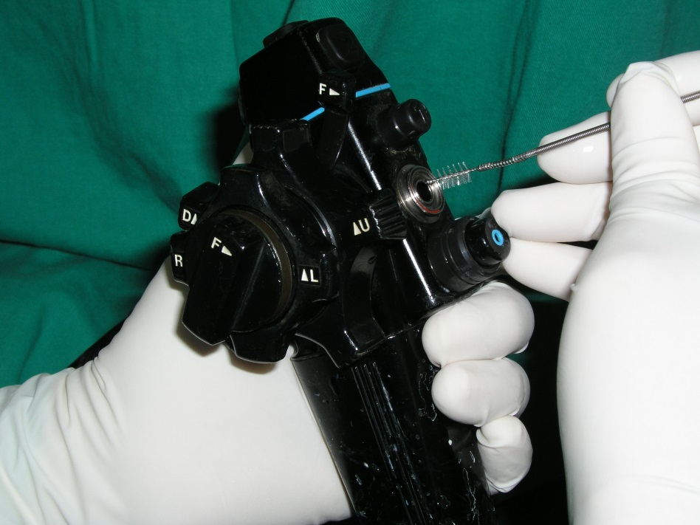
Figure 1 The manual cleaning procedure for flexible endoscopes including brushing and irrigation of the internal channels with enzymatic detergent solution that should be performed before disinfection.
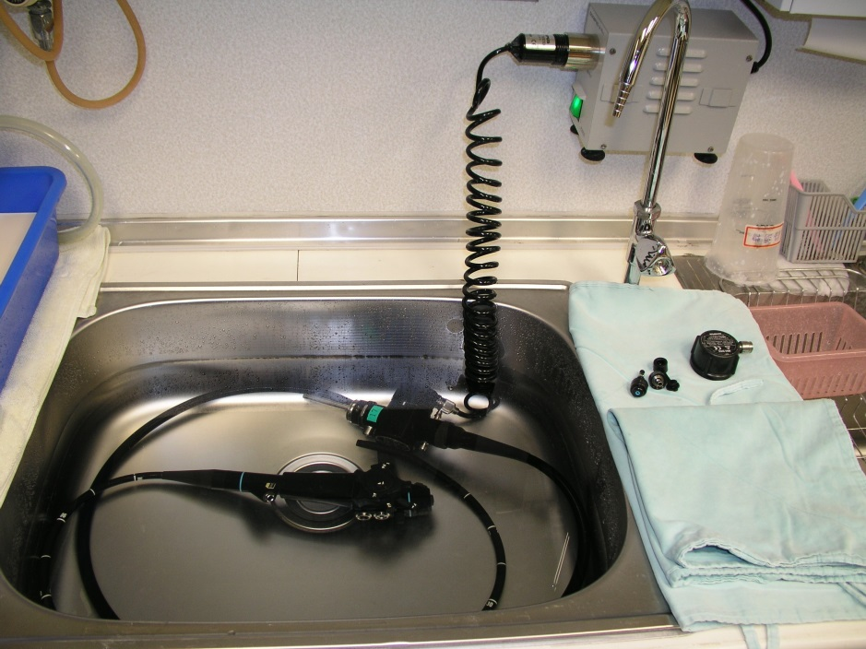
Figure 2 A manual leak test is conducted to examine any damage in and out of the gastrointestinal endoscope. It is very important to protect the endoscope from damage from the cleansing solution. No air bubbles should appear after attaching the water-resistant cap.

Table 1 Disinfection classification of gastrointestinal instruments
Category | Lever of disinfection | Gastrointestinal device
Critical | High-level | - Argon plasma coagulation device  - Aspiration Biopsy Needles  - Banding ligation device  - Biopsy forceps  - Biopsy Valves  - Cytology Curettes  - Dilation balloon  - Distal Attachments  - Electrical knife  - Foreign Body Retrieval  - Injection needle  - Manometery device  - Mouthpieces  - Snare  - Spray Catheter
Semicritial | Intermediate-level | - Gastroendoscope  - Small intestinal scope  - Colonoscope  - Sigmoidoscope  - Endoscopic ultrasonography scope  - Endoscopic retrograde cholangiopancreatography scope  - Naso-gastroendocope
Noncritical | Low-level | - Cautery plates  - Electrodes  - Stethoscopes  - Vital sign monitor
Table 2 High-level disinfection of gastrointestinal endoscope reprocessing in Kaohsiung Chang Gung Memorial Hospital
Procedure room | Manual washing  Precleaning (Enzymatic detergent cleaning)  - Wipe the outer surface by gauze  - Cleaning the channel by suction  Cleaning (Brushing working channels) (Figure 1)  - Long brush cleaning inner channels  - Immersion detergent solution
Disinfection room | High-level disinfection (HLD)  Leak test (Figure 2)  Automated endoscope reprocessor  - Normal relief valve pressure is 1.85 ± 0.05 kgf/cm²  - Water supply is 17 liter/minute  Liquid chemical germicide  Rising
Store room | Drying  Flushing 75% ethanol  Storage by vertical hanging
Table 3 Positive surveillance culture after automatic endoscope reprocessor with high-level disinfection
Gastrointestinal instrument | Positive rate (%) | Ref.
Colonoscope¹ | 71.4% | [24]
Colonoscope | 20.8 | [17]
Small intestinal scope, anal route | 19.2 | [16]
Gastroendoscope | 10.7-14.3 | [17,24]
Small intestinal scope, oral route | 12.9 | [16]
AER reprocess to gastroendoscope² | 2.0 | [17,27]
AER reprocess to colonoscope³ | 0.8 | [17,27]
¹AER was damaged in reprocessing; ²case size was 6/300; ³case size was 1/120. AER: automatic endoscope reprocessor.

