Name of Journal: World Journal of Clinical Cases
Manuscript NO: 90182
Manuscript Type: CASE REPORT

Appendicitis combined with Meckel’s diverticulum obstruction, perforation, and inflammation in children: Three case reports

Sun YM et al. Appendicitis with Meckel diverticulum in children

Yi-Meng Sun, Wang Xin, Yu-Fang Liu, Zhe-Ming Guan, Hao-Wen Du, Ning-Ning Sun, Yong-Dong Liu

Yi-Meng Sun, School of Clinical Medicine, Weifang Medical University, Weifang 261000, Shandong Province, China

Wang Xin, Zhe-Ming Guan, Hao-Wen Du, Ning-Ning Sun, Yong-Dong Liu, Department of Pediatric Surgery, Weifang People’s Hospital, Weifang 261000, Shandong Province, China

Yu-Fang Liu, Department of Burn Surgery, Weifang People’s Hospital, Weifang 261000, Shandong Province, China

Author contributions: Sun YM reviewed the literature, and contributed to manuscript drafting; Xin W, Liu YF and Guan ZM contributed to manuscript drafting; Du HW and Sun NN obtained informed consent; Liu YD was responsible for the revision of the manuscript; all authors gave final approval for the submitted version.

Corresponding author: Yong-Dong Liu, Deputy Director, Doctor, Department of Pediatric Surgery, Weifang People’s Hospital, No. 151 Guangwen Street, Kuiwen District, Weifang 261000, Shandong Province, China. 13141071616@163.com

Received: November 26, 2023
Revised: December 6, 2023
Accepted: January 8, 2024
Published online: February 6, 2024

Abstract
BACKGROUND
Meckel’s diverticulum is a common congenital malformation of the small intestine, with the three most common complications being obstruction, perforation, and inflammation. To date, only a few cases have been reported worldwide. In children, the clinical symptoms are similar to appendicitis. As most of the imaging features are nonspecific, the preoperative diagnosis is not precise. In addition, the clinical characteristics are highly similar to pediatric acute appendicitis, thus special attention is necessary to distinguish Meckel’s diverticulum from pediatric appendicitis. Patients with poor disease control should undergo laparoscopic exploration to avoid serious complications, including intestinal necrosis, intestinal perforation and gastrointestinal bleeding.

CASE SUMMARY
This report presents three cases of appendicitis in children combined with intestinal obstruction, which was caused by fibrous bands (ligaments) arising from the top part of Meckel's diverticulum, diverticular perforation, and diverticular inflammation. All three patients, aged 11-12 years, had acute appendicitis as their initial clinical presentation. All were treated by laparoscopic surgery with a favorable outcome. A complete dataset including clinical presentation, diagnostic imaging, surgical information, and histopathologic findings was also provided.

CONCLUSION
Preoperative diagnosis of Meckel’s diverticulum and its complications is challenging because its clinical signs and complications are similar to those of appendicitis in children. Laparoscopy combined with laparotomy is useful for diagnosis and treatment.

Key Words: Meckel’s diverticulum; Complications; Intestinal obstruction; Perforation; Appendicitis in children; Mesodiverticular band; Ligament; Diverticular disease; Case report

©The Author(s) 2024. Published by Baishideng Publishing Group Inc. All rights reserved.

Citation: Sun YM, Xin W, Liu YF, Guan ZM, Du HW, Sun NN, Liu YD. Appendicitis combined with Meckel’s diverticulum obstruction, perforation, and inflammation in children: Three case reports. World J Clin Cases 2024; 12(4): 865-871
URL: https://www.wjgnet.com/2307-8960/full/v12/i4/865.htm
DOI: https://dx.doi.org/10.12998/wjcc.v12.i4.865

Core Tip: Meckel's diverticulum is a congenital disorder with abnormal development of the gastrointestinal tract, which is easily confused with the clinical manifestations of acute abdominal conditions in children. We report three cases of acute appendicitis combined with Meckel's diverticulum causing obstruction, perforation, and inflammation. This disease is rare and is easily confused with appendicitis. In Meckel's diverticulum, laparoscopic surgery can diagnose and resolve the disorder. The differential diagnosis of acute appendicitis in children is of high educational and clinical importance.

INTRODUCTION
Meckel’s diverticulum is the most common congenital malformation of the gastrointestinal tract, occurring in 2% of the total population, with major complications including inflammation, intestinal obstruction, and perforation^{[1]}. Patients often become symptomatic in the first decade of life with an average age of 2.5 years^{[2]}. According to one of the largest databases of children with symptomatic Meckel's diverticulum, only 2% are symptomatic, and of these, 60% present with obstruction and 8% with inflammation^{[3]}. The most common presentation in childhood is gastrointestinal bleeding followed by intestinal obstruction. Symptoms associated with diverticula have been reported in approximately 50% of cases^{[4]}. Small bowel obstruction caused by ligaments (fibrous bands) originating from Meckel's diverticulum is very rare^{[5]}. It is easily confused with acute abdomen such as acute appendicitis in children, which is difficult to recognize on imaging. Recent studies have shown that Meckel's diverticulum is difficult to diagnose^{[6]}. A case of Meckel's diverticulum combined with appendicitis in an adult was recently reported^{[7]}. Recent neonatal case reports have also demonstrated that symptomatic Meckel's diverticulum is usually secondary to intestinal disorders such as intestinal obstruction, and therefore can be easily confused with an acute abdomen^{[8]}. The diagnosis of Meckel's diverticulum-related diseases is often challenging, and imaging plays an important role in the timely recognition and differentiation of other common diseases that may have similar clinical presentations^{[9]}.
The cases reported here include a comprehensive dataset of the clinical course, diagnostic imaging, histopathologic description, and surgical information. This report will provide physicians with valuable experience in the diagnosis and treatment of acute abdomen in children.

CASE PRESENTATION
Chief complaints
Case 1: The patient had abdominal pain for 3 d, which was aggravated for 3 h.

Case 2: The patient had abdominal pain for 8 h.

Case 3: The patient had abdominal pain for 3 d.

History of present illness
Case 1: The boy who was 12 years old was admitted to hospital due to spasmodic intermittent abdominal pain of 3 d duration which was aggravated for 3 h, accompanied by nausea and vomiting of gastric contents.

Case 2: The 11-year-old boy was admitted to hospital due to paroxysmal abdominal cramps for 8 h, accompanied by nausea and vomiting of gastric contents. The child was febrile with a maximum temperature of 38.9°C.

Case 3: The 12-year-old boy was admitted to hospital due to paroxysmal abdominal pain for 3 d accompanied by nausea and vomiting of gastric contents. The child did not have a fever.

History of past illness
The 3 patients had no relevant history of past illness.

Personal and family history
The 3 patients had no relevant personal or family history.

Physical examination
Case 1: The child's abdomen was flat, with slightly tense abdominal muscles, marked pressure in the right lower abdomen and around the umbilicus, and rebound pain.

Case 2: The child had a flat abdomen, slightly tense abdominal muscles, and right lower abdominal pressure without significant rebound pain.

Case 3: The child's abdomen was flat, with soft abdominal muscles, marked periumbilical pressure, and mild right lower abdominal pressure without rebound pain.

Laboratory examinations
Case 1: Routine blood tests showed the following: white blood cell (WBC) count: 12.1 × 10⁹/L, C-reactive protein (CRP): 30 mg/L, and granulocyte (GRAN): 91.2%.

Case 2: Routine blood tests showed the following: WBC: 13.02 × 10⁹/L, CRP: 48 mg/L, and GRAN: 89.2%.

Case 3: Routine blood tests showed the following: WBC: 12.03 × 10⁹/L, CRP: 33.9 mg/L, and GRAN: 81.5%.

Imaging examinations
Case 1: Abdominal computed tomography (CT) revealed suspected appendicitis; blurred and cloudy localized fat spaces in the abdominal cavity; part of the intestinal tract was pneumatized and dilated. Appendix ultrasound suggested intestinal dilatation, and appendicitis was suspected.

Case 2: Abdominal CT indicated suspected appendicitis; blurred and cloudy localized fat spaces in the abdominal cavity; part of the intestinal tract was pneumatized and dilated. Appendix ultrasound suggested possible appendicitis.

Case 3: Abdominal CT indicated that part of the small intestine was dilated and pneumatized, but there was no gas-liquid plane shadow. This suggested possible appendicitis or incomplete intestinal obstruction. Appendix ultrasound showed intestinal dilatation, right lower abdomen, interintestinal fluid (the deepest about 1.3 cm), suggesting possible appendicitis.

FINAL DIAGNOSIS
Case 1: Meckel's diverticulum, acute appendicitis, and intestinal obstruction.

Case 2: Perforation of Meckel's diverticulum, and acute appendicitis.

Case 3: Meckel's diverticulum inflammation, and acute appendicitis.

TREATMENT
Case 1: After 24 h of cephalosporin anti-infective treatment, the child's abdominal distension worsened and after communication with his family, laparoscopic exploration was performed. Intraoperative exploration showed serious intestinal tube distension, and the field of view was seriously obstructed. A 10 mL syringe was used for intestinal decompression, 5 min later, the field of view gradually cleared and a large amount of yellow liquid was seen in the abdominal cavity. Approximately 200 mL of the fluid was aspirated and examination revealed that 100 cm of the ileocecal value was compressed, and a 4 cm × 3 cm × 2 cm diverticulum was seen. The diverticulum was located at the top of the posterior wall of the peritoneum and a mesodiverticular band (Figure 1A) was visible, which was compressing part of the small bowel canal, resulting in strangulation of several bowel segments. No ischemia or small bowel necrosis was observed. Simultaneous exploration of the appendix revealed an enlarged, mildly edematous appendiceal end without suppuration or perforation. Therefore, the appendix was resected, the mesodiverticular band was secured distally with HemoLock clips, and was then severed by fine electrosurgical dissection, thereby releasing the obstructed intestinal collaterals (Meckel's diverticulum, Figure 1B) and the proximal diverticulum apical to the mesodiverticular band was marked. The labeled Meckel's diverticulum intestinal segment (Figure 1C) was completely removed from the intestinal lumen by an umbilical laparoscopic incision, the supplying vessels were ligated, and the intestinal canal was wedged and anastomosed.

Case 2: A laparoscopic appendectomy was planned for this patient. Intraoperative exploration showed yellow pus in the pelvic cavity, approximately 20 mL was aspirated, the small intestine in the lower abdomen was adhered into a mass, and there was a large amount of pus attached to the intestinal wall, After placing the trocar, separating the large omentum and adherent intestinal wall, a huge diverticulum was seen in the opposite edge of the mesentery of the small intestinal wall 100 cm from the ileocecal region, which was approximately 3 cm × 3 cm in size, with more pus on the surface (Figure 2A), and a perforation could be seen at the root of the diverticulum, connecting with the surface of the small intestinal tract. Congestion and edema were obvious. Continued examination of the small bowel for 2 m revealed no other lesions. The appendix was also explored and found to be elongated, with a congested and edematous surface, no pus or perforation was observed. Therefore, the appendix was removed and the perforated diverticulum was marked. The umbilicus was extended downward by a 1-cm incision, and the labeled Meckel's diverticulum was completely raised from the umbilical laparoscopic incision, and the mesentery of the small intestine was cut 5 cm from the root of the diverticulum on both sides, and after cutting the intestinal tubes, the incised mesentery of the small intestine was closed with sutures. The Meckel's diverticulum was completely resected (Figure 2B), and the incision revealed a large amount of pus attached to it (Figure 2C).

Case 3: A laparoscopic appendectomy was planned for this patient. Intraoperative exploration showed that the ileocecum was located above the iliac fossa, the ileocecal intestinal tube was adhered to the iliac fossa, and the appendix was wrapped by the ileocecal intestinal tube and the greater omentum. Separation of the greater omentum and adherent intestinal wall, adherent intestinal tubes and the omentum was carried out, and the appendix was seen to be enlarged and congested, with no sepsis or perforation observed. Therefore, the appendix was removed. The ileocecal intestinal canal was explored proximally from the ileocecal region, and a diverticulum-like protrusion was seen at the opposite edge of the mesentery approximately 100 cm from the ileocecal region, with redness and swelling at the end of the diverticulum (Figure 3A), thickening, and no signs of sepsis, and the end was attached to the umbilicus (Figure 3B). Meckel's diverticulum was considered. The end was severed from the umbilicus with a fine electrosurgical knife. The incision was extended 1 cm downward from the umbilicus, and the intestinal segment of Meckel's diverticulum was completely raised into the intestinal lumen from the umbilical laparoscopic incision (Figure 3C), the supplying vessels were ligated, and the intestinal tubes were wedged and anastomosed.

OUTCOME AND FOLLOW-UP
Case 1: The histopathologic specimen showed chronic inflammation of intestinal mucosa, accompanied by multifocal lymphoid hyperplasia and lymphoid follicle formation. The local mucosal lamina propria showed hemorrhage, and the submucosal layer was loose and edematous, which was consistent with the changes of Meckel's diverticulum; the tubular tissues were congested blood vessels.

Case 2: The histopathologic specimen showed inflammation of the intestinal mucosa with perforation, laxity, and edema of the submucosa, consistent with Meckel's diverticulum.

Case 3: The histopathologic specimen was consistent with inflammatory changes of Meckel's diverticulum. All three pediatric patients recovered uneventfully after laparoscopy, and histopathologic examination of the appendix confirmed acute simple appendicitis and histopathologic examination of the diverticulum confirmed Meckel's diverticulum. The inflammatory indices of WBC, CRP, and GARN showed a linear decreasing trend (Figure 4), and all three patients were discharged from the hospital in good health on the 7th postoperative day.

DISCUSSION
Johann Frederick Merkel first described Meckel’s diverticulum as a congenital anomaly. It is caused by incomplete occlusion of the most recent portion of the vitelline duct or umbilical mesenteric duct^{[10]}. Meckel's diverticulum is a remnant of the embryonic vitelline duct connecting the fetal intestine to the yolk sac, which usually degenerates between the fifth and seventh weeks of gestation. Meckel's diverticulum is the most prevalent congenital anomaly of the gastrointestinal tract with an incidence of 2%^{[11]}. Patients are generally asymptomatic, with symptoms reported in 4%-7% of cases^{[12]}. Almost half of children with Meckel's diverticulum present with symptoms of rectal bleeding or intussusception before the age of 2 years^{[1]}. However, it is difficult to make a definitive diagnosis before surgery. Laparoscopy has also been reported to be a diagnostic tool in symptomatic cases of Meckel's diverticulum^{[10]}. All three of their patients presented with total peritonitis and therefore emergency surgery was performed to confirm the diagnosis.
Intestinal obstruction caused by Meckel's diverticulum occurs via different mechanisms such as intussusception, intestinal torsion, abdominal wall hernia, Meckel's diverticulitis (Figure 3A), entrapment of intestinal collaterals below the mid-diverticular band (Figure 1A), diverticular stones, ileal collaterals trapped by bands extending between Meckel's diverticulum and the base of the mesentery, vegetative fecal stone formation, gallstone intestinal obstruction, and obstruction related to a diverticulum may behave similar to obstructions of other origins in the small bowel^{[4]}. Intestinal obstruction caused by diverticular fibrous bands is extremely rare. The yolk sac is supplied by two arteries. If one of the two arteries of the yolk sac does not degenerate, this artery forms a fibrous band that covers the greater omentum or diverticulum (ligament). These fibrous bands usually extend from the apical level of Meckel's diverticulum to the posterior wall of the abdomen and cause intestinal obstruction^{[5]}. At the same time, in our case, the above occurred.
Cases of perforated Meckel's diverticulum with subsequent abscess formation have been found in adults^{[13]}, but rarely in children^{[3]}. These rare cases of perforation led us to suspect the presence of Meckel's diverticulum in our patient^{[5]}. Our case is unique as it is one of the few case reports.
With regard to treatment, recent reports have shown that laparoscopic-assisted surgery, including even single-incision laparoscopic-assisted surgery, is feasible in children with symptomatic Meckel's diverticulum^{[14]}. If diagnosed promptly, Meckel's diverticulum has a favorable prognosis with a mortality rate of only 1%^{[5]}. In the present case, we performed laparoscopic surgery and as the lesion was small enough to pass through the umbilical incision, we were able to remove the lesion intact while making the incision relatively aesthetically pleasing, thus achieving a satisfactory outcome for the child's family.
There are few cases of Meckel's diverticulum combined with appendicitis in pediatric patients; therefore, there is little accurate knowledge of the age of onset in children. CT and magnetic resonance small bowel imaging or endoscopic techniques are likely to be the mainstay of Meckel’s diverticulum diagnosis in the future^{[15]}.

CONCLUSION
In children, appendicitis and Meckel's diverticulum had similar clinical manifestations, which is particularly evident when complications of Meckel's diverticulum occur. Pediatric clinicians should be aware of the distinction between these two disorders.

REFERENCES
1 Choi SY, Hong SS, Park HJ, Lee HK, Shin HC, Choi GC. The many faces of Meckel's diverticulum and its complications. J Med Imaging Radiat Oncol 2017; 61: 225-231 [PMID: 27492813 DOI: 10.1111/1754-9485.12505]
2 An J, Zabbo CP. Meckel Diverticulum. In: StatPearls [Internet]. Treasure Island (FL): StatPearls Publishing; 2023 [PMID: 29763135]
3 Mendoza Alvarez L, Rajderkar D, Beasley GL. An Unusual Case of a Perforated Meckel's Diverticulum. Case Rep Pediatr 2023; 2023: 2289520 [PMID: 37122498 DOI: 10.1155/2023/2289520]
4 Kuru S, Kismet K. Meckel's diverticulum: clinical features, diagnosis and management. Rev Esp Enferm Dig 2018; 110: 726-732 [PMID: 30032625 DOI: 10.17235/reed.2018.5628/2018]
5 Dang VC, Tran PN, Tran MC, Pham VT, Nguyen TTN. Intestinal obstruction due to ligament arising from the distal end of Meckel's diverticulum: A case report. Clin Case Rep 2023; 11: e7608 [PMID: 37361647 DOI: 10.1002/ccr3.7608]
6 Malligiannis Ntalianis D, Maloula RN, Malligiannis Ntalianis K, Giavopoulos P, Solia E, Chrysikos D, Karampelias V, Troupis T. Anatomical Variations of Vascular Anatomy in Meckel's Diverticulum. Acta Med Acad 2022; 51: 243-248 [PMID: 36799317 DOI: 10.5644/ama2006-124.394]
7 Mastud K, Lamture Y. Meckel's diverticulum presenting as acute abdomen. Pan Afr Med J 2023; 45: 54 [PMID: 37637406 DOI: 10.11604/pamj.2023.45.54.39639]
8 Honig J, Figueroa A, Castro R, Lotakis D, Bamji M, Wallack M, Cooper A. Meckel's Diverticulum, A Rare Presentation in a Neonate. Am Surg 2023; 89: 2904-2906 [PMID: 35302395 DOI: 10.1177/00031348211060431]
9 Titley-Diaz WH, Aziz M. Meckel Scan. In: StatPearls [Internet]. Treasure Island (FL): StatPearls Publishing; 2022
10 Kuru S, Bulus H, Kismet K, Aydin A, Yavuz A, Tantoglu U, Boztas A, Çoskun A. Mesodiverticular Band of Meckel's Diverticulum as a Rare Cause of Small Bowel Obstruction: Case Report and Review of the Literature. Visc med 2013; 29: 401–405 [DOI: 10.1159/000357533]
11 Shirakabe K, Mizokami K. A Case of Torsion of Meckel's Diverticulum. Cureus 2023; 15: e33850 [PMID: 36819440 DOI: 10.7759/cureus.33850]
12 Ahmed M, Elkahly M, Gorski T, Mahmoud A, Essien F. Meckel's Diverticulum Strangulation. Cureus 2021; 13: e14817 [PMID: 34094771 DOI: 10.7759/cureus.14817]
13 Hong J, Park SB. A case of retroperitoneal abscess: A rare complication of Meckel's diverticulum. Int J Surg Case Rep 2017; 41: 150-153 [PMID: 29078157 DOI: 10.1016/j.ijscr.2017.10.012]
14 Kohga A, Yamashita K, Hasegawa Y, Yajima K, Okumura T, Isogaki J, Suzuki K, Kawabe A, Komiyama A. Torsion of Atypical Meckel's Diverticulum Treated by Laparoscopic-Assisted Surgery. Case Rep Med 2017; 2017: 4514829 [PMID: 28785284 DOI: 10.1155/2017/4514829]
15 Saad Eddin A, Chowdhury AJ, Saad Aldin E. Meckel's diverticulum: Unusual cause of significant bleeding in an adult male. Radiol Case Rep 2023; 18: 3608-3611 [PMID: 37577078 DOI: 10.1016/j.radcr.2023.07.041]

Footnotes
Informed consent statement: Informed written consent was obtained from the patient for publication of this report and any accompanying images.

Conflict-of-interest statement: The authors declare that they have no conflict of interest to disclose.

CARE Checklist (2016) statement: The authors have read the CARE Checklist (2016), and the manuscript was prepared and revised according to the CARE Checklist (2016).

Open-Access: This article is an open-access article that was selected by an in-house editor and fully peer-reviewed by external reviewers. It is distributed in accordance with the Creative Commons Attribution NonCommercial (CC BY-NC 4.0) license, which permits others to distribute, remix, adapt, build upon this work non-commercially, and license their derivative works on different terms, provided the original work is properly cited and the use is non-commercial. See: https://creativecommons.org/Licenses/by-nc/4.0/

Provenance and peer review: Unsolicited article; Externally peer reviewed.

Peer-review model: Single blind

Peer-review started: November 26, 2023
First decision: November 30, 2023
Article in press: January 8, 2024

Specialty type: Pediatrics
Country/Territory of origin: China
Peer-review report’s scientific quality classification
Grade A (Excellent): 0
Grade B (Very good): B
Grade C (Good): 0
Grade D (Fair): 0
Grade E (Poor): 0

P-Reviewer: Glumac S, Croatia S-Editor: Lin C L-Editor: A P-Editor: Zhang YL
Figure Legends
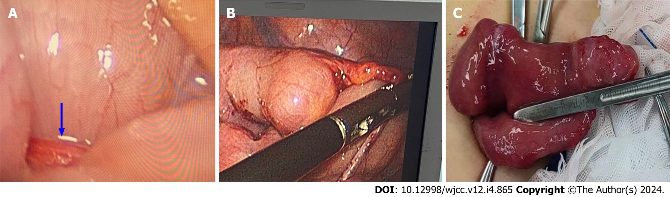
Figure 1 Child 1. A: Intestinal obstruction caused by compression of the mesodiverticular band (blue arrow); B: After disconnecting the mesodiverticular band; C: Meckel's diverticulum.

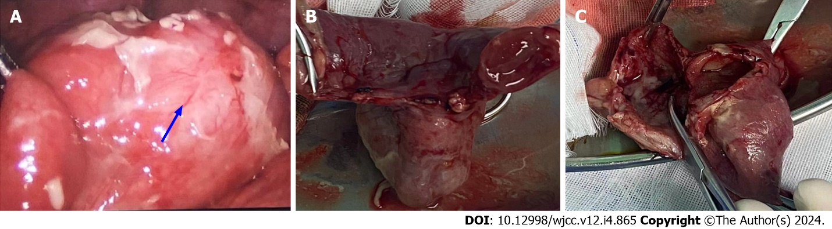
Figure 2 Child 2. A: Diverticulum wrapped in pus (blue arrow); B: Meckel's diverticulum; C: A large amount of pus in Diverticulum.

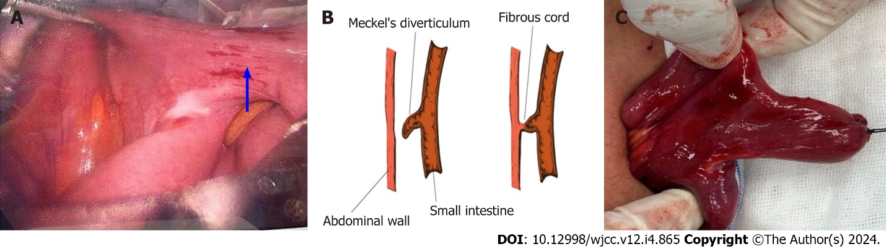
Figure 3 Child 3. A: Meckel's diverticulum inflammation, edema; B: Schematic diagram of the connection between the diverticulum and umbilical; C: Meckel's diverticulum.

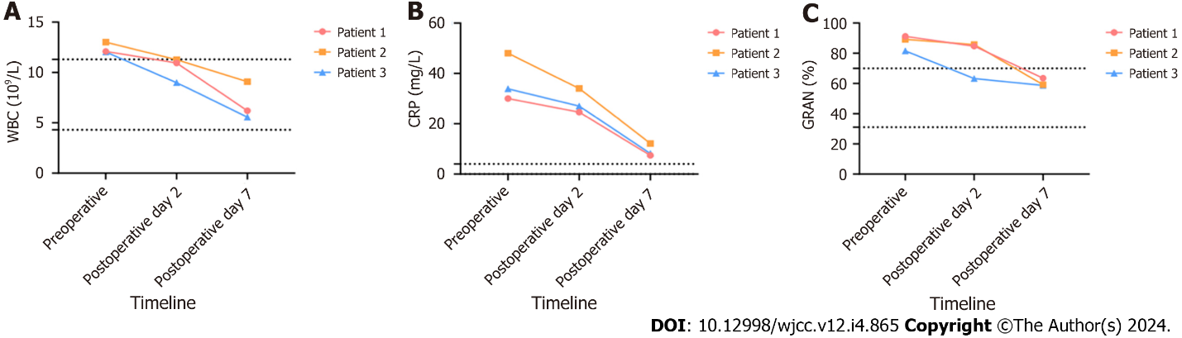
Figure 4 Changes in inflammatory indices in 3 patients. A: Changes in white blood cell before and after surgery in three children; B: Changes in C-reactive protein before and after surgery in three children; C: Granulocyte changes before and after surgery in three children. WBC: White blood cell; CRP: C-reactive protein; GRAN: Granulocyte.

Published by Baishideng Publishing Group Inc
7041 Koll Center Parkway, Suite 160, Pleasanton, CA 94566, USA
Telephone: +1-925-3991568
E-mail: office@baishideng.com
Help Desk: https://www.f6publishing.com/helpdesk
https://www.wjgnet.com

© 2024 Baishideng Publishing Group Inc. All rights reserved.

