Name of Journal: World Journal of Gastroenterology
Manuscript NO: 78854
Manuscript Type: ORIGINAL ARTICLE

Basic Study
3,6-dichlorobenzo[b]thiophene-2-carboxylic acid alleviates ulcerative colitis by suppressing mammalian target of rapamycin complex 1 activation and regulating intestinal microbiota

He QZ et al. BT2 ameliorates ulcerative colitis

Qiong-Zi He, Peng Wei, Jun-Zhi Zhang, Tong-Tong Liu, Kun-Qun Shi, Huan-Huan Liu, Jing-Wei Zhang, Shi-Jia Liu

Qiong-Zi He, Peng Wei, Jun-Zhi Zhang, Tong-Tong Liu, Kun-Qun Shi, Huan-Huan Liu, Shi-Jia Liu, Department of Medicine, First Affiliated Hospital, Nanjing University of Chinese Medicine, Nanjing 210000, Jiangsu Province, China

Qiong-Zi He, Peng Wei, Jun-Zhi Zhang, Tong-Tong Liu, Kun-Qun Shi, Huan-Huan Liu, College of The First Clinical Medicine, Nanjing University of Chinese Medicine, Nanjing 210029, Jiangsu Province, China

Jing-Wei Zhang, School of Life Science and Technology, China Pharmaceutical University, Nanjing 211198, Jiangsu Province, China

Author contributions: He QZ and Wei P contributed equally to this work; He QZ, Wei P, and Liu HH conceived and performed experiments; He QZ, Zhang JZ, Liu TT, and Shi KQ analyzed the data; He QZ and Wei P wrote the paper; Liu SJ revised the manuscript and obtained funding for the project; All authors read and approved the final manuscript.

Supported by National Natural Science Foundation of China, No. 82074241; and Project of Jiangsu Province Hospital of Traditional Chinese Medicine Peak Talent, No. y2021rc36.

Corresponding author: Shi-Jia Liu, PhD, Research Fellow, Department of Medicine, First Affiliated Hospital, Nanjing University of Chinese Medicine, No. 155 Hanzhong Road, Qinhuai District, Nanjing 210000, Jiangsu Province, China. liushijia2011@163.com

Received: July 20, 2022
Revised: November 4, 2022
Accepted: November 22, 2022
Published online:

Abstract
BACKGROUND
3,6-dichlorobenzo[b]thiophene-2-carboxylic acid (BT2) is a benzothiophene carboxylate derivative that can suppress the catabolism of branched-chain amino acid (BCAA)-associated mammalian target of rapamycin complex 1 (mTORC1) activation. Previous studies have demonstrated the therapeutic effects of BT2 on arthritis, liver cancer, and kidney injury. However, the effects of BT2 on ulcerative colitis (UC) are unknown.

AIM
To investigate the anti-UC effects of BT2 and the underlying mechanism.

METHODS
Mouse UC models were created through the administration of 3.5% dextran sodium sulfate (DSS) for 7 d. The mice in the treated groups were administered salazosulfapyridine (300 mg/kg) or BT2 (20 mg/kg) orally from day 1 to day 7. At the end of the study, all of the mice were sacrificed, and colon tissues were removed for hematoxylin and eosin staining, immunoblot analyses, and immunohistochemical assays. Cytokine levels were measured by flow cytometry. The contents of BCAAs including valine, leucine, and isoleucine, in mouse serum were detected by liquid chromatography-tandem mass spectrometry, and the abundance of intestinal flora was analyzed by 16S ribosomal DNA sequencing.

RESULTS
Our results revealed that BT2 significantly ameliorated the inflammatory symptoms and pathological damage induced by DSS in mice. BT2 also reduced the production of the proinflammatory cytokines interleukin 6 (IL-6), IL-9, and IL-2 and increased the anti-inflammatory cytokine IL-10 level. In addition, BT2 notably improved BCAA catabolism and suppressed mTORC1 activation and cyclooxygenase-2 expression in the colon tissues of UC mice. Furthermore, high-throughput sequencing revealed that BT2 restored the gut microbial abundance and diversity in mice with colitis. Compared with the DSS group, BT2 treatment increased the ratio of Firmicutes to Bacteroidetes and decreased the abundance of Enterobacteriaceae and Escherichia-Shigella.

CONCLUSION
Our results indicated that BT2 significantly ameliorated DSS-induced UC and that the latent mechanism involved the suppression of BCAA-associated mTORC1 activation and modulation of the intestinal flora.

Key Words: 3,6-dichlorobenzo[b]thiophene-2-carboxylic acid; Ulcerative colitis; Mechanistic target of rapamycin complex 1; Intestinal flora; Dextran sodium sulfate; Cyclooxygenase-2

He QZ, Wei P, Zhang JZ, Liu TT, Shi KQ, Liu HH, Zhang JW, Liu SJ. 3,6-dichlorobenzo[b]thiophene-2-carboxylic acid alleviates ulcerative colitis by suppressing mammalian target of rapamycin complex 1 activation and regulating intestinal microbiota. World J Gastroenterol 2022; In press

Core Tip: Gut microbiota dysbiosis and hyperactivated mammalian target of rapamycin complex 1 (mTORC1) make great contributions to the pathogenesis of ulcerative colitis (UC). In our study, 3,6-dichlorobenzo[b]thiophene-2-carboxylic acid (BT2) exerted significant therapeutic effects on the amelioration of dextran sodium sulfate-induced acute colitis. Our work reported that BT2 played an anti-UC role through suppression of branched amino acid-associated mTORC1 activation and modulation of the intestinal flora. Overall, BT2 could represent a potential candidate drug in the design of treatment strategies for UC.

INTRODUCTION
Ulcerative colitis (UC) is a chronic idiopathic intestinal disease characterized by persistent mucosal inflammation extending from the proximal rectum^{[1]}. Due to colonic mucosal damage and intestinal inflammation, UC patients generally experience abdominal pain, diarrhea, and bloody stools and are at a high risk for colorectal cancer^{[2,3]}. UC is traditionally regarded as a disease of Western nations, but recent data have shown that the incidence of UC is increasing worldwide, including in Asia and the Middle East, which indicates its emergence as a global public health challenge^{[4,5]}. Although the explicit etiology remains unclear, UC is primarily considered the result of gut microbiota dysbiosis, dysregulated immune responses, and disrupted intestinal epithelial function. The intestinal flora is involved in intestinal maturation, mucosal physiological functions, nutrient production, nutrient metabolism, and other processes. Patients with UC exhibit clearly disordered intestinal flora compared with healthy people^{[6-8]}, which reveals that gut flora imbalance plays an essential role in the pathogenesis of UC.
Mammalian target of rapamycin (mTOR), a crucial regulatory center of cell proliferation and growth, functions via two complexes called mTOR complex 1 (mTORC1) and mTOR complex 2. Previous studies have shown that mTORC1 makes a great contribution to the pathogenesis of UC and promotes the cyclooxygenase-2 (COX-2)-mediated inflammatory infiltration of T helper 17 cells to aggravate colitis^{[9-12]}. A wide range of intracellular signals such as amino acids, growth factors, energy, and hypoxia activate the mTORC1 pathway. Notably, high levels of branched-chain amino acids (BCAAs) including valine, leucine and isoleucine can maintain the persistent activation of mTORC1, leading to a series of diseases such as liver cancer^{[13-15]}. In general, the first step in BCAA catabolism is the branched-chain aminotransferase (BCAT)-mediated transamination reaction, which generates branched-chain α-keto acids (BCKAs). The BCKAs are then oxidatively decarboxylated by the branched-chain α-keto acid dehydrogenase complex (BCKDC) to produce substrates for the tricarboxylic acid cycle^{[16]}. 3,6-dichlorobenzo[b]thiophene-2-carboxylic acid (BT2) is a potent inhibitor of branched-chain α-keto acid dehydrogenase kinase (BCKDK), which can specifically phosphorylate and inactivate BCKDC. BCKDC is highly dephosphorylated and activated in the heart, muscle, kidney, and liver of mice treated with BT2, which results in reductions in plasma BCAA levels^{[17]}. Additionally, a previous study revealed that BT2 suppressed mTORC1 activation both in vitro and in vivo and caused no toxicity damage to mice following gavage administration^{[18,19]}. However, the effects of BT2 on UC and its potential mechanism remain unknown.
In our study, we not only evaluated the anti-UC effect of BT2 but also emphasized its impact on the gut microbiota and the inhibition of BCAA-related mTORC1 activation in UC mice.

MATERIALS AND METHODS
Chemicals and reagents
Dextran sodium sulfate (DSS) was purchased from MP Biomedicals (Irvine, CA, United States), and salazosulfapyridine (SASP) was purchased from Xinyi Pharmaceutical Group (Shanghai, China). BT2 was obtained from Yuanye Biotechnology Co., Ltd. (Shanghai, China). The LEGENDplex™ Multi-Analyte Flow Assay Kit was supplied by BioLegend (San Diego, CA, United States). The BCA Protein Quantification Kit and Supper ECL Detection Reagent were purchased from Yeasen Biotechnology Co., Ltd. (Shanghai, China). The antibodies used for these experiments were as follows: Ribosomal protein S6 (S6) [1:1000, #2317; Cell Signaling Technology (CST), Danvers, MA, United States], phosphorylated S6^{Ser235/236} (p-S6, 1:1000, 4858; CST), eukaryotic translation initiation factor 4E binding protein 1 (4EBP1) (9644, 1:1000; CST), p-4EBP1^{Thr37/46} (1:1000, 2855; CST), COX-2 (1:1000, 12282; CST), mTOR (1:1000, 66878-1-Ig; Proteintech, Rosemont, IL, United States), p-mTOR^{Ser2448} (1:1000, 67778-1-Ig; Proteintech), branched-chain amino transferase 2 (BCAT2) (1:1000, 16417-1-AP; Proteintech), rabbit antibody (1:10000, SA00001-2; Proteintech), mouse antibody (1:10000, SA00001-1; Proteintech), BCKDK (1:500, 274424; Santa Cruz, Dallas, TX, United States), and branched-chain α–keto acid dehydrogenase (BCKDHA) (1:500, 271538; Santa Cruz).

Animals and ethics statement
Forty female C57BL/6 J mice (aged 7-8 wk; 18-20 g) were purchased from the Model Animal Research Center of Nanjing University, Nanjing, China (License No: 202124233). All experiments were performed in accordance with the regulations of the pharmacology laboratory and Animal Ethics Committee of the Affiliated Hospital of Nanjing University of Chinese Medicine (2022DW-16-02).

Induction of UC and experimental design
The animals were maintained five per cage and housed in a specific sterile environment with a temperature of 23 ± 2 °C, relative humidity of 50%, and 12-h light/dark cycle. After 2 wk of acclimatization, the mice were randomly divided into four groups: Control group, model group, SASP group, and BT2 group. A total of 10 mice were included in each group. The mice in the control group were given normal drinking water, and the mice in the other groups were given 3.5% DSS in drinking water to induce colitis. The mice in the BT2 group and SASP group were treated with 20 mg/kg BT2 and 300 mg/kg SASP, respectively, by oral gavage in a volume of 0.2 mL. The mice in the control group and DSS group were given 0.5% carboxymethylcellulose sodium. The daily body weight loss and stool characteristics were recorded, and the mice were sacrificed 7 d later. On the 8th day, fecal samples and orbital blood samples were collected. The blood samples were clotted for at least 30 min and centrifuged for 20 min at 4 °C and 3000 r/min. Colon segments were extracted, and the lengths from the middle cecum to the end of the colon were measured. All abovementioned samples were stored at -80 °C until required for further investigation.

Multiple bead-based assay
The assay preparations were carried out according to the LEGENDplex™ Multi-Analyte Flow Assay Kit, and a flow cytometer (Beckman Coulter, Brea, CA, United States) was used for the detection of cytokine levels.

Assessment of the disease activity index score
The disease activity index (DAI) score comprehensively evaluates the severity of colonic inflammation from three aspects^{[20]}: (1) Body weight loss, 1 point for every 5% decrease in the mouse body weight up to 4 points; (2) Stool consistency, the stool form was scored from 0 (normal) to 4 points (watery diarrhea); and (3) Hematochezia, scores of 0-4 points were given for negative hemoccult to gross bleeding.

Western blotting
Colon tissue samples were lysed with RIPA buffer (Solarbio, Beijing, China), protease inhibitor (Biosharp, Beijing, China), and phosphatase inhibitors (Biosharp). The protein concentration was detected using the BCA protein assay reagent, and 10% sodium dodecyl sulfate-polyacrylamide gel electrophoresis was performed using 30 µg total protein samples at a constant voltage of 100 V. Separated proteins were blotted onto nitrocellulose membranes and then blocked in 5% skim milk for 1 h. The membranes were incubated overnight at 4 °C with primary antibodies diluted to appropriate concentrations and then incubated with secondary antibodies for 1 h at room temperature. The protein bands were visualized with enhanced chemiluminescence detection reagent and quantified using ImageJ software.

RNA extraction and quantitative polymerase chain reaction
Total RNA was extracted from colon tissues using the Total RNA Extraction Kit (Yeasen, Shanghai, China). The concentration and purity of the RNA samples were detected with an ultra-micro fluorescence UV spectrophotometer (DeNovix Inc., Wilmington, DE, United States). A kit (Yeasen) was used for the reverse transcription of total RNA into cDNA, and polymerase chain reaction (qPCR) was performed with a real-time fluorescence quantitative PCR detection system (Thermo Fisher Scientific, Waltham, MA, United States). The primers were as follows: β-actin forward, CTGTGCCCATCTACGAGGGCTAT and reverse, TTTGATGTCACGCACGATTTCC; COX-2 forward, GCGACATACTCAAGCAGGAGCA and reverse, AGTGGTAACCGCTCAGGTGTTG. All primers were provided by Tsingke Biotechnology Co., Ltd. (Beijing, China).

Immunohistochemical analysis
Colon tissue sections were dewaxed and dehydrated with different grades of alcohol and xylene. The tissue sections were placed in a repair box filled with citric acid (pH 6.0) antigen retrieval buffer for antigen retrieval in a microwave oven and then washed three times with phosphate-buffered saline (PBS). The sections were placed in 3% hydrogen peroxide to block endogenous peroxidase activity and then sealed with 3% bovine serum albumin for 30 min at room temperature. The sections were incubated with primary antibody overnight at 4 °C. The slices were washed three times with PBS, incubated with secondary antibody for 50 min, washed three times with PBS, and subjected to a diaminobenzidine color developing solution. The nuclei were counterstained with hematoxylin for 3-4 min. Images were collected by light microscopy and analyzed by expert pathologists. The immunohistochemistry score was calculated based on the proportion of cells with an unequivocal positive reaction (0: < 5%; 1: 5%-20%; 2: 21%-40%; 3: 41%-60%; 4: 61%-80%; and 5: > 80%).

Histopathological evaluation
Fresh colon tissues were fixed in fixing solution for more than 24 h and then embedded in paraffin blocks. Then the wax blocks were trimmed, cut into 4-μm-thick sections, and subjected to hematoxylin and eosin (H&E) staining. Histopathological changes were observed by a light microscope (Nikon, Tokyo, Japan). The histopathological score was divided into epithelial injury and inflammatory cell infiltration according to specific evaluation criteria described elsewhere^{[21]}.

16S ribosomal RNA sequencing of the gut microbiota
Total genomic DNA from fecal samples was extracted using the PowerSoil DNA Isolation Kit (MoBio Laboratories, Carlsbad, CA, United States) following the manufacturer’s protocol. The DNA quality and concentration were detected using a Nanodrop spectrophotometer (Thermo Fisher Scientific). The V3-V4 regions of bacterial 16S ribosomal DNA (rDNA) were amplified by PCR using the primers 338F (5’-ACTCCTACGGGAGGCAGCAG-3’) and 806R (5’-GGACTACNNGGGTATCTAAT-3’). The target bands were detected by 1% agarose gel electrophoresis, and the PCR products were purified by the magnetic bead method. Then microbial diversity sequencing library was established, and deep sequencing was performed with the Illumina MiSeq PE300 high-throughput sequencing platform at the Allwegene Company (Beijing, China). Pear (v0.9.6) software was used to filter and splice the data for the optimized sequence. Qualified reads were clustered into operational taxonomic units (OTUs) at a similarity level of 97% using the Uparse algorithm of Vsearch (v2.7.1) software. Taxonomic analysis at different levels (kingdom, phylum, class, order, family, genus, and species) was obtained using the Ribosomal Database Project classifier algorithm. QIIME1 (v1.8.0) software was used for α diversity index analysis (including the Shannon and Chao1 indexes), and nonmetric multidimensional scaling analysis (NMDS) was performed using the R package (v3.6.0).

Determination of BCAA concentrations
Serum amino acid concentrations were determined by liquid chromatography-tandem mass spectrometry with the Q-life Lab 9000 mass spectrometer at Shenzhen Institute of Life and Health Medicine Co., Ltd. (Jiangsu, China). Serum samples were loaded and separated online using the InfinityLab Poroshell 120 EC-C18 column (2.1 mm × 100 mm, 2.7 μm; Agilent, Santa Clara, CA, United States). The column temperature was set to 45 °C. The mobile phase consisted of 0.01% formic acid in water (solvent A) and acetonitrile (solvent B). The flow rate was 0.3 mL/min, and the injection volume was 2 μL. Gradient elution was used as follows: 0-1.5 min, 8% B; 3.5 min, 16% B; 6.5 min, 20% B; 8.0 min, 95% B; and 8.01-11.0 min, 8% B. The electrospray ionization settings were as follows: Capillary voltage, 3.5 kV; spray voltage, 300 V; drying gas temperature, 250 °C; drying gas flow rate, 7 L/min; sheath gas flow rate, 11 L/min; and sheath gas temperature, 250 °C.

Statistical analyses
The experimental data are expressed as the mean ± SD, and one-way analysis of variance was used to evaluate the significance among multiple groups. P < 0.05 was considered statistically significant. Data analysis and picture drawing were performed using GraphPad Prism 7.0 software (GraphPad, San Diego, CA, United States).

RESULTS
BT2 ameliorated DSS-stimulated colitis
The effects of BT2 on DSS-induced UC mice were assessed based on the DAI score, body weight loss, and colon length. Oral 3.5% DSS treatment led to a significant reduction in body weight (Figure 1A), but the weight loss was reversed by BT2 and SASP treatment. The DAI score including weight loss rate, stool consistency and hematochezia was markedly increased in colitis mice, whereas the BT2- and SASP-treated groups showed improvements in this metric (Figure 1B). Then we examined the changes in the colon length. DSS treatment evidently shortened the colon length compared with that of the control group, whereas 7 d of BT2 and SASP administration extended the length (Figure 1C and D). These data showed that BT2 could improve the clinical symptoms of UC mice.

BT2 suppressed inflammation in UC mice
Representative H&E staining images and the pathological scores of colon tissues from each group are shown in Figure 1E and F. The mucosal epithelium of the mice in the control group was intact, and the morphology of the cells was normal and showed no inflammatory infiltration. The tissues of the mice in the DSS-treated group displayed evident epithelial damage and inflammatory infiltration. However, the histological injury score revealed that BT2 and SASP treatment reduced the severity of UC. Furthermore, the contents of the predominant proinflammatory cytokines including interleukin (IL-6), IL-2, and IL-9 were increased in the DSS group. By contrast, the level of an anti-inflammatory cytokine (IL-10) was decreased in the DSS group. By contrast, BT2 and SASP treatment clearly inhibited the increase in these proinflammatory cytokines and decreased the level of IL-10 (Figure 2). Together, these data revealed that BT2 could improve histopathological damage and reduce proinflammatory cytokine production in UC mice.

BT2 improved BCAA catabolism in UC mice
To verify the effects of BT2 on BCAA catabolism in DSS-induced UC mice, the expression levels of the catabolic enzymes BCKDHA, BCAT2, and BCKDK in colon tissues were detected by immunoblotting (Figure 3). The DSS group showed increased BCKDK expression and decreased expression of BCKDHA and BCAT2, but these changes were notably reversed by BT2 administration (Figure 3B-E). Consistently, immunohistochemistry analysis showed that BCKDK expression was increased in colon tissues with severe inflammation but reduced in BT2-treated mice (Figure 3A). Moreover, higher concentrations of leucine, isoleucine, and valine were observed in the serum of DSS-treated mice, whereas BT2 treatment resulted in downregulation of these amino acids (Figure 3F). In summary, BCAA catabolism was impaired in UC mice but rescued by BT2 treatment.

BT2 suppressed the mTORC1 signaling pathway in UC mice
Based on the beneficial effect of BT2 on BCAA metabolism, we hypothesized that BT2 could suppress BCAA-related mTORC1 activation in UC mice. In accordance with this assumption, the phosphorylation of mTOR and its characterized downstream substrates 4-EBP1 and S6 were explored by Western blot analysis. As shown in Figure 4A-D, the expression levels of these phosphorylated proteins were markedly elevated in the colon tissues from the DSS group but decreased in the colon tissues from the BT2 group. Additionally, immunohistochemical staining showed that BT2 treatment significantly reversed the upregulation of phosphorylated 4-EBP1 and p-S6 expression in colon tissues induced by DSS (Figure 4E). Collectively, these results suggested that BT2 could inhibit BCAA-related mTORC1 activation in the colon tissues of UC mice.

BT2 inhibited the expression of COX-2 in UC mice
The overexpression of COX-2 in experimental colitis has been widely reported; therefore, we investigated the effect of BT2 on COX-2 expression in colon tissues of UC mice. As shown in Figure 5A and B, COX-2 expression was markedly induced by DSS but reduced in the BT2 group. As depicted in Figure 5C, mice in the DSS group showed higher mRNA levels of COX-2 but BT2 treatment reversed this effect.

BT2 restructured gut microbiota homeostasis in UC mice
The gut microbiota is involved in various physiological functions of the intestinal mucosa and is a new target for the prevention, diagnosis, and treatment of colonic inflammation. Therefore, 16S rDNA sequencing was performed to investigate whether BT2 regulates the composition of intestinal microflora in colitis mice (Figure 6). The rarefaction curve, which was used to estimate the sample size and the species richness, showed that the sequencing amount was reasonable (Figure 6D). NMDS analysis based on β diversity revealed that the flora structure was evidently different between the DSS group and the control group but that BT2 treatment improved this dissimilarity (Figure 6E). The Venn diagram was created to illustrate the number of common and unique OTUs among multiple samples. The overlapping part indicates the common OTUs, and the nonoverlapping areas represent the unique OTUs in each group. As shown in Figure 6A, 1443 OTUs were present in all groups, whereas 806, 319, and 363 OTUs were uniquely present in the control group, DSS group, and BT2 group, respectively. The α diversity index, including the Chao1 and Shannon indexes, showed that the gut microbiota diversity and richness were lower in colitis mice than in the control group. However, these alterations were normalized by BT2 treatment (Figure 6B and C).

BT2 altered the gut microbiota composition and functionality in UC mice
As shown in Figure 7A, the intestinal flora mainly consisted of Firmicutes, Bacteroidetes, and Proteobacteria at the phylum level. The relative abundance levels of Bacteroidetes and Proteobacteria were increased in the DSS group, whereas the abundance of Firmicutes was reduced. However, BT2 intervention significantly restored the abundance of the three phyla. Moreover, the ratio of Firmicutes to Bacteroidetes (F/B) was decreased in the fecal samples from the DSS group relative to the control group, but this decrease was markedly reversed by BT2 (Figure 7B). At the family level, UC mice displayed evidently higher populations of Clostridiaceae and Prevotellaceae, which are related to the synthesis of BCAAs compared with normal mice. As expected, BT2 treatment notably increased the abundance of Clostridiaceae and Prevotellaceae (Figure 7C-E). Furthermore, the administration of BT2 prevented the increases in Enterobacteriaceae and Escherichia-Shigella caused by DSS and slightly restored the downregulation of Oscillospiraceae (Figure 7F-H).

DISCUSSION
UC has emerged as one of the most common chronic recurrent intestinal diseases in recent years and is treated with 5-aminosalicylic acid preparations, glucocorticoids, anti-tumor necrosis factor agents and thiopurines. These drugs can relieve colonic inflammation to a certain extent but are usually accompanied by adverse reactions, intolerance, and treatment limitations^{[22,23]}. Therefore, research on new drug targets and therapeutics for UC has received increasing attention. A large number of studies have shown that disorder of the intestinal microbiota is crucial to the initiation and progression of UC. The metabolites produced by intestinal flora, such as BCAAs and short-chain fatty acids, can be absorbed by the host intestinal tract to affect its physiological and pathological functions, whereas an imbalance in the intestinal flora affects these functional metabolites^{[15]}. Bosch et al^{[24]} reported that the levels of leucine, isoleucine, and valine were significantly elevated in the feces of inflammatory bowel disease (IBD) patients. BT2 is a specific inhibitor of BCKDK that can improve BCAA catabolism and limit the tumor burden by inhibiting mTORC1 in mouse hepatocellular carcinoma models^{[18]}, but the impact of BT2 on UC has not been explored to date.
This study showed that BT2 exerted obvious therapeutic effects on DSS-induced UC. BT2 intervention led to a reduction in body weight loss; improved the pathological injury of colon tissues; decreased the content of proinflammatory cytokines including IL-6, IL-9 and IL-2; and decreased the level of IL-10 compared with the results obtained with DSS treatment. In particular, we found that BT2 could ameliorate the gut microbiota disruption caused by DSS. The diversity and richness of the fecal microbiota in the DSS group were decreased, but this downregulation was reversed in the BT2 group. At the phylum level, the fecal flora of mice was mainly composed of Firmicutes, Bacteroidetes, and Proteobacteria. In addition, upregulation of the phylum Proteobacteria and downregulation of the F/B value in the DSS group were normalized by BT2 treatment. In accordance with previous reports, Proteobacteria represent the largest phylum in the bacterial domain and play a key role in driving proinflammatory changes and inducing IBD development due to their adhesiveness and invasiveness^{[25]}. The F/B value has been used as an index for evaluating the disordered intestinal microbiome in UC and was significantly reduced in the fecal microbiota of IBD patients compared with controls^{[26,27]}. At the family level, it is worth noting that two BCAA-producing bacteria, Clostridiaceae and Prevotellaceae, were increased in the DSS group but were downregulated in the BT2 group. Notably, Prevotella copri is a representative species that drives the synthesis of BCAAs, which are capable of inducing insulin resistance, aggravating glucose intolerance, and increasing the circulating level of BCAAs^{[28]}. Intestinal microorganisms have great BCAA biosynthetic potential, and the increase in BCAA levels is related to the change in bacteria involved in BCAA biosynthesis^{[28]}. A previous study showed that the relative abundance of microbes associated with BCAA synthesis was increased in mice fed a high-fat diet including the order Clostridiales, family Clostridiaceae, and Prevotellaceae^{[29]}. The abundance of Clostridiaceae is positively correlated with the concentration of serum BCAAs in mice^{[30]}. We also found that the level of Oscillospiraceae was slightly increased in the BT2 group. Oscillospiraceae is widely present in the intestinal microorganisms of humans and animals and is associated with inflammatory diseases. A previous meta-analysis showed that Oscillospiraceae was significantly reduced in the intestines of patients with Crohn’s disease but increased in those with gallstones^{[31]}. Moreover, downregulation of Enterobacteriaceae and Escherichia-Shigella was also observed in the BT2 group. A recent report showed that host-induced inflammation disrupts gut microbes, leading to overgrowth of some aerobic bacteria, particularly Enterobacteriaceae, which is elevated in the intestinal tract of IBD patients and acts as an initiation inducer for inflammation^{[32]}. Shigella is a gram-negative short bacillus that is highly contagious and regarded as a pathogen of IBD^{[33]}.
mTORC1 is a complex of mTOR that jointly promotes protein synthesis, cell growth, and proliferation by phosphorylating its direct downstream substrates S6 kinase 1 and 4E-BP1^{[34,35]}. A growing number of findings have revealed the involvement of the mTORC1 pathway in the pathogenesis of UC. mTORC1 is hyperactivated in the colon tissues of UC patients and mice, and the overexpression of mTORC1 in colonic epithelial cells aggravates the inflammatory symptoms of UC mice^{[12]}. Supplementation with mTORC1 inhibitors such as rapamycin, AZD8055, and everolimus markedly improves experimental UC by reducing leukocyte extravasation in the mucosa, suppressing T-cell proliferation and blocking the release of interferon from lymphocytes^{[36-38]}. In our study, the activity of mTORC1 was enhanced in DSS-stimulated colitis mice, and BT2 significantly decreased mTORC1 activity. COX-2 is one of the isoforms of COX and is strongly associated with the development of IBD. COX-2 is highly expressed in the colon tissues of UC patients and animals and induces UC by producing prostaglandins (PGs), which promote inflammation and pain. The COX-2 inhibitor rofecoxib is potentially effective in improving experimental colitis by reducing PGE2 production, proinflammatory cytokines, and neutrophil infiltration^{[39,40]}. In clinical UC samples, a positive correlation has been detected between COX-2 expression and mTORC1 activity^{[12]}. Consistently, our study demonstrated that COX-2 expression was enhanced in UC mice but inhibited by BT2 intervention.
Amino acids, particularly BCAAs, serve as essential signaling factors for mTORC1 activation. The reduction of BCAA production by blocking BCAT1, a cytosolic aminotransferase for BCAAs, can significantly inhibit mTORC1 activation in chronic myeloid leukemia cells^{[41]}. Rag guanine triphosphate (Rag GTPase) has been identified as a critical activator of mTORC1 in response to amino acid signals^{[42]}. GATOR1, GATOR2, and Sestrin2 are three proteins involved in the regulation of recombination-activating genes. Sestrin2 is reportedly a leucine receptor for the mTORC1 signaling pathway^{[43]}. Previous studies have shown that BCAA-induced mTORC1 activation is associated with the development of hepatocellular carcinoma, liver cancer, and prostate cancer^{[18,44,45]}. Recently, Huangqin decoction relieves experimental colitis by regulating the metabolism of amino acids such as leucine and the mTOR pathway^{[46]}. These results revealed that BCAA-mediated mTORC1 activation is a key research topic in the field of UC. Our data established an unreported link between BCAA-related mTORC1 activation and UC and thus elucidate a novel mechanism of BT2 against UC. Further investigations need to combine gene knockout mouse models and fecal microbiota transplantation to validate the specific mechanism of BT2-regulated BCAA metabolism in the anti-UC effect.

CONCLUSION
In summary, our data showed that the intestinal microbiota was disordered and BCAA catabolism was impaired in DSS-induced colitis mice, resulting in activation of the mTORC1 signaling pathway and overexpression of COX-2. Importantly, BT2 substantially reversed these phenomena and thus demonstrates potential value in the treatment of UC.

ARTICLE HIGHLIGHTS
Research background
Ulcerative colitis (UC) is a chronic inflammatory disorder caused by multiple factors. As a novel inhibitor, 3,6-dichlorobenzo[b]thiophene-2-carboxylic acid (BT2) was recently shown to play an important role in improving amino acid metabolism and anti-inflammation. However, no relevant studies have reported the protective effect of BT2 on UC.

Research motivation
To investigate the therapeutic effect of BT2 on UC and the potential pharmacological mechanism.

Research objectives
To clarify the role of BT2 in UC treatment and its underlying mechanism.

Research methods
The acute colitis model was induced by 3.5% dextran sodium sulfate (DSS). The protective effect of BT2 was evaluated via clinical manifestations and colonic pathological changes. Flow cytometry was used to detect the contents of cytokines. Western blot analysis, immunohistochemical assays and liquid chromatography-tandem mass spectrometry were employed to estimate the mechanistic target of rapamycin complex 1 (mTORC1) activity and branched-chain amino acid (BCAA) catabolism. Moreover, the abundance of intestinal microbiota in feces was measured by 16S ribosomal DNA sequencing.

Research results
BT2 markedly alleviated colonic damage and reduced the release of proinflammatory cytokines in the DSS colitis model. BT2 also obviously improved BCAA catabolism in UC mice, as evidenced by the detection of related kinases in colon tissues and the targeted quantification of amino acids in serum. mTORC1 activity was enhanced in UC mice but inhibited by BT2 treatment. Moreover, 16S rRNA sequencing revealed that BT2 could prevent the decrease in the Firmicutes/Bacteroidetes ratio and the increase in harmful bacteria induced by DSS.

Research conclusions
BT2 relieved colitis by inhibiting BCAA-related mTORC1 activation and restoring gut microbiota metabolism homeostasis.

Research perspectives
BT2 showed significant efficacy on colitis and could serve as a promising therapeutic agent for UC treatment.

REFERENCES
1 Feuerstein JD, Cheifetz AS. Ulcerative colitis: epidemiology, diagnosis, and management. Mayo Clin Proc 2014; 89: 1553-1563 [PMID: 25199861 DOI: 10.1016/j.mayocp.2014.07.002]
2 Ullman TA, Itzkowitz SH. Intestinal inflammation and cancer. Gastroenterology 2011; 140: 1807-1816 [PMID: 21530747 DOI: 10.1053/j.gastro.2011.01.057]
3 Han YD, Al Bandar MH, Dulskas A, Cho MS, Hur H, Min BS, Lee KY, Kim NK. Prognosis of ulcerative colitis colorectal cancer vs. sporadic colorectal cancer: propensity score matching analysis. BMC Surg 2017; 17: 28 [PMID: 28327112 DOI: 10.1186/s12893-017-0224-z]
4 Molodecky NA, Soon IS, Rabi DM, Ghali WA, Ferris M, Chernoff G, Benchimol EI, Panaccione R, Ghosh S, Barkema HW, Kaplan GG. Increasing incidence and prevalence of the inflammatory bowel diseases with time, based on systematic review. Gastroenterology 2012; 142: 46-54.e42; quiz e30 [PMID: 22001864 DOI: 10.1053/j.gastro.2011.10.001]
5 Ng SC, Shi HY, Hamidi N, Underwood FE, Tang W, Benchimol EI, Panaccione R, Ghosh S, Wu JCY, Chan FKL, Sung JJY, Kaplan GG. Worldwide incidence and prevalence of inflammatory bowel disease in the 21st century: a systematic review of population-based studies. Lancet 2017; 390: 2769-2778 [PMID: 29050646 DOI: 10.1016/S0140-6736(17)32448-0]
6 Macfarlane S, Furrie E, Cummings JH, Macfarlane GT. Chemotaxonomic analysis of bacterial populations colonizing the rectal mucosa in patients with ulcerative colitis. Clin Infect Dis 2004; 38: 1690-1699 [PMID: 15227614 DOI: 10.1086/420823]
7 Frank DN, St Amand AL, Feldman RA, Boedeker EC, Harpaz N, Pace NR. Molecular-phylogenetic characterization of microbial community imbalances in human inflammatory bowel diseases. Proc Natl Acad Sci U S A 2007; 104: 13780-13785 [PMID: 17699621 DOI: 10.1073/pnas.0706625104]
8 Ott SJ, Musfeldt M, Wenderoth DF, Hampe J, Brant O, Fölsch UR, Timmis KN, Schreiber S. Reduction in diversity of the colonic mucosa associated bacterial microflora in patients with active inflammatory bowel disease. Gut 2004; 53: 685-693 [PMID: 15082587 DOI: 10.1136/gut.2003.025403]
9 Gao S, Liu W, Zhuo X, Wang L, Wang G, Sun T, Zhao Z, Liu J, Tian Y, Zhou J, Yuan Z, Wu Y. The activation of mTOR is required for monocyte pro-inflammatory response in patients with coronary artery disease. Clin Sci (Lond) 2015; 128: 517-526 [PMID: 25428582 DOI: 10.1042/CS20140427]
10 Lyons J, Ghazi PC, Starchenko A, Tovaglieri A, Baldwin KR, Poulin EJ, Gierut JJ, Genetti C, Yajnik V, Breault DT, Lauffenburger DA, Haigis KM. The colonic epithelium plays an active role in promoting colitis by shaping the tissue cytokine profile. PLoS Biol 2018; 16: e2002417 [PMID: 29596476 DOI: 10.1371/journal.pbio.2002417]
11 Cheon SY, Cho K. Lipid metabolism, inflammation, and foam cell formation in health and metabolic disorders: targeting mTORC1. J Mol Med (Berl) 2021; 99: 1497-1509 [PMID: 34312684 DOI: 10.1007/s00109-021-02117-8]
12 Lin X, Sun Q, Zhou L, He M, Dong X, Lai M, Liu M, Su Y, Jia C, Han Z, Liu S, Zheng H, Jiang Y, Ling H, Li M, Chen J, Zou Z, Bai X. Colonic epithelial mTORC1 promotes ulcerative colitis through COX-2-mediated Th17 responses. Mucosal Immunol 2018; 11: 1663-1673 [PMID: 30082707 DOI: 10.1038/s41385-018-0018-3]
13 Yoon MS. The Emerging Role of Branched-Chain Amino Acids in Insulin Resistance and Metabolism. Nutrients 2016; 8 [PMID: 27376324 DOI: 10.3390/nu8070405]
14 Uddin GM, Zhang L, Shah S, Fukushima A, Wagg CS, Gopal K, Al Batran R, Pherwani S, Ho KL, Boisvenue J, Karwi QG, Altamimi T, Wishart DS, Dyck JRB, Ussher JR, Oudit GY, Lopaschuk GD. Impaired branched chain amino acid oxidation contributes to cardiac insulin resistance in heart failure. Cardiovasc Diabetol 2019; 18: 86 [PMID: 31277657 DOI: 10.1186/s12933-019-0892-3]
15 Newgard CB, An J, Bain JR, Muehlbauer MJ, Stevens RD, Lien LF, Haqq AM, Shah SH, Arlotto M, Slentz CA, Rochon J, Gallup D, Ilkayeva O, Wenner BR, Yancy WS Jr, Eisenson H, Musante G, Surwit RS, Millington DS, Butler MD, Svetkey LP. A branched-chain amino acid-related metabolic signature that differentiates obese and lean humans and contributes to insulin resistance. Cell Metab 2009; 9: 311-326 [PMID: 19356713 DOI: 10.1016/j.cmet.2009.02.002]
16 Adeva MM, Calviño J, Souto G, Donapetry C. Insulin resistance and the metabolism of branched-chain amino acids in humans. Amino Acids 2012; 43: 171-181 [PMID: 21984377 DOI: 10.1007/s00726-011-1088-7]
17 Tso SC, Gui WJ, Wu CY, Chuang JL, Qi X, Skvora KJ, Dork K, Wallace AL, Morlock LK, Lee BH, Hutson SM, Strom SC, Williams NS, Tambar UK, Wynn RM, Chuang DT. Benzothiophene carboxylate derivatives as novel allosteric inhibitors of branched-chain α-ketoacid dehydrogenase kinase. J Biol Chem 2014; 289: 20583-20593 [PMID: 24895126 DOI: 10.1074/jbc.M114.569251]
18 Ericksen RE, Lim SL, McDonnell E, Shuen WH, Vadiveloo M, White PJ, Ding Z, Kwok R, Lee P, Radda GK, Toh HC, Hirschey MD, Han W. Loss of BCAA Catabolism during Carcinogenesis Enhances mTORC1 Activity and Promotes Tumor Development and Progression. Cell Metab 2019; 29: 1151-1165.e6 [PMID: 30661928 DOI: 10.1016/j.cmet.2018.12.020]
19 Yeh MC, Wu BJ, Li Y, Elahy M, Prado-Lourenco L, Sockler J, Lau H, Day RO, Khachigian LM. BT2 Suppresses Human Monocytic-Endothelial Cell Adhesion, Bone Erosion and Inflammation. J Inflamm Res 2021; 14: 1019-1028 [PMID: 33790617 DOI: 10.2147/JIR.S296676]
20 Wirtz S, Neufert C, Weigmann B, Neurath MF. Chemically induced mouse models of intestinal inflammation. Nat Protoc 2007; 2: 541-546 [PMID: 17406617 DOI: 10.1038/nprot.2007.41]
21 Kim JJ, Shajib MS, Manocha MM, Khan WI. Investigating intestinal inflammation in DSS-induced model of IBD. J Vis Exp 2012 [PMID: 22331082 DOI: 10.3791/3678]
22 Alexakis C, Saxena S, Chhaya V, Cecil E, Curcin V, Pollok R. Do Thiopurines Reduce the Risk of Surgery in Elderly Onset Inflammatory Bowel Disease? A 20-Year National Population-Based Cohort Study. Inflamm Bowel Dis 2017; 23: 672-680 [PMID: 28151735 DOI: 10.1097/MIB.0000000000001031]
23 Feuerstein JD, Moss AC, Farraye FA. Ulcerative Colitis. Mayo Clin Proc 2019; 94: 1357-1373 [PMID: 31272578 DOI: 10.1016/j.mayocp.2019.01.018]
24 Bosch S, Struys EA, van Gaal N, Bakkali A, Jansen EW, Diederen K, Benninga MA, Mulder CJ, de Boer NKH, de Meij TGJ. Fecal Amino Acid Analysis Can Discriminate De Novo Treatment-Naïve Pediatric Inflammatory Bowel Disease From Controls. J Pediatr Gastroenterol Nutr 2018; 66: 773-778 [PMID: 29112087 DOI: 10.1097/MPG.0000000000001812]
25 Mukhopadhya I, Hansen R, El-Omar EM, Hold GL. IBD-what role do Proteobacteria play? Nat Rev Gastroenterol Hepatol 2012; 9: 219-230 [PMID: 22349170 DOI: 10.1038/nrgastro.2012.14]
26 Sokol H, Seksik P, Furet JP, Firmesse O, Nion-Larmurier I, Beaugerie L, Cosnes J, Corthier G, Marteau P, Doré J. Low counts of Faecalibacterium prausnitzii in colitis microbiota. Inflamm Bowel Dis 2009; 15: 1183-1189 [PMID: 19235886 DOI: 10.1002/ibd.20903]
27 Kabeerdoss J, Jayakanthan P, Pugazhendhi S, Ramakrishna BS. Alterations of mucosal microbiota in the colon of patients with inflammatory bowel disease revealed by real time polymerase chain reaction amplification of 16S ribosomal ribonucleic acid. Indian J Med Res 2015; 142: 23-32 [PMID: 26261163 DOI: 10.4103/0971-5916.162091]
28 Pedersen HK, Gudmundsdottir V, Nielsen HB, Hyotylainen T, Nielsen T, Jensen BA, Forslund K, Hildebrand F, Prifti E, Falony G, Le Chatelier E, Levenez F, Doré J, Mattila I, Plichta DR, Pöhö P, Hellgren LI, Arumugam M, Sunagawa S, Vieira-Silva S, Jørgensen T, Holm JB, Trošt K; MetaHIT Consortium, Kristiansen K, Brix S, Raes J, Wang J, Hansen T, Bork P, Brunak S, Oresic M, Ehrlich SD, Pedersen O. Human gut microbes impact host serum metabolome and insulin sensitivity. Nature 2016; 535: 376-381 [PMID: 27409811 DOI: 10.1038/nature18646]
29 Yue SJ, Liu J, Wang AT, Meng XT, Yang ZR, Peng C, Guan HS, Wang CY, Yan D. Berberine alleviates insulin resistance by reducing peripheral branched-chain amino acids. Am J Physiol Endocrinol Metab 2019; 316: E73-E85 [PMID: 30422704 DOI: 10.1152/ajpendo.00256.2018]
30 Yang Y, Zhao M, He X, Wu Q, Li DL, Zang WJ. Pyridostigmine Protects Against Diabetic Cardiomyopathy by Regulating Vagal Activity, Gut Microbiota, and Branched-Chain Amino Acid Catabolism in Diabetic Mice. Front Pharmacol 2021; 12: 647481 [PMID: 34084135 DOI: 10.3389/fphar.2021.647481]
31 Walters WA, Xu Z, Knight R. Meta-analyses of human gut microbes associated with obesity and IBD. FEBS Lett 2014; 588: 4223-4233 [PMID: 25307765 DOI: 10.1016/j.febslet.2014.09.039]
32 Lupp C, Robertson ML, Wickham ME, Sekirov I, Champion OL, Gaynor EC, Finlay BB. Host-mediated inflammation disrupts the intestinal microbiota and promotes the overgrowth of Enterobacteriaceae. Cell Host Microbe 2007; 2: 204 [PMID: 18030708 DOI: 10.1016/j.chom.2007.08.002]
33 Kang E, Crouse A, Chevallier L, Pontier SM, Alzahrani A, Silué N, Campbell-Valois FX, Montagutelli X, Gruenheid S, Malo D. Enterobacteria and host resistance to infection. Mamm Genome 2018; 29: 558-576 [PMID: 29785663 DOI: 10.1007/s00335-018-9749-4]
34 Huang K, Fingar DC. Growing knowledge of the mTOR signaling network. Semin Cell Dev Biol 2014; 36: 79-90 [PMID: 25242279 DOI: 10.1016/j.semcdb.2014.09.011]
35 Wang X, Proud CG. mTORC1 signaling: what we still don't know. J Mol Cell Biol 2011; 3: 206-220 [PMID: 21138990 DOI: 10.1093/jmcb/mjq038]
36 Hu S, Chen M, Wang Y, Wang Z, Pei Y, Fan R, Liu X, Wang L, Zhou J, Zheng S, Zhang T, Lin Y, Zhang M, Tao R, Zhong J. mTOR Inhibition Attenuates Dextran Sulfate Sodium-Induced Colitis by Suppressing T Cell Proliferation and Balancing TH1/TH17/Treg Profile. PLoS One 2016; 11: e0154564 [PMID: 27128484 DOI: 10.1371/journal.pone.0154564]
37 Farkas S, Hornung M, Sattler C, Guba M, Steinbauer M, Anthuber M, Herfarth H, Schlitt HJ, Geissler EK. Rapamycin decreases leukocyte migration in vivo and effectively reduces experimentally induced chronic colitis. Int J Colorectal Dis 2006; 21: 747-753 [PMID: 16228179 DOI: 10.1007/s00384-005-0793-7]
38 Matsuda C, Ito T, Song J, Mizushima T, Tamagawa H, Kai Y, Hamanaka Y, Inoue M, Nishida T, Matsuda H, Sawa Y. Therapeutic effect of a new immunosuppressive agent, everolimus, on interleukin-10 gene-deficient mice with colitis. Clin Exp Immunol 2007; 148: 348-359 [PMID: 17437423 DOI: 10.1111/j.1365-2249.2007.03345.x]
39 Martín AR, Villegas I, Alarcón de la Lastra C. The COX-2 inhibitor, rofecoxib, ameliorates dextran sulphate sodium induced colitis in mice. Inflamm Res 2005; 54: 145-151 [PMID: 15883736 DOI: 10.1007/s00011-004-1337-2]
40 Martín AR, Villegas I, La Casa C, Alarcón de la Lastra C. The cyclo-oxygenase-2 inhibitor, rofecoxib, attenuates mucosal damage due to colitis induced by trinitrobenzene sulphonic acid in rats. Eur J Pharmacol 2003; 481: 281-291 [PMID: 14642796 DOI: 10.1016/j.ejphar.2003.09.033]
41 Hattori A, Tsunoda M, Konuma T, Kobayashi M, Nagy T, Glushka J, Tayyari F, McSkimming D, Kannan N, Tojo A, Edison AS, Ito T. Cancer progression by reprogrammed BCAA metabolism in myeloid leukaemia. Nature 2017; 545: 500-504 [PMID: 28514443 DOI: 10.1038/nature22314]
42 Kim E, Goraksha-Hicks P, Li L, Neufeld TP, Guan KL. Regulation of TORC1 by Rag GTPases in nutrient response. Nat Cell Biol 2008; 10: 935-945 [PMID: 18604198 DOI: 10.1038/ncb1753]
43 Wolfson RL, Chantranupong L, Saxton RA, Shen K, Scaria SM, Cantor JR, Sabatini DM. Sestrin2 is a leucine sensor for the mTORC1 pathway. Science 2016; 351: 43-48 [PMID: 26449471 DOI: 10.1126/science.aab2674]
44 Melnik BC. Dairy consumption and hepatocellular carcinoma risk. Ann Transl Med 2021; 9: 736 [PMID: 33987434 DOI: 10.21037/atm-2020-ubih-06]
45 Zhang BK, Moran AM, Bailey CG, Rasko JEJ, Holst J, Wang Q. EGF-activated PI3K/Akt signalling coordinates leucine uptake by regulating LAT3 expression in prostate cancer. Cell Commun Signal 2019; 17: 83 [PMID: 31345230 DOI: 10.1186/s12964-019-0400-0]
46 Li MX, Li MY, Lei JX, Wu YZ, Li ZH, Chen LM, Zhou CL, Su JY, Huang GX, Huang XQ, Zheng XB. Huangqin decoction ameliorates DSS-induced ulcerative colitis: Role of gut microbiota and amino acid metabolism, mTOR pathway and intestinal epithelial barrier. Phytomedicine 2022; 100: 154052 [PMID: 35344714 DOI: 10.1016/j.phymed.2022.154052]

Footnotes
Institutional animal care and use committee statement: All experimental procedures with mice were performed in accordance and in compliance with the regulations of the Pharmacological Laboratory and Animal Ethics Committee in Affiliated Hospital of Nanjing University of Traditional Chinese Medicine (SYXK2017-0069).

Conflict-of-interest statement: All the authors report no relevant conflicts of interest for this article.

Data sharing statement: No additional data are available.

ARRIVE guidelines statement: The authors read the ARRIVE guidelines, and the manuscript was prepared and revised according to the ARRIVE guidelines.

Open-Access: This article is an open-access article that was selected by an in-house editor and fully peer-reviewed by external reviewers. It is distributed in accordance with the Creative Commons Attribution NonCommercial (CC BY-NC 4.0) license, which permits others to distribute, remix, adapt, build upon this work non-commercially, and license their derivative works on different terms, provided the original work is properly cited and the use is non-commercial. See: https://creativecommons.org/Licenses/by-nc/4.0/

Provenance and peer review: Unsolicited article; Externally peer reviewed.

Peer-review model: Single blind

Peer-review started: July 20, 2022
First decision: October 22, 2022
Article in press:

Specialty type: Gastroenterology and hepatology
Country/Territory of origin: China
Peer-review report’s scientific quality classification
Grade A (Excellent): 0
Grade B (Very good): 0
Grade C (Good): C, C
Grade D (Fair): 0
Grade E (Poor): 0

P-Reviewer: Cabezuelo AS, Spain; Gu L, China S-Editor: Fan JR L-Editor: Filipodia CL P-Editor:
Figure Legends
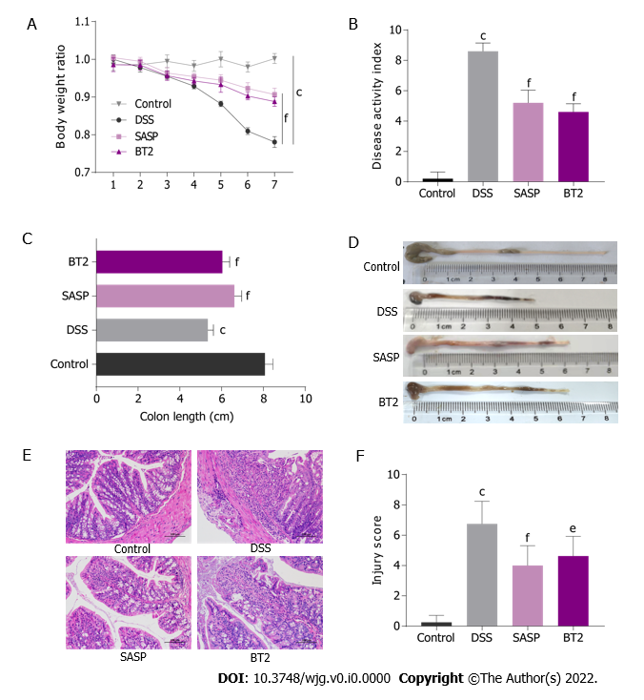
Figure 1 3,6-dichlorobenzo[b]thiophene-2-carboxylic acid improved colon inflammation in dextran sodium sulfate-treated mice. A: Changes in the body weight of mice; B: Disease activity index of each group of mice on day 8 (n = 5); C: The colon length of each group of mice was measured; D: Macroscopic observation of colons; E: Representative hematoxylin and eosin staining images of colon sections (200 × magnification); F: Injury scores. ^{e}P < 0.01 and ^{f}P < 0.001 vs the dextran sodium sulfate group; ^{c}P < 0.001 vs the control group. The data are shown as the mean ± SD (n = 5-8). DSS: Dextran sodium sulfate; SASP: Salazosulfapyridine.

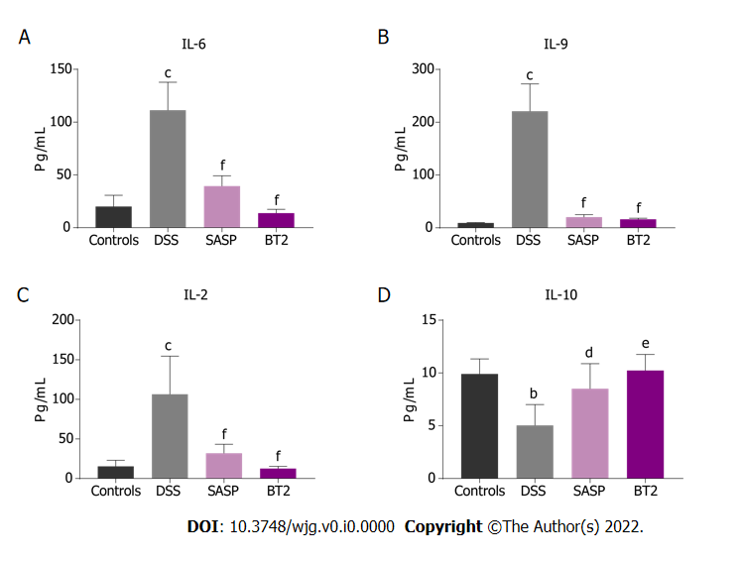
Figure 2 3,6-dichlorobenzo[b]thiophene-2-carboxylic acid reduced the inflammatory cytokine levels in serum. The contents of interleukin (IL)-6, IL-9, IL-2 and IL-10 in serum were detected by flow cytometry. A: IL-6; B: IL-9; C: IL-2; D: IL-10. ^{d}P < 0.05, ^{e}P < 0.01, and ^{f}P < 0.001 vs the dextran sodium sulfate group; ^{b}P < 0.01 and ^{c}P < 0.001 vs the control group. The data are shown as the mean ± SD (n = 4). DSS: Dextran sodium sulfate; SASP: Salazosulfapyridine.

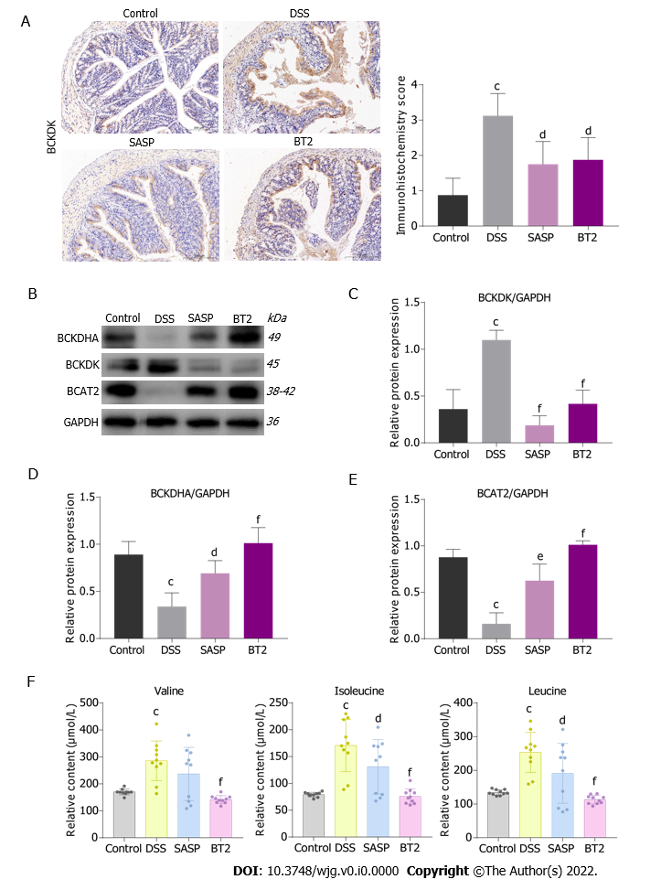
Figure 3 3,6-dichlorobenzo[b]thiophene-2-carboxylic acid improved branched-chain amino acid catabolism in dextran sodium sulfate-induced colitis mice. A: The expression of branched-chain α-keto acid dehydrogenase kinase in colon sections was detected by immunohistochemical assays (n = 4, 200 × magnification); B-E: Western blot images and quantitative data of branched-chain amino acid (BCAA) catabolic enzymes in colon tissues (n = 3-4); F: The contents of BCAAs, including valine, leucine and isoleucine, in mouse serum were determined by liquid chromatography-tandem mass spectrometry (n = 10). ^{d}P < 0.05, ^{e}P < 0.01, and ^{f}P < 0.001 vs the dextran sodium sulfate group; ^{c}P < 0.001 vs the control group. The data are shown as the mean ± SD. BCKDK: Branched-chain α-keto acid dehydrogenase kinase; DSS: Dextran sodium sulfate; SASP: Salazosulfapyridine.

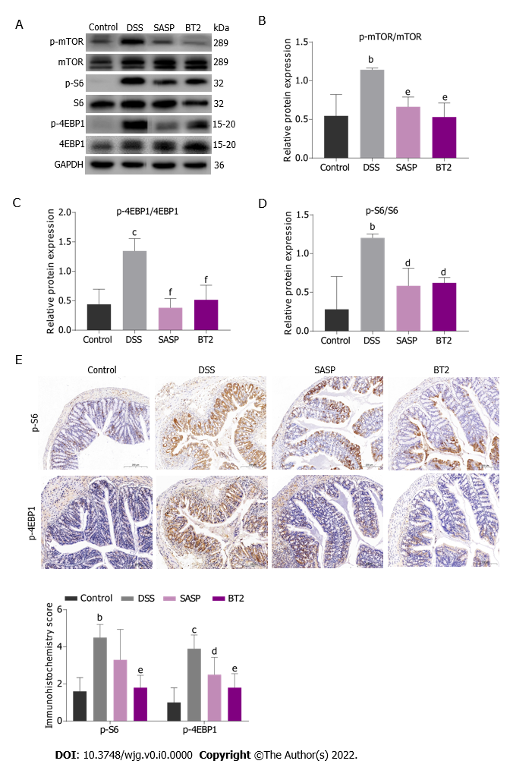
Figure 4 3,6-dichlorobenzo[b]thiophene-2-carboxylic acid suppressed the activity of the mammalian target of rapamycin complex 1 activation. A-D: The total and phosphorylated proteins of S6, eukaryotic translation initiation factor 4E binding protein 1 (4EBP1) and mammalian target of rapamycin were measured by Western blot analysis; E: Immunohistochemical analysis of the expression of phosphorylated S6 and phosphorylated 4EBP1 in colon tissues (200 × magnification). ^{d}P < 0.05, ^{e}P < 0.01, and ^{f}P < 0.001 vs the dextran sodium sulfate group; ^{b}P < 0.01 and ^{c}P < 0.001 vs the control group. The data are shown as the mean ± SD (n = 3-5). mTOR: Mammalian target of rapamycin; S6: Ribosomal protein S6; 4EBP1: Eukaryotic translation initiation factor 4E binding protein 1; DSS: Dextran sodium sulfate; SASP: Salazosulfapyridine.

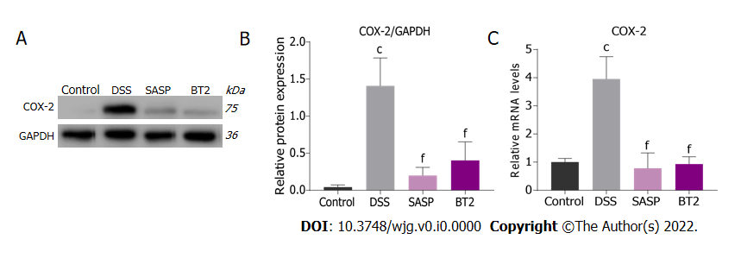
Figure 5 3,6-dichlorobenzo[b]thiophene-2-carboxylic acid reduced cyclooxygenase-2 expression. A and B: The level of cyclooxygenase-2 (COX-2) in colon tissues was detected by Western blotting; C: The mRNA level of COX-2 in colon tissues was detected by real-time polymerase chain reaction. ^{f}P < 0.001 vs the dextran sodium sulfate group; ^{c}P < 0.001 vs the control group. The data are shown as the mean ± SD (n = 4). COX-2: Cyclooxygenase-2; DSS: Dextran sodium sulfate; SASP: Salazosulfapyridine.

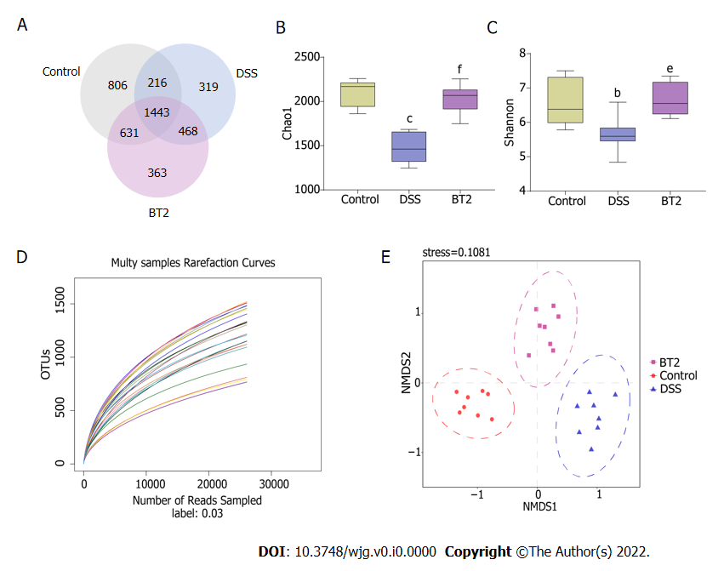
Figure 6 Effects of 3,6-dichlorobenzo[b]thiophene-2-carboxylic acid treatment on the overall structure of gut microbiota. A: The Venn diagram depicts the overlap of operational taxonomic units in each group; B: Chao1 index from fecal samples; C: Shannon index from fecal samples; D: The dilution curve indicates the rationality of the amount of sequencing data; E: Nonmetric multidimensional scaling analysis plot of fecal microbiota of each group. ^{e}P < 0.01 and ^{f}P < 0.001 vs the dextran sodium sulfate group; ^{b}P < 0.01 and ^{c}P < 0.001 vs the control group. The data are shown as the mean ± SD (n = 8). DSS: Dextran sodium sulfate; OUT: Operational taxonomic units.

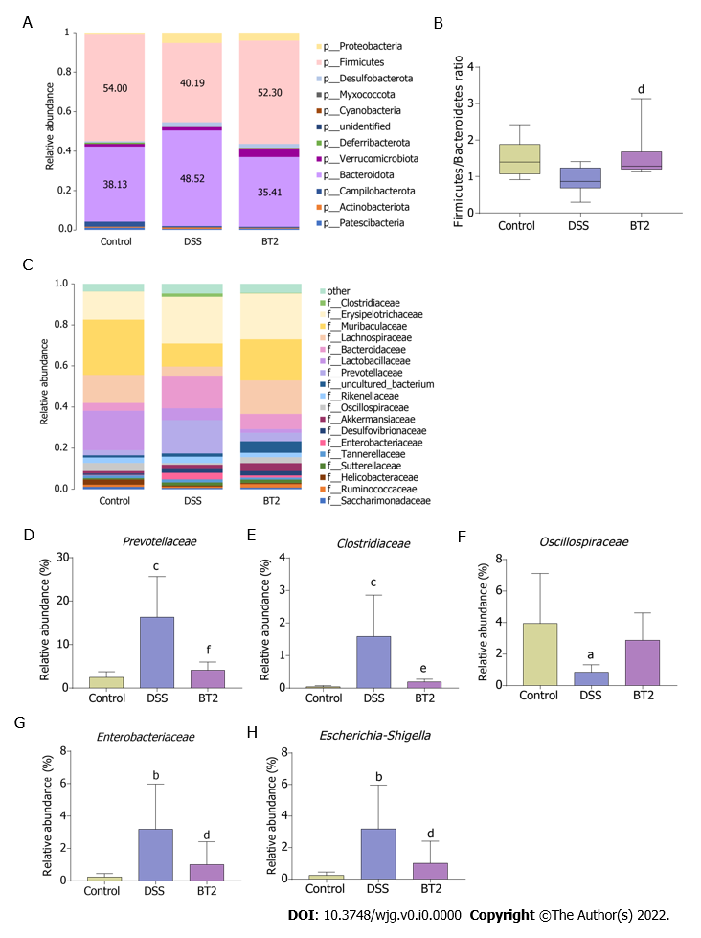
Figure 7 Effects of 3,6-dichlorobenzo[b]thiophene-2-carboxylic acid treatment on the species composition. A: Taxonomic analysis at the phylum level; B: BT2 treatment alters the Firmicutes/Bacteroidetes value in each group; C: Taxonomic analysis at the family level; D: Abundance of Prevotellaceae; E: Abundance of Clostridiaceae; F: Abundance of Oscillospiraceae; G: Abundance of Enterobacteriaceae; H: Abundance of Escherichia-Shigella. ^{d}P < 0.05, ^{e}P < 0.01, and ^{f}P < 0.001 vs the DSS group; ªP < 0.05, ^{b}P < 0.01, and ^{c}P < 0.001 vs the control group. The data are shown as the mean ± SD (n = 8). DSS: Dextran sodium sulfate.

