Name of journal: World Journal of Clinical Cases
ESPS Manuscript NO: 4672
Columns: CASE REPORT

Cystic benign teratoma of the neck in adult

Alimehmeti M et al. Adult benign teratoma of the neck

Mehdi Alimehmeti, Ridvan Alimehmeti, Majlinda Ikonomi, Myfit Saraci, Mentor Petrela

Mehdi Alimehmeti, Ridvan Alimehmeti, Majlinda Ikonomi, Myfit Saraci, Mentor Petrela, Service of Neurosurgery, University Hospital Center “Mother Theresa”, 370 Tirana, Albania

Author contributions: Alimehmeti M wrote the article and made hystological diagnosis; Alimehmeti R operated on the patient, prepared intraoperative photos and reviewed the manuscript; Ikonomi M performed literature research and prepared the histological photos; Saraci M operated on the patient; Petrela M reviewed the article for its intellectual content and approved the final version.

Correspondence to: Ridvan Alimehmeti, MD, PhD, Service of Neurosurgery, University Hospital Center “Mother Theresa”, Dibra Street, 370 Tirana, Albania.
ridvanalimehmeti@hotmail.com

Telephone: +355-42-362641 Fax: +355-69-2102140
Received: July 14, 2013 Revised: August 14, 2013
Accepted: August 20, 2013

Published online:

Abstract
Teratomas are embryonal neoplasms that arise when totipotential germ cells escape the developmental control of primary organizers and give rise to tumors containing tissue derived from all three blastodermic layers. Teratomas have been reported to occur in various sites and organs. Teratoma of the cervical neck are relatively rare in adulthood. It usually extends from the neck to the thoracic cavity causing local mass effect. In most of the cases intrauterine diagnosis is possible by ultrasound. Because of dyspnea due to mass effect, this condition is treated promptly after birth. However cases of teratoma in adulthood with supraclavicular localization have been reported rarely in the literature. The presented case is of a twenty-five years old female with a cervical mass. Histological examination revealed a benign mature teratoma. The patient has been disease free for more than nine years after surgical removal of a neck teratoma.

© 2013 Baishideng. All rights reserved.

Key words: Teratoma; Neck; Adult; Total surgical resection; Clinically disease-free

Core tip: Neck teratoma in adult is reported very rarely. We present a case of neck teratoma managed successfully with total surgical resection. The patient remains clinically disease-free more than nine years after surgery.

Alimehmeti M, Alimehmeti R, Ikonomi M, Saraci M, Petrela M. Cystic benign teratoma of the neck in adult. World J Clin Cases 2013;
Available from: URL: http://www.wjgnet.com/esps/
DOI:: http://dx.doi.org/10.12998/wjcc.v1.i0.0000

INTRODUCTION
Teratoma of the neck is found mostly with extension to mediastinal space generally before birth through ultrasound or immediately after birth due to its evident mass effect. In some cases it can reach enormous size and cause airway obstruction making resuscitation maneuvers difficult. Adult neck teratoma is very rarely encountered^{[1-4]}. It is reported as situated in the thyroid, but also between cervical structures.

CASE REPORT
A twenty five year-old female came to our attention for a right supraclavicular mass, that had shown slow progressive growing within two weeks. At physical examination a retromuscular mass was palpable behind and laterally the right sternocleidomastoid, not painful at digital pressure and without local discoloring of the overlying skin. Ultrasound had documented a heterogenic partially cystic lesion of approximately 4 cm diameter. The patient was claustrophobic and refuseda proposed magnetic resonance imaging (MRI).
The patient underwent, under local anesthesia and intravenous sedation, a small incision of 5 cm over the lamp parallel to the right clavicle. After dissecting the fibers of platysma a pluricystic lesion was discovered. The lesion was progressively detached from platysma and the adipose tissue under it. A sensitive branch of cervical plexus was preserved (Figure 1A and B). The tumor was completely removed as the adjacent structures were not infiltrated and discernibly dissectible from the pluricystic tumor. The lady was discharged next day without any particular complaints. Uneventful recovery followed.
The histological examination showed ectodermal derivatives consisted of keratinized squamous epithelium covering the wall of the cyst, hair and other skin adnexal structures, mature glial tissue, cartilage, muscle, and fat . The lesion was thus labeled as a mature cystic teratoma on basis of these histopathological features (Figure 2A-D). The patient was advised to undergo a computed tomography (CT) or MRI of the chest and neck that she regularly refused in phone interviews and consultations, with the excuse of claustrophobia and the stated feeling of being in the best of health. Nine years from surgery the patient leads a normal life without any signs or symptoms of the disease.

DISCUSSION
Teratomas are embryonal neoplasms that arise when totipotential germ cells escape the developmental control of primary organizers and give rise to tumors containing tissue derived from all three blastodermic layers (ectoderm, endoderm, and mesoderm). They are histologically heterogenous with cystic or solid areas, mature or immature components. Hystologically teratomas are classified as mature (benign in 95% of cases),and immature with malignant transformation^{[5]}.
They are rare tumours with a frequency of 1/40000 birth. The cervical localization represents 1.5% to 5% of all the localisations^{[6]}. They predominate in females (3/4 of the cases). The greminal cells or primary gonocytes migrate from the vitellin sac during the first week of the intrauterine life and colonize the sexual cordon forming thus primitive undifferentiated gonads. During this migaration they arrest and form a germinal tumor benign or malignant, being localised so from the head to the coxygeal of the infant^{[6]}.
Teratomas are located more often in the sacrococcygeal region and in the ovary, but they may be also found in many other anatomic regions. Teratomas of the neck and mediastinum are particularly rare and may give rise to severe respiratory distress. Prenatal diagnosis may be the only opportunity for perinatal relief of the obstruction before spontaneous breathing is established.
The differential diagnosis is done with a metastasis from thyroid carcinoma, cystic squamous cell carcinoma of cervical lymph node arising in the oro/nasopharynx, follicular adenomas of the thyroid, lymphangiomas, and bronchial cysts^{[7]}. Approximately 5% of germ-cell neoplasms appear in one of several extracranial sites in the head and neck region. Cervical teratomas are rarely encountered in adults. The radiological diagnosis is supported by ultrasonography, computed tomography or magnetic resonance imaging that reveal pluricystic tumor. Malignant transformation of cervical teratoma has been reported. Complete surgical removal is the elective treatment^{[5]}. Adjuvant radiotherapy or chemotherapy is generally considered ineffective.
In the presented case the surgical removal was deemed complete. The patient was advised to be checked with total body CT and MRI of the neck which sherefused repeatedly. The clinical long term follow up has demonstrated no recurrence so far.

REFERENCES
1 Abe H, Sako H, Tamura Y, Tango Y, Tani T, Kodama M. Benign cervical teratoma in an adult: report of a case. Surg Today 1997; 27: 469-472 [PMID: 9130356 DOI: 10.1007/]
2 Visset J, Lehur PA, Cousin C, Paineau J, Despins P, Mousseau M. [Teratoma of the neck. A report of one case (author's transl)]. J Chir (Paris) 1980; 117: 489-491 [PMID: 7430284]
3 Colton JJ, Batsakis JG, Work WP. Teratomas of the neck in adults. Arch Otolaryngol 1978; 104: 271-272 [PMID: 646721]
4 Woods RD, Pearson BW, Weiland LH. Benign cervical cystic teratoma. Otolaryngology 1978; 86: ORL468-ORL472 [PMID: 112538]
5 Muttillo IA, Maceli F, Giacovazzo F, Luzzatto L, Ruzzetti R, Cortese F, Lanzi G, Mero A. [Cervico-mediastinal teratoma. A case report and review of the liberature]. Ann Ital Chir 2006; 77: 335-339 [PMID: 17139964]
6 Shine NP, Sader C, Gollow I, Lannigan FJ. Congenital cervical teratomas: diagnostic, management and postoperative variability. Auris Nasus Larynx 2006; 33: 107-111 [PMID: 16168588 DOI: 10.1016/j.anl.2005.07.003.]
7 Batsakis JG, el-Naggar AK, Luna MA. Teratomas of the head and neck with emphasis on malignancy. Ann Otol Rhinol Laryngol 1995; 104: 496-500 [PMID: 7771726]

P-Reviewers Coskun A, Ha PK, Nagao T, Sanabria A S-Editor Gou SX
L-Editor E-Editor

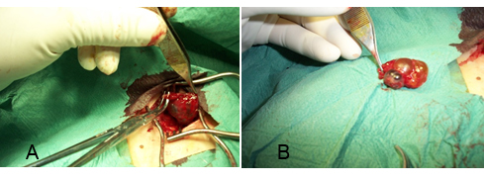
Figure 1 Intraoperative appearance of cystic lesion. A: Initial apperance of a cystic lesion separating fibres of cervical plexus from it; B: Intraoperative appearance of multicystic and solid lesion of different color.
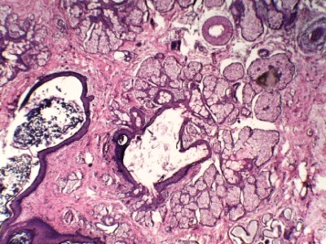
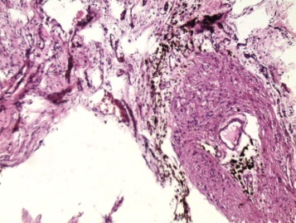
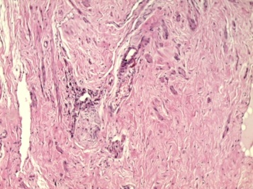
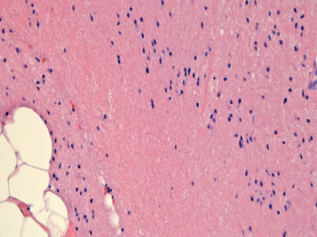

A B
C D

Figure 2 The cyst consisted of ectodermal derivatives with predominant keratinized squamous epithelium covering the wall of the cyst (HE stain, × 20). A: With hair and other skin adnetic lesional structures; B: Mature glial tissue; C: Cartilage; D: Muscle and fat.

