Name of Journal: World Journal of Clinical Cases
Manuscript NO: 59468
Manuscript Type: CASE REPORT

Oral and perioral herpes simplex virus infection type I in a five-month-old infant: A case report

Aloyouny AY et al. HSV in a five-month-old infant

Ashwag Yagoub Aloyouny, Hamad Nasser Albagieh, Rasha Hamed Al-Serwi

Ashwag Yagoub Aloyouny, Rasha Hamed Al-Serwi, Basic Dental Science Department, College of Dentistry, Princess Nourah bint Abdulrahman University, Riyadh 11671, Riyadh, Saudi Arabia

Hamad Nasser Albagieh, Oral Medicine and Diagnostic Science Department, College of Dentistry, King Saud University, Riyadh 12372, Riyadh, Saudi Arabia

Author contributions: Aloyouny AY served as the patient’s oral medicine specialist, reviewed the literature, and contributed to data collection, data interpretation, and manuscript drafting; Albagieh HN and Al-Serwi RH contributed to data collection, data interpretation, manuscript drafting, and manuscript revision; all authors have issued final approval for the version to be submitted.

Supported by Deanship of Scientific Research at Princess Nourah bint Abdulrahman University through the Fast-track Research Funding Program.

Corresponding author: Ashwag Yagoub Aloyouny, DDS, Doctor, Basic Dental Science Department, College of Dentistry, Princess Nourah bint Abdulrahman University, King Khalid International Airport Road, Riyadh 11671, Riyadh, Saudi Arabia. ayaloyouny@pnu.edu.sa

Received: September 12, 2020
Revised: December 4, 2020
Accepted: December 16, 2020
Published online: January 26, 2021

Abstract
BACKGROUND
Herpes simplex virus (HSV) is a highly infectious pathogen that is easily transmitted via the bodily fluids of an infected individual. This virus usually affects individuals older than six months of age, and rarely causes lesions or symptoms in younger patients.

CASE SUMMARY
We present the case of a five-month-old healthy girl who presented with painful herpetic gingivostomatitis and perioral vesicles. We discuss the pathophysiology of primary HSV infection and the effect of maternal antibodies on the infant’s immune system. In addition, we explain the diagnosis, management, and prognosis of HSV infection in young infants.

CONCLUSION
This case highlights the importance of early diagnosis and management of HSV infections to decrease the risk of developing severe complications and death.

Key Words: Herpetic gingivostomatitis; Oral lesions; Herpes simplex virus; Perioral lesions; Infants; Case report; Herpes simplex virus type 1

Citation: Aloyouny AY, Albagieh HN, Al-Serwi RH. Oral and perioral herpes simplex virus infection type I in a five-month-old infant: A case report. World J Clin Cases 2021; 9(3): 685-689
URL: https://www.wjgnet.com/2307-8960/full/v9/i3/685.htm
DOI: https://dx.doi.org/10.12998/wjcc.v9.i3.685

Core Tip: Although the herpes simplex virus (HSV) infection is highly contagious, it rarely develops in infants younger than six months of age. Our patient presented with oral and perioral manifestations of HSV type 1 infection. Early diagnosis and management of HSV infections is important to decrease the risk of developing severe complications.
INTRODUCTION
There are two known subtypes of herpes simplex virus (HSV): Type 1 and type 2. Infection with HSV type 1 is usually associated with oral and perioral lesions, while infection with HSV type 2 is associated with genital lesions.
HSV infection usually affects children between the ages of six months and four years and rarely develops in children younger than six months of age. However, in this case study, we report the case of a five-month-old healthy girl who presented with herpetic gingivostomatitis and perioral vesicles. Primary herpetic infection is very rare in this age. A review of the literature yielded few reported cases.

CASE PRESENTATION
Chief complaints
A five-month-old healthy girl was referred to an oral medicine clinic for evaluation of oral and perioral lesions.

History of present illness
The patient had a three-day-history of oral and perioral lesions accompanied by fever (38.6 °C), irritability, poor breastfeeding, and poor sleep.

History of past illness
The patient’s mother denied the presence of previous surgical procedures, pathologic medical diagnoses, or genetic conditions for the patient.

Personal and family history
The patient was born via cesarean delivery to a 37-year-old primigravid. She has been exclusively breastfed by her mother since birth with no intake of bottled milk. The mother has a history of recurrent intraoral HSV infections, and her last infection reportedly occurred seven weeks before the patient presented with primary perioral and oral HSV type 1infection. The mother’s anti-HSV-1 immunoglobulin (Ig) G level was 0.6 (seronegative) and her anti-HSV-2 IgG level was 0.4 (seronegative).

Physical examination
Physical and systemic examination: The patient was born in good health and has not taken any medications since birth.

Extraoral examination: Extraoral examination showed multiple perioral vesicular eruptions with crusted surfaces and erythematous halos (Figure 1A). Excessive drooling and submandibular lymphadenopathy were also observed.

Intraoral examination: Intraoral examination revealed a swollen, red gingiva with multiple ulcers at the upper anterior alveolar ridge with a yellow-gray coating (Figure 1). In addition, the examination revealed swollen palatine tonsils and halitosis.

Laboratory examinations
Blood tests revealed normal results: a red blood cell count of 4.2 × 10⁶/μL, a hemoglobin count of 12.4 g/dL, a platelet count of 432 × 10³/μL, and a white blood cell count of 15.6 × 10³/μL with 41% segmented neutrophils and 62% lymphocytes.

Imaging examinations
Not applicable.

Differential diagnosis
The main differential diagnoses in this case included HSV type 1, HSV type 2, herpangina, and varicella zoster virus infection.

Further diagnostic work-up
As part of the HSV infection workup, diagnostic procedures were carried out to arrive at a definitive diagnosis. Tzanck smear, which was taken from an oral sore and a perioral vesicle, showed multinucleated giant cells with inclusion bodies. Additionally, HSV-1 polymerase chain reaction (PCR) and IgM testing for HSV-1 yielded positive findings. All results were consistent with HSV type 1 infection.

FINAL DIAGNOSIS
The final diagnosis in this case was perioral and oral ulcerations due to HSV type 1 infection.

TREATMENT
The infant was transferred to a hospital for better management of her infection. She was immediately started on IV acyclovir (20 mg/kg/6 h/5 d) while acetaminophen suppositories (80 mg/8 h/5 d) were given to lower her body temperature. In addition, other palliative drugs, such as diphenhydramine syrup (12.5 mg/5 mL, 2.5 mL orally) once-a-night for five days, were given to ease the effort of drinking and to aid in achieving good sleep. Upon completion of five days of therapy, the patient showed complete recovery and was subsequently discharged from the hospital free from symptoms.

OUTCOME AND FOLLOW-UP
During a follow-up consult conducted a week after she was discharged, the patient’s oral and perioral lesions had healed completely without scarring. During a follow-up visit one month later, the patient was noted to be healthy and lesion-free; she had also gained some weight as feeding became comfortable once more. The patient was re-examined at the age of one year and no recurrence of HSV infection or complications were noted.

DISCUSSION
HSV is a DNA virus that has two subtypes: Type 1 and type 2. Infections with HSV type 1 usually manifests in areas above the waist, such as oral and perioral infections, whereas HSV type 2 infections occur below the waist, such as genital infections.
Primary oral HSV type 1 herpetic infection is very uncommon in newborns and infants younger than six months. In these rare cases, the infection ranges from a subclinical and asymptomatic condition to severe and symptomatic disease. Initially, HSV invades neural, epidermal, and dermal tissues before replicating. During viral contact with the skin, the virus travels to the sensory dorsal root ganglion where a latent stage begins. HSV type 1 then becomes reactivated from the trigeminal sensory ganglia to affect different parts of the facial mucosa, including the oral and perioral regions^{[1]}.
Primary oral HSV type 1 infection may manifest with prodromal symptoms before herpetic gingivostomatitis, perioral lesions, and lymphadenopathy develop. Intraoral lesions include painful vesicles on swollen, raw, and red bases. Afterwards, the vesicles rupture, leaving behind ulcerated lesions. Type 1 infections usually heal within 10 to 14 d^{[2]}.
Maternal antibodies normally cross the placenta passively during pregnancy, thereby increasing the newborn’s immune system during the first six-months of life^{[3]}. However, in very rare cases (approximately 1% of all adult cases), mothers do not develop antibodies against HSV and remain seronegative for the virus. Therefore, the lack of antibodies in an infant, due to their immature immune system, and the lack of maternal antibodies transmitted to the fetus through the placenta during pregnancy, may be risk factors for the early development of HSV infection^{[4,5]}.
In vaginal deliveries, the neonate is exposed to the virus as it passes through the birth canal, thereby increasing the risk of mother-to-infant viral transmission^{[6]}. This patient was born via cesarean delivery, which has a lower risk of viral transmission compared to vaginal delivery.
Confirmation of the diagnosis depends on isolation of the virus from active lesions using methods such as Tzanck smear and viral culture. Direct fluorescent antibody test (antigen detection) and PCR for viral DNA detection can also be used to confirm the diagnosis. On the other hand, indirect tests for HSV include enzyme immunoassay and western blotting^{[7]}.
The prognosis of HSV in infants depends on the patient’s health and immunological status. Acyclovir is the first-line therapy for HSV. Symptom relief using antipyretics, antihistamine therapies, and intravenous fluid hydration also aid and hasten recovery. Infection with HSV has a high recurrence rate; therefore, follow-up is highly encouraged to decrease the severity and number of HSV attacks^{[2]}.
Guardians must ensure that the infant does not touch their mouth or saliva to prevent autoinoculation of the virus on scratched fingers, which can lead to the development of herpetic whitlow, and on the patient’s eyes, which may lead to herpes simplex keratitis. Herpes simplex keratitis can cause pain, discomfort, permanent eye damage, and even blindness^{[8]}.

CONCLUSION
It is very uncommon for infants younger than six months to be infected with HSV. However, when it does occur, HSV infection can lead to severe, and sometimes fatal, disease. Therefore, pediatricians, physicians, and dentists should include HSV infection in the differential diagnosis list of young infants with oral and perioral lesions to allow for early diagnosis and treatment.

ACKNOWLEDGEMENTS
This research was funded by the Deanship of Scientific Research at Princess Nourah Bint Abdulrahman University through the Fast-track Research Funding program.

REFERENCES
1 Usatine RP, Tinitigan R. Nongenital herpes simplex virus. Am Fam Physician 2010; 82: 1075-1082 [PMID: 21121552]
2 Cernik C, Gallina K, Brodell RT. The treatment of herpes simplex infections: an evidence-based review. Arch Intern Med 2008; 168: 1137-1144 [PMID: 18541820 DOI: 10.1001/archinte.168.11.1137]
3 Kasubi MJ, Nilsen A, Marsden HS, Bergström T, Langeland N, Haarr L. Prevalence of antibodies against herpes simplex virus types 1 and 2 in children and young people in an urban region in Tanzania. J Clin Microbiol 2006; 44: 2801-2807 [PMID: 16891495 DOI: 10.1128/JCM.00180-06]
4 Taieb A, Body S, Astar I, du Pasquier P, Maleville J. Clinical epidemiology of symptomatic primary herpetic infection in children. A study of 50 cases. Acta Paediatr Scand 1987; 76: 128-132 [PMID: 3031926 DOI: 10.1111/j.1651-2227.1987.tb10428.x]
5 Batalla A, Flórez A, Dávila P, Ojea V, Abalde T, de la Torre C. Genital primary herpes simplex infection in a 5-month-old infant. Dermatol Online J 2011; 17: 8 [PMID: 21906488]
6 Buckley KS, Kimberlin DW, Whitley RJ. Neonatal herpes simplex virus infection. Herpes Simplex Viruses. 2005: 395-410
7 Singh A, Preiksaitis J, Ferenczy A, Romanowski B. The laboratory diagnosis of herpes simplex virus infections. Can J Infect Dis Med Microbiol 2005; 16: 92-98 [PMID: 18159535 DOI: 10.1155/2005/318294]
8 Pinninti SG, Kimberlin DW. Neonatal herpes simplex virus infections. Semin Perinatol 2018; 42: 168-175 [PMID: 29544668 DOI: 10.1053/j.semperi.2018.02.004]

Footnotes
Informed consent statement: Informed written consent was obtained from the patient for publication of this case report and accompanying images.

Conflict-of-interest statement: The authors declare that they have no conflicts of interest.

CARE Checklist (2016) statement: The authors have read the CARE Checklist (2016), and the manuscript was prepared and revised according to the CARE Checklist (2016).

Open-Access: This article is an open-access article that was selected by an in-house editor and fully peer-reviewed by external reviewers. It is distributed in accordance with the Creative Commons Attribution NonCommercial (CC BY-NC 4.0) license, which permits others to distribute, remix, adapt, build upon this work non-commercially, and license their derivative works on different terms, provided the original work is properly cited and the use is non-commercial. See: http://creativecommons.org/Licenses/by-nc/4.0/

Manuscript source: Unsolicited manuscript

Corresponding Author's Membership in Professional Societies: American Academy of Oral Medciine.

Peer-review started: September 12, 2020
First decision: November 30, 2020
Article in press: December 16, 2020

Specialty type: Medicine, research and experimental
Country/Territory of origin: Saudi Arabia
Peer-review report’s scientific quality classification
Grade A (Excellent): 0
Grade B (Very good): 0
Grade C (Good): C, C
Grade D (Fair): 0
Grade E (Poor): 0

P-Reviewer: Li P S-Editor: Gao CC L-Editor: A P-Editor: Xing YX

Figure Legends
A
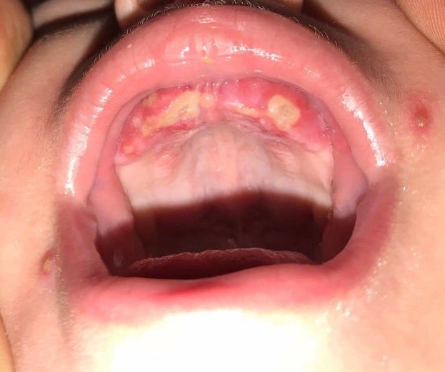
B
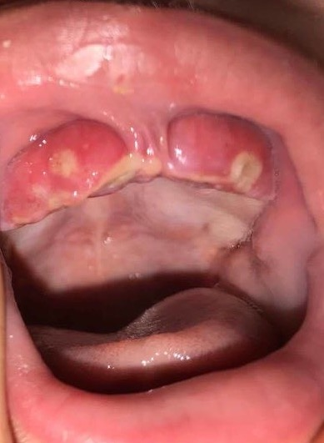
Figure 1 Extraoral and intraoral examination. A and B: Clinical pictures of a five-month-old infant show multiple perioral vesicular eruptions with crusted surfaces and erythematous halos. Red and swollen gingiva with multiple ulcers at the upper anterior alveolar ridge with yellow-gray coating can also be observed.

Published by Baishideng Publishing Group Inc
7041 Koll Center Parkway, Suite 160, Pleasanton, CA 94566, USA
Telephone: +1-925-3991568
E-mail: bpgoffice@wjgnet.com
Help Desk: https://www.f6publishing.com/helpdesk
https://www.wjgnet.com

© 2021 Baishideng Publishing Group Inc. All rights reserved.

