Name of journal: World Journal of Clinical Cases
ESPS Manuscript NO: 10530
Column: Clinical Trial Study

Distal biceps tendon rupture reconstruction using muscle-splitting double-incision approach

Tarallo L et al. Surgical treatment for distal biceps tendon rupture

Luigi Tarallo, Raffaele Mugnai, Francesco Zambianchi, Roberto Adani, Fabio Catani

Luigi Tarallo, Raffaele Mugnai, Francesco Zambianchi Roberto Adani, Fabio Catani, Orthopaedics and Traumatology Department, University of Modena and Reggio Emilia, 41124 Modena, Italy

Roberto Adani, Department of Hand Surgery and Microsurgery, University Hospital of Verona, 37134 Verona, Italy

Author contributions: Tarallo L and Adani R designed the research; Tarallo L, Adani R and Catani F performed the research; Mugnai R collected the data; Mugnai R and Zambianchi F wrote the paper.

Correspondence to: Raffaele Mugnai, MD, Orthopaedics and Traumatology Department, Modena Policlinic, University of Modena and Reggio Emilia, Modena, Via del Pozzo 71, 41124 Modena, Italy. raffaele.mugnai@gmail.com
Telephone: : + 39-59-4224916 Fax: +39-59-4224313

Received: April 5, 2014 Revised: June 21, 2014
Accepted: July 17, 2014

Published online:
Abstract
AIM: To evaluate the clinical and functional results after repair of distal biceps tendon tears, following the Morrey’s modified double-incision approach.

METHODS: We retrospectively reviewed 47 patients with distal rupture of biceps brachii treated between 2003 and 2012 in our Orthopedic Department with muscle-splitting double-incision technique. Outcome measures included the Mayo elbow performance, the DASH questionnaire, patient’s satisfaction, elbow and forearm motion, grip strength and complications occurrence.

RESULTS: At an average 18 mo follow-up (range, 7 mo–10 years) the average Mayo elbow performance and DASH score were respectively 97.2 and 4.8. The elbow flexion range was 94%, extension was -2°, supination was 93% and pronation 96% compared with the uninjured limb. The mean grip strength, expressed as percentage of respective contralateral limb, was 83%. The average patient satisfaction rating on a Likert scale (from 0 to 10) was 9.4. The following complications were observed: 3 cases of heterotopic ossification (6.4%), one (2.1%) re-rupture of the tendon at the site of reattachment and 2 cases (4.3%) of posterior interosseous nerve palsy. No complication required further surgical treatment.

CONCLUSION: This technique allows an anatomic reattachment of distal biceps tendon at the radial tuberosity providing full functional recovery with low complication rate.

© 2014 Baishideng Publishing Group Inc. All rights reserved.

Key words: Distal biceps tendon; Rupture; Double incision; Complications; Clinical outcome; Trans-osseous tunnels; Morrey

Core tip: Both single and double-incision approaches have been successfully used for distal biceps tendon lesions. At present there is no solid scientific evidence to support preference of one technique over the other. However, recently, it has been demonstrated that the 2-incision technique recreates more closely footprint position compared with that of the 1-incision approach. In the present research the Morrey’s modified double-incision repair provided excellent outcome (including functional outcome, satisfaction, elbow and forearm motion, and grip strength) with few post-operative complications, mainly represented by heterotopic ossification and posterior interosseous nerve injuries.

Tarallo L, Mugnai R, Zambianchi F, Adani R, Catani F. Distal biceps tendon rupture reconstruction using muscle-splitting double-incision approach. World J Clin Cases 2014; In press

INTRODUCTION
The incidence of distal biceps ruptures is estimated between 0.9 and 1.8 per 100000 population per year, and accounts for 3% of biceps brachii tendon injuries^{[1]}. This injury is very common in men who are in their fifth or sixth decade of life, but can also occur at any age^{[2-4]}.
Many studies demonstrated that surgical approaches allow better clinical results than conservative treatments^{[5,6]}. In literature, various surgical methods have been described, dating back to the first report by Acquaviva in 1898^{[7,8]}.
In 1956 Fischer and Shepanek^{[9]} used the volar Henry approach to reattach the distal biceps tendon to the radial tuberosity. This allowed a good recovery of flexion and supination strength, but radial nerve palsy occurred in several cases consequently to the extensive exposure needed using this approach^{[10,11]}.
To decrease the risk of neurologic complications limiting the exposure needed Boyd and Anderson in 1961^{[12]} described a two-incision technique to access the tuberosity more easily. They felt that a second dorsal incision was necessary in order to limit the volar surgical dissection required near the radial nerve as it passes through the supinator muscle^{[13-15]}. However, complications with special respect to heterotopic ossifications including loss of forearm rotation, radioulnar synostosis, and posterior interosseous nerve injury were described using the double-incision technique^{[16,17]}.
In an effort to overcome any complications connected with each approach, more modern techniques have been developed in the last decades. The two-incision approach was updated by Morrey et al^{[18]}, who used a posterior muscle-splitting approach that avoids subperiosteal exposure of the ulna, and therefore reduces the possibility of radioulnar synostosis. With this adjustment, the tendon can be reattached to the radial tuberosity through transosseous drill holes.
More recently approaches that use suture anchors and a limited single anterior incision have been described^{[11,19,20]}. Currently there is no consensus with respect to the best surgical approach and favorable results with both techniques^{[21-23]}.
The aim of our study is to evaluate the clinical and functional outcomes after surgical repair of distal tendons tears, using a muscle-splitting double incision approach modified by Morrey^{[18]}.

MATERIALS AND METHODS
This study has been authorized by the local ethical committee and was carried out in accordance with the Ethical standards of the 1964 Declaration of Helsinki as updated in 2004. We retrospectively reviewed 47 patients operated by two different surgeons of distal rupture of biceps brachii, treated in our Orthopedic Department between March 2003 and September 2012 using the muscle-splitting double-incision technique. Every patient undergoing distal biceps tendon acute rupture repair, was included in our review and informed consent was obtained. Exclusion criteria included the presence of an associated fracture, and dislocation about the elbow as etiology of biceps injury. All patients included in our cohort were treated within 15 days from trauma. We analyzed the rate of major and minor complications. Major complications included posterior interosseous nerve (PIN) palsy, heterotopic ossification and re-rupture. Minor complications included superficial infection, lateral antebrachial cutaneous nerve paresthesia and radial sensory nerve paresthesia. All 47 cases are men, with an average age of 45 (range, 28-66 years) at the time of injury. The dominant arm was involved in 43 patients, 91% of all cases. The injury mechanism was the same in every case: an eccentric load applied to a flexed elbow during daily or sport activity. Subjective outcomes included the Disability of Arm, Shoulder and Hand (DASH) questionnaire and the Mayo elbow performance score. In addition, levels of overall patient satisfaction were determined using a 10-point scale: in which 10 points denoting very satisfied and 1 point denoting very unsatisfied. All measurements were performed at an average 18 mo follow-up (range, 7 mo–10 years) by an independent assessor who measured elbow and forearm motion using a goniometer.
All patients underwent the same surgical method: the double incision technique uses a transverse incision in the antecubital fossa. After identification of the distal portion of the biceps tendon, the degenerated part is resected. Two locking Krackow sutures with N.2 fiber-wire (Arthrex, Naples, FL) are passed through the distal part of the tendon. After bicipital tuberosity identification, a curved clamp is lead through the interosseous space, forceps are then palped on the dorsal aspect of the proximal part of the forearm, and second longitudinal incision is made over it. With the forearm in maximal pronation, the tuberosity is exposed with a muscle-splitting technique. Three drill holes are placed approximately at 1 cm intervals through the dorsal cortical margin of the tuberosity. The tendon sutures are then passed through the holes. With the elbow at 90° of flexion and the forearm pronated, the biceps tendon is pulled into the bicipital tuberosity and sutures are pulled tight and tied (Figure 1). The elbow is then splinted for 4 wk. Early active-assistive and ROM activities into elbow flexion and extension are advised 3-4 times per day. All patients were treated with indomethacin 75 mg for 3 wk as a standard protocol to prevent heterotopic ossifications.

RESULTS
The average elbow flexion range was 94% of the uninjured limb (125° vs 135°). Average extension was -2°. Supination was 93 % and pronation 96% compared with the uninjuried limb (supination 80° vs 84°; pronation 86° vs 82°) (Figure 2). The average Mayo elbow performance and DASH score were respectively 97.2 and 4.8. The satisfaction rating score was 9.4 points (Table 1).
The reported complications included nerve dysfunction, heterotopic ossification and failure at repair site. We had 3 cases of heterotopic ossification with limited range of movement near to complete loss of forearm rotation. Resection of heterotopic bone was associated with restoration of near-normal motion. One re-rupture of the tendon at the site of reattachment was found. Two cases of posterior interosseous nerve (PIN) palsy were found but both were resolved without intervention (Table 1).

DISCUSSION
Distal biceps tendon ruptures usually arise in the dominant elbow of middle-aged male patients^{[24]}. The clinical presentation is characteristic and radiographs, MRI or ultrasound are not necessary to diagnose an acute rupture of the distal biceps. In recent decades surgical repair of this type of lesions have shown improved functional outcomes compared with conservative treatment. Baker et al^{[2]} compared operative and nonoperative treatment showing decreased supination strength of 55% and supination endurance of 86% with nonoperative approach compared with controls. Several surgical options have been described in literature: the one incision-approach, using suture anchor, endobuttons, biotenodesis screw for fixation and a two incision approach using bone tunnels^{[25]}. The recreation of an anatomic reattachment of the distal biceps tendon to its osseous insertion at the radial tuberosity has to be the main objective of operative treatment. The modified two-incision approach has demonstrated excellent clinical results with regards to postoperative range of motion, strength, and endurance^{[26]}. Distal biceps tendon repair sometimes lacks elbow motion, due to heterotopic ossification or radioulnar exostosis as well as neurological complications such as PIN injury^{[27]}. Heterotopic bone formation is common following distal biceps tendon surgery and has been reported in both single and double-incision repairs. Higher rates of heterotopic ossification have been described in double-incision treatments performed using the Boyd-Anderson method, where the posterior soft tissues are elevated off the ulna to expose the radial tuberosity^{[16,17]}. Radioulnar synostosis, although rare, is more common with the Boyd-Anderson method rather than with muscle-splitting double-incision approach, in which the periosteal surface of the ulna is not exposed. With this technique, the incidence of synostosis and heterotopic bone has substantially decreased^{[28,29]}. In our cohort complications were reported in 12.8% of cases: 3 cases of heterotopic ossification (6.4%), one (2.1%) re-rupture of the tendon at the site of reattachment and 2 cases (4.3%) of PIN palsy, all of them resolved without intervention. Our rate of complications appears similar to the 10% of cases reported by El-Hawary et al^{[21]} using the 2-incision technique, associated with 6-wk prophylaxis with indomethacin 25 mg 3 times a day for 6 wk. In particular they didn’t observed any case of heterotopic ossification, and the only type of complication reported was a transient superficial radial nerve paresthesia, supporting a longer lasting profilaxis against heterotopic ossification.
In our research tendon fixation was performed by 3 trans-osseous tunnels placed at the apex of radial tuberosity. In the last years, new fixation equipment like suture anchors, interference screws, and fixation buttons have been brought in and biomechanically tested^{[30-34]}, demonstrating encouraging results^{[35-37]}.
Clinical studies have found little difference between 1- and 2-incision approaches in terms of complications, re-ruptures, flexion and supination strength as well as endurance^{[21,23,26,38]}. However, recently, it has been demonstrated that the 2-incision approach recreates more closely footprint position compared with the 1-incision approach^{[39]}.
In conclusion, the Morrey’s modified double-incision repair provided excellent outcome (including functional outcome, satisfaction, elbow and forearm motion, and grip strength) with few post-operative complications, mainly represented by heterotopic ossification and PIN injuries.

COMMENTS
Background
Biceps tendon ruptures occur at the distal aspect in 3% of all lesions. Both single-incision and 2-incision techniques, using various fixation methods, have been described to accomplish tendon reattachment to the bicipital tuberosity; however there is no consensus with respect to the best surgical approach.

Research frontiers
Authors retrospectively reviewed 47 patients with distal rupture of biceps brachii treated between 2003 and 2012 in authors’ Orthopedic Department with muscle-splitting double-incision technique.

Innovations and breakthroughs
In the present research the Morrey’s modified double-incision repair provided excellent outcome (including functional outcome, satisfaction, elbow and forearm motion, and grip strength) with few post-operative complications, mainly represented by heterotopic ossification and posterior interosseous nerve injuries.

Peer review
The article is interesting, well written, documented and analyzed with tests valid and internationally recognized. Good and clear figures. The discussion and conclusions interesting and valid. I think it can be published with high priority.

REFERENCES
1 Safran MR, Graham SM. Distal biceps tendon ruptures: incidence, demographics, and the effect of smoking. Clin Orthop Relat Res 2002; : 275-283 [PMID: 12439270]
2 Baker BE, Bierwagen D. Rupture of the distal tendon of the biceps brachii. Operative versus non-operative treatment. J Bone Joint Surg Am 1985; 67: 414-417 [PMID: 3972865]
3 Dobbie RP. Avulsion of the lower biceps brachii tendon: analysis of 51 previously unreported cases. Am J Surg 1941; 51: 662-83[DOI: 10.1016 /S0002961041902039]
4 Norman WH. Repair of avulsion of insertion of biceps brachii tendon. Clin Orthop Relat Res 1985; : 189-194 [PMID: 3971622]
5 Hetsroni I, Pilz-Burstein R, Nyska M, Back Z, Barchilon V, Mann G. Avulsion of the distal biceps brachii tendon in middle-aged population: is surgical repair advisable? A comparative study of 22 patients treated with either nonoperative management or early anatomical repair. Injury 2008; 39: 753-760 [PMID: 18541242 DOI: 10.1016/j.injury.2007.11.287]
6 Miyamoto RG, Elser F, Millett PJ. Distal biceps tendon injuries. J Bone Joint Surg Am 2010; 92: 2128-2138 [PMID: 20810864 DOI: 10.2106/JBJS.I.01213]
7 DAVIS WM, YASSINE Z. An etiological factor in tear of the distal tendon of the biceps brachii; report of two cases. J Bone Joint Surg Am 1956; 38-A: 1365-1368 [PMID: 13376661]
8 McReynolds IS. Avulsion of the insertion of the biceps brachii tendon and its surgical treatment. J Bone Joint Surg 1963; 45A: 1780-1781
9 Fischer WR, Shepanek LA. Avulsion of the insertion of the biceps brachii; report of a case. J Bone Joint Surg Am 1956; 38-A: 158-159 [PMID: 13286276]
10 Meherin JM, Kilgore ES Jr. The treatment of ruptures of the distal biceps brachii tendon. Am J Surg 1960; 99: 636–638
11 Sotereanos DG, Pierce TD, Varitimidis SE. A simplified method for repair of distal biceps tendon ruptures. J Shoulder Elbow Surg 2000; 9: 227-233 [PMID: 10888168]
12 Boyd NB, Anderson LD. A method for reinsertion of the distal biceps brachii tendon. J Bone Joint Surg 1961; 43A: 1041-1043
13 Boucher PR, Morton KS. Rupture of the distal biceps brachii tendon. J Trauma 1967; 7: 626-632 [PMID: 6038592]
14 Friedmann E. Rupture of the distal biceps brachil tendon. Report on 13 cases. JAMA 1963; 184: 60-63 [PMID: 13959826]
15 Kron SD, Satinsky VP. Avulsion of the distal biceps brachii tendon. Am J Surg 1954; 88: 657-659 [PMID: 13197658]
16 Failla JM, Amadio PC, Morrey BF, Beckenbaugh RD. Proximal radioulnar synostosis after repair of distal biceps brachii rupture by the two-incision technique. Report of four cases. Clin Orthop Relat Res 1990; : 133-136 [PMID: 2317966]
17 Katzman BM, Caligiuri DA, Klein DM, Gorup JM. Delayed onset of posterior interosseous nerve palsy after distal biceps tendon repair. J Shoulder Elbow Surg 1997; 6: 393-395 [PMID: 9285880]
18 Morrey BF, Askew LJ, An KN, Dobyns JH. Rupture of the distal tendon of the biceps brachii. A biomechanical study. J Bone Joint Surg Am 1985; 67: 418-421 [PMID: 3972866]
19 Lintner S, Fischer T. Repair of the distal biceps tendon using suture anchors and an anterior approach. Clin Orthop Relat Res 1996; : 116-119 [PMID: 8542686]
20 Barnes SJ, Coleman SG, Gilpin D. Repair of avulsed insertion of biceps. A new technique in four cases. J Bone Joint Surg Br 1993; 75: 938-939 [PMID: 8245086]
21 El-Hawary R, Macdermid JC, Faber KJ, Patterson SD, King GJ. Distal biceps tendon repair: comparison of surgical techniques. J Hand Surg Am 2003; 28: 496-502 [PMID: 12772111]
22 Weinstein DM, Ciccone WJ, Buckler MC, Balthrop PM, Busey TD, Elias JJ. Elbow function after repair of the distal biceps brachii tendon with a two-incision approach. J Shoulder Elbow Surg 2008; 17: 82S-86S [PMID: 18069018]
23 Grewal R, Athwal GS, MacDermid JC, Faber KJ, Drosdowech DS, El-Hawary R, King GJ. Single versus double-incision technique for the repair of acute distal biceps tendon ruptures: a randomized clinical trial. J Bone Joint Surg Am 2012; 94: 1166-1174 [PMID: 22760383 DOI: 10.2106/JBJS.K.00436]
24 Siebenlist S, Elser F, Sandmann GH, Buchholz A, Martetschläger F, Stöckle U, Lenich A. The double intramedullary cortical button fixation for distal biceps tendon repair. Knee Surg Sports Traumatol Arthrosc 2011; 19: 1925-1929 [PMID: 21655996 DOI: 10.1007/s00167-011-1569-y]
25 Keener JD. Controversies in the surgical treatment of distal biceps tendon ruptures: single versus double-incision repairs. J Shoulder Elbow Surg 2011; 20: S113-S125 [PMID: 21281916 DOI: 10.1016/j.jse.2010.11.009]
26 Cil A, Merten S, Steinmann SP. Immediate active range of motion after modified 2-incision repair in acute distal biceps tendon rupture. Am J Sports Med 2009; 37: 130-135 [PMID: 18957526 DOI: 10.1177/0363546508323749]
27 Baratz M, King GJ, Steinmann S. Repair of distal biceps ruptures. J Hand Surg Am 2012; 37: 1462-1466 [PMID: 22480498 DOI: 10.1016/j.jhsa.2012.02.008]
28 Chavan PR, Duquin TR, Bisson LJ. Repair of the ruptured distal biceps tendon: a systematic review. Am J Sports Med 2008; 36: 1618-1624 [PMID: 18658024 DOI: 10.1177/0363546508321482]
29 Cheung EV, Lazarus M, Taranta M. Immediate range of motion after distal biceps tendon repair. J Shoulder Elbow Surg 2005; 14: 516-518 [PMID: 16194744]
30 Idler CS, Montgomery WH, Lindsey DP, Badua PA, Wynne GF, Yerby SA. Distal biceps tendon repair: a biomechanical comparison of intact tendon and 2 repair techniques. Am J Sports Med 2006; 34: 968-974 [PMID: 16476918 DOI: 10.1177/0363546505284185]
31 Kettler M, Lunger J, Kuhn V, Mutschler W, Tingart MJ. Failure strengths in distal biceps tendon repair. Am J Sports Med 2007; 35: 1544-1548 [PMID: 17395957 DOI: 10.1177/0363546507300690]
32 Lemos SE, Ebramzedeh E, Kvitne RS. A new technique: in vitro suture anchor fixation has superior yield strength to bone tunnel fixation for distal biceps tendon repair. Am J Sports Med 2004; 32: 406-410 [PMID: 14977665 DOI: 10.1177/0363546503261720]
33 Mazzocca AD, Burton KJ, Romeo AA, Santangelo S, Adams DA, Arciero RA. Biomechanical evaluation of 4 techniques of distal biceps brachii tendon repair. Am J Sports Med 2007; 35: 252-258 [PMID: 17192318 DOI: 10.1177/0363546506294854]
34 Pereira DS, Kvitne RS, Liang M, Giacobetti FB, Ebramzadeh E. Surgical repair of distal biceps tendon ruptures: a biomechanical comparison of two techniques. Am J Sports Med 2002; 30: 432-436 [PMID: 12016087]
35 Balabaud L, Ruiz C, Nonnenmacher J, Seynaeve P, Kehr P, Rapp E. Repair of distal biceps tendon ruptures using a suture anchor and an anterior approach. J Hand Surg Br 2004; 29: 178-182 [PMID: 15010168]
36 Greenberg JA, Fernandez JJ, Wang T, Turner C. EndoButton-assisted repair of distal biceps tendon ruptures. J Shoulder Elbow Surg 2003; 12: 484-490 [PMID: 14564273]
37 Khan W, Agarwal M, Funk L. Repair of distal biceps tendon rupture with the Biotenodesis screw. Arch Orthop Trauma Surg 2004; 124: 206-208 [PMID: 14758491]
38 Johnson TS, Johnson DC, Shindle MK, Allen AA, Weiland AJ, Cavanaugh J, Noonan D, Lyman S. One- versus two-incision technique for distal biceps tendon repair. HSS J 2008; 4: 117-122 [PMID: 18815854 DOI: 10.1007/s11420-008-9085-4]
39 Jobin CM, Kippe MA, Gardner TR, Levine WN, Ahmad CS. Distal biceps tendon repair: a cadaveric analysis of suture anchor and interference screw restoration of the anatomic footprint. Am J Sports Med 2009; 37: 2214-2221 [PMID: 19622792 DOI: 10.1177/0363546509337451]

P-Reviewer: Azzoni R S-Editor: Wen LL L-Editor: E-Editor:

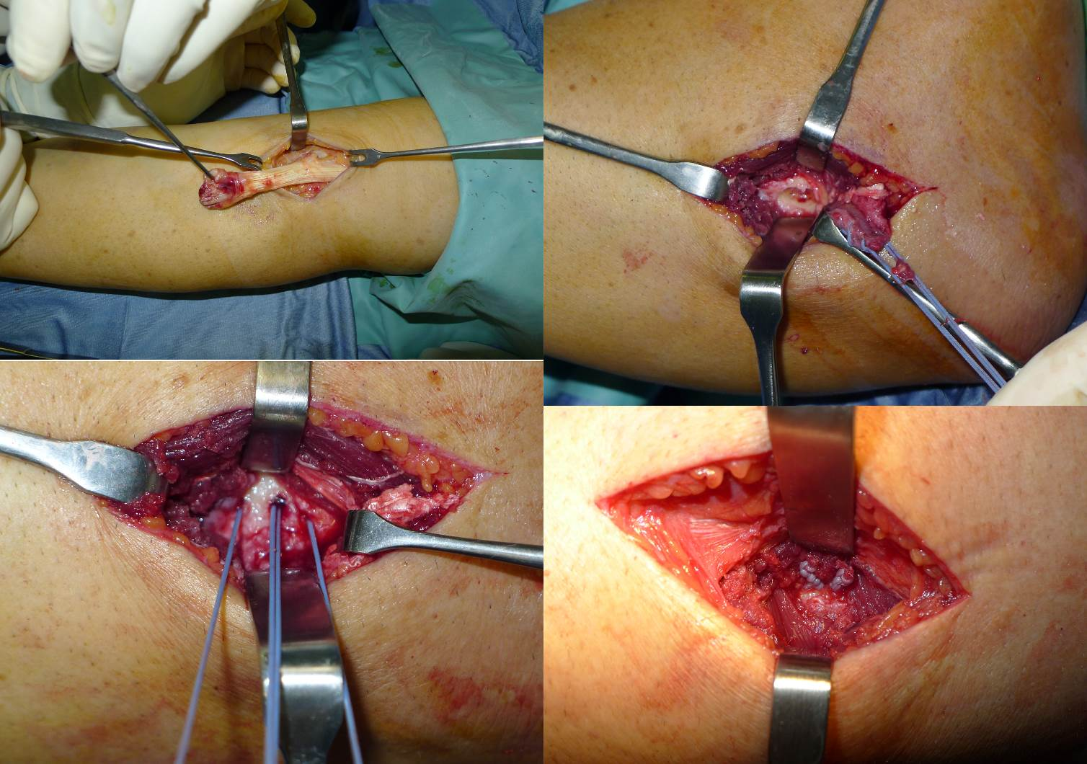

Figure 1 Intraoperative view showing the double access and the surgical procedure.

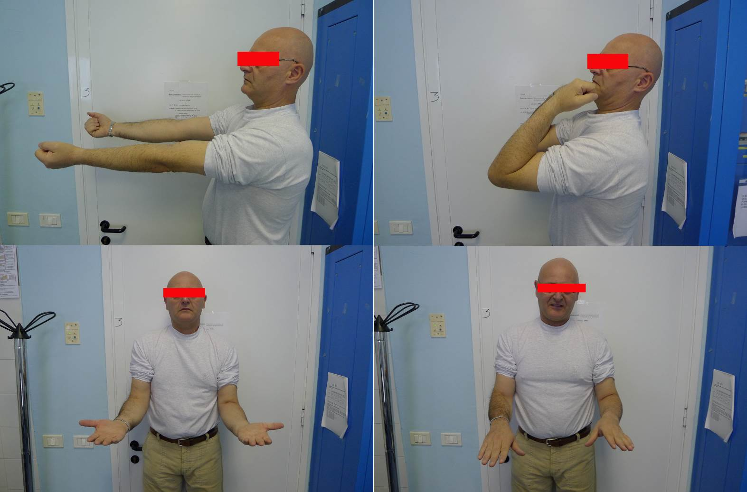
Figure 2 Clinical evaluation at 40 d after surgery showing complete recovery of the range of motion.

Table 1 Clinical outcome and complications occurrence
Clinical outcome
Range of motion |  |  |  |  |  |  |  |  |  |  |  | Complications
Flexion (°) |  | Extension (°) |  | Pronation (°) |  | Supination (°) |  | Mayo | Dash | Grip strengTH | Satisfaction | Eterotopic ossification | Tendon re-rupture | Pin palsy
Mean±SD | (%) | Mean±SD | (%) | Mean±SD | (%) | Mean±SD | (%) | Mean±SD | Mean±SD | (%) | Mean±SD | n (%) | n (%) | n (%)
125±8.4 | 94 | -2±4.3 | 97 | 80±5.7 | 93 | 82±6.5 | 96 | 97.2±12.0 | 4.8±8.2 | 83 | 9.4±5.6 | 3 (6.4) | 1 (2.1) | 2 (4.3)

