Name of Journal: World Journal of Cardiology
Manuscript NO: 61594
Manuscript Type: CASE REPORT

Device closure of fistula from lower left pulmonary artery to left atrium using a vascular plug: A case report

Mahapatra R et al. Pulmonary artery-to-left atrium fistula

Rudrapratap Mahapatra, Dibyasundar Mahanta, Jogendra Singh, Debasis Acharya, Ramachandra Barik

Rudrapratap Mahapatra, Department of Cardiothoracic Surgery, All India Institute of Medical Sciences, Bhubaneswar Pin-751019, Odisha, India

Dibyasundar Mahanta, Jogendra Singh, Debasis Acharya, Ramachandra Barik, Department of Cardiology, All India Institute of Medical Sciences, Bhubaneswar Pin-751019, Odisha, India

Author contributions: Barik R planned, performed the device closure and wrote the manuscript; Mahapatra R was the cardiothoracic surgeon who suggested device closure and supported editing of the manuscript editing; Mahanta D and Singh J supported the intervention as a fellow in training; Acharya D assisted in the planning of the case management and helped during the procedure.

Corresponding author: Ramachandra Barik, DNB, MD, Academic Research, Reader (Associate Professor), Department of Cardiology, All India Institute of Medical Sciences, Sijua Patrapada, Bhubaneswar Pin-751019, Odisha, India. cardioramachandra@gmail.com

Received: December 13, 2020
Revised: March 1, 2021
Accepted: April 14, 2021
Published online: April 26, 2021

Abstract
BACKGROUND
Pulmonary artery-to-left atrium fistula is a variant of pulmonary arteriovenous fistula and is a developmental anomaly. Delayed presentation, cyanosis and effort intolerance are some of the important features. The diagnosis is confirmed by computed tomography or pulmonary artery angiography. Catheter-based closure is preferred to surgery.

CASE SUMMARY
Left pulmonary artery-to-left atrium fistula is rare. A 40-year-old male presented with effort intolerance, central cyanosis, and recurrent seizures. He had a large and highly tortuous left pulmonary artery-to-left atrium fistula associated with a large aneurysmal sac in the course. Catheter-based closure was performed using a vascular plug.

CONCLUSION
Left pulmonary artery-to-left atrium fistula is relatively uncommon compared to right pulmonary artery-to-left atrium fistula. Percutaneous closure by either a transeptal technique or guide wire insertion into the pulmonary vein through the pulmonary artery is preferred. The need for an arteriovenous loop depends on the tortuosity of the course of the fistula and the size of the device to be implanted because a larger device needs a larger sheath, necessitating firm guide wire support to facilitate negotiation of the stiff combination of the delivery sheath and dilator.

Key Words: Pulmonary artery; Left atrium; Fistula; Hemangioma; Catheter-based; Vascular plug; Case report

©The Author(s) 2021. Published by Baishideng Publishing Group Inc. All rights reserved.

Citation: Mahapatra R, Mahanta D, Singh J, Acharya D, Barik R. Device closure of fistula from lower left pulmonary artery to left atrium using a vascular plug: A case report. World J Cardiol 2021; 111-116
URL: https://www.wjgnet.com/1949-8462/full/v13/i4/111.htm
DOI: https://dx.doi.org/10.4330/wjc.v13.i4.111

Core Tip: Pulmonary artery-to-left atrium fistula is a variant of pulmonary arteriovenous fistula and is a developmental anomaly. Left pulmonary artery-to-left atrium fistula is rare. We report the case of a 40-year-old male who presented with effort intolerance, central cyanosis, and recurrent seizures. He had a large and highly tortuous left pulmonary artery-to-left atrium fistula associated with a large aneurysmal sac in the course. Catheter-based closure was performed using a vascular plug.
INTRODUCTION
Left pulmonary artery-to-left atrium fistula is relatively rare compared to right pulmonary artery-to-left atrium fistula, as previously reported^{[1]}. The first case of pulmonary artery-to-left atrium fistula was reported in 1989 as an unusual cause of cyanosis in a newborn^{[2]}. A significant right-to-left shunt is clinically marked by effort intolerance, cyanosis, and polycythemia, as well as sometimes bleeding issues related to associated hemangioma^{[3,4]}. Pulmonary artery-to-left atrium fistula is a variant of pulmonary arteriovenous malformation. There is significant clinical suspicion of this condition when there is cyanosis without any obvious murmur in the precordium. Echocardiography shows a significant increase in pulmonary venous return to the left atrium, which is an additional clue and can be confirmed by cardiac catheterization or contrast-enhanced computed tomography. This case reports the relevant issues we encountered during the percutaneous device closure of a large and highly tortuous left pulmonary artery-to-left atrium fistula associated with a large aneurysmal sac in its course in an adult.

CASE PRESENTATION
Chief complaints
A 40-year-old male weighing 47 kg presented with effort intolerance, cyanosis, and clubbing.

History of present illness
The patient had a history of recurrent seizures and was on levetiracetam.

Personal and family history
The patient was a school teacher in profession and had no other significant comorbidities and no family history of congenital malformation.

Physical examination
The patient had central cyanosis and pandigital clubbing, and his room air oxygen saturation was 87%. There was no murmur on auscultation.

Laboratory examinations
The results of routine blood tests were normal. A genetic study could not be performed to exclude Osler-Weber-Rendu syndrome, which is also known as hereditary hemorrhagic telangiectasia^{[4,5]}.

Imaging examinations
Chest X-ray examination showed a dilated and enlarged left perihilar region. There were multiple small hemangiomas in several organs, including the brain. Echocardiography showed increased pulmonary venous return to the left atrium. Enhanced computed tomography of the pulmonary artery showed a left pulmonary artery-to-left atrium fistula with a highly tortuous course associated with an aneurysmal sac on its course from the pulmonary artery to the left atrium (Figure 1A, Videos 1 and 2). The narrowest diameter of the fistula was 1 cm just proximal to the aneurysmal sac in its course. A significant branch of the pulmonary artery was supplying the posterior segment of the lower left lobe.

MULTIDISCIPLINARY EXPERT CONSULTATION
The cardiothoracic surgeon suggested device closure as the first option if possible.

FINAL DIAGNOSIS
The final diagnosis was a large lower left pulmonary artery-to-left atrium fistula associated with an aneurysmal sac.

TREATMENT
Because the patient had multiple hemangiomas and recurrent seizures related to cerebral hemangioma based on the magnetic resonance angiography findings of the brain, the cardiac team suggested that a catheter-based intervention would be preferred over surgery. Device closure was planned after informed consent was obtained. Under local anesthesia and after infective endocarditis prophylaxis, the patient was taken for percutaneous vascular plugging of the fistula. Right ventricular saturation was 78%, and left ventricular saturation was 92% in room air. The pulmonary artery systolic pressure was 37 mmHg. The angiograms of the frontal and lateral projections showed a significantly tortuous course of the lower left pulmonary artery-to-left atrium fistula with an aneurysmal sac of 6 cm in diameter in its course (Figure 1B). The landing zone diameter was 16 cm, and the landing zone length was 2 cm after the origin of the lower left lobe segmental pulmonary artery branch (Figure 2A). A Terumo wire 0.35 cm × 260 cm in size (Terumo, Tokyo, Japan) was passed across the fistula from the left pulmonary artery through the sac far into the upper right pulmonary vein (Figure 2B). The insertion of a compatible 8-Fr sheath with its dilator was up to the sac was attempted but was not possible because of the tortuous course. The dilator was exchanged with a 5-Fr multipurpose diagnostic catheter, and the sheath was placed just proximal to the neck of the fistula. A 20-mm Amplatzer vascular plug (St. Jude Medical, Minnesota, United States) was deployed without any residual shunting (Figure 3, Videos 3 and 4). The arterial oxygen saturation immediately increased to 98%. The patient was discharged on aspirin on day three after the procedure. Oral anticoagulation was avoided in this case because of bleeding issues related to multiple hemangiomas.

OUTCOME AND FOLLOW-UP
At the 2-mo follow-up, contrast-enhanced computed tomography showed the position of the vascular plug in situ; there was no residual shunting, and the patient’s room air saturation was 98%.

DISCUSSION
Incomplete degeneration of the partition between the arterial and venous plexus of the splanchnic pulmonary vascular bed leads to the formation of thin-walled sacs, resulting in the formation of pulmonary arteriovenous fistulas, which may sometimes be absorbed into the left atrium, causing the pulmonary artery to form a left atrial fistula. The potential right-to-left shunt and aneurysmal dilatation of the pathway can cause thromboembolism and death due to rupture of the sac. The incidence of this kind of fistula is higher in males. Routine frontal chest X-ray examination may show perihilar vascular enlargement. Agitated saline contrast echocardiography could provide additional information when pulmonary artery-to-left atrium fistula is suspected. A close differential diagnosis of pulmonary arteriovenous fistula must always be kept in mind^{[6]}. Although invasive pulmonary angiography is diagnostic, it should be reserved for intervention because computed tomography angiography with three-dimensional reconstruction provides most of the information needed to decide whether a fistula can be percutaneously plugged by a device or requires surgical closure^{[7]}. Various plugging devices, such as vascular plugs, duct occluders and septal defect occluders, can be used depending upon the tortuosity of the course, availability of the landing zone and available delivery sheath and age of the patient. The plug can be deployed with or without an arteriovenous loop depending on the tortuosity of the course and size of the fistula^{[8]} with or without general anesthesia depending upon the age of the patient.
The proximal part of the lower left lobe pulmonary artery was tortuous before its division into anterior and posterior segmental branches. The sac was located along the course of the anterior segmental artery. We faced five major challenges to the catheter-based intervention in this case. (1) Negotiation of the 8-Fr sheath with its stiff default dilator was not possible; we overcame this difficulty by using a 5-Fr multipurpose catheter and substituting the dilator; (2) Although device implantation could have been performed using a transseptal approach with or without a loop, we could manage the antegrade approach from the pulmonary artery because of the good support provided by the guidewire in the upper right pulmonary vein; (3) The proximal end of the landing zone in this case was quite close to the ostium of a large postsegmental pulmonary artery branch, but the procedure was completed well because of the proper device selection, which is evident in the provided video clips (Videos 3 and 4); (4) The possibility of device embolization in this case was avoided by proper identification of the landing zone and its diameter and the selection of a well-fitting device; and (5) Although there was a fair indication for oral anticoagulation to prevent atheroembolism from the aneurysmal sac after device implantation, we only administered aspirin to avoid bleeding issues related to multiple hemangiomas. Percutaneous closure is preferred to open heart surgery whenever the anatomy allows, as in this case.

CONCLUSION
Left pulmonary artery-to-left atrium fistula is relatively uncommon compared to right pulmonary artery-to-left atrium fistula. Percutaneous closure by either a transeptal technique or guide wire insertion in the pulmonary vein through the pulmonary artery is preferred. The need for an arteriovenous loop depends upon the tortuosity of the course of the fistula and this size of the device to be implanted because a larger device needs a larger sheath, necessitating firm guide wire support to facilitate negotiation of the stiff combination of the delivery sheath and dilator.

ACKNOWLEDGEMENTS
The authors are extremely thankful to Mr. Pramanik S for his kind support during the procedure as our senior catheterization laboratory technician.

REFERENCES
1 Mongé MC, Russell HM, Popescu AR, Robinson JD. Right pulmonary artery to left atrial fistula in a neonate: case report and review of the literature. World J Pediatr Congenit Heart Surg 2014; 5: 306-310 [PMID: 24668980 DOI: 10.1177/2150135113508562]
2 Jimenez M, Fournier A, Choussat A. Pulmonary artery to the left atrium fistula as an unusual cause of cyanosis in the newborn. Pediatr Cardiol 1989; 10: 216-220 [PMID: 2687821 DOI: 10.1007/BF02083296]
3 Sivakumar K, Sean DR. Pulmonary artery to left atrial fistula: haemodynamic changes traced from fetus to infancy until its interventional closure. Cardiol Young 2018; 28: 1154-1156 [PMID: 30019660 DOI: 10.1017/S1047951118000616]
4 Nikolaou I, Rafailidis V, Kartas A, Kouskouras K, Giannakoulas G. A case of pulmonary arteriovenous malformation in the setting of Rendu Osler Weber syndrome. Radiol Case Rep 2021; 16: 483-486 [PMID: 33363687 DOI: 10.1016/j.radcr.2020.12.024]
5 Dunphy L, Talwar A, Patel N, Evans A. Hereditary haemorrhagic telangiectasia and pulmonary arteriovenous malformations. BMJ Case Rep 2021; 14 [PMID: 33419752 DOI: 10.1136/bcr-2020-238385]
6 Khanra D, Razi M, Tiwari P, Soni S, Thakur R. Successful occlusion of a large pulmonary arterio-venous fistula with Amplatzer septal occluder in a 16-year-old cyanotic boy. J Cardiol Cases 2020; 21: 242-245 [PMID: 32547663 DOI: 10.1016/j.jccase.2020.03.003]
7 Singhi AK, Roy RR, De A, Bari EA, Kumar RK. Percutaneous closure of large pulmonary artery to left atrial fistula. J Cardiol Cases 2020; 22: 166-169 [PMID: 33014197 DOI: 10.1016/j.jccase.2020.05.017]
8 Arya V, Azad S, Radhakrishnan S. Transcatheter closure of right pulmonary artery to left atrium fistula in an infant: technical consideration and possible closure techniques. Cardiol Young 2019; 29: 1561-1564 [PMID: 31679544 DOI: 10.1017/S1047951119002592]

Footnotes
Informed consent statement: Informed consent was obtained from the patient.

Conflict-of-interest statement: The authors have no conflicts of interests or financial disclosures relevant to this manuscript.

CARE Checklist (2016) statement: The authors have read the CARE Checklist (2016), and the manuscript was prepared and revised according to the CARE Checklist (2016).

Open-Access: This article is an open-access article that was selected by an in-house editor and fully peer-reviewed by external reviewers. It is distributed in accordance with the Creative Commons Attribution NonCommercial (CC BY-NC 4.0) license, which permits others to distribute, remix, adapt, build upon this work non-commercially, and license their derivative works on different terms, provided the original work is properly cited and the use is non-commercial. See: http://creativecommons.org/Licenses/by-nc/4.0/

Manuscript source: Unsolicited manuscript

Corresponding Author's Membership in Professional Societies: European Society of Cardiology, No. 663523; Cardiology Society of India, No. L-3559; Pediatric Cardiology Society of India, No. L-679; and Indian College of Cardiology, No. L-815.

Peer-review started: December 13, 2020
First decision: February 28, 2021
Article in press: April 14, 2021

Specialty type: Cardiac and cardiovascular systems
Country/Territory of origin: India
Peer-review report’s scientific quality classification
Grade A (Excellent): 0
Grade B (Very good): 0
Grade C (Good): C
Grade D (Fair): 0
Grade E (Poor): 0

P-Reviewer: Dai HL S-Editor: Gao CC L-Editor: P-Editor:
Figure Legends
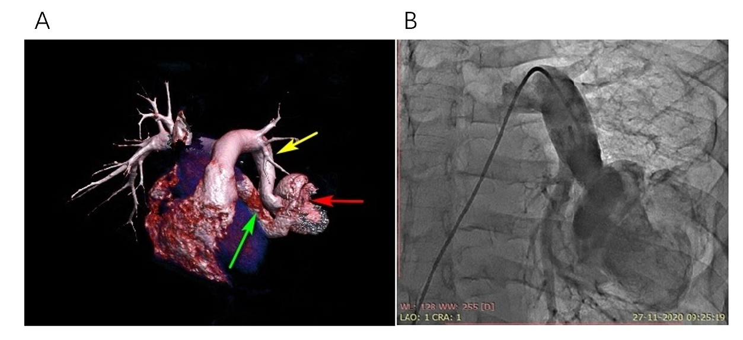
Figure 1 Three-dimensional computed tomography volume rendering and pulmonary artery angiogram. A: Contrast-enhanced computed tomography with three-dimensional reconstruction showing the lower left pulmonary artery-to-left atrium fistula with a highly tortuous course associated with an aneurysmal sac. Yellow arrow: lower left segmental artery; red arrow: aneurysmal sac; green arrow: last part of fistula connecting the left atrium; B: Anterior-posterior projection of pulmonary artery angiography using a 6-Fr pigtail catheter showing a highly tortuous large left pulmonary artery-to-left atrium fistula associated with a 6-cm aneurysmal sac. The right ventricular oxygen saturation was 79%, and the left ventricular saturation was 92% in room air without anesthesia.
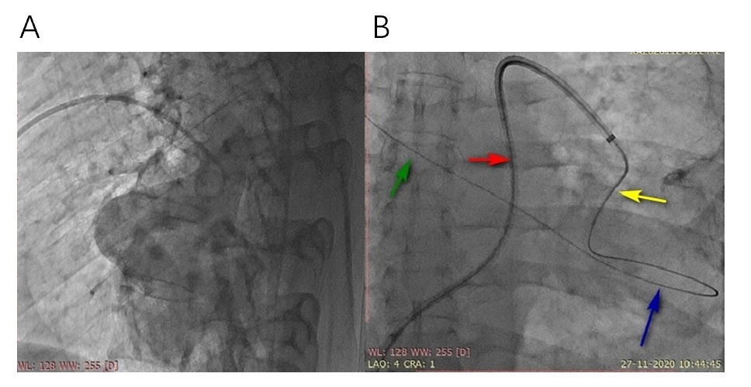
Figure 2 Lateral pulmonary angiography and the course of the guidewire. A: Lateral pulmonary artery angiography using a 6-Fr pigtail catheter showing a large left pulmonary artery-to-left atrium fistula associated with a large aneurysmal sac; B: A Terumo wire (0.35 cm × 260 cm) and 5-Fr multipurpose catheter helped to negotiate the highly tortuous course of the fistula to reach beyond the targeted landing zone and the site of guide wire placement in the upper right pulmonary vein via the aneurysmal sac for adequate support. Red arrow: 8-Fr sheath; yellow arrow: 5-Fr multipurpose catheter through the delivery sheath; blue arrow: guidewire in the aneurysmal sac; green arrow: upper right pulmonary vein.
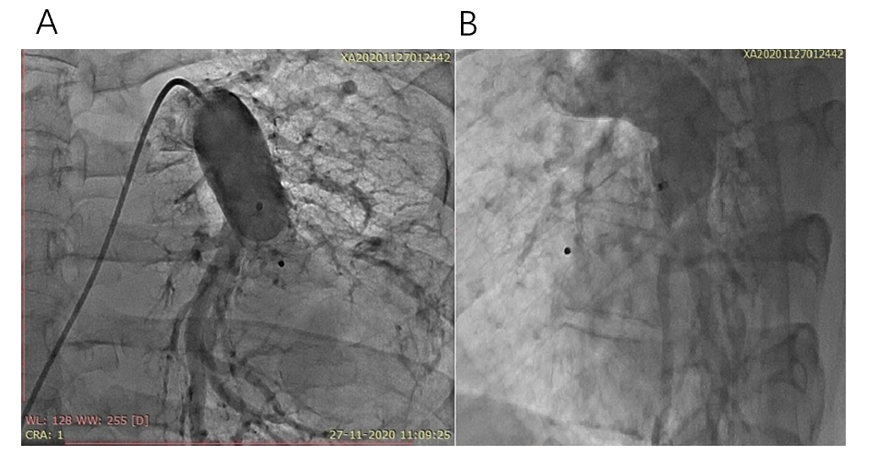
Figure 3 Pulmonary artery angiography after device deployment. Pulmonary artery angiography in the frontal projection and in the lateral projection showing perfect device positioning, no residual shunting and uncompromised blood flow in the lower left segmental artery. A: Frontal projection; B: Lateral projection,

Published by Baishideng Publishing Group Inc
7041 Koll Center Parkway, Suite 160, Pleasanton, CA 94566, USA
Telephone: +1-925-3991568
E-mail: bpgoffice@wjgnet.com
Help Desk: https://www.f6publishing.com/helpdesk
https://www.wjgnet.com

© 2021 Baishideng Publishing Group Inc. All rights reserved.

