Name of journal: World Journal of Gastroenterology
ESPS Manuscript NO: 3032
Columns: CASE REPORT

Mucocele of the appendix due to endometriosis: A rare case report

Tsuda M et al. Mucocele of the appendix due to endometriosis

Motoyuki Tsuda, Yukitaka Yamashita, Shunjiro Azuma, Takuji Akamatsu, Takeshi Seta, Shunji Urai, Yoshito Uenoyama, Yasunori Deguchi, Kazuo Ono, Tsutomu Chiba

Motoyuki Tsuda, Yukitaka Yamashita, Shunjiro Azuma, Takuji Akamatsu, Takeshi Seta, Shunji Urai, Yoshito Uenoyama, Department of Gastroenterology, Japanese Red Cross Wakayama Medical Center, 4-20 Komatubaradori, Wakayama 640-8558, Japan

Yasunori Deguchi, Department of Surgery, Japanese Red Cross Wakayama Medical Center, 4-20 Komatubaradori, Wakayama 640-8558, Japan

Kazuo Ono, Department of Pathology, Japanese Red Cross Wakayama Medical Center, 4-20 Komatubaradori, Wakayama 640-8558, Japan

Tsutomu Chiba, Department of Gastroenterology and Hepatology, Kyoto University Graduate School of Medicine, 54 Sakyouku Syougoinnkawaramachi, Kyoto 606-8507, Japan

Author contributions: Tsuda M, Yamashita Y designed the report; Tsuda M, Azuma S, Akamatsu T, Seta T, Urai S and Uenoyama S were the attending doctors for the patients; Deguchi Y performed the surgical operations; Ono K performed the pathological examinations; Chiba T organized the report; and Tsuda M wrote the paper.

Correspondence to: Motoyuki Tsuda, MD, Department of Gastroenterology, Japanese Red Cross Wakayama Medical Center, 4-20 Komatubaradori, Wakayama 640-8558, Japan. mtsuda@kuhp.kyoto-u.ac.jp

Telephone: +81-73-4224171 Fax: +81-73-4261168
Received: April 3, 2013 Revised: April 27, 2013
Accepted: May 7, 2013
Published online:

Abstract
Mucocele of the appendix due to endometriosis is extremely rare, and there are only 10 previously reported cases in the English literature. We report a case of mucocele of the appendix due to endometriosis and provide the first review of the literature. A 43-year-old woman was admitted to the hospital because of recurrent right lower abdominal pain during her menstrual periods. Colonoscopy revealed submucosal tumor-like elevations of the appendiceal orifice. A computed tomography scan and magnetic resonance imaging of the abdomen suggested cystic lesions near the appendix. Consequently, mucocele of the appendix was suspected preoperatively. An open ileocecal resection was performed. Multiple cystic lesions were observed around the appendix. The contents of the cystic lesions consisted of mucus. Histopathological examination was consistent with a mucocele of the appendix due to endometriosis. The postoperative course was uneventful. We present the first review of the literature to clarify the clinical features.

© 2013 Baishideng. All rights reserved.

Key words: Mucocele; Appendix; Endometriosis; Rare diseases; Female; Case report

Core tip: We report an extremely rare case of mucocele of the appendix due to endometriosis. Although it is uncommon, preoperative diagnosis of the mucocele is important; however, diagnosis is difficult using imaging modalities. We report a more accurate diagnostic possibility using preoperative imaging modalities, such as colonoscopy, ultrasonography, computed tomography, and magnetic resonance imaging. Furthermore, this report is important because it is the first review of the literature for mucocele of the appendix due to endometriosis.
Tsuda M, Yamashita Y, Azuma S, Akamatsu T, Seta T, Urai S, Uenoyama Y, DeguchiY, Ono K, Chiba T. Mucocele of the appendix due to endometriosis: A rare case report. World J Gastroenterol 2013;
Available from: URL: http://www.wjgnet.com/esps/
DOI: DOI:10.3748/wjg.v19.i0.0000

INTRODUCTION
Mucocele of the appendix is an uncommon disease. It is observed in 0.2%–0.3% of appendectomies and 8%–10% of appendiceal tumors^{[1]}. According to the modern classification^{[2,3]}, mucocele of the appendix includes 4 histological groups: simple mucocele, mucosal hyperplasia, mucinous cystadenoma, and mucinous cystadenocarcinoma. Simple mucocele is caused by mucus distention secondary to an obstruction of the appendix due to fecaliths, post-inflammatory scarring or, rarely, endometriosis. There are only 10 previously reported cases of mucocele of the appendix due to endometriosis in the English literature^{[4-12]}. We present a rare case of mucocele of the appendix due to endometriosis and a review of the literature.

CASE REPORT
A 43-year-old woman was admitted to the hospital because of recurrent right lower abdominal pain during her menstrual periods. On physical examination, she presented mild right lower abdominal tenderness without rigidity. Her blood and urine tests were normal. An abdominal computed tomography (CT) scan revealed low-density lesions near the appendix. Colonoscopy revealed submucosal tumor-like elevations of the appendiceal orifice. A group I biopsy was performed. Subsequent magnetic resonance imaging (MRI) revealed hyperintensity on the T2-weighted image (Figure 1). Consequently, mucocele of the appendix was diagnosed preoperatively. Her recurrent right lower abdominal pain during menstrual periods suggested the involvement of endometriosis. Our patient was offered open surgical resection because malignancy could not be ruled out. During surgery, several cystic lesions were observed around the appendix. Features of endometriosis were not observed in the pelvis, the uterus, or the rest of the abdominal cavity. An open ileocecal resection was performed. Multiple cystic lesions were observed around the appendix. The contents of the cystic lesions consisted of mucus (Figure 2). Histopathological examination indicated that the cysts were a simple type of mucocele and that endometriosis and smooth muscle hypertrophy were present in the muscle layer of the appendix around the mucocele (Figure 3). Consequently, we reached a diagnosis that the mucocele of the appendix was due to endometriosis. The postoperative course was uneventful.

DISCUSSION
A mucocele of the appendix is a rare lesion. Mucocele of the appendix occurs in 0.2%–0.3% of all appendectomies performed and 8%–10% of all resected appendiceal tumors^{[1]}. Endometriosis of the appendix is also a rare lesion; it is observed in 0.054%–0.8% of all appendectomies performed^{[13-15]}. Finally, mucocele of the appendix due to endometriosis is extremely rare.
According to the modern classification^{[2,3]}, mucocele of the appendix includes 4 histological groups: simple mucocele, mucosal hyperplasia, mucinous cystadenoma, and mucinous cystadenocarcinoma. A simple mucocele is characterized by degenerative epithelial changes due to obstruction and distention of the appendix. This type represents 20%–30% of cases. A simple mucocele is caused by mucus distention secondary to an obstruction of the appendix due to fecaliths, post-inflammatory scarring or, rarely, endometriosis. Mucosal hyperplasia is similar to a hyperplastic colon polyp histologically. This type represents 20%–30% of cases. Mucinous cystadenoma is a neoplasm that presents a tubular or papillar pattern with important mucus production and adenomatous epithelium. This type represents 30%–50% of cases. Mucinous cystadenocarcinoma differs from cystadenoma because glandular and stromal invasion is involved. Previously, it was believed that only mucinous cystadenocarcinoma could cause pseudomyxoma peritonei (PMP), but it has recently been reported that other types of mucocele can cause PMP. Ruiz-Tovar et al^{[3]} presented a case of simple mucocele that was apparently not perforated and developed PMP.
Consequently, the preoperative diagnosis of mucocele of the appendix is crucial. Colonoscopy, ultrasonography (USG), CT, and MRI are used for diagnosis. On colonoscopy, the appearance of the appendiceal orifice at the center of the mound has been called the "volcano sign." USG can be used to differentiate between acute appendicitis and mucocele. Dilatation of the appendiceal lumen to 15 mm or more suggests mucocele with 83% sensitivity and 92% specificity. CT offers better specificity in establishing a diagnosis of mucocele. The typical features are cystic masses that are well circumscribed with low attenuation. Wall calcifications are observed in 50% of cases, and they strongly suggest mucocele. In addition, enhancing nodules in the mucocele wall may suggest cystadenocarcinoma. MRI is also useful in establishing a diagnosis of mucocele. On MRI, a mucocele appears as a cystic mass with low to intermediate signal intensity on T1WI and high signal intensity on T2WI. These findings can be attributed to the high protein content of a mucocele^{[16]}. In our case, the CT, MRI, and colonoscopy imaging results were compatible with these findings.
When mucocele of the appendix is diagnosed preoperatively, open surgery is favored over laparoscopy to prevent a rupture of the mucocele, which may induce PMP. If mucocele is detected during a laparoscopic procedure, the patient must undergo a conversion to open surgery.
Appendiceal endometriosis is diagnosed pathologically. Glandular tissue, endometrial stroma, and hemorrhage are typically assessed in patients who present endometriosis^{[17]}. Approximately half of the cases of endometriosis of the appendix involve the body and half involve the tip of the appendix. Muscular and seromuscular involvement occurs in two-thirds of patients, and the serosal surface is involved in one-third of patients. The mucosa is not involved and the submucosa is involved in one-third of patients. There was no relationship between the location of the endometriotic foci and the symptoms of the patient. Our patient had endometriosis with muscular involvement.
Hapke et al^{[5]} noted that the progression of mucocele of the appendix due to endometriosis consisted of the following steps. Endometriosis results in smooth muscle hypertrophy of the appendix, including the muscularis mucosa, with obstructions of some of the gland crypts. These obstructions lead to local increased mucin production from the production of multiple small cysts. Ultimately, a number of these small cysts coalesce, resulting in a single layer cyst that can be dissected through the submucosa proximally.
In our case, multiple small cysts were observed surrounding the appendix. These findings confirm the proposal of Hapke.
There are only 10 previously reported cases of a similar condition in the English literature^{[4-12]}. We reviewed these reported cases and the present case. The mean age at presentation was 34 years (22–56 years). The patients presented various symptoms: four had recurrent abdominal pain during menstrual periods, three had chronic pelvic pain, two had acute abdominal pain with vomiting, one had increasing menorrhagia (she had complicated uterine myomas), and another had no symptoms. Preoperative diagnoses of mucocele were made in five cases, diagnostic laparoscopy was performed in five cases, and in one case, it was found by chance during surgery. Open surgery was performed in six cases, and two experienced ruptures during surgery. The mean tumor size was 2.5 cm (1.3–5.5 cm). Nine cases had a single cyst, and two had multiple cysts. One case was complicated with intussusception and another with ureteric obstruction.
In summary, we report a rare case of mucocele of the appendix due to endometriosis and provide the first review of the literature.

REFERENCES
1 García Lozano A, Vázquez Tarrago A, Castro García C, Richart Aznar J, Gómez Abril S, Martínez Abad M. [Mucocele of the appendix: Presentation of 31 cases]. Cir Esp 2010; 87: 108-112 [PMID: 19963210 DOI: 10.1016/j.ciresp.2009.07.020]
2 Higa E, Rosai J, Pizzimbono CA, Wise L. Mucosal hyperplasia, mucinous cystadenoma, and mucinous cystadenocarcinoma of the appendix. A re-evaluation of appendiceal "mucocele". Cancer 1973; 32: 1525-1541 [PMID: 4757938 DOI: 3.0.CO; 2-C']
3 Ruiz-Tovar J, Teruel DG, Castiñeiras VM, Dehesa AS, Quindós PL, Molina EM. Mucocele of the appendix. World J Surg 2007; 31: 542-548 [PMID: 17318706 DOI: 10.1007/s00268-006-0454-1]
4 Driman DK, Melega DE, Vilos GA, Plewes EA. Mucocele of the appendix secondary to endometriosis. Report of two cases, one with localized pseudomyxoma peritonei. Am J Clin Pathol 2000; 113: 860-864 [PMID: 10874887 DOI: 10.1309/EUTL-BC88-TLAX-1UJ4]
5 Hapke MR, Bigelow B. Mucocele of the appendix secondary to obstruction by endometriosis. Hum Pathol 1977; 8: 585-589 [PMID: 903147 DOI: 10.1016/S0046-8177(77)80118-4]
6 Kimura H, Konishi K, Yabushita K, Maeda K, Tsuji M, Miwa A. Intussusception of a mucocele of the appendix secondary to an obstruction by endometriosis: report of a case. Surg Today 1999; 29: 629-632 [PMID: 10452241 DOI: 10.1007/BF02482989]
7 Nopajaroonsri C, Mreyoud N. Retention mucocele of appendix due to endometriosis. South Med J 1994; 87: 833-835 [PMID: 8052897 DOI: 10.1097/00007611-199408000-00017]
8 O'Sullivan MJ, Kumar U, Kiely EA. Ureteric obstruction with mucocoele of the appendix due to endometriosis. BJOG 2001; 108: 124-125 [PMID: 11212988]
9 Abrao MS, Podgaec S, Carvalho FM, Gonçalves MO, Dias JA, Averbach M. Bowel endometriosis and mucocele of the appendix. J Minim Invasive Gynecol 2005; 12: 299-300 [PMID: 16036185 DOI: 10.1016/j.jmig.2005.04.003]
10 Miyakura Y, Kumano H, Horie H, A T Lefor, Yamaguchi T. Rupture of appendiceal mucocele due to endometriosis: report of a case. Clin J Gastroenterol 2012; 5: 220-224 [DOI 10.1007/s12328-012-0302-9]
11 Kohout E. Mucocele of the appendix caused by endometriosis. Am J Obstet Gynecol 1960; 79: 1181-1183 [PMID: 14410574]
12 Shemilt P. Endometrioma of the caecum causing mucocele of the appendix. Br J Surg 1949; 37: 118-120 [PMID: 18135668 DOI: 10.1002/bjs.18003714528]
13 Collins DC. 71,000 Human appendix specimens. a final report, summarizing forty years' study. Am J Proctol 1963; 14: 265-281 [PMID: 14098730]
14 Uohara JK, Kovara TY. Endometriosis of the appendix. Report of twelve cases and review of the literature. Am J Obstet Gynecol 1975; 121: 423-426 [PMID: 1115159]
15 Berker B, Lashay N, Davarpanah R, Marziali M, Nezhat CH, Nezhat C. Laparoscopic appendectomy in patients with endometriosis. J Minim Invasive Gynecol 2005; 12: 206-209 [PMID: 15922976 DOI: 10.1016/j.jmig.2005.03.003]
16 Koga H, Aoyagi K, Honda H, Fujishima M. Appendiceal mucocele: sonographic and MR imaging findings. AJR Am J Roentgenol 1995; 165: 1552 [PMID: 7484614 DOI: 10.2214/ajr.165.6.7484614]
17 Uncu H, Taner D. Appendiceal endometriosis: two case reports. Arch Gynecol Obstet 2008; 278: 273-275 [PMID: 18236056 DOI: 10.1007/s00404-008-0570-2]

P-Reviewer Liu Y S-Editor Gou SX L-Editor E-Editor

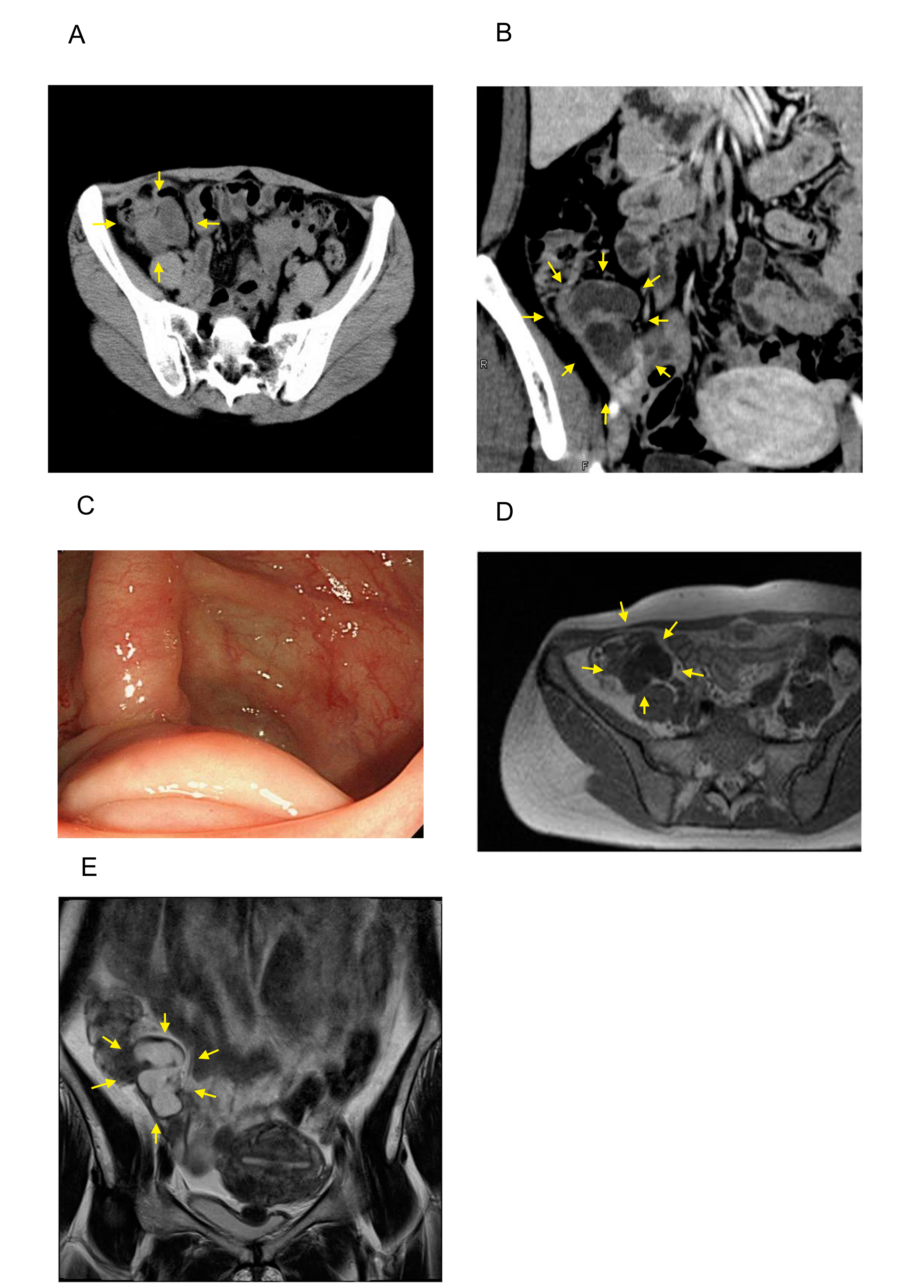Figure 1 Preoperative image of the mucocele. A: Computed tomography (axial image). A tumor was detected (arrows); B: Computed tomography (coronal image). A tumor was detected (arrows); C: Colonoscopy. Submucosal tumor-like elevations of the appendiceal orifice; D: Magnetic resonance imaging (T1-weighted image, axial image); E: Magnetic resonance imaging (T2-weighted image, coronal image).

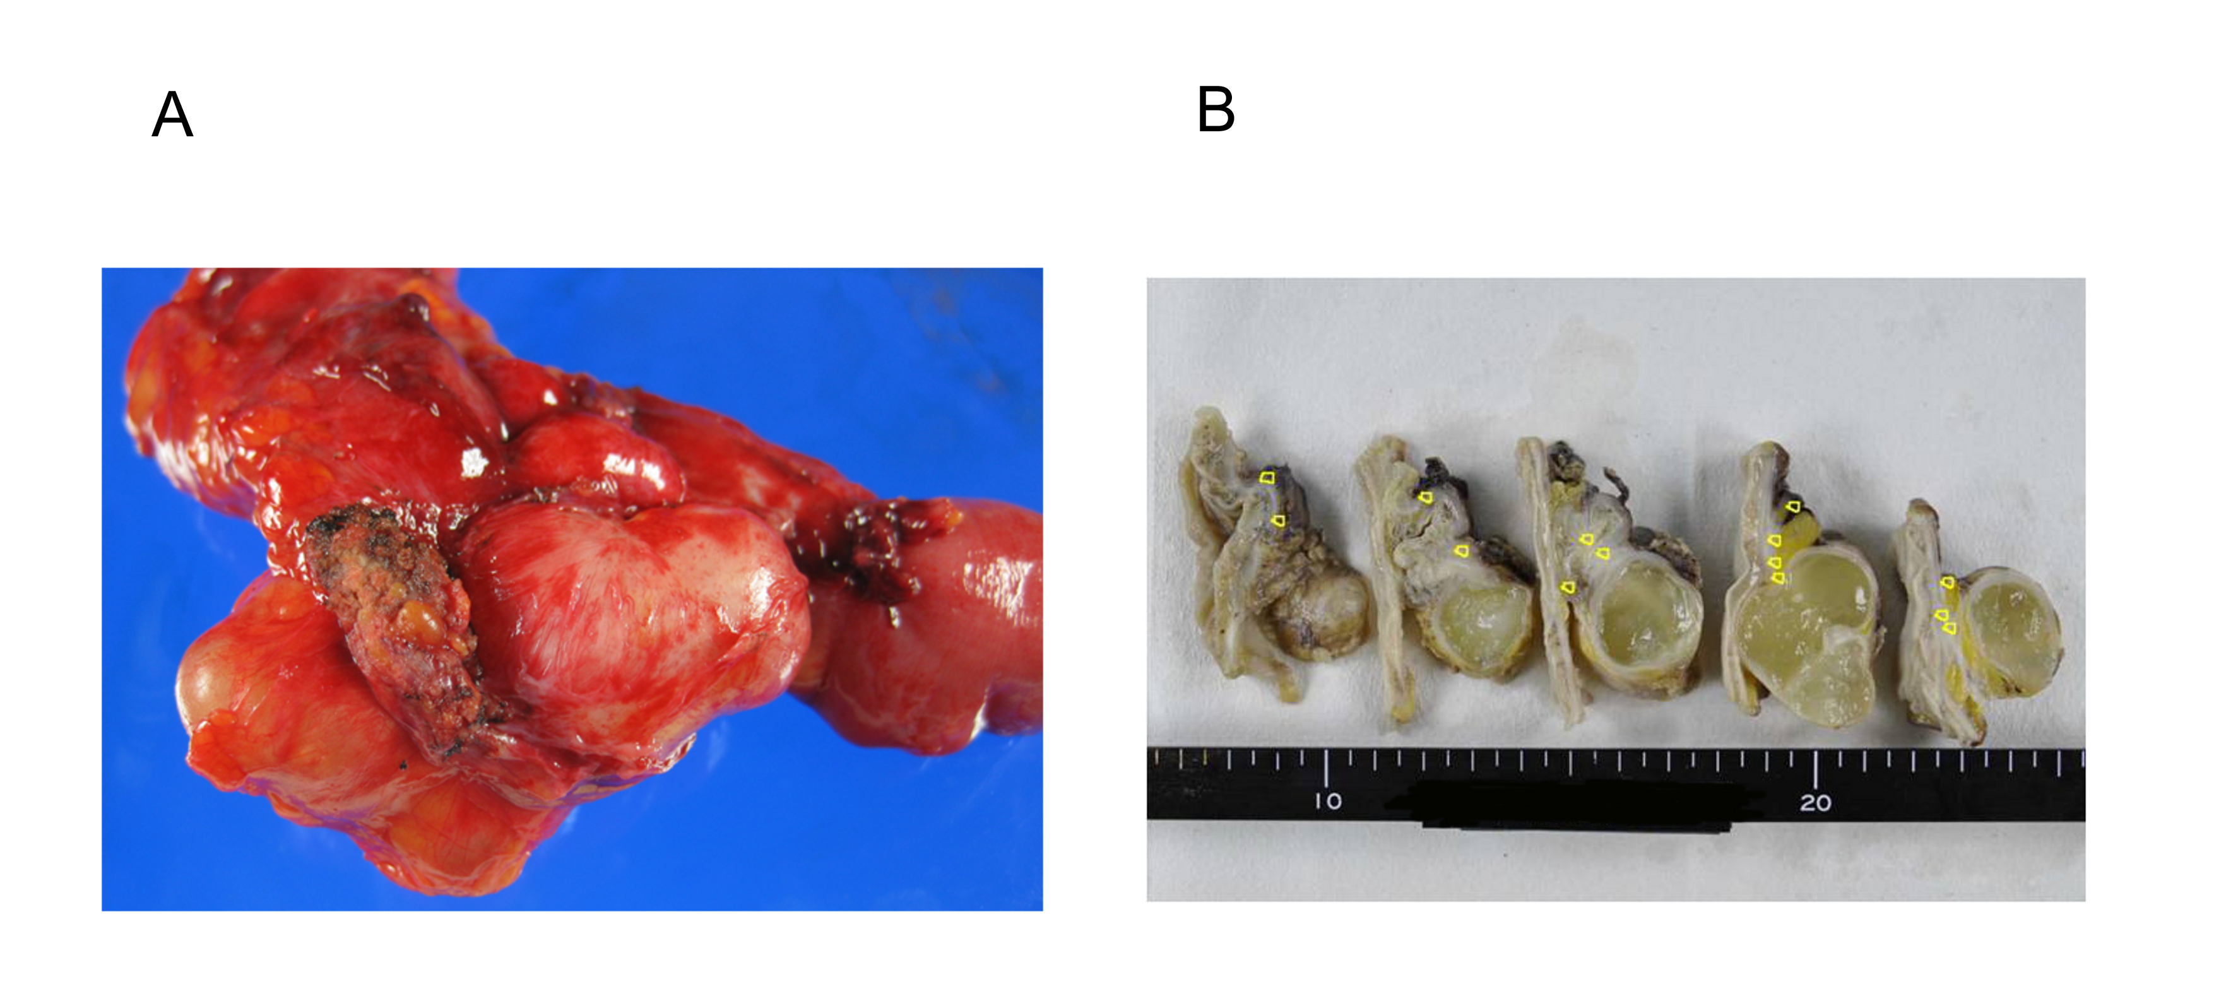
Figure 2 Macroscopic appearance of the resected specimen. A: The resected specimen contains thin-walled cystic masses; B: Cystic masses contain yellow mucin. Endometriosis is observed around the cyst (circle).
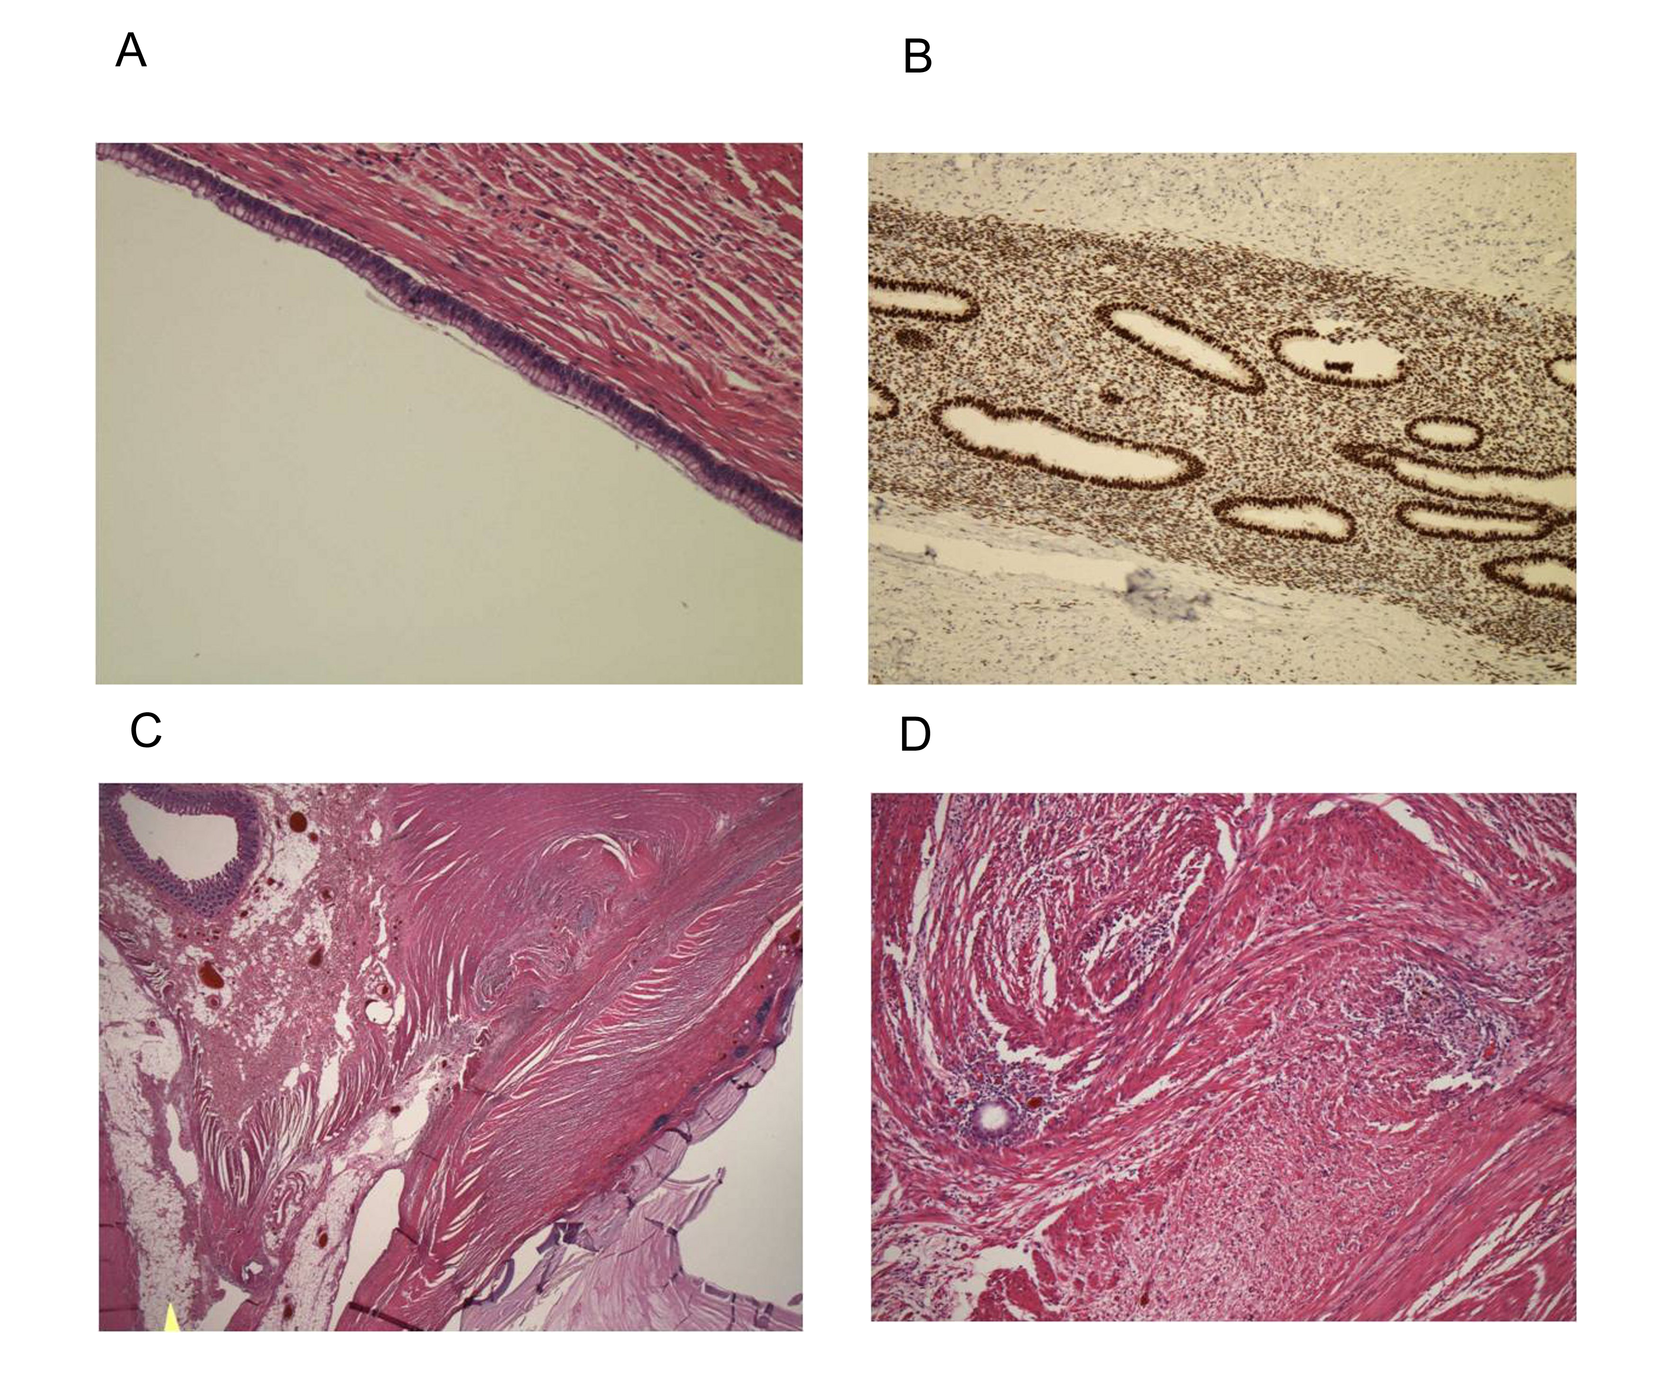
Figure 3 Pathological findings and immunohistochemical staining. A: Appendiceal mucosa is observed on the cyst wall; B: Estrogen receptor; C, D: Obstructive lesion of the appendiceal lumen. Endometriosis and smooth muscle hypertrophy are observed in the muscle layer (hematoxylin/eosin staining, C: × 20; D: × 100).

