Name of Journal: World Journal of Transplantation
Manuscript NO: 71815
Manuscript Type: MINIREVIEWS

In memoriam of Thomas Earl Starzl, the pioneer of liver transplantation

Yilmaz S et al. In memory of the father of LT

Sezai Yilmaz, Sami Akbulut

Sezai Yilmaz, Sami Akbulut, Surgery and Liver Transplant Institute, Inonu University, Malatya 44280, Turkey

Author contributions: Yilmaz S and Akbulut S wrote the manuscript; Akbulut S and Yilmaz S reviewed the final version.

Corresponding author: Sami Akbulut, MD, PhD, Professor, Surgery and Liver Transplant Institute, Inonu University, Elazig Yolu 10. Km, Malatya 44280, Turkey. akbulutsami@gmail.com

Received: September 22, 2021
Revised: November 5, 2021
Accepted: March 6, 2022
Published online:

Abstract
Starzl’s nearly 3000 publications that contribute to the science of transplantation in every field have been the most important resources for every scientist working in this field. For those of us who work in the liver transplant field, his contributions throughout his life have shaped our career and passion, even for those who have never met, spoken to, or worked with him. If we are able to help patients with liver failure today by offering them the chance of transplantation, it is because of Starzl’s passionate work and efforts. Thanks to Starzl’s scientific legacy, hundreds of scientists serve humanity and thousands of patients can hold on to life. It has been an honor for us to write this article about Professor Starzl.

Key Words: Liver transplantation; Thomas Earl Starzl; Pioneer of liver transplantation

Yilmaz S, Akbulut S. In memoriam of Thomas Earl Starzl, the pioneer of liver transplantation. World J Transplant 2022; In press

Core Tip: Starzl’s nearly 3000 publications that contribute to the science of transplantation in every field have been the most important resources for every scientist working in this field. Thanks to Starzl’s scientific legacy, hundreds of scientists serve humanity and thousands of patients can hold on to life thanks to this legacy. It has been an honor for us to write this article about Professor Starzl.

INTRODUCTION
Thomas Earl Starzl was born March 11, 1926, in LeMars, Iowa^{[1]}. He received his medical degree from Northwestern University^{[1]}. He worked at the University of Colorado as a surgeon from 1962 until 1981. Thomas Earl Starzl, MD, PhD, a surgeon who was a pioneer of liver transplantation (LT) died at the age of 91 years on Saturday, March 4, 2017 at his home in Pittsburgh, Pennsylvania^{[1,2]}. Starzl is called “the Father of Modern Transplantation”^{[1-3]}. Starzl’s death deeply saddened all liver transplant surgeons around the world. A better understanding Professor Starzl, requires mentioning his biography and the first liver transplant.
He performed the world’s first liver transplant in Denver on March 1, 1963 in a child, named Bennie Solis^{[4,5]}. Bennie Solis belonged to a Spanish American family, and suffered from biliary atresia. Bennie’s donor was another child who died during open heart surgery. The donor was already on a heart-lung machine for artificial circulation and the body temperature was cooled for organ preservation until the family gave consent for donation of the liver. Starzl and colleagues had performed nearly two hundred LTs in dogs. It took several hours just to make the incision and enter the abdominal cavity. Dissection was very difficult due to high-pressure venous collaterals as a result of portal hypertension. Previous operations resulted in highly vascularized and rough scar tissue that encased the liver. Bennie also had severe coagulopathy. Pharmaceutical or other human-derived factors that should have been used to prevent hemorrhage and deficiency of coagulation factor were not easily available. Bennie bled to death as Starzl tried everything to stop the hemorrhage. The transplantation could not be performed. Despite the fact that Bennie was three years old, he spent every day of his short life in agony. When his wound was closed and his body was washed and prepared the surgical team burst into tears. Starzl and his team remained in the operating room for a long time without saying a word. Starzl has always stated “it was not the last time that I would see this scene, both in my dreams and in reality”. Ever since, I have not heard anybody describe it as a case of Solis or the first human LT.
The efforts made during the process of initiating kidney transplants in research laboratories should now be made for LT which is a more difficult procedure. The main lesson to be learned from Bennie Solis’s surgery was dealing with the clotting problems in severe liver disease. An expert named Von Kaulla who was working on the coagulation pathway at the time was recruited to the team. Von Kaulla made important contributions such as the definition of fibrinolysis and recommending the use of epsilon amino caproic acid and specific coagulation agents in LT^{[6]}. Moreover, the prompt transplantation of a well-functioning liver graft was essential.
After the first 7 unsuccessful liver transplants (5 were performed by Starzl), a voluntary moratorium was declared that lasted for 3.5 years. Starzl then performed the first successful liver transplant in 1967 with long-term survival, after having experienced this battle many times and having been defeated in each time^{[7]}. An 19-mo-old girl named Julie Rodriguez underwent LT for hepatoblastoma. Julie lived 400 d and unfortunately passed away due to metastatic recurrence of her tumor.
In 1968, the liver transplant program at the University of Colorado was bolstered by the liver transplant program initiated by Roy Calne at Cambridge University. Starzl particularly emphasized the following statements “the fate of liver transplantation would depend on an unspoken transatlantic alliance between Cambridge and Denver”. Calne has made undeniable contributions related to the use of 6-mercaptopurine, azathioprine, and cyclosporine in transplantation^{[8,9]}.
Professor Starzl then went to the University of Pittsburgh which became the busiest transplant center in the world. In 1996, the transplant institute was renamed in Starzl’s honor. Starzl combined azathioprine and prednisone as a strategy that made renal allograft transplantation possible. He repeated the same steroid strategy to improve the success of LT. Starzl pioneered the use of cyclosporine in the 1970s and tacrolimus in the 1990s^{[10-12]}. The success of these treatments has revolutionized all organ transplants. Starzl performed baboon-to-human liver xenotransplantation in 1992^{[13]}. This patient lived 72 d. It was also a milestone for future generations. Thomas Starzl’s worked on organ preservation, abdominal multi-visceral transplantation, chimerism or immunotolerance are all revolutionary advances in the field of transplantation^{[14]}. Thanks to his work, the National Institutes of Health’s consensus report stated that liver transplant is now an acceptable treatment for end-stage liver disease.

Special comment (Professor Sezai Yilmaz)
I would like to briefly talk about my story regarding Professor Starzl. In the last months of 1998, I was assigned to University of Pittsburgh Medical Center (UPMC) as a visiting research fellow to initiate the LT program at Inonu University as a general and gastrointestinal surgery specialist. The director of the UPMC Thomas Starzl Transplantation Institute at that time was Professor John Fung. I received great help from Professor John Fung and transplantation surgery fellow Dr Daniel Katz during the registration and initial periods of my clinical work. This is how I met Starzl: Dr Vedat Kirimlioglu, my colleague from Malatya Inonu University had come to Pittsburgh for a period of one month. We made an appointment with Starzl’s secretary and went to visit him. It was actually a courtesy visit. Dr Kirimlioglu presented embroidered copper gifts to Professor Starzl, which were local art items he had brought from Turkey. I presented the dried apricots and pistachios that I planned to give to Starzl and Fung on my way from Malatya. In his 2-storey wooden office located on Fifth Avenue, opposite UPMC Presbyterian Hospital, he welcomed us with his secretary and his dog. We spent a very long and pleasing time together that day. He offered us coffee. We even talked about the Bosnian War, which was taking place in those years. Afterwards, we sat outside on the terrace and even took pictures there with the three of us and his dog. Later, I stated that I had prepared two medical articles and wanted to get his comments on them. Starzl took the printed-out articles and said he would evaluate them. We said goodbye to him and left. Early the next day, while I was at my home, I received a phone call from Starzl’s secretary who said that Starzl was waiting for me in the office at 1:00 pm. I was so surprised. I quickly got ready and went first to the hospital and then to Starzl’s office. He greeted me again with a smile and said that he liked my articles. He told me that I needed to make some corrections regarding hepatectomy terminology. He gave me a letter and asked me to forward it to Richard Wechsler at the Gastrointestinal Laboratory a few hundred yards away. I left after thanking him. The envelope was open. The letter consisted of 2 separate pages and had 2 copies. He probably made a copy for me. It was there that I learned that Richard L. Wechsler was the editor of Digestive Diseases and Sciences. When I got to Wechsler’s office, he immediately accepted me. I realized that Starzl had already talked to Wechsler about me. I handed him the letter and had a coffee then left. I read the letter line by line without missing a word. I would like to summarize Starzl’s statements.
“Two Turkish surgeons visited me yesterday and left the enclosed manuscripts. They asked me to review these papers, which I did. If I were asked to provide a formal review, I would advise acceptance of both. Both appeared to describe hitherto unreported conditions (metastatic solitary fibrous tumor of liver and hepatic artery aneurysm caused by choledochal cyst). Dr Yilmaz and Dr Kirimlioglu seem to be quite bright young men (37 and 45 years old, respectively)” (Figure 1). Both these articles were published in the first issue of Digestive Diseases and Sciences^{[15,16]}. This was an unforgettable moment for me and I was faced with the image of an exemplary scientist-mentor. Later, I met Starzl several times while visiting his transplant ward and at interesting coffee shops in Pittsburgh during those years. I have always seen his kind, loving and affectionate personality.

CONCLUSION
In conclusion, Professor Starzl’s nearly 3000 publications that contribute to the science of transplantation in every aspect and has been the most important resources for every scientist working in this area. For those of us who work in the liver transplant field, his lifetime contributions have defined our career and passion. Even for those individuals who have never met, talked to, or worked with him are affected by this work and efforts. If we can help patients with liver failure today by offering them the chance of LT, this is because of the passionate work and efforts of Starzl. Thanks to Starzl’s scientific legacy, hundreds of scientists serve humanity and thousands of patients can hold on to life. It has been an honor for us to write this article about Professor Starzl.

REFERENCES
1 Brenner DA. Thomas E. Starzl: Transplantation pioneer. Proc Natl Acad Sci U S A 2017; 114: 10808-10809 [PMID: 28893997 DOI: 10.1073/pnas.1714008114]
2 Fung JJ. Thomas Earl Starzl, MD, PhD, Transplant Pioneer, Polymath, Mentor, March 11th, 1926-March 4th, 2017. Transplantation 2017; 101: 896-897 [PMID: 28288015 DOI: 10.1097/TP.0000000000001731]
3 Barker CF. In memoriam: Thomas E. Starzl, MD, PhD, FACS, organ transplantation pioneer. Bull Am Coll Surg 2017; 102: 59-62 [PMID: 28885814]
4 Busuttil RW. International Liver Transplantation Society 2009 Presidential Address: The Internationalization of Liver Transplantation. Liver Transpl 2010; 16: 558-566 [DOI: 10.1002/lt.22048]
5 Starzl TE, Marchioro TL, Vonkaulla KN, Hermann G, Brittain RS, Waddell WR. Homotransplantation of the liver in humans. Surg Gynecol Obstet 1963; 117: 659-676 [PMID: 14100514]
6 Von Kaulla KN, Kaye H, von Kaulla E, Marchioro TL, Starzl TE. Changes in blood coagulation. Arch Surg 1966; 92: 71-79 [PMID: 5322193 DOI: 10.1001/archsurg.1966.01320190073016]
7 Starzl TE, Groth CG, Brettschneider L, Penn I, Fulginiti VA, Moon JB, Blanchard H, Martin AJ Jr, Porter KA. Orthotopic homotransplantation of the human liver. Ann Surg 1968; 168: 392-415 [PMID: 4877589 DOI: 10.1097/00000658-196809000-00009]
8 Calne RY, Rolles K, White DJ, Thiru S, Evans DB, McMaster P, Dunn DC, Craddock GN, Henderson RG, Aziz S, Lewis P. Cyclosporin A initially as the only immunosuppressant in 34 recipients of cadaveric organs: 32 kidneys, 2 pancreases, and 2 Livers. Lancet 1979; 2: 1033-1036 [PMID: 91781 DOI: 10.1016/s0140-6736(79)92440-1]
9 Calne RY. The initial study of the immunosuppressive effects of 6-mercaptopurine and azathioprine in organ transplantation and a few words on cyclosporin A. World J Surg 1982; 6: 637-640 [PMID: 6753347 DOI: 10.1007/BF01657885]
10 Starzl TE, Weil R 3rd, Iwatsuki S, Klintmalm G, Schröter GP, Koep LJ, Iwaki Y, Terasaki PI, Porter KA. The use of cyclosporin A and prednisone in cadaver kidney transplantation. Surg Gynecol Obstet 1980; 151: 17-26 [PMID: 6992310]
11 Todo S, Fung JJ, Demetris AJ, Jain A, Venkataramanan R, Starzl TE. Early trials with FK 506 as primary treatment in liver transplantation. Transplant Proc 1990; 22: 13-16 [PMID: 1689886]
12 Fung JJ, Starzl TE. FK506 in solid organ transplantation. Ther Drug Monit 1995; 17: 592-595 [PMID: 8588226 DOI: 10.1097/00007691-199512000-00008]
13 Starzl TE, Fung J, Tzakis A, Todo S, Demetris AJ, Marino IR, Doyle H, Zeevi A, Warty V, Michaels M. Baboon-to-human liver transplantation. Lancet 1993; 341: 65-71 [PMID: 8093402 DOI: 10.1016/0140-6736(93)92553-6]
14 Starzl TE, Demetris AJ, Murase N, Ildstad S, Ricordi C, Trucco M. Cell migration, chimerism, and graft acceptance. Lancet 1992; 339: 1579-1582 [PMID: 1351558 DOI: 10.1016/0140-6736(92)91840-5]
15 Kirimlioglu V, Yilmaz S, Katz DA, Hilmioglu F, Caglikulekci M, Kayaalp C, Akoglu M, Aksoy F. Choledochal cyst spontaneously rupturing the hepatic artery. Dig Dis Sci 2000; 45: 544-548 [PMID: 10749331 DOI: 10.1023/a:1005401425375]
16 Yilmaz S, Kirimlioglu V, Ertas E, Hilmioglu F, Yildirim B, Katz D, Mizrak B. Giant solitary fibrous tumor of the liver with metastasis to the skeletal system successfully treated with trisegmentectomy. Dig Dis Sci 2000; 45: 168-174 [PMID: 10695631 DOI: 10.1023/a:1005438116772]

Footnotes
Conflict-of-interest statement: The authors declare no conflicts of interest regarding this manuscript.

Open-Access: This article is an open-access article that was selected by an in-house editor and fully peer-reviewed by external reviewers. It is distributed in accordance with the Creative Commons Attribution NonCommercial (CC BY-NC 4.0) license, which permits others to distribute, remix, adapt, build upon this work non-commercially, and license their derivative works on different terms, provided the original work is properly cited and the use is non-commercial. See: https://creativecommons.org/Licenses/by-nc/4.0/

Provenance and peer review: Invited article; Externally peer reviewed.
Peer-review model: Single blind

Peer-review started: September 22, 2021
First decision: October 27, 2021
Article in press:

Specialty type: Transplantation
Country/Territory of origin: Turkey
Peer-review report’s scientific quality classification
Grade A (Excellent): 0
Grade B (Very good): 0
Grade C (Good): C, C
Grade D (Fair): D
Grade E (Poor): 0

P-Reviewer: Dhaliwal A, United States; Ferrarese A, Italy; Tavabie OD, United Kingdom S-Editor: Wang JJ L-Editor: Webster JR P-Editor:

Figure Legends
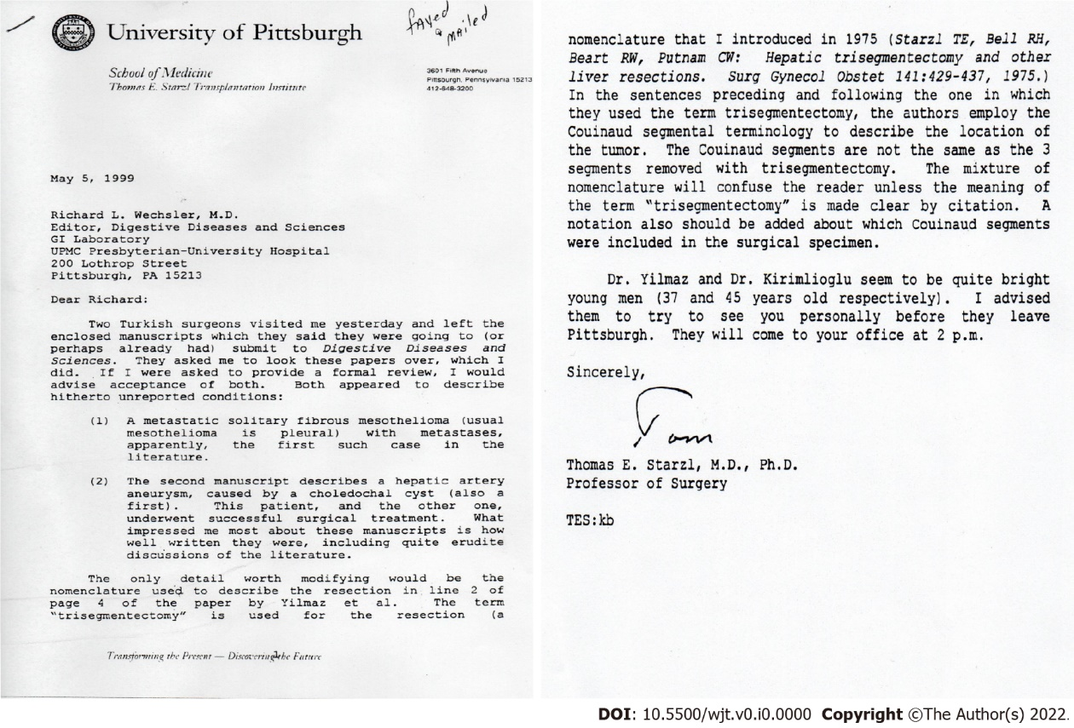
Figure 1 Letter from Professor Starzl to the editor of Digestive Diseases and Sciences (original version).

