Name of journal: World Journal of Gastroenterology
ESPS Manuscript NO: 15480
Columns: ORIGINAL ARTICLE

Basic Study
CD97 promotes gastric cancer cell proliferation and invasion through exosome-mediated MAPK signaling pathway

Li C et al. CD97 exosomes promote gastric cancer bioactivity

Chao Li, Da-Ren Liu, Guo-Gang Li, Hou-Hong Wang, Xiao-Wen Li, Wei Zhang, Yu-Lian Wu, Li Chen

Chao Li, Da-Ren Liu, Guo-Gang Li, Hou-Hong Wang, Xiao-Wen Li, Yu-Lian Wu, Li Chen, Department of Surgery, Second Affiliated Hospital, College of Medicine, Zhejiang University, Hangzhou 310021, Zhejiang Province, China

Wei Zhang, Department of Orthopedics, Second Affiliated Hospital, College of Medicine, Zhejiang University, Hangzhou 310021, Zhejiang Province, China

Author contributions: Li C and Liu DR contributed equally to this article; Chen L and Wu YL designed the study; Li C, Liu DR, Li GG, Wang HH, Li XW and Zhang W carried out the study; Li C, Liu DR, Guogang Li, Wu YL and Chen L analyzed the data; Li C and Liu DR wrote the paper; all the authors contributed to the preparation of the manuscript.

Supported by National Natural Science Foundation of China, No. 81101837; Research Fund for the Doctoral Program of Higher Education of China, No. 20110101120129; and Zhejiang Medical Health Science and Technology Plan, No. 2013KYB124.

Ethics approval: The authors have declared that no human sample, human or animal subjects are involved in this study.

Institutional animal care and use committee: The authors have declared that no animal was used in this study.

Biostatistics statement: The statistical methods of this study were reviewed by Guogang Li from Second Affiliated Hospital, College of Medicine, Zhejiang University.

Conflict-of-interest: The authors have declared that no competing interests exist.

Data sharing: Technical appendix, statistical code, and dataset available from the corresponding author at wuyulian@medmail.com.cn or chenli_hz@yahoo.com.

Open-Access: This article is an open-access article which was selected by an in-house editor and fully peer-reviewed by external reviewers. It is distributed in accordance with the Creative Commons Attribution Non Commercial (CC BY-NC 4.0) license, which permits others to distribute, remix, adapt, build upon this work non-commercially, and license their derivative works on different terms, provided the original work is properly cited and the use is non-commercial. See: http://creativecommons.org/licenses/by-nc/4.0/

Correspondence to: Yu-Lian Wu, PhD, Department of Surgery, Second Affiliated Hospital, College of Medicine, Zhejiang University, No. 88 Jiefang Road, Hangzhou 310021, Zhejiang Province, China. wuyulian@medmail.com.cn
Telephone: +86-571-87783582
Fax: +86-571-87022776
Received: November 27, 2014
Peer-review started: November 28, 2014
First decision: December 26, 2014
Revised: January 14, 2015
Accepted: February 12, 2015

Article in press:
Published online:

Abstract
AIM: To investigate the mechanism underlying the promoting role of CD97 in gastric cancer cell proliferation and invasion.

METHODS: Two kinds of exosomes released by gastric cancer cells with high (SGC/wt) or low (SGC/kd) CD97 expression were isolated by ultracentrifugation and identified by electron microscopy and western blot analysis. The influences of the two exosomes on gastric cancer cell proliferation and invasion were investigated through proliferation and matrigel invasion assay. Subsequently, exosomal miRNAs were isolated from the two samples and their miRNA profiles were compared via microarray assay analysis. Reverse transcription-quantitative real-time polymerase chain reaction was used to validate the microarray assay. Target genes of the differently expressed microRNAs were predicted based on five independent algorithms and were then subjected to gene oncology enrichment and Kyoto encyclopedia of genes and genomes (KEGG) pathway analysis. After identifying the pathway that was the most likely altered, tumor cells were treated with the two exosomes of different concentrations, and the pathway activation was identified through western blot analysis.

RESULT: Exosomes isolated from SGC/wt cells significantly promoted tumor cell proliferation in a dose-dependent manner in vitro. SGC/wt exosomes also dramatically elevated the invasiveness of both SGC/wt (129.67 ± 8.327 vs 76.00 ± 5.292, P < 0.001) and SGC/kd (114.52 ± 9.814 vs 45.73 ± 4.835, P < 0.001) cells as compared to the exosomes released by SGC/kd cells. Microarray assay of the two exosomes revealed that 62 miRNAs were differently regulated with a signal intensity of > 500 and a false discovery rate < 0.05. The following KEGG analysis defined MAPK signaling pathway as the most likely candidate pathway that regulated tumor cells proliferation and invasion. Through western blot analysis, dramatic up-regulations of phosphorylated MAPKs, including extracellular signal-regulated kinase, Jun NH2-terminal kinase, and p38 mitogen-activated protein kinase, were detected in a dose-dependent manner in the SGC/wt exosomes treated groups, confirming the activation of MAPK signaling pathway stimulated by SGC/wt exosomes.

CONCLUSION: CD97 promotes gastric cancer cell proliferation and invasion in vitro through exosome-mediated MAPK signaling pathway, and exosomal miRNAs are probably involved in the CD97-associated pathway activation.

Keywords: CD97; Exosome; miRNA; Proliferation; Invasion; Gastric cancer

© The Author(s) 2015. Published by Baishideng Publishing Group Inc. All rights reserved.

Core tip: CD97, belonging to the epidermal growth factor-seven-transmembrane subfamily, has been found to promote proliferation and invasion of gastric cancer cells. However, the underlying mechanism is poorly understood. In this study, we found that exosomes isolated from gastric cancer cells of high CD97 expression promoted tumor cell proliferation and invasion. Furthermore, through microarray and western blot analysis, MAPK signaling pathway activation was observed when cells were treated with those exosomes. These results indicated that CD97 promotes gastric cancer cell proliferation and invasion in vitro, at least in part, through exosome-mediated MAPK signaling pathway, and exosomal miRNAs are probably involved in the CD97-associated pathway activation.

Li C, Liu DR, Li GG, Wang HH, Li XW, Zhang W, Wu YL, Chen L. CD97 promotes gastric cancer cell proliferation and invasion through exosome-mediated MAPK signaling pathway. World J Gastroenterol 2015; In press
INTRODUCTION
CD97 is a member of the epidermal growth factor-seven-transmembrane subfamily, which belongs to the class B G-protein-coupled receptors^{[1,2]}. Originally, CD97 was found to be expressed by hematopoietic cells^{[3,4]}, then abundantly detected in numerous carcinomas including gastric, colorectal, thyroid, esophageal, pancreatic, and oral squamous cell carcinomas^{[5-10]}. In gastric cancer, previous studies have demonstrated that an enhanced CD97 expression is associated with the dedifferentiation and aggressiveness of tumor cells and directly correlates with the clinicopathological parameters such as TNM stage^{[11,12]}. Recently, we revealed that CD97 small isoform was associated with increased invasiveness in vitro as well as elevated local growth and metastatic spread of gastric cancer in vivo^{[13]}. However, the mechanisms underlying these promoting roles of CD97 are still poorly understood.
Exosomes are spherical and bilayered vesicles with a diameter of 30-100 nm, which are released extracellularly upon fusion of multivesicular bodies with plasma membrane^{[14,15]}. Many types of cells including tumor cells, lymphocytes, epithelial cells, and stem cells produce exosomes^{[15-18]}. During the past few years, an increasing number of studies have demonstrated that tumor-derived exosomes play important roles on tumor formation and progression. In breast and gastric cancer, it was observed that tumor exosomes could enhance tumor cell proliferation^{[19,20]}. Moreover, exosomes from breast and pancreatic cancer were found to contribute to form a niche which promoted tumor metastasis^{[21,22]}. Based on these observations, we speculate that tumor exosomes might be involved in the CD97-dependent promotion of biological behaviors of gastric cancer cells.
In addition, exosomes are enriched in proteins, lipids and nucleic acids including miRNA, mRNA and other non-coding RNAs^{[23,24]}. When internalized by recipient cells, exosomes deliver these biological molecules, which still maintain their bioactivity, to other cells, thus mediating intercellular communication^{[18,25]}. One topic of considerable interests is that these transferred exosomal miRNAs may participate in the regulation of biological behaviors of target cells. Yang et al^{[26]} found that macrophages regulated the invasiveness of breast cancer cells through exosome-mediated miRNAs delivery. Likewise, Rana et al^{[27]} reported that transferred exosomal miRNAs predominantly modulated pre-metastatic organ cells, thus facilitating metastasis of pancreatic cancer. In gastric cancer, tumor cells also produce a large number of exosomes that contain abundant miRNAs^{[20,28]}. Thus, it will be of great significance to further investigate the possible role of exosomal miRNAs in the CD97-dependent regulation of tumor cell behaviors.
In the present study, by employing ultracentrifugation, two kinds of exosomes from gastric cancer cells of high CD97 expression and cells with stable CD97 knockdown were isolated, and their effects on cell proliferation and invasion were investigated. Moreover, miRNA profiles of the two exosomes were compared by microarray assay and significantly regulated signaling pathways related to exosomes were predicted and verified.

MATERIALS AND METHODS
Cell culture
Stomach adenocarcinoma cell line SGC-7901 was purchased from ATCC (www.atcc.org). Cells from SGC-7901 were cultured in RPMI-1640 medium (Genom Biologic, Hangzhou, China) supplemented with 10% fetal bovine serum (FBS, Sijiqing Biologic, Hangzhou, China) and 1% penicillin/streptomycin (Genom Biologic). Cells were incubated in a standard humidified incubator in 5% CO₂ at 37 ˚C and passaged every 3-5 d using trypsin-EDTA (Genom Biologic).

Transfection and clones selection
Four miRNA candidate target sequences of human CD97 gene and the non-silencing sequence (Table 1) were designed and cloned into pcDNA6.2-GW/EmGFP-miR vector (Invitrogen, Shanghai, China). The SGC-7901 cells were transfected and selected using 4 μg/mL of Blasticidin S HCl (Life Technologies) as described previously^{[13]}. Down-regulation of CD97 was confirmed by reverse transcription polymerase chain reaction (RT-PCR) and western blot analysis.

Total RNA extraction and reverse transcription-polymerase chain reaction
Total RNAs from gastric cancer SGC-7901 wild-type cells (SGC/wt), non-silencing vector bearing cells (SGC/ns) and stable CD97 knockdown cells (SGC/kd) cells were extracted using Trizol reagent (Invitrogen) according to the manufacturer’s protocol. cDNA synthesis and PCR assay was performed as previously described using primers suitable for amplification of all three CD97 isoforms^{[13]}. PCR products were visualized on a 1% agarose gel with 0.05% ethidium bromide.

miRNA extraction and Reverse transcription-quantitative real-time polymerase chain reaction
Total RNAs including miRNA were extracted from exosomes of SGC/wt and SGC/kd using miRNeasy Mini kit (Qiagen) following the manufacture’s instruction. cDNA was synthesized using miScript II RT Kit (Qiagen). The reverse transcription reaction system included 4 μL of 5 × miScript HiSpec buffer, 2 μL of 10 × miScript nucleics mix, 2 μL of miScript reverse transcriptase mix, 5 μL of template RNA and 7 μL of RNase-free water. The mixture were Incubated for 60 min at 37 ˚C and followed by 95 ˚C for 5 min to inactivate the reaction. qPCR was performed using miScript SYBR Green PCR Kit (Qiagen) in an ABI PRISM Stepone Plus Sequence Detection System (Applied Biosystems, Foster City, CA, United States) in accordance with the manufacturer’s protocol. Briefly, 12.5 μL of 2 × QuantiTect SYBR Green PCR master mix, 2.5 μL of 10 × miScript universal primer, 2.5 μL of 10 × miScript primer assay, 2 ng of diluted template cDNA and RNase-free water added to 20 μL were mixed. The mixture were then incubated in a 96-well plate at 95˚C for 15 min, followed by 40 cycles of 94˚C for 15 s, 55˚C for 30 s and 70˚C for 30 s. The expression differences of miRNAs between SGC/wt and SGC/kd exosomes were analyzed using ΔΔCT method and were normalized by RNU6B expression^{[29]}.

Exosome isolation
Cells were cultured until 80% confluent when growth medium was replaced by serum-free medium, and the medium was collected after 2 d of incubation. Exosomes were then isolated by differential centrifugation as previously described^{[30]}. Briefly, the conditioned medium was centrifuged at 300 × g for 10 min at 4 °C to pellet cells and subsequently 16500 × g for 20 min to further remove cells and cell debris. Then, supernatants were filtered through 0.20 μm filters to remove particles larger than 200 nm. Exosomes were pelleted by ultracentrifugation (Beckman Coulter, Fullerton, CA, United States) at 120000 × g for 70 min at 4°C, washed in PBS and pelleted by ultracentrifugation at 120000 × g for 70 min at 4°C again. The final exosome pellets were resuspended in PBS and stored at -80 °C until use. The total exosomal protein concentration was measured using Enhanced BCA Protein Assay Kit (Beyotime, China).

Exosome identification by electron microscopy
Exosomes obtained via differential centrifugation were resuspended in 1% glutaraldehyde in PBS (pH 7.4). A 20 μL drop of suspension was pipetted onto electron-microscopy grid coated with formvar carbon and allowed to stand for 1 min at room temperature. Excess fluid was removed with a piece of Whatman filter paper. The sample was then stained with 2% phosphotungstic acid for 1min, allowed to dry under an electric incandescent lamp for 10 min and viewed using Philips tecnai 10 transmission electron microscopy (Philips, Netherlands). Exosome size was measured by scale bar.
Cell Proliferation Assay
Tumor cell proliferation was determined by 3-(4,5-dimethyl-2-yl)-5-(3-arboxymethoxyphenyl)-2-(4-sulfophenyl)-2H-etrazolium (MTS) assays. Cells were plated in 96-well plates at 5 × 10³ cells/well and cocultured with exosomes of different concentration for 24 h. At the time-point, medium was replaced by 100 μL serum-free medium, and 20 μL MTS solution (Promega, Madison, WI, United States) was added to each well. After incubated in a humidified incubator for another 2h, the plates were measured at 490 nm using Microplate Reader (Bio-rad, Hercules, CA, United States). The cell proliferation was expressed using the optical densities obtained at each concentration.

Cell Invasion Assays
Invasion assays were performed in 24-well TranswellTM chambers (Costar), which were separated by polycarbonate filters with 8 μm pore size between the upper and lower culture compartments. For tumor cell invasion, the upper chamber was coated with Matrigel matrix (0.8 mg/mL, BD Biosciences) before seeding cells. A number of 1.0 × 10⁵ of exosome-treated cells in RPMI-1640 medium were added to each of the upper chamber and the lower chamber was filled with medium with 10% FBS. After 36h incubation in a 5% CO₂ atmosphere at 37˚C, the non-invading cells were wiped off with cotton swabs and the invading cells were fixed and stained with 0.2% crystal violet (Sigma). Invaded cells were counted by light microscopy (Leica) in four separate high-power fields per filter.

Western blot analysis
Proteins were harvested and resolved on a 10% sodium dodecyl sulfate polyacrylamide gel electrophoreses (SDS-PAGE), and further transferred to PVDF membrane (Millipore, Billerica, MA, United States). After blocking with 5% non-fat milk for 2 h, the membranes were incubated overnight at 4 ˚C with antibodies specific against CD97 (Abnova), β-actin, CD9, hsp70, total-p38, -ERK, -JNK or phosphorylated -p38, -ERK, and –JNK (all from Santa Crutz), respectively. Horseradish peroxidase (HRP)-conjugated goat anti-mouse or goat anti-rabbit IgGs was applied as secondary antibody for 1h at room temperature. The immunoreactive protein bands were identified by luminescent visualization using an ECL kit (Millipore). Signal intensity was measured using a Bio-Rad XRS chemiluminescence detection system (Bio-Rad).

MicroRNA microarray assay
Total RNAs from exosomes was isolated using miRNeasy Mini Kit (Qiagen, Germany). MicroRNA microarray analysis following the miRbase v20.0 was performed by LC Sciences (Hangzhou, China; http://www.lc-bio.com/). Briefly, total RNA samples were 3’-extended with a poly(A) tail and hybridized overnight at 34 °C on a µParaflo microfluidic chip using 100L 6 × SSPE buffer (0.90 mol/L NaCl, 60 mmol/L Na2HPO4, 6 mmol/L EDTA, pH 6.8) containing 25% formamide. After hybridization, tag-conjugating Cy3 dye was circulated through the microfluidic chip for dye staining. Fluorescence images were then collected and digitized using Array-Pro image analysis software (Media Cybernetics, Bethesda, MD). Data analysis was started by first subtracting the background and then normalizing the signals using a LOWESS filter (Locally-weighted Regression). The normalized microarray data were validated by reverse transcription-quantitative real-time polymerase chain reaction (RT-qPCR).

Target genes prediction of differently expressed microRNAs
Five computational prediction algorithms (TargetScan, miRanda, PITA, RNAhybrid and microTar) were used to predict targets of the significant changed miRNAs identified in the microarray analysis. Following comparison of all datasets, a subset of genes that were targeted by more than four algorithms was generated.

GO enrichment and kegg pathway analysis of target genes
To comprehensively describe properties of the targets, the putative genes were subjected to gene oncology (GO) enrichment and Kyoto encyclopedia of genes and genomes (KEGG) pathway analysis based on DAVID 6.7 software (http://david.abcc.ncifcrf.gov/home.jsp). The Fisher’s exact test and χ² test were used to select the significant GO categories and signaling pathways. The threshold of significance was defined by P value with P < 0.001 or P < 0.05 regarding as significance for GO and KEGG analysis, respectively.

Statistical analysis
Statistical analysis was performed with the SPSS 19.0 software. Differences were examined using Student’s t-test or one-way analysis of variance. All experiments were performed at least in triplicates and were presented as mean ± SD with a P value of 0.05 or less considered as statistically significant.

RESULTS
Generation of transfectants with Stable CD97 knockdown
For this purpose, human gastric carcinoma cell line SGC-7901, which shows relatively high CD97 expression^{[13,31]}, was selected for stable transfection with miR-vectors targeting the site of CD97. After transfection, stable clones were selected and CD97 levels were evaluated by RT-PCR and western blot analysis. As shown in Figure 1, the CD97 knockdown cells (SGC/kd), which were generated from candidate 4, displayed a dramatic loss of CD97 in both mRNA and protein level comparing to the wile-type cells (SGC/wt) or the non-silencing vector bearing cells (SGC/ns). Therefore, this kind of cells was selected for the following experiments.

Isolation and identification of tumor-derived exosomes
Based on the unique size and density, exosomes released by SGC/wt and SGC/kd cells were isolated by ultracentrifugation and observed through electron microscopy. The isolated exosomes were small closed vesicles limited by a lipid bilayer, and their diameters ranged from 30 to 100 nm under electron microscopy (Figure 2A and B), which was consistent with the reported size of exosome^{[15]}. In addition, Hsp70 and CD9, the published exosomal markers^{[32,33]}, were detected in thesee membrane vesicles (Figure 2C), further confirming our successful isolation of tumor exosomes.

SGC/wt-derived exosomes promote tumor cell proliferation in vitro
To investigate effects of the two exosomes on proliferation of gastric cancer cells, we measured viability of cells treated with different concentrations of exosomes (0, 50, 100, 200 and 400 μg/mL) for 24h in vitro. MTS assay showed that SGC/wt-derived exosomes (wt-exo) increased proliferation of both SGC/wt and SGC/kd cells in a dose-dependent manner. However, in the SGC/kd-derived exosomes (kd-exo)-treated groups, no significant difference was observed. It is noteworthy that the promoting effect of wt-exo on SGC/wt cells was not as significant as on SGC/kd clones, implying SGC/kd cells were more sensitive to wt-exo stimulation when compared to SGC/wt cells (Figure 3A).

SGC/wt-derived exosomes promote tumor cell invasion in vitro
To evaluate effects of the two kinds of exosomes on gastric cancer cell invasion, SGC/wt and SGC/kd cells were incubated for 4 h with serum-free medium containing 200 μg/mL of indicated exosomes or equal amount of bull serum albumin (BSA) as control, then seeded on chambers coated with Matrigel matrix. After 36 h incubation in the upper chamber, the cells that had invaded through Matrigel to the undersurface of Transwell filters were stained and counted. Upon comparison with kd-exo or BSA control, wt-exo significantly enhanced the invasiveness of both SGC/wt and SGC/kd cells, especially for SGC/kd cells that generated 2.5-fold more invaded cells. In the kd-exo stimulated groups, however, neither the SGC/wt cells nor the SGC/kd cells were dramatically influenced in regard to cell invasiveness (Figure 3B and C).

MicroRNA microarray analysis and validation of differently expressed miRNAs by RT-qPCR
Exosomes are abundant of miRNAs that can be transferred from one cell to another via exosome secretion and internalization. These transferred miRNAs maintain their biological functions in the recipient cells. To determine whether exosomal miRNAs were relevant to cell biological behaviors, we compared their miRNA profiles across SGC/wt and SGC/kd exosomes via microarray assay. Analysis of microarray data indicated that a total of 265 detectable miRNA transcripts were present in SGC/wt and SGC/kd exosomes, of which 83 miRNAs were with a signal intensity of > 500. In order to reduce false negative rate, we considered differently regulated miRNAs as those with a fold change of more than 1.5 times and a false discovery rate (FDR) of less than 0.05 according to the microarray data. As displayed in Figure 4A, 62 miRNAs were differently regulated, among which 36 were up-regulated and 26 were down-regulated in SGC/wt exosomes comparing to SGC/kd exosomes. Aiming to verify the microarray assay data, four miRNAs displaying either an increased (miR-2861, miR-4734) or decreased (miR-4728-5p, miR-6165) expression were selected to perform RT-qPCR analysis. The outcomes confirmed the microarray data and indicated a positive correlation between the quantity of transcripts measured by microarray and RT-qPCR assay (Figure 4B).

Target gene prediction and GO and KEGG pathway enrichments of the predicted genes
To identify potential target genes of the 62 miRNAs differently expressed between SGC/wt and SGC/kd exosomes, we performed target gene prediction using five established algorithms. A total of 5746 putative targets were identified (data not shown). To better understand the functions of the predicted genes, those targets were subjected to GO functions from three ontologies: cellular component, molecular function and biological process. As shown in Figure 5, the high-enriched GO categories were nucleotide binding, plasma membrane, regulation of RNA metabolic process, regulation of transcription, and intracellular signaling cascade. These categories were mainly involved in cell metabolism, proliferation, signal transduction, apoptosis, and homeostatic process. Furthermore, these targets were classified according to KEGG functional annotations to identify pathways that might be actively regulated. The results suggested 38 relevant KEGG pathways, and the top three pathways enriched were pathways in cancer, cytokine-cytokine receptor interaction and MAPK signaling pathway (Table 2). It is worth to note that, among the list of high-enriched pathways, pathways in cancer were prominent, especially the MAPK signaling pathway. Thus, it is necessary to further investigate whether CD97 promotes tumor cell proliferation and invasion through exosome-mediated MAPK signaling pathway.

Western blot analysis verification the activation of MAPK Signaling Pathway
To verify the MAPK signaling pathway activation, expression of three best-characterized MAPKs, including extracellular signal-regulated kinase ERK), Jun NH2-terminal kinase (JNK), and p38 mitogen-activated protein kinase (p38), were determined by western blot analysis. The results revealed that SGC/wt exosomes caused dramatic up-regulation of phosphorylated ERK, JNK and p38 expression in a dose-dependent manner. On the other hand, though SGC/kd exosomes enhanced the expression of these three phosphorylated proteins, their expressions were much weaker when compared to SGC/wt exosomes stimulated groups (Figure 6). These observations demonstrated that exosomes derived from SGC/wt cells, which show high CD97 expression, could activate the MAPK signaling pathway, and the pathway activation might further lead to elevated proliferativeness and invasiveness of tumor cells.

DISCUSSION
Although it is well studied that overexpressed CD97 plays important roles on gastric cancer formation and progression, mechanisms underlying the functions are poorly investigated. In order to identify the possible mechanism, we isolated exosomes from wild type gastric cancer SGC-7901 cells with high CD97 expression and cells from SGC-7901 with stable CD97 knockdown. We demonstrated in this study that exosomes from wild type cells, but not from CD97 knockdown cells, significantly promoted tumor cell proliferation and invasion. Furthermore, through microarray and western blot analysis, we found the enhanced proliferation and invasion ability might be induced by the exosome-mediated activation of MAPK signaling pathway.
During the past few years, many studies have demonstrated that tumor-derived exosomes are involved in a wide range of tumor pathophysiological processes through numerous ways, such as promoting tumor growth and metastasis, activating certain kinds of signaling pathways, and exerting detrimental effects on anti-tumor immune system^{[19-21,34,35]}. The present study further suggested that the effects of exosomes on tumor biological behaviors depend on their parent cells. It was revealed here that exosomes from SGC/wt cells with high CD97 expression, significantly increased gastric cancer cell proliferation and invasion; whereas, exosomes from SGC/kd cells with low CD97 expression did not show similar effects. Depending on these observations, it is arguable that CD97 increases the proliferativeness and invasiveness of tumor cells, at least in part, through releasing CD97-related exosomes. We speculate that those two exosomes contain different biological molecules that biomaterials in SGC/wt exosomes have higher malignant-promoting capacities as compared to that of SGC/kd exosomes; and upon internalization, these biomaterials are transferred to the recipient cells, resulting in elevated malignant behaviors.
miRNAs are small, non-coding RNA molecules that regulate the activity of complementary mRNAs and play important roles in a wide range of physiologic and pathologic processes^{[36]}. Microarray analysis of the two exosomes showed significant differences between their exosomal miRNA profiles. The GO enrichments showed that the predicted targets were mainly located in cell membrane and organelles and significantly involved in cell metabolism, proliferation and signal transduction. As for KEGG analysis, results suggested MAPK signaling pathway was prominent. The subsequent western blotting verified the MAPK signaling pathway activation induced by SGC/wt exosomes. Thus, it is reasonable that the promoting role of CD97-related exosomes depends on the activation of MAPK signaling pathway and the activation is probably indirectly induced by the exosomal miRNAs.
In addition to the nucleic acids, exosomes comprise abundant proteins. In a study conducted by Liang et al^{[37]}, thousands of proteins were identified in exosomes released by two ovarian cancer cell lines, OVCAR-3 and IGROV1, and some proteins were tissue specific or associated with tumorigenesis or metastasis. Besides, exosomes from human breast and colorectal cancer cells were reported to contain full-length, signaling-competent epidermal growth factor receptor (EGFR) ligands^{[38]}. In that study, the researchers found that exosomes expressing individual EGFR ligands displayed different bioactivities. To be specific, exosomes with higher amphiregulin levels exhibited greater invasive potential than other EGFR ligand-contained exosomes, implying exosomes participate in diverse tumor biological activities via certain exosomal proteins. In the present study, though microarray analysis gave hints that the exosomal miRNAs were involved in the MAPK signaling pathway activation, possibilities that exosomal proteins directly regulated the signaling pathway and/or tumor biological behaviors could not be excluded. Thus, further studies are needed to focus on the relations between exosomal proteins and diverse biological behaviors of gastric cancer related to CD97.
Apart from the effects exerted on proliferation and invasion, tumor-derived exosomes were also proved to contribute to the establishment of pre-metastatic niche, which is a suitable microenvironment in distant metastatic organs generated by primary tumor prior to arrival of metastatic cells^{[22,39]}. Jung et al^{[22]} reported that depending on CD44v6, tumor exosomes prepared the pre-metastatic niche in distant organs, which allowed a highly metastatic pancreatic cells ASML embedding and growth. Recently, Rana et al^{[27]} suggested that exosomal miRNAs were recovered in pre-metastatic organs, where they dramatically influenced mRNA translation and predominantly modulated pre-metastatic organs to prepare stromal cells for tumor cell hosting. Obviously, tumor exosomes play important roles in the cross-talk between primary tumor and metastatic organ. Our previous study has demonstrated that CD97 small isoform facilitates gastric cancer metastasis in an orthotopically implanted mouse model^{[13]}. Therefore, the contribution of CD97 to metastasizing tumor cells settlement is probably facilitated by the formation of pre-metastatic niche, which may depend on CD97-related exosomes or exosomal miRNAs. However, to the best of our knowledge, there were few studies describing the relationship between CD97-related exosomes and tumor metastasis hitherto, which also merits investigation in our further studies in vivo.
In conclusion, by taking advantage of exosomes isolated from cells of high and low CD97 expression, we demonstrate that CD97 promotes gastric cancer cell proliferation and invasion in vitro, at least in part, through exosome-mediated MAPK signaling pathway, and that exosomal miRNAs are probably involved in the CD97-associated pathway activation. Although exemplified in vitro, these findings are required to be confirmed in other gastric cancer cell types as well as in animal models to have translational relevance.

COMMENTS
Background
Gastric cancer is one of the most common and lethal malignancies worldwide. Understanding how gastric cancer formation and progression will be of significant importance to find a way to treat this carcinoma. As a member of the epidermal growth factor-seven-transmembrane subfamily, CD97 has been found to be overexpressed in majority of gastric carcinoma tissues and been demonstrated to promote gastric cancer cell proliferation and invasion. However, the underlying mechanism remains unclear.

Research frontiers
During the past few years, an increasing number of studies have demonstrated that tumor-derived exosomes play important roles on tumorigenesis and tumor progression. In gastric cancer, it was observed that tumor exosomes could enhance tumor cell proliferation.

Innovations and breakthroughs
Previous studies have demonstrated that CD97 is involved in gastric cancer progression, but the underlying mechanism is less studied. In the present study, the authors combined CD97 and exosomes, and found that CD97 promotes gastric cancer cell proliferation and invasion in vitro through exosome-mediated MAPK signaling pathway. In addition, they suggested exosomal miRNAs are involved in the CD97-associated pathway activation. These findings will be helpful for understanding the role of CD97 in gastric cancer formation and progression.

Applications
In understanding the mechanism of CD97-dependent promotion of proliferation and invasion in gastric cancer, this study may represent a future strategy as a diagnostic biomarker and/or a way to improve clinical treatment for gastric cancer.

Terminology
Exosomes are spherical and bilayered vesicles with a diameter of 30-100 nm, which are released extracellularly upon fusion of multivesicular bodies with plasma membrane. Many kinds of cells including tumor cells, lymphocytes, epithelial cells, and stem cells can produce exosomes.

Peer-review
It is a well-written and a well-designed study, which showed, in an elegant manner, the potential role of CD97 and MAPK signaling in gastric cancer cell proliferation and invasion. This is thought to be interesting and excellent novel study. These findings must be demonstrated in vivo to have translational relevance.

REFERENCES
1 Galle J, Sittig D, Hanisch I, Wobus M, Wandel E, Loeffler M, Aust G. Individual cell-based models of tumor-environment interactions: Multiple effects of CD97 on tumor invasion. Am J Pathol 2006; 169: 1802-1811 [PMID: 17071601 DOI: 10.2353/ajpath.2006.060006]
2 Aust G, Steinert M, Schütz A, Boltze C, Wahlbuhl M, Hamann J, Wobus M. CD97, but not its closely related EGF-TM7 family member EMR2, is expressed on gastric, pancreatic, and esophageal carcinomas. Am J Clin Pathol 2002; 118: 699-707 [PMID: 12428789 DOI: 10.1309/A6AB-VF3F-7M88-C0EJ]
3 Martens GJ. Molecular biology of G-protein-coupled receptors. Prog Brain Res 1992; 92: 201-214 [PMID: 1338880 DOI: 10.1016/S0079-6123(08)61176-0]
4 Eichler W, Aust G, Hamann D. Characterization of an early activation-dependent antigen on lymphocytes defined by the monoclonal antibody BL-Ac(F2). Scand J Immunol 1994; 39: 111-115 [PMID: 8290889 DOI: 10.1111/j.1365-3083.1994.tb03348.x]
5 Veninga H, Becker S, Hoek RM, Wobus M, Wandel E, van der Kaa J, van der Valk M, de Vos AF, Haase H, Owens B, van der Poll T, van Lier RA, Verbeek JS, Aust G, Hamann J. Analysis of CD97 expression and manipulation: antibody treatment but not gene targeting curtails granulocyte migration. J Immunol 2008; 181: 6574-6583 [PMID: 18941248 DOI: 10.4049/jimmunol.181.9.6574]
6 Han SL, Xu C, Wu XL, Li JL, Liu Z, Zeng QQ. The impact of expressions of CD97 and its ligand CD55 at the invasion front on prognosis of rectal adenocarcinoma. Int J Colorectal Dis 2010; 25: 695-702 [PMID: 20339853 DOI: 10.1007/s00384-010-0926-5]
7 Steinert M, Wobus M, Boltze C, Schütz A, Wahlbuhl M, Hamann J, Aust G. Expression and regulation of CD97 in colorectal carcinoma cell lines and tumor tissues. Am J Pathol 2002; 161: 1657-1667 [PMID: 12414513 DOI: 10.1016/S0002-9440(10)64443-4]
8 Aust G, Eichler W, Laue S, Lehmann I, Heldin NE, Lotz O, Scherbaum WA, Dralle H, Hoang-Vu C. CD97: a dedifferentiation marker in human thyroid carcinomas. Cancer Res 1997; 57: 1798-1806 [PMID: 9135025]
9 Hoang-Vu C, Bull K, Schwarz I, Krause G, Schmutzler C, Aust G, Köhrle J, Dralle H. Regulation of CD97 protein in thyroid carcinoma. J Clin Endocrinol Metab 1999; 84: 1104-1109 [PMID: 10084602]
10 Jaspars LH, Vos W, Aust G, Van Lier RA, Hamann J. Tissue distribution of the human CD97 EGF-TM7 receptor. Tissue Antigens 2001; 57: 325-331 [PMID: 11380941 DOI: 10.1034/j.1399-0039.2001.057004325.x]
11 Liu Y, Chen L, Peng SY, Chen ZX, Hoang-Vu C. Role of CD97(stalk) and CD55 as molecular markers for prognosis and therapy of gastric carcinoma patients. J Zhejiang Univ Sci B 2005; 6: 913-918 [PMID: 16130195 DOI: 10.1631/jzus.2005.B0913]
12 Liu Y, Chen L, Peng S, Chen Z, Gimm O, Finke R, Hoang-Vu C. The expression of CD97EGF and its ligand CD55 on marginal epithelium is related to higher stage and depth of tumor invasion of gastric carcinomas. Oncol Rep 2005; 14: 1413-1420 [PMID: 16273233]
13 Liu D, Trojanowicz B, Ye L, Li C, Zhang L, Li X, Li G, Zheng Y, Chen L. The invasion and metastasis promotion role of CD97 small isoform in gastric carcinoma. PLoS One 2012; 7: e39989 [PMID: 22768192 DOI: 10.1371/journal.pone.0039989]
14 Schorey JS, Bhatnagar S. Exosome function: from tumor immunology to pathogen biology. Traffic 2008; 9: 871-881 [PMID: 18331451 DOI: 10.1111/j.1600-0854.2008.00734.x]
15 Vlassov AV, Magdaleno S, Setterquist R, Conrad R. Exosomes: current knowledge of their composition, biological functions, and diagnostic and therapeutic potentials. Biochim Biophys Acta 2012; 1820: 940-948 [PMID: 22503788 DOI: 10.1016/j.bbagen.2012.03.017]
16 Andre F, Schartz NE, Movassagh M, Flament C, Pautier P, Morice P, Pomel C, Lhomme C, Escudier B, Le Chevalier T, Tursz T, Amigorena S, Raposo G, Angevin E, Zitvogel L. Malignant effusions and immunogenic tumour-derived exosomes. Lancet 2002; 360: 295-305 [PMID: 12147373 DOI: 10.1016/S0140-6736(02)09552-1]
17 Escrevente C, Keller S, Altevogt P, Costa J. Interaction and uptake of exosomes by ovarian cancer cells. BMC Cancer 2011; 11: 108 [PMID: 21439085 DOI: 10.1186/1471-2407-11-108]
18 Zhu W, Huang L, Li Y, Zhang X, Gu J, Yan Y, Xu X, Wang M, Qian H, Xu W. Exosomes derived from human bone marrow mesenchymal stem cells promote tumor growth in vivo. Cancer Lett 2012; 315: 28-37 [PMID: 22055459 DOI: 10.1016/j.canlet.2011.10.002]
19 Koga K, Matsumoto K, Akiyoshi T, Kubo M, Yamanaka N, Tasaki A, Nakashima H, Nakamura M, Kuroki S, Tanaka M, Katano M. Purification, characterization and biological significance of tumor-derived exosomes. Anticancer Res 2005; 25: 3703-3707 [PMID: 16302729]
20 Qu JL, Qu XJ, Zhao MF, Teng YE, Zhang Y, Hou KZ, Jiang YH, Yang XH, Liu YP. Gastric cancer exosomes promote tumour cell proliferation through PI3K/Akt and MAPK/ERK activation. Dig Liver Dis 2009; 41: 875-880 [PMID: 19473897 DOI: 10.1016/j.dld.2009.04.006]
21 Suetsugu A, Honma K, Saji S, Moriwaki H, Ochiya T, Hoffman RM. Imaging exosome transfer from breast cancer cells to stroma at metastatic sites in orthotopic nude-mouse models. Adv Drug Deliv Rev 2013; 65: 383-390 [PMID: 22921594 DOI: 10.1016/j.addr.2012.08.007]
22 Jung T, Castellana D, Klingbeil P, Cuesta Hernández I, Vitacolonna M, Orlicky DJ, Roffler SR, Brodt P, Zöller M. CD44v6 dependence of premetastatic niche preparation by exosomes. Neoplasia 2009; 11: 1093-1105 [PMID: 19794968]
23 Simons M, Raposo G. Exosomes--vesicular carriers for intercellular communication. Curr Opin Cell Biol 2009; 21: 575-581 [PMID: 19442504 DOI: 10.1016/j.ceb.2009.03.007]
24 Wang K, Zhang S, Weber J, Baxter D, Galas DJ. Export of microRNAs and microRNA-protective protein by mammalian cells. Nucleic Acids Res 2010; 38: 7248-7259 [PMID: 20615901 DOI: 10.1093/nar/gkq601]
25 Théry C, Ostrowski M, Segura E. Membrane vesicles as conveyors of immune responses. Nat Rev Immunol 2009; 9: 581-593 [PMID: 19498381 DOI: 10.1038/nri2567]
26 Yang M, Chen J, Su F, Yu B, Su F, Lin L, Liu Y, Huang JD, Song E. Microvesicles secreted by macrophages shuttle invasion-potentiating microRNAs into breast cancer cells. Mol Cancer 2011; 10: 117 [PMID: 21939504 DOI: 10.1186/1476-4598-10-117]
27 Rana S, Malinowska K, Zöller M. Exosomal tumor microRNA modulates premetastatic organ cells. Neoplasia 2013; 15: 281-295 [PMID: 23479506]
28 Ohshima K, Inoue K, Fujiwara A, Hatakeyama K, Kanto K, Watanabe Y, Muramatsu K, Fukuda Y, Ogura S, Yamaguchi K, Mochizuki T. Let-7 microRNA family is selectively secreted into the extracellular environment via exosomes in a metastatic gastric cancer cell line. PLoS One 2010; 5: e13247 [PMID: 20949044 DOI: 10.1371/journal.pone.0013247]
29 Livak KJ, Schmittgen TD. Analysis of relative gene expression data using real-time quantitative PCR and the 2(-Delta Delta C(T)) Method. Methods 2001; 25: 402-408 [PMID: 11846609 DOI: 10.1006/meth.2001.1262]
30 Lässer C, Eldh M, Lötvall J. Isolation and characterization of RNA-containing exosomes. J Vis Exp 2012; (59): e3037 [PMID: 22257828 DOI: 10.3791/3037]
31 Liu D, Trojanowicz B, Radestock Y, Fu T, Hammje K, Chen L, Hoang-Vu C. Role of CD97 isoforms in gastric carcinoma. Int J Oncol 2010; 36: 1401-1408 [PMID: 20428763]
32 Subra C, Grand D, Laulagnier K, Stella A, Lambeau G, Paillasse M, De Medina P, Monsarrat B, Perret B, Silvente-Poirot S, Poirot M, Record M. Exosomes account for vesicle-mediated transcellular transport of activatable phospholipases and prostaglandins. J Lipid Res 2010; 51: 2105-2120 [PMID: 20424270 DOI: 10.1194/jlr.M003657]
33 Cho JA, Lee YS, Kim SH, Ko JK, Kim CW. MHC independent anti-tumor immune responses induced by Hsp70-enriched exosomes generate tumor regression in murine models. Cancer Lett 2009; 275: 256-265 [PMID: 19036499 DOI: 10.1016/j.canlet.2008.10.021]
34 Liu C, Yu S, Zinn K, Wang J, Zhang L, Jia Y, Kappes JC, Barnes S, Kimberly RP, Grizzle WE, Zhang HG. Murine mammary carcinoma exosomes promote tumor growth by suppression of NK cell function. J Immunol 2006; 176: 1375-1385 [PMID: 16424164]
35 Taylor DD, Gerçel-Taylor C. Tumour-derived exosomes and their role in cancer-associated T-cell signalling defects. Br J Cancer 2005; 92: 305-311 [PMID: 15655551 DOI: 10.1038/sj.bjc.6602316]
36 Stefani G, Slack FJ. Small non-coding RNAs in animal development. Nat Rev Mol Cell Biol 2008; 9: 219-230 [PMID: 18270516 DOI: 10.1038/nrm2347]
37 Liang B, Peng P, Chen S, Li L, Zhang M, Cao D, Yang J, Li H, Gui T, Li X, Shen K. Characterization and proteomic analysis of ovarian cancer-derived exosomes. J Proteomics 2013; 80: 171-182 [PMID: 23333927 DOI: 10.1016/j.jprot.2012.12.029]
38 Higginbotham JN, Demory Beckler M, Gephart JD, Franklin JL, Bogatcheva G, Kremers GJ, Piston DW, Ayers GD, McConnell RE, Tyska MJ, Coffey RJ. Amphiregulin exosomes increase cancer cell invasion. Curr Biol 2011; 21: 779-786 [PMID: 21514161 DOI: 10.1016/j.cub.2011.03.043]
39 Psaila B, Lyden D. The metastatic niche: adapting the foreign soil. Nat Rev Cancer 2009; 9: 285-293 [PMID: 19308068 DOI: 10.1038/nrc2621]

P-Reviewer: Aoyagi K, Jacome AAA S-Editor: Qi Y
L-Editor: E-Editor:

Table 1 Four miRNA candidates and negative control sequences of CD97
Oligo | Sequence (5’ -3’ )
1F | TGCTGATGACATTCTGGATGGTGACCGTTTTGGCCACTGACTGACGGTCACCACAGAATGTCAT
1R | CCTGATGACATTCTGTGGTGACCGTCAGTCAGTGGCCAAAACGGTCACCATCCAGAATGTCATC
2F | TGCTGTATCTTCAAGGTTTGAGAGCAGTTTTGGCCACTGACTGACTGCTCTCACCTTGAAGATA
2R | CCTGTATCTTCAAGGTGAGAGCAGTCAGTCAGTGGCCAAAACTGCTCTCAAACCTTGAAGATAC
3F | TGCTGAAGAAAGTAGAGCTCCAGGCCGTTTTGGCCACTGACTGACGGCCTGGATCTACTTTCTT
3R | CCTGAAGAAAGTAGATCCAGGCCGTCAGTCAGTGGCCAAAACGGCCTGGAGCTCTACTTTCTTC
4F | TGCTGAAGATGAACAGGCCAAAGACCGTTTTGGCCACTGACTGACGGTCTTTGCTGTTCATCTT
4R | CCTGAAGATGAACAGCAAAGACCGTCAGTCAGTGGCCAAAACGGTCTTTGGCCTGTTCATCTTC
Negative control
Negative-F | tgctgAAATGTACTGCGCGTGGAGACGTTTTGGCCACTGACTGACGTCTCCACGCAGTACATTT
Negative-R | cctgAAATGTACTGCGTGGAGACGTCAGTCAGTGGCCAAAACGTCTCCACGCGCAGTACATTTc

Table 2 Significant kyoto encyclopedia of genes and genomes pathways enriched for target genes of differently expressed miRNAs
No. | Pathway ID | Pathway description | Target genes with pathway annotation n (%) | P Value
1 | hsa05200 | Pathways in cancer | 179 (2.37) | 5.50 ×10⁻³
2 | hsa04060 | Cytokine-cytokine receptor interaction | 152 (2.01) | 4.00 × 10⁻⁴
3 | hsa04010: | MAPK signaling pathway | 146 (1.93) | 1.13 × 10⁻²
4 | hsa04080 | Neuroactive ligand-receptor interaction | 139 (1.84) | 1.81 × 10⁻²
5 | hsa04510 | Focal adhesion | 121 (1.60) | 2.00 × 10⁻⁴
6 | hsa04810 | Regulation of actin cytoskeleton | 116 (1.54) | 3.79 × 10⁻²
7 | hsa04062 | Chemokine signaling pathway | 107 (1.42) | 5.60 × 10⁻³
8 | hsa04020 | Calcium signaling pathway | 95 (1.26) | 5.88 × 10⁻²
9 | hsa04142 | Lysosome | 72 (0.95) | 2.3 × 10⁻³
10 | hsa04670 | Leukocyte transendothelial migration | 68 (0.90) | 2.36 × 10⁻³

Figure 1 Identification of transfectants with stable CD97 knockdown. A: RT-PCR analysis was used to assess CD97 mRNA levels of SGC/wt, SGC/ns and SGC/kd. The result showed a decreased CD97 level of SGC/kd compared to SGC/wt and SGC/ns; B: The -80 kDa CD97 protein was detected by western blot analysis in total cellular extracts of SGC/wt, SGC/ns and SGC/kd; C: Western blot analysis showed a significant decrease of CD97 protein of SGC/kd. Data are expressed as mean ± SD. ªP < 0.05 vs SGC/wt or SGC/ns. SGC/wt: Wild-type gastric cancer cells SGC-7901; SGC/ns: Non-silencing vector bearing cells; SGC/kd: Stable CD97 knockdown cells generated from SGC-7901.
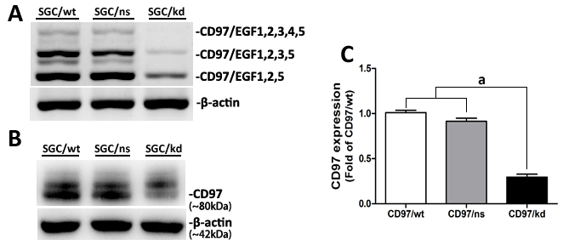

Figure 2 Characterization of tumor-derived exosomes by electron microscopy and western blot analysis. A and B: Exosomes released by SGC/wt or SGC/kd cells were isolated and observed with an electron microscope. The exosomes were small round vesicles limited by a lipid bilayer, and their diameters were mostly between 30 to 100 nm. Scale bars were as indicated; C: Western blot analysis of exosomal lysate proteins. The published exosomal markers, Hsp70 and CD9, were detected in exosomes derived from gastric cancer cells, indicating our successful exosome isolation. SGC/wt-exo: exosomes isolated from SGC/wt cells; SGC/kd-exo: exosomes isolated from SGC/kd cells.
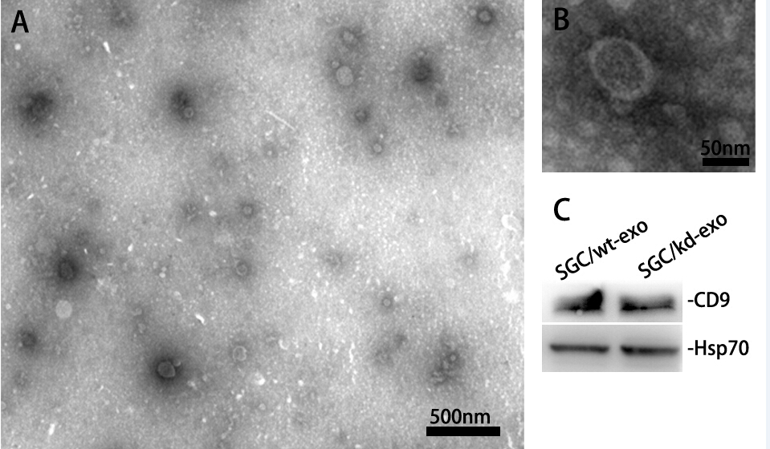

Figure 3 SGC/wt cells-derived exosomes promoted tumor cell proliferation and invasion in vitro. A: A total of 5 × 10³/well SGC/wt and SGC/kd cells were seeded in 96-well plates in RPMI 1640 medium without fetal bovine serum (FBS). After incubating overnight, the cells were treated with wt-exo or kd-exo of different concentrations of 0, 50, 100, 200 and 400 μg/mL for 24h, and cell proliferation was measured by MTS assay. The result showed that wt-exo significantly promoted proliferation of both SGC/wt and SGC/kd cells in a dose-dependent manner. ªP < 0.05, ^{b}P < 0.01 vs kd-exo group; B: SGC/wt and SGC/kd cells were treated with 200 μg/mL of indicated exosomes for 4 h, and seeded on Matrigel matrix coated chambers for invasion assay. Representative crystal violet staining after 36 h invasion showed invaded cells of each group; C: Invaded cell counting revealed that the number of penetrated cells of wt-exo group was significantly higher than that of kd-exo group. ^{b}P < 0.01 vs kd-exo group. Data are expressed as mean ± SD. wt-exo: SGC/wt-derived exosomes; kd-exo: SGC/kd-derived exosomes.
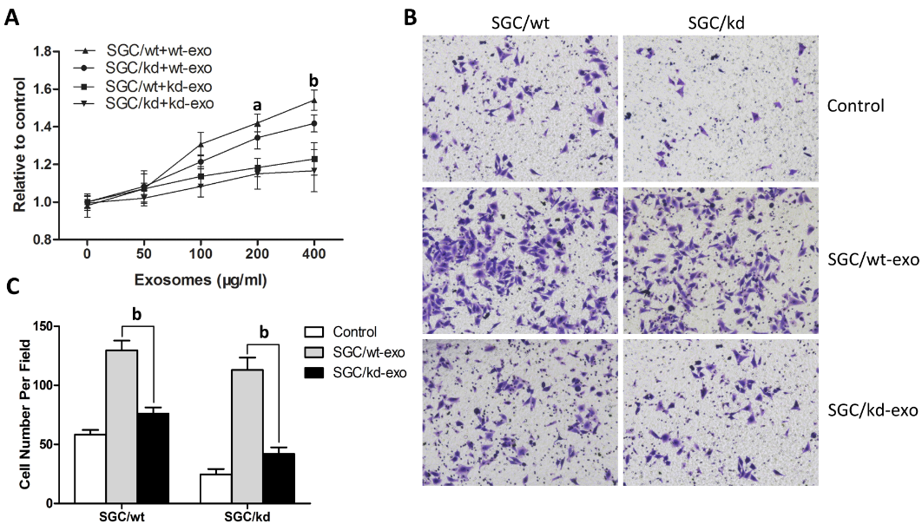

Figure 4 Comparison of miRNA profiles of the two exosomes by microarray analysis and validation of differently expressed miRNAs by RT-qPCR analysis. A: Bar graph showed differently expressed miRNAs in kd-exo by microarray as compared to wt-exo; B: Four miRNAs that displayed either an increased or decreased expression were selected for RT-qPCR validation of microarray assay. The same expression trends were observed between microarray and RT-qPCR for all the miRNAs. wt-exo: SGC/wt-derived exosomes; kd-exo: SGC/kd-derived exosomes.
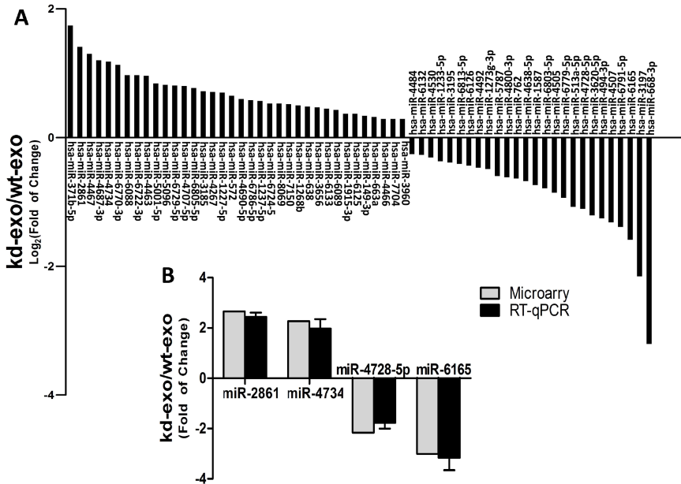

Figure 5 Gene ontology analysis of the significant predicted genes of differently expressed miRNAs. The results were classified in three main categories: cellular component, molecular function, and biological process. The vertical axis indicated the percent of genes in each category. The horizontal axis was the enrichment of Gene ontology (GO).
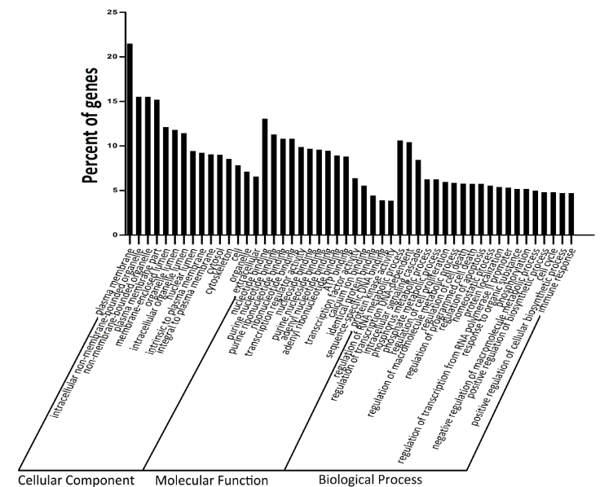

Figure 6 Network between MAPK signaling pathway-related genes and miRNAs. Square represented miRNAs; circle represented target genes; straight line represented miRNA-MAPK signaling pathway-related gene relationship. The size of the square represented the degree of miRNAs, larger degree had larger number of target genes.
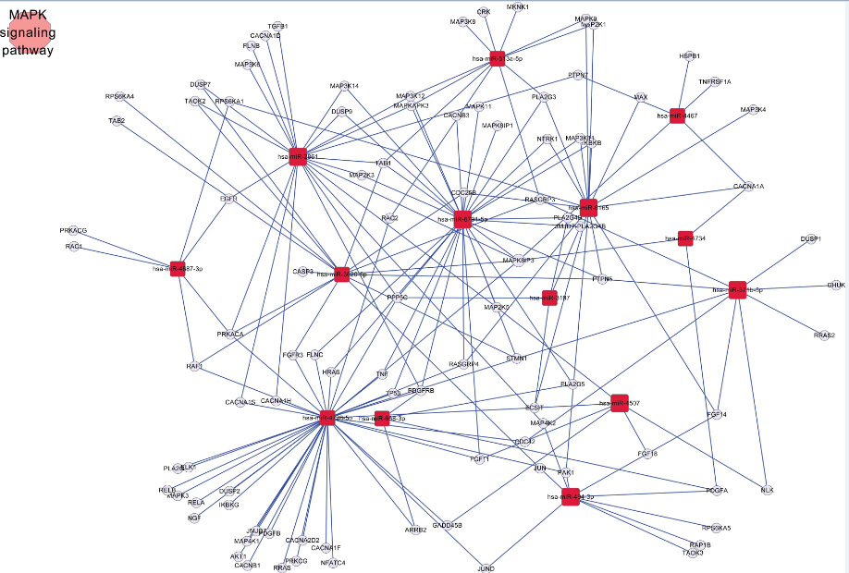

Figure 7 Modulation of JNK, ERK, and p38 MAPK expression by tumor exosomes. SGC/kd cells were stimulated with wt-exo or kd-exo at certain concentrations for 6 h in serum-free medium. Cells were then lysed, and an equal amount of protein from each group was examined by immunoblotting using specific antibodies against phosphorylated (p-) ERK, JNK, p38 and total (t-) ERK, JNK and p38. A: Representative immunoblot of JNK, ERK, and p38 MAPK protein levels; B: Bar graph showed the expression ratio of p-ERK over t-ERK, p-JNK over t-JNK, and p-p38 over t-p38 by densitometric quantification, respectively. Data are expressed as mean ± SD. ªP < 0.05, ^{b}P < 0.01 vs kd-exo group. wt-exo: SGC/wt-derived exosomes; kd-exo: SGC/kd-derived exosomes.
