Name of Journal: World Journal of Methodology
Manuscript NO: 89853
Manuscript Type: ORIGINAL ARTICLE

Observational Study
Artificial night light and thyroid cancer

Tselebis A et al. Artificial light and TC

Athanasios Tselebis, Eftychia Koukkou, Charalampos Milionis, Lina Zabuliene, Argyro Pachi, Ioannis Ilias

Athanasios Tselebis, Argyro Pachi Department of Psychiatry, “Sotiria” General Chest Diseases Hospital, Athens GR-11527, Greece

Eftychia Koukkou, Charalampos Milionis, Ioannis Ilias, Department of Endocrinology, Diabetes and Metabolism, Elena Venizelou General Hospital, Athens GR-11521, Greece

Lina Zabuliene, Faculty of Medicine, Vilnius University, Vilnius LT-03101, Lithuania

Author contributions: Tselebis A and Ilias I designed this research work; Tselebis A, Koukkou E, Milionis C, Zabuliene L, Pachi A and Ilias I performed the research; Tselebis A and Ilias I analyzed the data; Tselebis A, Koukkou E, Milionis C, Zabuliene L, Pachi A and Ilias I wrote the paper; All authors have read and agreed to the published version of the manuscript.

Corresponding author: Ioannis Ilias, MD, PhD, Consultant Physician-Scientist, Department of Endocrinology, Diabetes and Metabolism, Elena Venizelou General Hospital, 2 Elena Venizelou Square, Athens GR-11521, Greece. iiliasmd@yahoo.com

Received: November 14, 2023
Revised: December 6, 2023
Accepted: February 2, 2024
Published online:

Abstract
BACKGROUND
The occurrence of thyroid cancer (TC) has increased in recent decades. Exposure to outdoor artificial light at night (ALN) is associated with an increased risk of cancer.

AIM
To investigated the impact of ALN, as a significant environmental pollutant, on TC incidence worldwide.

METHODS
The assessment involved analyzing satellite ALN data in conjunction with TC incidence data [adjusted standardized rate (ASR)], while considering the quality of cancer registries (QCR), gross domestic product (GDP) per person, and health expenditure per person (HEP) for each country.

RESULTS
Results indicated a correlation between higher ASR and ALN exposure percentages, particularly in countries with higher GDP or HEP quartiles (all P< 0.05). Significant differences in ASR were observed across QCR levels, both high and low quality (all P < 0.05), but not in countries without registry activity. However, when evaluating ASR against ALN exposure percentages while considering GDP/HEP quartiles or QCR levels, no significant associations were found (all P > 0.10).

CONCLUSION
The findings suggest a potential link between higher GDP and adverse health conditions, serving as possible risk factors for TC, rather than a direct association with ALN. Limitations include the use of cross-sectional data, temporal misalignment, and reliance on ALN as a socioeconomic proxy. It is proposed that light pollution might be connected to a lifestyle conducive to carcinogenesis. Additionally, the presence of higher GDP/HEP could enhance access to diagnostic resources, potentially facilitating TC diagnosis and inclusion in cancer registries.

Key Words: Lighting; Human; Epidemiology; Thyroid; Cancer

Tselebis A, Koukkou E, Milionis C, Zabuliene L, Pachi A, Ilias I. Artificial night light and thyroid cancer. World J Methodol 2024; In press

Core Tip: We explored the impact of outdoor artificial light at night (ALN) on thyroid cancer (TC) worldwide. While a correlation was found between higher TC rates and ALN exposure in countries with greater economic indicators [gross domestic product (GDP) and health expenditure per person (HEP)], the association disappeared when accounting for registry quality. The findings suggest that high GDP may be more closely linked to health conditions and TC risk factors than ALN, possibly indicating a lifestyle connection to carcinogenesis. While correlations between ALN and economic factors are observed, a direct link of ALN to TC remains unconfirmed. Additionally, higher GDP/HEP could contribute to better diagnostic access, aiding TC diagnosis and registry inclusion.

INTRODUCTION
The occurrence of thyroid cancer (TC) has increased in recent decades, in contrast to the incidence of most solid tumors in developed countries, which either remains stable or decreases. The reasons for this increase are still unclear; this epidemiological discrepancy compared to other neoplasias merits further research. Outdoor artificial light at night (ALN) is ubiquitous in the modern world and exposure to it is one of the major environmental pollutants^{[1]}. Light pollution has increased to such an extent that it no longer affects not only residents of large cities, but also those living in more remote areas. Exposure to ALN is associated with an increased risk of cancer^{[2]}. The association of ALN with carcinogenesis is relatively novel. It has been suggested that exposure to ALN reduces nocturnal production of melatonin, which acts as a tumor suppressor^{[3]}. However, little data focused on TC in relation to light pollution have been presented in the literature so far^{[3]}. In this study we aimed to assess, worldwide, the potential impact of ALN on TC, using available satellite ALN data and reported TC epidemiological data.

MATERIALS AND METHODS
To study the potential impact of ALN on TC, published satellite data on light pollution worldwide in 173 countries were used^{[1]} (for a global image of ALN circa 2016,https://www.nasa.gov/specials/blackmarble/2016/globalmaps/BlackMarble_2016_3km.jpg). In particular, exposure levels-per (%) population and per (%) surface area of each country- to ALN > 87 μcd/m² and ALN > 688 μcd/m² (levels at which the ability to view the natural night sky is lost and where the Milky Way is no longer visible, respectively) were used. These thresholds were chosen because the 87 μcd/m² level corresponds to 50% more night luminance compared to normal, whereas the 688 μcd/m² level denotes the total loss of the natural appearance of the night sky^{[1]}. Light pollution data were estimated with reference to the correspondingper countryTC incidence data as provided by the World Health Organization and the Global Initiative for Cancer Registry Development (https://gco.iarc.fr/). In particular, we used the standardizedper age and per 100.000 population of each countryTC incidence adjusted standardized rate (ASR). The normality of the data distribution was assessed by the Kolmogorov-Smirnoff test. To assess financial influences (as an indirect measure of living conditions and lifestyle) data were collected for gross domestic product (GDP) per person for each country (https://data.worldbank.org/indicator/NY.GDP.PCAP.CD) and health expenditure per person (HEP) for each country (https://data.worldbank.org/indicator/SH.XPD.CHEX.PC.CD) from the World Bank. The quality of cancer registries (QCR), classified in three groups as either high quality registries, registries of lower quality or no registry activity, per the Global Initiative for Cancer Registry Development; https://gco.iarc.fr/) was also noted. Comparisons of ASR and ALN exposure percentages were done according to GDP/HEP quartiles or QCR levels with the Kruskall Wallis test (KW, with statistical significance set at P < 0.05). The ASR was evaluated against ALN exposure percentages, conditioned for GDP/HEP quartiles and QCR levels, with Kendall’s Tau test (KT, due to non-normal data distribution, with statistical significance set at P < 0.05). Statistical analyses were done with Minitab v.17.1 (Minitab Inc, State College, PA, United States, 2010) and JASP v0.15 (JASP Team, University of Amsterdam, NL, 2021).

RESULTS
The median value worldwide, per (%) population or per (%) area, of ALN > 87 μcd/m², was 67.3% and 7.5%, while ALN > 688 μcd/m² was 34.6% and 0.7%, respectively. The median ASR was 4.2/100000 population. There were significant differences of ASR and ALN exposure percentages by GDP quartiles or HEP quartiles (Figures 1 and 2).
Higher ASR and ALN exposure percentages were noted with higher GDP quartiles or HEP quartiles (all P < 0.05, KW). Differences in ASR were significant for QCR of high quality and lower quality (all P < 0.05, KW), but not for data with countries with no registry activity. Evaluation of ASR against ALN exposure percentages, taking into account GDP/ HEP quartiles or QCR levels did not yield significant results (KT ranged from -0.145 to + 0.272, all P > 0.10) (Figure 3, Supplementary Figure 1).

DISCUSSION
The global scale of the ALN problem is illustrated by the fact that, according to available data, 83% of the world’s population lives under conditions of severe light pollution^{[1]}. In our study we aimed to clarify the nature of the relationship between ALN and TC, taking into account GDP or HEP and level of QCR. We noted differences in ASR by GDP quantiles and HEP quantiles worldwide; however ASR was not associated with exposure to ALN. Moreover, the higher the QCR was the higher ASR was noted. Thus, financial indicators were associated with the incidence of TC, whereas ALN was not associated with its incidence.
Currently, the annual rate of TC’s new cases worldwide is increasing, estimated at about 20% from 1990 to 2013. The rise recorded is similar in Europe, the United States of America, Canada and Australia, although changes in increased incidence are greater in low income countries compared to high income countries^{[4,5]}. The causes of this "epidemic" remain largely unclear^{[6]}. It may represent a true increase or simply an increase in diagnoses of subclinical tumors that would otherwise have caused no symptoms, had they gone undetected^{[7]}. Possibly, the ease of diagnosing very small tumors, due to advances in medical technology and screening programs, may play a role^{[8-10]}. Perhaps, however, some factors related to lifestyle are also to blame.
Research has already identified some factors that affect the likelihood of developing TC. Genetics, exposure to ionizing radiation and iodine intake have been found to increase the risk^{[4]}. There are also studies that have associated air pollution, obesity, smoking and alcohol intake to TC^{[11,12]}. Recently, a study published also inculpated light pollution^{[3]}. The researchers reported that city lights at night suppress melatonin (which may regulate estrogen activity, has antineoplastic properties and assists in the adaptability of humans to their environment) and disrupts circadian rhythms, which is also a risk factor for carcinogenesis^{[13]}.
Regarding the data that we used, the satellite night illumination data used in this work were from 2016; these were obtained with Visible Infrared Imaging Radiometer Suite (VIIRS), and are considered to be very accurate^{[1]}. The VIIRS ALN data are also considered to be a proxy of socioeconomic conditions. Data for the latter, which we used, were from 2019 and 2020, mostly before or at the beginning of the coronavirus disease 2019 pandemic. The TC incidence data which were used were also from 2019-2020. Experts argue that the latency period from the beginning of the neoplastic process to diagnosis of TC is approximately 2.5 years^{[14]}. Thus, for ALN vs TC incidence, this study takes into consideration this lag time. However, the temporal misalignment of cross-sectional data from different years (2016 for ALN, 2019-2020 for TC incidence, and 2019-2020 for economic data) may have affected the accuracy of the associations studied, especially considering the latency period for TC. Another limitation of the study is that the accuracy of epidemiological data for cancer incidence may not be satisfactory in countries with low quality cancer registries or without cancer registries. This introduces potential bias, as the accuracy of TC data may vary widely between countries. The VIIRS ALN data may be a proxy of socioeconomic conditions^{[15,16]}, but to a differentdegree depending on the country^{[17,18]}; the relationship may be more accurate in richer vis-à-vis poorer ones^{[19]}. Thus, the relationship between ALN data and socioeconomic conditions may not be uniform across all countries; while we recognize this, we have to accept a consequent degree of uncertainty in the interpretation of results. According to our results, light pollution might be associated with a lifestyle leading to carcinogenesis, but we were not able to delve deeply into specific lifestyle factors. Another caveat, regarding the analysis performed for this study is that all the data which were used were cross-sectional; while the use of such data is commonly implemented, particularly in the social sciences, experts argue that there are limits to the representability of such an approach.

CONCLUSION
Our findings imply that intense ALN is indeed associated to financial measures such as GDP but it is the latter, and not ALN, which may create conditions that are detrimental to health and a potential risk factor for TC. It is possible that light pollution is associated with a lifestyle that leads to carcinogenesis. Furthermore, higher GDP and HEP implies better access to diagnostic means, possible facilitation of TC diagnosis and better inclusion in cancer registries. Exploring the underlying mechanisms linking light pollution, socioeconomic status, and lifestyle factors to TC risk is crucial for a more comprehensive understanding of these associations. Physicians should be aware of the potential impact of lifestyle, including exposure to ALN, on cancer risk. Further research seems imperative to elucidate the intricate relationship between ALN, lifestyle factors, and TC. Future investigations should delve into specific aspects of lifestyle, such as sleep hygiene and circadian rhythm disruptions, to identify modifiable risk factors. The broader implications for public health should not be overlooked: public health initiatives aimed at reducing light pollution, promoting healthy sleep habits, and raising awareness about the potential impacts of ALN on health may contribute to overall cancer prevention strategies.

ARTICLE HIGHLIGHTS
Research background
The increasing incidence of thyroid cancer (TC) globally has sparked interest in identifying potential environmental factors contributing to this rise. While prior research has explored various risk factors, the association between artificial light at night (ALN) and TC remains an underexplored area. Present status: Current data indicate a notable increase in TC cases, along with a rise in exposure to ALN. Significance of the Study: Our findings imply that intense ALN is indeed associated to financial measures such as gross domestic product (GDP), but it is the latter, and not ALN, which may create conditions that are detrimental to health and a potential risk factor for TC.

Research motivation
The study is motivated by the need to comprehensively investigate the impact of ALN on TC at a global scale, recognizing the ubiquitous nature of light pollution in the modern world. Main topics and key problems: The primary focus is on evaluating the relationship between ALN exposure and TC incidence worldwide. The study delves into the prevalence of ALN using satellite data and examines whether there is a significant association with rates of TC. The research investigates the role of socioeconomic conditions, as indicated by GDP and health expenditure per person (HEP), in contributing to TC incidence. The study incorporates the quality of cancer registries (QCR) as a variable, recognizing the potential impact of data accuracy on the observed relationships. Significance for future research: By exploring the interplay between ALN exposure, socioeconomic factors, and TC, this study lays the groundwork for a more holistic understanding of the risk factors associated with TC. The study contributes to the broader field of environmental determinants of cancer, emphasizing the need for researchers to consider light pollution as a potential lifestyle-related factor impacting cancer risk. Acknowledging the limitations in exploring specific lifestyle factors in this study, future research can delve deeper into understanding the precise elements of lifestyle, such as sleep hygiene and circadian rhythm disruptions, which may contribute to TC risk.

Research objectives
Main objectives: To quantify and assess the prevalence of ALN exposure globally vis-à-vis TC epidemiology, using satellite data and cancer registries, respectively and controlling for financial conditions by country. Realized: Achieved through the analysis of ALN levels exceeding specific thresholds vis-à-vis TC epidemiology. Correlations among different financial indicators with both ALN exposure and TC incidence were noted, providing insights into potential socioeconomic influences. We integrated the QCR as a variable to account for potential variations in data accuracy. Future research: Significance: The study sets the stage for future research by highlighting the intricate relationship between ALN, socioeconomic factors, lifestyle, and TC risk. Future investigations can build upon these insights, delving deeper into specific lifestyle factors and refining preventive interventions.

Research methods
Research Methods Used-Novelty: The study leveraged ALN data to explore its potential association with TC, integrating ALN exposure data with socioeconomic indicators such as GDP and HEP. Moreover, it considered the QCR as a variable that potentially leads to variations in data accuracy. Statistical Analyses: The data were analyzed with the Kolmogorov-Smirnoff, Kruskall Wallis and Kendall's Tau tests.

Research results
The global prevalence of ALN exposure was assessed, revealing that 67.3% of the world's population experiences ALN levels surpassing 87 μcd/m², and 34.6% surpassing 688 μcd/m². Globally, TC incidence, measured by the Adjusted Standardized Rate (ASR), was found to be 4.2 per 100000 population. Significant variations in ASR and ALN exposure percentages were noted across GDP and HEP quartiles, with higher values correlating to higher economic indicators. Differences in ASR were observed concerning the QCR, showing higher ASR in high-quality registries compared to lower quality ones. ASR by GDP and HEP quartiles demonstrated higher rates with increased economic indicators, and ALN exposure percentages also rose with higher economic quartiles. Direct associations between ASR and ALN exposure percentages were not significant. The study underscores the intricate relationship between ALN, economic indicators, and TC, emphasizing the role of socioeconomic conditions in cancer epidemiology. Problems that Remain to be Solved: The study found no direct link between ALN and TC, emphasizing the need for further research to understand their complex relationship. Consideration of QCR is crucial, urging refined assessments of data accuracy.

Research conclusions
New theories proposed: While this study primarily focused on empirical investigations rather than proposing new theoretical frameworks, it introduced a nuanced perspective on the relationship between ALN, socioeconomic factors, and TC. The absence of a direct correlation between ALN and TC challenges existing theories that oversimplify the link between light pollution and cancer risk. The findings encourage a more complex understanding of environmental and socioeconomic influences on cancer incidence, prompting future theoretical developments in this field. New Methods Proposed: The study did not explicitly propose new research methods but demonstrated an innovative approach through the integration of diverse methodologies. Notably, the interdisciplinary analysis, global scale examination and incorporation of socioeconomic indicators represent methodological advancements. The study's emphasis on the QCR as a variable and its statistical analyses contribute to methodological robustness.

Research perspectives
Future research should delve deeper into understanding the complex dynamics between ALN exposure and cancer risk. Investigating specific patterns of light exposure, considering variations in intensity, duration, and timing, may provide a more nuanced understanding of how ALN influences cancer incidence. Future research could also investigate the role of economic factors in shaping lifestyle choices, healthcare access, and environmental exposures, refining our understanding of the socioeconomic mechanisms influencing cancer incidence. Research focusing on the improvement of cancer registry quality assessment methods is crucial. Developing strategies to enhance data accuracy, especially in regions with lower-quality registries, will contribute to more reliable and comparable cancer incidence data. This could involve collaborations to standardize data collection practices globally.

REFERENCES
1 Falchi F, Cinzano P, Duriscoe D, Kyba CC, Elvidge CD, Baugh K, Portnov BA, Rybnikova NA, Furgoni R. The new world atlas of artificial night sky brightness. Sci Adv 2016; 2: e1600377 [PMID: 27386582 DOI: 10.1126/sciadv.1600377]
2 Jones RR. Exposure to artificial light at night and risk of cancer: where do we go from here? Br J Cancer 2021; 124: 1467-1468 [PMID: 33483586 DOI: 10.1038/s41416-020-01231-7]
3 Zhang D, Jones RR, James P, Kitahara CM, Xiao Q. Associations between artificial light at night and risk for thyroid cancer: A large US cohort study. Cancer 2021; 127: 1448-1458 [PMID: 33554351 DOI: 10.1002/cncr.33392]
4 Pizzato M, Li M, Vignat J, Laversanne M, Singh D, La Vecchia C, Vaccarella S. The epidemiological landscape of thyroid cancer worldwide: GLOBOCAN estimates for incidence and mortality rates in 2020. Lancet Diabetes Endocrinol 2022; 10: 264-272 [PMID: 35271818 DOI: 10.1016/S2213-8587(22)00035-3]
5 Olson E, Wintheiser G, Wolfe KM, Droessler J, Silberstein PT. Epidemiology of Thyroid Cancer: A Review of the National Cancer Database, 2000-2013. Cureus 2019; 11: e4127 [PMID: 31049276 DOI: 10.7759/cureus.4127]
6 Kim J, Gosnell JE, Roman SA. Geographic influences in the global rise of thyroid cancer. Nat Rev Endocrinol 2020; 16: 17-29 [PMID: 31616074 DOI: 10.1038/s41574-019-0263-x]
7 Rossi ED, Pantanowitz L, Hornick JL. A worldwide journey of thyroid cancer incidence centred on tumour histology. Lancet Diabetes Endocrinol 2021; 9: 193-194 [PMID: 33662332 DOI: 10.1016/S2213-8587(21)00049-8]
8 Soheylizad M, Khazaei S, Jenabi E, Delpisheh A, Veisani Y. The Relationship Between Human Development Index and Its Components with Thyroid Cancer Incidence and Mortality: Using the Decomposition Approach. Int J Endocrinol Metab 2018; 16: e65078 [PMID: 30464773 DOI: 10.5812/ijem.65078]
9 Lee TJ, Kim S, Cho HJ, Lee JH. The incidence of thyroid cancer is affected by the characteristics of a healthcare system. J Korean Med Sci 2012; 27: 1491-1498 [PMID: 23255848 DOI: 10.3346/jkms.2012.27.12.1491]
10 Ades F, Senterre C, de Azambuja E, Sullivan R, Popescu R, Parent F, Piccart M. Discrepancies in cancer incidence and mortality and its relationship to health expenditure in the 27 European Union member states. Ann Oncol 2013; 24: 2897-2902 [PMID: 24078620 DOI: 10.1093/annonc/mdt352]
11 Sadeghi H, Rafei M, Bahrami M, Haghdoost A, Shabani Y. Attributable risk fraction of four lifestyle risk factors of thyroid cancer: a meta-analysis. J Public Health (Oxf) 2018; 40: e91-e98 [PMID: 28977647 DOI: 10.1093/pubmed/fdx088]
12 Huo S, Liu Y, Sun A, Zhang B. Environmental and social determinants of thyroid cancer: A spatial analysis based on the Geographical Detector. Front Endocrinol (Lausanne) 2022; 13: 1052606 [PMID: 36523594 DOI: 10.3389/fendo.2022.1052606]
13 Tordjman S, Chokron S, Delorme R, Charrier A, Bellissant E, Jaafari N, Fougerou C. Melatonin: Pharmacology, Functions and Therapeutic Benefits. Curr Neuropharmacol 2017; 15: 434-443 [PMID: 28503116 DOI: 10.2174/1570159X14666161228122115]
14 Howard J. Minimum Latency and Types or Categories of Cancer. Centers for Disease Control. 2015. Available from: https://www.cdc.gov/wtc/pdfs/policies/WTCHP-Minimum-Cancer-Latency-PP-01062015-508.pdf
15 Gibson J, Susan O, Boe-Gibson G. Night lights in economics: Sources and uses, LICOS Discussion Paper, No. 419. LICOS Centre for Institutions and Economic Performance. 2020. Available from: https://www.econstor.eu/bitstream/10419/230506/1/1688648216.pdf
16 Gibson J, Olivia S, Boe-Gibson G, Li C. Which night lights data should we use in economics, and where? J Dev Econ 2021; 149: 102602 [DOI: 10.1016/j.jdeveco.2020.102602]
17 Hu Y, Yao J. Illuminating Economic Growth. J Econom 2022; 228: 359-378 [DOI: 10.1016/j.jeconom.2021.05.007]
18 Zumbrun J. Nighttime Light Can Illuminate Fudged Data. Wall Street Journal 2023; January 21-22: A2Available online as Shining a Light (Literally) on How Much Dictators Manipulate Their Economic Stats. Available from: https://www.wsj.com/articles/shining-a-light-literally-on-how-much-dictators-manipulate-their-economic-stats-11674183190
19 Perez-Sindín XS, Chen THK, Prishchepov AV. Are night-time lights a good proxy of economic activity in rural areas in middle and low-income countries? Examining the empirical evidence from Colombia. Remote Sens Appl 2021; 24: 100647 [DOI: 10.1016/j.rsase.2021.100647]
Footnotes
Institutional review board statement: Since this work is based on available, anonymized epidemiological data no IRB approval was necessary.

Informed consent statement: Since this work was based on available anonymized epidemiological data no informed consent was required.

Conflict-of-interest statement: The authors report that they have no conflict of interest.

Data sharing statement: No additional data are available.

STROBE statement: The authors have read the STROBE Statement-checklist of items, and the manuscript was prepared and revised according to the STROBE Statement-checklist of items.

Open-Access: This article is an open-access article that was selected by an in-house editor and fully peer-reviewed by external reviewers. It is distributed in accordance with the Creative Commons Attribution NonCommercial (CC BY-NC 4.0) license, which permits others to distribute, remix, adapt, build upon this work non-commercially, and license their derivative works on different terms, provided the original work is properly cited and the use is non-commercial. See: https://creativecommons.org/Licenses/by-nc/4.0/

Provenance and peer review: Invited article; Externally peer reviewed.

Peer-review model: Single blind

Peer-review started: November 14, 2023
First decision: November 30, 2023
Article in press:

Specialty type: Medical laboratory technology
Country/Territory of origin: Greece
Peer-review report’s scientific quality classification
Grade A (Excellent): 0
Grade B (Very good): B
Grade C (Good): C, C
Grade D (Fair): 0
Grade E (Poor): 0

P-Reviewer: Qin Y, China; Tzeng IS, Taiwan S-Editor: Qu XL L-Editor: A P-Editor:

Figure Legends
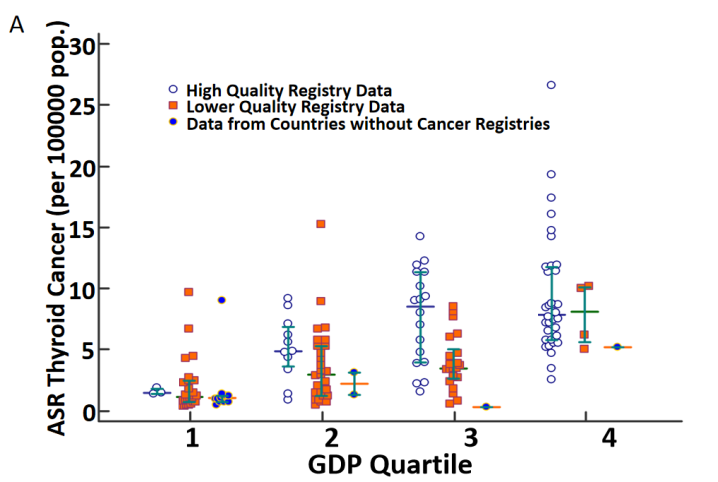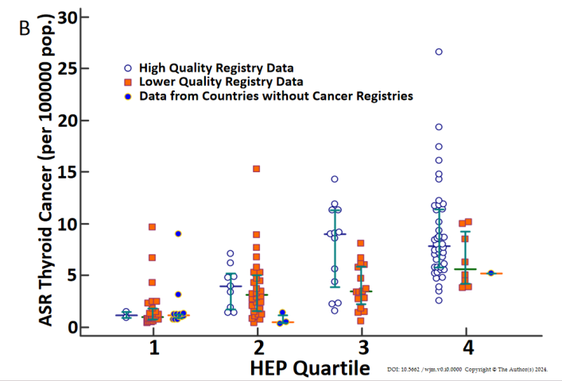
Figure 1 Plots of adjusted standardized rate for thyroid cancer, taking into account quality of cancer registries level. A: By gross domestic product per person quartile; B: By health expenditure per person quartile; horizontal lines indicate the 25thand 75th percentiles, respectively, with the median in between. GDP: Gross domestic product; HEP: Health expenditure per person.

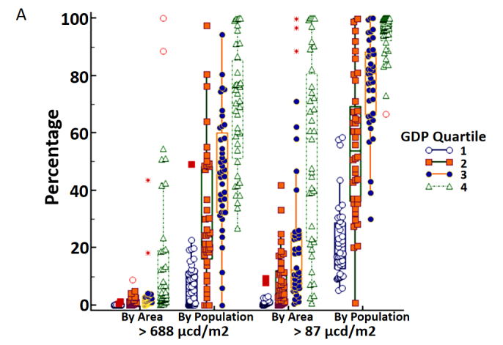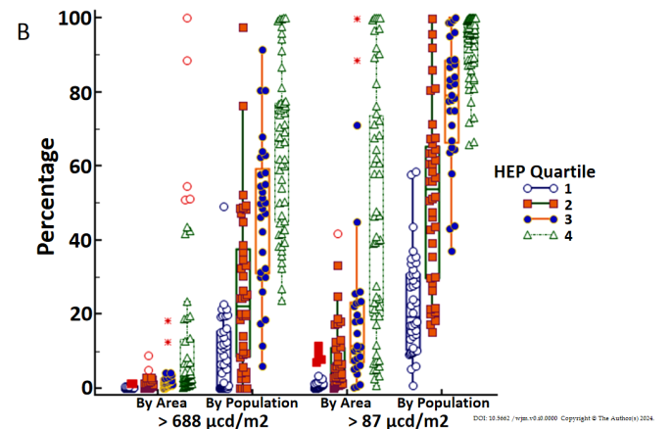

Figure 2 Plots of artificial light at night exposure percentages (vertical scale), by area or population. A: By gross domestic product per person quartile; B: By health expenditure per person quartile; boxplots are framed by the 25thand 75th percentile. GDP: Gross domestic product; HEP: Health expenditure per person.
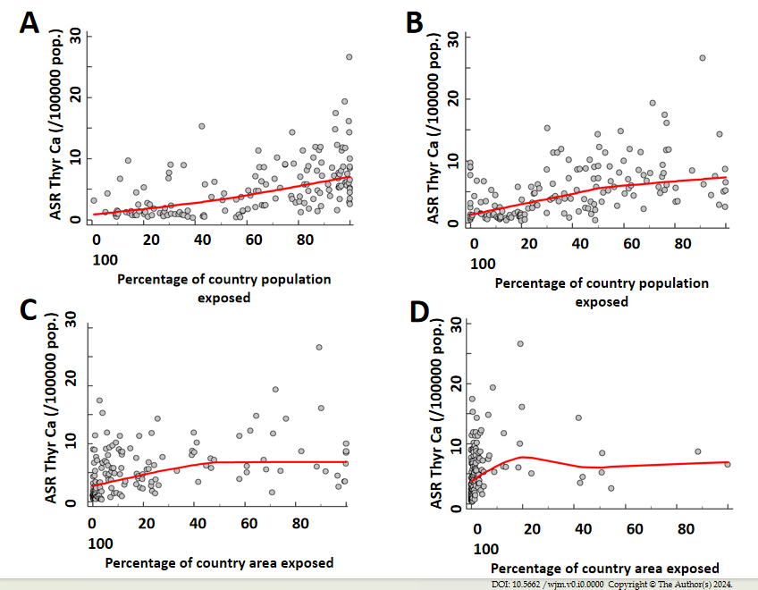

Figure 3 Scatterplots of thyroid cancer incidence by level of exposure to artificial light at night, with locally weighted scatterplot smoothing curves. A: Thyroid cancer (TC) incidence versus percentage of country population exposed to artificial light at night > 87 μcd/m²; B: TC incidence versus percentage of country population exposed to artificial light at night > 688 μcd/m²; C: TC incidence versus percentage of country area exposed to artificial light at night > 87 μcd/m²; D: TC incidence versus percentage of country area exposed to artificial light at night > 688 μcd/m²; ASR Thyr Ca: Adjusted standardized rate of TC incidence per 100000 population.

