Name of Journal: World Journal of Orthopedics
Manuscript NO: 39967
Manuscript Type: ORIGINAL ARTICLE

Observational Study
Long-term results of an anatomically implanted hip arthroplasty with a short stem prosthesis (MiniHipTM)

von Engelhardt LV et al. Long-term results after MiniHipTM

Lars V von Engelhardt, Andreas Breil-Wirth, Christian Kothny, Jörn Bengt Seeger, Christian Grasselli, Joerg Jerosch

Lars V von Engelhardt, Faculty of Health, University of Witten/Herdecke, Witten 58448, Germany

Lars V von Engelhardt, Department of Trauma Surgery Orthopedics and Sports Medicine, Katholisches Karl-Leisner Klinikum, Kleve 47533, Germany

Andreas Breil-Wirth, Christian Grasselli, Joerg Jerosch, Department of Orthopedics, Trauma Surgery and Sports Medicine, Johanna Etienne Hospital, Neuss 41462, Germany

Christian Kothny, Munich Ortho Center, Munich 80802, Germany

Jörn Bengt Seeger, Department of Orthopaedics and Orthopaedic Surgery, University Hospital Giessen and Marburg, Giessen 35392, Germany

Christian Grasselli, Department of Orthopaedics and Traumatology, Waldburg-Zeil Clinic Tettnang, Tettnang 88069, Germany

ORCID number: Lars V von Engelhardt (0000-0002-3181-6163); Andreas Breil-Wirth (0000-0003-1077-1901); Christian Kothny (0000-0002-6992-8670); Jörn Bengt Seeger (0000-0002-6443-8875); Christian Grasselli (0000-0002-9746-4367); Joerg Jerosch (0000-0002-1965-5977).

Author contributions: Jerosch J, Kothny C and Seeger JB contributed to the study conception and design; Seeger JB, Breil-Wirth A, Jerosch J and Grasselli C contributed to the data acquisition, analysis and data interpretation; von Engelhardt LV contributed to the data interpretation, the literature research, the preparation of the figures and the writing of the article which was approved by all authors.

Supported by A sponsorship from Corin (Corin Group, Cirencest, United Kingdom).

Institutional review board statement: The study was reviewed and approved by the local ethical committee of the Medical Association of North Rhine (Ärztekammer Nordrhein) in Düsseldorf (Study No. 2011379).

Informed consent statement: All persons involved in this study gave their informed consent prior to study inclusion. All details that might disclose the identity of the subjects under study were omitted or anonymized.

Conflict-of-interest statement: This paper’s publication fee is paid by a sponsorship from Corin (Corin Group, Cirencest, United Kingdom). Except for Jörn Bengt Seeger, all authors have a paid consultancy/speakers contract for Corin. All authors declare to have no further interests, commercial or otherwise, which represent a conflict of interest in relation to this study.

Open-Access: This article is an open-access article which was selected by an in-house editor and fully peer-reviewed by external reviewers. It is distributed in accordance with the Creative Commons Attribution Non Commercial (CC BY-NC 4.0) license, which permits others to distribute, remix, adapt, build upon this work non-commercially, and license their derivative works on different terms, provided the original work is properly cited and the use is non-commercial. See: http://creativecommons.org/licenses/by-nc/4.0/

Manuscript source: Unsolicited manuscript

Correspondence to: Lars V von Engelhardt, MD, PhD, Surgeon, Department of Trauma Surgery Orthopedics and Sports Medicine, Katholisches Karl-Leisner Klinikum, Alfred-Herrhausen-Straße 50, Kleve 47533, Germany. chirurgie.ahk@kkle.de
Telephone: +49-2821-4901151
Fax: +49-2821-4901080

Received: May 22, 2018
Peer-review started: May 23, 2018
First decision: June 5, 2018
Revised: June 17, 2018
Accepted: June 28, 2018
Article in press:
Published online:

Abstract
AIM
To evaluate the clinical and radiological outcome nine and ten years after short-stemmed, bone preserving and anatomical hip arthroplasty with the MiniHipTM system.

METHODS
In a prospective study, 186 patients underwent hip arthroplasty with a partial neck preserving short stem (MiniHipTM, Corin). Elderly patients were not excluded from this study, thus the mean age at the time of surgery was 59.3 years (range 32 to 82 years). Surgery and the follow-up assessments were performed at two Centers. Up until now, the mean follow-up was 112.5 ± 8.2 mo. The Oxford Hip Score (OHS) and the Hip Dysfunction Osteoarthritis and Outcome Score (HOOS) was assessed pre- and each year after surgery. The clinical follow-up was accompanied by standardized a.p. and axial radiological examinations. Periprosthetic lucencies, hypertrophies within the Gruen zones one to fourteen were assessed. A subsidence of the stem was investigated according to Morray and heterotopic ossifications were assessed according to Brooker.

RESULTS
The OHS and HOOS improved from 18 ± 3.3 to 46 ± 2.0 and from 30 ± 8.3 to 95 ± 4.6 points, P < 0.001 respectively. There were no differences regarding age, etiology, friction pairings, etc., (P > 0.05). Two stems were revised due to a symptomatic subsidence four and twelve months postoperatively. Thus, the survivorship for aseptic loosening at nine to ten years was 98.66%. Including one stem revision due to a symptomatic exostosis, bursitis and thigh pain as well as one revision because of a septic stem loosening, the overall survival for the stem with revision for any reason was 97.32%. Besides one asymptomatic patient, radiological signs of a proximal stress-shielding, such as bone resorptions within the proximal Gruen zones, were not noticed. Findings suggesting a distal loading, e.g., bony hypertrophies or bone appositions of more than 2 mm, were also not detected.

CONCLUSION
Regarding these first long-term results on the MiniHipTM, the implant performed exceedingly well with a high rate of survivorship for aseptic loosening. Our radiological results within the Gruen zones support the design rationale of the Minihip to provide a reliable metaphyseal anchoring with the expected proximal, more physiological load transfer. This might minimize or exclude a stress shielding which might be associated with thigh pain, proximal bone loss and an increased risk of aseptic loosening. The MiniHipTM is a reliable partial-neck retaining prosthesis with good a clinical long-term outcome in younger as well as elderly patients.

Key words: Primary hip arthroplasty; Short stem endoprothesis; Prospective follow-up study; Long-term results; Stress-shielding

© The Author(s) 2018. Published by Baishideng Publishing Group Inc. All rights reserved.

Core tip: An innovative aspect of the MiniHipTM short stem prosthesis is that the design provides the possibility to restore the joint geometry by using an individual femoral neck cut. In general, there is an increasing demand for long-term results of newer arthroplasty systems. In contrast to other studies on short stems for hip replacement, this study was explicitly not only conducted in young and active patients. Therefore, this clinical and radiological long-term follow-up study is of particular interest. This study revealed an excellent and lasting clinical outcome, a reliable metaphyseal anchoring with a physiological proximal load transfer and an excellent long-term stem survivorship which is at least comparable to standard prostheses and other short stem concepts.

von Engelhardt LV, Breil-Wirth A, Kothny C, Seeger JB, Grasselli C, Jerosch J. Long-term results of an anatomically implanted hip arthroplasty with a short stem prosthesis (MiniHipTM). World J Orthop 2018; In press

INTRODUCTION
Short-stemmed cementless hip arthroplasty prostheses have been designed to preserve bone stock, facilitate an eventual revision surgery and achieve a more physiological loading to the proximal part of the femur^{[1-4]}. In comparison to conventional cementless stems, short stems are therefore described to reduce the stress shielding around the stem, which might be associated with thigh pain, bone loss and an increased risk of aseptic loosening^{[5-8]}.
In different conventional stems as well as short stems, digital planning analysis studies and clinical studies on the radiological outcome frequently demonstrate an inadequate reconstruction of the individual femoral offset^{[9,10]}. Such changes in hip geometry often lead to a reduced soft tissue tension as well as a decreased muscular preload. This might be accompanied by an insufficiency of the gluteus muscle group and/or a relevant hip instability^{[11,12]}. However, the widely used standardized femoral neck cut of most prosthesis stems leads to a “bottom up strategy” where the restoration of the joint geometry can only be guaranteed by selecting different modular conus components for a modular tapered stem or different designs of a monoblock prosthesis. The MiniHipTM short stem (Corin Group PLC, Cirencester, United Kingdom) is different. Based on a large series of preoperative CT data collected in hip arthroplasty patients, it is designed to allow the use of individual resection levels for the femoral neck^{[13]}. According to this concept, the MiniHipTM implant is a partial neck retaining prosthesis. This leads to a “top down concept” which provides a completely different possibility to restore the individual joint geometry. Thus, the physiological orientation of the partially retained femoral neck allows a much easier and reliable reconstruction of the individual anteversion, offset and CCD angle (Figure 1)^{[13-15]}. Using 3-dimensional CT scans in cadaver hips, Mihalko et al^{[16]} investigated the value of different femoral neck resection levels for the implantation of a short stem prothesis without modular components. They showed that all geometrical parameters, including the femoral neck anteversion, the CCD angle and the center of the femoral head, were reconstructed within a mean error of 2° and/or 1 mm^{[16]}. Moreover, Windhagen et al^{[17]} have shown that a short stem partial neck-retaining implant provides a more balanced hip in terms of the surrounding soft tissue structures, whereas a straight stem alters the head position and induces much more non-physiological strains.
Clinical follow-up studies of the MiniHipTM showed a good short-term clinical outcome^{[18-20]} as well as good densitometric results with a comparatively lower proximal bone density reduction^{[1,21]}. To our knowledge, this is the longest study on this well-established femoral neck retaining metadiaphysial prosthesis. In contrast to other studies on short stems for hip replacement, this prospective study was explicitly not only conducted in young and active patients. The purpose of the current study was to assess the clinical and radiological long-term outcome of the MiniHipTM in a relatively diverse population with a wide range of patient age.

MATERIALS AND METHODS
This prospective follow-up examination has been approved by the Ethical Committee of the Medical Association of North Rhine (Ärztekammer Nordrhein) in Düsseldorf, Germany under the No. 2011379. All patients gave their written informed consent before enrollment in the study. A total of 186 consecutive hip joint arthroplasties (right/left = 97/89) in 186 patients (m/f = 94/92) were included for the follow-up assessment. Fourteen patients received a bilateral hip arthroplasty with the MiniHipTM as a two-staged procedure. Patients’ mean age at the time of surgery was 59.3 years (range 32 to 82 years). Indications for surgery included advanced osteoarthritis arthritis recalcitrant to conservative treatments. All surgeries were carried out between 2008 and 2010 at the Department of Orthopedics, Trauma Surgery and Sports Medicine of the Johanna-Etienne Hospital Neuss (n = 108) and at the Munich Ortho Center (n = 78) in Germany.
During the subsequent follow-up, 37 patients were excluded from this study. Reasons were an osteosynthesis on the same leg in one patient, one aseptic loosening of the stem on the other side (no MiniHipTM), a severe, immobilizing spinal canal stenosis in one case, two severe other diseases, nine patients wanted to quit the study, one patient died and 22 were lost for unknown reasons.
Pre-operative planning of the prosthesis components was performed in all cases on scaled anteroposterior digital radiographs using the MediCAD® software. In all patients, the meta-diaphyseal anchoring short-stem system MiniHipTM (Corin Group PLC, Cirencester, United Kingdom) was implanted. The MiniHipTM was introduced by Jerosch^{[13]} in 2008. The stem is designed to fit and fill the retained part of the femoral neck. After the femoral neck cut and the opening of the metadiaphyseal cavity, the implant side is prepared by using impactors with an increasing size. This compression of the metadiaphyseal spongious bone might improve the filling of the metaphysis. Moreover, the MiniHipTM stem is designed to provide an extended contact area with a wide load transfer at the femoral calcar region. The MiniHipTM stem is available in nine sizes, each providing a centrum collum diaphyseal angle of 130° (Figure 2). The material of the stem is an alpha-beta titanium alloy (Ti-6Al-4V) and it is coated by a layer of hydroxyapatite applied over a layer of pure titanium (Bi-coat™). The elevated roughness might contribute to the primary stability of the prosthesis, whereas the additional hydroxyapatite coating may serve as an osseoconductor between bone and prosthesis and therefore enhance the secondary stem stability. The stem is intended to be used with 12/14 taper heads of different lengths. The distal tip of the prosthesis is polished and is designed to prevent a ﬁxation in this area. This feature is expected to reduce the risk of anterior thigh pain (Figure 3). The frequencies of implanted stem sizes used in this study are depicted in Figure 3. At the Johanna-Etienne Hospital Neuss, surgery was performed in the supine position using the antero-lateral minimal invasive (ALMI) for supine position described by Jerosch^{[22]}. This approach protects the abductor muscles to facilitate the post-operative rehabilitation. The exposure of the femur and the acetabulum as well as the positioning of the patient allows an excellent orientation which is mandatory for an optimal positioning of the prosthesis components. At the Munich Ortho Center, two approaches were used. In 60 patients, a standard direct anterior approach through the intermuscular plane was performed. Similarly to the ALMI approach, this approach has been described to preserve the hip abductor muscles^{[23,24]}. In 18 patients, a lateral, transgluteal approach with a splitting of the gluteus medius muscle was used^{[25]}. During the implantation of the MiniHipTM, the stem follows the curvature of the medial calcar. Therefore, an individual femoral neck can be used to restore the joint geometry^{[15]}. The height of the femoral neck cut is planned on the preoperative X-ray. In a valgus hip, a deep resection leads to an increased CCD angle and a smaller offset, whereas a high cut near to the head neck junction is used to reconstruct the low CCD angle of a varus hip (Figure 1). Intraoperatively, the landmark for the femoral cut is the piriformis fossa, which is easy to visualize when a minimally invasive approach is used. The cut is made parallel to the head neck junction and at 90° to the femoral neck. Then, the implant side is prepared by using different impactors of increasing size. The postoperative and rehabilitative treatment was started in all patients on the first postoperative day. Patients started weight-bearing as tolerated with two crutches for six weeks. If there were no contraindications, Ibuprofen was recommended for ten days as prophylaxis for heterotopic ossiﬁcations.
The follow-up examinations were performed preoperatively and annually by two independent examiners. The preoperative and follow-up clinical evaluations included the Oxford Hip Score (OHS)^{[26]}, and the Hip Dysfunction Osteoarthritis and Outcome Score (HOOS)^{[27]}. Both the HOOS and the OHS are validated and reliable scores used to assess the functional and symptomatic results after total hip arthroplasty^{[26,27]}. First descriptive statistics were used to compare our data to the literature. To assess predictors such as sex, age, friction pairings, etc. which might influence the outcome scoring, we used a linear mixed model analysis.
The X-ray assessments were performed preoperatively, postoperatively immediately after the initial mobilization and at the follow-up appointments. Standardized standing antero-posterior (AP) and lateral radiographs of the proximal femur were taken. To assess the bone remodeling around the prosthesis, radiographs were inspected within the Gruen zones for the presence of radiolucencies, bony hypertrophies or atrophies, reactive lines and pedestal formation according to the criteria by Engh et al^{[28]}. A change of the stem position was investigated according to Morray by using the osteotomy as a bony reference^{[29]}. A subsidence of the stem as a detectable pathology was documented for a position change of at least 2 mm. Ossifications were analyzed according to the Brooker classification^{[30]}. All complications related to the prosthesis such as a septic or aseptic loosening, infection, subsidence, dislocation and all operative revision were documented.
Data analyses were reviewed and supported by a biomedical statistician. Analyses were performed with Excel Statistics software (Microsoft, Redmond, WA, United States) and SPSS Statistics software 22.0 (SPSS Inc., Chicago, IL, United States).

RESULTS
Functional outcome
One year after surgery, both, the HOOS and OHS improved significantly from a mean of 30 ± 8.3 to 91 ± 6.7 and from 18 ± 3.3 to 44 ± 5.8 points, P < 0.001, respectively. After this initial improvement after one year, the scorings at the follow-up investigations two to ten years after the implantation stayed on the same level or showed only slight increases, which were not significant, P > 0.05 respectively (Figure 4). A further linear mixed model analysis revealed that there were no significant differences regarding sex, age, component sizes, etiology and friction pairings (P > 0.05).

Revisions and complications
The primary outcome measure was the stem revision for loosening as the failure endpoint of the stem. In our series, we noticed two cases with an aseptic stem loosening four and twelve months after surgery with a symptomatic subsidence of 12 and 15 mm (Figure 5). In these patients, a one-stage revision to a conventional stem was conducted. Thus, the survivorship for aseptic loosening at nine to ten years is 98.66% (147 of 149). Another patient had a symptomatic exostosis with a chronical bursitis and thigh pain. Besides the removal of the exostosis a revision of the stem was performed. One patient suffered a septic stem loosening with the detection of proprioni bacteria 20 mo postoperatively. Therefore, the overall survival for the stem with revision for any reason was 97.32% (145 of 149). Another important outcome measure was the number of cup revisions for any reason as the failure endpoint for the cup. In our series, we had one patient with an aseptic cup loosening four months postoperative. Another patient had a symptomatic iliopsoas impingement at the anterior border of the cup which showed an early loosening three weeks postoperatively. These early revisions lead to an overall survival for the cup with revision for any reason of 98.66% (147 of 149). Other major complications, such as dislocations, periprosthetic fractures, a deep venous thrombosis and nerve injuries were not observed during the immediate postoperative inaptient care and the subsequent follow-up insvestigations.

Radiological results
A subsidence was investigated according to Morray^{[29]}. Besides the patients with a symptomatic subsidence mentioned above, we documented one asymptomatic sintering of the stem at the one-year control. The subsidence measured 6 mm and remained unchanged during our subsequent follow-up investigations.
Heterotopic ossifications were assessed according to Brooker et al^{[30]}. Radiologically, we saw nine cases of heterotopic ossifications, three with a Brooker grade II and six cases with a grade I finding (Figure 6).
In a further inverstigation, periprosthetic bone resorptions or bony hypertrophies within the Gruen zones were assessed (Figure 7). One patient showed a bony atrophy with an ostolysis of more than 2 mm in Gruen zones 1, 2, 8 and 14 (Table 1). Further patients with extended bony resoprtions of more than 2 mm were not detected. A small ostolysis of less than 2 mm outlined by a discrete sclerotic margin was detected in a large number of patients around the tip of the stem. This finding was only noticed in the distal Gruen zones 3, 4, 5, 10, 11, 12 (Table 1). Because this finding was exclusively noticed around the polished tip of the stem, it might be indicative for a fibrous ingrowth at the polished tip of the stem. Further radiological and/or clinical signs of a loosening were not noticed in these cases (Figure 7). Bony hypertrophies of less than 2 mm were detected in three cases in Gruen zone 3 und in one case in Gruen zone 5 (Table 1). Further cortical hypertrophies, neocortex formations or a spot welding with new bone formations between the endostal surface and the stem were not noticed in our series.

DISCUSSION
The bi-coating and an optimized initial press fit within an extended contact area at the proximal femur is expected to provide a solid primary and secondary fixation of the MiniHip^{TM[13-15,18,31]}. This might provide a good long-term survival. Searching for data on the survival in short stems, short- and mid-term but only a few long-term results are published^{[18,32-35]}. In a review article by Oldenrijk et al^{[35]}, the majority of the studies had a follow-up of less than 5 years. Out of 49 studies on 19 short stems, midterm result were only reported for the Mayo (Zimmer Inc., Warsaw, United States), Metha (B.Braun Aesculap, Tuttlingen, Germany) and CFP stem (Collum Femoris Preserving, Waldemar Link GmbH, Hamburg, Germany). In contrast to this relatively poor data pool, an increasingly large number of different short stem designs are currently available. Thus, we have to notice a strong need for follow-up studies. For the MinihipTM stem, an overall survival of 98.16%, 97.26% and 99.3% was reported after 60, 18 and 37 mo, respectively^{[18-20]}. These short- and mid-term results are encouraging. The present study is the ﬁrst one in the MinihipTM after a follow-up of nine to ten years. Two of 186 stems subsided within the first year and required revision (Figure 5). Both patients reported a severe thigh pain. A third case of a subsidence of 6 mm at the first-year follow up was asymptomatic. During the following radiological controls, the stem remained stable without any further subsidence and/or loosening. Further cases with a subsidence of more than 2 mm were not noticed. Thus, the rate of aseptic stem loosening as an important outcome measure showed an overall survivorship of 98.66%. This rate is similar to a recent seven year follow-up study in the monoblock design of the Metha stem, where the revision rate was 1%. Zero point five percent were revised for aseptic loosening and 0.4% because of a femoral fracture during the postoperative follow-up. It is important to mention that the revision rate for the modular design of this stem was 9.4% for the titanium and 4.6% for the cobalt chrome neck^{[34]}. Thus, the adapter fractures of the modular Metha stem lead to much higher stem revision rates, whereas the revision rates for the monoblock were similar compared to conventional stems. This supports our preference for a short monoblock prosthesis which we combine with our “top down” concept for an exact joint geometry reconstruction^{[13]}. In the present study, one late infection and one exostosis with thigh pain lead to two further stem revisions. Therefore, the overall survivorship, including all revisions for any reasons was 97.32%. Regarding these long-term results, the implant performed exceedingly well. This is in accordance with the clinical outcome showing a lasting improvement at the OHS and HOOS scorings (Figure 4). Corresponding to these clinical data, the assessment of bone resorptions within the Gruen zones demonstrate good long-term results. Nonetheless, regarding the distal Gruen zones (Table 1) the large number of small (< 2 mm) radiolucencies outlined by a discrete sclerotic margin has to be mentioned (Figure 7). These findings were always noticed around the polished bullet tip of the stem and are indicative for a fibrous interface membrane without any bony ingrowth. This special radiological finding has frequently been documented in uncemented polished taper designs and never been described to be indicative for a loosening or as any other detrimental condition^{[36,37]}. On the contrary, this finding has to be recognized differently. According to the design rationale of the MinihipTM, the polished bullet tip is expected to minimize endosteal abutment. This way, pressure peaks and/or a bony ingrowth at the tip of the stem are expected to be avoided. Moreover, this might decrease the stiffness of the implant and prevent the occurrence of thigh pain at the tip of the stem^{[38]}. Another aspect is the more proximal and therefore more physiological load transfer to the metaphysis of the femur. This proximal load transfer, which is an important goal of the design of the MinihipTM, should not be affected by the tip of the prosthesis. Therefore, the absence of a bony ingrowth around the polished bullet tip is a desirable finding for the MinihipTM stem. Our investigations on bone density changes within the proximal Gruen zones (Table 1) might support our thesis that this principle of a proximal load might actually work. Besides one single patient, where we documented an asymptomatic bone atrophy of more than 2 mm in Gruen zones 1, 2, 8 and 14, further resorptions were not detected within these proximal areas. In regard to these findings, a distal load transfer leading to a stress shielding and bone resorptions within the proximal zones appears quite unlikely. Moreover, bony hypertrophies within the distal Gruen zones, which might be indicative for an unphysiological distal load transfer, were only detected in one patient. For the CLS Spotorno stem (Zimmer, US), in contrast, bony hypertrophies and/or appositions within the distal zones with or without a bone loss within the proximal areas have been described after a 2-4 years in 53% of the cases^{[39]}. For the Hipstar (Stryker, Duisburg, Germany) and the Zweymueller stem (SL-Plus®-Plus Orthopedics AG, Rotkreuz, Switzerland) similar findings were detected already after one year in 60% and 87% of the cases^{[40]}. These findings are indicative for an unphysiological distal load with correspondingly high rates of a proximal stress-shielding. As a logical consequence, the authors discussed, if a progression of these proximal bone resorptions may influence the clinical results and the survival of the implant^{[40]}. Our radiological long-term results showing a more physiological proximal load transfer and a reduced stress-shielding, have been confirmed by several densitometric studies comparing the bone remodeling between different short and conventional straight stems^{[41,42]}. For the MinihipTM but also for other stems, an initial bone resorption in all periprosthetic zones is a typical finding immediately after the implantation^{[1,21]}. However, in studies on the MinihipTM, the initial bone resorption within the first months had a much lesser extend compared to different conventional stems^{[13,41-43]}. More important is that a relatively strong subsequent bone remodelling within the proximal Gruen zones was documented during the following years. Thus, compared to conventional straight stems, a much lower proximal bone density loss was noticed^{[1,21]}. Because of this process of bone formation, which continued till the second year, the bone-friendly design of the MinihipTM as a representative of a partially neck-sustaining stem has been discussed^{[21]}. Similar results were demonstrated on other partially neck-retaining prostheses, demonstrating a signiﬁcant bone remodeling leading to a markedly lower bone density reduction in the proximal Gruen zones^{[44,45]}. Taken together, all these radiographic and osteodensitometric data support the thesis of a more physiological proximal load. Regarding these convincing data, it is not surprising that a lower frequency of thigh pain was reported in short stems compared to straight, conventional stem types^{[46]}.
Short stems have become increasingly utilized in younger patients^{[38]}. This may reﬂect the surgeon’s desire to conserve bone stock in these patients. Because of the lack of long-term studies, this may also reflect some concerns regarding the achievement of a lasting stable fixation in elderly patients. In regard to studies reporting an increased intraoperative fracture risk with advanced age^{[47]}, worries about such complications might further influence the indication of a short stem in elderly patients. Therefore, the wide range of patients’ ages between 32 and 82 years is an interesting feature of this study. The analysis of the outome scorings revealed no significant differences regarding the patients’ age. Intraoperative fractures were not noticed and a loosening of the stem with a subsidence was a rare and early occurring complication in two patients of a mean age. Thus, in comparison to conventional stems as a current benchmark level^{[48]}, the MinihipTM short stem might also be a reliable alternative in elderly patients.
In conclusion, this long-term study revealed an excellent and long-lasting clinical outcome, low complication rates, a reliable metaphyseal anchoring with a more physiological proximal load transfer and an excellent long-term stem survivorship. Therefore, the MiniHipTM might be a convincing concept for a partial-neck retaining prosthesis in a wide range of patients.

ARTICLE HIGHLIGHTS
Research background
In contrast to a poor scientific data pool, an increasingly large number of different short stem designs are currently available. Thus, we have to notice a strong need for follow-up studies especially on long-term results of these stems. Regarding the MinihipTM stem, previous short-term results are encouraging, whereas long-term studies are lacking. Thus, the present study is the ﬁrst one after a follow-up period of nine to ten years. In contrast to studies on short-stemmed hip replacements, which are mainly conducted in relatively young and active patients, this study included a wide range of patients including elderly persons.

Research motivation
The MiniHipTM monoblock stem is designed to fit and fill the retained part of the femoral neck and the metaphysis. Using an individual femoral neck cut, the implant is normally used as a partial neck retaining prosthesis. This leads to a “top down concept” which provides a completely different possibility to restore the joint geometry. Using this concept, the physiological orientation of the partially retained femoral neck allows an easy and reliable reconstruction of the individual anteversion, CCD angle and offset. Moreover, this might lead to a more physiological loading of the proximal femur. The key question is, if these design features are useful to reduce the stress shielding around the stem with its’ complications such as thigh pain, bone loss and aseptic loosening. Thus, this concept might possibly solve or reduce some typical problems of conventional hip arthroplasty. Our optimistic expectation is that this might also secure a good long-term outcome of such prostheses.

Research objectives
The design of the MiniHipTM prosthesis seems to provide some reasonable advantages. The main objective was to assess the long-term clinical and radiological outcome and the complication rates of this prosthesis in a relatively diverse study cohort with a wide range of patients’ age. This might support the understanding in recent developments of partial-neck retaining, short-stemmed hip prostheses, which provide a metaphyseal anchoring as well as a more physiological proximal load transfer to the femur.

Research methods
This study on the MiniHipTM is the ﬁrst one after such a long mean follow-up period of nine to ten years. 186 patients, with a comparatively wide age range between 32 and 82 years, were included. Hip arthroplasty with the MiniHipTM prosthesis was performed at two Centers. The clinical follow-up, which included the Oxford Hip Score (OHS) and the Hip Dysfunction Osteoarthritis and Outcome Score (HOOS), was accompanied by standardized p.a. and axial radiological examinations. The radiological evaluation included the assessment of periprosthetic lucencies, hypertrophies within the Gruen zones, the assessment of a possible stem subsidence and the detection of heterotopic ossifications.

Research results
The OHS and HOOS score improved significantly from 18 to 46 and from 30 to 95 points. Stem related complications included two cases with a symptomatic subsidence after four and twelve months. The survivorship for aseptic loosening remained unchanged after the subsequent follow-up of nine to ten years. Thus, the final survivorship was 98.66%. Including one stem revision due to a symptomatic exostosis, bursitis and thigh pain as well as one revision because of a septic stem loosening, the overall survival for the stem with revision for any reason was 97.32%. Besides one asymptomatic patient, signs of a proximal stress shielding, such as corresponding bone resorptions within the proximal Gruen zones, were not noticed. Bony hypertrophies and/or bone appositions which might be indicative for a distal loading, were also not noticed.

Research conclusions
This study is the first one on the MiniHipTM prosthesis evaluating the long-term outcome in patients with a wide range of ages. This study revealed a convincing and lasting clinical outcome. The radiological findings suggest a physiological proximal load transfer with a reliable metaphyseal anchoring and an excellent long-term stem survivorship, which is at least comparable to standard prostheses and other short stem concepts. The MiniHipTM is designed to fit and fill the retained part of the femoral neck. During surgery, the implant side is prepared and compressed by using impactors with an increasing size. Moreover, the MiniHipTM stem is designed to provide an extended contact area and an optimized filling with a wide load transfer at the femoral calcar region. This new concept is expected to provide a solid fixation. Moreover, a porous coating of a hip stem leads to an elevated roughness and an additional hydroxyapatite coating may serve as an osteoconductor between bone and prosthesis. All these features of this partial neck-retaining prosthesis might enhance the primary as well as secondary stem stability, provide an optimized proximal loading and finally provide a good long-term survival of this prosthesis. We hope that this concept might solve or reduce some typical problems of conventional hip arthroplasty stems. Short-stemmed, partial neck retaining hip arthroplasty seems to realize a more physiological proximal load transfer with a reliable metaphyseal anchoring and an excellent long-term stem survivorship. Partial neck retaining hip arthroplasty using the MiniHipTM stem might be a convincing concept for a wide range of patients. The study presented here was a necessary step in exploring this prosthesis, which seems to provide reasonable advantages. Short-stemmed, partial neck retaining hip arthroplasty by using an individual femoral neck cut provides a physiological proximal load transfer and an excellent long-term stem survivorship, which is at least comparable to other prosthesis concepts. This might be a contributory factor to the convincing and lasting clinical outcome demonstrated in this study. This study includes a population with a wide range of ages. The follow-up comprises a long-term period of nine to ten years. The radiological assessment included typical changes of the periprosthetic bone within the Gruen zones as well as the detection of a possible stem subsidence. In contrast to other studies on short stems for hip replacement, this study was explicitly not only conducted in young and active patients. Therefore, this clinical and radiological long-term follow-up study might be of particular interest and might provide a better understanding of such partial neck retaining prostheses. This long-term study on theMiniHipTM revealed an overall survivorship for an aseptic stem loosening of 98.66%. The promising clinical and radiological outcome was proved to be lasting in a wide range of patients. The radiological findings within the Gruen zones suggest a more physiological proximal load transfer and a reliable proximal metaphyseal anchoring. This might explain the excellent long-term stem survivorship of the MiniHipTM prosthesis. In our future clinical practice, we will follow this concept of a proximal, metaphyseal anchored partial-neck retaining prosthesis. Especially the concept of the MiniHipTM, which allows an individual femoral neck cut and which recommends a compression of the implant side by using different impactors, might provide some reasonable advantages to achieve such reliable and long-lasting results. Moreover, this concept might be interesting in a wide range of patients including those with an advanced age.

Research perspectives
In consideration of conventional stems as a current benchmark for survival rates and for typical complications occurring intraoperatively, but also in the long-term follow-up, a proximal-metaphyseal anchored partial-neck retaining prosthesis might be a reliable alternative in younger as well as elderly patients. Further clinical outcome studies in larger study populations might be useful to find out limitations regarding the indication for this short-stemmed, partial neck retaining hip prosthesis. Perhaps the indication for such short-stemmed prostheses will be reconsidered in the future. Regarding our initial long-term results, signs for an upcoming implant failure based on a material failure or a mechanical mismatch of implant and bone structure are not imminent. Ongoing assessments with longer follow-up periods will evaluate the durability of these first nine to ten year results. Follow-up studies with larger cohorts and longer follow-up periods will be a useful method for the future research.

REFERENCES
1 Ercan A, Sokkar SM, Schmid G, Filler TJ, Abdelkafy A, Jerosch J. Periprosthetic bone density changes after MiniHipTM cementless femoral short stem: one-year results of dual-energy X-ray absorptiometry study. SICOT J 2016; 2: 40 [PMID: 27855776 DOI: 10.1051/sicotj/2016033]
2 Falez F, Casella F, Panegrossi G, Favetti F, Barresi C. Perspectives on metaphyseal conservative stems. J Orthop Traumatol 2008; 9: 49-54 [PMID: 19384482 DOI: 10.1007/s10195-008-0105-4]
3 Leali A, Fetto J, Insler H, Elfenbein D. The effect of a lateral flare feature on implant stability. Int Orthop 2002; 26: 166-169 [PMID: 12073110 DOI: 10.1007/s00264-002-0355-3]
4 Tanner KE, Yettram AL, Loeffler M, Goodier WD, Freeman MA, Bonfield W. Is stem length important in uncemented endoprostheses? Med Eng Phys 1995; 17: 291-296 [PMID: 7633757 DOI: 10.1016/1350-4533(95)90854-5]
5 Brinkmann V, Radetzki F, Delank KS, Wohlrab D, Zeh A. A prospective randomized radiographic and dual-energy X-ray absorptiometric study of migration and bone remodeling after implantation of two modern short-stemmed femoral prostheses. J Orthop Traumatol 2015; 16: 237-243 [PMID: 25666724 DOI: 10.1007/s10195-015-0335-1]
6 Chen HH, Morrey BF, An KN, Luo ZP. Bone remodeling characteristics of a short-stemmed total hip replacement. J Arthroplasty 2009; 24: 945-950 [PMID: 18848420 DOI: 10.1016/j.arth.2008.07.014]
7 Kim YH, Choi Y, Kim JS. Comparison of bone mineral density changes around short, metaphyseal-fitting, and conventional cementless anatomical femoral components. J Arthroplasty 2011; 26: 931-940.e1 [PMID: 21130598 DOI: 10.1016/j.arth.2010.10.001]
8 Yan SG, Weber P, Steinbrück A, Hua X, Jansson V, Schmidutz F. Periprosthetic bone remodelling of short-stem total hip arthroplasty: a systematic review. Int Orthop 2017; Epub ahead of print [PMID: 29178044 DOI: 10.1007/s00264-017-3691-z]
9 Jerosch J, Funken S. [Change of offset after implantation of hip alloarthroplasties]. Unfallchirurg 2004; 107: 475-482 [PMID: 15197454 DOI: 10.1007/s00113-004-0758-2]
10 Wedemeyer C, Quitmann H, Xu J, Heep H, von Knoch M, Saxler G. Digital templating in total hip arthroplasty with the Mayo stem. Arch Orthop Trauma Surg 2008; 128: 1023-1029 [PMID: 17994244 DOI: 10.1007/s00402-007-0494-5]
11 Asayama I, Chamnongkich S, Simpson KJ, Kinsey TL, Mahoney OM. Reconstructed hip joint position and abductor muscle strength after total hip arthroplasty. J Arthroplasty 2005; 20: 414-420 [PMID: 16124955 DOI: 10.1016/j.arth.2004.01.016]
12 Matsushita A, Nakashima Y, Jingushi S, Yamamoto T, Kuraoka A, Iwamoto Y. Effects of the femoral offset and the head size on the safe range of motion in total hip arthroplasty. J Arthroplasty 2009; 24: 646-651 [PMID: 18534445 DOI: 10.1016/j.arth.2008.02.008]
13 Jerosch J. Kurzschaftprothesen an der Hüfte. 1st ed. Springer-Verlag GmbH, Germany, 2017: 197-233 [DOI: 10.1007/978-3-662-52744-3]
14 Buttaro M, Nally F, Diaz F, Stagnaro J, Rossi L, Comba F, Zanotti G, Piccaluga F. Which prosthetic system restores hip biomechanics more effectively? ICJR World Arthroplasty Congress, 2015 Apr 16-18; Paris, France
15 Jerosch J, Grasselli C, Kothny PC, Litzkow D, Hennecke T. [Reproduction of the anatomy (offset, CCD, leg length) with a modern short stem hip design--a radiological study]. Z Orthop Unfall 2012; 150: 20-26 [PMID: 21487992 DOI: 10.1055/s-0030-1270965]
16 Mihalko WM, Assaf D, Sungu M. Reproducing the hip center with a femoral neck-retaining implant. Orthopedics 2015; 38: S21-S26 [PMID: 25826628 DOI: 10.3928/01477447-20150215-52]
17 Windhagen H, Chincisan A, Choi HF, Thorey F. Soft-tissue balance in short and straight stem total hip arthroplasty. Orthopedics 2015; 38: S14-S20 [PMID: 25826627 DOI: 10.3928/01477447-20150215-51]
18 Breil-Wirth A, von Engelhardt LV, Grasselli C, Jerosch J. 5- to 6-years-results of a cementless short stem hip joint endoprothesis [Article in German]. Orthopädische und Unfallchirurgische Praxis 2016; 6: 370-375
19 Dettmer M, Pourmoghaddam A, Kreuzer SW. Comparison of Patient-Reported Outcome from Neck-Preserving, Short-Stem Arthroplasty and Resurfacing Arthroplasty in Younger Osteoarthritis Patients. Adv Orthop 2015; 2015: 817689 [PMID: 26101669 DOI: 10.1155/2015/817689]
20 Teoh KH, Lee PY, Woodnutt DJ. Our early experience of the Corin Minihip prosthesis. Hip Int 2016; 26: 265-269 [PMID: 27034100 DOI: 10.5301/hipint.5000343]
21 Shafy TA, Sayed A, Abdelazeem AH. Study of the bone behavior around a neck preserving short stem implant: bone densitometric analysis over a span of two years. SICOT J 2016; 2: 31 [PMID: 27716459 DOI: 10.1051/sicotj/2016025]
22 Jerosch J, Theising C, Fadel ME. Antero-lateral minimal invasive (ALMI) approach for total hip arthroplasty technique and early results. Arch Orthop Trauma Surg 2006; 126: 164-173 [PMID: 16523344 DOI: 10.1007/s00402-006-0113-x]
23 Matta JM, Shahrdar C, Ferguson T. Single-incision anterior approach for total hip arthroplasty on an orthopaedic table. Clin Orthop Relat Res 2005; 441: 115-124 [PMID: 16330993 DOI: 10.1097/01.blo.0000194309.70518.cb]
24 Oinuma K, Eingartner C, Saito Y, Shiratsuchi H. Total hip arthroplasty by a minimally invasive, direct anterior approach. Oper Orthop Traumatol 2007; 19: 310-326 [PMID: 17728988 DOI: 10.1007/s00064-007-1209-3]
25 Bauer R, Kerschbaumer F, Poisel S, Oberthaler W. The transgluteal approach to the hip joint. Arch Orthop Trauma Surg 1979; 95: 47-49 [PMID: 526126 DOI: 10.1007/BF00379169]
26 Dawson J, Fitzpatrick R, Carr A, Murray D. Questionnaire on the perceptions of patients about total hip replacement. J Bone Joint Surg Br 1996; 78: 185-190 [PMID: 8666621 DOI: 10.1302/0301-620X.78B2.0780185]
27 Klässbo M, Larsson E, Mannevik E. Hip disability and osteoarthritis outcome score. An extension of the Western Ontario and McMaster Universities Osteoarthritis Index. Scand J Rheumatol 2003; 32: 46-51 [PMID: 12635946 DOI: 10.1080/03009740310000409]
28 Engh CA, Massin P, Suthers KE. Roentgenographic assessment of the biologic fixation of porous-surfaced femoral components. Clin Orthop Relat Res 1990; : 107-128 [PMID: 2199114 DOI: 10.1097/00003086-199008000-00022]
29 Morrey BF, Adams RA, Kessler M. A conservative femoral replacement for total hip arthroplasty. A prospective study. J Bone Joint Surg Br 2000; 82: 952-958 [PMID: 11041581 DOI: 10.1302/0301-620X.82B7.10420]
30 Brooker AF, Bowerman JW, Robinson RA, Riley LH Jr. Ectopic ossification following total hip replacement. Incidence and a method of classification. J Bone Joint Surg Am 1973; 55: 1629-1632 [PMID: 4217797 DOI: 10.2106/00004623-197355080-00006]
31 Castellini I, Andreani L, Parchi PD, Bonicoli E, Piolanti N, Risoli F, Lisanti M. Hydroxyapatite in total hip arthroplasty. Our experience with a plasma spray porous titanium alloy/hydroxyapatite double-coated cementless stem. Clin Cases Miner Bone Metab 2016; 13: 221-227 [PMID: 28228786 DOI: 10.11138/ccmbm/2016.13.3.221]
32 Hauer G, Vielgut I, Amerstorfer F, Maurer-Ertl W, Leithner A, Sadoghi P. Survival Rate of Short-Stem Hip Prostheses: A Comparative Analysis of Clinical Studies and National Arthroplasty Registers. J Arthroplasty 2018; 33: 1800-1805 [PMID: 29428465 DOI: 10.1016/j.arth.2018.01.017]
33 Kendoff DO, Citak M, Egidy CC, O'Loughlin PF, Gehrke T. Eleven-year results of the anatomic coated CFP stem in primary total hip arthroplasty. J Arthroplasty 2013; 28: 1047-1051 [PMID: 23523502 DOI: 10.1016/j.arth.2012.10.013]
34 Schnurr C, Schellen B, Dargel J, Beckmann J, Eysel P, Steffen R. Low Short-Stem Revision Rates: 1-11 Year Results From 1888 Total Hip Arthroplasties. J Arthroplasty 2017; 32: 487-493 [PMID: 27639304 DOI: 10.1016/j.arth.2016.08.009]
35 van Oldenrijk J, Molleman J, Klaver M, Poolman RW, Haverkamp D. Revision rate after short-stem total hip arthroplasty: a systematic review of 49 studies. Acta Orthop 2014; 85: 250-258 [PMID: 24694271 DOI: 10.3109/17453674.2014.908343]
36 Pluot E, Davis ET, Revell M, Davies AM, James SL. Hip arthroplasty. Part 2: normal and abnormal radiographic findings. Clin Radiol 2009; 64: 961-971 [PMID: 19748001 DOI: 10.1016/j.crad.2009.05.002]
37 Vanrusselt J, Vansevenant M, Vanderschueren G, Vanhoenacker F. Postoperative radiograph of the hip arthroplasty: what the radiologist should know. Insights Imaging 2015; 6: 591-600 [PMID: 26487647 DOI: 10.1007/s13244-015-0438-5]
38 Khanuja HS, Vakil JJ, Goddard MS, Mont MA. Cementless femoral fixation in total hip arthroplasty. J Bone Joint Surg Am 2011; 93: 500-509 [PMID: 21368083 DOI: 10.2106/JBJS.J.00774]
39 Robinson RP, Lovell TP, Green TM. Hip arthroplasty using the cementless CLS stem. A 2--4-year experience. J Arthroplasty 1994; 9: 177-192 [PMID: 8014649 DOI: 10.1016/0883-5403(94)90067-1]
40 Bergschmidt P, Bader R, Finze S, Gankovych A, Kundt G, Mittelmeier W. Cementless total hip replacement: a prospective clinical study of the early functional and radiological outcomes of three different hip stems. Arch Orthop Trauma Surg 2010; 130: 125-133 [PMID: 19526245 DOI: 10.1007/s00402-009-0907-8]
41 Freitag T, Hein MA, Wernerus D, Reichel H, Bieger R. Bone remodelling after femoral short stem implantation in total hip arthroplasty: 1-year results from a randomized DEXA study. Arch Orthop Trauma Surg 2016; 136: 125-130 [PMID: 26613788 DOI: 10.1007/s00402-015-2370-z]
42 Koyano G, Jinno T, Koga D, Yamauchi Y, Muneta T, Okawa A. Comparison of Bone Remodeling Between an Anatomic Short Stem and a Straight Stem in 1-Stage Bilateral Total Hip Arthroplasty. J Arthroplasty 2017; 32: 594-600 [PMID: 27554784 DOI: 10.1016/j.arth.2016.07.016]
43 Roth A, Richartz G, Sander K, Sachse A, Fuhrmann R, Wagner A, Venbrocks RA. [Periprosthetic bone loss after total hip endoprosthesis. Dependence on the type of prosthesis and preoperative bone configuration]. Orthopade 2005; 34: 334-344 [PMID: 15726320 DOI: 10.1007/s00132-005-0773-1]
44 Lerch M, von der Haar-Tran A, Windhagen H, Behrens BA, Wefstaedt P, Stukenborg-Colsman CM. Bone remodelling around the Metha short stem in total hip arthroplasty: a prospective dual-energy X-ray absorptiometry study. Int Orthop 2012; 36: 533-538 [PMID: 21935621 DOI: 10.1007/s00264-011-1361-0]
45 Zeh A, Pankow F, Röllinhoff M, Delank S, Wohlrab D. A prospective dual-energy X-ray absorptiometry study of bone remodeling after implantation of the Nanos short-stemmed prosthesis. Acta Orthop Belg 2013; 79: 174-180 [PMID: 23821969]
46 Banerjee S, Pivec R, Issa K, Harwin SF, Mont MA, Khanuja HS. Outcomes of short stems in total hip arthroplasty. Orthopedics 2013; 36: 700-707 [PMID: 24024994 DOI: 10.3928/01477447-20130821-06]
47 Zhao R, Cai H, Liu Y, Tian H, Zhang K, Liu Z. Risk Factors for Intraoperative Proximal Femoral Fracture During Primary Cementless THA. Orthopedics 2017; 40: e281-e287 [PMID: 27874909 DOI: 10.3928/01477447-20161116-06]
48 Rometsch E, Bos PK, Koes BW. Survival of short hip stems with a "modern", trochanter-sparing design - a systematic literature review. Hip Int 2012; 22: 344-354 [PMID: 22878970 DOI: 10.5301/HIP.2012.9472]

P-Reviewer: Li JM, Robertson GA S-Editor: Ji FF L-Editor: E-Editor:

Specialty type: Orthopedics
Country of origin: Germany
Peer-review report classification
Grade A (Excellent): 0
Grade B (Very good): B, B
Grade C (Good): 0
Grade D (Fair): 0
Grade E (Poor): 0

Table 1 Periprosthetic bone density changes within the Gruen zones (G1-14) detected in standardized a.p. and axial X-rays
a.p. | Axial
G1: 1 × bony atrophy > 2 mm | G8: 1 × bony atrophy > 2 mm
G2: 1 × bony atrophy > 2 mm | G9: No abnormalitiy
G3: 3 × bony hypertrophy < 2 mm 16 × RL¹ | G10: 36 × RL¹
G4: 47 × RL | G11: 21 × RL¹
G5: 1 × bony hypertrophy < 2 mm 54 × RL¹ | G12: 31 × RL¹
G6: No abnormality | G13: No abnormality
G7: No abnormality | G14: 1 × bony atrophy > 2 mm
¹Small radiolucency < 2 mm with discrete sclerotic margin.

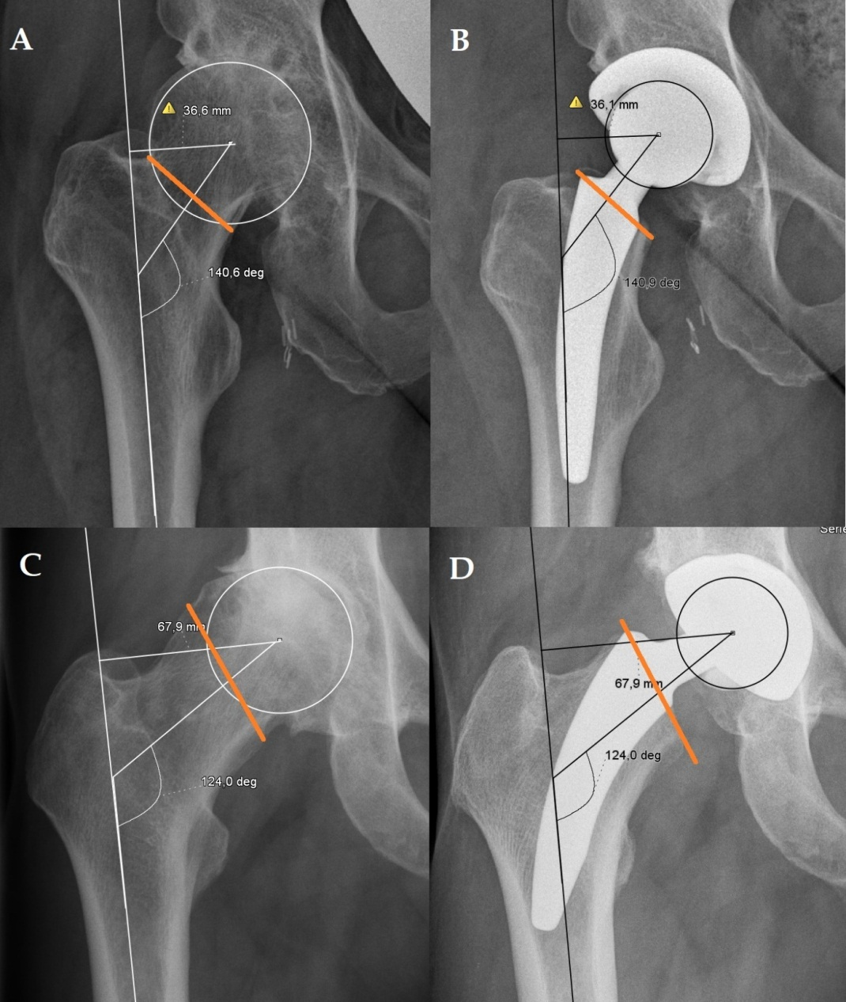

Figure 1 “Top down concept” of the MiniHipTM to restore the individual joint geometry. The individual femoral neck cut and physiological orientation of the partially retained femoral neck allows the reconstruction of the individual joint geometry. A: Valgus hip deformity; B: A deeper femoral neck cut leads a reduction of the femoral offset with an accurate reconstruction of the joint geometry; C: Varus hip; D: A low femoral neck provides a reconstruction of the geometry with an increased femoral offset with an appropriate successfully reconstructed joint geometry.

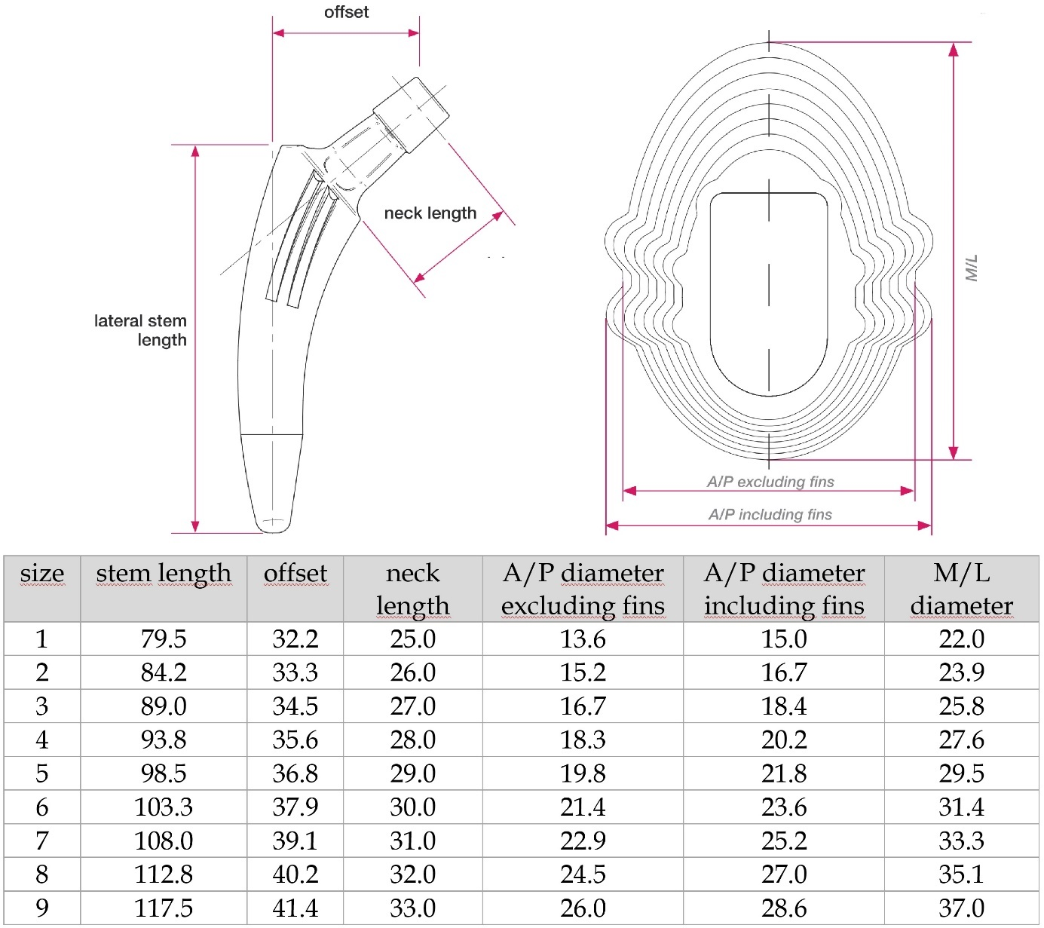

Figure 2 Dimensions (mm) of the different sizes of the MiniHipTM stem.

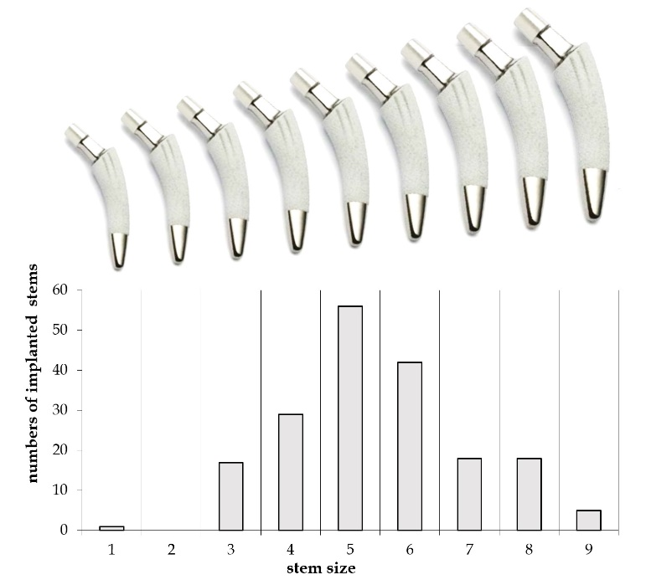

Figure 3 Frequencies of the implanted stem sizes used in this study. The distribution of sizes used in this study is similar to a Gauss curve. The increasing dimensions of the conus according to the nine different sizes of the implant are depicted. The distal bullet tip of the prosthesis is polished. This design might prevent a ﬁxation in this area and therefore reduce the risk of thigh pain.

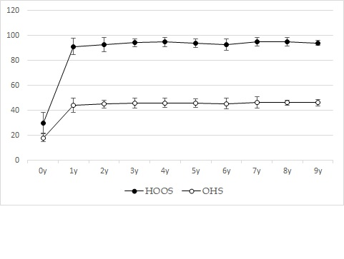
Figure 4 Outcome at the Hip Dysfunction Osteoarthritis and Outcome Score and Oxford Hip Score scoring over ten years. After the initial improvement after one year, the subsequent scorings at our follow-up investigations two to ten years after the implantation showed only slight increases, which were not significant, P > 0.05 respectively. HOOS: Hip Dysfunction Osteoarthritis and Outcome Score; OHS: Oxford Hip Score.

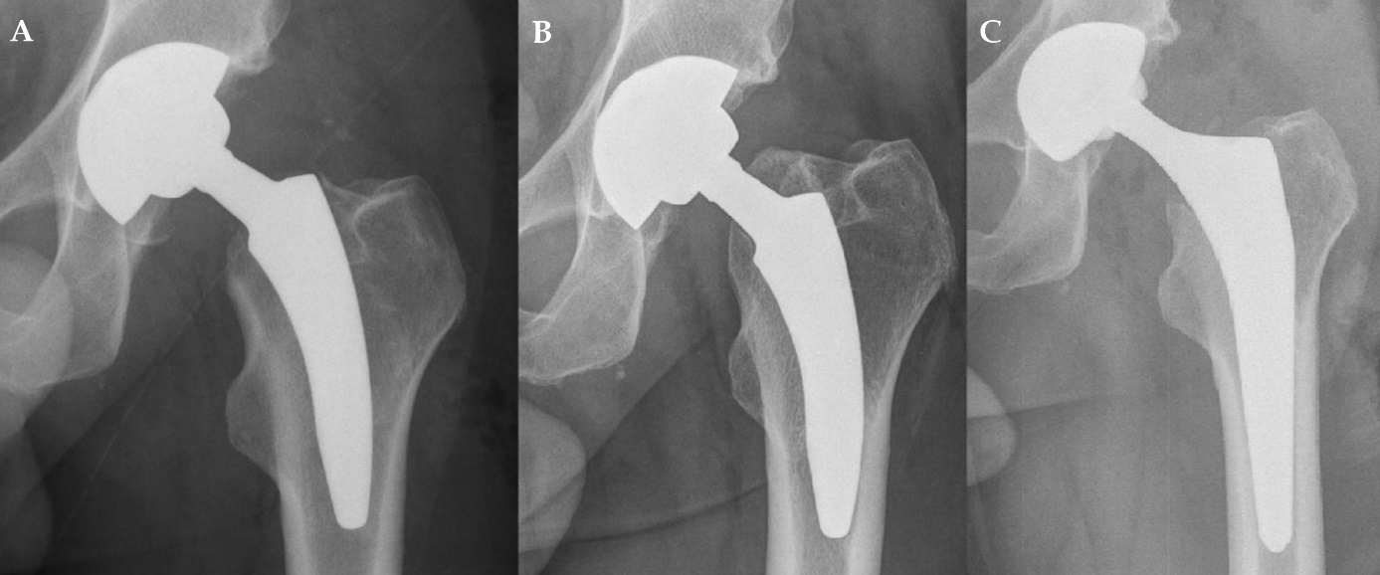

Figure 5 Exemplary X-ray of one of the two cases with a symptomatic subsidence. A: Postoperative X-ray; B: Subsidence of 15 mm twelve months after surgery; C: X-ray of the one-stage revision to a conventional stem.

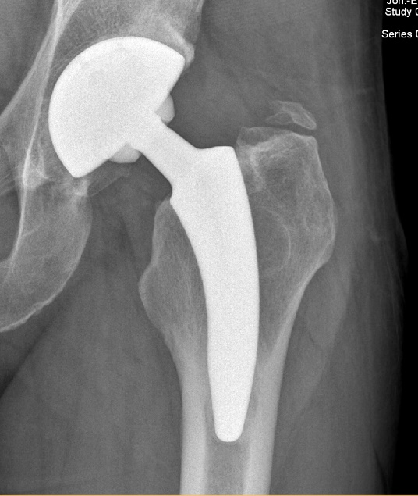

Figure 6 Exemplary X-ray of one of the nine cases with a heterotopic ossifications grade I according to Brooker.

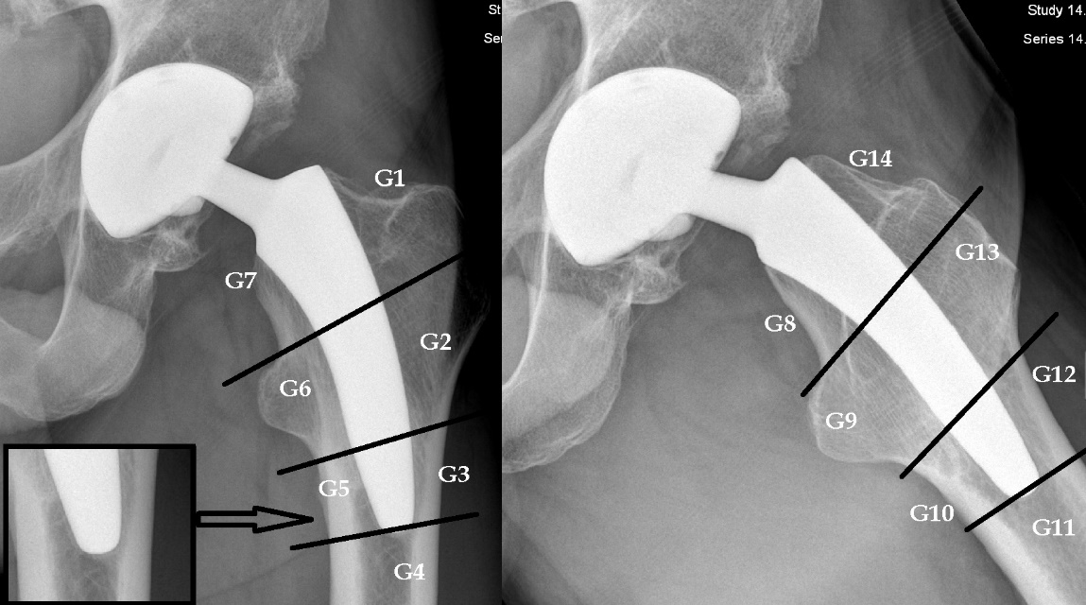
Figure 7 Periprosthetic bone resorptions or bony hypertrophies were assessed within the Gruen zones 1-14. A small ostolysis of less than 2 mm outlined by a discrete sclerotic margin was detected in a large number of patients around the tip of the stem. Being detected exclusively around the polished tip of the stem, it might be indicative for a fibrous ingrowth at the bullet polished tip of the stem. Further radiological and/or clinical signs of a loosening were not noticed in these cases.

