Name of journal: World Journal of Gastrointestinal Surgery
ESPS Manuscript NO: 15678
Columns: Case Report

Gastrointestinal stromal tumour presenting as palpable abdominal mass - a rare entity

Bhambare MR et al. GIT stromal tumour - palpable abdominal mass

Manoj R Bhambare, Jayashri S Pandya, Sudatta B Waghmare, Tilakdas S Shetty

Manoj R Bhambare, Jayashri S Pandya, Sudatta B Waghmare, Tilakdas S Shetty, Department of General Surgery, Topiwala National Medical College and Bai Yamunabai Laxman Nair Hospital, Mumbai 400008, India

Author contributions: All authors contributed to this manuscript.

Ethics approval: The study reviewed and waivered by the BYL Nair Hospital and T N Medical College ethics committee.

Informed consent: The study participant provided informed written consent.

Conflict-of-interest: We certify that there is no conflict of interest with ant financial organisation regarding material discussed in the manuscript.

Open-Access: This article is an open-access article which was selected by an in-house editor and fully peer-reviewed by external reviewers. It is distributed in accordance with the Creative Commons Attribution Non Commercial (CC BY-NC 4.0) license, which permits others to distribute, remix, adapt, build upon this work non-commercially, and license their derivative works on different terms, provided the original work is properly cited and the use is non-commercial. See: http://creativecommons.org/licenses/by-nc/4.0/

Correspondence to: Dr. Jayashri S Pandya, Professor, Department of General Surgery, Topiwala National Medical College and Bai Yamunabai Laxman Nair Hospital, Mumbai Central, Mumbai 400008, India. smruti63@hotmail.com

Telephone: +91-02-223027148

Received: December 3, 2014
Peer-review started: December 7, 2014
First decision: February 7, 2015
Revised: April 16, 2015
Accepted: May 5, 2015
Article in press:
Published online:

Abstract
Gastrointestinal stromal tumours (GISTs) are the most common mesenchymal tumour of Gastro-intestinal tract. Annual incidence of GIST in United States is approximately 3000-4000. Clinical presentation of GIST varies with location and size of tumour but GIST presenting with palpable abdominal mass is rare. We report a case of 38 years old male presented as large abdominal lump. Computed tomography (CT) scan showed a large solid-cystic lesion encasing second part of duodenum and distal common bile duct. On CT differential diagnosis of Leiomyoma, Leiomyosarcoma and GIST were made. The diagnosis of GIST was confirmed by immune-histochemical study of the biopsy material. Patient underwent pancreaticodudenectomy. Post-operative course was uneventful. Patient started on Imatinib therapy post–operatively. No recurrence noted at six months follow up.

Key words: Gastrointestinal stromal tumours; Abdominal mass; Pancreaticoduodenectomy; Imatinib

© The Author(s) 2015. Published by Baishideng Publishing Group Inc. All rights reserved.

Core tip: Gastrointestinal stromal tumours presenting with palpable abdominal mass are rare. Diagnosis is based upon histopathology and immunehistochemistry. Pre operatively patient should be evaluated with different modalities for diagnosis and resectability of tumour. Surgical resection with postoperative Imatinib chemotherapy helps to provide long term survival.

Bhambare MR, Pandya JS, Waghmare SB, Shetty TS. Gastrointestinal stromal tumour presenting as palpable abdominal mass - a rare entity. World J Gastrointest Surg 2015; In press

INTRODUCTION
Gastro-intestinal stromal tumor (GIST) is the most common primary mesenchymal tumor of gastro-intestinal tract arising from interstitial cell of Cajal or their stem cell precursor^{[1,2]}. The incidence of GIST in United States is approximately 3000-4000 annually^{[1,2]}. GISTs generally arise in stomach (60%-70%), small intestine (25%-35%), rectum and colon (5%-10%), duodenum (4%) mesentry or omentum (7%) and oesophagus (5%)^{[2]}. They commonly affect men with median age of presentation is 55-60 years^{[3]}. Pre-operative diagnosis is difficult due to its non-specific signs and symptoms. GISTs presents commonly as abdominal pain and bleeding. GISTs presenting with palpable abdominal mass is rare^{[4]}. Only 25 such cases have been published in world literature from 2001 to 2011^{[4]}. We report a case of GIST presenting as a large abdominal mass. Computed tomography (CT) abdomen showed a large solid cystic lesion encasing second part of duodenum, and distal common bile duct (CBD) causing its dilatation. Ultrasonography guided biopsy was taken to aid the diagnosis which was confirmed by Histo-pathological and immune-histochemical study. Patient underwent pancreaticodudenectomy. Post-operative course was uneventful. Patient was started on Imatinib post-operatively. No clinical and radiological recurrence noted at six month follow up.

CASE REPORT
A 38-year-old male presented with lump in abdomen of seven years duration,gradually increasing in size associated with intermittent, non-radiating dull aching pain. On abdominal examination a 14 cm × 12 cm firm to hard lump was palpable in epigastric, right hypochondriac, right lumbar region. Systemic examination showed no distant or lymph node metastasis. CT scan of abdomen showed a large solid cystic mass with lobulated margin measuring 14.8 cm × 11.4 cm × 11.2 cm in right hypochondriac and right lumbar region. It showed amorphous calcification with heterogenous enhancing solid component and septae within cystic areas. Mass appeared to be encasing duodenum and distal bile duct causing dilatation of proximal CBD and IHBRD (Figure 1). The diffential diagnosis based on CT Abdomen was leiomyoma, leiomyosarcoma and GIST. The patient underwent USG-guided biopsy of the tumour (Figure 2). Microscopically, the tumour section showed proliferation of non-specific monomorphic spindle cells and small mesenchymal cells. Mitotic figures and atypical cells were occasionally observed (< 5/50 high-power fields).
On Immunohistochemistry the tumour was positive for Ckit, DOG 1 and SMA whereas it was negative for Desmin and S100.
On exploratory laparotomy through roof top incision a huge mass of 14 cm × 15 cm × 11 cm was found encasing second part of duodenum and adherent to head of pancreas. There was dilatation of CBD. Pancreatico-duodenectomy with en-block resection of mass done (Figure 3). The tumour capsule was intact. Intra-operative and post-operative course was uneventful. Histopathological study revealed GIST of duodenal origin with < 5 mitosis/50 high power field and low to moderate malignant potential. All resection margins were free of tumour (R0). Tablet Imatinib 400 mg was started post-operatively. No clinical and radiological recurrence noted at six month follow up.

DISCUSSION
GIST s are the most common mesenchymal tumour of gastrointestinal tract, first described by Clarke and Mazur^{[1,2]} in 1983. GISTs are derived from the interstitial cells of Cajal which serves as pace maker of gastrointestinal tract triggering smooth muscle contraction^{[1,2]}. There is male preponderance and peak age is fifth and sixth decade^{[3]}.
GISTS are commonly seen in stomach (60%-70%) and rarely in duodenum (4%)^{[2]}. GISTs are characterised by genetic expression of c-kit (a trans-membrane tyrosine kinase receptor) and immune-histo-chemical staining of CD 117, CD34 (70%), SMA (40%) and a novel gene DOG1^{[2,5]}.
GISTs are spread by heterogenous route to liver and peritoneum^{[6]} and rarely to lung, bone, lymph nodes.
Pre-operative diagnosis of GIST is difficult as the patient presents with non-specific signs and symptoms^{[4]}. Pain in abdomen and GI bleed being the most common presentation mentioned in the literature^{[4]}. However, patient presenting with palpable abdominal mass is very rare and only 25 cases have been reported^{[4]}. Pre-operative CT Scan and MRI although of not much aid to locate the origin of the tumour but helps in deciding the resectability of the tumour and metastasis^{[4]}. The Basic modality of tumour treatment for GIST is surgery with complete removal of the tumour and microscopic negative margins (Ro resection)^{[4,6]}.
Recurrence rate of about 40% is reported in patients undergoing complete resection. Most common site of recurrence being local and liver mets^{[6]}. Imatinib has played an important role in neo-adjuvant therapy as well as recurrent disease^{[2]}. In case of advanced disease or resistance/tolerance to imatinib,a newer drug Sunitinib is used as a second line therapy^{[2]}.
Prognosis of tumour depends mainly upon size, location and mitotic index^{[2]}. Other important factors are age of presentation, histopathological and immunohistochemistry features and molecular genetics. Poor prognosis is associated with tumours > 5 cm in size and > 5 mitosis per HPF^{[2]}.
PET CT is particularly useful auxillary diagnostic modality as baseline for verification of the early response to therapy with Imatinib, aTKI^{[7]}. Literature mentions five year survival rate as 30% and it increases to 54% after complete surgical resection with microscopic negative margins^{[8]}.

COMMENTS
Case characteristics
A 38-year-old male presented with lump in abdomen of seven years duration, gradually increasing in size associated with intermittent, non-radiating dull aching pain.

Clinical diagnosis
Physical examination showed firm to hard lump in epigastric, right hypochondriac and lumbar region with no evidence of metastasis

Differential diagnosis
Hepatoma, malignancy of stomach, lymphoma, gastrointestinal stromal tumours (GIST).

Laboratory diagnosis
Haemoglobin, haematocrit, liver function test, renal function test were within normal range.

Imaging diagnosis
Computed tomography scan of abdomen showed a large solid cystic mass with lobulated margin measuring 14.8 cm × 11.4 cm × 11.2 cm in right hypochondriac and right lumbar region with amorphous calcification, heterogenous enhancing solid component and encasing duodenum and distal bile duct causing dilatation of proximal common bile duct and IHBRD.

Pathological diagnosis
USG-guided biopsy of the tumour showed proliferation of non-specific monomorphic spindle cells and small mesenchymal cells. Mitotic figures (< 5/50 high-power fields). Immunohistochemistry of the tumour was positive for C-kit, DOG 1 and SMA whereas it was negative for Desmin and S100.

Treatment
Pancreatico-duodenectomy with adjuvant imatinib chemotherapy.

Related reports
Only 25 such cases have been published in world literature from 2001 to 2011.

Term explanation
GIST are the most common mesenchymal tumour of gastrointestinal tract.

Experiences and lessons
The diffential diagnosis of GIST should be kept in mind while dealing with palpable abdominal mass.

Peer-review
The manuscript presents a case report of a very large GIST of duodenal origin.

REFERENCES
1 Dematteo RP, Ballman KV, Antonescu CR, Maki RG, Pisters PW, Demetri GD, Blackstein ME, Blanke CD, von Mehren M, Brennan MF, Patel S, McCarter MD, Polikoff JA, Tan BR, Owzar K. Adjuvant imatinib mesylate after resection of localised, primary gastrointestinal stromal tumour: a randomised, double-blind, placebo-controlled trial. Lancet 2009; 373: 1097-1104 [PMID: 19303137]
2 Tan CB, Zhi W, Shahzad G, Mustacchia P. Gastrointestinal stromal tumors: a review of case reports, diagnosis, treatment, and future directions. ISRN Gastroenterol 2012; 2012: 595968 [PMID: 22577569]
3 Laperouse P, Raines D, Diamond K, Rivera S, Newman W, Hew AY, Lopez FA. Gastrointestinal stromal tumors: a case report and review of the literature. J La State Med Soc 2008; 160: 128-133; quiz 134 [PMID: 18655648]
4 Patil S, Jain S, Kaza RC, Chamberlain RS. Giant gastrointestinal stromal tumor presenting as a palpable abdominal mass: an unusual presentation. ISRN Surg 2011; 2011: 894829 [PMID: 22084785]
5 Dorfman DM, Bui MM, Tubbs RR, Hsi ED, Fitzgibbons PL, Linden MD, Rickert RR, Roche PC. The CD117 immunohistochemistry tissue microarray survey for quality assurance and interlaboratory comparison: a College of American Pathologists Cell Markers Committee Study. Arch Pathol Lab Med 2006; 130: 779-782 [PMID: 16740027]
6 Miettinen M, Kopczynski J, Makhlouf HR, Sarlomo-Rikala M, Gyorffy H, Burke A, Sobin LH, Lasota J. Gastrointestinal stromal tumors, intramural leiomyomas, and leiomyosarcomas in the duodenum: a clinicopathologic, immunohistochemical, and molecular genetic study of 167 cases. Am J Surg Pathol 2003; 27: 625-641 [PMID: 12717247 DOI: 10.1097/00000478-200305000-00006]
7 Sornmayura P. Gastrointestinal stromal tumors (GISTs): a pathology view point. J Med Assoc Thai 2009; 92: 124-135 [PMID: 19260254]
8 DeMatteo RP, Lewis JJ, Leung D, Mudan SS, Woodruff JM, Brennan MF. Two hundred gastrointestinal stromal tumors: recurrence patterns and prognostic factors for survival. Ann Surg 2000; 231: 51-58 [PMID: 10636102 DOI: 10.1097/00000658-200001000-00008]

P-Reviewer: Topaloglu S, Widmann G S-Editor: Ji FF L-Editor: E-Editor:

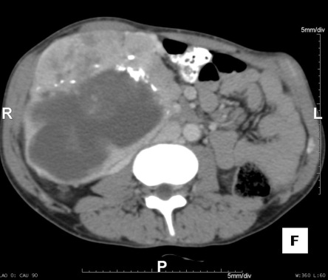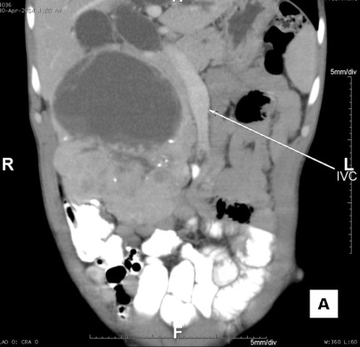
Figure 1 Computed tomography abdomen showing tumour encasing second part of duodenum and dilated common bile duct.

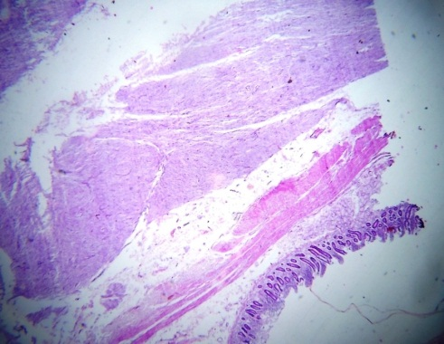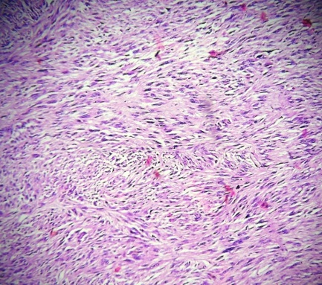
Figure 2 Microscopic findings (hematoxilin-eosin).

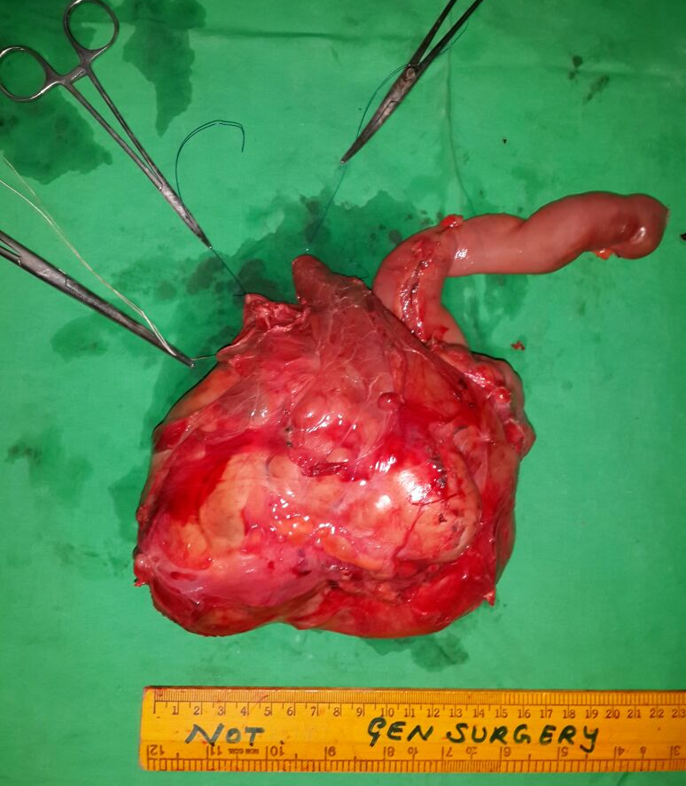
Figure 3 Gross specimen showing tumour.

